WASTE-TO-ENERGY: A STRATEGY FOR URBAN SPRAWL MANAGEMENT IN ENUGU METROPOLIS, SOUTH EAST, NIGERIA
Chijioke, Edmond Ogochukwu¹ (Corresponding Author)
Department of Urban and Regional Planning, Faculty of Environmental Sciences, Enugu State University of Science and Technology, Enugu, Enugu State, Nigeria
chijioke.ogochukwu@esut.edu.ng, +234 81 396 13505, ORCID HYPERLINK "https://orcid.org/ID"ID: 0000-0003-2249-0947
Eke, Bemsodi Linda²
Department of Architecture, Faculty of Environmental Sciences, Enugu State University of Science and Technology, Enugu, Enugu State, Nigeria
ABSTRACT
Solid waste buildup, urban sprawl, and energy shortage are the results of Enugu's rapid urbanization, population growth, and economic activity. Even if there is now a clear connection between garbage and energy, the term "waste-to-energy" is still ambiguous in Nigeria. Despite urban growth, the study has revealed some prospects for the Enugu urban region to turn its solid waste into electricity. According to the report, Enugu's six waste management zones produce roughly 420 tons of solid trash every day. The investigation makes it clear that each tonne of municipal solid trash from Enugu has the capacity to produce 17.001 million BTU. This indicates that solid waste in the Enugu metropolitan region may potentially provide 5.0 MW of energy per day. If solely organic garbage is burned, it will produce roughly 2.96 million Btu (1.1MW), which is enough to power about 900 homes in the city of Enugu. According to the research, the authorities should establish strict regulations for solid waste management and provide clear guidelines for garbage collection and transportation methods. Additionally, the landfill site needs to include a biofiltration system for odor control; sanitary landfills must be used in place of open dumps; and anaerobic digestion, a cost-effective method of converting solid waste into energy, should be taken into consideration. In order to meet the need for energy, the government must ultimately collaborate with the private sector to acquire technology that can turn solid waste into gas or electricity.
Key words: Population, Generation, Electricity, Composition, Waste-To-Energy

1.0 INTRODUCTION
The city's ongoing urban sprawl, geometrical population growth, fast rate of urbanization, shifting lifestyles, and increase in economic activity have all had a negative influence on management, cleanliness, and health of garbage, spontaneous housing developments, and energy sources (Shrestha, Sartohadi, Ridwan & Hizbaron, 2014).
Over the past ten years, the Enugu metropolis has seen urban growth, which has impacted the solid waste management dynamics in the 6 waste management divisions (New Haven, Abakpa, Agbani Road, Coal Camp (Ogbete), Emene, and Ogui). The zones produce roughly 420 metric tons of solid waste daily at a rate of 0.48 kg per person (Nwoke et al., 2020). This enormous volume of solid trash must be transformed into energy in order to alleviate Enugu's severe power generation shortage.

1.1 Statement of the Problem
Enugu's urban population has grown dramatically in recent years, and in order to accommodate this growth, residential layouts must be expanded. The ongoing production of solid waste is a result of this enormous population growth. It presents problems for the environment and insufficient power.

1.2 Aim and Objectives
The aim of the study is to understand the waste-to-energy concept for the management of urban sprawl in Enugu Metropolis, South East with the objectives of:
i. Determining the physical composition of Enugu urban solid waste (EUSW).
ii. Determining the energy content of Enugu urban solid waste (EUSW) that can be generated from the solid waste in Enugu Metropolis.

2.0 LITERATURE REVIEW
This section reviews the related literature associated with solid waste generation, management and conversion of waste to energy.
2.1 Urban Areas Solid Waste Management (SWM) System
Solid handling waste has long been a major concern in many developing nations. Up until the late 1980s, Greece managed solid waste utilizing open dump and landfill methods (Shrestha et al., 2014). The absence of organized facilities, coordination, and the governance of the relevant institutions has led to significant issues with the disposal of solid waste (Boemi, Papadopoulos, Karagiannidis, and Kontogianni, 2010). However, Greece's environmental planning and regulations later established the goal of implementing internal solid waste management, followed by the continuous decrease of biodegradable solid waste, which is currently leaning toward landfilling, stepping up recycling efforts, and closing open disposal locations (Karagiannidis, Boemi, Papadopoulos, and Kontogianni, 2010).
Numerous researchers have studied municipal waste management in Enugu, but they lack much thought to sustainable waste management techniques. As a result, the amount of ecological harm keeps increasing (Nnaemeka-Okeke, 2023). Thus, the purpose of this research is to determine the quantity of energy that Enugu, a city in southeast Nigeria, can produce from solid waste.

2.2 Waste-To-Energy Concept
The primary sources of garbage are residential regions, commercial, industrial, and institutional operations. An undesired byproduct of a nuclear reactor, chemical lab, or manufacturing process is referred to as "waste." The first incinerator was constructed in history in 1903 in Denmark (Habib, Schmidt, and Christensen, 2013). The concept of turning solid waste into energy becomes crucial in promoting an alternative energy source as energy consumption rises (Habib, Schmidt, and Christensen, 2013). Recycling and reusing materials are the most favored methods in the majority of waste management initiatives (Pratel, 2021). Nonetheless, turning garbage into energy is seen as a crucial component of solid waste management.

2.3 Current Energy Trend of Waste-To-Energy concept in Nigeria
Nigeria’s electricity distribution network comprised of high voltage (19,226 Km of 11KV and 23,753 km of 33KV) networks from primary and sub-primary substations. Table 2.1 shows Nigeria electricity substations fed with the ratings.
The substations fed with their respective ratings are shown in table 1.

Table I: Nigeria Electricity substations fed with the ratings.
Substations
679 | 20,543
Ratings
33/11 kV | 33/0.415KV; 11/0.415KV
Source: (Nwoke et. al., 2020)
Furthermore, there are 680 injection transformers and 1,790 distribution transformers. The transmission system is overcrowded and has a wheeling capacity of less than 4,000 MW. Poor voltage patterns are experienced by several networks, particularly in the northern region. This is a result of high frequency of inadequate dispatch and control infrastructure, a fragile and radial grid network, frequent system collapse, and abnormally large transmission losses. An estimate according to Nwoke et al. (2020), 70% of Nigerians do not have access to electricity. The amount of electricity consumed per person is approximately 145 kWh, compared to 4,198 kWh in South Africa and 3,927 kWh in China.
Many renewable energy sources in Nigeria need to be investigated further, but the majority of stakeholders are specific about hydropower development because its capacity is insufficient to meet the country's enormous population's demand for electricity (Agwi and Udo, 2021).

2.4 Gap of the Study
Unfortunately, a lot of research has been done on urban trash management in Enugu, but it hasn't given much thought to sustainable garbage management. As a result, ecological damage keeps increasing, which is why this study is being done to address the gap.

3.0 STUDY AREA
The Enugu urban area is roughly situated within latitudes 06˚30'N as well as 06˚40'N and longitudes 07˚20'E and 07˚35'E. Nine main districts and three local government units make up the city of Enugu. The six waste management zones are Trans-Ekulu, Uwani, and Coal Camp, according to empirical data (Ogbete), Ogui, Achara layout, and New Haven. The town's population was 772,664 in 2006, according to the National Population Commission (2006). Using the approved 3% growth rate for Nigerian urban areas, the town's population was predicted to reach 910,003 in 2014. (Nwoke et al., 2020) (200 km2). In order to manage solid trash, the urban area is empirically divided into six zones. Agbani Boulevard, Emene, Abakpa Nike, Coal Camp, Ogui, and New Haven zone are the zones (see to figure 3.1). Each zone is responsible for gathering and delivering the waste to the Ugwuaji landfill (Nwoke et al., 2020).
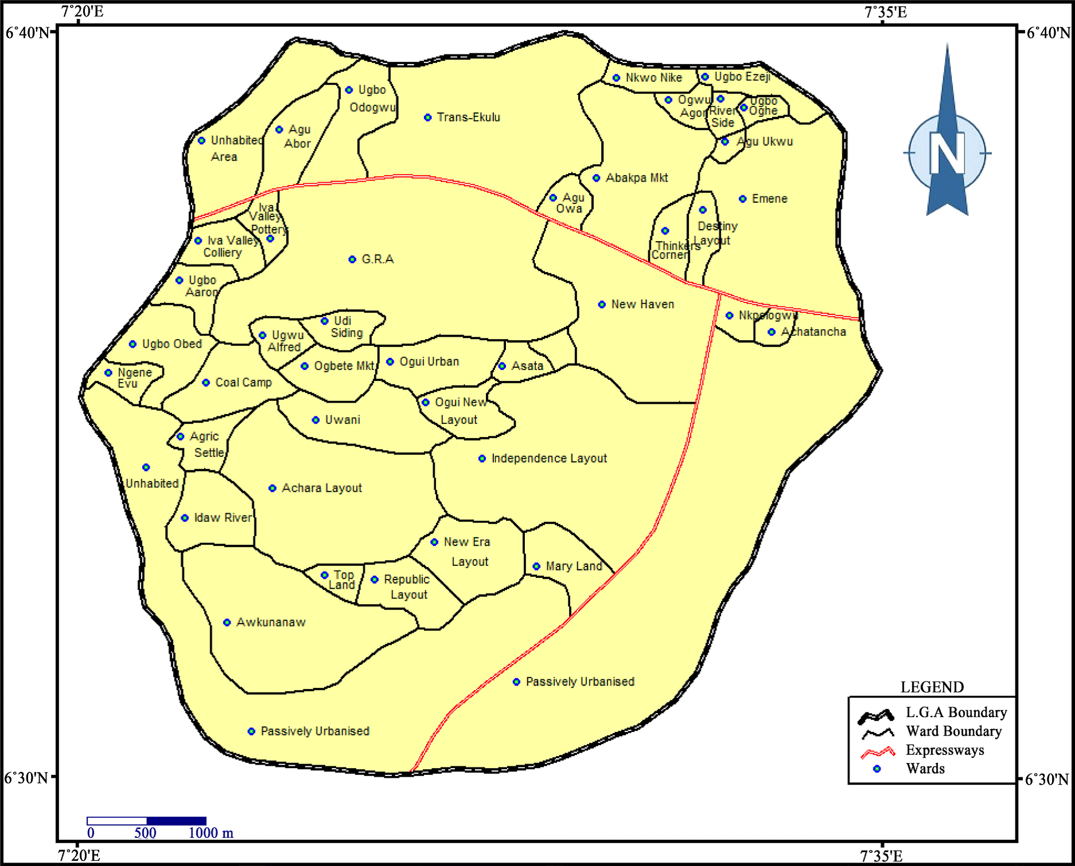 Figure 1: Map of Enugu metropolis
Source: Ezenwaji et. al. (2016)

4.0 RESEARCH METHODOLOGY
This section presents the materials and method used for the collection of data for the purpose of this research.
4.1 Research Design
The research combined both the field trip and the laboratory analyses of waste.
4.2 Data needs of the study
The data needed for this research included environmental data, waste quantification data and socio-economic data.

4.3 Sources of data
Both primary and secondary data were used for this research.
4.3.1 Primary sources of data
These were the data collected through the field survey which included waste collection, characterization and segregation.
4.3.2 Secondary sources of data
Environmental Management magazines, NITP journals, published census data (National Population Reports), statistical data (National Bureau of Statistics), and data archives (Enugu Electricity Distribution Authority) provided the secondary data for this study.
4.3.3 Methods of data Presentation
The data were presented in tables, bar charts and graphs.

5.0 FINDINGS AND DISCUSSIONS
According to Nwoke et al. (2020), the municipal solid waste, or MSW, in the Ugwuaji landfill is physically composed of 39% organic matter on average, with a large fraction of vegetables and food waste, among other things, as seen in Table 5.1.
Table I: Average composition of Enugu urban solid waste
Waste constituents | % Composition
Organic matter | 39
Plastics | 21
Paper | 16
Textile | 5
Metal | 2
Glass | 3
Others | 19
Source: Nwoke et al., (2020)
Figure 2: Physical composition of urban solid waste from various sectors Source: Nwoke et. al., (2020)
Figure 3: Enugu urban solid waste composition Source: Nwoke et. al., (2020)
Table II: Characteristics of waste stream compositions in Nigeria
 | Organic matter | Plastics | Paper | Textile | Metal | Glass | Others
Onitsha | 30.7 | 9.2 | 23.1 | 6.2 | 6.2 | 9.2 | 15.4
Nsukka | 56 | 8.4 | 13.8 | 3.1 | 6.8 | 2.5 | 9.4
Lagos | 59 | 4 | 14.0 | - | 4.0 | 3.0 | 19.0
Kano | 43.0 | 4.0 | 17.0 | 7.0 | 5.0 | 2.0 | 22.0
Ibadan | 76 | 4.0 | 6.6 | 1.4 | 2.5 | 0.6 | 8.9
Maidugri | 25.8 | 18.1 | 7.5 | 3.9 | 9.1 | 4.3 | 31.3
Markurdi | 52.2 | 8.2 | 12.3 | 2.5 | 7.1 | 3.6 | 14.0
Enugu | 39.0 | 21.0 | 11.0 | 5.0 | 2.0 | 3.0 | 19.0
Others: ash, rubber, soil, bones, and dust
Source: Nwoke et al., (2020)
Figure 4: Characteristics of waste stream compositions in others cities in Nigeria Source: Nwoke et al., (2020)

5.1 Solid Waste and Energy Content in Enugu urban area: Prospects in Enugu
There are variations in the calorie counts of the various components that make up solid waste. It is essential to understand both the composition and moisture level of solid waste in order to calculate its heat content. To ascertain a solid's heat content waste, each solid waste component's heat value is utilized. The amount of heat of solid waste can be determined using the formula below.
Heat content (HC) = Xi * HVi; where Xi = the fraction of component i
HVi = Heat Value of component i. Thus, the heat content of Enugu urban area solid waste is simply calculated as: HC = 0.39 * 7.6 + 0.21 * 22.6 +0.11 * 6.7 + 0.05 * 13.8 + 0.02 * 0.7 + 0.03 * 0.1 + 0.19 * 41.3 = 17.001 million BTU
It is clear from the analysis that Enugu urban solid trash has the ability to produce 17.001 million Btu per tonne. This implies that a total of 5.0 MW of energy might theoretically be used each day to light around 900 dwellings. Although the amount produced is insufficient, it is not little enough to be disregarded as it can be used to produce electricity in the urban area of Enugu from solid waste. If only organic waste is burned as it will produce roughly 2.96 million Btu (1.1MW), with additional components being recyclable or reusable.
Table IV: Average heat value of possible components in Solid waste
Waste Component | Heat Value (Btu/ton x 10⁶)
Plastic | 22.6
Rubber | 26.9
Leather | 14.4
Textiles | 13.8
Glass | 0.1
Organic waste | 7.6
Paper | 6.7
Metal | 0.7
Source: Shrestha et al., (2014)

5.2 Plans and Support from the Government
The Waste-To-Energy concept requires a comparatively large initial expenditure, complete backing from the government is required (Pratel, 2021). As new technologies for solid waste management have emerged, the Enugu State Government has been working to support the Enugu State Waste Managemen in order to dispose of the waste that is starting to accumulate in the city's dump sites, the Authority (ESWAMA) established a 12-person committee tasked with offering all of its domestic, commercial, and industrial clients including the government unprecedentedly effective waste management services.
Through its collaboration with private garbage collectors, who are assigned to each of the 29 zones established to guarantee better trash management, the committee has already provided relief to the locals. Additionally, the state government has launched its garbage program to riches with the goal of utilizing a new economic sector and attracting potential investors by creating an environment that is conducive to resource management and environmental conservation through the reuse and redistribution of waste materials (Uwaegbulam, 2017).

6.0 CONCLUSION AND RECOMMENDATION
This section contains the conclusion and the recommendation drawn from the studies.
6.1Conclusion
Despite urban sprawl, the study has revealed a wealth of options for the Enugu urban region to turn its solid waste into electricity. According to the report, Enugu's six waste management zones produce roughly 420 tons of solid trash every day. It is clear from the analysis that every tonne, 17.001 million BTU might be produced from the urban solid trash in Enugu. This indicates that solid trash in the Enugu urban area may theoretically produce 5.0 MW of energy each day. The potential of solid waste to energy, government sponsorship, and private sector involvement would be the preparation for using garbage from urban sprawl to generate electricity.

6.2 Recommendations
i. Strong solid waste management policies should be established by the government, together with clear guidelines for waste collection and transportation methods.
ii. A waste management policy that aims to turn all waste into wealth is necessary.
iii. Sanitary landfills must take the place of open dumps.
iv. Anaerobic digestion is considered the most cost-effective method for converting solid waste into electricity.
v. In order to meet the need for energy, the government must ultimately work in tandem with the private sector to acquire technologies that can transform solid waste into gas or electricity.

REFERENCES
Agunwamba, J. C. (1998). Analysis of scavengers’ activities and recycling in some cities of Nigeria. Environmental Management, 32(1): 116-127.
Boemi, S., Papadopoulos, A., Karagiannidis, A. and Kontogianni, S. (2010) Barriers on the Propagation of Renewable Energy Sources and Sustainable Solid Waste Management Practices in Greece. Waste Management and Research, 28, 967-976.
Cointreau, S. J. (1982). Environmental Management of Urban Solid Waste in Developing Countries: A Project Guide. Urban Development Technical Paper No 5. Washington, DC.: The World Bank.
Dauda, M., and O. O. Osita. (2003) Solid waste management and reuse in Maiduguri, Nigeria. In Proceedings of 29th WEDC International Conference towards the Millennium Development Goal, 20-23. Abuja, 22-26 September.
Diaz, L.F. and C.G. Golueke, (1985). Solid waste management in developing countries, BioCycle, 26:46-52.
Ezenwaji, E.E., Nzoiwu, C.P. and Eduputa, B.M. (2016) Enhancing Urban Water Supply through Rainwater Collection in Enugu Town, Nigeria. Journal of Geoscience and Environment Protection, 4, 82-88.
Gunamantha, M. (2012) Life Cycle Assessment of Municipal Solid Waste Treatment to Energy Options: Case Study of Kartamantul Region, Yogyakarta. Renewable Energy, 41, 277-284.
Habib, K., Schmidt, J.H. and Christensen, P. (2013) A Historical Perspective of Global Warming Potential from Municipal Solid Waste Management. Waste Management, 33, 1926-1933. http://dx.doi.org/10.1016/j.wasman.2013.04.016
National Population Commission (2006) 2006 Population Statistics. National Bureau of Statistics, Abuja.
Nwoke, O. A., W. I. Okonkwo , E. A. Echiegu, C. H. Okechukwu, and B.O. Ugwuishiwu. (2020). Determination of the calorific value of municipal solid waste in enugu, nigeria andits potential for electricity generation. Agricultural Engineering International: CIGR Journal, 22(2):86-97.
Onyia, C.J., Agbatah, O.B., Nnam, L.E., Nze, O.N., Amasiatu, I.S., Okoli, C.C., Onoh, C.J. (2019). Solid waste as renewable source of energy: current and future possibility in Nigeria. Journal of Research and Innovation in Engineering, 4(2): 2659-1790
Shrestha, R.M. and Malla, S. (2013) Air Pollution from Energy Use in a Developing Country City: The Case of Kathmandu, Nepal.
Uwaegbulam, C. (2017), ‘Enugu begins solid waste reform, partners private sector’ ‘Guradian Newspaper, 25th December. (https://guardian.ng/property/enugu-begins-solid-waste-reform-partners-private-sector/ accessed on 20 April, 2025).
Zahari, M. S., W. M. F. W. Ishak, and M. A. Abu-Samah. (2010). Study on solid waste generation in Kuantan, Malaysia: It’s potential for energy generation. International Journal of Engineering Science and Technology, 2(5): 1338-1344.

