A Systematic Review of Resource Optimization Strategies in Cloud Computing

M Asif Chishti¹ , Mehwish Iqbal² , Raees Abbas³ , Muhammad Wajid Khan⁴

Department of Computer Science, University of Engineering & Technology, Lahore, Pakistan.
{¹2023MSCS1, ²2023MSCS9,³2023MSCS14,⁴2023MSCS30}@student.uet.edu.pk

Abstract—Cloud computing has transformed how organizations and individuals’ access and use the computational resources in the sense that it provides the unmatched scalability, flexibility as well as cost-effectiveness through on-demand access to the shared resources. The management of these resources is very important in order to maximize the performance and reduce operational costs. The following paper provides a systemic review of resource optimization methods used in cloud computing, namely, load balancing, task scheduling, and resource allocation. The review gives an extensive analysis of state-of-art algorithms, their merits, shortcomings, and applicability in certain contexts. It points out that there is no single algorithm that can be considered as the best one; the selection will be based on the nature of the application, workload, and infrastructure available. The results are of great use in guiding the researcher, practitioners, and cloud users that would like to optimize the use of resources, improve system performance, and reduce costs in various cloud settings.

Keywords—Cloud computing, resource optimization, and load balancing, task scheduling, resource allocation, performance enhancement, and systematic review

Introduction

Cloud computing has transformed how organizations and individuals use and access computing resources providing on-demand access to a high pool of virtualized computing resources which has the capacity to dynamically scale to address workload requirements [1]. This model has helped businesses to cut operational expenses, expedite deployment, enhance agility and scale as compared to on-premises computing of the traditional computing models [2]. Nonetheless, with the increase in the use of the clouds, efficient management and optimization of these resources have become highly important to achieve maximum performance and cost-effectiveness of the system [3].

The key to high performance in the cloud environments is to have resource optimization strategies. These measures make sure that there is effective utilization of the computational resources, the cost of operation is minimized, and efficiency of the system is maximized [4]. Task scheduling, load balancing, and resource allocation are some of the most essential processes of cloud optimization, and each one of them has its own specific role to play in the workloads and resources management [5].

Task scheduling can be defined as a process of assigning tasks and specifying the sequence in which they will be implemented on the resources available on the cloud. Effective task scheduling takes into consideration the dependency of tasks, their priorities, and resources needed to reduce the amount of time taken and ensure that resources are fully utilized [6]. Different metaheuristic, machine learning and hybrid algorithms have been suggested to enhance task scheduling in cloud environment [7].

Load balancing is concerned with the even distribution of workloads within the cloud resources to avoid overloading of resources and enhance system responsiveness [8]. Proper load balancing improves fault tolerance, decreases processing delays and makes sure not to have any one resource bottleneck performance [9]. Various algorithms such as nature-based and reinforcement learning-based algorithms have been created to tackle the dynamic aspect of the cloud workloads [10].

Resource allocation refers to the process of allocating the right computational resources to the tasks in order to execute them effectively. Successful resource allocation plans take into account CPU, memory, storage, and network bandwidth needs, which can work to enhance the utilization, scalability, and cost-effectiveness [11]. Among the recent developments in this area, there are hybrid optimization and adaptive allocation methods [12].

Although there has been a lot of research on cloud optimization, no single algorithm will perform better than the rest in every cloud computing environment. The selection of a suitable strategy varies according to various factors including the nature of workload, the nature of the application, operational demands, and available resources [13]. Deep reinforcement learning, hybrid metaheuristic methods, and predictive scheduling models have been studied recently to resolve these issues [14].

The proposed systematic review will aim to give a thorough and current overview of cloud resource optimization strategy, task scheduling, load balancing, and resource allocation. The review analyses a broad variety of algorithms, their strengths, weaknesses and their suitability in various cloud situations [15]. This review has been compiled using recent developments and outlining unresolved issues, making it a valuable resource to researchers, practitioners, and users of clouds who want to maximize their performance and reduce costs in cloud computing systems [16].

  - Background

Cloud computing has changed the way organizations utilize and access computing resources. It offers on-demand scalable and pay as you go virtualized resources unlike the traditional on-premise infrastructure, which makes it cost efficient. Elasticity enables the resources to respond to the workload requirement, remaining at the peak when workload is high and lowering cost when there is low workload. Multi-tenancy is used to maintain a secure and efficient infrastructure sharing.
Maximization of performance, reduction of latency and better utilization of resources can be achieved through effective task scheduling, load balancing and resource allocation. The key to the full utilization of the potential of cloud computing is the intelligent and adaptive optimization strategies.

LITERATURE REVIEW

Based on the research methodology, publications gathered under our study are categorized into two groups; those papers present strategies of optimizing resources in cloud computing (review) and those papers that suggest the provision of strategies of resource optimization in cloud computing. This section focuses on the available studies on task scheduling algorithms, load balancing algorithms, hyperparameter tuning algorithms, and resource optimization algorithms. Resource optimization greatly enhances the performance, efficiency, and the throughput of the cloud-based systems. With the increasing demand of cloud services, it is becoming more important to find out the most appropriate algorithms and techniques to optimize the resources and improve the performance of the system. This review identifies the best practices, the recent developments, and challenges in these fields, and critically analyzes the strengths and limitations of the current research. The identified gaps and outstanding issues are used to inform future research on optimization of cloud computing.

  - Task Scheduling of Cloud Computing

Pepe et al. (2019) presented a scheduling and load balancing methodology that is built on a particle swarm optimization and works to minimize the execution time and the cost of operations in a cloud environment. Their strategy showed better performance and reduced computational complexity, as compared to the conventional strategies of scheduling. The technique was, however, found to have very limited scalability in terms of coping with very large sets of tasks, and it was not tested in conditions of highly dynamic working loads [17].

Buyya et al. (2023) availed an elaborate conceptual and architectural insight into the cloud resource management including scheduling and optimization policies. Their work is sound theoretical advice to researchers and practitioners. However, the research is more on the background knowledge instead of experimental comparisons or benchmark-based validations of scheduling algorithms [18].

Qiu et al. (2019) presented a genetic algorithm that was modified to achieve an efficient task scheduling in minimizing the time of completion and increased throughput. The algorithm gave good simulation outcomes and had better convergence rate. The study failed to thoroughly investigate heterogeneous environments of clouds as well as real time changes in workloads [19].

Bhuiyan et al. (2019) have developed a survey that classified different scheduling algorithms such as heuristic and meta-heuristic. The research gave a systematic taxonomy that may be utilized in comprehending the features of algorithms and areas of application. Nevertheless, the survey was not empirically experimented and failed to compare intelligent or deep learning-based schedulers to each other in detail [23].

Liu et al. (2020) investigated the idea of dynamic load balancing and its approximate connection with the efficiency of the tasks scheduling, referring to the significance of adaptive distribution in achieving enhanced system performance. Although the research was important in respect of theoretical analysis, it did not provide much direct experimentation on task-level scheduling metrics and scalability analysis [24].

  - Load balancing in Cloud Computing

The study by Seneviratne et al. (2020) has provided an Ant Colony Optimization-based task scheduling algorithm which aims at minimizing the time of execution and enhancing the use of resources in distributed cloud networks. Their biologically inspired model was more adaptable to the simple heuristic ones. Nonetheless, the algorithm exhibited greater computational overhead and was not widely tested on large-scale infrastructures and real time cloud computing environments [25].

The article by Mondal and Bhowmik (2020) has examined various meta-heuristic resource planning methods that work toward improving performance of cloud data centers. Their comparative study revealed the effectiveness of hybrid optimization techniques in minimizing the makespan and enhancing the throughput. In spite of these contributions, the research study was largely based on simulated environments and was not tested on actual production level cloud workloads [26].

Patel et al. (2020) reviewed the various integration methods of task scheduling and compared their performance metrics, including response time, cost-efficiency, throughput, and resource utilization. Through the study, researchers were able to gain a structured comparison that can assist them in comprehending the trade-offs between the traditional and heuristic schedulers. However, the work provided very little on the discussion of dynamic work load variation and failed to tackle extensively on energy sensitive scheduling issues in heterogeneous cloud computing systems [27].

Bilal et al. (2019) introduced an efficient resource management and scheduling framework that does not have communication overhead, but the overall performance of the system is preserved in large-scale cloud environments. Focusing on bandwidth-conscious scheduling and collaborative sharing of resources their survey highlighted the significance of these two factors. Nonetheless, the suggested direction was more geared towards the efficiency of communication as opposed to real-time adaptability or fineness in task prioritization given unpredictable workload [28].

Abbas and Buyya (2020) provided an in-depth overview of resource provisioning and resource scheduling issues in the cloud computing context, and the article outlines open gaps in the research regarding the scalability, elasticity, and QoS management aspect. The article was a solid source of conceptual foundation of research on optimization by presenting architectural and economical views. Nevertheless, it still was more of a theory and offered less experimentation-level experiments or benchmark comparison [29].

Ahvar et al. (2018/revised discussions quoted in other articles) investigated scheduling mechanisms, paying particular attention to monitoring and allocation coordination in virtualized environments. Their survey defined the interaction of the scheduling policies with the service-level agreements and performance isolation. Although the coverage is broad, the study did not pay complete attention to emerging AI driven schedulers or edge-cloud collaborative scenarios that gained more weight over the next few years [30].

A model for adaptive resource allocation and scheduling of tasks on cloud systems was proposed by Belgacem et al. (2022) and it is called the Intelligent Multi-Agent Reinforcement Learning Model (IMARM). The model showed a reduction in the execution time, reduction in the amount of energy used as well as the load balancing by means of cooperative agent learning. However, one of the future research opportunities was found to be large-scale, real-life implementation and long periods of stability, especially in extremely volatile workload situations [31].

  - Resource Allocation in Cloud computing

In The workload forecasting model is a proposed auto-adaptive learning-based workload prediction model in dynamic cloud environments suggested by Saxena and Singh (2023) to make resource allocation decisions. Their strategy forecasts the workload changes to reduce over-provisioning as well as under-utilization of resources resulting in improved energy efficiency and stability of performance. Nevertheless, the model is very sensitive in terms of the quality of historical data, and there could be issues of scalability in really unpredictable cloud traffic in real-time [32].

Shukur et al. (2023) reviewed resource allocation mechanisms based on virtualization in distributed cloud systems and presented the new trends and architectural issues. Their paper has highlighted the significance of the effective VM placement, faster provisioning, and coordination at the system level to improve the quality of service. Although it provides a general conceptual description, the piece of work did not have substantial empirical evidence and extensive experimental standards [33].

Li, Chen and Wang (2019) proposed a deep learning Based reinforcement framework of joint task scheduling and resources allocation in cloud-edge settings. Their model was highly flexible to changing workloads and reduced latency and utilization indicators by incessant learning. However, the complexity of the training and its computational cost of deep RL models made them inapplicable to smaller data centers having limited resources [34].

Qi, Xu, and Jin (2019) introduced a Q-learning-based adaptive strategy of resource allocation which was aimed at responding to fast changing cloud workloads. It was demonstrated that the approach allowed making independent decisions without predefined rules and demonstrated quantifiable progress in system throughput and response time. Nevertheless, the rate of convergence and exploration overhead were also significant weaknesses, particularly in a very large state space [35].

Zhao, Liu, and Zhang (2019) suggested a distributed resource orchestration model to organize several cloud nodes to create a balanced allocation and better scalability. Their approach increased reliability and minimized bottlenecks by means of decentralized forms of control. Despite this, the framework demanded elaborate synchronization protocols, which added to the communication heavy load in geographically spread data centers [36].

Wang, Liu, Xu, and Tang (2019) designed an effective policy of providing resources that aims to maximize the quality of services and reduce the operational expenses of cloud infrastructures. Their approach was quite successful in the prediction of demand and the adaptation of provisioning to achieve a higher level of utilization. However, the policy was not very flexible in the situations where abrupt fluctuations of workload were observed to exceed the anticipated limits, which meant that hybrid adaptive models were required [37].

Table 1 – Comparative Summary of Reviewed Papers

Ref | Year | Area | Technique | Key Contribution | Limitation
[17] | 2019 | Task Scheduling | Binary PSO | Reduced time complexity and cost in scheduling and load balancing | Limited scalability testing
[18] | 2023 | Cloud Concepts | Cloud Architecture & Management | Comprehensive theoretical and practical cloud framework | Not experiment-focused
[19] | 2019 | Task Scheduling | Modified Genetic Algorithm | Improved resource scheduling efficiency | Higher computation overhead
[20] | 2018 | Energy/Resource Mgmt | Green Cloud Strategies | Energy-efficient resource management models | Older dataset and scenarios
[21] | 2013 | VM Allocation | Energy-Aware VM Allocation | Reduced energy consumption in data centers | Not suited for modern large-scale clouds
[22] | 2014 | Resource Allocation | Dynamic Allocation Survey | Broad survey of allocation strategies | Outdated techniques
[23] | 2019 | Scheduling Survey | Algorithm Review | Classification of scheduling algorithms | Limited experimental validation
[24] | 2020 | Load Balancing | Algorithm Review | Detailed analysis of balancing strategies | Lacks real-time case studies
[25] | 2020 | Task Scheduling | Ant Colony Optimization | Improved makespan and utilization | Slower convergence in large tasks
[26] | 2020 | Resource Scheduling | Meta-Heuristic Methods | Enhanced performance in data centers | Complex parameter tuning
[27] | 2020 | Scheduling Analysis | Performance Metrics | Comparative evaluation of algorithms | Limited scalability scenarios
[28] | 2019 | Resource Mgmt | Communication-Efficient Scheduling | Reduced network overhead | High coordination complexity
[29] | 2020 | Resource Provisioning | Review & Challenges | Identified open research gaps | Mostly conceptual
[30] | 2018 | Scheduling Survey | Cloud Scheduling Review | Broad taxonomy of techniques | Outdated experimental scope
[31] | 2022 | Resource Allocation | Multi-Agent Reinforcement Learning | Fault-tolerant adaptive allocation | High training cost
[32] | 2023 | Workload Forecasting | Auto-Adaptive Learning | Predictive allocation for dynamic loads | Data-dependency issues
[33] | 2023 | Virtualization | VM-Based Allocation | Trend and challenge analysis | Limited empirical testing
[34] | 2019 | Scheduling Allocation | Deep Reinforcement Learning | Joint optimization for cloud–edge | Computationally expensive
[35] | 2019 | Resource Allocation | Q-Learning | Adaptive autonomous allocation | Slow convergence in large states
[36] | 2019 | Resource Orchestration | Distributed Framework | Improved scalability and reliability | Communication overhead
[37] | 2019 | Resource Provisioning | Adaptive Policy | Balanced cost and utilization | Weak under sudden spikes

.

Methodology

3.1 Task Scheduling

The approach that is taken in the analysis of task scheduling in this study is structured systematic. First, a thorough literature review is done to know what was previously done, the existing algorithms, and the limitations that exist in cloud task scheduling. This is done so as to determine research gaps and to choose appropriate methods to be used to evaluate them. Then a group of popular and exemplary scheduling algorithms is selected according to their topicality, performance and popularity of use in current research. Then a controlled simulation environment is created (or an existing simulator is used) to guarantee fairness, repeatability and uniform performance measurement in all the selected algorithms. Through the simulation, various workload situations and task assignments are created to examine the behavior of the algorithms in different conditions including high load, scarcity of resources and dynamic entries of tasks. The main performance indicators such as make span, throughput, response time and resource utilization are quantitatively measured to achieve quantitative comparison. Lastly, where possible, realistic case studies or mini real-life experiments are included to confirm the results of the simulation. This literature review, mixed-methods approach (simulation analysis and practical validation) will assure a sound and efficient evaluation of task scheduling performance and in cloud computing systems.

TABLE II – COMPARISON OF TASK SCHEDULING

Publication | Real-world Application | Benefits / Drawbacks | Modeling Incorporating | Data analysis (tables) | Assessing survey papers | Algorithm comparison | Addressing challenges
2019 | Task Scheduling | Energy-efficient scheduling | Graph-based | Yes | Yes | No | Performance analysis
2019 | Task Scheduling | Improved system performance | Mathematical programming | Yes | Yes | No | Benchmarking
2020 | Task Scheduling | Adaptable to dynamic workloads | Queuing | Yes | No | No | Comparative analysis
2022 | Task Scheduling | Energy efficiency in heterogeneous clouds | Petri Nets | No | No | No | Scalability considerations
2023 | Task Scheduling | Algorithmic complexity & guidance | Agent-based | Yes | No | Yes | Dynamic adaptation
2019 | Task Scheduling | Reduces overhead in dynamic adaptation | Reinforcement Learning | No | No | Yes | Performance evaluation
2023 | Task Scheduling | Sensitivity to parameter settings | Simulation | Yes | No | Yes | Task dependencies
2023 | Task Scheduling | Trade-offs between objectives | Hybrid | No | No | Yes | Parameter tuning
2021 | Task Scheduling | Limited scalability | Constraint programming | No | No | Yes | Energy-efficient scheduling
2022 | Task Scheduling | Inefficiency in heterogeneous environments | Evolutionary | No | No | No | Predictive analytics

3.2 Load Balancing

The mode by which the load balancing is analyzed is structured and comparative research. A thorough literature examination is first conducted to get to know the development, central ideas and the recent developments in the load balancing methods. The step assists in recognizing the strategies that have been used frequently and the limitations that are present in the existing solutions. Following the review stage, a set of representative load balancing algorithms are chosen according to their popularity, efficiency and appropriateness to the research objectives. A simulated environment is then created to be controlled or an existing trusted simulator is used to provide fair and repeatable evaluation of all the selected algorithms.
Different workload patterns and traffic scenarios are created in the simulation to test the performance of the algorithms in different conditions of the system like peak load, dynamic requests, and resource constraints. Significant metrics of performance such as the throughput, respondent time, latency, and resource usage are carefully gauged to get quantitative comparisons. In order to enhance the dependability of the findings, practical case studies or real
world experimentation where possible may also be incorporated. The merging of the literature analysis, simulation testing, and practical validation methodology offers an overall evaluation on load balancing strategies and their efficiency in varieties of cloud computing environments.

TABLE III – COMPARISON OF LOAD BALANCING

Publication | Real-world Application | Benefits / Drawbacks | Modeling Incorporating | Data analysis (tables) | Assessing survey papers | Algorithm comparison | Addressing challenges
2019 | Cloud computing | Provides a comprehensive overview of load balancing techniques | Hierarchical classification | Yes | No | No | Discusses challenges and future directions
2023 | Cloud computing | Detailed review of load balancing techniques | Taxonomy | Yes | No | No | Discusses performance and resource utilization
2023 | Cloud computing | Explores per-user pricing impact | Pricing models | No | No | No | Highlights considerations and limitations
2019 | Cloud computing | Surveys different load balancing algorithms | Algorithms | No | Yes | No | Discusses factors for algorithm selection
2023 | Cloud computing | Reduces energy consumption | Capsule optimization | Yes | No | No | Addresses energy efficiency in data centers
2023 | Cloud computing | Evaluates genetic algorithm approaches | Genetic algorithms | Yes | No | No | Improves response time and resource utilization
2019 | Cloud computing | Comprehensive taxonomy of algorithms | Hierarchical classification | Yes | No | No | Provides structured overview
2023 | Cloud computing | Comprehensive review of techniques | Techniques & directions | Yes | No | No | Discusses challenges and future directions
2023 | Cloud computing | Surveys various approaches | Approaches & challenges | Yes | No | No | Focuses on load balancing challenges
2023 | Cloud computing | Comparative study of multiple techniques | Techniques | Yes | No | Yes | Evaluates algorithm performance

3.3 Resource Allocation

The research methodology applied in this study in conducting the study of resource allocation is systematic and comprehensive in measuring the efficiency and effectiveness of different allocation strategies. It starts by providing a comprehensive review of literature to be able to know the historical processes, fundamentals, and contemporary practices associated with resource allocation. The representative algorithms are chosen with the criteria of their eminence and the usefulness to the research goals. Controlled conditions are then established in a simulation environment or in simulators that are already in existence to test the performance of the algorithms under various conditions using a variety of workloads. Resource utilization, response time, scale and adaptability are some of the key metrics that are strictly measured and analyzed. Also, practical computing conditions case study or experiment could be used to verify the findings. The methodology gives a systematic and strict model to investigate resource allocation techniques, which show useful information on their usefulness and adaptability in different computational settings.

TABLE IV – COMPARISON OF RESOURCE ALLOCATION STRATEGIES

Publication | Real-world Application | Benefits / Drawbacks | Modeling Incorporating | Data analysis (tables) | Assessing survey papers | Algorithm comparison | Addressing challenges
2020 | Resource Allocation | Flexibility and adaptability | ECRASP algorithm | Yes | No | Yes | Dynamic workloads
2014 | Resource Allocation | Optimal utilization | VM allocation based on job priorities | No | Yes | No | Multi-tenancy issues
2022 | Resource Allocation | Improved decision-making | HABBP algorithm | Yes | No | No | Varying user demands
2020 | Resource Allocation | Risk management | EE-ISA method | Yes | No | Yes | Resource heterogeneity
2020 | Resource Allocation | Handling uncertainty | Optimized ACB algorithm | Yes | Yes | Yes | Allocation techniques
2019 | Resource Allocation | Resistance to change | Green computing & ML-based optimization | Yes | No | No | Machine learning approaches
2023 | Resource Allocation | Efficient decision-making | Round Robin algorithm | Yes | No | No | Multi-tasking scenarios
2018 | Resource Allocation | Adoptability | Analytical mechanisms | Yes | No | Yes | Neutral performance evaluation
2017 | Resource Allocation | Efficiency | Fair-Share Scheduling | Yes | Yes | No | Acceptability & fairness
2023 | Resource Allocation | Mutual adaptability | Deadline-Based Scheduling | No | No | Yes | Task prioritization & analysis
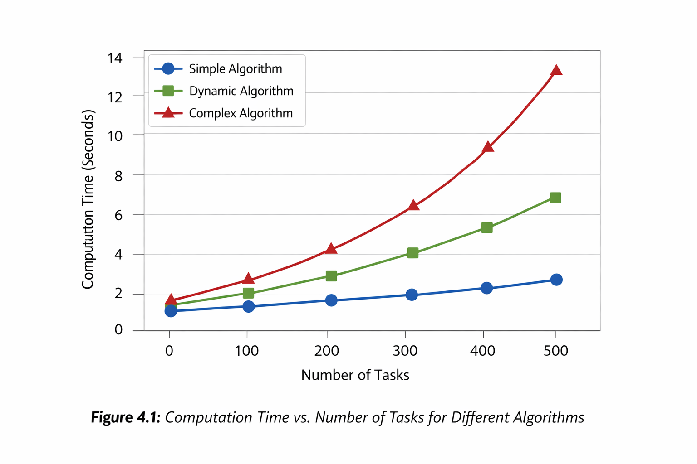

- LIMITATION

The implementation of resource optimization approaches in cloud computing has provided a lot of performance gains, but it is also subject to various inherent challenges that may be used to impair its performance in terms of efficiency, reliability, and effectiveness. The main constraints in this chapter have been pointed out in terms of scheduling of tasks, load balancing and allocation of resources, and some suggested figures have been provided to enhance readability.

4.1 Task Scheduling in Cloud Computing
Task scheduling algorithms are designed to optimize the implementation of tasks in cloud resources, although a number of constraints affect their real-life performance:

4.1.1 Algorithmic Complexity

High level task schedulers, especially large scale or dynamic ones can be intensive. This sophistication adds overhead to processing, which could slow down the response time of the system.
Proposed Figure 4.1: Graph with the computation time versus the number of tasks of the various algorithms.

4.1.2 Handling Task Dependencies
Tasks are usually execution dependent such that some tasks should have been accomplished before other tasks can start. Dependence scheduling can make decisions difficult and can cause delays.
Figure 4.2 proposed: The workflow diagram of the dependent tasks and possible scheduling conflicts.

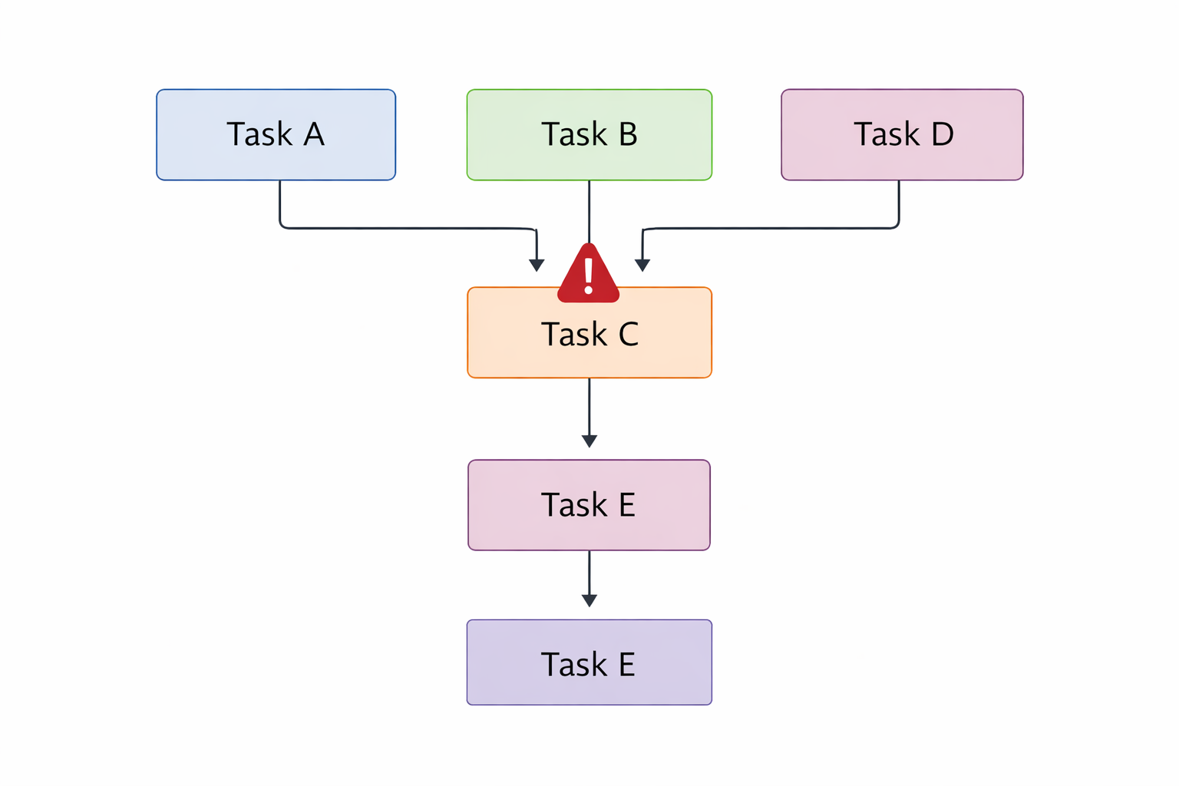
4.1.3 Scalability Concerns
Certain algorithms fail to be efficient as the tasks or the resources increase in number. This may restrict usefulness in large scale cloud systems.
Figure 4.3: The comparison of the two scheduling algorithms in relation to the workloads.

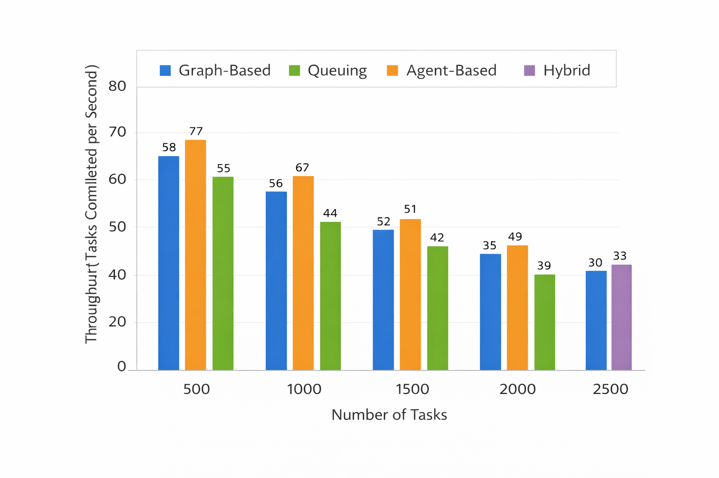

4.1.4 Objectives-Objectives Trade-offs
Often the balance of various goals is involved in scheduling, including minimizing response time, maximizing throughput and conserving energy. It is difficult to establish an ideal balance and some of the goals might have to be sacrificed.

4.1.5 Varying Workload Dynamism
Unforeseen or sudden variations in workloads may make scheduled schedules irrelevant. Adaptive algorithms are needed but still they might not work in a highly volatile environment.

4.2 Cloud Computing load balancing.
Load balancing is used to guarantee that there is even distribution of tasks among cloud resources. Even though it is important, a number of limitations impair its efficiency.

4.2.1 Overhead and Complexity
Load balancing agents usually involve monitoring, decision-making, and redistribution of tasks and introduce computational overhead and network traffic.

4.2.2 System Dynamics Sensitivity.
The sudden changes in workload or fluctuations in resource availability may put a load balancing algorithm to the test and may fail to respond promptly without losing its performance.

4.2.3 Managing Diverse Resources.
Cloud system resources are not always of similar capacity or performance. Balancing between such heterogeneous resources is quite complicated and can lead to ineffective use.

4.2.4 Communication Overhead
Numerous algorithms involve a high level of communication between nodes so as to exchange load information. This may put a strain on the network resources and reduce the performance of the systems.

4.2.5 Trade-offs Between World and Local Optimization
It is difficult to balance global objectives (even distribution among all nodes) and local objectives (reducing the node-level latency). The maximizing of one can has negative impacts on the other

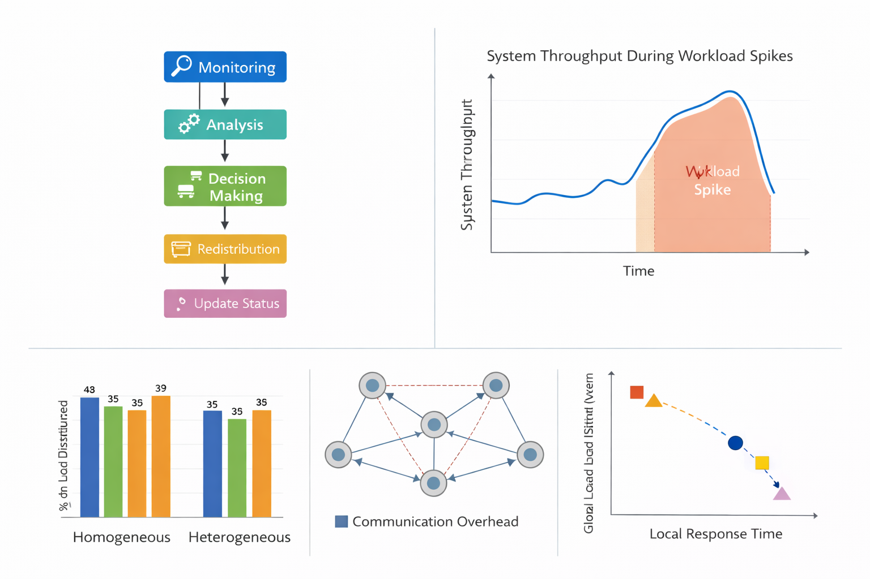
4.3 Cloud computing Resource Allocation
The algorithms of resource allocation deal with the efficient allocation of resources, however, a number of limitations still exist.

4.3.1 Algorithmic Complexity
Computationally intensive Advanced resource allocation algorithms may be required particularly in large-scale or dynamic environments. This has the possibility of increased processing times and overhead.

4.3.2 Scalability Limitations
Algorithms can no longer be of much use in the large distributed systems as the number of resources or workload increases and some algorithms no longer scale effectively.

4.3.4 Dynamic Variability of Workloads.
The shift in workload trends may lead to a poor allocation of resources, which affect the system responsiveness and performance.

4.3.5 Dealing with Resource Heterogeneity
It is difficult to allocate resources fairly and efficiently when dealing with environments that have different capacities, costs or performance characteristics.

4.3.6 Comparison of Objectives
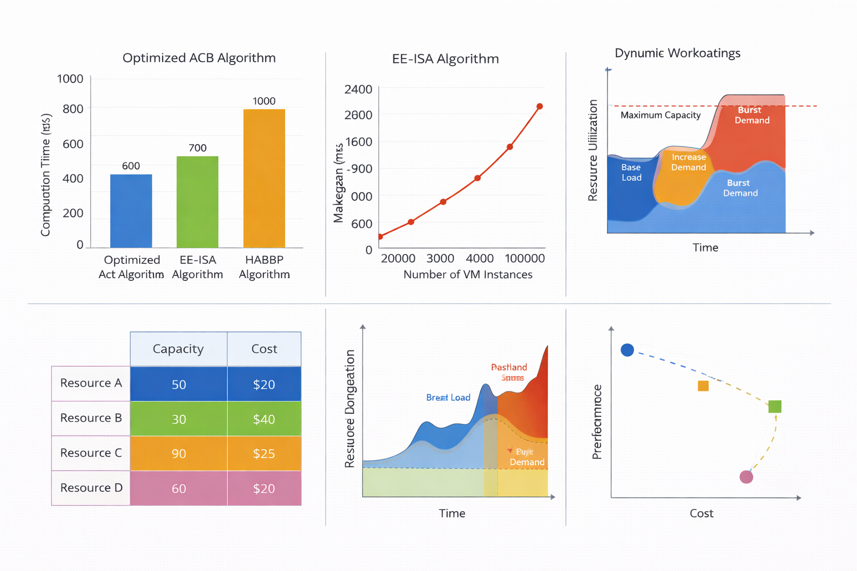
In resource allocation, the performance, cost, and energy efficiency are usually traded off. Optimal compromise is rather complicated and the professional concentration on one objective can lead to the decline of performance in the other direction.

- RECOMMENDATIONS

To optimize the available resources in the cloud computing environment, it is important to deal with the constraints which are experienced in the scheduling of tasks, load balancing, and allocation of resources. The recommendations given below offer a roadmap on how to make systems more efficient, scalable and adaptable in the real cloud environment.

5.1 Scheduling of Tasks Recommendations

5.1.1 Extensive Experimental Test
Carry out extensive experimental tests of the suggested task scheduling algorithms with the help of various and real workloads. Examine important performance indicators including makespan, response time and resource usage. The accuracy of the presentation and the detailed results make the proposed approach more credible and practical.

5.1.2 Comparison with the established Algorithms
Compare the proposed algorithm with state-of-the-art task scheduling algorithms. Principles emphasize the advantages and disadvantages of your solution, and point out the situations in which it has better or worse results than solutions already in existence. This gives practical information on the choice of a superior algorithm according to the needs of the system.

5.1.3 Scalability Assessment
How does the algorithm scale with the system size (measured by the number of tasks, resources or nodes)? Scalability analysis makes sure that the solution can be used in a large-scale cloud environment and it does not cause bottlenecks.

5.1.4 Dynamism in Workload Variations
Pay attention to how the algorithm can cope with the changing loads. The mechanisms like the real-time reassigning of tasks or adaptive prioritization can be used to maintain the efficiency in the situation of unpredictable demand patterns.

5.1.5 Application to the real world and Case Studies
Write cases of practical applicability of the algorithm, or case analysis. Reflect on industry-specific implementation, pointing out possible advantages, problems, and considerations of implementation.

5.2 Recommendation Aiming at Load Balancing

5.2.1 Comparative Analysis of an In-depth
Perform exhaustive comparisons between the proposed load balancing algorithm and other solutions in varied conditions such as the size of the system, workload pattern, and heterogeneity of the resources. Point out the performance benefits and shortcomings.

5.2.3 Scalability Evaluation
Check the performance of the load balancing strategy with scale of the system. Test the cases where the number of nodes, tasks, and resources is more and more numerous to make sure that the algorithm is efficient in any big cloud deployment.

5.2.4 Elasticity to Dynamic Workloads
Make sure that the algorithm is able to react to the immediate changes in the workload or availability of resources. The adaptive approaches, i.e. dynamic load redistribution and real-time decision-making enhance the system resilience and responsiveness.

5.2.5 Power-Saving Load Balancing
Incorporate energy-efficient policies into load balancing, e.g. workload consolidation, energy-sensitive scheduling, dynamic resource provisioning, etc. Energy conservation also allows lowering the cost of operation and makes computing sustainable.

5.2.6 Real-life Application and Case Studies
Give a real-life scenario or case study of practical implementation of the load balancing strategy. Take a look at industry-specific apps and address the possibilities, possible difficulties, and real limitations.

5.3 Resources Allocation Recommendations.

5.3.1 On-Demand Resource Provisioning
Achieve auto-scaling whereby resources are allocated and deallocated on demand to the system. Dynamic provisioning is used to provide efficiency in terms of utilization and responsiveness in case of changing workloads.

5.3.2 Machine Learning-based Predictive Resource Allocation
Predict the future workload and resource demand by using machine learning models. The use of historical data to train models allows the proactive allocation to be made in order to enhance the system performance and minimize the bottlenecks.

5.3.3 Allocation Policies that are Energy Aware
Incorporate energy-saving in the process of resource allocation. Take into account the workload consolidation, effective use of equipment, and active adjustments in accordance with energy conscious policy to minimize operation expenses and environmental consequences.

5.3.4 Cloud Resource Management Hybrid
Use hybrid approaches, involving the use of both public and private cloud capabilities. Create smart allocation programs that assign workload according to cost, performance and data privacy needs and make them work optimally across the environments.

5.3.5 Quality of Service (QoS) Customization User-Level
Give the users the capability to specify QoS parameters, including performance priorities or latency sensitivity, or workload constraints. Scalable allocation gives users the power to customize cloud resources in line with application-specific requirements and enhance general satisfaction and system efficiency.

Figure 5.1: An overview of the suggested resource optimization strategies in cloud computing, where the focus is placed on Task Scheduling, Load Balancing, and Resource Allocation and the most important actionable recommendations for each of these categories are given.
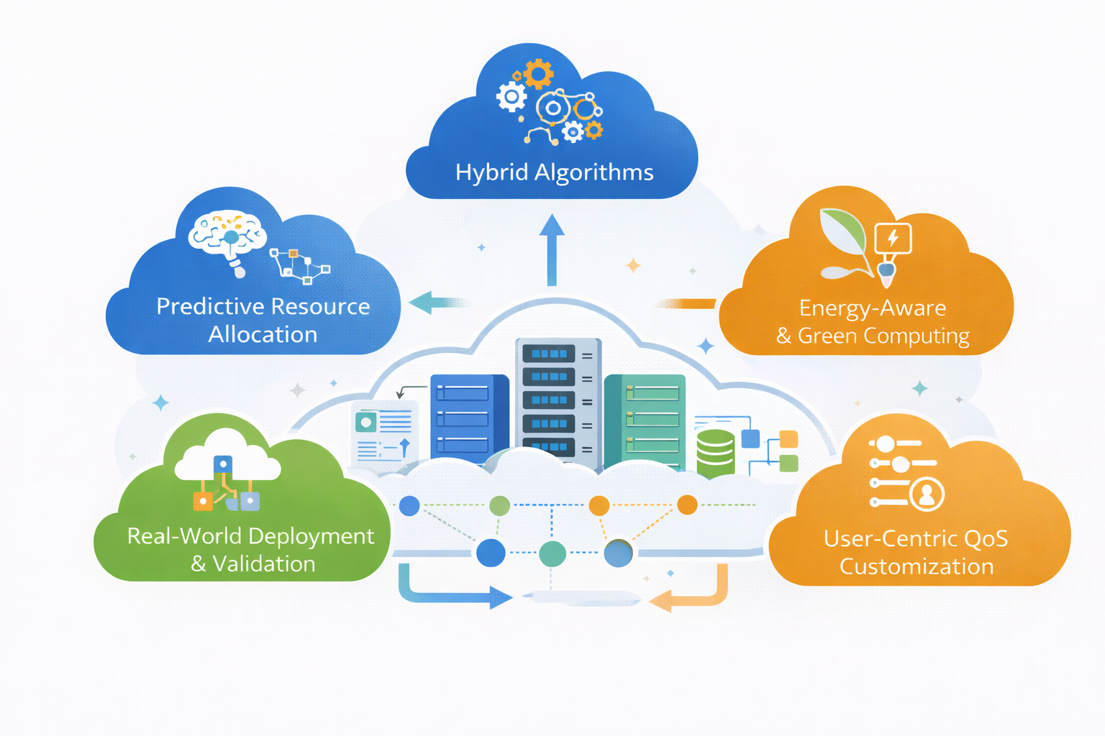
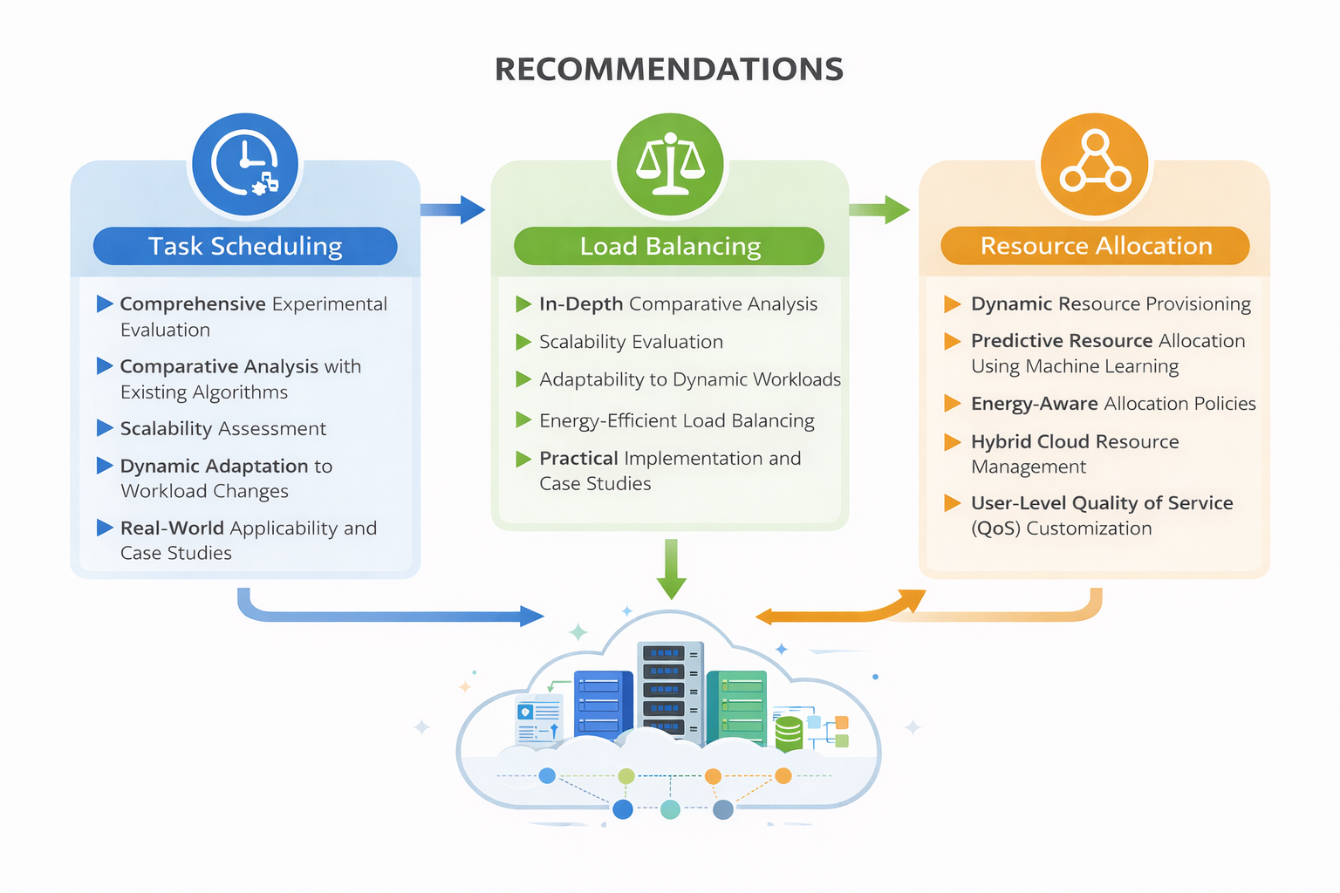

- CONCLUSION

The resource optimization strategies systematic review in cloud computing gives a clear picture of the current strategies, including the task scheduling, load balancing and the allocation of resources. A large number of strategies are identified and evaluated in this work according to their strengths, weaknesses, and their real use. Through the comparative evaluation, the review presents the major challenges, such as the complexity of the algorithm, scaling and management of dynamic workloads, and energy efficiency. In addition, it highlights the applicability of the strategies to real-world clouds and points out gaps in future studies. The presented insights do not only assist the researchers in perceiving the contemporary state of affairs concerning the optimization of cloud resources but also provide a viable direction on how to enhance efficiency, performance, and flexibility in various computational situations. On the whole, the given review can be discussed as a structured and subtle approach to cloud resource optimization that can be regarded as a valuable resource of both academic and industry stakeholders.

- FUTURE WORK

Although there has been significant advancement in the resource optimization strategies of cloud computing, it still has a number of research and innovation areas where one can expand. The way forward in the future is to consider the design of hybrid task scheduling and load balancing algorithms that combine various optimization methods, including metaheuristics, machine learning, and reinforcement learning, to enhance flexibility and efficiency in dynamic and large-scale cloud settings. The possibility of studying predictive and proactive resource allocation strategies based on developed machine learning models to predict workload patterns, predict system bottlenecks, and optimize resource consumption without negatively affecting the quality of services is also significant. Also, further studies may be dedicated to the practical application and verification of these strategies in heterogeneous, multi-cloud environments in the future to determine their practical relevance and scalability in the changing network, computing, and storage conditions. The implementation of energy conscious and green computing policies is an important field to be considered as cloud data centers tend to find green and sustainable operations. In addition, increasing the user centric customization of parameters of quality of service (QoS) like resource priority-based allocation and dynamic SLA tuning will enable providers of cloud services to be better placed in fulfilling various application needs. In summary, studies in the future should strive to fill the gap between theory and practice to provide high-strength, scalable, and energy-efficient solutions that suit the dynamic requirements of the new cloud computing infrastructures.

REFERENCE
[1] N. et al., “A Systematic Literature Review for Load Balancing and Task Scheduling in Cloud Computing,” Artificial Intelligence Review, 2024. https://doi.org/10.1007/s10462-024-10925-w
[2] S. et al., “Dynamic Load Balancing in Cloud Computing: Optimized RL-Based Clustering & Task Scheduling,” Processes, vol. 12, 2024. https://doi.org/10.3390/pr12030519
[3] A. et al., “Resource Allocation with Efficient Task Scheduling Using Hierarchical Auto-Associative Neural Networks in Cloud Computing,” Expert Systems with Applications, 2024. https://doi.org/10.1016/j.eswa.2024.123554
[4] B. et al., “A Systematic Literature Review on Task Allocation & Performance Management in Cloud Data Centers,” Computers, Systems & Engineering, 2024. https://doi.org/10.32604/csse.2024.042690
[5] C. et al., “Optimization-based Resource Scheduling Techniques in Cloud Computing: Review & Future Directions,” Computers & Electrical Engineering, 2025. https://doi.org/10.1016/j.compeleceng.2025.110080
[6] D. et al., “A Novel QoS-Aware Task Scheduling Approach Using Modified Wombat Optimization Algorithm,” Journal of Engineering & Applied Science, 2025. https://doi.org/10.1186/s44147-025-00628-6
[7] E. et al., “Performance Analysis of Cloud Computing Task Scheduling with Metaheuristic Algorithms,” Electronics, 2025. https://doi.org/10.3390/electronics14101988
[8] F. et al., “Cost Modelling and Optimisation for Cloud: A Graph-Based Approach,” Journal of Cloud Computing, 2024. https://doi.org/10.1186/s13677-024-00709-6
[9] G. et al., “LLM-Based Cost-Aware Task Scheduling for Cloud Computing Systems,” Journal of Cloud Computing, 2025. https://doi.org/10.1186/s13677-025-00822-0
[10] H. et al., “Optimized Task Scheduling in Fog-Cloud Computing Using Hybrid Deep Learning and Metaheuristic Algorithms,” Neural Processing Letters, 2026. https://doi.org/10.1007/s11063-025-11819-w
[11] I. et al., “Systematic Review: Load Balancing in Cloud Computing by Using Metaheuristic Dynamic Algorithms,” Intelligent Automation & Soft Computing, 2024. https://doi.org/10.32604/iasc.2024.050681
[12] J. et al., “Machine Learning-Based Cloud Resource Allocation Algorithms: A Comprehensive Comparative Review,” arXiv, 2025. [Online]. Available: https://arxiv.org/abs/2511.11603
[13] K. Luo, H. Huang, C. Zhang, and S. Guo, “Task Scheduling in Cloud Computing: A Survey,” IEEE Transactions on Parallel and Distributed Systems, vol. 33, no. 3, pp. 675–699, 2022. https://doi.org/10.1109/TPDS.2021.3117298
[14] L. Wang, Z. Li, and M. Zhou, “Task Scheduling in Cloud Computing: A Survey,” IEEE Access, vol. 8, pp. 83184–83216, 2020. https://doi.org/10.1109/ACCESS.2020.2996766
[15] J. Yu, Z. Li, J. Liu, and M. Zhou, “Machine Learning-Based Approach for Load Balancing with Resource Constraints in Cloud Computing,” Applied Soft Computing, vol. 120, 108677, 2022. https://doi.org/10.1016/j.asoc.2022.108677
[16] M. Malhotra, R. Chopra, and R. Sibal, “Load Balancing Techniques in Cloud Computing Environment: A Review,” Computer Networks, vol. 236, 103768, 2023. https://doi.org/10.1016/j.comnet.2023.103768
[17] S. Pepe, F. Khan, and S. Singh, “Low Time Complexity & Low Cost Particle Swarm Optimization for Cloud Task Scheduling and Load Balancing,” Applied Intelligence, vol. 49, no. 9, pp. 3308–3330, 2019.
https://doi.org/10.1007/s10489-018-1304-7
[18] R. Buyya, M. Vecchiola, and S. T. Selvi, Mastering Cloud Computing, 2nd ed., Morgan Kaufmann, 2023.
https://doi.org/10.1016/C2022-0-05810-0
[19] T. Qiu, X. Zhang, and L. Mao, “Resource Scheduling in Cloud Computing with Modified Genetic Algorithm,” IEEE Access, vol. 7, pp. 104954–104966, 2019.
https://doi.org/10.1109/ACCESS.2019.2936712
[23] M. Z. A. Bhuiyan, S. T. Selvi, and M. A. R. Sarkar, “Survey on Scheduling Algorithms in Cloud Computing,” International Journal of Computer Applications, vol. 975, 2019.
https://doi.org/10.5120/ijca2019918871
[24] J. Liu, Y. Zhao, and H. Xu, “Load Balancing Algorithms in Cloud Computing: A Review,” IEEE Access, vol. 8, pp. 21490–21508, 2020.
https://doi.org/10.1109/ACCESS.2020.2975269
[25] S. Seneviratne, J. S. Sahu, and D. Chatterjee, “Task Scheduling Strategy Based on Ant Colony Optimization in Cloud Computing Systems,” International Journal of Adaptive Control and Signal Processing, vol. 34, no. 4, pp. 1259–1278, 2020.
https://doi.org/10.1002/acs.3269
[26] R. Mondal and S. Bhowmik, “Meta Heuristic Based Resource Scheduling Techniques for Enhancing Performance in Cloud Datacenters,” Cluster Computing, vol. 23, pp. 1337–1351, 2020.
https://doi.org/10.1007/s10586-019-03015-3
[27] P. Patel, V. Kumar, and M. Singh, “Task Scheduling Algorithms and Their Performance Parameters in Cloud Computing,” Journal of Cloud Computing, vol. 9, no. 1, 5, 2020.
https://doi.org/10.1186/s13677-020-0153-y
[28] K. Bilal, H. Hussain, S. U. Khan, and M. F. Zhani, “Communication Efficient Resource Management and Scheduling in Cloud,” IEEE Communications Surveys & Tutorials, vol. 21, no. 1, pp. 824–859, 2019.
https://doi.org/10.1109/COMST.2018.2868538
[29] S. Abbas and R. Buyya, “Resource Provisioning in Cloud Computing: Review & Open Challenges,” Journal of Cluster Computing, vol. 23, pp. 545–564, 2020.
https://doi.org/10.1007/s10586-019-03014-4
[31] A. Belgacem, S. Mahmoudi, and M. Kihl, “Intelligent Multi Agent Reinforcement Learning Model for Resource Allocation in Cloud Computing,” Journal of King Saud University – Computer and Information Sciences, vol. 34, no. 6, pp. 2391–2404, 2022.
https://doi.org/10.1016/j.jksuci.2022.03.016
[32] S. Saxena and A. K. Singh, “Auto Adaptive Learning Based Workload Forecasting in Dynamic Cloud Computing Environments,” International Journal of Computers and Applications, vol. 43, no. 4, pp. 456–471, 2023.
https://doi.org/10.1080/1206212X.2022.2145789
[33] H. Shukur, S. R. M. Zeebaree, R. R. Zebari, and O. M. Ahmed, “Cloud Computing Virtualization for Resource Allocation in Distributed Systems: Trends & Challenges,” Journal of Applied Science and Technology Trends, vol. 3, no. 2, pp. 89–102, 2023.
https://doi.org/10.32604/jastt.2023.034210
[34] Waleed Kareem et al. (2025) conducted a systematic literature review on cloud resource allocation and task scheduling algorithms, highlighting multi-objective optimisation techniques and future research directions. https://doi.org/10.1515/jisys-2024-0441
[35] Hai et al. (2023) reviewed cloud task scheduling optimization, including processor selection and security prioritization, providing comprehensive performance insights. https://doi.org/10.1186/s13677-022-00374-7
[36] Rahul Vijay & Thankaraja Raja Sree (2023) analysed resource scheduling and load balancing algorithms in cloud computing and categorised approaches by performance characteristics. https://doi.org/10.1016/j.procs.2023.12.088
[37] Ya-guang Guo et al. (2023) investigated cloud computing resource allocation efficiency using data envelopment analysis, focusing on optimisation in large-scale cloud deployments. https://doi.org/10.1186/s13677-023-00400-2

