A STUDY ON SEED RAKSHA: A TRACEABILITY PLATFORM FOR INDIGENOUS SEED PRESERVATION

Dr D J Samatha Naidu, B.Mounika*

Professor, MCA department, Annamacharya PG college of Computer studies, rajampeta, samramana44@gmail.com

Student, MCA Department, Annamacharya PG college of Computer studies, rajampeta,

mounikabodagala@gmail.com

ABSTRACT
Seed Raksha, a traceability platform for indigenous seed preservation, provides a digital solution to document, monitor, and conserve traditional crop landraces that are rapidly declining due to modernization and environmental changes. The platform helps record seed information such as origin, crop type, and conservation status, enabling better identification of endangered landraces and red-zone areas where native germplasm is at risk. By supporting traceability and data management, the system contributes to the preservation of crop diversity and promotes sustainable agricultural practices. The platform also supports different conservation approaches such as continuous cultivation of landraces, their use in breeding programs, and long-term storage in seed banks. Overall, the proposed system demonstrates how digital technologies can assist researchers, farmers, and conservation organizations in protecting indigenous seeds and ensuring the sustainability and resilience of future food systems.
Keywords:
Indigenous Seeds, Seed Traceability, Crop Diversity, Landraces, Seed Conservation, Sustainable Agriculture, Red List, Biodiversity

INTRODUCTION
Agriculture has always been the foundation of human civilization, and seeds play a crucial role in sustaining food production and biodiversity. For centuries, farmers across different regions have cultivated and preserved indigenous seed varieties, also known as landraces, which are naturally adapted to local climatic and soil conditions. These traditional seeds are an important part of Indian Knowledge Systems (IKS), as they represent the collective wisdom, agricultural practices, and ecological understanding developed by farming communities over generations. Indigenous seeds contribute to sustainable agriculture, nutritional diversity, and resilience against environmental changes.
However, with the rapid expansion of modern agricultural technologies and the widespread adoption of high-yielding hybrid varieties, many traditional seed varieties are gradually disappearing. The replacement of indigenous seeds with commercial hybrids, along with factors such as climate change, urbanization, and changing agricultural practices, has led to a significant reduction in crop biodiversity. This loss of genetic diversity threatens food security and weakens the resilience of agricultural systems. Additionally, traditional knowledge related to seed preservation, storage techniques, and cultivation practices is also at risk of being lost.
By combining Indian Knowledge Systems with modern information technology, the Seed Raksha platform promotes the preservation of agricultural biodiversity and empowers farming communities. The system not only protects traditional seeds but also supports research, policy development, and sustainable farming practices. Ultimately, the project contributes to safeguarding indigenous seed heritage for future generations while strengthening food security and ecological balance.

Materials
Operating System
The operating system used for the development and execution of the Seed Raksha: A Traceability Platform for Indigenous Seed Preservation project is Windows or Linux. These operating systems provide a stable environment for running development tools, executing backend servers, and managing database systems. They support programming languages, web servers, and database management systems required for building and testing the application.

Frontend
The frontend of the project is developed using HTML, CSS, and JavaScript. HTML is used to create the basic structure of the web pages, CSS is used to design and style the interface, and JavaScript is used to add interactive functionality to the system. These technologies allow users such as farmers, researchers, and administrators to interact with the platform through forms, dashboards, and information pages.
Backend
The backend of the system is implemented using Python. The backend manages server-side operations such as processing user requests, handling application logic, validating user inputs, and connecting the frontend interface with the database. It ensures that the system performs operations such as seed registration, seed tracking, and user authentication efficiently.
Database
The database used in the project is MySQL, a relational database management system. MySQL is responsible for storing and managing all system data including user details, seed information, traceability records, seed exchanges, and conservation status. It organizes data into structured tables, enabling efficient storage, retrieval, and management of information.
Methods
The development of the Seed Raksha platform follows a systematic process to design, implement, and deploy the system.
System Design
The system architecture is designed as a web-based platform consisting of a front-end interface and a backend database. The React-based user interface communicates with the Supabase backend to store and retrieve data related to indigenous seeds.
User Authentication
The system provides secure authentication using Supabase authentication services. Users can register, log in, and access system features based on their credentials.
Seed Data Management
The platform allows users or administrators to register seed varieties with details such as seed name, crop type, origin location, and registration date. This information is stored in the PostgreSQL database.
Traceability System
The traceability module records the origin and movement of seeds. It helps track the history of indigenous seeds and ensures transparency in seed conservation.
Red List Monitoring
The system includes a red list module that identifies endangered seed varieties. Seeds are categorized based on risk levels such as vulnerable, endangered, or critically endangered.
Data Visualization
The dashboard module uses graphical charts to present statistical information about seeds, crop distribution, and conservation status. This helps users understand trends in seed preservation.
Web Deployment
The completed system is deployed as a web-based platform, allowing users to access the application through a web browser from different devices.

Results and Discussion
The Seed Raksha platform was developed to create a digital traceability system for indigenous seed preservation. The system was successfully implemented as a web-based application that allows users to register, manage, and monitor seed information through an interactive dashboard.
The results demonstrate that the platform effectively stores and retrieves seed-related data using a structured database. Users are able to register seed varieties by entering details such as seed name, crop type, origin location, and registration date. The stored data is then displayed and analyzed through various dashboard components, providing meaningful insights into seed diversity and conservation status.
The dashboard interface provides statistical summaries of the stored seed information. Figure 1 illustrates the distribution of seed varieties based on crop type using a pie chart. The x-axis represents different crop categories while the y-axis represents the number of registered seed varieties. This visualization helps users easily understand which crop types are most commonly registered in the system.
The system also categorizes endangered seeds using a red list classification. Figure 2 presents the risk level distribution of seed varieties using a bar chart. The x-axis represents the different risk categories such as vulnerable, endangered, and critically endangered, while the y-axis represents the number of seed varieties in each category. This graphical representation helps identify seed varieties that require immediate conservation efforts.
The graphical results obtained from the dashboard demonstrate that the system can effectively visualize agricultural biodiversity data. These visualizations assist researchers and administrators in monitoring seed diversity trends and identifying endangered landraces. The traceability mechanism further supports the documentation of seed origins, which is essential for maintaining genetic diversity and sustainable agricultural practices.
Overall, the results indicate that the Seed Raksha platform provides a practical and efficient digital solution for indigenous seed conservation. The integration of data storage, traceability mechanisms, and visual analytics improves the accessibility and management of seed information. The system can support farmers, researchers, and conservation organizations in protecting traditional crop varieties and promoting sustainable agriculture.
Flow charts:
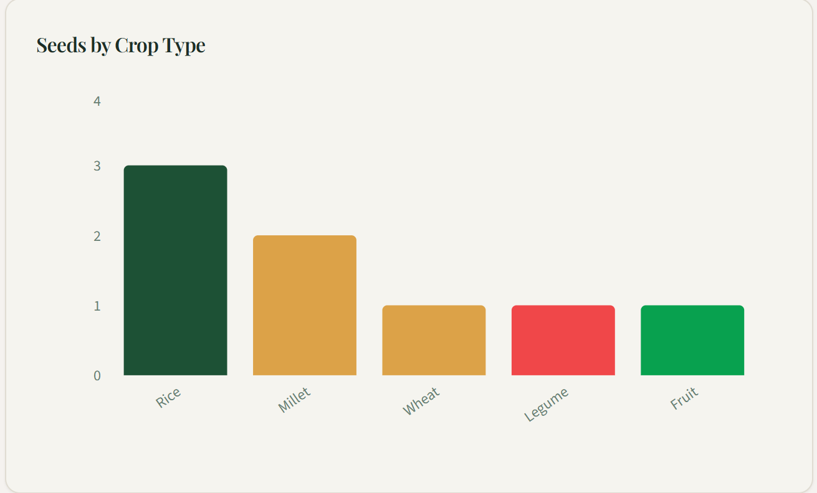
Figure 1
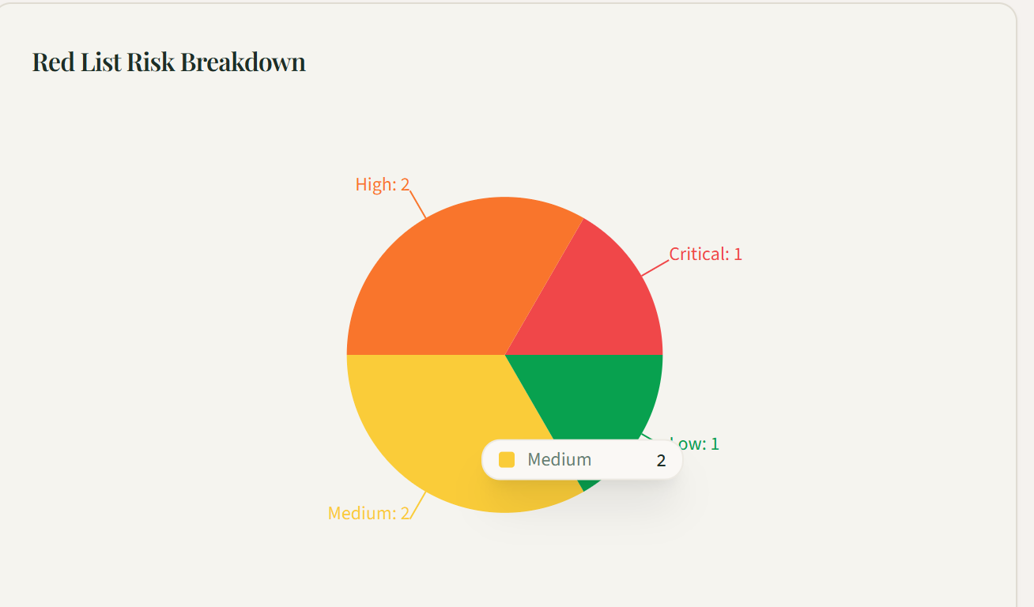
Figure 2
Screens:
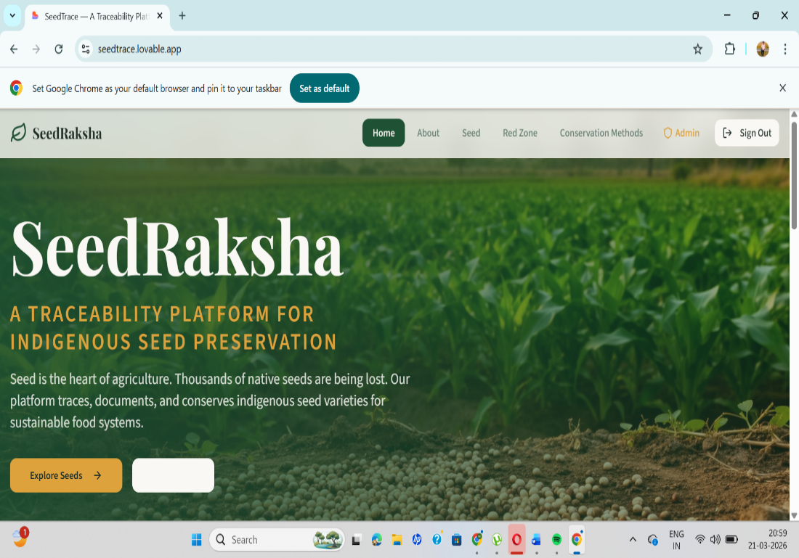
Screen1: Seed Raksha Home Page 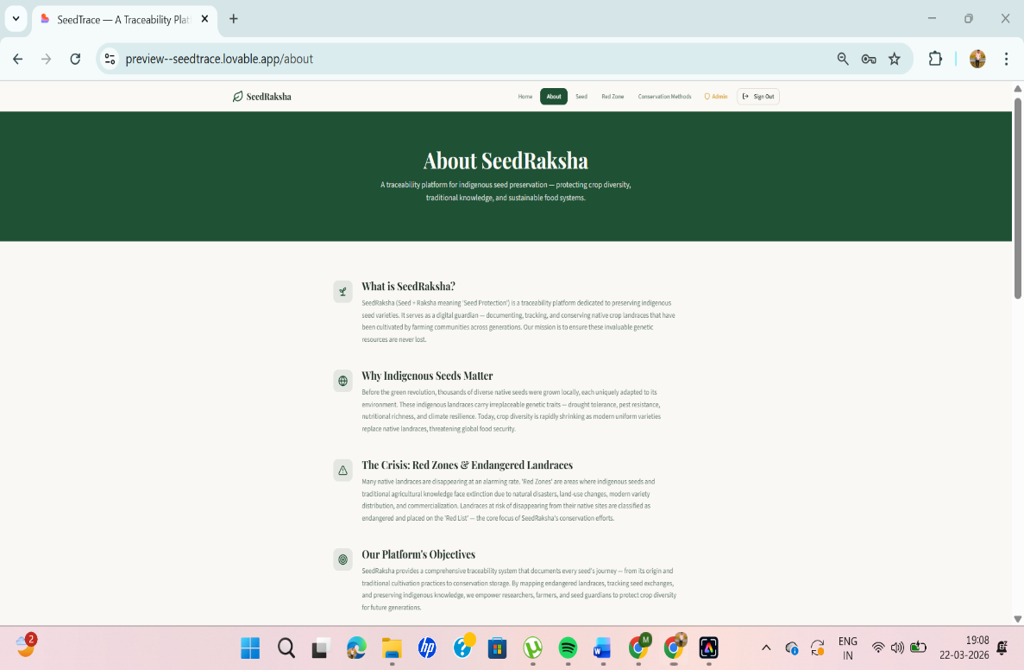
screen2: About Seed Raksha Platform
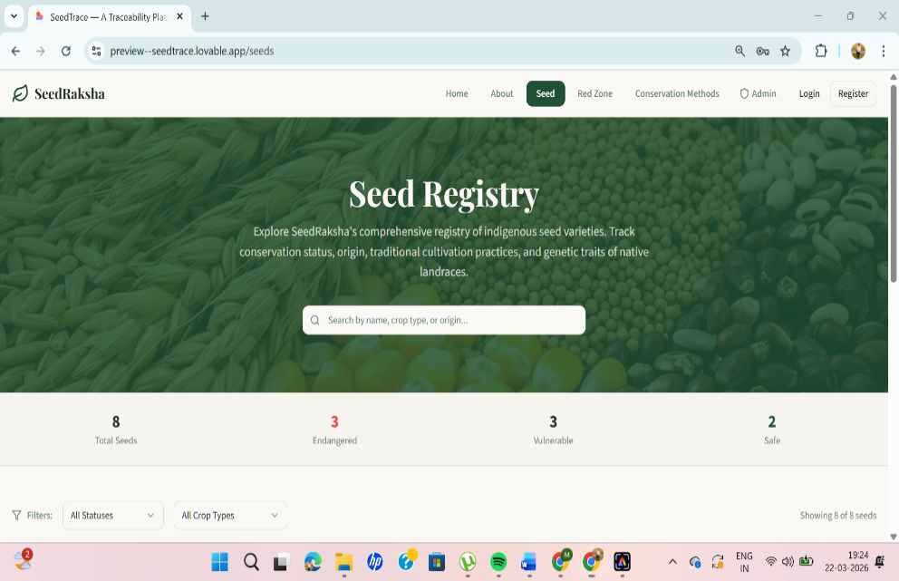
Screen 3: Figure 5.2.6: Seed Database Page

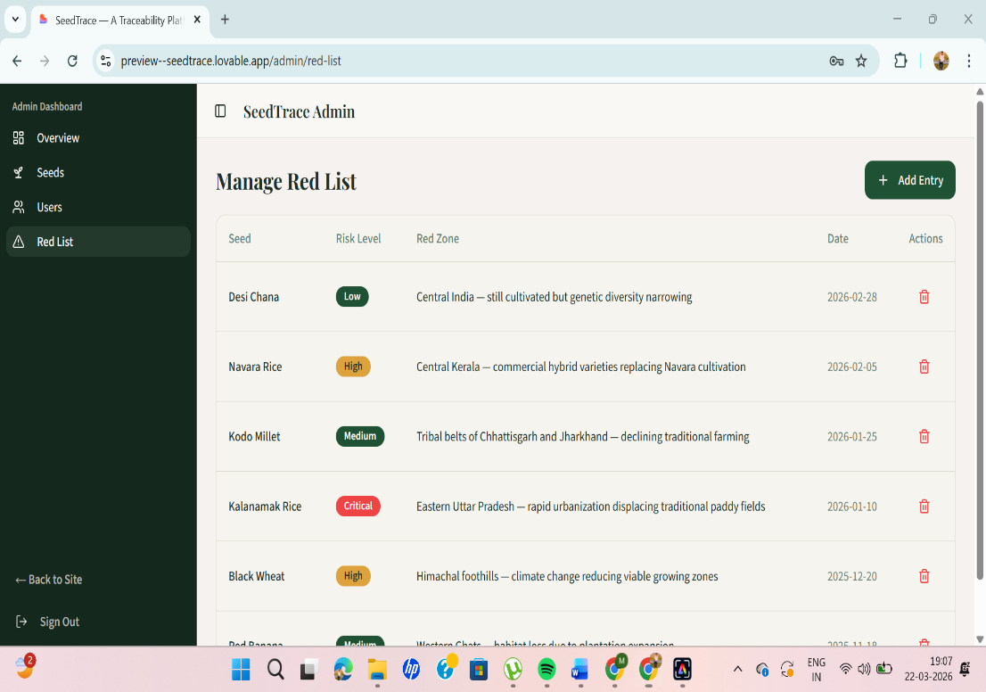
Screen 4: Manage Red Zone Areas

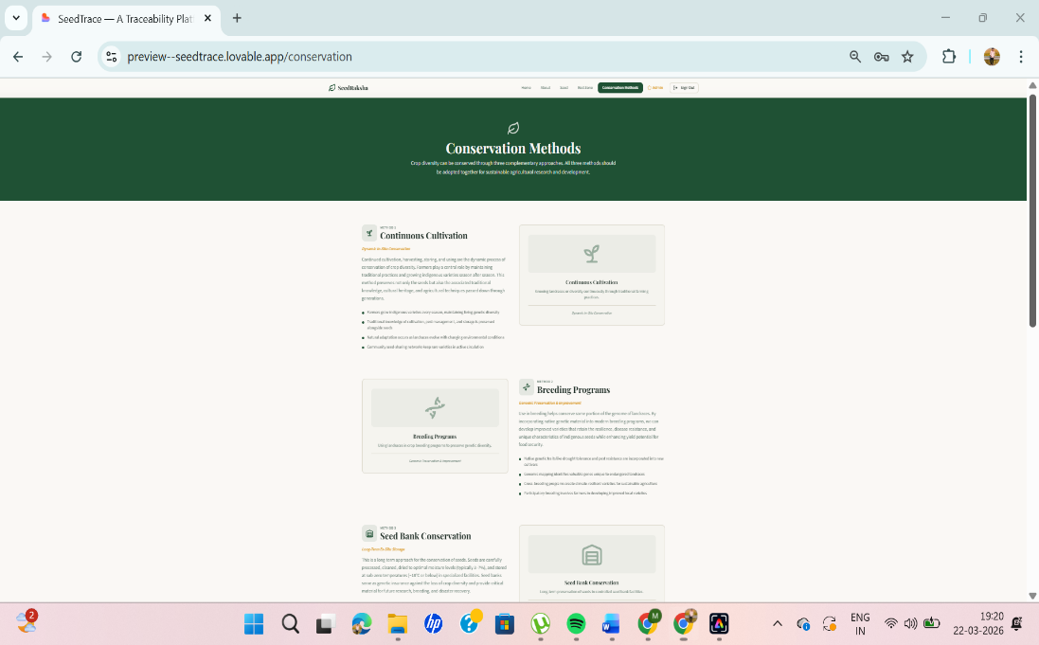
Screen 5: Conservation Methods Page

Conclusion
In conclusion, the Seed Raksha platform represents an important step toward using digital technology to support sustainable agriculture and biodiversity conservation. By preserving indigenous seeds and documenting their origins, the system contributes to maintaining crop diversity and promoting resilient agricultural systems. The platform has the potential to serve as a valuable tool for agricultural research, seed conservation initiatives, and community-based seed preservation programs.
Conflict of Interest
The author declares that there is no conflict of interest regarding the publication and development of this project titled “Seed Raksha: A Traceability Platform for Indigenous Seed Preservation.” The research and development of this project were carried out solely for academic purposes, and no financial, commercial, or personal relationships influenced the outcomes of the study.
All information presented in this project is based on independent research, and the results have been reported honestly without any bias or external influence.

REFERENCES

[1] A. Banks and E. Porcello, Learning React: Modern Patterns for Developing React Apps, 2nd ed., O’Reilly Media, 2020.

[2] D. Flanagan, JavaScript: The Definitive Guide, 7th ed., O’Reilly Media, 2020.

[3] J. Duckett, HTML and CSS: Design and Build Websites, Wiley Publications, 2021.

[4] E. Brown, Web Development with Node and Express, 2nd ed., O’Reilly Media, 2020.

[5] Food and Agriculture Organization (FAO), The State of the World’s Biodiversity for Food and Agriculture, FAO, Rome, 2021.

Journals

[1] I. Thormann and M. Dulloo, “Conservation and Sustainable Use of Plant Genetic Resources for Food and Agriculture,” Plants, vol. 10, no. 2, pp. 234–245, 2021.

[2] A. Kumar and R. Singh, “Digital Technologies for Sustainable Agriculture and Biodiversity Conservation,” Journal of Agricultural Informatics, vol. 13, no. 1, pp. 45–55, 2022.

[3] S. Ceccarelli and S. Grando, “Participatory Plant Breeding: Who Did It, Who Does It and Where?,” Experimental Agriculture, vol. 56, no. 3, pp. 321–334, 2020.

[4] M. Halewood, I. Lopez Noriega, and S. Louafi, “Crop Genetic Resources as a Global Commons,” Food Security, vol. 12, no. 3, pp. 449–463, 2020.

[5] R. Jamnadass, F. Place, S. Torquebiau, et al., “Agroforestry for Food Security and Climate Change,” Annual Review of Environment and Resources, vol. 45, pp. 345–368, 2020.

[6] P. Dawson, J. Powell, and L. Hendre, “Digital Platforms for Agricultural Biodiversity Management,” Agricultural Systems, vol. 190, pp. 103–115, 2021.

[7] N. Singh and P. Sharma, “Role of Indigenous Seed Systems in Sustainable Agriculture,” Journal of Sustainable Agriculture, vol. 14, no. 2, pp. 98–110, 2022.

[8] L. Guarino and E. Coomes, “Crop Diversity and Food Security in the Era of Climate Change,” Nature Plants, vol. 8, pp. 190–196, 2022.

