Salivary Glucose as a Non-Invasive Alternative in Monitoring Diabetics Attending General Hospital Minna, Niger State, Nigeria

Aliyu Haruna Sani^{1*}, Adetona Oluwafunmilayo Esther¹, Abdullahi Habibu Etsugaie¹, Muhammad Tasalla Hauwa¹,
Medical Laboratory Department, General Hospital Minna, Niger State, Nigeria
Email: elharun014@gmail.com

Abstract
Introduction: Monitoring glucose levels is crucial for effective management of diabetes mellitus, a chronic metabolic disorder that remains a global health concern, implicating over 500 million people worldwide. The diagnosis of diabetes through blood is difficult in children, older adults, debilitated and chronically ill patients, so diagnosis by analysis of saliva can be potentially valuable as collection of saliva is noninvasive, easier and technically insensitive, unlike blood. The aim of the study was to correlate blood glucose level (BGL) and salivary glucose level (SGL) among individuals with normal fasting glucose (NFG), impaired fasting glucose (IFG) and provisional diabetes mellitus (PDM).
Methodology: A cross-sectional study was conducted in 423 patients aged between 18 and 65 years, categorised as 141 impaired diabetics, 142 provisional diabetics and 140 healthy individuals constituting the controls. The blood and unstimulated saliva samples were collected from the patients for fasting glucose levels. These samples were then subjected for analysis of glucose in blood and saliva via the enzymatic Glucose Oxidase Peroxidase (GOD-POD) end-point method, using RT-9200 Semi-auto Chemistry Analyser.
Results: The mean SGLs and BGLs were higher in provisional diabetics and impaired diabetics groups than in non-diabetic group (3.15:225.40 vs. 2.19:112.43 vs. 0.85:77.76 mg/dL; p-val=1.498852e-153), indicating a significant positive correlation between fasting saliva glucose and fasting blood glucose in all the groups.
Conclusion: In conclusion, tests measuring salivary glucose levels provide a promising alternative to conventional blood glucose tests in the realm of diabetes management, making it a reliable indicator. While addressing technical and clinical challenges requires additional research, the appealing non-invasive nature and the potential for frequent monitoring make salivary glucose level tests an attractive option for enhancing diabetes care. Future advancements in salivary glucose sensing technologies may revolutionise glucose monitoring, improving the quality of life for individuals with diabetes.
Keywords: global health, diabetes mellitus, salivary glucose, non-invasive, correlation.

Introduction
1.1 Background of the study
Diabetes remains to be a global health concern with over 400 million people affected worldwide (World Health Organisation [WHO], 2016), with an increasing prevalence and estimated increase to 552 million by 2030 (Knip, 2010). About 4.2 million adults died from diabetes mellitus and its complications, which is equivalent to 1 death every 8 seconds (International Diabetes Federation [IDF], 2019); with the advancement of living standards and environmental changes, the incidence of diabetes mellitus is increasing daily, which has steadily developed into one of the major threats to the health and well-being of modern people, imposing a significant financial burden on society (Sun et al., 2021).

Diabetes mellitus is a group of metabolic disorders of carbohydrate metabolism in which glucose is underutilized, producing hyperglycaemia with metabolic disturbance of carbohydrate, fat and protein because of either defects in insulin secretion, insulin action, or both (Nermeen et al., 2021). It is a floodgate to metabolic dysfunction of array of organ, especially the eyes, kidneys, nerves, heart, and blood (American Diabetes Association [ADA], 2014).
Saliva research is rapidly advancing because of the use of novel approaches such as metabolomics, genomics, proteomics and bioinformatics (Ahmadi et al., 2010). Saliva is an exocrine secretion of the salivary glands that contains mostly water (99 %), electrolytes, proteins, and enzyme. It is often referred to as the “mirror of the body” as it is the indicator of health not just in the oral cavity but also throughout the body. Saliva plays an important role in maintaining the equilibrium of the oral ecosystem by providing the sensory perception of food, aids in chewing, swallowing, and food digestion (Thayumanavan et al., 2015). Whole saliva contains locally produced as well as serum-derived biomarkers that have been found to be useful in the diagnosis of a variety of systemic disorders such as Grave’s diseases, Rheumatoid arthritis, hypertension, Myasthenia gravis. Understanding the role of each salivary component in the oral cavity homeostasis is crucial to perceive how its changes or absence may be linked with pathological conditions (Lasisi and Fasanmade, 2012).
Several epidemiological studies have suggested that diabetes is a risk factor for the development of oral diseases in human (Chavez et al., 2010). Diabetes besides damaging various systems of the body may also impair salivary gland functions, which leads to a reduction in the salivary flow and changes in saliva’s composition and Periodontitis (Agoro et al., 2017; Lasisi and Fasanmade, 2012). Screening for diabetes in general practice by measuring fasting blood glucose levels is feasible, stressful, invasive and time consuming. Different strategies have been suggested to improve diabetes detection and there has been increased interest towards non-invasive method to diagnose this disease, including the use of the saliva sample (Tiongco et al., 2018). Salivary gland hypofunction has a//lso been reported to be frequent in people with diabetes majorly due to overall diminished flow of saliva which is a consequence of dehydration which might contribute to their susceptibility to oral infections like candidiasis, dental caries, xerostomia, etc. (Kumar et al., 2017).
1.2 Statement of research problem
Self-monitoring of blood glucose is critical for diabetes mellitus control and serves as the foundational tool for all management strategies (Janapala et al., 2019). Sim et al. (2021) also point out that the frequent monitoring of blood glucose is of great significance for patients in order to manage the condition and control the development of their complications. Unfortunately, traditional blood glucose monitoring methods usually require blood sampling operations. Blood extraction is painful, inconvenient and presents the risk of infection and mental pains to patients, especially for those patients who need to check their blood glucose levels several times a day (Shang et al., 2022).

Not only does an urgent need exist for a non-invasive glucose monitoring technology so as to make a major improvement in the lives of millions of people around the world living with diabetes mellitus, but also to ease preventive monitoring (Bamgboje et al., 2021). Furthermore, saliva has numerous advantages as a diagnostic fluid because it is non-invasive, simple to collect, preserve, and contains exceedingly high-quality DNA. Thus, saliva could serve an excellent substitute for blood (Cui et al., 2022).

1.3 Justification of the research
Although the biomarkers in saliva reflect the health status of the human body, the use of salivary glucose as a diagnostic fluid for diabetes mellitus has been hindered, mainly because the correlation between salivary glucose and blood glucose has been greatly controversial (Zhao and Leung, 2020). Over the past few decades, the non-invasive monitoring of diabetes mellitus by fluid analysis (as well as other biological fluids such as saliva, sweat and urine) has attracted worldwide attention (Alizadeh et al., 2018; Ahmed and Haque, 2021; Zhang et al., 2021). Among the existing non-invasive methods, salivary glucose has a very positive significance, and has received much attention (Turner, 2013; Palomar et al., 2021). Saliva is considered an ultrafiltrate of blood and is a potential source of clinical information that accurately reflects the pathological state, according to the literature (Cui et al., 2021). Studies have shown that for diabetes mellitus patients, the salivary glucose level is positively correlated with the blood glucose level, so salivary glucose can be used as a marker for the detection of diabetes mellitus (Chakraborty et al., 2021; Goel et al., 2021).

1.4 Aim and Objectives
1.4.1 Aim
The study is aimed at assessing salivary glucose as a non-invasive alternative in screening, diagnosis and monitoring diabetics attending General Hospital Minna, Niger State, Nigeria.
1.4.2 Objectives
- Determining the fasting salivary and blood glucose levels of diabetics attending General Hospital Minna, Niger State.
- Determining the fasting salivary and blood glucose levels among individuals with normal fasting glucose (NFG) attending General Hospital Minna, Niger State.
- Correlating the levels of salivary and blood glucose among individuals with normal fasting glucose (NFG), impaired fasting glucose (IFG) and provisional DM (PDM).

Material and Methods
2.1 Study area
This present study was conducted at the Medical Laboratory Department of General Hospital Minna, Niger State, between the months of July 2024 and September 2025. Minna lies between Latitudes 9˚33' and 9˚40' North of the Equator and Longitudes 6˚29' and 6˚35' East of the Greenwich Meridian.
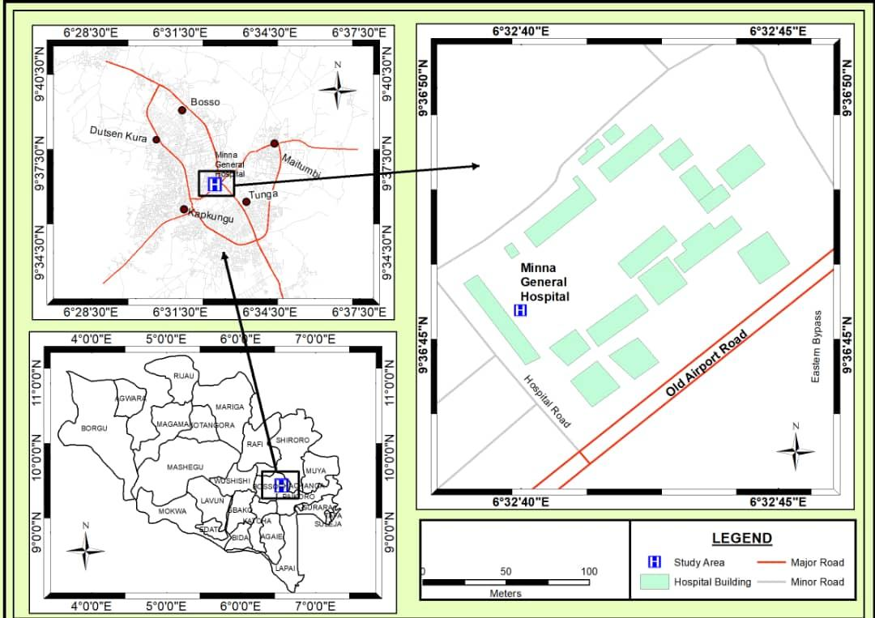
Fig. 2.1: Map Showing General Hospital Minna
Source: Department of Geography and Planning, Federal University of Technology, Minna (2023)

2.2 Research design
The present study was conducted at the Medical Laboratory Department of General Hospital Minna, Niger State, Nigeria. Four hundred and twenty three (423) human participants aged between 18 and 65 years were recruited for this study, and were equally divided into 3 groups (normal fasting glucose, impaired fasting glucose and provisional diabetes mellitus) based on their fasting blood glucose level.
Respondents with an FBG level of <100 mg/dL classified under Group A or those with a normal fasting glucose (NFG), those with an FBG between 100 and 125 mg/dL to be classified under Group B or those with an impaired fasting glucose (IFG), and those with an FBG of greater than or equal to 126 mg/dL classified under Group C or those who have provisional diabetes mellitus (PDM). According to the American Diabetes Association 2015 following criteria: (FBG ≥ 126mg/dl or 2-hour PG ≥ 200mg/dl or A1C ≥ 6.5% or random plasma glucose ≥ 200mg/dl with classic symptoms of hyperglycemia or hyperglycemic crises).

2.2.1 Inclusion criteria:
- Subjects diagnosed with DM in age range 20–65 years
- Age- and gender-matched healthy individuals for control.
2.2.2 Exclusion criteria:
- Participants having any other systemic diseases and on regular medication for the same
- Pregnant women
- Mentally compromised
- Uncooperative patients
- Participants with poor oral hygiene or tumor of the salivary gland

2.3 Salivary sample collection
The unstimulated whole saliva was used for the estimation of salivary glucose (Bapat et al., 2021). Unstimulated whole saliva was then collected (2ml) by passive drooling (spitting method). Participants were instructed to spit the pooled saliva in a sterile, disposable plastic container.

2.4 Blood sample collection
A volume of 2 ml of peripheral venous blood was collected from the antecubital vein with syringe into a glucose-specific tube (Glucomedics) containing NaF/KOx, citrate and EDTA to minimize glycolysis (Dimeski et al., 2015), before immediate analysis at the clinical chemistry laboratory.

2.5 Salivary glucose and blood glucose estimation
Each unstimulated saliva sample and blood sample were centrifuged at 3000 rpm for 20 min. Clear supernatants were processed immediately for estimation of glucose. Glucose was analysed with (GOD-PAP Spectrum Diagnostic Glucose kit, Ismailia Free Zone, Egypt) via the enzymatic Glucose Oxidase Peroxidase (GOD-POD) end-point method, using RT-9200 Semi-auto Chemistry Analyser.

3.0 Results
No study participant left the research project for any reason. No side effects or complications were observed during the study period. Baseline characteristics of the patients are shown in (Table 1). No statistically significant difference was found between the 2 groups in terms of sex and family history (p>0.05). Most of diabetic patients were from urban regions (73%) while (27%) were from rural areas. The mean age of the participants under control group was 25.76 years, compared to 46.74 years for participants from the diabetic group.

The mean fasting blood glucose (FBG), random blood glucose (RBG) and fasting saliva glucose (FSG), random salivary glucose (RSG) was compared among Group C, Group B and Group A using the Kruskal–Wallis test. There was a significant difference across the 3 groups as seen in Tables 2-4.
The correlation between FBG and FSG was assessed for all 3 groups using the Pearson’s correlation test. There was a significant correlation between FBG and FSG as seen in Fig 1- 3.
In the present study, statistically significant correlation was found between salivary glucose level (SGL) and BGL in patients with diabetes and controls as well. Significantly higher mean SGL was found in group with diabetes compared to healthy nondiabetic group. For Group A Controlled Diabetic group, the mean FBG was 77.76 ± 10.60 mg/dL, and the mean FSG was 0.85 ± 0.26 mg/dL. Pearson’s correlation test showed significant correlation at 0.57 level (Table 2).
The mean salivary and blood glucose levels of Group B (IFG) is significantly lower compared to Group C (PDM), but is significantly higher when compared to Group A (NFG) (1 < 2 < 3). This suggests that blood glucose correlates with the levels of glucose in the saliva.
Figures 2-4 show that there were highly significant positive correlation observed between blood and salivary glucose levels in the diabetic group. Both blood and salivary glucose levels are higher in patient group (impaired, diabetic) than normal group with a highly statistically significant difference (p<0.001).

Table 1: Demographic data of diabetic subjects and controls.
 | Control group  N= 140 | Subject group  N=283 | p value
Age  Mean±SD | 3 25.76±2.91  (range 20-63) | 46.74±3.37  (range 24-65) | 0.296
Sex  Female (%)  Male (%) | 64(46%) 76(54%) | 139(49%) 144(51%) | 0.671
Residence  Rural %  Urban % | 11(8%) 129(92%) | 76(27%) 207(73%) | 0.000**
Family history  Negative %  Positive % | 126(90%) 14(10%) | 235(83%) 48(17%) | 0.148 NS
p-value >0.05: Non significant (NS).
**p-value <0.01: Highly significant.

Table 2: Comparison of mean FBG and FSG levels (mg/dL) among Group A using Kruskal-wallis test.
Group A | Range (mg/dL) | Mean±SD (mg/dL)
FBG | 53.90 - 98.90 | 77.76±10.60
FSG | 0.40 - 2.00 | 0.85±0.26
p value  Pearson’s correlation  n | 1.3802  0.5713  140
**Correlation is significant at the 0.01 level. SD: standard deviation, FSG: Fasting saliva glucose, FBG: Fasting blood glucose, n: number of samples analysed
Table 3: Comparison of mean FBG and FSG levels (mg/dL) among Group B using Kruskal-wallis test.
Group B | Range (mg/dL) | Mean±SD (mg/dL)
FBG | 100.00 - 125.00 | 112.43±6.54
FSG | 1.24 - 2.74 | 2.19±0.16
p value  Pearson’s correlation  n | 8.0534  0.7106  141
**Correlation is significant at the 0.01 level. SD: standard deviation, FSG: Fasting saliva glucose, FBG: Fasting blood glucose, n: number of samples analysed

Table 4: Comparison of mean FBG and FSG levels (mg/dL) among Group C using Kruskal-wallis test.
Group C | Range (mg/dL) | Mean±SD (mg/dL)
FBG | 53.90 - 315.00 | 225.40±27.37
FSG | 0.40 - 4.71 | 3.15±0.43
p value  Pearson’s correlation  n | 3.5570  0.6609  142
**Correlation is significant at the 0.01 level. SD: standard deviation, FSG: Fasting saliva glucose, FBG: Fasting blood glucose, n: number of samples analysed

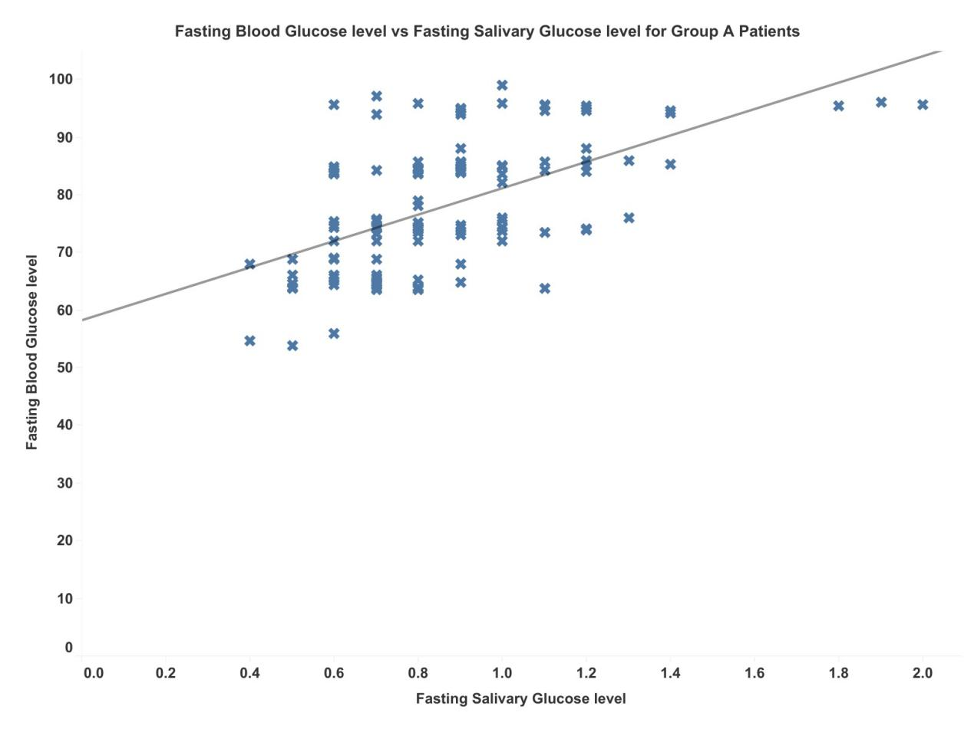Fig 1. Correlation between fasting blood glucose and salivary glucose levels in Group A subjects.
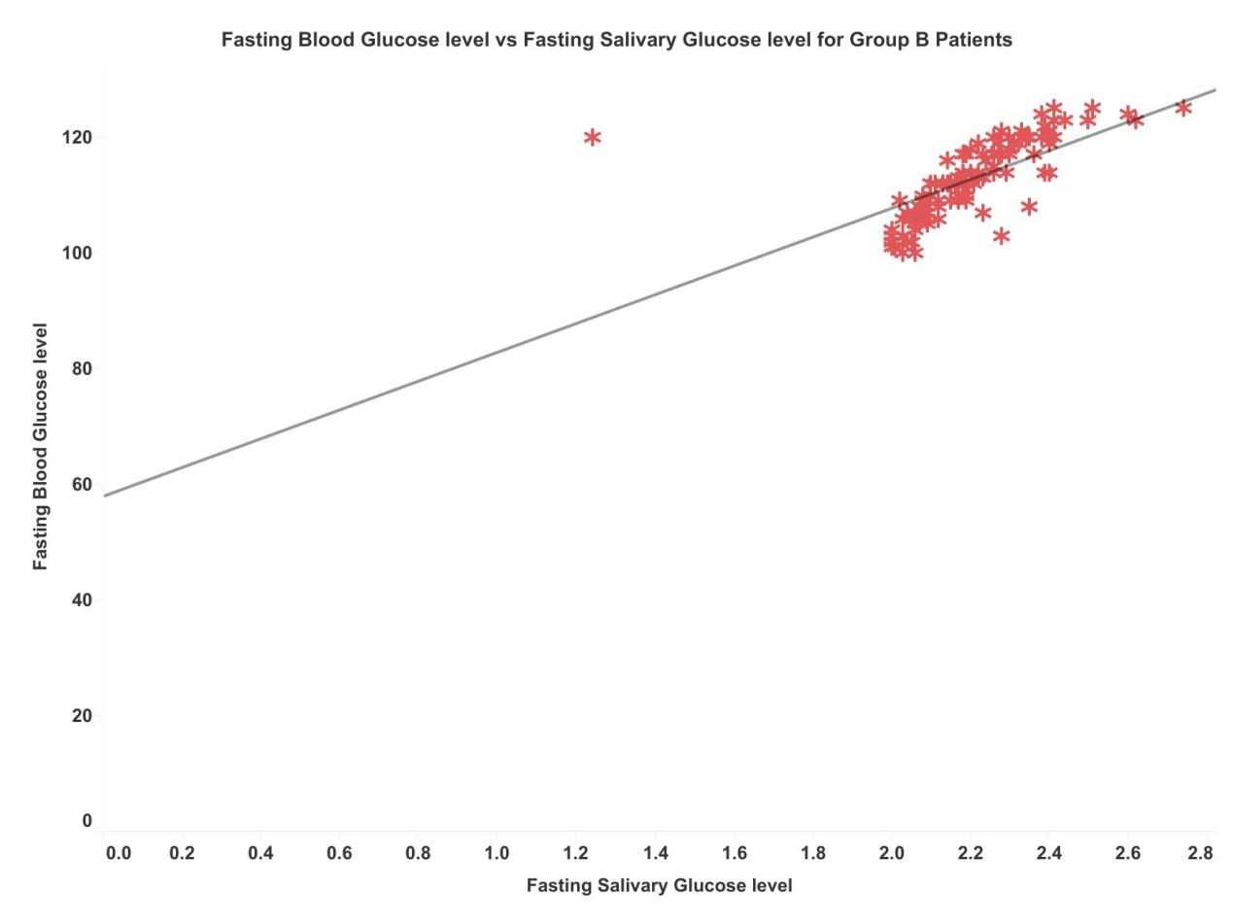
Fig 2. Correlation between fasting blood glucose and salivary glucose levels in Group B subjects.
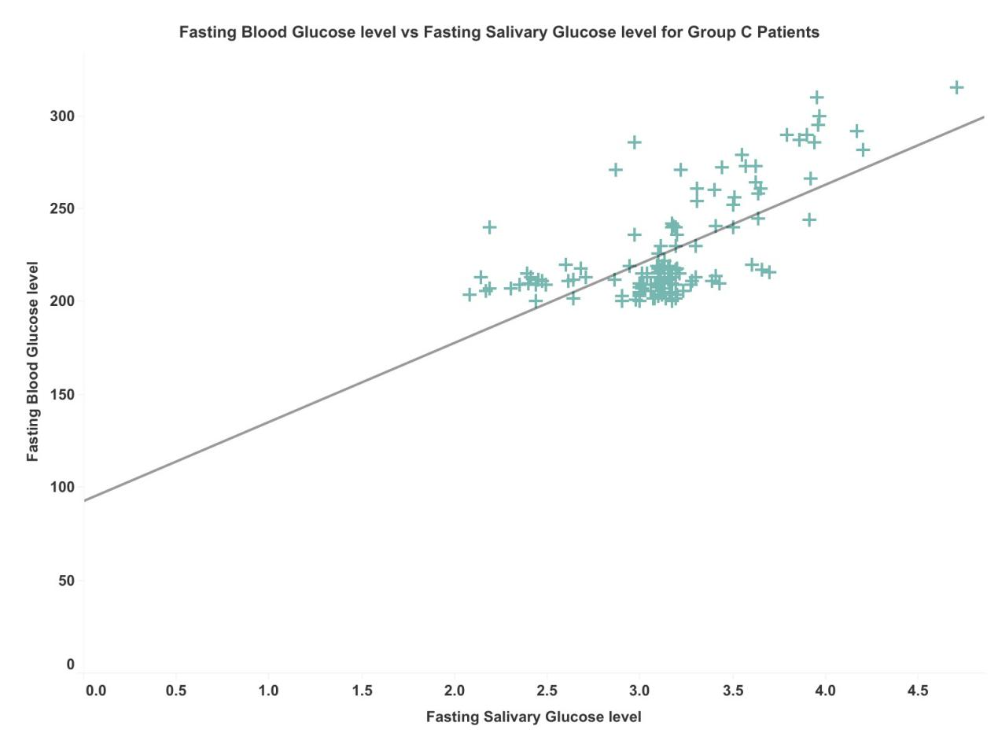
Fig 3. Correlation between fasting blood glucose and salivary glucose levels in Group C subjects.
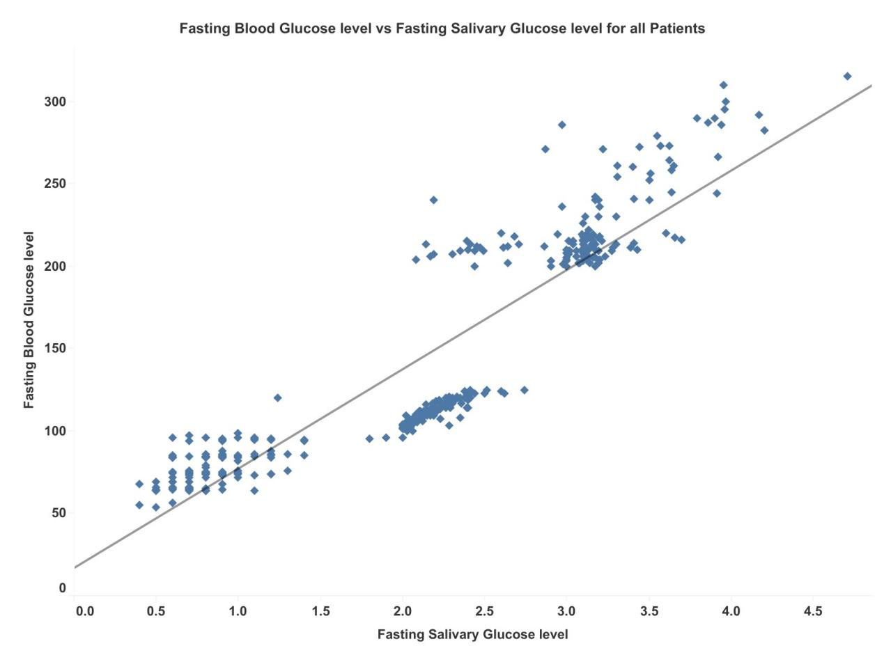
Fig 4. Correlation between fasting blood glucose and salivary glucose levels in all subjects.
4.0 Discussion
Diabetes mellitus is a major global public health challenge characterised by chronic hyperglycemia resulting from deficient insulin secretion by pancreatic β-cells, impaired insulin action at target tissues (insulin resistance), or both. These defects disrupt glucose homeostasis and lead to abnormal metabolism of carbohydrates, lipids, and proteins (ADA, 2014). Blood glucose measurement remains the gold standard for diagnosis and monitoring; however, repeated capillary or venous sampling is invasive, painful and often associated with poor patient compliance, particularly among pediatric, geriatric and needle-phobic populations. Salivary glucose assessment has therefore emerged as a promising non-invasive alternative. Saliva collection is painless, rapid, cost-effective and easily performed in both clinical and home settings, aligning with the WHO ASSURED criteria for ideal diagnostic tools. Recent advances in biosensor technology have further enhanced its feasibility, with several enzymatic and non-enzymatic electrochemical and optical platforms demonstrating clinically relevant detection ranges (14.5–213 mg/dL), high sensitivity, rapid response times (<3 min) and strong correlations with blood glucose levels (r = 0.90–0.97) in diabetic cohorts (Panwar et al., 2025). Despite these advantages, significant challenges limit the immediate clinical translation of salivary glucose monitoring. A 2026 systematic review and meta-analysis of 25 studies reported only weak overall correlations between salivary and blood glucose (r² ≈ 0.05 for whole-mouth saliva; r² ≈ 0.11 for parotid saliva), accompanied by extremely high heterogeneity (I² approaching 100%). This variability stems from differences in saliva collection protocols, diurnal fluctuations, xerostomia, oral contaminants, dietary influences and analytical methodologies (Haba et al., 2026). Earlier meta-analyses indicated moderate to large effect sizes in type 2 diabetes mellitus (T2DM) (Hedge’s g = 1.37; overall r ≈ 0.49), with stronger associations observed at higher glycemic levels (Mascarenhas et al., 2014). Salivary glucose concentrations are typically 10–100 times lower than blood levels, which necessitates highly sensitive detection methods. Current evidence suggests salivary glucose is more reliable for monitoring poorly controlled diabetes than for diagnosis or fine glycemic titration in well-controlled patients (Shettigar et al., 2024). The present study demonstrated a significant positive correlation between salivary and blood/plasma glucose concentrations in individuals with T2DM, consistent with multiple observational studies reporting moderate to strong correlations (r = 0.56–0.715) and elevated salivary glucose levels in diabetic patients compared with healthy controls (Cui et al., 2022; Tiongco et al., 2018). Several authors have proposed that salivary glands function as filters of blood glucose, with concentrations modulated by hormonal and neural regulation (Zhang et al., 2021). Chronic hyperglycemia induces microvascular changes and alters the basement membrane of salivary glands, increasing glucose leakage into saliva (Gupta et al., 2020). These mechanisms explain the significantly higher salivary glucose levels observed in diabetic patients relative to controls (p < 0.001), a finding corroborated by earlier studies in both type 1 and type 2 diabetes (Shahbaz et al., 2014; Nagalaxmi et al., 2011; Iqbal et al., 2011). Nevertheless, conflicting results across the literature have prevented consensus on whether salivary glucose can fully replace blood-based monitoring (Cui et al., 2022; Haba et al., 2026; Shettigar et al., 2024). While saliva offers clear practical advantages, especially for frequent monitoring across all age groups, its clinical utility requires further standardisation of collection and analytical protocols, improved sensor technologies and large-scale validation studies before widespread adoption.

5.0 Conclusion
This study reveals that salivary glucose is increased in diabetics. Significant correlation was found between FSG level and FBG level of controlled diabetes, uncontrolled diabetes and healthy individuals. This means that saliva can be used as adjuvant diagnostic tool to blood in early diagnosis for DM. Saliva also finds great advantage over blood in case of children, elderly, critically ill and debilitated patients. However, further studies should be conducted to assess the potential of saliva as an alternative diagnostic fluid. Furthermore, the researchers recommend further investigations that would fully support the claims of this study. A longitudinal large-scale study should be conducted due to the limitations of this cross-sectional study. Other parameters such as glycemic control, insulin resistance, and metabolic syndrome are also recommended to be included. The researchers also recommend future studies to elaborate further other salivary analytes that can be used for the diagnosis of diabetes as well as other factors that contribute to their excretion in saliva.

References
Agoro, E.S., Nelson-Ebimie, E., Soroh, A. E., & Odegbemi, J.O. (2017). The Suitability of Non-Invasive Sample in the Assay of Glucose in Diabetes Mellitus Diagnosis and Sex Difference. Journal of Applied Microbiology and Biochemistry, 2, 6.
Ahmad, R., & Haque, M. (2021). Oral health messiers: Diabetes mellitus relevance. Diabetes Metabolic Syndrome Obesity Targets Therapy, 14, 3001.

Ahmadi, M.F., Davoodi, P., & Dalband, M. (2010). Saliva as a Mirror of the Body Health. Dental Journal of Health, 1, 1–15.

Alizadeh, A., Burns, A., Lenigk, R., Rachel, G., Jeffrey, A., Adam, P., Margaret, M. C., & Ruairi, B. (2018). A wearable patch for continuous monitoring of sweat electrolytes during exertion. Lab A Chip, 18, 2632–2641.

American Diabetes Association (ADA) (2014). Standards of medical care in diabetes. Diabetes Care, 37 (1): S14–S80.

Bamgboje, D., Christoulakis, I., & Smanis, I. (2021). Continuous non-invasive glucose monitoring via contact lenses: Current approaches and future perspectives. Biosensors, 11, 189.

Bapat, S., Nagarajappa, R., Ramesh, G., & Bapat, K. (2021). Effect of propolis mouth rinse on oral microorganisms—A randomized controlled trial. Clinical Oral Investigation, 25, 6139–6146.

Caixeta, D. C., Aguiar, E., Cardoso-Sousa, L., & Coelho, L. M. D. (2019). Salivary molecular spectroscopy: A rapid and non-invasive monitoring tool for diabetes mellitus during insulin treatment. PLoS ONE, 15, e0223461

Chakraborty, P., Deka, N., Patra, D. C., Debnath, K., & Mondal, S. P. (2021). Salivary glucose sensing using highly sensitive and selective non-enzymatic porous NiO nanostructured electrodes. Surface Interfaces, 26, 101–324.

Cui, Y., Zhang, H., Zhu, J., Lu, P., Zhili, D., Tian, L., Jiasheng, Z., Lu, X., Zhenhua, L., Song, W., et al. (2021). Unstimulated Parotid Saliva Is a Better Method for Blood Glucose Prediction. Applied Science, 11, 11367.

Cui, Y., Yu, M., Yao, Z., Gong, J., Li, Z., & Chen, L. (2022). Correlations of salivary and blood glucose levels among six saliva collection methods. International Journal of Environmental Research and Public Health, 19(7), Article 4122. https://doi.org/10.3390/ijerph19074122

Dimeski, G., Yow, K. S., & Brown, N. N. (2015). What is the most suitable blood collection tube for glucose estimation? Annals Clinical Biochemistry, 52:2270–5. doi: 10.1177/0004563214544708.

Goel, R.K., Munjal, A., & Talukdar, A. (2021). Saliva as a potential diagnostic and monitoring tool in diabetes mellitus. Journal of Current Medical Research Opinion, 4, 1088–1095.

Gupta V, et al. (2020). Salivary glucose levels in diabetes mellitus patients: A case-control study. Journal of Pathology and Translational Medicine (or similar journal).Describes the mechanism in detail, including AGEs, endothelial dysfunction, and multifactorial aspects (including gingival crevicular fluid contribution).
Gupta, S., Nayak, M. T., Sunitha, J. D., Dawar, G., Sinha, N., & Rallan, N. S. (2017). Correlation of salivary glucose level with blood glucose level in diabetes mellitus. Journal of Oral Maxillofac Pathology, 21, 334.

Haba, K. S., Kreuter, P. K., Qian, X., Agócs, G., Bánki, E., & Varga, G. (2026). Salivary glucose testing for diabetes mellitus: A systematic review and meta-analysis of current evidence and methodological heterogeneity. Journal of Clinical Medicine, 15(5), Article 1829. https://doi.org/10.3390/jcm15051829
Idowu, O. O., Bako, A. I., & Aduloju, O. T. B. (2020).Analysis of the trend of peri-urban development in Minna, Niger State. Journal of Geographic Information System, 12, 411–431. https:doi.org//10.4236/jgis.2020.125025

International Diabetes Federation (IDF) (2019). Diabetes Atlas, 9th ed. Brussels, Belgium.

Janapala, R. N., Jayaraj, J. S., Fathima, N., Kashif, T., & Sachmechi, I. (2019). Continuous glucose monitoring versus self-monitoring of blood glucose in type 2 diabetes mellitus: A systematic review with meta-analysis. Cureus, 11, 37–43.

Knip, M., Virtanen, S. M., & Akerblom, H. K. (2010). Guidelines on Diabetes, Prediabetes, and Cardiovascular Diseases Developed in Collaboration. European Heart Journal, 91, 1506–1513.

Krishnaveni, P., & Ganesh, V. (2021). Electron transfer studies of a conventional redox probe in human sweat and saliva bio-mimicking conditions. Scientific Reports, 11, 7663.

Lasisi, T., & Fasanmade, A. (2012). Salivary flow and composition in diabetic and non-diabetic subjects, Annals of Ibadan Postgraduate Medicine, 10(1), 25–30.

Mascarenhas, P., Fatela, B., & Barahona, I. (2014). Effect of diabetes mellitus type 2 on salivary glucose – A systematic review and meta-analysis of observational studies. PLOS ONE, 9(7), Article e101706. https://doi.org/10.1371/journal.pone.0101706
Mussavira, S., Dharmalingam, M., & Omana, S. B. (2015). Salivary glucose and antioxidant defense markers in type II diabetes mellitus. Turkish Journal of Medical Sciences, 45:141-7.
Navazesh, C. Christensen, V., & Brightman, (2010). Clinical criteria for the diagnosis of salivary gland hypofunction, Journal of Dental Research. 71, 1363–1369.

Nermeen, M. F., Sanya, A. E., Fahmy, M., & Makled, S. (2021). Prevalence Evaluation of Salivary Glucose and Total Proteins Levels in Children with Type I Diabetes. Medical Journal of Cairo University, 89:2, 817–823.

Ochei, J., & Kolhatar, A. (2003). Haematology. In: Medical laboratory science theory and practice. Tata McGraw-Hill, India. p. 251.

Palomar, B. M., Atienza, M., Hernández, L. B., & Cantero, J. L. (2021). Associations of Salivary Total Antioxidant Capacity with Cortical Amyloid-Beta Burden, Cortical Glucose Uptake, and Cognitive Function in Normal Aging. Journal of Gerontology Series A, 76, 1839–1845.

Panwar, S., Syed Kasim, D., Sarkar, P., Anand, R., Priya, A., Prakash, S., & Jha, S. K. (2025). A non-invasive device for glucose monitoring through saliva – A paradigm shift in diabetes care. Sensors & Diagnostics. Advance online publication. https://doi.org/10.1039/D5SD00027K

Rodrigues, R. Vieira, W. Siqueira, W. L. Bernardo, A., & Luiz, R. (2021). Saliva as a tool for monitoring hemodialysis: A systematic review and meta-analysis. Brazilian Oral Research, 35, e016.

Shahbaz, S., Katti, G., GhalI, S.R., Katti, C., Diwakar, D. D., & Guduba,V. (2014). Salivary alteration in type 1 diabetes mellitus patients: Salivary glucose could be noninvasive tool of monitoring diabetes mellitus. Indian Journal of Dental Research, 25: 420.

Shang, T., Zhang, J. Y., & Thomas, A. (2022). Products for monitoring glucose levels in the human body with noninvasive optical, noninvasive fluid sampling, or minimally invasive technologies. Journal of Diabetes Science and Technology,16, 168–214.

Shettigar, L., Shenoy, P. A., D’Souza, V., D’Souza, H., D’Souza, J., & Baliga, M. S. (2024). Correlational analysis between salivary and blood glucose levels in individuals with and without diabetes mellitus: A cross-sectional study. Acta Odontologica Scandinavica, 83, 1–8. https://doi.org/10.1080/00016357.2023.2267678
Sim, R., & Lee, S.W.H. (2021). Patient preference and satisfaction with the use of telemedicine for glycemic control in patients with type 2 diabetes: A review. Patient Preference Adherence, 15, 283.

Sun, J., Ren, J., Hu, X., Hou, Y., & Yang, Y. (2021). Therapeutic effects of Chinese herbal medicines and their extracts on diabetes. Biomedicine and Pharmacotherapy 142, 111–977.

Thayumanavan, B., Jeyanthikumari, T., Abu, D., & Vani, N. (2015). Diabetes and oral healthan overview of clinical cases. International Journal of Medical and Dental Sciences, 4(2), 901–905.

Tiongco, M. R. E., Bituin, A., Arceo, E., Rivera, N., & Singian, E. (2018). Salivary glucose as a non-invasive biomarker of type 2 diabetes mellitus, Journal of Clinical Experimental Dentistry, 10(9) e902–e907

Turner, A.P.F. (2013). Biosensors: Sense and sensibility. Chemical Society Review, 42, 3184–3196.

World Health Organisation (2016). Global Report on Diabetes. World Health Organization; 978:88.

Zhang, Y., Sun, J., Liu, L., & Qiao, H. (2021). A review of biosensor technology and algorithms for glucose monitoring. Journal of Diabetes Complications, 35, 107929.

Zhao, M., & Leung, P.S. (2020). Revisiting the use of biological fluids for noninvasive glucose detection. Future Medicinal Chemistry, 12, 645–647.

