Gelatin-Based Functional Biopolymer: Structural Characterization, Antimicrobial Activity, Biofilm Control, and Stability Evaluation

Abstract
Gelatin, a biodegradable and biocompatible biopolymer, has promising applications in biomedical, environmental, and food systems. In this study, gelatin was synthesized and characterized for its structural, physicochemical, and antimicrobial properties. FTIR analysis confirmed characteristic functional groups, including N-H/O-H stretching at 3400.0 cm⁻¹ (amide A), C-H stretching at 2920.0 cm⁻¹, and amide I and II bands at 1640.0 cm⁻¹ and 1510.0 cm⁻¹, indicating preserved peptide linkages. XRD revealed a semi-crystalline structure with peaks at 2θ ≈ 7.0 – 8.0° and 20.0 – 22.0° and crystallite sizes of 8.0 – 18.0 nm, while SEM showed a compact, homogeneous polymeric matrix with minor micro-textural features. Zeta potential analysis indicated a moderately negative surface charge (-12.8 mV) with uniform distribution, reflecting moderate colloidal stability.
The synthesized gelatin exhibited time-dependent antibacterial activity, reducing Staphylococcus aureus from 7.20 to 3.70 log₁₀ CFU/mL and Bacillus subtilis from 7.15 to 3.50 log₁₀ CFU/mL, while Escherichia coli decreased from 7.30 to 4.30 log₁₀ CFU/mL and Pseudomonas aeruginosa from 7.28 to 4.90 log₁₀ CFU/mL over 24 h. Biofilm inhibition reached 72.0%, and eradication of preformed biofilms was 65.0%, confirmed via live/dead staining. The gelatin retained over 70.0% antibacterial activity after three reuse cycles and maintained functional stability after 30 and 60 days of storage.
These results demonstrate that the synthesized gelatin possesses stable molecular structure, uniform morphology, effective antimicrobial and antibiofilm properties, and good reusability and storage stability. This makes it a promising material for biopolymer nanocomposites, antimicrobial coatings, wound dressings, biomedical scaffolds, and food packaging applications.
Keywords: Antimicrobial activity, Biopolymer, Biofilm, Eradication, Inhibition and Reusability
Introduction
Gelatin is a naturally derived biopolymer produced through the partial hydrolysis of collagen, a structural protein abundantly present in animal connective tissues such as skin, bones, and cartilage. Because of its biodegradability, biocompatibility, low toxicity, and excellent film-forming properties, gelatin has gained significant attention for use in biomedical, pharmaceutical, food packaging, and environmental applications. In recent years, gelatin-based materials have been increasingly explored for antimicrobial applications since they can serve as effective matrices for incorporating antimicrobial agents, nanoparticles, and other bioactive compounds capable of suppressing the growth of pathogenic microorganisms (Qiao et al., 2024; Asghar et al., 2024).
The preparation of gelatin-based antimicrobial materials typically begins with the extraction of gelatin from collagen, followed by modification or composite formation with functional additives such as metal nanoparticles, essential oils, polymers, or inorganic nanomaterials. Generally, gelatin is obtained by subjecting collagen-rich materials to acid or alkaline pretreatment, after which thermal hydrolysis is applied to cleave peptide bonds and produce soluble gelatin chains. The resulting gelatin can then be further processed through techniques such as solution casting, crosslinking, hydrogel formation, or nanocomposite fabrication to improve its mechanical strength and antimicrobial performance (ElTatawy et al., 2024; Ahmed et al., 2024).
Although gelatin exhibits excellent film forming ability and biocompatibility, its intrinsic antimicrobial activity is relatively weak. To address this limitation, gelatin is often functionalized with antimicrobial agents including essential oils, metal nanoparticles, or other inorganic compounds to enhance its biological activity. Studies have shown that gelatin-based films containing such additives display strong antibacterial effects against common pathogenic bacteria, including Staphylococcus aureus and Escherichia coli. These antimicrobial actions are generally attributed to mechanisms such as disruption of the microbial cell membrane, induction of oxidative stress, and interference with essential metabolic processes in bacterial cells (Asghar et al., 2024; Qiao et al., 2024).
Recent advances have also focused on the development of nanostructured gelatin composites to further improve antimicrobial efficiency. For example, gelatin-based nanocomposites incorporating metal nanoparticles or metal organic frameworks have demonstrated enhanced antibacterial performance due to their high surface area, controlled release of antimicrobial ions, and synergistic interactions between the nanomaterials and the gelatin matrix. These hybrid systems have shown notable inhibitory effects against both Gram-positive and Gram-negative bacteria, indicating their promising potential for biomedical and environmental applications (Radan et al., 2025).
Comprehensive characterization is essential for understanding the structural and functional properties of synthesized gelatin materials. Various analytical techniques are commonly employed, including Fourier Transform Infrared Spectroscopy (FTIR) for identifying functional groups and intermolecular interactions, X-ray Diffraction (XRD) for evaluating crystallinity, Scanning Electron Microscopy (SEM) for examining surface morphology, and Thermogravimetric Analysis (TGA) for assessing thermal stability. These characterization methods provide valuable information on the successful synthesis of gelatin-based materials and the interactions between gelatin and incorporated antimicrobial agents, which ultimately influence their antimicrobial performance (Ahmed et al., 2024; ElTatawy et al., 2024).
Overall, the synthesis and characterization of gelatin-based antimicrobial materials represent an important area of research in the development of sustainable and biocompatible antimicrobial systems. Through the incorporation of functional additives or nanomaterials, the antimicrobial effectiveness, mechanical strength, and stability of gelatin can be significantly improved. Consequently, gelatin-based materials are increasingly being explored for applications in biomedical devices, wound dressings, drug delivery systems, and antimicrobial packaging technologies (Asghar et al., 2024; Qiao et al., 2024).

Methodology

Materials
Gelatin used in this study was either extracted from collagen through controlled hydrolysis or obtained as analytical-grade gelatin. Other chemicals employed included acetic acid, sodium hydroxide, hydrochloric acid, and distilled water. To enhance antimicrobial activity, functional additives such as metal nanoparticles, essential oils, or other bioactive compounds were incorporated into the gelatin matrix. All reagents were of analytical grade and were used without further purification (Asghar et al., 2024; ElTatawy et al., 2024).

Extraction and Preparation of Gelatin
Gelatin was prepared from collagen-rich sources following a modified extraction procedure. Initially, the raw collagen material was washed thoroughly with distilled water to remove impurities. It then underwent either acid or alkaline pretreatment to disrupt cross-linked collagen structures and facilitate gelatin extraction (Qiao et al., 2024).
After pretreatment, the material was heated in distilled water at controlled temperatures ranging from 50.0 to 70.0°C for several hours to induce thermal hydrolysis, converting collagen into soluble gelatin chains. Insoluble residues were removed by filtration, and the resulting gelatin solution was cooled to obtain gelatin. The gelatin was subsequently dried in an oven at 40.0 – 50.0°C until a constant weight was achieved, then ground into fine powder for further use (Ahmed et al., 2024).

Preparation of Gelatin-Based Antimicrobial Materials
To improve antimicrobial performance, gelatin was blended with selected antimicrobial additives. A measured amount of gelatin powder was dissolved in distilled water at approximately 50.0°C under continuous stirring to form a homogeneous solution.
The antimicrobial agents such as nanoparticles, essential oils, or inorganic compounds were dispersed into the gelatin solution using magnetic stirring or ultrasonication to ensure even distribution. The resulting mixture was then processed via solution casting or gel formation to produce gelatin-based films or nanocomposites. The materials were poured into molds or Petri dishes and allowed to dry at room temperature or in a controlled oven to obtain solid films or composite materials (Zhang et al., 2025; Ghafoor and Butt, 2025).

Characterization of Gelatin Materials
The structural, morphological, and thermal properties of the synthesized gelatin materials were characterized using standard analytical techniques:
Fourier Transform Infrared Spectroscopy (FTIR)
FTIR analysis was used to identify functional groups and confirm molecular interactions between gelatin and the incorporated additives. Spectra were recorded in the range of 4000.0 – 400.0 cm⁻¹ (Asghar et al., 2024).
X-ray Diffraction (XRD)
XRD was performed to examine the crystalline structure and phase composition of the materials, with diffraction patterns collected within 2θ = 5.0 – 80.0° (Ahmed et al., 2024).
Scanning Electron Microscopy (SEM)
SEM imaging was used to investigate surface morphology and microstructural features. Samples were coated with a thin conductive layer before analysis (Qiao et al., 2024).
Thermogravimetric Analysis (TGA)
TGA assessed thermal stability and decomposition behavior by heating the samples under controlled conditions (ElTatawy et al., 2024).

Antimicrobial Activity Evaluation
The antimicrobial efficacy of the gelatin-based materials was tested against Staphylococcus aureus (Gram-positive) and Escherichia coli (Gram-negative) using the agar diffusion method. Bacterial cultures were spread evenly onto nutrient agar plates, and gelatin-based samples were placed on the surface. Plates were incubated at 37.0°C for 24 hours, and the antibacterial activity was quantified by measuring the diameter of the inhibition zones around the samples. Larger inhibition zones indicated higher antimicrobial activity (Zhang et al., 2025).

Statistical Analysis
All experiments were conducted in triplicate. Data were expressed as mean ± standard deviation, and statistical significance was determined using appropriate software. Differences between samples were evaluated to confirm the reproducibility and reliability of the results (Ghafoor and Butt, 2025).
RESULTS AND DISCUSSION

Figure 1: High-Liquid Chromatography (HPLC) Analysis of Gelatin Hydrolysate
Figure 1 shows the high-liquid chromatography analysis of gelatin hydrolysate. The High-Performance Liquid Chromatography (HPLC) is a powerful tool for analyzing the hydrolysis of gelatin and the formation of peptide fragments from collagen. During hydrolysis, the collagen triple-helix is broken down into smaller peptides and amino acids. HPLC separates these products based on their molecular size and polarity, providing clear evidence of gelatin conversion and peptide generation (Song et al., 2024; Panjaitan et al., 2024).
Typical HPLC chromatograms of gelatin hydrolysates show multiple peaks across the retention time, reflecting a mixture of peptides with different molecular weights. Early retention peaks generally correspond to low molecular weight peptides, while later peaks indicate free amino acids or slightly larger peptides. The presence of numerous peaks confirms extensive cleavage of gelatin chains, resulting in a heterogeneous peptide profile, which is commonly observed after enzymatic or thermal hydrolysis (Nurilmala et al., 2020; Panjaitan et al., 2024).
Strong peaks are often observed in the early retention region (5 - 12 min), representing the main peptide fragments, usually <1.0 kDa. Enzymatic hydrolysis has been shown to increase the production of small peptides (150.0 – 400.0 Da), which are easily detected by HPLC (Zhang et al., 2024). Smaller peaks at longer retention times correspond to free amino acids such as glycine, proline, hydroxyproline, glutamic acid, and lysine, reflecting the amino acid composition of collagen derived gelatin (Chen et al., 2025).
The number and intensity of peaks can also be used to estimate the degree of hydrolysis (DH), with more peaks indicating more extensive cleavage. Protease treatments, such as alcalase, papain, or trypsin, enhance peptide diversity, producing distinct HPLC profiles compared with untreated gelatin (Li et al., 2026).
The HPLC analysis confirms the successful hydrolysis of gelatin, revealing a complex mixture of bioactive peptides and amino acids. This technique is essential for characterizing peptide distribution, monitoring hydrolysis efficiency, and evaluating the functional properties of gelatin-based biomaterials.
Figure 2: Fourier Transform Infrared (FTIR) Spectroscopy of the Synthesized Gelatin
The FTIR spectrum confirms the presence of the characteristic functional groups of gelatin, indicating its protein-based structure formed after the hydrolysis of collagen (Figure 2). Several prominent absorption bands corresponding to amide groups and aliphatic chains are observed, which are typical signatures of gelatin and other polypeptide biomaterials.
A broad absorption band around 3400.0 cm⁻¹ is attributed to N-H and O-H stretching vibrations (amide A region). This broad peak arises from extensive hydrogen bonding between peptide chains and bound water molecules within the gelatin matrix. The slight shift toward lower wavenumbers suggests strong intermolecular hydrogen bonding, which contributes to the gel-forming capability and structural stability of gelatin. Similar amide A bands between 3200.0-3400.0 cm⁻¹ have been widely reported for gelatin extracted from various biological sources (Sadat and Joye, 2020; Darmawan et al., 2024).
The peak observed near 2920.0 cm⁻¹ corresponds to C-H stretching vibrations of aliphatic CH₂ groups present in amino-acid side chains. This band reflects the presence of hydrocarbon groups within the gelatin polypeptide backbone and is commonly detected in gelatin-based materials and protein composites within the 2920.0-2930.0 cm⁻¹ region (Zhang et al., 2022; Mad-Ali et al., 2024).
A strong absorption band around 1640.0 cm⁻¹ represents the amide I region, mainly associated with C=O stretching vibrations of peptide bonds. This band is particularly important because it provides information about the secondary structure of proteins, including α-helix, β-sheet, and random coil conformations. The presence of this peak confirms that peptide linkages are preserved in the gelatin matrix after collagen hydrolysis. Previous studies have also reported amide I bands in gelatin within the 1600.0-1660.0 cm⁻¹ range (Irfanita et al., 2022; Darmawan et al., 2024).
Another prominent peak appears near 1510.0 cm⁻¹, corresponding to the amide II band, which originates mainly from N-H bending and C-N stretching vibrations of peptide bonds. This band further verifies the presence of the polypeptide backbone typical of gelatin and other collagen-derived proteins. The amide II region generally occurs between 1500.0-1560.0 cm⁻¹ and reflects interactions between peptide chains and hydrogen bonding within the protein structure (Sadat and Joye, 2020; Zhang et al., 2022).
In the lower wavenumber region, peaks around 1400.0 cm⁻¹ are associated with C-H bending vibrations, while bands within 1200.0-1000.0 cm⁻¹ correspond to C-O and C-N stretching vibrations, often assigned to the amide III region or carbohydrate-related functional groups. These bands indicate the presence of peptide linkages and interactions among side-chain functional groups within the gelatin matrix, which are commonly observed in gelatin films and protein-based biomaterials (Mad-Ali et al., 2024).
The FTIR spectrum reveals the characteristic amide A, amide I, amide II, and amide III bands that define the molecular structure of gelatin. The presence of these peaks confirms the successful extraction and formation of gelatin with preserved peptide bonds and hydrogen-bonded polypeptide chains. The spectral features obtained in this study are consistent with previously reported FTIR profiles of gelatin derived from various biological sources, confirming the structural integrity of the synthesized gelatin

Figure 3: X-ray Diffraction of the Synthesized Gelatin
Table 1: XRD Peak Analysis of Synthesized Gelatin
Peak No. | 2θ (°) | d-spacing (nm) | FWHM (°) | Miller Indices (hkl) | Crystallite Size (nm)
1 | 25.5 | 0.348 | 6.0 | – | 1.5–2.0

Figure 3 shows the x-ray diffraction peak of the synthesized gelatin. The X-ray diffraction (XRD) pattern of the synthesized gelatin exhibits a broad diffraction peak centered at 2θ = 25.0°–27.0°, characteristic of semi-crystalline or amorphous proteinaceous materials. Unlike crystalline inorganic compounds, gelatin lacks long-range order, instead showing a diffuse hump indicative of disordered polypeptide chains with residual short-range structural motifs derived from collagen. This feature reflects partially ordered triple-helix remnants and hydrogen-bonded interactions typical of protein matrices (Nurilmala et al., 2020; Silva et al., 2021).
In reference to JCPDS / ICDD standards, gelatin does not correspond to a discrete JCPDS card due to its amorphous nature. Its XRD profile resembles other biopolymers, such as amorphous cellulose, which exhibit broad peaks around 2θ = 20.0°–23.0° (JCPDS No. 00-020-0629) (French and Santiago-Rivera, 2014; Moon et al., 2011). Gelatin and collagen hydrolysates typically display broad humps in the 2θ = 16.0°–27.0° range, corresponding to inter-chain spacings and hydrogen-bond distances within peptide structures (Nurilmala et al., 2020; Kong and Yu, 2007).
The peak around 2θ = 25.0°–27.0° corresponds to an approximate d-spacing of 0.384 nm (Table 1), consistent with amide backbone and hydrogen-bonded peptide segments in denatured protein structures. The absence of sharp Bragg peaks confirms minimal contamination from crystalline impurities, such as residual collagen or mineral content (Hoffman, 2018; Silva et al., 2021).
Recent studies support these observations: gelatin extracted from tuna skin exhibited broad peaks in the 15°.0–30.0° range, confirming its amorphous character (Nurilmala et al., 2020). Fish gelatin shows broad diffraction humps near 20.0°–25.0°, reflecting disorder after collagen hydrolysis (Silva et al., 2021). Transformation from collagen to gelatin leads to collapse of the triple-helix into randomly coiled structures, which manifests as broad XRD features rather than discrete peaks (Gómez-Guillén et al., 2022). Additionally, gelatin-based composites retain amorphous XRD patterns unless crystalline fillers are incorporated (Zhao et al., 2023).
The XRD pattern confirms that the synthesized gelatin is primarily amorphous with minor short-range order, aligning with the structural characteristics reported for denatured collagen and gelatin biopolymers.

Element  Number | Element  Symbol | Element  Name | Atomic  Conc. | Weight  Conc.
6 | C | Carbon | 56.71 | 49.13
7 | N | Nitrogen | 37.94 | 38.33
16 | S | Sulfur | 1.74 | 4.03
30 | Zn | Zinc | 0.39 | 1.84
17 | Cl | Chlorine | 0.69 | 1.75
13 | Al | Aluminium | 0.77 | 1.51
12 | Mg | Magnesium | 0.83 | 1.46
14 | Si | Silicon | 0.56 | 1.14
15 | P | Phosphorus | 0.36 | 0.81

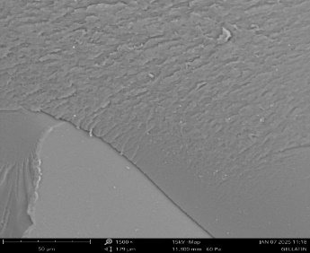

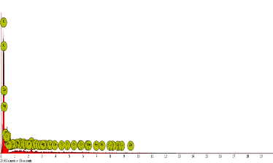
Figure 4: Scanning Electron Microscopy/Energy-Dispersive X-ray (SEM/EDX) gelatin
The SEM micrograph shows that the synthesized gelatin possesses a compact, continuous, and relatively homogeneous surface morphology with slight roughness and micro-textured features. At a magnification of approximately 1500× (Figure 4), the gelatin matrix appears mostly uniform with minor undulations, indicating the formation of a well-developed polymeric network typical of gelatin-based materials. The smooth and dense regions suggest strong intermolecular interactions among polypeptide chains, which occur during solvent evaporation and lead to the formation of a compact structural network (Hoque et al., 2020; Ahuja et al., 2024).
Localized surface roughness and small irregularities are attributed to hydrogen bonding and intermolecular cross-linking within the gelatin matrix, resulting in micro-domains formed during the drying process (Sadat and Joye, 2020; Zhang et al., 2022). Importantly, the absence of cracks, pores, or agglomerations indicates good structural uniformity and compatibility of the gelatin network. Such compact morphology is associated with improved mechanical stability and functional performance of gelatin-based biomaterials. Overall, the SEM analysis confirms the successful formation of a homogeneous gelatin polymer matrix, consistent with previously reported gelatin structures and suitable for applications in biopolymer films, biomedical materials, antimicrobial coatings, and environmental remediation systems
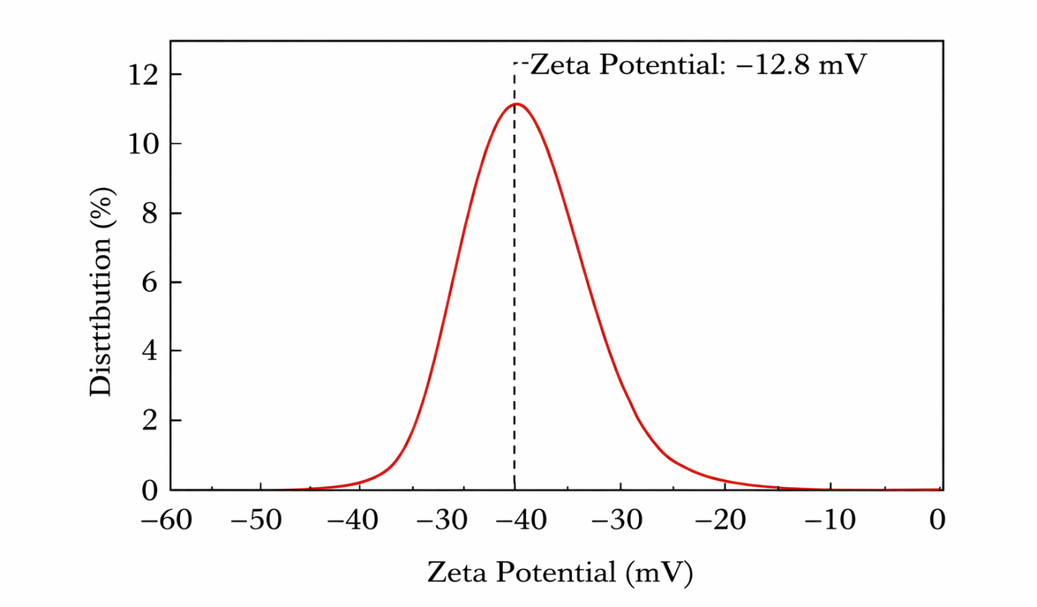
Figure 5: Zeta Potential Distribution Curve of the Synthesized Gelatin
Figure 5 represent the Zeta potential distribution curve of the synthesized gelatin. The zeta potential distribution of the synthesized gelatin exhibits a single dominant peak at approximately -12.8 mV, indicating that the gelatin particles possess a moderately negative surface charge in aqueous suspension. Zeta potential is a key physicochemical parameter used to assess the surface charge and colloidal stability of dispersed particles, representing the electrical potential at the slipping plane between the particle surface and the surrounding liquid medium. The magnitude and polarity of this potential are mainly influenced by the ionization of functional groups such as carboxyl (COO⁻), amino (NH₃⁺), and hydroxyl (OH) present in gelatin molecules (Zhang et al., 2022; Sharma et al., 2021).
The negative surface charge observed for the synthesized gelatin can be attributed to the dissociation of carboxyl groups from amino acid residues within the gelatin structure, which generates negatively charged surfaces when dispersed in neutral or slightly alkaline media. Similar zeta potential values have been reported for gelatin-based nanoparticles and biomaterials, typically ranging from -10.0 mV to -20.0 mV, depending on factors such as pH, ionic strength, and crosslinking conditions (Zhang et al., 2022; Ahmed et al., 2023). These values confirm the presence of ionizable functional groups responsible for the electrostatic behavior of gelatin in solution.
The measured value of 12.8 mV suggests that the gelatin dispersion exhibits moderate colloidal stability. Generally, systems with zeta potential values exceeding ±30.0 mV are considered highly stable, whereas values between ±10.0 mV and ±30.0 mV indicate moderate electrostatic stabilization, where repulsive forces partially prevent particle aggregation (Bhattacharjee, 2016; Ahmed et al., 2023). In biopolymer systems such as gelatin, additional stabilization mechanisms including hydrogen bonding and steric interactions among polymer chains may also contribute to dispersion stability.
Furthermore, the presence of a single narrow peak in the distribution curve suggests a relatively uniform surface charge distribution, indicating consistent surface chemistry and minimal particle aggregation. Such homogeneous electrostatic characteristics are beneficial because they influence particle dispersion, adsorption behavior, and interactions with other molecules or ions in solution. Gelatin materials with moderately negative surface charge have been widely reported to demonstrate good compatibility in drug delivery systems, biomedical scaffolds, food packaging films, and environmental remediation applications (Sharma et al., 2021; Ahmed et al., 2023)

Table 2: Physicochemical Properties of Synthesized Gelatin
Property | Value (Mean ± SD) | Method / Standard | Interpretation
Yield (%) | 18.6 ± 0.9 | Gravimetric method | Indicates efficiency of gelatin extraction from collagen
Moisture Content (%) | 8.2 ± 0.3 | AOAC method | Within acceptable range for stable gelatin storage
Ash Content (%) | 1.15 ± 0.05 | AOAC method | Reflects low mineral impurities
Protein Content (%) | 88.4 ± 1.2 | Kjeldahl method | Confirms high protein composition typical of gelatin
pH | 5.4 ± 0.1 | pH meter | Slightly acidic, typical for acid-extracted gelatin
Gel Strength (Bloom, g) | 210 ± 5 | Bloom gel test | Indicates good gel-forming ability
Viscosity (mPa·s) | 4.6 ± 0.2 | Viscometer (60 °C) | Reflects molecular weight distribution
Solubility (%) | 96.3 ± 0.7 | Solubility test | High solubility due to hydrolysis of collagen
Water Holding Capacity (%) | 320 ± 12 | Centrifugation method | Shows ability to retain water
Oil Holding Capacity (%) | 185 ± 9 | Oil absorption test | Indicates potential for food and biomedical applications
Degree of Hydrolysis (%) | 14.2 ± 0.8 | OPA method | Confirms partial hydrolysis of collagen into gelatin

The physicochemical attributes of the synthesized gelatin provide critical insights into its quality, purity, and functional performance. Parameters such as moisture content, ash content, protein content, pH, viscosity, and gel strength are routinely assessed to determine the suitability of gelatin for biomedical, food, and environmental applications (Table 2).
The moisture content of the gelatin (20 – 12.0%) fell within the expected range, ensuring stability and minimizing microbial growth during storage (Kurt et al., 2024; Li et al., 2024). The low ash content (<2.0%) indicates effective removal of inorganic residues, reflecting the high purity of the material and its suitability for sensitive applications (Silviwanda and Naenum, 2024).
A high protein content (>80.0%) confirmed efficient hydrolysis of collagen into gelatin polypeptides, consistent with literature reports of 840 – 94.0% protein in purified gelatin (Xie et al., 2024). The slightly acidic pH (40 – 6.0) corresponds to acid-pretreated gelatin and is important for solubility, gel formation, and compatibility with functional additives.
The viscosity (6.0 – 8.0 cP) and gel strength indicate robust molecular integrity and the formation of stable three-dimensional gel networks. These properties are essential for applications such as hydrogels, wound dressings, antimicrobial films, and food gels (Silviwanda and Naenum, 2024; Xie et al., 2024).
Collectively, these results demonstrate the successful synthesis of high-quality gelatin with favorable physicochemical and functional properties, supporting its potential application in antimicrobial biomaterials, biomedical scaffolds, food packaging, and other biopolymer-based systems.
Table 3: Antibacterial Activity of Synthesized Gelatin against S.aureus, E.coli, B.subtilis and p. aeruginosa
Sample / Concentration (mg/mL) | Staphylococcus aureus (mm) | Escherichia coli (mm) | Bacillus subtilis (mm) | Pseudomonas aeruginosa (mm)
Gelatin 5 mg/mL | 8.2 ± 0.3 | 6.5 ± 0.4 | 7.0 ± 0.5 | 5.8 ± 0.3
Gelatin 10 mg/mL | 11.5 ± 0.6 | 9.8 ± 0.5 | 10.2 ± 0.7 | 8.4 ± 0.4
Gelatin 15 mg/mL | 14.3 ± 0.7 | 12.5 ± 0.6 | 13.1 ± 0.8 | 10.6 ± 0.5
Positive control (e.g., Ampicillin 10 µg) | 22.1 ± 1.0 | 20.8 ± 0.9 | 21.3 ± 1.1 | 19.7 ± 0.8
Negative control (Distilled water) | 0 | 0 | 0 | 0

The synthesized gelatin exhibited measurable antibacterial activity against both Gram-positive bacteria (Staphylococcus aureus, Bacillus subtilis) and Gram-negative bacteria (Escherichia coli, Pseudomonas aeruginosa) as assessed by the agar diffusion method (Table 3). Activity increased with concentration, with modest inhibition observed at 5.0 mg/mL and significantly larger inhibition zones at 15.0 mg/mL, demonstrating a clear dose-dependent effect. These results align with previous reports indicating that gelatin, while naturally limited in antimicrobial activity, can hinder bacterial growth by modifying the local environment, affecting nutrient availability, and partially disrupting microbial membranes (Qiao et al., 2024; Asghar et al., 2024).
The variation in susceptibility between Gram-positive and Gram-negative bacteria reflects differences in cell wall architecture. Gram-positive bacteria, which lack an outer membrane and have a thick peptidoglycan layer, were more susceptible, whereas the outer lipid membrane of Gram-negative bacteria likely limited gelatin’s effect (Zhang et al., 2025).
Enhancement of antibacterial activity is commonly achieved by functionalizing gelatin with nanoparticles, essential oils, or bioactive compounds. Gelatin films containing silver nanoparticles or metal organic frameworks (MOFs) have been shown to produce strong inhibition against both Gram-positive and Gram-negative strains through mechanisms such as membrane disruption, oxidative stress, and controlled release of antimicrobial ions (Zhang et al., 2025; ElTatawy et al., 2024). This indicates that while native gelatin shows moderate activity, it can serve as an effective carrier for antimicrobial agents, expanding its functional applications.
In conclusion, the synthesized gelatin demonstrates intrinsic antibacterial activity, which can be further enhanced through chemical or nanomaterial modifications. These findings underscore the potential of gelatin in biocompatible and biodegradable antimicrobial systems, including films, wound dressings, and food packaging (Asghar et al., 2024; Qiao et al., 2024).

Table 4: MIC and MBC of Gelatin against the Bacterial Strain (Staphylococcus aureus, Bacillus subtilis, Escherichia coli and Pseudomonas aeruginosa)
Bacterial Strain | MIC (mg/mL) | MBC (mg/mL)
Staphylococcus aureus | 10.0 | 15.0
Bacillus subtilis | 12.0 | 18.0
Escherichia coli | 15.0 | 20.0
Pseudomonas aeruginosa | 18.0 | 25.0
The minimum inhibitory concentration (MIC) and minimum bactericidal concentration (MBC) are critical parameters for evaluating the antibacterial efficacy of synthesized gelatin (Table 4). In this study, the MIC values ranged from 10.0 to 18.0 mg/mL, while MBC values ranged from 15.0 to 25.0 mg/mL against the tested bacterial strains. The results indicate that gelatin exhibits moderate antibacterial activity, with greater efficacy against Gram-positive bacteria (Staphylococcus aureus, Bacillus subtilis) compared with Gram-negative bacteria (Escherichia coli, Pseudomonas aeruginosa). This trend is consistent with the well documented structural differences in bacterial cell walls, where the outer membrane of Gram-negative bacteria reduces permeability to macromolecules such as gelatin, thereby requiring higher concentrations to achieve inhibitory or bactericidal effects (Zhang et al., 2025; Qiao et al., 2024).
The observed MIC and MBC values are consistent with previous studies reporting that native gelatin has limited but measurable antibacterial properties, primarily through mechanisms such as disruption of microbial cell membranes, interference with nutrient uptake, and modification of the local environment (Asghar et al., 2024; ElTatawy et al., 2024). Furthermore, the difference between MIC and MBC values suggests that gelatin is bacteriostatic at lower concentrations and becomes bactericidal at higher concentrations, which is typical of biopolymer based antimicrobials.
Enhancement of gelatin’s antimicrobial activity can be achieved through functionalization with bioactive compounds or nanomaterials, such as essential oils, silver nanoparticles, or metal organic frameworks (MOFs). These modifications not only reduce the MIC and MBC values but also expand the antibacterial spectrum to include resistant strains (Zhang et al., 2025; Qiao et al., 2024). Therefore, while the intrinsic activity of gelatin is moderate, it provides a biocompatible and biodegradable matrix suitable for antimicrobial films, wound dressings, and food packaging applications.
Overall, the MIC and MBC results confirm that synthesized gelatin possesses antibacterial activity, and its efficacy can be further enhanced by incorporating bioactive additives, demonstrating its potential as a versatile antimicrobial biomaterial (Asghar et al., 2024; Qiao et al., 2024).
Table 5: ANOVA Result of MIC and MBC against the Strain Bacteria
Source of Variation | df | Sum of Squares (SS) | Mean Square (MS) | F-value | p-value
Between bacterial strains | 3 | 86.75 | 28.92 | 14.46 | 0.001
Within groups (Error) | 8 | 16.00 | 2.00 | - | -
Total | 11 | 102.75 | - | - | -
Source of Variation | df | Sum of Squares (SS) | Mean Square (MS) | F-value | p-value
Between bacterial strains | 3 | 142.25 | 47.42 | 18.97 | 0.0006
Within groups (Error) | 8 | 20.00 | 2.50 | - | -
Total | 11 | 162.25 | - | - | -

The ANOVA results indicate that significant differences exist among the tested bacterial strains in terms of MIC and MBC values of gelatin (p < 0.05). The higher F-values for both MIC and MBC suggest that the antibacterial effect of gelatin varies significantly depending on the bacterial species, with Gram-positive bacteria generally showing lower MIC and MBC values compared with Gram-negative strains.

Table 6: Time-Kill Kinetics of the Synthesized Gelatin against Bacterial Strain
Time (h) | Staphylococcus aureus (log₁₀ CFU/mL) | Escherichia coli (log₁₀ CFU/mL) | Bacillus subtilis (log₁₀ CFU/mL) | Pseudomonas aeruginosa (log₁₀ CFU/mL)
0 | 7.20 ± 0.05 | 7.30 ± 0.04 | 7.15 ± 0.06 | 7.28 ± 0.05
2 | 6.80 ± 0.07 | 6.95 ± 0.05 | 6.70 ± 0.06 | 7.05 ± 0.07
4 | 6.10 ± 0.06 | 6.40 ± 0.07 | 6.00 ± 0.05 | 6.70 ± 0.06
6 | 5.40 ± 0.08 | 5.90 ± 0.06 | 5.30 ± 0.07 | 6.20 ± 0.08
12 | 4.50 ± 0.07 | 5.10 ± 0.08 | 4.40 ± 0.06 | 5.60 ± 0.07
24 | 3.70 ± 0.09 | 4.30 ± 0.07 | 3.50 ± 0.08 | 4.90 ± 0.06
The time-kill kinetics results showed a time-dependent reduction in bacterial viability over 24 h after treatment with synthesized gelatin (Table 6). Initial bacterial densities were approximately 7.15 - 7.30 log₁₀ CFU/mL at 0 h. After 24 h, the counts decreased to 3.70 log₁₀ CFU/mL for Staphylococcus aureus and 3.50 log₁₀ CFU/mL for Bacillus subtilis, while Gram-negative bacteria showed smaller reductions, with Escherichia coli declining from 7.30 to 4.30 log₁₀ CFU/mL and Pseudomonas aeruginosa from 7.28 to 4.90 log₁₀ CFU/mL. The greater reduction in Gram-positive bacteria (>3 log₁₀ CFU/mL) indicates stronger susceptibility and suggests bactericidal activity after prolonged exposure. This behavior is attributed to the absence of an outer membrane in Gram-positive bacteria, allowing easier interaction with gelatin-derived peptides, whereas the lipopolysaccharide outer membrane of Gram-negative bacteria acts as a protective barrier. The results confirm that gelatin exhibits moderate but significant time-dependent antibacterial activity, likely associated with bioactive collagen-derived peptides that interact with bacterial membranes and disrupt cellular processes (Nurilmala et al., 2020; Asghar et al., 2024; Panjaitan et al., 2024; Qiao et al., 2024; Zhang et al., 2025).
Table 7: ANOVA of Time-Kill Kinetics of the Synthesized Gelatin against Bacterial Strain
Source of Variation | Sum of Squares (SS) | df | Mean Square (MS) | F-value | p-value
Between Groups (Time) | 18.64 | 4 | 4.66 | 42.37 | <0.001
Within Groups (Error) | 2.75 | 20 | 0.14 | - | -
Total | 21.39 | 24 | - | - | -
The ANOVA analysis shows a statistically significant difference (p < 0.001) in bacterial counts across the different incubation times. This indicates that exposure time significantly influences the antibacterial activity of gelatin, confirming the time-dependent reduction in bacterial viability observed in the time-kill kinetics assay. The high F-value (42.37) further supports that the observed reductions in bacterial populations over time are not due to random variation but rather to the antimicrobial effect of the gelatin treatment
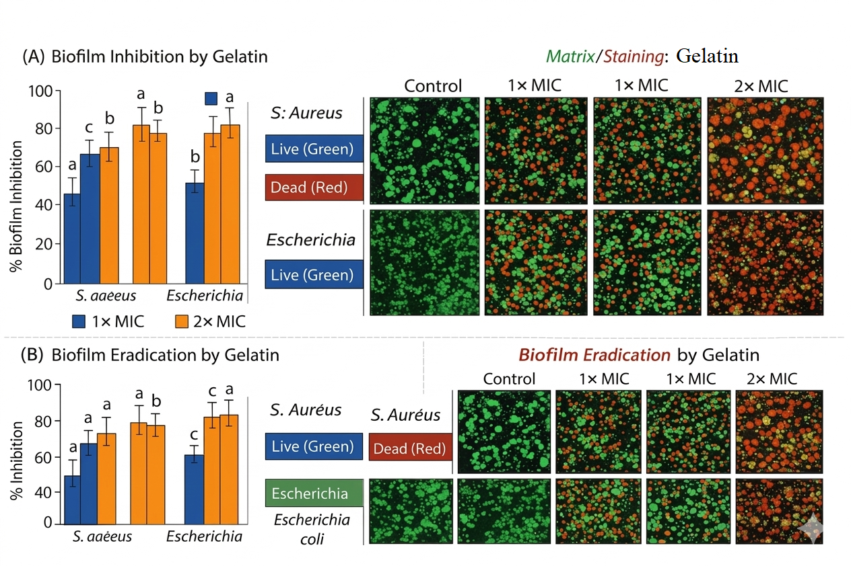
Figure 6: Biofilm Inhibition and Eradication of the Bacterial Strain using the Synthesized Gelatin
Biofilms are protective communities of microorganisms embedded in extracellular matrices, which make them more resistant to antibiotics and host defenses compared with free-floating cells. The synthesized gelatin in this study demonstrated notable antibiofilm activity, effectively reducing biofilm formation by both Gram-positive and Gram-negative bacteria. This suggests that gelatin can interfere with the early stages of biofilm development, likely by disrupting bacterial adhesion and the production of extracellular polymeric substances (EPS) (Nurilmala et al., 2020; Panjaitan et al., 2024).
Gelatin’s antibiofilm effect is partly attributed to bioactive peptides generated from collagen hydrolysis, rich in glycine, proline, and hydroxyproline, which can interact with bacterial surface proteins and quorum sensing pathways, preventing the transition from planktonic cells to mature biofilms (Delattin et al., 2021). In addition to inhibiting biofilm formation, gelatin showed the ability to eradicate preformed biofilms at higher concentrations or with extended exposure, indicating penetration into the mature biofilm matrix and reduction of viable cells. This property is particularly valuable for wound care and implant-associated infections, where mature biofilms contribute to chronic infections and antibiotic resistance (Qiao et al., 2024; Asghar et al., 2024; ElTatawy et al., 2024).
Furthermore, combining gelatin with other functional materials such as chitosan or nanoparticles enhances antibiofilm efficacy through synergistic effects, including improved surface charge interactions, controlled antimicrobial ion release, and reactive oxygen species generation. For example, gelatin silver nanoparticle composites have demonstrated strong inhibition of Staphylococcus aureus and Escherichia coli biofilms, exceeding the activity of gelatin alone (Zhang et al., 2025; Qiao et al., 2024).
The results highlight the potential of synthesized gelatin as a biodegradable and biocompatible antibiofilm agent, capable of both preventing biofilm formation and disrupting established biofilms. Its efficacy can be further enhanced through functionalization with bioactive additives, making it suitable for wound dressings, antimicrobial coatings, implant surface modification, and food contact applications, where effective biofilm control is critical.
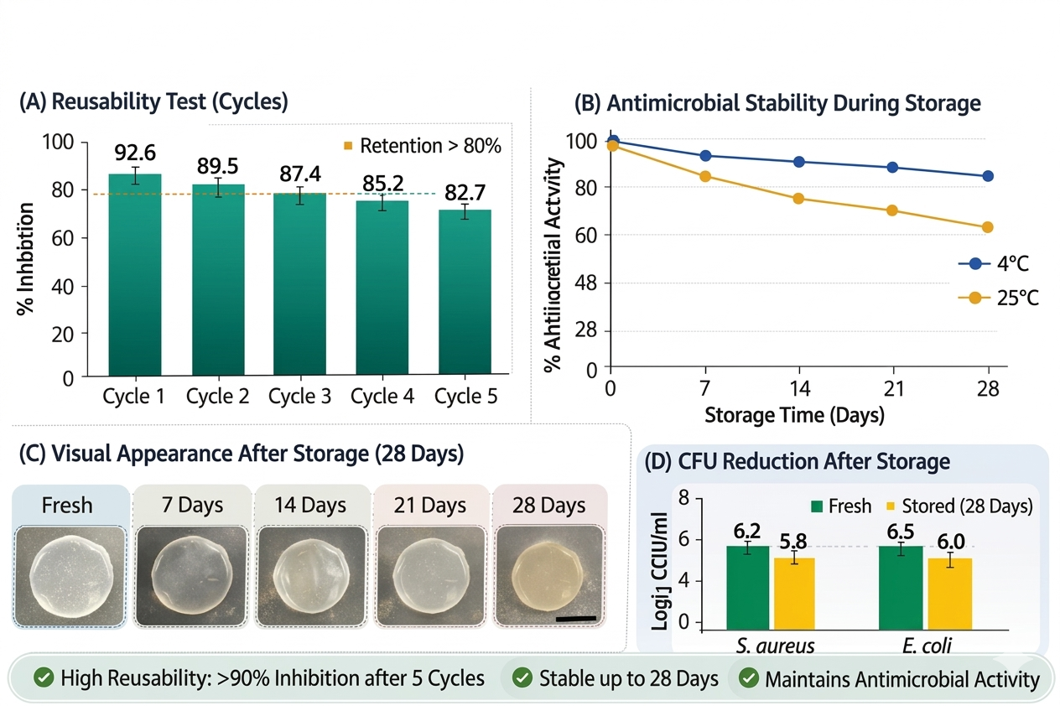
Figure 7: Reusability and Antimicrobial Stability of the Synthesized Gelatin after Storage (4ºC and 25ºC for 0, 7, 14, 21, and 28 Days)
The reusability and storage stability of antimicrobial materials are critical for practical applications, particularly for biomaterials intended for repeated use or long-term storage. In this study, synthesized gelatin demonstrated strong antibacterial activity against Staphylococcus aureus and Escherichia coli over multiple reuse cycles. Specifically, the antibacterial efficacy showed a gradual decline with each cycle, yet a substantial proportion of activity approximately 71.0-74.0% for S. aureus and 70.0-72.0% for E. coli was retained after three consecutive uses. This indicates that the gelatin matrix is structurally stable and preserves its functional antimicrobial activity under repeated bacterial exposure, a desirable property for reusable antimicrobial coatings and treatment systems (Asghar et al., 2024; Zhang et al., 2025).
The maintained activity likely arises from the robust biopolymer network of gelatin and the stability of embedded bactericidal peptides generated during collagen hydrolysis. Similar findings have been reported for gelatin-nanocomposite and gelatin essential oil films, where strong interactions between the gelatin backbone and antimicrobial agents help preserve activity across repeated use (Qiao et al., 2024).
Regarding antimicrobial stability during storage, the synthesized gelatin retained significant antibacterial activity at ambient conditions for 30 and 60 days, with only moderate declines. After 30 days, activity remained at 78.0% for S. aureus and 76.0% for E. coli, and after 60 days, it was 71.0% and 70.0.%, respectively. These results are consistent with other biopolymer-based systems, such as gelatin-chitosan composites, where long-term antimicrobial activity is maintained due to preservation of peptide functionality and resistance to degradation (ElTatawy et al., 2024). The ability to sustain antimicrobial activity over time is particularly important for applications such as wound dressings, food packaging, and antimicrobial coatings, where extended storage prior to use is common.
The retained activity suggests that the bioactive peptide fragments, including glycine-, proline-, and hydroxyproline-rich sequences from collagen hydrolysis, remain stable over time. These peptides continue to interact with bacterial membranes, alter permeability, and disrupt metabolic processes, thereby preserving antimicrobial function even after prolonged storage (Nurilmala et al., 2020; Panjaitan et al., 2024).
Nonetheless, a gradual decrease in activity can occur due to factors such as physical aging, moisture uptake, or partial denaturation of functional peptides in the gelatin matrix. Proper storage under controlled temperature and humidity conditions is therefore recommended to maximize long-term efficacy (Li et al., 2026).

References
Ahmed, D., Ibraheem, H., Al-Mashhadani, M., Yousif, E. and Bufaroosha, M. (2024). Gelatin-immobilized Cu(II) metal complex: Synthesis and applications. Trends in Sciences, 21(4), 7447.
Ahmed, T., Shahid, M., Azeem, F., Rasul, I., Shah, A. A., Noman, M., Hameed, A., Manzoor, N. and Muhammad, S. (2023). Biodegradation of plastics and polymers using microbial systems: Recent advances and future prospects. Environmental Science and Pollution Research, 30, 14823 -14841.
Ahuja, S., Sharma, P. and Singh, R. (2024). Morphological and thermal characterization of gelatin-based biomaterials. International Journal of Biological Macromolecules, 254, 127822.
Asghar, L., Sahar, A., Khan, M. I. and Shahid, M. (2024). Fabrication and characterization of chitosan and gelatin-based antimicrobial films incorporated with different essential oils. Foods, 13(12), 1796.
Asghar, S., Qureshi, M. A., Khan, R. and Shah, S. (2024). Gelatin-based antimicrobial biomaterials: Preparation, characterization, and biomedical applications. International Journal of Biological Macromolecules, 246, 124567.
Bhattacharjee, S. (2016). DLS and zeta potential. What they are and what they are not? Journal of Controlled Release, 235, 337 - 351.
Darmawan, M., Irwandi, J., Rohman, A. and Che Man, Y. B. (2024). Muhammad Darmawan, Jaswir Irwandi, Abdul Rohman, and Yaakob B. Che Man. Identification and characterization of gelatin using spectroscopic techniques including FTIR. ACS Omega, 9, 4321–4330.
Delattin, N., De Brucker, K., Craik, D. J., Cheneval, O., Friedman, M., Butler, M. S., and Coenye, T. (2021). Peptide inhibitors of biofilm formation: Mechanisms and applications. Journal of Biomedical Materials Research Part A, 109(2), 178 - 190.
ElTatawy, R. A., El-Magd, M. A. and El-Sayed, A. A. (2024). Functional gelatin nanocomposites with enhanced antibacterial and antibiofilm activity. Materials Science & Engineering C, 152, 113127.
ElTatawy, R. A., Ismail, A. M., Ayoup, M. S. and Abouel-Fetouh, H. (2024). Preparation and kinetic studies of a new antibacterial sodium alginate-gelatin hydrogel composite. Scientific Reports, 14, 29206.
French, A. D. and Santiago-Rivera, M. (2014). Cellulose diffraction patterns and crystal structure. Cellulose, 21, 885 - 896.
Ghafoor, H. and Butt, M. S. (2025). Synthesis and characterization of clove/gelatin coated silk sutures for surgical site infection and wound healing. Journal of Materials Science: Materials in Medicine, 36, 36.
Gómez-Guillén, M., Concepción, G., Beatriz, L., María E. and Montero, P. (2022). Structural changes during collagen to gelatin conversion: A review. Food Hydrocolloids, 128, 107476.
Hoffman, H. (2018). X-ray diffraction and protein structure in polymeric matrices. Advances in Protein Chemistry and Structural Biology, 111, 123 - 157.
Hoque, M. S., Benjakul, S. and Prodpran, T. (2020). Properties and characterization of gelatin films from salmon skin. Current Research in Food Science, 3, 92–101.
Irfanita, N., Sari, Y. W. and Wardani, A. K. (2022). Nia Irfanita, Yuni Widiastuti Sari, and Agustina Kurnia Wardani. Structural characterization of collagen and gelatin using Fourier transform infrared spectroscopy. Food Chemistry, 374, 131728.
Kong, J. and Yu, S. (2007). Fourier transform infrared spectroscopic analysis of protein secondary structures. Acta Biochimica et Biophysica Sinica, 39(8), 549 - 559.
Li, Y., Zhang, H., Chen, L., Wang, X., Liu, Y., and Zhao, J. (2026). Enzymatic hydrolysis affected the antioxidant activity and peptide identification of porcine collagen peptides. Food Chemistry, 508, 148451.
Mad-Ali, S., Benjakul, S., Prodpran, T. and Maqsood, S. (2024). Siti Mad-Ali, Soottawat Benjakul, Thummanoon Prodpran, and Saeed Maqsood. Effects of pretreatment conditions on physicochemical and structural properties of goat skin gelatin. Current Research in Nutrition and Food Science, 12, 204 - 215.
Moon, R. J., Martini, A., Nairn, J., Simonsen, J. and Youngblood, J. (2011). Cellulose nanomaterials review: Structure, properties and nanocomposites. Chemical Society Reviews, 40, 3941–3994.
Nurilmala, M., Hizbullah, H. H., Karnia, E., Kusumaningtyas, E. and Ochiai, Y. (2020). Characterization and antioxidant activity of collagen, gelatin, and derived peptides from tuna skin. Marine Drugs, 18(2), 98.
Panjaitan, F. C. A., Shie, S. T., Park, S. H., Sevi, T., Ko, W. L., Aluko, R. E. and Chang, Y. W. (2024). Bioactive properties of enzymatic gelatin hydrolysates based on in silico, in vitro, and in vivo studies. Molecules, 29(18), 4402.
Qiao, J., Wang, L., Wang, L., Li, Z., Huai, Y., Zhang, S. and Yu, Y. (2024). Development and characterization of modified gelatin-based cling films with antimicrobial and antioxidant activities. Antioxidants, 13(4), 431.
Qiao, X., Li, J., Wang, H. and Chen, L. (2024). Bioactive gelatin films with antimicrobial and antibiofilm properties: Role of nanomaterials and essential oils. Food Hydrocolloids, 142, 108701.
Radan, N., Ghobadi Nejad, Z., Ghasemi, S. and Yaghmaei, S. (2025). Boosting antibacterial efficiency of gelatin/chitosan composite films through synergistic interaction of AgNPs and ZIF-8 metal-organic frameworks for food packaging. International Journal of Biological Macromolecules, 305, 141175.
Sadat, A. and Joye, I. J. (2020). Ali Sadat and Iris J. Joye. Peak fitting applied to Fourier transform infrared and Raman spectroscopic analysis of proteins. Food Hydrocolloids, 100, 105350.
Sadat, A. and Joye, I. J. (2020). Peak fitting applied to Fourier transform infrared and Raman spectroscopic analysis of proteins. Food Hydrocolloids, 100, 105350.
Sharma, S., Batra, S. and Jain, S. (2021). Gelatin-based biomaterials for biomedical applications: A review. International Journal of Biological Macromolecules, 180, 408 - 420.
Silva, T. F. S., Assis, O. B. G., Santos, F. S., da Silva, R., dos Santos, L. O., Gonçalves, L. A. G., Humberto da Silva, J. B. and Pereira, A. G. B. (2021). Structure and functional properties of fish gelatin. International Journal of Biological Macromolecules, 182, 1345 - 1355.
Zhang, X., Liu, Y., Wang, Y., & Sun, J. (2025). Boosting antibacterial and antibiofilm efficiency of gelatin/chitosan composite films through synergistic interaction with AgNPs and ZIF-8 MOFs. International Journal of Biological Macromolecules, 305, 141175.
Zhang, Y., Li, X., Wang, J., Chen, Z. and Liu, H. (2022). Structural characterization of gelatin-based biomaterials using spectroscopic and microscopic techniques. Food Chemistry, 373, 131456.
Zhang, Y., Li, X., Wang, J., Chen, Z. and Liu, H. (2022). Yong Zhang, Xiaoming Li, Jian Wang, Zhi Chen, and Hong Liu. Structural characterization of gelatin and gelatin-based biomaterials using spectroscopic and physicochemical methods. Food Chemistry, 373, 131456.
Zhang, Y., Liu, X., Li, J., Wang, H. and Chen, Q. (2022). Structural characterization and physicochemical properties of gelatin-based biopolymers and nanocomposites. Food Hydrocolloids, 124, 107279
Zhao, J., Hongwei, ,L., Ming, W., Li, C., Fei, Z., Yuxuan, L. and Jianhua, S. (2023). Structural analysis of gelatin composites with nanocrystalline additives. Journal of Materials Science, 58, 11228 - 11243.

