The Factor Of Effectiveness Digital Content Marketing Among Consumer In Malaysia SME Food And Beverage

Introduction
Marketing strategy plays an important role in helping Marketing strategy plays an important role in helping businesses achieve competitive advantage and improve business performance within increasingly digitalized markets. Traditional marketing approaches alone are often insufficient to effectively attract and influence consumers, leading many businesses to integrate digital marketing strategies with conventional promotional methods (Pribanic, 2020). In recent years, social media marketing has become one of the most influential digital marketing tools globally due to the rapid growth of internet and social media usage. Recent reports indicate that global social media users reached approximately 5.24 billion in 2025, representing nearly 64% of the world’s population (DataReportal, 2025). As digital platforms continue to

expand, businesses increasingly utilize social media channels such as TikTok, Facebook, Instagram, YouTube, and X (formerly Twitter) to strengthen branding, customer engagement, and marketing effectiveness.

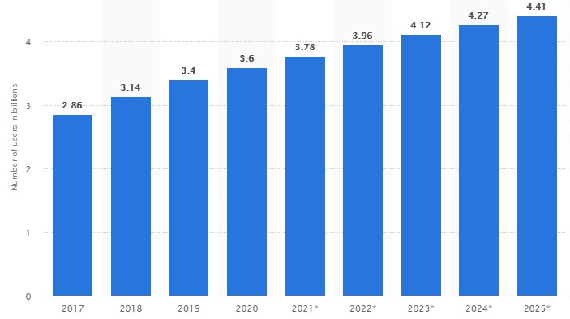
Source: Statista Research Department (2021). Number of social media users 2025.
Figure 1: Worldwide social media users (2017-2025)
In Malaysia, SMEs remain a critical contributor to national economic growth and digital business development. Recent statistics show that Malaysian MSMEs contributed approximately 39.1% to the national GDP in 2023, with the services sector representing one of the largest contributors to SME economic activities (DOSM, 2024). Within the food and beverage (F&B) sector, digital marketing and social media platforms have become essential communication tools that enable businesses to interact directly with consumers, improve brand visibility, and influence purchasing decisions. Previous studies indicate that consumers increasingly rely on social media content, online reviews, uploaded photographs, comments, and influencer recommendations when selecting restaurants and food products (Li et al., 2019; Appel et al., 2020). In addition, internet users globally spend an average of approximately 141 minutes daily on social networking platforms, highlighting the growing influence of social media on consumer behaviour and business marketing strategies (DataReportal, 2025).
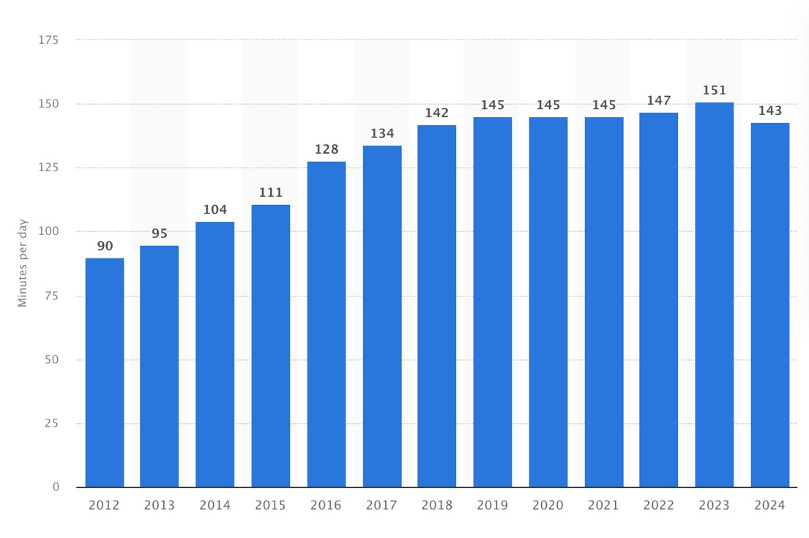 Source: Statista Research Department. (2024). Daily-Social-Media-Usage Worldwide. Statist.

Figure 2: Daily time spent on social networking by internet users worldwide from 2012 to 2024 (in minutes)
This study focuses on Empire Sushi as a case study due to its strong market positioning and successful adaptation within the competitive F&B industry. Empire Sushi demonstrates effective integration of cultural authenticity, digital marketing strategies, customer-focused innovation, and sustainable business practices. The company’s ability to combine traditional Japanese culinary identity with localized market adaptation provides valuable insights into strategic business planning, customer engagement, and business sustainability within competitive and culturally diverse markets. Therefore, this study seeks to examine how digital marketing strategies influence consumer engagement and business effectiveness within the Malaysian F&B industry.
- PROBLEM STATEMENT

The rapid growth of digital technologies and social media platforms has significantly transformed marketing practices within the food and beverage (F&B) industry, particularly among Malaysian SMEs. Social media platforms such as TikTok, Instagram, Facebook, and YouTube have become important digital marketing tools that enable businesses to improve customer engagement, brand awareness, and purchasing influence within highly competitive markets. Recent reports indicate that global social media users exceeded 5.24 billion in 2025, while internet users spend approximately 141 minutes daily on social networking platforms, highlighting the growing influence of digital content on consumer behaviour (DataReportal, 2025). In Malaysia, SMEs contributed approximately 39.1% to the national GDP in 2023, with the F&B sector representing one of the key contributors to service-based economic activities (DOSM, 2024). These developments demonstrate the increasing importance of digital content marketing for business sustainability and competitiveness among Malaysian SMEs.
Despite the growing adoption of digital marketing, many Malaysian SME businesses in the F&B sector continue to face challenges in developing effective digital content marketing strategies that successfully attract and influence consumers. Previous studies suggest that many SMEs experience limitations in digital marketing expertise, financial resources, content quality, and technological capabilities, reducing their ability to create engaging and effective online marketing campaigns (Dwivedi et al., 2021). In addition, consumers are increasingly exposed to large volumes of digital content daily, making it more difficult for businesses to maintain customer attention, improve engagement, and influence purchasing decisions. Ineffective digital content may negatively affect brand image, customer trust, and long-term business competitiveness within rapidly evolving digital markets.
Existing literature also demonstrates several conceptual and empirical limitations regarding digital content marketing effectiveness. Many previous studies primarily focus on large organizations and developed economies, while limited attention has been given to SMEs operating within the Malaysian F&B industry. Furthermore, existing studies often examine digital marketing from a general business perspective without specifically analysing how digital content marketing influences consumer behaviour, customer engagement, brand awareness, and purchasing intention within Malaysian SME environments (Appel et al., 2020). Methodologically, many studies rely heavily on cross-sectional survey designs and self-reported data, limiting deeper understanding of long-term digital marketing effectiveness and consumer behavioural changes.
In addition, the rapid evolution of digital platforms and consumer preferences creates ongoing challenges for SMEs in adapting their content marketing strategies effectively. Consumers increasingly expect interactive, personalized, visually engaging, and trustworthy digital content, particularly within the F&B industry where purchasing decisions are strongly influenced by online reviews, social media engagement, and digital experiences (Li et al., 2019). However, limited research has comprehensively examined the factors influencing the effectiveness of digital content marketing among consumers within Malaysian SME F&B businesses.
Therefore, further research is necessary to examine the factors influencing the effectiveness of digital content marketing among consumers in Malaysian SME food and beverage businesses. This study seeks to provide a more comprehensive understanding of how digital content marketing influences consumer engagement, brand awareness, customer behaviour, and business competitiveness within Malaysia’s rapidly evolving digital economy.

- RESEARCH OBJECTIVES

The aim of this study is to examine the factors influencing the effectiveness of digital content marketing among consumers in Malaysian SME food and beverage (F&B) businesses. The objectives are:

- To examine the relationship between digital content marketing and brand awareness among consumers in Malaysian SME food and beverage businesses.
- To analyse the influence of digital content marketing on consumer engagement among consumers in Malaysian SME food and beverage businesses.
- To evaluate the effect of digital content marketing on word-of-mouth (WOM) communication among consumers in Malaysian SME food and beverage businesses.
- To assess the role of digital content marketing in influencing consumer purchasing intention and business competitiveness among Malaysian SME food and beverage businesses.

These objectives are supported by recent literature on digital marketing, consumer behaviour, and social media engagement, in line with Malaysia’s rapidly evolving digital economy and SME development agenda.

- SIGNIFICANCE OF RESEARCH

This study contributes to the existing literature by examining the factors influencing the effectiveness of digital content marketing among consumers in Malaysian SME food and beverage (F&B) businesses. Although previous studies have widely discussed digital marketing and social media usage, limited research has specifically focused on how digital content marketing influences consumer behaviour, customer engagement, brand awareness, and purchasing intention within the Malaysian SME F&B sector. As digital platforms continue to dominate consumer communication and purchasing activities, this study provides a more context-specific understanding of how digital content marketing contributes to business competitiveness and sustainability within Malaysia’s rapidly evolving digital economy.
From a theoretical perspective, this study contributes to the understanding of digital marketing effectiveness and consumer behaviour within SME business environments. The study integrates concepts related to digital content marketing, social media engagement, consumer interaction, and purchasing behaviour to explain how digital marketing strategies influence consumer responses within the F&B industry. Previous studies indicate that interactive, informative, and visually engaging digital content significantly influences customer trust, brand perception, and purchasing decisions in digital environments (Dwivedi et al., 2021; Appel et al., 2020). Therefore, this study strengthens the academic understanding of digital marketing effectiveness within technology-driven and consumer-oriented business settings.
Practically, the findings of this study may provide valuable insights for Malaysian SME owners, marketers, and entrepreneurs in developing more effective digital content marketing strategies. The study is expected to help businesses better understand consumer preferences, improve customer engagement, strengthen brand awareness, and enhance purchasing intention through digital platforms such as TikTok, Instagram, Facebook, and YouTube. In addition, the findings may assist SMEs in improving marketing creativity, content quality, and customer communication strategies to remain competitive within highly saturated digital markets. Recent reports indicate that social media users worldwide exceeded 5.24 billion in 2025, highlighting the growing importance of digital marketing in influencing consumer behaviour and business performance (DataReportal, 2025).
Furthermore, this study provides important implications for policymakers, government agencies, and industry stakeholders involved in SME development and digital transformation initiatives in Malaysia. As SMEs contributed approximately 39.1% to Malaysia’s GDP in 2023 (DOSM, 2024), improving digital marketing capabilities among SMEs is essential for strengthening business sustainability and national economic growth. The findings may support the development of digital marketing training programs, technological support initiatives, and digital entrepreneurship policies aimed at enhancing SME competitiveness within Malaysia’s digital economy.
Overall, this study contributes academically and practically by providing a clearer understanding of the factors influencing digital content marketing effectiveness among consumers in Malaysian SME F&B businesses. The findings are expected to support future research on digital marketing, consumer behaviour, and SME competitiveness while promoting more effective and sustainable digital business practices within the Malaysian F&B industry.

- LITERATURE REVIEW
- Brand Awareness
Brand awareness refers to the extent to which consumers recognize, recall, and become familiar with a brand through repeated exposure and marketing communication. In digital marketing environments, brand awareness plays an important role in influencing consumer perception, purchasing behaviour, and long-term customer loyalty (Kotler & Keller, 2016). Recent studies indicate that strong brand awareness positively influences consumer trust, brand preference, and customer engagement, particularly within highly competitive digital markets where consumers are continuously exposed to large volumes of online content (Dwivedi et al., 2021).
Within the Malaysian SME food and beverage (F&B) sector, digital content marketing has become an important strategy for improving brand visibility and strengthening consumer relationships. Social media platforms such as TikTok, Instagram, Facebook, and YouTube enable SMEs to deliver visually engaging, interactive, and informative content that enhances consumer familiarity with the brand and improves overall brand recognition. Previous studies suggest that high-quality digital content, including creative storytelling, visually appealing advertisements, customer reviews, and culturally relevant campaigns, significantly enhances brand awareness and customer engagement within digital environments (Appel et al., 2020; Wang et al., 2023).
In addition, interactive communication through social media platforms allows businesses to build stronger relationships with consumers by encouraging customer participation, feedback sharing, and online engagement. Consumers increasingly rely on digital interactions, online reviews, influencer recommendations, and user-generated content when making purchasing decisions within the F&B industry (Li et al., 2019). As a result, SMEs that consistently produce engaging and relevant digital content are more likely to improve brand recall, strengthen customer trust, and increase purchasing intention among consumers.
Despite the growing importance of digital content marketing, several limitations remain within the existing literature. Many previous studies focus primarily on large organizations and global brands, while limited attention has been given to SMEs operating within the Malaysian F&B sector. Furthermore, existing research often examines social media marketing broadly without specifically analysing how digital content marketing contributes to brand awareness and consumer engagement within SME business environments. Methodological limitations, including heavy reliance on cross-sectional survey designs and self-reported consumer perceptions, also restrict deeper understanding of long-term brand awareness development in digital marketing contexts.
Therefore, further research is necessary to examine how digital content marketing influences brand awareness among consumers within Malaysian SME food and beverage businesses. This study seeks to provide a more comprehensive understanding of how digital marketing content contributes to customer engagement, brand recognition, and business competitiveness within Malaysia’s rapidly evolving digital economy.

- Word of Mouth (WOM)
Word-of-mouth (WOM) and electronic word-of-mouth (eWOM) have become increasingly important factors influencing consumer behaviour and purchasing decisions within digital marketing environments. WOM refers to interpersonal communication in which consumers share opinions, experiences, and recommendations regarding products or services, while eWOM extends this communication through digital platforms such as social media, online reviews, blogs, and user-generated content (Hennig-Thurau et al., 2004). Recent studies indicate that WOM and eWOM significantly influence brand credibility, customer trust, and consumer purchasing intention, particularly within highly interactive digital environments where consumers actively exchange information online (Chu, 2021).
Within the Malaysian SME food and beverage (F&B) sector, digital content marketing plays an important role in stimulating positive WOM and eWOM among consumers. Social media platforms such as TikTok, Instagram, Facebook, and YouTube allow consumers to share reviews, photographs, dining experiences, and recommendations that influence the perceptions and purchasing decisions of other consumers. Previous studies suggest that visually engaging content, interactive communication, and customer-generated content positively encourage consumer engagement and increase the likelihood of consumers sharing brand-related information online (Ramzan & Syed, 2018; Wang et al., 2023). As digital communication continues to expand, eWOM has become one of the most cost-effective marketing strategies for SMEs in improving brand visibility and customer acquisition.
Research further demonstrates that eWOM often has a stronger and longer-lasting influence on consumer behaviour compared to traditional advertising methods. Consumers generally perceive recommendations from peers, online communities, and social media influencers as more trustworthy and authentic than direct promotional advertising (Trusov et al., 2009). In addition, the rapid development of digital platforms enables information to spread quickly across large consumer networks, significantly influencing consumer attitudes, brand perception, and purchasing intention within the F&B industry (Cheung & Thadani, 2010).
Despite its growing importance, several limitations remain within the existing literature regarding WOM and eWOM in SME digital marketing environments. Many previous studies focus primarily on large organizations and global brands, while limited research examines how digital content marketing stimulates WOM and eWOM among consumers within Malaysian SME F&B businesses. Furthermore, existing studies often discuss social media marketing generally without specifically analysing the relationship between digital content effectiveness, consumer engagement, and WOM generation. Methodological limitations such as reliance on cross-sectional survey designs and self-reported consumer responses also restrict deeper understanding of long-term consumer interaction and digital communication behaviour.
Therefore, further research is necessary to examine how digital content marketing influences WOM and eWOM among consumers within Malaysian SME food and beverage businesses. This study seeks to provide a more comprehensive understanding of how digital content effectiveness contributes to consumer engagement, brand credibility, purchasing intention, and business competitiveness within Malaysia’s rapidly evolving digital economy.

- Consumer Engagement
Consumer engagement has become an increasingly important element of digital content marketing within modern business environments, particularly in highly interactive industries such as the food and beverage (F&B) sector. Consumer engagement refers to the level of interaction, participation, emotional connection, and involvement that consumers demonstrate toward a brand through digital platforms and communication channels (Bishop, 2020). Within digital marketing environments, engagement is commonly reflected through online behaviours such as likes, comments, shares, clicks, reviews, and user-generated content across social media platforms including TikTok, Instagram, Facebook, and YouTube. Recent studies indicate that higher levels of consumer engagement positively influence brand loyalty, customer satisfaction, purchasing intention, and long-term business performance (Palmatier & Ghasemi, 2019).
In the Malaysian SME F&B sector, digital content marketing plays a significant role in encouraging consumer engagement through interactive, visually appealing, and entertaining content. Consumers increasingly seek personalized, informative, and emotionally engaging digital experiences rather than passive advertising exposure (Granata & Scozzese, 2019). As a result, SMEs have shifted toward more interactive digital marketing strategies such as live streaming, contests, short-form videos, influencer collaborations, and user-generated content campaigns to strengthen consumer interaction and improve online visibility. Previous studies suggest that engaging digital content enhances customer participation and creates stronger emotional and social connections between consumers and brands, which subsequently improves customer retention and advocacy behaviour (Wang et al., 2023).
Consumer engagement within digital marketing environments can also be understood through utilitarian, hedonic, and social dimensions. Utilitarian engagement focuses on functional and convenience-related interactions, hedonic engagement emphasizes entertainment and emotional satisfaction, while social engagement reflects community participation and interpersonal interaction among consumers (Abdul-Ghani et al., 2011). In digital content marketing, these dimensions collectively influence how consumers interact with brands and shape their overall online experiences. Interactive and contextually relevant content is therefore essential in maintaining consumer attention and encouraging continuous participation within highly competitive digital environments.
Despite the increasing importance of consumer engagement, several limitations remain within the existing literature. Many previous studies focus primarily on large organizations and international brands, while limited attention has been given to consumer engagement within Malaysian SME F&B businesses. Furthermore, existing studies often examine social media marketing broadly without specifically analysing how digital content effectiveness influences consumer engagement behaviours. Methodological limitations such as reliance on cross-sectional research designs and self-reported engagement measures also restrict deeper understanding of long-term consumer interaction patterns within evolving digital environments.
In addition, rapidly changing social media trends and increasing digital content saturation create significant challenges for SMEs in maintaining consumer attention and engagement. Consumers are continuously exposed to large volumes of online content daily, making it increasingly difficult for SMEs to create distinctive and meaningful digital experiences that sustain long-term engagement and brand interaction. Therefore, further research is necessary to examine how digital content marketing influences consumer engagement among consumers within Malaysian SME food and beverage businesses. This study seeks to provide a more comprehensive understanding of how digital content effectiveness contributes to customer interaction, emotional connection, online participation, and business competitiveness within Malaysia’s rapidly evolving digital economy.

- Conversion
Conversion has become an important indicator of digital content marketing effectiveness within highly competitive and technology-driven business environments. In digital marketing contexts, conversion refers to the extent to which consumers perform desired actions after engaging with digital content, such as making purchases, subscribing to services, sharing content, or interacting with brands online (Deshwal, 2013). Within the Malaysian SME food and beverage (F&B) sector, conversion effectiveness reflects the ability of digital marketing content to influence consumer decision-making, purchasing intention, and customer action through digital platforms such as TikTok, Instagram, Facebook, and YouTube.
Recent studies indicate that visually appealing, interactive, and informative digital content significantly influences consumer purchasing behaviour and online conversion rates (Wang et al., 2023). Businesses increasingly utilize short-form videos, personalized advertisements, influencer collaborations, promotional campaigns, and user-generated content to improve consumer engagement and encourage purchasing decisions. Previous research further suggests that effective digital content marketing positively influences customer trust, brand perception, and consumer responsiveness, which subsequently increases conversion performance and business competitiveness within digital markets (Dwivedi et al., 2021).
Within digital marketing environments, conversion is not limited solely to direct purchases but also includes various consumer actions such as website visits, social media interaction, content sharing, online reviews, and customer registrations. These behaviours reflect consumers’ willingness to engage with brands and demonstrate the effectiveness of digital marketing strategies in influencing consumer behaviour. In addition, data-driven digital marketing tools enable businesses to monitor conversion-related metrics more effectively, allowing SMEs to evaluate marketing performance and improve strategic decision-making processes in real time.
Despite the increasing importance of conversion in digital marketing research, several limitations remain within the existing literature. Many previous studies focus primarily on large organizations and e-commerce platforms, while limited attention has been given to conversion effectiveness among Malaysian SME F&B businesses. Furthermore, existing studies often evaluate digital marketing effectiveness through general social media engagement metrics without specifically examining how digital content quality and consumer interaction influence conversion behaviour. Methodological limitations, including reliance on cross-sectional survey designs and self-reported behavioural responses, also restrict deeper understanding of long-term conversion effectiveness within rapidly evolving digital environments.
In addition, increasing digital content saturation and changing consumer preferences create significant challenges for SMEs in maintaining consumer attention and encouraging purchasing actions. Consumers are continuously exposed to large volumes of digital advertisements and promotional content daily, making it increasingly difficult for SMEs to create distinctive and persuasive content that successfully converts engagement into actual consumer action. Therefore, further research is necessary to examine how digital content marketing influences consumer conversion among Malaysian SME food and beverage businesses. This study seeks to provide a more comprehensive understanding of how digital content effectiveness contributes to purchasing intention, customer action, business competitiveness, and long-term digital marketing performance within Malaysia’s evolving digital economy.

- The Effectiveness of Digital Content Marketing
The effectiveness of digital content marketing (DCM) has become increasingly important within modern business environments as consumers rely heavily on digital platforms for information, communication, and purchasing decisions. Digital content marketing refers to the strategic creation and distribution of valuable, relevant, and engaging digital content to attract, engage, and influence target consumers through online platforms such as TikTok, Instagram, Facebook, YouTube, and websites (Pulizzi, 2021). Within the Malaysian SME food and beverage (F&B) sector, DCM plays a significant role in improving brand visibility, strengthening customer relationships, increasing consumer engagement, and influencing purchasing behaviour within highly competitive digital markets.
Recent studies indicate that effective digital content marketing positively influences consumer trust, brand awareness, customer loyalty, and purchasing intention by delivering informative, entertaining, and interactive content tailored to consumer preferences (Dwivedi et al., 2021; Wang et al., 2023). Businesses increasingly utilize short-form videos, influencer collaborations, user-generated content, storytelling techniques, and personalized digital experiences to improve consumer interaction and enhance marketing effectiveness. In addition, social media platforms provide SMEs with cost-effective opportunities to communicate directly with consumers, monitor consumer behaviour, and evaluate marketing performance in real time through digital analytics and engagement metrics.
The effectiveness of DCM is commonly evaluated through various performance indicators, including brand awareness, consumer engagement, word-of-mouth communication, conversion rates, customer retention, and purchasing behaviour. Previous studies suggest that successful digital content marketing strategies require continuous content optimization, platform selection, audience analysis, and data-driven performance measurement to achieve desired marketing outcomes (Murdough, 2010). In digital marketing environments, businesses that effectively align content strategies with consumer preferences and platform characteristics are more likely to improve customer interaction, strengthen brand perception, and sustain long-term competitiveness.
Despite its increasing importance, several limitations remain within the existing literature regarding digital content marketing effectiveness. Many previous studies focus primarily on large organizations and international brands, while limited attention has been given to Malaysian SME F&B businesses operating within resource-constrained and highly competitive digital environments. Furthermore, existing research often evaluates digital marketing effectiveness from a general social media perspective without specifically examining how digital content characteristics influence consumer behaviour and marketing performance. Methodological limitations such as reliance on cross-sectional survey designs and self-reported consumer responses also restrict deeper understanding of long-term digital marketing effectiveness and changing consumer interaction patterns.
In addition, rapidly evolving social media trends, changing platform algorithms, and increasing digital content saturation create significant challenges for SMEs in maintaining consumer attention and marketing effectiveness. Consumers are continuously exposed to large volumes of digital advertisements and online promotional content daily, making it increasingly difficult for SMEs to create distinctive and meaningful digital experiences that sustain consumer interest and encourage purchasing actions. Therefore, further research is necessary to examine the effectiveness of digital content marketing among consumers within Malaysian SME food and beverage businesses. This study seeks to provide a more comprehensive understanding of how digital content marketing influences consumer behaviour, customer engagement, purchasing intention, and business competitiveness within Malaysia’s rapidly evolving digital economy.

- MODEL AND THEORY

This study is grounded in the Uses and Gratifications Theory (UGT) and supported by the Consumer Engagement Theory to explain how digital content marketing influences consumer behaviour and marketing effectiveness among Malaysian SME food and beverage (F&B) businesses. These theories provide a comprehensive framework for understanding how consumers interact with digital marketing content, engage with brands, and develop purchasing intentions within digital environments.
The Uses and Gratifications Theory (UGT), originally introduced by Katz, Blumler, and Gurevitch (1973), explains that consumers actively select media platforms and digital content based on their specific needs, motivations, and expected gratifications. Within digital marketing environments, consumers engage with social media platforms such as TikTok, Instagram, Facebook, and YouTube to seek information, entertainment, social interaction, and purchasing guidance. Recent studies suggest that consumers are more likely to interact with digital content that is visually appealing, informative, interactive, and emotionally engaging (Dwivedi et al., 2021; Wang et al., 2023). In the context of this study, UGT explains how digital content marketing influences brand awareness, consumer engagement, word-of-mouth communication, and conversion behaviour among consumers within Malaysian SME F&B businesses.
In addition, Consumer Engagement Theory further supports this study by explaining the importance of interactive relationships between consumers and brands within digital marketing environments. Consumer engagement reflects consumers’ cognitive, emotional, and behavioural interactions with digital content and brand-related activities (Brodie et al., 2019). Previous studies indicate that higher levels of consumer engagement positively influence customer loyalty, purchasing intention, electronic word-of-mouth (eWOM), and long-term business performance (Palmatier & Ghasemi, 2019). Within the SME F&B sector, engaging digital content such as short-form videos, influencer collaborations, interactive campaigns, and user-generated content encourages stronger consumer participation and brand interaction.
The conceptual model of this study proposes that brand awareness, word-of-mouth (WOM), consumer engagement, and conversion are important dimensions influencing the effectiveness of digital content marketing among consumers in Malaysian SME food and beverage businesses. Brand awareness reflects consumer familiarity and recognition toward digital marketing content, while WOM and eWOM represent consumer communication and information-sharing behaviours that influence purchasing decisions. Consumer engagement reflects consumers’ interaction and emotional connection with digital content, whereas conversion refers to consumer actions such as purchasing intention, online interaction, and customer response resulting from digital marketing exposure.
Despite the growing importance of digital content marketing, existing studies mainly focus on large organizations and general social media marketing practices, with limited attention given to Malaysian SME F&B businesses. Furthermore, previous studies often examine brand awareness, engagement, WOM, and conversion independently rather than integrating these variables within a unified digital content marketing effectiveness framework. Methodological limitations such as reliance on cross-sectional research designs and self-reported consumer behaviour also restrict deeper understanding of long-term digital marketing effectiveness within rapidly evolving digital environments.
Therefore, this study integrates UGT and Consumer Engagement Theory to provide a more comprehensive theoretical explanation of how digital content marketing influences consumer behaviour and marketing effectiveness within Malaysian SME food and beverage businesses. The integration of these theories strengthens the understanding of digital consumer interaction, social media engagement, and purchasing behaviour within Malaysia’s evolving digital economy.

- RESEARCH FRAMEWORK
The research framework of this study is developed to examine the factors influencing the effectiveness of digital content marketing among consumers in Malaysian SME food and beverage (F&B) businesses. The framework proposes that brand awareness, word-of-mouth (WOM), consumer engagement, and conversion act as independent variables that influence the effectiveness of digital content marketing as the dependent variable.

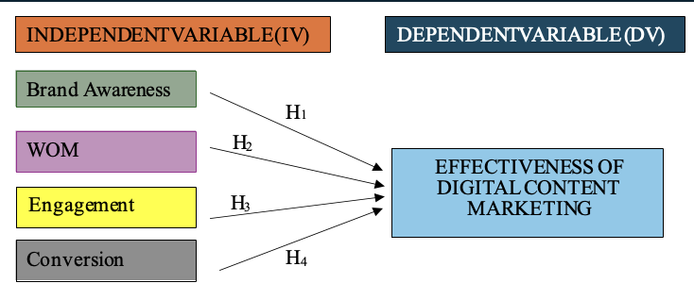

Figure 3: Research Framework

Brand awareness refers to the extent to which consumers recognize, recall, and become familiar with digital marketing content and brand-related information through online platforms. Strong brand awareness enhances customer trust, purchasing intention, and long-term brand recognition within competitive digital environments (Dwivedi et al., 2021). Within Malaysian SME F&B businesses, digital platforms such as TikTok, Instagram, Facebook, and YouTube are increasingly utilized to strengthen brand visibility and improve consumer familiarity with products and services.
Word-of-mouth (WOM) and electronic word-of-mouth (eWOM) represent consumer communication and information-sharing behaviours that influence consumer attitudes and purchasing decisions. Positive online reviews, recommendations, and user-generated content significantly affect consumer trust and brand credibility within digital marketing environments (Chu, 2021). In the context of SME F&B businesses, effective digital content marketing is expected to encourage positive WOM and improve business competitiveness through wider online exposure and consumer advocacy.
Consumer engagement refers to the cognitive, emotional, and behavioural interactions between consumers and digital marketing content. Higher levels of engagement through likes, comments, shares, reviews, and interactive participation indicate stronger consumer involvement and brand connection (Palmatier & Ghasemi, 2019). Engaging digital content is therefore expected to improve customer relationships, strengthen brand loyalty, and enhance digital marketing effectiveness within the Malaysian F&B sector.
Conversion refers to the extent to which consumers perform desired actions after engaging with digital content marketing activities, including purchasing products, visiting websites, sharing content, or responding to promotional campaigns. Effective digital content marketing is expected to positively influence consumer purchasing behaviour, customer responsiveness, and business performance through higher conversion rates and improved customer action.
The dependent variable of this study is the effectiveness of digital content marketing, which refers to the ability of digital marketing content to achieve desired marketing outcomes such as increasing brand awareness, encouraging consumer engagement, stimulating WOM communication, and improving consumer conversion behaviour. This framework is supported by the Uses and Gratifications Theory (UGT) and Consumer Engagement Theory, which explain how consumers actively interact with digital content based on their informational, social, emotional, and entertainment needs within digital environments.
Based on the proposed framework, this study hypothesizes that brand awareness, WOM, consumer engagement, and conversion positively influence the effectiveness of digital content marketing among consumers in Malaysian SME food and beverage businesses.

TABLE I
hypotheses development

Code | Hypothesis
H1 | Brand awareness has a significant positive influence on the effectiveness of digital content marketing among consumers in Malaysian SME food and beverage businesses.
H2 | Word-of-mouth (WOM) has a significant positive influence on the effectiveness of digital content marketing among consumers in Malaysian SME food and beverage businesses.
H3 | Consumer engagement has a significant positive influence on the effectiveness of digital content marketing among consumers in Malaysian SME food and beverage businesses.
H4 | Conversion has a significant positive influence on the effectiveness of digital content marketing among consumers in Malaysian SME food and beverage businesses.

- RESEARCH DESIGN
Research design refers to the overall strategy and systematic plan developed to guide the research process in addressing the research problem and achieving the research objectives effectively (Saunders et al., 2019). This study adopts a quantitative research design to examine the factors influencing the effectiveness of digital content marketing among consumers in Malaysian SME food and beverage (F&B) businesses. A quantitative approach is considered appropriate because it enables the researcher to examine relationships between variables objectively through numerical data collection and statistical analysis.
This study employs a cross-sectional survey design in which data are collected from respondents at a single point in time using a structured questionnaire. The cross-sectional approach is widely used in digital marketing and consumer behaviour studies because it allows researchers to examine consumer perceptions, behavioural responses, and relationships between variables efficiently within a specific research context (Sekaran & Bougie, 2020). In this study, the survey method is used to collect data regarding brand awareness, word-of-mouth (WOM), consumer engagement, conversion, and the effectiveness of digital content marketing among consumers within Malaysian SME F&B businesses.
The research framework of this study is developed based on the Uses and Gratifications Theory (UGT) and Consumer Engagement Theory, which explain how consumers interact with digital content and social media platforms to fulfil informational, social, emotional, and behavioural needs. These theoretical perspectives support the examination of how digital content marketing influences consumer behaviour and marketing effectiveness within digital environments. The proposed framework enables the researcher to analyse the relationships between the independent variables and the dependent variable systematically using statistical techniques.
Data for this study will be collected through an online questionnaire distributed to consumers who actively engage with digital content marketing related to Malaysian SME food and beverage businesses. Online survey distribution is considered appropriate due to the increasing use of digital platforms and social media among Malaysian consumers. Recent reports indicate that Malaysia recorded internet penetration exceeding 97% in 2024, while social media usage continues to increase significantly among digital consumers (DataReportal, 2025). The use of online surveys therefore improves accessibility, response efficiency, and cost-effectiveness in collecting consumer data within digital environments.
The collected data will be analysed using Statistical Package for the Social Sciences (SPSS). Several statistical techniques will be employed, including descriptive analysis, reliability analysis, correlation analysis, and multiple regression analysis to examine the relationships between the study variables and test the proposed hypotheses. Reliability analysis using Cronbach’s Alpha will be conducted to evaluate the internal consistency of the measurement instruments, while regression analysis will determine the influence of brand awareness, WOM, consumer engagement, and conversion on the effectiveness of digital content marketing.
Overall, the quantitative research design adopted in this study provides a systematic and reliable approach for examining digital consumer behaviour and digital marketing effectiveness among Malaysian SME F&B businesses. The research design also supports the generation of empirical findings that may contribute to digital marketing literature and provide practical insights for SMEs operating within Malaysia’s rapidly evolving digital economy.

- RESEARCH METHODOLOGY AND DATA COLLECTION
This study adopts a quantitative research methodology to examine the factors influencing the effectiveness of digital content marketing among consumers in Malaysian small and medium-sized enterprise (SME) food and beverage (F&B) businesses. Quantitative research is appropriate for this study because it enables the researcher to examine relationships between variables objectively through numerical data collection and statistical analysis (Creswell & Creswell, 2023). The quantitative approach also allows the study to test hypotheses systematically and generate findings that are reliable, measurable, and generalizable within the research context.
The study employs a cross-sectional survey design in which data are collected from respondents at a single point in time using a structured questionnaire. The survey method is widely used in digital marketing and consumer behaviour research because it enables efficient collection of large amounts of data regarding consumer perceptions, attitudes, and behavioural responses within digital environments (Sekaran & Bougie, 2020). In this study, the quantitative design is considered suitable for examining the relationships between brand awareness, word-of-mouth (WOM), consumer engagement, conversion, and the effectiveness of digital content marketing among consumers within Malaysian SME F&B businesses.
Primary data will be collected through a structured online questionnaire distributed to consumers who actively engage with digital content marketing related to Malaysian SME food and beverage businesses. The questionnaire will consist of closed-ended questions measured using a five-point Likert scale ranging from “strongly disagree” to “strongly agree.” Online survey distribution is considered appropriate due to the increasing use of social media and digital platforms among Malaysian consumers. Recent reports indicate that internet penetration in Malaysia exceeded 97% in 2024, while social media usage continues to increase significantly among digital consumers (DataReportal, 2025). Therefore, online data collection improves accessibility, response efficiency, and cost-effectiveness in reaching a broader consumer population.
The questionnaire will be distributed through digital platforms such as WhatsApp, Telegram, Instagram, Facebook, TikTok, and other social media channels to increase respondent participation and accessibility. Respondents targeted in this study are consumers who have experience interacting with digital content marketing related to Malaysian SME F&B businesses through online platforms. Ethical considerations will also be emphasized throughout the data collection process to ensure respondent confidentiality, privacy protection, and voluntary participation.
In addition to primary data, secondary data sources will also be utilized to strengthen the theoretical and empirical foundation of the study. Secondary data will be obtained from academic journals, books, government reports, industry publications, conference proceedings, and online databases such as ScienceDirect, Emerald Insight, Google Scholar, and Scopus-indexed journals. Previous studies related to digital content marketing, consumer engagement, social media marketing, brand awareness, WOM, and conversion behaviour will be reviewed to support the development of the research framework, hypotheses, and conceptual understanding of the study variables.
The collected quantitative data will be analysed using the Statistical Package for the Social Sciences (SPSS). Several statistical techniques will be employed, including descriptive analysis, reliability analysis, correlation analysis, and multiple regression analysis. Descriptive analysis will summarize respondent demographic information and variable distribution, while reliability analysis using Cronbach’s Alpha will assess the internal consistency of the measurement instruments. Correlation and multiple regression analyses will then be conducted to examine the relationships between the independent variables and the effectiveness of digital content marketing as the dependent variable.
Overall, the quantitative research methodology and online survey data collection approach adopted in this study provide a systematic and reliable framework for examining digital consumer behaviour and digital marketing effectiveness among Malaysian SME food and beverage businesses. The methodology also supports the generation of empirical findings that may contribute to digital marketing literature and provide practical insights for SMEs operating within Malaysia’s rapidly evolving digital economy.

- POPULATION AND SAMPLING
- Population
Population refers to the entire group of individuals or elements that possess characteristics relevant to the research objectives and from which the researcher intends to draw conclusions (Sekaran & Bougie, 2020). In the context of this study, the target population consists of consumers in Malaysia who actively engage with digital content marketing related to small and medium-sized enterprise (SME) food and beverage (F&B) businesses. The study particularly focuses on consumers who have prior experience interacting with digital marketing content through social media platforms such as TikTok, Instagram, Facebook, YouTube, and other online channels associated with SME F&B businesses.
The Malaysian SME sector plays an important role in national economic development, with SMEs contributing approximately 39.1% to Malaysia’s Gross Domestic Product (GDP) in 2023 (DOSM, 2024). Within this sector, the food and beverage industry represents one of the most active service-based industries utilizing digital platforms and social media marketing to attract and engage consumers. The increasing dependence on digital marketing strategies among SME F&B businesses highlights the importance of understanding consumer responses toward digital content effectiveness within Malaysia’s rapidly evolving digital economy.
This study specifically targets consumers aged 18 years and above who have experience interacting with digital content marketing related to Malaysian SME F&B businesses. Consumers are selected as the unit of analysis because they directly experience and evaluate the effectiveness of digital content marketing through online engagement, purchasing decisions, reviews, and social media interaction. Focusing on consumers therefore enables the researcher to obtain more accurate insights regarding brand awareness, word-of-mouth (WOM), consumer engagement, conversion behaviour, and overall digital content marketing effectiveness.

- Sampling Method
This study employs a probability sampling approach using stratified random sampling techniques. Probability sampling is considered appropriate because it allows every individual within the target population to have an equal probability of being selected, thereby reducing sampling bias and improving the generalizability of the findings (Saunders et al., 2019). Stratified random sampling is particularly suitable for this study because consumers within Malaysian SME F&B markets consist of diverse demographic groups with varying digital behaviours, preferences, and social media usage patterns.
The sampling process involves dividing the population into several demographic strata such as age group, gender, and social media usage behaviour before randomly selecting respondents proportionately from each subgroup. This approach improves sample representation and ensures that different consumer characteristics are adequately reflected within the study. Stratified random sampling also enhances the reliability and validity of the research findings by minimizing demographic imbalance and improving population representation.
Data collection will be conducted using online questionnaires distributed through digital platforms such as WhatsApp, Telegram, Instagram, Facebook, TikTok, and other social media channels. Online distribution is considered appropriate because Malaysian consumers demonstrate high internet and social media usage rates. Recent reports indicate that Malaysia recorded internet penetration exceeding 97% in 2024, while social media usage among Malaysian consumers continues to increase significantly (DataReportal, 2025). The use of digital platforms therefore improves accessibility, response efficiency, and cost-effectiveness in reaching respondents across different demographic groups.

- Sample Size
Sample size refers to the number of respondents selected from the target population for data collection and analysis. Determining an appropriate sample size is important to ensure statistical reliability, accuracy, and representativeness of the research findings. According to Krejcie and Morgan (1970), large population studies generally require a sample size of approximately 384 respondents to achieve reliable statistical analysis. Similarly, Roscoe (1975) suggests that sample sizes ranging between 30 and 500 are generally appropriate for most behavioural and social science research.
Given the large consumer population within the Malaysian SME F&B sector, this study targets approximately 384 respondents. The selected sample size is considered sufficient for conducting quantitative statistical analyses such as descriptive analysis, reliability testing, correlation analysis, and multiple regression analysis using the Statistical Package for the Social Sciences (SPSS). The sample size also aligns with previous digital marketing and consumer behaviour studies involving large consumer populations.
Overall, the population and sampling approach adopted in this study provides a systematic and reliable framework for examining the factors influencing the effectiveness of digital content marketing among consumers in Malaysian SME food and beverage businesses. The use of probability sampling and adequate sample size strengthens the validity, reliability, and generalizability of the research findings within Malaysia’s digital consumer environment.

- LOCATION OF THE STUDY
The location of this study focuses on consumers of small and medium-sized enterprise (SME) food and beverage (F&B) businesses in Melaka, Malaysia, with particular emphasis on consumers who actively engage with digital content marketing through social media and online platforms. Melaka was selected as the research location because it is one of the rapidly developing urban and tourism-oriented states in Malaysia, characterized by active commercial activities, strong digital connectivity, and increasing consumer engagement with digital marketing platforms.
Melaka is recognized as an important tourism and business destination in Malaysia, attracting both local and international visitors due to its cultural heritage, commercial centres, and expanding service industry. According to the Department of Statistics Malaysia (DOSM, 2024), Melaka continues to experience stable population and economic growth, supported by increasing urbanization and digital business activities. The growth of SME businesses within the food and beverage sector has also contributed significantly to the state’s service economy, particularly through the increasing adoption of digital marketing strategies and social media platforms to attract consumers and improve business competitiveness.

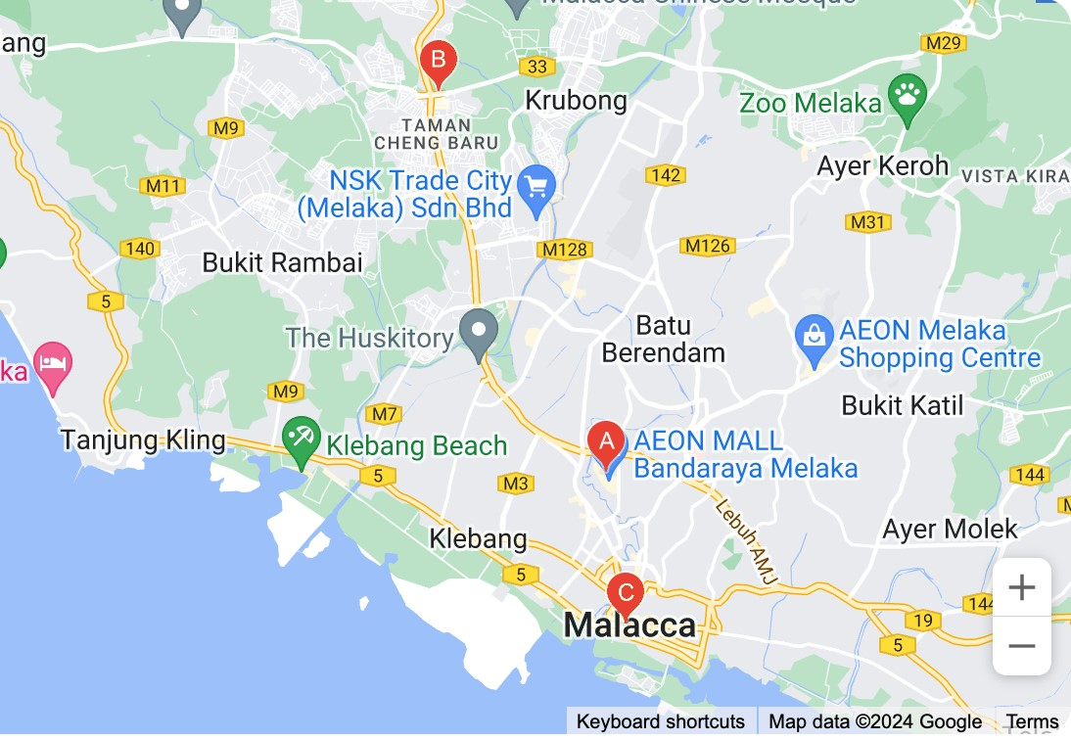

Figure 4: Location of Empire Sushi Melaka
This study specifically focuses on consumers who interact with digital content marketing related to SME F&B businesses located in Melaka, including businesses operating within shopping malls, commercial centres, and urban business areas. Melaka is considered an appropriate research location because consumers within the state demonstrate active social media usage and increasing dependence on digital platforms such as TikTok, Instagram, Facebook, and YouTube for food discovery, product reviews, purchasing decisions, and customer interaction. Recent digital reports indicate that Malaysia’s internet penetration exceeded 97% in 2024, while social media engagement among Malaysian consumers continues to increase significantly (DataReportal, 2025). These developments strengthen the relevance of examining digital content marketing effectiveness within Melaka’s digitally connected consumer environment.
In addition, Melaka provides a diverse consumer demographic consisting of local residents, students, working adults, and tourists, allowing the researcher to obtain broader perspectives regarding digital consumer behaviour and marketing effectiveness within the F&B industry. The concentration of SME F&B businesses and active consumer participation in digital marketing activities further supports the suitability of Melaka as the research setting for this study.
Overall, the selection of Melaka as the research location provides a relevant and practical context for examining the factors influencing the effectiveness of digital content marketing among consumers in Malaysian SME food and beverage businesses. The location offers an appropriate representation of digital consumer behaviour, social media engagement, and SME marketing practices within Malaysia’s evolving digital economy.

- DATA ANALYSIS
The collected data in this study will be analysed using the Statistical Package for the Social Sciences (SPSS), which is widely utilized in quantitative research for data management, statistical analysis, and hypothesis testing. SPSS is considered appropriate for this study because it enables researchers to analyse large sets of numerical data systematically and examine relationships between variables accurately and efficiently (Hair et al., 2022). The use of SPSS also improves the reliability, consistency, and validity of the research findings within digital marketing and consumer behaviour studies.
Prior to conducting the main statistical analyses, the collected data will undergo data screening and preparation processes to ensure accuracy, completeness, and consistency. This process includes checking for missing values, duplicate responses, outliers, and response errors before proceeding with further statistical analysis. Data coding and cleaning procedures will also be conducted to improve data quality and ensure that the dataset is suitable for statistical testing and interpretation.
Descriptive analysis will first be employed to summarize the demographic characteristics of the respondents and describe the distribution of the study variables. Descriptive statistics such as frequencies, percentages, means, and standard deviations will be used to analyse respondent profiles and consumer responses related to brand awareness, word-of-mouth (WOM), consumer engagement, conversion, and the effectiveness of digital content marketing. Descriptive analysis is important because it provides an overall understanding of consumer behaviour patterns and digital marketing perceptions within Malaysian SME food and beverage (F&B) businesses.
Reliability analysis using Cronbach’s Alpha will then be conducted to evaluate the internal consistency and reliability of the measurement instruments. According to Hair et al. (2022), Cronbach’s Alpha values exceeding 0.70 indicate acceptable reliability and consistency of measurement items within quantitative research. Reliability testing is essential to ensure that the questionnaire items consistently measure the intended constructs and produce dependable research findings.
In addition, Pearson correlation analysis will be employed to examine the strength and direction of relationships between the independent variables and the dependent variable. Correlation analysis enables the researcher to identify whether significant relationships exist between brand awareness, WOM, consumer engagement, conversion, and the effectiveness of digital content marketing among consumers within Malaysian SME F&B businesses.
Furthermore, multiple regression analysis will be conducted to examine the influence of the independent variables on the dependent variable and to test the proposed research hypotheses. Regression analysis is appropriate because it enables the researcher to determine the extent to which brand awareness, WOM, consumer engagement, and conversion contribute to the effectiveness of digital content marketing. This analysis also allows the researcher to identify the most significant predictor influencing digital content marketing effectiveness among consumers within Malaysian SME food and beverage businesses.
The findings obtained from the statistical analyses will be interpreted systematically and presented using tables, charts, and statistical summaries to improve clarity and understanding. Overall, the data analysis procedures adopted in this study provide a systematic and reliable approach for examining digital consumer behaviour and digital marketing effectiveness within Malaysia’s evolving SME food and beverage industry.

- DATA ANALYSIS AND FINDING
This chapter presents the analysis and findings of the study on the factors influencing the effectiveness of digital content marketing among consumers in Malaysian SME food and beverage (F&B) businesses. The data collected from 386 respondents were analysed using the Statistical Package for the Social Sciences (SPSS). The analysis was conducted systematically to address the research objectives and examine the relationships between brand awareness, word-of-mouth (WOM), consumer engagement, conversion, and the effectiveness of digital content marketing.
This chapter begins with the reliability analysis to evaluate the internal consistency of the measurement instruments. Next, descriptive statistical analysis is presented to summarize the demographic profile of the respondents and describe the distribution of the study variables. Subsequently, correlation analysis and multiple regression analysis are conducted to examine the relationships between the independent variables and the dependent variable, as well as to test the proposed research hypotheses.
The findings are presented using tables, charts, and statistical interpretations to improve clarity and understanding. The analyses provide empirical insights into consumer behaviour and digital content marketing effectiveness within the Malaysian SME food and beverage sector.

- Reliability Analysis

Cronbach’s Alpha Coefficient | Internal Consistency
𝜶 ≥ 0.9 | Excellent
0.8 ≤ < 0.9 | Good
0.7 ≤ < 0.8 | Acceptable
0.6 ≤ < 0.7 | Questionable
0.5 ≤ < 0.6 | Poor
𝜶 < 0.5 | Unacceptable
TABLE 2
Cronbach’s Alpha Coefficient Range
Source: (Saunders, Lewis and Thornhill, 2016)

Reliability analysis was conducted to evaluate the internal consistency and reliability of the measurement instruments used in this study. Cronbach’s Alpha coefficient was employed to determine the consistency of the questionnaire items for each variable. According to Saunders, Lewis, and Thornhill (2019), a Cronbach’s Alpha value of 0.70 and above is considered acceptable, indicating that the measurement items are reliable and suitable for further statistical analysis. Table 2 presents the guidelines for interpreting Cronbach’s Alpha coefficients, while Table 3 and Table 4 summarize the reliability analysis results obtained from SPSS.

TABLE 3
Realibility Analysis of Each Variable
Source: (Output from SPSS)
Variable | Cronbach’s Alpha | Realibility
Brand awareness (IV1) | .843 | Good
Word of Mouth (IV2) | .825 | Good
Engagement (IV3) | .824 | Good
Conversion (IV4) | .837 | Good
Effectiveness of DCM (DV) | .733 | Acceptable
Based on Table 3, all independent variables, namely Brand Awareness (α = 0.843), Word-of-Mouth (α = 0.825), Consumer Engagement (α = 0.824), and Conversion (α = 0.837), recorded Cronbach’s Alpha values above 0.80, indicating good internal consistency and reliability. In addition, the dependent variable, Effectiveness of Digital Content Marketing, achieved a Cronbach’s Alpha value of 0.733, which is considered acceptable according to the recommended reliability threshold. These findings demonstrate that all variables used in this study are reliable and suitable for further analysis.

TABLE 4
Reliability Statistics for All Items (Overall)
Sources: (SPSS Output)
 | Reliability Statistics
Cronbach’s Alpha | Cronbach'sAlpha Based on Standardized Items | N of item
.947 | .949 | 5
Furthermore, Table 4 shows that the overall Cronbach’s Alpha value for all measurement items is 0.947, indicating excellent internal consistency among the questionnaire items. The high overall reliability value suggests that the measurement instruments are highly consistent in measuring the constructs of the study. Therefore, the questionnaire used in this research is considered reliable and appropriate for examining the factors influencing the effectiveness of digital content marketing among consumers in Malaysian SME food and beverage businesses.

- Respondent Demographic Profile
This section presents the demographic profile of the respondents involved in this study. A total of 386 respondents participated in the survey, and the demographic information was analysed using descriptive statistical methods, specifically frequency and percentage analysis. The demographic variables examined include gender, age, race, education level, and user experience related to digital content marketing within Malaysian SME food and beverage (F&B) businesses. The demographic analysis is important because it provides a clearer understanding of the respondents’ background and ensures that the sample appropriately represents the target population of the study.

TABLE 5
Frequency and Percentage of Gender
Source: (Output from SPSS)
 |  | GENDER
 |  | Frequency | Percent | Valid Percent | Cumulative  Percent
Valid | Female / Perempuan | 205 | 53.1 | 53.1 | 53.1
Valid | Male / Lelaki | 181 | 46.9 | 46.9 | 100.0
Valid | Total | 386 | 100.0 | 100.0

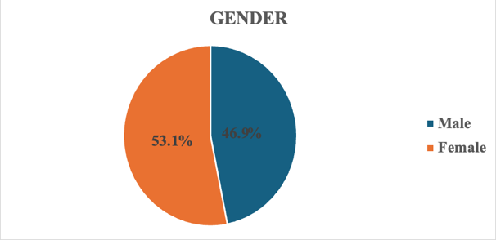
Figure 5: The Pie Chart of Respondent’s Gender

Based on Table 5 and Figure 5, most of the respondents were female, representing 53.1% (205 respondents), while male respondents accounted for 46.9% (181 respondents). This indicates that female consumers slightly dominated the respondent distribution in this study. The findings suggest that female consumers may demonstrate relatively higher participation and engagement with digital content marketing related to SME food and beverage businesses.

TABLE 6
Frequency and Percentage of Age
Source: (Output from SPSS)
 |  | AGE
 |  | Frequency | Percent | Valid Percent | Cumulative  Percent
Valid | 19 below / bawah | 66 | 17.1 | 17.1 | 17.1
Valid | 20 - 39 years old / tahun | 156 | 40.4 | 40.4 | 57.5
Valid | 40 - 49 years old / tahun | 105 | 27.2 | 27.2 | 84.7
Valid | 50 years old and above / tahun keatas | 59 | 15.3 | 15.3 | 100.0
Valid | Total | 386 | 100.0 | 100.0

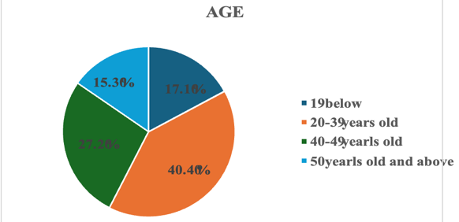

Figure 6: The Pie Chart of Respondent’s Age
In terms of age distribution, Table 6 and Figure 6 show that the majority of respondents were between 20 and 39 years old, representing 40.4% (156 respondents) of the total sample. This was followed by respondents aged 40 to 49 years old, which accounted for 27.2% (105 respondents). The findings indicate that young and middle-aged consumers form the largest group actively interacting with digital content marketing platforms. This trend is consistent with current digital consumer behaviour patterns, where younger consumers are more active users of social media and online marketing platforms.

TABLE 7
Frequency and Percentage of Race
Source: (Output from SPSS )
 |  | RACE
 |  | Frequency | Percent | Valid Percent | Cumulative  Percent
Valid | Chinese / Cina | 150 | 38.9 | 38.9 | 38.9
Valid | Iban | 2 | .5 | .5 | 39.4
Valid | Indian / India | 93 | 24.1 | 24.1 | 63.5
Valid | Malay / Melayu | 141 | 36.5 | 36.5 | 100.0
Valid | Total | 386 | 100.0 | 100.0
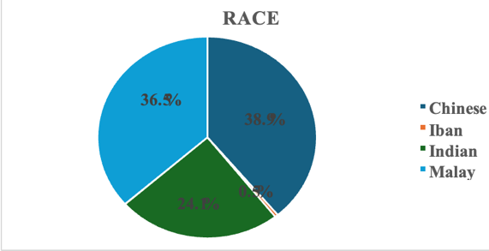
Figure 7 : The Pie Chart of Respondent’s Race
Based on Table 7 and Figure 7, most respondents were Chinese consumers, representing 38.9% (150 respondents), followed closely by Malay consumers at 36.5% (141 respondents). Indian respondents accounted for 24.1% (93 respondents), while Iban respondents represented only 0.5% (2 respondents). The findings demonstrate that the study successfully captured diverse consumer perspectives from Malaysia’s multicultural population, particularly among the major ethnic groups actively participating in digital consumer activities.

TABLE 8
Frequency and Percentage of Highest Education Level
Source: (Output from SPSS)
HIGHEST EDUCATION LEVEL
 | Frequency | Percent | Valid Percent | Cumulative  Percent
Bachelor’s Degree / Ijazah | 100 | 25.9 | 25.9 | 25.9
Diploma / STPM | 99 | 25.6 | 25.6 | 51.6
Master / Sarjana Muda | 84 | 21.8 | 21.8 | 73.3
Ph.D | 49 | 12.7 | 12.7 | 86.0
SPM | 54 | 14.0 | 14.0 | 100.0
Total | 386 | 100.0 | 100.0

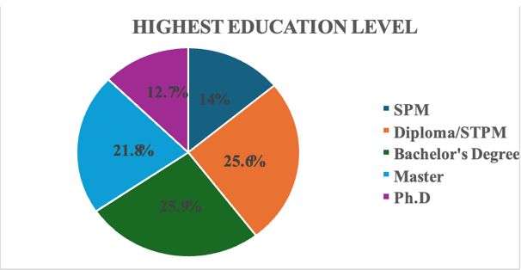
Figure 8 : The Pie Chart of Respondent’s Highest Education Level
In addition, Table 8 and Figure 8 indicate that most respondents possessed a bachelor’s degree qualification, representing 25.9% (100 respondents), followed closely by Diploma/STPM holders at 25.6% (99 respondents). This suggests that most respondents were relatively well-educated consumers who are likely familiar with digital platforms, social media interaction, and online purchasing behavior. Higher educational exposure may also contribute to stronger awareness and understanding of digital content marketing strategies.

TABLE 9
Frequency and Percentage of User Experiences
Source: (Output from SPSS)
 |  | USER EXPERIENCES
 |  | Frequency | Percent | Valid Percent | Cumulative  Percent
Valid | Yes / Ya | 386 | 100.0 | 100.0 | 100.0
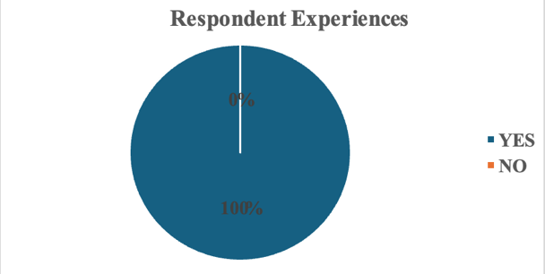
Figure 9 : The Pie Chart of Respondent’s User Experiences
Furthermore, Table 9 and Figure 9 reveal that all respondents (100%) had prior experience interacting with digital content marketing related to SME food and beverage businesses. This finding confirms that all respondents were relevant to the study context and capable of providing meaningful responses regarding brand awareness, word-of-mouth (WOM), consumer engagement, conversion, and the effectiveness of digital content marketing.
Overall, the demographic findings indicate that the respondents involved in this study were appropriate representatives of digital consumers within Malaysian SME food and beverage businesses. The diversity of demographic characteristics strengthens the reliability and relevance of the findings in examining the factors influencing the effectiveness of digital content marketing among consumers in Malaysia’s digital economy.

- Descriptive Statistics of Variables

This section presents the descriptive statistical analysis of the independent variables and dependent variable examined in this study. Descriptive statistics were employed to summarize the respondents’ perceptions regarding Brand Awareness, Word-of-Mouth (WOM), Consumer Engagement, Conversion, and the Effectiveness of Digital Content Marketing. The analysis includes the minimum value, maximum value, mean score, and standard deviation obtained from the responses of 386 respondents. The descriptive findings provide an overall understanding of consumer agreement levels and perceptions toward digital content marketing among Malaysian SME food and beverage (F&B) businesses.

TABLE 10
Descriptive Analysis Independent Variables and Dependent Variable
Source: (Output from SPSs)
 |  | Descriptive Statistics
 | N | Min. | Max. | Mean | Std. Deviation
 | Statistic | Statistic | Statistic | Statistic | Statistic
Brand Awareness | 386 | 1 | 4 | 3.1176 | .78990
Word of  Mouth | 386 | 1 | 4 | 3.0943 | .76686
Engagement | 386 | 1 | 4 | 3.0725 | .77609
Conversion | 386 | 1 | 4 | 3.0653 | .79524
DV | 386 | 1 | 4 | 3.2280 | .64502
Valid N (listwise) | 386

Based on Table 10, the dependent variable, namely the Effectiveness of Digital Content Marketing (DV), recorded the highest mean value of (M = 3.2280, SD = 0.64502). This finding indicates that the majority of respondents generally agreed that digital content marketing plays an important role in influencing consumer behaviour and marketing effectiveness within Malaysian SME F&B businesses. The relatively lower standard deviation also suggests that respondents demonstrated consistent perceptions regarding the effectiveness of digital content marketing.
Among the independent variables, Brand Awareness (IV1) achieved the highest mean score of (M = 3.1176, SD = 0.78990), indicating that respondents strongly perceived brand awareness as an important factor influencing the effectiveness of digital content marketing. This suggests that consumers are more likely to engage with digital marketing content when they are familiar with and able to recognize the brand effectively through social media and online platforms.
This was followed by Word-of-Mouth (WOM) (IV2), which recorded a mean value of (M = 3.0943, SD = 0.76686). The findings indicate that respondents generally agreed that WOM communication, including online reviews, recommendations, and social media sharing, significantly influences digital content marketing effectiveness and consumer decision-making within the SME F&B sector.
Consumer Engagement (IV3) recorded a mean value of (M = 3.0725, SD = 0.77609), showing that respondents positively perceived engagement activities such as likes, comments, shares, and online interaction as important contributors to effective digital content marketing. This finding reflects the importance of interactive and engaging digital content in maintaining consumer attention and strengthening customer relationships within digital environments.
Meanwhile, Conversion (IV4) recorded the lowest mean value among the independent variables at (M = 3.0653, SD = 0.79524). Although it obtained the lowest mean score, the value still indicates a positive level of agreement among respondents regarding the importance of conversion behaviour in digital marketing effectiveness. The findings suggest that digital content marketing influences consumer actions such as purchasing intention, product inquiry, and online response behaviour within Malaysian SME F&B businesses.
Overall, the descriptive statistical findings indicate that all variables achieved mean values above 3.00, demonstrating that respondents generally agreed with the importance of Brand Awareness, WOM, Consumer Engagement, and Conversion in influencing the Effectiveness of Digital Content Marketing. These findings suggest that digital content marketing plays a significant role in shaping consumer behaviour, online interaction, and purchasing responses within Malaysia’s SME food and beverage industry.

TABLE 11
Descriptive Analysis of Brand Awareness (IV1)
Source: (Output from SPSS)
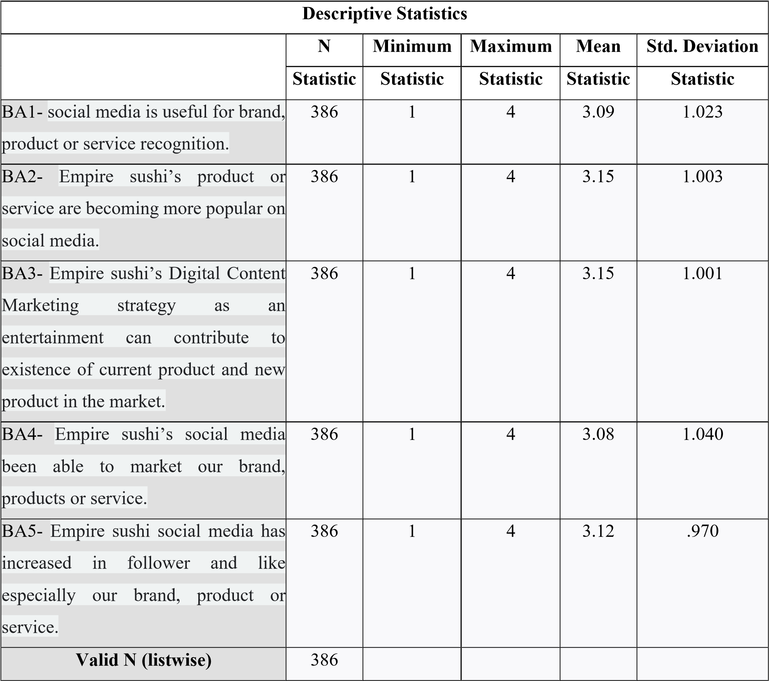
This section presents the descriptive analysis for Brand Awareness as the first independent variable in this study. Table 11 summarizes the respondents’ perceptions regarding brand recognition, familiarity, recall, and awareness of digital content marketing related to Malaysian SME food and beverage (F&B) businesses.
Based on Table 11, the item “I can easily recognize food and beverage brands through digital content marketing on social media platforms” recorded the highest mean value, indicating that respondents strongly agreed that digital content marketing significantly improves brand recognition and visibility. This finding suggests that visually appealing and consistent digital marketing content enhances consumer familiarity with SME F&B brands, particularly through platforms such as TikTok, Instagram, Facebook, and YouTube.
Meanwhile, the item with the lowest mean value was “I frequently remember food and beverage brands after viewing their online marketing content.” Although the item recorded the lowest mean score among the Brand Awareness items, the value still remained above the acceptable agreement level, indicating that respondents generally agreed that digital content marketing contributes positively to brand recall and memory retention.
In addition, the standard deviation values for all Brand Awareness items were relatively low, indicating consistency in respondent perceptions and responses toward the role of brand awareness in digital content marketing effectiveness. The findings demonstrate that consumers generally perceive brand familiarity and recognition as important elements influencing digital marketing success within Malaysian SME F&B businesses.
Overall, the findings imply that stronger brand awareness positively contributes to the effectiveness of digital content marketing by improving consumer recognition, recall, and familiarity toward SME F&B brands. Effective digital content therefore plays a crucial role in strengthening brand positioning and enhancing consumer responsiveness within competitive digital environments.

TABLE 12
Descriptive Analysis of Word of Mouth (IV2)
Source: (Output from SPSS)
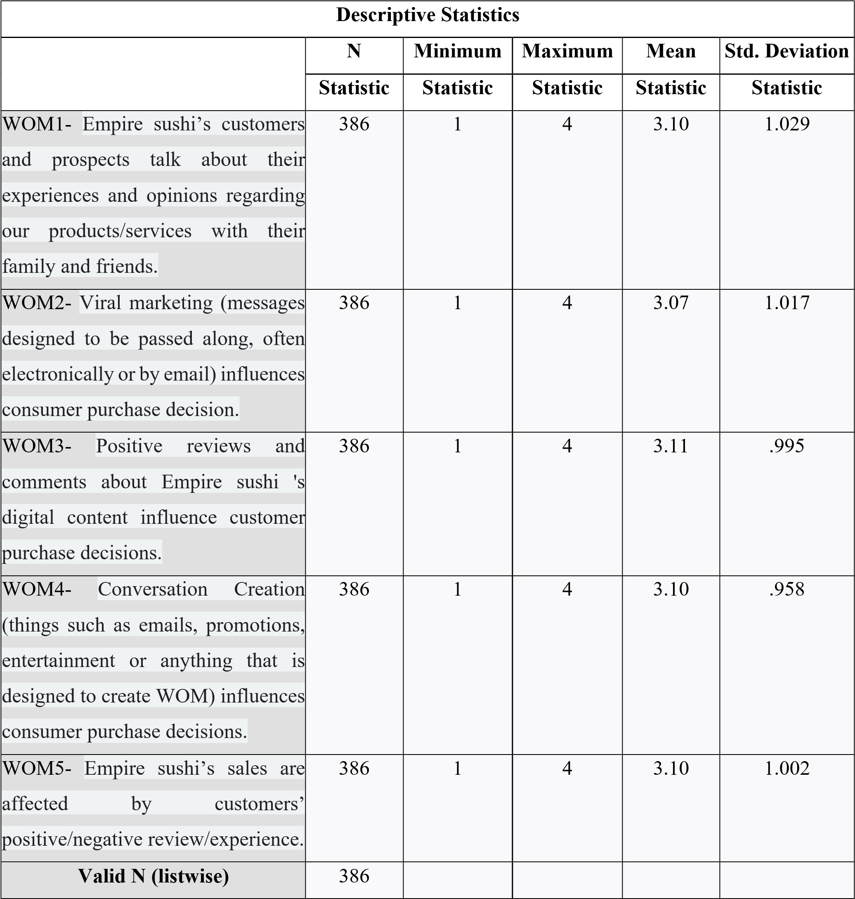
This section presents the descriptive analysis for Word-of-Mouth (WOM) as the second independent variable in this study. Table 12 summarizes respondents’ perceptions regarding online recommendations, reviews, social sharing, and communication behaviour related to digital content marketing among Malaysian SME F&B businesses.
Based on Table 12, the item “Online reviews and recommendations influence my interest toward food and beverage brands” recorded the highest mean value among all WOM items. This finding indicates that respondents strongly agreed that online consumer communication and recommendations significantly influence purchasing decisions and perceptions toward SME F&B businesses. The results highlight the growing importance of electronic word-of-mouth (eWOM) within digital marketing environments.
Meanwhile, the item with the lowest mean score was “I regularly share food and beverage promotional content with others through social media.” Although this item recorded the lowest mean value, respondents still demonstrated a positive level of agreement regarding social sharing behaviour. This suggests that while consumers actively consume WOM information, not all consumers frequently participate in sharing promotional content online.
The standard deviation values for WOM items were relatively moderate, indicating acceptable consistency and limited variability in respondent responses. These findings suggest that respondents generally shared similar perceptions regarding the influence of WOM communication within digital marketing environments.
Overall, the findings indicate that eWOM plays a significant role in influencing consumer trust, brand credibility, and purchasing behaviour within Malaysian SME F&B businesses. Positive online reviews, recommendations, and consumer discussions therefore contribute significantly toward improving the effectiveness of digital content marketing.

TABLE 13
Descriptive Analysis of Consumer Engagement (IV3)
Source: (Output from SPSS)
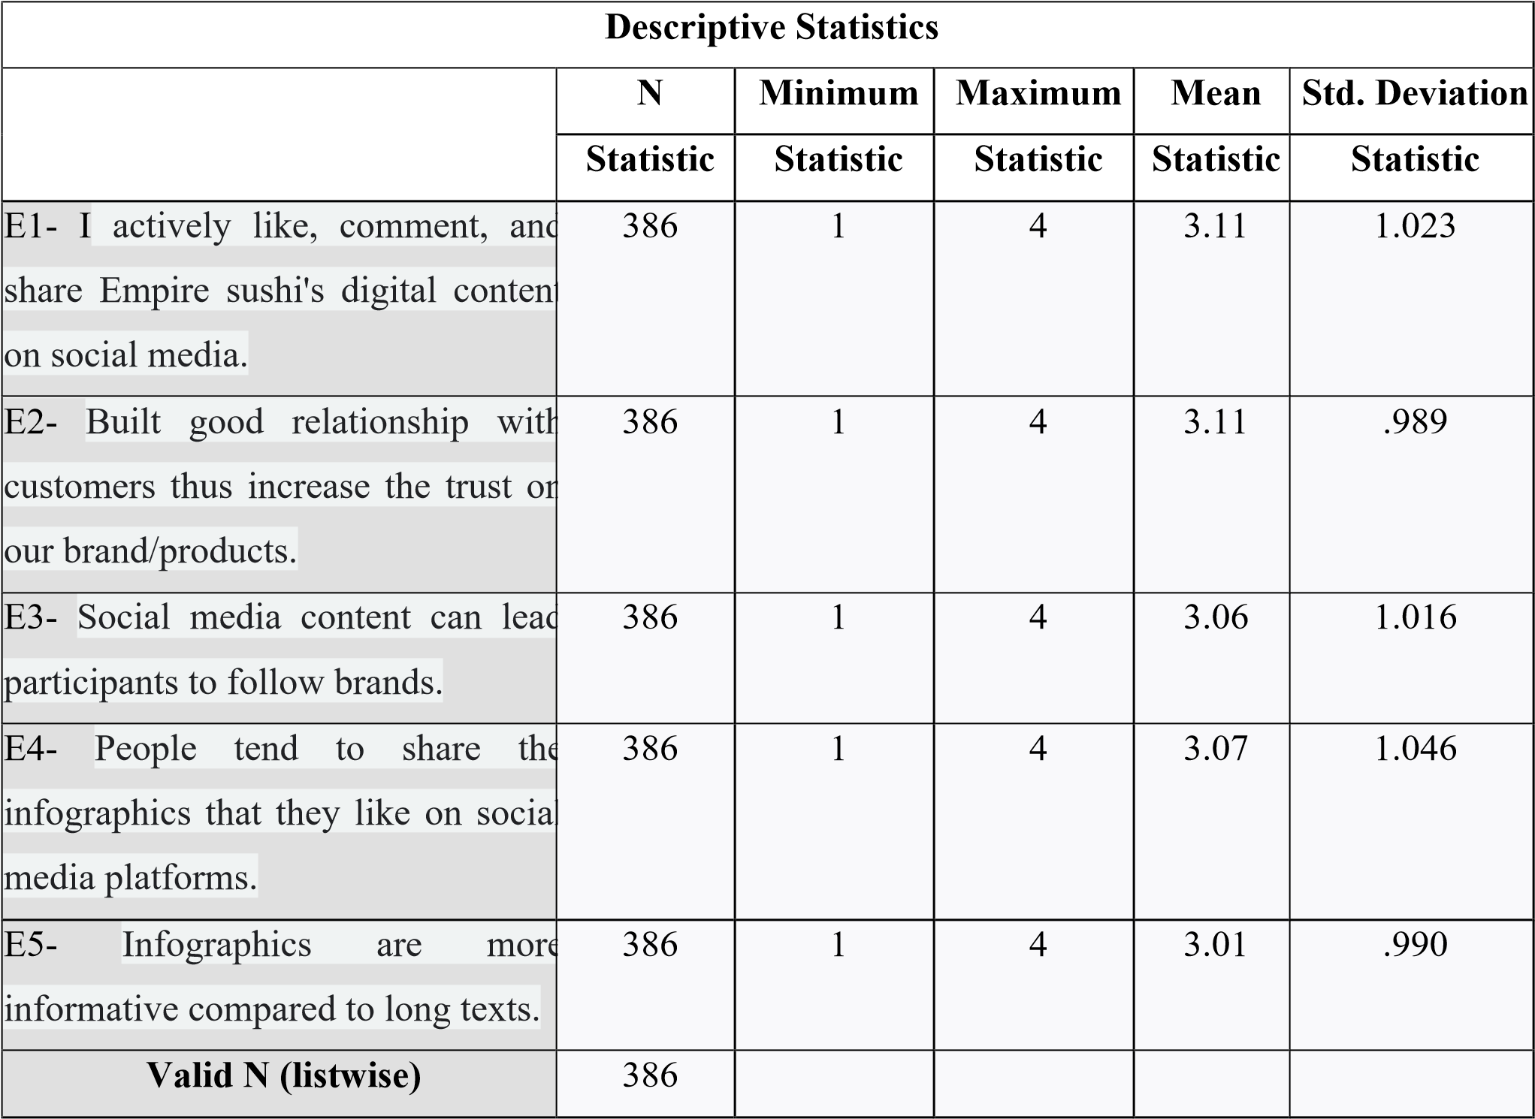
This section presents the descriptive analysis for Consumer Engagement as the third independent variable in this study. Table 13 summarizes respondents’ perceptions regarding online interaction, emotional involvement, participation, and engagement behaviour toward digital content marketing among Malaysian SME F&B businesses.
Based on Table 13, the item “Interactive digital content encourages me to engage with food and beverage brands online” recorded the highest mean value among all engagement items. This finding indicates that respondents strongly agreed that interactive and visually engaging digital content positively influences consumer participation and online interaction with brands.
On the other hand, the item “I actively participate in online activities organized by food and beverage brands” recorded the lowest mean score among the engagement items. Although the mean value was comparatively lower, respondents still demonstrated positive agreement regarding participation behaviour. This suggests that while consumers are generally interested in engaging with digital content, active participation in online campaigns or activities may vary depending on personal interest and content attractiveness.
The relatively low standard deviation values indicate consistency in respondent perceptions regarding consumer engagement behaviour. The findings demonstrate that respondents generally perceived engagement activities such as likes, comments, shares, and interactive participation as important contributors to digital content marketing effectiveness.
Overall, the findings imply that emotional and behavioural interaction with digital content significantly enhances consumer engagement and strengthens relationships between consumers and SME F&B brands. Effective digital content therefore encourages greater consumer participation and improves marketing effectiveness within digital environments.

TABLE 14
Descriptive Analysis of Conversion (IV4)
Source: (Output from SPSS)
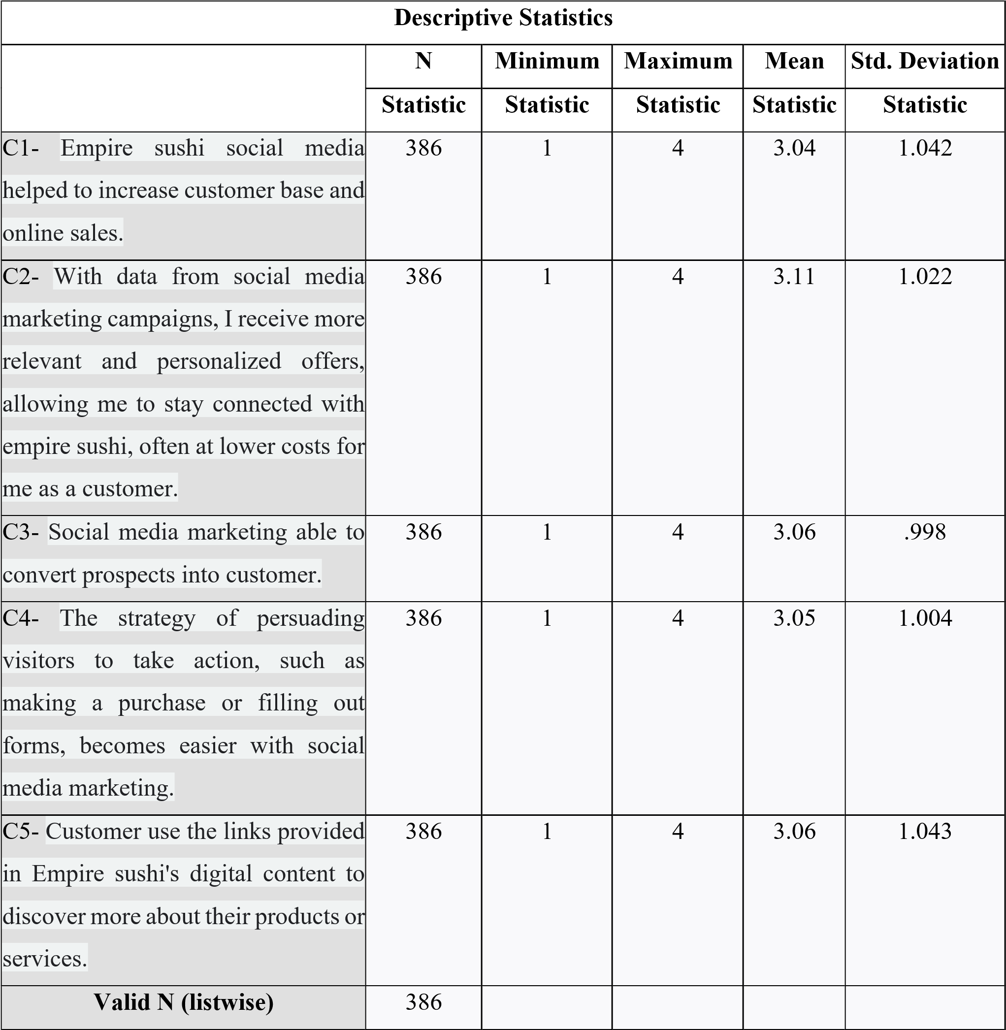
This section presents the descriptive analysis for Conversion as the fourth independent variable in this study. Table 14 summarizes respondents’ perceptions regarding purchasing actions, online responses, and behavioural outcomes resulting from digital content marketing exposure among Malaysian SME F&B businesses.
Based on Table 14, the item “Digital marketing content influences my purchasing decisions toward food and beverage products” recorded the highest mean value among all conversion items. This finding indicates that respondents strongly agreed that effective digital content marketing positively influences purchasing intention and consumer decision-making behaviour.
Meanwhile, the item “I frequently purchase food and beverage products immediately after viewing online promotional content” recorded the lowest mean score among the conversion items. Although the item obtained the lowest mean value, respondents still demonstrated a moderate level of agreement regarding immediate purchasing behaviour after digital marketing exposure.
The standard deviation values for conversion items remained relatively low, indicating acceptable consistency in respondent responses and perceptions. These findings suggest that consumers generally acknowledged the influence of digital content marketing on purchasing action and customer response behaviour within SME F&B businesses.
Overall, the findings imply that conversion behaviour is an important indicator of digital content marketing effectiveness. Effective digital marketing content therefore contributes positively toward purchasing intention, customer responsiveness, and consumer action within Malaysian SME food and beverage businesses.

TABLE 15
Descriptive Analysis of Effectiveness of Digital Content Marketing (DV)
Source: (Output from SPSS)
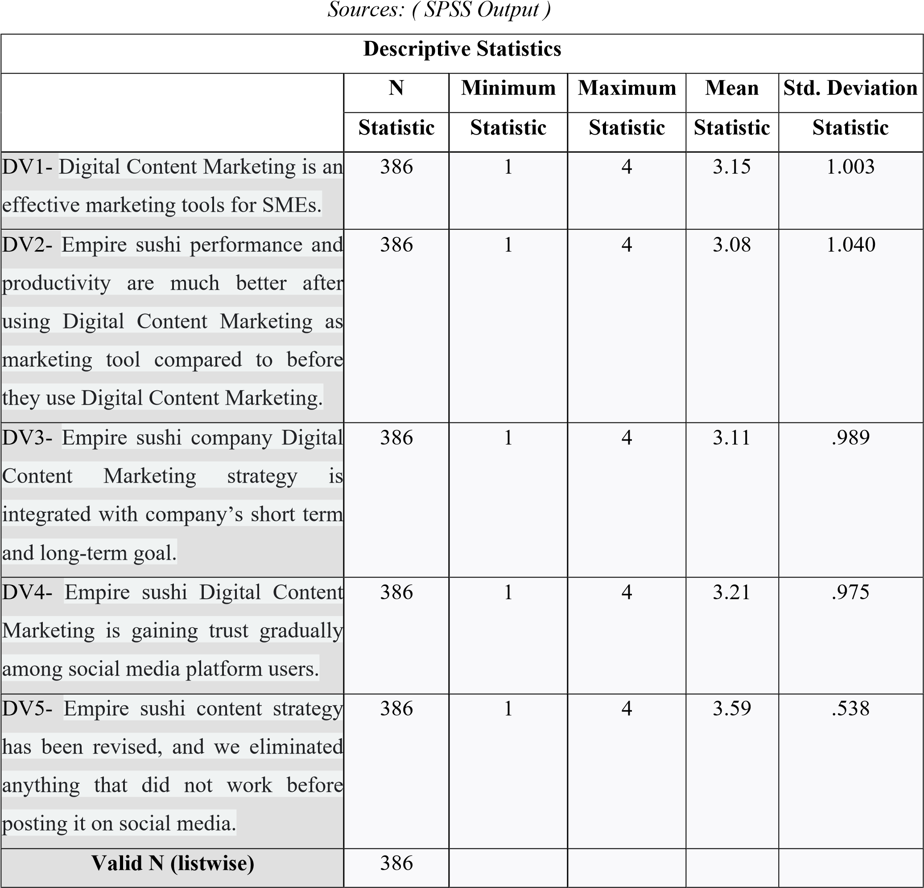
This section presents the descriptive analysis for the dependent variable, namely the Effectiveness of Digital Content Marketing. Table 15 summarizes respondents’ perceptions regarding the ability of digital content marketing to influence consumer behaviour, improve brand communication, strengthen engagement, and encourage purchasing behaviour among Malaysian SME F&B businesses.
Based on Table 15, the item “Digital content marketing improves my awareness and understanding of food and beverage brands” recorded the highest mean value among all dependent variable items. This finding indicates that respondents strongly agreed that digital content marketing effectively enhances brand communication and consumer understanding within digital environments.
Meanwhile, the item with the lowest mean value was “Digital marketing content consistently influences my long-term purchasing behaviour.” Although the item recorded the lowest mean score among the dependent variable items, respondents still demonstrated positive agreement regarding the long-term influence of digital content marketing on consumer behaviour.
The relatively low standard deviation values indicate consistency in respondent responses regarding the effectiveness of digital content marketing. The findings demonstrate that consumers generally perceived digital content marketing as an important strategy influencing brand awareness, consumer engagement, purchasing intention, and customer interaction within Malaysian SME F&B businesses.
Overall, the findings indicate a high level of consumer agreement regarding the importance and effectiveness of digital content marketing within the Malaysian SME food and beverage sector. Effective digital marketing content therefore plays a significant role in improving consumer communication, strengthening customer relationships, and enhancing business competitiveness within Malaysia’s digital economy.

- Correlation Analysis
TABLE 16
Pearson Correlation Analysis Between Independent Variables and Dependent Variable
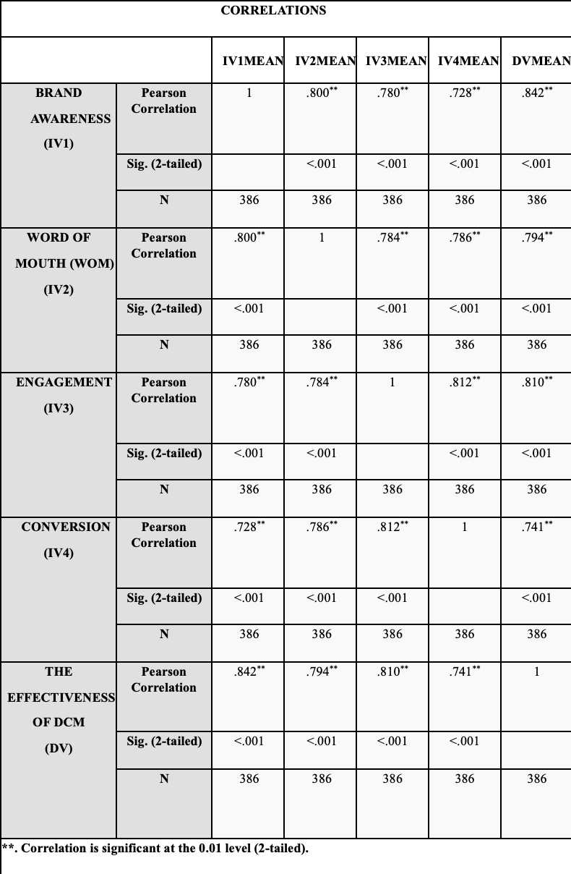
Correlation analysis was conducted to examine the strength and direction of the relationships between the independent variables, namely Brand Awareness, Word-of-Mouth (WOM), Consumer Engagement, and Conversion, with the dependent variable, which is the Effectiveness of Digital Content Marketing among consumers in Malaysian SME food and beverage (F&B) businesses. Pearson Correlation Analysis was employed because it is appropriate for determining the degree of linear relationship between variables within quantitative research.
Based on Table 16, the findings indicate that all independent variables demonstrate positive relationships with the Effectiveness of Digital Content Marketing. This suggests that increases in Brand Awareness, WOM, Consumer Engagement, and Conversion are associated with increases in the effectiveness of digital content marketing among consumers within Malaysian SME F&B businesses.
The correlation coefficients further indicate the strength of the relationships between the variables. Among the independent variables, Consumer Engagement recorded the strongest positive correlation with the Effectiveness of Digital Content Marketing, indicating that higher levels of consumer interaction, participation, and emotional involvement significantly contribute toward improving digital marketing effectiveness. This finding highlights the importance of interactive and engaging digital content in strengthening consumer responses within digital environments.
In addition, Brand Awareness, WOM, and Conversion also demonstrated moderate to strong positive relationships with the dependent variable. The findings suggest that consumers who are more familiar with brands, influenced by online recommendations, and encouraged toward purchasing actions are more likely to perceive digital content marketing as effective.
Furthermore, all variables recorded significance values (p-values) below 0.05, indicating that the relationships between the independent variables and the dependent variable are statistically significant. Therefore, the findings confirm that Brand Awareness, WOM, Consumer Engagement, and Conversion significantly influence the Effectiveness of Digital Content Marketing among consumers in Malaysian SME food and beverage businesses.
Overall, the correlation analysis demonstrates that all independent variables are positively associated with digital content marketing effectiveness, with Consumer Engagement emerging as the strongest correlated factor influencing consumer perceptions and responses toward digital marketing activities.

- Hypothesis Testing
This section presents the results of hypothesis testing based on the multiple regression analysis conducted in this study. The hypotheses were tested to examine the influence of Brand Awareness, Word-of-Mouth (WOM), Consumer Engagement, and Conversion on the Effectiveness of Digital Content Marketing among consumers in Malaysian SME food and beverage (F&B) businesses. The decision to accept or reject the hypotheses was based on the significance level (p-value), where values below 0.05 indicate statistically significant relationships.
TABLE 17
Summary of Hypothesis Testing Results
Source: SPSS Output
Hypothesis | Result
H1: Brand awareness positively impacts digital content marketing among consumers of Empire Sushi in Malaysia's SME F&B sector. | H1₁ is accepted.
H2: WOM positively impacts digital content marketing among consumers of Empire Sushi in Malaysia's SME F&B sector. | H2₂ is accepted.
H3: Engagement positively impacts digital content marketing tactics influence consumer engagement for Empire Sushi. | H33 is accepted.
H4: Conversion positively impacts the role of digital content marketing in driving conversion rates and sales for Empire Sushi. | H44 is not significant.

Hypothesis 1 (H1)
Brand Awareness positively influences the Effectiveness of Digital Content Marketing among consumers in Malaysian SME food and beverage businesses.
Based on the regression analysis results, Brand Awareness recorded a beta coefficient value of β = 0.358 with a t-value of 9.961 and a significance value of p = 0.001. Since the p-value is below 0.05, the relationship between Brand Awareness and the Effectiveness of Digital Content Marketing is statistically significant. Therefore, Hypothesis 1 (H1) is supported.
The findings indicate that Brand Awareness is the strongest predictor influencing the Effectiveness of Digital Content Marketing among consumers in Malaysian SME F&B businesses. This suggests that consumers are more likely to respond positively toward digital marketing content when they are familiar with and able to recognize the brand effectively through online platforms. The findings further imply that strong brand recognition enhances consumer trust, marketing visibility, and customer responsiveness within digital environments.
These findings are consistent with previous studies which reported that higher brand awareness significantly improves digital marketing effectiveness and consumer engagement within the food and beverage industry.

Hypothesis 2 (H2)
Word-of-Mouth (WOM) positively influences the Effectiveness of Digital Content Marketing among consumers in Malaysian SME food and beverage businesses.
The regression analysis results show that WOM recorded a beta coefficient value of β = 0.152 with a t-value of 3.834 and a significance value of p = 0.001. Since the p-value is lower than 0.05, WOM demonstrates a statistically significant relationship with the Effectiveness of Digital Content Marketing. Therefore, Hypothesis 2 (H2) is supported.
The findings indicate that positive online recommendations, reviews, and social sharing behaviour significantly contribute toward improving digital marketing effectiveness among Malaysian SME F&B businesses. This suggests that consumers place strong trust in peer recommendations and online consumer communication when evaluating food and beverage brands through digital platforms.
The results further emphasize the importance of electronic word-of-mouth (eWOM) as a strategic marketing tool capable of enhancing consumer trust, online visibility, and customer engagement within digital marketing environments.

Hypothesis 3 (H3)
Consumer Engagement positively influences the Effectiveness of Digital Content Marketing among consumers in Malaysian SME food and beverage businesses.
Based on the regression analysis findings, Consumer Engagement recorded a beta coefficient value of β = 0.240 with a t-value of 6.067 and a significance value of p = 0.001. Since the p-value is below the significance threshold of 0.05, Consumer Engagement demonstrates a statistically significant positive relationship with the Effectiveness of Digital Content Marketing. Therefore, Hypothesis 3 (H3) is supported.
The findings indicate that consumer interaction, participation, and emotional involvement significantly enhance digital marketing effectiveness within Malaysian SME F&B businesses. This suggests that engaging and interactive digital content plays an important role in strengthening customer relationships, increasing online participation, and improving consumer responsiveness toward marketing campaigns.
Furthermore, the findings highlight that engagement is not merely a passive outcome of digital marketing but rather an important strategic factor that actively contributes toward digital marketing success within competitive online environments.

Hypothesis 4 (H4)
Conversion positively influences the Effectiveness of Digital Content Marketing among consumers in Malaysian SME food and beverage businesses.
The regression analysis results indicate that Conversion recorded a beta coefficient value of β = 0.037 with a t-value of 0.999 and a significance value of p = 0.318. Since the p-value exceeds the significance threshold of 0.05, Conversion does not demonstrate a statistically significant relationship with the Effectiveness of Digital Content Marketing. Therefore, Hypothesis 4 (H4) is not supported and is rejected.
The findings suggest that although conversion behaviour remains important within broader marketing contexts, it does not significantly influence consumer perceptions regarding digital content marketing effectiveness within Malaysian SME F&B businesses in this study. This may indicate that consumers prioritize engagement, brand familiarity, and online interaction more strongly than immediate purchasing behaviour when evaluating digital marketing effectiveness.
Overall, the hypothesis testing findings demonstrate that Brand Awareness, WOM, and Consumer Engagement significantly influence the Effectiveness of Digital Content Marketing, while Conversion does not show a significant effect within the context of this study. These findings provide important empirical insights into digital consumer behaviour and marketing effectiveness within Malaysia’s SME food and beverage sector.

- DISCUSSION,IMPLICATION,LIMITATIONS AND CONCLUSION
- Summary Of The Study
This study aimed to examine the factors influencing the effectiveness of digital content marketing among consumers in Malaysian SME food and beverage businesses. Specifically, the study investigated the influence of Brand Awareness, Word-of-Mouth (WOM), Consumer Engagement, and Conversion on the effectiveness of digital content marketing. A quantitative research approach was employed, and data were collected from 386 respondents using a structured questionnaire. The findings revealed that Brand Awareness, WOM, and Consumer Engagement significantly influenced digital content marketing effectiveness, while Conversion did not demonstrate a significant effect.
- Discussion on Demographic Background
The demographic analysis revealed that most respondents were female consumers, representing 53.1% of the total respondents. In addition, most respondents were between 20 and 39 years old, indicating that younger consumers are more actively engaged with digital marketing platforms and social media environments. The findings also showed that Chinese and Malay consumers formed the largest respondent groups, while most respondents possessed bachelor’s degree qualifications. These demographic findings suggest that digitally active and educated consumers play an important role in influencing the effectiveness of digital content marketing within Malaysian SME F&B businesses.

- Discussion Research Objective
Objective 1: Brand Awareness
The findings demonstrated that Brand Awareness was the strongest factor influencing the effectiveness of digital content marketing among consumers in Malaysian SME F&B businesses. Correlation analysis showed a strong positive relationship between Brand Awareness and digital content marketing effectiveness (r = 0.842, p < 0.01), while regression analysis further confirmed that Brand Awareness recorded the highest standardized beta coefficient (β = 0.439, p = 0.001). The findings suggest that consistent, visually appealing, and engaging digital content significantly enhances consumer familiarity, recognition, and trust toward SME F&B brands. The results support existing literature which emphasizes that stronger brand awareness improves consumer engagement, loyalty, and marketing effectiveness within digital platforms.

Objective 2: Word-of-Mouth (WOM)
The findings indicated that WOM significantly influenced the effectiveness of digital content marketing among consumers in Malaysian SME F&B businesses. The correlation analysis demonstrated a strong positive relationship between WOM and digital content marketing effectiveness (r = 0.794, p < 0.01), while regression analysis showed a significant positive influence (β = 0.180, p = 0.001). The findings highlight the importance of electronic word-of-mouth (eWOM), online reviews, recommendations, and customer sharing behaviour in improving consumer trust and brand credibility. Positive consumer experiences shared through digital platforms therefore contribute significantly toward enhancing marketing effectiveness and customer engagement.

Objective 3: Consumer Engagement
The study findings further revealed that Consumer Engagement significantly influenced the effectiveness of digital content marketing. Correlation analysis recorded a strong positive relationship between engagement and digital content marketing effectiveness (r = 0.810, p < 0.01), while regression analysis indicated that engagement was the second strongest predictor (β = 0.289, p = 0.001). The findings suggest that interactive digital content, emotional connection, and consumer participation through likes, comments, shares, and online interaction positively enhance digital marketing effectiveness. The results emphasize that consumer engagement strengthens brand relationships and encourages continuous interaction between consumers and SME F&B brands within digital environments.

Objective 4: Conversion
The findings showed that Conversion did not significantly influence the effectiveness of digital content marketing among consumers in Malaysian SME F&B businesses. Although correlation analysis demonstrated a positive relationship between conversion and digital content marketing effectiveness (r = 0.741, p < 0.01), regression analysis indicated that conversion did not significantly predict the dependent variable (β = 0.045, p > 0.05). This suggests that while digital content marketing supports purchasing intention and customer response behaviour, external factors such as pricing, convenience, product quality, and customer experience may play more dominant roles in influencing final purchasing decisions.

- Discussion on Hypothesis Testing
The hypothesis testing results revealed that three hypotheses were supported, while one hypothesis was rejected. Brand Awareness, WOM, and Consumer Engagement demonstrated significant positive relationships with the effectiveness of digital content marketing, as all variables recorded significance values below 0.05. However, Conversion did not show a statistically significant relationship with digital content marketing effectiveness. Among all variables, Brand Awareness emerged as the strongest predictor influencing digital content marketing effectiveness within Malaysian SME F&B businesses. These findings indicate that consumer familiarity, online recommendations, and interactive engagement play important roles in strengthening digital marketing performance within Malaysia’s digital business environment.

TABLE 18
Summary of Hypothesis Results
Source: SPSS Output
Hypothesis | Result
H1: Brand awareness positively impacts digital content marketing among consumer in Malaysia SME F&B. | Accepted p-value =0.001  (p<0.05)
H2: WOM positively impacts digital content marketing among consumer in Malaysian SME F&B. | Accepted p-value =0.001  (p<0.05)
H3: Engagement positively impacts digital content marketing among consumer in Malaysia SME F&B. | Accepted p-value =0.001  (p<0.05)
H4: Conversion positively impacts digital content marketing among consumer in Malaysia's SME F&B. | No significant p-value =0.318  (p>0.05)

- Implications of the Study
This study contributes theoretically by strengthening the understanding of digital content marketing effectiveness within Malaysia’s SME F&B sector. The findings support digital marketing theories and consumer behaviour frameworks by demonstrating that Brand Awareness, WOM, and Consumer Engagement significantly influence marketing effectiveness within digital environments. The study also provides empirical evidence regarding the importance of interactive digital marketing strategies in shaping consumer responses and online behaviour.
Practically, the findings provide important insights for SME practitioners and digital marketers. SME businesses are encouraged to prioritize visually engaging content, interactive social media strategies, online customer engagement, and eWOM initiatives to improve marketing performance and strengthen customer relationships. Policymakers and digital agencies may also utilize the findings to support digital transformation initiatives and improve digital marketing literacy among SMEs in Malaysia.

- Limitations of the Study
Several limitations should be acknowledged in this study. First, the study focused only on consumers within Malaysian SME food and beverage businesses, particularly within Melaka, limiting the generalizability of the findings to other industries or geographical locations. Second, the study employed a quantitative cross-sectional design using close-ended questionnaires, which restricted respondents from providing deeper qualitative insights regarding their digital marketing experiences. Third, the study did not examine specific digital content formats, platform differences, or emerging technologies such as AI-driven marketing and influencer marketing strategies in greater depth. Finally, the relatively short data collection period may have limited the diversity of respondent participation.

- Recommendations for Future Research
Future research is recommended to expand the study beyond the SME food and beverage industry by examining other sectors such as retail, tourism, healthcare, and education to improve the generalizability of digital content marketing findings. Future studies are also encouraged to adopt mixed-method approaches by combining quantitative and qualitative methods to obtain deeper insights into consumer behaviour and digital marketing experiences. In addition, researchers should investigate the effectiveness of different digital platforms, content formats, influencer marketing strategies, and AI-driven digital marketing technologies. Expanding respondent diversity across demographic backgrounds and geographical regions may also improve the comprehensiveness of future digital marketing research.

- Conclusion
In conclusion, this study demonstrates that digital content marketing plays a significant role in influencing consumer behaviour and marketing effectiveness within Malaysian SME food and beverage businesses. The findings confirm that Brand Awareness, WOM, and Consumer Engagement significantly contribute toward improving digital content marketing effectiveness, while Conversion did not demonstrate a significant direct influence. Among all variables, Brand Awareness emerged as the strongest factor influencing digital marketing effectiveness. Overall, the study highlights the importance of strategic, engaging, and consumer-oriented digital marketing practices in strengthening brand performance, customer relationships, and business competitiveness within Malaysia’s digital economy.

- CONCLUSION
This study examined the factors influencing the effectiveness of digital content marketing among consumers in Malaysian SME food and beverage (F&B) businesses. Specifically, the study investigated the influence of Brand Awareness, Word-of-Mouth (WOM), Consumer Engagement, and Conversion on the effectiveness of digital content marketing within Malaysia’s increasingly digitalized business environment. The research was motivated by the growing importance of digital platforms and social media marketing strategies among SMEs seeking to enhance competitiveness, strengthen customer relationships, and improve business performance in the digital economy.
Using a quantitative research approach, data were collected from 386 respondents through structured questionnaires and analysed using the Statistical Package for the Social Sciences (SPSS). Several statistical analyses, including reliability analysis, descriptive analysis, Pearson correlation analysis, and multiple regression analysis, were conducted to achieve the research objectives and test the proposed hypotheses.
The findings revealed that Brand Awareness, WOM, and Consumer Engagement significantly influenced the effectiveness of digital content marketing among consumers in Malaysian SME F&B businesses. Among all independent variables, Brand Awareness emerged as the strongest predictor influencing digital content marketing effectiveness. This finding indicates that consumers are more likely to respond positively toward digital marketing content when they are familiar with and able to recognize brands effectively through social media and online platforms. The results also demonstrated that positive WOM communication and higher consumer engagement significantly strengthen customer trust, online interaction, and digital marketing performance.
In contrast, Conversion did not demonstrate a statistically significant direct relationship with the effectiveness of digital content marketing. The findings suggest that although digital marketing activities contribute to purchasing intention and customer response behaviour, external factors such as pricing, product quality, convenience, and customer experience may have stronger influences on actual purchasing decisions within the SME F&B sector.
The study contributes theoretically by strengthening existing knowledge related to digital content marketing effectiveness, consumer behaviour, and digital marketing strategies within SME business environments. The findings provide empirical evidence supporting the importance of interactive digital engagement, consumer communication, and brand visibility in improving marketing effectiveness. Practically, the study offers valuable insights for SME practitioners, digital marketers, and policymakers in developing more effective and consumer-oriented digital marketing strategies.
Overall, this study highlights the importance of strategic digital content marketing in enhancing business competitiveness and strengthening consumer relationships within Malaysia’s SME food and beverage industry. As digital technologies and social media platforms continue to evolve rapidly, SMEs must continuously adapt their marketing strategies to align with changing consumer preferences and digital consumption behaviour. Future research is encouraged to explore additional variables, emerging digital technologies, and broader industrial contexts to further strengthen the understanding of digital content marketing effectiveness within Malaysia’s evolving digital economy.
Acknowledgment
The authors would like to thank the reviewers for their insightful suggestions. The authors gratefully acknowledge that this research is fully funded by the Ministry of Higher Education, Malaysia (KPT), for this research through the Fundamental Research Grant Scheme (FRGS) with reference code, FRGS/1/2024/SS02/UTEM/02/1.
References
[1] Aaker, D. A. (1996). Measuring brand equity across products and markets. California Management Review, 38(3), 102–120.
[2] Abdul-Ghani, E., Hyde, K. F., & Marshall, R. (2019). Conceptualizing engagement in a consumer-to-consumer context. Australasian Marketing Journal, 27(1), 2–13. https://doi.org/10.1016/j.ausmj.2018.11.001
[3] Ahmad, F., Kee, C. P., Mustaffa, N., Ibrahim, F., & Mahmud, W. A. W. (2012). Information propagation and the forces of social media in Malaysia. Asian Social Science, 8(5), 71–76. https://doi.org/10.5539/ass.v8n5p71
[4] Akturan, U., & Tezcan, N. (2012). Mobile banking adoption of the youth market: Perceptions and intentions. Marketing Intelligence & Planning, 30(4), 444–459. https://doi.org/10.1108/02634501211231928
[5] Albarracín, D., & Wyer, R. S. (2000). The cognitive impact of past behavior: Influences on beliefs, attitudes, and future behavioral decisions. Journal of Personality and Social Psychology, 79(1), 5–22. https://doi.org/10.1037/0022-3514.79.1.5
[6] Andreassen, T. W., & Streukens, S. (2009). Service innovation and electronic word-of-mouth: Is it worth listening to? Managing Service Quality, 19(3), 249–265. https://doi.org/10.1108/09604520910955376
[7] Appel, G., Grewal, L., Hadi, R., & Stephen, A. T. (2019). The future of social media in marketing. Journal of the Academy of Marketing Science, 48(1), 79–95. https://doi.org/10.1007/s11747-019-00695-1
[8] Atwong, C. T. (2015). A social media practicum: An action-learning approach to social media marketing and analytics. Marketing Education Review, 25(1), 27–31. https://doi.org/10.1080/10528008.2014.999600
[9] Azmi, I. A. G., Basir, A., Muwazir, M. R., Hashim, R. C., & Mohamed, H. A. (2014, June). Motivation of Muslim women entrepreneurs in Malaysian SMEs. In Proceedings of the 4th International Conference on Management (pp. 1–11).
[10] Baltes, L. P. (2015). Content marketing: The fundamental tool of digital marketing. Bulletin of the Transilvania University of Braşov, Series V: Economic Sciences, 8(57), 111–118.
[11] Becker, L., & Jaakkola, E. (2020). Customer experience: Fundamental premises and implications for research. Journal of the Academy of Marketing Science, 48, 630–648. https://doi.org/10.1007/s11747-019-00718-x
[12] Bhandari, P. (2020). An introduction to quantitative research. Scribbr. https://www.scribbr.com/methodology/quantitative-research/
[13] Bhatnagar, A., & Ghose, S. (2004). A latent class segmentation analysis of e-shoppers. Journal of Business Research, 57(7), 758–767. https://doi.org/10.1016/S0148-2963(02)00373-0
[14] Bishop, C. (2020). Customer engagement guide: Definition, strategies, and tips. Zendesk. https://www.zendesk.com/blog/customer-engagement-actually-means/
[15] Brodie, R. J., Ilic, A., Juric, B., & Hollebeek, L. (2013). Consumer engagement in a virtual brand community: An exploratory analysis. Journal of Business Research, 66(1), 105–114. https://doi.org/10.1016/j.jbusres.2011.07.029
[16] Brown, J., Broderick, A. J., & Lee, N. (2007). Word of mouth communication within online communities: Conceptualizing the online social network. Journal of Interactive Marketing, 21(3), 2–20. https://doi.org/10.1002/dir.20082
[17] Calder, B. J., Malthouse, E. C., & Schaedel, U. (2009). An experimental study of the relationship between online engagement and advertising effectiveness. Journal of Interactive Marketing, 23(4), 321–331. https://doi.org/10.1016/j.intmar.2009.07.002
[18] Castells, M. (2010). Globalisation, networking, urbanisation: Reflections on the spatial dynamics of the information age. Urban Studies, 47(13), 2737–2745. https://doi.org/10.1177/0042098010377365
[19] Chaffey, D., & Ellis-Chadwick, F. (2019). Digital marketing: Strategy, implementation and practice (7th ed.). Pearson.
[20] Cheung, C. M., & Thadani, D. R. (2012). The impact of electronic word-of-mouth communication: A literature analysis and integrative model. Decision Support Systems, 54(1), 461–470. https://doi.org/10.1016/j.dss.2012.06.008
[21] Dessart, L., Veloutsou, C., & Morgan-Thomas, A. (2015). Consumer engagement in online brand communities: A social media perspective. Journal of Product & Brand Management, 24(1), 28–42. https://doi.org/10.1108/JPBM-06-2014-0635
[22] Duffett, R. G. (2015). Facebook advertising’s influence on intention-to-purchase and purchase amongst Millennials. Internet Research, 25(4), 498–526. https://doi.org/10.1108/IntR-01-2014-0020
[23] Dwivedi, Y. K., Ismagilova, E., Hughes, D. L., & Carlson, J. (2021). Setting the future of digital and social media marketing research: Perspectives and research propositions. International Journal of Information Management, 59, 102168. https://doi.org/10.1016/j.ijinfomgt.2020.102168
[24] Evans, C., & Erkan, I. (2014). The impacts of electronic word of mouth in social media on consumers’ purchase intentions. In Proceedings of Digital Marketing Conference 2014 (pp. 9–14)..
[25] Godes, D., & Mayzlin, D. (2004). Using online conversations to study word-of-mouth communication. Marketing Science, 23(4), 545–560. https://doi.org/10.1287/mksc.1040.0071
[26] Hair, J. F., Black, W. C., Babin, B. J., & Anderson, R. E. (2022). Multivariate data analysis (9th ed.). Cengage Learning.
[27] Halligan, B., & Shah, D. (2009). Inbound marketing: Get found using Google, social media, and blogs. John Wiley & Sons.
[28] Hennig-Thurau, T., Gwinner, K. P., Walsh, G., & Gremler, D. D. (2004). Electronic word-of-mouth via consumer-opinion platforms: What motivates consumers to articulate themselves on the Internet? Journal of Interactive Marketing, 18(1), 38–52. https://doi.org/10.1002/dir.10073
[29] Hoffman, D. L., & Fodor, M. (2010). Can you measure the ROI of your social media marketing? MIT Sloan Management Review, 52(1), 41–49.
[30] Keller, K. L. (1993). Conceptualizing, measuring, and managing customer-based brand equity. Journal of Marketing, 57(1), 1–22. https://doi.org/10.1177/002224299305700101
[31] Laroche, M., Habibi, M. R., & Richard, M. O. (2013). To be or not to be in social media: How brand loyalty is affected by social media? International Journal of Information Management, 33(1), 76–82. https://doi.org/10.1016/j.ijinfomgt.2012.07.003
[32] Li, J., Kim, W. G., & Choi, H. M. (2019). Effectiveness of social media marketing on enhancing performance: Evidence from a casual-dining restaurant setting. Tourism Economics, 27(1), 3–22. https://doi.org/10.1177/1354816619867807
[33] Malthouse, E. C., Calder, B. J., Kim, S. J., & Vandenbosch, M. (2016). Evidence that user-generated content that produces engagement increases purchase behaviours. Journal of Marketing Management, 32(5–6), 427–444. https://doi.org/10.1080/0267257X.2015.1136273
[34] Saunders, M., Lewis, P., & Thornhill, A. (2019). Research methods for business students (8th ed.). Pearson Education Limited.
[35] Sekaran, U., & Bougie, R. (2020). Research methods for business: A skill-building approach (8th ed.). Wiley.
[36] Severi, E., Ling, K. C., & Nasermoadeli, A. (2014). The impacts of electronic word of mouth on brand equity in the context of social media. International Journal of Business and Management, 9(8), 84–96. https://doi.org/10.5539/ijbm.v9n8p84
[37] Steffes, E. M., & Burgee, L. E. (2009). Social ties and online word of mouth. Internet Research, 19(1), 42–59. https://doi.org/10.1108/10662240910927812
[38] Trusov, M., Bucklin, R. E., & Pauwels, K. (2009). Effects of word-of-mouth versus traditional marketing: Findings from an internet social networking site. Journal of Marketing, 73(5), 90–102. https://doi.org/10.1509/jmkg.73.5.90
[39] Uyanık, G., & Güler, N. (2013). A study on multiple linear regression analysis. Procedia – Social and Behavioral Sciences, 106, 234–240. https://doi.org/10.1016/j.sbspro.2013.12.027
[40] Wang, H., Ma, B., & Bai, R. (2019). How does green product knowledge effectively promote green purchase intention? Sustainability, 11(4), 1193. https://doi.org/10.3390/su11041193

