A Study to Assess the Prevalence of COVID-19 among People at Kalitheerthalkuppam, Puducherry”

Mrs. M. Yamunambigai¹, P. Vasikaran²

¹ Assistant professor, Department of Community Health Nursing , Sri Manakula Vinayagar Nursing College, Puducherry- 605107, India
2B.sc Nursing student, Sri Manakula Vinayagar Nursing College, Puducherry- 605107, India

ABSTRACT
Coronavirus disease 2019 (COVID-19), caused by Severe Acute Respiratory Syndrome Coronavirus-2 (SARS-CoV-2), emerged in Wuhan, China in December 2019 and was declared a pandemic by the World Health Organization on March 11, 2020. The present study aimed to assess the prevalence of COVID-19 among people at Kalitheerthalkuppam, Puducherry, and to determine its association with selected demographic variables. A quantitative research approach with a descriptive research design was adopted. A total of 30 samples were selected using a convenient sampling technique. Data were collected over a period of two weeks using demographic variables and a rating scale. Descriptive and inferential statistics were used for data analysis. The findings revealed that 50% of participants had a moderate level of prevalence, 26.7% had a high level, and 23.3% had a low level of prevalence. The mean prevalence score was 16.03 with a standard deviation of 5.334. Among demographic variables, occupation and vaccination status showed a statistically significant association with prevalence (p < 0.05). Other variables such as age, sex, education, marital status, family type, comorbidities, and testing history were not significantly associated. The study concludes that moderate prevalence was observed among the majority of participants, highlighting the need for continued public health interventions and large-scale studies.

Introduction:

COVID-19 entered into our lives at the end of 2019 in the whole world threatening the health of countless people and reached pandemic status as well. Since December 2019, there has been an outbreak of pneumonia of an unknown aetiology that was first reported in Wuhan, Hubei Province, China. The causative virus for the pandemic in China and other parts of the world by the World Health Organization On March 11, 2020 declared Covid-19 as a pandemic. Covid19 has affected more than 110 million peoples worldwide .Coronavirus disease 2019 (COVID-19) is a contagious disease caused by a virus, the severe acute respiratory syndrome coronavirus 2 (SARS-CoV-2). The first known case was identified in Wuhan, China, in December 2019. The disease quickly spread worldwide, resulting in the COVID-19 pandemic. COVID-19 is caused by infection with a strain of coronavirus known as 'Severe Acute Respiratory Syndrome coronavirus 2' (SARSCoV-2).

KEYWORDS: COVID-19, SARS-CoV-2, Pandemic, Infectious Disease, Public Health

STATEMENT OF THE PROBLEM

"A study to assess the prevalence of covid-19 among people at kalitheerthalkuppam, puducherry"

OBJECTIVES OF THE STUDY

- To assess the prevalence of COVID-19 among people in community.

- To associate the prevalence of COVID -19 among people with their selected demographic variables

METHODOLOGY

The research approach used for this study was quantitative research approach. A descriptive Research design was used to assess the prevalence of covid-19 among people in Kalitheerthalkuppam at Puducherry. By using Convenient Sampling Technique 30 samples was selected for the present study. The period of data collection was two week. The tool consists of demographic data, and Rating scales methods. The outcome of the study was evaluated by using descriptive and inferential statistics.

ORGANISATION OF THE DATA
Data collected were organized under the following sections.

Section A: Description of the demographic variables among community people.

Section B: Assess the prevalence of covid 19 among people at selected community people.
Section C: Assess the prevalence of covid 19 among community people with their selected demographic variables.

SECTION A: DESCRIPTION OF THE DEMOGRAPHIC VARIABLES AMONG COMMUNITY PEOPLE
Table 1:- Frequency and percentage wise distribution of demographic variables among prevalence of covid 19.

(N=30)

SL. NO | DEMOGRAPHIC VARIABLES | FREQUENCY (N) | PERCENTAGE (%)
1 | Age in years
 | a) 20-24 | 5 | 16.7
 | b) 25-30 | 7 | 23.3
 | c) 31-35 | 8 | 26.7
 | d) Above 40 | 10 | 33.3
2 | Sex
 | a) Male | 10 | 33.3
 | b) Female | 20 | 66.7
3 | Educational Status
 | a) Primary | 4 | 13.3
 | b) Secondary | 11 | 36.7
 | c) Graduate | 12 | 40
 | d) Illiterate | 3 | 10
4 | Martial Status
 | a) Married | 22 | 73.3
 | b) Unmarried | 8 | 26.7
 | c) Divorced | 0 | 0
5 | Place of Living
 | a) Urban | 0 | 0
 | b) Rural | 30 | 100
6 | Occupation
 | a) Unemployed | 13 | 43.3
 | b) Private | 15 | 50
 | c) Government job | 2 | 6.7
 | d) Business | 0 | 0
7 | Family Type
 | a) Joint family | 14 | 46.7
 | b) Nuclear family | 16 | 53.3
8 | Do you have any renal disease, heart disease, or diaberes so far?
 | a) Yes | 3 | 10

 | b) No | 27 | 90
9 | Do you get vaccinated?
 | a) Yes | 24 | 80
 | b) No | 6 | 20
10 | Have you ever been tested for covid?
 | a) Yes | 17 | 56.7
 | b) No | 13 | 43.3

Table 1 shows frequency and Percentage wise distribution of demographic variables among adults. Out of the 30 adults who were interviewed, Majority of the adults 10(33.3%) of study population were in the age group are above 40years. Majority of the adults were female 20(66.7%). Majority of the adults were Graduate 12(40%). Majority of the adults were married 22(73.3%). All of the adults were Rural 30(100%). Majority of the adults were had Private job 15(50%). Majority of the adults were Nuclear family 16(53.3%). Majority of the patients were had not renal disease, heart disease, or diabetes 27(90%). Majority of the adults were got vaccinated 24(80%). Majority of the adults were tested for covid 17(56.7%).

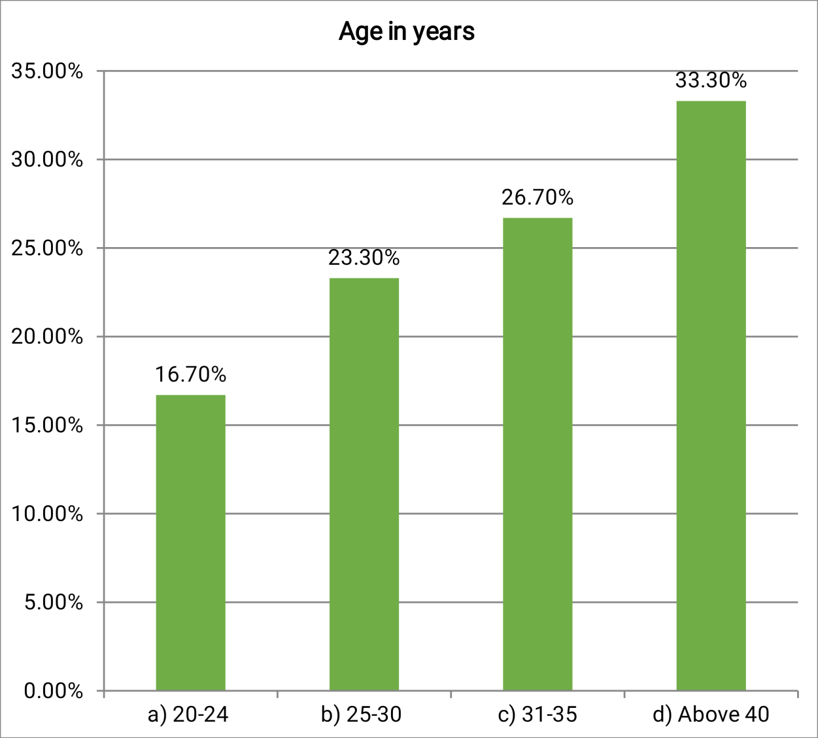

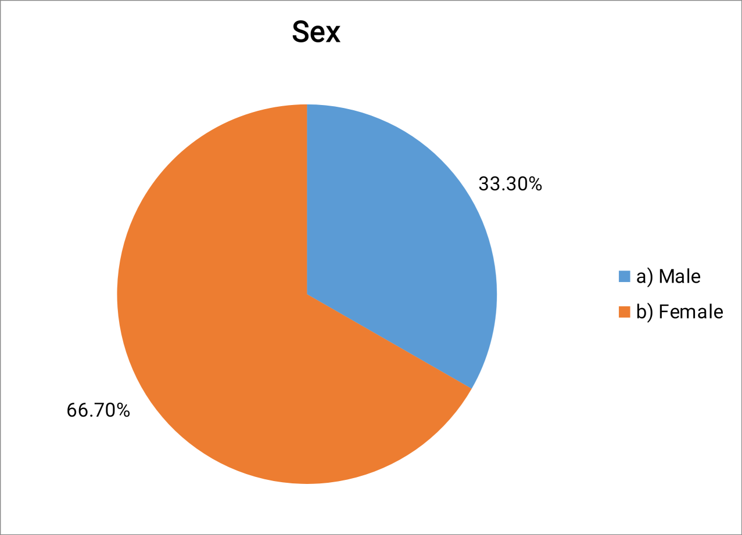

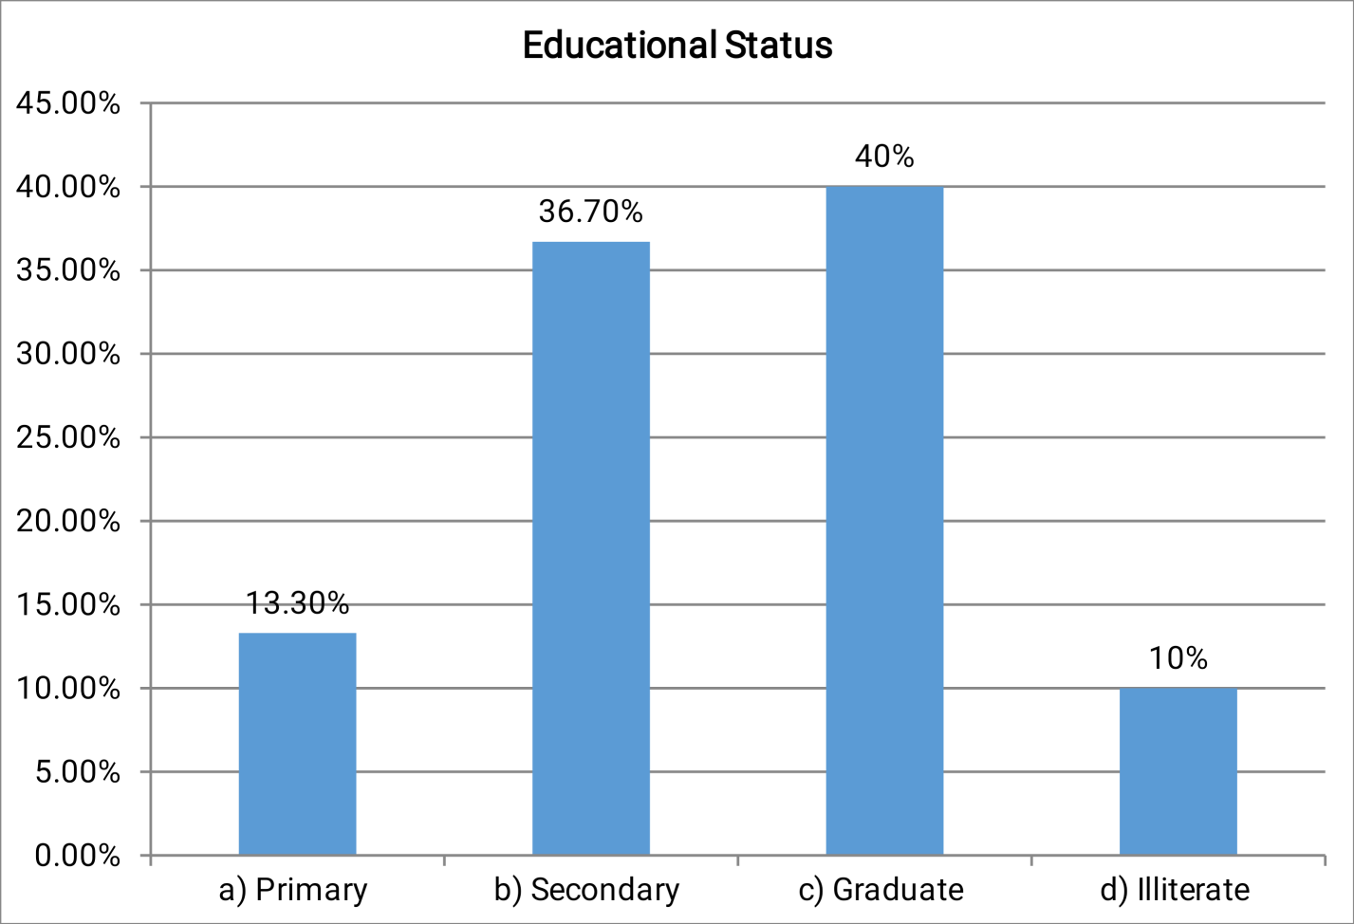

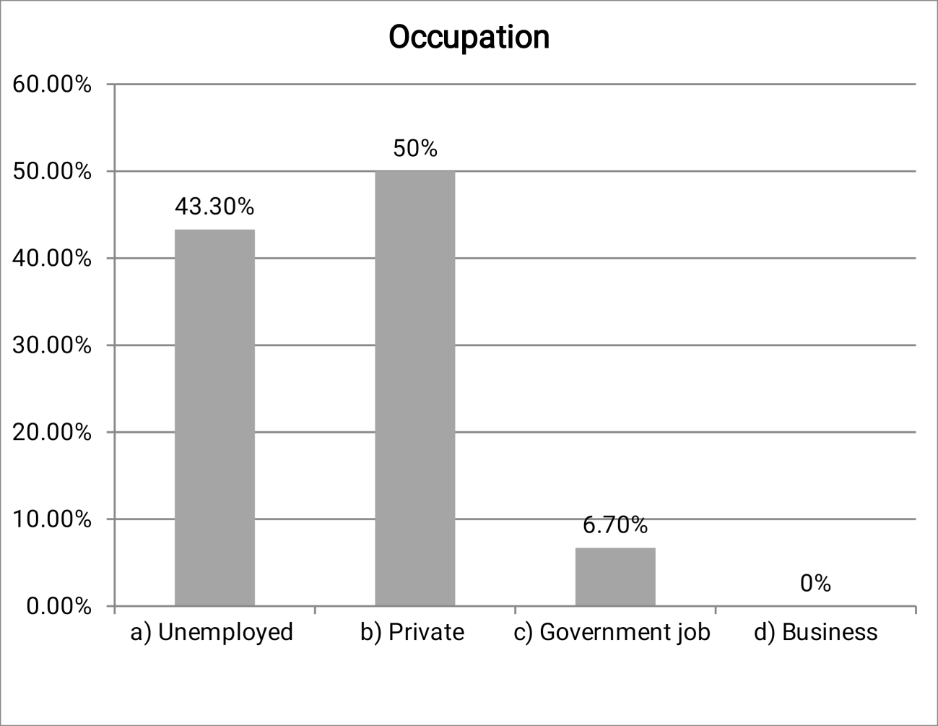

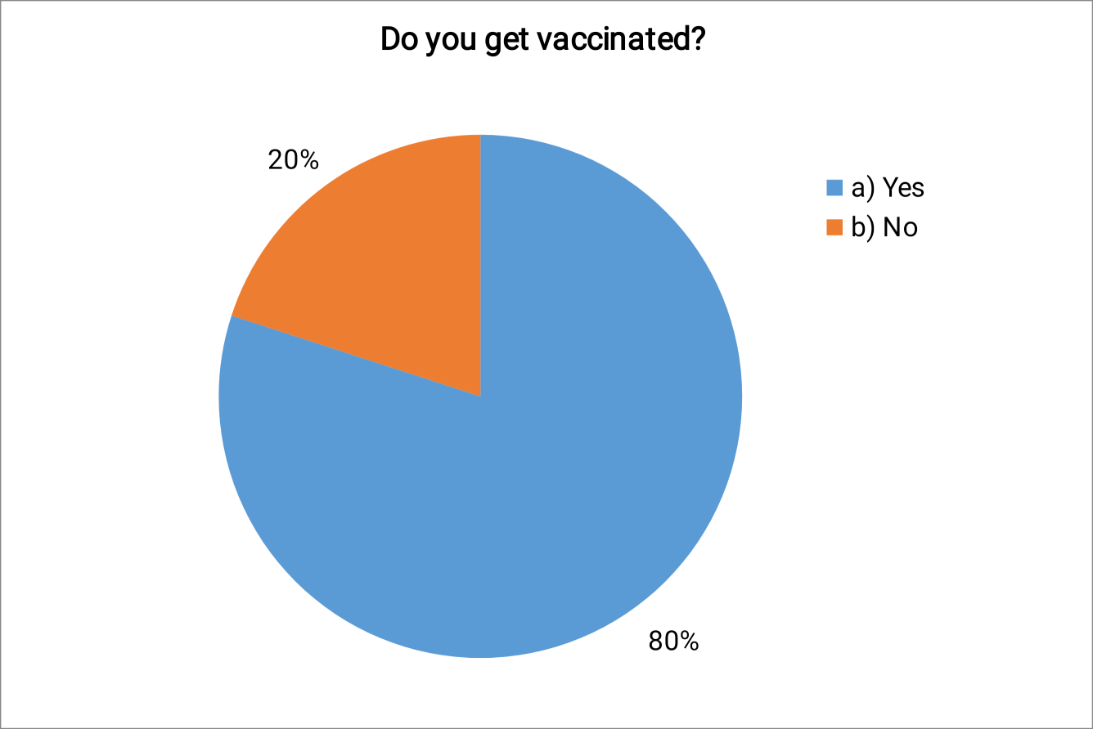

Section B: Assessment of the level of prevalence regarding COVID-19 among adults.

Table 2:- Frequency and percentage wise distribution of the level of prevalence

regarding COVID-19 among adults.

(N = 30)

LEVEL OF PREVALENCE | FREQUENCY  (n) | PERCENTAGE  (%)
Low | 7 | 23.3
Moderate | 15 | 50
High | 8 | 26.7
Total | 30 | 100
Mean+Standard deviation | 16.03+5.334

Table –2 shows frequency and percentage wise distribution of the level of prevalence regarding COVID-19 among adults. Majority of the adults 15(50%) had moderate level of prevalence, 8(26.7%) had high level of prevalence and 7(23.3%) had low level of prevalence. The mean and standard deviation of the level of prevalence regarding COVID-19 among adults is (16.03+5.334) respectively.

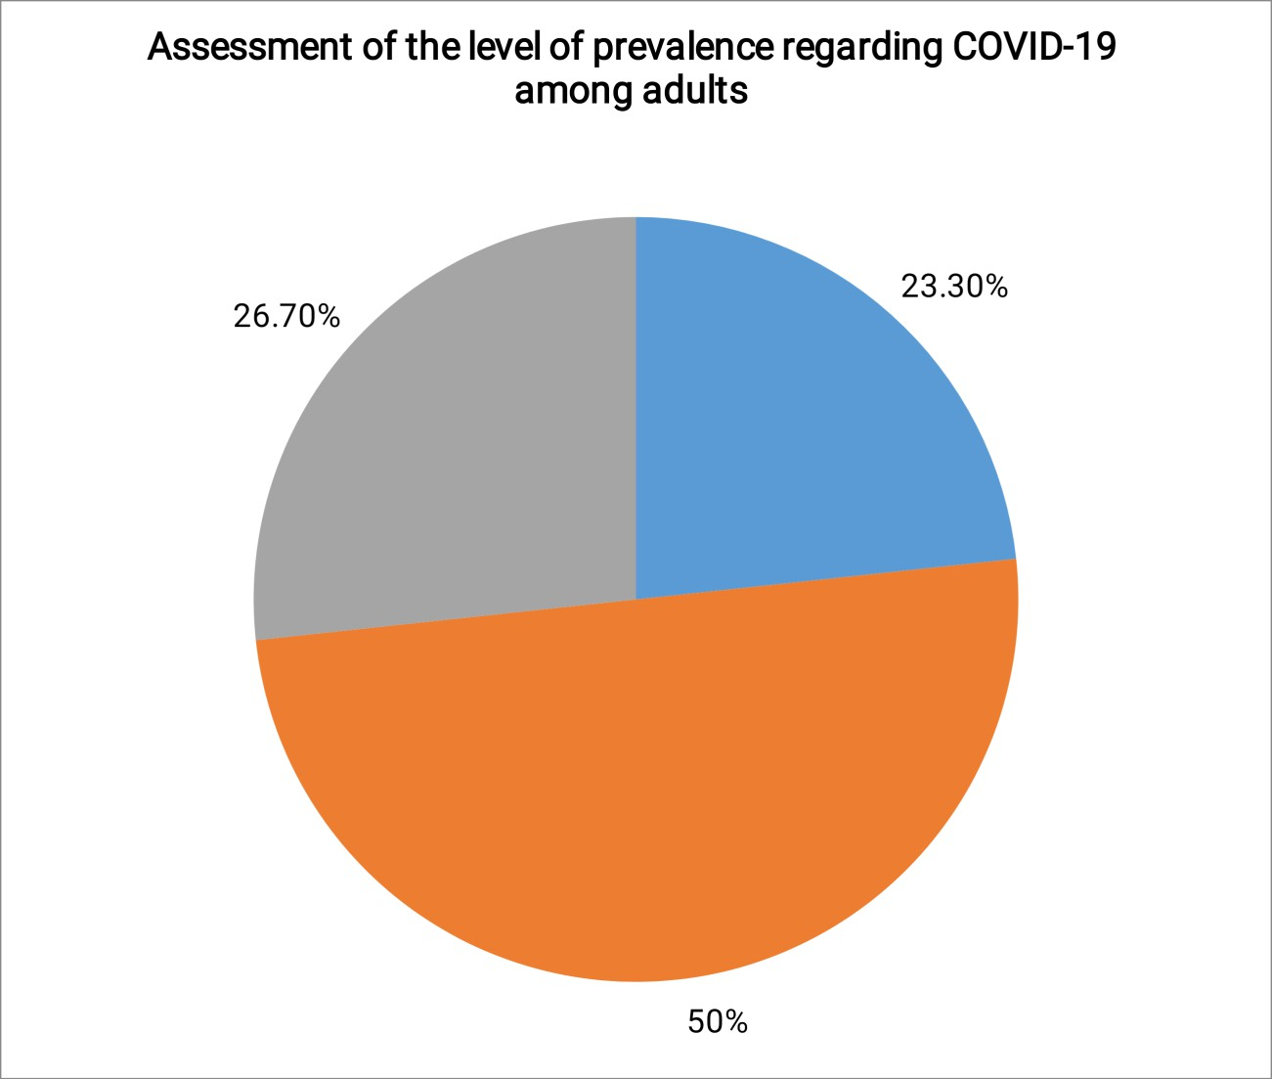

Section C: Association between the level of prevalence regarding COVID-19 among adults with their selected demographic variables.
Table –3: Association between the level of prevalence regarding COVID-19 among adults with their selected demographic variables.

(N=30)

SL. NO | DEMOGRAPHIC VARIABLES | LEVEL OF PREVALENCE |  |  |  |  |  | Chi-square X2 and P-Value
SL. NO | DEMOGRAPHIC VARIABLES | LOW |  | MODERATE |  | HIGH |  | Chi-square X2 and P-Value
SL. NO | DEMOGRAPHIC VARIABLES | N | % | N | % | N | % | Chi-square X2 and P-Value
1 | Age in years |  |  |  |  |  |  | X²=7.37 Df=6  p =0.288 NS
 | a) 20-24 | 1 | 14.3 | 2 | 13.3 | 2 | 25 | X²=7.37 Df=6  p =0.288 NS
 | b) 25-30 | 2 | 28.6 | 3 | 20 | 2 | 25 | X²=7.37 Df=6  p =0.288 NS
 | c) 31-35 | 0 | 0 | 7 | 46.7 | 1 | 12.5 | X²=7.37 Df=6  p =0.288 NS
 | d) Above 40 | 4 | 57.1 | 3 | 20 | 3 | 37.5 | X²=7.37 Df=6  p =0.288 NS
2 | Sex |  |  |  |  |  |  | X²=0.536 Df=2  p =0.765 NS
 | a) Male | 3 | 42.9 | 5 | 33.3 | 2 | 25 | X²=0.536 Df=2  p =0.765 NS
 | b) Female | 4 | 57.1 | 10 | 66.7 | 6 | 75 | X²=0.536 Df=2  p =0.765 NS
3 | Educational Status |  |  |  |  |  |  | X²=3.85 Df=6  p =0.697 NS
 | a) Primary | 2 | 28.6 | 1 | 6.7 | 1 | 12.5 | X²=3.85 Df=6  p =0.697 NS
 | b) Secondary | 2 | 28.6 | 7 | 46.7 | 2 | 25 | X²=3.85 Df=6  p =0.697 NS
 | c) Graduate | 3 | 42.9 | 5 | 33.3 | 4 | 50 | X²=3.85 Df=6  p =0.697 NS
 | d) Illiterate | 0 | 0 | 2 | 13.3 | 1 | 12.5 | X²=3.85 Df=6  p =0.697 NS
4 | Marital Status |  |  |  |  |  |  | X²=2.733 Df=2  p =0.255 NS
 | a) Married | 6 | 85.7 | 9 | 60 | 7 | 87.5 | X²=2.733 Df=2  p =0.255 NS
 | b) Unmarried | 1 | 14.3 | 6 | 40 | 1 | 12.5 | X²=2.733 Df=2  p =0.255 NS
 | c) Divorced | 0 | 0 | 0 | 0 | 0 | 0 | X²=2.733 Df=2  p =0.255 NS
5 | Place of Living |  |  |  |  |  |  | CONSTANT
 | a) Urban | 0 | 0 | 0 | 0 | 0 | 0 | CONSTANT
 | b) Rural | 7 | 100 | 15 | 100 | 8 | 100 | CONSTANT
6 | Occupation |  |  |  |  |  |  | X2=10.11
 | a) Unemployed | 1 | 14.3 | 8 | 53.3 | 4 | 50 | X2=10.11

 | b) Private | 6 | 85.7 | 7 | 46.7 | 2 | 25 | Df=4 p =0.039  *S
 | c) Government job | 0 | 0 | 0 | 0 | 2 | 25 | Df=4 p =0.039  *S
 | d) Business |  |  |  |  |  |  | Df=4 p =0.039  *S
7 | Family Type |  |  |  |  |  |  | X²=1.72 Df=2  p =0.422 NS
 | a) Joint family | 2 | 28.6 | 7 | 46.7 | 5 | 62.5 | X²=1.72 Df=2  p =0.422 NS
 | b) Nuclear family | 5 | 71.4 | 8 | 53.3 | 3 | 37.5 | X²=1.72 Df=2  p =0.422 NS
8 | Do you have any renal disease, heart disease, or diaberes so far? |  |  |  |  |  |  | X²=0.384 Df=2  p =0.825 NS
 | a) Yes | 1 | 14.3 | 1 | 6.7 | 1 | 12.5 | X²=0.384 Df=2  p =0.825 NS
 | b) No | 6 | 85.7 | 14 | 93.3 | 7 | 87.5 | X²=0.384 Df=2  p =0.825 NS
9 | Do you get vaccinated? |  |  |  |  |  |  | X2=10.84 Df=2  p =0.007  *S
 | a) Yes | 6 | 85.7 | 11 | 73.3 | 7 | 87.5 | X2=10.84 Df=2  p =0.007  *S
 | b) No | 1 | 14.3 | 4 | 26.7 | 1 | 12.5 | X2=10.84 Df=2  p =0.007  *S
10 | Have you ever been tested for covid? |  |  |  |  |  |  | X²=2.97 Df=2  p =0.226 NS
 | a) Yes | 2 | 28.6 | 10 | 66.7 | 5 | 62.5 | X²=2.97 Df=2  p =0.226 NS
 | b) No | 5 | 71.4 | 5 | 33.3 | 3 | 37.5 | X²=2.97 Df=2  p =0.226 NS

*-p < 0.05 significant, *-p < 0.001highly significant, NS-Non significant

The table 3 depicts that the demographic variable, Occupation and Do you get vaccinated had shown statistically significant association between the level of prevalence regarding covid-19 among adults with their selected demographic variables.
The other demographic variable had not shown statistically significant association between the level of prevalence regarding covid-19 among adults with their selected demographic variables respectively.

RESULTS

The major findings of the study were;

Majority of the people are 15(50%) had moderate level of prevalence, 8(26.7%) had high level of prevalence and 7(23.3%) had low level of prevalence. The mean and standard deviation of the level of prevalence regarding COVID-19 among adults is (16.03+5.334) respectively.

RECOMMENDATIONS:

- The study can do at the large number of samples.
- The study can be implemented at the various states of India.

CONCLUSION

A study to assess the prevalence of COVID-19 among people at kalitheerthalkuppam, Puducherry. The result of the study is Majority of the people are 15(50%) had moderate level of prevalence, 8(26.7%) had high level of prevalence and 7(23.3%) had low level of prevalence of COVID-19 regarding towards COVID-19.

BIBLIOGRAPHY

BOOK REERENCE:

- Basavanthappa BT, community health nursing 1st edition, 1998,Jaypee brothers,Delhi,pg no.,330-341.
- Communicating Climate Change During the COVID-19 Crisis, by Robin Webster, Adam Corner, Jamie Clark, and Stuart Capstick (Climate Outreach 2020, 25 pages.
- Control of communicable diseases manual,20th edition ,alpha press publication, America,pg no.;2456-2502.
- COVID-19: The Pandemic That Never Should Have Happened and How to Stop the Next One, by Debora MacKenzie (Hachette Books 2020, 304 pages.

- PARK K, parks textbook of preventive and social medicine,23 edition,banarasidas bhanot , jabalpur,2010,page -644-648.
- Polit. D.F. Hungler Bp, “Essentials of Nursing Research”, (1999), JB Lippincott Company, Philadelphia, 16th edition, Pg-40 to 43.
- Sharma R.N, “Methodology of Education Research”, (1993), Surjeet Publication, 1st edition, Pg-253 to 258.
- Simulating the Potential Impacts of COVID-19 School Closures on Schooling and Learning Outcomes: A Set of Global Estimates, by João Pedro Azevedo, Amer Hasan, Diana Goldemberg, Syedah Aroob Iqbal & Koen Geven (World Bank 2020, 57 PAGES.
- Sundar Rao P.S, Richard.J, “An Introduction to Biostatistics”, (1999), Elsevier Publication, 3rd edition, pg-- 78 to 79.
- The Consequences of COVID-19 for the Decades Ahead: A Vision 2050 Issue Brief, by Julian Hill-Landolt and Richard Roberts (WBCSD 2020, 20 pages.

JOURNAL REFERENCE:

- Cleveland clinic journal of medicine.

- European Respiratory journal.

- International journal of community health nursing.

- Ipsa Mohapatra, Chitrangada Mistry,Journal of Medical Science and Clinical research (2017).
- Journal of community health nursing.

- Journal of multidisciplinary health care.

- Melyani Puspitasari ( 2020) knowledge, attitude,and practice during the COVID -19 Pandemic.
- New England journal of medicine.

- Rima shretta (2021) :Vaccinating the world against COVID -19: getting the delivery right is the greatest challenge.
- Suman Gupta (2020) Social analysis and COVID – 19 Crisis.

NET REFERENCES:

- https://covid19.who.int

- https://www.covid19india.org/

- https://www.mygov.in/covid-19

- https://pubmed.ncbi.nlm.nih.gov/35689645/

- https://mohfw.gov.in/

- https://en.m.wikipedia.org/wiki/COVID-19

- https://www.un.org/en/coronavirus

- https://www.ncbi.nlm.nih.gov/books/NBK554776/

- https://coronaphobia.org/assets/stress-scales/covid-stress-scales-english.pdf

