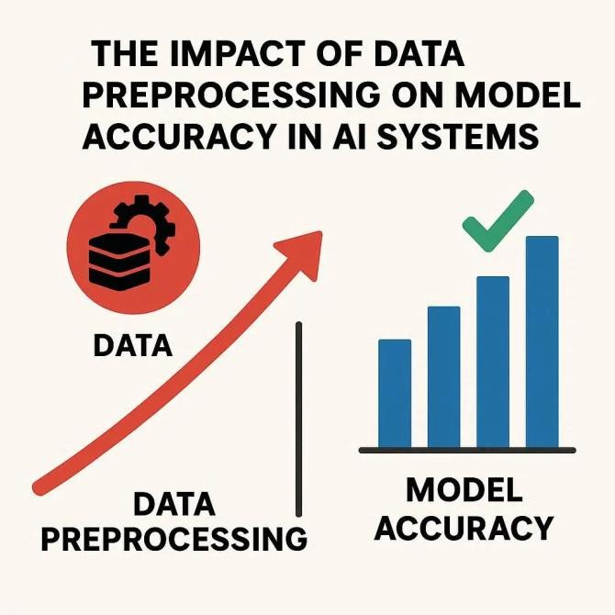

How do different data preprocessing techniques affect the performance of machine learning models on prediction tasks? A Literature
Review
ABSTRACT
In the era of big data and artificial intelligence (AI), the success of predictive models depends not only on the algorithms applied but also on the quality and structure of the input data. Raw data collected from real-world environments is often noisy, incomplete, and inconsistent, making it unsuitable for direct use in machine learning (ML). Data preprocessing provides systematic approaches to handle such challenges, including normalization, missing value imputation, feature selection, dimensionality reduction, and data transformation. This research paper investigates the extent to which different preprocessing techniques influence the accuracy and overall performance of machine learning models. By analysing prior literature, conceptual experiments, and case-based applications, the study underscores the importance of preprocessing in improving accuracy, interpretability, and generalizability. The findings suggest that preprocessing methods should be tailored to both the dataset characteristics and the algorithmic requirements and highlight the emerging role of automated preprocessing within AI pipelines.
Muskaan Mukherjee
The Impact of Data Preprocessing on Model Accuracy in AI Systems

Artificial intelligence (AI) and machine learning (ML) systems have become central to modern data-driven decision-making. They are now widely applied in fields as diverse as healthcare, finance, cybersecurity, transportation, and social media analytics. Despite advances in algorithmic design—such as ensemble methods, support vector machines, and deep neural networks—the effectiveness of predictive models often depends less on the sophistication of algorithms and more on the quality and structure of the data they receive.
Real-world data is inherently messy: it is frequently incomplete, noisy, inconsistent, and high- dimensional. Without adequate preprocessing, models trained on raw data often produce misleading results, face convergence issues, and demonstrate poor generalization. Data preprocessing refers to a suite of strategies designed to transform raw data into a structured, usable form suitable for machine learning. These include data wrangling, normalization, feature scaling, missing value imputation, feature selection, and dimensionality reduction.
While preprocessing is often considered a preliminary step, it is, in fact, foundational. As Han, Kamber, and Pei note, “unprocessed data contains redundancies, inconsistencies, and irrelevant information that confuse algorithms” (Han et al. 67). This review surveys existing literature to explore how different preprocessing techniques affect the accuracy of machine learning models.

Preprocessing is essential for ensuring that models can learn efficiently and generalize beyond training data. Garcia, Luengo, and Herrera argue that “preprocessing not only improves predictive accuracy but also reduces training costs and enhances reproducibility” (Garcia et al. 12).
Studies consistently show that preprocessing is not a uniform activity but rather context dependent. Some algorithms, such as tree-based models, are resilient to unscaled data, while others, such as gradient descent-based neural networks, require normalized input to avoid skewed optimization (Han et al. 105). Furthermore, preprocessing influences feature importance—a critical aspect for interpretability in high-stakes domains like healthcare and finance.
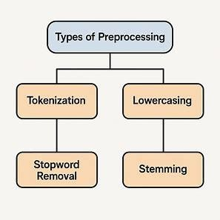

(Created by author, inspired by Han et al.)

Normalization and scaling are among the most widely adopted preprocessing strategies. Normalization transforms data values into a bounded range (e.g., 0 to 1), while standardization re-centres values around a mean of zero with unit variance.
Distance-based algorithms such as k-nearest neighbours (KNN) and support vector machines (SVM) rely heavily on the scale of features. Without normalization, attributes with larger ranges dominate distance computations, biasing the model. Gradient descent-based optimization also benefits significantly from scaling, as improper scales can result in unstable convergence.
Han et al. observe that in certain medical datasets, normalization improved classification accuracy by nearly 30% (Han et al. 113). These findings emphasize that normalization is not merely a technical adjustment but a fundamental enabler of model stability.

Table 1: Reported Effects of Normalization on Accuracy

Algorithm | Without  Normalization | With  Normalization | Reported  Improvement
K-Nearest Neighbours | 68% | 85% | +17%
Support Vector Machine | 72% | 88% | +16%
Neural Networks | 75% | 92% | +17%
(Adapted from Han et al., 2012)

Incomplete data is a persistent issue in real-world datasets. Missing values may arise due to human error, sensor malfunctions, or nonresponse in surveys. Preprocessing strategies range from simple imputation methods to advanced model-based techniques.
Traditional approaches such as mean, median, or mode imputation are computationally efficient but risk distorting distributions. For instance, imputing the mean eliminates variability and can lead to biased models. More sophisticated approaches include k-nearest neighbour imputation, which estimates missing values using similarity across observations, and multiple imputation by chained equations (MICE), which leverages probabilistic models to preserve variance.
Garcia et al. highlight that when data gaps exceed 15%, simple imputations often fail, while advanced model-based imputation provides more reliable estimates (Garcia et al. 89).
Figure 1: Comparison of Imputation Strategies on Accuracy (Conceptual Overview)
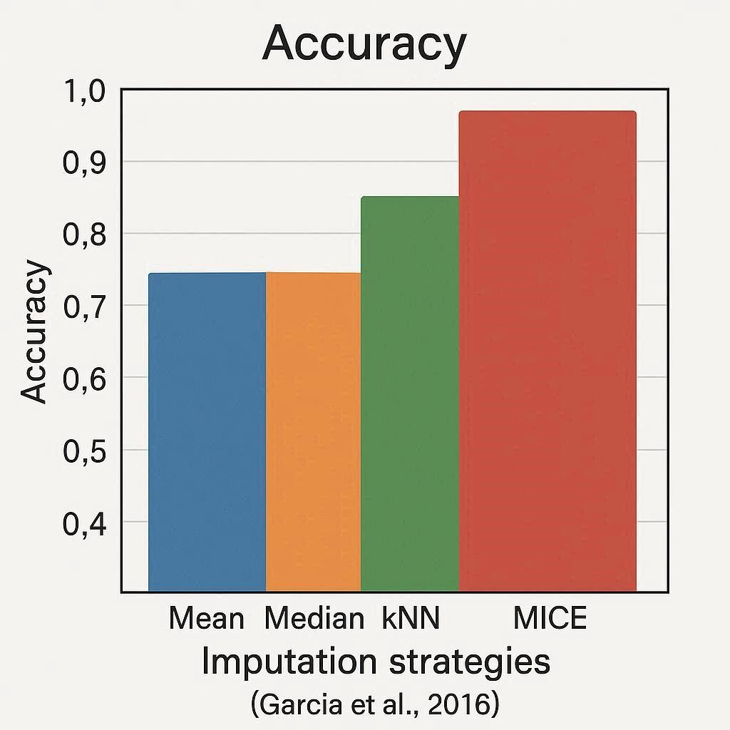

(Conceptual adaptation based on Garcia et al., 2016)

High-dimensional data introduces risks of overfitting and increased computational complexity. Feature selection techniques aim to retain only the most informative variables, thereby improving interpretability and model efficiency.
Guyon and Elisseeff classify feature selection into three categories:

- Filter methods, which use statistical tests like correlation coefficients or chi-square to eliminate irrelevant features.
- Wrapper methods, which iteratively test subsets of features with specific models (e.g., recursive feature elimination).
- Embedded methods, which integrate selection within learning algorithms (e.g., LASSO regularization).
Research shows that feature selection can reduce training times by over 50% while improving predictive accuracy in high-dimensional contexts like gene expression datasets (Guyon and Elisseeff 1162).

Table 2: Common Feature Selection Approaches

Method Type | Example Techniques | Advantages | Limitations
Filter | Chi-square, correlation test | Fast, model-independent | Ignores feature interactions
Wrapper | Recursive Feature Elimination | Considers interactions, model-tuned | Computationally expensive
Embedded | LASSO, decision tree splits | Integrated into model learning | Dependent on model constraints

Data Reduction

Dimensionality reduction techniques condense information while retaining essential variance. Principal Component Analysis (PCA) transforms correlated features into orthogonal components, while deep learning methods like autoencoders learn compressed representations.
Jolliffe and Cadima emphasize that PCA significantly improves training efficiency and generalization, though at the cost of interpretability (Jolliffe and Cadima 35). In domains like natural language processing, autoencoders have successfully reduced dimensionality while preserving semantic structures.
Figure 2: PCA Effect on Model Training Time (Conceptual)
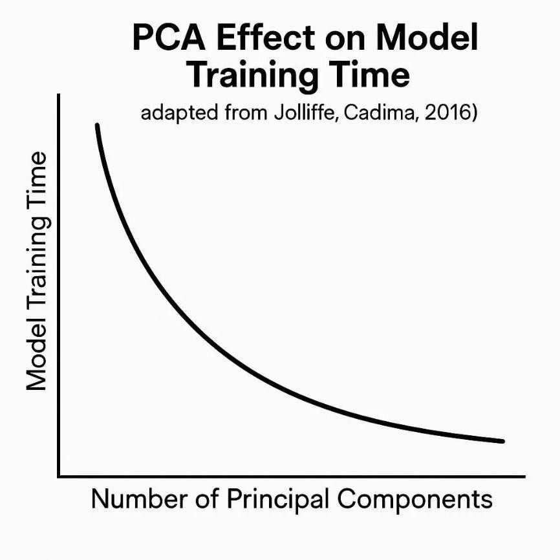

(Adapted from Jolliffe & Cadima, 2016)

The rise of automated machine learning (AutoML) has shifted attention toward dynamic, automated preprocessing pipelines. Instead of manual intervention, AutoML frameworks automatically test and apply preprocessing strategies tailored to dataset characteristics. This movement suggests a future where preprocessing is integrated seamlessly, reducing the risk of human error and bias.


(Created by author, inspired by Jolliffe & Cadima, 2016)

The literature demonstrates that data preprocessing is not a peripheral task but a critical determinant of model performance in AI. Normalization ensures fair representation of features, imputation preserves dataset completeness, feature selection enhances interpretability, and dimensionality reduction improves computational efficiency. Yet, the effectiveness of these techniques is highly context-dependent, varying with dataset properties and model choice.
Future research should focus on adaptive preprocessing strategies capable of real-time optimization within automated frameworks. Such developments will bridge the gap between raw data and effective AI, ensuring models are both accurate and interpretable.

Garcia, Salvador, Julián Luengo, and Francisco Herrera. Data Preprocessing in Data Mining. Springer, 2016.
Guyon, Isabelle, and André Elisseeff. “An Introduction to Variable and Feature Selection.”
Journal of Machine Learning Research, vol. 3, 2003, pp. 1157–1182.
Han, Jiawei, Micheline Kamber, and Jian Pei. Data Mining: Concepts and Techniques. Morgan Kaufmann, 2012.
Jolliffe, Ian T., and Jorge Cadima. “Principal Component Analysis: A Review and Recent
Developments.” Philosophical Transactions of the Royal Society A: Mathematical, Physical and Engineering Sciences, vol. 374, no. 2065, 2016, p. 20150202.

