Real-Time Performance Evaluation of an MPPT-Based EV Charging System Incorporating LiFePO₄ Battery Backup

Abstract—This paper presents the design, development, and experimental validation of a real-time solar tracking system integrated with a Maximum Power Point Tracking (MPPT) controller, and a Lithium Iron Phosphate (LiFePO₄) battery storage unit. The proposed system is designed to improve photovoltaic (PV) energy harvesting by continuously optimizing the panel orientation while simultaneously acquiring and monitoring critical electrical and environmental parameters in real time. An MPPT charge controller is incorporated to extract the maximum available power from the solar module under varying irradiance conditions, thereby improving overall energy conversion efficiency. The generated energy is stored in a high-performance LiFePO₄ battery (IFR32700N60, 6000 mAh, 3.2 V), selected for its high energy density, thermal stability, and extended cycle life. Solar panel positioning is achieved using a bipolar stepper motor driver controlled by a PIC-based embedded controller, while a Real-Time Clock (RTC) ensures accurate daylight-based tracking. In addition, load current is measured through a potential-divider-based sensing circuit, and a temperature-compensated operational amplifier (OP-AMP) filter is employed to improve signal quality and measurement reliability. the proposed system offers a reliable and scalable solution for smart-grid, standalone, and distributed solar energy applications.
Index Terms—Solar Tracking System, MPPT, LiFePO₄ Bat- tery, Data Acquisition System (DAS), PIC Microcontroller, Renewable Energy, Embedded Systems, PV Efficiency, Real-Time Monitoring.

I. INTRODUCTION
The rapid growth in global energy demand, coupled with increasing environmental concerns, has accelerated the adoption of renewable energy technologies, with solar photovoltaic (PV) systems emerging as one of the most promising solutions. Despite the vast availability of solar energy, the amount of power that can be harvested from PV systems is strongly influenced by changing environmental conditions, including solar irradiance, panel orientation, and operating temperature. Solar tracking systems improve the efficiency of PV installations by continuously aligning the solar panels with the sun's position throughout the day, thereby increasing the amount of incident solar radiation captured. Compared with fixed-tilt installations, tracking systems can substantially improve energy generation. However, many conventional solar tracking systems are characterized by complex mechanical structures, limited flexibility, and inadequate adaptability to rapidly changing environmental conditions. These limitations highlight the need for an integrated, reliable, and cost-effective solution capable of combining accurate solar tracking, efficient MPPT control, real-time system monitoring, and intelligent energy storage within a single platform. On the other hand, MPPT algorithms ensure that the PV panel always operates at its optimal power point under varying irradiance and load conditions. However, MPPT alone cannot compensate for misalignment losses caused by static panel positioning. MPPT-enabled charge controller, and a high-performance LiFePO₄ (Lithium Iron Phosphate) battery for efficient energy storage. The system employs a PIC microcontroller to interface with stepper motors for mechan- ical tracking, real-time clocks (RTC) for temporal alignment, and an LCD unit for system diagnostics. The data acquisition layer collects voltage, current, and power data across dual PV strings, filtered through an OP-AMP-based design and processed for feedback control. The proposed system also incorporates a programmable MPPT algorithm based on incremental conductance or perturb and observe (P&O) logic, ensuring real-time optimization of panel output. demonstrate improvements in power output, voltage regula- tion, and current stability compared to conventional fixed- angle systems. This study contributes to the development of adaptive, efficient, and field-deployable PV systems suitable for rural electrification, IoT-based monitoring, and microgrid architec- tures.
II. RELATED WORKS
Several researchers have investigated methods to improve photovoltaic (PV) efficiency using solar tracking systems and MPPT techniques. Fixed-tilt PV systems, although simpler and less costly, suffer from significant efficiency losses due to misalignment with the sun’s path [?]. Dual-axis tracking systems have been proven to enhance solar energy capture by up to 40% compared to static systems, yet their high maintenance cost and mechanical complexity limit widespread adoption [2].
MPPT techniques such as Perturb and Observe (P&O), Incremental Conductance (INC), and fuzzy logic controllers have been widely employed to extract maximum power under varying irradiance and temperature conditions [3]. However, most implementations operate under static configurations and are not integrated with dynamic panel orientation or real-time data logging, which limits their adaptability. Data Acquisition Systems (DAS) in PV systems typically focus on energy logging and status monitoring. Integration of DAS with solar trackers and battery systems has received limited attention. Moreover, most DAS designs are bulky, expensive, or dependent on proprietary protocols, making them less suitable for modular or rural deployment [4].
Battery energy storage systems, especially LiFePO₄ batter- ies, offer promising characteristics including higher thermal stability, longer lifecycle, and improved safety compared to lead-acid and standard Li-ion batteries [5]. However, their efficient utilization in small-scale, programmable embedded solar systems is still an area under exploration. The present work addresses these gaps by proposing a low- cost, modular, and embedded solar tracking system with MPPT and DAS integration. It combines the benefits of adaptive solar tracking, MPPT efficiency, and LiFePO₄ storage in a programmable microcontroller environment[6]. Unlike prior studies, the proposed design emphasizes real-time control, dynamic feedback, and experimental validation using field- acquired data.
III. SYSTEM DESIGN
The proposed system integrates a solar tracking mechanism with a Data Acquisition System (DAS), a Maximum Power Point Tracking (MPPT) charge controller, and LiFePO₄ battery storage. The design aims to achieve maximum energy extrac- tion by combining mechanical solar alignment and electrical optimization.
A. Overall Architecture
The system is built around a PIC-based microcontroller that coordinates the solar tracker, MPPT algorithm, data ac- quisition, and battery management. The primary components include:
- Photovoltaic (PV) Panels: Two PV modules arranged with a tilting mechanism to maximize irradiance capture.
- MPPT Charge Controller: Implements a Perturb and Observe (P&O) algorithm to ensure operation at the maximum power point.
- Data Acquisition System (DAS): Monitors and records voltage, current, and power of the PV panels using sensors and OP-AMP-based filters. 3.2 V is used for energy storage, ensuring high thermal stability and safety.
The solar tracker uses a compact and modular structure suitable for single-axis or dual-axis tracking. The bipolar stepper motor driver is capable of handling up to 2 A per phase and operates between 9–24 V.It supports full and half- step modes, with real-time directional control provided by the microcontroller. A kill switch input is included for emergency motor disablement.
- Battery Management
The LiFePO₄ battery is charged using a constant- current/constant-voltage (CC-CV) charging approach. The bat- tery parameters follow the manufacturer specifications [?], with a charging voltage of 3.65 V and standard charging current of 0.2C (1.2 A for 6000 mAh). Over-charge, over- discharge, and thermal protections are ensured via the MPPT controller and battery management logic.
- System Flowchart

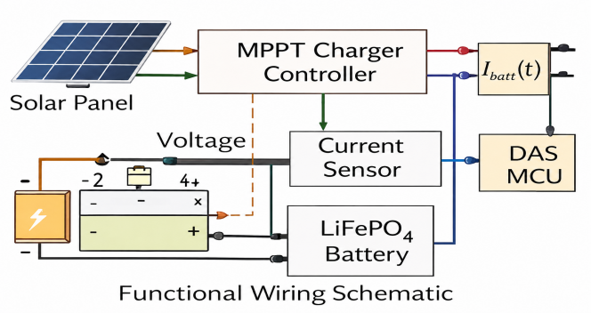
III. CIRCUIT DIAGRAMS
This section presents the hardware and control architecture used in the implementation of the solar tracking system. The focus is on three key circuits: the MPPT charge controller flowchart, the DAS control process, and the bipolar stepper motor driver used for solar panel positioning.[7]
- MPPT Charger Flowchart and Hardware Integration .The Maximum Power Point Tracking (MPPT) logic is implemented using the Perturb and Observe (P&O) algorithm. As depicted in Fig. 1, the algorithm adjusts the duty cycle of a DC-DC converter by perturbing the operating voltage and observing the change in output power. The direction of adjustment (increase or decrease in PWM duty cycle) is based
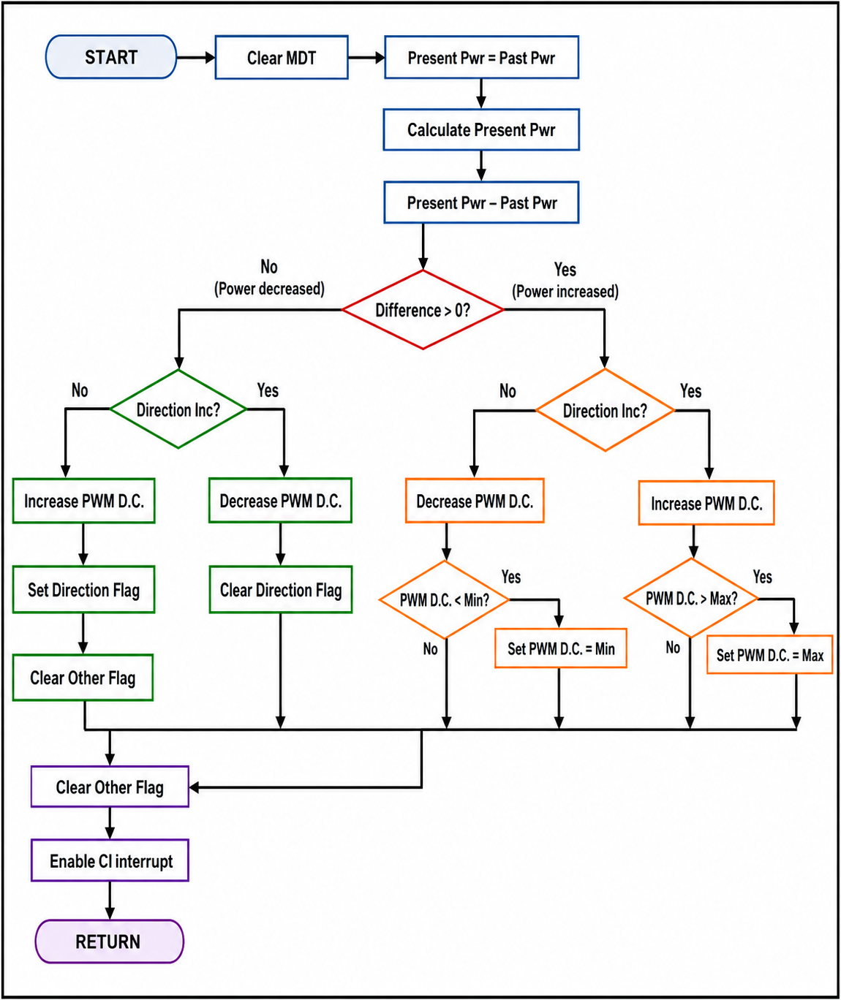
Fig. 2. Flowchart of MPPT Charger Using P&O Algorithm

on whether the power output rises or falls in response to voltage change.
In addition to the control algorithm, the actual wiring and component layout of the MPPT charger system is shown in Fig. 2, which highlights the electrical connections between the PV panel, Data Acquisition System (DAS), MPPT charger, and battery bank.

Connection Details:
- The positive terminal of the solar panel is connected to the positive PV input of the DAS (J4).
- A switch is inserted between the positive terminal of the solar panel and the red cable for manual cutoff or fault protection.
- The blue cable from the solar panel connects to the negative terminal of the panel and feeds into the DASinput (J4).
- The positive terminal of the battery from the MPPT solar charger connects to the positive terminal of the DAS (J5).
- Similarly, the negative terminal of the solar charger connects to the negative terminal of DAS (J5).
- The DAS output terminals (J5) are directly connected to the battery bank, ensuring real-time monitoring and logging of battery behavior.
- Both the negative terminals of the PV (J4) and battery (J5) at the DAS are unified and connected to the common ground of the battery bank.
This physical layout ensures efficient power flow, accurate sensing of PV and battery parameters, and proper grounding to avoid loop interference. The design also enables the DAS to capture real-time current and voltage profiles, supporting MPPT operation and battery state estimation.
- DAS Control Flow
The embedded firmware in the PIC microcontroller follows the control sequence shown in Fig. 3. Initialization of periph- erals (RTC, ADC, LCD) is followed by a continuous loop to acquire and display solar parameters.
- Limit Switch Integration
A limit switch circuit prevents the mechanical structure from over-rotation. When the panel hits its maximum tilt, the circuit generates a stop signal that interrupts the stepper motor rotation.
D. Experimental Control Logic
The MPPT, panel rotation, and battery charging logic are managed through interrupt-driven control loops in the PIC microcontroller, operating with an internal clock up to 40 MHz. PWM output resolution is up to 10-bit, suitable for fine- tuned DC-DC converter control.
The real-time tracking ensures optimal irradiance alignment, while the MPPT loop converges to V_{mpp} within a few seconds after perturbation.
IV. EXPERIMENTAL RESULTS AND DATA ANALYSIS
To validate the performance of the implemented MPPT strategy, a detailed statistical and correlation analysis was car- ried out on the acquired data. Table I presents the descriptive statistics for key parameters such as panel voltage (Vpv), panel current (Ipv), photovoltaic power (Ppv), load power (Pld), and system efficiency. It is observed that the mean power generated by the PV panel is approximately 208.82 W with a relatively high standard deviation (2556.42 W), reflecting the wide range of dynamic solar conditions during the experiment. To further explore parameter interdependencies, the Pearson correlation matrix is visualized.Strong positive correlations are observed between Ipv and Ppv (1.00), and between Vpv and Ipv (0.58), which is consistent with the power equation P = V × I. Moreover, system efficiency exhibits a high positive correlation with both current (0.85) and voltage (0.82), confirming that the algorithm successfully tracks the operating point that maximizes efficiency under varying input conditions. The low correlation between time and other parameters implies that the variations are primarily driven by environmental and load conditions, rather than time progression.
These observations not only reinforce the functional in- tegrity of the MPPT logic but also validate the system’s ability to adapt to real-time changes, achieving maximum power transfer and efficient energy utilization.
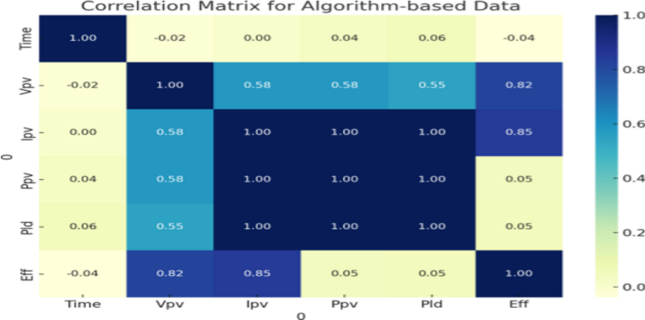

Fig. 9. Correlation Matrix for Algorithm-based MPPT Data. Strong positive correlations are observed between photovoltaic current (Ipv ), power (Ppv ), and system efficiency, validating the dynamic tracking behavior of the MPPT control logic.

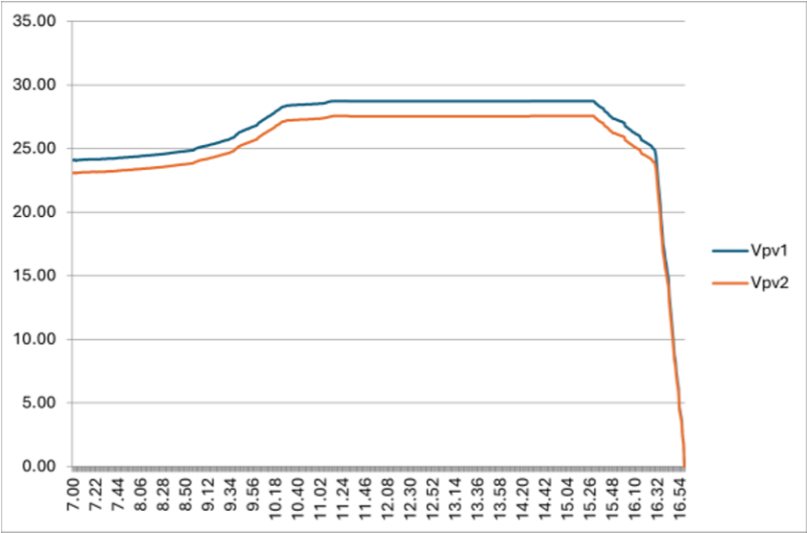

Power output (PV1 and PV2) vs. Time

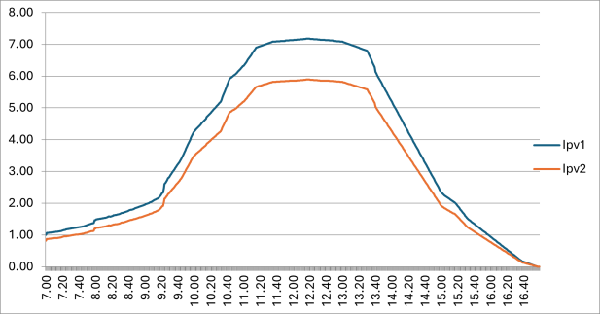

Fig. 11. Panel voltage variation vs. Time

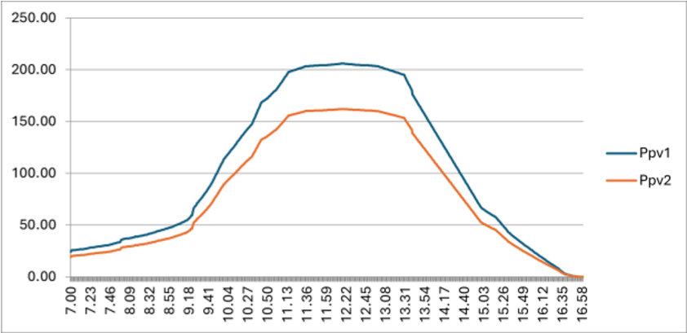

Fig. 12. Current output from PV1 and PV2 vs. Time

V CONCLUSION AND FUTURE SCOPE
This work presents the successful design, implementation, and experimental evaluation of an MPPT-based solar charging system integrated with a real-time Data Acquisition System (DAS) and LiFePO₄ battery storage. The proposed system employs a Perturb and Observe (P&O) MPPT algorithm to continuously track the maximum power point of the photovoltaic (PV) module, enabling efficient power extraction under varying solar irradiance and load conditions. The integration of real-time monitoring through the DAS facilitates continuous acquisition, visualization, and recording of key electrical parameters, providing valuable insights into system performance and operational reliability.The developed MPPT charge controller effectively maximizes energy conversion efficiency while ensuring stable battery charging. The LiFePO₄ battery (IFR32700N60) offers reliable energy storage owing to its high thermal stability, long cycle life, and enhanced safety characteristics, making it well suited for standalone and renewable energy applications. Experimental results demonstrate stable operation of the charging system, efficient power transfer from the PV module to the battery, and reliable real-time performance monitoring under practical operating conditions.The modular hardware architecture and programmable control strategy make the proposed system flexible, cost-effective, and easily scalable for a wide range of solar energy applications, including off-grid power systems, educational laboratories, EV charging prototypes, and community-based renewable energy installations. Overall, the integration of MPPT control, real-time DAS, and LiFePO₄ battery storage provides an effective and intelligent energy management solution capable of enhancing the efficiency, reliability, and practicality of modern photovoltaic systems.

VI REFERENCES
[1] I. Miri, A. Fotouhi, and N. Ewin, “Electric vehicle energy consumption modelling and estimation—A case study,” Int. J. Energy Res., 2021.
[2] S. Sadagopan et al., “A solar power system for electric vehicles with maximum power point tracking for novel energy sharing,” 2014.
[3] A. Sayyad et al., “Solar Powered Electric Bicycle With Kinetic Energy Restoration System (KERS),” 2016.
[4] S. R. Chafle, U. B. Vaidya, and Z. Khan, “Design of Cuk converter with MPPT technique,” 2013.
[5] A. Harrasi and A. F. Zobaa, “A cost-effective harmonic cancellation method for high-frequency silicon carbide MOSFET-based single phase inverter,” 2016.
[6] V. Vaideeswaran, S. Bhuvanesh, and M. Devasena, “Battery Management Systems for Electric Vehicles using Lithium Ion Batteries,” 2019.
[7] S. Chanagala, B. P. Eppe, N. Dudhe, and A. Akkewar, “A review on battery management system for electric vehicles and a hypothesis for an improvised battery management system,” 2020.
[8] M. Nizam et al., “Design of battery management system (BMS) for lithium iron phosphate (LFP) battery,” 2019.
[9] N. A. Zainurin et al., “A review of battery charging-discharging management controller,” 2021.
[10] M. Ismail and R. Ahmed, “A comprehensive review of cloud-based lithium-ion battery management systems for electric vehicle applications,” 2024.
[11] Z. Lyu et al., “Towards an intelligent battery management system for electric vehicle applications,” 2024.
[12] J. Smith and M. Lee, “A comprehensive review of battery management systems in electric vehicles,” 2023.
[13] W. Chen and L. Zhao, “Optimization strategies for battery management systems in electric vehicles: A survey,” 2022.
[14] P.-E. Hartz, L. Liu, and G. Zhu, “State of charge estimation for lithium-ion batteries using extended Kalman theorem,” 2015.
[15] R. M. Imran, Q. Li, and F. M. Flaih, “An enhanced lithium-ion battery model for estimating the state of charge using an optimized extended Kalman filter,” 2020.
[16] J. Hou et al., “Robust lithium-ion state-of-charge and battery parameters joint estimation based on an enhanced adaptive unscented Kalman filter,” 2023.
[17] Y. Liu, X. Zhang, and X. Li, “Particle swarm optimization of Elman neural network applied to lithium-ion battery state of charge and health estimation,” 2023.
[18] M. Yasin et al., “Improved capacity estimation method for Li-ion battery cells using a modified Kalman filter and a cell thermal model,” 2025.
[19] BatteryDesign.net, “Enhancing lithium-ion battery management with advanced Kalman filter tuning,” 2024.
[20] S. Chanagala et al., “A rate-capacity and recovery-effect aware battery management system for electric vehicles,” 2021.
[21] Y. Yang et al., “Optimization of the energy management system in hybrid electric vehicles considering cabin temperature,” 2024.
[22] Y. Zhang, X. Li, and J. Wang, “Modified particle swarm optimization-based powertrain energy management strategy for hybrid electric vehicles,” 2023.
[23] H. Li, Z. Wang, and Z. Chen, “Particle swarm-optimized fuzzy logic energy management strategy for a battery–ultracapacitor hybrid energy storage system in electric vehicles,” 2024.
[24] S. Umathe and R. Hiware, “Artificial intelligence and IoT based smart battery management system for electric vehicle,” 2022.
[25] Microchip Technology Inc., “Brushless DC Motor Control Using PIC18Fxx31 Microcontrollers,” 2003.
[26] J. Dunn, “Determining MOSFET driver needs for motor drive applications,” 2003.
[27] O. IEEE Industry Applications Society, 2017 IEEE Industry Applications Society Annual Meeting, 2017.
[28] E. Hossain et al., “A Comprehensive Review on Second-Life Batteries,” 2019.
[29] R. Hiware and S. Umathe, “Review on power system security of grid connected hybrid power system,” 2020.
[30] R. P. Tapaskar, P. P. Revankar, and S. V. Ganachari, “Advancements in battery management systems for electric vehicles: A MATLAB-based simulation of 4S3P lithium-ion battery packs,” 2024.
[31] R. S. Hiware, S. K. Umathe, and S. Bire, “Design of sine filter for GTO-based auxiliary converter for electric locomotive using MATLAB Simulink,” 2020.
[32] N. Rahmani and M. Mostefai, “Multi-objective MPSO/GA optimization of an autonomous PV-wind hybrid energy system,” 2022.

