HEAT TREATMENT ANALYSIS ON MICROSTRUCTURE AND MECHANICAL PROPERTIES OF THIXOFORMED ALUMINIUM ALLOYS

ABSTRACT
This study investigates the combined effects of magnesium (Mg) content and artificial aging duration on the microstructural evolution and mechanical properties of thixoformed A356 Al–Si–Mg alloys. Magnesium additions of 0.1, 0.3, and 0.5 wt.% were introduced into A356 alloy, followed by thixoforming and T6 heat treatment with artificial aging at 180 °C for 1, 3, and 5 hours. A Taguchi L9 orthogonal array was employed to systematically evaluate the influence of process parameters on yield strength (YS), ultimate tensile strength (UTS), elongation to fracture, and Vickers hardness. The results demonstrate that increasing Mg content and aging duration significantly enhance YS, UTS, and hardness, attributed to precipitation strengthening by Mg₂Si phases and refinement of spheroidized α-Al globules. However, a reduction in ductility was observed with higher Mg levels and prolonged aging. The findings provide an optimized processing window for achieving a balance between strength and ductility in thixoformed A356 alloys, offering practical implications for automotive and lightweight structural applications.

Key Words: A356 Alloy; Thixoforming; Magnesium content; Artificial aging; Mechanical properties; Taguchi method
______________________________________________________________________________________________
1.0 Introduction
Al–Si–Mg alloys are widely used in automotive and aerospace industries due to their excellent strength-to-weight ratio, good castability, and favorable response to heat treatment (A. Megalingam et al., 2024). Among these alloys, A356 has attracted considerable attention for manufacturing lightweight structural components where mechanical performance and dimensional precision are critical. The incorporation of magnesium plays a vital role in enhancing mechanical properties through precipitation of Mg₂Si phases during aging heat treatment (Abdelgnei et al., 2022).
Thixoforming, a semisolid metal processing technique, has emerged as an effective route to improve the microstructural uniformity and mechanical behavior of aluminum alloys. By processing the alloy in its semisolid state, thixoforming promotes the formation of spheroidized αAl grains and a more homogeneous distribution of eutectic silicon, resulting in reduced porosity and improved strength–ductility balance (Abdelgnei et al., 2020). Previous studies have shown that combining thixoforming with T6 heat treatment can significantly improve tensile strength and hardness of Al–Si–Mg based alloys, although excessive Mg addition may lead to reduced ductility due to the formation of brittle intermetallic phases (Alhawari et al., 2017).
Despite extensive studies on Al–Si–Mg alloys, systematic investigations focusing on the combined effects of Mg content and artificial aging duration on thixoformed A356 alloys remain limited. Optimization of these parameters using a statistical design approach is still underexplored. Therefore, the present study aims to evaluate the influence of varying Mg content and aging time on the microstructure and mechanical properties of thixoformed A356 alloy using the Taguchi method. The outcomes of this work are expected to provide useful guidelines for optimizing heat treatment parameters in industrial thixoforming applications.

2.0 Materials and Methods
2.1 Material Preparation

The base material used in this study was a commercial A356 aluminum alloy, supplied in ingot form. Prior to casting, the chemical composition of the base alloy was verified to ensure compliance with the standard A356 composition range. Magnesium was subsequently added to the molten alloy to achieve target Mg contents of 0.1, 0.3, and 0.5 wt.%, respectively.
The alloy was melted in an electric resistance furnace using a graphite crucible at a temperature of approximately 720–750 °C. Once fully molten, the melt was held for sufficient time to ensure chemical homogeneity. The required amount of magnesium was then added in the form of pure Mg lumps and gently stirred to promote uniform dissolution while minimizing oxidation losses. To reduce hydrogen porosity and non-metallic inclusions, a degassing process was carried out using a commercial degassing tablet prior to casting.
After melting treatment, the alloy was poured into a preheated permanent steel mold to produce cylindrical billets suitable for subsequent thixoforming. The mold was preheated to approximately 200–250 °C to promote uniform solidification and reduce thermal shock. Gravity casting was employed, and care was taken to ensure a stable and continuous pour to minimize turbulence and oxide entrainment. The cast billets were allowed to solidify under ambient conditions before being removed from the mold.
This controlled casting route was selected to ensure consistent initial microstructure and chemical composition across all samples prior to semisolid processing and heat treatment. By maintaining identical melting and casting conditions for all Mg levels, the influence of casting related variables on the subsequent thixoforming and mechanical properties was minimized.

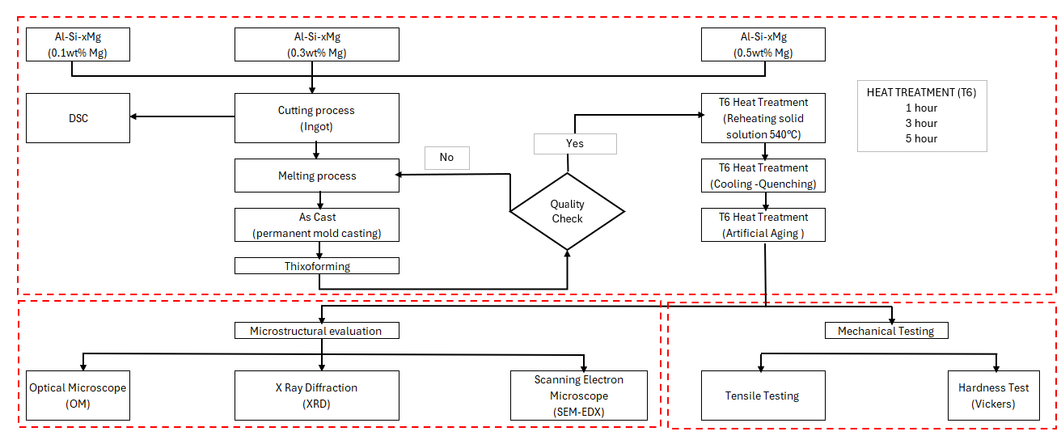
Figure 2.1.1: Flow chart on Al-Si-Mg alloying with different amounts Mg using casting mold and Thixoforming process

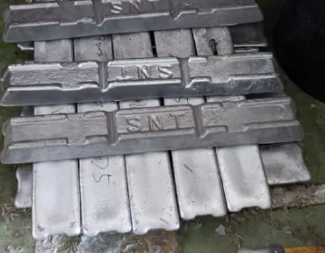
Figure 2.1.2: Aluminum Ingot (A356)

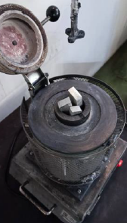
Figure 2.1.3: Aluminum ingot insertion into crucible

Thixoforming and Heat Treatment
Following casting, the billets were prepared for thixoforming by reheating of the semisolid temperature range. The reheating temperature was determined based on preliminary Differential Scanning Calorimetry (DSC) analysis to ensure an appropriate solid fraction suitable for semisolid processing. The billets were reheated in a controlled furnace until a non-dendritic, semisolid microstructure was achieved.
Thixoforming was carried out by transferring the reheated billets into a steel die and applying forming pressure to produce near-net-shaped specimens. This process promotes the breakdown of dendritic structures and the formation of spheroidized α-Al grains surrounded by a liquid eutectic phase, resulting in reduced porosity and improved microstructural uniformity.
After thixoforming, all specimens underwent a T6 heat treatment cycle. Solution heat treatment was performed at an elevated temperature to dissolve soluble phases, followed by rapid quenching in water to retain a supersaturated solid solution. Artificial aging was subsequently conducted at 180 °C for 1, 3, and 5 hours to promote precipitation hardening through the controlled formation of β-Mg₂Si precipitates.

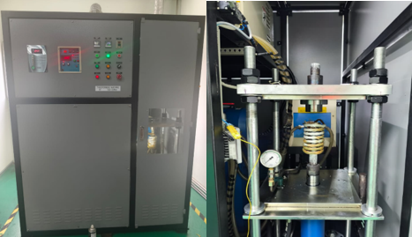
Figure 2.2.1: Thixoforming process

Experimental Design
A Taguchi design of experiments approach was employed to systematically evaluate the influence of magnesium content and artificial aging duration on the mechanical properties of thixoformed A356 alloys. A two-factor, three-level Taguchi L9 orthogonal array was selected to minimize the number of experimental runs while maintaining sufficient statistical reliability.
The two control factors investigated were Mg content (0.1, 0.3, and 0.5 wt.%) and artificial aging duration (1, 3, and 5 h). The response variables included yield strength, ultimate tensile strength, elongation to fracture, and Vickers hardness. This experimental design enabled the identification of dominant factors affecting mechanical performance and facilitated optimization of processing parameters with reduced experimental cost and time.

Table 2.3: Design summary method of Taguchi method
# Run  (Code) | Magnesium  amount addition  (wt%) | Artificial Aging  duration (ºC) at  180 ºC
1 | 0.1 | 1 hour
2 | 0.1 | 3 hour
3 | 0.1 | 5 hour
4 | 0.3 | 1 hour
5 | 0.3 | 3 hour
6 | 0.3 | 5 hour
7 | 0.5 | 1 hour
8 | 0.5 | 3 hour
9 | 0.5 | 5 hour

Characterization
Microstructural characterization was performed using Optical Microscopy (OM) and Scanning Electron Microscopy (SEM) to examine grain morphology, eutectic silicon distribution, and precipitate formation. Specimens for metallographic examination were sectioned, ground, polished, and etched using Keller’s reagent to reveal the aluminum matrix and microstructural features. Energy Dispersive X-ray (EDX) analysis was employed to identify elemental distribution and confirm the presence of Mg-containing phases.
Mechanical characterization was carried out through tensile testing and hardness measurements. Tensile tests were conducted in accordance with ASTM E8/E8M standards using a universal testing machine, and key parameters such as yield strength, ultimate tensile strength, and elongation to fracture were recorded. Vickers microhardness measurements were performed following ASTM E92 using an appropriate load and dwell time. Multiple measurements were taken for each condition to ensure repeatability, and average values were reported for analysis.
The experimental results were analyzed statistically using signal-to-noise (S/N) ratios to evaluate the influence of process parameters and determine optimal conditions.

- Results and Discussion
3.1 Effect of Mg Content and Aging Duration on Tensile Properties
The tensile properties of thixoformed A356 alloys with varying Mg content and aging duration are summarized in Table 2. A clear increasing trend in yield strength and ultimate tensile strength was observed with increasing Mg content and prolonged aging time, which is consistent with previously reported behavior in Al–Si–Mg alloy systems (Alhawari et al., 2017; Bahrami et al., 2012; C. Barbosa et al., 2023). Notably, the UTS values obtained in the present study for thixoformed alloys aged 5 h are comparable to, and in some cases higher than those reported for conventional T6-treated A356 alloys (Alhawari et al., 2017; Jin, 2022) , highlighting the beneficial influence of semisolid processing on mechanical performance.
The observed strength enhancement is primarily attributed to the increased density and uniform distribution of β-Mg₂Si precipitates formed during artificial aging, which effectively hinder dislocation motion and promote precipitation hardening (Abdelgnei et al., 2020; Alshammari et al., 2020; Singh et al., 2023). In comparison with ascast A356 alloys reported in the literature, the thixoformed samples in this work exhibit a more refined and spheroidized α-Al microstructure, consistent with observations reported for semisolidprocessed Al alloys (Andrea Marterior et al., 2025; Cai et al., 2020; Yildirim & Özyürek, 2013). This refined microstructure contributes to improved load transfer efficiency and reduced stress concentration at grain boundaries.

However, a gradual reduction in elongation to fracture was observed with increasing Mg content and aging duration. This strength–ductility trade-off has been widely reported in Al–Si– Mg alloys subjected to extended artificial aging, where increased precipitate density and intermetallic phase formation limit plastic deformation capability (C. Barbosa et al., 2023; Jin, 2022). These findings indicate that an optimal combination of Mg content and aging duration is required to balance strength and ductility for structural applications.

The present results therefore provide experimental evidence supporting previous findings while extending current knowledge by demonstrating that thixoforming combined with controlled Mg addition can achieve superior mechanical performance compared to conventional casting routes (Cai et al., 2020; Yildirim & Özyürek, 2013).

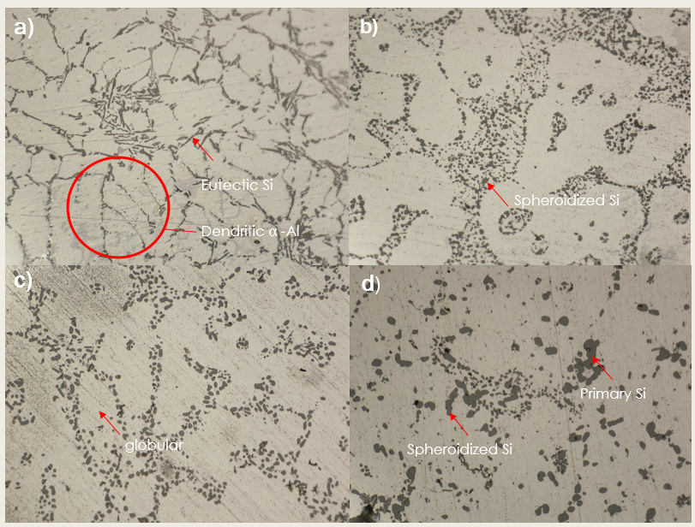

Figure 3.1.1: Optical microstructures of the Al–Si–Mg alloy with different Mg contents: (a) as cast condition showing dendritic α-Al structure with acicular eutectic Si; (b) 0.1 wt.% Mg exhibiting partial spheroidization of eutectic Si particles; (c) 0.3 wt.% Mg showing a more refined and globular eutectic Si morphology with improved distribution; (d) 0.5 wt.% Mg characterized by well-spheroidized Si particles with the presence of primary Si embedded in the α-Al matrix.
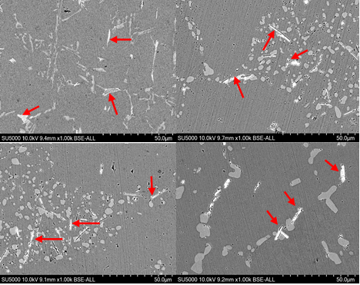

Figure 3.1.2: SEM images of Al–Si–Mg alloys in (a) as-cast, (b) 0.1 wt.% Mg, (c) 0.3 wt.% Mg, and (d) 0.5 wt.% Mg conditions, illustrating the evolution of eutectic Si morphology and intermetallic distribution with increasing Mg content.

3.2 Hardness Evaluation
Vickers hardness measurements exhibited a trend closely aligned with the tensile strength results, whereby increasing magnesium (Mg) content and prolonged aging duration led to a systematic rise in hardness values. This enhancement in hardness can be primarily attributed to the precipitation hardening mechanism inherent to Al–Si–Mg alloys. During artificial aging, supersaturated Mg and Si atoms progressively precipitate as finely dispersed Mg₂Si phases within the aluminum matrix. These coherent and semi-coherent precipitates effectively impede dislocation motion, thereby increasing resistance to plastic deformation and resulting in higher hardness values.

Furthermore, a higher Mg content promotes the formation of a greater volume fraction of Mg₂Si precipitates, while extended aging duration allows for more complete precipitation and improved precipitate distribution. The combined effect of increased precipitate density and optimized precipitate size strengthens the alloy matrix, which explains the parallel improvement observed in both hardness and tensile strength. Similar correlations between Mg content, aging time, and hardness evolution have been widely reported in previous studies on Al–Si–Mg alloys, confirming that precipitation strengthening is the dominant mechanism governing the mechanical response of these alloys after heat treatment.

Table 3.2: Tensile properties evaluation for Aluminum alloy sample A356 with various Mg addition and various Artificial Aging duration
Run | Mg content (wt%) | Aging duration (Hours) | Yield strength (MPa) | Ultimate tensile strength (MPa) | Elongation to fracture (%) | Hardness (HV)
1 | 0.1 | 1 | 235.02 | 284.60 | 7.02 | 111.43
2 | 0.1 | 3 | 240.85 | 291.42 | 6.53 | 116.09
3 | 0.1 | 5 | 263.45 | 310.99 | 6.03 | 122.13
4 | 0.3 | 1 | 265.82 | 335.18 | 5.74 | 125.79
5 | 0.3 | 3 | 276.00 | 342.80 | 5.65 | 129.01
6 | 0.3 | 5 | 261.21 | 345.71 | 5.51 | 130.01
7 | 0.5 | 1 | 263.19 | 321.56 | 4.74 | 127.43
8 | 0.5 | 3 | 290.74 | 370.09 | 4.57 | 137.56
9 | 0.5 | 5 | 300.74 | 375.87 | 4.34 | 140.00

  - Optimization Using Taguchi Analysis
Based on the signal-to-noise (S/N) ratio analysis, the optimal processing condition for maximizing both tensile strength and hardness was determined to be 0.5 wt.% Mg combined with 5 hours of artificial aging. This parameter combination yielded the highest S/N ratio, indicating superior performance stability and reduced variability in mechanical properties. The improved strength and hardness under this condition can be attributed to the effective precipitation of fine and uniformly distributed Mg₂Si phases, which enhance dislocation resistance without excessive precipitate coarsening.

However, while this condition is optimal for achieving peak strength and hardness, it may not necessarily provide the best compromise between strength and ductility. Higher aging durations or Mg contents, although beneficial for hardness, can promote precipitate coarsening and increased matrix strengthening, which may reduce the alloy’s ability to undergo plastic deformation. Consequently, intermediate Mg levels and aging durations offer a more balanced microstructural state, where sufficient precipitation strengthening is achieved while maintaining adequate ductility. Such trade-offs are particularly important for structural and automotive applications, where components are often subjected to combined loading conditions and require both high strength and reasonable formability.

Table 3.3.1: Main effects plot for S/N ratios of Aluminum alloy sample A356 with various Mg addition and various Artificial Aging duration
 | Yield Strength (YS) |  | Ultimate tensile strength (UTS)
Level | Mg content (wt%) | Aging duration (Hours) | Mg content (wt%) | Aging duration (Hours)
1 | 47.82 | 48.11 | 49.41 | 49.91
2 | 48.55 | 48.57 | 50.66 | 50.45
3 | 49.08 | 48.77 | 51.00 | 50.71
Delta | 1.26 | 0.67 | 1.26 | 0.67
Rank | 1 | 2 | 1 | 2

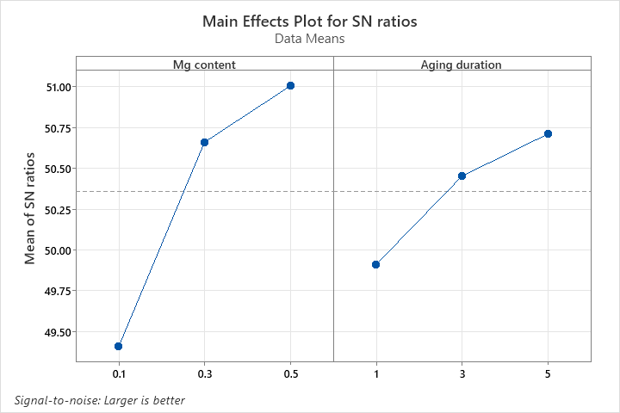
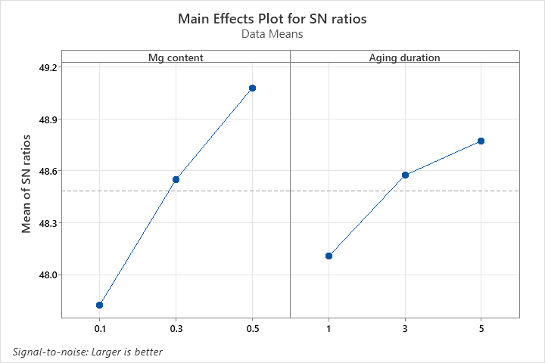

Figure 3.3.1: Main effects plot of control factors on the S/N ratio for (a) Yield Strength (YS), (b) Ultimate Tensile Strength (UTS)

Table 3.3.2: Main effects plot for S/N ratios of Aluminum alloy sample A356 with various
Mg addition and various Artificial Aging duration
 | Elongtion (ETF) |  | Hardness
Level | Mg content (wt%) | Aging duration (Hours) | Mg content (wt%) | Aging duration (Hours)
1 | 16.28 | 15.21 | 41.32 | 41.68
2 | 15.06 | 14.90 | 42.16 | 42.09
3 | 13.15 | 14.39 | 42.60 | 42.31
Delta | 3.12 | 0.81 | 1.28 | 0.63
Rank | 1 | 2 | 1 | 2

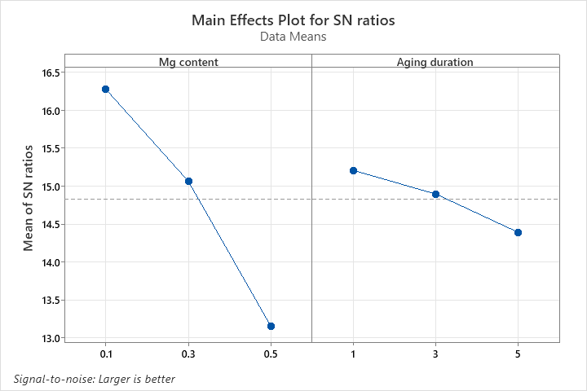
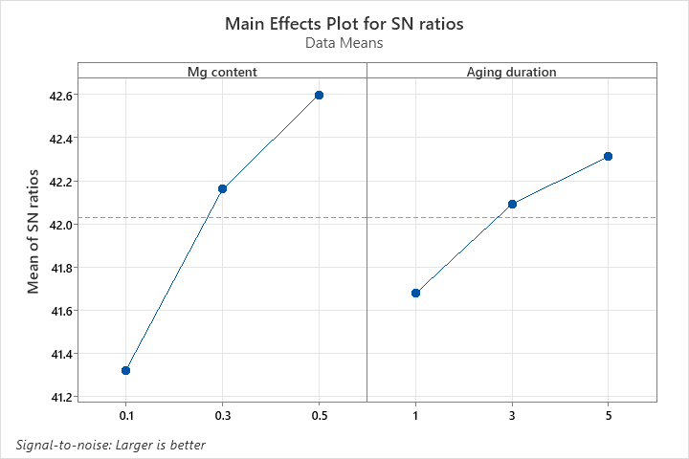

Figure 3.3.2: Main effects plot of control factors on the S/N ratio for (c) Elongation, and (d) Hardness

4.0 Results and Discussion
The present study systematically evaluated the combined effects of magnesium content and artificial aging duration on the microstructure and mechanical properties of thixoformed A356 Al– Si–Mg alloys using a Taguchi experimental design. The results demonstrate that increasing Mg content from 0.1 to 0.5 wt.% and extending artificial aging time from 1 to 5 hours significantly enhance yield strength, ultimate tensile strength, and hardness due to effective precipitation strengthening by β-Mg₂Si phases and refined spheroidized α-Al grains.
In comparison with previously reported data for conventionally cast A356 alloys, the thixoformed alloys investigated in this work exhibit comparable or superior strength levels under similar T6 aging conditions, underscoring the effectiveness of combining semisolid processing with controlled Mg addition. However, excessive Mg content and prolonged aging result in reduced ductility, highlighting an inherent strength and ductility trade-off that must be considered when optimizing material performance. Overall, the Taguchi method proved to be an effective tool for identifying optimal processing parameters and clarifying the relative influence of Mg content and aging duration. The findings contribute new insights into parameter optimization for thixoformed A356 alloys and provide a reliable basis for tailoring mechanical properties to meet specific engineering requirements.
The present study systematically evaluated the combined effects of magnesium content and artificial aging duration on the microstructure and mechanical properties of thixoformed A356 Al– Si–Mg alloys using a Taguchi experimental design. The results demonstrate that increasing Mg content from 0.1 to 0.5 wt.% and extending artificial aging time from 1 to 5 hours significantly enhance yield strength, ultimate tensile strength, and hardness due to effective precipitation strengthening by β-Mg₂Si phases and refined spheroidized α-Al grains. In comparison with previously reported data for conventionally cast A356 alloys, the thixoformed alloys investigated in this work exhibit comparable or superior strength levels under similar T6 aging conditions, underscoring the effectiveness of combining semisolid processing with controlled Mg addition.
However, excessive Mg content and prolonged aging result in reduced ductility, highlighting an inherent strength–ductility trade-off that must be considered when optimizing material performance. Overall, the Taguchi method proved to be an effective tool for identifying optimal processing parameters and clarifying the relative influence of Mg content and aging duration. The findings contribute new insights into parameter optimization for thixoformed A356 alloys and provide a reliable basis for tailoring mechanical properties to meet specific engineering requirements.
The findings of this study demonstrate that thixoforming combined with optimized magnesium content and artificial aging parameters can be effectively applied in industrial production of A356 aluminum components (A.M. Aziz et al., 2024; Cai et al., 2020; Yildirim & Özyürek, 2013) . The ability to achieve higher strength levels while maintaining acceptable ductility offers significant advantages for lightweight structural applications, particularly in the automotive and aerospace sectors, where Al–Si–Mg alloys are widely adopted (Abdelgnei et al., 2022; Jin, 2022; C. Barbosa et al., 2023) .
The identified processing window provides practical guidance for manufacturers to tailor mechanical properties according to component design requirements, such as load-bearing capacity and weight reduction targets (Alhawari et al., 2017; Salleh et al., 2015) . Furthermore, the use of a statistically guided optimization approach supports improved process consistency, reduced trial-and-error during process setup, and enhanced quality control, thereby facilitating potential implementation in large-scale manufacturing environments (Salleh et al., 2015; Yildirim & Özyürek, 2013).

ACKNOWLEDGMENTS

The study is funded by the Ministry of Higher Education (MOHE) of Malaysia through the Fundamental Research Grant Scheme (FRGS)FRGS/1/2022/TK10/UTEM/02/18. The authors would like to thank Universiti Teknikal Malaysia Melaka (UTeM) for supporting this study.

REFERENCES

A. Megalingam, A.H. Ahmad, N.A Alang, N. Muhammad, & K. Muduli. (2024). A review of viscosity measurement techniques for semi-solid metal fluids in thixoforming processes. INTERNATIONAL JOURNAL OF AUTOMOTIVE AND MECHANICAL ENGINEERING, 21(3), 11526–11541. https://doi.org/https://doi.org/10.15282/ijame.21.3.2024.6.0889
Abdelgnei, M. A., Omar, M. Z., & Ghazali, M. J. (2022). Improving Mechanical Properties of Al-Si-Cu Alloy Using Thixoforming Process with T6 Heat Treatment. International Science and Technology Journal (ISTJ), (Special Issue (LICASE 2022).), 72–86.‬‬
Abdelgnei, M. A., Omar, M. Z., Ghazali, M. J., Mohammed, M. N., & Rashid, B. (2020). Dry sliding wear behaviour of thixoformed Al-5.7Si–2Cu-0.3 Mg alloys at high temperatures using Taguchi method. Wear, 442–443. https://doi.org/10.1016/j.wear.2019.203134
Alhawari, K. S., Omar, MM. . Z., GHAZALI, M. J., Salleh, M. S., & Mohammed, M. N. (2017). Microstructural evolution during semisolid processing of Al–Si–Cu alloy with different Mg contents. Transactions of Nonferrous Metals Society of China (English Edition), 27(7), 1483–1497. https://doi.org/10.1016/S1003-6326(17)60169-9
Alshammari, T. T., Alharbi, H. F., Soliman, M. S., & Ijaz, M. F. (2020). Effects of mg content on the microstructural and mechanical properties of al‐4cu‐xmg‐0.3ag alloys. Crystals, 10(10), 1–13. https://doi.org/10.3390/cryst10100895
Andrea Marterior, A. M., Joyce Nocheseda, C. C., & Donnabelle Balela, M. L. (2025). Effect of T6-like and T5-like Heat Treatment on the Microstructure and Hardness of Cast and 3D-Printed Al-Si-Mg Alloy Systems. Philippine Journal of Science, 154, 37–45.
Bahrami, A., Miroux, A., & Sietsma, J. (2012). An age-hardening model for Al-Mg-Si alloys considering needle-shaped precipitates. Metallurgical and Materials Transactions A: Physical Metallurgy and Materials Science, 43(11), 4445–4453. https://doi.org/10.1007/s11661-012-1211-8
Cai, Q., Mendis, C. L., Chang, I. T. H., & Fan, Z. (2020). Effect of short T6 heat treatment on the microstructure and the mechanical properties of newly developed die-cast Al–Si–Mg–Mn alloys. Materials Science and Engineering: A, 788. https://doi.org/10.1016/j.msea.2020.139610
Jin, C. K. (2022). Microstructures and Mechanical Properties of A356 Alloy and A6061 Alloy through Rheo, Upsetting, Thixo, Forming Process, and T6 Heat Treatment. Metals, 12(12). https://doi.org/10.3390/met12122051
Salleh, M. S., Omar, M. Z., & Syarif, J. (2015). The effects of Mg addition on the microstructure and mechanical properties of thixoformed Al-5%Si-Cu alloys. Journal of Alloys and Compounds, 621, 121–130. https://doi.org/10.1016/j.jallcom.2014.09.152
Singh, P., Ramacharyulu, D. A., Kumar, N., Saxena, K. K., & Eldin, S. M. (2023). Change in the structure and mechanical properties of Al–Mg–Si alloys caused by the addition of other elements: A comprehensive review. Journal of Materials Research and Technology, 27, 1764–1796. https://doi.org/10.1016/j.jmrt.2023.09.220
Yildirim, M., & Özyürek, D. (2013). The effects of Mg amount on the microstructure and mechanical properties of Al-Si-Mg alloys. Materials and Design, 51, 767–774. https://doi.org/10.1016/j.matdes.2013.04.089
Carolina Barbosa, Hugo Azevedo, Sharlane Costa, João Ribeiro, José Carlos, Thiago Costa & Otávio Rocha Solidification and heat-treatment conditions affecting the tensile properties of an automotive AlSiMg alloy, Silicon 15 (2023) 4931–4942. https://doi.org/10.1007/s12633-023- 02409-3
A.M. Aziz, M.Z. Omar, S. Samat, I.F. Mohamed, Z. Sajuri, A.H. Baghdadi, Microstructural and tensile behavior of a thixoformed Al–Si–Cu–Mg given T5 and T6 heat treatments, Int. J. Metalcasting 18 (2024) 2343–2356. https://doi.org/10.1007/s40962-023-01155-x

