GEOMETRIC PRINCIPLES IN AVIAN MIGRATION:

NATURE’S NAVIGATORS
¹Aleena Khan, ² Dr. Swati Singh Rana
¹Post Graduation Student, ² Assistant Professor
Department of Mathematics
Mohammad Ali Jauhar University, Rampur, India

Abstract: Bird migration is one of nature’s most complex and awe-inspiring phenomena, involving thousands of kilometers of travel with remarkable accuracy. While biological instincts play a significant role, birds also rely on geometric and spatial principles for navigation and route optimization. This study examines how birds utilize natural geometry—such as Earth’s curvature, angular positioning of celestial bodies, and geomagnetic field orientation—for accurate long-distance movement. Great circle routes, solar and stellar geometry, magnetic field lines, triangulation, and energy optimization in flight formations are analyzed mathematically and conceptually. The findings highlight that avian migration integrates biological instincts with advanced geometric reasoning, offering insights into both natural navigation systems and applied mathematics.

Index Terms: Avian migration; great circle routes; celestial geometry; geomagnetic mapping; triangulation; energy optimization.

1. Introduction
Every year, billions of birds migrate between breeding and wintering grounds, often traversing continents and oceans. This feat requires not only biological adaptation but also advanced spatial cognition. Geometry—the study of space, angles, and positions—plays a pivotal role in how birds determine direction, measure distance, and maintain efficient migratory paths. This paper explores the geometric principles underpinning avian migration, focusing on route optimization, celestial cues, geomagnetic orientation, and aerodynamic efficiency.

2. Materials and Methods
This work is based on theoretical and mathematical analysis of geometric principles that influence avian migration. The study draws on prior ornithological and mathematical literature and translates observed migratory behavior into formal geometric models.

3. Results

3.1. Great Circle Routes: Shortest Paths on a Sphere
Birds traveling across Earth’s curved surface often follow great circle routes rather than straight lines on a flat map. The great circle distance between two points with coordinates (φ1, λ1) and (φ2, λ2) is given by:
d = R × arccos [sin φ1 × sin φ2 + cos φ1 × cos φ2 × cos (λ2 − λ1)]
where R is Earth’s radius. Long-distance migrants, such as Arctic terns, demonstrate understanding of this principle by following curved flight paths across hemispheres.
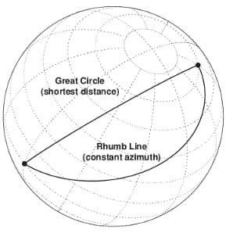

figure 1. comparison between a great buntings recognize constellations circle route and rhumb line on a globe.

3.2. Celestial Geometry: Using the Sun and Stars
Birds use solar and stellar cues for orientation.
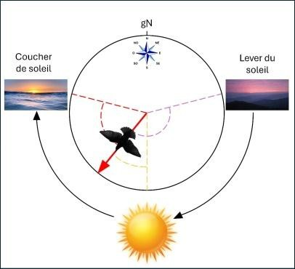
3.2.1 Sun Compass: By observing the sun’s azimuth in relation to an internal circadian clock, birds estimate longitudinal displacement.

figure 2. birds adjust their flight direction according to the position of the sun in the sky over the course of a day (from sunrise to sunset) to reach their destination.
3.2.2 Star Navigation: Nocturnal migrants identify star patterns, particularly Polaris in the Northern Hemisphere, as a fixed point for orientation. Indigo buntings, for example, learn geometric star patterns during early development.
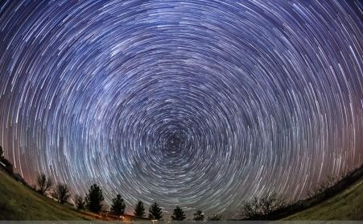

figure 3. star trails demonstrating the apparent rotation of the night sky around polaris.

3.3. Magnetic Field Lines and Geometric Orientation
Earth’s magnetic field provides predictable angular cues:
3.3.1 Inclination Angle: Birds detect the angle between the magnetic field and the horizontal plane, offering latitudinal estimation.
3.3.2 Geomagnetic Mapping: Variations in field intensity and inclination allow positional triangulation, functioning similarly to a natural GPS.
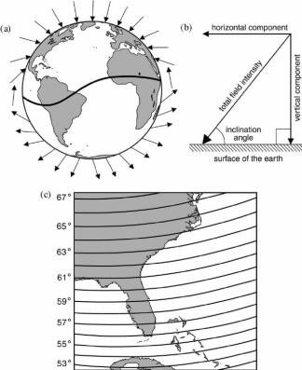
figure 4. representation of earth’s magnetic field lines, showing inclination angles

3.4. Landmarks, Triangulation, and Cognitive Mapping
Some species use topographical features as reference points:
3.4.1 Triangulation: Birds identify two or more landmarks and estimate their position by measuring relative angular separation.
3.4.2 Mental Geometry: Homing pigeons employ Euclidean reasoning, constructing cognitive maps to return home with precision.

3.5. Energy Optimization: Geometry of Wind and Terrain
Migratory birds also exploit geometric strategies to reduce energy costs.
3.5.1 V-Formation Flight: Geese arrange themselves in a V-shape, minimizing drag and maximizing uplift from the bird ahead. This aerodynamic formation distributes energy expenditure efficiently.

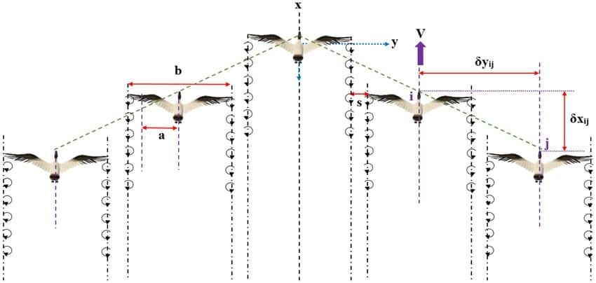

figure 5. geese flying in a vformation to optimize energy expenditure.

4. Discussion
The study demonstrates that avian migration, while biologically motivated, is profoundly mathematical. Birds integrate spherical geometry, celestial triangulation, and geomagnetic field analysis in ways comparable to human navigation systems. The results suggest that migratory efficiency is rooted in natural optimization problems, combining instinctive behavior with geometric logic.
Future studies may extend these principles into bio-inspired navigation algorithms for aviation and autonomous robotics, where geometry-driven strategies can enhance route optimization and energy efficiency.

5. Conclusions
Avian migration highlights the deep connection between biology and geometry. From great circle routes to V-formations, birds employ natural mathematics to solve navigation challenges. This work contributes to applied mathematics by framing migration as a dynamic geometric system, offering insights for both biological sciences and engineering applications.

References
[1] Emlen, S.T. The stellar-orientation system of a migratory bird. Scientific American 1975, 233(2), 102–111.
[2] Alerstam, T. Conflicting evidence about long-distance animal navigation. Science 2006, 313(5788), 791–794.
[3] Wiltschko, W.; Wiltschko, R. Mechanisms of orientation and navigation in migratory birds. In Avian Migration; Springer: Berlin/Heidelberg, Germany, 2003; pp. 433–456.
[4] Gagliardo, A. Forty years of olfactory navigation in birds. Journal of Experimental Biology 2013, 216(12), 2165–2171.

