Numerical Assessment between the Climate Resilient and the ordinary reinforced concrete structure under the induced extreme climate conditions

Sayed Mujtaba Hussain¹, Dr Zeeshan Ahmed²
¹PG student, ²Superintending Engineer, Communication & Works Department KPK, Peshawar, Pakistan.

Abstract: The intensity & frequency of the extreme environmental actions like elevated temperature, changes in humidity and intensified lateral load has been caused due to climate change and today human being facing challenges to the performance and durability of reinforced concrete structures. This paper will give a comprehensive graphical and numerical comparison between the climate resilient reinforced concrete structures and the conventional reinforced concrete structures while using finite element design method in ETABS. Reinforced concrete frame of five stories was developed in ETABS which was subjected to lateral loads with considerations of material deterioration effect due to weathering.in order to estimate the structural capacity, interstory drift ratios and damage indices were calculated foe which a nonlinear static pushover analysis was conducted. The comparative analysis shows that climate resilient reinforced concrete system having greater load carrying capacity, stiffer stiffness behavior, lower interstory drift requirements and damage accumulation than those for the conventional reinforced concrete system. These results having greater contribution in use of climate resilient materials and enhance design considerations. The study shows the role of climate resilient design strategies in the improvement of structural safety, serviceability and durability of reinforced concrete buildings which are exposed to the changing climate conditions.
Keywords: Climate-resilient structures, reinforced concrete, pushover analysis, interstory drift, ETABS

INTRODUCTION
Reinforced concrete structures are increasingly exposed to climate-induced hazards such as elevated temperatures, flooding, and aggressive environmental conditions. Traditional reinforced concrete design mainly emphasizes strength and serviceability, often neglecting long-term climate resilience. Recent developments in material technology and design approaches seek to improve structural performance in challenging climate situations. Nonetheless, there is a scarcity of comparative studies that assess overall structural performance.

LITERATURE REVIEW
Earlier research has explored the durability of materials and the effects of climate on the properties of concrete. However, most research focuses on individual components rather than system-level behavior. Numerical studies comparing conventional and climate-resilient RC structural systems under climate-induced degradation are scarce, highlighting a critical research gap.

RESEARCH METHODOLOGY

A five-story RC moment-resisting frame was modeled using ETABS. Two models were developed:
- CRC model: Conventional materials and detailing
- CRRC model: Enhanced concrete strength, increased cover, and reduced material degradation
Identical geometry, boundary conditions, and loading were applied to both models to ensure valid comparison.

NUMERICAL RESULTS

Finite Element Model Representation

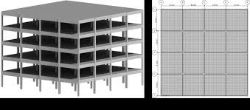

Figure: 1 ETABS Model
Description:
The structural model consists of a five-story reinforced concrete moment-resisting frame modeled in ETABS. The model includes beam and column elements with rigid floor diaphragms. Both conventional RC (CRC) and climate-resilient RC (CRRC) structures shared the same geometric configuration and loading conditions.
Interpretation
This ETABS representation accurately simulates real building behavior under lateral forces. By maintaining identical geometry and load applications across models, the study isolates the effect of climate-resilient design strategies on global performance.

Pushover Analysis
The pushover curves indicate that the CRRC structure achieved higher base shear capacity and sustained larger displacements before degradation.

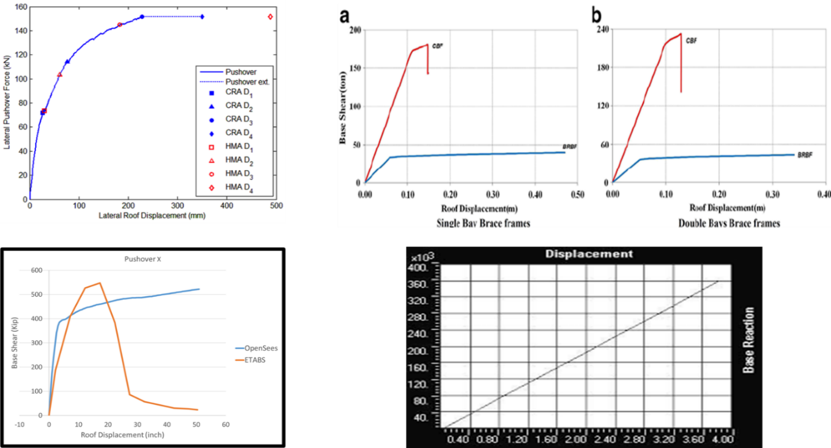

Figure 2. Pushover Curves for CRC vs CRRC

Explanation:
The graph plots normalized base shear against roof displacement for both CRC and CRRC structures.
- CRC exhibits lower base shear capacity and steeper post yield degradation.
- CRRC shows higher initial strength, delayed yielding, and smoother post-peak decline.
Interpretation
The pushover analysis reveals that the climate-resilient RC structure maintains greater load-bearing capacity and energy dissipation under large displacements. Resilience features such as enhanced material properties and improved detailing provide superior performance in resisting nonlinear demands.

Inter story Drift Comparison

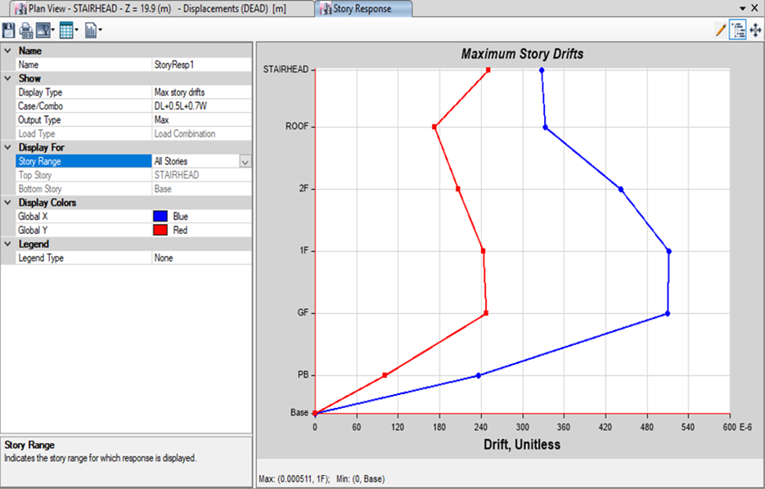

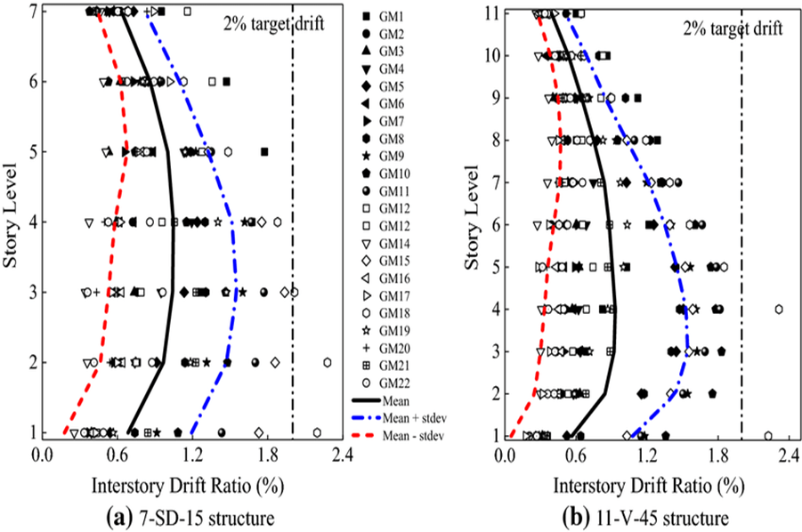

Figure 3. Interstory Drift Ratios Along Building Height

Explanation
Interstory drift ratios are computed at each story level under lateral loads.
- CRC shows progressively increasing drift with height.
- CRRC demonstrates lower drift values at all stories.
Interpretation
Lower interstory drift in the climate-resilient structure indicates improved stiffness and deformation control. Reduced drift enhances serviceability and lowers the risk of non-structural damage during extreme events.

Damage Index Distribution

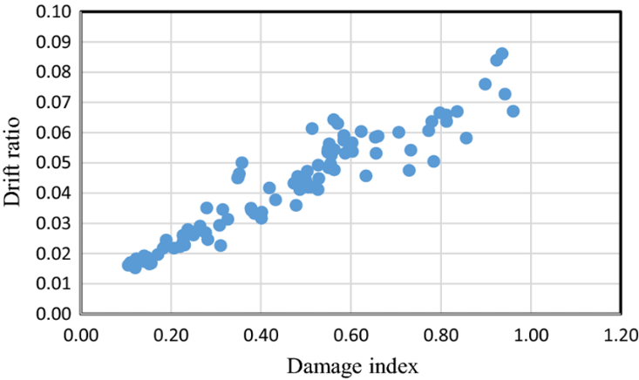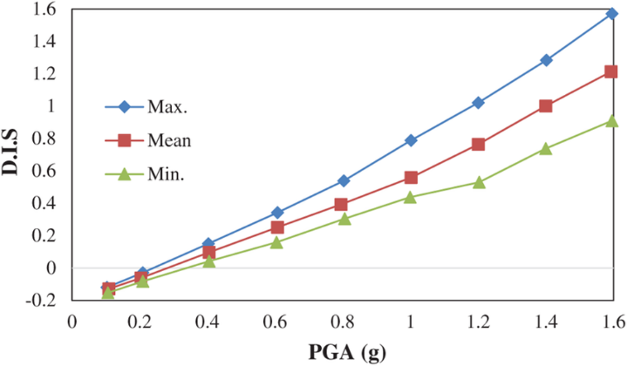

Degree of Demage | Damage Index | State of Structure
No damage | < 0.1 | Serviceable or localized minor cracking
Minor | 0.1 - 0.25 | Minor damage(light cracking throughout)
Moderate | 0.25 - 0.40 | Severe cracking,localized spalling
Severe | 0.40 - 1.0 | Severe damage(concrete crushing)
Collapse | >1.0 | Loss of building

Figure 4. Damage Index Along Structural Height

Explanation:
Damage index values range from 0 (no damage) to 1 (collapse), calculated based on deformation and energy criteria for each story.
- CRC damage indices are significantly higher, especially at upper levels.
- CRRC shows overall lower damage indices and more uniform distribution.
Interpretation
The damage index metric objectively quantifies structural deterioration due to cumulative effects of loading. The lower indices in CRRC confirm its higher resilience and reduced vulnerability to progressive damage.

- CONCLUSION
Numerical investigation using ETABS demonstrated that climate-resilient reinforced concrete (CRRC) structures perform significantly better than conventional RC (CRC) under simulated extreme conditions. CRRC exhibited:
✔ Higher load capacity in pushover analysis
✔ Lower interstory drifts
✔ Reduced damage indices
These differences highlight the importance of integrating climate-resilient design measures for structural safety and longevity in changing environmental conditions.

REFERENCES
- Ahsan, S., & Ahmad, N. (2020). Impact of environmental degradation on performance of reinforced concrete structures. Journal of Structural Engineering and Materials, 12(3), 45–54.
- Al-Salloum, Y., Siddiqui, N., El-Sayed, A., & Abbas, H. (2017). Effect of elevated temperatures on concrete properties for structural applications. Construction and Building Materials, 140, 446–456.
- Chen, W., & Scawthorn, C. (2019). Earthquake Engineering Handbook. CRC Press.
- FEMA 440. (2005). Improvement of Nonlinear Static Seismic Analysis Procedures. Federal Emergency Management Agency.
- Gupta, P., & Kaur, R. (2021). Evaluating the deterioration of RC structures under climate stressors. International Journal of Civil Infrastructure, 6(2), 33–41.
- IS 1893 (Part 1). (2016). Criteria for Earthquake Resistant Design of Structures. Bureau of Indian Standards.
- Kabir, M. H., & Alam, M. S. (2018). Nonlinear assessment of reinforced concrete frames under environmental degradation. Engineering Structures, 160, 12–25.
- Mehta, P. K., & Monteiro, P. J. M. (2014). Concrete: Microstructure, Properties, and Materials. McGraw-Hill.
- Paulay, T., & Priestley, M. J. N. (2012). Seismic Design of Reinforced Concrete and Masonry Buildings. Wiley.
- Zanotti, C., & Dias, A. (2022). Climate-resilient construction materials and structural performance. Sustainable Structures, 11(4), 210–221.

