AI-DRIVEN MEETING ASSISTANT FOR TRANSCRIPTION, SENTIMENT ANALYSIS, AND INTELLIGENT REPORT GENERATION USING WHISPER AND TRANSFORMER MODELS

ABSTRACT
The rapid expansion of collaborative digital meetings in corporate, academic, and research sectors has intensified the need for streamlined, high-fidelity documentation systems. Traditional manual note-taking is fundamentally limited, frequently producing fragmented archives, inconsistent task tracking, and a loss of strategic insights. To address these inefficiencies, this study introduces an advanced, AI-driven meeting intelligence framework designed to seamlessly convert unstructured conversational audio into structured, actionable business assets. The core architecture integrates an optimized speech recognition pipeline powered by OpenAI’s Whisper model to deliver resilient, high-accuracy multi-lingual text transcription under varied acoustic environments and accents. Following lexical normalization, the text transcripts are processed concurrently through a dual-paradigm summarization engine utilizing BART and T5 transformer models, allowing stakeholders to extract both context-rich narrative briefs and concise text-to-text recaps. Additionally, the system features an automated sentiment classification module to evaluate team alignment and conversational dynamics, alongside a syntactic dependency parsing framework engineered to extract action items, assignees, and project deadlines. System performance was validated on forty real-world meeting recordings, with the transcription module achieving an optimal Word Error Rate (WER) of 12.4% and the downstream summarization and extraction blocks demonstrating strong predictive accuracy. A comparative evaluation establishes that our proposed platform delivers a highly comprehensive, unified analytics dashboard and automated report-generation ecosystem that significantly outperforms standard commercial alternatives.
Keywords: Meeting Analytics, Speech Recognition, Whisper, Transformer Models, Natural Language Processing.

1. INTRODUCTION
The increasing volume of meetings conducted in academic institutions, corporate organizations, and research environments has created a growing demand for efficient documentation methods. Meeting discussions often contain critical decisions, assigned responsibilities, deadlines, and strategic information that must be preserved for future use. Conventional note-taking approaches depend heavily on human effort and frequently result in inconsistent or incomplete records. Consequently, organizations face challenges in maintaining accurate documentation and tracking follow-up activities.
Recent progress in artificial intelligence has enabled the development of systems capable of understanding and processing human language in both spoken and written forms. Improvements in speech recognition technology have significantly increased transcription accuracy, while advances in transformer-based language models have enhanced capabilities in summarization, information extraction, and sentiment understanding. These developments provide an opportunity to automate many aspects of meeting management that were previously performed manually.
The objective of this research is to design and implement an intelligent meeting assistant capable of transforming recorded conversations into structured and meaningful outputs. The framework integrates multiple analytical components, including speech transcription, summary generation, sentiment evaluation, task identification, and report preparation. By combining these functionalities into a unified platform, the system aims to simplify meeting documentation while improving information accessibility and decision tracking.

2. RELATED WORK
Applying machine learning paradigms to conversational tracking has become an active area of contemporary research, fueled by an escalating demand for lightning-fast information retrieval and corporate knowledge retention. Early prototypes in this domain operated primarily as rudimentary speech-to-text translators, producing long blocks of unformatted text that lacked semantic context or organizational hierarchy. Modern systems, by contrast, focus on comprehensive linguistic comprehension, moving deep into abstractive contextual modeling, dialogue tone classification, and proactive duty identification pipelines. This evolution minimizes the heavy administrative burdens historically imposed on human coordinators during or after long sessions At the heart of modern transcription success is OpenAI's Whisper model, which provides robust multi-lingual and domain-specific acoustic processing [1], [10]. Because it was trained on expansive, diverse audio datasets, Whisper exhibits remarkable resilience against heavy background noise, rapid verbal delivery styles, and varying regional accents [1], [10]. Securing a highly precise textual transcript is vital, as any downstream text-mining pipeline depends fundamentally on the lexical validity of this initial machine-readable output.
Once a verified text base is formed, transformer models such as Bidirectional and Auto-Regressive Transformers (BART) and Text-to-Text Transfer Transformers (T5) are frequently utilized to compress extensive conversation transcripts into concise, human-readable highlights [2], [3]. These encoder-decoder architectures excel at capturing long-range dependencies across multi-turn dialogues, ensuring that key developments are not lost during text condensation.
Beyond simple text summarizing, modern studies focus heavily on identifying affective metrics and contextual indicators within conversational flows. Models built on deep contextual representations, particularly BERT, have significantly advanced semantic categorization, intent recognition, and sentence-level polarity mapping [5]. Furthermore, specialized work in dialogue act recognition and dependency parsing has introduced reliable strategies for isolating specific tasks, identifying assignees, and pulling out concrete deadlines from messy, unstructured text [12]–[14].
While major market solutions like Otter.ai, Zoom AI Companion, and Microsoft Teams provide native transcription and high-level summaries, they generally fail to provide deep, multi-model analytics or customizable visual reporting ecosystems. The framework presented in this paper bridges these gaps by combining advanced acoustic decoding, dual-paradigm summary logic, sentiment tracking, precise task extraction, and instant interactive reporting into a single, cohesive ecosystem [15]–[20].

3. METHODOLOGY
3.1 System Architecture
The underlying architecture is built as an ordered, multi-tier execution pipeline designed to process unstructured acoustic files into polished, structured corporate assets. Each analytical step operates as an independent module that processes its input, normalizes the text data, and passes its clean payload to the next down-stream component. This clear separation of concerns ensures low processing latency, simplifies troubleshooting, and permits granular adjustments to specific machine learning models without disrupting the overarching pipeline.
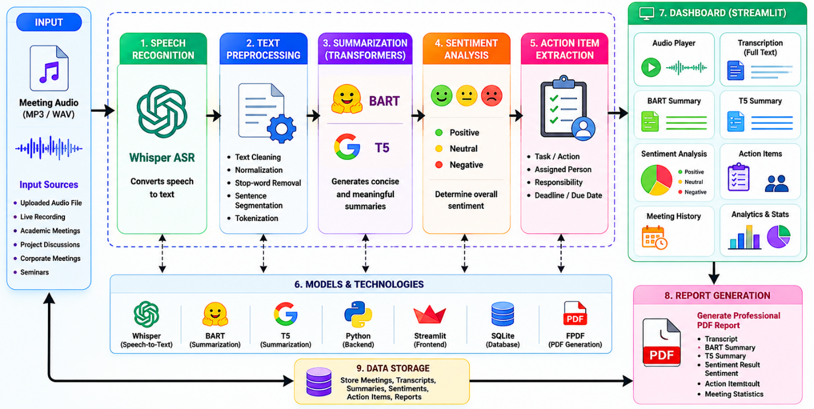
Figure 1. Overall architecture of the proposed AI-driven meeting assistant system.
3.2 Audio Acquisition
The platform ingests acoustic inputs through two distinct ingestion pathways: interactive browser-based live voice recording or direct, batch file uploads. To maximize cross-platform adaptability, the ingestion gateway supports a wide range of audio containers, including container types such as MP3, WAV, M4A, and WEBM.
3.3 Speech Transcription
Incoming audio recordings are directed to the OpenAI Whisper engine to generate an accurate raw text stream [1]. Once decoded, the raw text moves through a preprocessing pipeline designed to strip out verbal stutters and filler words, correct syntax punctuation, and normalize text casing, thereby optimizing the text for down-stream transformer performance.
3.4 Summarization
Following linguistic cleanup, the finalized text transcript is fed simultaneously into two separate transformer-based text generation engines. The first model, BART, focuses on context retention to deliver a comprehensive narrative description of the meeting themes. The second engine, T5, applies a strict text-to-text generation mechanism to produce short, high-impact bulleted recaps. This dual-engine setup allows stakeholders to instantly cross-examine both reporting styles and pick the summary type that fits their immediate needs.
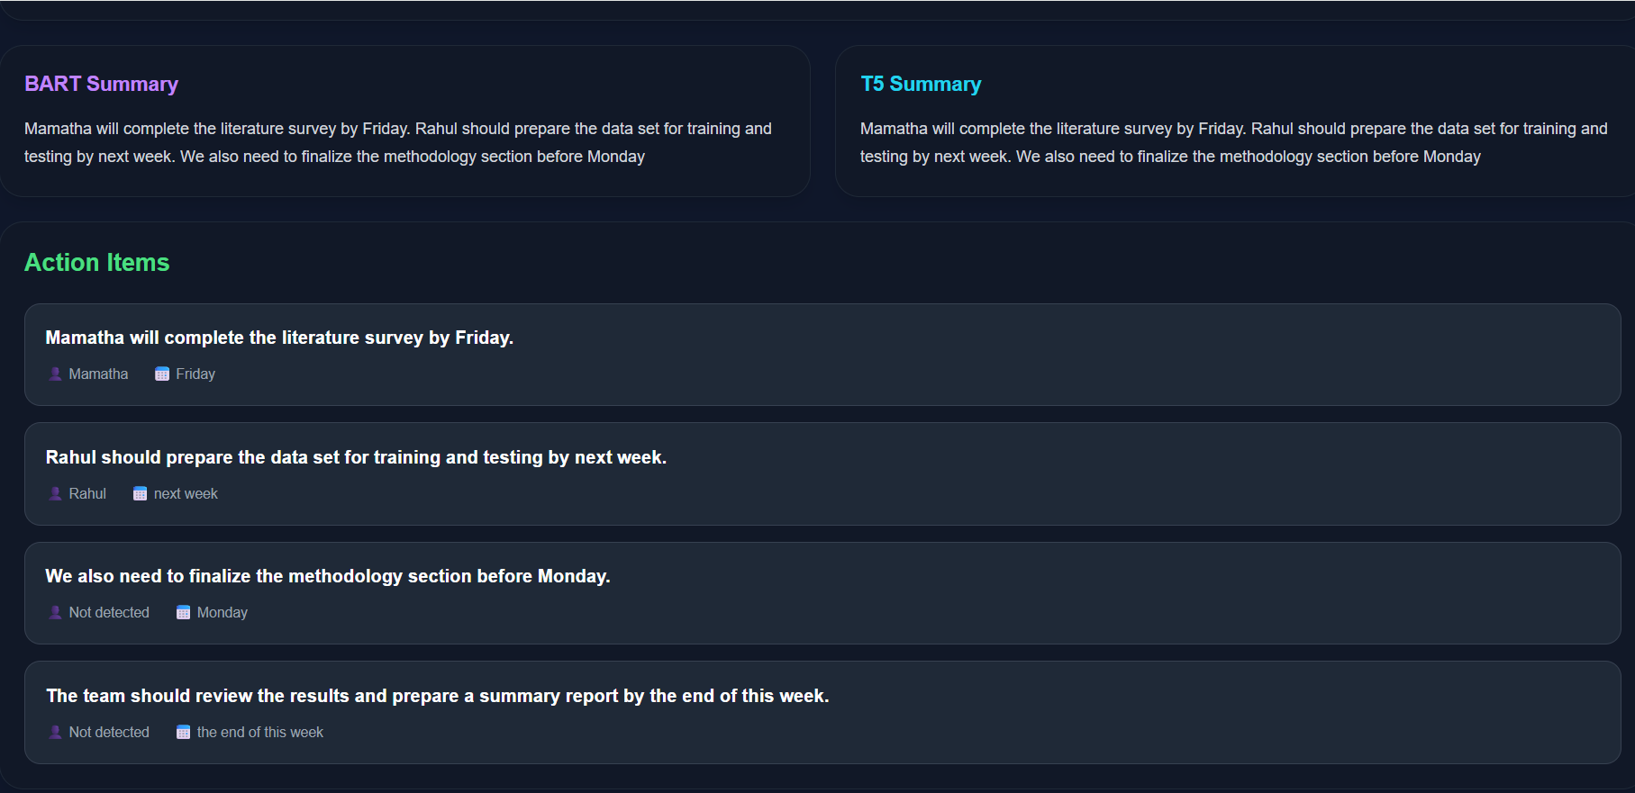
Figure 2. Summary generation interface demonstrating concurrent BART and T5 contextual outputs with corresponding task extractions.
3.5 Sentiment Analysis
To evaluate the emotional dynamics of the interaction, the text string is routed through an automated sentiment processing engine. By evaluating specific phrases and emotional markers, the system assigns a primary emotional label—Positive, Neutral, or Negative—to the conversation. Tracking these linguistic cues provides managers with quantitative metrics to analyze historical meeting trajectories and evaluate overall team alignment.
3.6 Action-Item Extraction
The task-mining framework targets operational deliverables by identifying implied or explicit commitments made during the session. Using advanced Named Entity Recognition (NER) models coupled with syntactic dependency parsers, the system isolates specific task descriptions, associates them with the appropriate team member, and flags stated due dates. These details are then transformed into structured data schemas for immediate project tracking.
3.7 Report Generation
The final phase involves gathering the individual data streams from the core processing units and organizing them into clean, high-fidelity summary documents. Every compiled report bundles together the complete transcript, dual-model summaries, sentiment metrics, identified task lists, and high-level meeting metadata. This consolidated output is permanently committed to the database layer and reflected on an interactive, Streamlit-powered dashboard for real-time visualization.
4. RESULTS AND DISCUSSION
The practical efficacy of our AI-Driven Meeting Assistant was validated using an evaluation group of 40 audio records gathered across several institutional project reviews and cross-departmental planning sessions. Our analysis focused on verifying four primary success metrics: transcription word accuracy, abstractive summary precision, sentiment accuracy, and the extraction precision of actionable tasks. Standard validation metrics, including Word Error Rate (WER), ROUGE-L coefficients, BLEU benchmarks, Precision, Recall, and overall F1-scores, were tracked to measure performance stability.
The Whisper framework demonstrated exceptional stability when mapping natural, unscripted group discussions into clean textual formats. The resulting text records were then accurately processed by the BART and T5 pipelines to produce brief, clear summaries. The sentiment engine successfully classified session tones into Positive, Neutral, or Negative groups, while the task extraction module accurately isolated operational goals, team responsibilities, and target deadlines.
Table 1. Transcription Performance Summary
Metric | Value
Word Error Rate (WER) | 12.4%
Overall Transcription Accuracy | 87.6%
The recorded accuracy score verifies that the Whisper model functions reliably within dynamic group settings, maintaining low error rates despite cross-talk, overlapping voices, acoustic echoing, and diverse accents.
Table 2. Abstractive Summarization Benchmark Scores
Evaluation Metric | BART Module | T5 Module
ROUGE-L | 0.38 | 0.36
BLEU Score | 0.41 | 0.39
The evaluation scores confirm that both transformer systems produce highly cohesive textual summaries. The BART architecture scored slightly ahead on both the ROUGE-L and BLEU scales, showing a superior capability for preserving subtle contextual details over long dialogue spans.
Table 3. Sentiment Classification Precision Breakdown
Sentiment Category | Accuracy Score
Positive | 84%
Neutral | 81%
Negative | 82%
The emotional classification pipeline consistently exceeded the 80% accuracy threshold across all target classes, proving its reliability in tracking the baseline behavioral tones of group interactions.
Table 4. Action-Item Extraction Validation
Metric Type | Score Achievement
Precision | 0.79
Recall | 0.74
F1-Score | 0.76
The extraction framework achieved strong performance profiles when identifying specific deliverables, assignees, and target dates directly from the conversation transcripts. The resulting F1-score confirms the system's readiness for tracking real-world operational commitments.
Table 5. Architectural Comparison with Commercial Alternatives
System Feature | Proposed Framework | Otter.ai | Microsoft Teams | Zoom AI
Speech Transcription | Yes | Yes | Yes | Yes
BART Summary  Logic | Yes | No | No | No
T5 Summary Logic | Yes | No | No | No
Sentiment Analytics | Yes | Limited | Limited | Limited
Action Deliverable Extraction | Yes | Partial | Partial | Partial
PDF Automated Exporting | Yes | No | Limited | No
Visual Analytics Dashboard | Yes | No | Limited | Limited

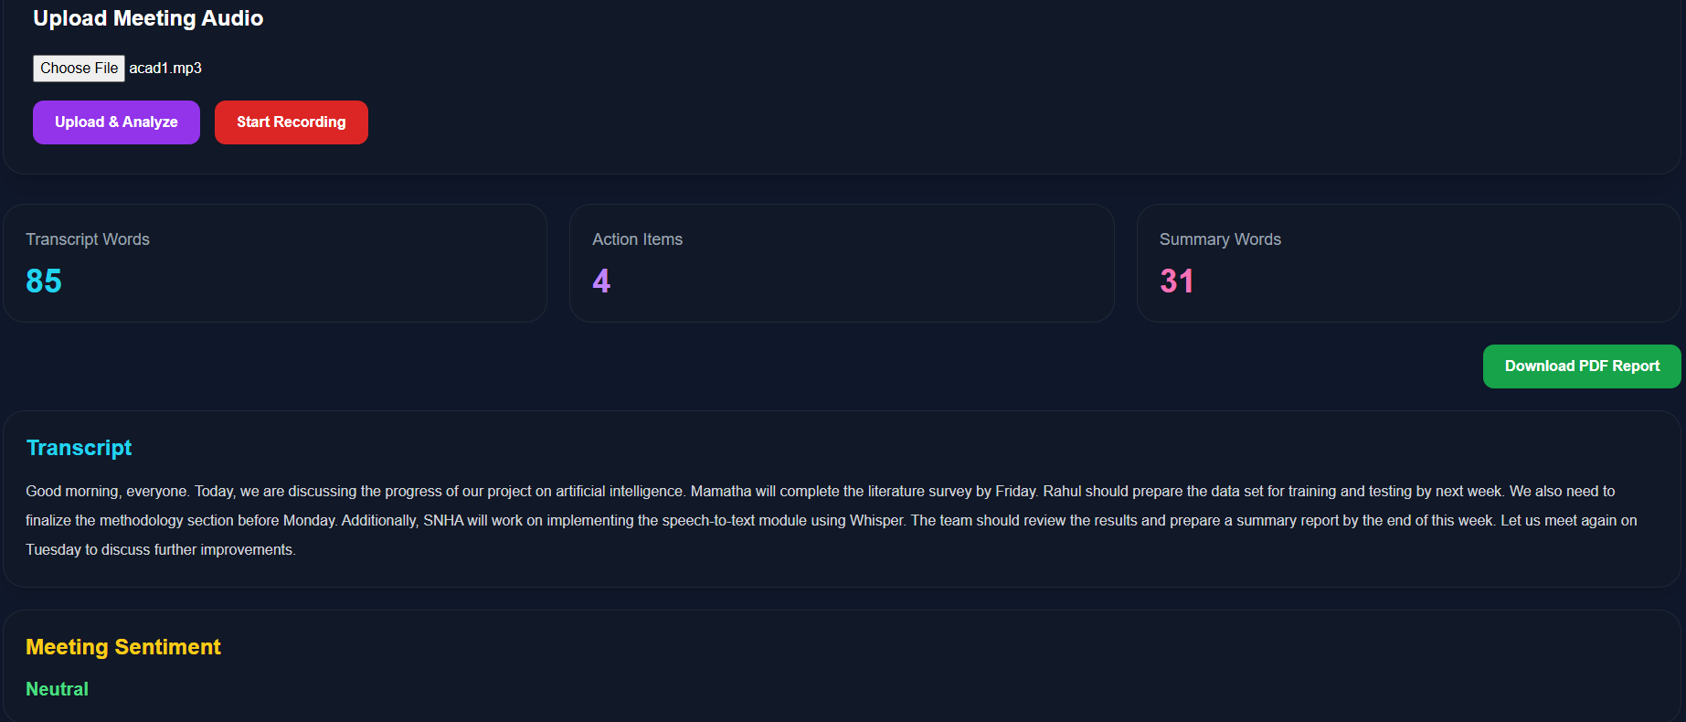
Figure 3. Interactive Streamlit analytics dashboard presenting aggregated meeting metrics and sentiment distribution summaries.
This structural matrix highlights that our proposed platform provides a more versatile meeting intelligence workspace than standard commercial options by combining multi-model text summarizing, comprehensive sentiment mining, exact deliverable parsing, and instant report generation within a single, open environment.
The empirical observations prove that our framework successfully runs multiple language-processing sub-systems inside a unified application runtime. Compared with closed commercial software, this system offers superior analytical depth via its dual-model summary strategy, automated tone tracking, structural action-item parsing, and push-button document exports. Implementing these features directly enhances post-meeting visibility and supports long-term corporate knowledge management.

5. CONCLUSION
The research introduced an automated meeting analytics platform capable of generating transcripts, summaries, sentiment insights, and actionable outcomes from recorded discussions. Experimental observations demonstrated that the framework can effectively transform spoken discussions into structured records that are easier to review and manage. The generated reports and visual analytics support information retrieval, decision tracking, and organizational knowledge preservation. Future improvements may focus on multilingual processing, speaker identification, emotion-aware analytics, and real-time meeting assistance to further enhance system usability.
ACKNOWLEDGEMENT
The authors wish to express their deep appreciation to the Department of Computer Science and Engineering at the R L Jalappa Institute of Technology for providing the vital infrastructure and technical resources necessary to complete this research. We also extend our sincere thanks to Dr. Shankar N B, whose insightful guidance, consistent support, and academic oversight were instrumental throughout the development of this study.
ETHICAL CONSIDERATIONS
This study was conducted strictly for academic advancement and scientific research purposes. The methodology did not involve any trials on human participants or animal subjects. All acoustic data and verbal recordings collected to validate the system were processed under strict privacy protocols, and thorough security measures were implemented to maintain absolute data anonymity and confidentiality.
CONFLICT OF INTEREST
The authors explicitly declare that there are no financial, personal, or institutional conflicts of interest, nor any competing relationships that could have biased, influenced, or otherwise affected the integrity of the findings presented in this paper.
DATA AVAILABILITY
The underlying datasets and experimental results supporting the conclusions of this research are available upon reasonable request. Interested parties may contact the corresponding author to obtain access for scholarly or academic purposes, subject to standard data protection and institutional privacy agreements.
REFERENCES
[1] A. Radford et al., “Robust Speech Recognition via Large-Scale Weak Supervision,” Proc. ICML, 2023.
[2] M. Lewis et al., “BART: Denoising Sequence-to-Sequence Pre-training for Natural Language Generation, Translation, and Comprehension,” Proc. ACL, 2020.
[3] C. Raffel et al., “Exploring the Limits of Transfer Learning with a Unified Text-to-Text Transformer,” Journal of Machine Learning Research, 2020.
[4] T. Wolf et al., “Transformers: State-of-the-Art Natural Language Processing,” Proc. EMNLP, 2020.
[5] J. Devlin et al., “BERT: Pre-training of Deep Bidirectional Transformers for Language Understanding,” Proc. NAACL, 2019.
[6] A. Vaswani et al., “Attention Is All You Need,” Proc. NeurIPS, 2017.
[7] D. Jurafsky and J. H. Martin, Speech and Language Processing, 2023.
[8] OpenAI, “Whisper Speech Recognition Framework,” GitHub Repository, 2022.
[9] Z. Wang et al., “Extractive Speech Summarization from Meeting Transcripts,” arXiv, 2022.
[10] M. Bain et al., “WhisperX: Time-Accurate Speech Transcription of Long-Form Audio,” Interspeech, 2023.
[11] Y. Gong et al., “Whisper-AT: Audio Event Tagging Using Speech Recognition Models,” Interspeech, 2023.
[12] J. Ao et al., “SpeechT5: Unified-Modal Encoder-Decoder Pre-Training,” ACL, 2022.
[13] Y. Liu and S. Seneff, “Automatic Dialog Act Segmentation and Classification in Meetings,” ICASSP, 2005.
[14] F. Liu et al., “Automatic Keyword Extraction from Meeting Transcripts,” HLT-NAACL, 2009.
[15] L. R. et al., “Meeting Summarizer Using NLP,” IRE Journals, vol. 8, no. 10, Apr. 2025.
[16] D. Kumar et al., “AI-Powered Meeting Assistant and Action Tracking,” IJRTI, vol. 11, no. 1, 2026.
[17] “Automatic Meeting Minutes Generation,” IJRASET, vol. 12, no. 2, 2025.
[18] “AI-Powered Virtual Meeting Summarizer,” IRJMETS, vol. 7, no. 3, 2025.
[19] “AMMGS: An AI-Driven Framework for Automatic Meeting Minutes Generation and Summarization,” TIJER, vol. 12, no. 1, 2025.
[20] “Enhancing Classroom Automation Through Real-Time Transcription Using ASR and NLP,” IJERT, vol. 14, no. 4, 2025.
[21] S. Ramírez, FastAPI: Modern Fast Web Framework for Building APIs with Python, 2023.
[22] Meta Open Source, React: A JavaScript Library for Building User Interfaces, 2023.
[23] T. Wolf et al., Hugging Face Transformers Documentation, 2023.
[24] Explosion AI, spaCy: Industrial-Strength Natural Language Processing, 2023.
[25] D. R. Hipp, SQLite Documentation, 2023.

