Python Based Library Management System
C. Sai Sanket , P. Sandhya

Abstract: As we are seeing a rapid growth in technology in recent times, it has increased the need for efficient solutions in library management and operations. This paper presents the design and implementation of a Library Management System (LMS) which is developed by using Python as programming language. The proposed system aims to simplify managing library activities such as tracking book issuance and return and cataloging and adding new books. This system ensures efficient, and user friendly interface which enables librarians to access information quickly and securely. The primary objective of this system is to replace traditional manual system of managing library records with a computerized system that ensures efficiency, accuracy, error free and with ease of use. In existing manual systems, maintain records and tracking all details can be time consuming and can be prone to errors. This research addresses these challenges by using a user friendly system using python. The research focusses on demonstrating how software solutions can effectively navigate problems in manual management of data and improve operational efficiency.
Key words: LMS , Library Management System, Python , Data Management , User Friendly.
I. INTRODUCTION
Libraries are an essential source of information and knowledge for academic institutions by providing access to books, journals, and various other sources. Majority of libraries use traditional management systems by relying on manual record keeping, which are often time consuming and are prone to errors. As the volume of information increases there is a need for an automated system which can help handle all operations regarding library operations with much increased efficiency and accuracy. Library Management System developed by using python as programming language is used as it is simple, and suitable for rapid application. The system can store data and retrieve data efficiently, ensuring data consistency. It is usually used to manage library resources and issuing and returning books. Mainly this proposed system aims to improve efficiency of library operations and reduce manual workload and limit errors. By digitalizing this process, there is an increase in efficiency , accuracy, accessibility. This system can be used to simplify tasks such as issuing books, returning books , adding and deleting books from the data base . This system can usually reduce the chances of data inconsistency, and quick retrieval of data. In recent years higher level programming languages are being used to develop robust and scalable software systems such as Python, it has gained significant name due to its simplicity , readability , and extensive library support. Python provides flexibility and helps programmers to build efficient applications. Python supports integration of multiple database management such as MySQL, and SQLite, and enabling efficient storage and retrieval of data and also manipulation of data. Hence these features make Python an ideal choice for developing a Library Management System.
The proposed Library Management System is designed using python to address the shortcomings and disadvantages of traditional library systems by providing and automated and user friendly solution. The system is designed with an architecture that includes user management, book management . It allows librarians to add , update and delete book records, and also monitoring borrowing activities . User can search for book, based on titles which enhances accessibility and usability. This system can assist in efficient library administration.
This system can enhance data integrity and security. This system can also reduce risk of data loss and unauthorized access which are common issues faced in traditional manual management of library systems. This system can also accommodate a growing amount of data making it suitable for small, medium and large scale libraries.

II. LITERATURE SURVEY
The evolution of Library Management Systems has been driven by increase in need to automate traditional managing of library operations and improve efficiency in managing vast information . Early management systems were majorly manual, relying on paper based record keeping of all library operations. These systems were not only time consuming , but were also more prone to errors, and inefficiency in data retrieval. Modern advancements in technology were introduced to address these short comings and limitations.
Several researchers have proposed various approaches to develop Library Management Systems using several technologies. A study conducted in June 2020 by Nishitha Singh et al focused on creating web based tracking, issuing, and managing of library records . Key aspects of this research were that the systems were designed for interaction between librarians, students and staff. The system had core functionalities focused on developing user friendly interfaces, and databases using SQL and MySQL . Another research was conducted by Asefeh Asemi et al . 2016 . They researched on application of artificial intelligence and expert systems in libraries. The core research areas of this research was on intelligent libraries which involves the use of expert system and robotics to automate and optimize library systems .
Research on library management systems was also done by ACRL in the year 2020 focusing on technological aspects of LMS. Research was particularly done on “Top Trends in Academic Libraries”. This research identified a shift towards more sophisticated systems and user centric services . Key trends identified in this research were on Evolving Integrated Library Systems (ILS), Data Driven Decision Making where library management systems are leveraged to track resource usage, and on Open access and shared infrastructure.
Despite these advancements, certain challenges still exist. Many stems face security risks and difficulty in integration with other institutional systems. Moreover, some require high setup costs and technical expertise for maintenance.
Based on review of existing literature, it is understood that although significant advancements are made in development on Library Management Systems, there is still scope for further improvements in terms of usability and cost effectiveness. The proposed Python based library management system aims to address these limitations and offer effective solutions.
III. SYSTEM ANALYSIS AND SYSTEM DESIGN
System analysis is considered as a critical phase in development of LMS . As it involves understanding of existing processes, and identifying limitations , and defining requirements for proposed system. Existing systems involves manual entry of book details, librarians maintain details by maintain registers which leads to several drawbacks such as difficulty in searching books , lack of data security and backup, and issuing and retrieval of books which is time consuming. The proposed system using Python aims to optimize and automate library functions . The system ensures accuracy and increase speed of operations. It has functional requirements and nonfunctional requirements. Functional such as user login , adding and deleting books , issuing and returning of books, nonfunctional includes performance , usability and reliability, security.
Whereas System design defines overall architecture and structure of the proposed library management systems. The proposed LMS follows a layered architecture consisting of user interface interaction such as GUI or web based interface . Application layer handles business logic and Data base layer manages data storage .Module description handles user management module, book management module, and search module.
Data flow design (REFER FIGURE I) uses input through interface which gets processed by application layer, when a user requests information system retrieves relevant data from database and displays information. Data base design consists of tables , key tables include book ID, title , author . Entity relationships focus on key concepts like entity which focuses real world objects like books, students and transactions . attributes focus on names and titles , and foreign keys focus on links between tables like Book Id , Student Id . Advantages of ER relationships are that it provides clear visualization of database structure , and helps in designing efficient data base and improves data consistency.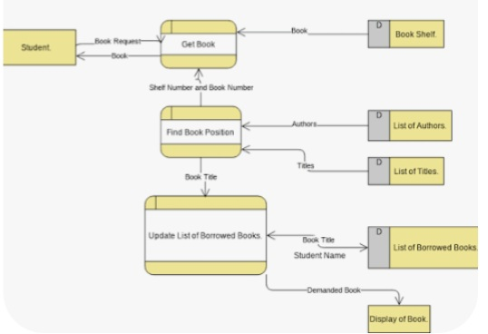
FIGURE I : DATA FLOW DIAGRAM
IV . IMPLEMENTATION AND METHODOLOGY
Data base implementation is an important part of LMS. It handles all data related to books , students and transactions, stored and managed efficiently. In this proposed system the relational database such as SQLite/ MySQL is used . The database is connected to the application using python libraries such as sqlite3 or MySQL.connector. Main operations included are inserting(figure II) , selecting, updating, displaying available books(figure III), and deleting the books(figure VI). The methodology includes a structural and systemic approach to designing and development. The development process includes requirement analysis and then system designing where architecture , modules and database structures are defined. While implementation SQLite or MySQL is integrated to manage data efficiently. Then the program is tested for any errors , and after testing the system is applied and it is implemented in actual library environments.
V. TESTING AND RESULTS
Testing is an essential part in software development. Testing is performed on individual modules such as user management, book management, and transaction management. For example: The book management module is tested by performing operations such as adding , updating , or deleting books. By testing we can confirm that the system is running smoothly and efficiently.
RESULTS: figures below show how data is processed and viewed.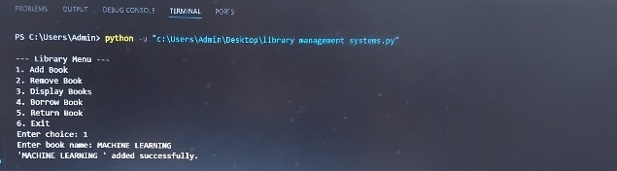FIGURE II: ADDING BOOK.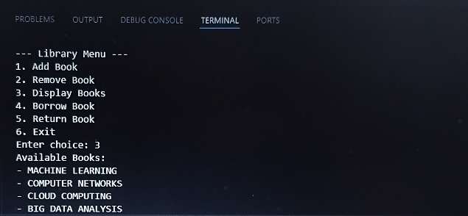FIGURE III: DISPLAY BOOKS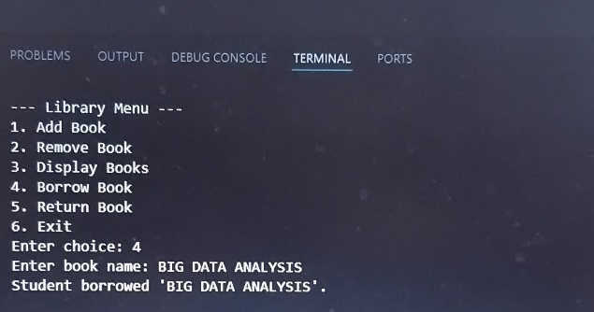FIGURE IV: DISPLAYS BORROWED BOOK.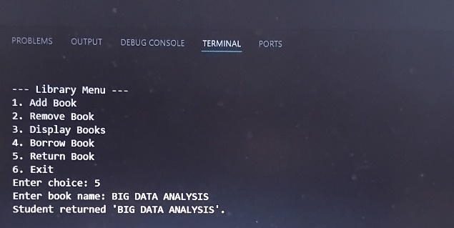FIGURE V: RETURNED BOOK.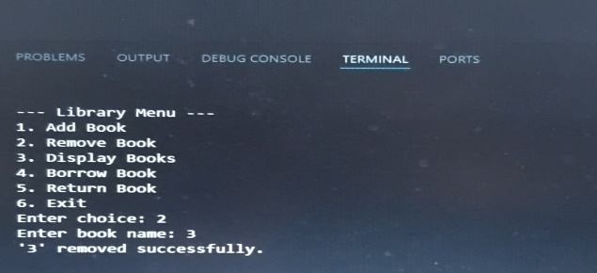FIGURE VI: DELETE BOOK.
VI. CONCLUSION
By using this system, library operations become easier, faster and more accurate and it is user friendly and chances of errors are reduced.
VII. REFERENCES
1.Nishitha singh,Sejal ayade, Vikash lakra “Library management system” published in International Journal of Advanced Research in Computer and Communication Engineering(IJARCCE),June 2020.
2.Asefeh asemi et. al . “Artificial Intelligence in library systems” in proceedings of 47th International Conference on internet technologies and society(ICITS).

