International Journal of Research and Science Innovation (IJRSI)

PERFORMANCE, EVALUATION AND OPTIMIZATION OF BIODIESEL FROM DESERT DATE OIL USING RESPONSE SURFACE METHODOLOGY
Lasisi I.O¹, Akinola A.O², Akintunde M.A³, Akpambang V.O.E.^{4,} Adeyemi A. J^{5,} Abdulkadir M⁶,
1,5-6 Department of Mechanical Engineering Technology, Waziri Umaru Federal Polytechnic, P.M.B 1034, Birnin Kebbi, Kebbi State, Nigeria.
2-4 Federal University of Technology Akure. (FUTA), OndoState, Nigeria

Abstract
Growing instability in conventional fuel, and mounting environmental concerns have stirred up interest in renewable diesel substitutes. This study investigates the production of biodiesel from desert date (Balanites aegyptiaca) seed oil through alkaline-catalyzed transesterification and statistically optimizes the process using Response Surface Methodology (RSM) based on a Central Composite Design (CCD). The influence of catalyst concentration (0.1-0.7 wt%), reaction time (35-65 min), and methanol-to-oil molar ratio (1:1-10:1) on biodiesel yield were investigated. The extracted oil showed a saponification value of 196.98 mgKOH/g, iodine value of 7.42I₂/100 g, and density of 0.904 g/cm³, indicating good suitability for biodiesel synthesis. Statistical analysis confirmed the significance of the quadratic model (F=40.82, P$˂0.0001)$, with methanol ratio and catalyst concentration identified as dominant factors. Optimal conditions (0.4 wt% catalyst,65 min reaction time, 6:1 methanol ratio) yielded 98.33% biodiesel, with strong agreement between predicted and experimental values. The findings demonstrate the technical viability of desert date oil as a sustainable non-edible biodiesel feedstock
Keywords: Biodisel,desert date oil,transesterification,optimization.
- Introduction
In Nigeria and numerous other African nations, the expense of conventional fuel constitutes a critical determinant influencing daily existence and the national economy. Whenever petrol or diesel prices escalate, the repercussions are promptly experienced by consumers, enterprises, and the government. Currently, in Nigeria, the abolition of fuel subsidies has resulted in a substantial increase in transportation costs. This development has rendered the movement of people and goods more expensive. Agricultural commodities frequently traverse considerable distances, thereby increasing transportation expenditures for households and contributing to rising food prices.
For businesses, rising fuel prices increase production costs, especially in sectors such as manufacturing, agriculture, and transportation. These additional costs are often passed on to consumers. The situation also creates serious social challenges, particularly in rural areas where public transportation is limited or unavailable. High fuel prices restrict access to healthcare services, markets, and educational institutions for isolated communities.
Despite these challenges, conventional fuels remain essential to the economic development of many nations. Energy consumption is evident across various sectors, including domestic (homes and offices), transportation, and agriculture. Conventional energy sources form through natural processes such as the anaerobic decomposition of buried organic material. Millions of years ago, the remains of plants and animals were buried underground. Over time, heat from the Earth’s core and pressure from rock layers transformed these materials into fossil fuels. These fuels, rich in carbon, include petroleum, coal, and natural gas. They are extensively used for transportation, cooking, lighting, electricity generation, washing, manufacturing plastics and paints, and numerous other industrial purposes.
However, the increasing global cost of fuel and heavy reliance on fossil fuels have intensified the search for alternative energy sources. One such alternative is biodiesel.
Biodiesel is derived from vegetable oils or recycled oils obtained from the food industry and is chemically designated as fatty acid methyl ester (FAME). It can be synthesized through various techniques, including pyrolysis, micro-emulsification, dilution, and transesterification. Among these methods, transesterification is the most prevalently employed. Although transesterification is theoretically a reversible reaction, the reverse process does not take place in biodiesel production, as the glycerol produced does not influence the final product.
As an alternative fuel, biodiesel can be utilized directly in diesel engines without the need for modifications, owing to its comparable properties such as specific gravity, cetane number, viscosity, cloud point, and flash point—similar to those of traditional diesel. Consequently, biodiesel serves as a viable substitute or supplement to fossil diesel fuel.
Biodiesel presents numerous benefits, including a reduction in carbon dioxide emissions by approximately 78%, non-toxicity, and biodegradability. These attributes render it an environmentally sustainable fuel. Moreover, biodiesel constitutes a renewable energy resource that aids in conserving fossil fuel reserves and enhances the operational efficiency of diesel engines. Although biodiesel is predominantly manufactured via traditional transesterification reactions, the implementation of heterogeneous catalysts has considerably enhanced production efficiency and engine performance.

1.1 Desert Date (Balanites aegyptiaca)
The Desert Date (Balanites aegyptiaca) is a tree species that can attain heights of 12 to 14 meters. It is classified within the Zygophyllaceae or Balanitaceae family. This arboreal species exhibits numerous branches and small flowers, thriving in hot, arid environments. Additionally, it demonstrates adaptability to diverse soil types, including sandy and heavy clay soils, as well as to varying moisture conditions.
Balanites aegyptiaca is a perennial plant extensively utilized in culinary preparations, especially across Africa and other developing regions. Nearly all parts of the plant, including leaves, thorns, roots, and fruit, possess economic value. The fruit has traditional applications in the treatment of liver diseases. Seeds, representing approximately 15% of the total fruit mass, contain an average of 10% oil.
The global production of date fruit increased from 1.85 million tonnes in 1961 to 8.16 million tonnes in 2017. These statistics indicate that ten countries account for nearly 89% of the world's date production, primarily in the Middle East and Africa ( FAOSTAT 2020) (Besbes et al., 2009).. Based on these data, it is estimated that approximately 1.22 million tonnes of date seeds are generated annually, which could potentially yield about 122,490 tonnes of date seed oil. Consequently, approximately 122,490 tonnes of biodiesel could be derived annually from this resource. This quantity is significant when compared to the 38,700 tonnes produced in the Middle East and Africa in 2015 (British Petroleum Company, 2017). The high yield suggests that utilization for biodiesel production would be economically advantageous without substantially disrupting its use as food. Therefore, this study examines the production of biodiesel from desert date (Balanites aegyptiaca) seed oil via alkaline-catalyzed transesterification and employs Response Surface Methodology (RSM) based on a Central Composite Design (CCD) to statistically optimize the process.

2.1 Materials and Methods

2.2 Sample Collection
Fresh desert date fruits were collected from the Birnin Kebbi area. Figure (1) and (2) shows the Ripened Desert Date and the Seed Kernel respectively.
The transesterification process and characterization of the extracted oil were conducted at the Department of Pure and Applied Chemistry, Kebbi State University of Science and Technology, Aliero.
Figure 1: Ripened Desert Date See Figure 2: Seed Kernel

2.3 Oil Extraction
Several methods are available for extracting Desert Date Oil (DSO) for biodiesel production. These include mechanical expression methods such as hydraulic and screw presses, which may be manual, semi-automated, or fully automated. Other extraction techniques include Soxhlet extraction, supercritical fluid extraction, ultrasonic-assisted extraction, and microwave-assisted extraction.
The efficiency of oil extraction depends on factors such as solvent type, solvent-to-seed ratio, extraction time, and particle size. In this study, a locally fabricated mechanical extractor was used to obtain the required quantity of Desert Date Oil.

2.4 Transesterification
The transesterification and esterification processes were conducted in a 250 mL glass reactor equipped with a reflux condenser and a digital electric magnetic stirrer.
Thirty (30) grams of Desert Date Oil were heated to 100°C to remove moisture and then cooled to 60°C. A catalyst solution consisting of 99% methanol and 1.4 wt% potassium hydroxide (KOH) was prepared. The methanol-to-oil molar ratio was kept at 6:1. The mixture was stirred at 305.5 rpm for 60 minutes at 60°C.
After the reaction, the mixture was transferred into a separatory funnel and left to stand for 24 hours, forming three layers: biodiesel (top), glycerol (middle), and catalyst residue (bottom).
Biodiesel Yield (%) = (Weight of biodiesel / Weight of oil sample used) × 100

2.5 Characterization of Desert Date Oil and Biodiesel
The physicochemical properties of the oil and biodiesel were analysed using ASTM standard methods.

Acid Value Analysis
A 2 g oil sample was dissolved in ethyl alcohol and diethyl ether, gently heated, and titrated with 0.1 M KOH using phenolphthalein as the indicator.
Acid Value = (Vs − Vb) × M × 56 / Weight of sample (g)

Iodine Value Analysis
A 0.25 g oil sample was dissolved in carbon tetrachloride, treated with Wij’s solution, kept in the dark for 2 hours, and titrated with sodium thiosulfate using starch indicator.
Iodine Value (IV) = (Vs − Vb) × M × 12.69 / Weight of sample (g)

Saponification Value
A 2 g oil sample was refluxed with alcoholic KOH for one hour. Excess alkali was titrated with standard HCl solution.
Saponification Value (SV) = (Vs − Vb) × 0.02805 × 1000 / Weight of sample (g)

Specific Gravity
Specific gravity was determined using a density bottle at 20°C.
Specific Gravity = W1 / W2

Viscosity
Viscosity was measured at 40°C using a calibrated viscometer.
Viscosity = (Flow time × Specific gravity × 1.002) / Flow time of water

Cetane Number
Cetane Number = 46.3 + (5458 / SV) − 0.225(IV)

High Heating Value
High Heating Value (HHV) = 49.43 − 0.041(SV) − 0.015(IV)

2.6 Biodiesel Yield Optimization
Response Surface Methodology (RSM) was employed to optimize biodiesel yield through the calibration of parameters including catalyst concentration, reaction time, temperature, methanol ratio, and stirring speed.
Central Composite Design (CCD) was employed in this study. The quadratic regression model is given as:
Y = β0 + Σβj xj + Σβjj xj² + ΣΣβij xi xj + ε

3. RESULTS

The experiment's results are shown in Tables 1 to 6. Tables 1 and 2 compare the physical and chemical properties of the extracted Desert Date oil and transesterified biodiesel against conventional diesel and standard specification limits.

The summary of the properties of the tested samples is presented in Table 1.
Table 1: Summary of the chemical properties of Desert Date
S/N | Parameters | Result
1 | Iodine value (g/100g) | 7.42 ± 0.13
2 | Peroxide value (Meq/kg) | 64.67 ± 1.04
3 | Saponification value (mgKOH/g) | 196.98 ± 0.49
4 | Acid value (mgKOH/g) | 15.77 ± 0.86
5 | Free Fatty Acid (mgKOH/g) | 5.22 ± 0.14
Mean ± standard deviation of three replicates.
Table 2: Summary of the physical properties of Desert Date
S/N | Parameters | Properties | FAO/WHO STANDARD
1 | Color | Pale yellow | Pale yellow
2 | Density (g/cm³) | 0.904 | 0.909
3 | Specific Gravity | 0.906 | 0.9 - 1.16
4 | Refractive Index | 1.464 | 1.4677 – 1.4705
5 | Viscosity | 19.70 | 19.79
Table 3
Define factor ranges
factor | symbol | Low level (-1) | Center (0) | High level (+1)
Catalyst (%) | A | 0.1 | 0.4 | 0.7
Time (min) | B | 35 | 50 | 65
Methanol ratio | C | 1 | 5.5 | 10

Table 4
Experimental Results of Desert Date oil
Run | A: Catalyst (%) | B: Time (min) | C: Methanol Ratio | Yield (%) | Predicted Yield (%)
1 | 0.1 | 35 | 1 | 83.37 | 83.10
2 | 0.7 | 35 | 1 | 86.66 | 86.69
3 | 0.1 | 65 | 1 | 90.00 | 91.98
4 | 0.7 | 65 | 1 | 93.33 | 96.95
5 | 0.1 | 35 | 10 | 96.66 | 97.90
6 | 0.7 | 35 | 10 | 98.33 | 97.24
7 | 0.1 | 65 | 10 | 98.33 | 97.21
8 | 0.7 | 65 | 10 | 98.00 | 95.49
9 | 0.1 | 50 | 5.5 | 95.00 | 97.25
10 | 0.7 | 50 | 5.5 | 96.00 | 86.66
11 | 0.4 | 35 | 5.5 | 87.00 | 92.37
12 | 0.4 | 65 | 5.5 | 91.00 | 86.23
13 | 0.4 | 50 | 1 | 85.00 | 98.22
14 | 0.4 | 50 | 10 | 97.50 | 94.58
15 | 0.4 | 50 | 5.5 | 94.50 | 94.58
16 | 0.4 | 50 | 5.5 | 94.80 | 94.58
17 | 0.4 | 50 | 5.5 | 94.60 | 94.58

Table 5
ANOVA analysis of variance for a yield of biodiesel.
Source | Sum Sq | df | Mean sq | F- value | p- value
Model | 580.20 | 9 | 64.47 | 40.82 | $$<0.0001$$
Catalyst concentration (A) | 120.56 | 1 | 120.56 | 76.28 | $$<0.0001$$
Reaction Time (B) | 85.34 | 1 | 85.34 | 53.96 | $$<0.0001$$
Methanol Ratio (C) | 134.22 | 1 | 134.22 | 84.93 | $$<0.0001$$
AB (Interaction) | 33.56 | 1 | 33.56 | 21.24 | 0.0006
AC ( interaction) | 28.67 | 1 | 28.67 | 18.15 | 0.0011
BC (Interaction) | 19.45 | 1 | 19.45 | 12.31 | 0.0047
Catalyst² | 55.33 | 1 | 55.33 | 35.03 | $$<0.0001$$
Time² | 42.11 | 1 | 42.11 | 26.65 | $$<0.0001$$
Methanol² | 61.96 | 1 | 61.96 | 39.20 | $$<0.0001$$
Residual | 15.80 | 10 | 1.58
Lack of fit | 12.30 | 6 | 2.05 | 2.34 | 0.094
Pure Error | 3.50 | 4 | 0.88
Total | 596.00 | 19

Table 6: Significance of Model Terms
Term | F- value | P- value | Interpretation
A | 76.28 | < 0.0001 | Very strong effect
B | 53.96 | < 0.0001 | Significantly influences yield
C | 84.93 | < 0.0001 | Strongly impacts yield
AB | 21.24 | 0.0006 | Significant
AC | 18.15 | 0.0011 | Significant
BC | 12.31 | 0.0047 | Significant
A², B², C² | >26 | < 0.0001 | All quadratic terms are significant, indicating curvature in the response surface

3.1 Analysis of the Impact of Transesterification Parameters
Graphically, contour and 3D surface plots illustrate the influence of transesterification parameters on the outcome (biodiesel yield).
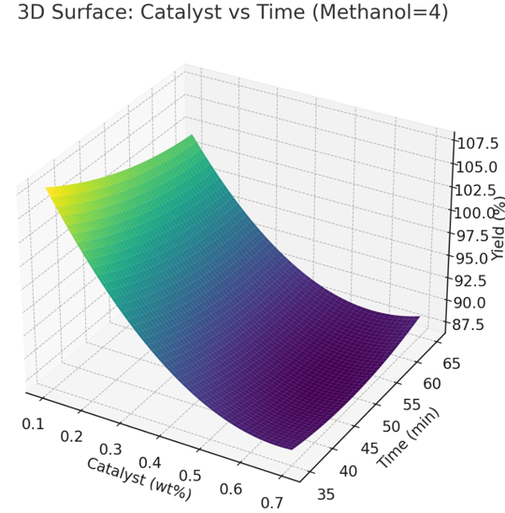

FIG 1a: shows a 3D surface plot showing the interaction of Catalyst and time
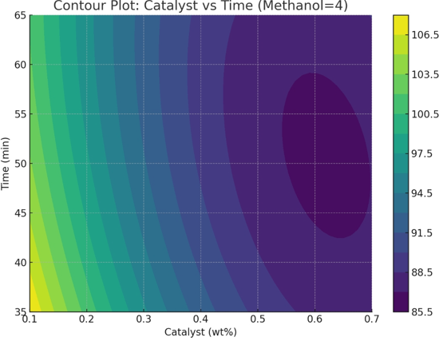
FIG 1b: Represents a Contour plot of Catalyst and time
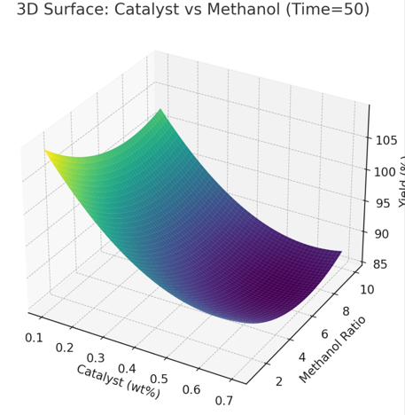
FIG 2a: shows a 3D surface plot showing the interaction of catalyst and methanol
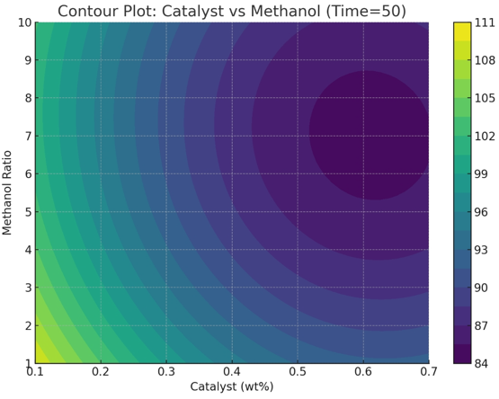
FIG 2b: Represents a Contour plot of catalyst and methanol,
3D Surface: Time vs Methanol (Catalyst = 0.4)
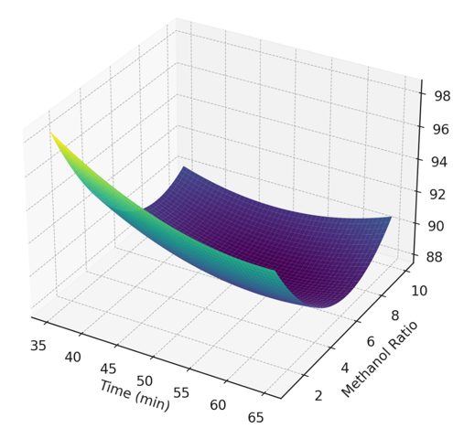
FIG 3a: shows a 3D surface plot showing the interaction of time and methanol
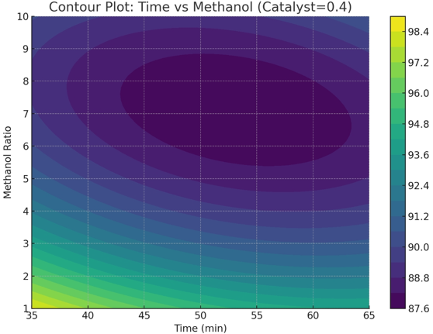
FIG 3b: Represents a Contour plot of time and methanol

3.2 DISCUSSION

Iodine Value
The iodine value signifies the level of unsaturation in biodiesel. The measured iodine value for Desert Date oil was 7.42 g per 100 grams, indicating excellent oxidative stability and minimal propensity for polymerization. This finding aligns with the 14.53 g per 100 grams reported by Karaye et al. (2020).

Saponification Value
The saponification value of Balanites aegyptiaca kernel oil is 196.98 mgKOH/g, which is within the FAO/WHO standard range of 195–205 mgKOH/g for edible oils. This figure is slightly below the 198 mgKOH/g reported by Datti et al. (2020), but higher than the 136 mgKOH/g and 151 mgKOH/g values reported by Abdulhamid et al. (2023) and Karaye et al. (2020), respectively.

Density
The density of the extracted oil was 0.904 g/cm³, which falls within acceptable FAO/WHO limits. Conventional diesel has a density of 0.848 g/cm³. Density affects spray pattern and fuel injection efficiency in engines.

Viscosity
The oil viscosity was 19.70 mm²/s, which falls within acceptable biodiesel limits and is close to the 19.67 mm²/s reported by Abdulhamid et al. (2023). Proper viscosity ensures smooth injector operation and reduces engine wear.

3.3 Yield Optimization
Central Composite Design (CCD) within Response Surface Methodology (RSM) was employed to optimise biodiesel yield based on methanol ratio, catalyst concentration, and reaction time.
The highest biodiesel yield (98.33%) was reached with 0.7 wt.% catalyst concentration, a 10:1 methanol ratio, and a reaction time of 35 minutes. The lowest yield was observed at 0.1 wt.% catalyst concentration, a 1:1 methanol ratio, and a reaction time of 35 minutes.
Quadratic regression model:
Y = 148.54 - 97.94A - 0.85B - 3.84C + 62.38A² + 0.0054B² + 0.19C² + 0.37AB + 0.54AC + 0.018BC
3.4 ANOVA analysis showed an F-value of 40.82 and p-value < 0.05, indicating that the quadratic model is statistically significant.

3.6 Conclusion
The Response Surface Methodology effectively optimized the biodiesel production process derived from Desert Date oil. The optimal parameters were identified as a methanol ratio of 6:1, a reaction duration of 65 minutes, and a catalyst concentration of 0.4%, resulting in a maximum yield of 98.33%. The physicochemical properties of the oil complied with ASTM and FAO/WHO standards. Elevated saponification and viscosity values enhance lubrication, whereas a low iodine value signifies robust oxidative stability. Consequently, Desert Date oil is deemed suitable for biodiesel production.
Acknowledgement
The authors would like to acknowledge the Tertiary Education Trust Fund (TETFUND Nigeria) for the financial support under their Institutional Based Research programme (IBR).

References
Abdulhamid et al. (2023). Biodiesel Production using Balanites aegyptiaca Seed as Raw Material. AJBAR, 2(2), 124–134.
Aboje et al. (2023). Optimization and Characterization of Biodiesel Production from Desert Date Seed Oil. Journal of Energy Technology and Environment, 5(2), 181–186.
Besbes, S.; Drira, L.; Blecker, C.; Deroanne, C.; Attia, H. Adding value to hard date (Phoenix dactylifera L.): Compositional, functional and sensory characteristics of date jam. Food Chem. 2009, 112, 406–411. [CrossRef]
Demirbas, A. (2003). Biodiesel fuels from vegetable oils via catalytic and non-catalytic supercritical alcohol transesterifications and other methods: a survey. Energy conservation and management. 44(13): 2093-2109.
FAOSTAT. Statistical databases of the Food and Agriculture Organization of the United Nations. 2020. Available online: http://www.fao.org/faostat/en/#home (accessed on 17 December 2023).
Giwa, S. O., Haggai, M. B., & Giwa, A. (2021). Production of biodiesel from desert date seed oil using heterogeneous catalysts. International Journal of Engineering Research in Africa, 53, 180-189.
Karaye, I. U., Ladan, M. U., Adili, I. S., Shehu, A., Lawal, H. M. and Sahabi, M., H.(2020). Phytochemistry and Proximate Composition of Fruit Pulp and Seed of Desert Date, Balanites aegyptiaca (Del.). International journal of science for global sustainability, fugusau VOL 6(2): 109 – 117
Kumar Ghosh, U. and Mittal, V. 2021. Application of response surface methodology for optimization of biodiesel production from microalgae through nano catalytic transesteriication process. Fuel Process. Technol., 92(3): 407-413.
Manji, AJ; Sarah, EE; Modibbo, UU (2013). Studies on the potentials of Balanites aegyptiaca seed oil as raw material for the production of liquid cleansing agents. Int. J. Phys. Sci. 8(33): 1655- 1660.
Mohamed AA and Mohammed AA. (2018). Extraction and Physico-Chemical Properties of Balanites aegyptiaca (Heglig) Seed Oil Grown In Libya. International Journal of Agricultural Research and Review, 6(2), 674-679.
Mohammed F. B. , Muhammad I. M. , Gutti B. , Abdulkarim A. Y.& Ahmed S. I. 2018. Characterization and application of balanites aegyptiaca seed (desert date) kernel as natural coagulant and disinfectant for water purification. Nigerian Journal of Engineering Faculty of Engineering, Vol. 24, No. 2, 68-74.
Mohibbe M.A., Amtul W., & Nahar N.M. 2005. Prospects and potential of fatty acid methyl esters of some non-traditional seed oils for use as biodiesel in India, Biomass and Bioenergy 29 (2005) 293–302
The British Petroleum Company, BP. BP Statistical Review of World Energy, June 2017. Availableonline:https://www.bp.com/content/dam/bp/en/corporate/pdf/energyeconomics/statistical-review-2017/bp-statistical-review-of-world-energy-2017 -full-report.pdf (accessed on 23 August 2018).
Production from Waste Cooking Oil—A Case Study of Hong Kong. Int. J. Mol. Sci. 2015, 16, 4362–4371. [CrossRef]
Ogala, H., Elinge, C.M., Wawata I.G., Adegoke, A.I., Muhammad, A.B., & Ige, A.R., (2018), Extraction and Physicochemical Analysis of Desert Date (Balanite Aegyptiaca) Seed Oil, International Journal of Advanced Academic Research | Sciences, Technology & Engineering | ISSN: 2488-9849 Vol. 4, Issue 4.
Orhevba, B.A., Adebayo, S.E. and Salihu, A.O., (2016). Synthesis of Biodiesel from Tropical Almond (Termmalia Catappa) Seed Oil. Current Research in Agricultural Sciences. 3(4):57:63.
Yunus, M., and Zuru, A. (2017). Kinetics study of balanites aegyptiaca oil transesterification for the production of biodiesel. Nigerian Journal of Chemical Research, 22(1), 9-19. Biodiesel fuel (B100) Blend, Philadelphia.
Yun-Hin, Taufiq-Yap, Nurul FA, Manhiran B. Biodiesel Production via Transesterification of Palm Oil Using NaOH/Al2O3 Catalysts. Sains Malaysi. 2011, 40(6), 587-597
Waseem H., Asma El Zerey-B , Farwa N. and Iqra Y. (2016). The downside of biodiesel fuel – A review. International Journal of Chemical and Biochemical Sciences (ISSN 2226-9614, , 9(2016):97-106

