Analyzing the ICT Curriculum for the Middle Stage in Bihar State Government Schools: A Content-Based Study

Abstract
The present study highlights a systematic content-based analysis of the Information and Communication Technology (ICT) curriculum prescribed for the middle stage (Classes 6–8) in Bihar State Government Schools. Grounded in the context of increasing digitalization and guided by national frameworks such as the National Education Policy (2020), the study examines the extent to which the curriculum supports the development of digital literacy, critical thinking, and practical ICT competencies among learners. A Curriculum Analysis Matrix was developed to analyze key components including themes, topics, competencies, learning outcomes, pedagogical approaches, activities, assessment strategies, and ethical aspects.
The findings reveal that the curriculum is well-structured and progressively organized, beginning with fundamental computer concepts and advancing to applications, cyber security, and emerging technologies such as artificial intelligence and the Internet of Things. It emphasizes activity-based and experiential learning, integrates real-life applications, and incorporates ethical and social dimensions of ICT, including digital citizenship and cyber safety.
However, the study also highlights that the effectiveness of the curriculum is contingent upon factors such as infrastructure availability, teacher preparedness, and access to digital resources. The paper concludes that while the curriculum is conceptually comprehensive and aligned with contemporary educational goals, its successful implementation requires strengthened institutional support. The study offers insights for curriculum developers and policymakers to enhance the relevance, inclusivity, and practical impact of ICT education in Bihar.
Keywords: ICT curriculum, middle stage, Bihar State Government Schools, curriculum analysis matrix.
Background
In the contemporary era of rapid digital advancement, Information and Communication Technology (ICT) has significantly transformed the landscape of education across the globe. The 21st century demands digital literacy as not merely an optional skill rather a fundamental requirement for students to navigate efficiently in an increasingly complex technology-driven society. Integration of ICT in school curricula is recognized globally to enhance teaching-learning processes, foster critical thinking and prepare learners for future challenges.
In India, the importance of ICT in education has been recognized through various national initiatives and policies, such as the National Policy on Education (1986, revised 1992) and the National Education Policy (2020), which emphasize the integration of technology in school curriculum. The National Education Policy (NEP) 2020 envisions a holistic transformation of educational ecosystem. The policy emphasizes a shift from rote learning to conceptual understanding, supported by extensive use of technology in pedagogical processes. For states like Bihar, which grapple with significant socio-economic diversity and infrastructure disparities, the implementation of these ICT goals presents both a formidable challenge and a transformative opportunity.
The middle stage of schooling (comprising grades 6 to 8) represents a crucial juncture in a student's cognitive and academic development. It is at this stage that intellectual thinking matures and foundational academic concepts are solidified. According to the National Education Policy (2020), this stage focuses on experiential learning, critical thinking, and the introduction of abstract concepts. An ICT curriculum tailored for this stage, therefore, carries the responsibility of developing foundational digital skills, problem-solving abilities, and learner autonomy.
The history of ICT in Indian government schools—tracing back to the early Educational Technology (ET) schemes of the 1970s and the subsequent ICT in Schools scheme launched in 2004—demonstrates a long-standing national commitment to bridging the digital divide. However, the efficacy of these initiatives has historically been contingent on localized implementation. Bihar, through various interventions, has recognized that providing hardware is insufficient; the meaningful integration of ICT into the curriculum is what truly improves learning outcomes. Despite this, empirical research in the region frequently highlights persistent hurdles, including limited access to functional digital devices, unreliable power supply, a lack of specialized IT personnel, and, crucially, a significant digital literacy gap among both teachers and students.
Despite policy emphasis and programmatic efforts, concerns remain regarding the adequacy, relevance, and contextual suitability of ICT curriculum in government schools, particularly in states like Bihar where infrastructural and socio-economic challenges persist. Questions arise as to whether the existing ICT curriculum content adequately addresses digital literacy and caters to the diverse needs of learners in government school settings.
In this context, a systematic content-based analysis of the ICT curriculum for the middle stage in Bihar State Government Schools becomes imperative. Such an analysis can help identify strengths, gaps and areas for improvement in the curriculum, thereby contributing to more effective integration of ICT in education. The findings of the study aim to provide actionable insights for curriculum developers, policymakers and educational administrators striving to make ICT education in Bihar more inclusive, equitable and effective.
Literature Review
The integration of Information and Communication Technology (ICT) curriculum in school education has been widely examined in global and Indian contexts. The existing literature review can be organized into key thematic areas: ICT curriculum integration, ICT curriculum components, ICT curriculum and pedagogical approaches, and challenges in ICT curriculum implementation.
ICT Curriculum Integration
ICT has emerged as a fundamental component of modern education system. Studies indicate that ICT integration fosters creativity, solving complex problem, and learner engagement, making it a core element of contemporary curricula (Diyal, 2024; Cai, Bi, & Feng, 2025). Researches further highlight that ICT-enhanced curriculum contributes to the development of problem-solving skills and digital competencies necessary for 21st-century learners (Dolmaci, & Acar, 2025; Weber, & Greiff, 2023).
The Government of India’s ICT curriculum framework emphasizes hands-on learning, critical thinking, and ethical use of technology, while also acknowledging the rapidly evolving nature of technological tools and the need for continuous curriculum updates (Government of India, n.d.).
ICT Curriculum Components
ICT education not only encompasses technical skills but also the ability to access, evaluate, and create information using digital tools (UNESCO, 2018). Researchers emphasized that ICT education has evolved beyond basic computer skills to include critical thinking, communication, and ethical awareness in digital environments (Soomro, Khan, & Rind, 2025; Sukri, & Iksan, 2023).
Research on curriculum components suggests that an effective digital literacy curriculum should include multiple dimensions such as information handling, media literacy, communication skills, and responsible use of technology (UNESCO, 2021). Additionally, studies on teacher education reveal that existing curricula often provide limited opportunities for developing comprehensive digital literacy skills, indicating a gap between policy expectations and curriculum design (Tiwari, & Magre, 2025; Varghese, & Arya, 2024).
ICT Curriculum and Pedagogical Approaches
Webb & Cox (2004) emphasize that ICT changes pedagogy by requiring more complex, interactive, and learner-centered teaching approaches, rather than traditional content delivery. Furthermore, research underscores the importance of aligning ICT curriculum with pedagogical goals, including fostering higher-order thinking skills and interdisciplinary learning.
Approaches such as project-based learning, digital storytelling, and collaborative content creation have been identified as effective strategies for meaningful ICT integration (Bell, 2010; Robin, 2008). Studies on digital storytelling in Indian schools highlight how ICT can support constructivist learning by engaging students in real-world problem-solving and content creation (Gupta & Sharma, 2023; Nitika & Pandey, 2026). The inclusion of emerging areas such as artificial intelligence and computational thinking in school curricula reflects a shift toward future-oriented education (Mills, Cope, Scholes, & Rowe, 2025).
Challenges in ICT Curriculum Implementation
Despite the recognized importance of ICT in education, several studies point to persistent challenges in its implementation. Key issues include inadequate infrastructure, limited teacher training, and disparities in access to digital resources, particularly in developing regions (Kour & Mirza, 2026; Soomro, Kale, Curtis, & Akcaoglu, 2020). Research indicates that such constraints often hinder the effective integration of ICT into school curricula, leading to gaps between intended and actual learning outcomes (Msafiri, Kangwa, & Cai, 2023).
The digital divide remains a significant concern, especially in government school systems, where socio-economic factors influence students’ access to technology and digital learning opportunities (Reddy, Sharma, & Chaudhary, 2021). Additionally, the rapidly changing nature of technology necessitates frequent curriculum revisions; failure to update content can result in outdated and less relevant learning materials (UNESCO, 2018).
Research Gap
While existing literature provides valuable insights into ICT integration, curriculum components, pedagogical approaches and implementation challenges, there is a noticeable lack of studies focusing specifically on the content analysis of ICT curriculum at the middle school level, particularly in the context of Bihar State Government Schools. Gaps remain in understanding the alignment of ICT curriculum with educational objectives and learner needs in specific regional contexts. This underscores the need for a systematic content-based analysis of the ICT curriculum for the middle stage in Bihar.
Rationale of the study
The integration of Information and Communication Technology (ICT) in school education has become a critical component of modern learning. In the context of Bihar State Government Schools, efforts have been made to introduce ICT as a subject and as a pedagogical tool. Despite these initiatives, there remains a lack of systematic academic inquiry into the actual content of the ICT curriculum, particularly at the middle stage (Grades 6–8), which is a foundational period for the development of conceptual understanding and skill acquisition. The middle stage is especially significant because it marks a transition from basic literacy to more structured and analytical learning; thus, the nature and organization of ICT content at this level can have long-term implications for students’ digital competence.
Existing studies on ICT in education have largely focused on infrastructure availability, teacher readiness, and implementation challenges, often overlooking the curriculum content itself. There is limited evidence on whether the prescribed ICT curriculum in Bihar aligns with national educational goals, reflects contemporary technological developments, and addresses the contextual realities of government school learners. Furthermore, disparities in access, socio-economic backgrounds, and resource constraints necessitate a curriculum that is not only technically sound but also inclusive and adaptable.
A content-based analysis of the ICT curriculum is therefore essential to critically examine its structure, themes, progression, and alignment with educational objectives. Such an analysis can reveal gaps in content coverage, redundancies, or outdated material, and assess whether the curriculum adequately promotes higher-order thinking skills, digital ethics, and practical competencies. It can also provide insights into whether the curriculum supports experiential and learner-centered approaches as envisioned in current educational reforms.
This study is undertaken to address these gaps by systematically analyzing the ICT curriculum for the middle stage in Bihar State Government Schools. The rationale lies in the need to generate evidence-based insights that can inform curriculum revision, policy decisions, and effective classroom practices. Ultimately, the study seeks to contribute to strengthening ICT education in Bihar by ensuring that the curriculum is relevant, equitable, and aligned with the broader goals of quality education and digital inclusion.
Objective
The paper focuses to examine the content of the ICT curriculum prescribed for the middle stage in Bihar State Government schools.
Operational Definition of the Terms
It is imperative to define the following terms operationally to avoid variation in the analysis and interpretation.
- ICT curriculum, in the context of this study, refers to the officially written document and prescribed textbook related to Information and Communication Technology (ICT) developed by State Council of Educational Research and Training (SCERT), Bihar to be used in Bihar State Government Schools at the middle stage. It includes learning objectives, content topics (such as basic computer skills, digital literacy, internet use, and software applications), pedagogical approaches, practical exercises and assessment methods.
- Middle stage, in this study, refers to the grade levels corresponding to Classes 6 to 8 in Bihar State Government Schools, aligning with the stage of schooling defined in the National Education Policy (NEP) 2020. It represents learners typically aged between 11 to 14 years and serves as the unit of analysis for examining the ICT curriculum content.
- Bihar State Government Schools, the term, refers to schools that are owned, funded and administered by the Department of Education, Government of Bihar. These schools follow the state-prescribed curriculum and guidelines issued by relevant authorities (such as SCERT Bihar) and serve as the context within which the ICT curriculum for the middle stage is implemented and analyzed.
Research Method
Content analysis was used to analyze the ICT curriculum prescribed for the Middle Stage in Bihar state government schools.
In order to analyze the ICT curriculum for the Middle Stage, a Curriculum Analysis Matrix was developed by the researchers. This matrix was structured around various thematic components including:
- Themes and units
- Topics and subtopics
- Keywords and descriptions
- Competencies
- Learning outcomes
- Teaching methods and activities
- Examples and illustrations
- Assignment and evaluation strategies
- Ethical and social aspects related to ICT
Through this structured framework, the curriculum content was examined systematically in order to identify the conceptual focus, pedagogical orientation, learning expectations, and the scope of activities and assessments embedded within the curriculum. This content analysis helped in understanding the conceptual coverage and practical orientation of ICT education at the Middle Stage.

Analysis and Interpretation
Content analysis of the ICT curriculum prescribed for the Middle Stage was carried out to achieve the objective. The analysis focused on the topics, concepts, competencies, learning outcomes, activities, and ethical aspects included in the curriculum. The following steps were followed in the analysis process:
- Identification of ICT curriculum units and chapters prescribed for the Middle Stage.
- Selection of chapters as units of analysis.
- Identification of content categories for analysis (chapter name, topics, keywords, competencies, learning outcomes, activities, examples, assignments, and ethical aspects).
- Detailed examination of the conceptual content of each chapter.
- Analysis of competencies and learning outcomes included in the curriculum.
- Analysis of teaching–learning methods and activities suggested in the chapters.
- Analysis of examples and illustrations used to explain ICT concepts.
- Analysis of assignments and evaluation methods provided in the curriculum.
- Analysis of ethical and social aspects related to ICT.
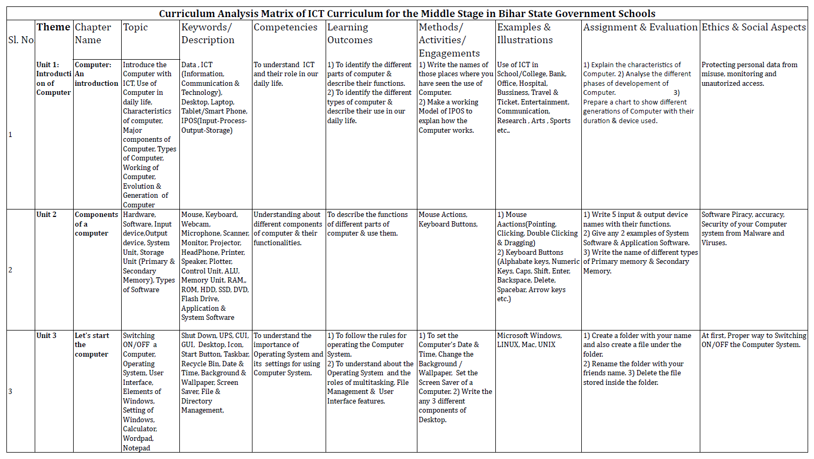
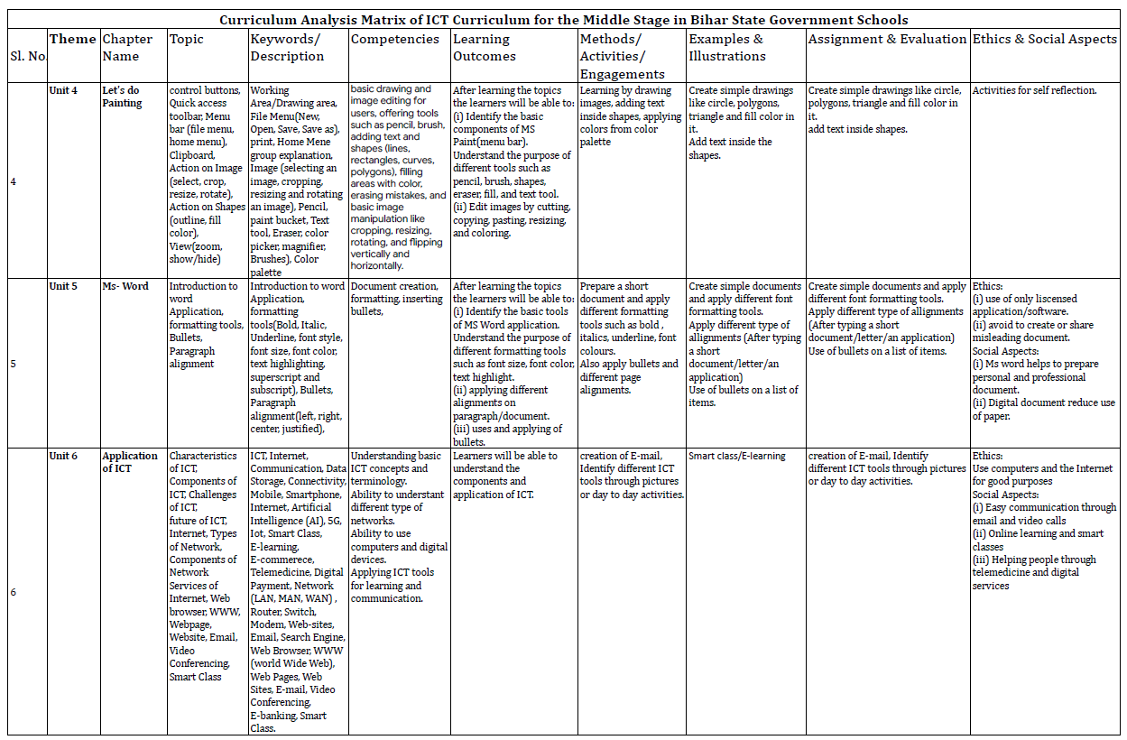
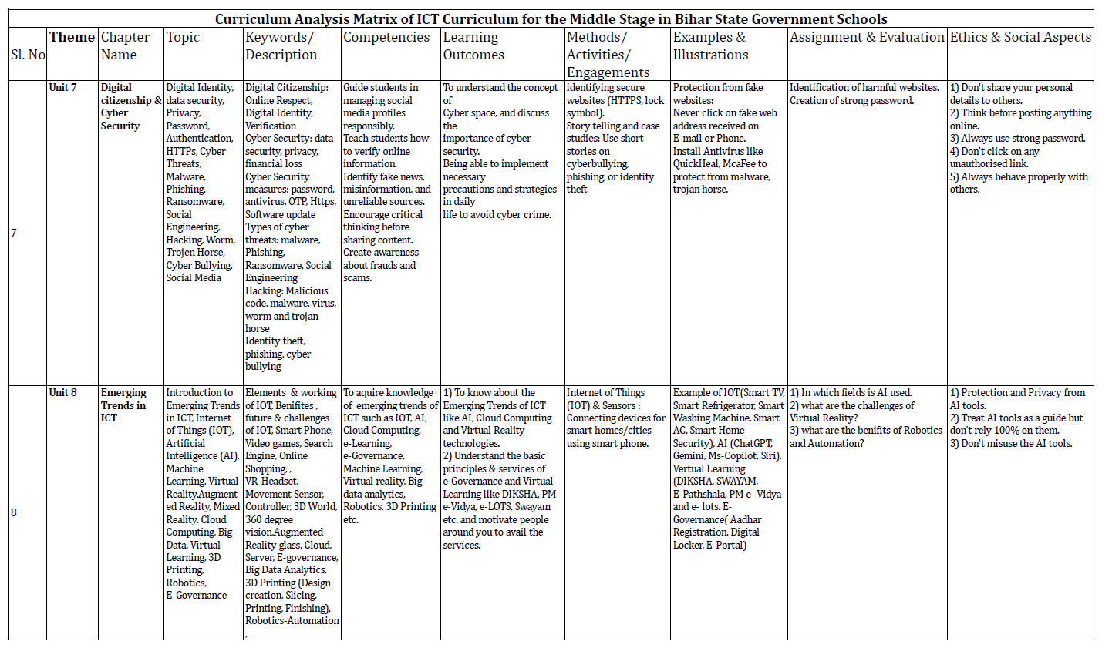
Interpretation of findings to understand the overall nature and scope of ICT content in the Middle Stage curriculum
Unit 1: Introduction of Computer
- Chapter Name: Computer: An Introduction
- Topic: The chapter introduces the concept of the computer in relation to Information and Communication Technology (ICT). It explains the use of computers in daily life, the characteristics of computers, major components of a computer, types of computers, and the working of computers. It also discusses the evolution and different generations of computers.
- Keywords / Description: The important concepts included in this chapter are Data, ICT (Information, Communication and Technology), Desktop, Laptop, Tablet, Smart Phone, and the IPOS model (Input–Process–Output–Storage).
- Competencies: The chapter aims to develop an understanding of ICT and its role in daily life. It helps learners become familiar with computers and their applications in different fields.
- Learning Outcomes: Learners are expected to identify the different parts of a computer and describe their functions. They are also expected to identify different types of computers and explain their uses in everyday life.
- Methods / Activities / Engagements: Learners are encouraged to list the places where they have seen computers being used. They may also prepare a working model of the IPOS cycle to demonstrate how a computer works.
- Examples and Illustrations: Examples are drawn from the use of ICT in various sectors such as schools and colleges, banks, offices, hospitals, business, travel and ticketing systems, entertainment, communication, research, arts, and sports.
- Assignment and Evaluation: Students may be asked to explain the characteristics of computers, analyze the different phases in the development of computers, and prepare a chart showing the different generations of computers along with their duration and the devices used.
- Ethics and Social Aspects: The chapter also emphasizes ethical issues such as protecting personal data from misuse and preventing unauthorized access or monitoring of computer systems.
Unit 2: Components of Computer
- Chapter Name: Components of a Computer
- Topic: This chapter explains the different components of a computer system. It introduces the concepts of hardware and software, various input and output devices, the system unit, and storage units including primary and secondary memory. The chapter helps learners understand how different components work together for the functioning of a computer.
- Keywords / Description: The important concepts included in this chapter are Hardware, Software, Input Devices, Output Devices, System Unit, Storage Unit (Primary and Secondary Memory), and Types of Software. Examples include Mouse, Keyboard, Webcam, Microphone, Scanner, Monitor, Projector, Headphone, Printer, Speaker, Plotter, Control Unit, ALU, Memory Unit, RAM, ROM, HDD, SSD, DVD, Flash Drive, Application Software, and System Software.
- Competencies: The chapter aims to develop an understanding of the different components of a computer and their functions. It enables learners to recognize the role and importance of hardware and software in the working of a computer system.
- Learning Outcomes: Learners are expected to describe the functions of the different parts of a computer and demonstrate the ability to use common input and output devices effectively.
- Methods / Activities / Engagements: Students may be engaged in activities related to mouse actions and keyboard usage. These include identifying and practicing mouse operations such as pointing, clicking, double clicking, and dragging, as well as understanding the functions of different keyboard buttons.
- Examples and Illustrations: Practical examples include mouse actions such as pointing, clicking, double clicking, and dragging. Keyboard illustrations include the use of alphabet keys, numeric keys, caps lock, shift key, enter key, backspace key, delete key, spacebar, and arrow keys.
- Assignment and Evaluation: Students may be asked to write the names of five input and output devices along with their functions. They may also be required to give two examples each of system software and application software. In addition, students may write the names of different types of primary and secondary memory.
- Ethics and Social Aspects: The chapter also highlights ethical and security aspects such as avoiding software piracy, ensuring accuracy in computer use, and protecting computer systems from malware and viruses.
Unit 3: Processing
- Chapter Name: Let’s Start the Computer
- Topic: This chapter introduces the basic procedures for starting and operating a computer system. It explains the process of switching a computer on and off, the concept of an operating system, and the role of the user interface in interacting with the computer. The chapter also discusses the elements of the Windows operating system and basic system settings such as calculator, WordPad, and Notepad.
- Keywords / Description: Important concepts included in this chapter are Shut Down, UPS, CUI (Character User Interface), GUI (Graphical User Interface), Desktop, Icon, Start Button, Taskbar, Recycle Bin, Date and Time settings, Background and Wallpaper, Screen Saver, and File and Directory Management.
- Competencies: The chapter aims to develop an understanding of the importance of the operating system and its settings for the effective use of a computer system.
- Learning Outcomes: Learners are expected to follow the proper rules for operating a computer system. They are also expected to understand the concept of the operating system and its functions, including multitasking, file management, and user interface features.
- Methods / Activities / Engagements: Students may perform practical activities such as setting the computer’s date and time, changing the background or wallpaper, and setting a screen saver. They may also be asked to identify and list different components of the desktop.
- Examples and Illustrations: Examples include different types of operating systems such as Microsoft Windows, Linux, Mac, and Unix.
- Assignment and Evaluation: Students may be asked to create a folder with their name and create a file within that folder. They may also rename the folder using a friend’s name and delete the file stored inside the folder as part of practicing file management operations.
- Ethics and Social Aspects: The chapter emphasizes the importance of following the proper and safe procedure for switching on and switching off the computer system.
Unit 4: Painting
- Chapter Name: Let’s Do Painting
- Topic: This chapter introduces learners to basic drawing and image editing using MS Paint. It explains the use of control buttons, the quick access toolbar, and the menu bar including file and home menus. The chapter also describes various actions that can be performed on images such as selecting, cropping, resizing, and rotating. In addition, it explains how shapes can be created and edited using outline and fill colors, along with view options such as zoom and show or hide features.
- Keywords / Description: Important concepts included in this chapter are the Working Area or Drawing Area, File Menu options such as New, Open, Save, Save As, and Print, and the Home Menu group. It also includes tools such as Image tools for selecting, cropping, resizing, and rotating images; Pencil; Paint Bucket; Text Tool; Eraser; Color Picker; Magnifier; Brushes; and the Color Palette.
- Competencies: The chapter aims to develop basic drawing and image editing skills among learners. It enables them to use tools such as pencil and brush, add text and shapes such as lines, rectangles, curves, and polygons, fill colors in selected areas, erase mistakes, and perform simple image manipulations such as cropping, resizing, rotating, and flipping images vertically or horizontally.
- Learning Outcomes: After learning this chapter, learners will be able to identify the basic components of MS Paint, including the menu bar. They will understand the purpose of different tools such as pencil, brush, shapes, eraser, fill tool, and text tool. They will also be able to edit images by performing actions such as cutting, copying, pasting, resizing, and coloring.
- Methods / Activities / Engagements: Learners may participate in activities such as drawing images, adding text inside shapes, and applying colors from the color palette. These activities help them develop creativity and familiarity with the tools of MS Paint.
- Examples and Illustrations: Examples include creating simple drawings such as circles, polygons, and triangles and filling them with colors. Learners may also practice adding text inside different shapes.
- Assignment and Evaluation: Students may be asked to create simple drawings such as circles, polygons, and triangles and fill them with colors. They may also be required to add text inside shapes as part of their practice and evaluation.
- Ethics and Social Aspects: The chapter encourages activities for self-reflection and responsible use of digital tools while creating and editing images.
Unit 5: Word Processing Software
- Chapter Name: MS Word
- Topic: This chapter introduces learners to the MS Word application and its basic features. It explains how to create and format documents using various formatting tools. The chapter also focuses on text formatting options such as bold, italic, underline, font style, font size, font color, text highlighting, superscript, and subscript. In addition, it introduces the use of bullets and different paragraph alignment options such as left, right, center, and justified.
- Keywords / Description: Important concepts included in this chapter are MS Word application, formatting tools such as bold, italic, underline, font style, font size, font color, text highlighting, superscript, and subscript. It also includes features such as bullets and paragraph alignment options including left alignment, right alignment, center alignment, and justified alignment.
- Competencies: The chapter aims to develop the ability to create and format documents using MS Word. It helps learners understand document creation, text formatting, inserting bullets, and organizing content through appropriate paragraph alignment.
- Learning Outcomes: After learning this chapter, learners will be able to identify the basic tools of the MS Word application and understand the purpose of different formatting tools such as font size, font color, and text highlighting. They will also be able to apply different paragraph alignments in documents and use bullets effectively to present information in a structured manner.
- Methods / Activities / Engagements: Learners may prepare a short document and apply different formatting tools such as bold, italic, underline, and font colors. They may also apply bullets and different paragraph alignments while creating the document.
- Examples and Illustrations: Examples include creating simple documents and applying different font formatting tools. Learners may practice typing a short document, letter, or application and apply different types of paragraph alignments and bullet lists.
- Assignment and Evaluation: Students may be asked to create simple documents and apply various font formatting tools. They may also apply different types of alignments after typing a short document, letter, or application and use bullets to present a list of items.
- Ethics and Social Aspects: The chapter highlights ethical considerations such as using only licensed software and avoiding the creation or sharing of misleading documents. It also emphasizes social aspects, including the usefulness of MS Word in preparing personal and professional documents and the role of digital documents in reducing the use of paper.
Unit 6: Applications of ICT
- Chapter Name: Application of ICT
- Topic: This chapter explains the various applications and characteristics of Information and Communication Technology (ICT). It discusses the components of ICT, challenges in its implementation, and the future prospects of ICT in different fields. The chapter also introduces the concept of the Internet, types of computer networks, components of networks, and the services provided through the Internet. In addition, it explains digital communication tools such as email, web browsers, websites, and video conferencing, along with the use of ICT in smart classrooms and online learning environments.
- Keywords / Description: Important concepts included in this chapter are ICT, Internet, Communication, Data Storage, Connectivity, Mobile and Smartphone technologies, Artificial Intelligence (AI), 5G technology, Internet of Things (IoT), Smart Class, E-learning, E-commerce, Telemedicine, and Digital Payment. It also covers networking concepts such as LAN, MAN, and WAN, as well as networking devices like routers, switches, and modems. Other terms include websites, email, search engines, web browsers, the World Wide Web (WWW), web pages, video conferencing, e-banking, and smart classes.
- Competencies: The chapter aims to develop an understanding of basic ICT concepts and terminology. It also enables learners to understand different types of networks, use computers and digital devices effectively, and apply ICT tools for learning, communication, and information sharing.
- Learning Outcomes: After learning this chapter, learners will be able to understand the components and various applications of ICT and recognize the importance of ICT tools in modern life.
- Methods / Activities / Engagements: Learners may be engaged in activities such as creating an email account and identifying different ICT tools through pictures or through examples from daily life activities.
- Examples and Illustrations: Examples include the use of ICT in smart classrooms and e-learning environments, demonstrating how digital technologies support modern teaching and learning processes.
- Assignment and Evaluation: Students may be asked to create an email account and identify various ICT tools used in daily life through pictures or examples from their surroundings.
- Ethics and Social Aspects: The chapter emphasizes the ethical use of computers and the Internet for positive and constructive purposes. It also highlights social aspects such as easy communication through email and video calls, opportunities for online learning through smart classes, and the use of ICT in providing services such as telemedicine and digital platforms that support social and economic activities.
Unit 7: Social and Technical Aspects of ICT
- Chapter Name: Digital Citizenship and Cyber Security
- Topic: This chapter introduces the concepts of digital citizenship and cyber security. It explains the importance of maintaining a secure digital identity and protecting personal data and privacy while using the internet. The chapter discusses issues such as passwords, authentication, secure websites (HTTPS), and various cyber threats. It also highlights common cyber risks such as malware, phishing, ransomware, hacking, and cyber bullying, along with the responsible use of social media and online platforms.
- Keywords / Description: Important concepts included in this chapter are Digital Citizenship, Online Respect, Digital Identity, Verification, Data Security, Privacy, and Financial Safety. It also covers cyber security measures such as strong passwords, antivirus software, OTP authentication, HTTPS protocols, and regular software updates. The chapter further explains types of cyber threats including malware, phishing, ransomware, social engineering, hacking, viruses, worms, and Trojan horses, as well as issues such as identity theft and cyber bullying.
- Competencies: The chapter aims to guide students in managing their social media profiles responsibly and safely. It helps learners develop the ability to verify online information, identify fake news and misinformation, and recognize unreliable sources. It also encourages critical thinking before sharing online content and creates awareness about online frauds and cyber scams.
- Learning Outcomes: After learning this chapter, learners will be able to understand the concept of cyberspace and recognize the importance of cyber security. They will also be able to apply necessary precautions and strategies in their daily lives to protect themselves from cyber-crimes and online threats.
- Methods / Activities / Engagements: Learners may participate in activities such as identifying secure websites through HTTPS and lock symbols. Storytelling and case studies related to cyber bullying, phishing, and identity theft may also be used to develop awareness and understanding of cyber safety practices.
- Examples and Illustrations: Examples include learning how to protect oneself from fake websites by avoiding suspicious web addresses received through email or mobile messages. Learners may also understand the importance of installing antivirus software such as Quick Heal or McAfee to protect computer systems from malware and Trojan horses.
- Assignment and Evaluation: Students may be asked to identify harmful or suspicious websites and demonstrate the ability to create strong and secure passwords to protect their online accounts.
- Ethics and Social Aspects: The chapter emphasizes responsible and ethical behavior in the digital world. Learners are encouraged not to share personal information with others, to think carefully before posting anything online, to use strong passwords for security, to avoid clicking on unauthorized links, and to maintain respectful and responsible behavior while interacting with others on digital platforms.
Unit 8: Emerging Trends in ICT
- Chapter Name: Emerging Trends in ICT
- Topic: This chapter introduces learners to the emerging trends and advanced developments in Information and Communication Technology. It explains modern technological concepts such as the Internet of Things (IoT), Artificial Intelligence (AI), Machine Learning, Virtual Reality, Augmented Reality, Mixed Reality, Cloud Computing, Big Data, Virtual Learning, 3D Printing, Robotics, and E-Governance. The chapter highlights how these technologies are transforming communication, education, industry, and everyday life.
- Keywords / Description: Important concepts included in this chapter are elements and working of IoT, its benefits, future prospects, and challenges. It also includes examples of digital devices and services such as smartphones, video games, search engines, online shopping platforms, VR headsets, movement sensors, controllers, and 360-degree virtual environments. Other concepts include augmented reality glasses, cloud computing with servers, e-governance systems, big data analytics, and the processes of 3D printing such as design creation, slicing, printing, and finishing. The chapter also discusses robotics and automation technologies.
- Competencies: The chapter aims to develop knowledge and awareness about emerging trends in ICT such as IoT, Artificial Intelligence, Cloud Computing, E-learning, E-Governance, Machine Learning, Virtual Reality, Big Data Analytics, Robotics, and 3D Printing.
- Learning Outcomes: After learning this chapter, learners will be able to understand the concept of emerging ICT technologies such as Artificial Intelligence, Cloud Computing, and Virtual Reality. They will also understand the basic principles and services of e-governance and virtual learning platforms such as DIKSHA, PM e-Vidya, e-LOTS, and SWAYAM, and will be motivated to use and promote these services in their communities.
- Methods / Activities / Engagements: Learners may participate in activities related to the Internet of Things and sensors, such as identifying devices connected through smartphones in smart homes or smart cities.
- Examples and Illustrations: Examples include IoT devices such as Smart TVs, Smart Refrigerators, Smart Washing Machines, Smart Air Conditioners, and Smart Home Security systems. Artificial Intelligence examples include tools such as ChatGPT, Gemini, MS Copilot, and Siri. Virtual learning platforms include DIKSHA, SWAYAM, e-Pathshala, PM e-Vidya, and e-LOTS. E-governance examples include Aadhaar registration, Digital Locker services, and government e-portals.
- Assignment and Evaluation: Students may be asked questions such as identifying the fields in which Artificial Intelligence is used, discussing the challenges associated with Virtual Reality technologies, and explaining the benefits of robotics and automation.
- Ethics and Social Aspects: The chapter highlights the importance of ethical use of emerging technologies. Learners are encouraged to ensure protection and privacy while using AI tools, treat AI tools as supportive guides rather than relying completely on them, and avoid the misuse of AI technologies.
Major Findings
The analysis of the Curriculum Analysis Matrix yielded the following major findings:
- The ICT curriculum of the SCERT for Middle Stage is systematically organized into eight thematic units, beginning with basic concepts of computers and gradually progressing toward advanced ICT topics such as cyber security and emerging technologies.
- The curriculum provides comprehensive conceptual understanding of basic computer knowledge, including computer introduction, components of computers, operating systems, and software applications.
- The content emphasizes practical ICT skills, such as operating computers, using application software (MS Paint and MS Word), and performing basic computer operations.
- The curriculum integrates activity-based learning approaches, including hands-on tasks, project work, drawing activities, and practical exercises that promote experiential learning among students.
- The learning outcomes focus on developing digital literacy and functional ICT competencies, enabling students to use computers and digital tools in daily life.
- The curriculum includes real-life examples and illustrations, such as the use of ICT in banks, hospitals, communication, education, and online services, which help learners connect theoretical concepts with real-world applications.
- Ethical and social aspects of ICT are incorporated throughout the curriculum, including digital citizenship, cyber security awareness, protection of personal data, responsible internet usage, and prevention of cyber threats.
- The curriculum also introduces contemporary and emerging ICT technologies, including Artificial Intelligence, Internet of Things (IoT), cloud computing, robotics, and virtual learning platforms.
- Assessment strategies included in the curriculum consist of assignments, practical tasks, project activities, and reflective exercises, which help evaluate students’ understanding and practical ICT skills.
- The curriculum encourages students to develop critical thinking, problem-solving skills, and responsible digital behavior while interacting with technology.
Conclusion and Suggestions
The ICT curriculum for the middle stage in Bihar state government schools provides a balanced combination of conceptual knowledge, practical ICT skills, and ethical awareness related to digital technology. The structure of the curriculum reflects a gradual progression from basic computer literacy to more advanced ICT concepts. The curriculum emphasizes activity-based learning and real-life applications, which help students develop practical ICT competencies and digital literacy required in the modern technological environment. Moreover, the inclusion of topics related to cyber security, digital citizenship, and emerging technologies prepares learners to become responsible and informed digital citizens.
However, while the curriculum covers a wide range of ICT topics, the effective implementation of these components largely depends on availability of ICT infrastructure, trained teachers, and adequate practical exposure in schools. Strengthening these aspects can further enhance the effectiveness of the ICT curriculum and support meaningful integration of technology in school education.
References
Bell, S. (2010). Project-based learning for the 21st century: Skills for the future. The Clearing House, 83(2), 39–43.
Cai, X., Bi, Y., & Feng, Y. (2025). Exploring the impact of ICT interaction on students’ creative thinking. Frontiers in Psychology. https://doi.org/10.3389/fpsyg.2025.1655731.
Diyal, S. B. (2024). Integration of constructivist pedagogy and ICT tools. Educational Journal, 3(1), 59–67.
Dolmaci, A., & Acar, F. E. (2025). Development of a 21st century skills curriculum. Humanities and Social Sciences Communications, 12, 1666.
Government of India, Ministry of Education. (2020). National education policy 2020. https://www.education.gov.in/sites/upload_files/mhrd/files/NEP_Final_English_0.pdf
Government of India, Ministry of Human Resource Development. (1986). National policy on education 1986. New Delhi: Author.
Government of India, Ministry of Human Resource Development. (1992). National policy on education 1986: Programme of action 1992. New Delhi: Author.
Government of India. (n.d.). Curricula for ICT in education. Retrieved from
https://ictcurriculum.gov.in.
Gupta, N., & Sharma, A. (2023). Exploring digital storytelling as a pedagogical tool for emergent literacy skills. Journal of Indian Education, 49(2), 7–23.
Kour, H., & Mirza, T. (2026). Bridging the digital divide: Exploring teachers’ perspectives on challenges and barriers to ICT integration in rural schools of Jammu Division, J&K. Indian Journal of Educational Technology, 8(1), 361–383.
Mills, K. A., Cope, J., Scholes, L., & Rowe, L. (2025). Coding and computational thinking across the curriculum: A review of educational outcomes. Review of Educational Research, 95(3), 581–618. https://doi.org/10.3102/00346543241241327.
Msafiri, M. M., Kangwa, D., & Cai, L. (2023). A systematic literature review of ICT integration in secondary education: What works, what does not, and what next? Discover Education, 2, Article 44. https://doi.org/10.1007/s44217-023-00070-x.
Nitika, & Pandey, M. (2026). Role of digital storytelling in promoting inclusive language pedagogy. Indian Journal of Educational Technology, 8(1), 43–61.
Reddy, P., Sharma, B., & Chaudhary, K. (2021). Digital divide in online education: Inequality in access and learning outcomes. Journal of Educational Technology Systems, 50(1), 1–18. https://doi.org/10.1177/00472395211023401.
Robin, B. R. (2008). Digital storytelling: A powerful technology tool for the 21st century classroom. Theory Into Practice, 47(3), 220–228.
Soomro, K. A., Kale, U., Curtis, R., & Akcaoglu, M. (2020). Digital divide among higher education faculty. International Journal of Educational Technology in Higher Education, 17, Article 21. https://doi.org/10.1186/s41239-020-00191-5.
Soomro, R. B. K., Khan, R. A., & Rind, I. A. (2025). Exploring ESL teachers’ experiences about ICT-based 4Cs skills: A phenomenological study. Discover Education, 4, Article 12. https://doi.org/10.1007/s44217-024-00376-4.
Sukri, R., & Iksan, Z. H. (2023). Utilizing information and communication technology (ICT) on communication skills: A systematic review. International Journal of Academic Research in Progressive Education and Development. 12(2). DOI:10.6007/IJARPED/v12-i2/17483.
Tiwari, K. R., & Magre, S. (2025). Trends and gaps in digital competency training for teachers: A systematic review of existing literature. South Eastern European Journal of Public Health. https://doi.org/10.70135/seejph.vi.5144
UNESCO. (2018). A global framework of reference on digital literacy skills for indicator 4.4.2. Paris: UNESCO.
UNESCO. (2018). ICT competency framework for teachers (Version 3). Paris: UNESCO.
UNESCO. (2021). Media and information literacy curriculum for educators and learners. Paris: UNESCO.
Varghese, J., & Arya, A. K. (2024). Exploring digital literacy skills among prospective teachers for holistic learning. Indian Journal of Educational Technology, NCERT. https://journals.ncert.gov.in/IJET/article/view/448
Webb, M., & Cox, M. (2004). A review of pedagogy related to information and communication technology. Technology, Pedagogy and Education, 13(3), 235–286.
Weber, A. M., & Greiff, S. (2023). ICT skills in the deployment of 21st century skills: A cognitive developmental perspective. Applied Sciences, 13(7), 4615. https://doi.org/10.3390/app13074615.

