SILENT VECTORS: THE SPREAD OF LEISHMANIASIS ACROSS THE INDIAN SUBCONTINENT AND INTO THE HIMALAYAS

INTRODUCTION
Leishmaniasis is a vector-borne disease of major public health importance, particularly in tropical and subtropical regions where environmental and socioeconomic conditions favor its persistence (WHO, 2023). It is caused by protozoan parasites of the genus Leishmania and is transmitted through the bite of infected female phlebotomine sandflies (Burza et al., 2018). Historically, the disease has been endemic in lowland areas characterized by warm temperatures and favorable ecological conditions for vector survival.
Recent epidemiological evidence indicates a progressive expansion of leishmaniasis into high-altitude regions, particularly across the Himalayan belt (Gálvez et al., 2020). This shift presents new public health challenges, as populations in these areas often lack prior exposure and immunity, and healthcare systems may be inadequately prepared to manage emerging infectious diseases (WHO, n.d.).

MATERIALS AND METHODS
This study adopts a qualitative approach based on a comprehensive review of existing literature, epidemiological data, and environmental studies. Peer-reviewed articles, WHO reports, and global health databases were analyzed to identify key determinants influencing the spread of leishmaniasis.
The literature selection focused on climate change impacts, vector ecology, and socioeconomic determinants. Comparative analysis of multiple studies enabled identification of consistent patterns and emerging trends in disease distribution (Purse et al., 2017; Koch et al., 2017).

RESULTS

Climate change and vector expansion
The analysis reveals that climate change is a primary determinant driving the altitudinal expansion of leishmaniasis into previously non-endemic high-altitude regions. Increasing mean temperatures, reduced diurnal temperature variation, and changing precipitation patterns have collectively expanded the ecological suitability for Phlebotomus sandfly vectors (Purse et al., 2017). Warmer temperatures accelerate the gonotrophic cycle of sandflies, increase biting frequency, and shorten the extrinsic incubation period of Leishmania parasites, thereby enhancing transmission efficiency.
Ecological niche modeling studies further support these observations, demonstrating a measurable upward shift in vector distribution limits, particularly across the Himalayan belt (González et al., 2010). Regions that were previously constrained by low temperature thresholds are now crossing the minimum survival and reproductive thresholds required for vector persistence. Additionally, predictive models indicate that continued warming could result in sustained endemicity in these regions rather than transient outbreaks (Koch et al., 2017).
Climate variability also influences seasonal transmission dynamics. Increased humidity and altered rainfall patterns create favorable microhabitats for larval development and adult resting sites. Episodic climatic events such as unseasonal rainfall or prolonged warm periods further amplify vector density, leading to localized spikes in transmission (Bounoua et al., 2013). These findings collectively confirm that climate change is not only expanding geographic range but also intensifying transmission potential.

Environmental and anthropogenic influences
The results highlight that environmental modifications significantly contribute to the emergence of leishmaniasis in high-altitude ecosystems. Deforestation, agricultural expansion, and infrastructure development disrupt natural habitats and alter the ecological balance between vectors, reservoir hosts, and humans (Oryan & Akbari, 2016). Such disturbances often lead to the adaptation of sandflies to peri-domestic and domestic environments, increasing human exposure.
Land-use changes also influence reservoir host dynamics. Expansion of human settlements into forested or previously undisturbed areas increases contact with animal reservoirs, facilitating zoonotic transmission cycles. Furthermore, construction activities and tourism development in mountainous regions create artificial breeding and resting sites for sandflies, enhancing their survival.
Human migration emerges as another critical driver. Population movement from endemic lowland areas introduces infected individuals into immunologically naïve high-altitude populations, thereby initiating new transmission foci (WHO, 2012). Seasonal labor migration, military deployment, and tourism further increase population mixing, accelerating disease spread. These anthropogenic factors act synergistically with climatic changes, reinforcing the establishment of leishmaniasis in new ecological niches.

Clinical and diagnostic challenges
The study identifies significant challenges in clinical recognition and diagnosis of leishmaniasis in newly affected regions. The disease presents in diverse forms—cutaneous, mucocutaneous, and visceral—each with varying clinical manifestations that often overlap with other infectious or dermatological conditions (Burza et al., 2018). This heterogeneity complicates clinical suspicion, particularly in areas where healthcare providers have limited prior experience with the disease.
In high-altitude settings, limited diagnostic infrastructure further exacerbates the problem. Advanced diagnostic tools such as molecular assays (PCR) and serological tests are often unavailable, leading to reliance on clinical diagnosis or basic microscopy, which may lack sensitivity and specificity. Consequently, cases are frequently misdiagnosed or underreported, contributing to an underestimation of disease burden.
Delayed diagnosis is particularly critical in visceral leishmaniasis, where untreated infections can lead to severe complications and high mortality rates (Alvar et al., 2012). The findings emphasize the need for improved diagnostic capacity and increased clinical awareness in emerging endemic regions.

Socioeconomic determinants
The results demonstrate a strong association between socioeconomic vulnerability and increased leishmaniasis risk. Populations residing in high-altitude regions often experience poverty, poor housing conditions, and inadequate sanitation, all of which facilitate vector breeding and human exposure (Oryan & Akbari, 2016). Houses constructed with mud walls, cracks, and organic materials provide ideal resting sites for sandflies.
Malnutrition and compromised immune status further increase susceptibility to infection and disease progression. Limited access to healthcare services results in delayed treatment, prolonged infectivity, and higher transmission rates. Additionally, lack of awareness regarding preventive measures contributes to sustained disease transmission (WHO, 2023).
These findings indicate that leishmaniasis is not solely an environmental or biological issue but is deeply intertwined with social and economic inequities.

Limitations in control strategies
The study identifies several limitations in current leishmaniasis control strategies, particularly in the context of high-altitude expansion. Vector control measures such as indoor residual spraying and insecticide-treated nets remain the primary interventions; however, their effectiveness is increasingly compromised by the emergence of insecticide resistance among sandfly populations (Ready, 2014).
Operational challenges also hinder effective implementation. Difficult terrain, dispersed populations, and limited infrastructure in mountainous regions restrict the reach of control programs. Additionally, surveillance systems in these areas are often weak or non-existent, leading to delayed outbreak detection and response (WHO, 2012).
The results further indicate that existing control programs are largely designed for traditional endemic regions and may not be suitable for the unique ecological and social contexts of high-altitude areas. This highlights the urgent need for adaptive, region-specific strategies that incorporate climate data, vector ecology, and local socioeconomic conditions.
Overall, the results provide strong evidence that the altitudinal expansion of leishmaniasis is a multifactorial process driven by climate change, environmental disruption, human mobility, and socioeconomic vulnerability. These interconnected factors collectively contribute to the emergence and establishment of the disease in previously unaffected regions, underscoring the need for integrated and forward-looking public health interventions.
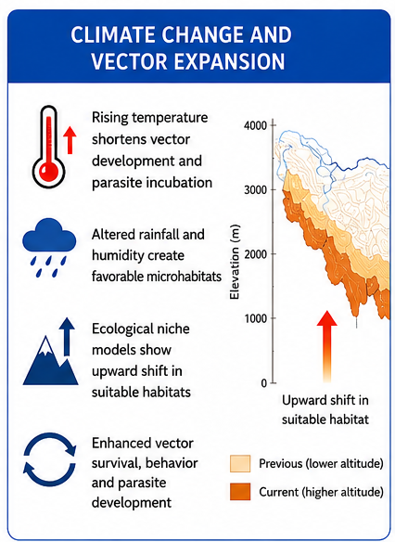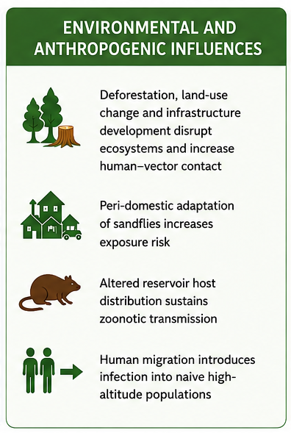
A B
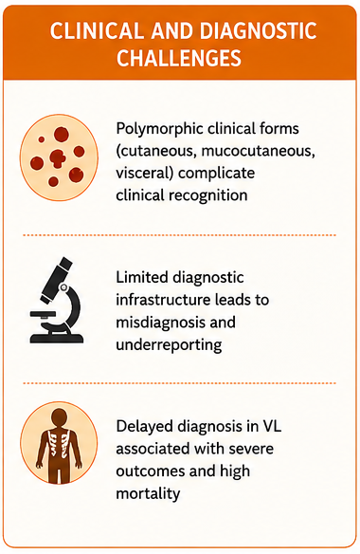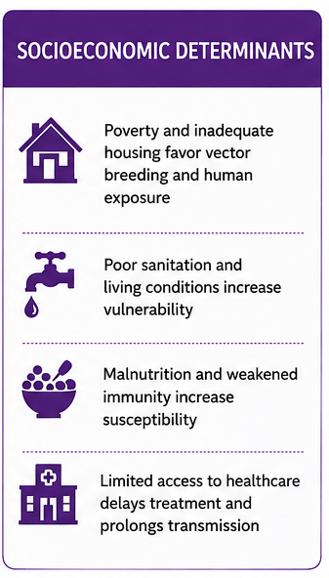
C D
Figure No. 01: Results of the study A. Climate Change and Vector Expansion B. Environmental and Anthropogenic Influences C. Clinical and Diagnostic Challenges & D. Socioeconomic Determinants
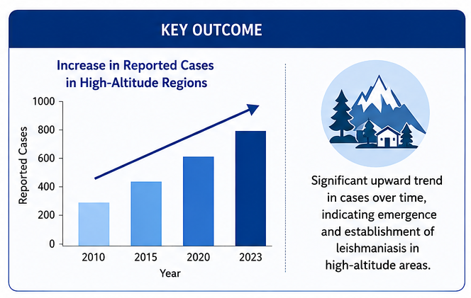Figure No. 02: Trend of the incidence of Leishmaniasis in High altitude regions

DISCUSSION
This study demonstrates that the altitudinal expansion of leishmaniasis is driven by an interaction of climatic, ecological, and socioeconomic factors, with climate change acting as the primary determinant. Rising temperatures and altered precipitation patterns are expanding the ecological range of Phlebotomus sandflies while enhancing vector activity and parasite development (Purse et al., 2017). Although climate sensitivity of vector-borne diseases is well established, prior research has largely focused on lowland systems; this study extends that framework to high-altitude regions, highlighting an emerging epidemiological shift.
Predictions from ecological niche models (González et al., 2010; Koch et al., 2017) are increasingly reflected in observed transmission patterns, suggesting a transition from potential suitability to active establishment. This shift marks a critical threshold where transmission may become self-sustaining. Additionally, climate-driven changes in humidity and rainfall create microhabitats that support vector survival and seasonal amplification (Bounoua et al., 2013), reinforcing ecological findings while emphasizing their epidemiological relevance in mountainous environments.
Anthropogenic environmental changes further intensify these dynamics. Consistent with earlier studies (Oryan & Akbari, 2016), deforestation and land-use change increase human–vector contact; however, this study highlights the peri-domestic adaptation of sandflies in high-altitude settings, a mechanism less emphasized in previous work. Human mobility also plays a critical role. While recognized as a driver (WHO, 2012), its importance is amplified in the Himalayan context, where migration, tourism, and military activity facilitate the introduction and persistence of infection.
Clinical challenges identified here align with existing literature (Burza et al., 2018; Alvar et al., 2012), but are exacerbated in newly affected regions due to limited awareness and diagnostic capacity, leading to underreporting and delayed treatment. Socioeconomic vulnerability remains central (Oryan & Akbari, 2016; WHO, 2023), with this study emphasizing the added impact of geographic isolation on healthcare access and disease outcomes.
Current control strategies face significant limitations. Insecticide resistance (Ready, 2014) and logistical constraints in mountainous terrain reduce intervention effectiveness, indicating that lowland-based approaches may not be directly transferable. Moreover, weak surveillance systems (WHO, 2012) hinder early detection and response, underscoring the need for climate-informed and geospatially integrated monitoring.
In conclusion, this study advances existing literature by integrating multiple drivers into a systems-level understanding of leishmaniasis expansion in high-altitude regions. Addressing this evolving threat requires adaptive, multidisciplinary strategies that incorporate climate data, strengthened surveillance, and context-specific interventions.

DECLARATIONS
Funding
No funding was received for this study.
Conflict of interest
The author declares no conflict of interest.

Ethical approval
This article does not contain any studies involving human participants or animals.

REFERENCES:
- Alvar, J., Vélez, I. D., Bern, C., Herrero, M., Desjeux, P., Cano, J., Jannin, J., & den Boer, M. (2012). Leishmaniasis worldwide and global estimates of its incidence. PLOS ONE, 7(5), e35671. https://doi.org/10.1371/journal.pone.0035671
- Bounoua, L., Kahime, K., Houti, L., Blakey, T., Ebi, K. L., Zhang, P., Imhoff, M. L., Thome, K. J., Dudek, C., & Sahabi, S. A. (2013). Linking climate to incidence of zoonotic cutaneous leishmaniasis in pre-Saharan North Africa. International Journal of Environmental Research and Public Health, 10(8), 3172–3191. https://doi.org/10.3390/ijerph10083172
- Burza, S., Croft, S. L., & Boelaert, M. (2018). Leishmaniasis. The Lancet, 392(10151), 951–970. https://doi.org/10.1016/S0140-6736(18)31204-2
- Gálvez, R., Descalzo, M. A., Guerrero, I., Miró, G., & Molina, R. (2020). Seasonal dynamics of phlebotomine sand flies and transmission of Leishmania infantum in high-altitude ecosystems. Acta Tropica, 205, 105749. https://doi.org/10.1016/j.actatropica.2020.105749
- González, C., Wang, O., Strutz, S. E., González-Salazar, C., Sánchez-Cordero, V., & Sarkar, S. (2010). Climate change and risk of leishmaniasis in North America: Predictions from ecological niche models of vector and reservoir species. PLoS Neglected Tropical Diseases, 4(1), e585. https://doi.org/10.1371/journal.pntd.0000585
- Karamian, M., Ghatee, M. A., Shayesteh, M., Taylor, W. R., & Mohebi-Nejad, S. (2021). The effect of geo-climatic determinants on the distribution of cutaneous leishmaniasis in a recently emerging focus in eastern Iran. Parasites & Vectors, 14, 538. https://doi.org/10.1186/s13071-021-05046-0
- Koch, L. K., Kochmann, J., Klimpel, S., & Cunze, S. (2017). Modeling the climatic suitability of leishmaniasis vector species in Europe. Scientific Reports, 7, 13325. https://doi.org/10.1038/s41598-017-13822-1
- Oryan, A., & Akbari, M. (2016). Worldwide risk factors in leishmaniasis. Asian Pacific Journal of Tropical Medicine, 9(10), 925–932. https://doi.org/10.1016/j.apjtm.2016.06.021
- Peterson, A. T., & Shaw, J. (2003). Lutzomyia vectors for cutaneous leishmaniasis in southern Brazil: Ecological niche models, predicted geographic distribution, and climate change effects. International Journal for Parasitology, 33(9), 919–931. https://doi.org/10.1016/S0020-7519(03)00094-8
- Purse, B. V., Masante, D., Golding, N., Pigott, D. M., Day, J. C., Ibañez-Bernal, S., Kolb, M., & Jones, L. (2017). How climate change pathways and mitigation options alter the incidence of vector-borne diseases: A framework for leishmaniasis. PLOS ONE, 12(10), e0183583. https://doi.org/10.1371/journal.pone.0183583
- Ready, P. D. (2014). Epidemiology of visceral leishmaniasis. Clinical Epidemiology, 6, 147–154. https://doi.org/10.2147/CLEP.S44267
- Trájer, A. J. (2022). The alteration of the suitability patterns of Leishmania infantum due to climate change in Iran. International Journal of Environmental Health Research, 32(7), 1567–1580. https://doi.org/10.1080/09603123.2021.1897535
- World Health Organization. (2012). Control of the leishmaniases (WHO Technical Report Series No. 949). https://www.who.int/publications/i/item/WHO-TRS-949
- World Health Organization. (2023). Leishmaniasis. https://www.who.int/news-room/fact-sheets/detail/leishmaniasis
- World Health Organization. (n.d.). Leishmaniasis in India. https://www.who.int/india/health-topics/leishmaniasis

