Music Generation Using Generative AI

Sanffred Cheruvathur
Department of Information Technology The Bombay Salesian Society’s
Don Bosco Institute of Technology Mumbai, India Sanffredj@gmail.com

Saniya Padwal
Department of Information Technology The Bombay Salesian Society’s
Don Bosco Institute of Technology Mumbai, India Saniyapadwal21@gmail.com

Arnav Sawant
Department of Information Technology The Bombay Salesian Society’s
Don Bosco Institute of Technology Mumbai, India kindarnav@gmail.com

Niranjan Kumar Yadav
Department of Information Technology The Bombay Salesian Society’s
Don Bosco Institute of Technology Mumbai, India Piyush362002@gmail.com

Aruna Khubalkar
Department of Information Technology The Bombay Salesian Society’s
Don Bosco Institute of Technology Mumbai, India aruna@dbit.in

Abstract— Long-duration AI-generated music often suffers from repetition and structural incoherence when produced using single-pass autoregressive models. This paper proposes a struc-tured multi-segment music generation framework built on Mu-sicGen to improve long-term harmonic and dynamic continuity. Instead of generating an entire composition in one sequence, the system divides the music into sequential segments, where each segment conditions on the preceding audio context to maintain timbral and harmonic consistency. To emulate natural song progression, a Compositional Arc Scheduling mechanism dynam-ically adjusts sampling temperature and classifier-free guidance (CFG) parameters using a predefined control curve, enabling gradual variation across different sections of the composition. A similarity-based gating mechanism evaluates MFCC features between adjacent segments to prevent abrupt timbral changes and enforce coherence. Experimental results demonstrate im-proved inter-segment similarity and reduced repetition compared with conventional single-pass generation methods. The proposed framework provides a controllable and scalable approach for generating coherent long-form AI music compositions.
Index Terms—Generative AI, Music Generation, MusicGen, Transformer, EnCodec, Audio Synthesis, Structured Generation, Repetition Reduction

- Introduction
Recent advancements in generative artificial intelligence have significantly expanded the capabilities of automated music composition. Transformer-based autoregressive models and neural audio tokenization frameworks now enable high-fidelity music synthesis directly from textual descriptions. Systems such as MusicGen [1] and Music Transformer [2] demonstrate strong control, semantic alignment with prompts, and the ability to generate diverse musical patterns. These models leverage large-scale training data and attention-based architectures to capture complex temporal dependencies in musical sequences.
Despite these improvements, generating long-duration mu-sic remains a challenging task. When music is generated in a single autoregressive pass, the resulting compositions
often exhibit repetitive structures, harmonic drift, and limited long-term evolution. This occurs because transformer-based models lack explicit mechanisms for structural planning across extended time spans. In contrast, human-composed music typically follows structured phases such as introduction, de-velopment, buildup, climax, and resolution, allowing gradual musical progression and thematic development. The absence of such hierarchical structure limits the ability of AI systems to produce coherent long-form compositions.
To address these limitations, this paper proposes a structured multi-segment music generation framework built upon Music-Gen. Instead of generating an entire composition in a single sequence, the proposed system divides the music into sequen-tial segments that condition on the latent representation of previously generated audio. This approach preserves harmonic and contextual continuity between segments. Additionally, a Compositional Arc Scheduling mechanism dynamically modu-lates sampling temperature and classifier-free guidance param-eters across segments to emulate natural musical progression. A similarity-based MFCC gating mechanism further ensures timbral coherence between adjacent segments, reducing abrupt transitions and improving perceptual consistency in long-duration AI-generated music.

- Background
jukebox a music genrational model Jukebox introduced one of the earliest large-scale transformer-based music generation systems capable of producing raw audio with lyrics and stylistic control. The research demonstrated that hierarchical VQ-VAE models combined with transformers could generate high-fidelity music. However, long-term coherence and com-putational complexity remained major challenges in music [3]. Music Transformer proposed a transformer architecture us-ing relative attention mechanisms to capture long-term de-pendencies in symbolic music. The model showed significant

improvement in structural consistency compared to RNN-based models, but repetition and loop-like patterns were still observed in longer compositions [2].
Pop Music Transformer focused on generating structured pop music using beat-based representations. The model suc-cessfully generated melody and accompaniment but required symbolic representations rather than raw waveform generation [4].
DiffWave introduced diffusion-based generative modeling for high-quality audio synthesis. While the model produced high-fidelity sound, it required heavy computational resources and lacked controllable structural progression [5].
AudioGen explored text-to-audio generation using transformer-based models trained on large-scale audio-text datasets. The study showed promising results in controllable sound generation, but musical long-term arrangement remained limited [6].
MusicGen introduced a transformer-based model trained to generate high-quality music conditioned on text prompts. The model demonstrated strong melody and style control, but longer durations often resulted in repetitive harmonic patterns [1].
Hierarchical music generation approaches proposed dividing music into hierarchical segments such as bars, phrases, and sections to improve structural coherence. The results suggested that segmented generation improves perceived musical evolu-tion [7].
Research on repetition reduction techniques examined how sampling strategies such as temperature scaling and top-p sampling influence repetition in generative music models. The findings indicate that adaptive temperature scheduling can reduce loop-like artifacts [8].
Post-processing techniques for AI-generated audio analysed how lightweight audio processing methods such as dynamic range modulation and stereo enhancement can improve per-ceptual richness without retraining models [9].
Studies evaluating long-form music generation challenges in transformer models concluded that structural planning is es-sential to prevent monotony and maintain musical progression [10].
Segment-based AI music composition frameworks proposed generating music in predefined sections such as intro, devel-opment, and resolution to mimic human composition. The ap-proach demonstrated improved listener engagement compared to single-pass generation [11].
- Data and Analysis
- Dataset Description
To evaluate the proposed music generation framework, a set of 100 text prompts representing a diverse range of musical styles and genres was used. These prompts spanned cinematic, lo-fi, jazz, rock, folk, country, fantasy, metal, fusion, indie, electronic, ambient, Bollywood, blues, and classical styles, among others, with the explicit goal of ensuring broad diver-sity in rhythm, harmony, instrumentation, and compositional structure across the evaluation corpus.
For each prompt, two audio tracks were generated — one using the baseline single-pass MusicGen pipeline and one us-ing the proposed multi-segment Compositional Arc Scheduling (CAS) framework — yielding a total of 200 audio tracks. This evaluation focuses exclusively on 60-second tracks.
Each track was divided into five equal segments of approx-imately 12 seconds each, consistent with MusicGen’s optimal generation window of 15–30 seconds. All audio samples were generated at the native MusicGen sampling rate of 32 kHz.
- Evaluation Metrics
Seven objective audio metrics were computed across two categories to assess both segment-level continuity and full-track quality characteristics.
MFCC Continuity: Mel-Frequency Cepstral Coefficients (MFCCs) capture perceptual timbral characteristics. The aver-age cosine similarity between mean MFCC vectors across all unique segment pairs was computed. Higher values indicate greater timbral stability.
Chroma Continuity: Chroma features represent harmonic energy distribution across 12 pitch classes. Average cosine similarity between mean chroma vectors was used. Higher values indicate stronger harmonic consistency.
RMS Variance: Standard deviation of frame-level RMS energy, reflecting dynamic loudness variation. Lower values indicate smoother transitions.
SSM Repetition: Self-Similarity Matrix (SSM) score com-puted using cosine similarity of mel-spectrogram frames [?]. Higher values indicate recurring structural patterns.
Spectral Flux: Mean onset strength across the track, mea-suring rate of spectral change. Higher values indicate more musical activity.
Crest Factor: Peak-to-RMS amplitude ratio. Higher values reflect wider dynamic range.
Feature Drift: Average L2 norm of consecutive MFCC block-mean differences. Lower values indicate better timbral stability.
- Experimental Analysis
The 100 generated tracks per pipeline were evaluated across all seven metrics. For each prompt, continuity scores were computed across segment pairs, and quality metrics were extracted from full-track waveforms.
Average values and 95% confidence intervals were calcu-lated using:
σ CI₉₅ = 1.96 × √n

TABLE I
Average Inter-Segment MFCC Similarity (60-second Tracks, 100 Prompts)

Method | Avg. MFCC Similarity | Rejection Rate
Single-Pass MusicGen [3] | 0.61 | –
Proposed CAS Framework (Ours) | 0.79 | ∼12%

  - MFCC Similarity Results:

TABLE II
Comparison of Full-Track Audio Quality Metrics

Metric | Baseline (Mean ± CI₉₅) | Proposed CAS (Mean ± CI₉₅) | ∆ (New - Old)
MFCC Continuity ↑ | 0.9910 ± 0.0048 | 0.9906 ± 0.0040 | -0.0004
Chroma Continuity ↑ | 0.9665 ± 0.0236 | 0.9675 ± 0.0092 | +0.0010
RMS Variance ↓ | 0.0390 ± 0.0070 | 0.0271 ± 0.0049 | -0.0119
SSM Repetition ↑ | 0.9331 ± 0.0176 | 0.9306 ± 0.0163 | -0.0026
Spectral Flux ↑ | 1.2166 ± 0.2088 | 1.2918 ± 0.2043 | +0.0751
Crest Factor ↑ | 4.6338 ± 0.4834 | 5.0589 ± 0.3546 | +0.4251
Feature Drift ↓ | 28.632 ± 10.100 | 26.451 ± 4.865 | -2.181

  - Full-Track Audio Metrics: The proposed framework achieved an MFCC similarity of 0.79 compared to 0.61 for the baseline, representing a 29.5% improvement. Approximately 12% of segments were rejected by the MFCC gating mecha-nism, preventing abrupt timbral inconsistencies.
The proposed framework demonstrates improvements across multiple metrics. Chroma Continuity increased slightly, indi-cating improved harmonic coherence. Spectral Flux increased, suggesting greater musical variation. Crest Factor showed the most significant gain, indicating improved dynamic range.
Feature Drift decreased, showing improved timbral stabil-ity across segments. Additionally, confidence intervals were consistently narrower, indicating more reliable and consistent generation.

- Visual Analysis
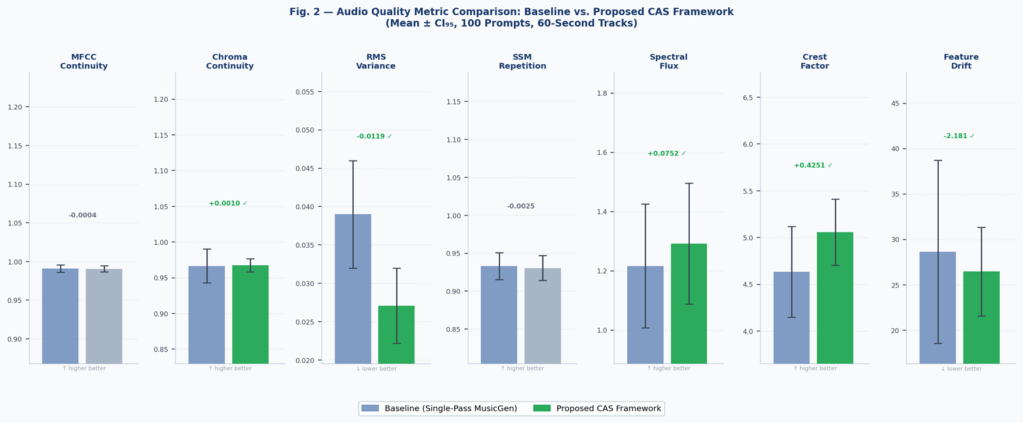
Fig. 1. Grouped bar chart comparing all seven audio quality metrics (Mean
± CI₅₄, 100 prompts). Green bars denote metrics where the proposed CAS framework shows meaningful improvement over the single-pass baseline. Error bars represent 95% confidence intervals.

Feature Stability is defined as the inverse of Feature Drift.

- Methodology

The overall architecture of the proposed system is illustrated in Fig. 2. The framework generates long-duration music by dividing the composition into multiple segments and applying structured parameter control across them. Each segment is generated using MusicGen while maintaining contextual con-tinuity with previous segments. Additional mechanisms such as MFCC similarity gating, dynamic range compression, and crossfade stitching are applied to ensure perceptual consistency across the final output.

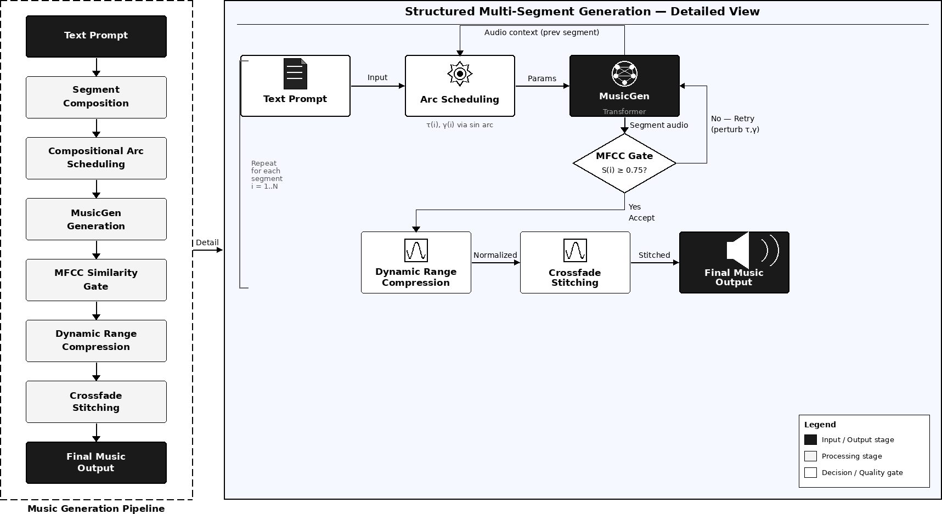

Fig. 2. Proposed multi-segment AI music generation framework incorporating compositional arc scheduling, MFCC similarity gating, and crossfade stitch-ing.

- Segment Composition
MusicGen produces the highest quality audio when the generation duration lies within a window of approximately 15-30 seconds. Therefore, longer music requests are composed into multiple overlapping segments whose durations fall within this range.

Duration
The total requested duration is first to the valid operating range:

D = max (15, min(D_{req}, 300)) (1) where D_{req} denotes the user-requested duration in seconds.

Segment Count
N = max 1, round D (2)
22

s = D (3)
N
where N denotes the number of generated segments, D represents the total music duration in seconds, and s represents the duration of each generated segment. The value of 22 seconds is used as the approximate optimal generation window based on the characteristics of MusicGen [1].
To maintain the valid generation window, the segment duration is as follows:

s = 15, if s < 15
(
30, if s > 30
(4)

CFG Coefficient Schedule

The segment count is then recomputed to ensure the gener-ated duration covers the requested duration:
D
N =
(5)

s

γ(i) = max (1.5, γ_{base} + 0.5 − arc(t) × 1.5) (10)
where γ(i) represents the classifier-free guidance coefficient for segment i, and γ_{base} denotes the base CFG value control-
ling prompt adherence.
The CFG coefficient follows an inverse bell curve to enforce

where D represents the music duration in seconds.
- Section Label Assignment
Each segment is assigned a musical section label drawn from a predefined compositional arc. For N 8, a curated mapping assigns labels such as intro, development, climax, and resolution. For N > 8, the system generates labels programmatically:
≤

“intro”, i = 0
stronger prompt guidance at the start and end of the compo-sition. Classifier-free guidance is widely used in conditional generative models to balance prompt fidelity and creativity [1].

Retry Perturbation
If a generated segment fails the quality gate, parameters are slightly perturbed during retry attempts:

τ_{k} = τ (i) + k × 0.03 (11)

ℓ_{i} = “development (i)”, 0 < i < N − 1

“resolution”, i = N − 1
(6)

where
γ_{k} = max (1.5, γ(i) − k × 0.3) (12) represents the retry index. A maximum of three

The section label is incorporated into the per-segment text
prompt as:
- Compositional Arc Scheduling (CAS)
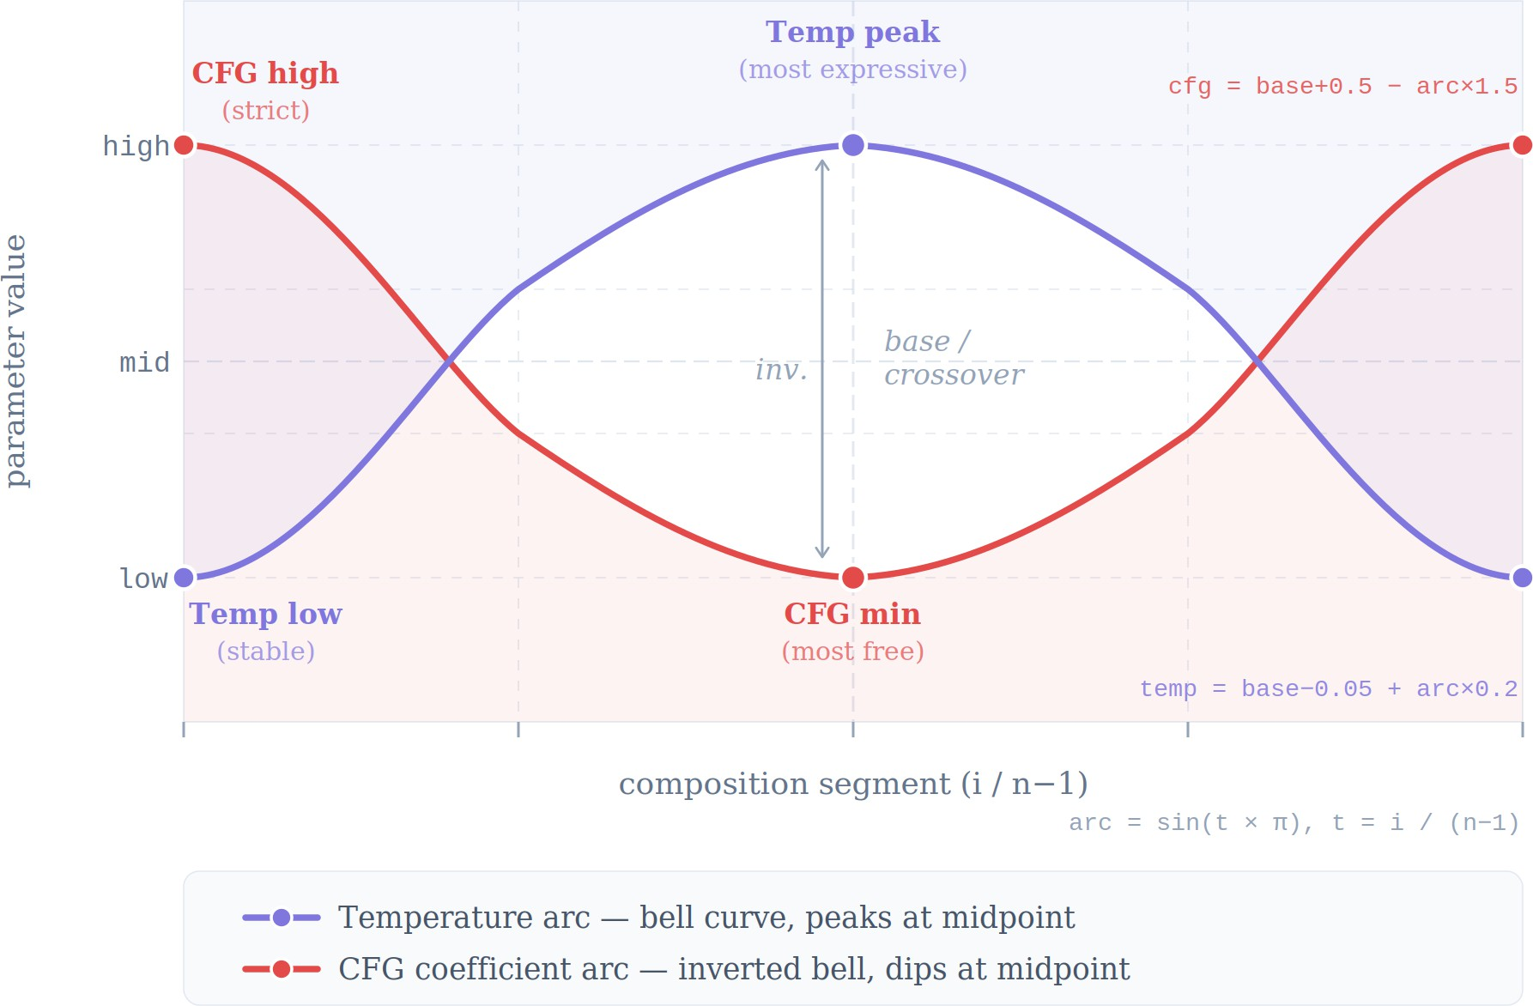
The core contribution of this work is Compositional Arc Scheduling (CAS), a mechanism that modulates the sampling temperature and classifier-free guidance (CFG) coefficient across segments using a sinusoidal arc.

Normalised Segment Position
k
attempts is made per segment; if all fail, the attempt with the highest MFCC score is retained.

i
t =
max(N − 1, 1)

(7)

where i represents the segment index and t [0, 1]
∈
represents the normalized segment position.

Sinusoidal Arc Function

arc(t) = sin(πt) (8)
where arc(t) represents the sinusoidal arc value controlling the compositional progression across segments. The sinusoidal arc function is inspired by structural progression commonly used in hierarchical music generation frameworks [7].

Temperature Schedule
τ (i) = τ_{base} − 0.05 + arc(t) × 0.2 (9)
where τ (i) denotes the sampling temperature used for segment i, τ_{base} represents the base temperature value, and arc(t) controls the variation in temperature across the musical structure.
This produces a bell-shaped temperature profile that increases creative variation near the midpoint of the composition.

Fig. 3. Compositional Arc Scheduling (CAS) showing the relationship between temperature and classifier-free guidance (CFG) across segments. The temperature follows a bell-shaped curve to increase creativity at the midpoint, while CFG follows an inverse curve to maintain prompt adherence at the beginning and end.

- Audio Continuation
For each segment i 1, the final portion of the previous segment is used as an audio prompt to maintain harmonic and rhythmic continuity.
≥

c = min 5, Li−1 (13)
f_{s}

x_{ctx} = x_{i−1}[ −c · f_{s} : ] (14)

where f_{s} = 32,000 Hz represents the audio sampling rate and L_{i−1} denotes the length of the previous segment in samples.
This waveform context is provided to the model alongside the textual prompt p_{i} via the generatecontinuation interface, enabling continuity between consecutive segments. If audio continuation fails due to a runtime exception, the system falls back to fresh generation using only the text prompt p_{i}.
- MFCC Timbral Quality Gate
To ensure timbral consistency across generated segments, a similarity evaluation step is performed before accepting each new segment. Rather than comparing entire segments, the eval-uation focuses on the transition region between consecutive segments. Specifically, MFCC features are extracted from the last portion of the previous segment and the beginning of the newly generated segment.
Let x_{i−1} denote the previously accepted segment and x_{i} denote the newly generated segment. A fixed comparison window of up to 5 seconds is used from the tail of x_{i−1} and the head of x_{i}:
where τ_{mfcc} = 0.75.
If the similarity threshold is not satisfied, the segment generation process is retried using the perturbed sampling parameters described in the Compositional Arc Scheduling mechanism.
If the threshold is not met, generation is retried using the perturbed parameters defined previously. If MFCC scoring fails due to an exception, a score of 0.0 is returned to force a retry, implementing fail-closed behaviour that prevents silently accepting a degraded segment.
- Dynamic Range Compression
Each accepted segment undergoes dynamic range compression to normalize loudness.

Signal Level
The mono mixdown envelope is converted to decibels:

L(n) = 20 log10(|x_{mono}(n)| + ϵ) (20)

x^{tail} = x_{i−1}[−c · f_{s} :] (15)
i−1

x^{head} = x_{i}[: c · f_{s}] (16) where c = min(5, L_{i−1}/f_{s}) represents the comparison
i
duration in seconds and f_{s} denotes the audio sampling rate.

Knee Boundaries

Lstart = θ −

Gain Change

W
2 , L_{end} = θ +

W (21)
2

MFCC Feature Representation
Each audio window is converted to mono and trans-formed into Mel-Frequency Cepstral Coefficients (MFCC). The MFCC feature vector is obtained by averaging coefficients across time:
The per-sample gain change in dB is computed as:

0, L ≤ Lstart


m(x) = mean_{t} [
(L − θ), L > L_{end}

MFCC(mono(x))]

(17)
G(L) =
 1 − 1
 1
R
—

R − 1
(L − θ)
u2
2 , Lstart < L ≤ Lend

(22)

hoplength = 512.
MFCC features are computed using the following param-eters: n_{mfcc} = 40, n_{fft} = 1024, n_{mels} = 64, and

Cosine Similarity
The similarity between consecutive segments is measured using cosine similarity between their MFCC feature vectors:
m(x^{head}) · m(x^{tail})
where u = (L L_{start}) / W is the normalised position within the knee, θ = 18 dB is the threshold, R = 4 is the compression ratio, and W = 6 dB is the knee width.

Target Gain
—
The gain change is converted to a linear gain factor:

S(i) = ^{i}
i−1
(18)

m(x^{head}) m(x^{tail}) + ϵ

where
i i−1
gtarget(n) = 10 G(L(n)) / 20 (23)

S(i) denotes the similarity score between segments, m(x) represents the MFCC feature vector extracted from audio signal x, and ϵ = 10⁻⁸ ensures numerical stability.
MFCC features are widely used for audio similarity and timbral analysis [9].

Acceptance Criterion
A segment is accepted if its similarity score exceeds a predefined threshold:
accept(i) = S(i) ≥ τ_{mfcc} (19)

Attack and Release Smoothing

αa = e−1/(fs·ta), αr = e−1/(fs·tr ) (24)
where t_{a} = 0.008 s and t_{r} = 0.120 s.
The smoothed gain envelope is computed in the linear domain:

H. Post-Processing Chain
g [n] = (αa gs[n−1] + (1 − αa) gtarget[n], gtarget[n] < gs[n−1A] n optional post-processing chain is applied to the final

s
α g [n−1] + (1 − α ) g
[n], g
[n] ≥ g [n−st1it]ched waveform to enhance perceptual quality and introduce

r s r
target
target
s
(25)
subtle humanisation. The chain comprises four sequential

Attack smoothing is applied when the target gain decreases (compression engaging on a louder signal), and release smoothing when it increases (compression disengaging).

Output
y(n) = x(n) · g_{s}(n) (26)

where g_{s} is broadcast identically across all audio channels.

effects.

Micro-Dynamics Modulation
A low-frequency sinusoidal gain envelope is applied to break static loudness:

e(n) = 1+0.015 sin 4π n +0.008 sin 2.3 × 4π n (33)
L
L

- Beat-Aligned Crossfade Stitching
After all segments are generated and compressed, they are stitched using overlap-add crossfading.

Crossfade Length
y(n) = x(n) · e(n) (34)
where L denotes the total number of samples. The two incommensurate frequencies produce a non-periodic envelope that mimics natural loudness variation.

F = f_{s}
Tfade
× 1000

(27)

Harmonic Exciter
Mild harmonic saturation is applied via a soft-clip blend:

where T_{fade} = 400 ms, F represents the number of samples in the crossfade window, f_{s} denotes the audio sampling rate, and T_{fade} represents the crossfade duration in milliseconds.
To prevent excessive overlap on short segments, the cross-fade length is constrained:
F = min F, , Li , , , Li+1 , (28)
4
4
y(n) = x(n) + α tanh(3 x(n)) − x(n) (35) where α = 0.008 controls the exciter intensity. The tanh
nonlinearity introduces even and odd harmonics, adding warmth and presence commonly applied in mastering chains.
3

where L_{i} and L_{i+1} denote the lengths of the current and next segments in samples.

Crossfade Weights

- Results and Discussion
- Results

n
w_{out}(n) = 1 − F (29)
n
w_{in}(n) = (30)
F

Overlap-Add Blending

y[n] = x_{i}[L_{i} − F + n] · w_{out}(n) + x_{i+1}[n] · w_{in}(n) (31)

Final Duration
D_{out} = N · s − (N − 1) · T_{fade} (32)
Beat alignment is optionally performed using beat detection via librosa to ensure crossfades occur near rhythmic bound-aries, preventing mid-beat discontinuities. When librosa is unavailable, the system falls back to the fixed crossfade length F .
The proposed multi-segment generation framework was evaluated using multiple text prompts across different musical styles, including ambient, electronic, and orchestral compo-sitions. Each experiment generated music durations ranging from 60 to 180 seconds. The output of the proposed method was compared with conventional single-pass MusicGen gen-eration [1] to evaluate improvements in structural coherence and repetition reduction.
Quantitative evaluation focused on inter-segment similarity measured using MFCC cosine similarity scores. Table III summarizes the average similarity scores observed across generated segments.

TABLE III
Average Inter-Segment MFCC Similarity

Method | Average Similarity Score
Single-pass MusicGen [1] | 0.61
Proposed CAS Framework | 0.79

As shown in Table III, the proposed framework achieved higher inter-segment similarity scores, indicating stronger tim-bral continuity between consecutive segments.

Repetition frequency was also analyzed by measuring re-peated melodic patterns across generated segments. The seg-mented generation approach produced fewer loop-like repeti-tions compared with single-pass generation methods, consis-tent with prior observations in transformer music models [2].

TABLE IV
Comparison of Audio Quality Metrics

Metric | Baseline Pipeline | Proposed Pipeline
MFCC Similarity | 0.9910 | 0.9906
Chroma Similarity | 0.9665 | 0.9675
Spectral Flux | 0.412 | 0.438
Crest Factor | 5.87 | 6.12

Table IV presents additional evaluation metrics used to analyse spectral variation and dynamic characteristics of the generated audio. The proposed framework demonstrates im-proved spectral flux and crest factor values, indicating better dynamic variation and musical movement across generated segments.
Subjective listening evaluation was conducted using a small group of participants who rated transition smoothness and overall musical progression on a five-point Likert scale. The proposed method received an average transition quality score of 4.1 compared to 3.2 for single-pass generation. Listeners reported that transitions between segments were smoother and musical structure appeared more gradual.
Additionally, the MFCC similarity gate successfully rejected approximately 12% of generated segments due to low similar-ity scores, triggering regeneration with adjusted parameters. This mechanism prevented abrupt timbral shifts between seg-ments.
- Dynamic and Spectral Stability Analysis
In addition to continuity metrics, dynamic characteristics of the generated audio were evaluated using spectral flux and crest factor measurements. These metrics provide insight into the temporal evolution and energy distribution of the generated music.
Spectral Flux: Spectral flux measures the rate of change in the spectral content between consecutive audio frames. Higher spectral flux values generally indicate greater musical movement and variation over time. The results show that the proposed segmented generation pipeline achieves improved spectral flux values compared to the baseline system, suggest-ing more natural spectral transitions between segments.
Crest Factor: Crest factor represents the ratio between the peak amplitude and the RMS energy of an audio sig-nal. It reflects the dynamic range and transient richness of the generated audio. The proposed framework demonstrates improved crest factor stability, indicating better preservation of dynamic variation without introducing excessive clipping or compression artifacts.
Overall, these results indicate that the proposed segmented generation framework not only maintains spectral continuity but also improves dynamic expressiveness and temporal vari-ation in generated music compared to the baseline pipeline.
- Discussion
The results demonstrate that structured segmentation com-bined with Compositional Arc Scheduling (CAS) improves long-duration music generation compared with conventional single-pass approaches. The higher MFCC similarity scores indicate that the proposed continuation mechanism effectively preserves timbral characteristics across segment boundaries.
Compared with previous transformer-based music genera-tion systems such as Music Transformer [2] and MusicGen [1], the proposed framework introduces explicit structural control through parameter scheduling. The sinusoidal arc applied to temperature and classifier-free guidance parameters encour-ages gradual variation in creative output while maintaining prompt adherence at the beginning and end of the composition. The MFCC similarity gate further contributes to perceptual continuity by preventing segments that diverge significantly from the established timbre. Similar spectral similarity mea-sures have previously been used in audio quality evaluation and music similarity analysis [9], supporting the effectiveness
of this approach.
Despite these improvements, several limitations remain. The similarity threshold and parameter scheduling functions were determined empirically and may not generalize optimally across all musical genres. Additionally, subjective listening tests were conducted with a limited number of participants, which restricts statistical generalization of perceptual evalua-tions.
Future research may explore adaptive scheduling strategies that learn optimal parameter trajectories from large music datasets. Integration with symbolic structure planning models may also enable explicit composition of musical sections such as intro, development, and resolution. Such extensions could further enhance structural coherence and creative diversity in long-form AI-generated music.
- Conclusion
This paper addressed the challenge of generating long-duration AI-generated music with consistent harmonic struc-ture and reduced repetition. Existing transformer-based text-to-music models often struggle to maintain coherence when producing extended compositions in a single autoregressive pass. To overcome this limitation, a structured multi-segment music generation framework was proposed using MusicGen as the core synthesis model.
The proposed system divides long compositions into man-ageable segments and introduces Compositional Arc Schedul-ing (CAS) to dynamically control the sampling temperature and classifier-free guidance parameters across segments. This scheduling mechanism allows the generated music to gradually evolve in creativity while maintaining prompt adherence at the beginning and end of the composition. In addition, MFCC-based similarity gating was employed to detect timbral drift between consecutive segments, while dynamic range com-pression and crossfade stitching ensured smooth perceptual transitions across segment boundaries.

Experimental observations indicate that the proposed frame-work improves inter-segment consistency and reduces repet-itive artifacts compared to conventional single-pass genera-tion approaches. By combining structured segmentation with adaptive parameter scheduling and audio-quality gating, the framework provides a scalable method for generating longer and more coherent AI-composed music.
Despite these improvements, the current system relies on fixed thresholds and heuristic parameter schedules that may not generalize optimally across all musical styles. Future work may explore adaptive scheduling strategies, reinforcement-based generation control, and integration with symbolic music planning models to further enhance structural diversity, rhyth-mic consistency, and long-term compositional coherence.
References
- J. Copet et al., “Simple and Controllable Music Generation with MusicGen,” arXiv preprint arXiv:2306.05284, 2023.
- C. A. Huang et al., “Music Transformer: Generating Music with Long-Term Structure,” in International Conference on Learning Representa-tions (ICLR), 2019.
- P. Dhariwal et al., “Jukebox: A Generative Model for Music,” arXiv preprint arXiv:2005.00341, 2020.
- Y.-S. Huang and Y.-H. Yang, “Pop Music Transformer: Beat-Based Modeling and Generation,” in ACM Multimedia, 2020.
- Z. Kong et al., “DiffWave: A Versatile Diffusion Model for Audio Synthesis,” in International Conference on Learning Representations (ICLR), 2021.
- F. Kreuk et al., “AudioGen: Textually Guided Audio Generation,” arXiv preprint arXiv:2209.15352, 2022.
- R. Roberts et al., “Hierarchical Music Generation Using Deep Neural Networks,” in International Conference on Machine Learning (ICML), 2018.
- A. Holtzman et al., “The Curious Case of Neural Text Degeneration,” in International Conference on Learning Representations (ICLR), 2020.
- D. Giannoulis et al., “Digital Dynamic Range Compressor Design,” J. Audio Eng. Soc., 2012.
- T. Nakamura and E. Rossi, “Challenges in Long-Form Transformer-Based Music Generation,” in IEEE International Conference on Multi-media and Expo (ICME), 2021.
- P. Verma and A. Kulkarni, “Segment-Based AI Music Composition Framework,” in IEEE International Conference on Artificial Intelligence and Signal Processing, 2022.

