ChatGPT in Radiology: The Advantages and Limitations of Artificial Intelligence for Medical Imaging Diagnosis
Dr.J.Sreedhar K.Keerthi Reddy Elecrtical and Electronics Engineering Computer Science and Engineering
Sree Dattha Institute of Engineering and Science Sree Dattha Group Of Institutions
Hyderabad,India Hyderabad,India
sreedhar.jadapalli@gmail.com keerthireddyyyy30@gmail.com

T.Goutham Reddy K.Swetha Yadav
Computer Science and Engineering Computer Science and Engineering
Sree Dattha Group Of Institutions Sree Dattha Group Of Institutions
Hyderabad,India Hyderabad,India
gouthamreddy1001@gmail.com kukatalaswetha49@gmail.com

K.Sindhu P.Uma Maheshwari
Computer Science and Engineering Computer Science and Engineering
Sree Dattha Group Of Institutions Sree Dattha Group Of Institutions
Hyderabad,India Hyderabad,India
kolbaisindhu22@gmail.com partilumamaheshwari@gmail.com

Abstract:
Artificial intelligence (AI) is the term used to illustrate the use of computers and technologyies to replicate smart actions and logical reasoning comparable to a human being. John McCarthy first described the term AI in 1956 as the science and engineering of making intelligent machines. This review article provides an summary of using artificial intelligence (AI) in radiology. It discusses the merits and constraints of ChatGPT, a large language model, for medical imaging diagnosis. ChatGPT has shown great promise in improving the correctness and performance of radiological diagnoses by minimizing interpretation variability and inaccuracies and boosting operation efficiency. However, there are also limitations, including the need for high-quality training data, ethical considerations, and further research and development to improve its performance and usability. Despite these obstacles, ChatGPT has the capability to significantly impact radiology and medical imaging diagnosis. The review article highlights the need for continued research and development, coupled with ethical and regulatory considerations, to ensure that ChatGPT is used to its full potential in improving radiological diagnoses and patient care.

Categories: Medical Education
Keywords: limitations, advantages, medical imaging diagnosis, artificial intelligence, radiology, chatgpt

Introduction And Background:
Radiology plays a essential role in detecting and caring for many medical conditions, providing physicians with images of the body's internal structures to supports in diagnosis and treatment planning. However, analyzing medical images is a sophisticated and labor-intensive process, often requiring advanced knowledge and comprehensive training. In recent years, artificial intelligence (AI) has appeared as a valuable tool in radiology, offering new possibilities for improving exactness, performance, and patient results. One of the most hopefull AI technologies for medical imaging diagnosis is ChatGPT, a large language model trained by OpenAI that uses natural language processing (NLP) to study and clarify medical images [1,2].

ChatGPT has the potential to revolutionize the field of radiology by providing a more efficient and accurate way to diagnose medical images. Its ability to analyze and interpret images in real time could significantly reduce the time and resources required for diagnosis, improving patient outcomes and reducing healthcare costs [3,4].

The purpose of this eview is to provide a complete overview of the present status in AI for medical imaging diagnosis, with a special attention on the role of ChatGPT technology in radiology. The review will investigate the advantages and limitations of AI for medical imaging, including the potential benefits of using ChatGPT for image interpretation, classification, and diagnosis. The review will also discuss the challenges and weaknesses of AI for medical imaging, including issues related to data quality, bias, and the need for human oversight. Ultimately, the goal of the review is to provide insights into the expected of ChatGPT technology to improve medical imaging diagnosis and inform future research in this area.

Review:

Methodology:
A comprehensive search was performed in major medical databases, including PubMed, Scopus, and Web of Science, to detect tertinent articles on using ChatGPT in radiology for medical imaging diagnosis. The search used index terms, such as “ChatGPT,” “artificial intelligence,” “radiology,” and “medical imaging diagnosis.” The search was narrowed to articles published in English from 2010 to 2023. To guarantee the quality and sigifince of the review, the review procedure followed a blind and relevance of the review, the review process followed a blind and relevance of the approach. This means that the identities of the authors and reviewers were concealed from one another review,the review to minimize bias. The blinding process helps maintain objectivity while evaluating the articles process followed a blind and prevents any potential influence from personal. The authors worked collaboratively throughout the review process. They collaborated on tasks, such as study selection, data extraction, quality assessment, and synthesis of findings. This collaborative approach allows for a comprehensive evaluation of the articles and helps ensure that the final review represents a consensus among the authors. Articles were included in the review if they discussed the use of ChatGPT in radiology and provided insights into its advantages and limitations for medical imaging diagnosis. The review encompassed different types of studies, including case studies, observational studies, and randomized controlled trials. Articles that did not discuss the use of ChatGPT in radiology, duplicates of previously identified articles, and non-peer-reviewed articles were excluded from the review. Figure 1 in the study describes the selection process used to identify the articles included in the review. The figure visually represents the steps to narrow the initial search results and select the most relevant articles for the review.

Advantages of ChatGPT in radiology :

Improved Accuracy and Efficiency in Diagnosing Medical Images
ChatGPT's capability to examine and interpret medical images using NLP-based techniques represents a significant benefit in radiology. In conventional radiology, human radiologists must manually analyze medical images and interpret their findings, which can be both time-intensive
and susceptible to mistakes. However, to fully utilize ChatGPT's precision, carefully designed prompts tailored to the specific medical images are necessary. By providing detailed prompts that include relevant information about images, such as the patient's medical history, symptoms, and image characteristics, ChatGPT can effectively process and interpret the images in real time, resulting in quick and accurate diagnoses. This modern approach not only decreases the burden on human radiologists but also improves the overall efficiency and reliability of the diagnostic workflow.

ChatGPT's algorithms are developed to detect patterns in medical images and interpret them in a manner similar to human radiologists These algorithm can examine vast amounts of imaging data to recognize patterns and abnormalities,and they can also learn from previous cases to enhance diagnostic accuracy.

ChatGPT can assist in detecting even the most minor abnormalities in medical images that may sometimes be overlooked by human radiologists. This capability helps improve patient outcomes by ensuring timely and precise diagnoses. In addition, ChatGPT can help reduce the need for additional testing and treatment, as the accuracy of its diagnoses can help prevent unnecessary examinations and procedures.

Reduction in Interpretation Variability and Errors
One of the major benefits of using ChatGPT in radiology is its ability to decrease interpretation variability and reduce errors. Since ChatGPT's algorithms are trained on large amounts of data, allowing it to learn patterns and interpret medical images with greater consistency and accuracy. ChatGPT is also not affected by human biases or cognitive limitations that may influence traditional radiologists.

ChatGPT also helps reduce the inconsistencies and errors associated with conventional radiological diagnoses by delivering more consistent and precise results. This can ultimately lead to better patient outcomes and enhance the overall quality of healthcare services. Moreover, ChatGPT allows radiologists to concentrate on more complicated cases that demand higher expertise nad focused attention.
Improved Workflow Efficiency and Patient Outcomes
Improved workflow efficiency and patient outcomes can be achieved using ChatGPT in radiology for medical imaging diagnosis. ChatGPT can quickly analyze and interpret medical images in real time, reducing the time and resources required for diagnosis. This saves the radiologists time and helps reduce patient waiting times, leading to an overall improvement in patient experience

Moreover, with improved workflow efficiency, healthcare providers can serve more patients in a shorter amount of time, which can result in reduced healthcare costs. ChatGPT can also help reduce the need for repeat imaging studies, as it is less prone to interpretation errors, which can also save costs

Limitations of ChatGPT in radiology
Data Quality and Quantity Limitations:
ChatGPT's effectiveness in radiology strongly relies on the quality and amount of data used for training. The algorithm needs high-quality data to learn and develop the necessary patterns and features to diagnose medical images accurately. However,collecting such data is often difficult because of privacy issues,security restrictions,limited availability of medical imaging data,and differences in data collection methods.
Ethical Considerations and Concerns Around AI's Role in Medical Decision-Making:
Ethical issues related to the use of AI in healthcare decision-making are becoming increasingly important as AI technologies are being integrated into healthcare systems. AI algorithms, such as ChatGPT, may create ethical challenges involving bias, responsibility, and transparency .
For instance, AI systems can develop biases based on the training data,which may lead to unequal healthcare outcomes. This is particularly concerning in radiology, where incorrect diagnoses can seriously affect patient health.Additionally, using AI in decision-making raises concerns about who is responsible and how transparent the decisions are. It may also be difficult to understand how the AI reaches its conclusions,making it harder for healthcare professionals to justify and explain decisions to patients.

Challenges and opportunities for future development:
Limited Availability of High-Quality Training Data:
In radiology, the accuracy and dependability of ChatGPT’s diagnoses mainly rely on the quality and volume of the training data. ChatGPT applies machine learning techniques to identify patterns and generate predictions based on the data used during training. Creating improved methods for data collection, organization, and validation can help reduce this limitation and enhance the diagnostic performanc. However, obtaining high-quality datasets remains difficult in certain situations, especially for rare or complicated medical conditions. For instance,uncommon diseases or unusual forms of common illnesses may not be sufficiently represented in training data, which can lead to less accurate or inconsistent diagnostic outcomes.

Need for Further Research and Development:
It is essential to recognize and address the constraints of ChatGPT regarding advanced cognitive skills, including explanation, utilization, and categorization. Additional study and technological advancement are required to improve these capabilities, particularly in the field of radiology for medical image interpretation. Although current outcomes show potential, it is important to extend the range of images and medical conditions that ChatGPT can accurately analyze and diagnose. While encouraging results have been noted in the evaluation of CT scans and X-rays, further efforts are needed to develop and refine its performance in diagnosing other

forms of medical imaging and diseases.

Furthermore, it is important to identify and address possible biases in the data used to train ChatGPT. Machine learning models, including ChatGPT, are only as effective as the data they learn from. Therefore, it is essential to ensure that the training data is varied, inclusive, and unbiased, so that it does not negatively affect the model’s performance and accuracy.
Lastly, enhancing the interpretability of ChatGPT’s diagnoses is an important focus for future research and development. Although ChatGPT has demonstrated strong potential in increasing the accuracy and speed of medical image analysis, its internal processes can be complex and hard to understand. Therefore, it is necessary to create methods that clearly explain how ChatGPT reaches its conclusions, so that doctors and patients can trust and rely on its outcomes.

2.Review
Artificial intelligence in medicine:
Much of the work in the modern era was influenced by earlier studies, and initial research on how the mind works helped to shape modern logical thinking. Programs that allow computers to operate in ways that appear intelligent like humans are known as artificial intelligence systems. The British mathematician Alan Turing (1950) was one of the pioneers of modern computer science and AI. He described intelligent behavior in a machine as the ability to perform cognitive tasks at a human level, which later became known as the Turing Test. Since the mid-20th century, researchers have investigated the possible uses of intelligent methods across all areas of medicine. The use of AI in surgery was first systematically examined by Gunn in 1976, when he studied the use of computer analysis to diagnose acute abdominal pain. In the past twenty years, there has been a significant increase in interest in medical AI.
Artificial neural networks:
Based on the number of publications over the past two decades, Artificial Neural Networks (ANNs) are the most widely used AI method in medicine. ANNs are computational tools inspired by the human nervous system. They are made up of networks of strongly connected processing units called neurons, which can perform parallel processing for handling data and representing knowledge. Their capability to learn from past data, process complex (non-linear) information, manage uncertain inputs, and generalize results to new data makes them a highly valuable tool in medical applications.
These networks consist of different layers of neurons, usually including an input layer, one or more hidden layers, and an output layer, all of which are fully interconnected. The neurons are linked through connections, each having a numerical weight. A neural network learns by continuously adjusting these weights through training. One key feature of ANNs is their ability to learn from experience in a training setup. The development of multilayer feedforward perceptrons was limited earlier due to the absence of an effective learning method until Paul Werbos (1974) introduced the backpropagation algorithm. Other commonly used network types include Hopfield networks, Radial Basis Function networks, and the Self-Organizing Feature Map.

Fuzzy expert systems:
Fuzzy logic is a field of reasoning and decision-making that understands and applies the real-world idea that most things exist in degrees rather than absolutes. Instead of treating everything as strictly true or false (as in traditional logic), fuzzy logic accepts that most situations fall within a range or spectrum, often described as different shades of grey.
Fuzzy logic methods have been applied widely in medical fields. Research by Schneider and colleagues showed that fuzzy logic performed more effectively than multiple logistic regression in detecting lung cancer using tumour markers. In a similar way, it has been used in diagnosing acute leukaemia, as well as breast and pancreatic cancers. It has also been utilized to analyze and classify medical images, including breast ultrasound images, liver lesion images from ultrasound and CT scans, and brain tumour images from MRI. Additionally, fuzzy logic has been used to estimate survival rates in breast cancer patients. Fuzzy control systems have also been developed to manage blood pressure by administering vasodilators during the perioperative period, and to control anaesthesia delivery in surgical settings

Prognosis:
Prognosis plays a crucial role in planning suitable treatment methods and follow-up care. Proper identification of high-risk patients can enable focused and intensive additional therapy, which may improve chances of recovery and extend survival. Artificial Neural Networks (ANNs), due to their ability to handle complex and non-linear relationships, are especially useful for analyzing detailed cancer data. Studies have shown that neural networks can estimate survival outcomes in patients with breast and colorectal cancers. ANNs have also been found to outperform experienced colorectal surgeons in predicting outcomes for colorectal cancer patients.
The authors of this study also demonstrated the adaptability of ANNs, showing that once trained on a specific dataset, the model could predict outcomes for patients from different institutions without retraining. Additionally, ANNs have been used to forecast outcomes in lung and prostate cancers. They have also been applied in intensive care units (ICUs), where they performed better than the APACHE II severity scoring system in predicting patient outcomes.

Hybrid intelligent systems:
Each AI method has its own advantages and limitations. Neural networks mainly focus on learning from data, fuzzy logic deals with uncertainty and vagueness, and evolutionary computation is used for searching and optimization. These technologies can be combined to create hybrid intelligent systems that work together in a complementary way. Their integration enables such systems to apply common-sense reasoning, extract patterns from raw data, mimic human-like thinking, handle uncertainty and imprecision, and adapt to dynamic and unpredictable environments.
There are various types of hybrid systems, with common ones including using ANNs to design fuzzy systems, applying fuzzy logic to improve ANNs, and employing Genetic Algorithms to automatically train and develop neural network structures. These hybrid intelligent systems have been used in many clinical applications, such as breast cancer detection, analysis of microcalcifications in digital mammograms, diagnosis of coronary artery narrowing, evaluation of heart muscle viability, and control of anaesthesia depth.

3.REVIEW:
To Engage or Not to Engage with AI for Critical Judgments:
Artificial intelligence (AI) technologies are gradually approaching human-level abilities and are often viewed as a transformative resource that promises ongoing advancements in problem-solving, perception, and reasoning. These technologies are considered key drivers of major organizational change, particularly in the area of professional work. There are increasing debates about whether AI will replace human roles by automating tasks completely or support human experts by working alongside them.

Many private and public organizations are increasingly choosing human-AI collaboration, believing it can create value through the combined strengths of both AI systems and human expertise. In this study, we examine how such collaboration operates in real-world settings by analyzing how professionals use AI tools to make three different types of medical diagnostic decisions.
We demonstrate how radiologists focused their efforts on minimizing uncertainty while making diagnostic decisions, and how the lack of transparency in AI tools initially increased this uncertainty across all three situations. Among the three departments we analyzed, only one (lung cancer diagnosis) showed that professionals were able to effectively use AI outputs to strengthen their own expertise, which is the main objective of human-AI collaboration. This situation
is referred to as engaged augmentation, where professionals actively combined AI-generated insights with their own knowledge. They were able to compare AI outputs with their initial opinions and resolve differences by applying “AI questioning practices,” which required considerable time and effort, especially since they were already under heavy workloads.
In the other two departments (breast cancer and bone age diagnosis), professionals showed what we call unengaged augmentation, where they either frequently ignored AI suggestions or accepted them without careful analysis. This study adds to the growing understanding of human-AI collaboration by explaining how users experience and manage the lack of transparency when working with AI systems.

Investigating Opacity of AI-in-Use Through Sociomaterial Practices of Knowledge Work

To explore this issue, we theoretically focus on the sociomaterial aspects of knowledge work in which AI tools are involved. We adopt a relational perspective that views actors and technologies as interconnected, highlighting how practices actively shape outcomes. This approach emphasizes that technologies and users are closely linked and continuously influence and recreate each other within specific social and historical settings. This framework has been used to gain valuable insights into how organizations use and are affected by technologies such as enterprise systems, social media platforms, online communities, and robotic tools. Following this view, we move away from abstract debates about AI and opacity and instead focus on real-world practices where humans and technologies interact.
Adopting this approach means paying attention to the active role of technological systems and treating AI tools as part of a broader sociomaterial environment. It also highlights that people’s understanding of technology can differ based on their context and experiences. In this sense, opacity is not seen as a fixed feature of AI but as something that emerges through its use in specific situations. Therefore, instead of viewing opacity as an inherent property of AI, we consider it as something that is created and experienced through practical interactions within organizations. Using this perspective, we aim to study how professionals perceive and manage the opacity of AI tools while making decisions.

Methods
Research Setting:
We carried out a detailed field study across three departments in a large diagnostic radiology center at Urbanside, a teaching hospital in a major U.S. city. Diagnostic radiology is a specialized branch of medicine that involves analyzing medical images to identify and treat diseases, and it has long been a leader in adopting advanced technologies, including AI. Recently, there has been an ongoing discussion and debate about how AI tools may affect professionals in this field and whether they could eventually replace radiologists.
We structured our research based on established approaches in studying technology, work, and organizations, allowing us to closely examine three radiology departments within the same institution. This approach helped us gain a deeper understanding of how professionals interact with and use AI tools in their daily work.
Data Collection:
Beginning in late 2018, we engaged deeply in the field of diagnostic radiology by attending professional conferences, seminars, and industry events to better understand the opportunities and challenges facing the profession. Our ethnographic research started in January 2019 and involved studying 40 radiologists (licensed physicians or senior fellows about to take up professional roles) across three departments that were actively using AI tools: breast imaging, chest imaging, and pediatric imaging.
Interviews: Observational data were supplemented with 33 semi-structured interviews. Among these, 21 were informal discussions conducted while radiologists were working or during short breaks, focusing on clarifying aspects of recent diagnoses, interactions with colleagues or patients, and specific instances of using or not using different technologies. The remaining 12 were formal interviews, which helped us gain a deeper understanding of the role of a radiologist, their diagnostic processes, and their views on various technologies. All formal interviews, along with some informal ones, were audio-recorded (with permission) and later transcribed for analysis.
Producing Lung Cancer Diagnoses Using AI Tools:
Diagnosing lung cancer was a major priority for Urbanside radiologists working in chest imaging. Like others in the field, these specialists were dedicated to delivering the most accurate diagnoses and improving patients’ treatment and health results. Similar to other departments at Urbanside, they managed heavy workloads and experienced strong pressure to work efficiently. At the same time, they ensured detailed evaluations, which required strong focus and careful decision-making.
While diagnosing lung cancer, radiologists dealt with the difficult task of detecting subtle lung nodules and assessing their probability of being cancerous. They were highly aware of the serious consequences of their decisions, including both the risk of incorrectly diagnosing a healthy patient and the risk of failing to detect cancer, and therefore carried out their work with great care and precision.
Producing Breast Cancer Diagnoses Using AI Tools:
Since breast cancer is common and very serious, early and accurate diagnosis was a top priority for radiologists specializing in breast imaging. On a typical day, each Urbanside breast radiologist reviewed more than 100 cases, creating a highly demanding workload, while making critical, life-impacting decisions for every patient. As one doctor explained, they needed to give their complete focus to make correct judgments, but the large number of cases created constant pressure.On average, they spent less than three minutes per case, which left little time for detailed analysis. The impact of these decisions was extremely significant, as patients were either told they were not at immediate risk or advised to undergo further tests, biopsies, or treatment, leading to considerable physical, emotional, and financial burdens.
Forming Critical Judgments (Without AI): While making important decisions about breast cancer, radiologists faced high levels of uncertainty from two main sources. First, similar to those identifying lung nodules, breast radiologists struggled to detect abnormal regions within the complex structure of breast tissue. The primary source of evidence was mammography imaging, a digital X-ray method that produced four 2D images and four 3D images (side and top views of each breast). In some cases, focused ultrasound imaging was also used for further examination.
Breast radiologists aimed to identify every possible abnormality in breast images, knowing that missing even one could lead to serious consequences. In mammography, abnormalities usually appear as small, bright white spots within normal tissue that ranges from white to dark gray. Due to the subtle differences in tissue appearance and the difficulty of interpreting these images, radiologists often worried about overlooking important signs.As Dr. C explained, the abnormalities of greatest concern are very faint and tiny, often indicating early-stage cancer, and can be extremely difficult to detect, similar to “finding a snowball in a snowstorm.” In some situations, radiologists requested additional imaging to
increase certainty, especially when the mammogram did not clearly show certain areas of the body, such as regions near the armpit.
Producing Bone Age Diagnoses Using AI Tools :
“Bone age” assessment involves radiologists specializing in pediatric imaging evaluating the skeletal development of children who have delayed growth or puberty. This important diagnosis helps in deciding whether the child should receive growth hormone treatment over a period of time. The process includes comparing the child’s bone maturity with standard pediatric references to determine if it falls within a normal or abnormal range for their age.At Urbanside, a pediatric radiologist may conduct seven to eight bone age assessments daily, along with 40–50 other diagnoses, such as analyzing lung conditions through CT scans, digestive issues via ultrasound, or spinal problems like scoliosis using X-rays. Similar to other departments, these radiologists experienced high workload pressure and were required to deliver accurate and timely evaluations for medical teams, as well as for concerned parents of young patients.

Forming Critical Judgments (Without AI):
Experienc- ing Lower Uncertainty. Unlike the previous two specialties, pediatric radiologists viewed this evaluation as a straightforward comparison task and
They did not experience significant uncertainty; as Dr. O mentioned, “I don’t think it’s a very complex task.” After briefly noting the patient’s age and gender, they examined the only source of evidence: a single digital X-ray of the patient’s hand, fingers, and wrist. They analyzed the size, structure, and appearance of specific bones and used their understanding of how different parts of the hand develop over time.
As Dr. R explained, the finger bones (phalanges) were treated as the main reference point, while other bones like the wrist (carpal bones) and forearm (radius and ulna) were considered less reliable due to their variability. Dr. D described how she evaluates and balances multiple bone regions to reach a more confident conclusion, giving greater importance to certain bones over others when there are differences or inconsistencies in development.

Appendix
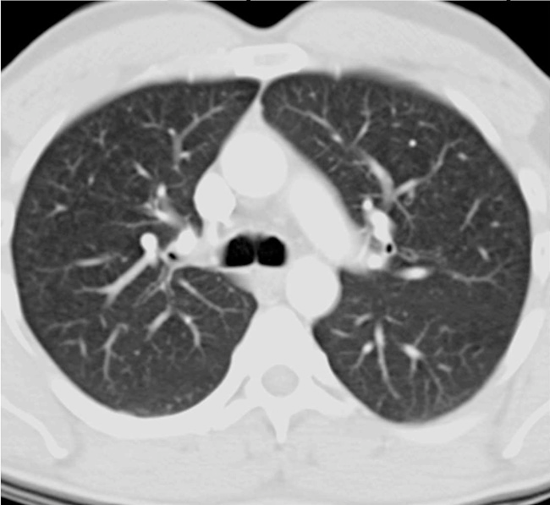
Figure A.1. Single Image from a CT Scan Showing Various Lung Structures

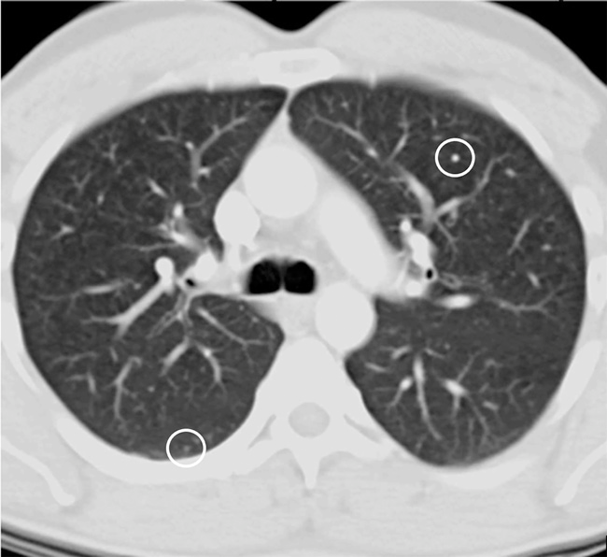
Figure A.2. CT AI Tool Outputs

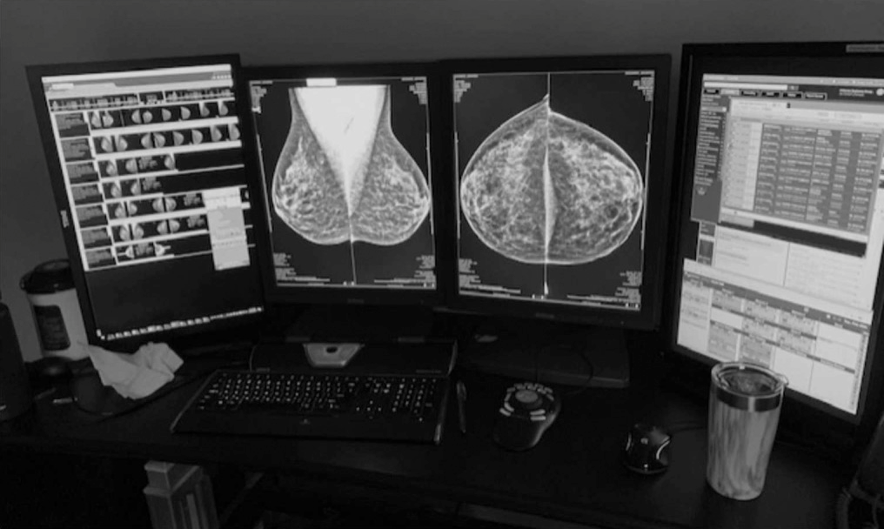
Figure A.3. Typical Display of the Digital Mammogram Images Used for Breast Cancer Diagnosis

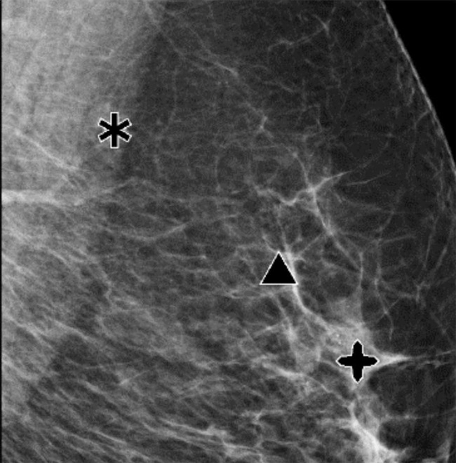
Figure A.4. Mammo AI Tool Outputs

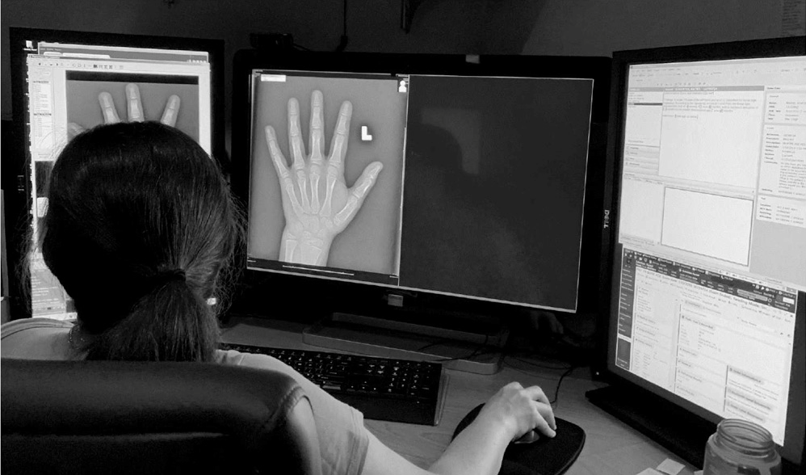
Figure A.5. Typical Display of the Digital Mammogram Images Used for Breast Cancer Diagnosis

Conclusions:
ChatGPT has demonstrated significant potential in enhancing the accuracy and effectiveness of radiological diagnoses. Its capability to process and interpret medical images in real time can help minimize variability and mistakes, improve workflow productivity, and ultimately lead to better patient outcomes. Beyond these advantages, ChatGPT also offers possibilities in areas such as medical training and differential diagnosis, which should be explored further. By utilizing ChatGPT in medical education, healthcare professionals can treat it as a useful resource for learning and strengthening their knowledge in radiology. It can support interactive education, enabling users to ask questions, receive clear explanations, and develop a deeper understanding of different imaging results and diseases.
Furthermore, integrating ChatGPT into educational programs can help standardize learning and distribute current medical information across institutions. This can enhance diagnostic precision and reduce the chances of missed or delayed diagnoses, ultimately improving patient care. However, despite these benefits, it is important to recognize certain challenges. The system depends heavily on high-quality and well-represented training data to function accurately and consistently. Therefore, efforts must be taken to ensure that the data reflects a wide variety of clinical imaging cases. Additionally, ethical aspects such as data privacy, patient consent, and transparency in AI decision-making must be carefully considered and managed.
However, it is the responsibility of researchers in this field to provide proof that these techniques are effective in real-world applications. Therefore, there is a strong need to conduct more randomized controlled trials to demonstrate the effectiveness of AI systems in medicine.

References:
1.Hosny A, Parmar C, Quackenbush J, Schwartz LH, Aerts HJ: Artificial intelligence in radiology. Nat Rev Cancer. 2018, 18:500-10. 10.1038/s41568-018-0016-5
2.The future role of radiology in healthcare . Insights Imaging. 2010, 1:2-11. 10.1007/s13244-009-0007-x
3. .The good, the bad and the ugly of using ChatGPT . (2023). Accessed: April 27: https://www.rsna.org/news/2023/march/use-of-chatGPT-in-radiology.
4. Turing AM. Computing machinery and intelligence. Mind 1950;

59: 433–60.
5..Lusted LB. Medical progress – medical electronics. N Engl J Med 1955; 252: 580-1
6.Le Berre C, Sandborn WJ, Aridhi S, et al. Application of artificial intelligence to gastroenterology and hepatology. Gastroenterology 2020;158:76-94.
7.Ruffle JK, Farmer AD, Aziz Q. Artificial intelligence-assisted gastroenter- ologydpromises and pitfalls. Am J Gastroenterol 2019;114:422-8.
8.Weizenbaum J. ELIZAda computer program for the study of natural language communication between man and machine. Commun ACM 1966;9:36-45.
9.Kuipers BF, Hart PE, Nilsson NJ. Shakey: from conception to history. AI Magazine 2017;38:88-103.
10.Kulikowski CA. Beginnings of artificial intelligence in medicine (AIM): computational artifice assisting scientific inquiry and clinical artd with reflections on present AIM challenges. Yearb Med Inform 2019;28:249-56.
11. Kulikowski CA. An opening chapter of the first generation of artificial intelligence in medicine: the first Rutgers AIM workshop, June 1975. Yearb Med Inform 2015;10:227-33.
12.Weiss S, Kulikowski CA, Safir A. Glaucoma consultation by computer. Comput Biol Med 1978;8:25-40.
13.Shortliffe EH, Davis R, Axline SG, et al. Computer-based consultations in clinical therapeutics: explanation and rule acquisition capabilities of the MYCIN system. Comput Biomed Res 1975;8:303-20.

