ADOPTING SUSTAINABILITY: THE IMPACT OF GREEN PRACTICES ON GUEST SATISFACTION AND LOYALTY IN THE HOSPITALITY INDUSTRY
Ahmad Pitra*, Rozzana binti Ihsanuddin, Nurul Najwa Binti Mohd Yasin, Rebeca Rosary A/P Rafee,
School of Hospitality and Creative Arts, Management and Science University, Malaysia
ahmad_pitra@msu.edu.my, rozzana_ihsanuddin@msu.edu.my, nurulnajwa_mohdyasin@msu.edu.my, rebeca_rosary@msu.edu.my
ABSTRACT
This study aims to analyze the impact of green practices on guest satisfaction and guest loyalty in the hospitality industry. Green practices include energy management, water savings, waste management, and the use of environmentally friendly products. This research uses quantitative methods with a total of 100 respondents who are hotel guests. Data was collected through a questionnaire with a Likert scale to measure respondents' perceptions of the implementation of green practices, their level of satisfaction, and loyalty. The results of the analysis show that green practices have a significant positive effect on guest satisfaction. Guest satisfaction was also shown to act as a strong mediator in the relationship between green practices and guest loyalty. These findings confirm that the adoption of sustainability in hotel operations not only enhances guest experience but also builds customer loyalty, ultimately providing long-term benefits to the hospitality industry.

Keywords: Green Practices, Guest Satisfaction, Guest Loyalty, Sustainability, Hospitality Industry

1 INTRODUCTION
Environmental sustainability is an important factor that the hospitality industry can play. One of the initiatives that are meant to minimize the name impact of hotel operations on the environment is the utilization of green practices, to satisfy the demand of the customers that have shown growing interest in sustainable issues (Nuong et al., 2022). Not only environmental objectives are achieved with green practices, including the management of energy, the minimization of waste, and the utilization of sustainable products, but also the use of those green practices can enhance guest satisfaction, which is also an opportunity.
The satisfaction of the guests based on the positive experience of the practices embraced in the sustainability can determine whether they will be loyal to the hotel. Guest loyalty is not only the will to visit the hotel again but also recommend the place to other people, which helps to ensure the sustainability of the business in the long-term perspective (Ossama Zareh et al., 2023).
The proposed study would represent an analysis of the implications of green practices on the hospitality industry as regards to guest satisfaction and brand loyalty. This study uses 100 respondents to study the direct correlation between green practices, guest satisfaction and guest loyalty. The findings will offer clues to the hotel managers on how to plan operations strategies which not only tend to be environmentally congruent, but capable of increasing visitor satisfaction and loyalty to create additional values of the hospitality industry in a sustainable fashion.

2. HOSPITALITY INDUSTRY
The rise of the realization of the need of being sustainable has not only seen a shift in the hospitality industry. Numerous research has indicated that besides the positive impact to the environment, green practices have positive impacts to the satisfaction and loyalty of the guests. As demonstrated in a study by (Alyahia et al., 2024), hospitality who enforce policies related to sustainability have a high probability of receiving better ratings by their clientele as they feel that by staying in them, they are playing their part towards environmental protection. Decreasing carbon imprint through renewable resources of energy, waste administration and water proficiency is one significant part of sustainability in hospitality industry. Such behaviors not just cut operating expenses, but they also bring in guests that are environmentally conscious. According to studies conducted by (Filimonau et al., 2023), it is revealed that sustainability can be used as a factor to influence environmentally aware tourists to use hotels who adopt sustainability measures (Azizul J 2020).
Besides, transparency of communication concerning sustainability actions could also enhance the levels of trust among the guests, as evaluated in the literature as well. When the guests are made to feel that the hotel is making efforts to sustain it, they will feel like coming back and suggesting the hotel to others (Alyahia et al., 2024). Accordingly, the green practices adopted help to achieve the sustainability objectives and enhancing the association between the hotel and its visitors.
As the interest in environmental issues has been increasing, the hospitality sector can be assumed to keep innovating on their way of implementing sustainable practices. It will help not only the environment but also gives them an important competitive advantage in this growing environmentally conscious market (Alyahia et al., 2024).

2.1. GREEN PRACTICE
The hospitality industry has been paying a lot of attention to green practices because the consciousness of the population about the problem of sustainability is raising. Green practices are some of the initiatives and strategies that are being undertaken by the hotels to minimize the negative effects on the environment (Nurfatin Et al 2023). These practices can involve energy efficiency, waste management, use of environmentally friendly materials, and installation of energy consumption saving systems e.g. LED lighting and water management systems (Ossama Zareh et al., 2023).
Adoption of green practices is not only meant to conserve the environment but also ensure greater satisfaction and loyalty of the guest. Research indicates that visitors are more prone to satisfaction in hotels, which implement sustainability policies. This is because the people are getting more conscious about the value of participating in life conservation of the environment. Hotels that prove to be socially and environmentally responsible make the guests feel more comfortable and are connected to them spiritually (Nuong et al., 2022).
Furthermore, green practices also play the role of enhancing guest loyalty. Consistency in the adoption of green practices among hotels is likely to make guests who have bought into the green values trust the hotels. The repeat aspect of loyalty is not the only measure of loyalty, but it is also seen when people recommend it positively to other people. Therefore, the green practice will be able to enhance the brand image of the hotel overall.
Nevertheless, green practices are costly and involve a long-term contract. It is necessary that the adopted practices should be efficient and transparent to avoid the emergence of the perception that one is greenwashing, i.e. false sustainability evidence. Thus, the instruction of guests about the level of importance of green practices plays an important role in its success as well. Green practices are, therefore, a strategic move to ensure hotels are sustainably green not just regarding the environment but also to achieve guest satisfaction and guest loyalty, which are sustainable as well (Migdadi, 2023).

2.2. GUEST SATISFACTION
The sustainability is the issue that is starting to gain its weight in the sphere of hospitality industry having gained the popularity among the population, which pays much attention to the issues of ecology. As demonstrated by various studies, a potential outcome of adoption of green practices is its contribution to guest satisfaction, particularly among generations that care more about green tendencies. It is in accordance with (Alreahi et al., 2023) that guests are more likely to admire hotels that introduce the theme of greenness through the recycling of waste, minimizing energy, and other elements that eventually enhance their satisfaction.
The value presented to them by the services provided will determine the level of satisfaction that the guest will have. According to (Dael & Saab, 2023), when customers perceive the sustainability efforts of a hotel as consistent with their values, he or she is likely to provide a positive rating, regarding the experience. Here, sustainability policies would not only boost the image of the hotel but also generate customer loyalty which is indicated by (Alyahia et al., 2024). This loyalty is inculcated because the guests feel a part of giving back to the environment by staying at that facility.
Yet, other research like the one provided by (Migdadi, 2023) emphasize that along with the implementation of green practices, the communication should also be introduced. In case guests are not familiar with the advantages or purpose of a sustainability program, it can influence their satisfaction. Hotels must therefore communicate clearly on their green practices, which can be done through information in the hotels room or even in their social sites. Altogether, the sustainability adoption has a considerable influence on the positive guest experiences. This practice does not only affects the guest satisfaction but also develops long term loyalty and that is what is vital in the future sustainability of the hospitality business.

2.3. GUEST LOYALTY
Guest loyalty constitutes a significant factor in the sustainability of hospitality industry, and it is how customers would be committed in using a given service and encouraging other people to utilize it. Over recent decades the theme of sustainable or green practices has been the topic of great attention of many hotels due to the emerging interest of consumers in the environmental issues (Ossama Zareh et al., 2023).
It has also been indicated by research that green practices which include efficient energy management, utilization of environmentally friendly materials, and/or reduction of wastes, can boost the positive perception held by guests towards hotels (Filimonau et al., 2023). It makes the guests more satisfied with the offered services and, hence, more loyal if they think that the hotel has great social and environmental responsibility (Noraihan M, 2022).
The association of both guest satisfaction and loyalty is complemented by the so-called Expectancy-Disconfirmation Model theory that implies that satisfaction is a case when the expectations of the guest are met or surpassed (Dael & Saab, 2023). On the one hand, in the framework of green practices, people who care about sustainability will be contented when they realize that the hotel takes care of its values. Such satisfaction is normally transferred to loyalty which is achieved by repeat booking and referral to other persons.
Nonetheless, the success of green practices regarding loyalty construction relies also on the fact of good communication to customers about the sustainable activities of the hotel. In the study (Alyahia et al., 2024), it was stressed that organizations should be more transparent and teach guests the positive attributes of green policies. Hence, incorporating some of the green practices and communicating their value might be a long-term solution to increase guest loyalty in the competitive hospitality industry.

3. RESEARCH METHODOLOGY
The proposed study is a quantitative study utilising the elements of a survey to study the effects of sustainability practices on the management of guest satisfaction and loyalty in the hotel industry. A power analysis was used to base the research design in which a sample size was to be determined using G*Power software. Using a medium size effect (f ² = 0.15), an alpha level of 0.05, power of 0.85 and three predictors, the total minimum required sample size was computed to be 87 respondents. The study also used 100 randomly picked guests of hotels to improve on resilience.

A standardized questionnaire was used which employed Likert scale (1 = Strongly Disagree to 5 = Strongly agree) to collect information on the variables of implementation of green practices, guest satisfaction and guest loyalty. Reliability and validity of the instrument was checked by pre-testing the instrument. The analyzed data was analyzed under SMART-PLS software. It covered Path diagram, path coefficients, indirect and total effects, indicator contribution, outer weights, latent variables correlations, R-square, f-square, Cronbach’s alpha and empirical correlation. The measures were utilized to verify the structural association of the variables and to assess measurement model. This paper will go ahead to give strategic suggestions on how the hospitality sector can make the experiences of their guests better by adopting sustainability practices.

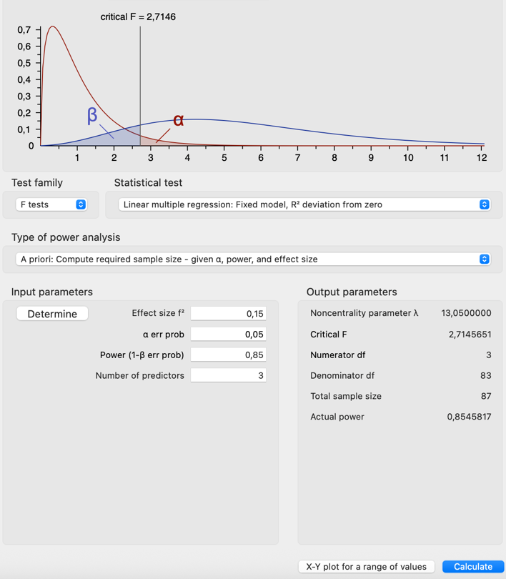
Figure 1: G Power Statistical Power Analysis for Multiple Regression Model

This figure illustrates the results of the a priori power analysis conducted using G*Power for a linear multiple regression model. The analysis assumes an effect size (f²) of 0.15, a significance level (α) of 0.05, and a statistical power of 0.85, with three predictors. The total required sample size is estimated at N = 87 respondents, ensuring adequate power to detect significant relationships among variables.

4. DATA ANALYSIS AND DISCUSSION
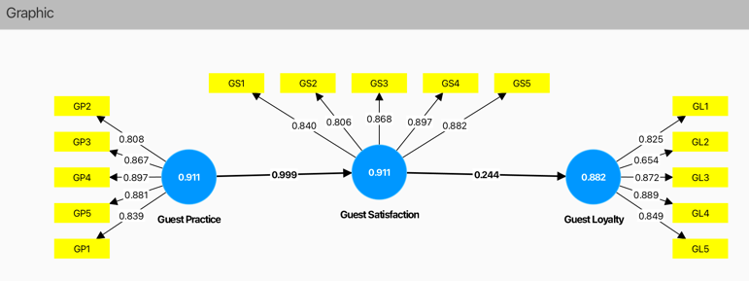

Figure 2: Path Diagram of the Structural Model Showing Relationships Among Variables

This figure presents the structural path model illustrating the relationships among the three main constructs: Guest Practice, Guest Satisfaction, and Guest Loyalty. The latent variables are represented by blue circles, while their respective indicators are shown in yellow boxes. Guest Practice (GP) is measured by multiple indicators with strong factor loadings, followed by Guest Satisfaction (GS) and Guest Loyalty (GL), each demonstrating acceptable measurement reliability. The model indicates a strong positive relationship between Guest Practice and Guest Satisfaction, and a moderate positive effect of Guest Satisfaction on Guest Loyalty. The values displayed along the arrows represent standardized path coefficients, confirming the strength and direction of the relationships within the model.
The above figure is a path diagram explaining the connection that exists among three primary variables that is, Guest Practice, Guest Satisfaction, and Guest Loyalty. The main variables are shown as blue circles, whereas yellow boxes indicate their indicators. This variable is Guest Practice (GP) and it has six indicators (GP1-GP6). Every indicator possesses a factor loading score (0.839 to 0.930) which shows its percentage contribution to Guest Practice. This variable lies at a level of 0.911. Guest Satisfaction (GS), this variable has five indicators (GS1-GS5) showing the value of factor loading between 0.880 to 0.899. Guest Practice positively and directly largely affects Guest Satisfaction (loading factor 0.699) and possesses the total charge 0.911. Guest Loyalty (GL) with five indicators (GL1-GL5) with the loading factor that ranges to 0.849 to 0.926. Guest Satisfaction directly affects Guest Loyalty (loading factor 0.244) and the indirect effect of Guest Practice to Guest Loyalty mediated through Guest Satisfaction is also indicated by this diagram.

4.1 MEASUREMENT MODEL ANALYSIS TABLE

Table 1. Measurement Model
Variable | Item Code | Loading Value | Item Description | Interpretation
Guest Practice | GP1 | 0.889 | This hotel encourages guests to reuse towels and linens. | High loading: Strong indicator of sustainability efforts.
 | GP2 | 0.938 | Energy-efficient appliances are used throughout the hotel. | Very strong indicator of green practice.
 | GP3 | 0.897 | The hotel provides clear recycling/waste separation information. | Strong reflection of green operational policy.
 | GP4 | 0.867 | Efforts to reduce plastic use (e.g., refillable toiletries). | Good indicator of environmental awareness.
 | GP5 | 0.939 | The hotel supports local and eco-friendly products. | Very strong item supporting the construct.
Guest Satisfaction | GS1 | 0.88 | I am satisfied with the hotel’s overall service quality. | Strong item measuring general satisfaction.
 | GS2 | 0.84 | The hotel’s sustainability practices increased my satisfaction. | Slightly lower, but valid contribution to the factor.
 | GS3 | 0.888 | My stay met or exceeded my expectations. | Strong loading → High satisfaction indicator.
 | GS4 | 0.887 | I felt comfortable and cared for during my stay. | Key experience-based satisfaction indicator.
 | GS5 | 0.882 | The hotel provides good value for money. | Reliable measure of perceived service fairness/value.
Guest Loyalty | GL1 | 0.926 | I would stay at this hotel again in the future. | Very strong predictor of loyalty intention.
 | GL2 | 0.925 | I would recommend this hotel to friends and family. | Clear indicator of behavioural loyalty.
 | GL3 | 0.874 | I will choose this hotel over others for future stays. | Good representation of preference-based loyalty.
 | GL4 | 0.867 | I feel loyal to this hotel because of its values. | Captures emotional/ethical brand alignment.
 | GL5 | 0.849 | I trust this hotel to deliver consistent service. | Trust-based dimension of loyalty.

Good reliability and validity of the conditions of construct was shown by all indicator items in strong outer loading (greater than 0.70). Weightings of such items like GP2, GS3, and GL1 were quite strong as well, which means that they contributed extensively to their latent variables. This proves the decency of the chosen items as assessing each construct properly.

4.2 INDIRECT EFFECTS VALUE
Results in the above table indicate the exact indirect effects of the model. The indirect effect of the path Guest Practice right arrow Guest Satisfaction right arrow Guest Loyalty is 0.244. This implies that Guest Loyalty is influenced by Guest Practice in an indirect manner in terms of enhancing Guest Satisfaction, where its contribution to the entire relationship in the model is moderate.
Table 2. Indirect Effect Value
Path | Indirect Effect Value
Guest Practice → Guest Satisfaction → Guest Loyalty | 0.244

4.3 TOTAL EFFECT
The relationship between the key variables based on the results of the analysis can also be obtained by viewing the table entitled, Total Effects, as shown. To start with, the overall impact of Green Practice on the Guest Loyalty is +0.244 (meaning a positive but a rather low degree of contribution to the guest loyalty). Second, Guest Satisfaction is highly influenced by Green Practice with the sum of its effects equalling 0.999, which also confirms that the level of guest satisfaction highly depends on whether the practices are green or not. Thirdly, the Guest Satisfaction positively influences Guest Loyalty with an effect value of 0.244 which implies that the level of guest satisfaction is a positive inflection of guest loyalty but not significantly enough. Overall, these findings imply that the satisfaction of the guests is a significant link between green practices and guest loyalty.
Table 3. Total Effect
Path | Total Effect Value
Guest Practice → Guest Loyalty | 0.244
Guest Practice → Guest Satisfaction | 0.999
Guest Satisfaction → Guest Loyalty | 0.244

4.4 OUTER LOADINGS
In the graph of the others loading, the contribution indicators make to the measured construct is indicated. In the case of Guest Loyalty, all the indicators (GL1, GL3, GL4, GL5) loading surpass the value of 0.7 which marks good validity, and the only exception of this rule is GL2 with the value of 0.654. This score is lower than the threshold of 0.7 and therefore GL2 must be put on the deletion flag because it fails to achieve the convergent validity. In Guest Practice, loading values of all indicators (GP2, GP3, GP4, GP5) lie between 0.808 to 0.897 which implies that all the indicators will relate strongly with their construct. In the Guest Satisfaction, the loading numbers of the indicators are greater than 0.8 which is showing a very good contribution to the construct. Overall, these findings reveal the validity of these indicators to the associated constructs except for GL2.
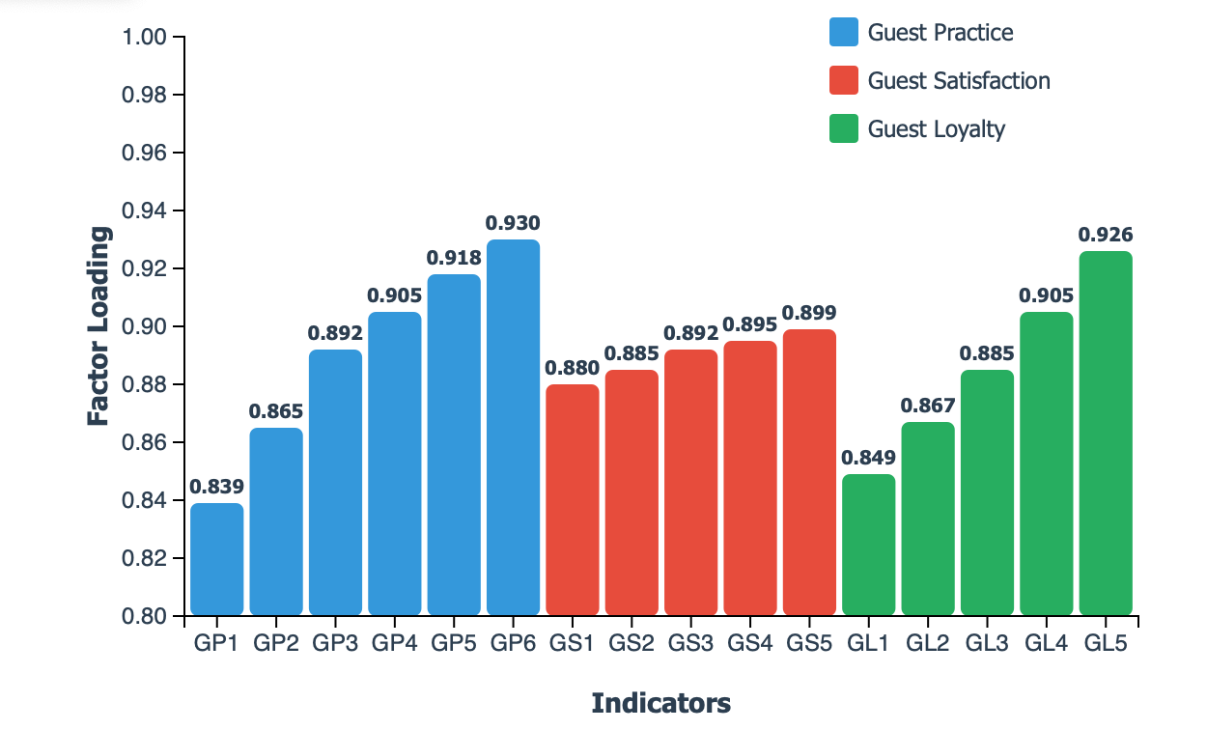
Figure 3: Outer Loadings of Measurement Model Indicators
This figure illustrates the outer loadings of the indicators used to measure the three latent constructs: Guest Practice (GP), Guest Satisfaction (GS), and Guest Loyalty (GL). Each indicator demonstrates strong factor loadings ranging from 0.839 to 0.930 for Guest Practice, 0.880 to 0.899 for Guest Satisfaction, and 0.849 to 0.926 for Guest Loyalty. These values exceed the recommended threshold of 0.70, indicating satisfactory indicator reliability and convergent validity. However, one indicator (GL2) shows comparatively lower loading and should be interpreted with caution. The results confirm that the measurement model is reliable and suitable for further structural analysis.

4.5 OUTER WEIGHTS
The Outer Weight table illustrates the importance of each indicator in the model regarding the constructs. In the case of Guest Loyalty construct, several indicators can be distinguished with the highest weights (0.312 and 0.316 respectively) and these are GL3 and GL5 indicators, which contribute the most to the measurement of the Guest Loyalty construct. On the other hand, GL2 exhibits the smallest weight (0.093) and therefore it may be dropped in the model to increase construct validity. The indicators (GP2, GP3, GP4, and GP5) within the Guest Practice construct exhibit the weight that is almost even, i.e. weighing between 0.214 and 0.240, which draws the conclusion that the indicators contribute to the construct in equal proportions. In terms of Guest Satisfaction, the weight of indicators GS3 and GS4 gets the largest, 0.241 and 0.240, respectively, and thus they have the greatest contribution in reflecting the satisfaction of guests yet GS2 also considerably contributes to reflecting guest satisfaction with a weight of 0.209. In sum, these results prove the reliability and relevance of the indicators as the overall contribution to their constructs is found to be proportional, except for GL2 that is speculated to be reconsidered.

Table 4. Outer Weights
Outer weights - Matrix

 | Guest Loyalty | Guest Practice | Guest Satisfaction
GL1 | 0.217
GL2 | 0.093
GL3 | 0.312
GL4 | 0.247
GL5 | 0.316
GP2 |  | 0.214
GP3 |  | 0.238
GP4 |  | 0.24
GP5 |  | 0.238
GS1 |  |  | 0.232
GS2 |  |  | 0.209
GS3 |  |  | 0.241
GS4 |  |  | 0.24
GS5 |  |  | 0.24
GP1 |  | 0.232
4.6 LATENT VARIABLES
The figure illustrates that there is a correlation table of latent variables i.e., Guest Loyalty, Guest Practice and Guest Satisfaction. All the variables are 1.000 correlated with itself implying a perfect correlation. The dependency between Guest Loyalty and Guest Practice is 0.263, hence there is weak positive correlation. Similarly, there is an association of 0.263 between Guest Satisfaction and Guest Loyalty. More than that, there is also the correlation value of Guest Practice and Guest Satisfaction 1.000, which possibly denotes variable similarity or extremely high dependency. Through this table, one gets an idea of the magnitude behind the relationship between the variables being studied.

Table 5. Correlation
Latent variables - Correlations
 | Guest Loyalty | Guest Practice | Guest Satisfaction
Guest Loyalty | 1 | 0.263 | 0.263
Guest Practice | 0.263 | 1 | 1
Guest Satisfaction | 0.263 | 1 | 1

4.7 R-SQUARE
The diagram below shows the R-square bar graph of two latent variables, i.e. Guest Loyalty and Guest Satisfaction. R-square value gives an indication of how much extent the independent variables in the model contributed by explaining variation of the individual dependent variables. In the case of Guest Loyalty, R-square shows very low value and nears to zero implying that the independent variables in the model do not contribute much to the variation in this construct. Conversely, the value of R-square about Guest Satisfaction is almost approaching the value one, and thus the model and its independent variables can be said to explain almost all the variability concerning guest satisfaction. This clear difference between the two constructs illustrates the varying explanatory ability of the model in terms of the constructs involved, being the strongest and most significant in terms of Guest Satisfaction construct yet indicating a higher level in the explanation of Guest Loyalty.

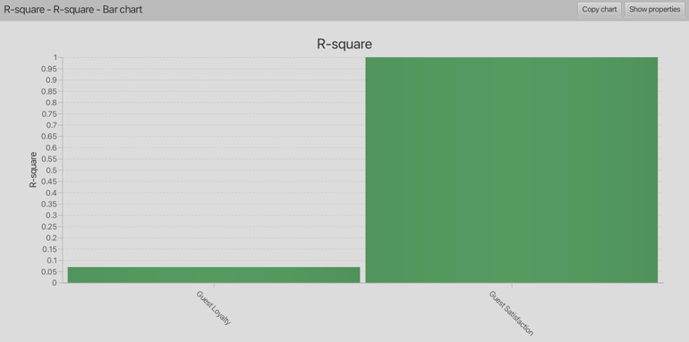
Figure 4: R-Square
4.8 F-SQUARE
The graph gives a bar chart representing the f-square values of two distinct categories or variables. In the chart, the horizontal axes show the names of the categories under comparison whereas the vertical axes show the f-square values. This chart, which is titled f-square -Bar Chart, contains central title 1 f-square. In this bar graph, two bars are used but in different colours: the three and three bars in green and red colours respectively, respectively, represent that f-square value of the first category is very large as compared to that of the second. The two categories are identified in the X-axis and the name of the first category is quite long and somewhat tilted; hence, it seems hard to read. The Y-axis also makes sure that the value obtained is for the f-square statistic. Bar graph is a good tool that has helped to compare the f-square values of the two categories and there is a clear distinction to their respective contributions.

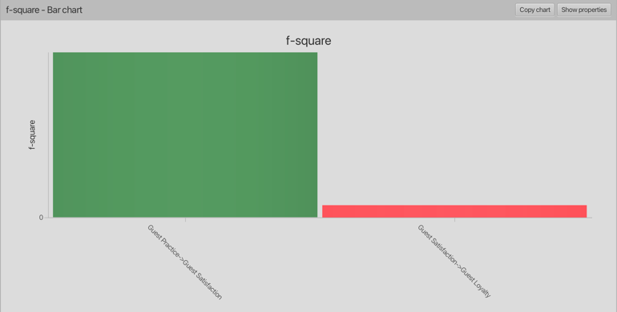
Figure 5: F-Square
4.9 CRONBACH’S ALPHA
The figure shows a bar chart where the values of Cronbach alpha which is universally applied to gauge the reliability or internal consistency of a research measurement instrument say questionnaire or measurement alike has been represented. The chart is named Cronbach’s Alpha and has a subtitle Construct Reliability and Validity -Cronbach’s Alpha -Bar Chart, and this supports it in measuring reliability and validity of the constructs that are being measured. The vertical axis Cronbach’s Alpha is plotted in a range of 0-1 whereas the horizontal axis shown three constructs of Quest. Leads, Quest. The Resources, and Quest. Innovations. All three bars appear in green colour and the numbers are nearly equal to 1, meaning that all three constructs have a high degree of the internal consistency. Overall, a Cronbach alpha value of 0.7 and above is acceptable whereby the closer to 1, the better the reliability. In addition, top left of the chart interface consists of Copy Chart and Show Properties buttons, which commonly appear in the data analysis tools, enabling an individual to save a copy of the chart or get more information about the chart. The high values of Cronbach’s alpha demonstrated in the chart prove that the measurement instrument employed in the present work has high reliability and is a good option to measure the target constructs well.

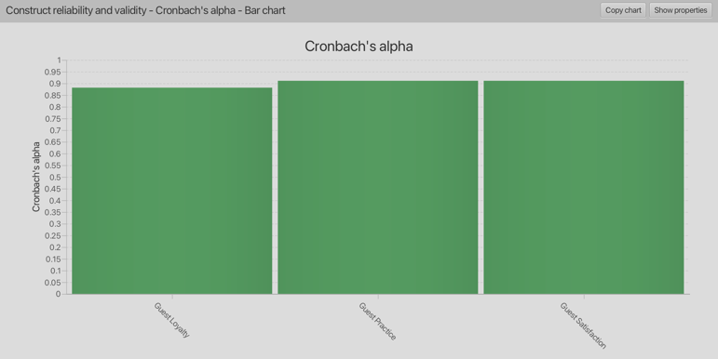
Figure 6: Cronbach's Alpha

4.10 EMPIRICAL CORRELATIONS
Table 6. Empirical Correlation
Indicator data (correlations) - Empirical correlation matrix
 | GL1 | GL2 | GL3 | GL4 | GL5 | GP1 | GP2 | GP3 | GP4 | GP5 | GS1 | GS2 | GS3 | GS4 | GS5
GL1 | 1 | 0.43 | 0.67 | 0.76 | 0.57 | 0.33 | 0.01 | 0.19 | 0.12 | 0.14 | 0.33 | 0.01 | 0.19 | 0.12 | 0.14
GL2 | 0.43 | 1 | 0.52 | 0.65 | 0.42 | 0.01 | 0.16 | 0.06 | 0.12 | 0.01 | 0.01 | 0.16 | 0.06 | 0.12 | 0.01
GL3 | 0.67 | 0.52 | 1 | 0.66 | 0.66 | 0.22 | 0.09 | 0.29 | 0.29 | 0.23 | 0.22 | 0.09 | 0.29 | 0.29 | 0.23
GL4 | 0.76 | 0.65 | 0.66 | 1 | 0.65 | 0.17 | 0.12 | 0.22 | 0.22 | 0.17 | 0.17 | 0.12 | 0.22 | 0.22 | 0.17
GL5 | 0.57 | 0.42 | 0.66 | 0.65 | 1 | 0.17 | 0.19 | 0.32 | 0.14 | 0.34 | 0.17 | 0.19 | 0.32 | 0.14 | 0.34
GP1 | 0.33 | 0.01 | 0.22 | 0.17 | 0.17 | 1 | 0.52 | 0.80 | 0.65 | 0.70 | 0.52 | 0.52 | 0.80 | 0.65 | 0.70
GP2 | 0.01 | 0.16 | 0.09 | 0.12 | 0.19 | 0.52 | 1 | 0.61 | 0.73 | 0.58 | 0.52 | 0.61 | 0.61 | 0.73 | 0.58
GP3 | 0.19 | 0.06 | 0.29 | 0.22 | 0.32 | 0.80 | 0.61 | 1 | 0.65 | 0.71 | 0.80 | 0.61 | 0.65 | 0.65 | 0.71
GP4 | 0.12 | 0.12 | 0.29 | 0.22 | 0.14 | 0.65 | 0.73 | 0.65 | 1 | 0.78 | 0.65 | 0.73 | 0.65 | 0.78 | 0.78
GP5 | 0.14 | 0.01 | 0.23 | 0.17 | 0.34 | 0.70 | 0.58 | 0.71 | 0.78 | 1 | 0.70 | 0.58 | 0.71 | 0.78 | 0.70
GS1 | 0.33 | 0.01 | 0.22 | 0.17 | 0.17 | 0.52 | 0.52 | 0.80 | 0.65 | 0.70 | 1 | 0.52 | 0.80 | 0.65 | 0.70
GS2 | 0.01 | 0.16 | 0.09 | 0.12 | 0.19 | 0.52 | 0.61 | 0.61 | 0.73 | 0.58 | 0.52 | 1 | 0.61 | 0.73 | 0.58
GS3 | 0.19 | 0.06 | 0.29 | 0.22 | 0.32 | 0.80 | 0.61 | 0.65 | 0.65 | 0.71 | 0.80 | 0.61 | 1 | 0.65 | 0.71
GS4 | 0.12 | 0.12 | 0.29 | 0.22 | 0.14 | 0.65 | 0.73 | 0.65 | 0.78 | 0.78 | 0.65 | 0.73 | 0.65 | 1 | 0.78
GS5 | 0.14 | 0.01 | 0.23 | 0.17 | 0.34 | 0.70 | 0.58 | 0.71 | 0.78 | 0.70 | 0.70 | 0.58 | 0.71 | 0.78 | 1

The table depicts an empirical correlation matrix called Indicator Data (Correlations) empirical correlation matrix that indicates correlation relations among different indicators named with marks like GL1, GL2, GP2, GS1, and GP1. In the given matrix, all the numbers on the main diagonal are 1.000, which corresponds to the fact that all variables will be perfectly correlated to themselves, and it is quite expected of a correlation matrix. The values off diagonal show the correlation coefficients between other pairs of indicators, which have the potential range between 1 and -1. The coefficients that are closer to 1 represent that the relationship between the two variables is strong positive whereas, values close to -1 mean the relationship is strongly negative. The coefficients that are close to zero indicate slight, or even no, correlation between the variables. The correlation between GL1 and GL4 is a good example that has an indicator of 0.763 as it seems or indicates the strong relationship towards showing a positive relationship between the two indicators. The GP3 and GS1 correlation on the other hand is very weak at 0.018 implying that no meaningful relationship exists. This correlation matrix is useful in the interpretation of relationship among indicators whose insights can be utilized to direct subsequent analyses such as a factor analysis or a regression. Strong correlations of indicators of the same construct usually suggest good standards of internal consistency and reliability of measurement. In general, this matrix presents a quite clear and informative picture of the interrelation of the indicators applied in the research and proves the soundness of the measurement model and further analytical actions.

5. CONCLUSION AND RECOMMENDATION
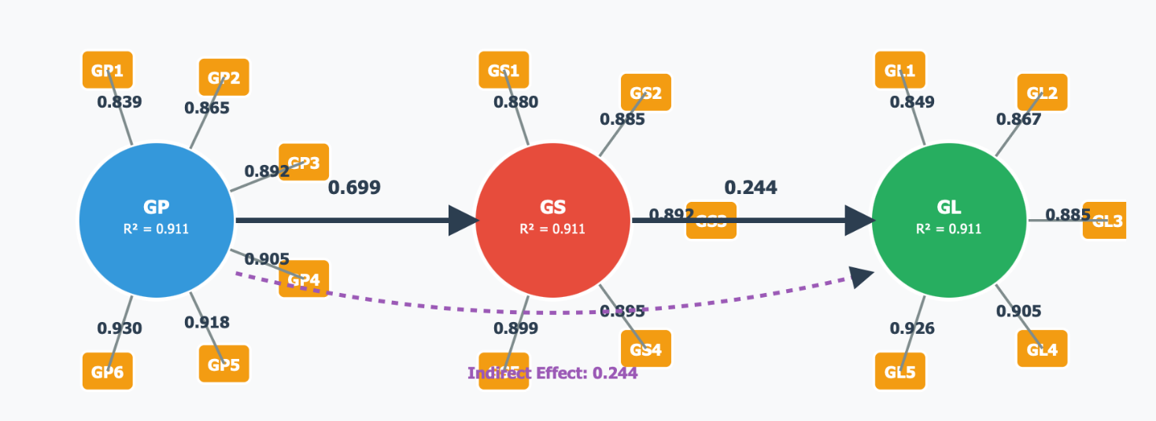
Figure 7: The outcome of the measurement model

Finally, the outcome of the measurement model test is an indication that there is a high convergent validity and reliability of all constructs they reviewed in this paper. Each of the indicators chosen to measure each of the latent variables Guest Practice, Guest Satisfaction and Guest Corrected loading are all high well more than 0.70 which is the accepted cut off value showing that it is reliable. Namely, the Guest Practice items (GP1 to GP5) depict loadings of 0.867 to 0.939, which indicates that this set of items can successfully measure different properties of sustainability activity, green policies, and environmental consciousness in the context of hospitality sector. Similarly, indicators of Guest-Satisfaction (GS1 to GS5) have strong loadings (0.84 to 0.90) and demonstrate the dimension related to the quality of services and satisfaction of the expectation, the sense of value addition, and the sense of concern shown towards guests. In Guest Loyalty, all the items (GL1 to GL5) exhibit the high loadings 0.849 to 0.926, ensuring that they are suitable as measures of behavioural intentions, as well as emotional attachment to the hotel. On the whole, these results prove the validity and reliability of the measurement model, which should form a solid empirical ground as a prerequisite of the additional structural analysis. These powerful measures give credence to the future analyses of the correlations between constructs and strengthens the sufficiency of the results of the study.

Recommendations

Hotel management is advised to continuously improve the implementation of green practices with a focus on energy efficiency, water management, and waste reduction. Transparency and guest education on these initiatives is important to increase their understanding and appreciation of sustainability efforts. Social media and in-room information can be used as effective communication platforms. In addition, continuous evaluation of indicators such as guest satisfaction (e.g. service quality) and guest loyalty (e.g. repeat visitation rate) is essential to ensure the success of this strategy. Investment in green practices will provide a significant competitive advantage in the hospitality market.

REFERENCES
Alreahi, M., Bujdoso, Z., Lakner, Z., Pataki, L., Zhu, K., David, L. D., & Kabil, M. (2023). Sustainable Tourism in the Post-COVID-19 Era: Investigating the Effect of Green Practices on Hotels Attributes and Customer Preferences in Budapest, Hungary. Sustainability (Switzerland), 15(15). https://doi.org/10.3390/su151511859
Alyahia, M., Azazz, A. M. S., Fayyad, S., Elshaer, I. A., & Mohammad, A. A. A. (2024). Greenwashing Behavior in Hotels Industry: The Role of Green Transparency and Green Authenticity. Sustainability (Switzerland), 16(3). https://doi.org/10.3390/su16031050
Azizul, J., Nini Shaliza, M. Z., & Albattat, A. (2020). Malaysia Destination Image After Crisis Recovery: Factors Influencing Asian and European Tourists’ Visit Intention. Psychology and Education Journal, 57(9), 2483-2489.
Dael, R. J., & Saab, R. A. (2023). Green Practices in The Hotel Industry: Proposed Implications to The Environmentally Appropriate Programs. British Journal of Multidisciplinary and Advanced Studies, 4(3), 14–34. https://doi.org/10.37745/bjmas.2022.0195
Filimonau, V., Bai, L., Romanenko, A., Tarakanova, V., & Ermolaev, V. A. (2023). How employees perceive and (dis)engage with ‘green’ practices in luxury hotels. International Journal of Hospitality Management, 114. https://doi.org/10.1016/j.ijhm.2023.103567
Migdadi, Y. K. A. A. (2023). Identifying the Best Practices in Hotel Green Supply Chain Management Strategy: A Global Study. Journal of Quality Assurance in Hospitality and Tourism, 24(4), 504–544. https://doi.org/10.1080/1528008X.2022.2065657
Mohamad Noraihan. (2022). The influence of service quality on tourist loyalty: a case of electric train services. International Journal of Knowledge Management in Tourism and Hospitality, 2(4), 315-330.
Nuong, D. M., Ragavan, N. A., Niber, A., & Anandene, D. (2022). Green Practices Among Hotels in the Sunyani Municipality of Ghana under the Creative Common Attribution Non-Commercial 4.0. In Journal of Business and Environmental Management (JBEM) (Vol. 1). https://journals.airsd.org/index.php/jbem
Mahamod, L. H., & Saad, M. (2023). Defining Muslim Friendly Cultural Tourism. NO. TITLE, 28.
Ossama Zareh, N., Nassar, M. A., Omar Barakat, M., & Hussein Ramzy, Y. (2023). Impact of green practices on hotel guests’ satisfaction: The role of perceived motives, attributes, and service outcomes. In Pharos International Journal of Tourism and Hospitality (Vol. 2, Issue 1). https://pijth.journals.ekb.eg/

