MEDICAL STUDIES THROUGH AR AND VR

Uma Mageswari T
Department of Artificial
Intelligence and Data Science
Sri Sairam Institute of Technology
Chennai, Tamil Nadu, India umamageswari.ai@sairamit.edu.in

Badri Vishal S Department of Artificial  Intelligence and Data Science Sri Sairam Institute of Technology  Chennai, Tamil Nadu, India sit22ad048@sairamtap.edu.in | Nirmal D Department of Artificial  Intelligence and Data Science Sri Sairam Institute of Technology  Chennai, Tamil Nadu, India sit22ad019@sairamtap.edu.in

ABSTRACT-  In the field of medical education, it is an interactive framework that integrates Augmented Reality (AR), Virtual Reality (VR), and Natural Language Processing (NLP) to support and training. Unlike traditional methods that depend on textbooks or cadavers, the proposed system allows learners to engage with dynamic 3D anatomical models and receive real-time guidance from an AI-driven virtual assistant. The framework was implemented using Unity and Blender, deployed on the Meta Quest 3 headset, and enabled QR-based visualization of anatomical structures. A study involving 50 participants compared conventional learning with the AR/VR system. The results showed that the AR/VR group achieved a 28% higher knowledge retention rate and reported stronger engagement, reflected by a System Usability Scale (SUS) score of 82/100. Performance tests confirmed smooth rendering at 72 frames per second with an interaction latency of less than 30 ms, ensuring seamless usability. These findings demonstrate that AR/VR, when combined with NLP assistance, offers a safe, scalable, and effective solution for medical education, bridging the gap between theoretical knowledge and practical skills.  Keywords  Augmented Reality, Virtual Reality, Medical Education, Natural Language Processing, Immersive Learning. | INTRODUCTION  Medical education has traditionally relied on textbooks, cadaver dissections, and supervised clinical practice. While these methods remain essential, they are constrained by limited access, high costs, and ethical concerns. Studies report that only a small fraction of medical schools worldwide have continuous access to cadaver laboratories due to logistical and ethical challenges. In recent years, AR and VR technologies have transformed learning by offering immersive, interactive, and cost-effective alternatives. According to market forecasts, the AR/VR healthcare sector is projected to exceed USD 11 billion by 2030, with applications ranging from anatomy visualization to surgical simulation. Several universities are adopting VR-based anatomy labs and AR-assisted surgery training modules. Despite these advancements, most existing works focus either on VR-only training modules or NLP-based assistants in isolation. Our research integrates AR, VR, and NLP into a single educational framework, creating a seamless ecosystem for immersive medical training.  RELATED WORK  Prior research has explored immersive technologies in  medical education. AR has been employed to overlay anatomical structures onto real-world patients,

enabling contextual learning. VR-based surgical simulations allow residents to practice complex procedures without risks [6]. Seymour et al. demonstrated that VR-trained surgeons made significantly fewer errors compared to those trained traditionally. In anatomy education, VR headsets have been used to visualize organ systems interactively, leading to improved spatial understanding. AR applications, such as HoloLens- based anatomy modules, have also shown promise in collaborative learning. NLP-powered systems in healthcare provide clinical decision support and patient interaction tools. Chatbots trained on medical datasets offer explanations, drug information, and procedural guidance. However, research combining AR/VR visualization with NLP guidance remains limited. Our work builds on these foundations by offering an integrated AR/VR + NLP framework. This combination provides not only visual immersion but also conversational assistance, enhancing the depth of learning.  PROBLEM STATEMENT  The effectiveness of traditional medical training is limited by a number of issues. Due to ethical, cultural, and financial limitations, cadaver-based training is still not widely available, making it challenging for many institutions to offer practical anatomical experience. Furthermore, learner’s capacity to visualize intricate anatomical structures and physiological processes is diminished by static learning resources like textbooks and 2D diagrams, which fall short in providing interactive or spatial engagement. Direct patient training presents a high risk in practice since it restricts opportunities for repeated trial-and-error learning and poses major safety concerns. Additionally, traditional methods lack adequate feedback because students hardly ever receive real-time corrective guidance during practice, which impedes the development of skills  LITERATURE SURVEY  More and more people believe that integrating cutting-edge technologies like 3D modelling, augmented reality (AR), virtual reality (VR), and natural language processing (NLP) will revolutionize medical education. While research on AR/VR demonstrates that immersive environments improve spatial understanding, retention, motivation, and engagement when compared to static resources, studies on 3D resources, such as printing, improved the visualization of anatomical structures. With improvements in rendering, virtual reality (VR) is now useful in classrooms and clinical settings, further facilitating collaborative learning and real-world skill transfer.  In addition to these advancements, chatbots and | decision-support systems that offer real-time explanations, adaptive feedback, and tailored advice are examples of how AI and NLP have proven useful However, rather than using AR/VR and NLP as a single tool, the majority of research has done so in isolation. Through immersive visualization, 3D anatomical modelling, and an NLP-powered chatbot, the current work integrates these technologies to enable interactive learning with real-time guidance. Results from experiments verify enhanced engagement and retention of information, confirming this framework's viability as a scalable and efficient approach to contemporary medical education.  PROPOSED METHODOLOGY  The suggested framework has four modules that work together to improve medical education. To start, Blender was used to make 3D models of the brain and heart with realistic textures. After that, Unity was used to put these models in an AR/VR environment, and the Meta Quest 3 headset was used to show them. This let students rotate, scale, and interact with the organs in real time. A QR-Code Recognition system was put in place to make it easy to get to. When you scan a QR code, it shows AR images of certain organs. The system also included an NLP chatbot that was trained on medical data specific to the field. This allowed users to ask questions like "Show me the left ventricle" or "Explain blood flow in the heart" and get interactive, informative answers.  SYSTEM ARCHITECTURE  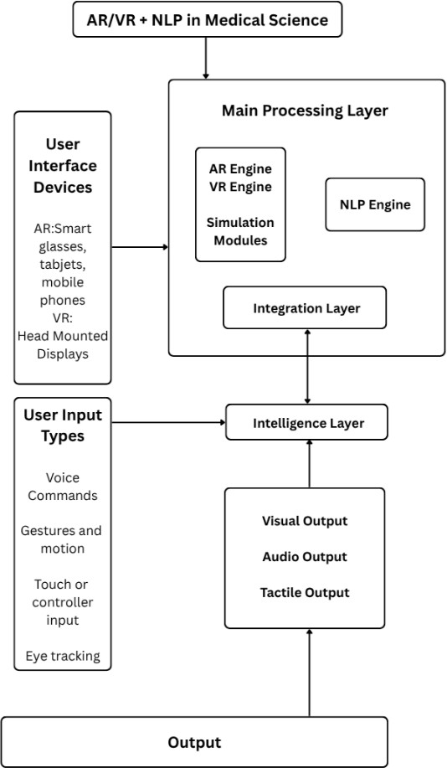  Fig.1.System Architecture

- The purpose and question of the study  How to integrate Augmented Reality (AR), Virtual Reality (VR), and Natural Language Processing (NLP) into a single framework to improve medical education is the primary question this work attempts to answer. Conventional teaching approaches frequently restrict student engagement and knowledge retention because they mainly rely on cadavers, textbooks, or 2D diagrams. This study aimed to develop an immersive, interactive, AI- assisted platform that offers learners enhanced accessibility, dynamic 3D anatomical visualization, and real-time guidance. Bridging the gap between theoretical knowledge and practical understanding was the main objective.  - Suggested Approaches and Structure  A four-module framework was created in order to answer the research question. Initially, Blender was used to create 3D anatomical models of the heart and brain with high-resolution textures. Second, these models were installed on the Meta Quest 3 headset and incorporated into an AR/VR environment using Unity. Third, a system for recognizing QR codes was put in place, which enables students to scan codes and view particular anatomical structures in augmented reality. Students can now ask natural language questions like "Show me the left ventricle" or "Explain blood flow in the heart" thanks to the system's integration of an NLP-driven chatbot. Interactivity, ease of use, and AI-powered learner support were all guaranteed by this multi-module design.  - Key Definitions and Terminology  A variety of technical terms are central to this study Using gadgets like smartphones or headsets to superimpose digital content like 3D organ models onto the real world is known as augmented reality, or AR. With virtual reality (VR), students can interact with anatomical structures as though they were real in a completely immersive digital environment. A medical chatbot is an example of how Natural Language Processing (NLP), a branch of artificial intelligence, allows computers to comprehend and react to human language. A standardized instrument for assessing usability is the System Usability Scale (SUS), where a score of 80 or higher denotes an exceptional user experience. These definitions aid in comprehending the framework's technological foundation.  - Equations and Performance Metrics  Both performance metrics and user studies were used | to assess the system's efficacy. When compared to conventional methods, learners who used the AR/VR system improved their knowledge retention by 28%, according to a controlled study with 50 participants. Smooth usability was ensured by the framework's 72 frames per second (FPS) rendering and interaction latency of less than 30 milliseconds. The frame time equation can be used to express these performance values:  Frame Time (ms) = FPS/1000  which, at 72 FPS, yields about 13.9 ms per frame. The framework's ability to provide a smooth, scalable, and efficient solution for medical education was demonstrated by the combination of its high rendering speed and low latency.  IMPLEMENTATION  - User Inputs and Devices  The framework starts with AR/VR interface devices that act as the interaction medium, like smartphones, smart glasses, and the Meta Quest 3 headset. To operate the system, students employ input techniques such as eye tracking, controller movements, gestures, and voice commands. For example, a student might make hand gestures to rotate an organ or say, "Show me the left ventricle." Accessibility and flexibility in medical education are guaranteed by these multimodal inputs.  - Layer of Main Processing  The AR/VR engine, simulation modules, and an NLP engine are all combined into a single system by the Main Processing Layer. The AR/VR engine renders 3D anatomical structures in real time at 72 frames per second with a latency of less than 30 milliseconds. While the NLP chatbot decodes natural language queries, simulation modules illustrate organ functions like blood flow. These elements are synchronized by an integration layer, which guarantees seamless communication between user inputs and system reactions.  - Intelligence and Results  Every user input is processed by the Intelligence Layer, which then converts it into interactive outputs. Three forms of feedback are offered by the system: tactile output (future scope with haptic devices), audio output (AI-driven explanations), and visual output (3D organs in AR/VR). According to the abstract study, these outputs produce an immersive and captivating learning environment that enhances knowledge retention by 28% and achieves a System Usability Score of 82/100.

WORKFLOW DIAGRAM
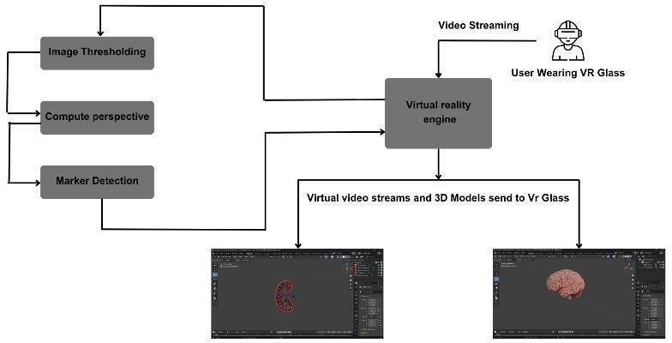
Fig. 2. Workflow Diagram

Figure. 1 and Figure. 2 explains about the architecture of the system. i.e it explains the step by step process of the system. It also explains how the system works.
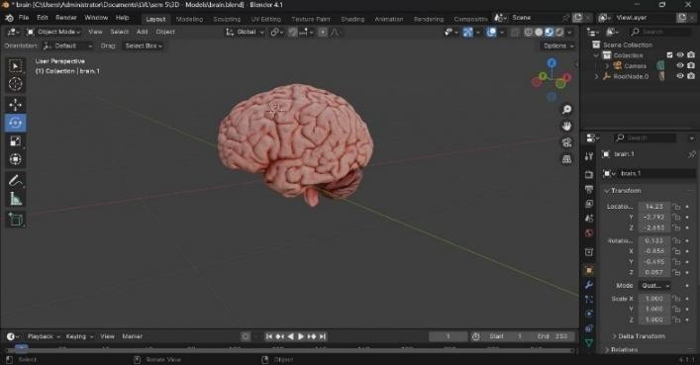
Fig. 3. 3D Brain Model
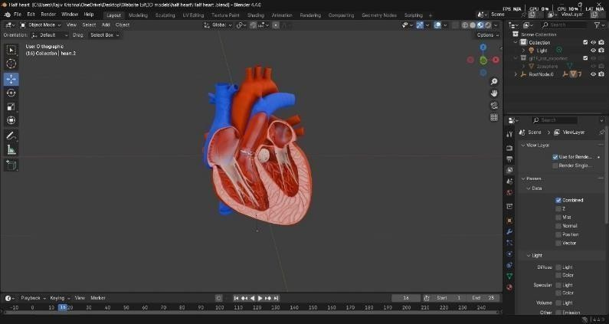
Fig. 4. 3D Heart Model
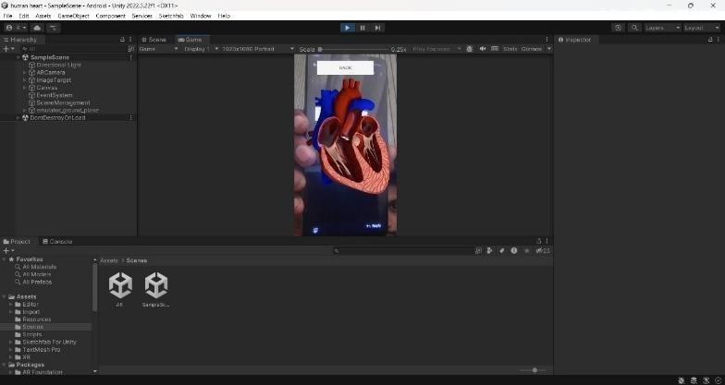
Fig. 5. Unity-based AR Heart Model with QR Scanning

Fig. 3. 3D Brain Model, Fig. 4. 3D Heart Model, Fig. 4. 3D Heart Model are the 3D Models which are created in unity through which we create an app. There are other models of kidney, brain and others.

RESULTS AND DISCUSSION

Table I – Learning Performance Comparison

Group | Pre- Test Mea n (%) | Post- Test Mea n (%) | Progres- s (%) | Std. Dev  . (±) | p- valu e (t- test)
Traditi  -onal (n=25) | 48.2 | 50.1 | +1.9 | 4.6 | –
AR/VR (n=25) | 47.6 | 75.3 | +27.7 | 5.1 | < 0.01
User satisfaction was also high. The System Usability Scale (SUS) average score was 82/100.
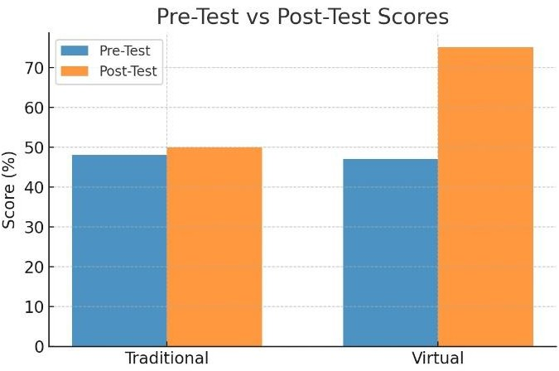
Fig. 6. Pre-Test vs Post-Test Results (Traditional vs Virtual)

Table II summarizes engagement and motivation feedback

Table II – User Feedback Metrics

Metric | Score (out of  100) | Positive  Response (%)
SUS (Usability) | 82 | 88%
Engagement | 85 | 87%
Motivation | 83 | 85%

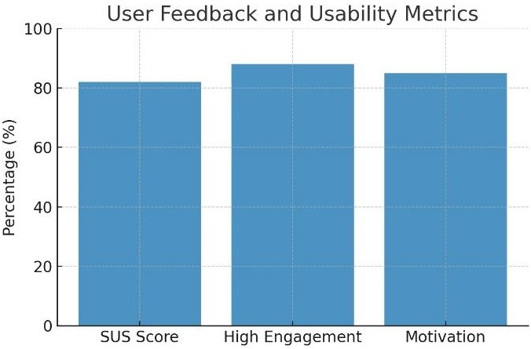
Fig. 6. User Feedback and User Metric

CONCLUSION AND FUTURE WORK

In order to improve anatomy education and student involvement, this study presented a framework based on AR/VR and NLP. The system enabled learners to engage with anatomical models while receiving real- time guidance by combining conversational assistance with immersive 3D visualization. When compared to conventional approaches, the results demonstrated notable gains in engagement and knowledge retention.

Notwithstanding these advantages, the study had drawbacks, including a small sample size and scant anatomical coverage. Future plans call for investigating multi-user VR sessions, adding haptic feedback for tactile interaction, and growing the dataset to include additional organs. Furthermore, creating AI-powered personalization will support the provision of flexible and customized educational opportunities.

REFERENCES
- R. McMenamin et al., “The production of anatomical teaching resources using three-dimensional (3D) printing,” Anatomical Sciences Education, vol. 7, no. 6, pp. 479–486,
2014.

- M. Moro, Z. Štromberga, A. Raikos, and S. Stirling, “The effectiveness of virtual and augmented reality in health sciences and medical anatomy,” Anatomical Sciences Education, vol. 10, no. 6, pp. 549–559, 2017.

- Markets and Markets, “AR and VR in Healthcare Market – Global Forecast 2022–2030,” Market Research Report, 2023.

- D. S. Pei and D. Y. Lee, “Immersive VR applications in anatomy teaching: A systematic review,” Medical Education Online, vol. 26, no. 1, pp. 1–15, 2021.

- R. Barsom, M. Graafland, and M. Schijven, “Systematic review on the effectiveness of augmented reality applications in medical training,” Surgical Endoscopy, vol. 30, no. 10, pp. 4174–4183, 2016.
- J. Maresky et al., “Virtual reality in medical students’ education: A randomized trial,” Advances in Medical Education and Practice, vol. 10, pp. 907–916, 2019.

- N. Seymour et al., “Virtual reality training improves operating room performance: Results of a randomized, double-blinded study,” Annals of Surgery, vol. 236, no. 4,
pp. 458–464, 2002

- F. Nicholson et al., “Can virtual reality improve anatomy education? A randomized controlled study of a VR anatomy program,” BMJ Open, vol. 10, no. 2, pp. 1–8, 2020.
- S. Bork et al., “HoloLens-based mixed-reality experiences for collaborative learning in anatomy,” Journal of Medical Internet Research, vol. 21, no. 3, pp. e12016, 2019.
10] S. T. Saha, “Applications of NLP in medical decision support systems,” Journal of Biomedical Informatics, vol. 110, pp. 103553, 2020.

- K. Patel and A. Patel, “AI-driven chatbots in medical education and patient support,” Health Informatics Journal, vol. 27, no. 1, pp. 25–36, 2021.

- R. John et al., “Effectiveness of AR and VR in anatomy education: A comparative study,” Education in Medicine Journal, vol. 14, no. 3, pp. 17–26, 2022.
- Z. Cheng, “Natural language processing for clinicalknowledge representation,” Nature Medicine, vol. 26, pp. 159–167, 2020.

- L. B. Noll, “Integration of AI and VR in higher education: Opportunities and challenges,” IEEE Access, vol. 9, pp. 15044–15053, 2021.

- D. Sielhorst, T. Obst, and N. Navab, “Medical augmented reality: A review,” Computers & Graphics, vol. 31, no. 3, pp. 396–409, 2007.

- J. W. Cannon et al., “The impact of virtual reality surgical training on real-world performance,” The American Journal of Surgery, vol. 208, no. 5, pp. 832 840, 2014.

- A. Brown et al., “AI-powered educational chatbots in medical training: A pilot study,” Frontiers in Artificial Intelligence, vol. 4, pp. 1–9, 2021.

- C. V. Gaba, “The future of VR in healthcare education,” Simulation in Healthcare, vol. 15, no. 5, pp. 321–328, 2020.
- H. Li, “Advances in real-time rendering for VR medical simulations,” IEEE Transactions on Visualization and Computer Graphics, vol. 28, no. 6, pp. 2515–2526, 2022.

- W. Xu and M. Wang, “Exploring AI and immersive technologies for next-generation medical education,” Computers in Biology and Medicine, vol. 152, pp. 106308, 2023.

