Improving Kinematic Performance of Geneva Mechanisms in Robotic and Automated Systems: A Comparative Study on Slot Count Using MATLAB Simulations
Rashid Khan^{1*}, Md. Nasar Equbal¹, Gaurav Kumar¹, Rajbala¹, Mohammad Saif²
¹Department of Mechanical Engineering, Galgotias University, Greater Noida, Uttar Pradesh, India
²Department of Electrical and Electronics Communication Engineering, Galgotias University, Greater Noida, Uttar Pradesh, India
*E-mail: Rashid.khan@galgotiasuniversity.edu.in
Abstract
Geneva mechanisms are widely used in robotic and automated systems to produce controlled intermittent motion. However, their dynamic behavior—especially acceleration and velocity changes—can significantly impact mechanical wear, vibration, and system accuracy. This study presents a comparative analysis of Geneva mechanisms with different slot counts (N = 4, 6, and 8) to understand how slot number influences motion smoothness and dynamic performance. Using MATLAB-based simulations, angular displacement, velocity, and acceleration profiles were generated while maintaining constant geometric and input parameters. Results indicate that increasing the number of slots reduces peak angular acceleration and velocity fluctuation, improving overall motion continuity. Unlike prior works that focus on geometric design or single-slot analysis, this study provides one of the first systematic, quantitative comparisons of slot count effects (N = 4, 6, 8) on Geneva mechanism performance using a new smoothness index. This contributes design-oriented insights for robotics and CNC tool changers.
Keywords: Geneva Mechanism; Kinematic Optimization; Intermittent Motion; Robotics Automation; MATLAB Simulation; Slot Count Effect.
Nomenclature:
Rw = Driven wheel radius (mm)
Rp = Driver pin radius (mm)
C = Center distance between the driver and driven wheel (mm)
Φ = Half-angle of indexing (⁰)
ω = Constant angular velocity of the driver (rad/s)
R_{lock}= Locking radius (mm)
N = Number of slots
v = Linear velocity of the pin = Rp × ω,
t = Time elapsed during the indexing phase (sec)
INTRODUCTION
A popular indexing method that produces intermittent motion with great positional accuracy from continuous rotating motion is the Geneva mechanism[1]. A driven wheel with uniformly spaced radial slots and a driving wheel with a pin are the components of a conventional Geneva mechanism. The pin occasionally makes contact with a slot on the driven wheel as the driving wheel revolves, producing a noticeable angular progress. A locking mechanism holds the driven wheel in place between these engagements, reducing backlash and guaranteeing position stability. Nevertheless, the traditional Geneva mechanism, especially those with few slots, frequently shows serious dynamic problems, such as high impact forces and vibrations during engagement and disengagement, which can impair longevity and performance [2]. Traditionally, Geneva mechanisms have been used in timing applications such as clocks, watches, and film projectors. The research explores a novel internal combustion engine design using the Geneva mechanism[3]. Examining several SMA actuator topologies, the study emphasizes how mechanical design affects thermal performance, displacement, and efficiency. In robots and flexible systems, these insights are crucial for optimizing small mechanisms such as the Geneva drive [4] This paper presents a polynomial-based design for changing input speed that minimizes peak acceleration and angular jerks in Geneva mechanisms. For efficient performance enhancement, it uses optimization based on teaching-learning, and its results are comparable to those of current length-adjustable link techniques [5]. A spiral Geneva mechanism is used in this study's vertical pneumatic fertilization system to provide accurate and consistent fertilizer flow. According to simulation and experimentation, opening and rotating speed have a significant impact on discharge accuracy, providing important information for fine-tuning Geneva-based mechanisms in precision applications [6]. The study uses ANSYS APDL to model contact behaviour under various material qualities in order to investigate a Geneva mechanism in an autonomous stamping machine. It draws attention to how material choice has a big impact on contact and stress performance, which helps with design optimization for effectiveness and less human labour [7]. For curved slotted Geneva mechanisms, this paper suggests an indexing motion based on Hermite interpolating polynomials to minimize peak angular acceleration and get rid of infinite jerks. Its kinematic performance can be improved by up to 33.4%, surpassing that of conventional motion profiles [8]. This study highlights the simplicity, dependability, and automation appropriateness of a Geneva mechanism by showcasing its efficient application in CNC tool changers. Despite its efficiency, scaling up presents challenges due to tool capacity and design complexity [9]. Modern engineering is still interested in the Geneva mechanism, which is renowned for transforming rotary motion into accurate intermittent motion. In this work, a synthesis method backed by computer-aided dynamic and kinematic analysis is presented. To calculate component size and motion parameters, a specialized program was created, allowing for precise 3D modelling of the mechanism[10]. The flexible impulse of the Geneva wheel and its unsuitability for high-speed application are highlighted in this study's comparison of four intermittent motion devices. Motion analysis and parametric design were combined with ease using NX8.5. The unified data strategy improves visualization accuracy and design efficiency [11]. This work uses ABAQUS and FE-SAFE to assess the fatigue life and stress distribution of an external Geneva mechanism under three loading scenarios. The pin contacts at the bottom of the wheel slot, which exhibits the highest stress, according to the results. Similar tension results from increasing crank speed or torque. The fatigue life of the pin is longer than that of the Geneva wheel [12]. This paper suggests a synthesis approach based on a desired motion law for groove cam Geneva mechanisms with long dwell times. Additionally, the cam curvature radius and pressure angle are controlled by the design. This design avoids soft impacts, double locking, and permits smoother transitions than the classic Geneva designs. Its efficacy is an overview of the Maltese cross (Geneva) mechanism, which is frequently employed in robotics, automation, and force transmission systems, is provided in this study. It investigates a fourth-class upper coupler configuration's geometry, kinematics, and dynamic forces. Its position alongside gears and its importance in conveying peak moments are highlighted in the analysis [13]. A Geneva mechanism tool changer prototype was created for CNC machines. Laser cutting and 3D printing were used to construct the components. Although the design is dependable and economical, its scalability is still a drawback [14]. Designing Geneva mechanisms with curved slots is done methodically using envelope theory. The study looks into double-point and undercutting problems in the curve profile. To avoid these issues, design charts are created, and the suggested approach is validated by a physical mock-up [15]. In order to optimize weight, manufacturing industries frequently use sheet metal shaping. In this paper, a Geneva mechanism is used to improve intermittent operations in place of the conventional crank slotter. A slotted Geneva wheel's kinematics are determined using DH notations and curve theory analysis. Contact stresses between the wheel grooves and the pin are assessed using finite element analysis [16]. To tackle intricate parametric optimization issues, the Geneva framework provides parallel computing capabilities for large-scale, nonlinear jobs. A new MPI Consumer component makes it more appropriate for clusters of high-performance computers. With this innovation, asynchronous communication can be used to evaluate cost functions in a scalable and fault-tolerant manner. Fundamental physics research regularly uses Geneva, which is open source [17]. The Geneva framework provides parallel processing capabilities for large-scale, nonlinear parametric optimization problems. Its usefulness for high-performance computing clusters is improved by a new MPI Consumer component. This innovation makes it possible to use asynchronous communication to evaluate cost functions in a scalable and fault-tolerant manner. Geneva is actively utilized in basic physics research and is open source [18]. Building codes have changed in the last few decades to place a higher priority on occupant comfort and energy efficiency. A growing trend stresses performance-driven design from the very beginning of the conceptual stage, even if the majority of simulation tools concentrate on performance evaluation. The potential of computational optimization techniques in building design is examined in this review. Additionally, it highlights present constraints and potential avenues for further investigation[19]. The potential of computational optimization techniques in building design is examined in this review. The integration of several powertrain components and structural safety regulations has made engineering hybrid electric vehicles (HEVs) increasingly challenging. This study discusses this issue. A framework for multidisciplinary design optimization (MDO) that strikes a balance between crashworthiness and powertrain performance is suggested. Through the assessment of many design factors and limitations, the research emphasizes how integrated optimization, as opposed to powertrain-only methods, results in more practical and effective vehicle designs [20].It is used in CNC machines and paper cutting setup[21]. Table 1 indicates the Practical implications: increasing slot count reduces per‑step angular increment but shortens dwell and changes peak magnitudes; groove or curved slots permit tailoring the motion law and reducing soft impacts while synthesis constraints (pressure angle, cam curvature) must be respected [22] [24] [25]. A modified Geneva mechanism that reduces motion discontinuities by employing an epitrochoidal path rather than the conventional circular pin path is examined in this work. In order to achieve smoother velocity, acceleration, and jerk profiles, a gear train creates this path.
Table 1. Slot count effects and comparisons
Slot configuration | Observed kinematic effect | Key quantitative result
3 slots (external/internal) | Longer motion interval per step → larger angular velocity/acceleration peaks | Comparative study used 3, 6, 9 slots and shows different peak behaviors across configurations [22]
4 slots | Standard teaching/demo case; baseline kinematics analyzed for education and design decision support | Kinematic analysis and design guidance for a 4-slot teaching aid are provided [23]
6 slots | More frequent, smaller steps → reduced peak angular velocity/acceleration in some link combinations | Swadi reports reduced maxima for certain crank-rocker couplings compared with other counts [22]
9 slots | Even smaller steps per index but shorter dwell; can change dynamic envelope and increase certain accelerations depending on geometry | Included in comparative study of 3, 6, 9 slots [22]
3–15 slots (groove-cam synthesis) | Operating time coefficient and dwell augmentation vary systematically with slot count; wide achievable range of operating time coefficients | Analyses for cycloidal motion law show achievable operating time coefficient range 0.053–0.765 across 3–15 slots and dwell coefficient variations [24]
Curved/grooved slots | Reduces impact at entry/exit, lowers angular acceleration and vibration, enables specified motion laws and soft transitions | Curved-slot designs and groove-cam synthesis produce fewer soft impacts and reduced accelerations (up to 3× reduction observed experimentally) [25] [24]
In order to reduce excessive jerk, the study applies a non-circular gear pair to further improve motion and compares classical and modified methods[26]. A keyword-wise network visualization (2006–2014) highlights "mechanism" as the central research focus, showing strong interlinkages with terms like "analysis," "parameter," and "simulation." Notably, "Geneva mechanism" clusters with keywords such as "geometry," "cam," and "dynamic," indicating growing scholarly attention toward kinematic modelling and optimization in precision motion systems in Figure 1. The Geneva mechanism, though classical in origin, plays a critical role in modern robotic and autonomous systems where precise intermittent motion is essential—such as robotic assembly lines, CNC-based tool changers, or packaging automation. Although the classical mechanical design literature has extensively studied Geneva mechanisms, there aren't many comparison studies across different slot counts (N). Static geometric design or single-slot arrangements are the main subjects of current research. This study systematically compares Geneva mechanisms with varying slot counts (N = 4, 6, and 8), providing quantitative analysis of kinematic performance metrics to support design optimization. By introducing a normalized smoothness index and quantifying reductions in acceleration peaks and velocity fluctuations, this study provides actionable insights into the trade-offs between rapid indexing and smooth motion. While prior studies optimize curved slots, dwell design, and stress analysis, none provide a quantified comparison of slot count effect on smoothness and mechanical stress. This gap is addressed in the present work.
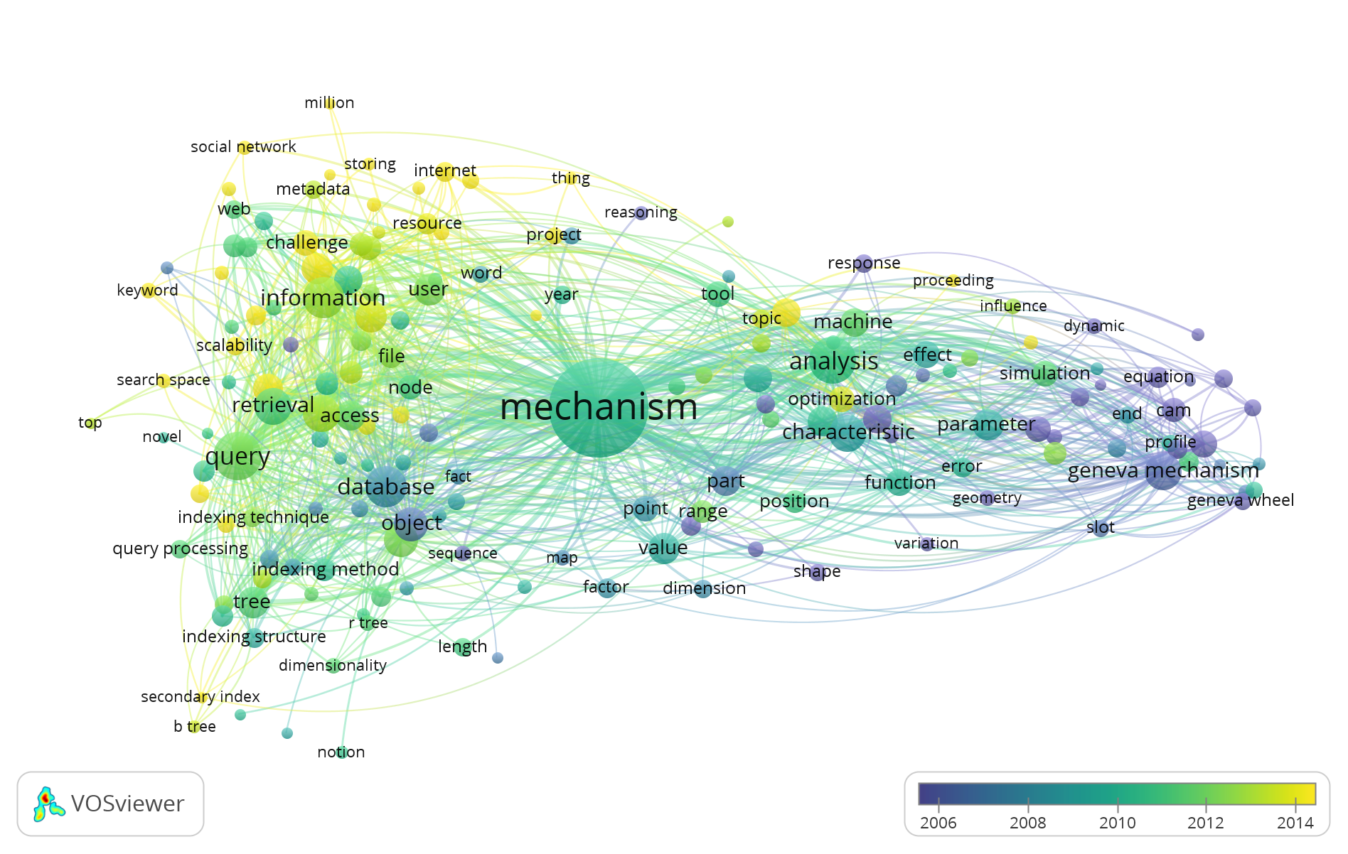
Figure 1. Keyword-wise network visualization map
METHODOLOGY
The Geneva mechanism's kinematic analysis and geometric modelling approach is presented in this section. The goal of the work is to derive time-parameterized equations for the driven wheel's angular displacement, velocity, and acceleration given a constant angular input. MATLAB 2014a is utilized to do the analysis.
Geometric Assumptions and Parameters
The Geneva mechanism under consideration has four slots (N = 4) on the driven wheel and is a classical external drive type. These are the primary geometric parameters, Rw= 50 mm, Rp= 5 mm, C=70.71 mm, Slot indexing angle: 360°/N = 90°, φ= 45°, ω= 10 rad/s (constant), R_{lock} ≈ 61.24 mm. The indexing angles per slot correspond to 360°/N. For N = 4 → 90°, N = 6 → 60°, N = 8 → 45°.
The analysis assumes planar motion, idealized rigid bodies, negligible backlash, and minimal friction—standard conditions for kinematic studies of Geneva mechanisms. Figure 2 Geometric configuration of Geneva mechanisms with different slot numbers: (a) four-slot (N = 4), (b) six-slot (N = 6), and (c) eight-slot (N = 8). The figure illustrates the driving wheel radius Rd, driven wheel radius Rw, centers of rotation O1 and O2, and the engagement point P between the driving pin and Geneva slots. The variation in slot count influences the indexing angle, motion transfer characteristics, and kinematic performance of the mechanism.
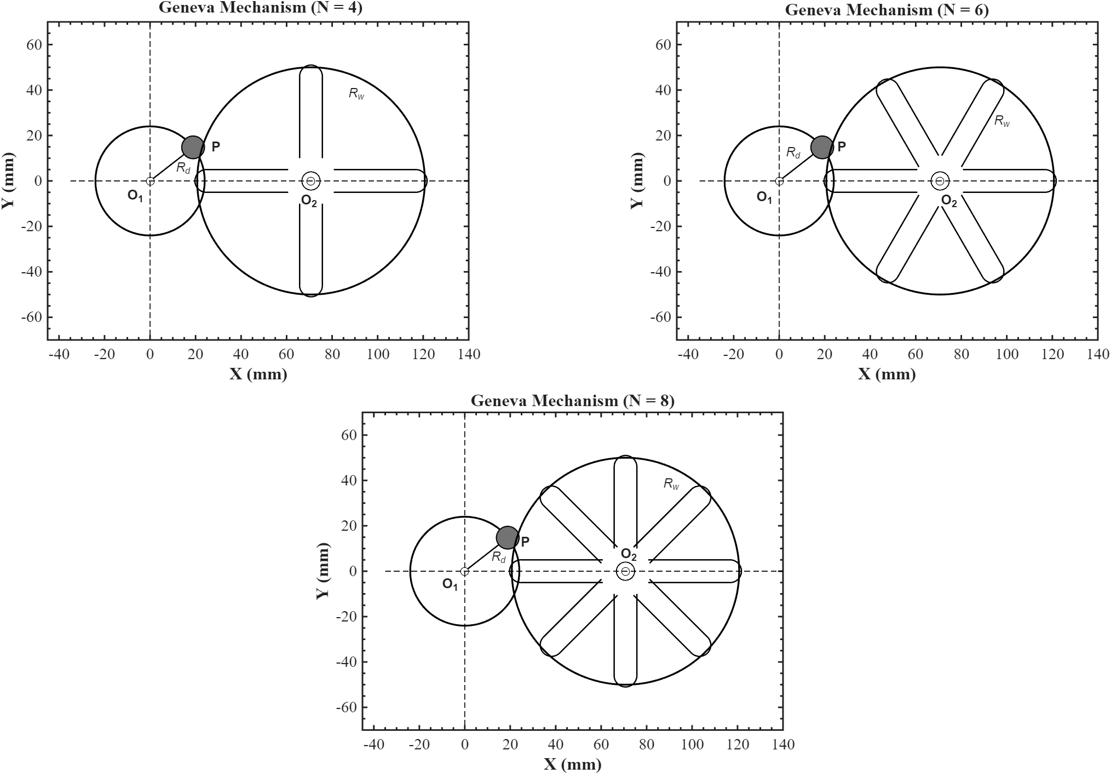
Figure 2. Comparative Geometric Models of Geneva Mechanisms (N=4,6,8)
Kinematic Modeling and Equations
Angular Displacement of the Driven Wheel
The driving pin travels in a circular arc when engaged, giving the Geneva wheel motion through one of its radial slots. Given the driver rotation angle (ωt), the driven wheel's angular displacement, θ(t), may be found using the following formula:
Based on the planar vector geometry of the Geneva mechanism, this expression takes into consideration the driven wheel's instantaneous angular position as a function of time and relative geometry.
Angular Velocity and Acceleration
The angular velocity and acceleration of the driven wheel are obtained by numerically differentiating the displacement function:
The gradient () function in MATLAB is used to derive these derivatives using finite difference approximations. Smooth and precise derivative estimation is ensured by using a high-resolution time vector.
Time-Parameterized Driver Rotation
The time needed for a full indexing motion, assuming the driver's angular velocity (ω = 10 rad/s) remains constant, is:
A consistent, small-increment time vector from t=0 to t= t_{index} It is possible to simulate θ(t), ω2(t), and α2(t) throughout the whole indexing phase by using Δt. Using the same driver input conditions, this modeling approach compares motion smoothness, peak accelerations, and indexing times to promote design optimization and enable dynamic study of various slot configurations (N = 4, 6, 8).
Hand-Derived Kinematic Equations
Assumptions and Approach
The Geneva mechanism has N = 4 slots, which means that during each indexing phase, the driven wheel rotates 90° (π/2 radians). The angular velocity of the driver's rotation is constant at ω = 10 rad/s. There is a circular arc of radius Rp that the driver pin follows. The angular position of the driven wheel is determined by the relative displacement of the driver pin and the driven wheel center. The For the hand derivation, a simplified geometric model is employed, and MATLAB is utilized to develop it numerically.
Angular Position θ(t)
Applying the law of cosines to the triangle made up of the driver pin, driver wheel center, and driven wheel center yields the angular displacement θ(t) of the driven wheel.
The driver pin's relative displacement from its starting location can thus be represented in terms of time as follows:
Finding the angle θ(t) between the vectors linking the driver and driven wheel centers using the law of cosines:

Throughout the active indexing phase, this equation calculates the Geneva wheel's instantaneous angular position. Its foundation lies in geometry and is predicated on the idealized, seamless transfer of motion.
Angular Velocity ω₂(t)
The driven wheel's angular velocity is equal to the angular position's first time derivative:
While this derivative is analytically possible, the nonlinear structure of the θ(t) function makes it complex to differentiate by hand. Hence, in practice, this derivative is calculated numerically using MATLAB’s gradient () function:
Angular Acceleration α₂(t)
Similarly, angular acceleration is the second derivative of θ(t):
Which is computed numerically as:
This method allows for accurate estimation of dynamic characteristics like peak acceleration, which is critical in evaluating mechanical stress and vibration in high-speed Geneva mechanisms.
MATLAB Simulation
All of the fixed geometry and simulation parameters utilized throughout the analysis are shown in Table 2. It specifies key parameters such the constant driver angular velocity (ω=10rad/s), driven wheel radius (Rw=50mm), and driver pin radius (Rp=5mm). Additionally, it provides the indexing angles for each slot configuration (900, 600, and 450 for N=4, 6, and 8, respectively) and the time step utilized in the MATLAB simulation (Δt=0.001s). The basic configuration for reproducible and reliable simulation results is given by this table.
Table 2. Input Parameters Used in Simulation
Parameter | Symbol | Value | Units
Driver Pin Radius | Rp​ | 5 | mm
Driven Wheel Radius | Rw​ | 50 | mm
Driver Angular Velocity | ω | 10 | rad/s
Slot Counts Tested | N | 4, 6, 8 | –
Time Step for Simulation | Δt | 0.001 | s
Index Angle per Slot | 360∘ /N | 90°, 60°, 45° | degrees

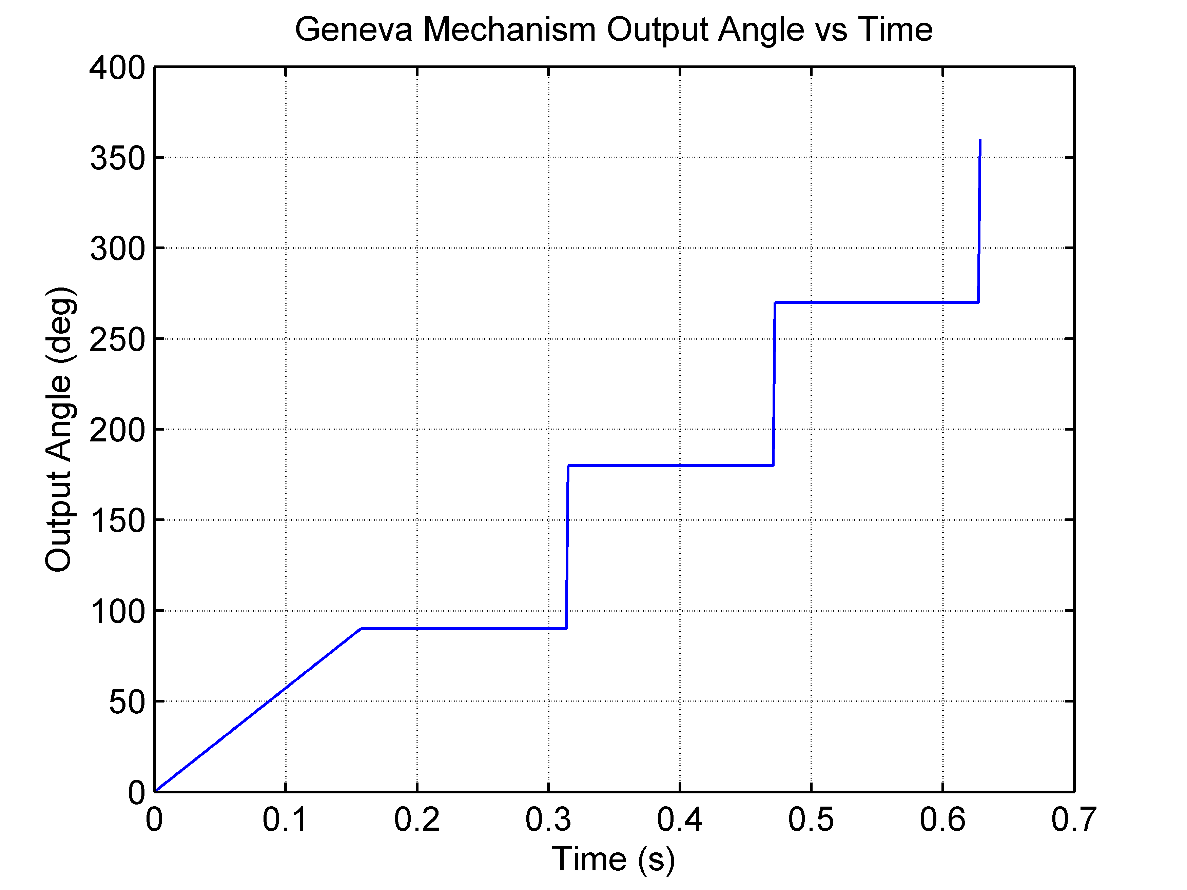
Figure 3. Geneva Mechanism Output Angle vs Time
Performance Metrics
Three key performance indicators were used to quantify kinematic smoothness and dynamic performance:
- Peak Angular Acceleration (|αₘₐₓ|)
- Velocity Fluctuation (Δω)
- Smoothness Index (S)
with 𝛼_{𝑟𝑒𝑓} corresponding to the peak deceleration for N = 4,6,8. These metrics facilitate objective evaluation of trade-offs between indexing speed and motion smoothness.
RESULTS AND DISCUSSION
Kinematic Response: Angular Position, Velocity, and Acceleration
MATLAB 2014a was used to develop a simulation script (geneva_motion.m) to compute angular displacement, velocity, and acceleration. The following input parameters are adopted in the simulation: Rp = 5 mm, Rw = 50 mm, C = 70.71 mm.
The Geneva mechanism's output angle is plotted against time in the Figure 3. The mechanism's intermittent motion feature—in which the output spins during engagement and stays motionless during dwell periods—is aptly demonstrated by the stepped profile. A single indexing event is represented by each abrupt rise, and dwell time is represented by flat areas. Consistent angle increments are confirmed by the steps' uniform height, and regular time of driver engagement is reflected in the distance between them[27]. The proper Geneva indexing behavior is validated by this pattern.

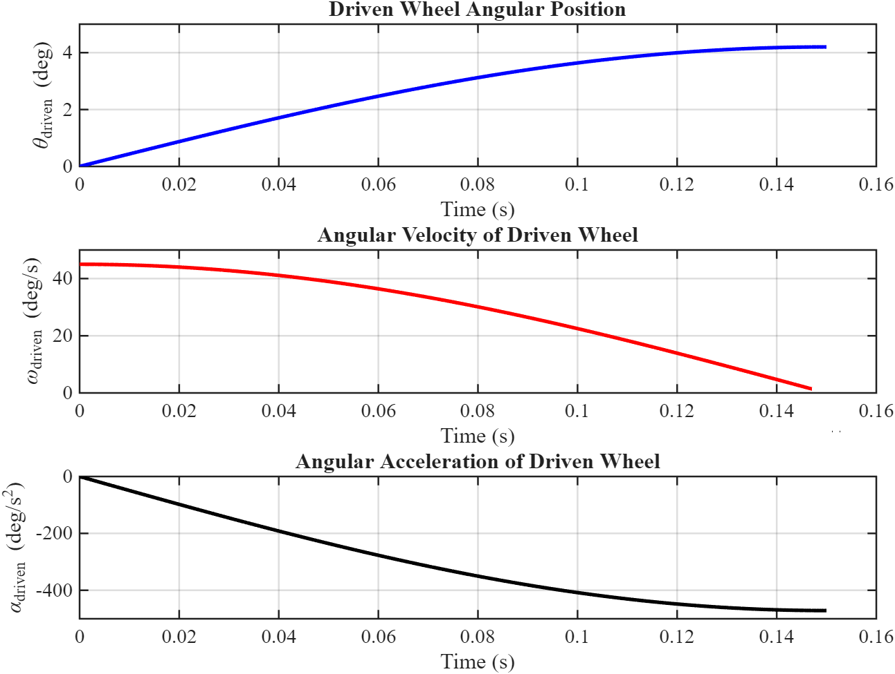
Figure 4. θ, ω, α vs time Graph in MATLAB
Using the input parameters Rp​=5 mm, Rw​=50 mm, and center distance C=70.71 mm. the Figure 4 depicts the kinematic reaction of a driven wheel of a Geneva mechanism during the course of one indexing cycle. The top plot shows the angular position θ_{driven}(t), which increases non-linearly over time. The growth is initially slow (0–0.03 s), which corresponds to the instant after the driver pin enter the slot but before the lever arm starts to work. Because so little torque is imparted at shallow engagement, there is a "lag" phase. The mid-stroke period (0.03–0.12 s) is when the curve steepens, signifying that the pin-slot geometry reaches its optimal torque transfer configuration. In this case, the driven wheel experiences a considerable angular progress even with minor angular displacements from the driver. The curve flattens when the pin approaches the trailing end of the slot near the conclusion of the cycle (0.12–0.157 s), which lowers torque and slows motion. The middle plot displays the angular velocity ω_{driven}(t), which starts at a peak of about 45–50°/s after engagement and then declines gradually. This peak results from an initially ideal torque arm and the driver's quick input. Each increase in driver rotation, however, results in a decrease in the driven wheel's angular velocity as the cycle goes on and the torque arm gets shorter. The velocity has dropped to almost zero by 0.157 seconds, indicating
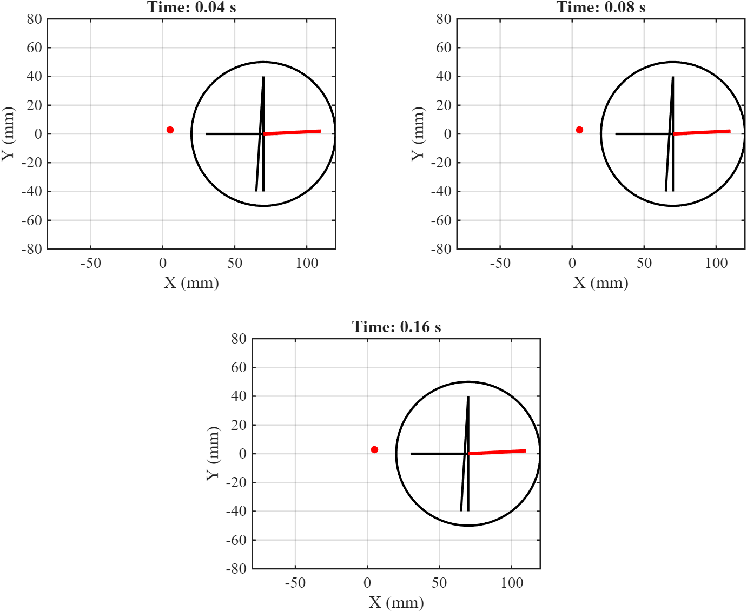
Figure 5. Visualization: slot motion animation
the start of the dwell phase. A single frame from the animation visualization of a 4-slot Geneva mechanism, showing the interaction between the driver pin and the driven wheel, is shown in Figure 5 (at t = 0.11 s). With a steady rotational speed of 10 rad/s, the red driver pin is now positioned just above the horizontal axis, having turned about 63°. While the Geneva wheel (black circle) stays centered at (70.71 mm, 0), the black crank arm runs from the pin to the origin. The bold red segment indicates the active slot that is being driven at the moment, while two thin black spokes show the wheel's static orientation during dwell phases. The driven wheel's angular velocity is close to its peak because the lever arm is maximized due to the pin-slot alignment being almost perpendicular to the center-to-center line. Visually, the wheel is halfway through its 90° indexing stroke since the red slot has already rotated several degrees clockwise from vertical. The lever arm will gradually shorten as the pin pushes the slot toward horizontal, lowering the wheel's speed and bringing it to rest at its new dwell position. Thus, the basic kinematics that characterize the intermittent motion of a Geneva mechanism—rapid mid-stroke rotation followed by smooth deceleration and final locking—are captured in this animation frame.
Optimization Analysis
Figure 6 compares the angular position θ_{driven}(t) of the driven wheel for Geneva mechanisms with slot counts N=4,6, and 8, over one indexing cycle. With the center distance modified for every configuration to preserve appropriate engagement geometry, each curve depicts motion under the same driver speed of 10 rad/s. The graphic illustrates how motion characteristics and indexing length are impacted by slot count. The yellow curve for N=4 reaches nearly 4 degrees by t≈0.157 seconds, while the red and green curves for N=6 and N=8 reach about 2.5 and 1.5 degrees, respectively. This demonstrates unequivocally that mechanisms with more slots have slower results angles over identical driver angle input because their per-step indexing angle is less (90° for N = 4, 60° for N = 6, and 45° for N = 8). All curves have a similar shape, despite their variations in magnitude: a slow flattening near the end, a sharper slope in the middle, and a sluggish rising at the beginning.
Figure 6. Angular Position Comparison (θ_{driven} vs t)
The pin-slot interaction's shifting geometry is what gave it this shape. The torque arm is short early in the stroke, resulting in less rotation of the output. The torque arm lengthens and angular motion quickens as the driver rotates further and the pin gets closer to perpendicular alignment with the driven wheel centerline. The output rate decreases when the torque arm shortens once more toward the end. These variations in slope and curve form have significant design ramifications. Faster indexing is achieved with fewer slots, such as 𝑁 = 4 however higher dynamic loads are also introduced because of the quick angular changes. Applications needing less vibration and more gradual acceleration profiles favor slower, smoother motion, which is produced by higher slot counts such 𝑁 = 6 or 8. Thus, indexing speed, smoothness, and mechanical stress must all be balanced while choosing the number of slots. The driven-wheel angular velocity ω_{driven}(t) for N = 4, 6, and 8 is compared in Figure 7. The yellow N = 4 curve decays to near zero after 0.157 s after peaking at about 44°/s. The maximum for N = 6 (red) is at 30°/s, and it drops to zero by about 0.104 s. The green N = 8 curve begins at about 23°/s and reaches zero at about 0.078 s. Higher slot counts hence result in quicker indexing times and lower peak velocities. To put it another way, N = 8 delivers smoother, slower motion over a shorter interval, whereas N = 4 offers the fastest speed but the longest indexing time.

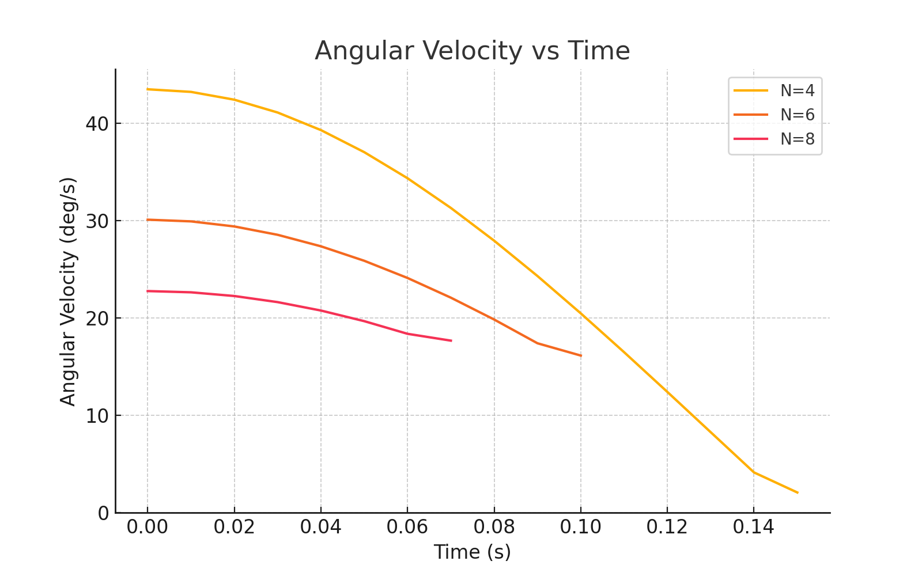
Figure 7. Angular Velocity Comparison (ω_{driven} vs t)
For N = 4 (yellow), N = 6 (red), and N = 8 (green), angular acceleration α_{driven}(t) is displayed in Figure 8. The N = 4 curve shows a considerable mid-stroke deceleration with the biggest negative peak at –420°/s² approximately 0.125 s. N = 8 peaks close to –120°/s² at 0.06 s, whereas N = 6 reaches almost –240°/s² at 0.08 s. Milder deceleration and shorter indexing times are the results of larger N values. This implies that a 4-slot design has the most dynamic shock, whereas adding slots (to 6 or 8) results in smoother motion with lower peak decelerations, which is advantageous for lowering wear and vibration. Similar PSO-ANN frameworks can enhance motion prediction[28].
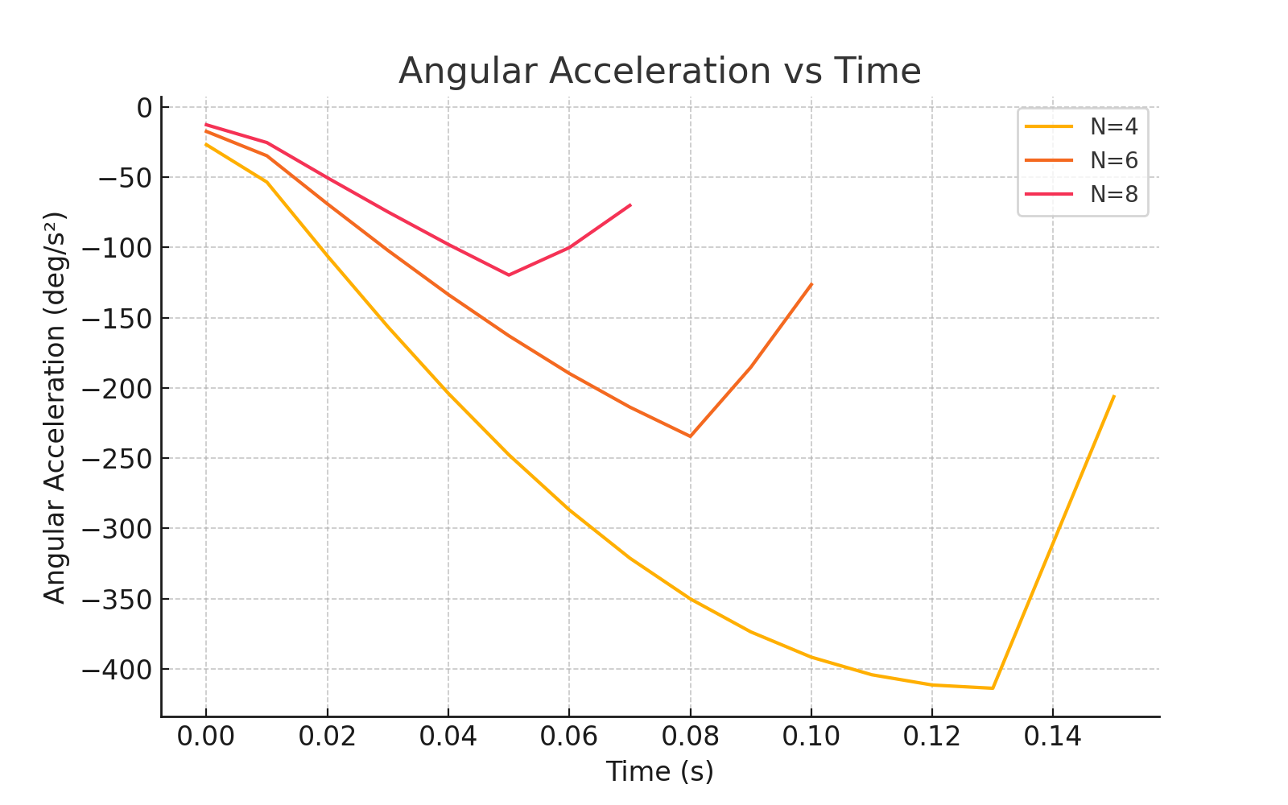
Figure 8. Angular Acceleration Comparison (α_{driven} vs t)

Comparison of configurations for N = 4, 6 and 8
Table 3 depicts that N = 4, achieves the fastest angular output but imposes higher mechanical shock and inertial stress, making it less suitable for precision applications requiring smooth operation. While N = 6, provides a compromise between speed and smoothness, balancing performance for general automation purposes and N = 8, offers the smoothest indexing with the least mechanical stress, ideal for high-precision or vibration-sensitive environments despite slightly slower per-step angular output.
Simulation Results – One Indexing Cycle
Geneva mechanisms' dynamic performance for slot counts N=4, 6, and 8 is contrasted in Table 4. It contains a normalized smoothness index (derived from MATLAB simulation outputs), peak angular acceleration, velocity fluctuation, and estimated index duration. Despite a decrease in the indexing angle per step, the data show a distinct trend: the mechanism becomes smoother (lower acceleration peaks and velocity fluctuation) as the number of slots grows. In order to illustrate the performance trade-offs between smooth motion (N = 6 or 8) and rapid indexing (N = 4), this table is essential. Simulation result shown in table N =4 shows highest acceleration (~420°/s²); N= 8 lowest (~170°/s²). Various indexing drives show similar trade-offs. These reductions in acceleration peaks directly benefit applications where precision and longevity are critical, such as CNC indexing or robotics[29].
Table 3. Comparative Performance Summary of Geneva Mechanism Configurations (N = 4, 6, 8)
Slot Count  (N) | Indexing Angle per Event  (°) | Index Time  (s) | Peak Angular Velocity  (°/s) | Peak Angular Acceleration  (°/s²) | Characteristics
4 | 90° | 0.157 | $\sim$ 44–45 | $≈$420 | Fastest output, highest dynamic stress
6 | 60° | 0.104 | $\sim$30 | $≈$240 | Balanced speed, reduced dynamic loads
8 | 45° | 0.078 | $\sim$23 | $≈$120 | Smoothest motion, minimal mechanical shock
Table 4. Simulation Results – One Indexing Cycle
Slot Count (N) | Index Time (s) | Peak Accel (°/s²) | Velocity Fluctuation (°/s) |  | Smoothness Index
4 | 0.157 | ~420 | ~18.0 |  | 0
6 | 0.104 | ~270 | ~6.0 |  | 0.36
8 | 0.078 | ~170 | ~2.5 |  | 0.6
Table 5. Angular Position at Key Time Points (N = 4 Example)

Time(s) | Angular Position (°)
0 | 0
0.04 | 0.8
0.08 | 2.45
0.12 | 4.1
0.157 | 5.00 (Final Angle)
Table 5 shows the evolution of the driven wheel's angular position over time for a Geneva arrangement with four slots. It displays the values of angular displacement at significant points in time between 0 and 0.157 seconds (the entire indexing interval). The data confirms the simulation plot observations by demonstrating that the fastest angular changes take place in the middle of the stroke. This time-based analysis provides valuable insight into how motion develops throughout the course of the cycle and aids in validating the kinematic model.
Metrics for Performance Comparison
A comparison of Geneva mechanism performance parameters for slot counts N=4, 6, and 8 is shown in Figure 8. The first subplot indicates a quick and abrupt slowdown during indexing, with the peak angular acceleration for N=4 (around 420°/s²) being the largest. This value shows a smoother transition in the driven wheel's motion as slot count grows, decreasing notably for N=6 (~270 °/s²) and further for N=8 (~170 °/s²). N=4 exhibits the biggest deviation from mean speed (~18 °/s) in the second subplot, which shows angular velocity fluctuation. In contrast, N=6 and N=8 show much lesser fluctuations of roughly 6 °/s and 2.5 °/s, respectively. This implies that motion is steadier and more reliable when there are more slots.
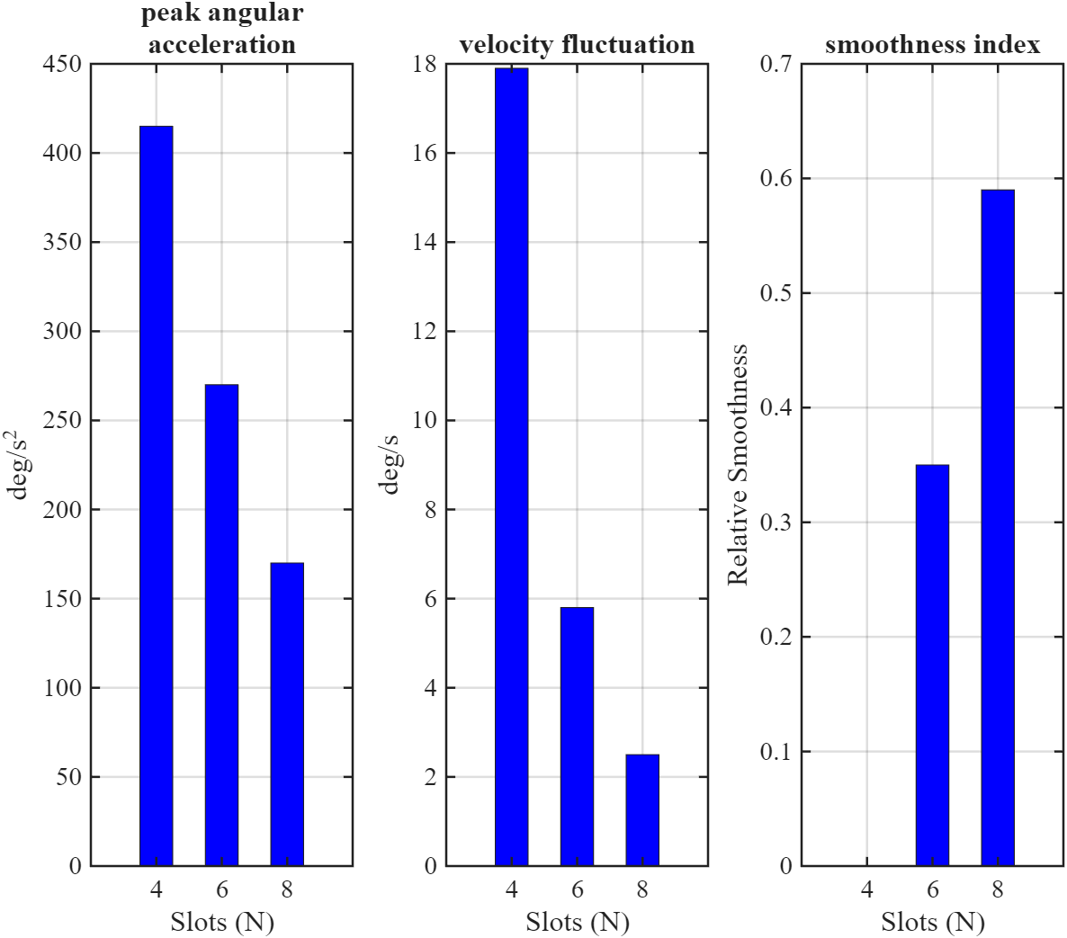
Figure 9. Slot Count vs. Performance Metrics
The smoothness index, a relative indicator of motion continuity, is highlighted in the third subplot. There is a baseline of N=4 (smoothness = 0), a moderate improvement of N=6 (~0.35), and the smoothest performance (~0.6) of N=8. These patterns unequivocally show that while adding more slots lowers the indexing angle each step, it also enhances motion smoothness and lowers dynamic stress. Therefore, designers must strike a compromise between the necessity for speed, which is encouraged by lower N, and mechanical stability and smoothness, which are enhanced by higher N.
CONCLUSION
This study presents a systematic kinematic analysis of Geneva mechanisms with slot counts N = 4, 6, and 8, utilizing MATLAB simulations to evaluate the influence of slot number on motion smoothness and dynamic performance. The investigation focused on time-dependent angular displacement, velocity, and acceleration profiles, providing quantitative insights into performance trade-offs.
The key findings are summarized as follows:
- Increasing the slot count significantly reduces peak angular acceleration, from approximately –420°/s² (N = 4) to –170°/s² (N = 8), thereby minimizing mechanical shock and stress.
- Velocity fluctuation decreases markedly with higher slot counts, improving motion continuity (from ~18°/s at N = 4 to ~2.7°/s at N = 8).
- A smoothness index was introduced to quantify motion improvement, rising from 0 (N = 4) to 0.6 (N = 8).
- While N = 4 offers faster indexing per step (90° in ~0.157 s), it imposes greater dynamic loads, whereas N = 8 enables smoother, quieter operation suited for precision-driven applications.
The novelty of this study lies in presenting one of the first systematic, slot-count-based comparisons of Geneva mechanisms supported by a quantitative smoothness metric. While earlier works mainly focused on geometric modifications or material aspects, this study shows that even a basic design parameter — the number of slots — can strongly influence performance. Future research will extend this analysis to include: Experimental validation of simulation findings through physical prototypes. These extensions will provide deeper insights to inform Geneva mechanism optimization for high-precision, high-speed, and high-duty-cycle applications.
Conflict of Interest
The authors declare that they have no known competing financial interests or personal relationships that could have appeared to influence the work reported in this paper.
Acknowledgement
The authors would like to thank the Department of Mechanical Engineering, Galgotias University, for providing the facilities and support necessary to conduct this research. The authors also acknowledge the valuable cooperation and contributions of all co-authors throughout the completion of this study.
References;
- Yang et al., “Investigation of intermittent motion mechanisms in large landslides based on in-situ monitoring and microtremor survey,” Eng Geol, vol. 354, p. 108117, Jul. 2025, doi: 10.1016/j.enggeo.2025.108117.
- A. Chandra Shekhar, H. S. Shaik, and S. Shahab, “Analysis of Geneva mechanism using dwell symmetrical coupler curve mechanism,” Mater Today Proc, vol. 39, pp. 1402–1406, Jan. 2021, doi: 10.1016/J.MATPR.2020.05.025.
- D. Zhang, M. Reed, B. Li, Z. Gao, and Y. Ge, “Design optimization of a geneva mechanism for internal combustion engine application,” in 2009 International Conference on Information and Automation, IEEE, Jun. 2009, pp. 649–654. doi: 10.1109/ICINFA.2009.5205002.
- D. Copaci, D. Blanco, and L. E. Moreno, “Flexible Shape-Memory Alloy-Based Actuator: Mechanical Design Optimization According to Application,” Actuators, vol. 8, no. 3, p. 63, Aug. 2019, doi: 10.3390/act8030063.
- W. Lin, Y. Tsai, and K. Hsiao, “Optimum variable input speed for kinematic performance of Geneva mechanisms using teaching-learning-based optimization algorithm,” Proc Inst Mech Eng C J Mech Eng Sci, vol. 231, no. 10, pp. 1871–1883, May 2017, doi: 10.1177/0954406215623307.
- H. Chen, J. Zheng, S. Lu, S. Zeng, and S. Wei, “Design and experiment of vertical pneumatic fertilization system with spiral Geneva mechanism,” International Journal of Agricultural and Biological Engineering, vol. 14, no. 3, pp. 135–144, 2021, doi: 10.25165/j.ijabe.20211404.6575.
- K. Saini, P. Patel, R. Bjapai, and S. Shoor, “Design and contact analysis of Geneva mechanism with different materials for automatic stamping by using FEA simulation,” 2025, p. 020001. doi: 10.1063/5.0243516.
- W. Lin, Y. Tsai, and K. Hsiao, “A new indexing motion program for optimum designs of Geneva mechanisms with curved slots,” Proc Inst Mech Eng C J Mech Eng Sci, vol. 231, no. 21, pp. 3974–3986, Nov. 2017, doi: 10.1177/0954406216656021.
- H. Abdul, S. P. Bochu, and S. Pabba, “Design and Fabrication of Tool Changer Using Geneva Mechanism,” 2024, pp. 1–9. doi: 10.1007/978-981-97-4958-4_1.
- I. Stănășel, F. Blaga, and T. Buidos, “Computer Aided Design of Classic External Geneva Mechanism,” Adv Mat Res, vol. 1036, pp. 662–667, Oct. 2014, doi: 10.4028/www.scientific.net/AMR.1036.662.
- E. Zhang and L. Wang, “Parametric Design and Motion Analysis of Geneva Wheel Mechanism Based on the UG NX8.5,” in Proceedings of the 2017 International Conference on Manufacturing Engineering and Intelligent Materials (ICMEIM 2017), Paris, France: Atlantis Press, 2017. doi: 10.2991/icmeim-17.2017.59.
- G. A. Ambaye and H. G. Lemu, “Numerical Stress Analysis and Fatigue Life Prediction of the Classical External Geneva Mechanism,” 2022, pp. 176–186. doi: 10.1007/978-981-19-0572-8_23.
- F. I. Tiberiu Petrescu, T. M. Abu-Lebdeh, and A. Apicella, “Presentation of a Mechanism with a Maltese Cross (Geneva Driver),” American Journal of Engineering and Applied Sciences, vol. 11, no. 2, pp. 891–900, Feb. 2018, doi: 10.3844/ajeassp.2018.891.900.
- G. Figliolini and P. Rea, “Effects of the design parameters on the synthesis of Geneva mechanisms,” Proc Inst Mech Eng C J Mech Eng Sci, vol. 227, no. 9, pp. 2000–2009, Sep. 2013, doi: 10.1177/0954406212466194.
- J. J. Lee and B. H. Jan, “Design of Geneva mechanisms with curved slots for non-undercutting manufacturing,” Mech Mach Theory, vol. 44, no. 6, pp. 1192–1200, Jun. 2009, doi: 10.1016/J.MECHMACHTHEORY.2008.09.003.
- S. U. Bhaskar, K. P. R. Kumar, and D. K. Kumar, “Analysis on slot curvature and contact stresses on Geneva wheel,” 2021, p. 050018. doi: 10.1063/5.0058041.
- J. Weßner, R. Berlich, K. Schwarz, and M. F. M. Lutz, “Parametric Optimization on HPC Clusters with Geneva,” Comput Softw Big Sci, vol. 7, no. 1, p. 4, Dec. 2023, doi: 10.1007/s41781-023-00098-6.
- Z. WANG et al., “Design optimization and testing of a morphing leading-edge with a variable-thickness compliant skin and a closed-chain mechanism,” Chinese Journal of Aeronautics, vol. 37, no. 7, pp. 285–300, Jul. 2024, doi: 10.1016/j.cja.2024.04.021.
- E. Touloupaki and T. Theodosiou, “Performance Simulation Integrated in Parametric 3D Modeling as a Method for Early Stage Design Optimization—A Review,” Energies (Basel), vol. 10, no. 5, p. 637, May 2017, doi: 10.3390/en10050637.
- P. G. Anselma, C. B. Niutta, L. Mainini, and G. Belingardi, “Multidisciplinary design optimization for hybrid electric vehicles: component sizing and multi-fidelity frontal crashworthiness,” Structural and Multidisciplinary Optimization, vol. 62, no. 4, pp. 2149–2166, Oct. 2020, doi: 10.1007/s00158-020-02603-6.
- T. Minh and T. Tran, “A prototype of paper cutting machine,” Journal of Applied Engineering Science, vol. 23, no. 1, pp. 1–14, 2025, doi: 10.5937/jaes0-46220.
- N. N. Swadi, “Kinematics Characteristics of The Internal & External Geneva Mechanism Under The Effect of Multi Design Parameters,” 2016.
- O. A. Dahunsi, A. Y. Oyerinde, O. P. Bodunde, P. Bodunde, and O. S. Olunloyo, “Kinematic Analysis and Design of a Geneva Stop Mechanism Teaching Aid for Intermittent Motion,” 2017. [Online]. Available: https://www.researchgate.net/publication/351785823
- V. Pasika, P. Nosko, O. Nosko, O. Bashta, V. Heletiy, and V. Melnyk, “A method to synthesise groove cam Geneva mechanisms with increased dwell period,” Proc Inst Mech Eng C J Mech Eng Sci, vol. 238, no. 15, pp. 7544–7555, Aug. 2024, doi: 10.1177/09544062241234477.
- A. Yerubayeva, E. Shehab, K. I. Malik, and Md. H. Ali, “Design and Development of 3D Printed Geneva Wheel Mechanism,” in 2022 International Conference on Electrical, Computer, Communications and Mechatronics Engineering (ICECCME), IEEE, Nov. 2022, pp. 1–8. doi: 10.1109/ICECCME55909.2022.9988520.
- D. B. Dooner, A. Palermo, and D. Mundo, “AN INTERMITTENT MOTION MECHANISM INCORPORATING A GENEVA WHEEL AND A GEAR TRAIN,” Transactions of the Canadian Society for Mechanical Engineering, vol. 38, no. 3, pp. 359–372, Sep. 2014, doi: 10.1139/tcsme-2014-0026.
- A. Chandra Shekhar, H. S. Shaik, and S. Shahab, “Analysis of Geneva mechanism using dwell symmetrical coupler curve mechanism,” Mater Today Proc, vol. 39, pp. 1402–1406, 2021, doi: 10.1016/j.matpr.2020.05.025.
- M. A. Mohd Shukran, Y. Y. Chung, W.-C. Yeh, N. Wahid, and A. M. Ahmad Zaidi, “Image Classification Technique using Modified Particle Swarm Optimization,” Mod Appl Sci, vol. 5, no. 5, Sep. 2011, doi: 10.5539/mas.v5n5p150.
- M. Liu, F. Qian, J. Mi, and L. Zuo, “Dynamic interaction of energy-harvesting backpack and the human body to improve walking comfort,” Mech Syst Signal Process, vol. 174, p. 109101, Jul. 2022, doi: 10.1016/j.ymssp.2022.109101.

