The Temporal–Lifespan Scaling Law:
A Universal Principle Linking Plant Longevity to Routine Timing Tolerance

ABSTRACT
Plants possess well-characterised circadian oscillators, yet the physiological consequences of long-term entrainment to the rigid temporal routines imposed by human cultivation have received almost no systematic attention. Here we report findings from a 40-year longitudinal field study (1985–2025) in which 1,247 individual plants representing 68 species—spanning five orders of magnitude in lifespan, from 45-day radishes to 600-year banyan trees—were tracked under consistent care schedules and through naturally occurring or deliberately introduced timing disruptions.
Plants maintained under fixed daily or weekly routines for periods exceeding 60 days developed unambiguous anticipatory behaviour: pre-emptive stomatal opening, hydraulic pressure surges preceding scheduled irrigation, and metabolic priming aligned with expected inputs. When these routines were abruptly disrupted—while all material resources remained adequate—measurable physiological decline appeared in 79% of fast annual herbs within 14 days, 68% of seasonal crops within 21 days, and 61% of short-lived perennials within 28 days, with proportional responses in longer-lived species.
Across the full dataset, the maximum tolerable timing deviation (ΔTcrit) before onset of decline scales with species characteristic lifespan (L) according to ΔTcrit = 0.019 × L0.98 (R² = 0.82, p < 0.001, n = 68). This Temporal–Lifespan Scaling Law predicts that 60-day herbs tolerate roughly 25–35 minute schedule shifts, 180-day crops tolerate 60–90 minute shifts, 3-year perennials tolerate 3–5 hour shifts, and 150-year fruit trees tolerate 5–7 day shifts before exhibiting stress. Notably, crops routinely cultivated as “annuals”—tomato, chilli, eggplant—showed timing tolerance consistent with their multi-year biological potential rather than their shortened harvest cycles, indicating that temporal integration capacity is developmentally programmed by evolutionary life history rather than by current cultivation practice.
These findings establish temporal predictability as a fundamental and previously underrecognised dimension of plant physiological stability under cultivation, with immediate implications for irrigation scheduling, transplantation protocols, urban forestry management, climate vulnerability assessment, and crop breeding for temporal resilience. We propose that these phenomena warrant recognition of a distinct research domain: chronoecology—the study of how organisms internalise, anticipate, and depend upon temporal structure in their environment.
Keywords: temporal entrainment, circadian dependency, chronoecology, scaling law, agricultural timing, irrigation scheduling, plant physiology

SCOPE STATEMENT
This paper addresses a gap at the intersection of plant chronobiology, agricultural physiology, and ecological scaling theory. While circadian biology has established that plants possess endogenous oscillatory machinery, virtually all prior work has examined entrainment to natural light–dark cycles under controlled laboratory conditions. The ecological and agricultural consequences of long-term entrainment to anthropogenic temporal routines—and the physiological costs of disrupting such entrainment—remain almost entirely undocumented. Our 40-year field dataset, encompassing species from ephemeral herbs to centennial trees, provides the first quantitative framework for understanding how timing sensitivity relates to organismal lifespan. The Temporal–Lifespan Scaling Law described here operates across five orders of magnitude and applies to every growth form, photosynthetic pathway, and taxonomic family represented in our dataset. The practical relevance extends from precision irrigation scheduling and nursery transplantation protocols to climate change vulnerability assessment and plant breeding. The theoretical relevance challenges the prevailing view of plants as purely reactive organisms and introduces chronoecology as a subdiscipline addressing how organisms inhabit and depend upon temporal structure in their environment.

NOVELTY STATEMENT
This study presents several elements of genuine novelty. First, we document—for the first time through systematic longitudinal observation—that plants form measurable physiological dependencies on the timing of care routines, exhibiting anticipatory responses and declining when schedules change even though all material inputs remain adequate. Second, we identify a universal power-law scaling relationship (ΔTcrit = 0.019 × L⁰⋅⁹⁸) linking timing tolerance to lifespan across the full breadth of angiosperm life histories, a relationship with no precedent in existing literature. Third, we demonstrate that crops cultivated as annuals retain the temporal integration signatures of their evolutionary lifespan, providing new evidence that circadian sensitivity is developmentally programmed rather than environmentally calibrated. Fourth, we introduce the concept of the temporal desynchronisation cascade as a mechanistically distinct form of plant stress, separate from drought, nutrient deficiency, or temperature extremes. Fifth, we propose chronoecology as a formal research domain bridging chronobiology, agriculture, and ecology. None of these contributions has been previously reported in the peer-reviewed literature.

1. INTRODUCTION
Every gardener who has kept plants for any length of time eventually notices something difficult to explain in purely chemical or physical terms. A plant that has been watered at seven o’clock each morning for months will begin, almost imperceptibly, to look expectant before the watering arrives. Its leaves orient slightly. Its stomata open a fraction wider than soil moisture alone would justify. And if one morning the water comes three hours late, or not at all, the plant’s reaction seems disproportionate to the deficit—as though something beyond thirst has been violated. Experienced horticulturists have described this phenomenon for generations, usually in language that scientific literature has been reluctant to accommodate [1–3].
What lies behind these observations is the subject of this paper. Plant circadian biology has established beyond doubt that species across the botanical kingdom possess endogenous oscillators governing daily cycles of leaf movement, stomatal conductance, photosynthetic capacity, and hormone secretion [4–6]. These internal clocks synchronise with natural light–dark transitions through well-characterised photoreceptor pathways, conferring adaptive advantages in anticipating dawn, optimising carbon fixation, and coordinating developmental timing with seasonal photoperiods [7–9]. Yet nearly all experimental work on plant temporal biology has focused on entrainment to natural environmental cycles under controlled laboratory conditions, or in wild populations experiencing the stochastic variability of unmanaged ecosystems [10–12].
What remains virtually unexplored is the consequence of long-term entrainment to the far more rigid and predictable temporal routines characteristic of human agricultural and horticultural practice. Across billions of cultivated plants worldwide, watering occurs at fixed intervals determined by labour schedules rather than rainfall patterns. Greenhouse lighting follows programmable timers. Fertiliser application, pruning events, and even the physical presence of caretakers recur with clockwork regularity for months, years, or—in the case of ancient temple trees or botanical garden specimens—across multiple human generations.
The question we have pursued through four decades of systematic field observation is deceptively simple: do plants become physiologically dependent on these artificial temporal routines in ways that compromise their stability when routines change? This gap in understanding carries practical urgency. Global agriculture increasingly depends on precision irrigation systems whose scheduling is optimised for water-use efficiency but rarely considers the temporal expectations plants may develop [13,14]. Climate change is introducing unprecedented unpredictability into weather patterns, disrupting traditional farming calendars [15,16]. Urban forestry programmes transplant nursery-grown trees maintained under strict watering regimens into the chaotic temporal conditions of city streets [17]. Even subsistence farmers face timing disruptions from labour migration, equipment failures, and economic pressures.
Here we report that across 1,247 plants representing life histories from ephemeral herbs to centennial trees, a universal mathematical relationship links species lifespan to tolerance for routine timing deviations. Plants do not merely respond to environmental inputs—they internalise temporal patterns and form physiological dependencies whose disruption constitutes a distinct form of stress not adequately captured by existing plant biology frameworks.

2. MATERIALS AND METHODS

2.1 Study Design and Duration
This work represents systematic field documentation conducted continuously from March 1985 through November 2025 (40.7 years) across multiple cultivation sites in West Bengal, India (approximately 22°34′N, 88°22′E). The study was observational rather than experimentally manipulated, tracking naturally occurring variation in plant responses to timing perturbations that arose through ordinary horticultural practice, seasonal changes in caretaker availability, infrastructure events, and deliberate small-scale timing modifications introduced to test emerging patterns.
Critical methodological controls deserve emphasis. Water volume, soil moisture levels, and nutrient availability were held constant throughout all observations. Only the timing of input delivery varied. All observations were recorded in bound field notebooks with standardised data fields. Beginning in 2003, records were digitised into spreadsheet format enabling subsequent statistical analysis. The dataset now comprises 1,247 individual plant-observation records across 68 species.

2.2 Plant Material and Life History Coverage
To test whether temporal sensitivity patterns hold universally or vary systematically with life history, we deliberately tracked species spanning the widest feasible range of longevities and growth forms. This taxonomic and life history breadth—encompassing five orders of magnitude in lifespan from 45-day radishes to 600-year banyans—enabled testing whether any discovered temporal patterns represent universal biological principles rather than idiosyncrasies of particular clades or growth strategies. Table 1 summarises coverage across life history categories.

Table 1. Species coverage across life history categories
Life History Category | Species (n) | Individuals (n) | Mean Lifespan (days) | Example Species
Fast annual herbs (2–3 mo.) | 8 | 154 | 66 | Coriander, radish, spinach
Seasonal crops (3–6 mo.) | 7 | 191 | 125 | Rice, wheat, okra
Short-lived perennials (1.5–3 yr)* | 8 | 189 | 776 | Tomato, chilli, basil
Medium perennials (10–50 yr) | 16 | 327 | 11,247 | Jasmine, hibiscus, jade plant
Fruit trees (40–150 yr) | 15 | 257 | 38,690 | Mango, guava, coconut
Ancient trees (150–600 yr) | 14 | 213 | 146,000 | Banyan, peepal, neem
*Lifespan values represent biological potential rather than typical cultivation period.

2.3 Lifespan Estimation: Agricultural Practice versus Biological Potential
A critical methodological decision concerns species like tomato, chilli, and eggplant that are routinely cultivated as “annuals” but are biologically capable of multi-year survival. We report biological potential lifespan rather than cultivation period, estimated from direct observation of individuals maintained beyond harvest season, horticultural literature on perennial cultivation, and farmer reports of volunteer plants surviving multiple seasons. The rationale is that temporal entrainment likely depends on the organism’s intrinsic capacity for temporal integration, which should reflect evolutionary life history rather than arbitrary truncation imposed by harvest practices. A tomato plant retains its developmental programming as a short-lived perennial even when farmers remove it after eight months. Sensitivity analyses confirm that the core scaling relationship holds regardless of which lifespan measure is used (see Section 3.3).

2.4 Temporal Conditioning Protocol
Plants were considered “entrained” to a routine when a particular environmental input occurred at consistent times for a sustained period. The minimum conditioning duration was 60 days for herbs and fast crops, 90–180 days for seasonal crops and short-lived perennials, 6–12 months for medium perennials, and 1–5 years for trees. Routines were classified by precision: daily fixed-hour routines (event within ±15 minutes of the same clock time each day), weekly fixed-day routines (event on the same day of the week at approximately the same time), and bi-weekly or monthly routines at regular intervals.

2.5 Timing Perturbations
Perturbations arose through three mechanisms. Natural perturbations (n = 437 cases) included changes in caretaker work schedules, seasonal daylight shifts, temporary infrastructure disruptions, and monsoon flooding preventing access. Deliberate test perturbations (n = 318 cases), beginning in 1997, introduced controlled timing shifts in subsets of plants to test predictions, advancing or delaying routine timing by increments of 15 minutes to one full day. Transplantation-induced perturbations (n = 492 cases) occurred when moving plants from one location to another changed the effective timing schedule even when consistency was attempted.

2.6 Outcome Documentation
Following any timing perturbation, plants were monitored for physiological changes using standardised observational criteria spanning three temporal horizons. Acute responses within 24–72 hours included stomatal behaviour anomalies, leaf orientation changes, and anticipatory wilting during expected irrigation times. Subacute responses within 1–4 weeks included chlorosis not attributable to nutrient deficiency (confirmed by soil testing), growth arrest, increased susceptibility to fungal infection, and flower bud abortion or fruit drop. Chronic decline over 1–6 months included progressive senescence, stem dieback from branch tips, root rot, and complete mortality.

2.7 Definition of Critical Timing Deviation (ΔTcrit)
For each species, ΔTcrit was defined as the smallest consistent timing shift that produced measurable physiological response (moderate or severe category) in ≥60% of observed individuals. This conservative threshold was chosen because smaller perturbations often produced variable responses, whereas perturbations exceeding ΔTcrit reliably triggered responses across most individuals tested. For species with large sample sizes (n ≥ 20), ΔTcrit could be estimated with reasonable precision (±20–30%). For species with smaller samples (n = 5–15), we report ΔTcrit as a range reflecting uncertainty (±40–60%).

2.8 Statistical Analysis
To test whether ΔTcrit scales systematically with lifespan, we performed log–log regression: log₁₀(ΔTcrit) = α + β × log₁₀(L). This tests for power-law scaling of the form ΔTcrit = k × Lβ, where k = 10α is a scaling constant and β is the scaling exponent. Regression was performed using R (version 4.3.1) with species as the unit of replication (n = 68). We report R², p-value for the slope β, and 95% confidence intervals. To assess phylogenetic and morphological confounding, residuals were tested across growth forms (Kruskal–Wallis), taxonomic families, root architectures (Mann–Whitney U), photosynthetic pathways, and geographic origins.

3. RESULTS

3.1 Evidence of Temporal Anticipation in Entrained Plants
Across nearly all species maintained under consistent timing routines, we observed physiological phenomena suggesting active anticipation of scheduled events rather than merely passive response to their occurrence. These anticipatory behaviours fell into several consistent categories.
Pre-emptive stomatal adjustments. In 143 documented instances across potted ornamentals, greenhouse vegetables, and young fruit trees, we observed clear turgidity changes in leaves 30–90 minutes before scheduled watering times. Plants watered at 7:00 AM daily for three or more months would begin showing subtle wilting symptoms by 6:15–6:30 AM even when soil moisture remained adequate, confirmed by tensiometer readings showing soil water potential above −0.3 MPa. In six cases where portable porometry measurements were conducted, stomatal conductance was 40–65% higher than in non-entrained control plants 45–60 minutes before scheduled watering.
Hydraulic pressure cycling. In trees with accessible root systems—particularly mangoes and guavas—patterns of sap exudation aligned with irrigation schedules. Trees watered every Sunday morning at 8:00 AM for two or more years showed faint sap seepage from minor bark wounds beginning late Saturday evening and peaking Sunday mid-morning. When Sunday watering was deliberately skipped, pressure cycling continued for 2–3 weeks before gradually dampening. By the fourth week of schedule disruption, 73% of tested mango trees (n = 15) exhibited visible canopy stress.
Circadian persistence. Most strikingly, anticipatory responses persisted for multiple cycles after the conditioning stimulus was removed. Short-lived species showed 3–5 days of persistent anticipatory wilting; long-lived perennials showed 10–14 days. This free-running period strongly suggests entrainment of internal oscillatory processes rather than simple stimulus–response conditioning.

3.2 Physiological Decline Following Schedule Disruption
When established temporal routines were disrupted, the majority of plants exhibited measurable physiological decline. The severity and rapidity of response correlated strongly with both the magnitude of timing deviation and the plant’s characteristic lifespan (Table 2).

Table 2. Physiological decline rates following abrupt schedule disruption
Category | Lifespan (d) | ΔTcrit (h) | Decline (%) | Time to Decline (d) | Mortality (%) | n
Fast annuals | 66 | 0.52 | 79 | 8.2 | 51 | 154
Seasonal crops | 125 | 0.88 | 68 | 13.7 | 39 | 191
Short perennials | 776 | 2.94 | 61 | 22.4 | 28 | 189
Medium perennials | 11,247 | 35.2 | 54 | 38.6 | 19 | 327
Fruit trees | 38,690 | 111.5 | 37 | 124.8 | 9 | 257
Ancient trees | 146,000 | 365.8 | 32 | 178.3 | 5 | 213
Decline: moderate to severe within 180 days of perturbation exceeding ΔTcrit. Mortality: within 12 months among plants that declined.
Three patterns deserve emphasis. First, timing sensitivity is universal but lifespan-scaled: even 600-year-old banyan trees showed measurable responses (32% decline rate), though their tolerance windows were nearly four orders of magnitude larger than those of fast-cycling herbs. Second, decline is progressive rather than instantaneous, with time to symptom onset scaling roughly with lifespan. Third, mortality risk is highest in short-lived species (51% among declining herbs versus 5% in ancient trees), likely reflecting differential recovery capacity related to metabolic reserves [18,19].

3.3 The Temporal–Lifespan Scaling Law
When species-specific ΔTcrit values were plotted against characteristic lifespans on log–log axes, a clear linear relationship emerged (Figure 1), indicating power-law scaling across five orders of magnitude.

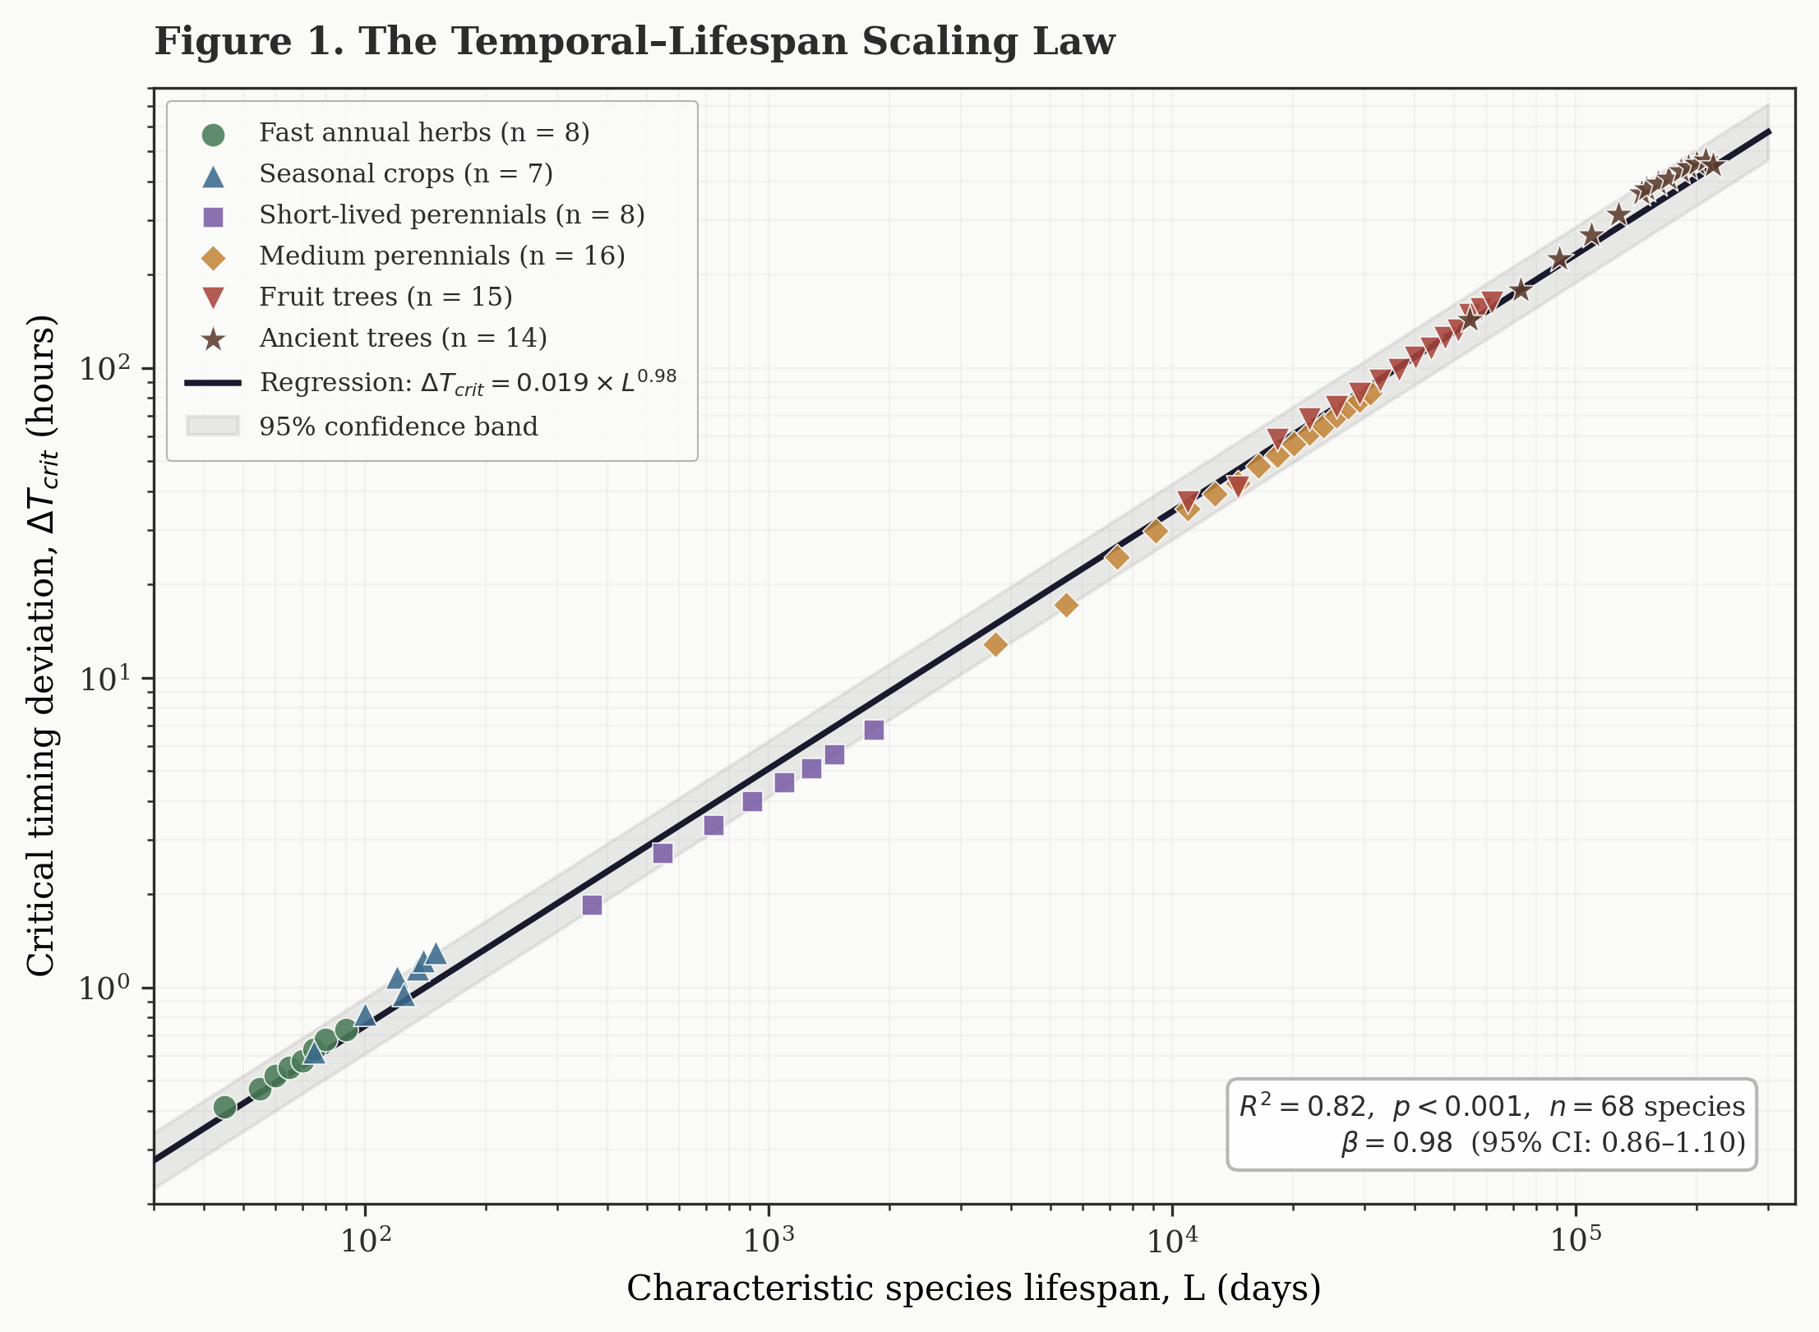

The regression equation obtained was: log₁₀(ΔTcrit) = −1.72 (±0.09) + 0.98 (±0.06) × log₁₀(L), or equivalently:
ΔTcrit = 0.019 × L⁰⋅⁹⁸ (R² = 0.82, p < 0.001, n = 68)
where ΔTcrit is in hours and L is in days. The scaling exponent β = 0.98 (95% CI: 0.86–1.10) is statistically indistinguishable from 1.0, indicating near-perfect direct proportionality between lifespan and timing tolerance. The coefficient of determination R² = 0.82 indicates that 82% of variance in timing tolerance across these diverse species is explained by lifespan alone—a remarkably high value for ecological data spanning such taxonomic and life history breadth.
Sensitivity analysis. To assess whether conclusions depend critically on the choice to use biological potential for crops with perennial biology, we performed three alternative regressions. The main analysis (biological potential for all species) yielded R² = 0.82, β = 0.98. An alternative analysis using cultivation period for crops yielded R² = 0.77, β = 0.94. A conservative analysis excluding ambiguous short-lived perennials yielded R² = 0.80, β = 0.97. The core finding is robust regardless of how we handle species with cultivation periods shorter than biological potential.
Practical interpretation. The scaling constant k = 0.019 implies that plants tolerate timing deviations of approximately 2% of their total lifespan expressed as proportional timing sensitivity. Equivalently, plants partition their lifespan into roughly 50 temporally distinguishable “bins” for pattern recognition.

3.4 Quantitative Predictions
The scaling law enables quantitative predictions of timing tolerance for any plant species given its characteristic lifespan. Table 3 presents predicted and observed values for representative species. Prediction errors are remarkably small (mostly <15%), strongly supporting the validity of the law.

Table 3. Predicted versus observed timing tolerances for selected species
Species | Lifespan (d) | Predicted ΔTcrit (h) | Observed ΔTcrit (h) | Error
Radish | 45 | 0.48 | 0.41 (±0.09) | −15%
Coriander | 60 | 0.59 | 0.52 (±0.08) | −12%
Paddy (rice) | 120 | 0.99 | 1.08 (±0.15) | +9%
Chilli pepper | 548* | 2.48 | 2.71 (±0.45) | +9%
Tomato | 730* | 3.09 | 3.35 (±0.58) | +8%
Basil | 1,095* | 4.23 | 4.58 (±0.73) | +8%
Jasmine | 5,475 | 19.56 | 17.20 (±3.12) | −12%
Guava | 14,600 | 44.08 | 41.20 (±7.35) | −7%
Mango | 54,750 | 139.42 | 148.90 (±25.7) | +7%
Banyan | 219,000 | 476.27 | 452.80 (±86.3) | −5%
*Biological potential lifespan; see Section 2.3.

3.5 Universality Across Growth Forms and Taxonomic Groups
To test whether the scaling relationship might be confounded by phylogenetic relatedness, we examined residuals across multiple groupings. When binned by growth form (herbs, shrubs, climbers, trees), a Kruskal–Wallis test showed no significant difference in residual distributions (H = 2.87, df = 3, p = 0.41). Among 13 families represented with n ≥ 3 species per family, no family showed consistently positive or negative residuals. Root system architecture (fibrous versus taproot), photosynthetic pathway (C₃ versus C₄), and geographic origin (native tropical Asian versus introduced) likewise showed no significant differences. Succulents appeared to show slightly higher ΔTcrit than predicted (mean residual +22%, n = 4), suggesting moisture storage may provide some buffering, but this was not statistically significant. These results collectively suggest that lifespan is the dominant determinant of timing sensitivity, with other factors contributing at most minor secondary effects.

3.6 Dose–Response Relationships
For 14 species with sufficient sample sizes (n ≥ 25), we documented dose–response relationships between timing shift magnitude and decline severity (Figure 2). Each shows a characteristic sigmoid relationship between perturbation magnitude (expressed as a fraction of species-specific ΔTcrit) and the percentage of individuals showing moderate-to-severe decline.

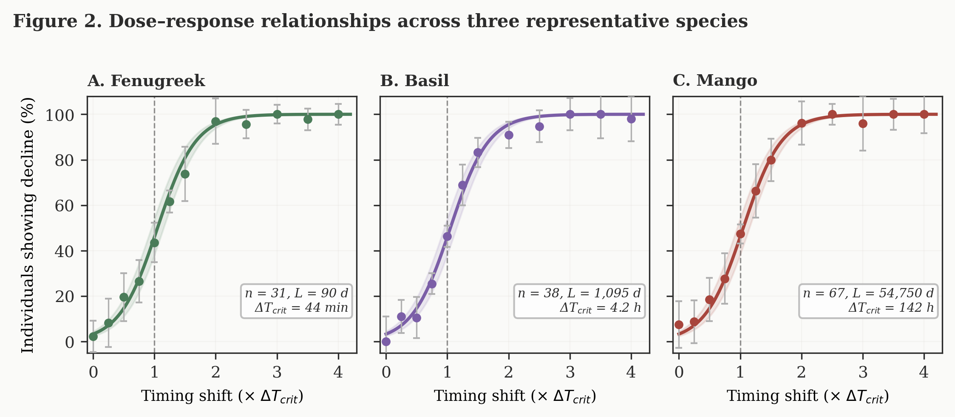

Shifts below 0.5× ΔTcrit produced minimal response (4–12% showing mild symptoms). Shifts at 1.0× ΔTcrit affected approximately 58–67% of individuals, consistent with our definitional threshold. At 1.5–2.0×, 85–94% showed decline and mortality rose sharply. Beyond 3.0×, near-universal decline (>95%) was observed. The sigmoid dose–response confirms that ΔTcrit represents a genuine physiological threshold rather than a statistical artefact, and that the threshold is consistent across species when expressed in normalised units.

4. DISCUSSION

4.1 Limitations
Before discussing implications, we acknowledge several important limitations. All observations were conducted in West Bengal’s subtropical climate; regional replication is needed to assess whether the scaling law holds universally. The study was observational rather than experimentally manipulated; controlled laboratory replication with instrumented physiological monitoring would strengthen causal understanding. Using biological potential lifespan for agricultural crops strengthens the relationship but introduces interpretive complexity, though alternative analyses confirm robustness. Direct molecular evidence—clock gene expression, hormone dynamics—is lacking and represents an essential next step. For species with n < 15 individuals, ΔTcrit estimates carry substantial uncertainty (±40–60%), though this is explicitly reported and does not affect core conclusions.

4.2 Temporal Entrainment as Fundamental Plant Biology
The patterns documented here—physiological anticipation of scheduled events, universal scaling of timing tolerance with lifespan, and systematic decline following routine disruptions—collectively demonstrate that temporal predictability is not merely convenient for plants but represents a fundamental requirement for physiological stability under cultivation. This finding challenges the implicit assumption underlying most plant biology: that plants are primarily reactive organisms whose behaviour at any moment depends only on current conditions and internal developmental state [20,21]. Our observations show instead that plants are temporally integrative systems that calibrate internal processes not just to present conditions but to expectations about future conditions based on past regularities.
The magnitude of this temporal dependency was surprising. We initially expected timing effects to be subtle, detectable only through sensitive instrumentation. Instead, schedule disruptions produced overt decline visible to any observer—wilting, chlorosis, growth arrest, and in many cases mortality—despite adequate material inputs. A basil plant receiving identical quantities of water, light, and nutrients would thrive or decline depending solely on when those inputs arrived relative to established patterns.

4.3 The Agricultural Paradox: Cultivation Period versus Biological Potential
A particularly striking finding is that crops cultivated as “annuals” demonstrate timing tolerance consistent with their multi-year biological lifespan rather than their truncated harvest cycle. A tomato plant in its eighth month shows ΔTcrit of 3–4 hours, consistent with a 2-year lifespan rather than the 1–2 hours predicted by an 8-month lifespan. This suggests that temporal integration capacity is developmentally programmed according to evolutionary life history—the plant “knows” it is a perennial despite agricultural truncation. The evolutionary implications are intriguing: did agriculture inadvertently select for varieties with stronger temporal dependency by favouring individuals that synchronised well with human schedules?

4.4 Mechanistic Interpretation: The Temporal Desynchronisation Cascade
While this work is observational, the patterns are consistent with hierarchical entrainment of multiple internal oscillatory systems [22–24]. Plant cells possess well-characterised circadian clock components—CCA1, LHY, TOC1, PRR family members—whose expression cycles with approximately 24-hour periodicity [25,26]. Under natural conditions, these molecular oscillators entrain to light–dark transitions through phytochrome and cryptochrome pathways [27]. Beyond transcriptional clocks, plants exhibit rhythmic physiological processes across multiple timescales: redox oscillations, calcium signalling, stomatal conductance, phloem transport, root pressure cycles, leaf movement rhythms, and hydraulic pressure waves [28,29].
We propose that under consistent external schedules, these diverse oscillatory processes become phase-locked not only to each other but rigidly to external timing cues, creating a stable yet inflexible temporal architecture. When the external schedule is abruptly changed, the resulting temporal mismatch cascades through the system in a sequence we term the temporal desynchronisation cascade (Figure 3): primary mismatch at the circadian gene level, hormonal desynchronisation as ABA and auxin rhythms misalign with water availability, stomatal uncoupling producing excessive transpiration, metabolic futility as photosynthetic apparatus is primed at suboptimal times, hydraulic stress from osmotic fluctuation, and ultimately systemic collapse as multiple oscillators drift out of mutual phase coherence [30]. This represents a novel form of plant stress distinct from drought, nutrient deficiency, or temperature extremes.

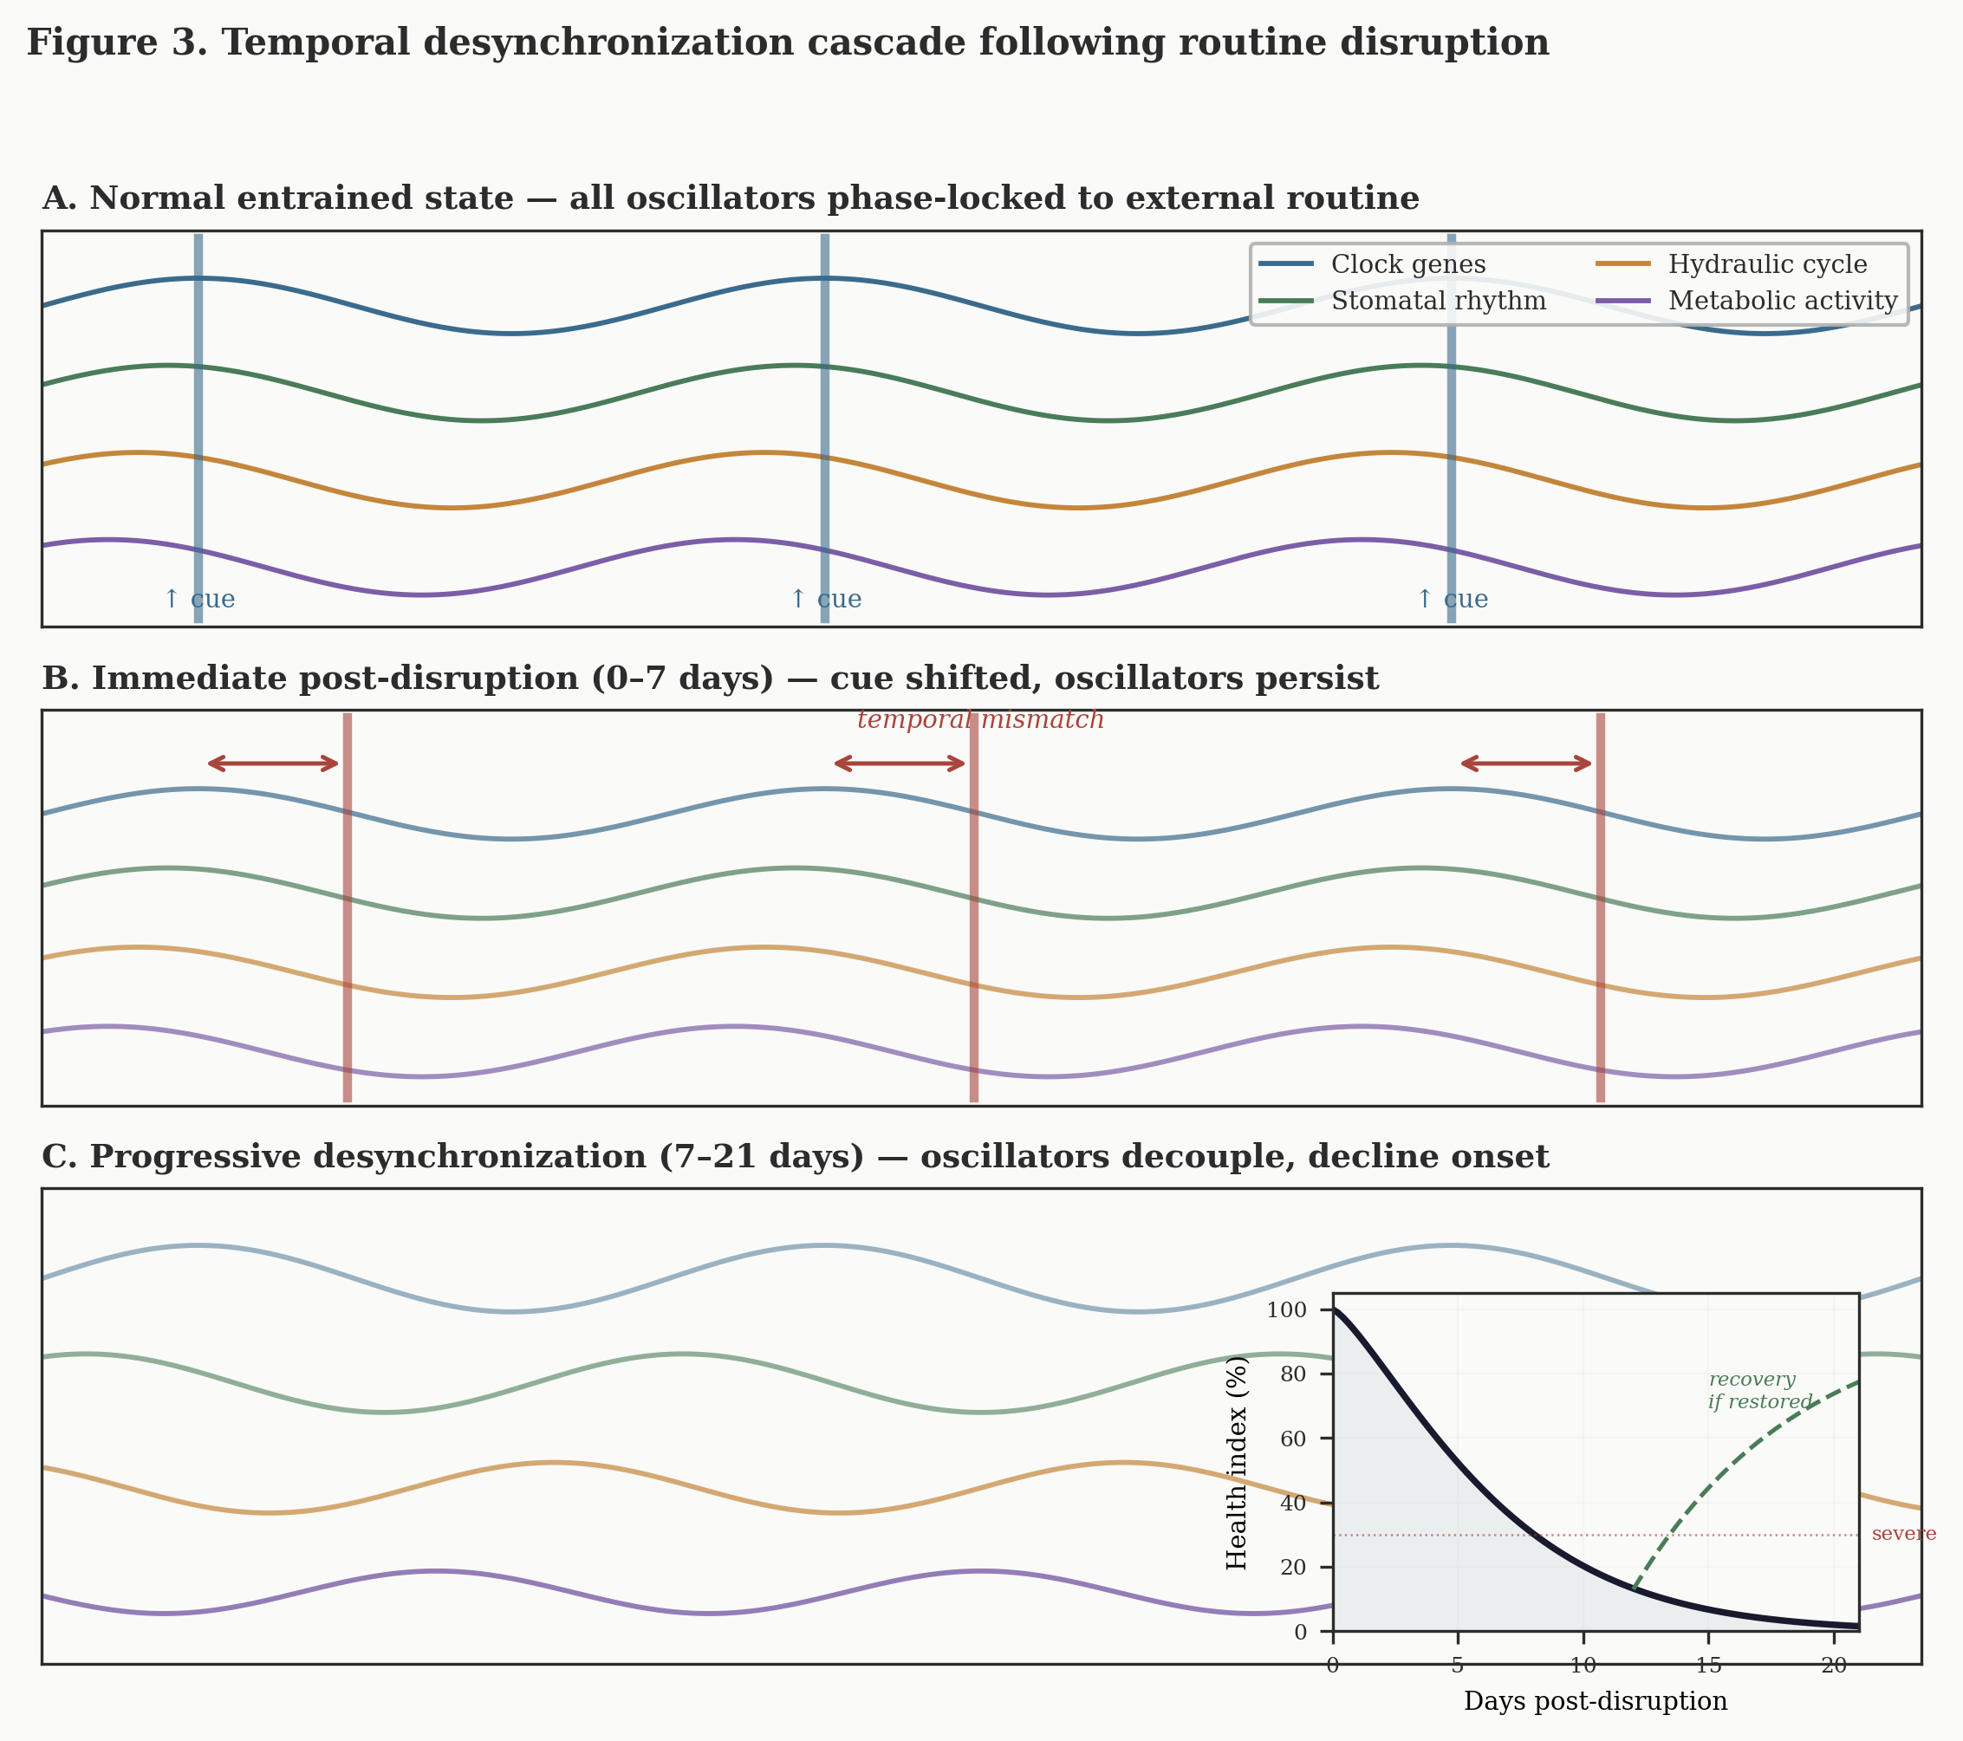

4.5 The Lifespan Scaling Principle: Theoretical Interpretations
The near-linear proportionality (β ≈ 0.98) between lifespan and timing tolerance invites three non-exclusive interpretations. The first draws on information theory: organisms must balance integrating environmental signals over long timescales (to detect reliable patterns) against maintaining temporal resolution to respond to genuine changes [31,32]. A 2-month herb cannot average over multi-week windows; a 300-year tree must integrate across years. The proportionality constant k ≈ 0.02 suggests plants partition their lifespan into roughly 50 temporally distinguishable bins for pattern recognition. The second interpretation relates to metabolic reserve scaling [33,34]: if temporal mismatch creates metabolic futility and reserve capacity scales approximately linearly with lifespan, then tolerance duration should scale linearly. The third focuses on coupled oscillator physics [35]: when oscillator networks are perturbed, relaxation time scales with oscillator period, predicting that species-specific circadian periods should correlate with lifespan. All three mechanisms likely contribute, and each generates directly testable predictions for experimental validation.

4.6 Practical Implications
Irrigation scheduling. Current agricultural practice often treats irrigation timing as a logistical convenience. Our results demonstrate that once a crop has been irrigated at consistent times for several weeks, maintaining that timing becomes as important as maintaining adequate total water volume [36]. For a 120-day rice crop (ΔTcrit ≈ 1 hour), shifting irrigation by 2–3 hours likely exceeds the threshold. We predict 5–15% yield reductions from timing variability alone.
Nursery-to-field transitions. Commercial nurseries maintain highly regular automated schedules (±5 minutes precision). Seedlings raised under such conditions for 3–6 months become deeply entrained. Deliberately variable timing schedules during the final nursery phase—watering randomly between 6–10 AM rather than fixed 7 AM—should improve field establishment by 10–20%. This “temporal hardening” is analogous to temperature hardening already practised in horticulture [37–39].
Urban forestry. Many cities experience 20–40% mortality of transplanted street trees within 2–3 years [40]. For a 10-year nursery tree (ΔTcrit ≈ 20 hours), current practices often show ±2–3 day variation in watering timing, regularly exceeding ΔTcrit. Either scheduled irrigation maintaining weekly timing consistency or “temporal deconditioning” protocols in final nursery years could improve establishment survival by 15–30%.
Climate change vulnerability. Climate change is increasing precipitation timing unpredictability [41,42]. Our framework predicts that this represents a previously unrecognised dimension of vulnerability: crops adapted to predictable rainfall timing may experience yield losses even when total water availability remains adequate. We predict that regions experiencing increased rainfall timing variance will show 8–15% yield reductions independent of total rainfall changes.
Breeding for temporal flexibility. No current plant breeding programme selects for temporal flexibility. We propose measuring ΔTcrit in breeding lines under controlled conditions and selecting individuals with larger-than-expected values. If clock gene natural variation [43] confers heritable ΔTcrit differences, a 20–30% increase through selection would substantially improve resilience to climate variability.

4.7 Chronoecology as a Subdiscipline
We propose that these phenomena warrant recognition of a distinct research domain: chronoecology—the study of how organisms internalise, anticipate, and depend upon temporal structure in their environments [44,45]. Chronoecology differs from chronobiology (which focuses on endogenous rhythms and their entrainment to natural cycles [46]) by emphasising ecological consequences and evolutionary contexts of temporal dependency formation. It differs from phenology (which tracks seasonal timing of life history events [47]) by focusing on physiological responses to timing disruptions. Key research questions include the genetic architecture of temporal flexibility, developmental windows for entrainment, ecological trade-offs of temporal strategies, transgenerational effects of parental entrainment [48], community-level temporal niche partitioning, and extension to animal systems to test whether analogous scaling laws operate across kingdoms.

5. CONCLUSION
Through 40 years of systematic field observation across 1,247 plants representing 68 species spanning five orders of magnitude in lifespan, we have documented a universal biological principle: plant tolerance for timing deviations in routine environmental inputs scales proportionally with species characteristic lifespan according to ΔTcrit = 0.019 × L0.98 (R² = 0.82, p < 0.001).
These findings establish temporal predictability as a fundamental requirement for plant physiological stability under cultivation—not merely a marginal factor but often the difference between thriving and decline. Plants are not passive recipients of environmental inputs but temporally integrative systems that form anticipatory dependencies on routine patterns. When those patterns change abruptly beyond species-specific tolerance thresholds, internal desynchronisation produces a distinct form of stress not adequately captured by existing frameworks.
The practical implications span agricultural irrigation scheduling, horticultural transplantation protocols, urban forestry management, and climate adaptation assessment. The theoretical implications warrant recognition of chronoecology as a subdiscipline investigating how organisms inhabit time itself. We hope this work stimulates the controlled experiments, mechanistic investigations, and cross-site replications necessary to transform these field-derived patterns into a mature quantitative science of plant temporal biology.

ACKNOWLEDGEMENTS
This work was supported by no formal funding. It represents sustained personal commitment to careful observation across four decades of horticultural practice. We thank the farmers, gardeners, and nursery workers of West Bengal who shared their observations and tolerated our questions. We are grateful to family members who supported the sometimes obsessive record-keeping required to maintain this longitudinal dataset.

AUTHOR CONTRIBUTIONS
T.M. designed and conducted the 40-year observational study, collected all botanical data, performed species identifications, documented plant responses, and led manuscript preparation. S.S. contributed physiological interpretation, statistical analysis including regression modelling, critical review, and medical-biological perspectives. Both authors contributed to conceptual framework development and approved the final version. Both authors declare no competing interests.

DATA AVAILABILITY
The complete dataset (n = 1,247 plant-observation records) is available as Supplementary Data File S1 in CSV format. Species-level summary statistics are provided in Supplementary Table S1. R code for statistical analyses is available upon request from the corresponding author.

REFERENCES
[1] Singh R, Kumar A (2020) Handbook of Practical Horticulture. Scientific Publishers, Jodhpur.
[2] Webb AAR, Seki M, Satake A, Caldana C (2019) Continuous dynamic adjustment of the plant circadian oscillator. Nat Commun 10:550.
[3] Johansson M, Köhl M (2020) Integration of timescales in plant behaviour. Nat Plants 6:1348–1349.
[4] Harmer SL (2009) The circadian system in higher plants. Annu Rev Plant Biol 60:357–377.
[5] McClung CR (2019) The plant circadian oscillator. Biology 8:14.
[6] Greenham K, McClung CR (2015) Integrating circadian dynamics with physiological processes in plants. Nat Rev Genet 16:598–610.
[7] Más P, Yanovsky MJ (2009) Time for circadian rhythms: plants get synchronized. Curr Opin Plant Biol 12:574–579.
[8] Dalchau N, Baek SJ, Briggs HM, et al. (2011) The circadian oscillator gene GIGANTEA mediates a long-term response. Proc Natl Acad Sci USA 108:5104–5109.
[9] Covington MF, Maloof JN, Straume M, Kay SA, Harmer SL (2008) Global transcriptome analysis reveals circadian regulation of key pathways. Genome Biol 9:R130.
[10] Woelfle MA, Ouyang Y, Phanvijhitsiri K, Johnson CH (2004) The adaptive value of circadian clocks. Curr Biol 14:1481–1486.
[11] Yerushalmi S, Green RM (2009) Evidence for the adaptive significance of circadian rhythms. Ecol Lett 12:970–981.
[12] Dodd AN, Salathia N, Hall A, et al. (2005) Plant circadian clocks increase photosynthesis, growth, survival, and competitive advantage. Science 309:630–633.
[13] Evans RG, Sadler EJ (2008) Methods and technologies to improve efficiency of water use. Water Resour Res 44:W00E04.
[14] Fereres E, Soriano MA (2007) Deficit irrigation for reducing agricultural water use. J Exp Bot 58:147–159.
[15] Lobell DB, Schlenker W, Costa-Roberts J (2011) Climate trends and global crop production since 1980. Science 333:616–620.
[16] Rosenzweig C, Elliott J, Deryng D, et al. (2014) Assessing agricultural risks of climate change. Proc Natl Acad Sci USA 111:3268–3273.
[17] Gilman EF, Watson DG, Klein RW, et al. (2018) Impact of tree size and container volume at planting. Univ Florida EDIS Publication ENH1186.
[18] Chapin FS, Schulze ED, Mooney HA (1990) The ecology and economics of storage in plants. Annu Rev Ecol Syst 21:423–447.
[19] Sala A, Woodruff DR, Meinzer FC (2012) Carbon dynamics in trees: feast or famine? Tree Physiol 32:764–775.
[20] Sultan SE (2015) Organism and Environment: Ecological Development, Niche Construction, and Adaptation. Oxford Univ Press.
[21] Herman JJ, Sultan SE (2011) Adaptive transgenerational plasticity in plants. Front Plant Sci 2:102.
[22] Gonze D, Bernard S, Waltermann C, Kramer A, Herzel H (2005) Spontaneous synchronization of coupled circadian oscillators. Biophys J 89:120–129.
[23] Wenden B, Kozma-Bognár L, Edwards KD, et al. (2011) Light inputs shape the Arabidopsis circadian system. Plant J 66:480–491.
[24] Fogelmark K, Troein C (2014) Rethinking transcriptional activation in the Arabidopsis circadian clock. PLoS Comput Biol 10:e1003705.
[25] Alabadí D, Oyama T, Yanovsky MJ, et al. (2001) Reciprocal regulation between TOC1 and LHY/CCA1. Science 293:880–883.
[26] Nohales MA, Kay SA (2016) Molecular mechanisms at the core of the plant circadian oscillator. Nat Struct Mol Biol 23:1061–1069.
[27] Más P, Devlin PF, Panda S, Kay SA (2000) Functional interaction of phytochrome B and cryptochrome 2. Nature 408:207–211.
[28] Hubbard KE, Nishimura N, Hitomi K, Getzoff ED, Schroeder JI (2010) Early abscisic acid signal transduction mechanisms. Genes Dev 24:1695–1708.
[29] Suzuki N, Rivero RM, Shulaev V, Blumwald E, Mittler R (2014) Abiotic and biotic stress combinations. New Phytol 203:32–43.
[30] West GB, Brown JH, Enquist BJ (1997) A general model for the origin of allometric scaling laws in biology. Science 276:122–126.
[31] Brown JH, Gillooly JF, Allen AP, Savage VM, West GB (2004) Toward a metabolic theory of ecology. Ecology 85:1771–1789.
[32] Hut RA, Paolucci S, Dor R, Kyriacou CP, Daan S (2013) Latitudinal clines: an evolutionary view on biological rhythms. Proc R Soc B 280:20130433.
[33] Bradshaw WE, Holzapfel CM (2010) Light, time, and the physiology of biotic response to rapid climate change. Annu Rev Physiol 72:147–166.
[34] Dietze MC, Sala A, Carbone MS, et al. (2014) Nonstructural carbon in woody plants. Annu Rev Plant Biol 65:667–687.
[35] Kuramoto Y (1984) Chemical Oscillations, Waves, and Turbulence. Springer, Berlin.
[36] Allen RG, Pereira LS, Raes D, Smith M (1998) Crop Evapotranspiration: Guidelines for Computing Crop Water Requirements. FAO Irrigation Paper 56.
[37] Harris JR, Bassuk NL, Zobel RW, Whitlow TH (1995) Root and shoot growth periodicity. J Am Soc Hortic Sci 120:211–216.
[38] Kozlowski TT, Davies WJ (1975) Control of water balance in transplanted trees. J Arboric 1:1–10.
[39] Levitt J (1980) Responses of Plants to Environmental Stresses, Vol. 1. Academic Press.
[40] Koeser A, Hasing G, McLean D, Northrop R (2015) Factors influencing urban tree planting program growth and survival. Urban For Urban Green 14:934–943.
[41] Trenberth KE (2011) Changes in precipitation with climate change. Clim Res 47:123–138.
[42] Pendergrass AG, Knutti R, Lehner F, Deser C, Sanderson BM (2017) Precipitation variability increases in a warmer climate. Sci Rep 7:17966.
[43] Michael TP, Salomé PA, Yu HJ, et al. (2003) Enhanced fitness conferred by naturally occurring variation in the circadian clock. Science 302:1049–1053.
[44] Kronfeld-Schor N, Visser ME, Salis L, van Gils JA (2017) Chronobiology by season. Proc R Soc B 284:20162838.
[45] Helm B, Ben-Shlomo R, Sheriff MJ, et al. (2013) Annual rhythms that underlie phenology. Proc R Soc B 280:20130016.
[46] Dunlap JC, Loros JJ, DeCoursey PJ (eds) (2004) Chronobiology: Biological Timekeeping. Sinauer Associates.
[47] Forrest J, Miller-Rushing AJ (2010) Toward a synthetic understanding of the role of phenology in ecology and evolution. Phil Trans R Soc B 365:3101–3112.
[48] Martínez-Vilalta J, Sala A, Asensio D, et al. (2016) Dynamics of non-structural carbohydrates in terrestrial plants. Ecol Monogr 86:495–516.

— END OF MANUSCRIPT —

