Battery Thermal Management System in Electric
Vehicles using Phase Change Material (PCM)
Sadhu Prasanth¹, Laveti Sivasai²,kanimeraka Lakshmana²,Karnapu Gowtham²,Nadiminti Chandraskhar²,Tatta Mohan²,Attada Hemanth Kumar²
¹Assistant professor, Department of Mechanical Engineering, Satya Institute of Technology and Management Vizianagaram Andhra Pradesh, India.
²UG students, Department of Mechanical Engineering, Satya Institute of Technology and Management Vizianagaram Andhra Pradesh, India

Abstract
With the advancement in technology, the world is moving fast and for its fast growth, the
automobile sector is also in the revolution period with the advancement in battery-driven vehicles. The Electric and Hybrid vehicles which run on the battery, face the main issue in thermal management. As there are so many electronic components inside the vehicle especially the battery, the heat dissipation is also more. Many of the researchers have proposed the Li-Ion cells as the most suitable for the battery packs in electric vehicles. And with many advantages of the Li-Ion cells, there is one major limitation of it as its heat dissipation rate. In order to get the best working performance of the battery electric vehicles, it’s equally important to keep its temperature in control. The various parameters
which directly influence the temperature rise of the PCM are mass of PCM, the thermal conductivity of the Paraffin material, water flow rate etc.
Keywords: Hybrid & electric vehicles, Li-Ion cells, Phase Change Materials (PCM),
Paraffin.
I. Introduction
In the 21st century, the world is facing critical health issues due to the increase in global warming. And it is believed that the poisonous exhaust gases being released by the IC engine driven motor vehicles are contributing a major role in global warming. To reduce that, scientists worldwide are emphasizing more on the advancement of battery-driven electric vehicles. Hybrid vehicles can be proved to be the game-changer to battle global warming. And therefore, the focus and efforts are more to increase its efficiency and control
its heat dissipation rate from the batteries and the other electronic parts of the vehicle. The electric vehicles are quite similar to the IC engine vehicle from the outer structure but the circuits inside the vehicle vary a lot. Unlike IC engines, the battery electric vehicles have batteries, inverter, motor and generator. And that’s why an electric vehicle is known by several names as Electric vehicle, Battery electric vehicle and hybrid electric vehicle. In a simple electric vehicle, the mode of drive mainly depends on the motor which is powered by the battery pack through an inverter.
Electric vehicles are classified into various categories as Plug-in electric vehicles and hybrid electric vehicles. Also according to the drive train, these are further categorized as
a series hybrid, parallel hybrid and combined hybrid(series and parallel). In pure electric vehicles, the IC engine is not employed but in hybrid electric vehicles, IC engines are also employed. Many researchers including Ravichandra Rangappa et al.[1] , Jiahao Cao et al. [2]etc proposed Lithium-Ion cells be used in the battery packs which has proved to be very effective in electric vehicles, Hybrid electric vehicles etc. in comparison with the other cells as of till date. But the main disadvantage of battery electric vehicles is the rate of heat removed from the large battery packs inside the vehicles. And to tackle this problem the battery thermal management system is being researched and employed inside the vehicles which are also called a battery cooling system.
This paper emphasized the modes and various types of battery thermal management system
for electric vehicles. In conventional vehicles, we generally employ air cooling or water cooling which was found to be effective for the conventional IC engine. But for the electric vehicles as referred by many researchers like Rasool Kalbasi et al. [3], Ravichandra Rangappa et al. [1], Lucia Ianniciello et al. [4] etc, proposed the use of Phase Change Material as the medium of coolant. And therefore, best efforts are made to understand the different boundary conditions, various types of PCMs and their characteristics and analyze them to come to a conclusion about the employability and effectiveness of the PCM to be used. Researchers like Ravichandra Rangappa et al. [1] highlighted that while employing phase change material cooling also there are various types of arrangements experimented, for example, Passive PCM cooling, Hybrid cooling and Pure PCM cooling. This means employing PCM material along with air cooling or water cooling, whichever suits best and
gives optimal results. Researchers like Hadi Bashir Pour-Bonab [4] talk about different types of PCM material and how they can be improved by enhancing their physical properties. Out of different types of PCM materials available in the market it is being experimented and came to the conclusion that the Paraffin PCM material is best suited to be employed inside the batteries. Also, by adding adequate additives to the PCM material, its properties can be improved and make it more effective and long-lasting. Lucia Ianniciello et al. [3] in their paper highlighted the importance of making PCM material encapsulated or in other words packaging of the PCM to make it chemically stable, non-toxic and make it resistive towards heat and electricity. Inside an electric vehicle, for the battery thermal management system, the circuit which involves different arrangements are battery pack, encapsulated PCM material, Copper tubes (for channel flow), liquid coolant, fins etc. The main aim of the paper is to identify the best arrangement for the circuit to work efficiently, to keep it less bulky and to reduce the overall size of the circuit.

II. Methodology:
The PCM were contained in different shaped packs, which needed to be simulated. The PCM used in this case is RT50. The Meshing is done using ICEM CFD software. The simulation was completed using the Ansys Fluent software.

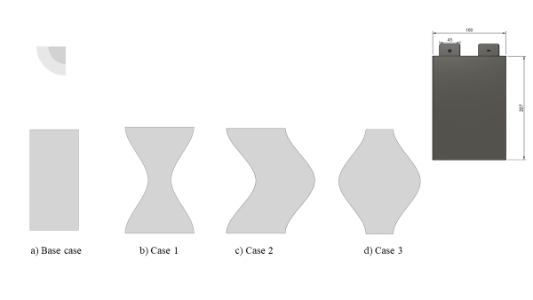
Figure:1 Geometry modelling of different shaped packs

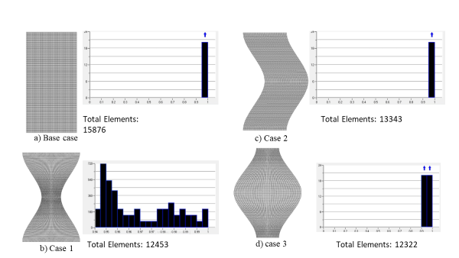
Figure:2 Meshing data of different shaped packs

III. Results and Observations
Effect of average PCM temperature in different encapsulations. Four different shapes of encapsulation were considered in this case study, the first one is the base case where it will be used to compare with the other 3 cases in the sequence. It is apparent that average temperature variation is plotted for 12 hours, and the temperature is shown for the period of 12 hours. The temperature is shown in the y axis and the time is shown in the x axis. The initial temperature of the PCM enclosure of all the cases at the start is 293 k. The change in temperature for the first three hours is 10.3 k. The enclosure of heat is in the y direction only. The temperature after 3 hours increased gradually for different cases. We have obtained the data of different temperatures for different cases. Case 3 showed the highest temperature at the eighth hour and remained constant for the next hours.
Figure:3 temperature curve for battery to discharge time

The different contours were obtained for the shapes or cases, the figures of the contours have been obtained at the end of the simulation. The contours are shown below. At the end of the simulations all the temperatures were compared with the base case temperatures obtained.

Figure:4 base case Battery temperature versus discharge time
Figure:5 case-1 Battery temperature versus discharge time

Figure:6 case-2 Battery temperature versus discharge time

Figure:7 case-3 Battery temperature versus discharge time

2. Melting Fraction:
Figure:8 temperature curve for battery and of PCM liquid fraction with respect to discharge time variations
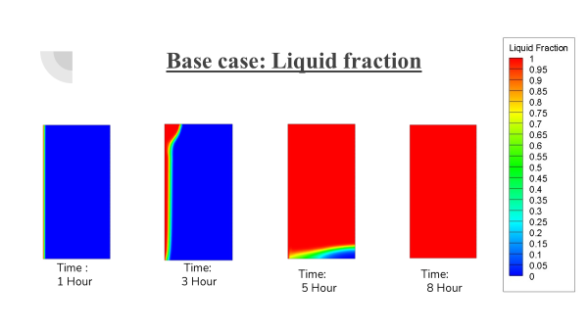
Figure:9 base case temperature curve for battery PCM liquid fraction with respect to discharge time
Figure:10 case-1 temperature curve for battery PCM liquid fraction with respect to discharge time

Figure:11 case-2 temperature curve for battery PCM liquid fraction with respect to discharge time

Figure:12 case-3 temperature curve for battery PCM liquid fraction with respect to discharge time

For the different cases the melting fraction also varied with time for the different cases, the PCM used for this simulation is RT50, the melting temperature starts from 300.15 k after one hour of observation the melting started to take place at different rates for different cases, as the area which is exposed for to the heat source is also different. The melting range is from 0 to 1. As shown in the graph, the melting fraction for the different cases are
shown. It is evident that case 3 took a longer time to melt, which is 11 hours to completely
convert into liquid. While the other cases took relatively less time to become liquid. As per
the liquid fraction, greater the time the PCM takes to melt, greater will be the heat holding
capacity of the PCM. where as in other cases, case 2 took less time to convert into liquid
at 8 hours. Each pack had different melting times.
All the melting of the PCM is observed in x direction as the heat incident on the y face.

IV. Conclusions:
Influence of the PCM on the battery thermal management was studied. As we all know, inside an electric vehicle, the system which generates the most amount of heat energy is the Battery. So in order to control and optimize the overall performance of the vehicle we
are employing various strategies and experiments on the design of the available battery cells in the market. So, in the paper, we have taken Lithium Ion battery pouch cells which
are widely used in electric cars. In the paper our major focus was on the encapsulation of the PCM pouch inside the battery packs. In order to achieve that, we have done the design and simulation of the software ANSYS Fluent. The viability of using PCM incorporated in electric vehicles to increase the performance of the battery by using CFD methodology and obtained results will be presented in terms of graphs, temperature contours etc. Results show that PCM integrated in different designs of pouches, the
battery had an average temperature of 304.4 – 306.2 K. The pouches were incorporated in between the batteries to maintain the optimum temperature. The analysis was done for 3 different designs of PCM pouch. It was found that case 3 encapsulation of the PCM offers better liquid fraction time of 11 hours, compared with that of the base case which showed the liquid fraction time of only 9 hours, where the battery can be maintained within the optimum temperature. The case1, case2, PCM encapsulation, showed similar results as that of the base case; they both offered a similar liquid fraction time of 8 hours. Hence, we can conclude that the PCM encapsulation in the case 3 has potential to reduce the temperature of the batteries, for better performance.

References:
[1] R. Rangappa and S. Rajoo, “Effect of thermo-physical properties of cooling mass on hybrid cooling for lithium-ion battery pack using design of experiments,” Int. J. Energy Environ. Eng., vol. 10, no. 1, pp. 67–83, 2019, doi: 10.1007/s40095-018- 0284-6.
[2] J. Cao, M. Luo, X. Fang, Z. Ling, and Z. Zhang, “Liquid cooling with phase change materials for cylindrical Li-ion batteries: An experimental and numerical study,” Energy, vol. 191, no. xxxx, p. 116565, 2020, doi: 10.1016/j.energy.2019.116565.
[3] H. Bashirpour-Bonab, “Thermal behavior of lithium batteries used in electric vehicles using phase change materials,” Int. J. Energy Res., no. December 2019, pp. 1–9, 2020, doi: 10.1002/er.5425.
[4] R. Rangappa, S. Rajoo, P. M. Samin, and S. Rajesha, “Compactness analysis of PCM-based cooling systems for Slithium battery-operated vehicles,” Int. J. Energy Environ. Eng., vol. 11, no. 2, pp. 247–264, 2020, doi: 10.1007/s40095-020-00339- z.
[5] L. Ianniciello, P. H. Biwolé, and P. Achard, “Electric vehicles batteries thermal management systems employing phase change materials,” J. Power Sources, vol. 378, no. December 2017, pp. 383–403, 2018, doi: 10.1016/j.jpowsour.2017.12.071.
[6] P. Goli, S. Legedza, A. Dhar, R. Salgado, J. Renteria, and A. A. Balandin, “Graphene-enhanced hybrid phase change materials for thermal management of Li-ion batteries,” J. Power Sources, vol. 248, pp. 37–43, 2014, doi: 10.1016/j.jpowsour.2013.08.135.
[7] S. K. Mohammadian and Y. Zhang, “Cumulative effects of using pin fin heat sink and porous metal foam on thermal management of lithium-ion batteries,” Appl. Therm. Eng., vol. 118, pp. 375–384, 2017, doi: 10.1016/j.applthermaleng.2017.02.121.
[8] L. H. Saw, Y. Ye, M. C. Yew, W. T. Chong, M. K. Yew, and T. C. Ng, “Computational fluid dynamics simulation on open cell aluminium foams for Li-ion battery cooling system,” Appl. Energy, vol. 204, pp. 1489–1499, 2017, doi: 10.1016/j.apenergy.2017.04.022.
[9] Y. Huo, Z. Rao, X. Liu, and J. Zhao, “Investigation of power battery thermal management by using mini-channel cold plate,” Energy Convers. Manag., vol. 89, pp. 387–395, 2015, doi: 10.1016/j.enconman.2014.10.015.
[10] M. Al-Zareer, I. Dincer, and M. A. Rosen, “Heat transfer modeling of a novel battery thermal management system,” Numer. Heat Transf. Part A Appl., vol. 73, no. 5, pp. 277–290, 2018, doi: 10.1080/10407782.2018.1439237.
[11] R. Kalbasi and M. R. Salimpour, “Constructal design of phase change material enclosures used for cooling electronic devices,” Appl. Therm. Eng., vol. 84, pp. 339–349, 2015, doi: 10.1016/j.applthermaleng.2015.03.031.
[12] S. Yang, C. Ling, Y. Fan, Y. Yang, X. Tan, and H. Dong, “A review of lithium-ion battery thermal management system strategies and the evaluate criteria,” Int. J. Electrochem. Sci., vol. 14, no. 7, pp. 6077–6107, 2019, doi: 10.20964/2019.07.06.
[13] C. Zhang et al., “A Li-ion battery thermal management system combining a heat pipe and thermoelectric cooler,” Energies, vol. 13, no. 4, 2020, doi: 10.3390/en13040841.
[14] Y. Gan, L. He, J. Liang, M. Tan, T. Xiong, and Y. Li, “A numerical study on the performance of a thermal management system for a battery pack with cylindrical cells based on heat pipes,” Appl. Therm. Eng., vol. 179, p. 115740, 2020, doi: 10.1016/j.applthermaleng.2020.115740.
[15] T. Grandjean, A. Barai, E. Hosseinzadeh, Y. Guo, A. McGordon, and J. Marco, “Large format lithium ion pouch cell full thermal characterisation for improved electric vehicle thermal management,” J. Power Sources, vol. 359, pp. 215–225, 2017, doi: 10.1016/j.jpowsour.2017.05.016.
[16] V. G. Choudhari, D. A. S. Dhoble, and T. M. Sathe, “A review on effect of heat generation and various thermal management systems for lithium ion battery used for electric vehicle,” J. Energy Storage, vol. 32, no. March, p. 101729, 2020, doi: 10.1016/j.est.2020.101729.
[17] Y. Ye, Y. Shi, N. Cai, J. Lee, and X. He, “Electro-thermal modeling and experimental validation for lithium ion battery,” J. Power Sources, vol. 199, pp. 227–238, 2012, doi: 10.1016/j.jpowsour.2011.10.027.
[18] W. Li, X. Zhuang, and X. Xu, “Numerical study of a novel battery thermal management system for a prismatic Li-ion battery module,” Energy Procedia, vol. 158, pp. 4441–4446, 2019, doi: 10.1016/j.egypro.2019.01.771.
[19] R. Kandasamy, X. Q. Wang, and A. S. Mujumdar, “Transient cooling of electronics using phase change material (PCM)-based heat sinks,” Appl. Therm. Eng., vol. 28, no. 8–9, pp. 1047–1057, 2008, doi: 10.1016/j.applthermaleng.2007.06.010.
[20] D. Chen, J. Jiang, G. H. Kim, C. Yang, and A. Pesaran, “Comparison of different cooling methods for lithium ion battery cells,” Appl. Therm. Eng., vol. 94, pp. 846– 854, 2016, doi: 10.1016/j.applthermaleng.2015.10.015.
[21] N. Putra, B. Ariantara, and R. A. Pamungkas, “Experimental investigation on performance of lithium-ion battery thermal management system using flat plate loop heat pipe for electric vehicle application,” Appl. Therm. Eng., vol. 99, pp. 784–789, 2016, doi: 10.1016/j.applthermaleng.2016.01.123.
[22] W. E. Technology, “Space for picture,” 2011.
[23] N. Ukrainczyk, S. Kurajica, and J. Šipušić, “Thermophysical comparison of five commercial paraffin waxes as latent heat storage materials,” Chem. Biochem. Eng. Q., vol. 24, no. 2, pp. 129–137, 2010.
[24] H. Behi et al., “A new concept of thermal management system in Li-ion battery using air cooling and heat pipe for electric vehicles,” Appl. Therm. Eng., vol. 174, no. April, p. 115280, 2020, doi: 10.1016/j.applthermaleng.2020.115280.
[25] V. Joshi and M. K. Rathod, “Experimental and numerical assessments of thermal transport in fins and metal foam infused latent heat thermal energy storage systems: A comparative evaluation,” Appl. Therm. Eng., vol. 178, no. June, p. 115518, 2020, doi: 10.1016/j.applthermaleng.2020.115518.
[26] J. A. Taylor, “(12) United States Patent,” vol. 2, no. 12, 2017.
[27] M. S. Wu, K. H. Liu, Y. Y. Wang, and C. C. Wan, “Heat dissipation design for lithium-ion batteries,” J. Power Sources, vol. 109, no. 1, pp. 160–166, 2002, doi: 10.1016/S0378-7753(02)00048-4.
[28] H. Liu, Z. Wei, W. He, and J. Zhao, “Thermal issues about Li-ion batteries and recent progress in battery thermal management systems: A review,” Energy Convers. Manag., vol. 150, no. August, pp. 304–330, 2017, doi: 10.1016/j.enconman.2017.08.016.
[29] W. Wu, X. Yang, G. Zhang, K. Chen, and S. Wang, “Experimental investigation on the thermal performance of heat pipe-assisted phase change material based battery thermal management system,” Energy Convers. Manag., vol. 138, pp. 486–492, 2017, doi: 10.1016/j.enconman.2017.02.022.
[30] Z. Ling et al., “Review on thermal management systems using phase change

