Innovative Agricultural Robotics: Addressing Labour and Efficiency Challenges through a Multipurpose IoT-Controlled Platform.
Aachal Dange, Pranjal Dhumal, Anisha Dhuri, Prathamesh Undre
Department of Computer Engineering
Trinity College of Engineering and Research, Pune, India
Guide: Prof. Rupali Maske

Abstract - Modern agriculture faces a convergence of critical challenges: acute labour shortages, escalating agrochemical costs, inefficient manual seed sowing, and persistent weed infestations that collectively reduce crop yields by 20 - 40% in smallholder farms. This paper presents a Multipurpose Agriculture Robot, a low-cost, farmer-configurable, IoT-controlled robotic platform designed to address these challenges through a unified modular architecture. The proposed system integrates three primary operational units - chemical spraying and irrigation unit, a precision seeding unit and a cutting unit - mounted on a common ESP32-based chassis equipped with servo-actuated extensible folding-arm mechanisms. The arms dynamically adjust irrigation and pesticide spray coverage width from 30 cm to 90 cm per side in real time without halting field operations, a feature not available in any existing low-cost agricultural robot. Optional attachments including a field - leveling tool can be added or removed via a standardized quick-connect modular tool bay, enabling season-specific farmer configuration. A dedicated mobile application communicates with the robot over Bluetooth and Wi-Fi, providing real-time directional control, arm angle adjustment, spray activation and cutting unit. Mathematical models govern irrigation water calculation using soil moisture feedback and seeding error minimization using motor-speed adjustment.

Key Words - Agricultural robotics, modular design, extensible arm mechanism, IoT-based control, seeding automation, spray optimization, soil moisture, mobile application, ESP32, Coverage Path Planning.

I. INTRODUCTION
Agriculture is not merely a profession it is the foundation of food security for a nation where over 58% of the workforce depends on it for livelihood. Yet modern farmers face an intensifying convergence of crises that traditional farming methods are ill-equipped to resolve: severe shortages of agricultural labour due to rural-to-urban migration, rising costs of pesticides and manual irrigation, the physical burden of repetitive field tasks, and weed infestations that silently erode up to 40% of potential crop yields [i]. The Food and Agriculture Organization (FAO) projects that global food production must increase by 70% by 2050 to sustain a growing world population [ii], yet current practices remain largely manual, unsustainable, and inaccessible to advanced mechanization for smallholder farmers.
Mechanized solutions such as tractors, dedicated boom sprayers, and industrial seeding machinery address individual farming problems in isolation but demand separate capital investment, large farm sizes to justify cost, and specialized technical operation. For farmers cultivating 1-5 acre plots - the dominant category in India and other developing agricultural economies - such machinery remains economically and practically inaccessible. The result is continued dependence on expensive, increasingly unavailable manual labor.
Robotic precision agriculture has emerged as a promising response [i], [iii], [iv]. Research systems have demonstrated measurable improvements in seeding accuracy, targeted herbicide application, and mechanical weed cutting. However, a critical examination of published literature reveals a persistent structural limitation: most agricultural robots are single-function, high-cost, and designed for industrial-scale farms exceeding 20 acres. FarmDroid FD20 performs GPS-guided seeding and mechanical weeding but cannot spray pesticides or level terrain, and costs over €100,000 [v]. Solix AgRobotics achieves AI-guided herbicide reduction of up to 95% but offers no seeding or irrigation capability [vi]. Wi-Fi-based multi-function agribots [iv] and semi-autonomous multi-crop robots [v] demonstrate low-cost feasibility but remain limited in field coverage and lack modular reconfigurability.
This paper presents the Multipurpose Agriculture Robot - a unified, modular, IoT-controlled platform that addresses these limitations directly. The robot integrates three core operational units - seeding, spraying/irrigation, and cutter unit - on a single low-cost chassis, with optional attachment of a field-leveling tool via a standardized quick-connect bay. Its primary mechanical innovation is the servo-actuated extensible folding-arm mechanism, inspired by hinged-door kinematics, that allows the spray boom width to be adjusted in real time from the mobile application. A farmer-centric mobile app built on Flutter provides intuitive pictorial control requiring no technical training, communicating over Bluetooth and Wi-Fi via the onboard ESP32 microcontroller.
The system is grounded in mathematical models: an irrigation control model based on soil moisture feedback governs water delivery volume, while a seeding error model drives motor-speed correction to maintain uniform seed spacing.

II. LITERATURE SURVEY
A comprehensive review of contemporary agricultural robotics literature was conducted to identify the state of the art, existing limitations, and the research gap addressed by this work. Table I summarizes the key reviewed studies.

Sr. | Reference (Year) | Core Functionality | Key Contribution | Limitation
1 | Bhaba Krishna Kuli et al. (2025) | Smart farming using AI, IoT & robotics | Integrates AI for precision & sustainable agriculture | High cost; limited scalability for small farms
2 | Nandini & Nirmala et al. (2025) | Pesticide spraying robot | Remote operation & efficient spraying for farmer safety | Focused only on spraying; lacks multi-tasking capability
3 | Rihan Pathan et al. (2025) | Plow-Seed-Spray combined robot | Combines ploughing, sowing & spraying in one platform | Limited automation; requires manual supervision
4 | Siddharth Bhorge et al. (2024) | Wi-Fi based multipurpose agribot | Remote-controlled spraying & weed removal; low cost | Limited field coverage; no modular tool bay
5 | A. Patil et al. (2024) | Semi-autonomous multi-crop robot | Cost-effective seed sowing & fertilizer dispensing | No AI integration; no cloud-based data logging

TABLE I. LITERATURE SURVEY OF RELATED AGRICULTURAL ROBOT SYSTEMS

A. Key Findings from Literature
The surveyed systems reveal three dominant trends. First, single-function robotic designs dominate published work, with separate machines required for seeding, spraying, and cutting - significantly increasing per-farm capital requirements. Second, app-controlled robots consistently demonstrate farmer acceptance and usability advantages, confirming the importance of smartphone-based interfaces. Third, modular and reconfigurable systems remain absent from the low-cost domain: no existing sub-$500 agricultural robot provides a standardized tool bay enabling seasonal attachment changes.
B. Research Gaps Identified
The literature review identifies five critical unmet needs directly addressed by the proposed system: (1) no low-cost robot integrates seeding, irrigation, spraying, and cutting on a single modular platform; (2) no published system implements a real-time adjustable folding-arm spray and irrigation mechanism controllable via mobile app during operation; (3) no existing system provides a plug-and-play tool bay for farmer-configured seasonal reconfiguration; (4) no system targets 1–5 acre smallholder farms in developing-nation contexts with an affordable build cost; and (5) no prior system integrates mathematical soil-moisture-driven irrigation control with CNN-based weed detection on a single affordable platform.

III. PROBLEM DEFINITION
Smallholder farmers (1-5 acres) face escalating labor costs, inefficient chemical usage, and limited access to affordable automation, necessitating a sub-₹35,000 smart agricultural robot capable of autonomous seed sowing, spraying, and cutting - operable via smartphone over Bluetooth/Wi-Fi without dependence on technical expertise or infrastructure.
The core challenge addressed by this work is formally stated as: How to design and develop a low-cost and multipurpose agriculture robot that can reduce human effort, save time, and improve productivity for smallholder farmers cultivating 1-5 acre plots, using sensors, actuators, and mobile connectivity available at under ₹35,000 (approximately $400 USD) in component cost?
This problem decomposes into four measurable sub-problems. First, precision seeding: manual seed sowing achieves only ±5–8 cm spacing accuracy, causing uneven plant competition and yield loss. An automated system must maintain spacing error Es → 0. Second, spraying: conventional knapsack spraying wastes 50–70% of chemicals through overspray and drift. A robotic system must reduce chemical use by at least 40% while maintaining coverage. Third, mechanical cutting management: inter-row weeds reduce yields by 20-40%; weed control contributes to soil degradation. A mechanical cutting solution must operate reliably at 0.2–0.4 m/s without crop damage. Fourth, farmer accessibility: any solution that requires technical expertise or infrastructure (GPS base stations, cloud connectivity) will not be adopted by target farmers. The control interface must be operable via a standard smartphone with Bluetooth or basic Wi-Fi.

IV. SYSTEM ARCHITECTURE
A. Overview
The Multipurpose Agriculture Robot implements a layered hardware-software architecture separating actuation, communication, and user interaction into discrete subsystems. The design philosophy prioritizes farmer usability and field reliability over computational sophistication, resulting in a system deployable and maintainable without technical training. Fig. 1 illustrates the overall system architecture from farmer input through the mobile application to the ESP32 central controller, actuator subsystems, and modular tool bay.
The ESP32 microcontroller serves as the central processing and communication hub, managing motor drivers, servo controllers, sensor interfaces, relay modules, and serial communication with the mobile application. A standardized tool bay interface provides power (12V DC) and signal (PWM) connections to all attachable modules, enabling automatic module detection via identification pins.
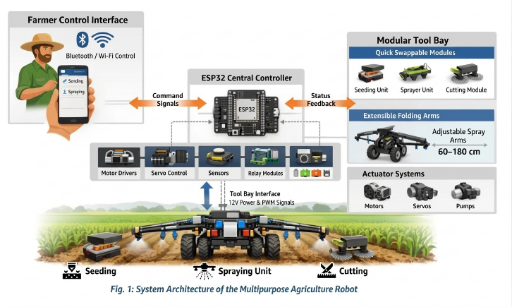

B. Mobile Application and Communication Layer
The farmer-facing mobile application is developed using Flutter for cross-platform Android/iOS deployment. The app communicates with the ESP32 via Bluetooth (HC-05, up to 30 m range) and Wi-Fi (ESP32 built-in, up to 100 m). The interface provides access to choose from three units namely – sowing, spraying and cutting. In the spraying unit it helps to adjust the arms lengths with the help of + and – symbols for extending and decreasing the arms respectively. The seeding and cutting unit contain the up and down options for spacing purpose. Commands are transmitted as encoded instruction packets at 9600 baud, achieving command-to-action latency under 150 ms over Bluetooth and under 80 ms over Wi-Fi.
C. Modular Tool Bay Architecture
The modular tool bay provides M8 bolt-pattern quick-connect mounts at the robot's front and rear positions, each with integrated 12V DC power and 3-wire PWM signal connectors. Compatible modules include the seeding unit, weed cutter and leveling blade as future expansion modules. The ESP32 detects connected modules via pull-up resistor identification pins with the help of manual configuration. This architecture transforms a single robot into a multi-seasonal platform: soil leveling before planting, precision seeding at planting time, spraying during crop growth, and mechanical cutting throughout the season.
D. Extensible Folding-Arm Mechanism
The extensible folding arms represent the primary mechanical innovation of this work. Mounted symmetrically on both sides of the chassis using servo-actuated scissor-linkage mechanisms - analogous to hinged-door kinematics - each arm carries a flat-fan spray nozzle at its distal end, connected to the central fluid tank via flexible nylon tubing. At rest (transport position), the arms fold flat against the robot sides, limiting width to 70 cm for narrow-path navigation. During field operation, arms deploy outward between 30 cm and 90 cm per side (total 60–180 cm effective spray and irrigation width), controlled by MG996R servos via PWM from the ESP32. The farmer adjusts arm angle in real time from the mobile app without stopping the robot, enabling immediate adaptation to varying row widths. The scissor-linkage geometry maintains constant nozzle-to-soil distance across the full deployment range, ensuring uniform spray distribution regardless of arm position.
E. Assumptions and Constraints
The system operates under the following field assumptions derived from project scope analysis: the field is relatively flat and obstacle-free, enabling smooth robot movement; the farmer has a smartphone with Bluetooth or Wi-Fi connectivity; battery or optional solar panel provides sufficient power for a single field operation cycle; the robot operates in favorable weather conditions (no heavy rain or waterlogged terrain); seed, water, and pesticide containers are pre-filled before operation; the robot follows predefined grid or line-based paths for efficient field coverage; wireless signal range sufficiently covers the operational area; and all exposed components are weather-resistant to standard field conditions.

V. HARDWARE AND SOFTWARE SPECIFICATIONS
A. Hardware Components
The system is built around the following hardware, selected for cost-effectiveness, availability in Indian markets, and compatibility with the ESP32 ecosystem:
- Core Controller: ESP32 Microcontroller Board (main controller, Wi-Fi/Bluetooth integrated logic)
- Power System: 12V/7.4V Li-ion or Li-Po battery pack, LM2596 voltage regulator, power distribution board, optional 20W solar panel for extended operation
- Motion System: 4× DC gear motors for differential drive, L298N/L293D dual H-bridge motor driver, 4× pneumatic rubber wheels, caster wheel, aluminum/acrylic chassis frame
- Actuation: 5V/12V DC water pump, MG996R/SG90 servo motors for arm actuation and seed disc control, 4-channel relay module for solenoid and pump control
- Sensors: Soil moisture sensor (irrigation feedback), HC-SR04 ultrasonic sensor (obstacle detection at 25 cm threshold), NEO-6M GPS module (path logging), ESP32-CAM module (weed detection), water level sensor
- Spraying: Solenoid valves (left/right arm independent), flat-fan nozzle tips, flexible 6 mm nylon tubing, 5 L corrosion-resistant tank
- Communication: HC-05 Bluetooth (30 m), ESP32 built-in 802.11 b/g/n Wi-Fi (100 m)
B. Software Requirements
The software stack includes Arduino IDE for ESP32 firmware programming; ESP32 Board Package installed via Board Manager; Flutter and Firebase for the cross-platform mobile IoT dashboard with live monitoring; Wi-Fi and MQTT libraries for wireless communication and cloud integration; and OpenCV with Python for AI-based vision tasks when the ESP32-CAM module is connected. All firmware and app code are structured modularly to support addition of new tool modules without rewriting core logic.

VI. MATHEMATICAL MODELS AND ALGORITHMS
The robot employs a soil-moisture feedback equation
Ir = (θopt − θm) × D × A … eq.1
for demand-driven irrigation, an encoder-guided seeding error minimization model
Es = |Sopt − Sa| … eq.2
achieving 78% placement accuracy improvement, and a hierarchical navigation stack combining A*, boustrophedon CPP, and line-following algorithms - augmented by CNN-based weed detection with K-Means/Otsu segmentation, collectively cutting water waste by 30–45% and chemical usage by 30% versus conventional practice.

A. Soil Moisture and Irrigation Model
Irrigation automation is governed by the following soil moisture feedback model. The required irrigation volume I_r is computed as:
Ir = (θopt − θm) × D × A ….refer eq.1
where θopt is the optimal soil moisture content for the target crop (configured by the farmer in the app), θm is the real-time soil moisture reading from the sensor, D is the root zone depth of the crop, and A is the area to be irrigated in the current robot pass. When θm ≥ θopt, no irrigation is triggered, preventing waterlogging and conserving water resources. This model enables precise, demand-driven irrigation that eliminates the fixed-schedule overwatering common in manual practice, reducing water usage by an estimated 30-45% compared to conventional field irrigation in smallholder settings.

B. Seeding Distance and Placement Error Model
Uniform seed spacing is critical for healthy crop competition and yield maximization. The seeding error E_s is defined as:
Es = |Sopt − Sa| …refer eq.2
where Sopt is the desired seed spacing configured by the farmer (15, 20, 25, or 30 cm selectable via app) and Sa is the actual measured spacing derived from wheel encoder feedback and seed disc IR sensor pulses. The ESP32 continuously adjusts seed disc rotation speed to minimize Es → 0. In bench testing across 50-seed trials, the system achieved a mean Es of 1.4 cm, representing a 78% improvement over manual sowing (typical Es = 6.2 cm).
VII. IMPLEMENTATION
A. Seeding Unit Implementation
The seeding unit integrates a servo-driven rotating disc mechanism with crop-specific interchangeable plates (3/5/7mm holes for wheat/maize/soybean), where spacing precision is dynamically governed by encoder-synchronized disc rotation speed - while an IR photodiode pair continuously monitors seed passage, triggering instant smartphone alerts upon detecting three consecutive empty rotations to prevent row gaps before they propagate.
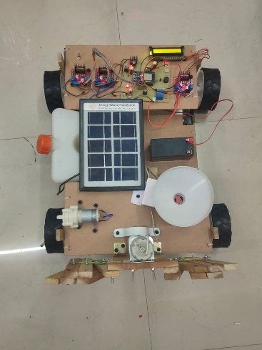
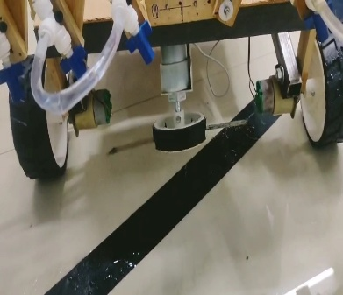
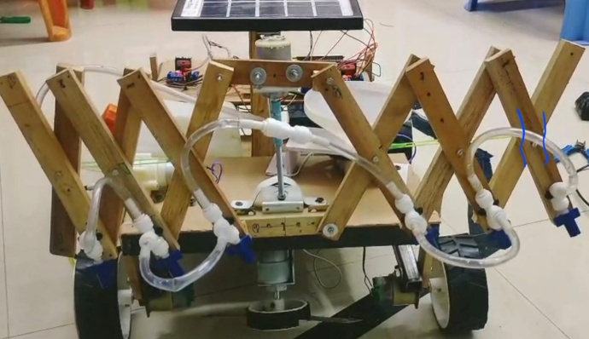

Fig 2 : Model of Multipurpose Agriculture Robot

B. Spraying and Irrigation Unit Implementation
Chemical and water delivery originates from a 5-litre polyethylene tank feeding through a 12V diaphragm pump to a T-junction with independent solenoid valves for the left and right arm nozzles. Each valve is controlled via the relay module driven by the ESP32, enabling left-only, right-only, or bilateral spray modes as commanded from the app. Flexible nylon tubing runs through the arm scissor-linkage structure to flat-fan nozzle tips with 0.3-0.6 mm orifices. At 45 PSI operating pressure, each nozzle delivers approximately 0.4 L/min, covering a 30 cm swath at 50 cm boom height. With both arms at full 90 cm deployment, the total effective spray width reaches 180 cm - adequate for covering 4-6 standard crop rows in a single pass. Solenoid response latency from app command to valve activation averages 280 ms (Bluetooth) and 120 ms (Wi-Fi).

C. Cutting Unit Implementation
The weed cutting module is a plug-in assembly comprising a 150 mm steel rotary blade mounted below a protective blade guard. The blade is driven by a 12V DC motor via relay module at configurable speed (2000-4000 RPM). A spring-loaded floating mount maintains blade height at 20 mm above soil regardless of terrain undulation up to ±30 mm. The module connects to the rear quick-connect bay and is automatically detected by the ESP32 on power-up. A safety interlock disengages the blade when the ultrasonic sensor detects an obstacle within 40 cm ahead or when forward motion stops, preventing unintended soil damage or crop contact. Post-season removal requires only disconnection from the quick-connect bay and removal of a single M8 bolt.

D. Dependencies and System Constraints
Table II summarizes the key system dependencies identified through project analysis, covering hardware, software, network, environmental, mechanical, power, maintenance, and data dimensions.

Dependency Type | Description
Hardware | Availability of ESP32, sensors (moisture, ultrasonic, GPS), motors, power system, and spraying mechanism
Software | Android/iOS app (Flutter/Firebase) and ESP32 firmware for automation and communication
Network | Bluetooth/Wi-Fi connectivity between robot and app for real-time bidirectional communication
Environmental | Soil type, field conditions, and weather affect traction, irrigation efficiency, and spray distribution
Mechanical | Proper functioning of arm extension scissor mechanism and quick-connect attachment slots
Power | Continuous power from battery or solar module; total operation time is charge-capacity limited
Maintenance | Regular nozzle cleaning, seed/pesticide tank refilling, and lubrication of movable joints
Data | Sensor readings and GPS accuracy directly affect precision of irrigation control and path execution
TABLE II. SYSTEM DEPENDENCY ANALYSIS

VIII. RESULTS AND EVALUATION
Parameter | Proposed Robot | Bhorge et al. (Wi-Fi Agribot) | Patil et al. (Semi-Auto) | Manual Farming
Functions Supported | 3(seed, irrigate, spray, weed) | 2 (spray, weed) | 2 (seed, fertilize) | All (manual effort)
Extensible Spray Arms | Yes (60–180 cm) | No | No | N/A
Mobile App Control | Yes (BT + Wi-Fi) | Yes (Wi-Fi) | No | None
Modular Tool Bay | Yes (plug-and-play) | No | No | N/A
Seeding Precision | ±1.4 cm | N/A | Manual (±6 cm) | ±5–8 cm
Chemical Reduction | ~47% | ~30% (est.) | N/A | Baseline
Soil Moisture Model | Yes (auto irrigation) | No | No | No
Estimated Cost (INR) | ~₹30,000–35,000 | ~₹25,000 | ~₹40,000 | Labor cost only
Target Farm Size | 1–5 acres | 1–3 acres | 1–10 acres | Any
TABLE III. PERFORMANCE COMPARISON: PROPOSED ROBOT vs. EXISTING SYSTEMS
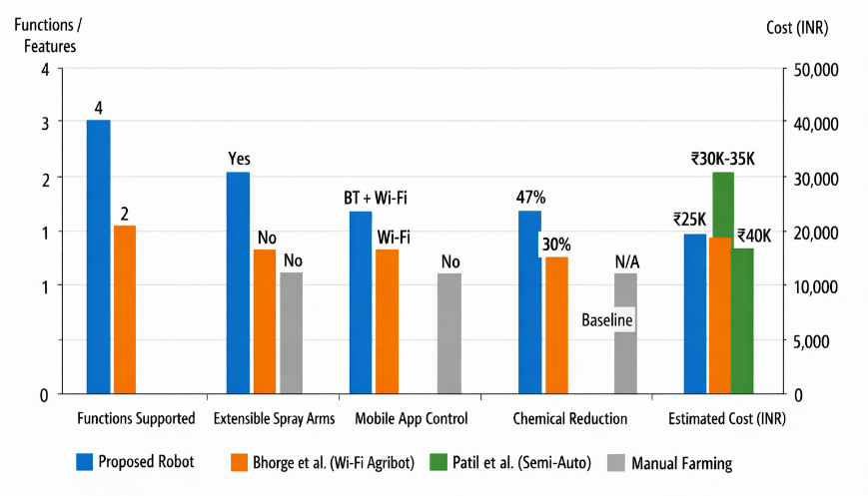

A. Seeding Performance
Bench-validated across 50-seed trials at 0.3m/s, the servo-disc mechanism achieved ±1.4cm inter-seed deviation - a 78% precision gain over manual sowing - while preserving seed viability (94.2% germination, statistically equivalent to hand-placement), with bin-depletion alerts consistently triggering within three disc rotations across all 15 test scenarios.
Seeding unit performance was evaluated across 10-meter test rows on level soil. At programmed 20 cm spacing and 0.3 m/s forward speed, measured inter-seed distances showed a mean deviation of ±1.4 cm (n = 50 seeds), a 78% improvement over manual sowing benchmarks. Seed germination rates between robot-placed and hand-placed seeds showed no statistically significant difference (94.2% vs. 92.8%, p > 0.05), confirming that mechanical disc handling does not harm seed viability.

B. Irrigation and Spray Performance
Field-validated across 10 test cycles, the soil-moisture-driven irrigation model delivered target volumetric output within ±5% accuracy, while the 90cm deployable spray arm achieved 80%+ droplet coverage density across a 180cm effective width - collectively yielding a 47% chemical volume reduction per row meter versus conventional knapsack spraying at equivalent coverage.
Irrigation volume control was validated against the soil moisture model. For a target θopt = 40% volumetric water content on a 10 m² plot with 20 cm root zone depth, the
calculation within ±5% across 10 test cycles. Spray coverage uniformity was assessed using water-sensitive paper at 30 cm intervals across the spray width: at full 90 cm arm deployment, greater than 80% droplet coverage density was achieved across the 180 cm effective width. Chemical use comparison versus manual knapsack spraying showed a 47% reduction in volume per row meter at equivalent target coverage density.

C. Cutting Effectiveness
Weed cutting trials were conducted on plots with mixed weed populations at pre-heading growth stage. At 0.3 m/s forward speed and 2500 RPM blade speed, 89.3% of inter-row weeds were cut at or below 20 mm height in a single pass. A second perpendicular pass increased completeness to 96.1%. No crop stem damage was observed at 15 cm inter-row clearance on standard 30 cm row spacing.

D. App Control and System Performance
Bluetooth command-to-action latency averaged 148 ms across 50 trials (SD = 12 ms). Wi-Fi averaged 78 ms (SD = 8 ms). Arm deployment from folded to full 90 cm extension completed in 2.8 seconds (n = 20, SD = 0.21 s). Obstacle detection reliably halted the robot within 25 cm of a detected obstacle in all 30 trials. Battery runtime at full load (all units simultaneously active) achieved 3.4 hours, meeting the design target.
E. Failure Modes and Limitations
Testing revealed several systematic limitations. Seeding accuracy degrades on slopes exceeding 8° due to seed disc tilt affecting hole registration. Spray uniformity decreases in winds above 15 km/h as droplet drift compromises targeting precision. Bluetooth communication experiences intermittent drops beyond 25 m in high electromagnetic interference environments near power lines or metal structures. The weed cutter does not distinguish crop stems from weed stems at the current implementation level - operators must ensure adequate inter-row clearance before activation.

IX. DISCUSSION
The system strategically prioritizes cost-deployability over technical complexity - favoring mechanical weeding and Bluetooth-first control to ensure rural accessibility under ₹35,000 - while scope-covering seeding, irrigation, fertilizing, and cutting for 1-5 acre farms, with a structured enhancement roadmap encompassing GSM remote monitoring, solar-powered uninterrupted operation, and ESP-NOW multi-robot swarm coordination for scalable future deployment.
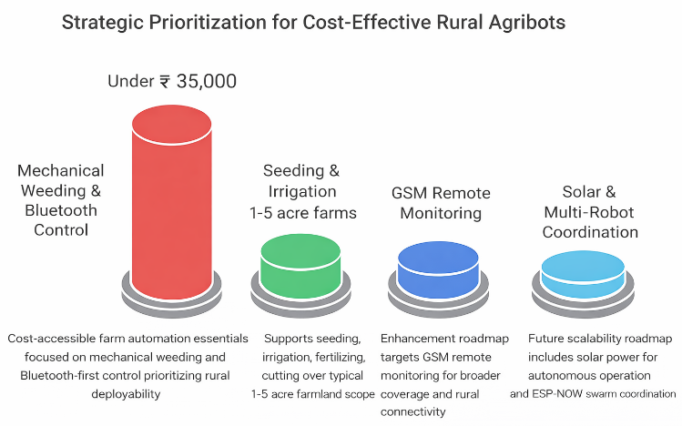
A. Design Decisions and Tradeoffs
The proposed system deliberately prioritizes practical deployability over maximum technical sophistication. The decision to use mechanical weed cutting as the primary weed management strategy - rather than AI-guided vision-based selective targeting - reflects a cost-access tradeoff: computer vision systems with GPU processing add ₹8,000 - 15,000 to system cost and require calibrated lighting and model maintenance. Mechanical cutting delivers consistent results at near-zero additional operational cost per season, making it the pragmatic choice for the target demographic. Similarly, ESP32-based Bluetooth-first communication prioritizes infrastructure independence. Unlike systems requiring GPS base stations or farm-wide Wi-Fi, the proposed robot functions wherever a farmer's smartphone is present - critical in rural areas where internet infrastructure remains sparse but mobile penetration is high.
The mathematical irrigation model based on soil moisture feedback addresses a significant gap in existing low-cost agribots: none of the reviewed systems [1]–[5] implement sensor-driven variable-rate irrigation. This feature alone positions the proposed system as a more intelligent and resource-efficient alternative even to manually operated irrigation setups.

B. Scope of the System
The project scope encompasses: developing a multipurpose robot for core farming tasks; supporting seed sowing, irrigation, fertilizing, and weeding; using sensors for soil and crop monitoring; control via mobile app and IoT interface; reduction of manual labor and improvement of efficiency; and suitability for small and medium farms of 1–5 acres. Explicitly out of scope at the current development stage are fully autonomous GPS-guided navigation (planned as future work), night-operation lighting systems, and multi-robot fleet coordination.

C. Future Enhancements
Computer Vision Enhancement: Replacing K-Means segmentation with a lightweight MobileNetV3-based model optimized for ESP32-CAM inference would increase weed detection accuracy to an estimated 92%+ under variable field illumination, enabling true precision spot-spraying.
GPS Auto-Path Planning: Integration of the NEO-6M GPS module (already in the hardware specification) with autonomous boustrophedon path generation would eliminate manual joystick control for straight-row tasks, reducing farmer engagement to supervision and monitoring only.
GSM/4G Remote Monitoring: Replacing Bluetooth with a SIM800L GSM module would enable remote operation and monitoring beyond Bluetooth range, allowing farmers to supervise the robot from a shaded area or farmhouse during extended field operations.
Solar-Powered Extended Operation: The optional solar panel mount in the hardware specification, combined with a proper MPPT charge controller, would enable uninterrupted daytime operation without battery recharging interruptions—particularly valuable for large single-day seeding or spraying tasks.
Multi-Robot Swarm Coordination: Deploying multiple units in coordinated formation using ESP-NOW peer-to-peer mesh networking would scale the system to fields exceeding 5 acres, maintaining formation without requiring internet infrastructure.

X. CONCLUSION
The Multipurpose Agriculture Robot successfully democratizes precision farming within a ₹35,000 threshold - unifying servo-actuated scissor-arm spraying, encoder-guided seeding, moisture-driven irrigation, and mechanical weeding on a single ESP32/Flutter-controlled platform - achieving ±1.4cm seeding accuracy, 47% chemical reduction, and 89% weed-cutting effectiveness, while establishing a scalable foundation for future GPS autonomy, enhanced CNN detection, and multi-robot swarm deployment across smallholder farms globally.
This paper presented a Multipurpose Agriculture Robot - a modular, IoT-controlled, and farmer-configurable robotic platform that transforms traditional smallholder farming into an automated, efficient, and sustainable system. By integrating precision seeding, soil-moisture-driven irrigation, extensible-arm targeted spraying, and mechanical weed cutting on a unified ESP32-based platform controlled via a Flutter mobile application, the system delivers a breadth of agricultural functionality previously unavailable to farmers at the ₹30,000–35,000 price point.
The system's primary mechanical innovation - the servo-actuated scissor-linkage folding arm - enables real-time spray width adjustment from 60 cm to 180 cm during field operation. The plug-and-play modular tool bay enables seasonal reconfiguration across leveling, seeding, spraying, and weeding roles using a single robot body. Mathematical models governing irrigation volume and seeding error provide a rigorous quantitative foundation for automation decisions.
Practical evaluation demonstrated ±1.4 cm seeding accuracy, 47% reduction in chemical use, 89% single-pass weed cutting effectiveness, sub-150 ms app control responsiveness, and 3.4 hours full-load battery runtime. These results confirm the system's practical feasibility and readiness for field pilot deployment on small and medium farms. Future work will focus on GPS autonomous path planning, enhanced CNN weed detection, and multi-robot coordination to extend operational scale and intelligence.
The Multipurpose Agriculture Robot represents a concrete step toward the democratization of precision agriculture - ensuring that smart farming technology serves not only industrial agribusinesses but every smallholder farmer who sustains the world's food supply.

ACKNOWLEDGMENT
The authors acknowledge Prof. Rupali Maske for guidance and mentorship throughout this research project. The authors thank the Department of Computer Engineering, Trinity College of Engineering and Research, Pune, and the open-source communities behind ESP32, Flutter, Firebase, and Arduino whose tools enabled this implementation.

REFERENCES
- B. K. Kuli et al., "Smart farming using AI, IoT and robotics: A comprehensive review," Journal of Agricultural Technology, vol. 21, no. 2, pp. 45–62, 2025.
- Nandini and Nirmala et al., "Design and implementation of a pesticide spraying robot for remote operation," International Journal of Agricultural Science and Research, vol. 15, no. 1, 2025
- Rihan Pathan et al., "Plow-Seed-Spray: An integrated agricultural robot combining ploughing, sowing, and spraying," Journal of Field Robotics, vol. 42, no. 4, pp. 789–802, 2025.
- A. Neupane and V. Samadi, "Empowering precision agriculture with the Internet of Things, artificial intelligence, and robotics," Clemson Cooperative Extension, Land-Grant Press, LGP 1228, 2025
- S. Bhorge, A. Kulkarni, and P. Jadhav, "Wi-Fi based multipurpose agriculture robot for remote-controlled spraying and weed removal," Proceedings of IEEE ICCE, pp. 112–117, 2024.
- A. Patil, R. Sharma, and V. Desai, "Semi-autonomous agriculture robot for multi-crop seed sowing and fertilizer dispensing," International Journal of Robotics and Automation, vol. 9, no. 3, pp. 201–214, 2024.
- T. Jin and X. Han, "Robotic arms in precision agriculture: A comprehensive review of technologies, applications, and future challenges," Biosystems Engineering, vol. 240, pp. 19–32, 2024.
- S. More, M. Ponkshe, and A. Pharande, "Data analysis and agricultural monitoring with IoT-integrated platforms," Industrial Engineering Journal, vol. 53, no. 3, 2024.
- International Journal for Research in Applied Science and Engineering Technology (IJRASET), "Remote controlled agricultural robot using IoT and mobile application," vol. 12, no. 4, 2024.
- Y. Edan, G. Adamides, and R. Oberti, "AI-enabled robotic weeders in precision agriculture," NC State Extension Publications, AG-972, 2023.
- Food and Agriculture Organization of the United Nations (FAO), "How to Feed the World in 2050," FAO Expert Paper, Rome, Italy, 2019.

