Design of a Smart Greenhouse Monitoring and Control System using a Global System for Mobile Communications (GSM) Module

Abstract
Greenhouse farming is a method of growing crops in a controlled environment that can increase the yield, quality and profitability of crops. However, this requires constant monitoring and control of various environmental factors such as temperature, humidity, soil moisture, and light intensity. Traditional methods of monitoring and control involve manual labour and are expensive, time-consuming and error-prone. To overcome these challenges, a Global System for Mobile Communication (GSM)-based smart greenhouse farming monitoring and control system capable of automatically detecting and adjusting environmental parameters using a temperature sensor, humidity sensor, soil moisture sensor, light sensor, fan, heater, water pump, and light-emitting diode (LED) light was designed. This system also used a GSM module to communicate with greenhouse caretakers via Short Message Service (SMS) messages. This system was tested and evaluated in simulation using Proteus software and was compared with existing monitoring and control methods. The results showed that the system was more accurate, efficient, cost-effective, and user-friendly.
- Introduction
Greenhouse farming is a method of growing crops in a controlled environment, regardless of outside weather conditions. It is widely used to produce various crops, such as fruits, vegetables, flowers, and herbs. Greenhouse agriculture can increase crop yield and quality by providing optimum temperature, humidity, lighting, ventilation, irrigation and fertilizer for plants [9].
However, managing a greenhouse is not a simple task. This requires constant monitoring and control of various environmental parameters to ensure they are within the desired ranges for different crops. For example, temperature and humidity should be adjusted according to the season and time of day, light intensity and duration should be adjusted according to the plant growth stage, and the timing of watering and fertilisation should be adjusted. adjusted according to soil moisture and nutrient levels, etc. [11].
Traditionally, greenhouse management has relied on manual labour, which is expensive, inefficient and error-prone. Manually monitoring and controlling environmental parameters can be tedious, time-consuming and inaccurate. In addition, manual methods cannot cope with the dynamic and complex nature of the greenhouse environment, which can vary greatly depending on location, season and time of day. Therefore, there is a need for smarter and more sustainable greenhouse management solutions that can improve crop quality and yield.
One of the possible solutions is to use smart systems that can sense and adjust the environmental parameters automatically using sensors and actuators. Sensors are devices that can measure physical quantities such as temperature, humidity, soil moisture, light intensity, etc. Actuators are devices that can perform actions such as turning on/off fans/heaters and irrigation/drainage systems, etc. By using sensors and actuators, the greenhouse environment can be monitored and controlled remotely and automatically without human intervention [11].
However, there are also challenges and limitations associated with smart greenhouse management systems. One of the main challenges is how to communicate between the sensors/actuators and the central controller or user interface. There are various communication technologies available for this purpose, like Wi-Fi, Bluetooth, ZigBee, etc. However, each of these technologies has its advantages and disadvantages in terms of cost, range, power consumption, reliability, security, and more [5]. Therefore, the design and development of an intelligent system for greenhouse management must consider the trade-offs between these communication technologies and select the one that best suits the particular application scenario. One of the communication technologies that can be used for this purpose is the Global System for Mobile (GSM). GSM is a mobile communication standard that uses cellular networks to transmit voice and data signals. GSM has several advantages, such as wide coverage, low cost, high reliability, easy integration with other systems, etc. [5]. Therefore, this project used GSM as the communication technology for the smart greenhouse agricultural monitoring and control system. Using GSM, the greenhouse sensor/actuator can send/receive data to/from the central controller or the user interface via Short Message Service (SMS) or General Packet Radio Service (GPRS). In this way, users can monitor and control the greenhouse environment from anywhere using a mobile phone or a web browser.
It is also worth mentioning that while several studies have explored greenhouse monitoring and automation using wireless and IoT-based technologies, many existing systems focus either on data acquisition without closed-loop control or require relatively complex network infrastructure and high implementation costs. In contrast, this work emphasizes a low-cost, GSM-based monitoring and control architecture that integrates sensing, decision logic, actuation, and user notification within a single, unified system. Rather than proposing a new control theory, this study focuses on practical system integration, operational logic, and deployment suitability for resource-constrained environments where Internet connectivity may be unreliable or unavailable.

1.2 Contribution of this Work
The main contributions of the system are as follows:
- the design of a GSM-based smart greenhouse monitoring and control system that integrates multiple environmental sensors, on-off control logic, and automated actuation within a single low-cost architecture;
- the development of an operational workflow that links sensor thresholds, actuator responses, and real-time Short Message Service (SMS) alerts to inform the user about the status of the greenhouse environment;
- the evaluation of the proposed system through detailed Proteus-based simulation under multiple operational scenarios, demonstrating its functional reliability and suitability for small-scale and resource-constrained greenhouse applications.
2. Methods
2.1 Design Concept
The design concept behind the Smart Greenhouse Cultivation System focused on monitoring and controlling key environmental parameters for optimal plant growth. These parameters included temperature, humidity, soil moisture and light intensity. By continuously monitoring these factors, the system detected any deviations from the desired range and took appropriate action to correct them. Table 1 shows the monitored parameters and their conditions.
Table 1: The Monitored Parameters and their Conditions
Parameters | Ranges | Conditions
Temperature | = 31 °C  > 30 °C  < 16 °C | Normal Temperature  High Temperature  Low Temperature
Soil Moisture | = 15 %  > 30 %  < 10 % | Normal Soil Moisture  High Soil Moisture  Low Soil Moisture
Light Intensity | = 48 lux  > 50 lux | Normal Brightness  High Brightness
Humidity | = 63 %  > 85 % | Normal Humidity  High Humidity
The central idea was to create a network of interconnected sensors and actuators, all integrated with the Arduino Uno microcontroller as the central processor. This system used selected components to collect real-time data about the greenhouse environment. Data analysis techniques were used to identify patterns, trends, and anomalies in collected data. Based on the analysis results, the system automatically activated the actuators to adjust the environmental conditions accordingly.
The GSM module was integrated into the system to provide real-time alarm capabilities. In the event of a serious deviation from the desired parameters, the system sent an SMS alert to the user-specified phone number. The GSM module acted as an alert system to notify the user of any emergency in the greenhouse, ensuring timely intervention. The design concept was aimed at creating an intelligent, automated system that improves greenhouse growing methods, increases yields and optimizes resource usage. The following sections delve into component selection, simulation techniques, and other aspects of methods used, providing a comprehensive understanding of system development. Figure 1 shows the smart system architecture.

Arduino Uno Microcontroller
Lamp
Fan/Heater
Liquid Crystal Display (20x4)

Temperature Sensor
Drain/Irrigator

Light Intensity Sensor

Soil Moisture Sensor

Humidity Sensor
Virtual Terminal

Global System for Mobile Communication (GSM) Module

Figure 1: Smart System Architecture
Figure 2 provides a flowchart of the processes involved in the functioning of the system.
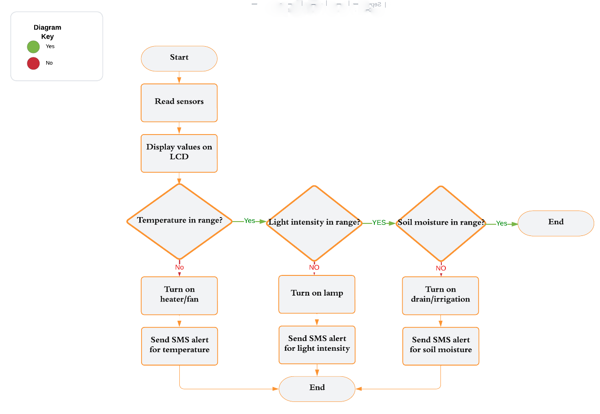
Figure 2: Flowchart of the Processes
2.2 Selection of Components for the Design of the Smart Greenhouse System
The selection of components for the design is critical to ensure the compatibility, reliability and accuracy of the smart greenhouse farming system. The components below were selected based on their availability, cost, compatibility, and functionality. Table 2 below summarizes the main features and functions of each component.

Table 2: Main Features and Functions of Each Component Used in the System Design [6]
Component | Function | Specification
220 V Alternators | Control fan and heater | Voltage: 220 V AC; Current: 10 A; Frequency: 50 Hz
Animated Light Bulb | Represent lamp | Voltage: 220 V AC; Power: 100 W; Colour: White
LCD 20x4 Module | Display sensor readings and system status | Voltage: 5 V DC; Resolution: 20x4 characters; Interface: I2C
LM35 Temperature Sensor | Measure temperature | Voltage: 4-30 V DC; Range: -55 °C to +150 °C; Accuracy: ±0.5 °C
Torch_LDR | Measure light intensity | Resistance: 1 kΩ – 10 kΩ; Sensitivity: 0.2 - 0.8 lux
Arduino Uno Microcontroller | Process data and control actuators | Voltage: 5 V DC; Memory: 32 KB Flash; Pins: 14 Digital, 6 Analog
Relay Driver Circuit | Control lamp | Voltage: 5 V DC; Current: 20 mA; Switching: SPDT
GSM Module SIM900D and Virtual Terminal | Send SMS alerts | Voltage: 5 V DC; Frequency: 850/900/1800/1900 MHz; Interface: UART

2.3 Simulation of Circuit
To validate the function of the smart greenhouse system before actual deployment, the circuit design was simulated using Proteus software. Proteus is a software tool for designing, testing, and debugging electronic circuits and embedded systems [7]. Proteus provided a graphical user interface that allowed for interactive testing and viewing of on-screen metrics to verify system performance in different scenarios. Figure 3 shows the system design on proteus.
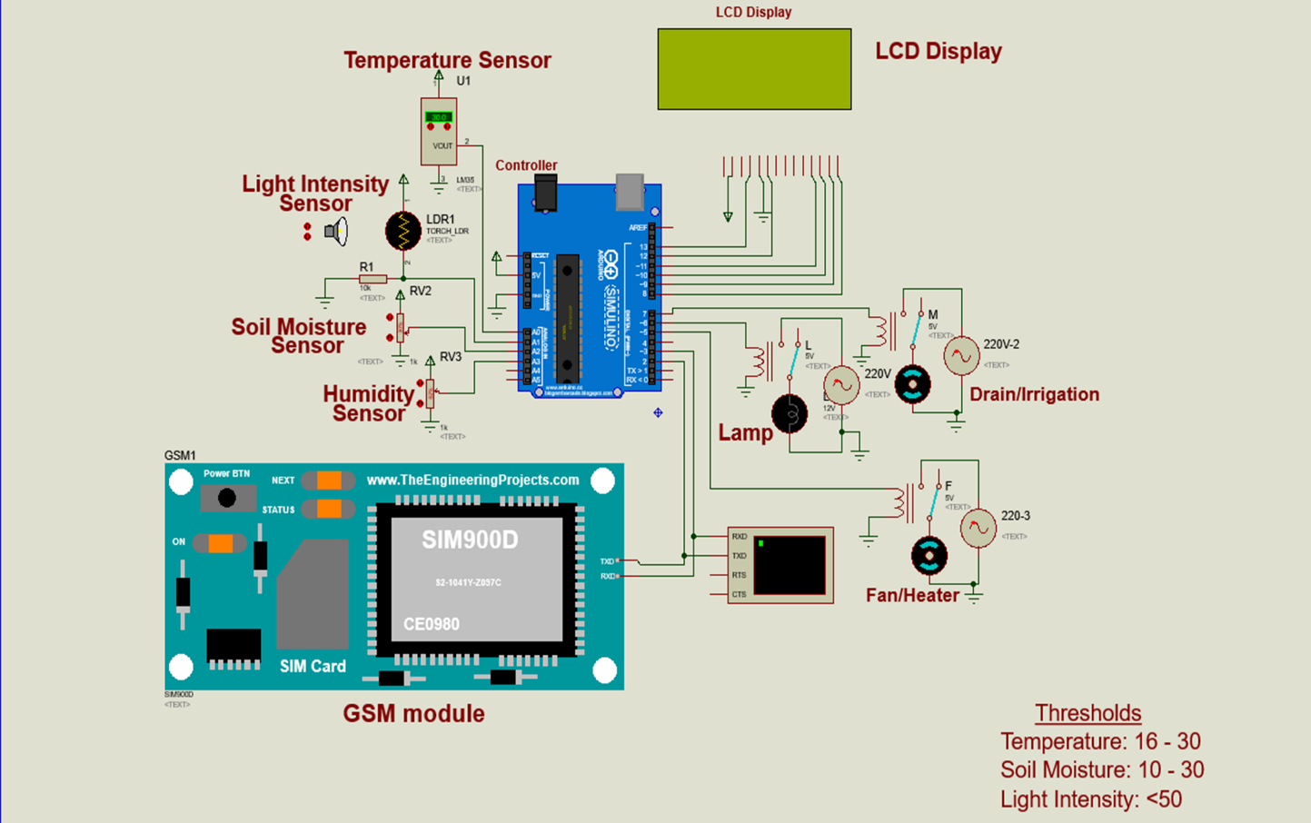
Figure 3: System Design
2.4 Sensor Assumptions and Description
The sensors employed in this work were modeled in the Proteus simulation environment using standard sensor models with idealized operating characteristics. For the purpose of functional validation, the sensors were assumed to operate within their nominal accuracy ranges as specified by typical commercial low-cost sensors commonly used in greenhouse applications. The sensor outputs were assumed to be linearly proportional to the measured environmental parameters, with negligible noise, hysteresis, or long-term drift.
Furthermore, sensor calibration within the simulation environment was performed using default reference values to ensure consistent and repeatable behavior across all test scenarios. The sensor response time was assumed to be sufficiently fast relative to the control loop execution, such that delays in sensor measurement did not significantly affect actuator activation or system decision-making. These assumptions allow the study to focus on validating system logic, control workflow, and communication performance rather than precise sensor metrology.
2.4.1 LM35 Temperature Sensor
The LM35 temperature sensor measures the temperature inside the greenhouse, providing crucial data for adjusting the fan and heater to maintain optimal temperature levels for plant growth. The LM35 temperature sensor is connected to the Arduino Uno microcontroller through analog pin A0. The LM35 temperature sensor converts temperature into voltage, which can be read by the Arduino Uno microcontroller using analogRead() function. The voltage can be converted into Celsius using a formula: Temperature (°C) = (Voltage * 1000) / 10
2.4.2 Torch_LDR
The Light Dependent Resistor (LDR) measures the light intensity inside the greenhouse. By monitoring the light levels, the system can control the lamp and ensure proper illumination for the plants. The LDR is connected to the Arduino Uno microcontroller through analog pin A1. The LDR changes its resistance according to the light intensity, which can be read by the Arduino Uno microcontroller using analogRead() function. The resistance can be converted into lux using a formula: Light Intensity (lux) = (5 / Resistance) * 1000.
2.5 Control Strategy
The control strategy implemented in this system follows a threshold-based ON/OFF logic rather than a continuous control approach such as PID. Sensor readings are continuously compared against predefined acceptable ranges, and actuators are activated or deactivated accordingly to restore optimal greenhouse conditions. This approach was selected due to its simplicity, low computational overhead, and suitability for microcontroller-based embedded systems intended for resource-constrained agricultural environments. While advanced control techniques such as PID or model-based controllers can offer smoother system responses, the ON/OFF control strategy is sufficient for demonstrating system functionality, real-time responsiveness, and reliable environmental regulation within the scope of this application-oriented study.
2.6 Summary of Methods Used
This provided a comprehensive overview of the methods used for the smart greenhouse farming monitoring and control system. The design concept focused on integrating sensors, actuators, and the GSM module to enable real-time monitoring and automatic adjustments for optimal plant growth. The selection of components ensured compatibility, reliability, and functionality. The simulation using Proteus software validated the system’s performance and allowed for testing and validation of the design before its physical implementation. Proteus provided an interactive environment where users could observe the behaviour of on-screen indicators and verify the circuit's performance under different scenarios.
3. Results and Discussion
This section presents the simulation results of the circuit design using Proteus 8.9 software to assess the performance of the GSM-Based Smart Greenhouse Farming Monitoring and Control System. All simulated scenarios follow a common operational logic in which sensor readings are continuously compared against predefined threshold values. When a threshold violation occurs, the corresponding actuator is automatically triggered and an SMS notification is sent to the user. The individual scenarios presented below differ primarily in the environmental parameter under consideration and are intended to demonstrate the system’s consistent response behavior under varying greenhouse conditions.
Simulation Results and Discussion
The simulation model of the system is shown in Figure 4, Figure 5, Figure 6, Figure 7, Figure 8, Figure 9, and Figure 10. The model was built in Proteus Design Suit. The programming was done in the Arduino Integrated Development Environment (IDE). The various cases in the design are as follows:
The Case of a Good Soil Condition
This scenario represents normal greenhouse operation, where all environmental parameters remain within their desired ranges. As shown in Figure 4, the LCD displays nominal values for temperature (30 °C), humidity (63%), soil moisture (30%), and light intensity (90 lux). Under these conditions, all actuators remain inactive, indicating that no corrective action is required.
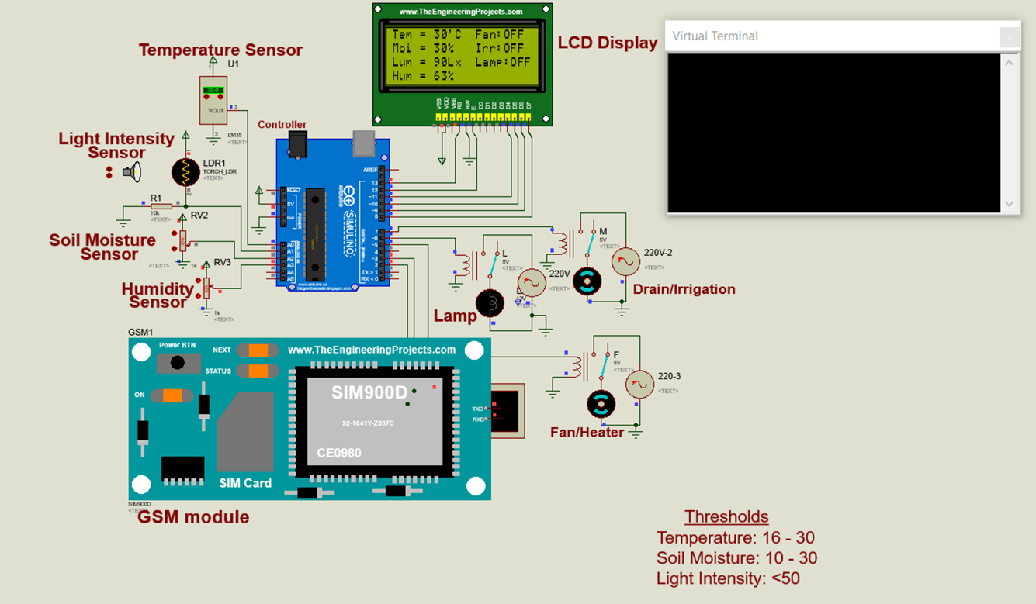
Figure 4: Proteus simulation output showing nominal greenhouse conditions, where all sensor readings remain within predefined threshold limits and no actuator action is required.
This scenario confirms that the system can continuously monitor greenhouse conditions and accurately reflect real-time sensor readings and system status on the LCD when environmental parameters are within acceptable limits.

The Scenario of High Temperature
In this scenario, the greenhouse temperature exceeds the upper threshold of 30 °C. As illustrated in Figure 5, a temperature value of 31 °C triggers automatic activation of the cooling fan while the heater remains off. An SMS alert is simultaneously sent to notify the user of the abnormal condition.
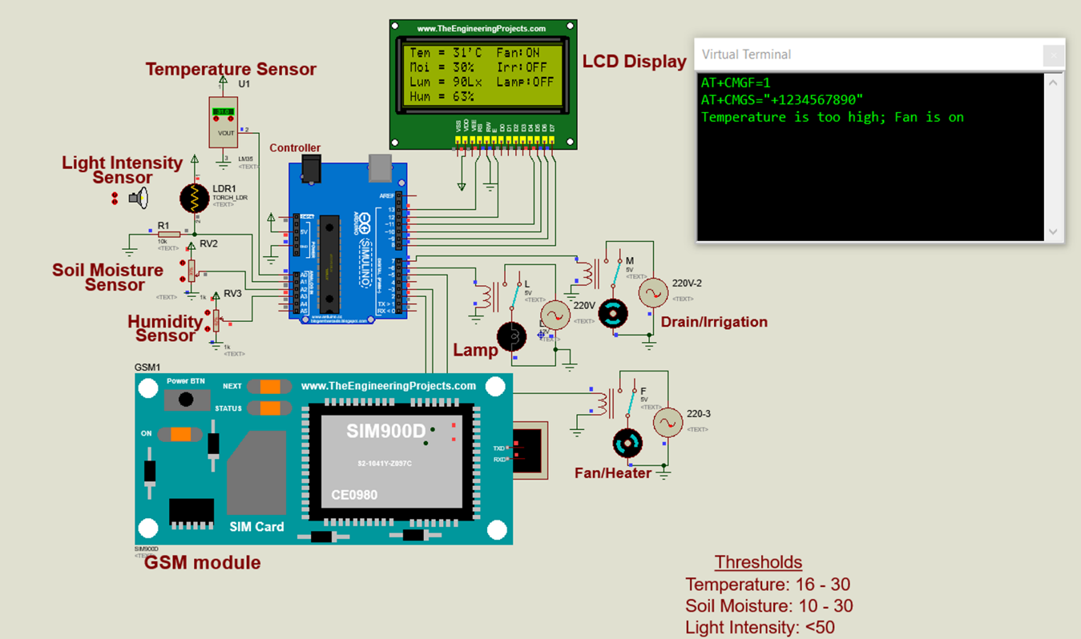
Figure 5: Simulation results illustrating system response to high temperature conditions exceeding the predefined temperature threshold, triggering automatic fan activation and SMS alert generation.
This demonstrates the system’s ability to detect excessive temperature levels and initiate appropriate corrective action while providing timely user notification.
The Scenario of Low Temperature
This scenario examines system behavior when the greenhouse temperature falls below the lower threshold of 16 °C. As shown in Figure 6, a temperature value of 15 °C results in heater activation and fan deactivation, accompanied by an SMS alert to the user.
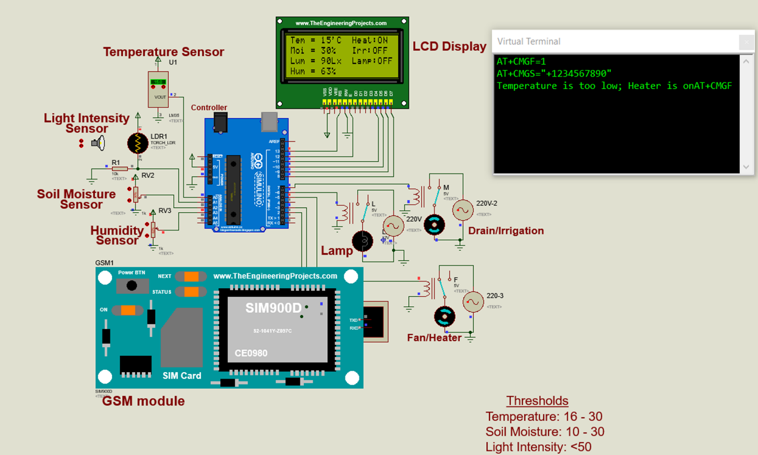
Figure 6: Simulation scenario demonstrating system behavior under low temperature conditions, triggering automatic heater activation to restore optimal greenhouse temperature, including SMS alert notification to the user.
The results confirm effective detection and correction of low-temperature conditions through appropriate actuator control and remote notification.
The Scenario of Low Soil Moisture
This scenario represents a situation where the soil moisture drops below the minimum threshold of 10%. As depicted in Figure 7. A soil moisture value of 9%, as displayed by the LCD module, activates the irrigation pump and triggers an SMS alert.
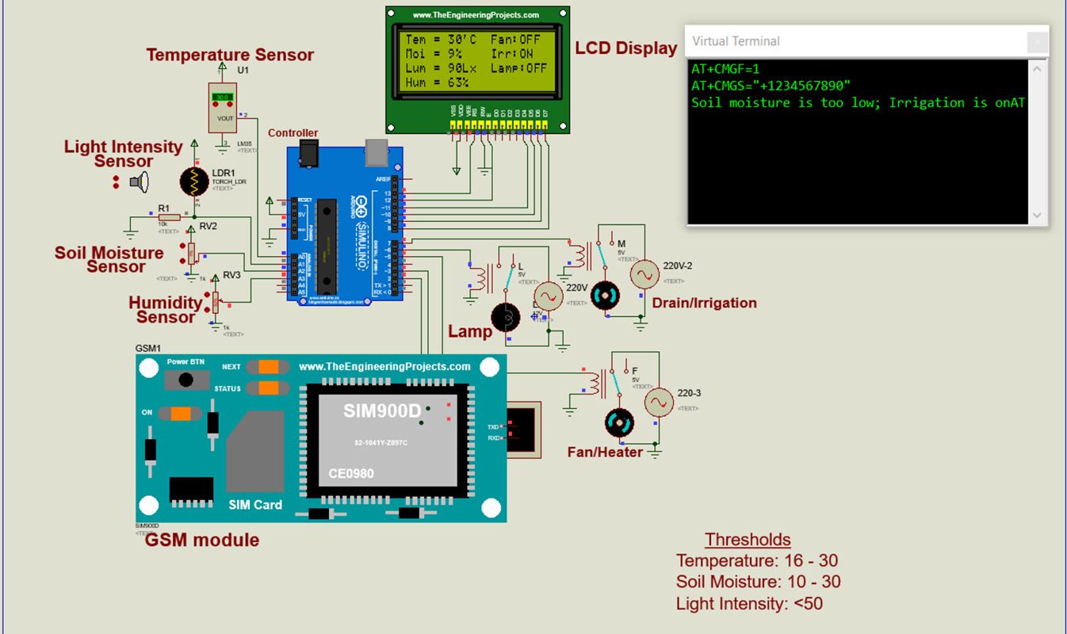
Figure 7: Simulation results illustrating soil moisture sensor behavior and automated water pump activation under low soil moisture conditions, including SMS alert notification to the user.
This scenario verifies the system’s capability to maintain adequate soil moisture levels by automatically initiating irrigation when dry conditions are detected.
The Scenario of High Soil Moisture
This scenario represents excessive soil moisture conditions, where the measured value, displayed by the LCD module, exceeds the upper threshold of 30%. As shown in Figure 8, the drainage mechanism is activated to reduce soil moisture, and an SMS alert is issued.
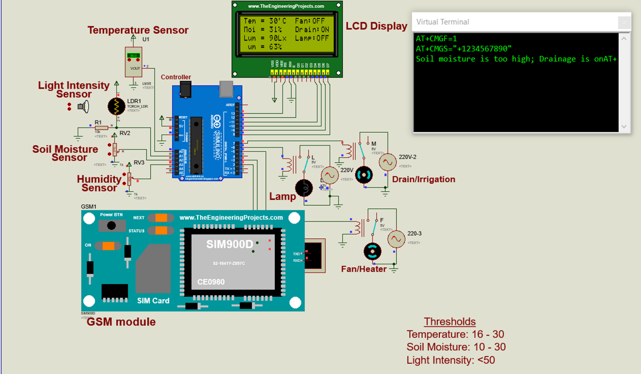
Figure 8: Simulation output showing high soil moisture conditions, where irrigation remains inactive to prevent overwatering.
The results demonstrate effective prevention of overwatering through automated drainage control and user notification.
The Scenario of Low Light Intensity
When light intensity falls below the defined threshold of 50 lux, the system activates supplemental lighting. As illustrated in Figure 9, a measured value of 48 lux triggers lamp activation and an SMS alert.
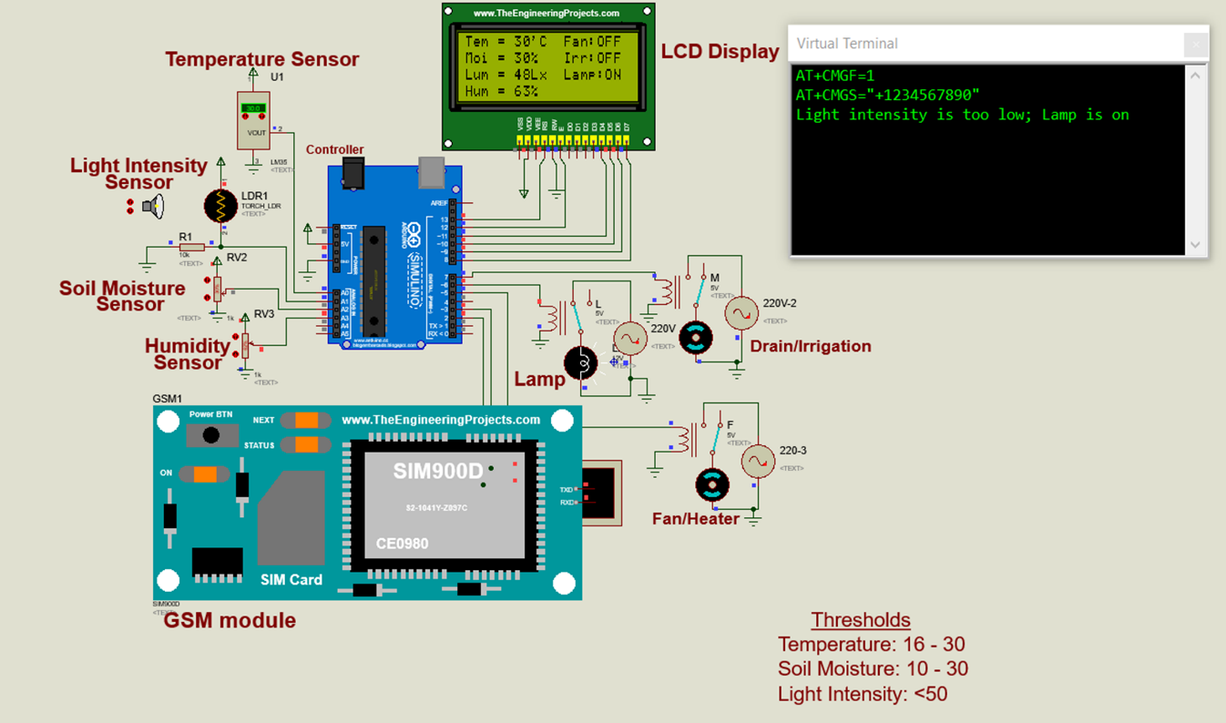
Figure 9: Simulation scenario demonstrating light intensity monitoring and automated lighting control when illumination levels fall below the defined threshold, including SMS alert notification to the user.
This confirms the system’s ability to maintain adequate illumination levels required for plant growth through automated lighting control.
The Scenario of Multiple Out-of-Range Values
This scenario represents a situation where multiple environmental parameters inside the greenhouse deviate from their desired ranges simultaneously. As shown in Figure 10, elevated temperature and soil moisture, along with low light intensity, result in coordinated actuator responses, including fan activation, lamp activation, and drainage control, alongside SMS alerts.
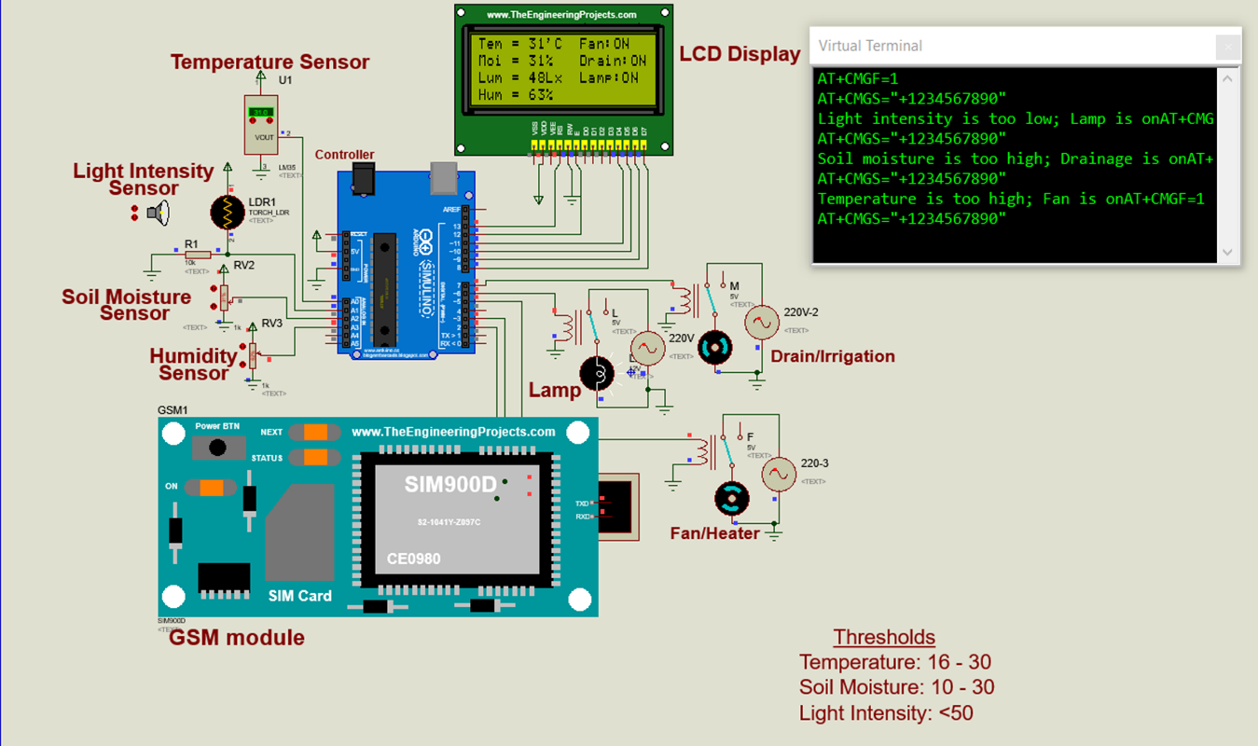
Figure 10: Simulation scenario illustrating system operation under multiple simultaneous out-of-range environmental conditions, with coordinated actuator responses and SMS alerts.
The results indicate that the system can manage complex greenhouse conditions by responding to multiple threshold violations concurrently while maintaining effective user notification.
Limitations of the Simulated System
This study relies on Proteus-based simulation to validate the functional behavior of the proposed smart greenhouse monitoring and control system. While simulation provides an effective platform for verifying system logic, communication flow, and actuator response under controlled conditions, it does not fully capture real-world factors such as sensor noise, calibration drift, environmental disturbances, communication latency, and hardware reliability. As a result, the findings primarily demonstrate system feasibility and logical correctness rather than absolute performance accuracy under practical deployment conditions.
Cost Analysis
The cost analysis aims to provide insights into the expenses associated with the development, installation, operation, and maintenance of the system. The prices were obtained mainly from two electronic stores online, Amazon and Alibaba Electronics. The prices of all products have been converted from the Dollar to their equivalent Ghana Cedi. After the cost analysis, the total cost of the design of the GSM-based smart greenhouse monitoring and control system amounted to GH¢ 2,530.00 at the rate of $1.00 = GH¢11.225 on the 10th day of August 2023. Table 3 gives the current prices of the components employed in the design.
Table 3: Cost Analysis of the Design
Component | Quantity | Unit Price  (GH Cedis) | Total Cost  (GH Cedis)
220 V Alternator | 2 | 1,000.00 | 2,000.00
Animated light bulb | 1 | 50.00 | 50.00
LCD 20x4 | 1 | 30.00 | 30.00
LM35 temperature sensor | 1 | 10.00 | 10.00
Torch_LDR | 1 | 20.00 | 20.00
Arduino UNO microcontroller | 1 | 35.00 | 35.00
Relay driver circuit | 2 | 15.00 | 30.00
12 V DC motor | 2 | 40.00 | 80.00
High Granularity Interactive Potentiometer and Resistor | 3 | 25.00 | 75.00
GSM module SIM900D | 1 | 100.00 | 100.00
Miscellaneous |  |  | 100
Total |  |  | 2,530.00
4. Conclusions
After the entire project work and based on the results, it can be concluded that a fully automated greenhouse monitoring and control system was successfully designed, the system continually monitored the temperature, light intensity, soil moisture and humidity content present in a greenhouse and took corrective actions to ensure that the environmental conditions are optimal for plant growth. Simulation results showed that the system provided a safe environment for crops to thrive.
Recommended Future Improvements
It is recommended that in the future, further work should focus on implementing a physical prototype of the proposed system and conduct experimental validation in a real greenhouse environment to assess robustness, sensor accuracy, response time, power consumption, and long-term operational stability. Additional enhancements may include the adoption of a hybrid communication architecture that combines GSM with Internet-based platforms to enable cloud data logging and remote visualization while maintaining GSM functionality for deployment in regions with unreliable Internet connectivity. Integration with mobile or web-based dashboards could further enhance user interaction and system monitoring capabilities. Lastly, future studies may explore energy-efficient operation and adaptive control strategies to improve system scalability and performance under dynamic greenhouse conditions.

Nomenclature
Abbreviations
LCD: | Liquid Crystal Display
GSM: | Global System for Mobile Communication
GPRS: | General Packet Radio Service
SMS: | Short Message Service
LED: | Light Emitting Diode
IDE: | Integrated Development Environment
AC: | Alternating Current
DC: | Direct Current
IoT: | Internet of Things
I2C: | Inter-Integrated Circuit

Data Availability
The data that support the findings of this study are available from the corresponding author upon reasonable request

Conflicts of Interest
The authors declare that there are no conflicts of interest regarding the publication of this paper.

Acknowledgments
The authors would like to thank Dr Shiphrah Ohene Adu for her support during the preparation of this manuscript. I also acknowledge the use of ChatGPT (https://chat.openai.com/) to refine the academic language and accuracy of my own work. I submitted my entire essay and entered the following prompts on 1 February 2026:
Improve the academic tone and accuracy of language, including grammatical structures, punctuation and vocabulary

References
[1] Abou-Mehdi-Hassani, F., Zaguia, A. and Mkhida, A. (2025) “A systematic literature review of smart greenhouse monitoring systems”, SN Computer Science, 6(2), pp. 1–20.
[2] Al-Ali, A.R., Zualkernan, I.A. and Rashid, M. (2018), "A Smart Greenhouse Management System Using IoT and Big Data Analytics", Procedia Computer Science, Vol. 142, pp. 61 - 68.
[3] AliExpress. (2021), “12v Led Bulb - Bulb - Aliexpress - Avail High-quality 12 V LED bulb”, www.aliexpress.com. Accessed: July 5, 2023.
[4] Al-Fagih, A., Al-Ali, A. R., Amin, A., & Abou-Elnour, A. (2010), “Design and Implementation of a Wireless Sensor Network for Smart Irrigation of Greenhouse”, International Conference on Computer Systems and Applications, pp. 1 - 6.
[5] Al-Fuqaha, A. Guizani, M. Mohammadi, M. Aledhari, and P. Ayyash (2015), “Internet of Things: A Survey on Enabling Technologies, Protocols, and Applications”, IEEE Communications Surveys & Tutorials, Vol. 17, No. 4, pp. 2347 - 2376.
[6] Anon. (2023), “The Essential Component of Digital Transformation,” https://bbr.org/2021 /11/the-essential-components-of-digital-transformation. Accessed: July 5, 2023.
[7] Anon. (2020), “Proteus Design Suite,” www.labcenter.com. Accessed: July 5, 2023.
[8] Asibeluo, U.N. and Ekruyota, O.G. (2023) “Design and development of a smart agricultural greenhouse monitoring system”, Turkish Journal of Agricultural Engineering Research, 4(2), pp. 191–202.
[9] Bhujel, A., Basak, J.K., Khan, F., Arulmozhi, E., Jaihuni, M., Sihalath, T., Lee, D., Park, J. and Kim, H.T. (2020), "Sensor Systems for Greenhouse Microclimate Monitoring and Control: A Review”, Journal of Biosystems Engineering, Vol. 45, No. 4, pp. 341 - 361.
[10] Kacira, M., Sase, S. and Okushima, L. (2004), “Developing Plant Growth Models for Plant Factories,” Acta Horticulturae, Vol. 63, pp. 27 - 34.
[11] Khan, A., Malik, A., Khan, A.A. (2018), “Smart Harvesting Robot for Strawberry in Greenhouses”, Computers and Electronics in Agriculture, Vol. 154, pp. 369 - 378.
[12] Kumar, S. and Singh, A.K. (2019), "Smart Greenhouse Monitoring System Using IoT and Cloud Computing", International Journal of Innovative Technology and Exploring Engineering, Vol. 8, No. 10, pp. 3086 - 3090.
[13] Moussa, M.M.M., El-Mahallawy, E.S.A., El-Sayed Ahmed, A.A. (2017), “Applications of GSM Technology in Smart Agriculture Systems”, International Journal of Advanced Research in Computer Science and Software Engineering (IJARCSSE), Vol. 7, No. 4, pp. 1 - 6.
[14] Raut, S., Patil, S., & Patil, S. (2018), “Automation of Greenhouse Using Arduino and GSM Module”, International Journal of Engineering Research and Technology, Vol. 7, No. 4, pp. 1 - 5.
[15] Singh V.K., Sharma, P., & Kumar P.R. (2011), “Greenhouse Automation Based on Wireless Sensor Network”, International Conference on Recent Trends in Information Technology (ICRTIT), pp. 1148 - 1153.
[16] Soussi, A. Zero, E. Sacile, R. Trinchero, D. Fossa, M. (2024) “Smart sensors and smart data for precision agriculture: a review”, Sensors, 24(8), 2647.
[17] Zhang, F., Li, D. and Li, G. (2024) “New horizons in smart plant sensors: key technologies, applications, and prospects”, Frontiers in Plant Science, 15, pp. 1–18.

