WORLD BUILDING: THE INFLUENCE OF MALAYSIA ELEMENTS IN RAYA AND THE LAST DRAGON (2021)

ABSTRACT

This research explores the representation of Malaysian cultural elements in the animated feature film Raya and the Last Dragon (2021), produced by Walt Disney Animation Studios. Although the film is widely recognized as being inspired by Southeast Asian traditions and aesthetics, the specific contributions of Malaysian culture have received limited scholarly attention. To address this gap, the study investigates how selected cultural elements—including architecture, customs, mythology, artifacts, food, language, and art—are incorporated into the film’s design and narrative, and how these features contribute to the construction of its fictional world. The analysis identifies several elements that can be traced to Malaysian cultural heritage. These include architectural motifs that resemble traditional Malay structures, artistic patterns and designs with regional influences, culinary references familiar within Malaysian food culture, and mythological aspects that resonate with local folklore. By highlighting these aspects, the research contributes to a more nuanced understanding of how international animated films engage with cultural identity and representation. In particular, it demonstrates the ways in which Malaysian culture has informed the film’s world-building, while also being involved under a broader Southeast Asian framework. This study not only helps to address a lack of academic discussion on Malaysian influences within the film but also extends existing literature on cultural identity and transnational representation in contemporary animation.

Keywords: World-building, Cultural Representation, Raya and the Last Dragon

INTRODUCTION

Raya and the Last Dragon is an animated film that is breathtaking in its visuals and is produced by Walt Disney Animation Studios, which was released in 2021. The setting of the film is in a fictitious land called Kumandra. However, the movie exhibits a very strong influence of the cultures of Southeast Asia, a country in the Malaysian region, especially among others, to depict a lively and highly inclusive world. Raya is a courageous and ambitious young female warrior who sets out on an expedition to search for the last surviving dragon, Sisu, whose mission is to bring the divided kingdom of Kumandra back together and thus restore peace. The kingdom has fallen to pieces because of the evil Druun, a force that turns people and dragons into stones. Creating mistrust and divisions amongst the people of Kumandra who were once united, Druun has ravaged the kingdom like a tornado. The character of Raya who is the film’s protagonist shows the strength of hope, trust, and thoughts of altruism, virtues of such importance that they are the ones through which the difficulties are overcome. In addition, along with Sisu, a mythological dragon with a fun yet well-informed disposition, Raya comes through a society that is filled with differing tribes and landscape types that range from green verdant jungles and towering, massive mountains to magnificent towns and marketplaces. While they travel together with her new friends, the movie shows that unity, mutual friendship, and understanding, which it aims at, are the necessary things to overcome the distances among people.

By examining the traditions of different nations, ethnic groups, and religions, some animation industries nowadays are creating the world in animated movies. The film Raya and the Last Dragon, an example of this at Disney Animation Studios, is the story of the conceptual world of Kumandra which possesses elements of the local traditions of Malaysian alongside the culture of Southeast Asia. Several other animated films before Raya and the Last Dragon have taken their inspiration from different countries’ cultures. One of them is Disney's Mulan was a film based on Mulan's Chinese culture and history and incorporated various traditional elements of architecture, clothing, and folklore through its world-building. In the same way, How to Train Your Dragon by DreamWorks was inspired by Norse mythology and Viking culture, where the setting and characters reflected the customs, architecture, and landscapes of Scandinavia. Furthermore, Pixar's Coco is another example of a film that has much to do with Mexican culture, especially the custom of Día de los Muertos (Day of the Dead). The film intelligently and profoundly highlights the Mexican customs, such as music, family values, and the cheerful soul of the holiday; and thus, an authentic and heartwarming narrative is created. The sure shot approach of Coco’s filmmakers was to take the Mexican cultural exactness and respect by a special trip to Mexico for firsthand immersion in the manner. Through the time spent on this trip, the filmmakers visited different regions of Mexico, such as Oaxaca city which is known for its high cultural heritage. They were introduced to local artisans, joined in the Día de los Muertos celebrations, and they remained in interactions with the families for a better understanding of the holiday as well as its connection to family, life, and death, leading to the best research trip which in turn was a fundamental part for the filmmakers to create a piece of art that would impart real Mexican culture by using authentic visuals, music, and storytelling to the fullest. The result was a well-structured film that not only entertained audiences but also respected the traditions and spirit of those involved.

Like other animated films that draw inspiration from various countries, such as Coco, Raya and the Last Dragon also takes inspiration from Southeast Asia, including Malaysia. This study will explore the deeper representation of Malaysian culture in the world-building of the animated film Raya and the Last Dragon from various aspects, such as landscapes, architecture, culture, and more. This study seeks to address the limited discussion of Malaysian cultural influences in Raya and the Last Dragon by examining how elements such as architecture, customs, myths, food, artifacts, language, and art are represented within the film’s world-building. In doing so, it aims to evaluate the role of culture in enriching the narrative and visual design of the film, while also considering how these cultural integrations contribute to broader conversations on representation and identity in animation. Furthermore, the study explores the potential influence of these cultural elements on the animation industry, highlighting their significance in shaping creative practices and transnational storytelling.

LITERATURE REVIEW

Culture is described as "the customary beliefs, social forms, and material traits of a racial, religious, or social group". Culture includes the customary way of life in a community. That means beliefs, traditions, values, artifacts, language, and other ways of living passed from one generation to another. These are the ones that define identities, create communities, and give some sense of how the world works. Culture has physical manifestations in dress, architecture, and food, with psychological manifestations in rituals, behaviours, and thoughts; hence, culture embodies the whole history of a certain group.

These CGI studios integrate cultural features in their products. One animated series, coco is a vivid portrayal of Mexico's Día de los Muertos 2007 animated film by Pixar presents into the fancy lights of Mexico's Día de los Muertos. The film delves into the deep aspects of the culture of this celebration, namely the cut-paper banners, for decorating altars, other symbolically meaningful traditions like marigold petals, etc. The handsome family story follows the aspiring successful young orphan musician named Miguel, who makes a trip to the Land of the Dead. The film showed how far family ties, remembrance for the ancestors, and how culture is passed on to new generations. So, by combining all these universal themes with certain specifics of Mexican customs, "Coco" appeals to a worldwide audience while still authentically illustrating the very cultural tradition it wishes to pay tribute to. The tribute to cultural veracity is unmistakably placed in each detail. The traditional music, the dress, the Mexican icons, and places were all things that" Coco wanted to put on the screen to represent Mexican heritage.

"Spirited Away" is melded by various forms of Japanese culture that permeate into the roots of the story as well as the themes it encompasses. At the heart of the film are the Myriad of Kami, spirits, that Chihiro interacts with. Kami, in this sense, are the spiritual forces that animate all the aspects of life, occupying rivers and trees, forests and mountains. The film's version of the spirits embodies a Shinto worldview of a saturated spiritual world, presenting an interrelationship between humanity and nature. The bathhouse's area, where most of the events occur, draws its influences from traditional Japanese Sentō (Moser.Z, 2023). These institutions have long stood for public hubs for relaxation and socializing in Japanese culture. In the film, the bathhouse attended to the spirits, which stand as a place of purification and renewal. directly with the Shinto practice of ritual cleansing. Miyazaki uses various narrative elements to subtly address environmental issues. The polluted spirit of the river, for instance, appears at the bathhouse in mud and debris, figuratively representing the impact of human pollution on natural waterways. Chihiro's act of cleaning the spirit is then seen as symbolic of restoring the environment and the respect due to nature. An exploration of generational gap and the transition into adulthood also runs through the film. Chihiro's journey is that of her initiation: a voyage toward learning responsibility and becoming resilient-ability and respect toward her roots. This reflects the general societal themes during modernization in Japan that really led to blind conflicts between contemporary and traditional values. Blending all these cultural segments into its fabric, "Spirited Away", presents a deep romance with meaning not only to the delight of the plot, but it also insinuates broader insight into Japanese traditions, beliefs, and social issues (Bocong Sun,2020).

In conclusion, Coco (2018) and Spirited Away (2021) are truly rich of culture element in the movie, Coco (2028) use Mexican culture while Spirited Away used Japanese culture to create the world-building, story, and design more amazing and connect to audience because people liked seeing actors, humour, and situations that reflect their own culture (Cuelenaere, 2021).

Malaysian Culture in Animation

"Kampung Boy," an animation created by Malaysian cartoonist Datuk Lat, provides an exciting presentation of Malaysian rural life within the cultural and social fabric of the country. The backdrop of a traditional kampung captures the essence of village life in its totality, vividly portraying local customs, festivals, and approaching daily contexts. Their activities tend to include playing traditional games, opening ceremonies, and agricultural labour, showing a closely knit community spirit typical in rural Malaysia. They illustrate, among others, local flora and fauna such as coconut trees, banana trees, and various animals that showcase the rich biodiversity of the region. It features local flora and fauna such as coconut trees and monkeys trained to pluck coconuts and allows us to gain a bigger respect for the country's rich biodiversity. Activities portrayed include communal gatherings and traditional festivals, which all weave out the close-knit community nature of the villages. It highlights how modernization has impacted rural communities, providing the contrast between traditional living and city influences. More importantly, Kampung Boy stands as a cultural monument that showcases the true life of villages, preserving and disseminating the unique aspects of Malaysian heritage to a wider audience (Zahferee, et al., 2023). The local culture that represents in the film create a connection between the local audience and the film (Rafik et al., 2020).

Creating Unique and Authentic World

Cultural elements play a critical role in adding charm to animated films-generating blueprints for real spaces that are thick with meaning (Luo et al., 2025). Leveraging various cultural traditions and symbols, the filmmakers fashion realms not only magical but steeped in real heritage. Examples include that of Moana, in which a world reflecting Polynesian inspirations has been brought to life through its traditional boats, tropical landscapes, and local customs, creating a world as wonderful as it is a homage to Polynesian culture (Broadway. D, 2024). Similarly, Coco adds Mexican traditions in, the Day of the Dead-to its narrative, equipping these cultural attributes with the power to heighten the emotional character of the storyline, thus rendering it an enchanting yet meaningful cinematic treat

Enriching Storytelling

Using cultural myths, legends, and folklore to tell stories gives the story more depth and universality, with value systems that resonate emotionally with the audience over time. These cultural stories layer meaning into the themes of family, identity, and life after death. An example would be that of Coco that centres its narrative on Mexican traditions and the concept of Día de los Muertos. The depiction of the afterlife and filial ties put forth provides not only an enchanting narrative but a meaningful one rooted in Mexican cultural customs. By intertwining themes of culture, family, and mortality, Coco delivers a sound multi-layered emotional experience that invites the filmgoer to relate both to the cultural traditions it espouses and to the universal themes of love and remembrance (Reyes, A., 2018).

Enhancing the Emotional Impact

Rituals, symbols, and traditions can elicit very powerful emotions by reaching into universal sentiments of belonging, family, and identity, which enhances the animation's enchantment and emotive power The local culture that represents in the film create a connection between the local audience and the film. it’s make audience more connect with the movie (Rafik et al., 2020). These customs bind the audience in an even deeper connection not only of the narrative but also of the viewers. “Authentic culture representation can lead to richer, more nuanced stories that resonate with audiences. It can also foster greater understanding and empathy between people of different backgrounds”.

Promoting Diversity and Inclusivity

“Diversity is also the mixture of races and religions that make up a group of people. However, Inclusivity is the practice or policy of including people who might otherwise be excluded or marginalized” (Cambridge Dictionary, 2024). Animation brings in varied cultural elements bringing real different ethnic groups or communities into the film and thus appealing to a wider range of audiences that relate to and see themselves represented in the story. Zootopia shows how anthropomorphic animal societies tackle issues about diversity and inclusion and appeal to audiences of many different backgrounds. In Zootopia, diversity comprises the coexistence of individuals or groups that different from each other in physical attributes, needs, abilities, and cultural backgrounds in a cohesive society. There's no one doing this better than the city, as its design considers both the needs of little gerbils and huge elephants, allowing them to collectively inhabit an environment where participation is proportionate toward all. Socially and professionally, there is still inclusion, Judy Hopps, the first rabbit police officer in a field dominated by much larger animals. Additionally, Zootopia showcases cultural and behavioural differences, characters of different species contribute unique characteristics and problems that foster mutual understanding and cooperation (Abdul Mahya, S. et al, 2025). In this light, diversity no longer merely signifies an acknowledgment of differences rather, the act of creating systems, architectures, and social paradigms where everyone can succeed interacts collectively in society.

METHODOLOGY

This research uses two methods of data collection, primary data and secondary data. It is conducted to identify and analyse the influence of Malaysian cultural elements in the worldbuilding of Raya and the Last Dragon (2021). Specifically, the study aims to investigate how Malaysian cultural elements are portrayed in the film and their significance in enhancing the film. The research adopts a qualitative method, employing both case studies of the film and insights from literature reviews and scholarly contributions to establish the cultural impact.

The definition of primary data, according to Mazhar et al. (2021), is data that is collected for the first time, original, and unprocessed. Primary data collection methods involve observation, interviews, and direct communication with respondents. In the context of this research, primary data is collected through an observation method, where the film is watching repeatedly to analysed and identify cultural elements. This
observational analysis provides fresh and first-hand insights into the integration of Malaysian cultural elements within the movie's world-building.

Secondary data, as defined by Mazhar et al. (2021), refers to data that has been collected and processed by others, often modified through statistical or interpretive processes. Secondary data sources include published materials such as books, academic reports, journals, and public records, as well as unpublished data like manuscripts, diaries, or raw research findings. For this research, secondary data is gathered from various publications, including reports by research scholars, university studies, and cultural archives. These sources provide essential contextual information and support the analysis of how Malaysian cultural elements contribute to the film's narrative and enhance the movie.

Conceptual Framework

The researcher chose primary data collection to analyse the Malaysian cultural elements in Raya and the Last Dragon due to its direct accessibility from the film itself. The observation method was employed, focusing on the visual and narrative elements of the movie. According to (The Duke University library, 2024), observation involves gathering data by studying behaviours, events, and physical characteristics in their natural settings. The researcher applied this method by analysing the cultural aspects presented in the film, such as Art, food, language, artifact, myth, value and Architecture. This approach allowed the researcher to observe and document these cultural elements objectively. The benefits of using observation include the flexibility of data collection regardless of time or location and the ability to analyse the film’s cultural representation without relying on external opinions.

Secondary data was also utilized to support the analysis of Malaysian cultural elements in the film. This method allowed the researcher to reference existing literature and past studies on cultural representation in animation. According to (McCombes, 2021), secondary data enables researchers to explore existing findings and develop new insights. By using this method, the researcher could examine scholarly articles, books, and reports that discuss Malaysian culture and its influence on media. This approach broadened the scope of the research, providing a deeper understanding of how Malaysian cultural elements contribute to Raya and the Last Dragon. The combination of primary and secondary data ensured a comprehensive analysis of the topic.
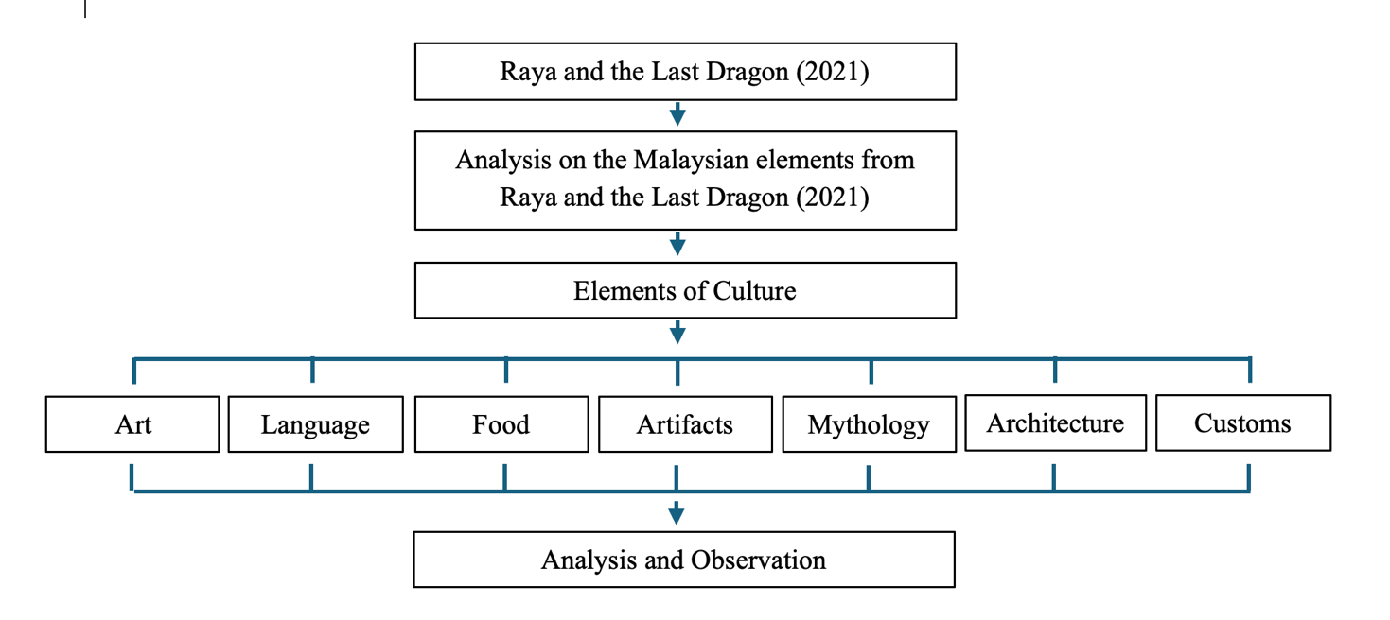
Figure 1. Conceptual Framework for Analysis on the Malaysian Elements from Raya and the Last Dragon (2021)

ANALYSIS AND FINDINGS

During this whole process, qualitative data will be extracted from literature reviews, scholarly articles, and interviews and compiled into thematic tables in searching for patterns and relationships. The data collected will then be analysed using these tables to serve the aims of this research, which are the exploration of how Malaysian cultural elements were incorporated into the worldbuilding of the film, how the culture element enhances the animation and how it improves the animation compony. The analysis shall entail the codification of such key architecture, custom, myth, artifact, food, language and art. in the film. In addition, the impact of these traits on narrative construction and visual aesthetics shall be assessed to assess the extent to which cultural representation to enhance the movie.

Custom
In Figure 2, a notable cultural gesture is observed when young Raya removes her shoes before entering the Dragon Gem chamber in Heart, as the people believed the chamber to be a holy and sacred place. This practice reflects a common Malaysian custom of showing respect when entering sacred or significant spaces, a tradition strongly influenced by Islamic teachings (Ibrahim, Y. et al, 2018).

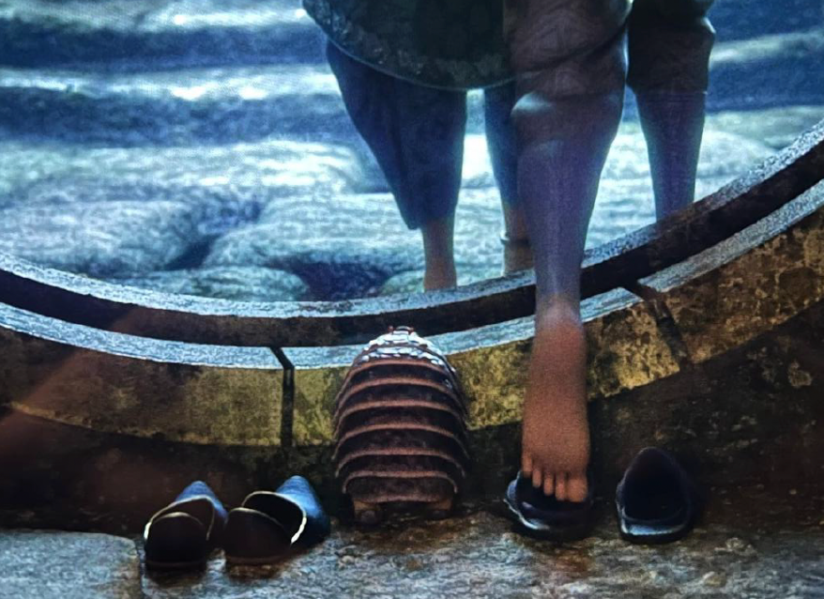
Figure 2. Raya removes her shoes before stepping inside the Dragon Gem chamber scene
(Raya and the Last Dragon, 2021)

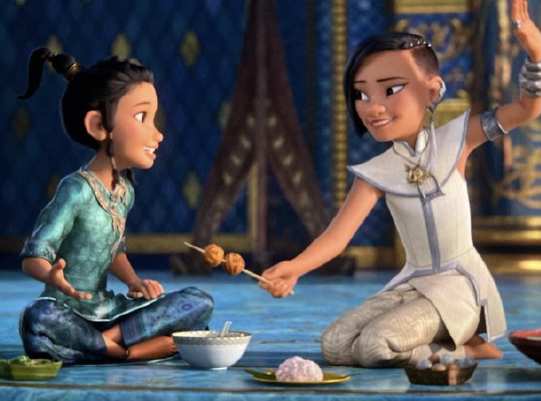
Figure 3. Small Raya eating with Namaari
(Raya and the Last Dragon, 2021)

In Figure 3, Raya and Namaari are depicted sharing a meal on the floor while engaging in conversation. Raya is seated in a cross-legged position, while Namaari adopts a posture with both legs folded to one side. Traditionally in Malaysia, meals are often taken on the floor, with food placed on a mat. Men typically sit cross-legged, a posture referred to in Malay as bersila, while women commonly sit with both legs folded to one side, known as bersimpuh (Raji, et al., 2017). Another Malay custom evident in this scene is the practice of eating with the right hand. Namaari is shown using her right hand while eating, which aligns with Malay cultural norms whereby food is handled exclusively with the right hand. The left hand is never used for eating under any circumstance; instead, only the fingers of the right hand are used while the palm remains clean (Raji et al., 2017). This cultural representation reinforces the claim that “the Heart region was inspired by Malaysian culture”.

Architecture
In Figure 4, the building is in Fang kingdom, one of the five lands in the fictional world of Kumandra in Raya and the Last Dragon. It serves as the central palace of the Fang tribe, a militaristic and highly structured society known for its strength and discipline. The grand design of the palace reflects the Fang tribe's power, pride, and political ambition. Here is the characteristic of Fang building:
- The wide roof and
- Resembles horns, symbolizing a buffalo.
- Sharp-edged roof
- Layered roof

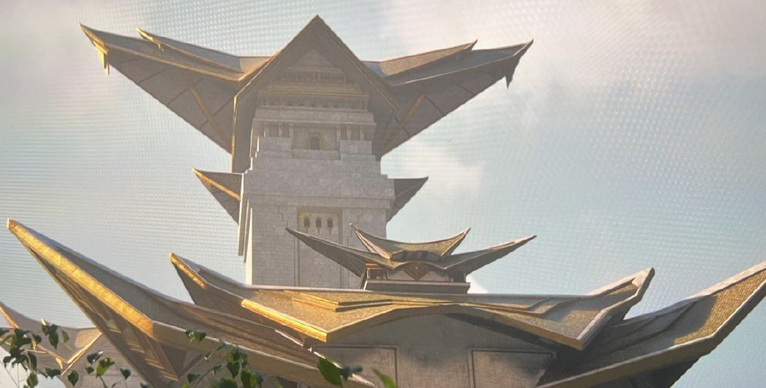
Figure 4. Fang’s Palace
(Raya and the Last Dragon, 2021)

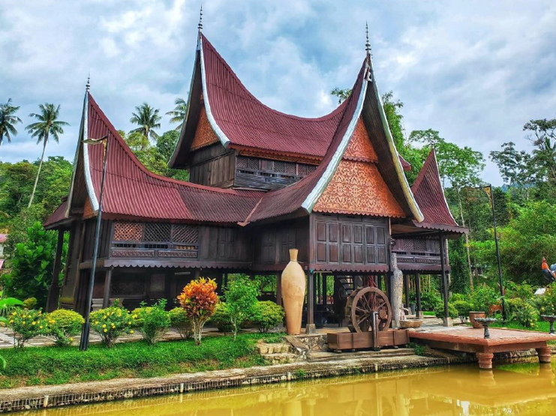
Figure 5. Minangkabau house in Negeri Sembilan, Kuala Klawang, Malaysia
(Portal Rasmi Negeri Sembilan, 2025)

During the 18th century, the Minangkabau people from Sumatra migrated to Negeri Sembilan, bringing their families and establishing communities organized around kinship ties. Although the name Negeri Sembilan literally translates to “nine states,” it does not refer to nine specific territorial divisions (Portal Rasmi Negeri Sembilan, 2025). While the Minangkabau originated in Indonesia, their long-standing presence in Malaysia—particularly in Negeri Sembilan—has deeply influenced local law, architecture, identity, and customs. Consequently, Minangkabau culture is widely acknowledged as an integral part of Malaysian heritage (Jani. et al., 2014).

In Figure 5, the architectural similarities between the Fang palace and the traditional Rumah Gadang of Kuala Klawang can be observed. The Rumah Gadang also features wide, layered, and sharp-edged roofs, closely resembling the design elements of the Fang building depicted in Raya and the Last Dragon.

Mythology
Sisu, the last remaining dragon in Raya and the Last Dragon, is portrayed as a kind, playful, and humble water dragon who embodies values of trust, unity, and hope. Her design is inspired by Southeast Asian dragons, which are typically benevolent, protective beings associated with water, and symbolic of cultural and spiritual values such as community and cooperation. Unlike Western dragons—often depicted as fierce, prideful, and individualistic—Sisu is not portrayed as superior to her siblings. Instead, her powers come from the collective gifts of her siblings, emphasizing the importance of respect, humility, and reliance on one’s community. Within the narrative, Sisu’s role reinforces the lesson that trust, rather than sheer strength, is essential in restoring a fractured and divided world, fostering both unity and hope.

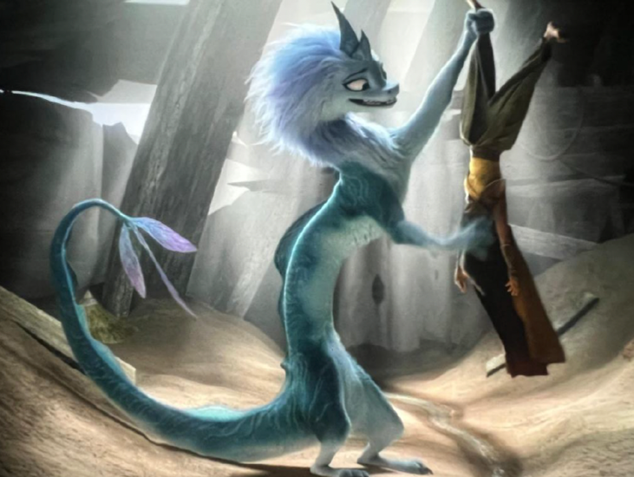
Figure 6. Sisu the Water Dragon
(Raya and the Last Dragon, 2021)

In Malaysia, similar dragon mythology exists, particularly in Pahang folklore. One well-known legend is the tale of Seri Gumum, which has been passed down through generations and is preserved in three versions: Asal Usul Tasik Chini, Kisah Cinta Antara Seri Gumum dan Seri Kemboja, and Lima Naga Bersaudara. Both Asal Usul Tasik Chini and Kisah Cinta Antara Seri Gumum dan Seri Kemboja feature dragons—locally referred to as naga. These stories reveal that the dragon motif is an integral part of traditional Malaysian folklore. When comparing the naga of Tasik Chini to Sisu, a key similarity lies in their association with water: Sisu is portrayed as a river dragon, while the Naga Tasik Chini is also tied to lakes and rivers in Pahang.

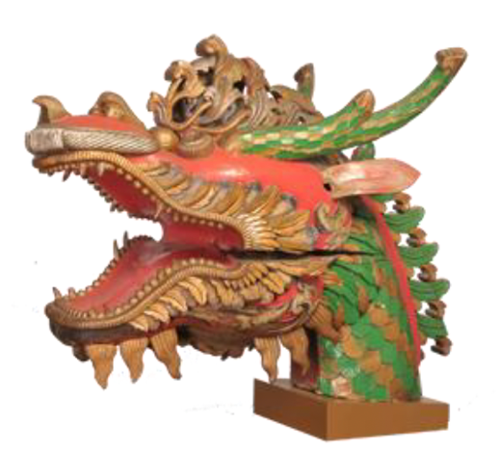
Figure 7. Kepala Perahu
(Muzium Negara, 2021)

Before the arrival of Islam in the Malay Peninsula, the Srivijaya Empire and early Malay kingdoms were heavily influenced by Hinduism and Buddhism, particularly between the 7th and 13th centuries. As a result, many ancient Malay artifacts feature deities, animal motifs, and symbolic figures outside Islamic norms. Figure 11 depicts a decorative figurehead once owned by the Pahang royal family in the 19th century. Carved from jackfruit wood, the ornament was affixed to the head of a royal boat. The carving, shaped like a dragon’s head, bears striking similarities to Sisu’s design, particularly in the head structure, teeth formation, and presence of horns.

In conclusion, Sisu can be seen as an element inspired by Malaysian cultural heritage, particularly Pahang folklore. The parallels between Sisu and the Naga Tasik Chini—most notably their connection to water—highlight a shared symbolic role. Furthermore, the similarities in physical form, such as the dragon’s head shape, teeth, and horns, reinforce the cultural resonance between the mythical naga of Malaysia and the animated representation of Sisu in Raya and the Last Dragon.

Artifact (Weaponry & Tools)
In the figure 14, Raya wields a uniquely designed sword that draws heavy inspiration from the traditional Malay Keris, a culturally significant weapon known across Southeast Asia. In the picture, we can see Raya sword was made by iron, bronze or maybe a material outside from earth like titanium and the keris blades are wavy. Raya blade was visualized with wave blade shape that like Keris (Walt Disney Animation Studio, 2021).

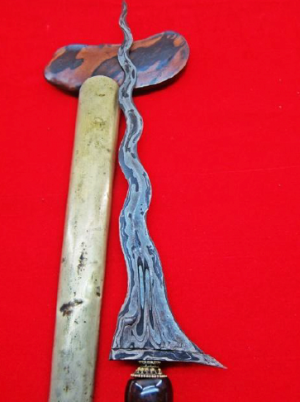
Figure 8. Keris
(Muzium Negara, 2021)

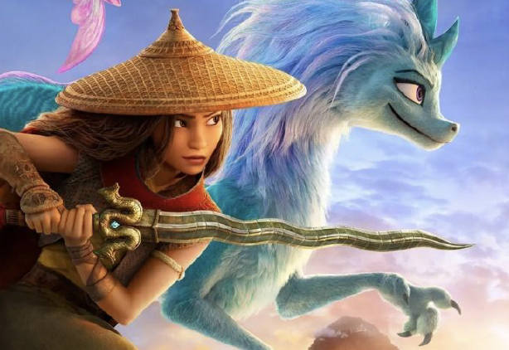
Figure 9. Raya’s sword (Keris) from main poster
(Raya and the Last Dragon, 2021)

Keris is deeply tied into Malaysian culture element; Keris it was more than just a traditional weapon. It is recognized as a symbol of Malaysa integrity, cultural heritage, and creativity, and is featured on countless occasions of cultural and official importance. Throughout time, the keris have used its practical use in battle to grow into a symbol of heritage, pride, and even spirituality. The keris an important part of identity for Malaysians, related to history, ceremony, and community values handed down through the generations. (Yusof, N. A, et al. 2022).

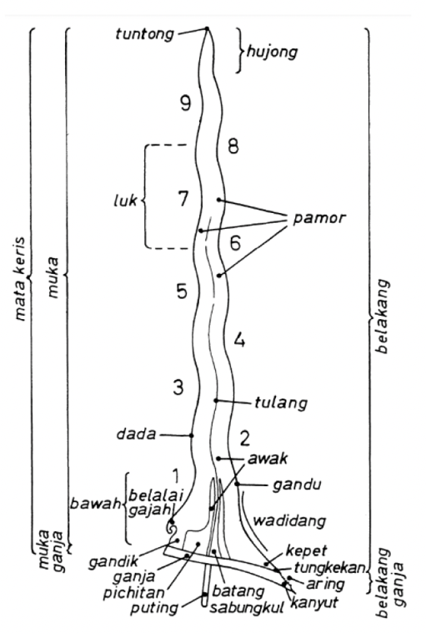
Figure 10. Anatomy of Keris
(Journal of the Malayan Branch of the Royal Asiatic Society)

Based on figure 15 show the Keris part. The anatomy of a keris or body is very complex, and a multitude of parts are essential to the keris. Each part has specific names and meanings. The blade (mata keris) is turned and folded many times and can be from a straight blade to a wavy one; the blade is folded and wrought out of several types of metal, which display distinct patterns called pamor, or damascene patterns. The base of the blade includes the ganja, which is a guard piece. Its body is also made up of other parts called the dagu (the chin), the kepala cicak (lizard head), the leher (neck), the perut (stomach), the ekor (tail). Each of these parts is unique, and embodies a functional component, and an artistic and philosophical meaning. Each keris is made in a painstaking process, that can take a lot of time and skill to complete. In this sense the keris embody the practice of the maker's art and the external complexities of social identity of the owner, beliefs, or family lineage (Yusof, N. A, et al. 2022).

In conclusion, the keris represent a significant aspect of Malaysia as a cultural symbol and a material representation of traditions, art, and identity. It is an embodiment of values, history, and philosophies of Malay civilization. Raya swords do inspiration from keris based on their appearance and design

Food
Raya and the Last Dragon features a wide variety of Southeast Asian foods, including those from Malaysia. One of the most visually rich and culturally expressive elements in the film is its portrayal of food. In the Talon night market scenes, when Raya and her friends eat on Boun’s boat, the characters share meals together. The film highlights dishes that resemble traditional Malaysian cuisine, such as satay. The food in Boun’s hand appears to be marinated meat served on skewers.

According to the Table of Popular Malaysian Heritage Foods adapted from the National Heritage Department (2005), satay is a beloved Malaysian heritage food. It features marinated meat skewers grilled over hot charcoal and served with a rich, fragrant peanut sauce. Its smoky flavour, paired with the creamy, slightly spicy dip, makes it a favourite during festive occasions and late-night market visits.

In one scene, when young Raya talks to Namaari, Raya asks her, “Do you like rice or stew more?” Namaari replies, “It’s my first time eating rice in a while.” From this exchange, we can see that rice was eaten by the people of Kumandra across different regions. In Malaysia, rice is unquestionably the main source of carbohydrates and calories, featuring in nearly every meal and most iconic dishes. Based on Table 3, we can see that rice-based dishes are also part of Malaysia’s popular heritage foods. The Heart region in the film was directly inspired by Malaysian culture (Solomon, K., & Ghez, D, 2021).

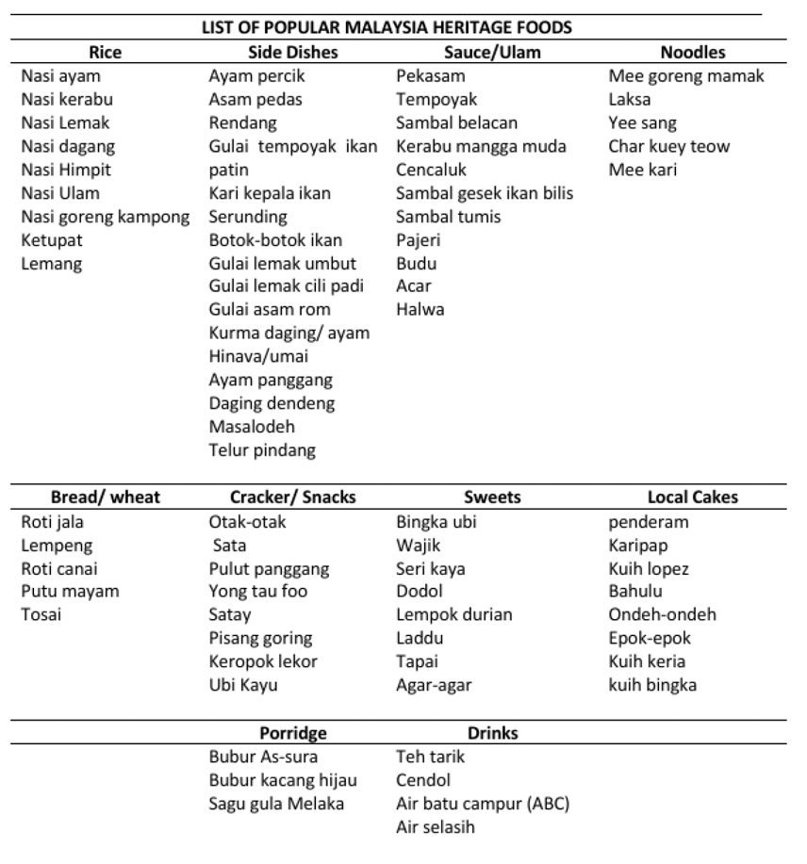
Figure 11. List of popular Malaysia Heritage Food
(National Heritage Department, 2005)

In conclusion, Raya and the Last Dragon highlights Malaysian foods such as satay and rice. Satay, a recognized Malaysian heritage dish, and rice, the nation’s staple food, are effectively represented in scenes like the Talon night market and Raya’s conversation with Namaari.

Language
The only explicit Malay-inspired component is the name of the main character. Screenwriter Adele Lim (a Malaysian) selected "Raya" because it means "celebration" in Malay. As Lim noted, the sound "Raya" (also "Eid" in Malay) imprinted a "this very joyful time" in Malay culture. Based on the Kamus Dewan and Pusat Rujukan Persuratan Melayu (Pusaka), "Raya" means a grand day or festive day, referring to a day of celebration. In conclusion, in the movie does use Malaysia language for a character name like Raya based on Adele Lim, a screenwriter said during the interview.

Art
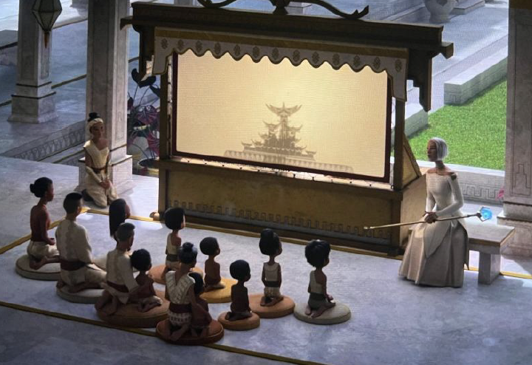
Figure 12. Watching a shadow puppet
(Raya and the Last Dragon, 2021)

Figure 12 depicts a scene in the Fang Kingdom where a group of children are seated cross-legged on mats, watching a shadow puppet performance. At the center is an illuminated screen displaying silhouettes and shapes that narrate a story, most likely one from Kumandra’s past. In Malaysia, this scene strongly resembles Wayang Kulit, or traditional shadow puppetry. The term “Wayang” means “shadow,” while “Kulit” refers to “leather,” the material from which the puppets are traditionally made. This form of storytelling involves intricately carved leather puppets that, when illuminated, cast dynamic shadows onto a screen. The performance is led by a Dalang (puppet master), regarded as the central figure of the art form. The Dalang manipulates the puppets from behind a white cloth, with bright light projecting their movements onto the screen, creating an illusion of interaction and motion. The performance is typically accompanied by traditional gamelan music, producing a full sensory experience.

Another segment of Raya and the Last Dragon portrays a female character creating intricate designs on a piece of white fabric using a traditional tool resembling a canting. The canting, which holds hot wax, is used to draw fine, symmetrical patterns, reflecting techniques associated with batik-making.

This scene represents the making of batik, a traditional textile art that holds deep cultural significance in Malaysia. In Malaysian practice, molten wax is applied to fabric using a canting tool to form detailed patterns, after which the fabric is dyed. The resulting motifs are often symmetrical and repetitive (Wahed et al., 2022). The process shown in the film is particularly similar to Batik Tulis (hand-drawn batik), which is recognized as part of Malaysia’s intangible cultural heritage (Abdullah, A.H, 2020). Batik not only symbolizes Malay cultural heritage but also reflects an essential part of Malaysia’s national identity. Its inclusion in the film underscores both the aesthetic richness and the cultural importance of Malaysia’s fine art traditions on an international platform.

In conclusion, the incorporation of Wayang Kulit and batik in Raya and the Last Dragon clearly demonstrates inspiration from Malaysian culture, as evidenced by the visual and thematic parallels in the film. According to The Art of Raya and the Last Dragon (2021), many elements of the Heart region were inspired by both Thai and Malaysian culture. The batik-making sequence, set within the Heart region, further emphasizes Malaysia’s influence on the film’s cultural world-building.

CONCLUSION

In conclusion, this study employed qualitative research methods to collect and analyze data related to the research topic. The primary source of data was the film Raya and the Last Dragon, while secondary data was obtained from scholarly articles, books, and other relevant literature that support the investigation. The purpose of this research was to analyze and interpret the influence of Malaysian cultural elements on the world-building of the film.

The findings indicate that several Malaysian cultural elements are explicitly represented in the film. For example, customs such as removing shoes before entering sacred spaces and dining traditions were reflected in the narrative. Architectural inspiration was also evident, particularly in the Fang kingdom palace, which shares similarities with the Rumah Gadang of Negeri Sembilan. Mythological elements such as the legend of Seri Gumum from Pahang parallel the characterization of Sisu, the water dragon. In terms of artifacts, Raya’s sword bears resemblance to the traditional Malaysian keris. Additionally, the protagonist’s name, Raya, is derived from the Malay word meaning “celebration.” Finally, heritage arts such as batik and wayang kulit were incorporated into the visual world-building of Kumandra. These examples collectively demonstrate that Raya and the Last Dragon draws significantly from Malaysian cultural heritage in the creation of its fictional universe.

Beyond identifying these elements, this study also highlights the broader role of culture in enhancing animated films. Cultural elements contribute to the creation of unique and authentic worlds, making the cinematic experience both enchanting and meaningful (News Pixar, 2018). They also enrich storytelling by incorporating myths, legends, and folklore, thereby adding depth, universality, and enduring emotional resonance (The Role of Mythology and Folklore in Artistic Storytelling, 2024). Moreover, authentic cultural representation enhances the emotional impact of narratives, leading to more nuanced and relatable stories (Cultural Authenticity in Animation: Why It Matters, 2024). Importantly, cultural integration also promotes diversity and inclusivity, as demonstrated in films such as Zootopia, which used metaphor to address issues of racism and coexistence.

For the animation industry, the inclusion of cultural elements provides significant benefits. Animation is evolving beyond entertainment to serve as a medium for education, cultural preservation, and moral storytelling (N. Azan, et al, 2010). This transition gives the industry new meaning and purpose, positioning animated films as tools for both artistic expression and cultural safeguarding.

ACKNOWLEDGMENT
We want to extend our heartfelt gratitude to the Faculty of Film, Theatre and Animation, Universiti Teknologi MARA (UiTM), for their invaluable support, expert guidance, and generous permission to utilise the faculty's facilities throughout our research titled "World Building: The Influence Of Malaysia Elements In Raya And The Last Dragon (2021)”. Their continuous encouragement and assistance played a crucial role in shaping the direction and execution of this study. Our sincere appreciation also goes to the Office of Research and Innovation, FiTA, for endorsing and approving this research for academic publication. Their trust in the potential of our work has been instrumental in advancing our scholarly contributions to the field of game narrative and cultural studies. Finally, we would like to acknowledge and thank all individuals, academics, collaborators, game developers, and respondents who have directly or indirectly contributed to the successful completion of this research.

REFERENCES

Abdul Mahya, S., Puspitasari, D., Wahyono, E., & Abdul Rosyid, O. (2025). An Analysis of Tolerance Values in the Movie of “Zootopia” .

Abdullah, A. H. (2020). The design and identity of batik tulis product selected of batik manufacturers in Klang Valley / Ahmad Hakim Abdullah - UiTM Institutional Repository. Uitm.edu.my. https://ir.uitm.edu.my/id/eprint/53710/1/53710.pdf

Broadway, D. (2024, November 29). “Moana 2” rides musical wave of Pacific culture and creativity. Reuters. https://www.reuters.com/lifestyle/moana-2-rides-musical-wave-pacific-culture-creativity-2024-11-26/

Cambridge Dictionary . (2019). DIVERSITY | meaning in the Cambridge English Dictionary. Cambridge.org. https://dictionary.cambridge.org/dictionary/english/diversity

Cuelenaere, E. (2020). Originality versus proximity: An explorative study of audience reactions to monolingual film remakes. International Journal of Cultural Studies, 136787792093879. https://doi.org/10.1177/1367877920938798

Ibrahim, B., Fauzi Yusof, & Saifudin, W. (2018). Malay Customs According to Islamic Perspective. International Journal of Academic Research in Business and Social Sciences, 8(10), 380–400. http://dx.doi.org/10.6007/IJARBSS/v8-i10/4743

Jani, H. H. M., & Hussain, M. R. M. (2014). Reclaiming the Loss of the Minangkabau Cultural Landscape in Negeri Sembilan. Procedia - Social and Behavioral Sciences, 153, 317–329. https://doi.org/10.1016/j.sbspro.2014.10.065

Kementerian Kebudayaan, Kesenian dan Pelancongan Malaysia. (2003). Koleksi siri mengenal budaya 1: Wayang Kulit. Cawangan Dokumentasi dan Penerbitan Bahagian Pembangunan Kebudayaan dan Kesenian.

Luo, Y., Aida, J., & Mohd Fitri Yusoff. (2025). Cultural elements in Chinese animation characters: A systematic review of their visual, narrative, and communicative roles. Edelweiss Applied Science and Technology, 9(5), 993–1009. https://doi.org/10.55214/25768484.v9i5.7047

McCombes, S. (2021, June 7). What is a research design | types, guide & examples. Scribbr. https://www.scribbr.com/methodology/research-design/

Mohamad, T., Shah, M., Rafik, H., Alimom, N., & Firdaus, N. (2020, May). CULTURAL IMPERIALISM IN MALAYSIAN ANIMATION.

Mohd Zahferee, I. M., Abdul Rani, M. K. A., & Rashid, M. A. (2023). Ethnography in Malaysia Animation Study: A Case Study on Kampung Boy. https://doi.org/10.30880/ahcs.2023.04.02.017

Moser, Z. (2023, March 5). The Japanese Folklore That Inspired Spirited Away. ScreenRant. https://screenrant.com/the-japanese-folklore-that-inspired-spirited-away/

Muzium Negara. (2023). Kepala Perahu | Official National Museum Website. Muziumnegara.gov.my. https://www.muziumnegara.gov.my/en/kepala-perahu

N. Azan et al. (2025). Convergence and Hybrid Information Technologies. Google Books. https://books.google.com.my/books?hl=en&lr=&id=1yWhDwAAQBAJ&oi=fnd&pg=PA209&dq=Azan

Omar, & Ishak, S. A. (2011). Understanding Culture through Animation: From the World to Malaysia. Jurnal Pengajian Media Malaysia, 13(2), 1–9.

Panjaitan, A., Rachman, A., & Handriyotopo. (2022, November). The interpretation of animation’s signs and meanings from Southeast Asian cultures through 12 principles: Raya and The Last Dragon. https://doi.org/10.33153/iicacs.v4i1.155

Raji, M. N. A., Ab Karim, S., Ishak, F. A. C., & Arshad, M. M. (2017). Past and present practices of the Malay food heritage and culture in Malaysia. Journal of Ethnic Foods, 4(4), 221–231. https://doi.org/10.1016/j.jef.2017.11.001

Reyes, A. (2018). A Celebration of Family and Culture: Disney/Pixar’s Coco – Gen Z Critics. Genzcritics.com. https://genzcritics.com/2018/02/a-celebration-of-family-and-culture-disney-pixars-coco/

Solomon, K., & Ghez, D. (2021). The art of Raya and the Last Dragon. Chronicle Books.
Sun, B. (2020a). Analysis on the Culture Concepts in the Movie Spirited Away. https://www.atlantis-press.com/article/125943999.pdf

Sun, B. (2020b, January). Analysis on the culture concepts in the movie spirited away. https://doi.org/10.2991/assehr.k.200826.107

Yusof, Nor Afian, Haron, H., Keng, L., & Mamat, M. (2022). The philosophy of keris design in malay civilization. International Journal of Academic Research in Business and Social Sciences, 12. https://doi.org/10.6007/IJARBSS/v12-i11/15302

