
Computer Professionals (Registration Council
of Nigeria)
Computer Engineering (CPE)
STUDY ON DESIGN AND SIMULATION OF A DRONE (QUADCOPTER)
By
Terrang, Atsaktiya Denis
Reg. No.: 203493
Supervisor
Dr. Essien Eyo

Submitted in partial fulfillment of the requirements for
CEN Programme
Computer Professionals (Registration Council of Nigeria)

April 2022
DECLARATION
I declare that this project on “Design and Simulation of a Drone (Quadcopter)” is my original work done by me with credit and proper attribution to outside sources under the supervision of Dr. Essien Eyo, Computer Professionals (Registration Council of Nigeria)

Terrang, Atsaktiya Denis

CERTIFICATION
This is to certify that this project work on “Design and Simulation of a Drone (Quadcopter)” was carried out by Terrang, Atsaktiya Denis with registration
Number: 203493.
We examined and found it acceptable for the award of membership in CEN program of the Computer Professionals (Registration Council of Nigeria)

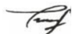
Dr. Essien Eyo
Signature:…………………………………….Date:…………18/4/2022………………….
Supervisor
ACKNOWLEDGEMENT
I am most grateful to God Almighty, the sole provider of all knowledge, wisdom, love mercy and grace without which this project or my existence would not have been possible. I also sincerely appreciate my supervisor Dr. Essien Eyo, who gave his time, effort, constructive criticism and corrections at every stage of this project development. I also appreciate my family, friends and colleagues that have one way or the other assisted me towards the success of this project.

ABSRACT
In the past, various industries and fields of endeavors has had a hard time in reaching certain places crucial to achieving their goals and objectives. This could be as a result of bad weather, awkward positions to reach or even places that could be dangerous for humans to access physically. For example, in the military, some enemy lines prove too difficult to conquer without mass casualty. In manufacturing, agriculture, commerce etc., poor weather and difficult positions makes accessing some places very strenuous. These were all before the advent of drones. A drone is an aerial vehicle which uses aerodynamic forces to provide vehicle lift which can be recoverable or expandable, can be piloted remotely or fly autonomously, does not carry a human operator, and can carry a non-lethal or lethal payload.
Beforehand, drones were used only for military applications like spying on both international and domestic threats because they do not put the life of a pilot at risk in combat zones. Currently, the developed drones can be used in a vast number of applications, such as deliveries, policing, monitoring flooded areas etc. This project focuses on designing and developing a general-purpose drone that can be used in different applications. A quadcopter is the model of drone that is simulated on this project depicting the aerodynamics and components needed for the development of a quadcopter.

Table of Contents
Chapter One 8
1.0 Introduction 8
1.1 Statement of Problem 10
1.2 Aim and Objectives 10
1.3 Scope of Study 11
1.4 Significance of Study 11
1.5 Limitations of Study 12
1.6 Definition of terms 12
1.7 List of abbreviations 13
Chapter Two (Literature Review) 14
2.0 Flight Dynamics 14
2.1 Six Degrees of Freedom (6DOF) 15
2.1.0 The Throttle Movements 16
2.1.1 The Roll Movements 17
2.1.2 The Pitch Movements 17
2.1.3 The Yaw Movements 18
2.2 Newtons Third Law 19
2.3.0 Rules for Determining the Movements of the Quadcopter 19
2.3.1 Rules for determining the Vertical Movements 19
2.3.2 Rules for determining the Lateral Movements 20
2.3.3 Rules for determining the Rotational Movements 20
Chapter Three (Methodology and Design) 22
3.0 System Requirements 22
3.1 Technical Specification 24
3.2 MATLAB Simulation 25
3.3 Simulation Code 26
3.4 Functions Code 28
3.5 CAD Design and Analysis 29
3.6.0 Components of the Quadcopter 30
3.6.1 Frame 30
3.6.1 Propellers 32
3.7.0 Electronic Design 35
3.7.1 BLDC Motors 35
3.7.2 Electric Speed Controllers 37
3.7.3 Battery 39
3.7.4 Arduino Nano Microcontroller Board 42
3.7.5 Inertia Measurement Unit (IMU) 44
3.7.6 RC Controller 46
Chapter Four 51
4.0 Implementation 51
4.1 Software 51
4.1.1 MultiWii 51
4.1.2 MultiWii Configuration 52
4.1.3 Proteus 61
Chapter Five 64
4.0 Summary 64
4.1 Conclusion 65
Reference 66
APPENDIX A: MATLAB Simulation & Functions 71
APPENDIX B: Schematics and Connections 73
APPENDIX C: MultiWii Configuration 74

CHAPTER ONE
INTRODUCTION
- Background of Study
For years, drones have been used for different purposes and has been of help in numerous occasions and applications. Today, these Unmanned Aeriel Vehicles (UAV) have evolved becoming more popular and their applications increased rapidly in various fields. The name “drone” is said to have originated from an old English word drān, drǣn, which means ‘male bee’. [1: Douglas, 2021] When we talk of drone as an electric device, it could be a missile or a remote-controlled pilotless aircraft designed to meet certain goals and objectives.
According to the figure below, the estimated investment in drone hardware in government, consumer, and enterprise has been increasing since 2015.
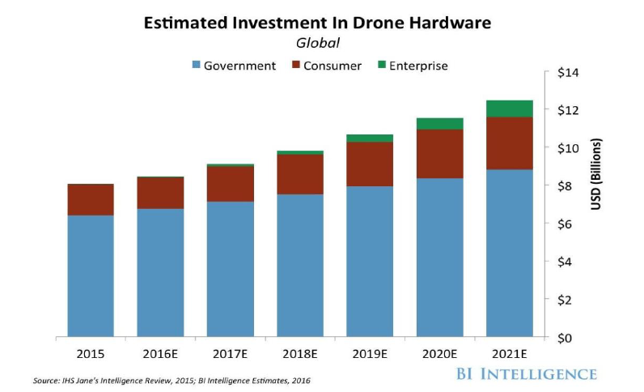
Figure 1: The Estimated Investment Growth in Drone Hardware [2: Joshi, 2019]
Undeniably, it was disclosed by research that human help is still required in order for the drone technology to start operating in new spaces. Currently, there are two types of drones. The former does not need a GPS as it hinges on a highly skilled person to keep full control of it. In other words, it relies on visual tracking in order to determine orientation as well as position. As for the latter, it contains GPS technology, which at first was reserved only for military purposes. Then, when they start allowing the use of this type of drone, many doors have opened for new fields of applications. It allows the drone to have multiple functions; for instance, it allows it to remain in a fixed position with respect to location and latitude. Another function is return to home, which allows it to remember the spot at which it took off and automatically returns to it, and this is made by pressing on a button called “return”. Clearly, this type of technology does not require any human pilot as it uses the autopilot concept by following the trajectory given by a set of GPS points, which is a way the autonomous flight predetermines the path of the drone [3: Chris, 2021].
Drones are technically called unmanned aerial vehicle as they are not operated by a pilot. These airborne crafts serve useful purposes in spying, military services and other related operations. Drones are often operated by a controlling person from the ground using a remote control or a computer.
Until recently, the idea of drones seemed futuristic, farfetched, and maybe unrealistic. The evolution of drones and its widespread adoption in various fields today is simply mouth-gaping. There applications not only in photography to take fun photos from the sky, geographic surveillance, package delivery or military operations have made drones the hottest toy on the market for both the young and old. The prices of drones range anywhere from under a hundred dollars to thousands upon thousands of dollars depending on specifications, and they come in different sizes everywhere from fitting into the palm of your hand to bigger than the average human being.
Quadcopter unmanned aerial vehicles are used for surveillance and reconnaissance by military and law enforcement agencies, as well as search and rescue missions in urban environments. The military use of unmanned aerial vehicles (UAVs) has grown because of their ability to operate in dangerous locations while keeping their human operators at a safe distance. The larger UAVs also provide a reliable long duration, cost effective, platform for reconnaissance as well as weapons. They have grown to become an indispensable tool for the military with or without payload in advanced countries. One such example is the Aeryon Scout, created by Canadian company Aeryon Labs which is a small UAV that can quietly hover in place and use a camera to observe people and objects on the ground [4: Aeryon, 2021].
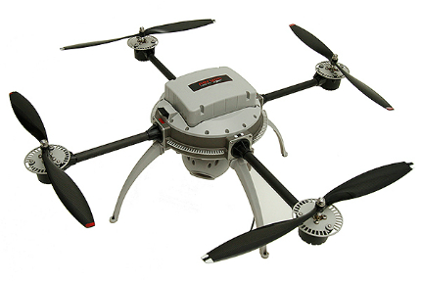
Figure 2: The Aeryon Scout Quadcopter
1.1 Statement of Problem
There are quite a number of challenges facing the design and implementation of drone systems.
- Unavailability of most of the critical electronic components that are crucial in prototyping a drone locally.
- Inadequate research sources and labs to fully deploy a simulated model.
- High cost of development of a drone system.
1.2 Aim and Objectives
The goal of my project is to promote and study the design of a drone system (Quadcopter).
The objective of study includes the following:
- Highlight the technology of the drone system and its application.
- Give breakdown of all the functional units of a drone system (Quadcopter) and their specifications.
- Design a detailed simulated model showing how stated functional components are connected and meet specification.

1.3 Scope of Study
The scope of this project shall cover an indebt study on Unmanned Aerial Vehicles (UAV) taking the design, modelling and development of a Quadcopter on center stage. This expands the scope of the electrical engineering education to include the control and the understanding of the mechanical components. The Quadcopter has many applications that we are interested to develop like mapping and video streaming especially in a disaster and dangerous area. It also opens up the possibilities to broaden the understanding and applications of control systems, stabilization, artificial intelligence and GPS navigation as it applies to the Quadcopter
1.4 Significance of Study
In addition to the military uses of the small UAV, we are interested in evaluating applications in the commercial and industrial sector. Our premise was that if smaller and cheaper UAVs become readily available, new markets and uses will emerge. Potential new markets in commercial and industrial applications include inspecting pipelines or even inspecting dangerous areas like a meltdown site at a nuclear power plant. Disaster relief or crop assessment seems also to be likely areas where small UAVs could be useful. We were also motivated by on-campus uses such as monitoring parking or quick-look video of an incident, or monitoring hard to reach locations, or exploration of a collapsed building or other dangerous location. Below is a list of fields of applications of drones:
- Military use
- Agriculture
- Engineering applications
- Search and rescue
- Aerial photography
- Shipping and delivery
- Aerial surveillance
- Research and science
- Mineral’s exploration.

1.5 Limitations of Study
- Cost of materials required in building a drone.
- Lack of free internet access for students to further their research.
- Limited or no access to Labs.
- Unavailable financial support to aid the student push further the development of the drone.
1.6 Definition of Terms
Drone: An unmanned aircraft or ship that can navigate autonomously without human control or beyond line of sight by way of GPS, remote control, or onboard computer.
Unmanned: Not having or needing a crew or staff.
Aeriel: Existing or being carried out in the air.
Missile: A guided airborne ranged weapon capable of self-propelled flight usually by a jet engine or rocket motor
Quadcopter: A simple flying mechanism that has four arms, which each one of them has a motor that is attached to a propeller.
Trajectory: the path followed by a projectile flying or an object moving under the action of given forces.
Latitude: A geographic coordinate that specifies the north–south position of a point on the Earth's surface.
Longitude: A geographic coordinate that specifies the east–west position of a point on the Earth's surface, or the surface of a celestial body.
Reconnaissance: Military observation of a region to locate an enemy or ascertain strategic features.
Airborne: In the air after taking off.
Pilotless: Lacking a pilot or needing no pilot.
1.7 List of Abbreviations
UAV - Unmanned Aeriel Vehicle
USART - Universal Synchronous Asynchronous Receiver Transmitter
GNC - Guidance, Navigation and Control
IMU - Inertial Measurement Unit
MCU - Microcontroller Unit
GPS - Global Positioning System
SPP - Serial Port Protocol
CW - Clock-Wise
CCW - Counter Clock-Wise
CFD - Computational Fluid Dynamics
BLDC - Brushless DC
LiPo - Lithium Polymer
ESC - Electronic Speed Control
6 DoF - 6 Degree of Freedom

CHAPTER TWO
LITERATURE REVIEW
2.0 Quadcopter Flight Dynamics
In a paper published in 2004 by Newcome (Newcome, 2012), he explained that unmanned aviation started almost the same time period as the manned one; thus, drone technology has existed for a century, but it is rooted to its testing drone in the first world war while its success was noted by most scholars in the second world war.
There are two frames which we will operate and need to be introduced. The first one is called the inertial frame and is defined by its position with respect to the ground along with the gravity pointing in the negative z-direction. The latter is called the body frame which is defined by the quadcopter’s different orientation. The figure below illustrates my explanation (Brown & McIsaac, 2018).
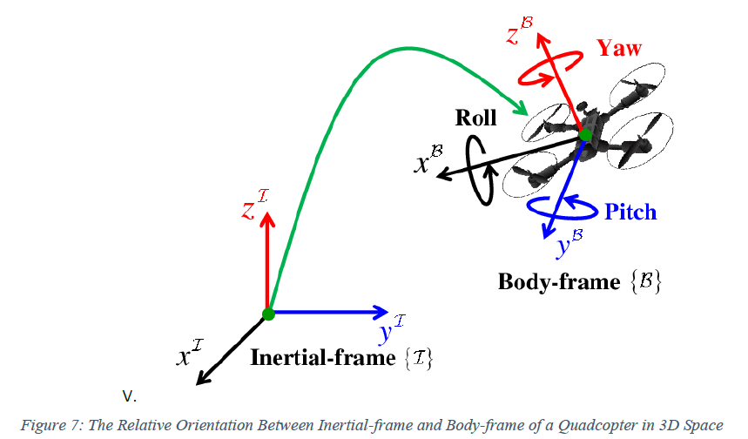
Figure 3: The relative Orientation Between Inertial-frame and Body-Frame of a Quadcopter in 3D space
The quadrotor’s position and attitude can be controlled by changing the speed of each motor to a desired value. Some moments and forces are performed on the drone such as; the thrust produced by the rotation of the motors, the rolling and pitching moments produced by the thrust of the difference of the four rotors, the gyroscopic effect which only appears in the drone construction lightweight, the gravity, and the yawing moment which may be cancelled out when two rotors rotate in the opposite direction.
Hence, the propellers and motors are split into two parts, which in each group has two diametrically opposite motors. Thanks to their rotation’s direction, we can distinguish as shown in figure 5 that left and right propellers (number 1 and 3) are rotating clockwise while rear and front ones (number 2 and 4) are rotating counter-clockwise (Sabatino, 2017).
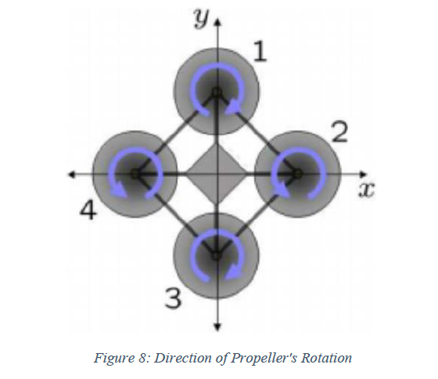
Figure 4: Direction of Propeller’s Rotation
2.1 Six Degrees of Freedom (6-DOF)
Six degrees of freedom are required to describe any time space motion of a rigid body and can be divided into two groups, which are the barycentre and the movement around it. There are three barycentre movements named as three translation motions that make the quadcopter move longitudinally (forward and backward), vertically (upward and downward), and laterally (right and left). In addition, there are three rotation motions along three axes which make the drone move rotationally among each axis to produce roll, pitch, and yaw movements.
These aforementioned motions when combined together generate what we call the six degrees of freedom. The quadrotor’s yaw motion is realized by the rotor that produces a reactive torque. The reactive torque’s size is relative to the speed of the rotor. When the speed of the four rotors is the same, the reactive torques will balance each other and hence the quadrotor will not rotate. However, when the speed of the four rotors is not absolutely the same, there will not be a balance in the reactive torque; thus, the quadrotors will start to rotate.
In order to control the quadrotors, its modelling process assumptions were made such as: its symmetric structure, its rigid body, and its ground effect is ignored. The quadrotor’s four basic movements which allows it to reach a certain altitude and height depending on each propeller’s speed of rotation are shown below along with their descriptions (Sabatino, 2017).
  - The Throttle Movements: This movement is provided by decreasing or increasing the speed of all the propellers with the same amount, which leads to a vertical force with respect to the body frame that lowers or raises the quadrotor. The vertical direction of the body frame coincides with the one of the inertial frames when the quadcopter is in a horizontal position. Otherwise, the inertial frame’s both the horizontal and vertical accelerations are generated by the thrust provided. The throttle movement in the quadcopter sketch is shown in figure 6. The propellers speed Ω𝑖,𝑖=1,…,4 are equal in this case to Ω𝐻+Δ𝐴 . For each. The Δ𝐴 (rad/s) is a variable (positive one) that represents with respect to the constant value an increment. The Δ𝐴 should not be too big because the quadrotor would ultimately be affected by saturations or non-linearities (Harpreet, 2021).
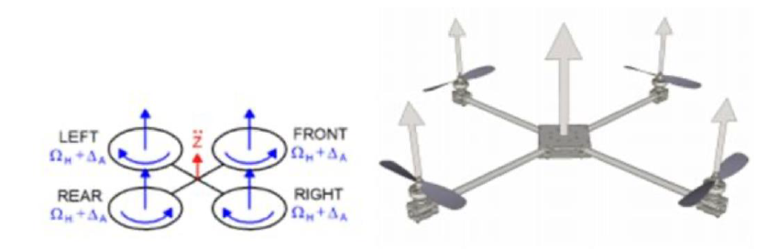
Figure 5: Throttle Movement
    - The Roll Movements: This movement is provided by decreasing or increasing the left and right of the propellers’ speed. With respect to the x- axis, this leads to a torque (figure 6), which makes the quadcopter tilt side to side (left or right). In hovering is the same as the overall vertical thrust; thus, this movement yields only to a roll angle acceleration towards the side with decreasing propeller speed (left or right). Figure 6 shows the roll movement on a quadrotor sketch. The Δ𝐵 positive variable is chosen so that the vertical thrust is remained unchanged. Similar to the previous case, it should not be too big because the quadrotor would ultimately be affected by saturations or non-linearities (Harpreet, 2021).
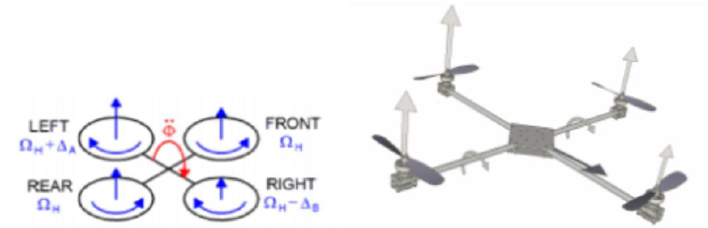
Figure 6: The Roll Movement
    - The Pitch Movements: This movement is very similar to the roll one and is provided by decreasing or increasing the rear and front of the propellers’ speed. With respect to the y- axis, this leads to a torque (figure 7), which would make the quadcopter tilt up and down from front to back. In hovering is the same as the overall vertical thrust; thus, this movement yields only to a pitch angle acceleration. Figure 7 shows the pitch movement on a quadrotor sketch. Similar to the previous case, the Δ𝐶 positive variable is chosen so that the vertical thrust is remained unchanged and cannot be too big.

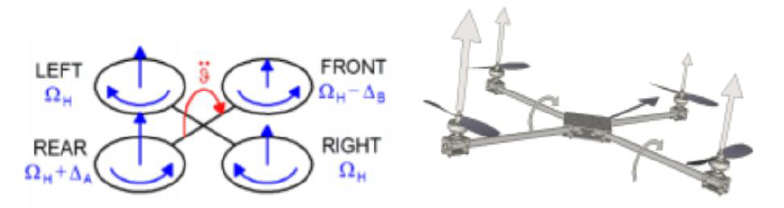
Figure 7: The Pitch Movement
    - The Yaw Movements: This movement is provided by decreasing or increasing the rear and front of the propellers’ speed and by increasing and decreasing that of the right-left couple. With respect to the z- axis, this leads to a torque, which makes the quadcopter move around in a counter-clockwise/clockwise rotation as it remains level to the ground. The fact that the rear-front propellers rotate counter-clockwise while the right-left ones rotate clockwise, generates the yaw movement (figure 8). Therefore, as stated previously, the quadcopter turns on itself when the overall torque is unbalanced. In hovering is the same as the overall vertical thrust; thus, this movement yields only to a yaw angle acceleration. Figure 8 above shows the yaw movement on a quadrotor sketch.
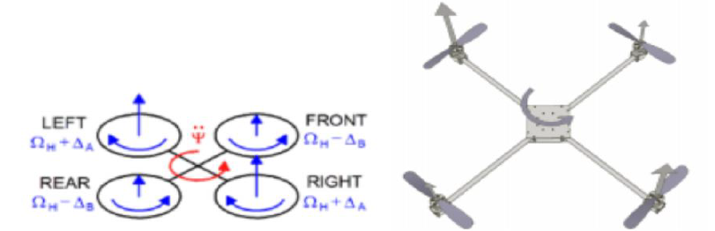
Figure 8: The Yaw movement

2.2 Newtons Third Law
In 1687, English scientist Sir Isaac Newton published his now famous three laws of motion. These laws describe how forces and objects interact to affect motion. Newton’s third law of motion states that for every action, there is an equal and opposite reaction. When a quadcopter’s propellers spin, they push air downward. Using Newton’s third law, this represents the action. For Newton’s law to be true, there must be an equal and opposite reaction. This reaction is an upward force pushing on the quadcopter. Once this force exceeds the force of gravity pulling the quadcopter downward, the quadcopter begins to move up. (NASA, 2020)
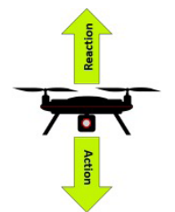
Figure 9: Newtons third law explains the upward motion of a quadcopter.
2.3.0 Rules for Determining the Movement of the Quadcopter
To determine the movement of the quadcopter, the following rules are used:
    - Rules for determining vertical movement
When the force of lift acts straight upward, the quadcopter moves vertically. But, when lift acts at an angle, it can also move laterally. This is because part of the force of the lift is upward and part of it is to the side, resulting in lateral movement that can be from side-to-side or forward and backward. Basic rules for vertical movement are stated below with reference to figure 10:
• If the total lift is greater than the force of gravity, the quadcopter moves up.
• If the total lift is equal to the force of gravity, the quadcopter doesn’t move vertically.
• If the total lift is less than the force of gravity, the quadcopter moves down.

    - Rules for determining lateral movement
Lateral movement occurs by varying the speed of the propellers. Increasing the speed of the two propellers on one side of the quadcopter and/or decreasing the speed of the two propellers on the other side creates uneven amounts of lift on the two sides. The lift created on the side with the faster spinning propellers is greater than the lift created on the opposite side. The result is that the quadcopter moves in the direction of the side where less lift is created. Basic rules for lateral movement are stated below with reference to figure 10:
• If the lifts of propellers 1 and 4 add up to more than the lifts of propellers 2 and 3 added together, it moves right.
• If the lifts of propellers 2 and 3 add up to more than the lifts of propellers 1 and 4 added together, it moves left.
• If the lifts of propellers 1 and 2 add up to more than the lifts of propellers 3 and 4 added together, it moves backward.
• If the lifts of propellers 3 and 4 add up to more than the lifts of propellers 1 and 2 added together, it moves forward.
2.3.3. Rules for determining rotational movement
This type of movement relies on a force called torque, a twisting force that causes rotation. When a propeller spins, this force is produced. And, according to Newton’s third law of motion, an equal and opposite force is produced as well. Basic rules for rotational movement are stated below with reference to figure 10:
• If the lifts of propellers 1 and 3 add up to more than the lifts of propellers 2 and 4, it rotates counterclockwise.
• If the lifts of propellers 2 and 4 add up to more than the lifts of propellers 1 and 3, it rotates clockwise.
• Otherwise, there is no rotational movement.
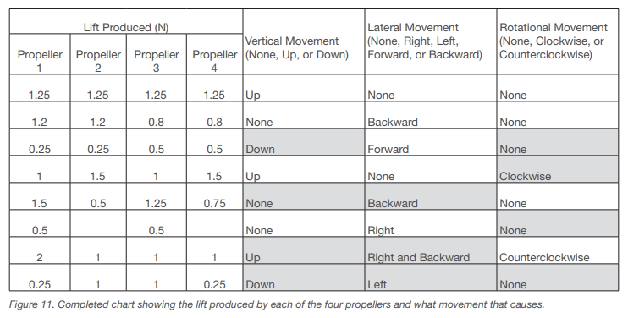
Figure 10: Completed chart showing the lift produced by each of the four propellers and what movement that causes

CHAPTER THREE
METHODOLOGY AND DESIGN
3.0 System Requirements
Requirements are important because they establish a foundation for product scope, vision, schedule, and cost. They eventually should target the quality and performance of a finished product. Requirements supply stakeholders like electrical engineering, software engineering, and mechanical engineering with one uniform set of goals and vision. Each stakeholder holds realistic expectations after understanding the requirements of the final product. No surprises should occur from the final product in terms of functionality and design, which will yield a profitable and a successful product launch (Mann, 2017). In order to determine the project requirements, a hierarchical decomposition of a quadcopter is shown below:
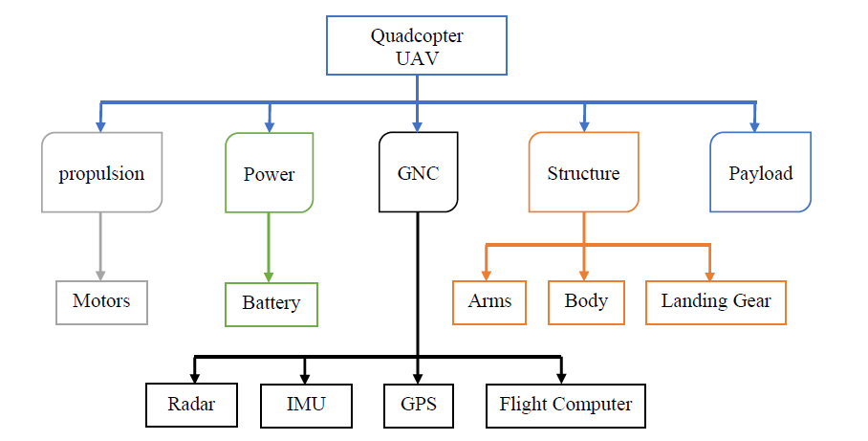
Figure 11: Hierarchical Decomposition of a Quadcopter
The figure above describes a hierarchical decomposition of a simplified model of a quadcopter drone by dividing it into two tiers. The first one has five primary subsystems, which consist of power, propulsion, structures, GNC, and payload. As for the second one, it further breaks down to smaller units comprising the battery, IMU, flight computer, radar, motors, GPS, body, arms, and landing gear.
The table below shows the quadcopter’s requirements along with their descriptions.
Requirements |  | Description
1 | The drone should fly remotely | The user should control the drone by using a handheld controller. The user should be able to fly the drone in any direction and at any height up to the maximum altitude.
2 | The drone should fly to a maximum height of 500 meters | The drone should be able to fly at any altitude up to 100 meters.
3 | The drone should carry a load up to 2kg | The drone should be able to carry a 2 kg load in the payload while flying. It should be controllable and stable.
4 | The drone should fly left, right, back, forward, up, and down | The user should be able to fly the drone at any direction.
5 | The drone should fly up to 600 meters away from the user | The drone should be controllable up to a distance of 600 meters from the user by operating it with the remote controller.
6 | The drone should fly with the maximum payload of 2kg for at least 15 minutes | The drone should provide a stable flight while carrying the maximum payload for a minimum of 15 minutes.
7 | The drone should spin both clockwise and counter-clockwise | The drone should be able to spin while flying when the user needs it to. The spin needs to be in both directions.
8 | The drone’s frame should be designed to provide a payload and an enough room for all components. | The drone’s frame should have enough room and support for an Arduino, flight controller, BLDCs, LiPo battery, ESCs, and any sensor. Also, a payload is required so that it can lift any object to deliver.
9 | It should be a medium size | The drone’s design should be compact (500 mm at most).
10 | Propellers of high thrust are needed | Propellers need to be 10 inch into 4.5 pitch to have enough thrust to lift the drone in such size.
Table 1: Quadcopters Requirements along with their descriptions
3.1 Technical Specification
The drone’s technical specification is the technical data that makes a clarified description for the drone’s specific use, functionality, or performance levels.
We should hence abridge the previous concept by claiming that the quadcopter’s technical specification is a set of Key Performance Indicators (KPIs), which is able to describe the performance competence of a quadcopter.
The set of the significant technical data or the technical specification plays a crucial role when it comes to make a formal decision about choosing the ideal drone; especially, when making a comparison between different quadcopter models. Nonetheless, when acquiring the right indicators of the technical specifications is not always easy for two reasons. The first one is because some fundamental parameters are hidden by some manufacturers as they are not optimal when compared to the rivalry (Affortunato, 2020). The second one because the specifications are not the same reported by all manufacturers. For instance, producer A can report his drone’s maximum tangency quota; on the other hand, producer B can only omit this data in the technical specs.
Having the system requirements in mind, the figure shown below describes the specifications that my quadcopter should meet.
Metric | Value
Dimensions | 405mm x 371mm x 70mm
Weight | 1000 g
Power | 200 W
Rotors | 4
Propellers | 10” x 4.5” (10 inches in diameter and 4.5 inches in pitch).
Battery | 3300 mAh (C) 3S LiPo 35C (Max)
Controller | Arduino uno
Payload Mass | 150 g
Diagonal Size (Propellers excluded) | 520 mm
Motors (for medium size quadcopter 500mm) | A2212 brushless outrunner dc motor, 1000kv.  No load current @ 10V: 0.5A  Thrust @ 3S with 1045 propeller: 800gms approx.
Current Capacity | 12A/60s
Motor Dimensions | 27.5 x 30mm
ESC Specification | 18A (30A Recommended)
Propellers RPM | 7536 RPM
Input Voltage | 11.1V
Pitch Speed | 32.1 MPH (51 KMH)
Efficiency | 80%
Weight that the drone can lift | 2 kg or more
Flight Time | Up to 15 minutes
Table 2: Quadcopter’s specification
3.2 MATLAB Simulation
After completing the motion’s equations which describe the flight system’s dynamics, now a simulation environment to view and test the results of several controllers and inputs can be created. Even though some methods, which are more advanced are available, a simulator which uses the method of Euler can quickly be written to solve differential equations that evolve the state of the system. This simulator along with the functions needed to compute all the physical torques and forces are shown in APPENDIX A using MATLAB. Besides, values needed for all my physical constants, which were not shown are: Functions to convert from the derivatives of yaw, pitch, and roll to an angular velocity vector omega and vice-versa, and a function that computes the rotation matrix R. Then, the 3D visualization quadcopter is drawn along with angular velocity and displacement as the simulation is running like shown below (Gibiansky, 2012).

Figure 12: Quadcopter Flight Simulation
3.3 Simulation Code
Although more advanced methods are available, we can quickly write a simulator which utilizes Euler’s method for solving differential equations to evolve the system state. we can create a simulation environment in which to test and view the results of various inputs and controllers. In MATLAB, this simulator would be written as follows:
1 % Simulation times, in seconds.
2 start_time = 0;
3 end_time = 10;
4 dt = 0.005;
5 times = start_time:dt:end_time;
6
7 % Number of points in the simulation.
8 N = numel(times);
9
10 % Initial simulation state.
11 x = [0; 0; 10];
12 xdot = zeros(3, 1);
13 theta = zeros(3, 1);
14
15 % Simulate some disturbance in the angular velocity.
16 % The magnitude of the deviation is in radians / second.
17 deviation = 100;
18 thetadot = deg2rad(2 * deviation * rand(3, 1) - deviation);
19
20 % Step through the simulation, updating the state.
21 for t = times
22 % Take input from our controller.
23 i = input(t);
24
25 omega = thetadot2omega(thetadot, theta);
26
27 % Compute linear and angular accelerations.
28 a = acceleration(i, theta, xdot, m, g, k, kd);
29 omegadot = angular_acceleration(i, omega, I, L, b, k);
30
31 omega = omega + dt * omegadot;
32 thetadot = omega2thetadot(omega, theta);
33 theta = theta + dt * thetadot;
34 xdot = xdot + dt * a;
35 x = x + dt * xdot;
36 end
3.4 Functions Code
We would then need functions to compute all of the physical forces and torques. The functions code below are used to take in physical inputs and used to calculate the thrust, torques, acceleration and angular acceleration of the quadcopter in flight.
1 % Compute thrust given current inputs and thrust coefficient.
2 function T = thrust(inputs, k)
3 % Inputs are values for ωi²
2
4 T = [0; 0; k * sum(inputs)];
5 end
6
7 % Compute torques, given current inputs, length, drag coefficient, and thrust coefficient
8 function tau = torques(inputs, L, b, k)
9 % Inputs are values for ωi²
10 tau = [
11 L * k * (inputs(1) - inputs(3))
6
12 L * k * (inputs(2) - inputs(4))
13 b * (inputs(1) - inputs(2) + inputs(3) - inputs(4))
14 ];
15 end
16
17 function a = acceleration(inputs, angles, xdot, m, g, k, kd)
18 gravity = [0; 0; -g];
19 R = rotation(angles);
20 T = R * thrust(inputs, k);
21 Fd = -kd * xdot;
22 a = gravity + 1 / m * T + Fd;
23 end
24
25 function omegadot = angular_acceleration(inputs, omega, I, L, b, k)
26 tau = torques(inputs, L, b, k);
27 omegaddot = inv(I) * (tau - cross(omega, I * omega));
28 end

3.5 CAD Design and Analyses
SolidWorks is used as the CAD design, which is a 3-D modelling CAD and CAE software that runs primarily on Windows operating systems. It is used for mechatronics systems development from the start to the end. Initially, SolidWorks is used to plan, visualize ideation, model, assess feasibility, prototype, and manage projects. Then, it is used to design and build software, mechanical, and electrical elements.
This software can also perform different analyses on the product in order to check its behaviour in the real world. Hence, it can be tested differently before the product is manufactured. To make it clearer, the product can go through three stages using this software.
First, the product is conceptualized and drawn. Second, it is modelled and analysed virtually depending on the user’s needs. Finally, it is modelled and analysed in real life by 3-D printing it or laser cutting it but this is beyond the scope of this project.
One of the SolidWorks major advantages over other CAE and CAD Software is that the desired part design can be rendered in many different materials, and the quality is so good in such a way that makes it very realistic.

3.6.0 Components of the Quadcopter
3.6.1 Frame
One of the most critical parts is the frame in every design. It needs to be formable, rigid (the material is selected carefully), and able to withstand the pressure and the seasonal weather like rain, wind, and so on so that the vehicle does not fail. Furthermore, it can be used as a mounting platform for all crucial components (mechanical, electrical, and propulsion).
In order to prepare a design for my drone project, many designs were observed from different websites. However, the one chosen by me is a wooden drone frame from a website called Grab-Cad, and many modifications can be made according to the material, dimensions, and thickness. Once I am done with the project the new developed design will be uploaded to the same website in order to make it available for interested members. The two figures below show the frame chosen in both the collapsed and exploded view (Dragatis, 2018).

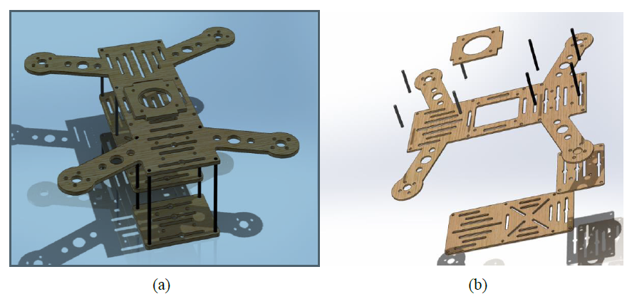
Figure 13: (a) The collapsed view of the drone. (b) The exploded view of the drone
The figure down below is the top view dimensions of the drone:
Figure 14: The Top View Dimensions of the Drone
Before launching a product in the market, a prototype should be made. Nonetheless, in addition to the time and money to make a prototype, analyses and tests should be performed to assure its design effectiveness and physical capabilities. Nowadays, many manufacturers use CAE or CAD to either 3D print or laser cut a desired product.
Consideration is taken into the latter information and different analysis made to compare materials used in laser cutter and 3D printing. There are two materials available to choose for the laser cutter, which are: Fiberboard (Plywood) and acrylic (plexiglass). The aforementioned materials are compared with the ABS (Acrylonitrile Butadiene Styrene), which is used as a material in 3D printing. The table below shows the properties of the discussed materials.
Materials | Plywood |  | Acrylic |  | ABS
Properties | Values |  |  |  |  |  | Units
Elastic Modulus |  | 8×109 |  | 3 ×109 |  | 2 ×109 |  | 𝑁/𝑚2
Poisson’s Ratio |  | 0.3 |  | 0.35 |  | 0.394 |  | 𝑁/𝐴
Shear Modulus |  | 0.62 ×109 |  | 0.89 ×109 |  | 0.3189 ×109 |  | 𝑁/𝑚2
Mass density |  | 615 |  | 1200 |  | 1020 |  | 𝐾𝑔/𝑚3
Tensile Strength |  | 31 ×106 |  | 73 ×106 |  | 30 ×109 |  | 𝑁/𝑚2
Yield Strength |  | 15.6 ×106 |  | 45 ×106 |  | 40 ×106 |  | 𝑁/𝑚2
Thermal conductivity | 0.21 |  | 0.2256 |  | W/(m.K)
Table 3: Properties of materials
One of the analyses is the drop test. It assesses an assembly or a part’s impact with a flexible or rigid planar surface. The software calculates the gravity and impact loads automatically, and no other restraints or loads are allowed. I chose the case if the drone is dropped from a height of 100 meters (front plane) for all materials.
From the materials’ table of properties and all the above analysis simulations taking into account the materials’ costs. I would say that the best option is to laser cut the frame with acrylic material. More than that, acrylic does not rot or absorb water and has more other advantages.
3.6.2 Propellers:
One of the most crucial parts the quadcopter are the propellers. The craft’s wings are these spinning blades which lift the system into the air by creating an airflow. There are many different sizes and shapes but the same overall purpose that the drone propellers come with; however, each flight characteristics can be different dramatically.
In order to choose the right drone propeller, we must take into consideration miscellaneous factors. Power and the drone flight smoothness can be significantly affected by the propellers; hence, the flight efficiency is one of the most fundamental considerations to be taken. Size and number of blades are important factors when selecting new propellers of a drone.
Depending on the platform, payload, and usage requirements, the number of blades per propeller required will vary. Smaller blades (under 8 inches) are most usually used for acrobatics and racing drones. Generally, smaller motors with high kV ratings are paired with smaller blades. Larger blades (over 8 inches) can be used to carry heavier payloads like spraying containers for agriculture and video equipment. They are generally paired with low kV motors. When selecting a propeller, we need to choose wisely taking into account its diameter and pitch.
Pitch: is known as the propeller’s traveling distance per each revolution. Frequently, it depends on what the specific application is for a quadcopter platform to determine the correct pitch. Lower pitch generally leads to less turbulence and more torque for lifting; as a consequence, it relieves how hard the motors have to work to lift heavy payloads resulting in a flight time increase because less current is drawn by the motors from the battery. Higher pitch propellers can move more air, but they create less torque and more turbulence.
Diameter: typically, a propeller blade with a larger diameter permits more contact with the air. This latter has a relation with the flight efficiency, when there is a small decrease or increase in diameter, it can change the efficiency of the drone performance. There is a tendency that when hovering, larger propellers are more stable than smaller ones. Nevertheless, less effort is required for the smaller propeller blades to slow down or speed up than larger ones, which make them more responsive. As said previously, larger propellers with low pitch are better suited for aerial video cameras and lifting heavy payloads while smaller propellers with high pitch are more appropriate for quick and fast manoeuvres.
As a summary, depending on the planned utilization and many other factors as aforementioned that need to be taken into account in order to select well the propeller blades of the quadcopter. For instance, larger propeller blades with low pitch are more suited in applications that require heavy lift (Rees, 2017).
Since I already know the components, to be used to create a quadcopter, we take advantage of the report discussed whereby the 30A ESC, A2212 1000 KV brushless motors, and the size (10” x 4.5”) of my propellers are used to see how much thrust and ampere can be obtained from them using excel. The motor propeller combination will be using for my quadcopter, and this test gives some important data for the dimensioning.
When the set of propellers chosen is used with the 3 cells battery and 1000KV motors, the ability of 0.97 kg of static thrust can be given by each motor in which 172 Watts that will be consumed. In other words, around 4kg that the system will be able to lift. From my background studies, it is known that it is recommended for the quadcopter to lift twice its weight, which means that at least 500 grams should be lifted by each arm.
A simulation of the propeller can be made in SolidWorks using Computational Fluid Dynamics (CFD), but before that, a propeller has to be imported to the Software. The propeller used is shown in the figure below:
Figure 15: Propeller Model Used in the Simulation (Wankhade, 2020)
Myriad of analysis methods are used by engineers to better understand the world’s impact around us on their designs. One of the best and a key analysis method that is used to analyze and solve problems, which involve the fluid flow impact like gases or liquids is Computational Fluid Dynamics. Many industries use CFD to solve a wide range of engineering problems, including aerodynamics and aerospace analysis, high-tech electronics cooling, combustion and engine analysis, industrial systems design, and many others (Staples, 2014).
3.7.0 Electronic Design
In order to have a safe and smooth flight, all drone components and parts are vital. When knowing the drone components, the user can have more confidence while flying it. After knowing each drone component, it will help the user to get to the bottom of any flight issue.
The figure 16 shows the schematics of the electrical components and in APPENDIX B it shows it in detail. Each component is shown and explained in detail in the following sections.
Figure 16: Quadcopter Electrical Connections Schematics
3.7.1. BLDC Motors
Brushless motors are brushless outrunner motors or DC electric motors, which are also known as ECMs (Electronically Commutated Motors). Those motors are synchronous, powered by an electric DC source through an integrated inverter switching power supply that produces an electric alternating current (AC) signal in order to drive the motors. This latter implies a bi-directional current with no restriction on waveform rather than a sinusoidal one. The BLDC motors I chose to work with are 1000 kV ones made specifically for multirotor and quadcopters. They provide power, high performance, quality, dependability at an affordable price, and brilliant efficiency. They are perfectly suited for medium size drones with propellers of 8 to 10 inch.
When ordered, they come with power leads, prop adapters, and mounting bolts as shown in the figure below. Each 30A ESC should be used to drive each motor.
Figure 17: A 1000KV BLDC Motor
These kinds of motors were made with wire wound stator poles and a permanent magnet rotor. The attractive magnetic forces between a rotating magnetic field, which is induced in the wound stator poles, and the permanent magnetic motor convert the electrical energy into a mechanical one.
There are 3 electromagnetic circuits that are commonly connected to a point, and each one of them is divided in the center; hereby, allowing the permanent magnetic rotor to move amidst the induced magnetic field.
Brushless motors can be used in so many applications, such as: electric bicycles, fans to raise the system’s overall efficiency, spindle drives, pumps, and so many others.

The table below shows the technical data sheet of the BLDC motor [19].
Table 4: Technical data sheet of the BLDC motor
3.7.2. Electric Speed Controllers (ESCs)
ESC or an electronic speed controller is a device installed in a remote-controlled model to control the speed and direction of a brushless motor. Each one of them has an output for a motor and an input for a battery. Four of them are required so as to control each motor.
Figure 18: Electronic Speed Controller (ESC)
In this experiment, a 30A ESC will be used to control each of the brushless motors which constantly provide required current to drive the motors. My ESC has the following specifications:
Continuous Current | 30A
Burst Current (>10s) | 40A for 15 seconds
Battery Cell | 2-3S (Li-Po)/ 5-9 cells (NiMH)
Maximum Speed | 210000 RPM (2 poles motor), 70000 RPM (6 poles motor), 35000 RPM (12 poles motor)
Usage | Applicable for medium size quadcopter
Weight | 39 g
Dimension | 68mm × 25mm × 8mm
Bec Output | 5V/ 2A
Bec Mode | Linear
Motor Type | Brushless
Voltage Input | 6.4V- 16.8V
Table 5: ESC Specifications
3.7.3. Battery
Li-Po batteries currently dominate the market due to their high current discharge and high energy density when it comes to lightweight drones. They are composed of many cells connected in series but rarely in parallel, which are denoted respectively by S or P. Depending on the charge’s state how the cell voltage changes; nonetheless, there is going to be permanent damage when discharging a Li-Po cell below 3V. Hence, discharging about 20% the battery is recommended, which gives an 80% depth of discharge. Besides, these batteries are characterized by a C rating, which identifies the maximum drawn current continuously, and their capacity in mAh. Obviously, this shows that maximum discharge current cannot be dependent on the battery capacity.
In this experiment, a high amount of current is needed for the brushless motors to be used. Therefore, a 3 cell 3300 mAh 11.1 V Li-Po battery that can supply roughly 3A current constantly is used. This latter is not heavy and provides sufficient current, which is ideal for this application. Unlike Li-Po, NiMH is cheaper but much heavier. These kinds of batteries (Li-Po) vary from single 3.7 cells up to 37V 10 celled. The most well-known one is the 3SP1 that is three celled and is 11.1V.
Figure 19: 3300mAh 3 Cell Li-Po Battery
The power that each motor outputs at 7500 RPM rotation is 52 Watts, which after summing four of them up, we get 208 Watts. As previously mentioned, the motors have a maximum of 80% efficiency, which leads to an input power of the motors of roughly 20880%=260 𝑊𝑎𝑡𝑡𝑠…(01)
No more than 20 Watts will be used by the rest of the system. This permits a total input power of 280 Watts as a safe estimation that the battery should deliver. Taking into consideration that a 3 cell 11.1V battery will be used, a 22A will be drawn by the current, and as previously mentioned, the battery capacity is 3300 mAh with a 35C max current discharge, this clearly means that the battery can safely draw 3.3𝐴ℎ × 35=115.5 𝐴 …(02)
This latter puts my system on the safe side. If we consider a constant current draw of 20A (the drone will not run at 7500 RPM the whole time), then the maximum flight time will be 3.3 𝐴ℎ20𝐴×60𝑚𝑖𝑛ℎ⁄≅10 𝑚𝑖𝑛𝑢𝑡𝑒𝑠. …(03)
This shows that my system will be able to fly for roughly 10 minutes at full throttle. Since from the start of the project, I specified that I want my drone to be able to fly for at least 15 minutes, we should consider a constant current draw of 13 A to fulfil that. In this case, the total flight time will be 3.3 𝐴ℎ13𝐴×60 𝑚𝑖𝑛ℎ⁄=15.23 𝑚𝑖𝑛𝑢𝑡𝑒𝑠. …(04)
The table below shows my current system’s battery specification.
Table 6: Battery Specifications.

3.7.4. Arduino Nano Microcontroller Board
When it comes to pinouts and features, the Arduino Nano Microcontroller board is quite similar to Arduino UNO. The only difference is its size, which made it better since it has the same functionalities but lighter. In my project, I made sure that each component I choose should be as light as possible so that my system’s flight remains smooth, and as it is known, it is preferred that the embedded devices to be smaller in size.
The Arduino Nano is a complete, small, and breadboard-friendly based on the ATmega328. This general-purpose microcontroller allows to make own flight controller by assembling the controller and coding it personally. It is a robust and reliable platform that can be connected to a computer by using a USB cable, an AC/DC adapter to power it up, and a battery. The best thing about this controller is it allows me not to worry about destroying it in case I mess with it. Finally, in order to program the Arduino Nano, the Arduino IDE Software is used.
Figure 20: Arduino Nano Microcontroller Board

Some of this Arduino features that need to be known are shown in the table below.
In total, it has 22 input/output pins.
14 of these pins are digital.
The last 8 are analogue.
Among the digital pins, the Arduino Nano has 6 PWM.
Its crystal oscillator has 16 MHz
Its operating voltage varies from 5V to 12V.
Table 7: Arduino Nano Features
The Arduino Nano Pinout is represented as shown in the figure below.
Figure 21: Arduino Nano pinout

The table below shows my Arduino Nano technical specifications.
Table 8: Arduino Nano Technical Specifications
3.7.5. Inertial Measurement Unit (IMU)
The IMU or Inertial Measurement Unit is used to level my quadcopter and measure its velocity, orientation, and force of gravity. This data is very significant for manoeuvring the quadcopter. This board uses the I2C-bus to interface with the Arduino Nano Microcontroller board.
The IMU uses a collection of sensors which is comprised of a gyroscope that reads the angular velocity values around the X, Y, and Z axis of the IMU and an accelerometer that measures the force (downwards gravity) and acceleration on the X, Y, and Z axis. These when combined are called the six degrees of freedom (6-DOF), which were previously explained in detail in this report. This is how it senses the orientation of the quadcopter.
Sometimes the IMU can be comprised of other sensors such as barometers, magnetometers, and other sensors to supplement these. As I reported previously, mine is a 6-DOF IMU that only contains a gyroscope and an accelerometer.
Figure 22: Inertial Measurement Unit (IMU)
The tables below show its technical specifications, including the accelerometer and gyroscope ones.
Specifications
Chip | MPU-6050
The Power Supply | 3-5 V (internal low voltage difference voltage stabilizing)
On-board Crystal | 32.768 KHz
Output Current | 3.6 mA
Supply Voltage | 5V
Communication | Standard IIC communication agreement
Pin Pitch | 2.54 mm
Size | Roughly 20 ×15×1.2 mm
Table 9: Technical Specifications
Accelerometer Specifications
Communication Interfaces | I2C
Range | ± 2g, ± 4g, ± 8g, and ± 16g
Sensitivity | 16.384 LSB/g (± 2g), 8192 LSB/g (± 4g), 4096 LSB/g (± 8g), and 2048 LSB/g (±16g)
Table 10: Accelerometer Specifications
Gyroscope Specifications
Range | ± 250°/sec (dps), ± 500 dps, ± 1000 dps, and ± 2000 dps
Sensitivity | 131 LSB/dps (± 250 dps), 65.5 LSB/dps (± 500 dps), 32.8 LSB/dps (± 1000 dps), and 16.4 LSB (± 2000 dps)
Table 11: Gyroscope Specifications
3.7.6. RC Controller
An RC controller is the use of a radio that transmits control signals to control a device remotely. There are many expensive high range receivers and transmitters in the market. Nevertheless, as what I am working on is a prototype and in order to minimize the cost, I have used an HC-05 Bluetooth receiver Module that can be used with any device with Bluetooth functionality like a laptop or Phone, which acts like a transmitter. In this case, an app called MultiWii is used. By the help of this app, one can control the flight system of the quadcopter.
(a) (b)
Figure 23: (a) HC-05 Bluetooth Module and (b) MultiWii App
For this project, the HC-05 can add a full-duplex (two-way) wireless functionality. As previously mentioned, it can communicate with a phone using already available android applications, which makes this process easier. This module can interface with an Arduino or any microcontroller that supports USART since it communicates with the help of this latter at 9600 baud. In other words, this wireless module is a right choice for transferring data from a phone or computer to a microcontroller or vice versa.
The HC-05 Bluetooth module can easily be paired with microcontrollers because it operates using the SPP (Serial Port Protocol). As shown in the figure below, the module is simply powered with +5V, the Rx pin of the module is connected to the Tx of MCU, and the Tx pin of the module is connected to Rx of MCU.
Figure 24: HC-05 Bluetooth Module Pinout
In the table below, it shows the pin configuration of the HC-05 module along with their descriptions.
Pin Number | Pin Name | Description
1 | Enable/Key | This pin is used to toggle between AT command mode (set high) and Data Mode (set low). By default, it is in Data mode.
2 | Vcc | Connect to + 5V supply voltage so to power the module.
3 | Ground | Connect to system ground, ground pin of module.
4 | Tx- Transmitter | Transmits Serial Data, which means that everything received via Bluetooth will be given out by this pin as serial data.
5 | Rx- Receiver | Receive Serial Data, which means that every serial data given to this pin will be broadcasted via Bluetooth.
6 | State | The state pin is connected to on board LED, it can be used as a feedback to check if Bluetooth is working properly.
7 | LED | Indicates the status of Module:  • Blink once in 2 sec: Module has entered Command Mode  • Blink twice in 1 sec: Connection successful in Data Mode  • Repeated Blinking: Waiting for connection in Data Mode
8 | Button | Used to control the Enable/Key pin to toggle between command mode and Data.
Table 12: The pin configuration of the HC-05 module along with their descriptions
Finally, the table below shows the HC-05 module technical specifications.
Serial Bluetooth Module | For Arduino and other microcontrollers
Length | 28 mm (1 𝑖𝑛)
Width | 15 mm (23⁄𝑖𝑛)
Height | 2.35 mm (0.1 𝑖𝑛)
Operating Voltage | 4V to 6V (Typically + 5V)
Operating Current | 30mA
Range | <100 m
Compatibility | Compatible with TTL and works with serial communication
Frequency | Uses FHSS (Frequency-Hopping Spread Spectrum)
Supported Baud Rate | 9600, 19200, 38400, 57600, 115200, 230400, 460800
Interface | Easily interfaced with mobile phones and Laptop with Bluetooth
Table 13: HC-05 Bluetooth Module Specifications

CHAPTER FOUR
IMPLEMENTATION
4.1. Software
4.1.1 MultiWii
The figure below shows the process flow chart of the drone code, namely, MultiWii. And the code configuration is shown in APPENDIX C (Kotelnikov, 2015). It is an open-source code, and it was written by several people in more than a year.
Figure 25: The Drone Code Flowchart
To explain how MultiWii works, I made a simple flowchart that highlights the process in which the drone goes through. As we can see, the drone starts by initializing the communication through the desired channel, which is Bluetooth for the drone. Next, a pre-loaded drone profile, which contains the settings for the drone, are loaded from the EEPROM. After that, the drone checks the modules chosen by the user in the parameters of the program and calibrates the sensors used in the drone. Then, the loop of the program starts as previously mentioned the parts were only performed once.
The drone takes user input from the controller through the desired channel and checks if there is any modification that the drone needs to have; otherwise, the program loops back and asks for input again until changes happen. If there is any, the drone checks if it is a noticeable one, as some changes generated from vibration or small signal noise should not cause the drone to go out of its course. The drone then selects the new state it needs to change into. After that, it acquires sensor data from the IMU and sends it back to the controller.
This makes the debugging process much easier and provides useful data that can be used to simulate the movement of the drone in a virtual environment. Finally, the drone calculates the changes it needs to make to the motors and writes those values to the micro-controller’s ports, sending those values to the ESCs and eventually to the brushless motors. In the end, the program goes back to the loop state.
    - MultiWii Configuration
The configuration code for the MultiWii as shown in Appendix C, can be further broken down showing the functions as obtained from an open source. The configuration code is explained by block comments denoted by /* to open and */ to end the inline comments as shown below (Kotelnikov, 2015).
#ifndef CONFIG_H_
#define CONFIG_H_
/* CONFIGURABLE PARAMETERS
this file consists of several sections
* to create a working combination you must at least make your choices in section 1.
* 1 - BASIC SETUP - you must select an option in every block.
* this assumes you have 4 channels connected to your board with standard ESCs and servos.
* 2 - COPTER TYPE SPECIFIC OPTIONS - you likely want to check for options for your copter type
* 3 - RC SYSTEM SETUP
* 4 - ALTERNATE CPUs & BOARDS - if you have
* 5 - ALTERNATE SETUP - select alternate RX (SBUS, PPM, etc.), alternate ESC-range, etc. here
* 6 - OPTIONAL FEATURES - enable nice to have features here (FlightModes, LCD, telemetry,
battery monitor etc.)
* 7 - TUNING & DEVELOPER - if you know what you are doing; you have been warned
* - (ESCs calibration, Dynamic Motor/Prop Balancing, Diagnostics,Memory savings.....)
* 8 – DEPRECATED – these futures will be removed in some future release
*/
/* SECTION 1 – BASIC SETUP */

#define QUADX /* The type of multicopter */
#define MINTHROTTLE 1100
/* Set the minimum throttle command sent to the ESC (Electronic Speed Controller) This is the minimum value that allow motors to run at a idle speed */
#define MAXTHROTTLE 1850
/* this is the maximum value for the ESCs at full power, this value can be increased up to 2000 */
#define MINCOMMAND 1000
/* this is the value for the ESCs when they are not armedin some cases, this value must be lowered down to 900 for some specific ESCs, otherwise they failed to initiate */

#define I2C_SPEED 100000L
/* I2C speed for old WMP config (useless config for other sensors) enable internal I2C pull ups (in most cases it is better to use external pullups) */

#define LOOP_TIME 2800 /* constant loop time */

#define MultiWii_32U4_SE
/* boards and sensor definitions (Use specific sensor board*/
#define MPU6050 /* 12C Gyroscope */
#define MS561101BA /* 12C Barometer */
#define HMC5883 /* 12C Magnetometer */

/* SECTION 2 - COPTER TYPE SPECIFIC OPTIONS */
#define PID_CONTROLLER 2
/* choose one of the alternate PID control algorithms
* 1 = evolved oldschool algorithm (similar to v2.2)
* 2 = new experimental algorithm from Alex Khoroshko - unsupported - http://www.multiwii.com/forum/viewtopic.php?f=8&t=3671&start=10#p37387
*/

#define PID_CONTROLLER 2

/* NEW: not used anymore for servo coptertypes <== NEEDS FIXING - MOVE TO WIKI */

#define YAW_DIRECTION 1 /* if you want to reverse the yaw correction direction */

#define ONLYARMWHENFLAT /*prevent the copter from arming when the copter is tilted */

#define ALLOW_ARM_DISARM_VIA_TX_YAW
/* optionally disable stick combinations to arm/disarm the motors. In most cases one of the two options to arm/disarm via TX stick is sufficient */

#define CAM_TIME_HIGH 1000
/* camera trigger function : activated via Rc Options in the GUI, servo output=A2 (the duration of HIGH state servo expressed in ms) */

#define FLAPPERON_EP { 1500, 1700 }
*/ Endpooints for flaps on a 2 way switch else set {1020,2000} and program in radio. */

#define FLAPPERON_INVERT { -1, 1 } /* Change direction om flapperons { Wing1, Wing2 } */

#define YAW_COLL_PRECOMP 10
*/ proportional factor in 0.1. Higher value -> higher precomp effect. value of 10 equals no/neutral effect */

#define YAW_COLL_PRECOMP_DEADBAND 120
/* deadband for collective pitch input signal around 0-pitch input value */

#define COLLECTIVE_PITCH
/* Channel to control CollectivePitch */

#define COLLECTIVE_RANGE { 80, 0, 80 } /* {Min%, ZeroPitch offset from 1500, Max%} */

#define YAWMOTOR 0 /* If a motor is used as YAW Set to 1 else set to 0. */
/* Servo mixing for heli 120 {Coll,Nick,Roll} */

#define SERVO_NICK { +10, -10, 0 }

#define SERVO_LEFT { +10, +5, +10 }

#define SERVO_RIGHT { +10, +5, -10 }
/* Limit Maximum controll for Roll & Nick in 0-100% */

#define CONTROL_RANGE { 100, 100 } // { ROLL,PITCH }
/* use servo code to drive the throttle output. You want this for analog servo driving the throttle on IC engines. if inactive, throttle output will be treated as a motor output, so it can drive an ESC */

/* SECTION 3 - RC SYSTEM SETUP */
#define SBUS_MID_OFFSET 988 //SBUS Mid-Point at 1500

/* SECTION 4 - ALTERNATE CPUs & BOARDS */

//#define D8BUZZER
/* this moves the Buzzer pin from TXO to D8 for use with ppm sum or spectrum sat. RX (not needed if A32U4ALLPINS is active) /

/* SECTION 5 - ALTERNATE SETUP */

#define SERIAL0_COM_SPEED 115200
#define SERIAL1_COM_SPEED 115200
#define SERIAL2_COM_SPEED 115200
#define SERIAL3_COM_SPEED 115200
/* This is the speed of the serial interfaces */

#define NEUTRALIZE_DELAY 100000
/* when there is an error on I2C bus, we neutralize the values during a short time. expressed in microseconds it is relevant only for a conf with at least a WMP */

/* SECTION 6 - OPTIONAL FEATURES */

#define FAILSAFE /* uncomment to activate the failsafe function */

#define FAILSAFE_DELAY 10 /* Guard time for failsafe activation after signal lost. 1 step = 0.1sec - 1sec in example */

#define FAILSAFE_OFF_DELAY 200 /* Time for Landing before motors stop in 0.1sec. 1 step = 0.1sec - 20sec in example */

#define FAILSAFE_THROTTLE (MINTHROTTLE + 200) /* Throttle level used for landing - may be relative to MINTHROTTLE - as in this case */

#define FAILSAFE_DETECT_TRESHOLD 985

#define GPS_BAUD 57600 /* GPS_BAUD will override SERIALx_COM_SPEED for the selected port */

#define GPS_LED_INDICATOR
/* indicate a valid GPS fix with at least 5 satellites by flashing the LED - Modified by MIS - Using stable LED (YELLOW on CRIUS AIO) led work as sat number indicator
- No GPS FIX -> LED blink at speed of incoming GPS frames
- Fix and sat no. bellow 5 -> LED off
- Fix and sat no. >= 5 -> LED blinks, one blink for 5 sat, two blinks for 6 sat, three for 7 ... */

/* GPS navigation can control the heading */

#define NAV_CONTROLS_HEADING 1
/* copter faces toward the navigation point, method must be enabled for it */

#define NAV_TAIL_FIRST 0
// true - copter comes in with tail first

#define NAV_SET_TAKEOFF_HEADING 1
/* true - when copter arrives to home position it rotates it's head to takeoff direction */

#define MAG_DECLINATION 4.02f
/* Get your magnetic declination from here : http://magnetic-declination.com/
Convert the degree+minutes into decimal degree by ==> degree+minutes*(1/60)
Note the sign on declination it could be negative or positive (WEST or EAST)
Also note, that maqgnetic declination changes with time, so recheck your value every 3-6 months */

#define GPS_LEAD_FILTER
/* Adds a forward predictive filterig to compensate gps lag. Code based on Jason Short's lead filter implementation */

#define GPS_FILTERING
/* add a 5 element moving average filter to GPS coordinates, helps eliminate gps noise but adds latency comment out to disable
use it with NMEA gps only */

#define GPS_WP_RADIUS 100
/* if we are within this distance to a waypoint then we consider it reached (distance is in cm) */

#define SAFE_WP_DISTANCE 500
/* Safe WP distance, do not start mission if the first wp distance is larger than this number (in meters)
// Also aborts mission if the next waypoint distance is more than this number

#define MAX_NAV_ALTITUDE 100
/* Maximum allowable navigation altitude (in meters) automatic altitude control will not go above this height */

#define NAV_SPEED_MIN 100 // cm/sec
/* minimum speed when approach waypoint */

#define NAV_SPEED_MAX 400 // cm/sec
/* maximum speed to reach between waypoints */

#define NAV_SLOW_NAV 0
/* Slow down to zero when reaching waypoint (same as NAV_SPEED_MIN = */

#define CROSSTRACK_GAIN .4
/* Weight factor of the crosstrack error in navigation calculations (do not touch) */

#define NAV_BANK_MAX 3000
/* Maximum allowable banking than navigation outputs
n meters) */

#define RTH_ALTITUDE 15
/* Defines the RTH altitude. 0 means keep current alt during RTH (In meters) */

#define WAIT_FOR_RTH_ALT 1
/*Wait to reach RTH alt before start moving to home (0-no, 1-yes) */

#define NAV_TAKEOVER_BARO 1
/*Navigation engine will takeover BARO mode control

#define IGNORE_THROTTLE 1
/* Throttle stick input will be ignored (only in BARO) */

#define FENCE_DISTANCE 600
/* If FENCE DISTANCE is larger than 0 then copter will switch to RTH when it farther from home than the defined number in meters */

#define LAND_SPEED 100
/* This governs the descent speed during landing. 100 is equals approc 50cm/sec */

#define LCD_SERIAL_PORT 0 /* must be 0 on Pro Mini and single serial boards; Set to your choice on any Mega based board

/* keys to navigate the LCD menu */
#define LCD_MENU_PREV 'p'
#define LCD_MENU_NEXT 'n'
#define LCD_VALUE_UP 'u'
#define LCD_VALUE_DOWN 'd'
#define LCD_MENU_SAVE_EXIT 's'
#define LCD_MENU_ABORT 'x'

/* battery voltage monitoring */

/* for V BAT monitoring, after the resistor divisor we should get [0V;5V]->[0;1023] on analog V_BATPIN with R1=33k and R2=51k
vbat = [0;1023]*16/VBATSCALE must be associated with #define BUZZER ! */
//#define VBAT // uncomment this line to activate the vbat code

#define VBATSCALE 131 /* change this value if readed Battery voltage is different than real voltage

#define VBATNOMINAL 126 // 12,6V full battery nominal voltage - only used for lcd.telemetry

#define VBATLEVEL_WARN1 107 // 10,7V

#define VBATLEVEL_WARN2 99 // (*) (**) 9.9V

#define VBATLEVEL_CRIT 93 // (*) (**) 9.3V - critical condition: if vbat ever goes below this value, permanent alarm is triggered

#define NO_VBAT 16 // Avoid beeping without any battery

#define VBAT_OFFSET 0 // offset in 0.1Volts, gets added to voltage value - useful for zener diodes

#define PSENSORNULL 510
/* hard only: set to analogRead() value for zero current; for I=0A my sensor gives 1/2 Vss; that is approx 2.49Volt; */

#define PINT2mA 132
/* (*) hard: one integer step on arduino analog translates to mA (example 4.9 / 37 * 1000) ; soft: use fictional value, start with 100. for hard and soft: larger PINT2mA will get you larger value for power (mAh equivalent) */

#define ALT_HOLD_THROTTLE_NEUTRAL_ZONE 50
/* defines the neutral zone of throttle stick during altitude hold, default setting is +/-50 uncomment and change the value if you want to change it. */

#define BOARD_NAME "MultiWii V2.50"
/*
* this name is displayed together with the MultiWii version number
* upon powerup on the LCD.
* If you are without a DISPLAY then You may enable LCD_TTY and
* use arduino IDE's serial monitor to view the info.
*
* You must preserve the format of this string!
* It must be 16 characters total,
* The last 4 characters will be overwritten with the version number.
*/

/* motors will not spin when the throttle command is in low position
this is an alternative method to stop immediately the motors */
//#define MOTOR_STOP

#define MIDRC 1500 /* some radios may not have a neutral point centred on 1500. can be changed here */

#define SERVO_RFR_50HZ

/* up to 160Hz servo refresh rate... works with the most analog servos*/

/* ESCs calibration */

/* to calibrate all ESCs connected to MWii at the same time (useful to avoid unplugging/re-plugging each ESC)
Warning: this creates a special version of MultiWii Code
You cannot fly with this special version. It is only to be used for calibrating ESCs
Read How To at http://code.google.com/p/multiwii/wiki/ESCsCalibration */
#define ESC_CALIB_LOW MINCOMMAND

#define ESC_CALIB_HIGH 1850
//#define ESC_CALIB_CANNOT_FLY // uncomment to activate

/* internal frequencies */

/* frequencies for rare cyclic actions in the main loop, depend on cycle time
time base is main loop cycle time - a value of 6 means to trigger the action every 6th run through the main loop
example: with cycle time of approx. 3ms, do action every 6*3ms=18ms
value must be [1; 65535] */
#define LCD_TELEMETRY_FREQ 23 // to send telemetry data over serial 23 <=> 60ms <=> 16Hz (only sending interlaced, so 8Hz update rate)

#define LCD_TELEMETRY_AUTO_FREQ 967// to step to next telemetry page 967 <=> 3s

#define PSENSOR_SMOOTH 16 // len of averaging vector for smoothing the PSENSOR readings; should be power of 2; set to 1 to disable

#define VBAT_SMOOTH 16 // len of averaging vector for smoothing the VBAT readings; should be power of 2; set to 1 to disable

#define RSSI_SMOOTH 16 // len of averaging vector for smoothing the RSSI readings; should be power of 2; set to 1 to disable

//#define D12_POWER // Use D12 on PROMINI to power sensors. Will disable servo[4] on D12
#define DISABLE_POWER_PIN
/* disable use of the POWER PIN (allready done if the option RCAUXPIN12 is selected) */

#endif /* CONFIG_H_ */

4.1.3 Proteus
Proteus is a virtual system modelling (VSM) program that enables the simulation of micro-controller systems and electronic circuits. It is designed to provide a virtual environment for rapid development of electronic systems without the need for any hardware. It is used by embedded engineers to design their own PCB circuits and integrate it with other required peripherals to create the desired systems. Because of its massive library of models such as motors, drivers, micro-controllers, and so on, I decided to use it in order to model my system.
First of all, I imported all of the drone components that I talked about in the report from the Proteus library except for the Bluetooth model HC-5. It was not available, thus, I had to look for it online and found a model developed by TheEngineeringProjects.com and imported it to my part library (Nasir, 2016). Next, a hex file was generated from an Arduino code I used to stimulate the rotation of all 4 motors with equal speed, which simulates the take-off procedure.
The Figure below shows an electronic system that uses the Arduino model discussed in my report in addition to the same Bluetooth module, namely, HC-05. Four Brushless motors are used and are connected to L293D Drivers and all the drivers are connected to a battery that supplies 12V.
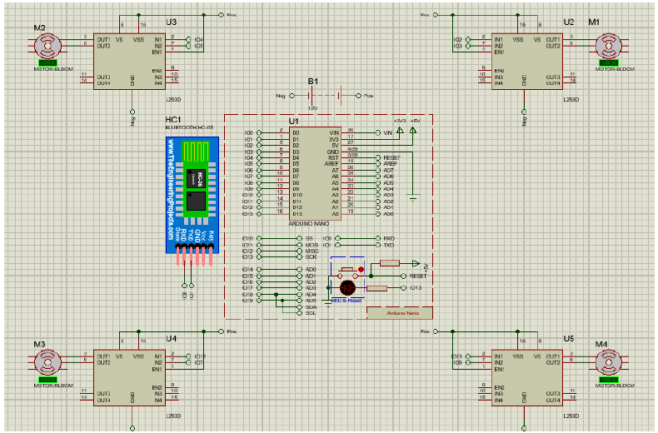
Figure 26: Electronic Connections in Proteus
To demonstrate the take-off procedure for my system, the simulation is started and the speed for all motors set to 0, which is shown in the figure 43. The reason for this is to make the behaviour of the system more controlled as the default value in the microcontroller pins are unpredictable and the speed keeps changing.
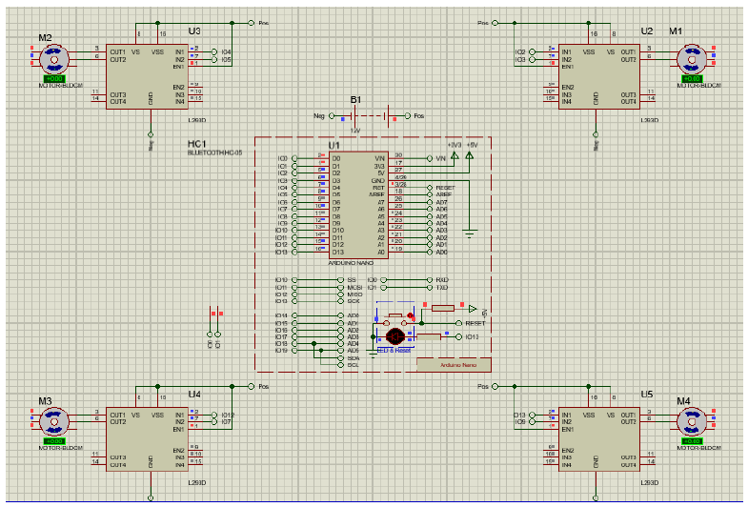
Figure 27: Simulation Started While all the Motors are Set to 0
To start the take-off, I chose a specific speed for the rotation of all the 4 motors by sending a signal from the Arduino to the ESCs. The speed of the motors started to rise until it reaches 162 RPM. These values can be modified, and we can go beyond them; however, the purpose of this demonstration is to show that the system is working fine with the components I chose.

CHAPTER FIVE
SUMMARY AND CONCLUSION
5.0 Summary
This project was one of the golden opportunities that prompted me not only to gain knowledge on different topics and learn a fair number of new technologies but also put them into practice. It was a great way for me to apply part of the skills and knowledge I have acquired during my undergraduate degree in Computer Science and lots of research work put in to make this possible. I was able to apply the engineering development process on a real-life project. I managed conducting a feasibility study, understanding and prioritizing the component requirements, designing and simulating the project, and eventually testing it.
During this project, I became much more familiar with the quadcopter flight dynamics and many software, such as SolidWorks, MATLAB, Proteus, and MultiWii. I used SolidWorks to work on the mechanical part of my project to determine the best available material to use (in developing a prototype) and to see the air’s velocity and pressure impact on the propeller. These were done by making different simulations and analyses, such as the linear static analysis (to generate the Von Mises stress, displacement, strain and factor of safety), the drop test analysis (to see which material would withstand falling from a height of 100 meters), fatigue analysis (to determine the damage percentage and life cycles), and the flow simulation (to simulate the air flows through and around the propeller in order to calculate its capabilities and performance).
MATLAB was used to generate the quadcopter thrust while flying along with its angular velocity and displacement. In addition, I made a sketch connecting the electrical components using Proteus so that I can upload the code from MultiWii to the software and simulate it.

5.1 Conclusion
I can never say I have learnt much or enough as I will always strive for learning more. Learning never ends and that being said, I do not see this project as complete. I aim to develop it further and once fully completed; a final version will be published online for free.
The principal work to be done next is to ensure the drone’s smoothness and stability. Besides, the feasibility of using the image processing has been investigated. The idea is to enable the drone to avoid obstacles and recognize people’s faces in order to identify missing people, civilians, and criminals. Thus, working on this will enable me to eliminate criminal activities; especially, that there is a massive increase in crime rate in Morocco and other countries. In 64

addition, this can be used in favour of many institutes to record attendance by detecting faces without wasting time or effort. This is only one of many other applications that this general-purpose drone could be used to accomplish, which could have a huge impact on societies.

Reference
Douglas, H. (2021).
Online Etymology Dictionary.
https://www.etymonline.com/word/drone
Joshi, D. (2019).
Drone Technology Uses And Applications For Commercial, Industrial And Military Drones In 2020 And The Future. Business Insider. https://www.businessinsider.in/tech/news/drone-technology-uses-and-applications-for-commercial-industrial-and-military-drones-in-2020-and-the-future/articleshow/72874958.cms
Chris, W. (2021).
Satellite Navigation. https://www.explainthatstuff.com/howgpsworks.html
Aeryon, S (2021).
Aeryon Scout Micro-UAV. https://www.homelandsecurity-technology.com/projects/aeryon-scout-micro-uav/
Newcome, L. (2012).
Unmanned Aviation: A Brief History of Unmanned Aerial Vehicles | Library Of Flight. https://arc.aiaa.org/doi/abs/10.2514/4.868894
Brown, L. and McIsaac, K. (2018).
Nonlinear Explicit Stochastic Attitude Filter On SO(3). https://www.researchgate.net/publication/329659566_Nonlinear_Explicit_Stochastic_Attitude_Filter_on_SO3
Sabatino, F. (2015).
Quadrotor Control: Modeling, Nonlinear Control Design, And Simulation. https://www.kth.se/polopoly_fs/1.588039.1600688317!/Thesis%20KTH%20-%20Francesco%20Sabatino.pdf

Sabatino, F. (2017).
Quadrotor Control: Modeling, Nonlinear Control Design, And Simulation. https://www.kth.se/polopoly_fs/1.588039.1600688317!/Thesis%20KTH%20-%20Francesco%20Sabatino.pdf
Harpreet, S. (2021).
What is roll, pitch and yaw. https://www.dronesvilla.com/roll-pitch-yaw/
NASA, (2020).
Stem Learning: Advanced Air Mobility; The Science behind Quadcopters reader student guide. https://www.nasa.gov/sites/default/files/atoms/files/aam-science-behind-quadcopters-reader-student-guide_0.pdf
Mann, C. (2017).
The Importance of Project Requirements. https://www.psi-software.com/2017/12/15/importance-project-requirements/
Affortunato, F. (2020).
The Technical Specifications of Drones - Guide - 4Mydrone. https://4mydrone.com/en/in-depth-drones/drone-technical-specification-guide/
Gibiansky, A. (2012).
Quadcopter Dynamics, Simulation, and Control. https://andrew.gibiansky.com/downloads/pdf/Quadcopter%20Dynamics,%20Simulation,%20and%20Control.pdf
Dragatis, K. (2018).
Free CAD Designs, Files & 3D Models: The GrabCAD Community Library. https://grabcad.com/library/wooden-drone-frame-1
Rees, C. (2017).
Factors To Consider When Selecting Drone Propeller Blades. https://www.unmannedsystemstechnology.com/2017/12/selecting-drone-propeller-blades-considerations/

Wankhade, G. (2020).
Free CAD Designs, Files & 3D Models: The GrabCAD Community Library. https://grabcad.com/library/propeller-441
Staples, G. (2014).
Propeller Static & Dynamic Thrust Calculation - Part 2 Of 2 - How Did I Come Up With This Equation? https://www.electricrcaircraftguy.com/2014/04/propeller-static-dynamic-thrust-equation-background.html
Kotelnikov, I. (2015).
MultiWii Configuration.
https://github.com/UAV-olimp/Multiwii-config/blob/master/config.h
Nasir, S.Z. (2016).
Bluetooth Library for Proteus, The Engineering Projects. https://www.theengineeringprojects.com/2016/03/bluetooth-library-for-proteus.html

APPENDIX A: MATLAB Simulation & Functions
Simulation:

Function:

APPENDIX B: Schematics and Connections
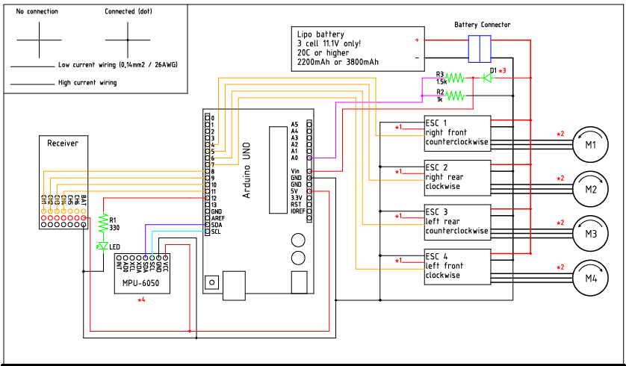

APPENDIX C: MultiWii Configuration

