PREDICTING SOYBEAN YIELD USING ENSEMBLE MACHINE LEARNING ALGORITHMS

ABSTRACT
Agriculture plays a vital role in driving economic growth, reducing poverty, and enhancing food security. However, traditional methods for predicting soybean yield are often labor-intensive and error-prone, hindering effective agricultural planning. This study aims to develop a predictive model for soybean yield using ensemble machine learning (ML) algorithms, specifically focusing on Random Forest, Gradient Boosting, Extreme Gradient Boosting (XGBoost), and Bagging. Data was collected from the Central Statistical Agency's demographic survey in Ethiopia, comprising 15,525 instances over ten years (2014-2024) related to soybean production. The data underwent thorough preparation, including cleaning, feature selection, transformation, imputation, and encoding of categorical variables. The results indicated that the XGBoost Classifier achieved the highest accuracy of 93.75%, highlighting its effectiveness in predicting soybean yield. Key determinants identified included historical yield data, crop health, management techniques, field type, seed variety, and agronomic practices. While the findings are promising for developing a soybean yield prediction system, the model's generalizability may be limited due to its reliance on a specific dataset. Future research should focus on expanding the dataset to include additional factors such as soil properties, weather conditions, pest management, crop rotation, harvesting timing, and market conditions.

Keyword: Soybean; Predicting Soybean Yield; Ensemble Machine Learning Algorithms

INTRODUCTION
In Ethiopia, agriculture serves as a cornerstone for driving economic growth, alleviating poverty, and enhancing food security, particularly among disadvantaged households. A key agricultural product is soybean, known locally as AkuriAter. This oilseed is vital not only for its nutritional profile but also for its importance in global trade. Soybean is primarily cultivated in the western and southwestern regions of Ethiopia, including Benishangul Gumuz, Gambela, parts of Oromia, and Amhara. Globally, soybean is recognized as a significant source of protein and oil, typically containing about 40% protein, 20% oil, and 35% carbohydrates, which determine its economic value [1] [2]. The crop thrives in warm, moist conditions and has a growing period of 100 to 130 days [3]. Its cultivation is crucial for food security and poverty alleviation across various regions in Africa [4].
In recent years, machine learning (ML) algorithms have emerged as a promising tool for predicting crop yields, including soybean, by utilizing large datasets and complex algorithms to identify patterns and make predictions with high accuracy [5]. By utilizing past experience, ML algorithms can detect useful patterns from large, unstructured, and complex datasets [6]. These days, the application of machine learning techniques to crop yield prediction has demonstrated promising accuracy and robustness of the prediction results. For instance, Murakami, et al [13] successfully used machine learning to predict winter wheat yields in Japan based on meteorological data, showcasing the potential of ML in agriculture. Studies have applied ML algorithms in various countries, including the United States, Brazil, and China, achieving promising results in soybean yield predictions [8][9][10]. In India, farmers have utilized support vector machines (SVM) and neural networks to predict crop yields with an accuracy of 86.80% [11]. Ensemble-based machine learning algorithms have also been used for soybean yield prediction. In India, a study used an ensemble of support vector machine (SVM) and linear regression models to predict soybean yield, achieving a prediction accuracy of 84% [12]. Another study in India used an ensemble of regression and decision tree models to predict soybean yield, achieving a prediction accuracy of 81% [13].
Despite some research on machine learning for soybean yield prediction in Ethiopia, there remains a significant gap in the application of these techniques [1]. This highlights the need for further research to identify suitable ML algorithms for predicting soybean yields in the Ethiopian context. Ensemble algorithms, which combine the predictions of multiple models, often outperform individual models by reducing overfitting and improving generalization to unseen data. They are more robust against noise and outliers, leveraging the strengths of various models while compensating for their weaknesses[14] [15]. Individual models may struggle with generalization and can be overly simplistic, leading to high bias and reduced accuracy [16]. By addressing these limitations, ensemble methods can provide more reliable and accurate predictions, enhancing agricultural productivity in Ethiopia.

Ensemble Learning
Ensemble learning is commonly used with classification algorithms to construct optimal predictive models for determining soybean production. Notable ensemble methods include Random Forest, Gradient Boosting, Extreme Gradient Boosting, Bagging, and Bayesian Model Averaging [17].
Random Forest: A supervised learning algorithm based on bagging, where multiple models are trained on different subsets of the dataset. Predictions are made by aggregating the outputs from all models. The process includes[18]:
Step 1: Select random samples from a given data or training set.
Step 2: This algorithm will construct a decision tree for every training data.
Step 3: Voting will take place by averaging the decision tree.
Gradient Boosting: An ensemble learning method that combines multiple weak learners, typically decision trees, to create a robust predictive model. It minimizes a loss function by iteratively adding weak learners that correct the errors of previous models.
XGBoost (Extreme Gradient Boosting): An optimized gradient boosting implementation that includes enhancements such as parallel processing, regularization techniques, and tree pruning, leading to improved accuracy and computational efficiency. XGBoost is widely used in machine learning competitions due to its high performance.

Related works

Champaneri et al. [19]conducted a study on crop yield prediction using the Random Forest algorithm, focusing on climatic parameters such as cloud cover, rainfall, and temperature. Their findings indicated an accuracy of over 75% for all crops and districts analyzed, highlighting the effectiveness of their predictive model. However, they noted the absence of soybean crops in their study and recommended exploring the integration of additional data sources, including soil information, management practices, and satellite imagery, to enhance prediction accuracy.
LI, Qian-chuan, and Shi-wei [20]investigated soybean yield prediction in China using Stacking Ensemble Learning, which incorporated k-nearest neighbors, Random Forest, and support vector machines based on meteorological data. Their Stacking Ensemble model demonstrated higher accuracy and greater robustness than the individual models. The authors suggested that future research could apply similar machine learning techniques and ensemble frameworks to predict crop yields in other regions and for different crops. Additionally, they emphasized the importance of considering other factors, such as soil characteristics and pest management, though their study was limited to two major soybean planting areas in China, affecting the generalizability of their results. Liu et al. [21] developed a machine learning model for predicting soybean yield in Argentina, utilizing weather data and satellite imagery from 2016 to 2018 in key soybean-growing regions. The Random Forest regression model achieved a coefficient of determination (R²) of 0.79, indicating relatively high accuracy in yield prediction. The authors recommended improving the model's accuracy by incorporating soil data and crop management information and suggested testing the model in other regions and for different crops. They acknowledged that their study's focus on a short time frame and limited geographic scope may restrict the applicability of their findings. Model [22] conducted early and end-of-season soybean yield prediction at the county-level. The study achieved high accuracy for end-of-season yield prediction with an RMSE of 329.53 and an R2 of 0.78 averaged from 2011 to 2015. The study recommends further work to include more features in the training data, such as soil moisture, soil quality, transpiration, and irrigation situation, to make the model more comprehensive.
Xu and Katchova [23]aimed to predict soybean yield in the United States using the Normalized Difference Vegetation Index (NDVI) and a flexible Fourier transform model (FFT). Their approach successfully captured nonlinear relationships between NDVI and yield, achieving an R² of 0.75. Wei, Molin, and José Paulo [24] explored soybean yield estimation through machine learning techniques, employing linear regression to achieve an R² of 0.70, a mean absolute error (MAE) of 639.99 kg ha−1, and a root mean squared error (RMSE) of 726.67 kg ha−1. Their study utilized on-farm data and highlighted the potential for further exploration of other machine learning algorithms and data sources, such as remote sensing, to improve yield estimation accuracy. However, they did not consider environmental factors like weather conditions, which could be addressed in future research.

Proposed Methods
We present an architecture that outlines the various steps involved in predicting soybean yield.
Dataset

- Data cleaning
- Data transformation

Data preprocessing
Attribute selection

Training set
Testing set
Validation set

Hyperparameter optimization

Soybean yield prediction
Apply classification algorithms

Prediction result
Prediction Model

High

Low
Medium

Figure 3. Proposed architecture
- Dataset Collection and understanding
For our soybean yield prediction study, we sourced detailed data from the Central Statistical Agency (CSA) of Ethiopia. The dataset spans ten years (2014–2024) and includes 15,525 instances with 19 attributes, each representing individual farmers' records. A sample of the dataset is presented in Table 3.
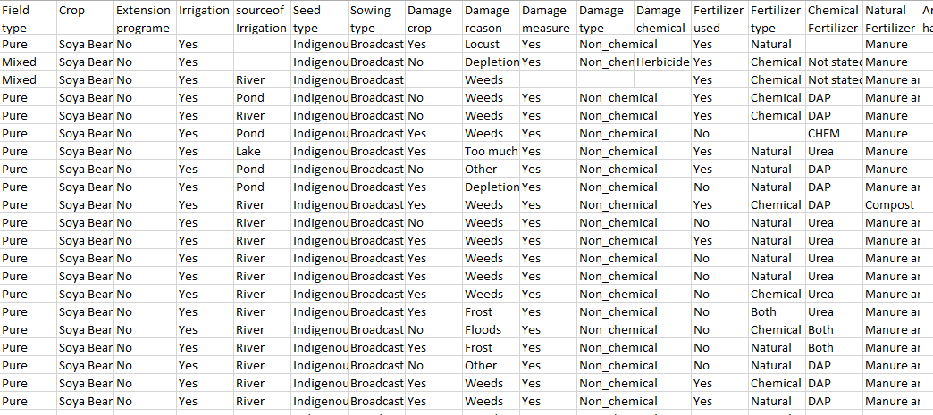
Table 3. Initial dataset
- Data Preprocessing
Preprocessing is essential before model training to enhance data quality. This step transforms raw data into a suitable format for analysis and includes identifying and addressing missing or redundant data, encoding variables, and resolving inconsistencies. Effective preprocessing is vital for improving prediction accuracy and efficiency, as unclean data can lead to unreliable outcomes. Generally, data preprocessing comprises three main steps: data cleaning, data transformation, and data reduction. [25].
- Data Cleaning
The dataset from the Central Statistical Agency (CSA) contained missing values due to manual entry errors, incorrect measurements, and data duplication. Identifying columns with missing values and assessing their extent is crucial. Columns with over 50% missing data should be dropped to avoid bias, while those with less can be imputed using the median for numeric attributes and the mode for categorical attributes.
- Data Transformation
Standardizing the data is essential to ensure that all values are on a similar scale, typically between 0 and 1. This process includes converting attribute values between numeric and nominal formats.
- Feature selection
Feature selection is critical in machine learning, involving the selection of a subset of features to improve model performance. Objectives include reducing dimensionality, enhancing algorithm speed, and improving accuracy and interpretability. ANOVA (Analysis of Variance) can be employed to evaluate significant differences among group means in the dataset. The SelectKBest method, using the f_classif score function, identifies the top features, with their scores stored in a DataFrame for further analysis.
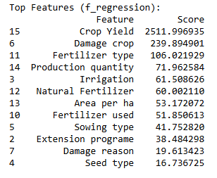
Table 3.1Top selected features with their score
- Encoding Categorical Features
The dataset includes categorical data that needs to be converted into numerical format for processing, as Python operates on numeric data. This encoding is crucial during preprocessing. We employed the LabelEncoder() from the scikit-learn library to transform categorical data into numerical values, utilizing the fit_transform() function. Sample encoded feature values are presented in Table 3.2.
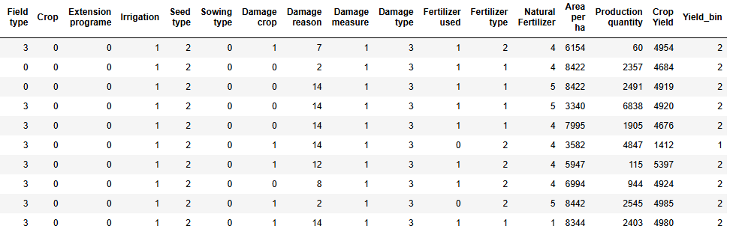
Table 3.2 Converted feature values from categorical to numeric data
- Confusion Matrix
The confusion matrix visually represents the number of correct and incorrect predictions made by the model compared to the actual classifications in the test data [26]. It evaluates performance metrics such as accuracy, precision, recall, and the balance between false positives and false negatives.
Accuracy measures the overall correctness of the model's predictions, calculated as the sum of True Positives (TP) and True Negatives (TN) divided by the total number of instances in the dataset [26].
$$Accuracy\left(\%\right)={\left(TP+TN\right)}/{Total}∗100 _________________________(1.1)$$
Precision assesses the probability of correctly classifying instances as positive, calculated as the ratio of True Positives to the sum of True Positives and False Positives (FP) [26].
$$Precision ={TP}/{(TP+FP)} _________________________________1.2)$$
Recall (or sensitivity) measures the model's ability to identify positive instances, computed as the ratio of True Positives to the sum of True Positives and False Negatives (FN) [26].
$$Recall ={TP}/{(TP+FP)} __________________________________(1.3)$$
F1-score is a combined metric that considers both precision and recall, calculated as the harmonic mean of these two metrics. It ranges from 0 to 1, with a higher score indicating better model performance [26].
$F1 Score={2∗\left(Precision∗Recall\right)}/{\left(Precision+Recall\right)}$$_____________________(1.4)$

Experimental Results
Splitting the data into training and testing sets is a critical step in preprocessing. We utilized a 60:20:20 ratio, which is widely regarded as optimal for achieving accurate outcomes. Table 4 presents the total data, along with counts and percentages for training, testing, and validation datasets.
Dataset | Data instances count | Percentage (%)
Total data | 15525 | 100
Training | 9315 | 60
Validation | 3105 | 20
Testing | 3105 | 20
Table 4. Splitting total data into training, validation and test data

Yield Class Definitions and Justification
    - Yield Class Definitions
This study categorizes soybean yield into three distinct classes based on average production levels per hectare:
- Low Yield: 0 to 150 quintals/hectare
- Medium Yield: 151 to 250 quintals/hectare
- High Yield: 251 quintals/hectare and above
These classifications are justified as they reflect common production thresholds recognized in agronomy, allowing for clearer communication of expected outcomes. Classifying yield levels assists in setting realistic goals for farmers and enables targeted interventions to improve productivity.
    - Hyperparameter Tuning Details(Hyperparameter optimization)
Hyperparameter tuning is critical for optimizing model performance. For each machine learning algorithm utilized Random Forest, Gradient Boosting, XGBoost, and Bagging the following hyperparameters were systematically optimized:
Random Forest:
- n_estimators: Number of trees; tuned to a maximum of 500.
- max_depth: Set to prevent overfitting; tuned between 5 and 20.
- min_samples_split: Minimum samples required to split a node; optimized based on dataset characteristics.
XGBoost:
- learning_rate: Set between 0.01 and 0.3 for effective boosting.
- subsample: Optimized to determine the proportion of data used for fitting; tuned around 0.5 to 0.9.
- max_depth: Set between 3 and 10 to avoid overfitting.
The tuning process employed grid search and cross-validation to ensure robust parameter selection, thus improving model accuracy. As this 100% training accuracy for XGBoost and Random Forest

Predictive Model

In this study, we employed four distinct machine learning techniques: Random Forest, Gradient Boosting, Extreme Gradient Boosting (XGBoost), and Bagging Classifier, to construct predictive models. We evaluated these models based on precision, recall, F1-score, and accuracy for testing, training, and validation.
Model | Precision | Recall | F1-score | Testing Accuracy | Training Accuracy | Validation Accuracy
Random forest | 93% | 93% | 93% | 92.66% | 100% | 91.82%
Gradient boosting | 92% | 92% | 92% | 91.82% | 92.53% | 90.82%
XGBoost | 94% | 94% | 94% | 93.75 % | 100 % | 92.91%
Bagging | 92% | 92% | 92% | 92.01 % | 97.87 % | 91.14%
Table 4.2 Performance summary classification algorithms
As shown in Figure 4.2, various ensemble machine learning algorithms, including Random Forest, Gradient Boosting, XGBoost, and Bagging, were used to predict soybean yield. Among these, the XGBoost Classifier achieved the highest accuracy at 93.75%, outperforming previous studies that reported an accuracy of 86%. Therefore, we recommend utilizing the XGBoost Classifier for soybean yield predictions due to its superior performance.

Error Analysis
Conducting error analysis is essential to understand model limitations and improve future iterations. The confusion matrices for each model highlighted the following misclassification issues:
- Instances of low yield were frequently misclassified as medium or high, indicating overlap in feature characteristics.
Example Cases with Similar Features
Damage Reason, Fertilizer Type, Sowing type, Irrigation used
Case 1:
High Yield:
Damage reason: Weeds
Fertilizer Type: Chemical
Sowing type: Broadcast
Medium Yield:
Damage reason: Weeds
Fertilizer Type: Chemical
Sowing type: Broadcast
- Similarly, medium and high yield instances exhibited confusion with low yield predictions, Feature Overlap, certain features may show similar values for both classes, leading the model to misclassify.
Example, Damage reason, Fertilizer Type, Sowing type
Medium Yield:
Damage reason: Weeds
Fertilizer Type: Chemical
Sowing type: Broadcast
Low Yield:
Damage reason: Weeds
Fertilizer Type: Chemical
Sowing type: Broadcast
In this case, both classes report similar damage reasons and management practices, causing confusion.

Conclusion and future works
This study focused on predicting soybean yield in Ethiopia using ensemble machine learning algorithms, particularly the Extreme Gradient Boosting (XGBoost) model, which achieved an accuracy of 93.75%. Utilizing a dataset from the Central Statistical Agency, we identified key factors influencing yield, such as field type, fertilizer use, and crop management practices.These findings demonstrate the potential of machine learning to significantly enhance agricultural productivity, serving as a valuable tool for farmers and agricultural practitioners in optimizing yield forecasts. The implications for practitioners and agribusinesses are substantial; by adopting the predictive model developed in this study, extension workers can make informed decisions regarding resource allocation and crop management. This leads to improved planning and better food security, ultimately increasing profitability for smallholder farmers. This study underscores the importance of continuous, data-driven enhancement of agricultural practices, advocating for the integration of advanced technologies to meet the challenges of soybean cultivation effectively.
Future research should investigate the reasons behind misclassification and explore more sophisticated modeling approaches to better capture the complex relationships between features and soybean yield. Establishing partnerships with agricultural institutions and government agencies will facilitate access to reliable data on soybean production. Additionally, integrating various factors that influence soybean yield such as environmental conditions, pest management, and agronomic practices will enhance the model's accuracy. Conducting field-level research and gathering primary data through surveys will provide deeper insights into the factors affecting crop yield, ultimately enabling more precise and context-specific predictions that can effectively inform agricultural practices.

ACKNOWLEDGMENT
Firstly, I would like to express my heartfelt gratitude to God for granting me the strength, wisdom, and perseverance to complete this work. I am deeply thankful to my advisor, Dr. Million Meshesha, for his guidance, support, and encouragement throughout my research journey. His insights and expertise have been invaluable in shaping this study. I also express my gratitude to Miss Azanu Mirolgn, a staff member of Computer Science, for providing the necessary data from the Central Statistical Agency. Furthermore, I wish to acknowledge the University of Gondar for providing the resources and environment that enabled this research. The support from the faculty and available facilities greatly contributed to my academic experience.
Thank you to everyone who contributed to this journey.
Reference
[1] O. Sobko, A. Stahl, V. Hahn, S. Gruber, S. Zikeli, and W. Claupein, “Environmental effects on soybean (Glycine max (l.) merr) production in central and south germany,” Agronomy, vol. 10, no. 12, pp. 1–14, 2020, doi: 10.3390/agronomy10121847.
[2] A. Agegn, Y. Bitew, and D. Ayalew, “Heliyon Response of yield and quality of soybean [ Glycine max ( L .) Merrill ] varieties to blended NPSZnB fertilizer rates in Northwestern Ethiopia,” Heliyon, vol. 8, no. December 2021, p. e09499, 2022, doi: 10.1016/j.heliyon.2022.e09499.
[3] S. Zeipiņa, I. Alsiņa, and L. Lepse, “Insight In Soybean Yield And Quality Parameters: A Review,” Res. Rural Dev., vol. 2, pp. 40–45, 2017, doi: 10.22616/rrd.23.2017.047.
[4] M. S. Islam et al., “Soybean and Sustainable Agriculture for Food Security,” Soybean - Recent Adv. Res. Appl., Apr. 2022, doi: 10.5772/INTECHOPEN.104129.
[5] A. Crane-Droesch, “Machine learning methods for crop yield prediction and climate change impact assessment in agriculture,” Environ. Res. Lett., vol. 13, no. 11, Oct. 2018, doi: 10.1088/1748-9326/AAE159.
[6] S. Uddin, A. Khan, M. E. Hossain, and M. A. Moni, “Comparing different supervised machine learning algorithms for disease prediction,” BMC Med. Inform. Decis. Mak., vol. 19, no. 1, pp. 1–16, 2019, doi: 10.1186/s12911-019-1004-8.
[7] Q. LI, S. XU, J. ZHUANG, J. LIU, Y. ZHOU, and Z. ZHANG, “Ensemble Learning Prediction of Soybean Yields in China Based on Meteorological Data,” J. Integr. Agric., 2023, doi: 10.1016/j.jia.2023.02.011.
[8] M. Herrero-Huerta, P. Rodriguez-Gonzalvez, and K. M. Rainey, “Yield prediction by machine learning from UAS-based mulit-sensor data fusion in soybean,” Plant Methods, vol. 16, no. 1, pp. 1–16, 2020, doi: 10.1186/s13007-020-00620-6.
[9] V. Barbosa dos Santos, A. Moreno Ferreira dos Santos, J. R. da Silva Cabral de Moraes, I. C. de Oliveira Vieira, and G. de Souza Rolim, “Machine learning algorithms for soybean yield forecasting in the Brazilian Cerrado,” J. Sci. Food Agric., vol. 102, no. 9, pp. 3665–3672, Jul. 2022, doi: 10.1002/jsfa.11713.
[10] C. Wang et al., “Impacts of Drought on Maize and Soybean Production in Northeast China During the Past Five Decades,” Int. J. Environ. Res. Public Health, vol. 17, no. 7, Apr. 2020, doi: 10.3390/IJERPH17072459.
[11] E. R. Abraham et al., “Time series prediction with artificial neural networks: An analysis using Brazilian soybean production,” Agric., vol. 10, no. 10, pp. 1–18, 2020, doi: 10.3390/agriculture10100475.
[12] A. Jindal, G., & Sharma, “Ensemble of support vector machine and linear regression models for soybean yield prediction.,” Int. J. Comput. Appl., vol. 182, no. 42, pp. 1–6, 2019.
[13] A. B. Kadam, P. P., & Patil, “Soybean yield prediction using ensemble of regression and decision tree models.,” Int. J. Eng. Res. Technol., vol. 9, no. 7, pp. 835-840., 2020.
[14] N. L. Rane, S. P. Choudhary, and J. Rane, “Ensemble Deep Learning and Machine Learning : Applications , Opportunities , Challenges , and Future Directions,” J. Appl. Artif. Intell., vol. 5, no. 2, pp. 18–41, 2024.
[15] M. Shahhosseini, G. Hu, S. Khaki, and S. V. Archontoulis, “Corn Yield Prediction With Ensemble CNN-DNN,” Front. Plant Sci., vol. 12, p. 1552, Aug. 2021, doi: 10.3389/FPLS.2021.709008/BIBTEX.
[16] S. Y. P. Wang, Jindong, Cuiling Lan, Chang Liu, Yidong Ouyang, Tao Qin, Wang Lu, Yiqiang Chen, Wenjun Zeng, “Generalizing to unseen domains: A survey on domain generalization.,” IEEE Trans. Knowl. Data Eng., vol. 8, no. 35, 2022.
[17] H. Search et al., “Machine Learning from Theory to Algorithms : An Overview Machine Learning from Theory to Algorithms : An Overview,” J. Phys. Conf. Ser. Pap., 2018, doi: 10.1088/1742-6596/1142/1/012012.
[18] S. S. Tripathy and B. Behera, “PERFORMANCE EVALUATION OF MACHINE LEARNING,” J. Biomech. Sci. Eng., no. April, pp. 621–640, 2023, doi: 10.17605/OSF.IO/WX6CS.
[19] M. Champaneri, D. Chachpara, C. Chandvidkar, and M. Rathod, “Crop Yield Prediction Using Machine Learning,” Int. J. Sci. Res., vol. 9, no. 4, pp. 2018–2021, 2020, doi: 10.21275/SR20402185927.
[20] L. I. Qian-chuan, X. U. Shi-wei, Z. Jia-yu, L. I. U. Jia-jia, Z. Yi, and Z. Zhang, “Ensemble Learning Prediction of Soybean Yields in China Based on Meteorological,” J. Integr. Agric., vol. 6, no. 01, 2023, doi: 10.1016/j.jia.2023.02.011.
[21] Y. X. Liu, Y., Wang, Z., Li, M., Liu, “developed a machine learning model for predicting soybean yield in Argentina using weather data and satellite imagery.,” Remote Sens. Agric. Environ., vol. 13, 2021.
[22] C. Model, “County-Level Soybean Yield Prediction Using Deep CNN-LSTM Model,” J. Integr. Agric., pp. 1–21, 2019, doi: 10.3390/s19204363.
[23] C. Xu and A. L. Katchova, “Predicting Soybean Yield with NDVI Using a Flexible Fourier Transform Model,” J. Agric. Appl. Econ., vol. 51, no. 3, pp. 402–416, 2019, doi: 10.1017/aae.2019.5.
[24] M. C. F. Wei and J. P. Molin, “Soybean yield estimation and its components: A linear regression approach,” Agric., vol. 10, no. 8, pp. 1–13, 2020, doi: 10.3390/agriculture10080348.
[25] V. C. Dodda and L. Kuruguntla, “Prediction of crop and yield in agriculture using machine learning technique,” Res. Conf. Pap., no. July 2021, 2022, doi: 10.1109/ICCCNT51525.2021.9579843.
[26] E. N. Hailemichael and A. Science, “FAKE NEWS DETECTION FOR AMHARIC LANGUAGE USING DEEP LEARNING Fake News Detection for Amharic Language Using Deep Learning,” Adama Sci. Technol. Univ., no. January, 2021.

