Become the Dragon: Myth, Dragon Symbolism, and Balinese–Chinese Acculturation in the Contemporary Indonesian Painting of Guh S Mana
R.M. Hapsoro Suryo Widigdo¹, Taufik Murtono^{2*}
^{1,2} Master’s Program in Arts, Postgraduate Program, Institut Seni Indonesia Surakarta, Indonesia
*Corresponding author: Taufik Murtono, taufik@isi-ska.ac.id
DOI: (to be assigned by IJRISS upon acceptance)
Received: 00 Month 2026; Accepted: 00 Month 2026; Published: 00 Month 2026
ABSTRACT
This study examines Become the Dragon, a contemporary painting by the Indonesian artist Guh S Mana that reinterprets the Balinese legend of King Jaya Pangus and the Chinese princess Kang Cing Wie, centring on Jaya Pangus’s transformation into a dragon. The research addresses a gap in Indonesian art scholarship, which has concentrated on art history, formal aesthetics, and socio-political issues while giving little attention to symbolism, visual narrative, and cultural acculturation in individual contemporary works; to date, no indexed academic study has specifically analysed this work. The study aims to (1) analyse the visual and narrative representation of the legend, (2) interpret the dragon symbol as a metaphor of identity transformation, (3) reveal the forms of Balinese–Chinese acculturation expressed in the work, and (4) situate the work within contemporary Indonesian art. A qualitative single-case-study design was used. Data were gathered through semi-structured interviews with the artist, curators, and art observers, direct observation of the exhibited work, and documentation, and were analysed thematically across visual, narrative, and contextual themes, with credibility secured through triangulation, member checking, and an audit trail. The findings show that Become the Dragon does not depict the legend literally but reconstructs it symbolically through a deconstructed, non-figurative dragon, earth-toned palettes, circular and spiral composition, white negative space, and mixed-media materials such as mangrove mud and fabric collage. The dragon operates simultaneously as a Balinese cosmological guardian of balance and a Chinese emblem of cosmic energy and fortune, fusing into a hybrid contemporary visual identity. The work thus functions not merely as an aesthetic object but as a medium for cultural representation, spirituality, and identity negotiation, demonstrating how Nusantara mythology remains a productive source for contemporary Indonesian and Southeast Asian art in a global context.
Keywords: Guh S Mana; Become the Dragon; dragon symbolism; Balinese–Chinese acculturation; contemporary Indonesian art; identity transformation
INTRODUCTION
Contemporary art across Southeast Asia has increasingly turned to local myth, ritual, and spirituality as strategies for articulating cultural identity amid globalization. Scholars have shown that the region’s contemporary art is shaped by the interplay of colonial history, modernity, tradition, and cultural identity, producing hybrid visual forms through processes of cultural negotiation (Antoinette & Maravillas, 2020; Flores, 2003). Many Southeast Asian artists mobilize local mythology and spiritual experience to construct cultural identity within global discourse (Twardzik Ching, 2023). Within this landscape, the reinterpretation of traditional narratives through modern visual language has become a defining practice, one in which inherited symbols acquire new meanings without losing their cultural roots.
The dragon is among the most resonant of these transcultural symbols. Research on the Chinese dragon shows that its meaning is neither fixed nor singular but continues to evolve across modern and global contexts (Meccarelli, 2021), and studies of dragon imagery in Southeast Asia demonstrate a shift from religious connotation toward representations of identity and contemporary cultural transformation (Chang, 2024). This semantic mobility makes the dragon a productive figure for artists working at the intersection of tradition and modernity, where a single image can hold layered and even contradictory associations of power, protection, spirituality, and change.
In Indonesia, the legend of Jaya Pangus and Kang Cing Wie occupies a distinctive place at this intersection. The story recounts how the Balinese king Jaya Pangus married Kang Cing Wie, a Chinese princess, and was ultimately transformed into a dragon; in Balinese tradition it is understood not merely as folklore but as a symbol of the social, spiritual, and cultural relationship between Bali and China. Bali has long served as a space of international cultural interaction owing to its role as a centre of trade and tourism (Picard, 1996), and Balinese–Chinese acculturation is legible in social practice, ritual, and architecture: studies of Chinese temple layout in Bali reveal Chinese spatial principles adapted to local Balinese culture (Hendrawan & Beynon, 2019), while the Chinese community in Bali has built a regional identity by combining Chinese and Balinese traditions (Olszewska, 2015).
The dragon also carries dense but divergent meanings across the two cultures the legend joins. In Balinese cosmology the naga represents balance, fertility, spiritual protection, and the relationship between humans and the cosmos, appearing throughout sacred architecture and reliefs (Covarrubias, 1937; Paramadhyaksa, 2009), and functioning, together with Garuda, as an axis mundi marking the lower world and the continuum of water (Wessing, 2006). In Chinese culture, by contrast, the dragon signifies imperial power, fortune, and prosperity, and forms part of a cosmological scheme representing the order of the universe (Garrido, 2023; Xu & Deng, 2024). A work that fuses these two traditions therefore stages a genuine dialogue of symbols rather than a simple borrowing.
Despite this richness, academic study of Become the Dragon remains scarce. Indonesian art scholarship has largely focused on the history of art movements, questions of formal aesthetics, or socio-political issues, so that in-depth analysis of symbolism, visual narrative, and cultural acculturation in the work of individual artists is comparatively rare. Existing studies of dragon symbolism in contemporary art address the figure mainly within global cultural contexts and do not connect it specifically to contemporary Indonesian art. To date, no indexed academic study has examined Guh S Mana’s Become the Dragon, leaving a clear gap concerning the representation of the Jaya Pangus and Kang Cing Wie myth, dragon symbolism, and Balinese–Chinese acculturation in a single contemporary visual work.
Accordingly, this study offers an in-depth qualitative case analysis of Become the Dragon that combines visual, symbolic, cultural, and interview-based analysis. It pursues four objectives: to analyse the visual and narrative representation of the Jaya Pangus and Kang Cing Wie legend in the work; to interpret the dragon symbol as a metaphor of identity transformation within Balinese culture and contemporary art; to reveal the forms of Balinese–Chinese acculturation the work expresses; and to explain the work’s contribution to, and position within, contemporary Indonesian art. In doing so, the study demonstrates how contemporary Indonesian art can serve as a medium for negotiating cultural identity through the reinterpretation of local myth.
THEORETICAL FRAMEWORK
The analysis draws on an interdisciplinary framework linking theories of representation, semiotics, myth, cultural hybridity, and contemporary art, because the object of study is not only a visual work but also a carrier of cultural narrative, spiritual symbol, and complex identity relations. Stuart Hall’s theory of representation frames how meaning is produced through language, signs, and visual imagery: representation is not a copying of reality but a culturally and ideologically conditioned practice of meaning construction, so that a work of art becomes a site for producing cultural meaning about identity, history, and social experience (Hall, 1997). Roland Barthes’s semiotics complements this by distinguishing denotative from connotative meaning and by insisting that cultural signs are never neutral but always carry ideology and social meaning; the dragon in the work can thus be read as a connotative sign open to plural cultural interpretation (Barthes, 1972).
Theories of myth and cultural hybridity situate the work’s cultural logic. Structural approaches treat myth as a symbolic system through which societies comprehend the relationship among humans, culture, and nature (Lévi-Strauss, 1963), while anthropological accounts hold that Balinese mythology is bound to the culture’s structure and value system and is expressed through symbolic representation in performance, visual art, and ritual (Covarrubias, 1937; Geertz, 1973). Homi Bhabha’s notion of cultural hybridity, in which intercultural encounter generates new identities, clarifies how the fusion of Balinese and Chinese dragon symbolism produces a third, hybrid visual identity (Bhabha, 1994); contemporary artists, in turn, mobilize such hybrid cultural identity to build practices relevant to globalization (Suyimeng et al., 2025). Studies of mythological elements in contemporary art (Feng et al., 2025; Makki, 2025; Sultan et al., 2025), of cross-cultural aesthetics (Xu & Xiao, 2025), and of Chinese cultural influence in Indonesian settings (Chan & Effendi, 2024; Hendrawan et al., 2025) further support reading the work as a negotiation of tradition and modernity. Perceptual theory additionally informs the analysis of form, texture, colour, and space (Arnheim, 1974), as does scholarship on the revitalization of Balinese tradition in the face of modernity (Mok, 2019) and on the interpretation of dragon imagery across cultures (Imola, 2023).
METHODOLOGY
This study adopts a qualitative paradigm because its focus is the understanding of meaning, symbolic interpretation, visual experience, and the cultural context surrounding the creation of the work. Qualitative inquiry is used to understand social and cultural phenomena in depth through interpretation of experience, symbol, and human practice (Creswell, 2016), which allows a work of art to be studied as a complex, multidimensional cultural phenomenon. Within this paradigm the research employs a single-case-study design, concentrating on one object—Become the Dragon by Guh S Mana—in order to explore, in one artistic and cultural whole, the relationships among visual representation, dragon symbolism, the Jaya Pangus myth, identity transformation, and cultural acculturation (Yin, 2014).
Setting and Data Sources
Fieldwork was conducted in the studio and exhibition space where the work was created and presented, since these sites are essential for understanding the creative process, material exploration, and the interaction between the work and its audience. Primary data were obtained through direct fieldwork and observation of the work; secondary data were drawn from theoretical books, Scopus-indexed journals, exhibition catalogues, media archives, art-criticism articles, and related research documents. The primary informants were the artist, Guh S Mana, whose interview probed the background of the work, the inspiration of the Jaya Pangus myth, the meaning of the dragon symbol, the creative process, material exploration, and the intended cultural and spiritual message, together with curators and art observers who provided external perspectives on the work’s symbolism, artistic quality, and position in contemporary Indonesian art.
Data Collection
Three techniques were combined. Semi-structured interviews provided depth while remaining flexible enough to follow the informants’ responses, guided by a protocol covering the origin of the idea, dragon symbolism, the creative process, cultural acculturation, and the work’s position in contemporary art. Direct observation of the work in the studio and exhibition space recorded visual form, colour, texture, material, composition, and audience interaction, on the premise that observation enables the researcher to grasp cultural meaning through direct experience of the phenomenon (Spradley, 1980). Documentation—photographs of the work, exhibition catalogues, media archives, and interview recordings—was used to reinforce the observational and interview data.
Data Analysis and Trustworthiness
Data were analysed thematically. Recorded interviews were transcribed, coded to identify salient themes such as the dragon symbol, identity transformation, spirituality, myth, and cultural acculturation, and then categorized according to the study’s focus. Thematic analysis was used to identify patterns of meaning and relationships among themes across the visual, narrative, and contextual data (Braun & Clarke, 2006). Trustworthiness was established through triangulation of interviews, observation, and documentation, and of the perspectives of artist, curators, observers, and audience; through member checking, in which informants reviewed the interpretation of their statements; and through an audit trail retaining field notes, transcripts, and visual documentation. As the research involved human informants, participation was voluntary and informed, and interview material is reported with attention to the informants’ stated positions.

RESULTS
Visual and Narrative Representation of the Legend
The analysis shows that Become the Dragon (Figure 1) does not represent Jaya Pangus and Kang Cing Wie figuratively, as in traditional Balinese art, but reconstructs the legend through a symbolic and atmospheric contemporary approach. The narrative core—Jaya Pangus’s transformation into a dragon—is rendered not as an illustrated scene but through a dragon figure that is deliberately deconstructed rather than realistic, appearing in fragmentary and symbolic form that widens the space of interpretation for the audience. The visual representation is built from earth-toned colour, the texture of mangrove mud, spiral dragon forms, white negative space, and mixed-media technique, together producing a reflective and spiritual visual experience in which the love story becomes a narrative of transformation and cultural encounter rather than a literal retelling (Figure 2).
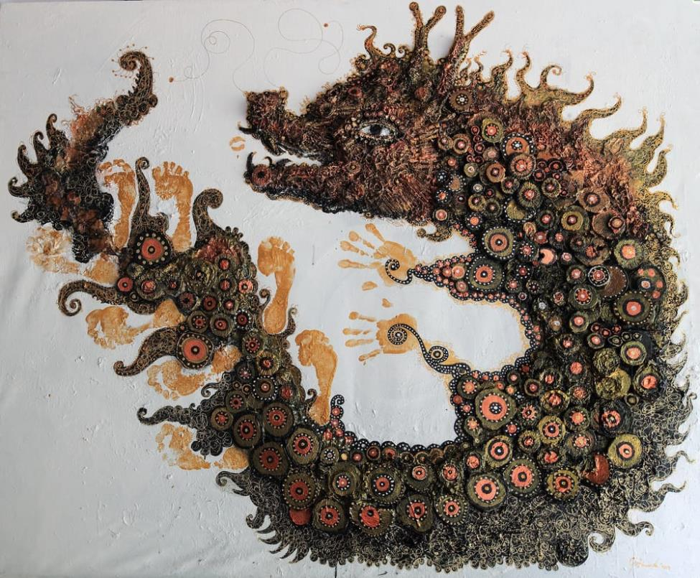
Figure 1. Become the Dragon by Guh S Mana. Mixed media (mangrove mud and fabric collage) on canvas. Source: research documentation.
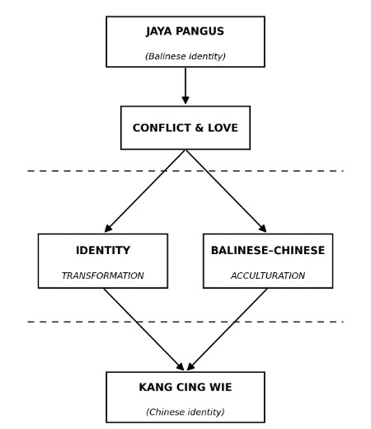
Figure 2. Narrative relation of Jaya Pangus and Kang Cing Wie in the work: Balinese identity moves through conflict and love toward identity transformation and Balinese–Chinese acculturation, converging on Chinese identity. Source: adapted from the original thesis.
Material Exploration and Creative Process
A distinctive finding concerns the artist’s material practice. According to the interviews, Guh S Mana soaked torn fabric in mangrove mud and applied it to the canvas, allowing natural drying and the spontaneous formation of texture, so that the work was constructed through an intense, experimental physical process aligned with the logic of process art, in which material process and the artist’s bodily action become part of the construction of visual meaning (Krauss, 1979). Layering of material produced tactile, uneven surfaces that carry emotional and symbolic depth, while the rough texture and weathering of the material function as metaphors of conflict, wounding, and the passage of a human life. The mangrove mud itself is read as a symbol of earth, fertility, and the lower world, which in Balinese cosmology is associated with the dragon as guardian of natural balance, so that technique and symbolism are inseparable in the work.
DISCUSSION
The Dragon as a Metaphor of Identity Transformation
The present study found that the dragon in Become the Dragon is meaningful primarily as a symbol of identity transformation, spirituality, and cosmic balance rather than as decorative motif. This reading aligns with earlier work: mid-twentieth-century ethnography already tied the Balinese naga to fertility, natural balance, and spiritual protection (Covarrubias, 1937), and later folklore scholarship identified the dragon as a marker of transition between states of being in Indonesian culture (Wessing, 2006), while recent studies read dragon imagery in Southeast Asian art as layered meaning shifting from religious connotation toward identity and transformation (Chang, 2024). The transformation of Jaya Pangus into a dragon can thus be interpreted as an ontological transcendence of identity—a metaphor for the human journey through cultural conflict, changing identity, and the search for spiritual awareness. The reinforcing use of mangrove mud, whose cracked and layered surface signals that identity change proceeds through instability and conflict, extends the symbol from visual representation into material and bodily experience.
Balinese–Chinese Acculturation and Cultural Hybridity
The study also found that the work represents Balinese–Chinese acculturation not decoratively or literally but through symbolic negotiation and visual atmosphere. This finding both confirms and extends prior scholarship. It confirms accounts of Balinese–Chinese acculturation in architecture and community practice (Chan & Effendi, 2024; Hendrawan & Beynon, 2019; Hendrawan et al., 2025; Olszewska, 2015) by showing the same negotiation operating in the register of contemporary painting, and it extends theories of cultural hybridity (Bhabha, 1994; Suyimeng et al., 2025) by demonstrating how the fusion of a Balinese guardian-of-balance dragon with a Chinese emblem of cosmic energy and fortune yields a new hybrid visual identity. The explanation lies in the artist’s method of reinterpretation: rather than depicting the two cultures side by side, Guh S Mana synthesizes their dragon symbolism, white negative space evoking Balinese spiritual emptiness, circular composition recalling cosmic balance, and materials linked to the Tri Hita Karana relationship between humans and nature. The implication is that culture is not static but continually transformed through social and historical interaction, and that contemporary art can make such transformation visible.
Position and Contribution within Contemporary Indonesian Art
Finally, the study found that the work occupies a significant position in contemporary Indonesian art through its strengthening of myth-based art and its development of local symbolism. Curators interviewed for the study described the work as presenting “mythology as a modern visual experience,” and audiences read the mangrove-mud texture as “primordial,” “organic,” and “spiritual,” indicating that the work broadens how mythology can be read in Indonesian visual art. This resonates with the view that mythological elements can deepen cultural meaning and connect tradition with modern contexts (Feng et al., 2025; Makki, 2025; Sultan et al., 2025) and with structural accounts of myth as a symbolic system mediating culture and nature (Lévi-Strauss, 1963). Read through the theory of representation, the work does not copy the legend but produces new cultural meaning appropriate to contemporary experience (Hall, 1997; Mok, 2019); read semiotically, its dragon sustains no single meaning but generates plural readings according to the audience’s cultural background (Arnheim, 1974; Barthes, 1972). By demonstrating that local symbols can develop into a universal visual language without losing their roots, the work also strengthens the position of Indonesian art within contemporary Southeast Asian practice (Antoinette & Maravillas, 2020; Flores, 2003; Twardzik Ching, 2023).
CONCLUSION
The study establishes that Become the Dragon is a contemporary visual reinterpretation that binds the Jaya Pangus and Kang Cing Wie myth, dragon symbolism, Balinese–Chinese acculturation, and a reflection on modern human identity into a single work. Rather than illustrating the legend, Guh S Mana reconstructs it symbolically through a deconstructed dragon, earth-toned palettes, spiral composition, white negative space, and mixed-media materials, so that the dragon becomes at once a Balinese guardian of cosmic balance and a Chinese emblem of energy and fortune, fused into a hybrid contemporary identity. Theoretically, the study contributes to interdisciplinary scholarship at the meeting point of art studies, cultural studies, and visual culture by showing how representation, semiotics, and hybridity operate together in a single contemporary work, and it offers the first focused academic analysis of this artist’s painting. Practically, it offers artists, curators, and students a model for reworking traditional narrative through modern visual means without severing cultural value, and it affirms the continued relevance of Nusantara mythology as a source for contemporary creation.
The study is limited by its focus on a single work and a single artist, and by its reliance on the interpretations of a small set of informants, so its findings are not intended to be generalized beyond the case. Future research could compare works by other contemporary artists who engage myth, cultural symbol, and local identity; develop interdisciplinary approaches linking visual art with cultural anthropology, ecology, and contemporary media studies; and investigate cross-cultural audience responses to myth-based contemporary works. Such directions would test and enrich the present account of how contemporary Indonesian art negotiates cultural identity through the reinterpretation of local myth.
DECLARATIONS
Ethical approval. The research involved adult informants who participated voluntarily and with informed consent; interview data are reported in accordance with the informants’ stated positions. No procedures involving vulnerable subjects or animals were undertaken.
Conflict of interest. The authors declare no conflict of interest.
Data availability. The qualitative data supporting the findings—interview transcripts, field notes, and visual documentation—are held by the authors and are available from the corresponding author on reasonable request, subject to the informants’ consent.
REFERENCES
1. Antoinette, M., & Maravillas, F. (2020). Positioning contemporary art worlds and art publics in Southeast Asia. World Art, 10(2–3), 161–189. https://doi.org/10.1080/21500894.2020.1821761
2. Arnheim, R. (1974). Art and visual perception: A psychology of the creative eye (The new version). University of California Press.
3. Barthes, R. (1972). Mythologies (A. Lavers, Trans.). Hill and Wang.
4. Bhabha, H. K. (1994). The location of culture. Routledge.
5. Braun, V., & Clarke, V. (2006). Using thematic analysis in psychology. Qualitative Research in Psychology, 3(2), 77–101.
6. Chan, Y.-K., & Effendi, T. D. (2024). Re-imagining Chinese cultural heritage in Surabaya: Mandarin, Chinatown, and Kampung Pecinan. Indonesia and the Malay World, 52(154), 265–286. https://doi.org/10.1080/13639811.2024.2426395
7. Chang, Y.-L. (2024). Naga imagery and the impact of the Internet on Naga worship in Thailand. International Journal of Asia Pacific Studies, 20(1), 23–52. https://doi.org/10.21315/ijaps2024.20.1.2
8. Covarrubias, M. (1937). Island of Bali. Alfred A. Knopf.
9. Creswell, J. W. (2016). Research design: Qualitative, quantitative, and mixed methods approaches (4th ed.). Pustaka Pelajar.
10. Feng, X., Prompongsaton, N., & Kotchapakdee, P. (2025). The use of Nanyang Han Dynasty stone-carved mythological elements in printmaking designs. Salud, Ciencia y Tecnología – Serie de Conferencias, 4, 1275. https://doi.org/10.56294/sctconf20251275
11. Flores, P. D. (2003). Undoing Europe in Southeast Asia: Contexts of a new contemporaneity. Filozofski Vestnik, 24(3), 87–107.
12. Garrido, V. V. (2023). The symbol of the dragon in the cosmogonic schemes of ancient China. Voprosy Filosofii, 2023(4), 156–166. https://doi.org/10.21146/0042-8744-2023-4-156-166
13. Geertz, C. (1973). The interpretation of cultures: Selected essays. Basic Books.
14. Hall, S. (Ed.). (1997). Representation: Cultural representations and signifying practices. Sage.
15. Hendrawan, F., & Beynon, D. (2019). An evaluation of the implementation of Chinese temple layout principles in Bali, Indonesia. ISVS e-journal, 6(4), 55–63.
16. Hendrawan, F., Dinata, R. D. S., Pratama, I G. Y., Suyoga, I P. G., & Ambarawati, I A. O. (2025). A symbolical model of together in difference: Classifying Tri Dharma temple architecture in Bali. Civil Engineering and Architecture, 13(2), 881–898. https://doi.org/10.13189/cea.2025.130210
17. Imola, K. (2023). On the trail of dragons: Texts, images, interpretations. Ethnographia, 134(1), 31–56.
18. Krauss, R. (1979). Sculpture in the expanded field. October, 8, 30–44.
19. Lévi-Strauss, C. (1963). Structural anthropology (C. Jacobson & B. G. Schoepf, Trans.). Basic Books.
20. Makki, L. (2025). Comparative analysis of folktales and oral traditions across cultures: Shared motifs and cultural values. Centre for Applied Linguistics Research Journal, 16(1). https://doi.org/10.60149/PESF9826
21. Meccarelli, M. (2021). Discovering the long: Current theories and trends in research on the Chinese dragon. Frontiers of History in China, 16(1), 123–142. https://doi.org/10.3868/s020-010-021-0006-6
22. Mok, E. W. C. (2019). Reinventing and promoting traditional cultures and values in Bali: A critical review of the government role in education and cultural exchange. In Education in the Asia-Pacific region (Vol. 49, pp. 85–100). Springer. https://doi.org/10.1007/978-981-13-6532-4_8
23. Olszewska, D. (2015). Local deities, traditions, and regional identity of the Chinese community in Bali: Introduction to the problem. Siberian Historical Research, 1, 98–109. https://doi.org/10.17223/2312461X/7/6
24. Paramadhyaksa, I N. W. (2009). Makna-makna figur naga dalam seni arsitektur bangunan suci tradisional Bali. Dewa Ruci: Jurnal Pengkajian dan Penciptaan Seni, 6(1), 67–78. https://doi.org/10.33153/dewaruci.v6i1.849
25. Picard, M. (1996). Bali: Cultural tourism and touristic culture. Archipelago Press.
26. Spradley, J. P. (1980). Participant observation. Holt, Rinehart and Winston.
27. Sultan, Y., Sagymbai, Z., & Aituganova, S. (2025). The system of mythical symbols in the cognitive layer of a literary text. Forum for Linguistic Studies, 7(7), 1060–1070. https://doi.org/10.30564/fls.v7i7.10194
28. Suyimeng, W., Shahir, S., & Ismail, M. U. (2025). Innovative practice of cultural identity in contemporary art under the context of globalization. Paper Asia, 41(4), 508–519. https://doi.org/10.59953/paperasia.v41i4b.624
29. Twardzik Ching, C. L. (2023). Ritual forage: Finding the self in mystical realms. In Reimagining Singapore: Self and society in contemporary art (pp. 75–105). Springer. https://doi.org/10.1007/978-981-99-0864-6_4
30. Wessing, R. (2006). Symbolic animals in the land between the waters: Markers of place and transition. Asian Folklore Studies, 65(2), 205–239.
31. Xu, X., & Xiao, S. (2025). Cultural values and aesthetics in Chinese and Western oil painting: An investigation into their impact on artistic localization and integration influencing students’ outcomes. Edelweiss Applied Science and Technology, 9(3), 1768–1776. https://doi.org/10.55214/25768484.v9i3.5688
32. Xu, Y.-B., & Deng, R. (2024). Going up into the clouds and mist: The image and significance of the Chinese dragon in the imagination. Sociétés, 163(1), 125–139. https://doi.org/10.3917/soc.163.0125
33. Yin, R. K. (2014). Case study research: Design and methods (5th ed.). Sage.

