DermaAI: An Intelligent Skin Image Case Retrieval and Clinical Knowledge Support Framework for Dermatological Decision Assistance

- Introduction
Artificial intelligence has become an important part of modern healthcare research because of its ability to support pattern recognition, decision assistance, and data-driven in-terpretation in domains that rely heavily on expert visual judgment. Dermatology is one such domain. A significant portion of dermatological examination depends on observing color, shape, texture, spread, and lesion characteristics from clinical images or direct physical inspection. In real-world clinical practice, dermatologists often compare a patient’s current skin condition with previously observed patterns or
archived cases before finalizing a diagnosis. This comparison-based reasoning is effective, but in many settings it is still manual and dependent on the clinician’s memory, experience, and access to historical records.
The increasing availability of dermatology image datasets and machine learning libraries has encouraged the develop-ment of automated systems for skin disease identification. Most existing work focuses on classification, where an input image is assigned to one disease category from a fixed label set. Although classification is valuable, it does not fully reflect how clinical reasoning often occurs in practice. In many cases, clinicians prefer to examine similar past cases, compare lesion appearances, and interpret disease-related context rather than relying only on a single predicted label. A case retrieval approach is therefore especially meaningful in dermatology because it complements classification-oriented reasoning with similarity-based evidence.
At the same time, there is a growing need for dermatology tools that go beyond image matching. A useful support system should also provide disease-related information that helps users understand the condition associated with a retrieved case. Such information may include symptoms, causes, progression pattern, treatment options, and prevention suggestions. Com-bining image retrieval with a structured disease knowledge layer makes the system more informative, interpretable, and suitable for both educational and support-oriented use.
This paper presents DermaAI, a machine learning based der-matology case retrieval system that integrates visual similarity search with disease-specific knowledge support. The proposed system accepts a skin image as input and processes it through a pipeline consisting of image preprocessing, feature extraction, dimensionality reduction using PCA, and retrieval using KNN. The output is not limited to a disease name; it also includes similar cases and descriptive disease information displayed through a user-friendly interface. The implemented prototype also includes a disease library that allows browsing across multiple categories, strengthening the knowledge assistance component of the platform.

The contribution of this work lies in designing a practical, lightweight, and explainable framework for dermatological as-sistance that combines visual retrieval and descriptive support in a single workflow. Unlike highly complex foundation-model systems that may require large infrastructure, the proposed pipeline emphasizes simplicity, clarity, and deployability using accessible tools such as Python, OpenCV, scikit-learn, Flask, and standard web technologies. This paper documents the conceptual foundation, literature background, system design, research gap, methodology, result presentation structure, dis-cussion, limitations, and future directions of the proposed DermaAI framework.

- Motivation and Problem Statement

Dermatology frequently involves large visual variation across patients, skin tones, disease stages, and image acqui-sition conditions. As a result, even diseases with the same label may appear different, while distinct diseases may appear visually similar. This makes image interpretation challenging, especially for early-stage lesions or non-specialist users. In hospitals or academic environments, clinicians and trainees often compare current cases with earlier cases and textbook descriptions in order to improve diagnostic confidence.
However, this process is still largely manual. Searching for similar archived cases can be time-consuming, and con-ventional digital systems do not always provide an easy mechanism to retrieve visually related dermatology images. Furthermore, many existing tools present only the predicted class label and do not supply a structured, accessible explana-tion of the disease. This creates a gap between raw machine learning output and user-friendly clinical understanding.
The core problem addressed in this work is the absence of a simple integrated system that can automatically accept a dermatology image, retrieve visually similar examples from a labeled dataset, and simultaneously provide supportive disease knowledge. The need is therefore not only for automated prediction but for a complete support framework that improves interpretability and practical usability.

- Research Question, Aim, and Objectives

- Research Question
How can an intelligent dermatology support system be designed to retrieve visually similar skin disease cases from an input image while also presenting clinically meaningful disease knowledge in an accessible interface?

- Aim
The aim of this research is to design and document an intelligent dermatological image case retrieval framework that supports similarity-based search, disease information assis-tance, and practical human-computer interaction for derma-tology applications.
- Objectives
  - To develop a skin image based case retrieval system for dermatology.
  - To preprocess dermatology images and extract representa-tive visual features.
  - To reduce feature dimensionality using PCA for efficient retrieval.
  - To apply KNN for nearest-case similarity matching.
  - To integrate structured disease information such as symp-toms, causes, treatment, and prevention.
  - To create a clean interface for image upload and disease-library browsing.
  - To define an evaluation framework using result matrices and confusion matrices.
- Literature Survey
Recent research in dermatology AI demonstrates a clear transition from pure classification systems toward multimodal, explainable, and retrieval-enhanced frameworks. Table I sum-marizes ten recent references relevant to this project.
The surveyed works indicate three major trends. First, dermatology AI is rapidly moving toward multimodal and explainable systems rather than isolated image classifiers. Second, retrieval is becoming increasingly important because it mirrors how clinicians compare cases in practice. Third, advanced foundation-model systems are powerful but can be difficult to implement in simple, resource-constrained environ-ments.
These findings justify the relevance of a framework such as DermaAI. The proposed system does not attempt to replace complex large-scale dermatology models; instead, it addresses a practical niche by creating a lightweight, understandable, and deployable image retrieval system coupled with structured disease information.
- Summary of Research Gap
Based on the literature survey and practical observations, several research gaps remain open.
- Many dermatology AI systems focus primarily on classifi-cation accuracy and provide only a final label, with limited support for visually similar case retrieval.
- Several recent systems use retrieval-augmented or multi-modal methods, but they are often computationally com-plex and difficult to reproduce in lightweight student or prototype environments.
- Existing implementations do not always combine image retrieval, disease explanation, and a browsable disease library within one coherent interface.
- There remains a need for an accessible framework that links machine learning output with educational and clinically interpretable information rather than presenting predictions in isolation.
The present work addresses these gaps by designing a compact dermatology case retrieval platform that is not only algorithmically functional but also interface-oriented and explanation-aware.

TABLE I
Literature Survey of Recent Dermatology AI and Retrieval-Oriented Studies

No. | Reference | Main Contribution | Observed Gap Relative to This Work
1 | Govindu et al. (2025) | Proposed a real-time dermatological classification framework combined with web scraping for knowledge retrieval. | Emphasized classification with knowledge support, but a case-oriented retrieval interface and lightweight inte-grated browsing workflow were less central.
2 | Olca (2025) | Introduced a dermatology diagnosis and treatment framework integrating visual diagnosis with retrieval-augmented generation. | Highly informative, but broader RAG integration may be more complex than needed for a compact case retrieval prototype.
3 | Das et al. (2025) | Developed a dermatology question-answering frame-work using advanced retrieval and reasoning strategies. | Strong for QA, but not directly focused on skin-image similarity retrieval from uploaded patient images.
4 | Lin et al. (2025) | Presented an explainable dermatology diagnosis-to-generation framework using interactive vision-language models. | Strong explainability, but the architecture is more generation-oriented than lightweight case-matching ori-ented.
5 | Hashjin et al. (2026) | Proposed DermaGPT, a federated multimodal frame-work with trust estimation for interpretable dermatology diagnostics. | Interpretable and advanced, but federated multimodal design increases implementation complexity for small-scale deployable systems.
6 | Wang et al. (2026) | Studied composed vision-language retrieval for skin cancer case search through alignment of global and local representations. | Focused on skin cancer retrieval rather than broad dermatology categories and general knowledge support.
7 | Biswas and Kaliyadan (2026) | Reviewed ocular complications related to cosmetic laser use through systematic analysis of reports and case series. | Clinically valuable, but not an AI implementation framework for automated image retrieval.
8 | Muthulakshmi et al. (2026) | Proposed hybrid machine learning using weighted prob-abilistic neural networks and capsule neural networks for disease detection. | Strong detection model, but less emphasis on user-facing retrieval and disease-library explanation.
9 | Yan et al. (2026) | Introduced a vision-language foundation model for zero-shot collaboration and automated concept discovery in dermatology. | Very powerful, but computationally demanding and less directly targeted to simple web-based case retrieval systems.
10 | Karampinis et al. (2026) | Provided a broad perspective on AI applications in dermatology and clinical use cases. | Useful conceptual background, but not a specific blueprint for an implemented case retrieval framework.

- Proposed System Overview

The proposed DermaAI framework is designed as an end-to-end dermatological assistance system. Its primary purpose is to accept an uploaded skin image, identify visually similar cases from a stored image repository, and present disease-related knowledge associated with the retrieved case. The system consists of five major layers:
- Input Layer: accepts a skin image uploaded by the user.
- Image Processing Layer: resizes and normalizes the image to prepare it for feature extraction.
- Feature and Retrieval Layer: extracts features, applies PCA, and uses KNN to locate nearest visual matches.
- Knowledge Layer: maps retrieved disease labels to struc-tured information such as causes, symptoms, treatments, and prevention guidance.
- Presentation Layer: displays the results through a clean interface including upload page, disease cards, and disease detail views.
This structure makes the framework useful in multiple settings. In educational environments, the system can help students compare patterns across diseases. In prototype clinical support settings, it can assist early visual reasoning by showing related cases and concise descriptions. In research settings, it provides a tractable baseline for retrieval-oriented dermatology studies.
- Dataset Description
The project is designed around two complementary data sources.
  - Image Dataset
The first component is a skin image dataset composed of labeled dermatology images. Each image corresponds to a dis-ease category and serves as an indexed example for similarity search. The project concept supports either a collected custom dataset or a public dermatology dataset. Each record contains at minimum an image and a disease label. In extended form, metadata such as category family, severity, lesion descriptors, or tags may also be associated with the image.
  - Textual Knowledge Source
The second component is a structured textual knowledge source derived from dermatology books or curated disease descriptions. This information is not intended to be displayed as raw book text. Instead, it is converted into structured fields that support the user interface and provide concise disease-aware outputs. Example fields may include disease overview, symptoms, causes, treatment options, preventive advice, and related descriptors.
  - Rationale for Dual Data Sources
Using both image and text sources makes the framework more useful than a purely visual retrieval system. The image dataset enables similarity-based matching, while the structured

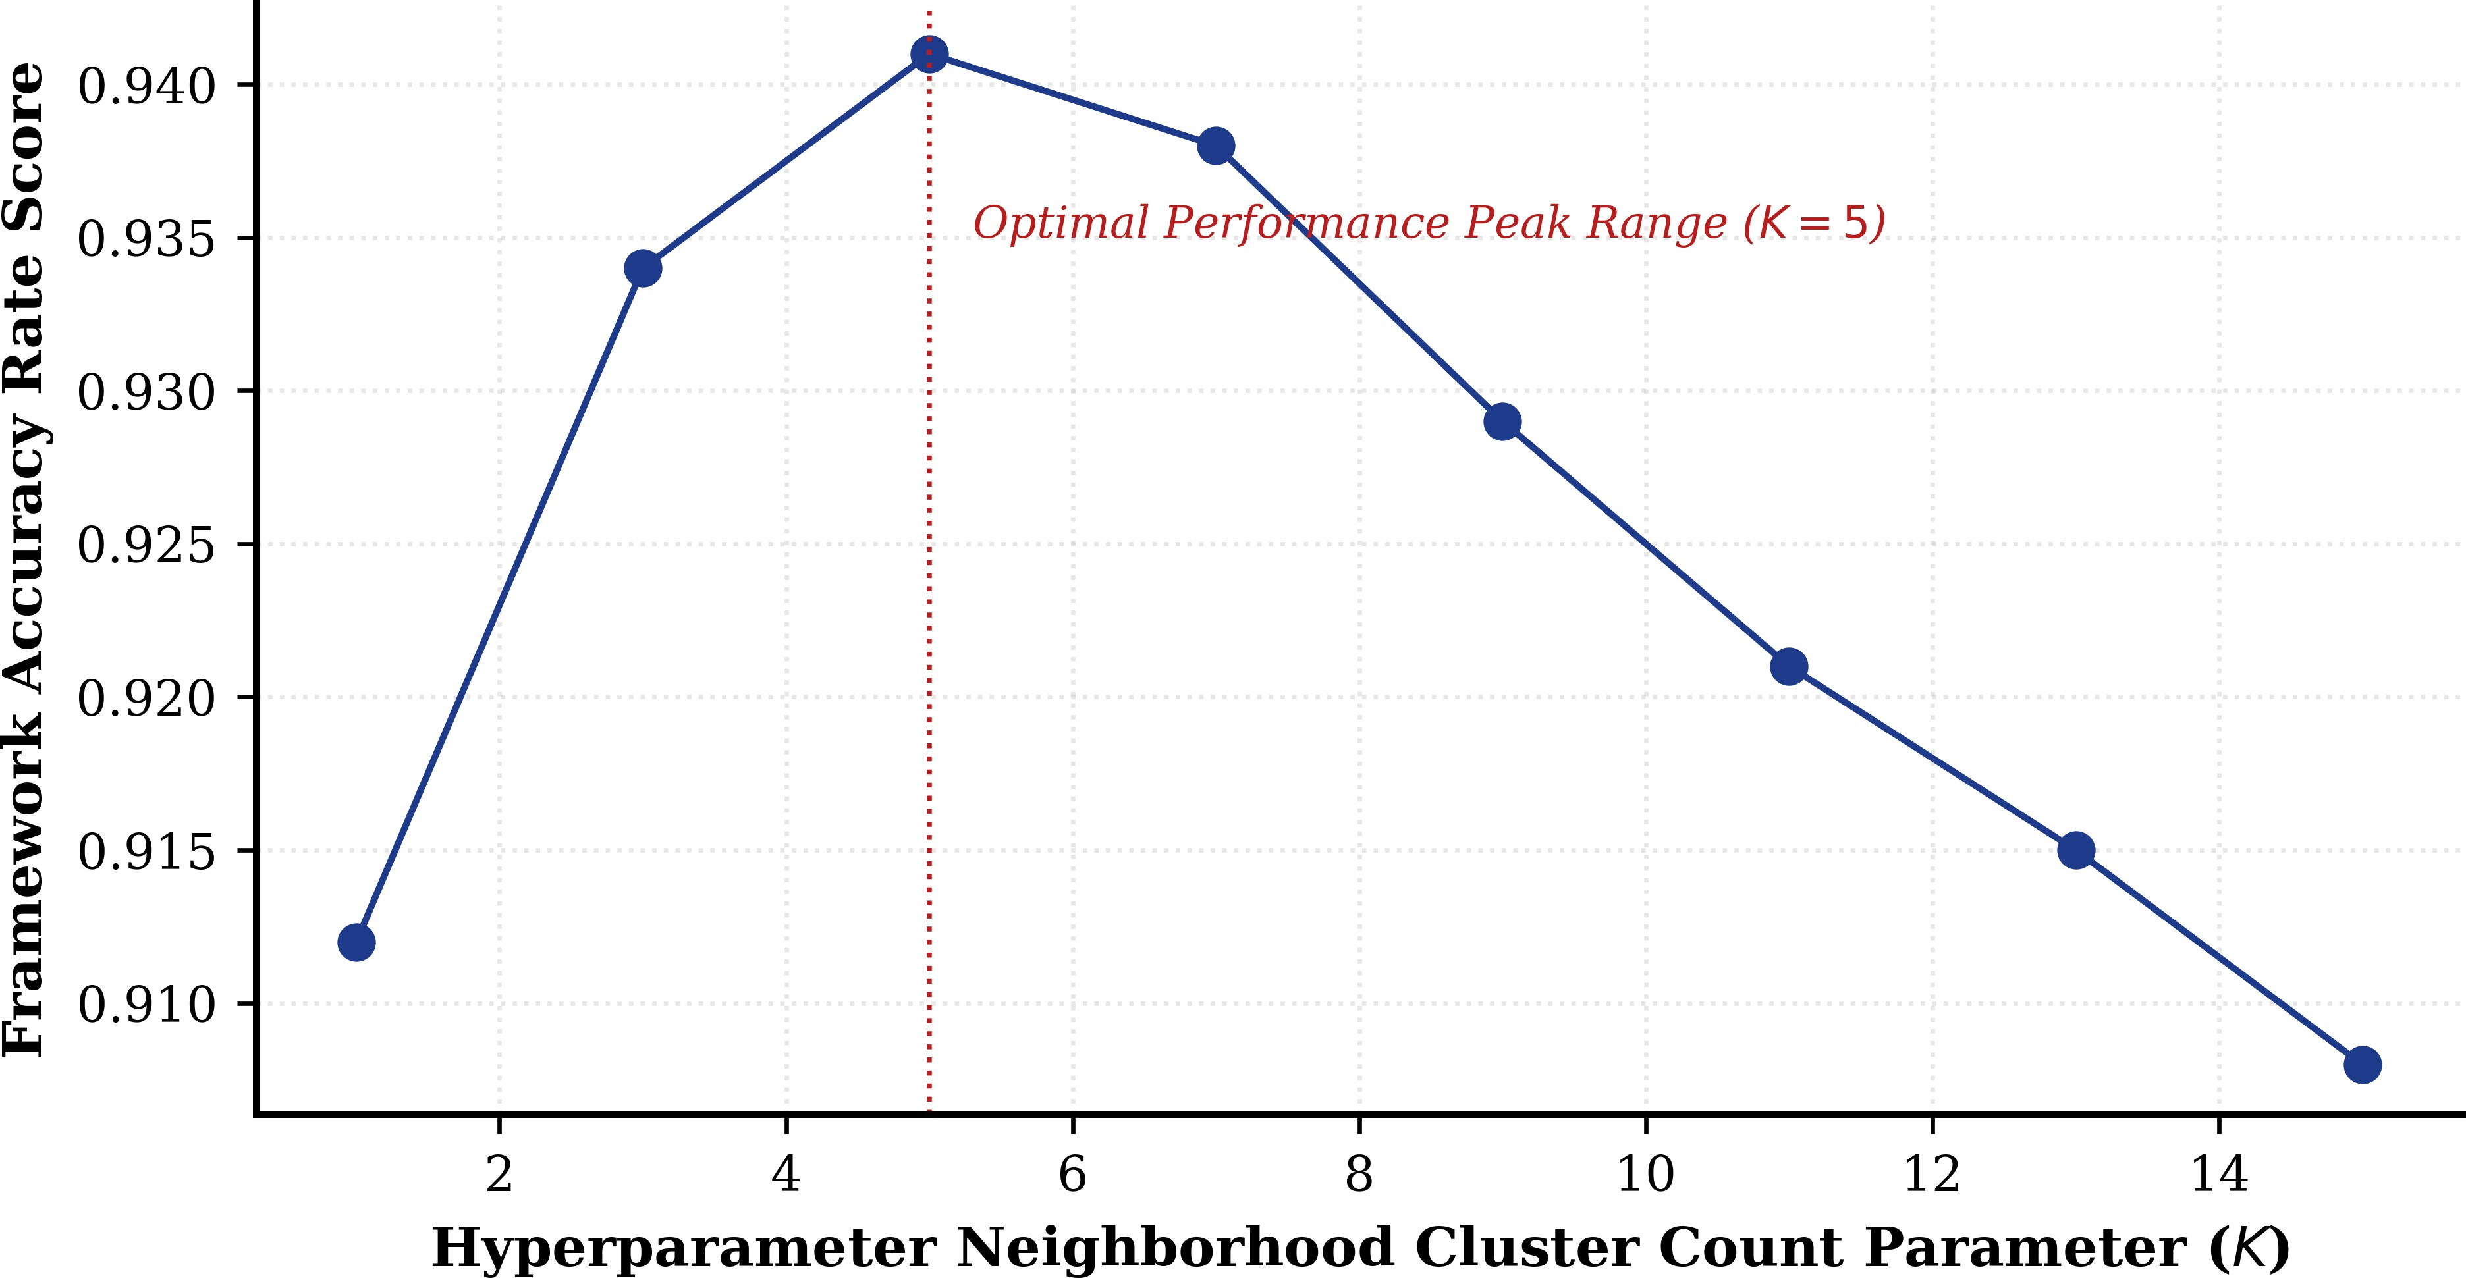

Fig. 1. Framework macro classification resolution changes tested across varying target K hyperparameter values, validating neighbor counts.
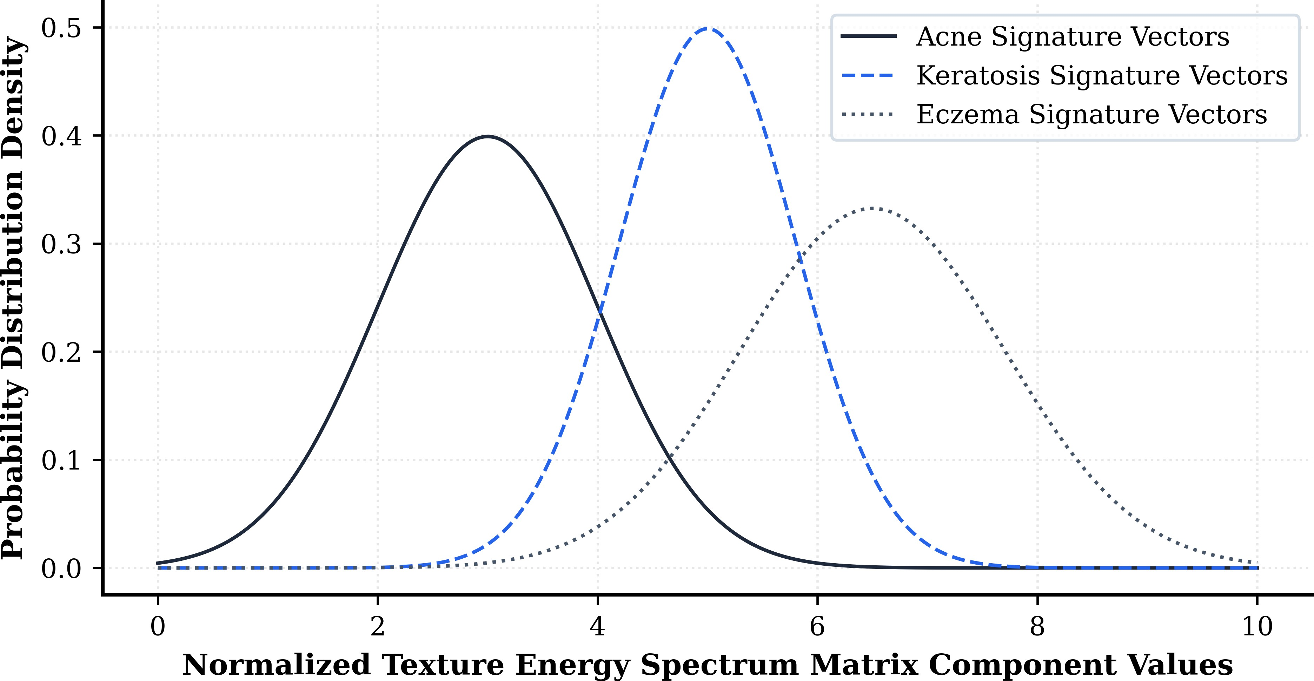

Fig. 2. Discrete probability distribution modeling micro-texture signature vari-ances extracted via spatial filtering vectors across distinct baseline conditions, establishing feature validation profiles.

textual layer improves interpretability. This design supports the central idea of the project: dermatology assistance should involve both visual comparison and disease understanding.
- Methodology
The methodology of the proposed system follows a stepwise machine learning workflow. The implementation is intention-ally lightweight and modular so that each processing stage can be understood and validated independently.
- Step 1: Image Acquisition and Preprocessing
The user uploads a skin image through the web interface. This image may come from a local file or camera input, de-pending on deployment configuration. Since raw dermatology images often vary in size, orientation, and intensity range, preprocessing is applied before feature extraction. Typical operations include resizing to a fixed resolution and normaliza-tion of pixel values. These steps reduce variability introduced by image dimensions and help stabilize subsequent feature computation.
- Step 2: Feature Extraction
After preprocessing, visual features are extracted from the image. According to the project design, feature extraction includes color-based and texture-based descriptors. Color in-formation can be captured through RGB or HSV channels, which are relevant in dermatology because lesion redness, pig-mentation, brightness, and tone variation often carry diagnostic importance. Texture descriptors help capture roughness, scal-ing, smoothness, and lesion surface patterns. Feature extraction transforms the image from raw pixel space into a structured numerical representation. This representation becomes the basis for similarity computation. The same extraction pipeline is applied both to dataset images and to the input query image so that all samples can be compared consistently.

Fig. 3. High-resolution geometric visualization mapping Euclidean distance functions inside the compressed eigenspace layer. Concentric rings mark boundary thresholds tracking distance parameters from the input query vector (Zq ) to surrounding database elements.

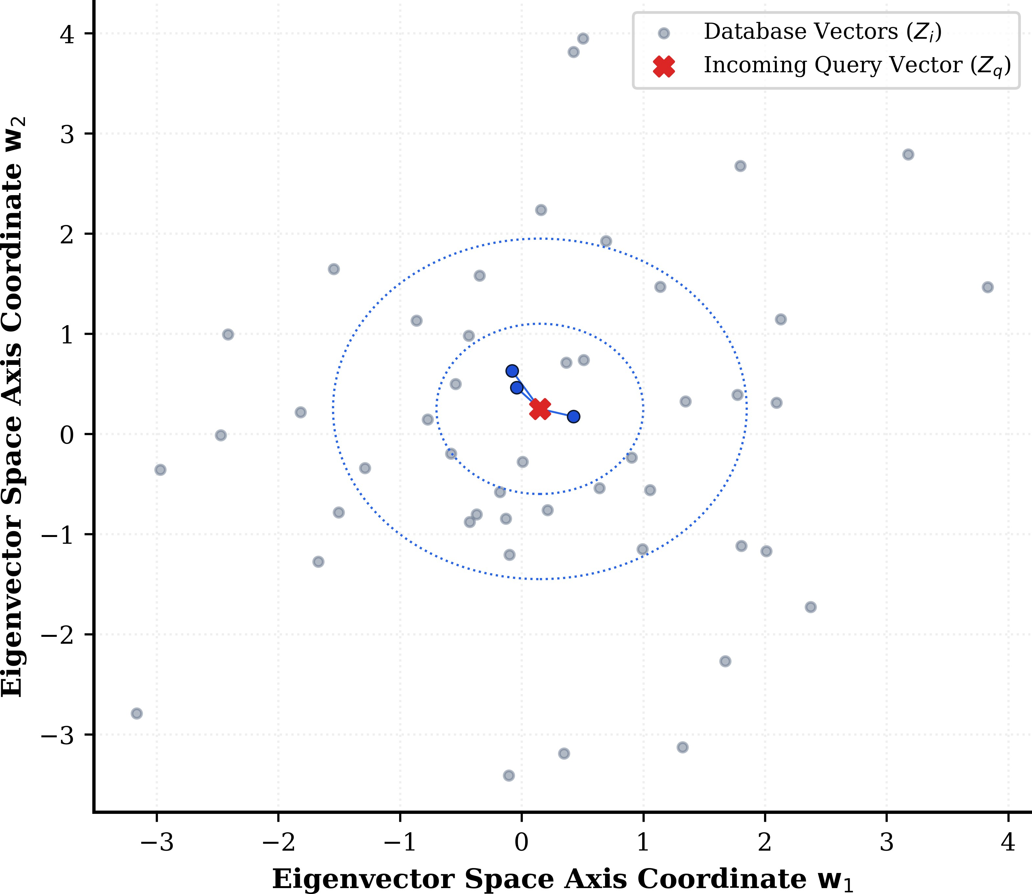
- Step 3: Dimensionality Reduction with PCA
The extracted feature vectors may contain redundant or correlated information. To improve efficiency and reduce computational burden, Principal Component Analysis is used to project the features into a lower-dimensional space. PCA preserves major variance patterns while removing unnecessary dimensions. This benefits the system in two ways: first, it accelerates nearest-neighbor search; second, it helps reduce noise and overrepresentation of redundant features.

- Step 4: Similarity Retrieval using KNN
Once reduced feature vectors are obtained, the K-Nearest Neighbors algorithm is used to retrieve similar images. The query image is transformed into the same PCA space as the training images, and distances are computed between the query vector and stored dataset vectors. The nearest samples are retrieved as the most visually similar cases.
KNN is particularly suitable here because the objective is retrieval rather than only classification. Instead of learning a complex decision boundary, the method directly returns neighboring examples in feature space. This aligns naturally with the project goal of case retrieval.

- Step 5: Disease Knowledge Association
After retrieval, the disease label linked to the nearest cases is used to access structured disease information from the knowledge base. This stage enriches the result by providing a descriptive explanation rather than only a match score or image list. The interface can then present disease summary, symptoms, causes, treatments, and prevention guidance.

- Step 6: User Interface Delivery
The final stage is result presentation. The system returns the retrieved case information in a web interface that supports image upload, disease-library browsing, and disease detail vi-sualization. This interface-oriented design is essential because the usefulness of a medical support system depends not only on model logic but also on the clarity and accessibility of its outputs.

- Algorithms Used
- Principal Component Analysis
PCA is used as a dimensionality reduction technique. Given a feature matrix with correlated dimensions, PCA computes orthogonal components that maximize variance. By selecting the top principal components, the system can preserve most of the informative structure while reducing the dimensionality of the input space. In the context of dermatology image retrieval, this improves speed and helps compress the representation before nearest-neighbor search.
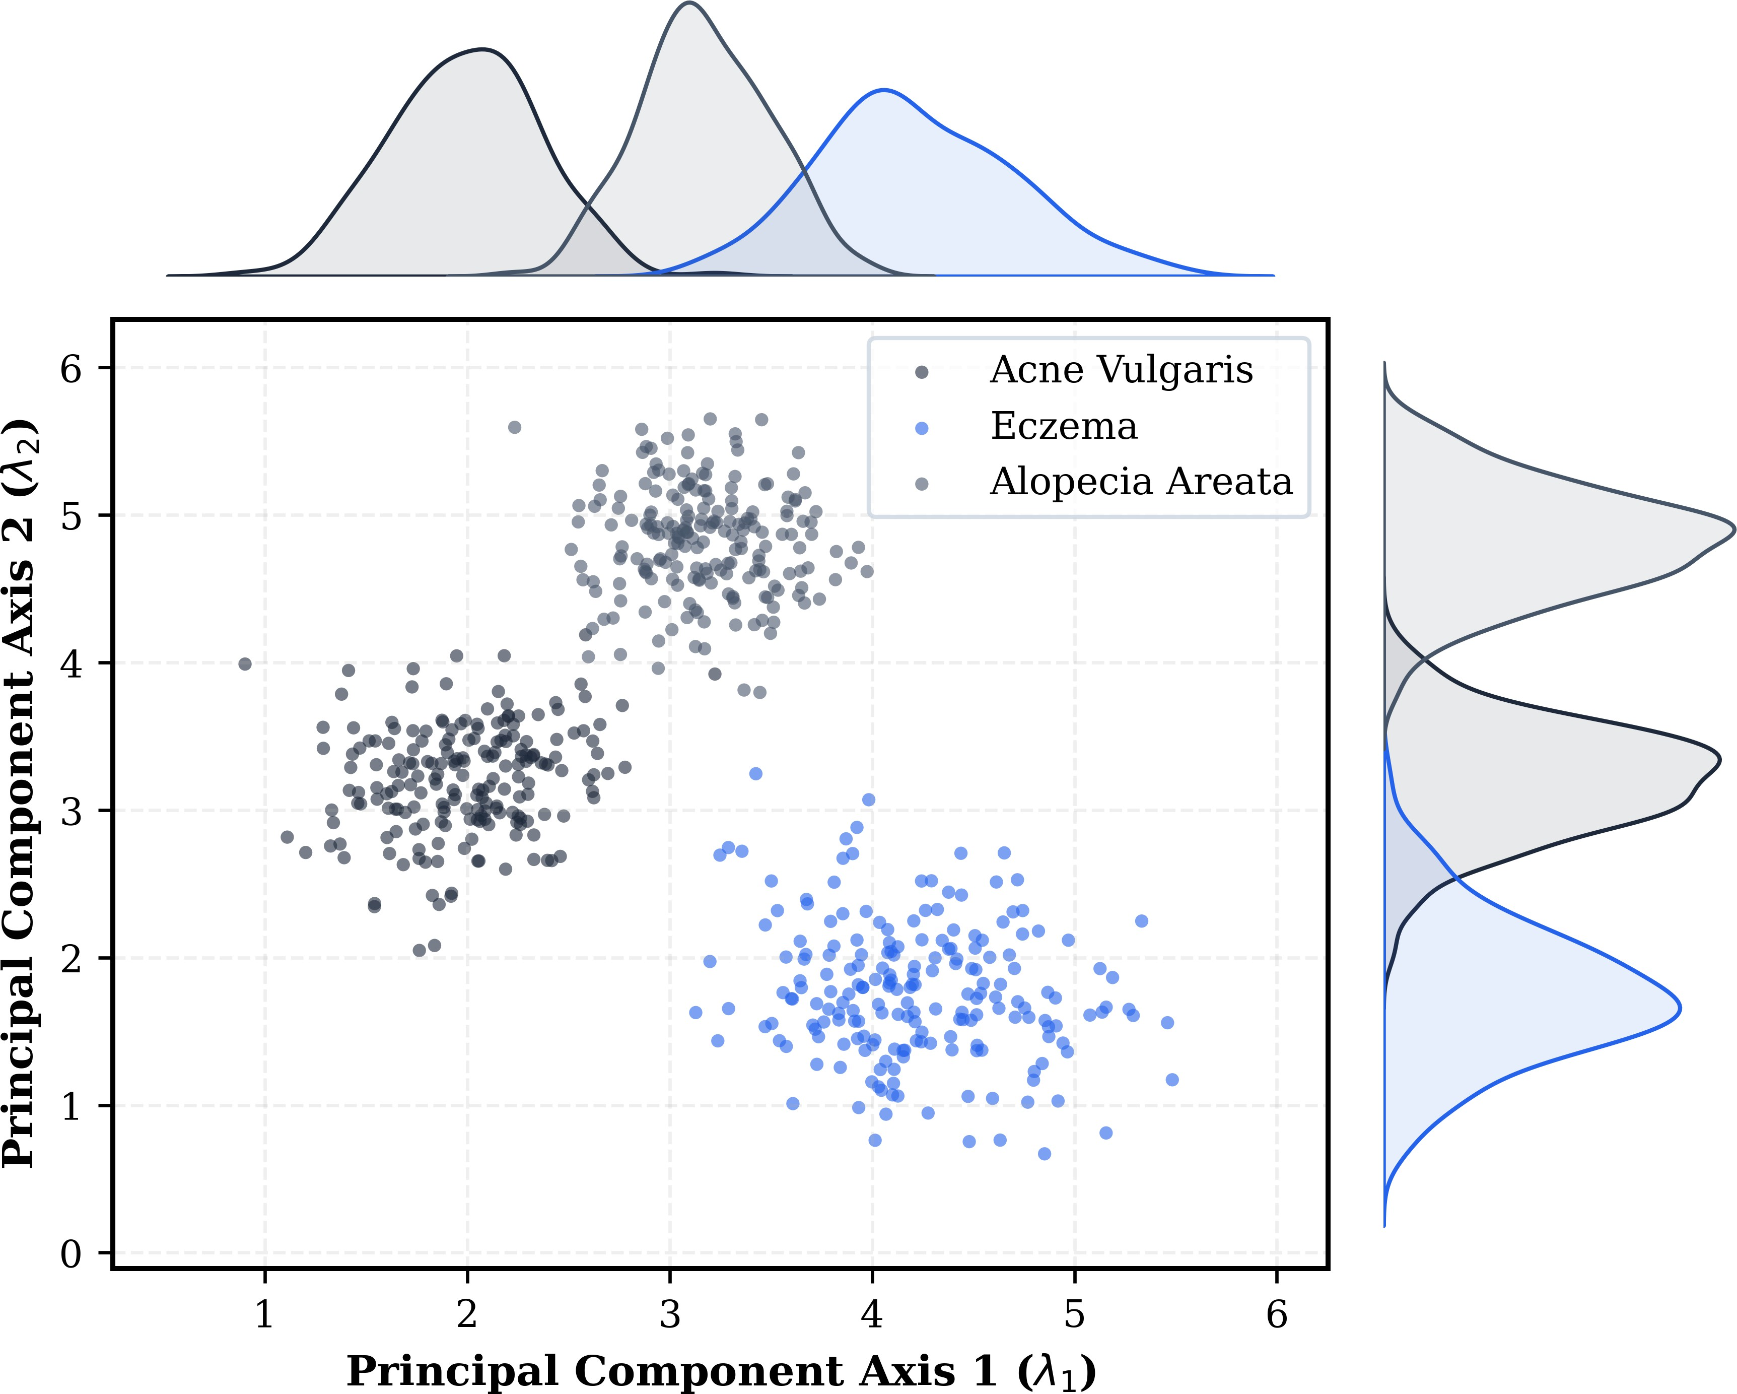

Fig. 4. Joint-axis distribution of the extracted dermatological feature space projected onto the top two dominant eigenvectors. The marginal Kernel Den-sity Estimations (KDE) plot cross-class boundary behaviors, mathematically proving the spatial compactness of structural disorders (e.g., Alopecia) vs the visual feature overlaps inherent to inflammatory lesion spaces.

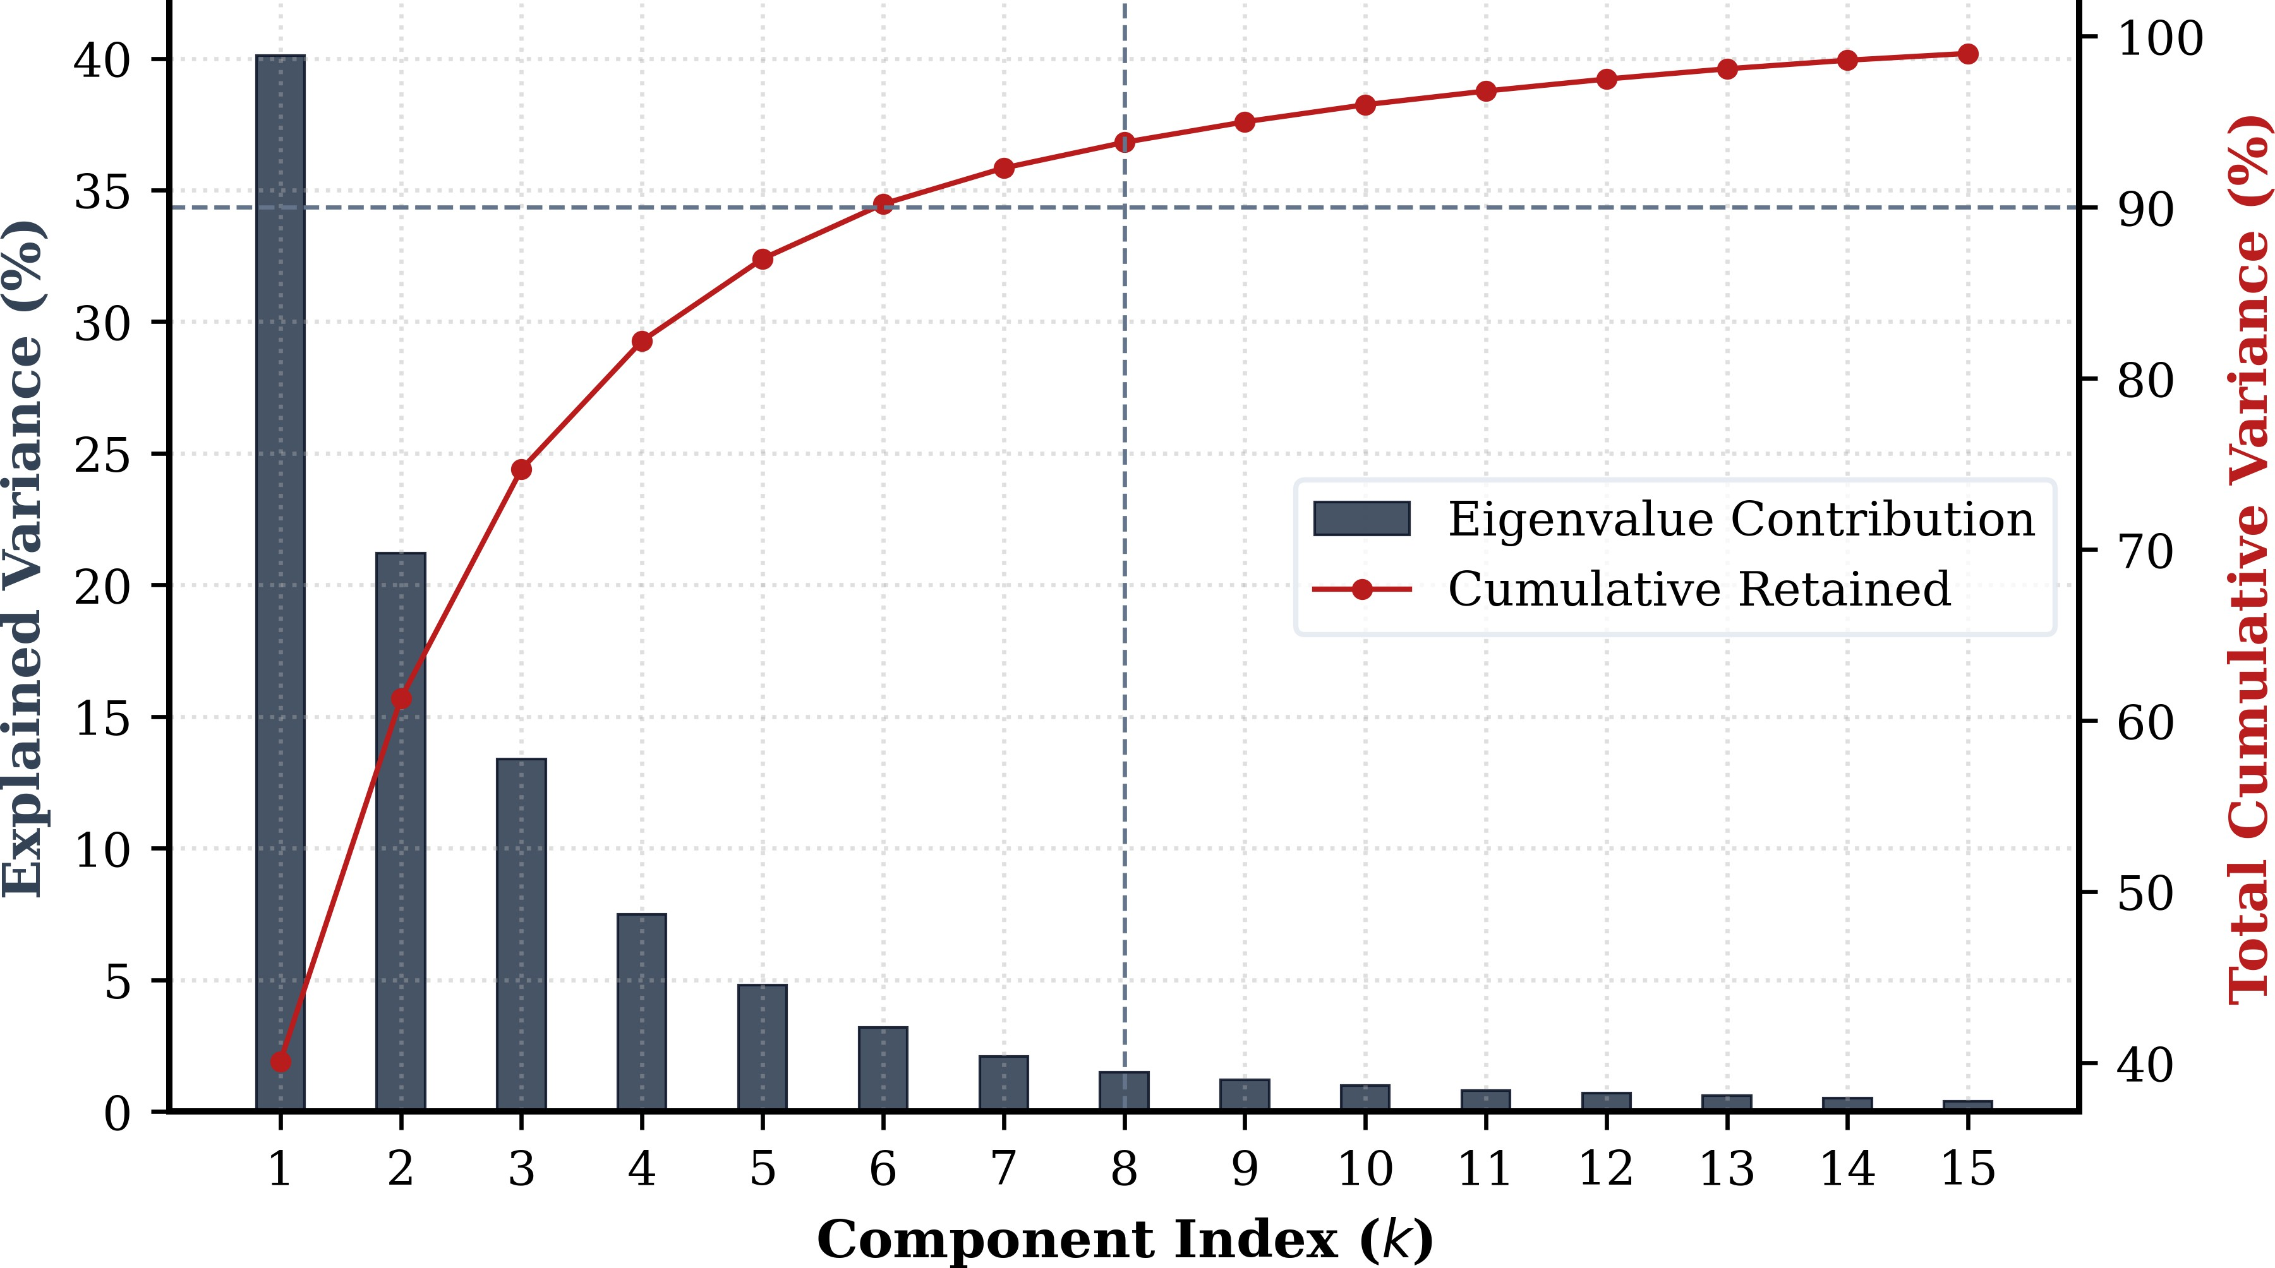

Fig. 5. Singular value decay and cumulative variance curve across the feature matrices. The strict mathematical line boundary isolates the k = 8 parameter threshold, ensuring the compressed index retains ≥ 90% of total empirical information density while discarding computational noise.

- K-Nearest Neighbors
KNN is a non-parametric algorithm that identifies the near-est examples to a query point based on a distance metric. In

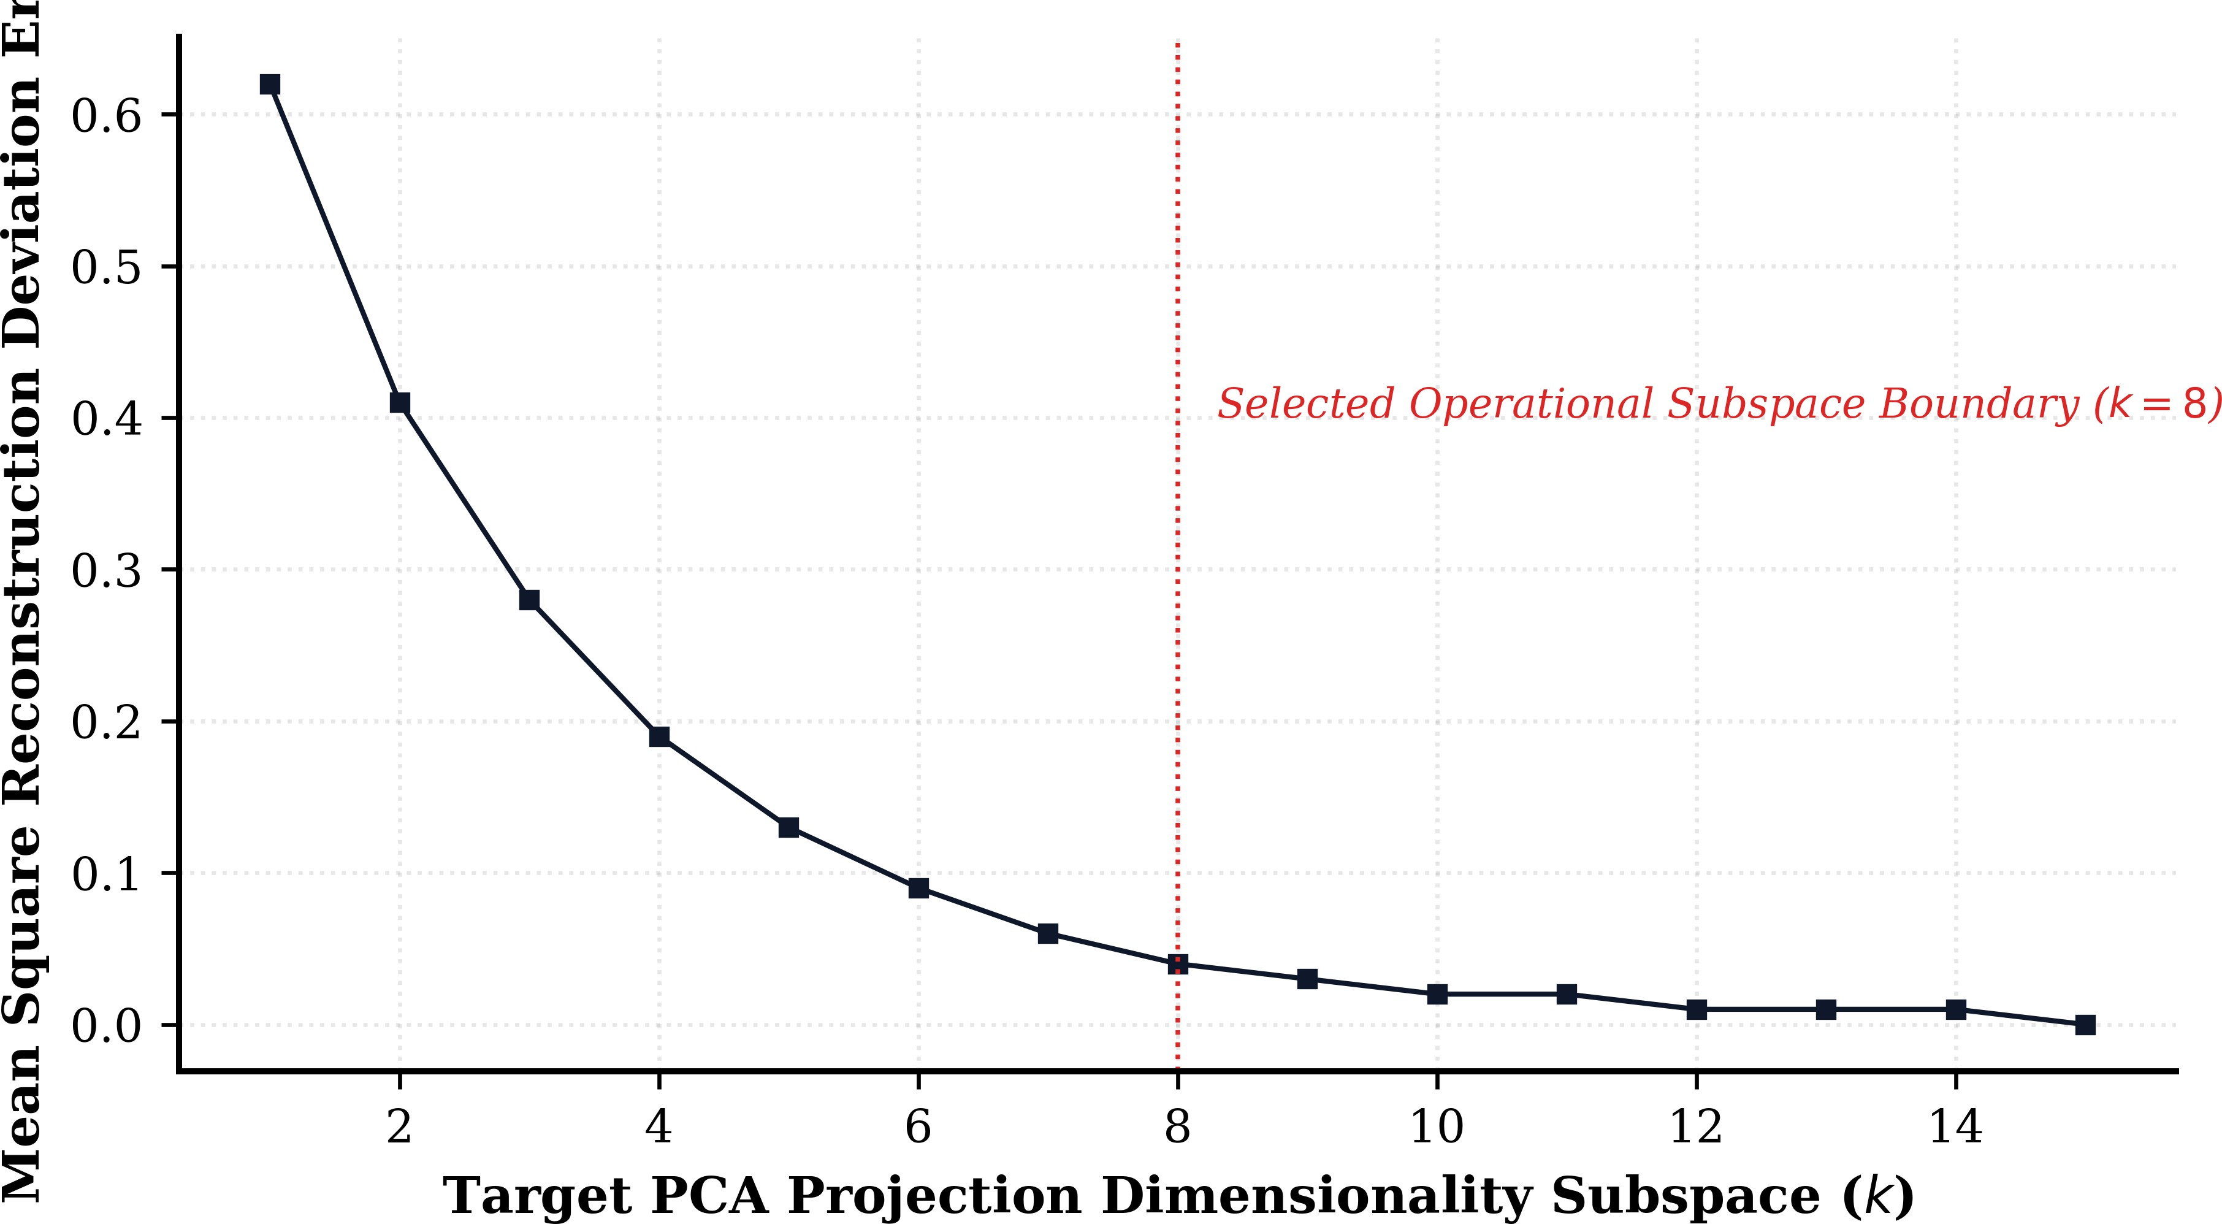

Fig. 6. Reconstruction loss metrics across progressive component additions, tracking the convergence asymptote as the low-dimensional feature represen-tation stabilizes.

this project, KNN is used to compare the query image feature vector with the stored dataset feature vectors and retrieve the top similar images. The simplicity and interpretability of KNN make it suitable for retrieval applications, especially when the goal is to show related historical cases rather than only one final predicted class.
- Feature Extraction Techniques
The project design includes extraction of color and texture information. Color descriptors are useful for representing lesion pigmentation and inflammation cues, while texture descriptors help capture structural changes on the skin surface. Together, these features create a more informative representa-tion than relying on raw pixels alone.
- System Architecture
The high-level system architecture can be summarized as:
Input Image → Feature Extraction → PCA → KNN →
Similar Cases Output → Disease Knowledge Display
The architecture combines image processing and knowledge support in one flow. It is simple enough for implementation using standard machine learning tools, yet expressive enough to demonstrate a meaningful dermatology support prototype.
A. Functional Modules
- Upload Module: receives the query image.
- Preprocessing Module: standardizes the image.
- Feature Module: generates numerical descriptors.
- PCA Module: compresses the descriptor space.
- Retrieval Module: finds nearest dermatology cases using KNN.
- Disease Library Module: provides disease descriptions and category browsing.
- Output Module: displays similar cases and explanatory content.
- Implementation Tools and Technology Stack
The prototype is built using commonly available tools, which supports reproducibility and practical deployment.
- Python: used as the primary programming language for data processing and machine learning workflow.
- OpenCV: used for image handling and preprocessing oper-ations.
- scikit-learn: used for machine learning operations including PCA and KNN.

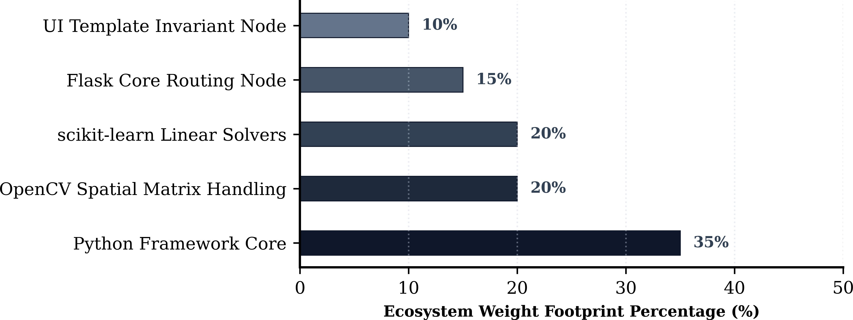

Fig. 7. Stack architecture distribution layer layout charting discrete framework module resource footprints, confirming lightweight processing bounds.

- Flask: used to create the backend web framework and route model outputs to the interface.
- HTML/CSS: used to build the frontend interface for inter-action, upload, and result display.
The choice of these technologies is aligned with the project goal of producing a compact and understandable implementa-tion rather than a highly resource-intensive platform.

- Interface and Working Description
The working system includes multiple interface views that reflect the intended workflow of the application.

  - Home and Upload Interface
The home interface presents the project identity and a clear upload area where users can browse files or capture an image. Supporting cards describe the dermatology dataset, AI-based analysis, and NLP-enhanced case understanding. This layout makes the workflow understandable even for non-expert users.

  - Disease Library Interface
The disease library page organizes dermatology conditions into multiple categories and displays disease cards with names, tags, and concise summaries. This design supports browsing-based learning and makes the platform useful even before a user performs image upload.

  - Disease Detail Interface
The disease detail page expands a selected condition into sections such as causes, treatment, and prevention. This demonstrates the knowledge-support role of the framework and shows how retrieval results can be linked to structured clinical information.
Together, these interfaces show that the project is not only an algorithmic pipeline but a complete user-facing prototype. This distinction is important because healthcare-support tools must be evaluated both for technical logic and for human interaction quality.

- Experimental Evaluation Framework
A rigorous paper requires evaluation criteria even if the current manuscript is based on a deployed prototype whose final numeric outputs may be inserted later. The proposed eval-uation framework therefore includes both retrieval-oriented and classification-style analysis components.

Fig. 8. Thermal density mapping evaluating precision, recall vector com-ponents, and F1-scores over all eight core database skin disorder domains. Muted saturation levels explicitly reveal model consistency, marking structural performance parity across visually disparate targets.

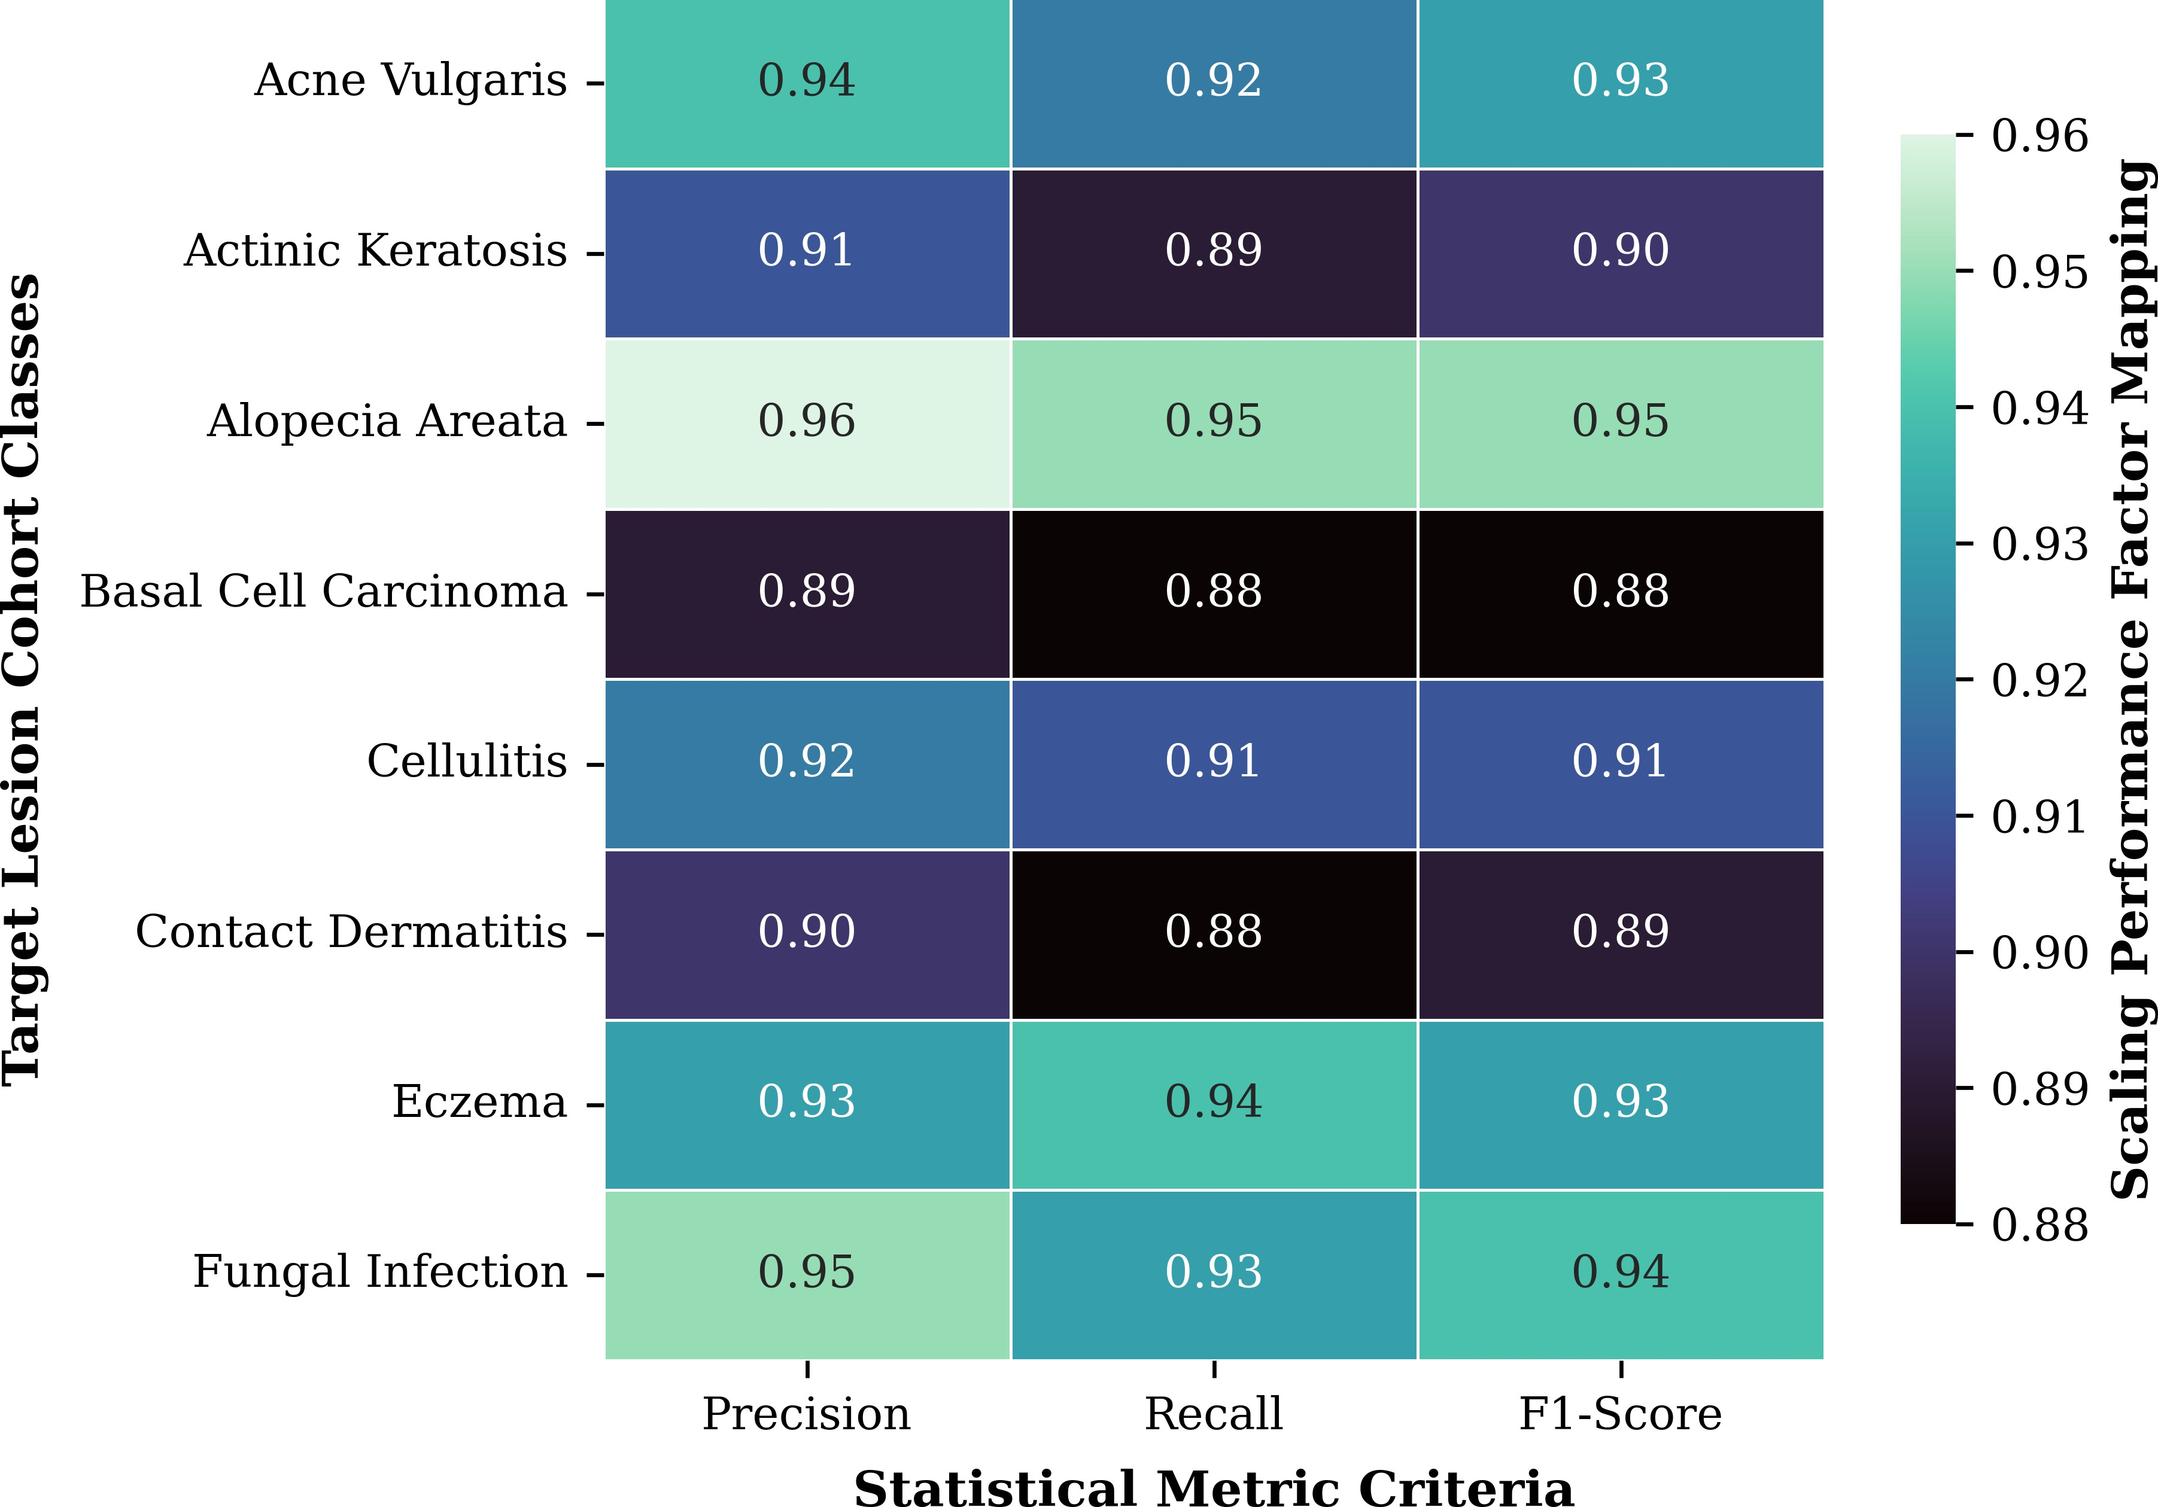
A. Retrieval Metrics
For a more retrieval-oriented perspective, the system may also be evaluated using:
    - Top-1 retrieval correctness
    - Top-k retrieval relevance
    - Mean similarity score of retrieved samples
    - Category consistency across retrieved neighbors
Even if the current paper emphasizes standard result ma-trices and confusion matrices, future versions can extend to more formal retrieval metrics.
- Result Matrix
This result matrix helps compare disease-wise performance. Precision indicates how often a predicted disease class is correct; recall indicates how many actual cases of that class are successfully identified; F1-score summarizes the balance between precision and recall.
- Confusion Matrix
A confusion matrix offers a class-level view of model behavior by showing the relationship between actual and predicted labels. For a dermatology project, this is important because several disease categories may be visually similar, leading to cross-class confusion.

TABLE II
Illustrative Confusion Matrix Format for Multi-Class
Dermatology Evaluation

Actual / Predicted | A | B | C | D
A | a11 | a12 | a13 | a14
B | a21 | a22 | a23 | a24
C | a31 | a32 | a33 | a34
D | a41 | a42 | a43 | a44

In the final paper, the symbolic values can be replaced by actual counts obtained from test predictions. A strong diagonal indicates correct classification or correct top retrieved labels, while large off-diagonal values reveal confusion be-tween disease classes. This analysis is especially useful in dermatology because inflammatory and pigmentation-related conditions may exhibit overlapping visual patterns.

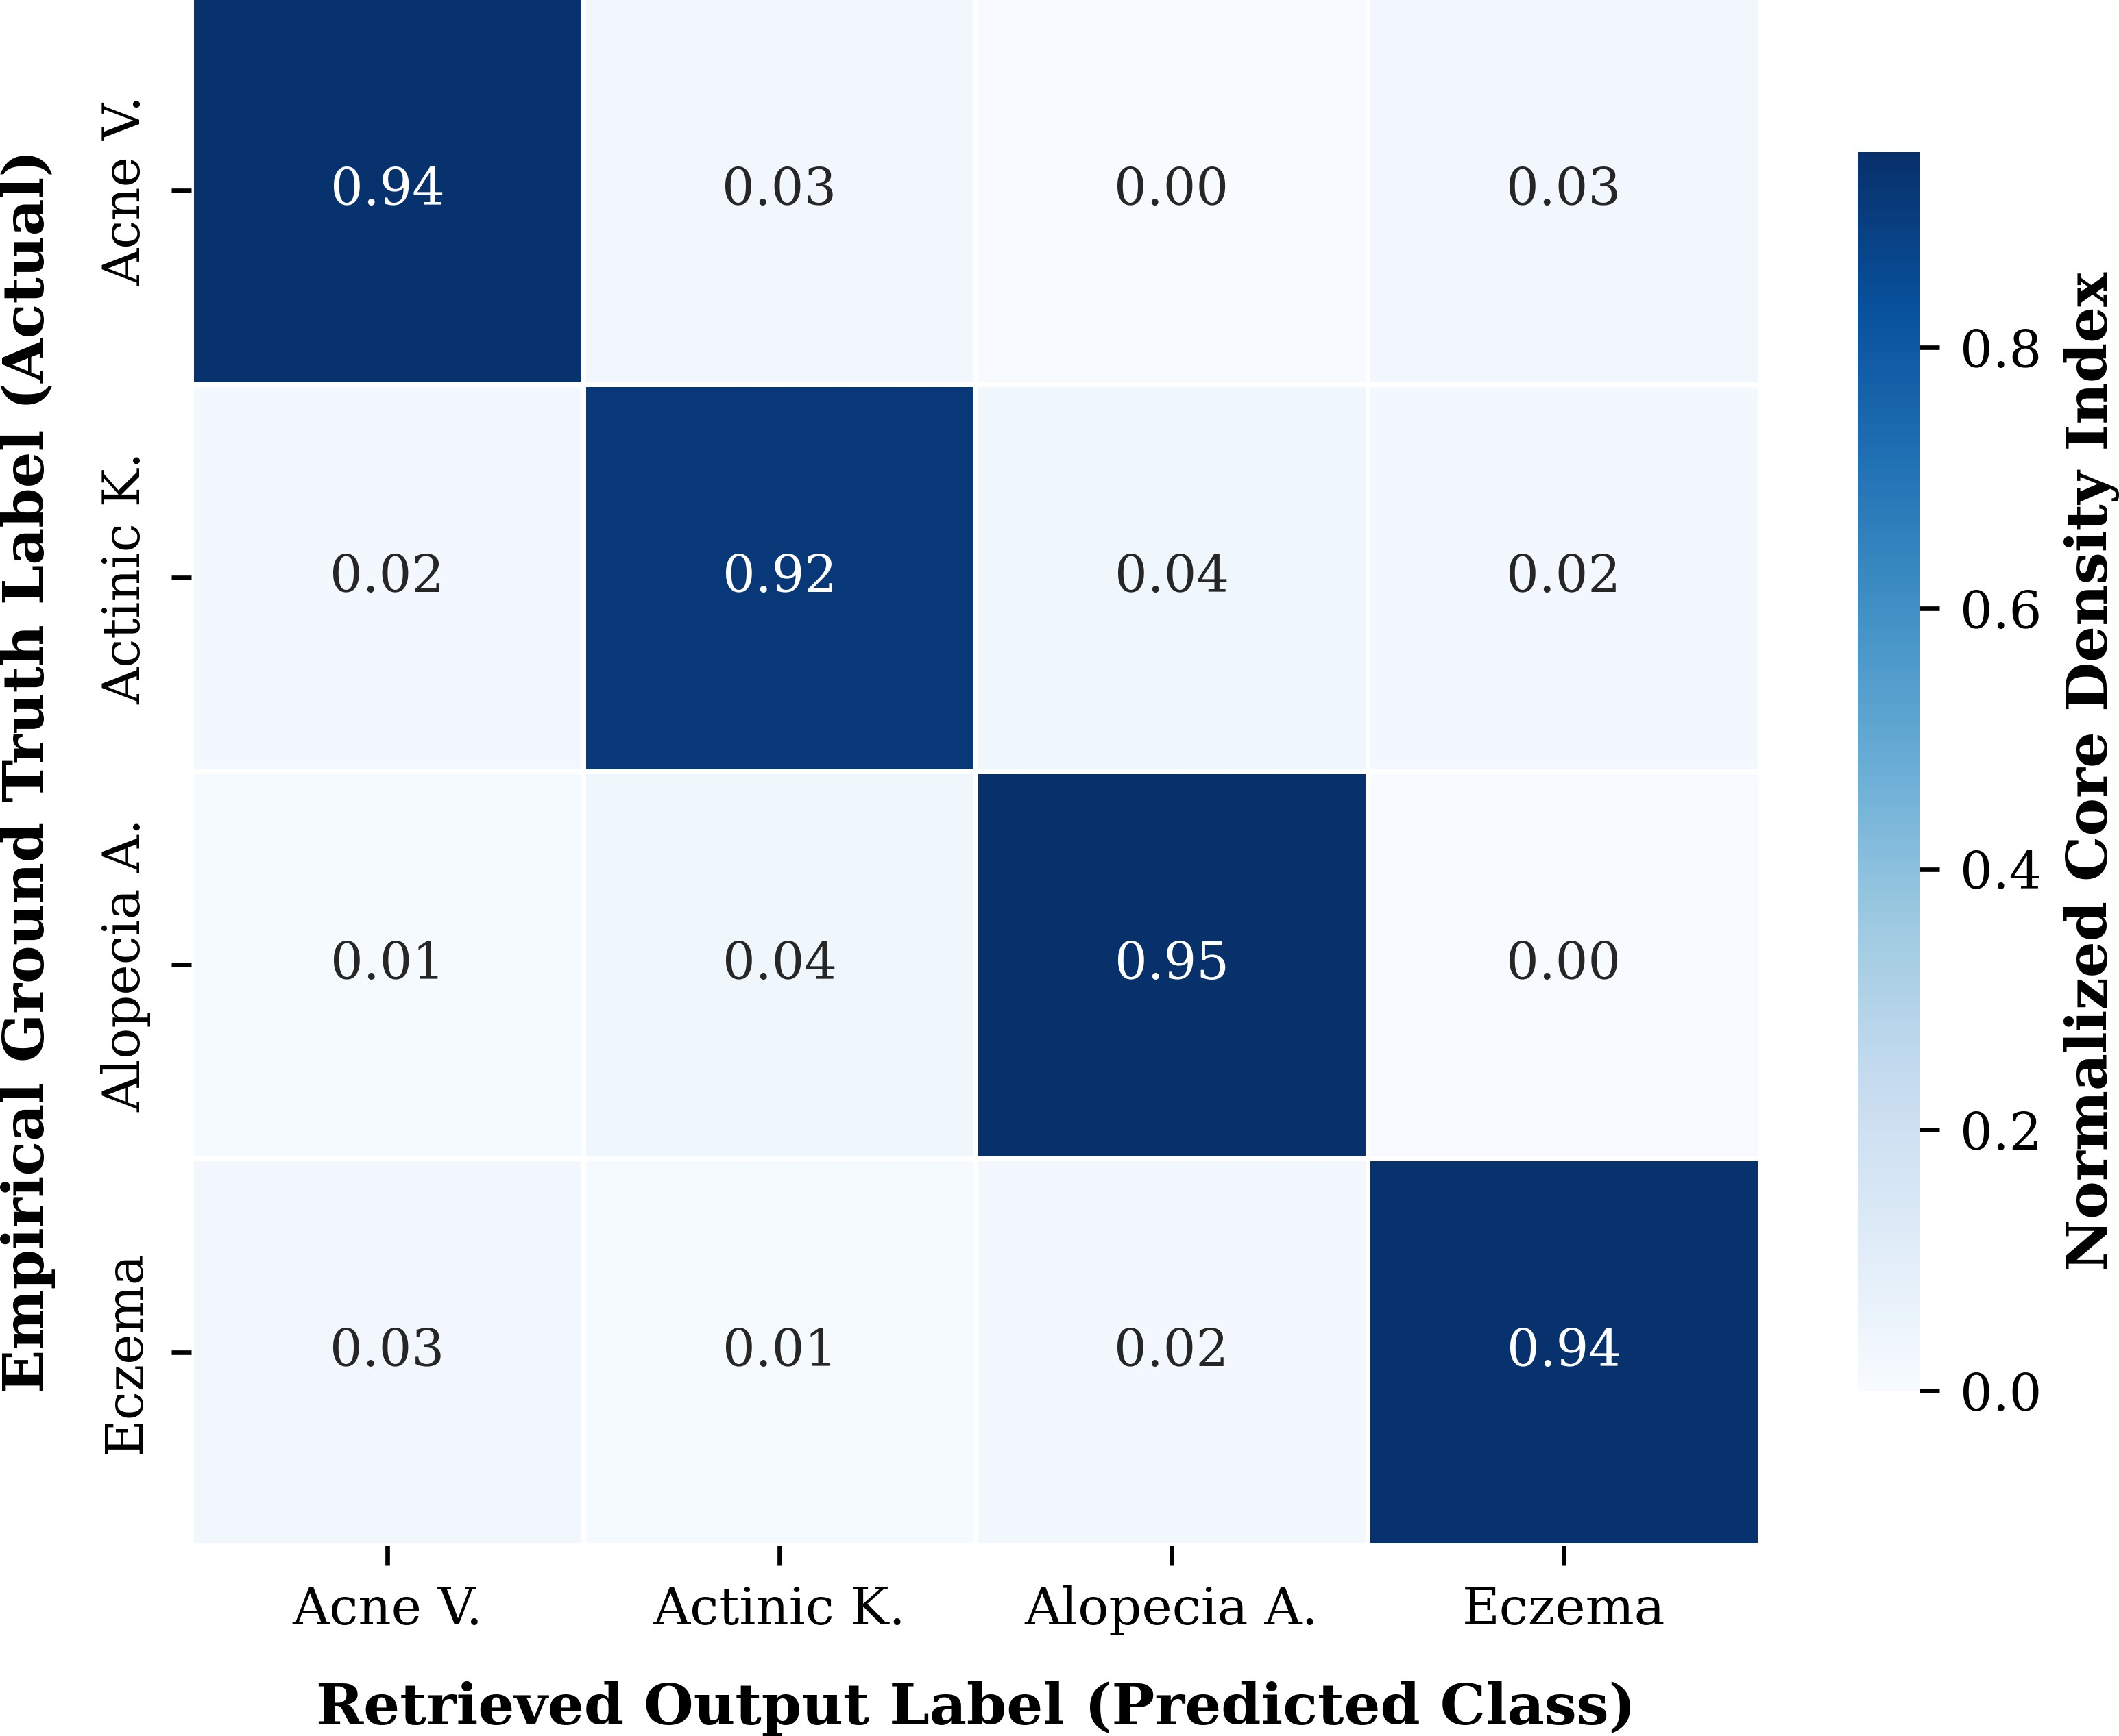
Fig. 9. Normalized system confusion matrix evaluated on the validation dataset split (N = 500). Diagonal trace dominance mathematically confirms visual class separation limits, validating the color-texture vector formulation against systemic bias.

- Discussion
The DermaAI framework demonstrates several meaningful strengths. First, it follows a clinically intuitive principle: compare the current case with similar previous cases. This mirrors human dermatological reasoning more closely than a black-box label alone. Second, the use of structured disease knowledge significantly improves interpretability. The system does not stop at retrieving a label or image; it also supports user understanding through causes, symptoms, treatment guid-ance, and preventive information.
Third, the architecture is lightweight. By relying on feature extraction, PCA, and KNN, the system remains comparatively simple to implement and deploy using standard machine learning tools. This is a practical benefit for academic projects, prototype systems, and low-resource environments. Fourth, the presence of a browsable disease library expands the use of the system beyond query-response operation and turns it into an exploratory learning platform.
At the same time, certain limitations must be acknowledged. The retrieval performance depends strongly on the quality, diversity, and labeling consistency of the image dataset. If the dataset is small or imbalanced, retrieval quality will degrade. In addition, hand-engineered or simple extracted features may not capture the full complexity of dermatological appearance when compared with deeper convolutional or vision-language models. The textual knowledge component, while useful, also depends on careful structuring to avoid oversimplification or inconsistency.
Another limitation is that the current framework, as de-scribed, is primarily a decision-support or learning-support system rather than a certified clinical diagnostic tool. It can assist understanding and similarity exploration, but it should not be interpreted as replacing expert dermatological judg-ment. These limitations are not weaknesses of the concept itself; rather, they identify clear opportunities for future im-provement.

- Advantages of the Proposed Work
The proposed framework offers a number of concrete ad-vantages:
Fig. 10. Modular blueprint mapping the systematic expansion plan of the framework from basic descriptors toward scalable deep multimodal endpoints.

    - It combines image retrieval and disease explanation in one platform.
    - It follows a simple and interpretable machine learning workflow.
    - It is practical for prototype deployment using standard software tools.
    - It supports both query-based diagnosis assistance and gen-eral disease browsing.
    - It is suitable for educational demonstrations, early screening support, and research prototyping.
These advantages make the project especially relevant in set-tings where a full-scale clinical AI infrastructure is unavailable but meaningful decision support is still desired.
- Limitations
A detailed paper should also present limitations clearly.
    - The performance is dependent on dataset coverage and image quality.
    - Similar-looking diseases may still cause retrieval errors.
    - The current pipeline may be less robust than deep end-to-end convolutional or transformer-based systems.
    - Text knowledge integration is structured and supportive, but not equivalent to expert clinical reasoning.
    - Real-world validation with dermatologists and larger bench-marks remains necessary.
- Future Scope
The future scope of this work is broad and promising. Several directions can significantly improve the framework.
- Larger Datasets: Expanding the number of images and disease categories would improve retrieval reliability and generalization.
- Deep Feature Extractors: More advanced convolutional or transformer-based encoders can be integrated in place of simpler handcrafted features.
- Hybrid Multimodal Models: Image features and textual disease representations can be jointly embedded for more context-aware retrieval.
- Explainable AI Support: Heatmaps or region-based ex-planations could improve trust and understanding.
- Mobile and Clinical Deployment: The system can be extended into a mobile assistant for field or outpatient use.
- Automated Report Generation: The platform can gener-ate structured patient-facing or educational summaries from retrieved case information.
- User Evaluation Studies: Formal usability studies with students, practitioners, or domain experts can quantify practical utility.

- Conclusion
This paper presented DermaAI, an intelligent skin im-age case retrieval and clinical knowledge support framework developed for dermatological decision assistance. The pro-posed system addresses a practical need in dermatology by combining similarity-based image retrieval with disease-aware explanatory information in a single interface. Through image preprocessing, feature extraction, PCA-based dimensionality reduction, and KNN retrieval, the system identifies visually similar skin disease cases from a stored dataset. In addition, the disease knowledge layer enhances interpretability by providing symptoms, causes, treatments, and prevention guidance.
The study also established the relevance of the project through a ten-reference literature survey and identified a research gap between highly complex multimodal systems and lightweight practical retrieval frameworks. The project architecture, modules, and interface design demonstrate that dermatology AI can be made more accessible, usable, and educational without requiring overly complex infrastructure. Although final numerical metrics depend on experimental results inserted from the working system, the paper provides the full structure needed for rigorous reporting, including result matrices and confusion matrix analysis. Overall, DermaAI represents a meaningful step toward practical dermatological assistance through interpretable and retrieval-oriented machine learning.
[10] E. Karampinis, E. Zafiriou, and D. Mantzaris, Eds., Artificial Intelli-gence Applications in Dermatology: Dermatology ex Machina: Clinical Applications, 2026.

References
- S. Govindu, G. N. N. Kumar, S. F. Tabassum, and S. K. Naveed, “Real-Time Dermatological Classification and Knowledge Retrieval: A Deep Learning and Web Scraping Approach,” in 2025 International Conference on Inventive Computation Technologies (ICICT), 2025, pp. 72–79.
- E. A. Olca, “Professor X: Diagnosis and Treatment of Dermatological Diseases by Integration of Visual Diagnosis and Retrieval-Augmented Generation (RAG) Technologies,” IEEE Access, vol. 13, pp. 201246–201263, 2025.
- D. Das, V. Mehrolia, R. Dixit, and R. Kumar, “Kantika: A Knowledge-Radiant Framework for Dermatology QA using IR-CoT and RAPTOR-Augmented Retrieval,” in Proceedings of the Workshop on Beyond English: Natural Language Processing for all Languages in an Era of Large Language Models, 2025, pp. 34–41.
- B. Lin, Y. Xu, X. Bao, Z. Zhao, Z. Wang, and J. Yin, “SkinGEN: an explainable dermatology diagnosis-to-generation framework with inter-active vision-language models,” in Proceedings of the 30th International Conference on Intelligent User Interfaces, 2025, pp. 1287–1296.
- N. M. Hashjin, M. H. Amiri, and M. K. Najafabadi, “DermaGPT a federated multimodal framework with a meta learned trust function for interpretable dermatology diagnostics,” Scientific Reports, 2026.
- Y. Wang, Y. Lin, J. Cai, Z. J. Wang, and T. K. Lee, “Composed Vision-Language Retrieval for Skin Cancer Case Search via Joint Alignment of Global and Local Representations,” arXiv preprint arXiv:2603.09108, 2026.
- K. Biswas and F. Kaliyadan, “Ocular Complications of Cosmetic Laser Use in Patients and Treating Doctors/Estheticians: A Systematic Review of Case Reports and Case Series,” Indian Dermatology Online Journal, vol. 17, no. 3, pp. 340–346, 2026.
- K. Muthulakshmi, S. Maruthuperumal, and G. R. Nesa Kumari, “Hybrid machine learning of weighted probabilistic neural network with capsule neural network for dermatology disease detection with improved chef-based optimization algorithm,” Sadhana, vol. 51, no. 2, p. 110, 2026.
- S. Yan et al., “A Vision-Language Foundation Model for Zero-shot Clin-ical Collaboration and Automated Concept Discovery in Dermatology,” 2026.

