Diagnosis and Lifestyle Recommendation System for Interstitial Lung Diseases

- Introduction
Interstitial lung diseases (ILDs) are chronic lung diseases that result from inflammation and fibrosis, hence causing diminished lung function. Diagnosis through HRCT is usually subjective and costly. In this project, CNNs, ViTs, and Effi-cientNet are used in the deep learning models to help improve automatic classification of ILDs.
HRCT images combined with patients’ data including their age, gender, SpO₂, smoking, and allergy will be used in order to provide customized solutions for the patient’s disease. ILD DB dataset will be used for data preprocessing and training using PyTorch with stratified sampling in order to handle

2nd Ramya Thavva
Department of Artificial Intelligence and Machine Learning Chaitanya Bharathi Institute of Technology
Hyderabad, India ramyatcseaiml@cbit.ac.in

imbalanced classes. Precision, recall, F1-score, confusion ma-trix, and ROC will be used to evaluate the performance. The proposed system will be implemented through Streamlit application with Gemini Vision to analyze CT scans and produce a report.
- Literature Survey
In recent years, there has been an increased focus on researching the use of automated diagnostic systems for In-terstitial Lung Disease (ILD). Deep learning technologies in conjunction with advances in medical imaging have produced more accurate diagnostic results, which also lead to improved clinical workflow. Convolutional neural networks and deep learning algorithms have demonstrated considerable accuracy when analyzing medical images; as such, they are capable of identifying complex lung patterns associated with different types of ILD.
In this section, I present current research involving the use of computerized tomography (CT) imaging and Digital Imaging and Communications in Medicine (DICOM) data for diagnosing, detecting, classifying, and segmenting ILD. In addition, I include a description of various deep learning algorithms that could serve as the foundation for develop-ing automated systems that diagnose pulmonary diseases. Additionally, I evaluate emerging health informatics systems that incorporate medical imaging technology with patient-centered systems and provide both clinical decision support and personalized healthcare and disease prevention through recommendations related to lifestyle.
- Deep Learning Approaches for ILD Classification
Hybrid convolutional models are efficient for detecting and segmenting ILD. Modern algorithms integrate various network designs such as U-Net, attention pyramids, and lightweight versions of MobileNets to perform lung region detection and image classification without manually specifying the region. The algorithm uses multi-level feature extraction techniques

to detect fibrosis, ground glass opacity, and emphysema from high resolution computed tomography (HRCT) scans. Several research papers confirm that hybrid training algorithms, to-gether with attention models, offer higher interpretability and efficiency compared to regular CNNs and DenseNets.
Modern 3D and transformer architectures have taken this approach one step further by introducing the notion of spatial consistency within volumetric CT scans. Updated versions of the 3D Convolution Neural Network (CNN) and Vision Transformers have been used to train the model using context-guided attention and multi-branch learning to enhance the adaptability of the model to pulmonary textures. Furthermore, capsule networks and prototype learning algorithms, such as the Efficient-Proto-Caps architecture, have added explanatory power to the diagnostic algorithm using a morphological representation of lung characteristics.

- Automated Screening and Detection Systems
Deep detection pipelines allow automated end-to-end work-flows. We adapted object detection frameworks such as YOLOv5 and Mask R-CNN to detect pulmonary nodules in chest CT images, while integrated CNN-SVM classification improved the precision of distinguishing benign from malig-nant nodules of different types. End-to-end CT-based screening systems comprised deep learning models that perform segmen-tation, volume estimations, and grading for disease, allowing for early detection, progression, and follow-up decisions to be embedded into clinical workflow.

- Clinical Paradigms and Diagnostic Tools
One of the key diagnostic approaches for ILD is high-resolution computed tomography (HRCT), which aids in rec-ognizing certain characteristic radiological findings of differ-ent forms of ILD. In addition to HRCT imaging, a patient may go through different tests aimed at achieving further diagnostic information, such as pulmonary function testing, biomarker analysis, and bronchoscopy or surgical lung biopsy for the acquisition of histopathological evidence. In general, an interdisciplinary panel of expert physicians from different specialties (respiratory medicine, radiology, pathology) may gather for achieving higher levels of diagnostic accuracy.
Besides traditional diagnostic techniques, a whole range of novel approaches is under development in modern medical science, which can be used not only for increasing diagnostic accuracy but also for non-invasive means of confirming a particular diagnosis. Genomic classification, proteomics, and the use of AI in HRCT imaging are some examples, which have been proven useful in the early and reliable diagnosis of ILD. Transbronchial lung cryobiopsy (TBLC) is another helpful tool that may serve as an alternative to surgical biopsy, and a diagnostic assessment made on the basis of TBLC by an interdisciplinary panel demonstrates excellent reliability. Modern-day diagnostic systems based on artificial intelligence are also assessed using standard measures like sensitivity, specificity, ROC analysis, and confusion matrix to enable
physicians to make informed and objective choices about the patient.
- Toward Lifestyle-Aware Health Systems
However, recent research has emphasized developing patient-centered healthcare systems by introducing lifestyle-aware systems that enable integrated management of ILD. For conditions such as ILD, besides continuous monitoring, there needs to be the adoption of a more comprehensive management strategy that should not only consider the initial diagnosis time but also look beyond. With the introduc-tion of advanced healthcare systems that involve integrating HRCT-based imaging biomarkers with other physiological, environmental, and lifestyle-related aspects, it is possible to understand the progress of the illness and offer personalized medical rehabilitation.
With the advent of technology in the field of medicine, what used to be pattern recognition based in its earlier stages has developed to become predictive health intelligence systems that can analyze multiple modalities of data to predict possible disease progress and suggest personalized interventions over a long period of time. As a result, patients will be able to keep track of their health condition consistently, intervene at the earliest opportunity, and interact with their physicians. Hence, a lifestyle-aware healthcare system can facilitate personalized medical care and ILD management for the patients.
- Motivation for the Proposed Framework
In spite of considerable advancements in ILD classification using deep learning algorithms and medical imagery, there is little attention being paid by researchers to exploring the application of artificial intelligence-based systems to provide assistance for people beyond classifying diseases or segment-ing their symptoms. Another major drawback of most of the developed approaches consists of a lack of interpretability and mechanisms that could help doctors and patients to deal with their diseases in the long term.
This project will try to tackle both problems by suggesting a solution based on the idea of combining diagnostic functional-ity provided by artificial intelligence with additional features such as visualization techniques and personal recommenda-tions for leading a healthier lifestyle.
- Methodology
The integrated solution to diagnose and manage Interstitial Lung Disease using AI technology can be considered to be a complete solution towards supporting diagnosis and man-agement of ILD. This involves applying the deep learning techniques in the area of image classification of medical images as well as employing a large language model to create personalized lifestyle recommendations. Both the two components create a holistic solution for providing diagnosis as well as personalized health recommendations. In particular, both the two components are an interconnected system of modules, with the first module being the ILD Image Classifica-tion Module, which uses deep learning techniques to classify

and predict the subtypes and likelihood of developing ILD based on HRCT images. The second one is the AI Lifestyle Recommendati on Module, which uses a large language model to provide recommendations on the lifestyle based on the predicted subtype from the previous module. Overall, by combining both disease prediction and personalized health recommendations, this solution to manage ILD becomes
  - Dataset Overview
The research uses the Interstitial Lung Disease (ILD) mul-timedia database, compiled by the University Hospitals of Geneva (HUG). The purpose of developing this database was to provide medical imaging and clinical data to be used to train computer-aided diagnostic systems to diagnose interstitial lung diseases. The ILD database consists of medical imaging and clinical data of 128 patients diagnosed with one of the 13 different histological types of interstitial lung diseases during a period of 38 months. The data includes full case histories including High-Resolution Computed Tomography (HRCT) lung image series representing details of lungs’ structure and interstitial lung diseases’ pathology. The dataset contains 108 HRCT image series, each of which has three-dimensional an-notations of regions of pathological lung tissues. Different lung tissues patterns associated with ILD are presented, comprising in total more than 41 liters of annotated lung tissues. They are considered as ground-truth data for automated diagnostics training and evaluation purposes.The data set contains 99 clinical parameters reflecting the patients’ health status. The parameters represent the key information about their age, gender, body mass index, disease-related symptoms, and ob-servations. The presence of the radiological imaging data and the clinical parameters allows developing multimodal machine learning models that possible
  - DICOM Image Conversion and Preprocessing
DICOM images cannot be used directly for convolutional neural networks (CNNs), each scan was preprocessed using the pydicom and PIL libraries. Each DICOM file was read using pydicom.dcmread() and converted into an 8-bit grayscale JPG image. The pixel intensity array was normalized between 0–255 for radiology consistency. Converted images were then
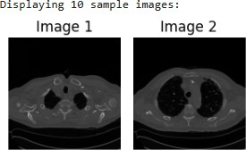

Fig. 1. Sample ILD CT Images After DICOM-to-JPEG Conversion.

exported as NumPy arrays (images.npy), and accompanying diagnostic labels (labels.npy) were derived from the clinical
dataset. Each image was resized to 128×128 pixels and nor-malized to a 0–1 range to help stabilize gradient propaga-tion.All preprocessed images were exported as NumPy arrays sized (N, 1, 128, 128) where N is the total quantity of CT slices, which is readily accepted into a CNN architecture based on PyTorch.
  - Deep Learning-Based Disease Diagnosis
As for the detection of Interstitial Lung Diseases (ILDs), many deep learning models were investigated at first, such as pre-trained models like ResNet, EfficientNet, MobileNet, and RegNet. All these models were compared to investigate their ability in terms of feature extraction from HRCT images and the capacity to classify the image into several classes based on that. Finally, after a number of tests and analysis, the custom Convolutional Neural Network (CNN) was chosen as the model that performed best and consistently. This neural network contains several convolutional layers for feature ex-traction, followed by the activation function and max-pooling layers for dimension reduction and further fully-connected layers for the classification task of distinguishing the different types of ILDs.
The model was optimized via the Adam optimizer and loss function being set to categorical cross-entropy loss. During the model training, it was done through 50 epochs to help it effectively find the needed patterns without unstable conver-gence of predictions. As for the data used in the experiment, it was divided into training, validation, and testing datasets.The determination of the final diagnosis is based on the class label associated with the highest probability of being true, corresponding to the identified ILD type.
  - Clinical Data Integration for Lifestyle Recommendation
Apart from diagnosing through the use of images, clinical infor- mation is equally important in the treatment of ILD. The patient information in clinicalParametersx˙lsx containing age, gender, oxygen saturation (SpO₂),, smoking status, diagnosis, and past allergies was used to give recommendations. The categorical features were all encoded numerically using Label Encoder after which cosine similarity was calculated for each of the patients. Using this approach, the system would be able to find out the top five similar patients and make recommen-dations based on the dataset comprising all the demographics and health attributes of each patient.
  - AI-Driven Lifestyle Recommendation System
The Lifestyle Recommendation Module incorporates the CNN2 Diagnostics through the clinical parameters from ILDDB’s clinicalParameters.xlsx.file. A top-5 co-sine similarity search on the encoded features [age, SpO₂, gen-der, diagnosis, smoking, al-lergies] provides context through similar patient cases. The Streamlit app takes user input for patient information and allows upload of their CT scans to be assessed for severity of ILD and patterns [fibrosis and honeycombing]. Using the AGNO agent and Gemini-2.5-flash, recommendations based on patient allergens and SpO2 levels are generated, along with safety messages.

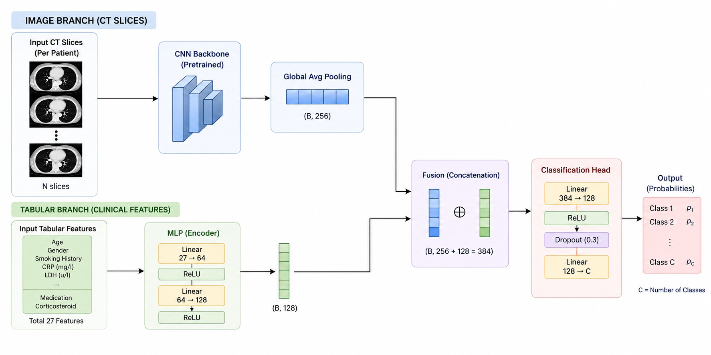

Fig. 2. Multimodal architecture

  - System Integration and Deployment
i want complete image only in my research paper without any matter on right side of it
The complete ILD diagnosis and recommendation pipeline is deployed through a production-ready Streamlit web interface that seamlessly integrates all system components. The frontend provides intuitive input forms for patient demographics (age, gender, SpO₂, smoking history, diagnosis, allergies) alongside CT scan upload functionality supporting JPG/PNG formats.
Backend processing orchestrates: (1) CNN2 inference for ILD subtype classification, (2) cosine similarity patient match-ing from clinicalParameters.xlsx, (3) optional Gemini-2.5-flash vision analysis of uploaded CT scans, and (4) AGNO agent-driven lifestyle recommendations. Custom CSS styling enhances professional presentation with expandable sections for CT analysis, recommendations, and safety considerations. The modular architecture supports scalability through con-tainerization (Docker) and cloud deployment (AWS/GCP), enabling telehealth integration. Session state management ensures persistent recommendation history, while API key authentication secures Gemini access. This end-to-end system bridges diagnostic precision with personalized management
for clinical deployment.
- Results
The CNN2 architecture showed impressive training stability throughout 50 epochs, with an accuracy of 85.09%, macro-averaged F1 score of 85.20%, precision of 89.83%, and recall of 81.92%. Convergence was excellent, evidenced by epoch 50’s low training loss of 0.0428, high training accuracy of 98.47%, and high validation accuracy of 82.77%–implying little overfitting despite the small data set of 232 CT images. Convergence behavior depicted gradual growth in validation
accuracy to reach 82.77% in epoch 50, accompanied by a decline in training loss to 0.0428. The high precision of 89.83% shows that the model makes accurate predictions for positive ILD cases, important in practical applications where false positive rates can be costly. The macro-averaged F1 score of 85.20% implies equal performance across the 13 classes of ILDs regardless of imbalance in class distribution, besting transfer learning models (EfficientNet-B2: 84.41%). Computing ROC-AUC values faced some hurdles owing to the multiple classes but were not as crucial compared to pri-mary metrics. Plots of accuracy and losses confirmed smooth convergence without oscillation, suggesting that the CNN2 architecture’s simplicity fits well with the ILDDB dataset.

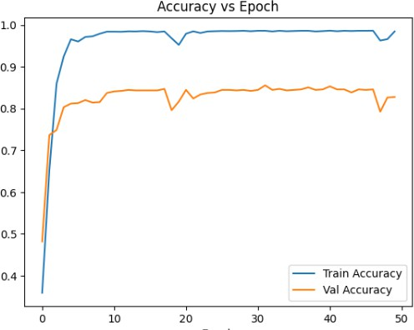

Fig. 3. Training and Validation Accuracy and Loss of ResNet18 for ILD Classification.

- Future Work
Future innovations will include the use of wearable IoT de-vices that can track SpO₂ and breathing in real time, providing continuous health analytics and personalized lifestyle advice based on health trends seen in ILD patients. Volumetric 3D analysis will also be implemented using HRCT imaging of the whole CT volume, and not just a series of 2D images, in order to provide better diagnosis due to the continuity of the spatial distribution of interstitial patterns within all 13 ILD subtypes. Distributed federated learning will provide increased model accuracy based on ILD datasets stored on multiple hospital networks without sacrificing patient privacy since no private data would be transferred.Generation of synthetic medical images using diffusion models and GANs will help overcome class imbalances in the ILDDB by expanding this limited database. Last but not least, cloud deployment of the Streamlit application with its REST API will provide telemedicine support and facilitate remote consultations with physicians
along with access to electronic health records.

- Conclusion
In summary, an integrated framework for clinical decision support is provided in this study using ILD classification using deep learning and lifestyle recommendations based on the generative AI. The custom CNN2 architecture proved to be effective for classifying 13 sub-types of ILD with HRCT images as input data. The developed web app using Streamlit has enabled a seamless integration of the diagnosis and recommendation process by providing both diagnostic output results and the inclusion of specific clinical parameters associated with a particular patient. In addition, cosine simi-larity matching and multimodal CT analysis using the Gemini-2.5-flash vision have improved recommendation accuracy and enhanced diagnostic capacity of the intelligent system.
The experiment results of the developed intelligent system have proven to be quite promising since they have shown high accuracy in classifying HRCT images of lungs concerning ILD. The proposed system uses the combination of medical image analysis along with different clinical parameters in order to develop a comprehensive system for the diagnosis of respiratory diseases. Moreover, the use of generative AI also helps this system provide recommendations with respect to the patient’s personal life with regard to the disease.With the use of generative AI, the intelligent system is also able to provide recommendations to the patient with regards to the context of the disease.
References
- E. M. Rodrigues, M. Gouveia, H. P. Oliveira, and T. Pereira, “Efficient-Proto-Caps: A Parameter-Efficient and Interpretable Capsule Network for Lung Nodule Characterization,” IEEE Access, vol. 13, pp. 56616–56630, 2025.
- F. Alafer, M. H. Siddiqi, M. S. Khan, I. Ahmad, S. Alhujaili, Z. Al-rowaili, and A. S. Alshabibi, “A Comprehensive Exploration of L-UNet Approach: Revolutionizing Medical Image Segmentation,” IEEE Access, vol. 12, pp. 140769–140791, 2024.
- R. Roy, S. Mazumdar, and A. S. Chowdhury, “ADGAN: Attribute-Driven Generative Adversarial Network for Synthesis and Multiclass Classification of Pulmonary Nodules,” IEEE Trans. Neural Netw. Learn. Syst., vol. 35, no. 2, pp. 2484–2495, Feb. 2024.
- C.-J. Lin, X.-Q. Lin, and J.-Y. Jhang, “Adversarial-Learning-Based Taguchi Convolutional Fuzzy Neural Classifier for Images of Lung Cancer,” IEEE Access, vol. 12, pp. 72766–72776, 2024.
- H. Zhang, H. Peng, H. Xu, F. Zhao, Y. Lou, and J. Yang, “An Unsupervised Convolutional LSTM Network (C-LSTMNet) for Lung 4D-CT Registration,” IEEE Access, vol. 12, pp. 64654–64662, 2024.
- P. Guan, K. Yu, W. Wei, Y. Tan, and J. Wu, “Big Data Analytics on Lung Cancer Diagnosis Framework With Deep Learning,” IEEE/ACM Trans. Comput. Biol. Bioinform., vol. 21, no. 4, pp. 757–768, Jul./Aug. 2024.
- R. Gunawan, Y. Tran, J. Zheng, H. Nguyen, A. Carrigan, M. K. Mills, and R. Chai, “Combining Multistaged Filters and Modified Segmen-tation Network for Improving Lung Nodules Classification,” IEEE J. Biomed. Health Inform., vol. 28, no. 9, pp. 5519–5530, Sep. 2024.
- N.-Y. Huang and C.-X. Liu, “Efficient Tumor Detection and Classifica-tion Model Based on ViT in an End-to-End Architecture,” IEEE Access, vol. 12, pp. 106096–106108, 2024.
- A. Wehbe, S. Dellepiane, and I. Minetti, “Enhanced Lung Cancer Detection and TNM Staging Using YOLOv8 and TNMClassifier: An Integrated Deep Learning Approach for CT Imaging,” IEEE Access, vol. 12, pp. 141414–141425, 2024.
- W. Zhang, A. Salmi, F. Jiang, and C.-F. Yang, “Enhancing Pulmonary Nodule Detection Rate Using 3D Convolutional Neural Networks With Optical Flow Frame Insertion Technique,” IEEE Access, vol. 12,
pp. 112881–112894, 2024.
- L. Cai, T. Long, Y. Dai, and Y. Huang, “Mask R-CNN-Based Detection and Segmentation for Pulmonary Nodule 3D Visualization Diagnosis,” IEEE Access, vol. 8, pp. 44400–44409, 2020.
- A. Depeursinge, A. Vargas, A. Platon, A. Geissbuhler, P. A. Poletti, and
H. Mu¨ller, “Building a Reference Multimedia Database for Interstitial Lung Diseases,” Comput. Med. Imaging Graph., vol. 36, no. 3, pp. 227–238, 2012.
- Y. Sun, S. Zhang, J. Li, Q. Han, and Y. Qin, “CAISeg: A Clustering-Aided Interactive Network for Lesion Segmentation in 3D Medical Imaging,” IEEE J. Biomed. Health Inform., vol. 29, no. 1, pp. 371–384, Jan. 2025.
- M. R. Salmanpour, M. Alizadeh, G. Mousavi, S. Sadeghi, S. Amiri,
M. Oveisi, A. Rahmim, and I. Hacihaliloglu, “Machine Learning Eval-uation Metric Discrepancies Across Programming Languages and Their Components in Medical Imaging Domains: Need for Standardization,” IEEE Access, vol. 13, pp. 47217–47229, 2025.
- A. M. Harale, V. K. Bairagi, E. Boonchieng, and M. R. Bachute, “Nodules Detection in Lungs CT Images Using Improved YOLOV5 and Classification of Types of Nodules by CNN-SVM,” IEEE Access, vol. 12, pp. 140456–140472, 2024.
- V. Acharya, D. Choi, B. Yener, and G. Beamer, “Prediction of Tubercu-losis From Lung Tissue Images of Diversity Outbred Mice Using Jump Knowledge Based Cell Graph Neural Network,” IEEE Access, vol. 12,
pp. 17164–17192, 2024.
- H. Yuan, Y. Wu, J. Cheng, Z. Fan, and Z. Zeng, “Pulmonary Nodule Detection Using 3-D Residual U-Net Oriented Context-Guided Attention and Multi-Branch Classification Network,” IEEE Access, vol. 10, pp. 82–95, 2022.
- S. R. Vinta, B. Lakshmi, M. Aruna Safalp, and G. Sai Chaitanya Kumar, “Segmentation and Classification of Interstitial Lung Diseases Based on Hybrid Deep Learning Network Model,” IEEE Access, vol. 12,
pp. 50444–50458, 2024.
- X. Xue, Y. Ma, W. Du, and Y. Peng, “Squeeze-and-Excitation Vision Transformer for Lung Nodule Classification,” IEEE Access, vol. 13,
pp. 24852–24866, 2025.

