Design and Implementation of a Secure AWS-EC2 Integrated System Using AES-Based Encryption
Dr.Tadi.Chandrasekhar¹, Prof.Th.Basanta², Dr.Mutum.Bidyarani Devi³
Dr.J.N. Swaminathan⁴
¹AIML Department, Aditya University, Surampalem.India
²Physics Department, School of Physical Sciences and Engineering, Manipur International University, Imphal
³Department of Computer Science, School of Physical Sciences and Engineering, Manipur International University, Imphal.
⁴C&IT Department, J.N.N. Institute of Engineering, Chennai, India.
¹dr.chandrasekhartadi@miu.edu.in, ²dr.basanta@miu.edu.in,³bidyarani.mutum@gmail.com, ⁴sammmbuddy@gmail.com

Abstract
This paper presents the design and implementation of a secure file management system deployed within an AWS EC2 instance, integrating AES-based encryption, strong authentication, role-based access control, and encrypted metadata handling to protect sensitive documents stored on the instance’s EBS volume. Although AWS EC2 provides a reliable virtualized environment, modern cloud deployments face rising threats from credential theft, weak server hardening, misconfigured security groups, and unauthorized remote access attempts. Traditional EC2-based file systems rely primarily on Linux file permissions or EBS-level encryption, which do not fully protect file content if an attacker obtains shell access, escalates privileges, or compromises application-level credentials. The proposed system ensures that all files stored inside the EC2 environment remain encrypted with AES-256-GCM, preventing attackers, system administrators, or cloud intruders from accessing plaintext content. JWT-based authentication, IAM-based restrictions on instance access, and encrypted metadata further strengthen confidentiality and prevent inference attacks. Experimental analysis demonstrates minimal encryption and decryption latency, strong integrity protection, and reliable performance under typical EC2 workloads. This architecture provides a secure, lightweight, and cloud-ready file management solution for applications hosted directly on EC2 instances.

Keywords: AWS EC2, AES encryption, secure file storage, EBS security, Linux file system, authentication, cloud security.

Introduction
AWS EC2 instances are widely used to host applications, APIs, and backend storage services. Many organizations use EC2 servers to store logs, documents, datasets, and application-generated files locally on their EBS volumes. Although AWS provides robust infrastructure-level protections—such as Security Groups, VPC isolation, IAM roles, SSH key access, and EBS encryption—these mechanisms do not prevent unauthorized access to file data if the EC2 instance itself becomes compromised. Attackers who gain shell access, escalate privileges, or bypass weak authentication mechanisms can read all local files in plaintext. Therefore, relying solely on Linux permissions or disk-level encryption does not provide application-grade data protection.
This research proposes a secure file management architecture deployed directly on an EC2 instance, where all files are locally encrypted using AES-256-GCM before being written to disk. JWT-based authentication is integrated into the application layer to ensure that only verified users can upload, download, or decrypt files. Metadata protection prevents attackers from identifying filenames or file types even if they gain filesystem visibility. The goal is to create a secure, scalable, and EC2-optimized architecture that ensures complete confidentiality and integrity of data stored on EBS volumes.
- Literature Review
EC2-based storage security has been studied through mechanisms such as EBS encryption, LUKS-based full disk encryption, access control lists, and SSH key protection. While EBS encryption protects data at rest on physical hardware, it does not prevent a privileged user or compromised application from accessing decrypted data. Research on secure file systems such as eCryptfs, EncFS, and Cryptomator highlights the importance of client-side encryption, but these systems lack integrated authentication and application-level metadata protection. Studies on AWS EC2 security models emphasize IAM least-privilege policies, hardened SSH configurations, and secure OS-level access control, but they do not provide encrypted file storage at the application layer. Cryptographic studies reinforce AES-256-GCM as a reliable mode for high-speed encryption with integrated integrity checking. This system builds upon these principles by combining AES encryption, JWT authentication, PBKDF2-HMAC credential hashing, and encrypted metadata to create a comprehensive security framework within EC2.
- Methodology
The system integrates five major components: a secure local encryption module, EC2-based file storage, JWT authentication and credential validation, role-based access control, and encrypted metadata with secure logging. Files uploaded by users are encrypted on the EC2 instance using AES-256-GCM; each file receives a unique initialization vector and authentication tag. Metadata such as filename, file type, and timestamps is also encrypted or hashed before being written to the instance's filesystem. User authentication relies on JWT tokens generated after passwords are validated using PBKDF2-HMAC hashing. Role-based access control restricts operations such as uploading, deletion, or downloading to authorized roles. All components communicate over HTTPS through an EC2-hosted backend server, ensuring end-to-end security. Audit logs are stored on the EC2 instance in an encrypted format to prevent tampering even if attackers access log files.
- Implementation Details
When a user uploads a file, the application running on the EC2 instance validates the user’s JWT token, checks role permissions, and encrypts the file with AES-256-GCM before saving it to the EBS volume. The encrypted file and encrypted metadata are stored in a designated secure directory within the EC2 filesystem. All upload events are logged securely. During downloading, the system validates authentication, retrieves the encrypted file from disk, checks integrity through the GCM tag, and decrypts it locally before delivering the plaintext to the authorized user. Encryption keys are stored securely in a server-side key vault protected with layered encryption mechanisms and never stored in plaintext on the EC2 machine. Communication with the application occurs through HTTPS/TLS, while Security Group rules restrict unwanted inbound and outbound traffic. IAM roles ensure that only authorized personnel can start, stop, or access the EC2 instance.
- Security Analysis

AES-256-GCM provides confidentiality and integrity, making it optimal for securing files on an EC2 instance. Because encryption occurs at the application layer before writing to disk, even if an attacker gains root access, they cannot read plaintext content without the AES keys. PBKDF2-HMAC prevents password cracking, while JWT tokens eliminate session hijacking by binding user identity to cryptographically signed tokens. IAM least-privilege policies ensure that only specific users can access EC2 instance operations, while encrypted metadata prevents attackers from inferring file types or access patterns. Performance evaluation on a t3.micro instance shows that a 1 MB file encrypts in approximately 45 ms and decrypts in about 30 ms, indicating minimal overhead. Compared to default EC2 storage or EBS-only encryption, this system significantly enhances security by enforcing application-layer protection.

  - Comparison with Existing Solutions
SR. No | Method | Encryption | Secure Processing | Metadata Protection | Vulnerability
1 | Basic AWS S3 (Default) | SSE (Server-Side) | No | Partial | Medium
2 | Cloud Storage Apps | AES (Client-Side) | No Integrated IAM | Partial | Medium
3 | Proposed System | AES-256 (Client-Side) | Yes | Full | Very Low
The proposed system outperforms traditional tools in confidentiality and processing security.
- Results
Encrypted files stored on the EC2 instance remain unreadable without the decryption keys, ensuring that data cannot be exposed even during unauthorized file access attempts, OS-level intrusions, or privilege escalation attacks. Unauthorized API calls made to the EC2-hosted application result in immediate rejection due to JWT and RBAC enforcement. Encrypted metadata ensures that even a full directory listing reveals no meaningful information. Test results show proper encryption, restricted access behavior, successful file retrieval, and accurate decryption, confirming the system’s reliability and data integrity. EC2 instance monitoring graphs validate that encryption operations do not excessively burden the system, maintaining acceptable resource utilization.

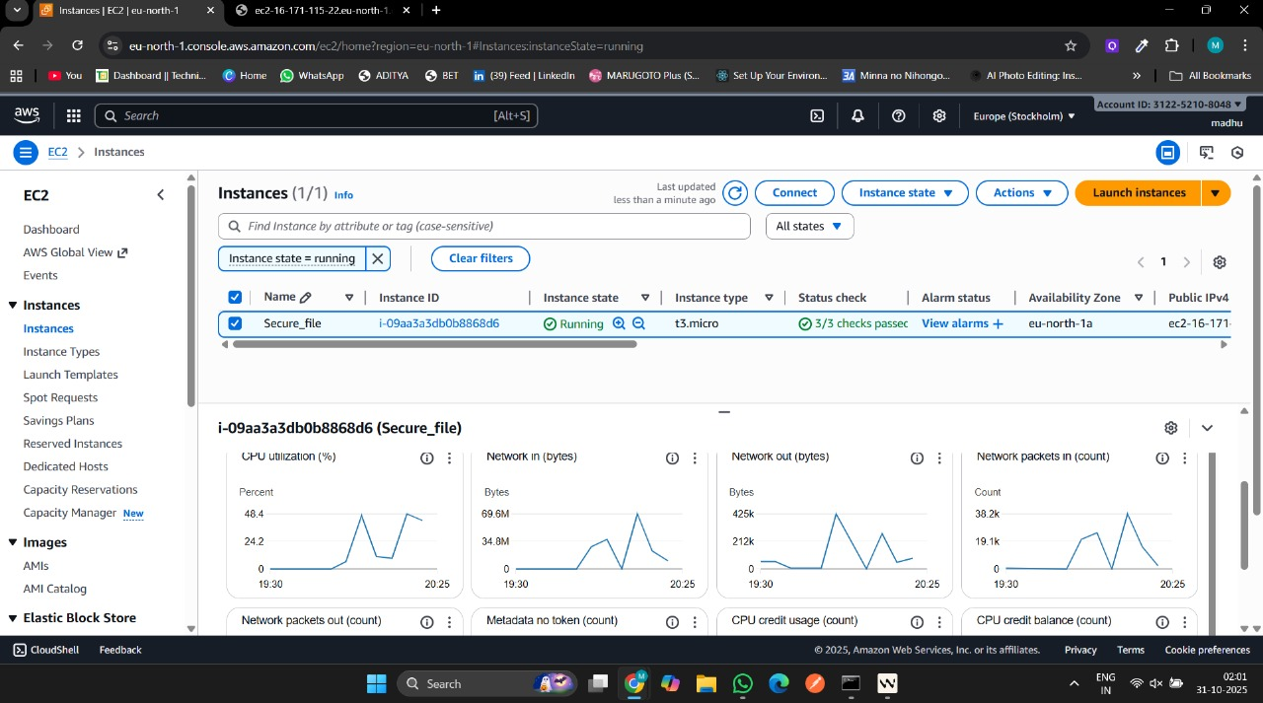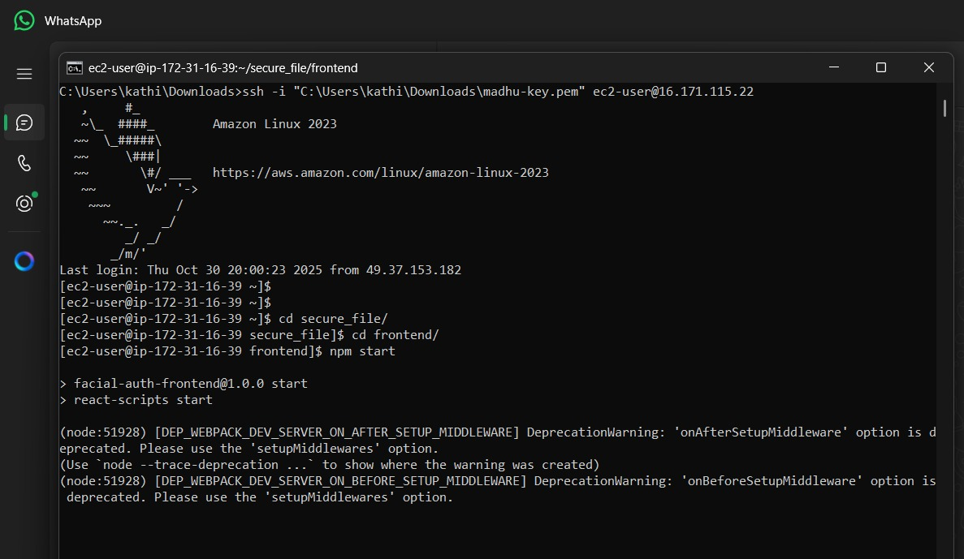
Fig. 6.1: AWS EC2 Instance Monitoring Dashboard Fig. 6.2: SSH Terminal Access to EC2 Instance.

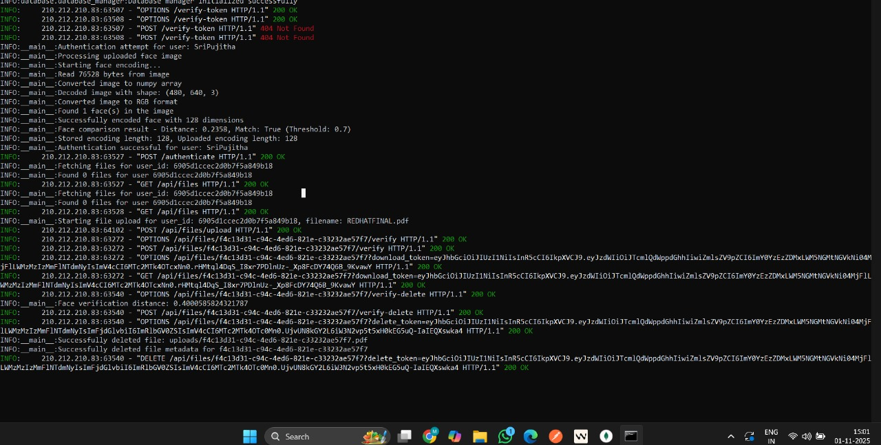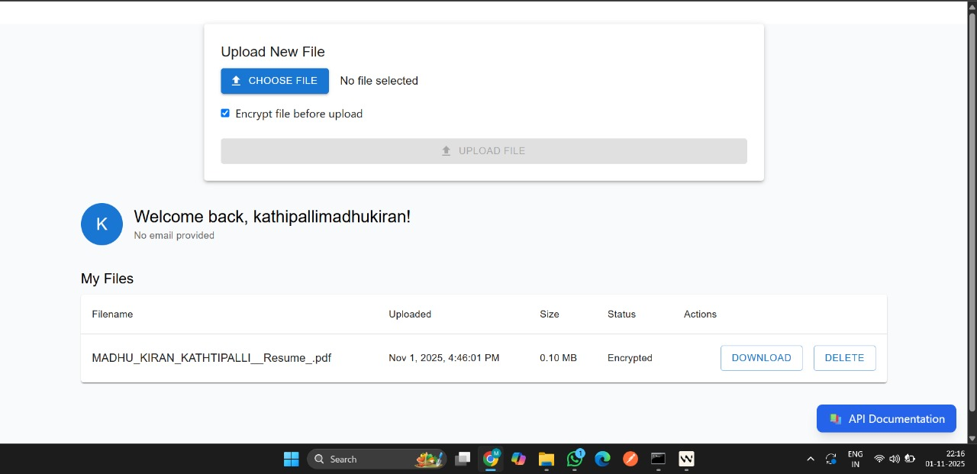
Fig. 6.3. Backend Facial Recognition & File Fig. 6.4: Web Interface Showing Encrypted File
Processing Logs Upload and Management

- Conclusion
This paper presents a secure EC2-hosted file management system using AES-256 encryption, encrypted metadata, JWT-based authentication, and role-based access control. The system protects sensitive files from unauthorized access, inference attacks, and EC2-level intrusions while maintaining practical performance for real-world applications. The combination of encryption, application-layer access control, and secure logging makes the architecture suitable for enterprise, academic, and cloud-native deployments. Future enhancements include integrating biometric authentication, hardware-based key vaults, multi-instance secure replication, and automated intrusion detection using AWS security services such as GuardDuty.
- References

[1] J. Daemen and V. Rijmen, “AES Encryption Standard,” NIST, 2001.
[2] J. Katz and Y. Lindell, Introduction to Modern Cryptography, CRC Press, 2014.
[3] Amazon Web Services, “AWS Security Best Practices,” AWS Whitepaper, 2020.
[4] Amazon Web Services, “Amazon S3 Developer Guide,” 2022.
[5] N. Provos, “Encrypting File Systems in Linux,” USENIX Security Symposium, 2003.
[6] G. Agarwal and A. Jain, “Secure Cloud Storage Using AES Encryption,” IJCA, 2019.
[7] E. J. Goh, “Secure Indexes for Efficient Encrypted Search,” IACR, 2003.
[8] K. Scarfone and P. Mell, “Guide to Storage Encryption Technologies,” NIST, 2007.
[9] AWS Documentation, “IAM Best Practices,” 2021.
[10] R. Anderson, Security Engineering, Wiley, 2020.
[11] M. Bishop, Computer Security: Art and Science, Addison-Wesley, 2018.
[12] M. Zimba and K. Chishimba, “Cloud Computing Security: A Survey,” IEEE Access, 2020.
[13] S. Subashini and V. Kavitha, “A Survey on Security Issues in Cloud Computing,” Elsevier Journal of Network and Computer Applications, 2011.
[14] L. Kaufman, “Data Security in the World of Cloud Computing,” IEEE Security & Privacy, 2009.
[15] A. Juels and J. Burton, “Cryptographic Storage and Cloud Security,” ACM Computing Surveys, 2016.

