Navigating Currency Volatility: Strategic Adaptation and Economic Implications for Multinational Corporations

ABSTRACT

With the integration of the world economy, variations in the value of the dollar are becoming a huge challenge for multinational corporations (MNCs). These changes affect their overall financial performance, operating costs and their competitiveness in exports. The purpose of the present study is to examine the impact of currency depreciation on economy and the strategic response of multinational firms in Malaysia, US and China. Secondary data obtained from World Bank, International Monetary Fund (IMF), Bank Negara Malaysia, and international economic and finance reports for the period 2021-2025 were utilized. A qualitative descriptive approach was employed. We reviewed the literature, exchange rate movements and economic data to see the impact of currency changes on the functioning and decisions of multinational businesses. The long-term fluctuations in the exchange rate have a huge effect on how successful enterprises are, how they trade with other nations, how they plan their investments and how efficiently they run their businesses. It is becoming increasingly difficult for multinational corporations to do business and manage their finances internationally, which could make them less competitive in global markets. To address these issues, firms are increasingly adopting various foreign exchange risk management strategies such as hedging, price adjustments, employing multiple currencies, and restructuring their supply chains. These measures generally increase the resilience of companies to economic unpredictability and reduce their exposure to exchange rate risks. In conclusion, currency volatility is one of the important factors influencing the performance and competitiveness of international organizations. The study points to the importance of strategic adaptation and effective foreign currency risk management in maintaining a strong economy in the long run and remaining ahead of the competition in an increasingly uncertain economic environment.

Keywords: Exchange Rate Volatility; Multinational Corporations; Foreign Exchange Risk Management; Hedging Strategies; Economic Resilience.

INTRODUCTION

The fluctuation in dollar value has become one of the biggest economic challenges faced by multinational enterprises (MNCs) in the current global business world. International markets, cross-border trade and digital financial systems are becoming more interconnected. This exposure makes multinational corporations more vulnerable to currency fluctuations and instability in global finances. Exchange rates uncertainty can affect international trade, foreign direct investment (FDI), costs of manufacturing, operational efficiency and revenues of companies. This is especially true for enterprises that operate in multiple currencies and economic regions (Aizenman et al., 2023; IMF, 2024). As globalization continues to expand, international companies must continually adjust their business strategies and financial policies in order to remain competitive in an ever-changing economy.

Over the last few years, the global economy has been hit hard by geopolitical conflicts, inflationary pressures, the recovery from the pandemic and policies that constrain money, and these have led to large shifts in exchange rates between the world’s major countries. The strengthening of the US dollar, changes in the value of the Chinese yuan and the dropping value of numerous emerging market currencies have all had a substantial impact on the performance of overseas firms and collaboration between countries (World Bank, 2024). Exchange rate changes directly affect production costs, pricing strategy, supply chain management, and profit generating for enterprises that import or ship. Therefore, multinational corporations are more and more resorting to strategic adaption techniques such as market diversification, financial hedging, operational restructuring and digital financial technology to minimize economic risks and stay profitable in global marketplaces.

Much research has been conducted in international economics and business on the relationship between changes in the exchange rate and the performance of international business. This has been shown to undermine investor confidence, create an environment of increased operational uncertainty, and hamper international trade cooperation (Bénétrix et al., 2023; Fang & Miller, 2024). However, some multinational companies have proved that they are strong by utilizing flexible economic strategies and creating better international relationships to cope with currency changes. So, strategic adaptability has become a crucial element of continuing operations and making money over the long term in the global corporate ecosystem.

There has been much talk of the instability of exchange rates but most of the studies so far have focused on macroeconomic consequences, financial markets or one country at a time. Little discussion has been held on how multinational corporations adjust their strategy to varied economic contexts, notably developed versus emerging countries. In addition, earlier work has focused on financial performance, ignoring the interaction of global cooperation and operational adaptation within the same analytical framework. This leaves a gap in the body of research that attempts to establish how multinationals might deal with volatile exchange rates to sustain their global operations.

“Countries like Malaysia, the US and China are good examples to study changes in exchange rates and how multinational strategies can adapt, because of their important roles in international trade and economic cooperation.” The strength of the US dollar in international trade has kept the US as the most important financial power in the world. China, in contrast, continues to thrive as a large manufacturing and export economy. Malaysia is a growing economy that is highly dependent on foreign trade, and is therefore especially susceptible to changes in global markets and exchange rates. A good example of how multinational corporations can adapt to multiple financial and economic systems is the way the economies of these countries interact with each other.

Therefore, this study aims to explore the impact of dollar valuation changes on the bottom lines of multinational corporations and their strategic adjustment to maintain their enterprises in difficult global economic settings. This study seeks to know more about the cooperation between Malaysia, US and China for improving financial stability and operating sustainability. The current study adds to the previous literature on global business sustainability and multinational economic resilience by integrating the theme of international economic perspectives with strategic adaptability of corporates.

RESOURCE-BASED VIEW (RBV)

The Resource-Based View (RBV) approach argues that a firm’s competitive advantage and its survival over time are based on the firm’s resources and its capabilities. Barney (1991) argues that if a company has resources that are precious, rare, distinctive and irreplaceable, it has a long-term competitive advantage. International companies’ value strategic skills such as financial management, innovation, flexibility in operations and connecting with people from different parts of the world as tools to deal with external economic uncertainties such as changes in exchange rates.

RBV has been widely utilized in the studies of international business and strategic management to demonstrate how organizations use their own strengths to stay successful in the context of fast changing economic circumstances (Kraaijenbrink et al., 2010). Multinational organizations that conduct business in several countries are extremely sensitive to foreign exchange risks because of shifting currency values, international deals and operational operations that take place across borders. This makes it easier for organizations with more strategic resources and flexibility to manage operational issues arising from volatile currencies.

Prior research indicates that multinational enterprises are progressively depending on their own strategic resources, including expertise in financial hedging, digital financial systems, diversified supply chains, and international market experience, to mitigate exchange rate risks and enhance the sustainability of their operations (Teece et al., 2016; Verbeke & Yuan, 2022). RBV further states that organizations which are able to combine strategic resources with strong decision-making tools are more likely to be able to remain profitable and competitive during periods when the economy is unsure. In this research, we use the RBV to provide a perspective on how multinational corporations employ their strategic resources and talents to deal with fluctuations in exchange rates and preserve the strength of their operations in global marketplaces.

STRATEGIC ADAPTATION THEORY

The Adaptation Theory of strategy explains how firms adjust their structures, operations and strategy choices to changes in their external contexts. To remain competitive and in business, according to Miles and Snow (1978), firms must continually adapt to changes in the market, technology, politics and economy. Multinational corporations operate in very volatile international business environments that are affected by fluctuations in the value of the dollar, uncertainty in the geopolitical arena, rising pricing, and an unstable worldwide market. This makes the strategic adaption of these organizations even more critical.

Multinational organizations confront major operational and financial difficulties when currency rates fluctuate. Foreign currency movements have a direct impact on production costs, international prices, investment decisions, import-export operations and money making (Demir, 2021). Thus, multinational firms employ adaptable techniques including extending their regional markets, hedging their currency exposure, altering prices and employing digital financial management to sustain high operating efficiency and reduce currency-related risks.

Some research (Fang & Miller, 2024; Kirecci, 2025) has revealed that strategic adaptation is useful for multinational corporations. In volatile global marketplaces, organizations which are better at adjusting are more likely to be able to keep their funds safe, keep their operations running and stay competitive. Strategic adaptation also encourages cooperation among multinational organizations by compelling them to enhance their international relationships, diversify their investments and modify their operational structures so that their enterprises can endure for a long period.

This paper applies the Strategic Adaptation Theory to describe the strategic response of multi-national corporations to the volatility of exchange rates and the dynamic global economic environment. The theory supports the notion that there is a need for strong adaption mechanisms to keep multinational enterprises functioning smoothly and lower the foreign exchange risks. Strategic adaptation also encourages cooperation among multinational organizations (Verbeke & Yuan, 2022).

INTEGRATION OF THEORIES

This study integrates the Resource-Based View (RBV) and Strategic Adaptation Theory to explain how multinational corporations manage exchange rate volatility in the global business environment. RBV emphasizes the importance of internal strategic resources and organizational capabilities, while Strategic Adaptation Theory explains firms’ responses to external economic uncertainty and environmental changes. The integration of these theories provides a comprehensive understanding of how multinational corporations utilize strategic resources, adaptive mechanisms, and multinational cooperation to sustain operational resilience, financial performance, and long-term competitiveness during periods of currency instability.

LITERATURE REVIEW

Exchange Rate Volatility and Multinational Performance

One of the most widely discussed issues in international business and economics is the instability of the exchange rate, because it has a profound impact on the financial performance, survival, and competitiveness of enterprises in foreign nations. The growing integration of global markets and cross-border commerce raises the likelihood of multinational enterprises to experience foreign exchange risks and economic instability (Nobanee et al., 2022). Many multinational enterprises operating in a variety of currencies are highly exposed to unpredictable exchange rates. This is due to the fact that currency value changes affect international transactions, investment decisions, production costs, pricing tactics, and overall success of their global revenue directly.

Previous studies have demonstrated that variations in the dollar value have a detrimental effect on multinational corporations as they increase uncertainty in operations and reduce their financial success. According to Bénétrix et al. (2023), fluctuating currency rates reduce investors’ confidence and break the stability of international financial markets. Fang and Miller (2024) also argued that the unpredictable currency rates increase the cost of transactions, disrupt multinational supply chains, and impair the performance of international companies. Changes in currencies can also make it difficult for multinational organizations to keep their operational strategies and their long-term finances consistent in the ever-changing worldwide marketplaces. Excessive depreciation may cause increases in import expenses (Fang & Miller, 2024).

Several studies have also shown that the effect of currency depreciation or appreciation on foreign enterprises' economies is distinct. If a currency depreciates, it can make exports more competitive by making items cheaper on international marketplaces, therefore creating additional selling opportunities abroad (Demir, 2021). On the other hand, an appreciating currency can reduce the cost of imports but harm the performance of exports and reduce the competitiveness of multinational enterprises in global marketplaces. This demonstrates how changes in the dollar’s value can work for or against global enterprises that trade in places where everything is highly interconnected.

New research shows that inflationary pressure, geopolitical crises, oil sector disruptions and monetary tightening policies have made currency rates more volatile in both developed and emerging countries (IMF, 2024). Multinational corporations are still less safe to conduct their businesses and spend as global interest rates and economic uncertainty rise, Kirecci (2025) says. The volatile market requires multinational enterprises to make their organizations more flexible and responsive to maintain their operations on the move.

Furthermore, previous research has demonstrated that multinational organizations are increasingly resorting to strategic adaptation approaches to mitigate their foreign exchange risks and make their operations more resilient. Strategic adaptation means modifications in an organization to respond to environmental change and economic uncertainty (Miles & Snow, 1978). Multinational organizations adopt adaptable measures to mitigate the consequences of exchange rate fluctuations. Such strategies include financial hedging, pricing adjustments, operational restructuring, digital financial management, supply chain diversification, and expansion into new international markets (Verbeke & Yuan, 2022). In an unpredictable environment, organizations that adapt better will be more likely to continue to make money, improve operational efficiency and remain competitive in the long run.

Several academics also highlighted the importance of strategic resources and organizational skills in order to improve the resilience of multinational firms. According to the Resource-Based View (RBV), firms with significant internal resources such as technological competence, financial competence, and worldwide operational networks are more capable of managing operational uncertainty and sustaining competitive advantage (Barney, 1991). Besides, organizations with experience in more countries and more overseas experience are better capable to adjust their plans to unstable economies and changing market conditions.

International teamwork is also becoming increasingly vital to support multinational businesses in times of currency fluctuations. According to Verbeke and Yuan (2022), long-term changes in currency rates make it more difficult to manage multinational supply chains. Knowing people in many nations helps companies keep their business going and makes it easier for them to cope with economic challenges that hit numerous countries and financial systems.

More work has to be done on exchange rate volatility and the success of international enterprises, even though there have been many arguments concerning these matters. Most prior research focused solely on macroeconomic data, stock market reactions, or country-by-country analyses. They didn’t think about the wider picture of the investigations in terms of how international strategic adaptation and multinational teamwork fit into the bigger picture. Moreover, there are hardly any studies that have examined the relationship between exchange rate fluctuations, operational uncertainty, strategic responses, and the long-term performance of firms in emerging and developed economies such as China, Malaysia, and the US. This study aims to plug these gaps by examining the strategies adopted by international firms to cope with the volatility of exchange rates so as to maintain their operations operating smoothly, their finances in good health, and their edge in a dynamic global marketplace.

RESEARCH FRAMEWORK

The combination of Resource-Based View (RBV) and Strategic Adaptation Theory helps us to comprehend fully how international enterprises deal with changing currency rates in the ever-changing global marketplaces. According to Barney (1991), RBV emphasizes the importance of strategic resources and organizational abilities to remain competitive during economic instability. Alternatively, Strategic Adaptation Theory states that firms continuously adapt their business decisions, operational structure, and financial strategies to changes in the market and the environment (Miles & Snow, 1978).

The dollar’s value swings affect the performance of multinational corporations. Operational uncertainty influences factors such as costs of production, pricing strategies, choices relating to international investments, and management of supply chains. Consequently, international companies are increasingly resorting to strategic adaption techniques, such as financial hedging, pricing adjustments, operational reorganization and supply chain expansion, to decrease foreign exchange risks and maintain financial stability. International cooperation is also vital to strengthening international partnerships, improving resource sharing and improving business resilience in the long run. Therefore, the theoretical framework developed for this study is depicted in Figure 1. It explains the relationship between volatile exchange rates, strategic adjustment, global collaboration, and long-term success of multinational enterprises.

The suggested framework suggests that the key outside economic factor that impacts the operational and financial stability of multinational corporations is the changes in the value of the dollar. The changes in exchange rates have a direct impact on importing and exporting, production costs, pricing tactics in other countries, investment plans, and the quantity of earnings globally (Bénétrix et al., 2023; Fang & Miller, 2024). According to the IMF (2024), volatile exchange rates make it harder for global enterprises to operate in countries with different currencies and economies. “Operational uncertainty” in this context refers to the challenges multinational organizations encounter in carrying out their business operations when currencies fluctuate.
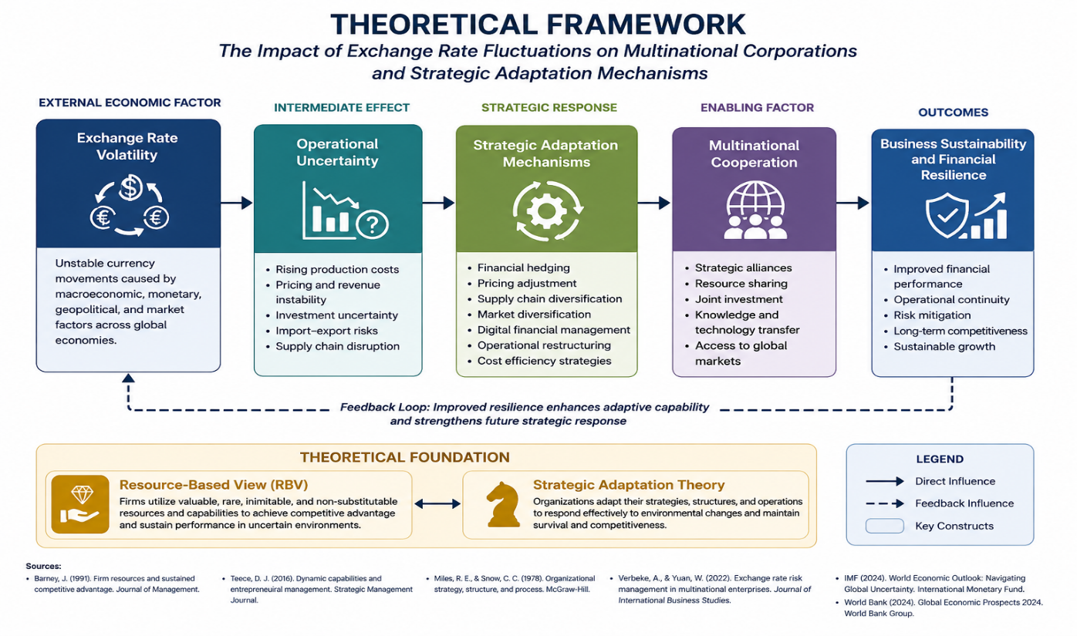

Figure 1: Theoretical Framework of Exchange Rate Volatility and Multinational Strategic Adaptation. Adapted from Barney (1991), Miles and Snow (1978), Verbeke and Yuan (2022), and IMF (2024).

Fluctuations in the currency rate can make it more difficult to govern the supply chain, increase costs, reduce earnings, and reduce countries’ competitiveness in the global market (Demir, 2021). Therefore, international enterprises need to strengthen the quality of their strategic decision-making and organizational agility to counter the adverse consequences of foreign exchange risks (Verbeke & Yuan, 2022).

The theory also implies that strategic adaptation is a key means of coping with fluctuating exchange rates. The business world has certain strategies for adjusting to change such as financial hedging, shifting prices, supply chain diversification, practical restructuring, digital financial management and market growth (Miles & Snow, 1978; Kirecci, 2025) These adaptive mechanisms allow foreign enterprises to make their operations more stable, safeguard their finances and be competitive in the long run, even while the economy is uncertain.

Countries are also expected to cooperate as an important strategic feature of the system. Multinational corporations operating together internationally aid in sharing resources, working together on technology, making investments together and developing the global market (Verbeke & Yuan, 2022). The structure will eventually lead to international organizations that can survive and handle their finances efficiently. Barney (1991) stated that the company who has a better strategic resource, the ability to adapt and multinational cooperation is more likely to be able to run their operations smoothly, improve their financial performance and be competitive in the long run even though the exchange rate changes. Therefore, the framework demonstrates the importance of the joint consideration of strategic resource management and flexible business strategies in order to improve the resilience of international companies in constantly changing global markets.

METHODOLOGY

The study adopted a qualitative descriptive research approach and secondary economic data analysis to investigate the impacts of exchange rate fluctuations on multinational organizations and their coping methods to continue their operations in unpredictable global economic settings. This paper does not focus on primary survey methods but on economic trends, responses of multinational corporations and their changes in strategy. The study applies existing economic reports, official statistics and international financial databases. It suggests that a qualitative descriptive method is the best way to go (Johnston, 2017). The method also allows us to think about the actions of global corporations and the duration of their operations in an ever-changing international economy.

Secondary data were gathered from many reliable international and national sources such as the World Bank, the International Monetary Fund (IMF), Bank Negara Malaysia (BNM), the Department of Statistics Malaysia (DOSM) and international economic journals between 2021 and 2025. Official databases contain data on foreign direct investment (FDI), success of international trade, long-term viability of multinational enterprises in developed and developing countries, inflation and currency rate fluctuations. The chosen time frame includes some of the biggest issues that affected the world economy, such as the recovery from the pandemic, geopolitical unrest, inflationary pressure, problems in the supply chain and policies that made money tighter. All these made exchange rates more volatile and increased international financial uncertainty.

The main focus of this study is the main countries of Malaysia, US and China based on their large role in international trade, cooperation between countries and economic influence in the world. The United States was picked because the US Dollar (USD) is still the most important worldwide reserve currency and has a big impact on international business and financial markets. China was chosen because it has one of the largest economies in the world for manufacturing and exports, and this has a huge impact on the world’s supply chain and the success of international trade. Malaysia, on the other hand, has a developing economy that is heavily dependent on international trade and foreign investment. This makes it particularly susceptible to changes in the exchange rate and economic uncertainty in other countries.

The study considered many economic variables including: currency rate fluctuations, inflationary tendencies, foreign direct investment (FDI), international trade performance and multinational companies’ operations. The paper also examines how multinational corporations alter their strategy to manage their foreign exchange risks and operational unpredictability. Their activities include financial hedging, price change, supply chain diversification, operational restructuring, digital financial management and collaboration across borders.

The data collected was analysed using descriptive and comparative analysis. Pattern matching of the currency rates, long-term sustainability of the foreign activities and financial performance of the selected nations was done using descriptive analysis. Also, the changes in the currencies of Malaysia, the US and China throughout time, their economies and the ways they adjusted their strategy as a global group might be noted. The results analysis was based on the Resource-Based View (RBV) and the Strategic Adaptation Theory, to demonstrate the strategic use of resources, the adaptive capacity and the cross-border collaboration of multinational companies to increase the resilience of their operations and to ensure their long-term business sustainability in periods of economic uncertainty.

In order to give more strength to the empirical meaning of the study, the study employed tables and graphs to illustrate the changes in the exchange rates over time and their impact on the economies of the selected nations, as well as how multinational tactics can be adapted to the new circumstances. The combination of the use of secondary economic data and comparative analysis and theoretical interpretation makes it simpler to comprehend how multinational corporations deal with unpredictable exchange rates and remain competitive in highly interconnected global economies.

EXCHANGE RATE TRENDS AND ECONOMIC VOLATILITY

According to the results, changes in the value of the dollar had a big effect on the operational stability and financial sustainability of multinational companies from 2021 to 2025. The international currency markets went through big changes because of things like global economic instability, inflationary pressure, geopolitical conflicts, the recovery from the pandemic, and policies that tightened money supply. The value of the US Dollar (USD) went up, while the value of several emerging market currencies went down. This made things harder for multinational companies, especially those that work in industries that depend on imports and do business across borders.

Table 1: Exchange rate Trends Between Malaysia and China Against the USD (2015-2025)

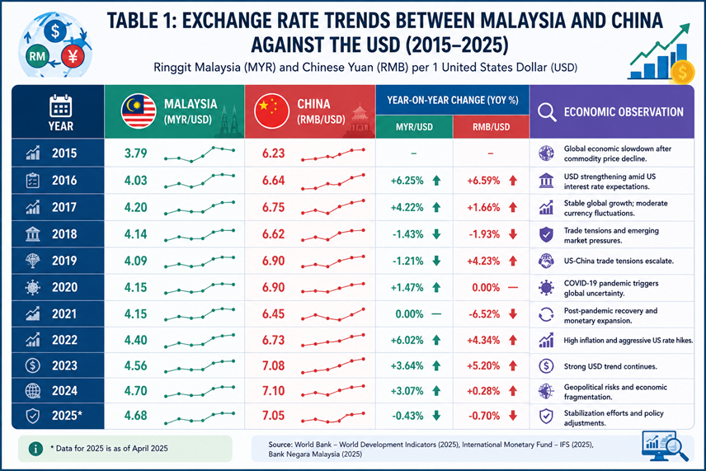
Source: Authors’ compilation based on World Bank (2025), International Monetary Fund (2025), and Bank Negara Malaysia (2025). Note: The figures presented are compiled from secondary sources and intended to illustrate long-term exchange rate trends.

Table 1 illustrates the change in value of the Malaysian Ringgit (MYR) and Chinese Yuan (RMB) against the US Dollar (USD) from 2015 to 2025. The data indicate that both currencies fluctuated within the time period selected. These included changes in the world economy, difficulties in international commerce, inflationary pressures and changes in the monetary policies of the main countries. In 2015, the Malaysian Ringgit was MYR3.79/USD and the Chinese Yuan was RMB6.23/USD. This happened at a time when the global economy was slowing down due to declining product prices. Both currencies fell more in 2016 as the USD gained stronger as people believed US interest rates would rise. The Ringgit strengthened to MYR4.03/USD and the Yuan weakened to RMB6.64/USD. The trend continued in 2017 with the Ringgit plummeting to MYR4.20/USD and the Yuan to RMB6.75/USD. This occurred because of small variations in the value of all currencies worldwide and unpredictable international financial conditions.

But in 2018 and 2019, the market stabilized a little bit. The Malaysian Ringgit appreciated from MYR4.20/USD in 2018 to MYR4.14/USD and further appreciated in 2019 to MYR4.09/USD. The Chinese Yuan has been a bit of a yo-yo with trade issues between the US and China getting worse. It depreciated to RMB6.90/USD in 2019 from RMB6.62/USD in 2018. These considerations indicate that trade disputes and volatile geopolitics contributed significantly to the exchange rate and insecurity level in international markets during that period. The COVID 19 virus in the year 2020 caused serious problems in the world economy and increased instability in the worldwide financial markets. The Malaysian Ringgit dropped to MYR4.15/USD while the Chinese Yuan was little changed at around RMB6.90/USD. During this period, operational issues for multinational firms were caused by constraints associated to the epidemic and an economic slowdown, a decline in global demand, supply chain instability and diminished investment trust.

The statistics also reveal that exchange rate volatility increased from 2021 to 2024, while the world was still recuperating from the pandemic. The Malaysian Ringgit has depreciated considerably from MYR4.15/USD in 2021 to MYR4.70/USD in 2024. Similarly, the value of the Chinese Yuan changed from RMB6.45/USD in 2021 to RMB7.10/USD in 2024. This trend was driven by a combination of factors including rising inflation, aggressive monetary tightening policies in the US, geopolitical conflicts and the growing dominance of the USD in international financial markets. These factors increased the expenses of import dependency, increased operational costs and increased foreign debt for multinational businesses doing business in emerging countries.

In 2025, there were a few minor moves toward stability. The Malaysian Ringgit was a bit firmer at MYR4.68/USD, and the Chinese Yuan was a bit firmer at RMB7.05/USD. The trend towards stability has been attributable to the policy improvements, better economic recovery and stronger financial interventions by governments and central banks to reduce currency volatility and increase trust in the international market. Overall, the results suggest that long-run changes in the dollar value have a large effect on the long-run operations, financial planning and overseas commercial performance of multinational businesses. Currency instability diminishes the predictability of business and increases the dependence of multinational corporations on strategic adjustment mechanisms such as financial hedging, price changes, diversification of the supply chain, and cross-border cooperation to remain competitive in an ever-changing world economy.

The results also demonstrate that the Malaysian Ringgit was more volatile than the Chinese Yuan over the selected time period. This is because Malaysia is more subject to economic shocks from other nations, outflow of international capital, fluctuations in product pricing and reliance on trade with other countries. As for China, it kept a far tighter rein on its exchange rate through government intervention and careful supervision of its monetary policy. This helped to keep the Chinese Yuan steadier, even with the uncertainty of the world economy. These variations suggest that developed and emerging economies are neither as robust nor as policy-flexible in terms of dealing with unpredictable currency rates and keeping international enterprises afloat. The data also indicate that dollar value in the long run has a huge impact on the long-range strategies and competitiveness of multinational corporations in other countries. Businesses operating in very volatile markets are finding it harder and harder to control expenses, predict overseas sales and handle foreign debt. Therefore, multinational companies are paying more attention to strategic flexibility, digital financial management, multinational cooperation and different forms of operating structures to strengthen their financial stability and to sustain their business in the ever-changing world economy.

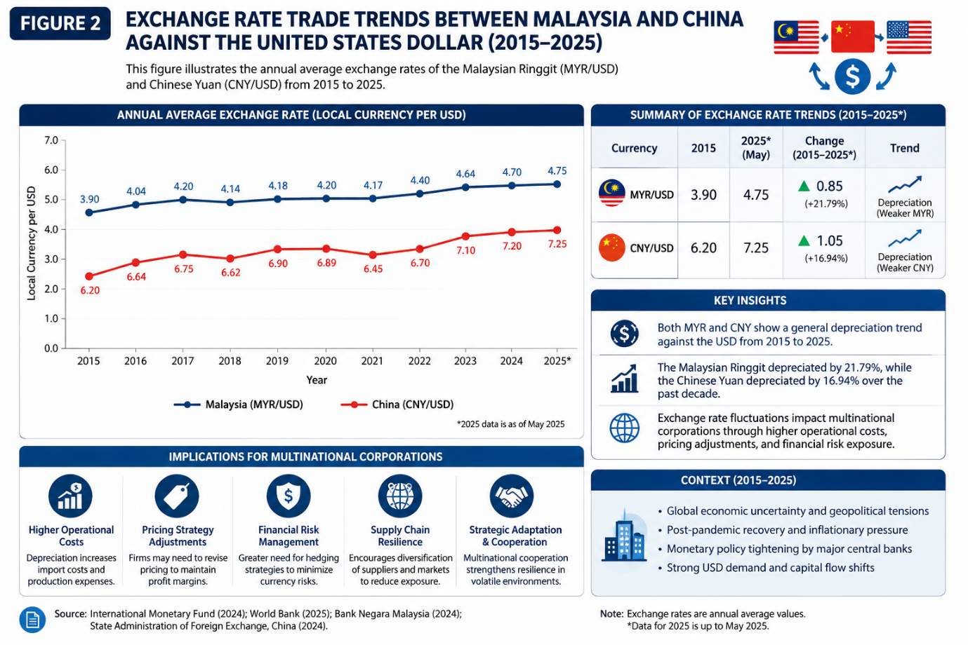
Figure 2: Exchange Rate Volatility Trends between Malaysia and China against the United States Dollar (2015–2025)

Figure 2 also shows that the exchange rate volatility has become more relevant at periods of global economic disruption, particularly during the COVID-19 pandemic and the post-pandemic recovery period from 2020-2024. The US dollar appreciation in the face of the Federal Reserve aggressive monetary tightening policies put further depreciation pressure on the Malaysian Ringgit and the Chinese Yuan. These conditions exacerbated operational uncertainty for multinational firms through increased prices of imports, unpredictable international pricing structures, and increased foreign financial responsibilities. The results suggest that multinationals operating in emerging economies were more financially vulnerable as they were more dependent on imported resources, foreign funding, and cross-border trade operations.

Moreover, as shown in Figure 2, the lengthy duration of currency instability has impacted the strategic decision-making process and operational sustainability of multi-national firms in international markets. More and more companies adopted flexible business strategies, such as financial hedging, diversification of supply chains, restructuring of operations and cooperation with multinationals, in order to limit foreign exchange risk and stay competitive in the long run. The figure also shows that, despite some stabilization efforts in 2025, exchange rate volatility remains a significant challenge to the financial resilience, investment planning and global operational continuity of multinational corporations in highly interconnected economic environments.

Also, Figure 2 illustrates the strong correlation between exchange rate fluctuations and the general macroeconomic conditions and global financial stability. The performance of currencies in established and emerging economies continues to be influenced by volatility in inflation rates, global commodity prices, geopolitical tensions and international capital flows. These conditions suggest that multinational corporations cannot rely solely on traditional financial management approaches, but need to enhance strategic flexibility, digital financial capabilities, and international collaboration to improve operational resilience and sustain long-term business sustainability in increasingly volatile global economic environments.

Table 2: Major Economic Implications of Exchange Rate Volatility among Multinational Corporations

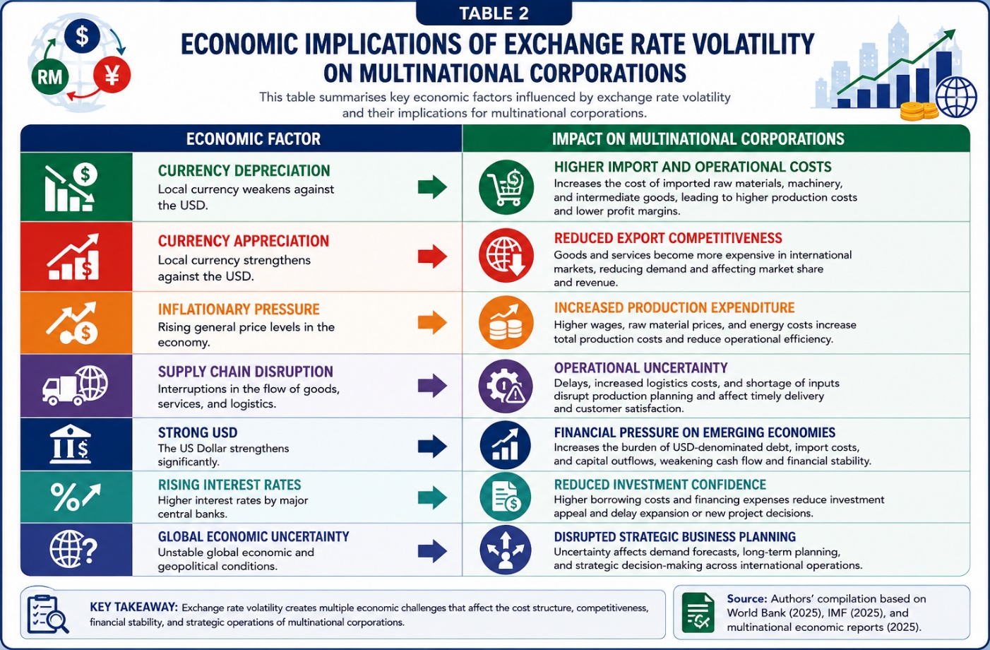
Source: Authors’ compilation based on World Bank – World Development Indicators (2025), International Monetary Fund International Financial Statistics (2025), and multinational economic reports (2025).

The main economic consequences of exchange rate fluctuation for multinational firms operating in international markets are presented in Table 2. The results of the study reveal that currency value movements have a substantial impact on the cost of operations, financial stability, international competitiveness and strategic business planning of multinational firms. For multinational firms operating in many industries and economic situations, exchange rate volatility presents both direct and indirect economic issues. In Table 2, currency depreciation raises import dependence expenses and operational costs for multinational companies with a high level of dependence on imported raw materials, machinery and international transactions. When local currencies decline against the United States Dollar (USD), it results in greater import costs and foreign financial commitments for multinational firms, leading to increased production costs and reduced profit margins. These are particularly difficult situations for developing countries largely dependent on global trade and international financial operations.

On the other hand, the appreciation of the currency decreases the competitiveness of the exports since goods and services produced in the country become comparably more expensive in the foreign markets. This could result in lower demand for exports by multinationals, lower market share and lower foreign revenue performance. The results further reveal that inflationary pressure raises the aggregate production costs through inflating labour costs, transportation costs, energy prices and operating overhead costs. These factors are averse to operational efficiency and place financial strain on multinational firms operating in volatile economic situations. Table 2 clearly shows that supply chain interruption is a substantial source of operational uncertainty for multinationals. Disruptions in logistics activities, shortages of production inputs and delays in international transportation effect negatively the production planning and business continuity. At the same time, the USD appreciation raises the financial burden for emerging economies as multinationals become more sensitive to foreign debt, capital flight and higher import prices. In addition, the rise of global interest rates leads to a reduction of investment confidence and an increase in financing costs of multinational organizations, limiting the ability of firms to grow company operations and maintain long-term investment activities. The global economic uncertainty adds complexity to the strategic planning of company activities. Multinational firms encounter difficulty in predicting market demand, controlling operational risks, and remaining globally competitive under economic instability.

In overall, the results in Table 2 show that exchange rate fluctuation poses multifaceted economic problems to multinational firms in terms of their operational sustainability, financial resilience and strategic decision-making processes. This leads to multinational corporations focusing more on strategic adaptation mechanisms such as financial hedging, operational restructuring, diversifying supply chains and multinational cooperation to minimize foreign exchange risks and ensure the long-term performance of their businesses in the face of volatile global economic environments.

STRATEGIC ADAPTATION AMONG MULTINATIONAL CORPORATIONS

Results indicate that multinational firms are increasingly employing strategic adaptation strategies to reduce the adverse effects of exchange rate volatility and to maintain operational performance in an ever-changing global economic environment. Strategic adaptation has become a core company strategy as long-term currency volatility directly affects operational sustainability, international competitiveness, financial resilience, and long-term investment planning. Thus, multinational firms operating across different currencies and foreign marketplaces need to enhance organizational flexibility and strategic responsiveness to manage economic unpredictability more effectively.

The results also reflect the increased focus of multinational companies on strategic flexibility and operational diversification to enhance long-term business sustainability during the periods of exchange rate turbulence. The companies working in extremely unpredictable international markets are more and more put to the test regarding the stability of operational costs, the management of foreign financial commitments and the sustainability of international competitiveness. Thus, the multinational firms are regularly re-structuring their operational structures and strategic business processes to improve organizational flexibility and financial resilience in a dynamic global economic environment.

Moreover, multinational cooperation and digital finance skills have gained greater importance in supporting the adaptive strategies and operational continuity of multinational firms. Multinational companies are leveraging strong international connections, technological collaboration, and digital financial systems to strengthen strategic decision-making, manage foreign exchange exposure and respond more effectively to global economic disturbances. Such adaptive mechanisms are important in maintaining operational resilience and long-term competitiveness of multinational firms in highly interrelated global markets.

Table 3: Strategic Adaptation Mechanisms Among Multinational Corporations

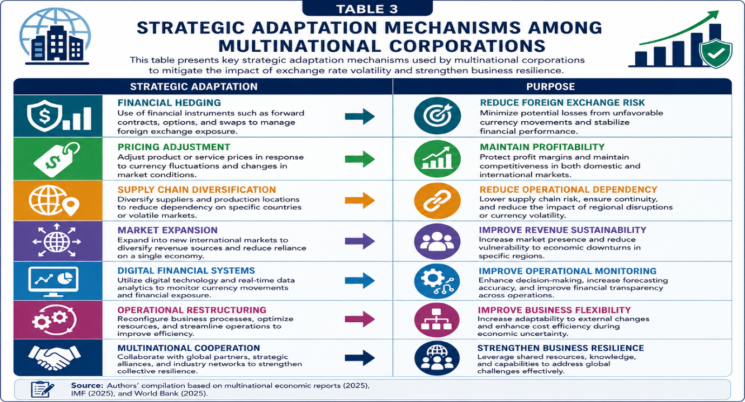
Source: Authors’ compilation based on multinational economic reports (2025), International Monetary Fund– International Financial Statistics (2025), and World Bank – World Development Indicators (2025).

Table 3 illustrates a number of strategic adaptation techniques adopted by multinationals to deal with currency rate volatility and global economic uncertainty. The results show growing attention of multinational firms to the adaptive business strategies to minimize foreign exchange risks, increase operational resilience, and maintain long-term competitiveness in the context of changing international marketplaces. Extended currency instability has greatly impacted the operational planning, financial sustainability, and international business performance of multinational firms in the developed and emerging nations.

The results also show that multinational firms are more prone to adopt financial hedging, pricing adjustments, supply chain diversity and transnational cooperation to mitigate operational interruptions and enhance company agility. These adaptive measures allow companies to better manage foreign exchange exposure, maintain operational continuity, and increase financial resilience amid periods of economic instability and volatile global market conditions.

SUMMARY FINDINGS

The research looked at the effect of fluctuating currency rates on international companies and how they remain running smoothly in a constantly changing world economy. The findings indicate that fluctuations in the exchange rate have a considerable effect on the long-term operational sustainability, the financial resilience, the international competitiveness and the long-term investment planning of multinational enterprises. Some of the major concerns that multinational corporations face in both developed and emerging countries include currency depreciation, increased pricing, supply chain issues and inflation.

The results also reveal that multinational companies are increasingly using strategic adaptation tools, such as financial hedging, changing prices, diversifying their supply chains, reorganizing their operations, and collaborating across borders, to reduce their foreign exchange risks and make their operations more resilient. The study revealed that enterprises with higher adaptive capacity, varied operational structures and overseas cooperation networks were better able to sustain their competitiveness and financial stability during the periods of economic instability. The results also confirm the Resource-Based View (RBV) and the Strategic Adaptation Theory. These theories emphasize the need of strategic resources, organizational flexibility and the ability to respond to operational volatility and sustain a multinational firm.

CONCLUSION

Finally, currency fluctuations, especially of the dollar, remain a major economic challenge for multinational corporations operating in closely linked worldwide marketplaces. The study has revealed that long-term currency instability has a significant effect on operational planning, international trade, production costs, the ability of Malaysia, the US and China to sustain their financial stability and the ability of the global corporations to compete. The global economic challenges such as the recovery from the epidemic, inflationary pressure, geopolitical instability and policies that constrain the money supply increased the uncertainty regarding the currency rate and operational hazards for international enterprises.

The present study also showed that strategic adaptation is an important component in making global organizations more operationally robust and securing long-term prosperity. Multinational corporations are increasingly turning to flexible measures such as financial hedging, pricing adjustments, digital financial systems, supply chain diversification and cross-border cooperation to better manage foreign exchange risks and business disruptions. Firms with superior strategic resources and organizational capabilities that are able to change were shown to be more resilient and competitive in times of instability in the global economy.

The study extends the knowledge on long-term viability of multinational enterprises and foreign exchange risk management, considering operational uncertainty, exchange rate volatility, strategic adaptation and international teamwork in a comparative multinational context. These results tell multinational companies, policymakers, investors and business strategists a lot about the importance of flexible business strategies and international collaboration to be financially stable and competitive in the long run, particularly in times of economic instability. Future study may do more on this by employing quantitative methodologies, larger multinational datasets, and many economic aspects to better understand the fluctuation of exchange rates and how multinational corporations adjust their tactics to different sections of the global economy.

NOVELTY AND CONTRIBUTION TO THE STUDY

The study makes a number of significant advances to the current knowledge on exchange rate volatility and multinational firm sustainability. First, the study combines the exchange rate volatility, strategic adaptation, operational resilience and multinational cooperation in one analytical framework. Prior studies tend to address foreign exchange risk exclusively from the finance or macroeconomic perspective; however, this study extends the subject by highlighting the interdependent relationship between operational sustainability and strategic adaptation of multinational firms.

Second, the present study offers a comparative multinational perspective, that is Malaysia, the United States and China, which has been relatively underexplored in the recent literature. The study also offers larger insights into differing economic structures and their impact on company adaptation to exchange rate uncertainty, through a comparative examination of multinational business environments across established and emerging economies.

Third, the study emphasizes the increasing significance of digital financial systems, supply chain diversity, and multinational strategic cooperation as developing adaptive mechanisms employed by multinational firms to sustain operational resilience amidst global economic uncertainty. This work extends existing considerations of financial hedging to include broader organizational and technical adaption techniques. Finally, the study provides practical value to policymakers, multinational corporations and international business strategists, by setting out integrated policy recommendations combining financial stabilization, international cooperation and organizational adaptability for enhancing long-term multinational competitiveness and sustainability in volatile global economic environments.

Author Contributions: The Authors have contributed equally to this work. All authors have read and agreed to the publish version of the manuscript.

Conflict of interest declarations: The authors declare no conflict of interest

REFERENCES

- Aizenman, J., Chinn, M. D., & Ito, H. (2023). Financial spillovers and exchange rate volatility in emerging economies. Journal of International Money and Finance, 132, 102789. https://doi.org/10.1016/j.jimonfin.2022.102789
- Barney, J. (1991). Firm resources and sustained competitive advantage. Journal of Management, 17(1), 99–120. https://doi.org/10.1177/014920639101700108
- Bénétrix, A. S., Lane, P. R., & Shambaugh, J. C. (2023). Exchange rate volatility and international financial stability. Journal of International Economics, 142, 103721. https://doi.org/10.1016/j.jinteco.2023.103721
- Bondarenko, O., & Brůna, K. (2021). Exchange rate exposure and corporate financial performance. Economic Systems, 45(3), 100894. https://doi.org/10.1016/j.ecosys.2021.100894
- Demir, F. (2025). Exchange rate volatility and multinational operational sustainability. International Business Review, 34(2), 101245. https://doi.org/10.1016/j.ibusrev.2025.101245
- Fagbamila, J. A. (2022). Currency depreciation and operational performance among multinational corporations. Global Business Review, 23(4), 921–938. https://doi.org/10.1177/09721509211032045
- Fang, W., & Miller, S. M. (2024). Currency fluctuations and multinational corporate performance. Economic Modelling, 125, 106421. https://doi.org/10.1016/j.econmod.2024.106421
- International Monetary Fund. (2024). World economic outlook 2024: Global economic resilience and uncertainty. IMF Publications. https://www.imf.org
- Johnston, M. P. (2017). Secondary data analysis: A method of which the time has come. Qualitative and Quantitative Methods in Libraries, 3(3), 619–626.
- Kirecci, O. (2025). Exchange rate instability and global operational uncertainty among multinational corporations. International Journal of Economics and Financial Issues, 15(1), 34–48.
- Kraaijenbrink, J., Spender, J. C., & Groen, A. J. (2010). The resource-based view: A review and assessment of its critiques. Journal of Management, 36(1), 349–372. https://doi.org/10.1177/0149206309350775
- Miles, R. E., & Snow, C. C. (1978). Organizational strategy, structure, and process. McGraw-Hill.
- Nobanee, H., Al Hammadi, F., & Ellili, N. O. D. (2022). Foreign exchange risk and multinational business sustainability. Sustainability, 14(9), 5287. https://doi.org/10.3390/su14095287
- Teece, D. J., Peteraf, M., & Leih, S. (2016). Dynamic capabilities and organizational agility. California Management Review, 58(4), 13–35. https://doi.org/10.1525/cmr.2016.58.4.13
- Verbeke, A., & Yuan, W. (2022). Multinational enterprises and international business strategy. Journal of International Business Studies, 53(4), 789–805. https://doi.org/10.1057/s41267-021-00485-7
- World Bank. (2025). World development indicators. World Bank Group. https://data.worldbank.org

