Design And Simulation Of An Internet Café Network Infrastructure With Centralized Game Server, Bandwidth Management, And Security Restrictions Using Star Topology

Abstract
Internet cafés continue to serve as important venues for online gaming, internet access, and digital services. However, many establishments encounter issues such as network congestion, inefficient bandwidth utilization, slow game updates, and security vulnerabilities. This study aimed to design and simulate an Internet Café Network Infrastructure incorporating a centralized game server, bandwidth management mechanisms, and security restrictions using a star topology. A Design and Development Research approach was employed. The proposed network consisted of thirty client computers, one game server, one router, one managed switch, and one administrative workstation. The network design was developed through floor plan creation and simulated using Cisco Packet Tracer. Network performance was evaluated through connectivity testing, server accessibility, VLAN segmentation, and security validation. Results demonstrated that the proposed network design provided reliable connectivity, efficient resource utilization, centralized management, and enhanced network security. The findings suggest that the proposed infrastructure is suitable for small- and medium-sized Internet cafés and can serve as a model for future network deployment projects.

I. INTRODUCTION

Background of the Study

Internet cafés provide customers with access to computers, online games, internet services, printing facilities, and other digital resources. As online gaming becomes increasingly demanding in terms of bandwidth and network performance, Internet café operators must implement reliable network infrastructures capable of supporting multiple users simultaneously.

Many Internet cafés experience operational challenges caused by inadequate network design. Common issues include network congestion during peak hours, excessive internet bandwidth consumption due to repeated game updates, and security risks associated with unauthorized access and malware infections. These problems negatively affect customer satisfaction and business operations.

One solution is the implementation of a properly designed network infrastructure that incorporates centralized game servers, bandwidth management policies, and network security controls. A centralized game server can reduce external bandwidth usage by providing local access to game files and updates. Bandwidth management ensures fair allocation of internet resources, while security restrictions protect network devices and users from threats.

This study proposes a network infrastructure design for an Internet café and evaluates its performance through simulation using Cisco Packet Tracer.

Statement of the Problem
- What network topology is most suitable for an Internet café?
- How can a game server improve network efficiency?
- How can bandwidth management reduce network congestion?
- What security restrictions can protect the network from unauthorized access?
- Can the proposed network design effectively support gaming and internet services?

General Objective
To design and evaluate an Internet Café Network that provides efficient connectivity, centralized gaming services, bandwidth management, and network security.

Specific Objectives
- To develop a floor plan suitable for an Internet café environment.
- To design a network topology that supports gaming and internet services.
- To integrate a centralized game server within the network infrastructure.
- To implement bandwidth management strategies.
- To apply security restrictions that protect network resources.
- To evaluate the performance of the proposed network through simulation.

Significance of the Study
This study provides a practical guide for building and testing a fast, secure network for gaming and internet setups. The findings of this research will directly benefit the following groups:
- Internet Café Owners: This study gives owners a clear, ready-to-use plan to fix common business problems like slow internet, lag during busy hours, and computer viruses. By using a local game server to handle updates, owners can save money on internet bills because they will not have to download the same game updates over and over on every computer.
- Network Administrators: This paper works as a helpful guide for IT professionals who need to set up a stable network for heavy online gaming. It offers easy-to-follow examples for dividing the network safely (using VLANs), blocking unauthorized users, and sharing internet speed fairly among all customers.
- Academic Institutions: This research benefits schools and universities by showing a real-world application of computer networking lessons. It serves as an excellent classroom example of how textbook engineering theories are used to solve everyday business and technical problems.
- Students and Future Researchers: This project gives students a simple step-by-step model for designing and testing a network using free software like Cisco Packet Tracer before spending money on expensive physical hardware. It also gives future researchers a solid starting point to test more advanced systems later on.

Scope and Delimitations
This section defines exactly what this research covers and what it leaves out.
The study focuses entirely on designing and testing a network setup meant for a standard internet café. The entire network design is built around a specific set of hardware, which includes:
- Twenty (30) client computers for customers to use.
- One (1) game server to store and share game files locally.
- One (1) router to connect the entire café to the internet.
- One (1) managed switch to direct data traffic smoothly between devices.
- One (1) administrative workstation for the staff or owner to manage operations.

To keep the project focused, the study has the following limits:
- Simulation Only: The network is created and tested only inside a computer program called Cisco Packet Tracer.
- No Real-World Setup: The project does not include buying physical equipment or installing the actual wires and computers in a real building.
      - No Money Analysis: This study does not look into budgets, equipment costs, electricity bills, or any other financial aspects of running a business

II. METHODS

Research Design
The study employed a Design and Development Research Methodology. This methodology was selected because the primary objective was to develop, simulate, and evaluate a network infrastructure rather than investigate behavioral or social phenomena.

System Development Procedure
The research followed five phases:

Phase 1: Requirement Analysis
The requirements for the Internet café were identified, including:
- Number of client computers
- Internet connectivity requirements
- Gaming requirements
- Security requirements
- Administrative requirements

Phase 2: Floor Plan Development

A floor plan was developed to optimize workstation arrangement, customer accessibility, equipment placement, and cable management. The layout consists of a main client PC area, a cashier/administration room, a VIP room, and a comfort room to support efficient operation and user convenience.
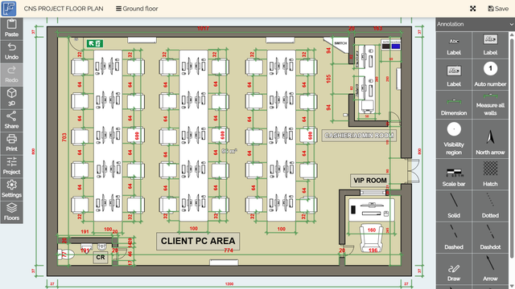
Figure 1. Proposed Internet Café Floor Plan.
The proposed physical layout of the Internet café. The design includes a dedicated client PC area, a cashier/administration room for network monitoring and business operations, a VIP room for premium customers, and a comfort room for customer convenience. The arrangement promotes efficient space utilization and simplified network deployment.
Room / Area | Length (cm) | Width (cm) | Total Area (m2)
Total Room Area | 1200 | 800 | 96.0
Client PC Area | 1017 | 703 | ~71.5
Cashier / Admin Room | 293 | 163 | ~4.8
VIP Room | 245 | 196 | ~4.8
Comfort Room (CR) | 191 | 77 | ~1.5
Table 1. Structural and Room Dimensions

Table 1 shows that the internet café has an outside boundary of dimension 1200 cm x 800 cm and an approximate usable area of 96 square meters. The biggest zone inside the floor plan is allocated for the Client PC Area which occupies an area of dimension 1017 cm (length) x 703 cm (breadth) that is about 71.5 square meters. Having fewer partitions on the floor plan allows more ventilation and space for movement of customers. On the other hand, areas with partitions are reserved for specific purposes such as the cashier/administration room which occupies the smallest space with dimensions of 293 cm x 163 cm. Placed close to the entrance, it is easily accessible for purposes such as assistance and payments. Also reserved for privacy is the VIP room which has dimensions 245 cm x 196 cm and is bordered by 20 cm partitions on the inside of the floor plan. Guests who use this room are served with more privacy because they are farther away from the client PC area. In the southwest section of the internet cafe is the Comfort Room (CR) of dimensions 191 cm x 77 cm.

Component / Item | Length / Depth (cm) | Width (cm) | Dedicated Clearance Space (cm)
Standard Client Desk (Per Node) | 60 | 100 | —
Standard Client Chair Spacing | 64 | 64 | 32 (Rear clearance)
Row End Clearance | — | — | 32 (Top/Bottom)
Admin Desk Layout | 240 | 58 | —
VIP Desk | 160 | ~70 | —
Client PC chair | 60 | 60 | —
Game Server, VIP and Admin Monitor | 82 | 16 | —
Client Monitor | 60 | 16 | —
Vip Chair | 82 | 99 | —
Sofa in admin | 180 | 50 | —
Table 2. Workstation and Furniture Dimensions

Seats arrange easily with comfort in mind. All chair rows (3 total) will be configured to fit standardized desks. Chairs in the Client PC Room will be spaced to support comfortability of movement. This includes enough room for computers (21.5cm to 27cm gaming monitors recommended), keyboards, mice, and whatever the end user wants. Each chair will occupy a space of 64cmx64cm and will also have an additional 32cm of space behind them. This is to prevent chairs from hitting the row behind when standing. There will also be an additional 32cm of space on both ends of the rows. This is to allow for clearances during emergencies and to allow walkways to not be obstructed. Admin Room desk will be 240cmx58cm to support POS systems, monitor(s), and networking equipment. Desktops in the VIP Room will be increased to 160cm to allow for luxurious spacing.

Phase 3: Network Design
A star topology was selected because it offers:
- High reliability
- Easy troubleshooting
- Better performance
- Scalability
- Simplified management
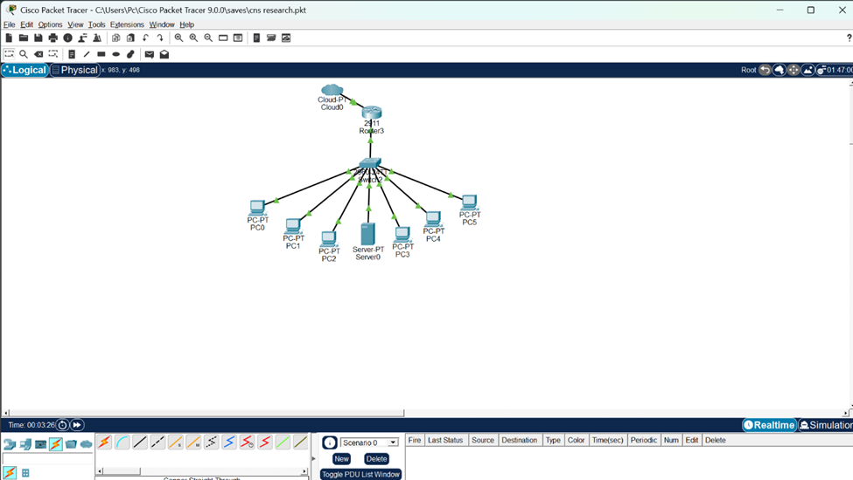
Network Topology
Figure 2. Cisco Packet Tracer

The network topology developed and tested using Cisco Packet Tracer. The diagram demonstrates the interconnection of all network devices through a star topology, providing centralized management, scalability, and reliable network performance.
Network Components
Component | Quantity
Router | 1
Managed Switch | 1
Game Server | 1
Admin PC | 2
Client PCs | 30
Table 3. Network Components of the Proposed Internet Café Network

The hardware components required for the implementation of the proposed Internet café network infrastructure. These devices were selected to provide reliable connectivity, centralized management, and efficient network operations. The combination of client computers, server, router, and managed switch supports both gaming and internet services.
IP Addressing Scheme
Device | IP Address
Router | 192.168.1.1
Game Server | 192.168.1.10
Admin PC | 192.168.1.20
Client PCs | 192.168.1.100-119
Table 4. IP Address Allocation Scheme

Subnet Mask: 255.255.255.0
The IP addressing scheme assigned to the network devices. Proper IP allocation ensures organized communication between network components and simplifies network administration. The addressing plan also helps maintain connectivity and reduce configuration errors.
VLAN Configuration
VLAN | Purpose
VLAN 10 | Client PCs
VLAN 20 | Game Server
VLAN 30 | Administration
Table 5. VLAN Segmentation Configuration

The VLAN configuration used to separate network resources according to their functions. VLAN segmentation enhances network security by restricting unauthorized access between different user groups. It also improves network management and traffic control within the Internet café environment.
Bandwidth Management Strategy
Assuming a 200 Mbps internet connection:
User Group | Allocation
Client PCs | Fair Sharing
Game Server | High Priority
Admin Station | High Priority
Table 6. Bandwidth Allocation Strategy for Network Users

The bandwidth management strategy implemented in the proposed network design. High-priority bandwidth allocation was assigned to the game server and administrative workstation to ensure stable performance and uninterrupted operations. Meanwhile, the remaining bandwidth was distributed fairly among client computers to minimize network congestion.

Bandwidth policies included:
- Gaming traffic prioritization
- Download control
- Streaming limitation
- Fair bandwidth distribution

Security Restrictions
The following restrictions were implemented:

Firewall Controls
- Block unauthorized ports
- Restrict peer-to-peer traffic
- Prevent external access to administrative resources

User Restrictions
- Disable software installation
- Restrict access to system settings
- Prevent unauthorized device connections

VLAN Segmentation
Network resources were isolated based on function to improve security and management.

Simulation Procedure
The proposed network was implemented in Cisco Packet Tracer using:
- Router
- Managed Switch
- Server
- Client Computers

The following tests were conducted:
- Ping Connectivity Test
- Server Accessibility Test
- VLAN Isolation Test
- Security Validation Test
- Network Traffic Evaluation

III. RESULTS

Connectivity Testing
All client computers successfully established communication with the router, game server, and administrative workstation.

Test | Result
PC to Router | Successful
PC to Server | Successful
PC to Admin PC | Restricted
Internet Access | Successful
Table 7. Connectivity Test Results

The results of the connectivity tests conducted during the simulation phase. The successful test outcomes indicate that the network devices were able to communicate properly according to the proposed design. These results demonstrate the effectiveness and reliability of the network infrastructure.

Server Accessibility Testing
The game server successfully provided centralized access to game resources and updates for all client computers.
The use of a centralized server reduced the need for repeated external downloads and improved local access speeds.

VLAN Segmentation Testing
Simulation results showed successful separation of network segments.
VLAN | Access Status
Client VLAN | Accessible
Server VLAN | Accessible Through Rules
Admin VLAN | Restricted
Table 8. VLAN Segmentation Test Results

The results of the VLAN segmentation testing performed in the simulated environment. The findings confirm that access restrictions and network isolation policies were successfully implemented. This configuration helped improve security by preventing unauthorized communication between protected network segments.

The configuration prevented unauthorized access between network segments.

Security Validation
Security restrictions successfully prevented unauthorized access to administrative resources and protected critical devices from direct user interaction.

Network Performance Evaluation
The proposed bandwidth management design provided fair resource allocation among client computers while prioritizing gaming traffic and server operations. Network congestion was minimized during simulated operation.

IV. DISCUSSION

The findings show that the proposed Internet Café Network Design has successfully overcome some typical problems that arise during Internet café operations. Star topology was used to provide consistent connectivity while making network management easy. In contrast to bus and ring topologies, the malfunctioning of one workstation had no effect on the rest of them.
The incorporation of a centralized game server increased network performance by minimizing the consumption of external bandwidth and offering fast access to games locally. This type of arrangement will be very helpful to Internet cafés that often require updates of gaming software.
Effective bandwidth management has resulted in an equitable distribution of Internet resources among the users, preventing the consumption of too much bandwidth by each of them.
Additional security restrictions have added extra protection to the network by protecting sensitive information from the wrong hands. The simulation shows that the proposed design is feasible and scalable.

Conclusion
The research has been able to develop and simulate the Internet Café Network Infrastructure by designing the network using a centralized game server, bandwidth management techniques, and security constraints.
From the simulation test, it is clear that there was successful connectivity of the devices, VLAN segmentation, resource isolation, and network management. The use of the centralized game server helped in saving on the bandwidth usage, and the security measures improved the security aspect.
From the research results, it is evident that the network design could effectively help in Internet café operations and form a basis for future implementation in real life internet cafes.

Recommendations
Based on the empirical results and simulation results obtained from this research study, there are various recommendations which can facilitate improvements with regards to the scalability and validation capabilities of the designed network infrastructure. First of all, it is strongly advised that the developed star topology model should be transformed into practical terms by installing the actual networking hardware in order to have the opportunity to prove its feasibility in a real-life operational setting.
In addition, while configuring this practical network system, operators will need to employ high-powered managed switches that will enable the implementation of efficient Virtual Local Area Network (VLAN) configurations as well as the traffic analysis. Moreover, in order to enhance the data saving process, companies should install their own local game servers which will be optimized in such a way that the repetitive WAN bandwidth usage associated with software updates will be minimized. For achieving better QoS routing capabilities, future developers should apply the state-of-the-art bandwidth management systems using MikroTik routers.
Finally, in order to ensure the secure operation of this infrastructure, security systems should be improved by deploying intrusion detection systems (IDS) as well as implementing content filtering technologies.

ABOUT THE AUTHORS

Edrian O. Gagote is a 21-year-old student currently pursuing a Bachelor of Science in Computer Engineering (BSCpE)
at the Eulogio "Amang" Rodriguez Institute of Science and Technology (EARIST). Now in her third year, she is a
curious learner who enjoys exploring new research ideas and applying them in real-world projects.

Mariene Guisihan Adriatico is a 21-year-old student currently pursuing a Bachelor of Science in Computer Engineering
(BSCpE) at Eulogio “Amang” Rodriguez Institute of Science and Technology (EARIST). She enjoys learning,
collaborating on projects, and exploring new technologies in the field of computer engineering.

Jhenycis Matthew L. Buenafe is a 20-year-old student pursuing a Bachelor of Science in Computer Engineering
(BSCpE) at Eulogio “Amang” Rodriguez Institute of Science and Technology (EARIST). He is a Computer
Engineering student passionate about technology, with a strong interest in developing software solutions. He is eager
to enhance his skills and apply his knowledge to real-world projects within the field.

Carlo B. Cortezano is a 21-year-old student pursuing a Bachelor of Science in Computer Engineering (BSCpE) at
Eulogio “Amang” Rodriguez Institute of Science and Technology (EARIST). He is a dedicated learner with a strong
willingness to grow and has a keen interest in networking and computer technologies.

Katrina Ysabel Gruy is a 21-year-old third-year student taking up Bachelor of Science in Computer Engineering
(BSCpE) at the Eulogio "Amang" Rodriguez Institute of Science and Technology (EARIST). She is passionate about
building practical solutions through technology and continuously developing her skills in programming, systems, and
real-world applications.

Kenneth George L. Malejana is a student pursuing a Bachelor of Science in Computer Engineering (BSCpE) at Eulogio
“Amang” Rodriguez Institute of Science and Technology (EARIST). He is an engineering student with a growing
interest in developing his knowledge and skills in the field of computer engineering.

Ma. Chelsea B. Parale is a student pursuing a Bachelor of Science in Computer Engineering (BSCpE) at Eulogio
“Amang” Rodriguez Institute of Science and Technology (EARIST). She has a keen interest in understanding the
inner workings of technology, particularly in the areas of signals, networks, and wireless systems.

Harvey U. Velasquez is a 21-year-old student pursuing a Bachelor of Science in Computer Engineering (BSCpE)
at Eulogio “Amang” Rodriguez Institute of Science and Technology (EARIST). He is a determined individual who
believes in creating his own path, demonstrating independence and a strong sense of direction in his academic and
personal pursuits.

Andrei Lanz P. Domingo is a student pursuing a Bachelor of Science in Computer Engineering (BSCpE)
at Eulogio “Amang” Rodriguez Institute of Science and Technology (EARIST). He is a Computer
engineering student focused on applying technology to real-world solutions. He is eager to enhance his
skills and contribute to practical projects in the field.

Engr. Minerva C. Zoleta, a Professional Computer Engineer, is a dedicated Computer Engineering Professor at the Eulogio “Amang” Rodriguez Institute of Science and Technology in the Philippines, specializing in Embedded Systems, Operating Systems, and Computer Network and Security. With a strong background in academia and industry. She has been instrumental in shaping the next generation of Engineers through innovative teaching methods and hands-on research. Engr. Zoleta holds a Master’s degree in Electrical Engineering major in Computer Engineering at Technological University of the Philippines, Manila and is pursuing her doctorate degree in Engineering with specialization in Computer Engineering AT Technological Institute of the Philippines. She has presented published research on topics such as Embedded System, IoT applications, and wireless communication international conferences and journals. . Passionate about technology-driven solutions, She has led various projects integrating smart systems into real-world applications, contributing to the advancement of local and international engineering communities.

REFERENCES
Cisco Networking Academy. (2020). Introduction to networks companion guide (CCNAv7) (1st ed.). Cisco Press.
Cisco Systems, Inc. (2026). Packet trace configuration guide. Cisco Systems.
Cisco Systems, Inc. (2025). Use the traceroute command on operating systems. Cisco Systems.
Forouzan, B. A. (2017). Data communications and networking (5th ed.). McGraw-Hill Education.
Kurose, J. F., & Ross, K. W. (2022). Computer networking: A top-down approach (8th ed.). Pearson.
Odom, W. (2020). CCNA 200-301 official cert guide, volume 1. Cisco Press.
Odom, W. (2020). CCNA 200-301 official cert guide, volume 2. Cisco Press.
Stallings, W. (2020). Foundations of modern networking: SDN, NFV, QoE, IoT, and cloud (2nd ed.). Addison-Wesley.
Walia, S., Iyer, T., Tripathi, S., & Vanaparthy, A. (2023). Safe and secure smart home using Cisco Packet Tracer. arXiv.
Sulaiman, M. K. E. B. (2020). Teaching creativity using a realistic multi-user operation: Packet Tracer. arXiv.

