A COMPREHENSIVE STUDY ON IMPACT OF AI TOOLS ON
STUDENT’S CREATIVITY IN ACADEMIC LEARNING

Authors: Sakthi. S, Pawan Kumar.V, Gautham.V
Bangalore North University,
Master Of Business Administration (MBA),
Patel Institute of Science and Management (PISM) Bangalore, India

ABSTRACT

The increasing usage of Artificial Intelligence (AI) tools in academic learning has completely changed the way students build and deliver their creativity. This abstract mainly examines the impact of AI tools on students’ creativity by combining findings from multiple studies taken place in digital learning environments. AI tools are majorly used by students for innovative and unique academic activities such as idea generating, content creation, completion of assignment, and project development. These tools help students by providing quick access to information, give ideas suggestions and support the students in creative and better ways in their academic learning.

Research findings showcase that AI tools will have a positive influence on students’ creativity in academic learning when it is used in a limited and purposeful manner. Moderate use of AI tools encourages students to explore new ideas. However, the studies also point out certain negative effects when AI tools are used unthoughtfully or unethically. Excessive dependence in AI tools may limit the creativity and originality in their academic related works and personal contribution will reduce Feedback from students indicates lower personal contribution and reduced ownership of creative work when AI tools are heavily used for academic tasks, The overall findings give suggestions that there should be proper guidance and ethical use of AI tools in academics. AI tools should be a supportive resource rather than substitute for human creativity. Educators should motivate the students to use AI tools responsibly while making the personal contribution remain constant. In conclusion, AI tools have a positive impact on students' creativity in academic learning but balanced and ethical use of AI tools is necessary to sustain the originality of students' thinking in their academic learning.

Key Words:
Artificial Intelligence in Education, Students’ Creativity, AI Tools Usage, Creative Thinking, Digital Learning Environment.

INTRODUCTION

The increasing use of Artificial Intelligence (AI) tools has drastically influenced academic learning. Students now widely use AI tools to assist many things such as assignments completion, project development presentations, and problem solving. These tools have become an integral part of the modern learning process. These tools have gradually become part of the academic learning process, assisting students in activities like creative writing, project preparation, presentation making etc. Creativity plays a crucial role in academic learning, as it encourages independent thinking, originality, and innovative expression of ideas. AI tools have altered creative practices by delivering immediate assistance to students. When it’s used in a purposeful and controlled manner, these tools help students handle creative challenges, improve self-confidence, and enhance the overall academic performance. At the same time, heavy reliance on AI results important concerns. Excessive dependence on automated contents may decrease originality, weaken creative thinking skills, and limit students ‘personal engagement with learning tasks. But heavy reliance on AI tools may decrease originality, decrease critical thinking, and limit independent idea development. Therefore, it is important to analyse and understand both the positive and negative outcomes of AI tools usage on creativity of the students. This study explores the impact of AI tools on students’ creativity in academic settings, focusing on usage patterns, student perceptions on AI tools usage, and creative outcomes to understand responsible and ethical use of AI tools.

OBJECTIVES OF THE STUDY

- To assess the level of AI tool adoption among students for academic activities.

- To evaluate the influence of AI tools on students’ creative thinking and idea development.

- To examine the positive contributions of AI tools to academic creativity and performance.

SCOPE OF THE STUDY

- The scope of this research is centred on examining how Artificial Intelligence tools affect students’ creativity within academic learning environments. The study considers students who regularly use AI tools for academic purposes such as assignments writing, making presentations, developing projects, and idea generation.

- It focuses on majorly used AI applications that support students in content creation, language improvement, brainstorming etc. This study analyses the impact of varying levels of AI usage - low, moderate, and high-on students’ creative skills.

- Both cognitive and behavioural dimensions of creativity are considered, including originality, confidence, depth of idea exploration, and personal contribution to academic work. Additionally, students’ experiences, perceptions, and feedback regarding AI-assisted learning are taken into account.

- The research is confined to academic creativity and does not examine the technical or programming aspects of artificial intelligence. Major importance is given to the educational outcomes rather than technological performance. The findings are focused to encourage students, educators, and institutions by offering proper guidance on using AI tools responsibly and ethically.

- Additionally, the study concentrates on ongoing academic discussions on purposeful and balanced AI tools used
in the development of strategies that protect student’s creativity in academic learning.

LITERATURE REVIEW

- Aakanksha, Ravish Sharma, Shiksha Shrivastava & Sadhana Singh, (15 May 2025), The study examines the role of AI in enhancing students’ creativity.AI tools support creative thinking of students in academic learning. They reduce cognitive effort and improve students creative thinking efficiency. Students view AI as a support for academic learning. The study concludes that balanced AI use enhances creativity.

- Zeliya Arifa Hulmi & Eko Aziz Apriadi, (2025), AI can enhance students’ critical thinking and analytical skills. It provides adaptive learning and focused content to support understanding. Excessive reliance on AI tools may reduce independent thoughts and reasoning. Heavy use can reduce creativity and problem-solving abilities of the users. Balanced integration of AI tools is very much essential to strengthen and preserve critical thinking.

- Mohammed Zeinu Hassen, (2025), AI can increase students’ reading, critical thinking. It provides personalized learning experience and adaptive feedback which encourages students. Heavy reliance may reduce deep analysis and independent reasoning. Guidance on balanced usage AI tools is recommended in academics.

HYPOTHESIS OF THE STUDY

H1: The dependence of Artificial intelligence (AI) tools affects the creative thinking level of students and affects the originality. Tools such as ChatGPT, Grammarly etc.

H0: These tools can support creative thinking and improve learning outcomes when it’s used in a thoughtful manner. However, heavy dependence on AI may reduce students’ creative thinking ability and limit their originality in output.

RESEARCH METHODOLOGY

This study uses an analytical and systematic way of approach to understand AI tools impact on student creativity in academic learning. The data were collected through questionnaires that were distributed to students, along with the help of secondary information that was gathered from journals, online sources and research articles. The questionnaire focused on students’ frequency of AI usage, idea-generation methods, and learning habits. The collected data were analysed in order to understand patterns in AI usage and its influence on students’ creative thinking in academic learning.

DATA ANALYSIS AND INTERPRETATION

The survey responses were analysed to understand how AI tools affect student creativity. However, over-reliance on AI reduces one's own thinking and originality. The below figure shows students’ opinions on the role of AI tools in enhancing creativity in academic learning.

Figure 1. What is your overall opinion of AI’s role in enhancing student creativity.
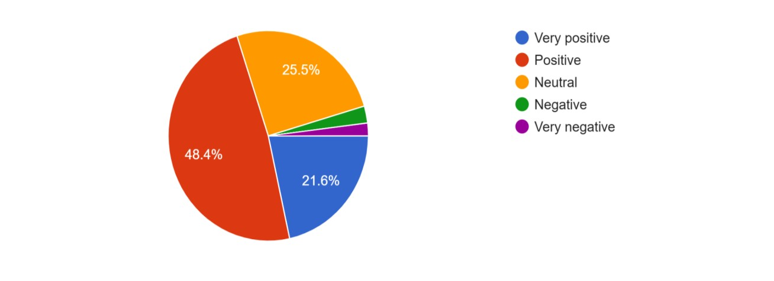

Table 1. Representation of table shows the overall opinion of AI’s role in enhancing student creativity.

Sl No. | Descriptive | Responses | Percentage
1 | Very Positive | 22 | 21.60%
2 | Positive | 48 | 48.40%
3 | Neutral | 26 | 26%
4 | Negative | 3 | 3%
5 | Very Negative | 2 | 2%
 | Total | 153 | 100%

The majority of responses expressed a favourable view, with 48.4% resulting in a positive opinion and 21.6% resulting in a very positive opinion, showcasing that AI tools are widely perceived as supportive for creativity in academic learning. 25.5% of students remained neutral, suggesting varied experiences with AI usage. Only 3% and 2% expressed negative and very negative and overall results says AI tools has majorly positive impact on student’s creativity.

Figure 2. How often do you use AI tools for academic or creative purposes.
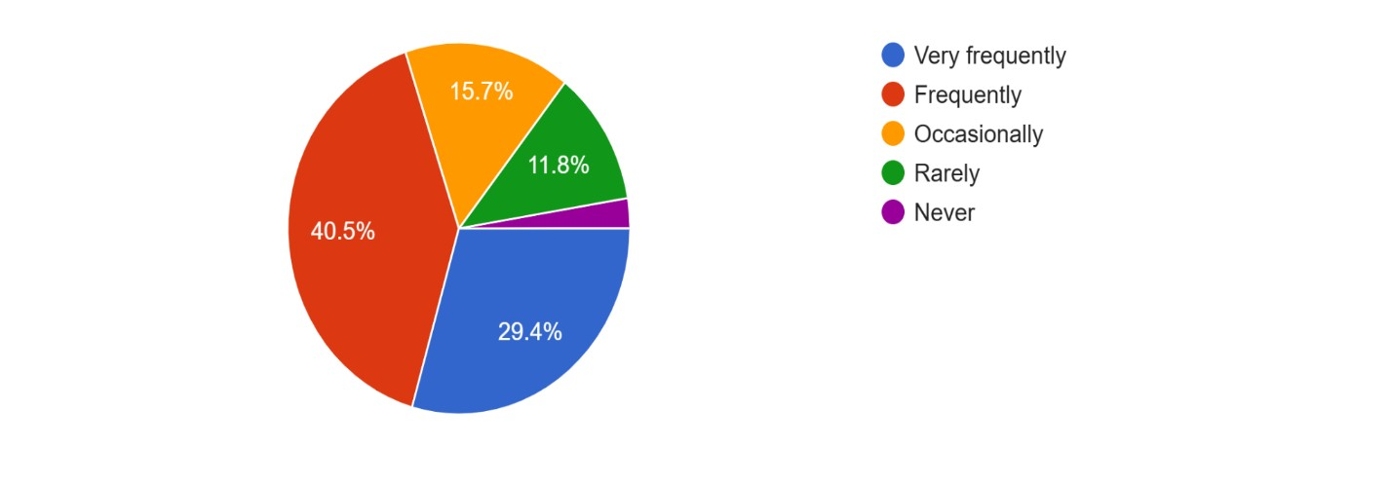

Table 2. Representation of table shows how often does students use AI tools for academic or creative purposes.

Sl No. | Descriptive | Responses | Percentage
1 | Very frequently | 45 | 29.40%
2 | Frequently | 62 | 40.50%
3 | Occasionally | 24 | 16%
4 | Rarely | 18 | 12%
5 | Never | 4 | 3%
 | Total | 153 | 100%

Out of 153 respondents (100%),40.50% are using AI tools frequently and 29.40% reported experiencing it very frequently, additionally 16% mentioned that they use AI tools occasionally,12% are expressed that rarely they are using the AI tools, and 3% never. In Overall, around 70% of respondents use AI tools either frequently or very frequently, which is showcasing the wide spread adoption of these tools among the majority.

Figure 3. AI tools encourage new learning methods or creative styles.

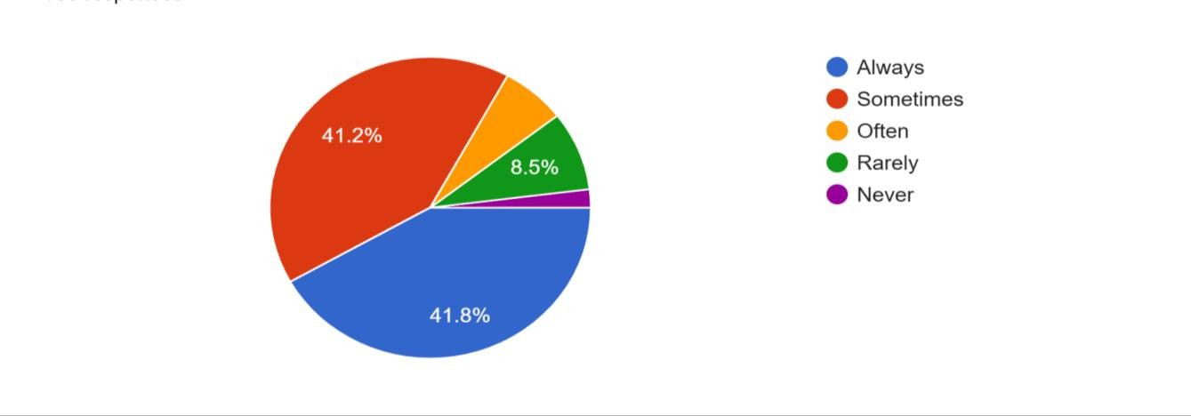

Table 3. Representation of table shows AI tools encouragement in new learning methods or creative styles.

Sl No. | Descriptive | Responses | Percentage
1 | Always | 64 | 41.80%
2 | Sometimes | 63 | 41.20%
3 | Often | 10 | 7%
4 | Rarely | 13 | 9%
5 | Never | 3 | 2%
 | Total | 153 | 100%

Most respondents feel that AI tools encourage exploring new learning methods or creative styles, with 80% reporting always or sometimes. Only 9% and 2% expressed rarely or never experience such influence, showing a strong positive impact of AI tools.

FINDINGS

- Students use AI tools to support their academic tasks, especially for writing assignments and supporting project work, brainstorming and solving complex problems.

- Students who rely heavily on AI will result in lack of originality in the academic work.

- In contrast, students who take AI support with personal contribution and critical thinking will result in higher creativity and improved academic performance.

SUGGESTIONS

- Students should take support from AI tools rather than using AI tools as a substitute for completing their work. AI can help in improving ideas, but original thinking should remain constant to academic work.

- Colleges should conduct workshops and training programs to educate students to give knowledge on the ethical and effective use of AI tools.

- Motivating independent thinking and creativity will help students maintain originality while using AI ethically to enhance learning.

CONCLUSION

The study highlights that AI tools have a positive impact on students’ creativity in their academic learning. While tools like ChatGPT can improve efficiency, idea generation, and academic quality, excessive reliance will result in lack of originality and independent thinking in the work. Therefore, a balanced usage of AI tools and personal contribution and efforts are very much important to achieve better learning outcomes. Educational institutions play a very important role in guiding students towards using AI in balanced and ethical way. Ultimately, purposeful and balanced use of AI strengthens creativity while protecting students’ creative ideas and thoughts. Future research will cover wide responses and will include deeper analysis.

REFERENCES

- Aakanksha, Ravish Sharma, Shiksha Shrivastava & Sadhana Singh. (2025). The Influence of Artificial Intelligence on Students’ Creativity: Perspectives and Perceptions, 197-215.

- Mohammed Zeinu Hassen. (2025). The Impact of AI on Students’ Reading, Critical Thinking, and Problem-Solving Skills, 9, 82-90.

- Zeliya Arifa Hulmi & Eko Aziz Apriadi. (2025). Analysis of the Effect of Using Artificial Intelligence on Critical Thinking Power of Students in the Digital Age, 1, 38-50.

