IoT-Enabled Autonomous Drug Delivery Robot for Smart Healthcare Applications

Bhavya Karunaharan
Assistant Professor
Department of BME
Karpaga Vinayaga College of Engineering and Technology
Chengalpet, India
bhavyakarunaharan19@gmail.com

Eraiarutselvi. G
UG Student
Department of BME
Karpaga Vinayaga College of Engineering and Technology
Chengalpet, India
Eraiarutselvieraia@gmail.com
Nishalini. S
UG Student
Department of BME
Karpaga Vinayaga College of Engineering and Technology
Chengalpet, India
nishalini7339@gmail.com

V. Reshma
UG Student
Department of BME
Karpaga Vinayaga College of Engineering and Technology
Chengalpet, India
vreshma1507@gmail.com
Nishanthi. S
UG Student
Department of BME
Karpaga Vinayaga College of Engineering and Technology
Chengalpet, India
nishanthini3006@gmail.com

Harini. R
UG Student
Department of BME
Karpaga Vinayaga College of Engineering and Technology
Chengalpet, India
harunimuu2915@gmail.com

Abstract— Healthcare systems are rapidly implementing automation technology to minimize medical staff workload and increase patient care efficiency. In hospitals, manual drug delivery by nurses takes time and increases the danger of human mistake and infection transmission. This study suggests a smart medication delivery robot that will automate the procedure of distributing medicines in hospitals. The proposed system uses microcontroller-based control, wireless communication, and obstacle detection sensors to autonomously navigate hospital corridors and deliver medications to specific patient rooms. The robot can receive delivery commands via a wireless interface and navigate safely through challenging situations using ultrasonic sensors. The experimental results show that the suggested approach greatly decreases pharmaceutical delivery time and increases operational efficiency in healthcare facilities. The proposed solution offers a low-cost and reliable approach for hospital automation.

Keywords— Healthcare robotics, Drug transportaion robot, Autonomous navigation, IoT healthcare, Hospital automation

Introduction
The fast growth in the robotics and automation field has significantly shifted over various sectors, including healthcare. Hospitals are rapidly adopting intelligent systems to enhance operational efficiency, improve patient care, and decrease the workload of healthcare professionals. Day- to -day tasks in hospitals include the delivery of medicines to patients across different wards. Conventionally, this process is handled by nursing staff, which is time- consuming and often cause bottlenecks and errors especially during peak hospital hours.
Over the past few years, healthcare environments have been progressively adopting service robots to automate routine and high-volume tasks. Robots can help medical staff by performing tasks such as drug transportation, patient monitoring, and logistics management within hospitals. Automated drug delivery robots can help to reduce direct contact between healthcare staff and patients, which is particularly beneficial in situations involving infectious diseases like COVID or high patient loads.
The integration of sensor networking and wireless communication ensures mobile medical robots execute safe, efficient, and autonomous navigation in hospital premises. By melding intelligent control systems and obstacle detection mechanisms, such mobile robots can autonomously move through hospital corridors and deliver medicines to designated patient locations. This model enhances operational efficiency furthermore, it also allows healthcare professionals to focus more on critical medical responsibilities.
.
In this paper, a smart drug delivery robot for healthcare applications is proposed. The system is designed to autonomously transport medicines within hospital environments using a microcontroller-based control system and sensor-based obstacle detection. The proposed solution aims to provide a low-cost and efficient approach for hospital automation while ensuring safe and reliable medicine delivery.

Literature Review

The integration of IoT in drug transportation systems is transforming the landscape by enabling real-time monitoring and analysis of patients' health matrices, which supports personalized and targeted drug transportation [1]. Recent advancements in drug transportation technologies have led to the creation of nanoparticle therapeutics and nanocarriers like liposomes, polymer-drug conjugates, and protein-based microspheres. These innovations improve solubility of drug, accumulation of target site, success rate, pharmacological activity, and pharmacokinetic properties, while reducing drug toxicity [3].
Glucose sensors integrated with insulin pumps have concluded in the advancement of closed-loop systems, commonly referred to as artificial pancreas systems, which enable continual monitoring of blood glucose levels and automatic adjustment of insulin transportation according to live measurements. [4]. In the future, medication will be more efficiently administered, individualized, and seamlessly incorporated into the patient's lifestyle due to the ongoing development and integration of new materials, nanotechnology, and Internet of Things-enabled devices in drug transportation systems [5].
Utilizing low-power components, implementing energy-saving modes, and investigating sources of renewable energy are essential for the efficient operation of drug transportation robots with minimal energy resources. [7]. Diverse Medical Functions in healthcare robots are not limited to drug transportation; they perform a variety of critical functions including patient interaction, environmental monitoring, and emergency responses. Their roles extend to data mining for pharmacy efficiency and hospital room disinfection. Surgical precision and rehabilitation surgical-assistance robots are enhancing the precision of minimally invasive surgeries and are crucial in rehabilitation processes for patients recovering from strokes or traumatic injuries [8]. Autonomous Operations for future advancements may enable robots to autonomously perform lab tests, remove arterial plaque, and even target cancerous tumours without human intervention. AI and Machine learning robots equipped with AI technologies are set to revolutionize surgery and treatment, offering precision and reducing human error. AI also facilitates cognitive healthcare advancements, improving treatment outcomes. IoT and Connectivity for the integration of IoT enhances real-time data collection and device interconnectivity, ensuring efficient operation and personalized patient care [9].
Table 1. Literature Comparison of Healthcare Robots
Author | Year | Technology Used | Application
Smith et al. | 2022 | Autonomous mobile robot | Hospital logistics
Lee & Kim | 2023 | IoT based robot | Medicine delivery
Patel et al. | 2021 | Service robot with sensors | Patient assistance
Cheng & Zhang | 2025 | ROS navigation system | Drug delivery robot
Khan et al. | 2020 | Healthcare robotics systems | Pandemic healthcare support
Ibrayev et al. | 2024 | LiDAR + SLAM | Hospital navigation robot
Proposed System | 2026 | IoT + Sensor based robot | Smart drug delivery

Methodology
Our proposed system, focuses on designing the drug transportation hardware model, implementing code for line following robot followed by obstacle detection and validating the resulting prototype. The drug transportation system hardware comprise sensors, microcontrollers, motors and the drug dispensing mechanism. The detailed technical specification, functionality and integration of every component. Specifically, we optimized motor selection for torque and speed, choosing sensor types like infra-red and ultrasonic sensor, for obstacle detection, line following and implementing microcontroller to manage these hardware components. Next we analysed the software implementation, emphasizing the program logic algorithms for line following functionalities and obstacle detection. This involved implementing firmware for sensor data interpretation, utilizing sensor feedback for autonomous navigation , motor control based on sensor inputs, and also logic for drug dispensing when reaching appropriate locations.
Following hardware design and code implementation comprehensive testing was executed to validate the performance and redundancy of the drug delivery prototype. Our testing phase combined both simulated environments real world scenarios. Key metrics include focusing on its ability to detect obstacles, line following precession, successful transportation of medication to targeted locations. During validation process we collected data on different parameters like navigation accuracy, obstacle detection, response times, and overall system stability. we also analysed the results got from the validation tests, identifying strengths, weaknesses, and areas for improvement in the drug transport system. This analysis included considerations in system motor control precision, sensor calibration.

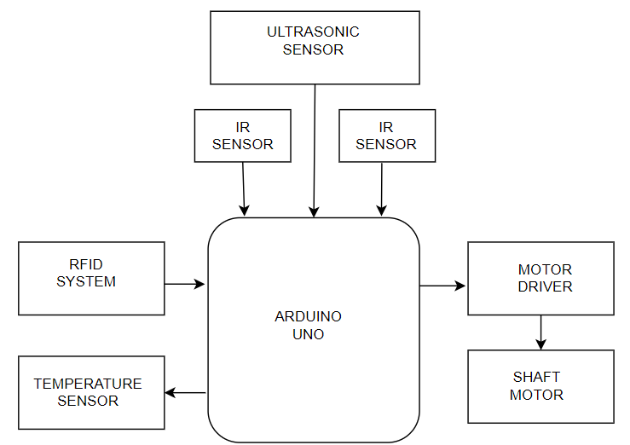
- Block Diagram of the Proposed System

System Architecture
The proposed system architecture consists of the following major components: Microcontroller, ultrasonic sensor for obstacle detection, Motor driver module, DC motor drive for locomotion, Wireless communication module, Battery power supply, RFID reader and RFID tags for identification, Medicine storage compartment. The microcontroller acts as the central processing unit that coordinates the operation of all modules. The RFID reader identifies RFID tags placed at different hospital rooms or patient beds. Based on the detected tag information, the robot confirms the correct delivery location.

Hardware Implementation of the Proposed System
The smart drug delivery robot's hardware implementation includes many electrical components that allow for autonomous navigation and accurate medicine distribution in hospital settings. A microcontroller is at the key component of the system, which controls the sensors, motors, and communication modules. Acting as the core processing, the microcontroller controls overall robot operation. It gathers input signals from sensors and the RFID reader, processes them, and provides control signals to the motor driver for execution. An RFID reader is built into the robot to identify specific areas or patient locations. RFID tags placed at designated delivery points utilizes unique identification numbers. As the robot approaches a location, the RFID reader captures the unique ID, allowing the microcontroller to verify the location and confirm the correct delivery point.
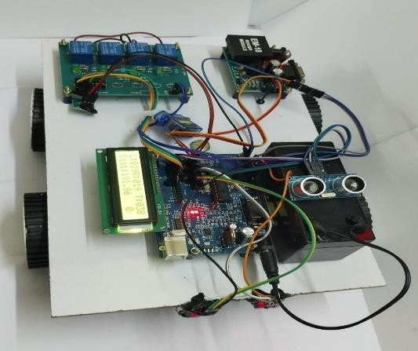
- Prototype of the proposed system
Obstacle detection and collision avoidance are achieved through ultrasonic sensors. The sensors continuously measure the robot's distance from nearby objects. The microcontroller pauses the robot and modifies its course to prevent collisions if it detects an obstruction within a predetermined threshold distance. The movement of the robot is controlled by a motor driver module connected to DC motors. The motor driver gets control signals from the microcontroller and regulates the speed and direction of the motors, enabling the robot to move forward, backward, or turn. A wireless communication module enables hospital staff to send medicine delivery requests to the robot. The system operates using battery power, which provides sufficient energy for continuous operation during hospital service. The incorporation of RFID identification, ultrasonic sensors, and wireless communication allows the robot to perform efficient and accurate drug delivery tasks within hospital premises. Throughout the task, the ultrasonic sensor gives feedback to the microcontroller continuously regarding obstacle presence and distances. Based on this feedback, the Arduino board transmits control signals to the robot's motors, directing the sequence of movements for obstacle avoidance and line following according to the programmed algorithm.
The distance between the robot and an obstacle is calculated using the ultrasonic sensor based on the time taken for sound wave reflection.
Distance Calculation for Obstacle Detection.
d = (v × t) / 2
Where
d = distance between robot and obstacle
v = speed of sound in air
t = time taken for the ultrasonic signal to return
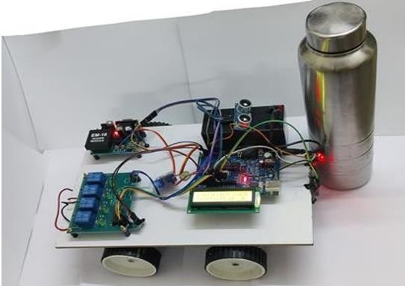
- Experimental Prototype of the RFID-Based Drug Delivery Robot

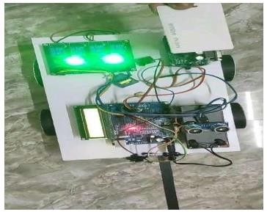
- Drug Delivery Robot Scanning RFID Tags

Table 2. Hardware Components and Functional Description of the Proposed Drug Transportation Robot System.
Component | Purpose
Microcontroller | Controls overall system
RFID Reader | Reads RFID tags
RFID Tags | Identify patient locations
Ultrasonic Sensor | Detect obstacles
Motor Driver | Controls motors
DC Motors | Robot movement
Wireless Module | Communication
Battery | Power supply

Fig. 5 illustrates the control algorithm used for the operation of the smart drug delivery robot. The system begins with initialization and receives the delivery request, after which the robot navigates toward the destination while avoiding obstacles. RFID verification is then performed to confirm the correct delivery location before dispensing the medicine and returning to the base station.
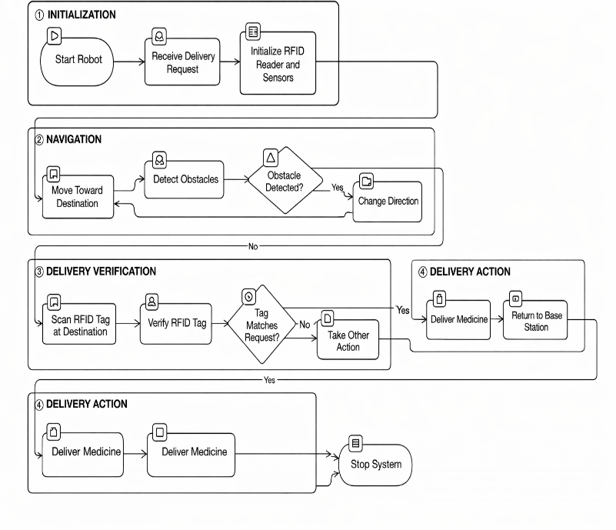
- Control Algorithm for the proposed system

Results and Discussion
To evaluate the performance of the proposed robot, several experiments were conducted in a simulated hospital environment.

- Delivery time Vs Distance
From above figure it can be observed that delivery time increases proportionally with distance.

- Battery Consumption time for drug Delivery robot.
These results demonstrate that the robot can operate efficiently for extended periods. The average obstacle detection accuracy achieved by the system is 95%. The proposed smart drug delivery robot was experimentally tested in a controlled environment that simulates a hospital corridor. The mobile medical robot was designed to autonomously navigate through the environment, point out the correct delivery location via RFID technology, and dispenses the medication efficiently while avoiding obstacles. During the experimental evaluation, several trials were conducted to analyse the navigation performance, RFID identification accuracy, and delivery efficiency of the robot. The ultrasonic sensors successfully detected obstacles placed in the robot's path, enabling the robot to change its direction and continue navigation without collision. This ensured safe movement of the robot within the testing environment.
The experimental results indicates that the system provides reliable navigation and precises verification of deliveries. The integration of RFID technology significantly minimizes the misdirected medication deliveries, while obstacle detection sensors enhance the operational safety.
The delivery time was also validated for different travel distances. As predicted, the delivery time increased with the distance between the base station and the destination location. However, the system maintained the robust performance across all test cases. The robot was able to complete the delivery process and return to the base station successfully after each task.

Conclusion
The smart robotic system provides a practical way to automate the distribution medications in clinical environment. Inorder to ensure dependable navigation and precises medicine distribution the system combines RFID based identification, ultrasonic sensor for obstacle detection.
Experimental evaluation demonstrated that the robot can successfully detect obstacles, identify the correct delivery location using RFID tags, and complete the delivery process effectively. The implementation of RFID technology improves delivery accuracy and reduces the chances of errors in medicine distribution. This system can significantly reduce the workload of healthcare staff and improve operational efficiency in hospitals. In future work, the system can be enhanced by integrating AI-based navigation and advanced sensors such as cameras or LiDAR for improved environment perception. Additionally, IoT-based monitoring and mobile application interfaces can be incorporated to enable real-time tracking and remote control of the robot.

Acknowledgment
We are grateful to our college managements for their consistent encouragement and support.

Reference
- Raikar, Amisha S., et al. "Advances and challenges in IoT-based smart drug delivery systems: a comprehensive review," Appl. Syst. Innovation, 2023.

- Kashani, M Haghi, et al. "A systematic review of IoT in healthcare: Applications, techniques, and trends," J. Netw. Computer Appl, 2021.
- Su, Shi, and Peter M Kang. "Recent advances in nanocarrier-assisted therapeutics delivery systems." Pharmaceutics, 2020.
- Awad, Atheer, et al. "Connected healthcare: Improving patient care using digital health technologies." Adv. Drug Delivery Reviews, 2021.
- Cicha, Iwona, et al. "Biosensor-integrated drug delivery systems as new materials for biomedical applications." Biomolecules, 2022.
- Yadav, D Vishnu, PY. Dinesh And ML Krian. "Autonomous Robots for Hospital Logistics and Patient Care: An Effective Way for Elderly Care and Monitoring." I-Manager's J. Augmented & Virtual Reality (JAVR) , 2024.
- S Pasupuleti , "Designing Human-Robot Interaction Interfaces For Safe And Efficient Medical Robotics," ESP International J. Advancements Sci. Technol., vol. 2, 2024, pp: 74–81.
- Cruz,Vera, Oliveira, and Correia, "Robotics applications in the hospital domain: A literature review." Appl. Syst. Innov., 2024.
- Tiwari, Meena, and Akhilesh A. Waoo, "Transforming Healthcare: The Synergistic Fusion of AI and IoT for Intelligent, Personalized Well-Being," Revolutionizing Healthcare: AI Integration with IoT for Enhanced Patient Outcomes. Cham: Springer Nature Switzerland, 2024, pp. 109-149.
- Khan ZH, Siddique A, Lee CW. Robotics Utilization for Healthcare Digitization in Global COVID-19 Management. Int J Environ Res Public Health. 2020 May 28;17(11):3819. doi: 10.3390/ijerph17113819. PMID: 32481547; PMCID: PMC7312924

