Library as a Pillar of Wisdom in the Indian Knowledge System: Evolution, Preservation, and Dissemination of Knowledge
Dr.T.Sureshkumar
Librarian, National College (Autonomous), Tiruchirappalli, TN
P.C.Grishkumar
Librarian, Vidya Academy of Science and Technology, Thrissur, Kerala
Mrs. A.Radha Jeyalakshmi
Asst. Librarian, National College (Autonomous), Tiruchirappalli, TN

Abstract
The Indian Knowledge System (IKS) represents one of the oldest, most diverse, and most profound intellectual traditions in the world. From the oral transmission of the Vedas to the establishment of ancient manuscript libraries and modern digital repositories, libraries have played a vital role in preserving, organizing, and disseminating knowledge. This research article examines the historical evolution of libraries in India, their philosophical foundation within the Indian Knowledge System, and their critical role in safeguarding religion, history, culture, and scientific traditions. The study highlights how the destruction of libraries leads to irreversible cultural loss and discusses the transformation of libraries from manuscript repositories to modern information dissemination centers. The article concludes with suggestions for strengthening libraries as cultural and knowledge preservation institutions in contemporary India.

Key Words: IKS, Indian Knowledge, Traditional Library, Digital Library, Preservation, Dissemination of Knowledge

Introduction
The concept of knowledge in India is deeply connected with spirituality, ethics, science, and social development. The Indian Knowledge System (IKS) is a comprehensive intellectual tradition encompassing philosophy, medicine, astronomy, mathematics, linguistics, literature, arts, governance, and environmental sciences. From the sacred hymns of the Rigveda to the political philosophy of the Arthashastra and the medical wisdom of the Charaka Samhita, India has preserved knowledge through structured documentation and systematic learning traditions.
Libraries have been the backbone of this preservation process. In ancient India, libraries were not merely buildings storing manuscripts; they were centers of intellectual discourse, debate, and spiritual inquiry. Institutions like Nalanda University and Takshashila University maintained extensive libraries that attracted scholars from across Asia.
The destruction of such libraries resulted in an immeasurable loss to world civilization. For example, historical records indicate that the library of Nalanda was set ablaze during invasions, leading to the destruction of thousands of manuscripts. When a nation loses its libraries, it risks losing its cultural memory, religious traditions, historical evidence, and intellectual heritage.
This research explores how libraries function as pillars of wisdom within the Indian Knowledge System and how they evolved into modern centers of information dissemination.

Objectives of the Study
The major objectives of this study are:
- To define and explain the Indian Knowledge System.
- To analyse the historical development of libraries in India.
- To examine the role of libraries in preserving religion, history, and culture.
- To evaluate the transformation of traditional libraries into modern information dissemination centers.
- To identify challenges faced by libraries in safeguarding cultural heritage.
- To provide suggestions for strengthening libraries within the framework of the Indian Knowledge System.

Indian Knowledge System (IKS): Concept and Meaning
The Indian Knowledge System refers to the cumulative intellectual traditions developed in India over thousands of years. It includes:
- Vedic Literature (Vedas, Upanishads, Brahmanas)
- Philosophical Systems (Nyaya, Vaisheshika, Sankhya, Yoga, Mimamsa, Vedanta)
- Ayurveda and Medical Sciences
- Mathematics and Astronomy (e.g., Aryabhata’s works)
- Grammar and Linguistics (Panini’s Ashtadhyayi)
- Arts, Music, Architecture, and Culture
- Governance and Economics
IKS is characterized by:
- Integration of spiritual and scientific knowledge
- Oral and written traditions
- Gurukul system of education
- Manuscript culture
- Ethical foundation of knowledge (Dharma-based approach)
Libraries became crucial institutions in recording this vast intellectual wealth.

Literature Review
Several scholars have studied the history of Indian libraries and the Indian Knowledge System:
- Ranganathan (1963) emphasized the Five Laws of Library Science, highlighting the importance of libraries as service institutions.
- S. R. Ranganathan’s work positioned libraries as living organisms evolving with society.
- Studies on Nalanda and Takshashila indicate that ancient India had well-organized manuscript collections.
- Research on palm-leaf manuscripts in South India shows systematic cataloging methods.
- Contemporary research under India's National Education Policy (NEP 2020) recognizes IKS as foundational for national development.
The review suggests that libraries have consistently functioned as knowledge preservation centers and facilitators of intellectual growth.

Statement of the Problem
Despite India’s rich intellectual heritage:
- Many ancient manuscripts remain uncatalogued.
- Several traditional libraries are deteriorating.
- There is insufficient digitization of rare texts.
- Awareness of IKS among youth is limited.
- Destruction of libraries historically resulted in cultural and religious loss.
If libraries are neglected, the continuity of Indian Knowledge Systems may be disrupted. There is a need to systematically strengthen libraries as guardians of cultural heritage.

Research Methodology

1 Research Design
This study adopts a descriptive and historical research design.

2 Sources of Data
- Primary sources: Ancient texts, inscriptions, manuscripts.
- Secondary sources: Books, journal articles, government reports.
- Digital archives and library catalogs.

3 Research Tools
- Document analysis
- Historical interpretation
- Comparative study of traditional and modern libraries

Evolution of Libraries in India

1 Oral Tradition (Shruti and Smriti Period)
In the earliest period, knowledge was transmitted orally. The Vedas were memorized and passed through generations. Though not written initially, this system functioned as a “living library.”

2 Manuscript Era
With the development of writing on palm leaves and birch bark, knowledge began to be preserved physically. Temples, monasteries, and universities stored manuscripts.
Example:
Nalanda University Library (Dharmaganja)
Nalanda University
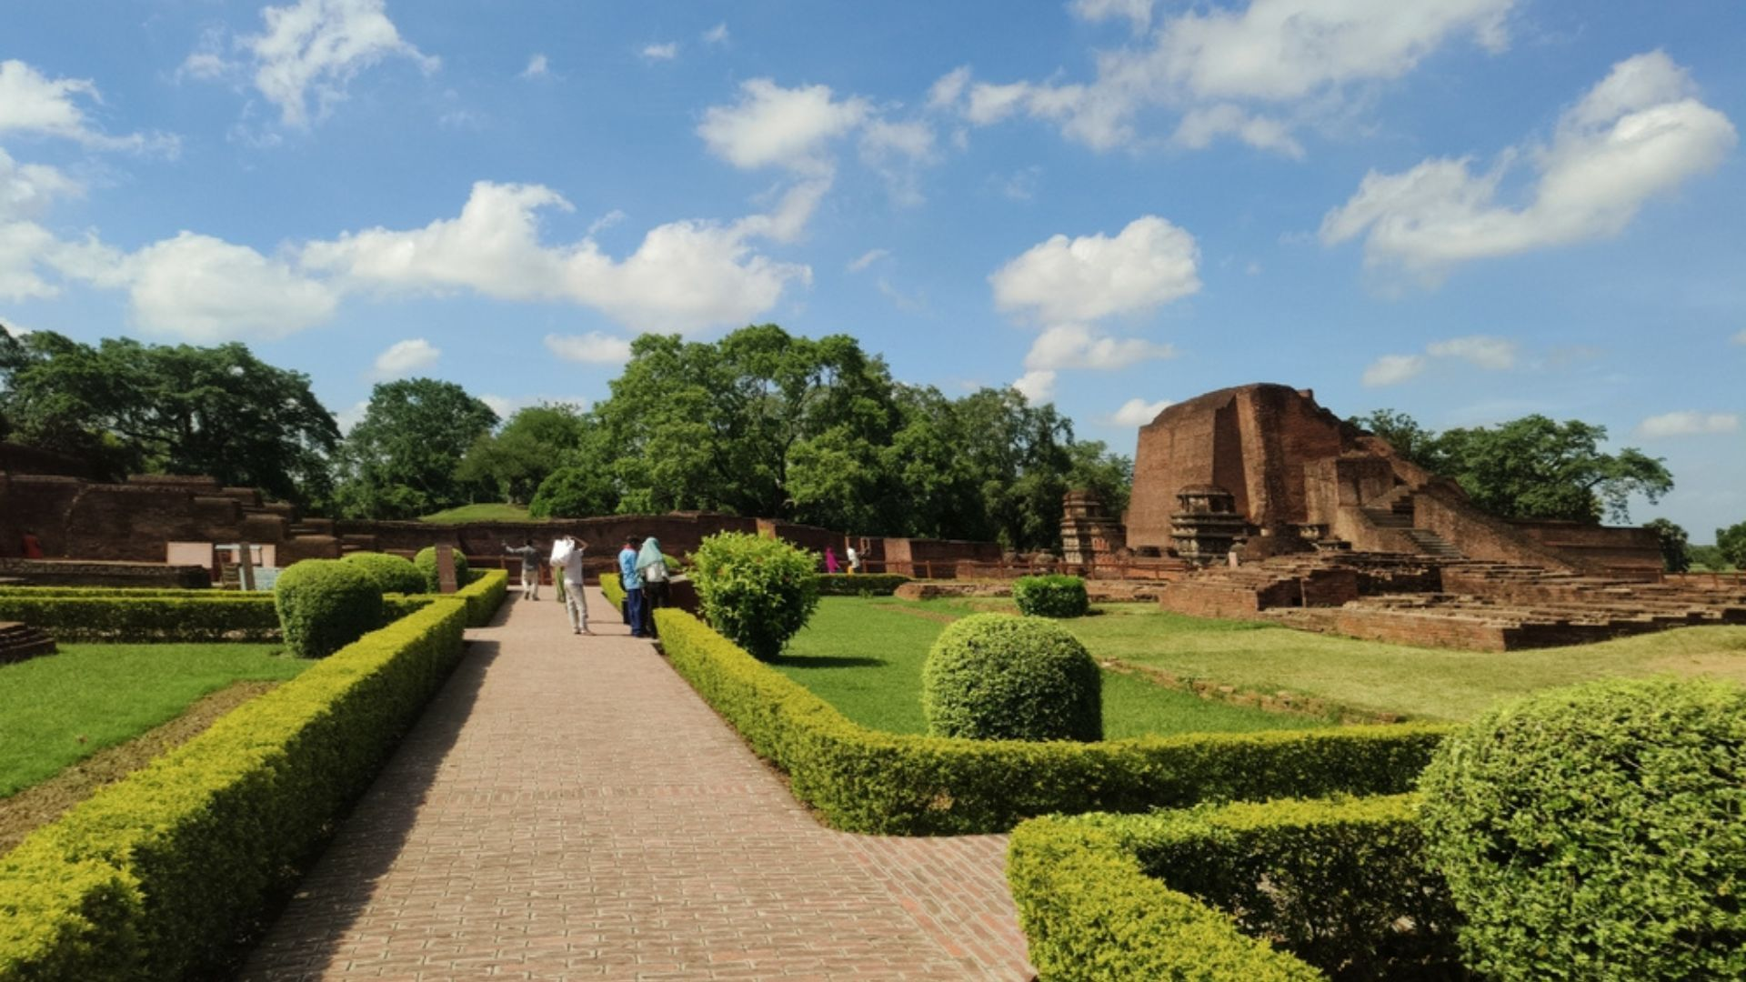
It reportedly had three large buildings storing thousands of manuscripts.

3 Medieval Period
Libraries were attached to temples and royal courts. Sanskrit, Persian, and regional language manuscripts were preserved.
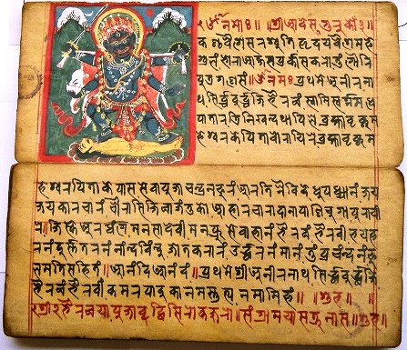

4 Colonial Period
Modern public libraries were established. Printing technology enabled mass dissemination of knowledge.
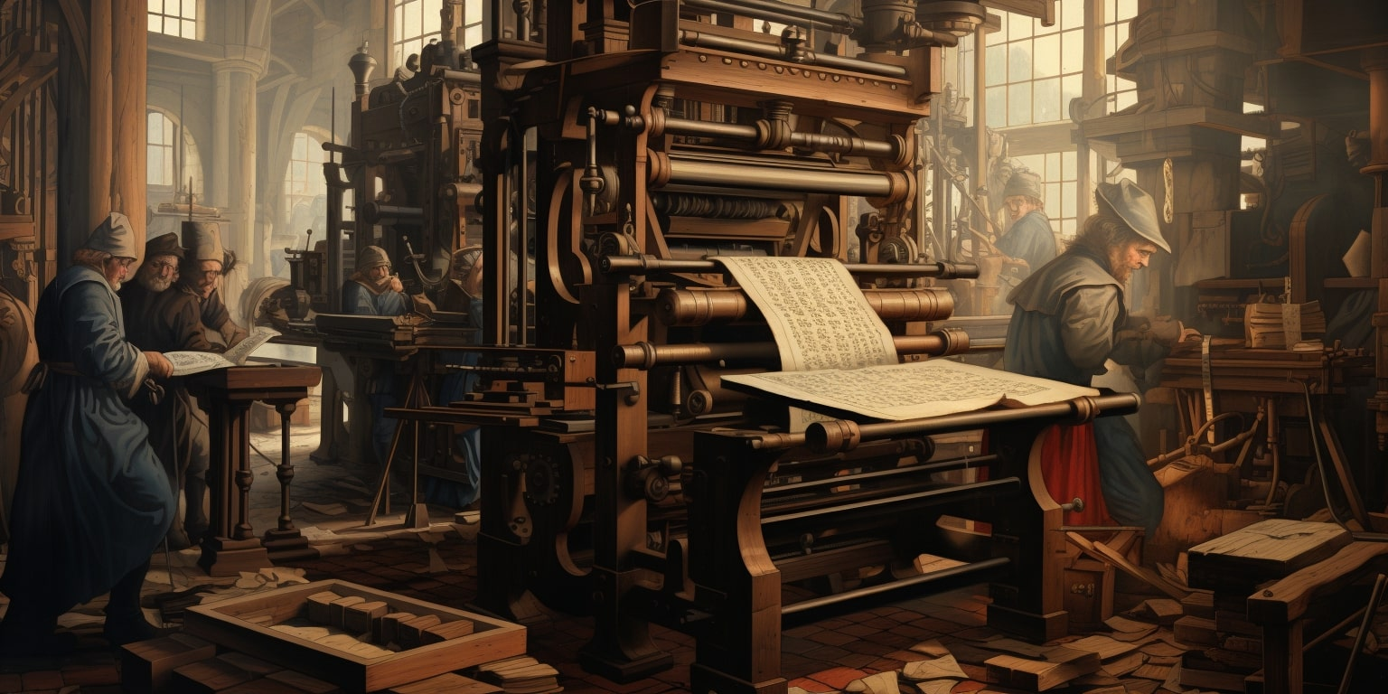

5 Post-Independence Period
National institutions like:
- National Library of India
- Raja Rammohun Roy Library Foundation
These institutions promoted public library development.

6 Digital Era
Today libraries function as:
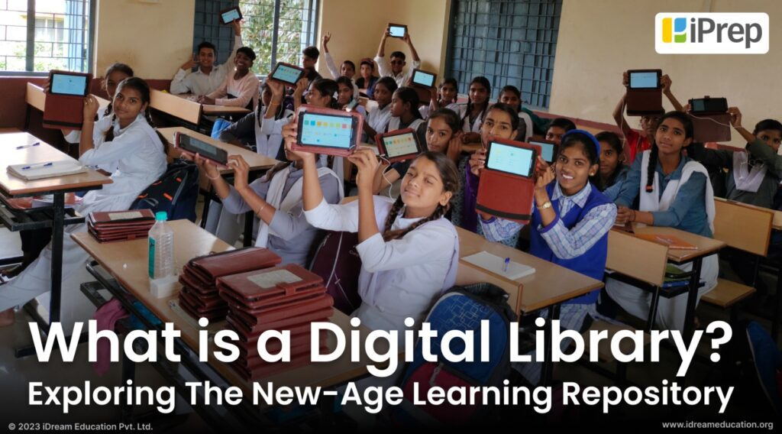
- Digital repositories
- E-learning centers
- Research databases
- Community knowledge hubs
Libraries are transforming into Information Dissemination Centers.

Role of Libraries in the Indian Knowledge System

1 Preservation of Religion
Sacred texts like the Bhagavad Gita and Upanishads are preserved in libraries. Without libraries, religious continuity may break.

2 Preservation of History
Historical records, inscriptions, and rare manuscripts provide evidence of India's past.

3 Cultural Preservation
Libraries safeguard literature, art, folklore, and classical music documentation.

4 Educational Development
Libraries support formal and informal education systems.

5 Research and Innovation
Modern research depends on archival records preserved in libraries.

Research Analysis and Findings
The analysis indicates:
- Libraries function as cultural memory institutions.
- Destruction of libraries leads to loss of identity.
- Traditional Indian libraries were highly advanced.
- Modern libraries need technological integration.
- Digitization is essential for preservation.
- Libraries enhance national integration by preserving diverse traditions.

Suggestions
- Establish IKS-focused research libraries in every state.
- Digitize ancient manuscripts.
- Introduce IKS courses in library science programs.
- Provide government funding for preservation.
- Promote community libraries in rural areas.
- Develop national digital manuscript repositories.
- Encourage interdisciplinary research.

Conclusion
Libraries are not merely buildings filled with books; they are repositories of civilization. Within the Indian Knowledge System, libraries function as guardians of wisdom, preservers of culture, and transmitters of intellectual traditions. The evolution from oral traditions to digital knowledge centers demonstrates India’s adaptive capacity.
If a nation’s libraries are destroyed, its religion, history, and culture may gradually disappear. Therefore, strengthening libraries is equivalent to strengthening national identity and intellectual heritage.Libraries must continue to evolve as information dissemination centers while preserving the philosophical and ethical foundation of the Indian Knowledge System.
REFERENCES
1. Mitra, S. (2017). Indian philosophical traditions and their relevance to modern education. Journal of Indian Philosophy, 45(2), 123–145. https://doi.org/10.1007/s10781-017-9295-9
2. NCERT. (2018). National curriculum framework for school education. National Council of Educational Research and Training. http://www.ncert.nic.in/pdf/nc-framework/ncf_2005.pdf
3. Patwardhan, B. (2005). Ayurveda and traditional knowledge: Challenges and opportunities. Current Science, 89(5), 747–752. https://www.currentscience.ac.in/Volumes/89/05/0747.pdf
4. Ranganathan, S. (2020). Integrating Indian Knowledge Systems into modern education: A holistic approach. International Journal of Educational Reform, 29(1), 56–74. https://doi.org/10.1177/1056787920908303
5. Rao, M. (2019). Yoga and mindfulness in Indian schools: Impacts on student mental health. Journal of Education and Health, 33(1), 44–53. https://doi.org/10.1177/0022057418821234
6. Roy, P. (2021). Bridging traditional knowledge and modern education: A framework for meaningful integration. Indian Journal of Educational Studies, 12(3), 210–225. https://doi.org/10.5958/2231- 1599.2021.00029.5
7. Schroth, H. (2019). Are Gen Z really that different? Refining, extending, and revisiting generational differences in work values. Journal of Career Development, 46(4), 373–386. https://doi.org/10.1177/0894845319827977
8. Dr. T. Sureshkumar, Dr. A. Abul Hussain, Mrs. A. Radha Jeyalakshmi, 2025, Enhancing Library Efficiency and user Experience through RFID and Kiosk Integration, INTERNATIONAL JOURNAL OF ENGINEERING RESEARCH & TECHNOLOGY (IJERT) Volume 14, Issue 11 , November – 2025, 10.17577/IJERTV14IS110303 DOI : https://doi.org/10.5281/zenodo.18074505
9. Seemiller, C., & Grace, M. (2016). Generation Z: A century in the making. Routledge.
10. Smith, G. H. (1999). The development of kaupapa Māori: Theory and praxis. Unpublished doctoral thesis, University of Auckland, New Zealand.
10. Turner, A. (2015). Generation Z: Technology and social interest. The Journal of Individual Psychology, 71(2), 103–113. https://doi.org/10.1353/jip.2015.0021

