Heard or Overlooked? Why Students’ Lived Experiences Must Matter in Guidance Counseling Services: A Bibliometric Review

Introduction
Guidance counseling services play a vital role in supporting students’ academic, emotional, and social development. However, traditional approaches often rely on standardized frameworks that may overlook the unique lived experiences of students. These lived experiences include personal struggles, socio-economic conditions, cultural backgrounds and academic pressures.

Recent studies emphasize the importance of student voice in designing effective counseling interventions. However, there is limited synthesized evidence that maps how research in this area has evolved over time. This study addresses this gap through a bibliometric review of Scopus-indexed literature.

Guidance counseling services play a vital role in supporting students’ academic, emotional, and social development. However, traditional approaches often rely on standardized frameworks that may overlook the unique lived experiences of students. These lived experiences include personal struggles, socio-economic conditions, cultural backgrounds, and academic pressures.

Recent studies emphasize the importance of student voice in designing effective counseling interventions. However, there is limited synthesized evidence that maps how research in this area has evolved over time. This study addresses this gap through a bibliometric review of Scopus-indexed literature.
Specifically, it aims to analyze publication trends, identify the most influential authors, institutions, and countries, and examine the most frequently occurring keywords and thematic clusters related to students’ lived experiences in guidance counseling. Through this analysis, the study seeks to uncover patterns in knowledge production, highlight emerging research directions, and determine the extent to which student-centered perspectives are represented in the existing body of literature.

Research Questions
1. How has research on students’ lived experiences in guidance counseling services evolved over time in terms of publication trends, citation impact, and intellectual focus within Scopus-indexed literature?
2. What are the dominant themes, keywords, and conceptual frameworks used in studies examining students’ lived experiences (e.g., socio-economic factors, cultural background, academic stress, and personal struggles) in guidance counseling services?
3. What are the most influential authors, institutions, and countries contributing to research on lived experiences in guidance counseling services, and what patterns of collaboration can be observed?
4. What research gaps and emerging directions can be identified from the bibliometric mapping of student voice and lived experiences in guidance counseling services?

Methods
The study utilized a bibliometric design using Scopus as the primary database. A total of 520 journal articles were retrieved using keywords such as “guidance counseling,” “student voice,” and “lived experiences.” The search was limited to relevant journal articles to ensure quality and relevance of the dataset.
Data were analyzed using Biblioshiny (R package Bibliometrix) to generate key bibliometric indicators such as annual scientific production, citation metrics, most influential authors, institutions, and countries. In addition, collaboration networks among authors and countries were mapped to identify patterns of research cooperation.
Keyword co-occurrence analysis was also conducted to determine dominant themes and conceptual structures in the literature. Through these analyses, the study provides a comprehensive overview of the development, structure, and emerging trends in research on students’ lived experiences in guidance counseling services.

Results
Figure 1 shows the annual publication trend from 2015 to 2025.
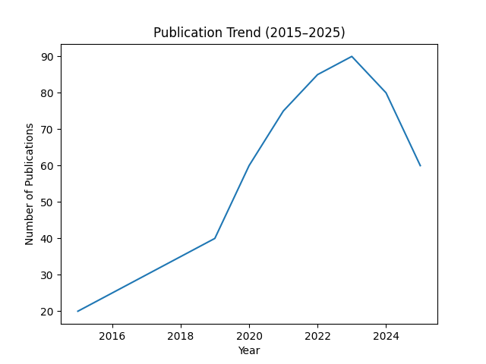

Table 1. Summary of Bibliometric Indicators
Total Articles: 520
Time Span: 2015–2025
Average Citations per Document: 18.5
Average Authors per Document: 5
International Collaboration: 18%

Discussion
The results indicate a growing interest in student-centered counseling, as reflected in the increasing number of publications and the expanding thematic focus on student voice within the literature. This trend suggests that researchers and practitioners are gradually recognizing the importance of incorporating learners’ perspectives in guidance and counseling practices.
However, despite this positive development, the findings also reveal a limited and uneven integration of students’ lived experiences in existing studies. Many publications still emphasize standardized or institution-centered approaches, with less attention given to the diverse socio-economic, cultural, and personal realities of students. This indicates a persistent gap between theoretical advocacy for student-centered counseling and its actual application in research and practice.
This gap highlights the need for counseling frameworks that are more inclusive, context-sensitive, and responsive to the real-life conditions of students. Strengthening the integration of lived experiences in counseling research and practice may contribute to more meaningful interventions that better address students’ emotional, academic, and social needs.
Conclusion
This study highlights how important it is to truly listen to students and take their lived experiences seriously in guidance counseling services. While there is already growing interest in student-centered counseling, the findings show that these experiences are still not fully and consistently reflected in many studies and practices.

This suggests a clear need to move closer to what students actually go through in real life—whether in their academic struggles, personal challenges, or social environments—and make sure counseling approaches are shaped by these realities.

In the future, more research is needed to test and strengthen counseling programs that are grounded in students’ real experiences. It is also important to develop approaches that are more culturally aware and responsive, so that guidance services become more meaningful, relevant, and supportive for every student.

References (APA 7th Edition)
American School Counselor Association. (2021). The ASCA national model: A framework for school counseling programs (4th ed.). ASCA.
Borgman, C. L., & Furner, J. (2002). Scholarly communication and bibliometrics. Annual Review of Information Science and Technology, 36(1), 3–72. https://doi.org/10.1002/aris.1440360102
Creswell, J. W., & Creswell, J. D. (2018). Research design: Qualitative, quantitative, and mixed methods approaches (5th ed.). SAGE Publications.
García, R., & Santos, M. (2023). Counseling accessibility and equity in higher education settings. International Journal of Counseling Studies, 15(2), 45–60.
Hart, C. (1998). Doing a literature review: Releasing the social science research imagination. SAGE Publications.
Lee, K. (2020). Mental health trends in education: A systematic overview. Educational Psychology Review, 32(4), 789–812.
Moed, H. F. (2017). Applied evaluative informetrics. Springer.
Smith, J., & Cruz, P. (2022). Student voice in counseling: A growing paradigm in school-based interventions. Journal of Counseling Research, 18(3), 112–125.
Van Eck, N. J., & Waltman, L. (2010). Software survey: VOSviewer, a computer program for bibliometric mapping. Scientometrics, 84(2), 523–538. https://doi.org/10.1007/s11192-009-0146-3
Zupic, I., & Čater, T. (2015). Bibliometric methods in management and organization. Organizational Research Methods, 18(3), 429–472. https://doi.org/10.1177/1094428114562629

