CapGenie: A Scalable Real-Time Caption Generation Model for Live Audio Streams

- INTRODUCTION
The rapid expansion of digital media platforms has revolutionized how information is produced, distributed, and consumed across education, entertainment, corporate communication, and social media. Video content has become one of the most dominant forms of communication due to its ability to convey information effectively through audio- visual elements. However, despite these

advancements, accessibility remains a major concern, particularly for individuals with hearing impairments who often face barriers in accessing multimedia content. Many videos still lack accurate or timely captions, resulting in limited inclusivity. The Real-Time Caption Generator project addresses this gap by providing an intelligent system that generates real-time captions from video audio, ensuring equal access to digital content for all users.

Automatic Speech Recognition (ASR) has emerged as a powerful technology for transforming spoken language into written text. Recent advancements in artificial intelligence and machine learning have significantly improved ASR accuracy, speed, and adaptability. The proposed system leverages advanced ASR models to extract audio from video content and convert it into text with minimal latency. Real-time processing ensures that captions appear almost simultaneously with spoken words, preserving contextual flow and comprehension. This feature is especially crucial in educational lectures, online courses, and informational videos where delayed captions can disrupt learning and reduce engagement.

While the primary focus of the Real-Time Caption Generator is to assist individuals with hearing impairments, its benefits extend to a broader audience. Captions improve comprehension for non-native language speakers, individuals in noisy environments, and users who prefer text-based reinforcement while consuming video content. Educators, broadcasters, and content creators can use the system to enhance the reach and inclusivity of their content, thereby increasing engagement and retention. Additionally, captioned content aligns with accessibility standards and legal requirements, making it essential for institutions and organizations seeking to provide inclusive digital experiences. The system features a modern and responsive React-based user interface designed to deliver a seamless
user experience across multiple devices and platforms. Users are provided with customizable caption display options, including font size, color, contrast, and positioning, allowing personalization based on individual preferences and visual needs. Initially, the system supports pre-recorded video content, enabling real-time caption generation during playback while minimizing latency. The inclusion of domain-specific vocabulary support for specialized fields such as healthcare and law further enhances transcription accuracy, making the system suitable for professional and academic applications.
Future enhancements aim to broaden the system’s scope and capabilities significantly. Planned developments include multilingual caption support to serve a global audience and integration with live streaming platforms to generate real-time captions for live events, webinars, and broadcasts. Additional improvements will focus on enhancing noise robustness, refining speech recognition accuracy in diverse environments, and incorporating AI-driven language processing techniques for contextual understanding. Through continuous development, the Real-Time Caption Generator aspires to provide a scalable, inclusive, and intelligent solution that advances accessibility in multimedia communication.

- PROPOSED METHODOLOGY

The methodology adopted for the Real-Time Caption Generator follows a structured and user-centric approach that emphasizes practical implementation, system efficiency, and real-time performance. The development process begins with a thorough analysis of user requirements collected through interactions with individuals with hearing impairments, educators, and content creators. These interactions help identify critical functional requirements such as real-time caption generation, low latency, customization of captions, and support for diverse content types. In addition, non-functional requirements including system scalability, reliability, security, and responsiveness are carefully documented. This requirement analysis ensures that the system is aligned with real-world usage scenarios and accessibility standards. By clearly

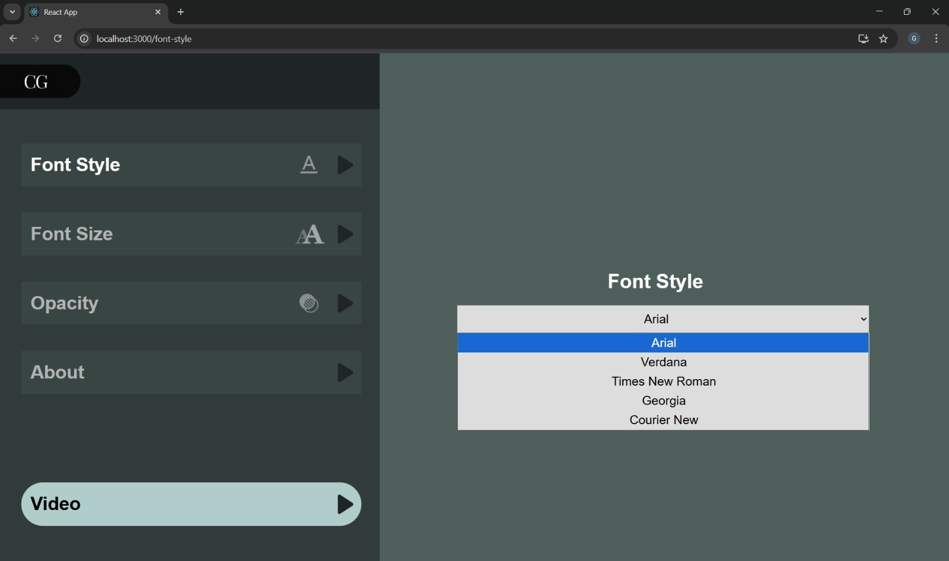
Fig 1. Introduction to CapGenie

defining expectations at an early stage, the methodology establishes a strong foundation for architectural decisions and technical implementation. This phase ensures that the system does not merely function correctly but also delivers a meaningful and usable experience to its intended audience. The outcome of this stage serves as a reference point throughout development, guiding design choices and ensuring consistency across system components.

Based on the identified requirements, a modular system architecture is designed to define the interaction between core components such as audio extraction, speech recognition, language refinement, and frontend rendering. The design phase focuses on establishing a clear and efficient data flow from video input to caption output. Architectural modeling is used to determine how backend services communicate with the frontend through secure APIs, ensuring smooth data exchange and real-time

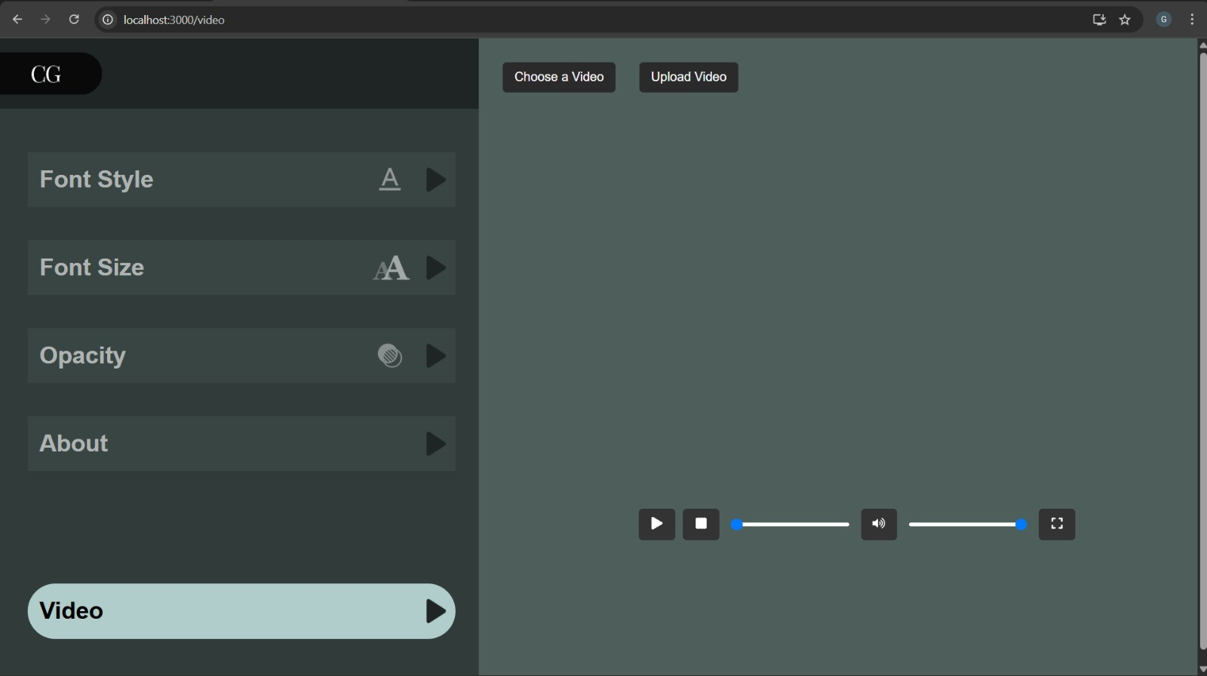
Fig 2. Upload/ Choose Video

updates. Emphasis is placed on modularity to allow individual components to be developed, tested, and improved independently. Scalability is also considered at this stage to support future extensions such as live streaming and multilingual processing. The design ensures that the system remains maintainable and adaptable as new features are introduced. By providing a comprehensive blueprint, this phase minimizes implementation errors and improves overall system coherence. The architectural design acts as a bridge between conceptual requirements and practical execution, ensuring that the system is technically sound and future-ready.
The implementation phase begins with structured input handling and audio processing, which form the backbone of the caption generation workflow. Video files are accepted as input and processed to extract the audio stream using standard media processing tools such as FFmpeg. The extracted audio is segmented into small, continuous frames to enable streaming-based processing rather than batch transcription. Each audio segment undergoes preprocessing steps including noise suppression, normalization, silence trimming, and conversion to a mono-channel format with a 16 kHz sampling rate. These steps ensure uniform audio quality and significantly reduce transcription errors caused
by background noise, overlapping speech, or inconsistent recording conditions. The preprocessed audio is then streamed to the Automatic Speech Recognition engine, which operates in real-time mode. This streaming-based approach ensures minimal delay between speech input and caption output. The methodology prioritizes stability and consistency in audio handling, making the system suitable for real-time and near–real-time captioning applications.
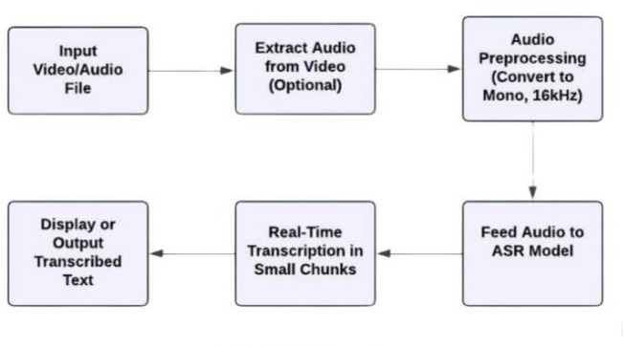
Fig 3. Flowchart

After speech recognition, the raw transcription output is processed through a language refinement pipeline to enhance readability and contextual accuracy. This stage focuses on converting unstructured speech-to-text output into clear and usable captions. The pipeline applies punctuation restoration, sentence boundary detection, and basic grammatical structuring to improve readability. To address accuracy challenges in professional environments, the system integrates domain-specific vocabulary modules using contextual biasing and custom dictionaries. This allows the ASR system to correctly interpret technical terminology used in fields such as education, healthcare, law, and technology. In addition, the methodology supports optional multilingual processing, enabling captions to be translated into different languages when required. This
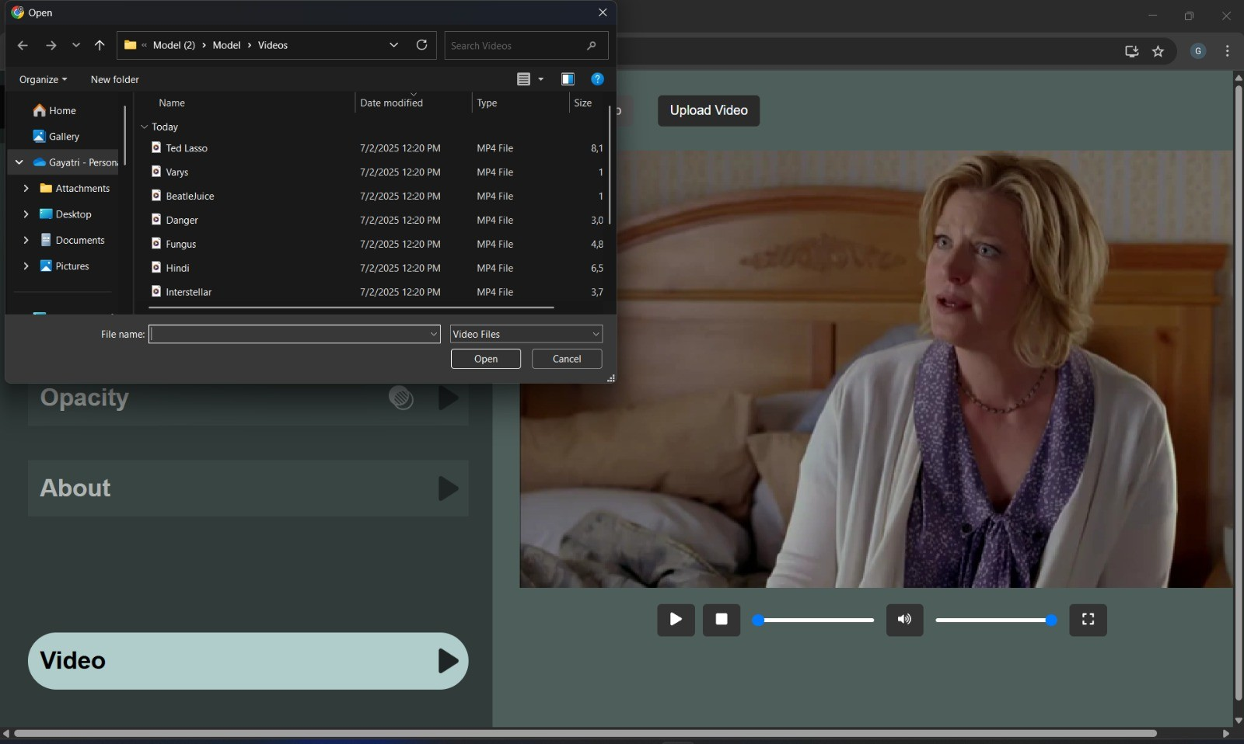
Fig 4. Video Upload

stage ensures that captions are not only accurate but also meaningful and context-aware. By refining raw transcripts before display, the system improves user comprehension

and reduces cognitive load. The refined output is then prepared for seamless integration with the frontend interface.
The final phase of the methodology focuses on frontend rendering, deployment, scalability, and long-term system reliability. A React-based frontend is developed to display captions in real time while maintaining synchronization with video playback. Caption data is received from the backend through secure API endpoints and rendered efficiently to prevent lag or flickering during continuous updates. Users are provided with customization options such as font size, color, background opacity, and caption positioning to enhance readability and user comfort. The system is deployed using an API-driven and cloud-compatible architecture to support scalability, high availability, and concurrent users. Initial validation is performed using pre-recorded video content to evaluate transcription accuracy, latency, and synchronization. Performance metrics collected during this phase are used to optimize system components. Ongoing testing, monitoring, and maintenance ensure system stability, while future enhancements focus on live streaming integration, noise robustness, and adaptive AI-based learning.

- RESULTS

The developed Real-Time Caption Generator was evaluated using pre-recorded video content to assess its overall functionality, accuracy, and system performance. Multiple video files with varying audio quality and speech patterns were used to test the robustness of the system. The system successfully processed uploaded video files, extracted the corresponding audio streams, and generated captions in real time. Captions were displayed in proper synchronization with video playback, demonstrating effective coordination between backend processing components and frontend rendering. These results confirm that the core workflow of audio extraction, speech recognition, and caption display operates as intended.
The system demonstrated strong transcription accuracy across different test scenarios. Generated captions closely matched the spoken content in the videos, indicating reliable speech-to-text conversion. The use of domain-
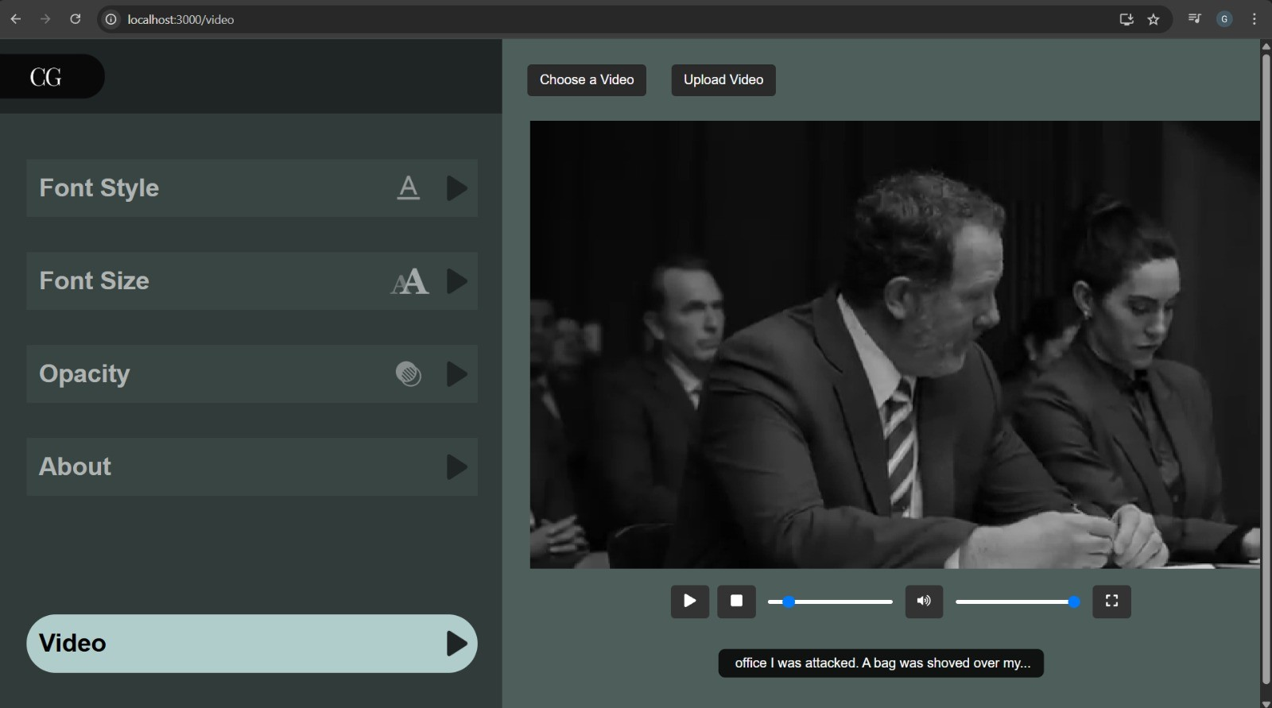
Fig 5. Real time Captions

specific vocabulary significantly improved recognition of technical and subject-specific terms commonly used in educational, professional, and technical content. This reduced common transcription errors and improved the overall quality of captions. The language refinement
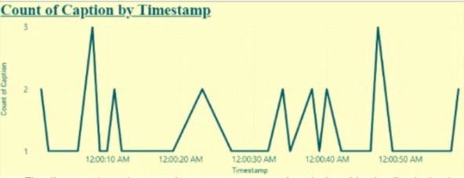
Fig 6. Timestamp

pipeline further enhanced readability by applying punctuation restoration and sentence structuring, making the captions easier to follow and understand.
Latency and timing performance were key evaluation parameters for the system. Testing showed that the Real-Time Caption Generator achieved near real-time captioning

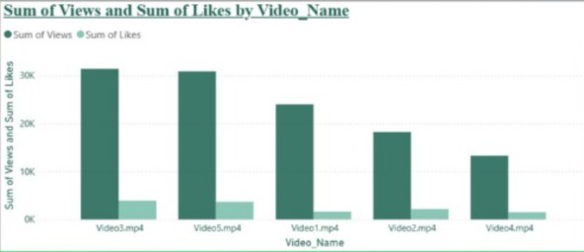
Fig 7. Sum of Views

with minimal delay between spoken words and displayed text. Captions updated continuously without noticeable interruptions, buffering, or lag. This smooth caption flow is particularly important for maintaining user engagement and comprehension, especially in learning and informational contexts where timing and clarity are critical.
The frontend interface developed using React performed efficiently during testing. The interface remained responsive throughout video playback and caption generation, even during continuous updates. Users were able to customize caption appearance through adjustable font size, text color,

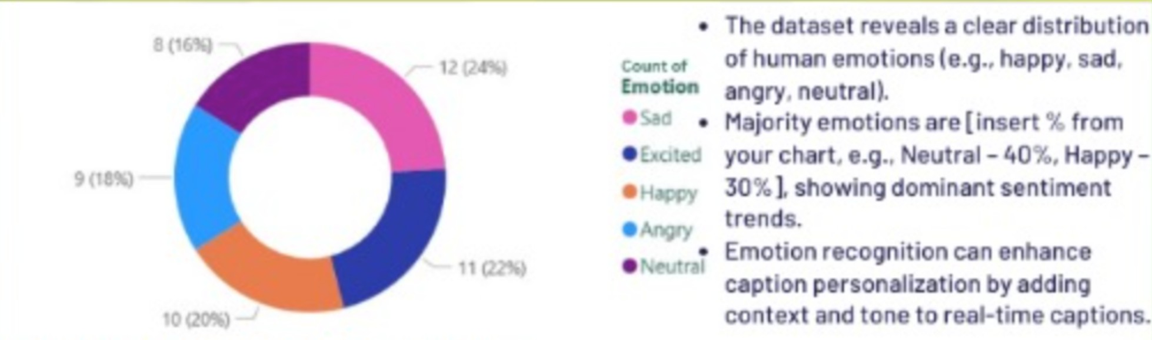
Fig 8. Piechart

background contrast, and positioning without affecting caption synchronization or system performance. These features contributed to improved usability and accessibility, allowing users to personalize their viewing experience according to individual preferences and visual needs.

System stability was evaluated by conducting multiple test runs and handling repeated video uploads. The backend services remained stable under these test conditions, successfully managing concurrent processing tasks without crashes or performance degradation. Secure file handling and resource management techniques ensured smooth operation and data integrity throughout testing. This stability indicates that the system is capable of supporting real-world usage scenarios with consistent performance.

Overall, the evaluation results demonstrate that the Real-Time Caption Generator is a reliable and effective solution for real-time captioning of video content. The system successfully meets its design objectives in terms of accuracy, latency, usability, and stability. These results validate the feasibility of extending the platform to support live streaming, multilingual captions, and further AI-driven enhancements in future developments.

- CONCLUSION

This paper presented the design and implementation of a Real-Time Caption Generator aimed at improving multimedia accessibility through accurate and low-latency captioning. By integrating efficient audio processing techniques with advanced Automatic Speech Recognition models, the system successfully generates real-time captions synchronized with video playback. The proposed solution demonstrates reliable performance in terms of transcription accuracy, responsiveness, and system stability when evaluated using pre-recorded video content.

The implementation highlights the effectiveness of a modular architecture that combines backend processing with a responsive React-based frontend. Customizable caption display options enhance usability and accessibility, allowing users to tailor the interface according to their preferences. The integration of domain-specific vocabulary further improves transcription quality in educational and professional contexts, making the system suitable for a wide range of applications.

Overall, the Real-Time Caption Generator provides a scalable and practical solution for enhancing digital content accessibility. The results confirm the feasibility of extending the system to support live streaming, multilingual captions, and improved noise robustness. With further enhancements, the system has the potential to significantly contribute to inclusive communication and accessible media technologies.
IV. REFERENCES

- Kandasamy, K., et al. “Towards a Multilingual Speech Recognition System: Challenges and Future Directions.” IEEE Transactions on Audio, Speech, and Language Processing, vol. 28, 2020, pp. 1147-1158.

- Jia, Yuxuan, et al. “Transfer Learning for Speech Recognition with Deep Learning.” Proceedings of the 2019 International Conference on Speech and Computer, 2019,
pp. 17-24.

- Baker, Janet, et al. “Automatic Speech Recognition: The Future of Captioning.” Journal of Accessibility and Design for All, vol. 8, no. 1, 2018, pp. 23-38.

- Zhang, Yang, et al. “End-to-End Speech Recognition with Transformer.” IEEE Access, vol. 9, 2021, pp. 53409-53420.

- González, José, et al. “A Review of Automatic Speech Recognition Systems for the Hearing Impaired.” Journal of Ambient Intelligence and Humanized Computing, vol. 10, 2019, pp. 6782.

- Pascual, Santiago, et al. “SEGAN: Speech Enhancement Generative Adversarial Network.”

- Proceedings of the 2017 International Conference on Acoustics, Speech and Signal Processing, 2017, pp. 164-168.

- Hinton, Geoffrey, et al. “Deep Neural Networks for Acoustic Modeling in Speech Recognition: The Shared Views of Four Research Groups.” IEEE Signal Processing Magazine, vol. 29, no.

- 6, 2012, pp. 82-97.

- Chen, Yan, and Matthew J. McCaffrey. "Real-Time Automatic Speech Recognition for Live Events: Challenges and Solutions." Proceedings of the IEEE International Conference on Acoustics, Speech, and Signal Processing, 2020, pp. 1857-1861.

- G. J. O. M. P. Silva, Rafael, and J. N. C. A. A. L. de Almeida, Thiago. “Real-Time Speech Recognition for Interactive Learning Environments.” Journal of Educational Technology & Society, vol. 22, no. 3, 2019, pp. 69-81.

- Rizwan Sheikh, Amravati, Swapnil Suryawanshi, Shivam Gupta. “An Approach Towards Generating Subtitles Automatically from Videos by Extracting Audio.”

- Rabiner, Lawrence R., and Biing-Hwang Juang. Fundamentals of Speech Recognition. Prentice Hall, 1993.
- Jurafsky, Daniel, and James H. Martin. Speech and Language Processing: An Introduction to Natural Language Processing, Computational Linguistics, and Speech Recognition. Pearson, 2021.

- Huang, X., et al. Spoken Language Processing: A Guide to Theory, Algorithms, and Applications. Prentice Hall, 2001.

- Kuo, C.-C. Jay, and Wu, Y. Speech Recognition and Understanding: A Review of the Current State and Future Directions. Wiley, 2017.

- Campbell, John P., and R. K. S. Paul. Speech Processing and Synthesis Using MATLAB. Wiley, 2010.

- Radford, A., et al. “Robust Speech Recognition via Large-Scale Weak Supervision.” Proceedings of the International Conference on Machine Learning (ICML), 2023, pp. 28492–28518.
- Baevski, A., Zhou, H., Mohamed, A., and Auli, M. “wav2vec 2.0: A Framework for Self-Supervised Learning of Speech Representations.” Advances in Neural Information Processing Systems (NeurIPS), vol. 33, 2020, pp. 12449–12460.
- Vaswani, A., et al. “Attention Is All You Need.” Proceedings of the 31st International Conference on Neural Information Processing Systems, 2017, pp. 5998–6008.
- Hannun, A., et al. “Deep Speech: Scaling Up End-to-End Speech Recognition.” arXiv preprint arXiv:1412.5567, 2014.
- Graves, A., Fernández, S., Gomez, F., and Schmidhuber, J. “Connectionist Temporal Classification: Labelling Unsegmented Sequence Data with Recurrent Neural Networks.” Proceedings of the 23rd International Conference on Machine Learning, 2006, pp. 369–376.
- Povey, D., et al. “The Kaldi Speech Recognition Toolkit.” IEEE 2011 Workshop on Automatic Speech Recognition and Understanding, 2011.
- Lasecki, W. S., et al. “Real-Time Captioning by Groups of Non-Experts.” Proceedings of the 27th Annual ACM Symposium on User Interface Software and Technology, 2014, pp. 23–34.
- World Wide Web Consortium (W3C). “Web Content Accessibility Guidelines (WCAG) 2.1.” W3C Recommendation, 2018.
- Mozilla Foundation. “DeepSpeech: An Open-Source Speech-to-Text Engine.” Mozilla Research, 2019.
- Koenecke, A., et al. “Racial Disparities in Automated Speech Recognition.” Proceedings of the National Academy of Sciences (PNAS), vol. 117, no. 14, 2020, pp. 7684–7689.
- Google Research. “Streaming Automatic Speech Recognition Models for Real-Time Applications.” Proceedings of the IEEE International Conference on Acoustics, Speech and Signal Processing (ICASSP), 2021, pp. 5889–5893.

