Unlocking the Potential for Microplastic Degradation: In Silico Mutagenesis and Molecular Dynamics Simulations of PET-PETase and MHET-MHETase Interactions by Reverse Screening

Mia Joy Inocencio, MS, CRS
Department of Biological Sciences, University of Southern Mindanao, Cotabato, Philippines

ABSTRACT

Plastic pollution remains a growing global concern, requiring efficient and sustainable solutions. Enzymes such as PETase and MHETase from Ideonella sakaiensis offer natural mechanisms for plastic degradation but need further enhancement for large-scale applications. This study aimed to improve the structural stability and substrate-binding performance of PETase and MHETase by engineering their homologous variants through in silico methods. Homologous proteins were identified via multiple sequence alignment, and functionally relevant residues near the active site were selected for site-saturation mutagenesis. The resulting variants were evaluated through molecular docking to assess binding energy and interaction profiles, while molecular dynamics (MD) simulations examined their behavior over time using RMSD, and RMSF. Among the MHETase variants, GLY103ALA (–9.5 ± 0.2 kcal/mol), PRO44PHE (–8.4 ± 0.1 kcal/mol), and GLY165HIS (–8.2 ± 0.1 kcal/mol) showed significantly enhanced ligand-binding affinity compared to wild type (–6.3 ± 0.1 kcal/mol). These variants also showed improved dynamic stability, as indicated by reduced ligand RMSD values (GLY103ALA: 0.22 ± 0.01 nm; PRO44PHE: 0.24 ± 0.01 nm; GLY165HIS: 0.25 ± 0.01 nm) compared to the wild type (0.36 ± 0.02 nm), along with stable backbone RMSF values (~0.10 ± 0.01 nm) relative to the wild type (0.18 ± 0.02 nm). For PETase, the GLY35GLN variant demonstrated the most favorable performance, with a lower binding energy (–6.0 ± 0.1 kcal/mol) compared to the wild type (–5.2 ± 0.1 kcal/mol). It also exhibited the lowest ligand RMSD (0.28 ± 0.02 nm) compared to wild type (0.41 ± 0.03 nm), and showed reduced structural fluctuation in RMSF (0.20 ± 0.01 nm) relative to wild type (0.26 ± 0.02 nm), indicating enhanced dynamic stability. These results suggest that even minor mutations can significantly improve enzymatic efficiency in microplastic (MP) degradation. Overall, the results show that in silico mutagenesis and simulation can help find enzyme variants with better binding and stability, making them good candidates for future lab testing and possible use in breaking down microplastic waste.

Keywords: active site mutations, protein engineering, computational docking, microplastic biodegradation, and protein-ligand interaction

INTRODUCTION

Plastic pollution, particularly microplastics (MPs), presents a pressing environmental and societal challenge. These microscopic particles, predominantly derived from the breakdown of larger plastic waste (Raza et al., 2022) such as polyethylene terephthalate (PET), are now found across ecosystems, from remote marine environments to urban drinking water systems (Jambeck et al., 2015). The persistence and bioaccumulation of MPs pose risks to aquatic organisms, food safety, and potentially human health. Addressing this issue is aligned with global priorities outlined in the United Nations Sustainable Development Goals (SDGs), especially SDG 12 (Responsible Consumption and Production), SDG 14 (Life Below Water), and SDG 15 (Life on Land).
Naturally occurring enzymes like PETase and MHETase from Ideonella sakaiensis have demonstrated promising potential for PET and MHET degradation (Danso et al., 2018). Despite these advances, many studies still focus primarily on wild-type enzymes and their specific interactions with ligands, often overlooking how adaptable or efficient these enzymes are under varying conditions. This leaves a gap in understanding homologous enzymes from diverse microorganisms and how their molecular interactions, binding affinities, and mutational potential can be improved for more effective MP degradation. This study explores the use of in silico mutagenesis and molecular dynamics simulations to enhance these enzymes’ performance by predicting mutation sites and analyzing molecular interactions. By improving substrate binding and structural stability, this research contributes a feasible and sustainable pathway toward biological plastic degradation. The broader implication is the promotion of biotechnological innovations capable of reducing plastic waste at a molecular level, aligning with ecological conservation efforts. These insights are intended to inform future experimental validation and contribute to the development of more effective strategies to address microplastic pollution that could yield wide-ranging benefits for scientists, researchers, environmental organizations, advocacy groups, the biotechnology sector, local communities, and ecosystems.

METHODOLOGY

Research Design

The research adopted a computational approach using in silico experimental quantitative research design grounded in structural bioinformatics and molecular modeling. The study used computer simulations to design improved versions of the PETase and MHETase enzymes in terms of structure and function. The outcomes of these computer experiments was analyzed and interpreted after the simulation of the in silico model, which usually entails custom-designed visualization of the resulting data.

Data Gathering Procedure

The workflow was divided into three phases:

Phase 1: Preparatory Phase:
The first phase focused on collecting and preparing enzyme and ligand data. The National Center for Biotechnology Information's Basic Local Alignment Search Tool (NCBI BLAST) was used to retrieve the Fast-All (FASTA) sequences of homologous MHET-degrading (6QZ2) and PET-degrading (6ANE) enzymes from various microorganisms. By using the Protein Data Bank (PDB) as the database, homologous enzyme sequences related to PETase and MHETase were identified using specific search parameters to filter sequences. For the criteria in mining the homologous proteins, the source organisms should be known and the sequence identity should be 30% minimum.

To prepare for the simulation phase, the researcher identified specific amino acid residues from the homologous protein sequences with the use of ConSurfdb. The homologous protein structure was first uploaded to ConSurfdb or enter the PDB ID of homologous protein, which produced a color-coded representation indicating the conservation level of each residue, with the most conserved residues labeled as “f” (functional) and downloaded the conservation map (*.pdf). The file was then downloaded in PyMOL format.

Phase 2: Simulation Phase:
The second phase involved the simulation of the wild-type and mutant enzymes. The initial step involved in acquiring the crystal structures of homologous enzymes of MHETase and PETase, as conducted in Phase 1, from the RCSB Protein Data Bank (PDB). The structures were downloaded and any non-essential components, such as water molecules, were removed, and polar hydrogen atoms were added using UCSF Chimera to create optimized proteins and prepare the models for site-saturation mutagenesis (SSM).
To evaluate the structural similarities between the wild-type protein and optimized protein, UCSF Chimera was used for structural alignment and comparison. Structural similarity below the threshold of SDM were selected (≤ –1.0 kcal/mol) to proceed with mutation All optimized enzyme variants were organized into a library. After optimizing, using PyMOL, residues marked as “f” in the ConSurf-generated conservation map were selected as mutation site. The target residues were substituted with other amino acids. This process applied the SSM by replacing one original amino acid at the chosen site with various other amino acids. Each mutated version was saved.

Once the mutations and optimizations were established, the researcher performed a series of molecular docking simulations using CB-Dock 2 to evaluate the binding affinity of each mutated protein toward its respective ligand substrate. The docking scores, expressed in kcal/mol, reflect the predicted binding energy: scores ranging from –5 to –10 kcal/mol suggest moderate to strong binding, while scores below –10 kcal/mol indicate high binding affinity. All findings, including binding poses, energies, and visualizations, were comprehensively documented. Interaction types such as hydrogen bonding and hydrophobic contacts were analyzed using Protein-Ligand Interaction Profiler (PLIP). For dynamic evaluation, molecular dynamics (MD) simulations were run using GROMACS, with topology files prepared through UCSF Chimera, SwissParam, and VS Code. This provided a time-resolved view of each variant’s structural flexibility, including RMSD, RMSF, and potential energy profiles.

Phase 3: Post-Simulation Phase:
The final phase focused on detailed analysis and comparison. Protein-ligand interactions were examined using PLIP and visualized in PyMOL. Simulation results were analyzed in GRACE and UCSF Chimera to visualize trends in molecular movement and stability. Wild-type enzymes were compared with variants in terms of binding strength and dynamic behavior. This helped identify top candidates with improved performance suitable for further experimental testing.

Data Analysis

In this part of in silico study, different data analysis tools used to analyze and interpret the data. Table 1 provides an overview tools essential for drawing conclusions and making informed decisions based on collected data. These were the tools to be used throughout the study:

Table 1. Tools and databases for data analyses
Tool | Link | Digital Platform | Licensing Type
AutoDock Vina PyRx | https://cadd.labshare.cn/cb-dock2/index.php | Web-based tool | GNU General Public License
BLAST | https://blast.ncbi.nlm.nih.gov | Web-based tool | Public Domain
CB-Dock 2 | Utilizes AutoDock Vina | Web-based tool | Creative Commons Attribution License
Clustal Omega Web Service | http://www.clustal.org/ | Software | GNU General Public License
ConSurf | https://consurf.tau.ac.il/consurf_index.php | Web-based tool | Public Domain
GROMACS | https://gromacs.org | Software | GNU General Public License
Mol*Viewer | https://molstar.org/viewer | Web-based tool | Massachusetts Institute of Technology License
PLIP | https://plip-tool.biotec.tu-dresden.de/plip-web/plip/index | Web-based tool | Free for academic use
PubChem | pubchem.ncbi.nlm.nih.gov | Web-based tool | Creative Commons Attribution License
Protein Data Bank | https://rcsb.org | Web-based tool | Creative Commons Attribution License
PyMol | https://pymol.org | Web-based tool | Open Source License (Schrodinger)
SwissParam | http://www.swissparam.ch/ | Web-based tool | Open Source License
UCSF Chimera | https://www.cgl.ucsf.edu/chimera/ | Web-based tool | Free for non-commercial use
Visual Studio Code | https://code.visu alstudio.com | Software | Open Source License
GRACE | https://sourcefor ge.net/projects/q tgrace/ | Software | Open Source License

RESULTS AND DISCUSSION

Identified Homologous Enzymes of MHETase and PETase of I. sakaiensis

BLASTp analysis showed that the PETase and MHETase enzymes from I. sakaiensis had strong similarities with plastic-degrading enzymes from bacteria such as Thermobifida fusca, Comamonas thiooxydans, and Thermobacillus composti. These homologous enzymes shared 85–99% identity with PETase and 73–96% identity with MHETase. After aligning the sequences, several key amino acid positions near the active site were found to be highly conserved, as shown in Figure 2. These conserved sites were prioritized for mutation using site-saturation mutagenesis, with support from ConSurf analysis showing their functional relevance (McGrath and Wilson, 2006; Graf et al., 2021).
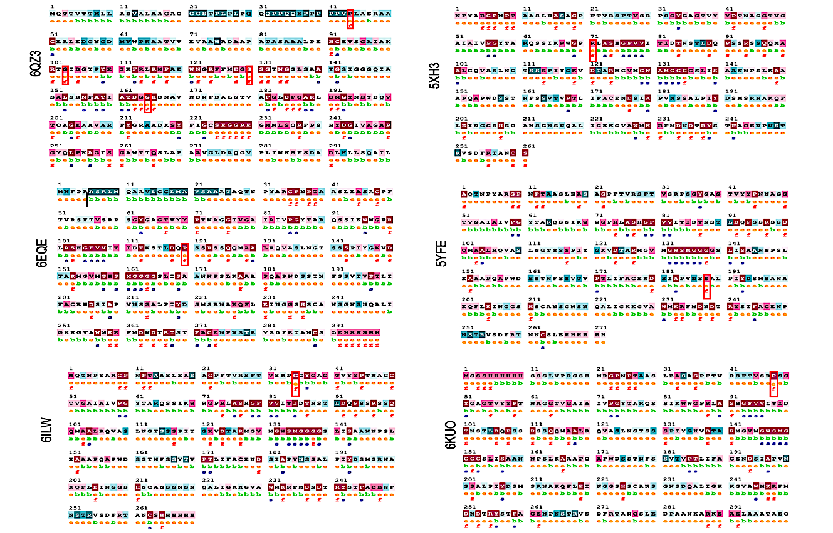

Figure 2. MSA of MHET and PET degrading enzymes and the residue sequences. The top 5 mutated residues of MHETase and PETase were highlighted in red box. Conservation colors – Low conservation (shades of blue) and high conservation (shades of red). Residue annotations are based on conservation and exposure predictions: e – exposed; b – buried; f – functional (highly conserved & exposed); s – structural (highly conserved & buried); x – insufficient data.

Engineered MHETase and PETase Variants Based on the Number and Position of Binding Mutations, and Molecular Docking
A total of 18,600 protein variants were created: 3,600 for MHETase and 15,000 for PETase. These variants were designed by changing specific amino acids one at a time to improve binding with PET or MHET. The top-performing MHETase variants (Figure 3) were GLY103ALA, PRO44PHE, and GLY165HIS. These showed stronger binding energy values of –9.5 ± 0.2, –8.4 ± 0.1, and –8.2 ± 0.1 kcal/mol, respectively, compared to the wild-type MHETase at –6.3 ± 0.1 kcal/mol. According to Graf et al. (2021), making changes close to the catalytic center can lead to better substrate recognition and improved enzyme efficiency. For PETase (Figure 4), the variant GLY35GLN had the best result with a binding energy of –6.0 ± 0.1 kcal/mol, better than the wild type which had –5.2 ± 0.1 kcal/mol.
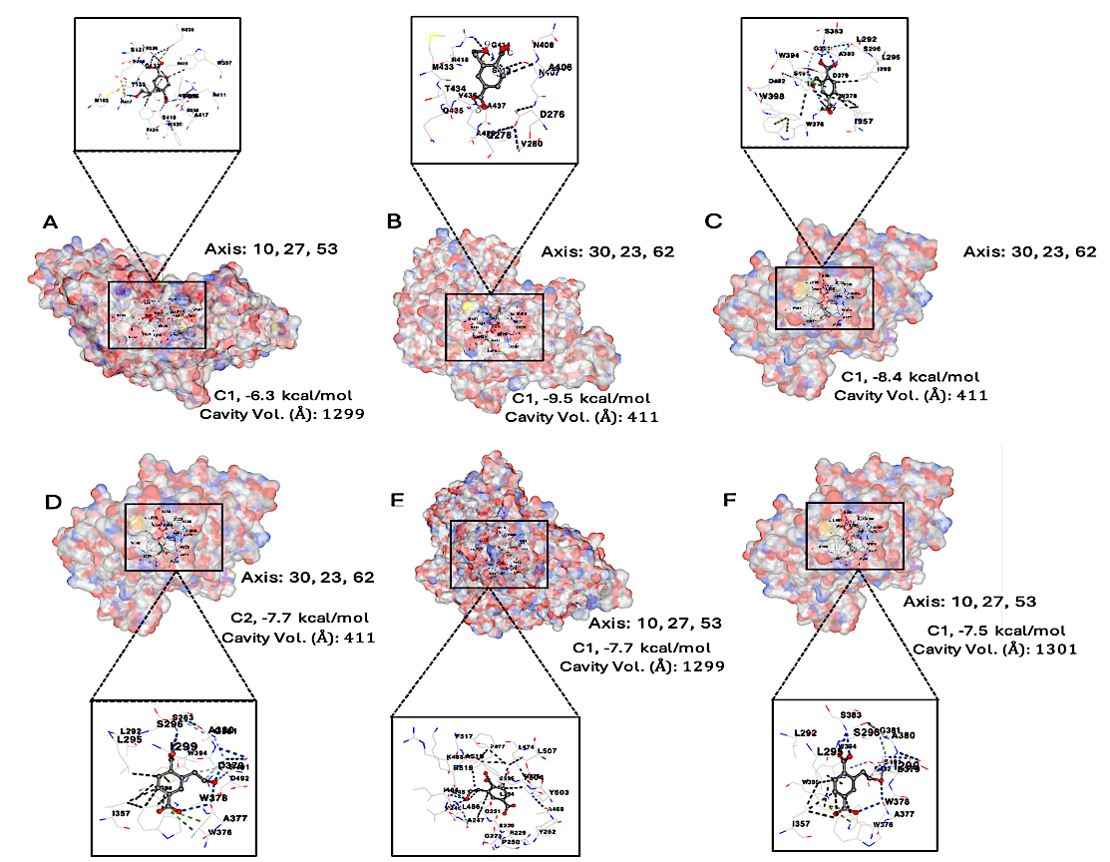
This supports earlier findings by Austin et al. (2018) and Chen et al. (2023), who noted that changes near the substrate channel help the enzyme hold onto PET more effectively. The location of the mutations helped explain why some variants performed better. In MHETase, GLY103ALA and GLY165HIS were close to the enzyme’s active center, while PRO44PHE was near a flexible loop that helped stabilize the ligand. In PETase, GLY35GLN was located near the entrance of the substrate-binding pocket, allowing better alignment with PET (Austin et al., 2018)

Figure 3. Molecular docking visualization of MHET-MHETase wild-type enzymes and engineered homologous protein-ligand binding interaction. (A) MHETase WT; (B) 6QZ3_GLY103ALA; (C) 6QZ3_PRO44PHE; (D) 6QZ3_GLY130HIS; (E) 6QZ3_GLY165HIS; and (F) 6QZ3_GLY130ALA. The electrostatic potential of the protein surface color-coded (red for negative, blue for positive, white for neutral).

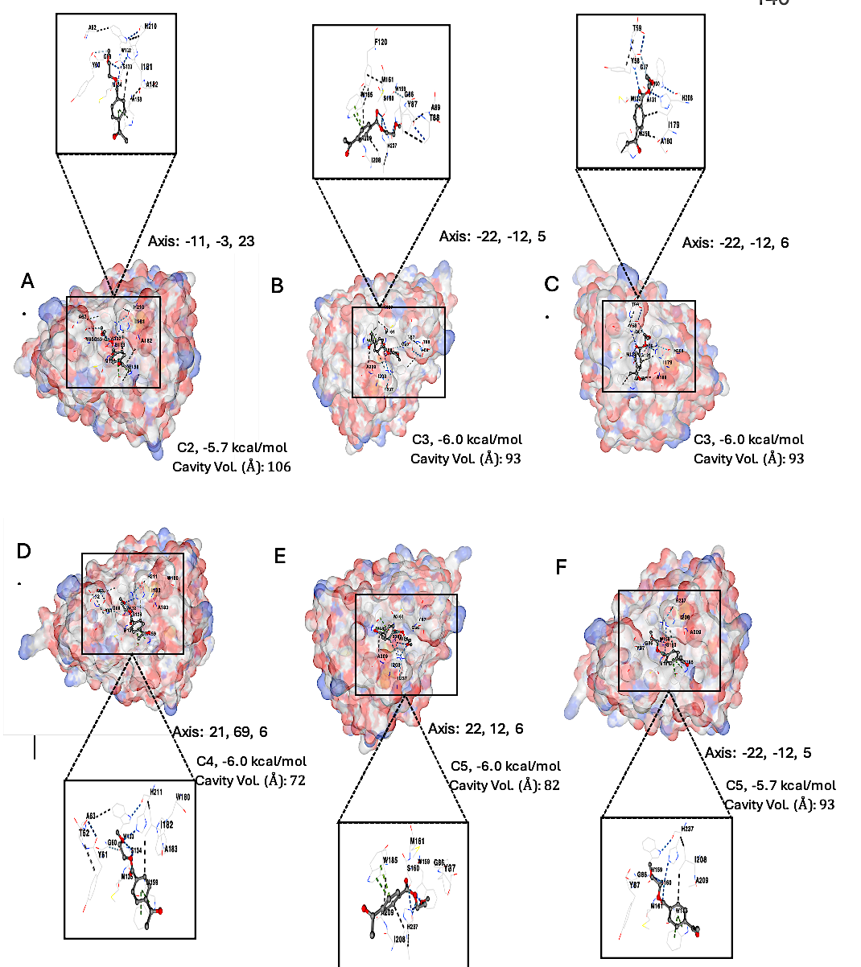
Figure 4. Molecular Docking Visualization of PET-PETase Wild-Type Enzymes and Engineered Homologous Protein-Ligand Binding Interaction. (A) PETase WT; (B) 5XH3_ARG71ASP; (C) 6EQE_PRO120PHE; (D) 5YFE_SER188TRP; (E) 6ILW_GLY35GLN; and (F) 6KUO_GLY48HIS. The electrostatic potential of the protein surface color-coded (red for negative, blue for positive, white for neutral).

Molecular Dynamics Simulations, and Binding Activity of Wild-Type and Engineered Proteins
Molecular dynamics simulations confirmed that these mutations also made the enzymes more stable. MHETase variants GLY103ALA, PRO44PHE, and GLY165HIS had lower RMSD values (Figure 5 and Table 2) between 0.22–0.25 ± 0.01 nm, compared to the wild-type MHETase at 0.36 ± 0.02 nm. Their RMSF values (Figure 6 and Table 2) were also lower (~0.10 ± 0.01 nm), while the wild type showed higher fluctuation at 0.18 ± 0.02 nm. According to Wei and Zimmermann (2017), enzymes with more stable backbones are generally better at catalyzing reactions. PETase variant GLY35GLN also showed better stability with an RMSD (Figure 7 and Table 3) of 0.28 ± 0.02 nm and an RMSF (Figure 8 and Table 3) of 0.20 ± 0.01 nm, compared to the wild-type PETase which had values of 0.41 ± 0.03 nm and 0.26 ± 0.02 nm, respectively. These results suggest that the single mutation made the enzyme more compact and stable, which likely helped it bind to PET more efficiently (Austin et al., 2018; Chen et al., 2023).

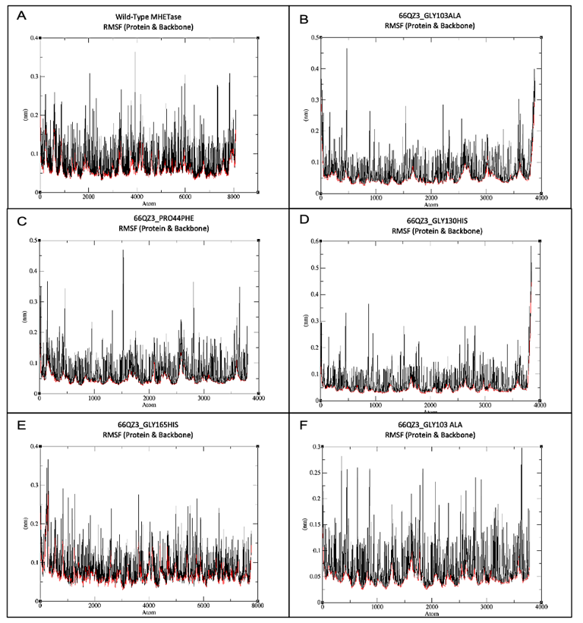
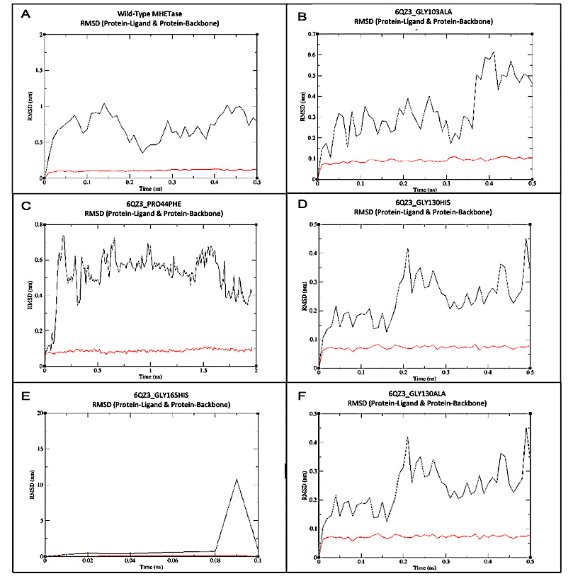
Analysis of how the enzymes interacted with their ligands showed that the mutant variants formed stronger and more consistent bonds. MHETase variant GLY103ALA and PETase variant GLY35GLN formed more hydrogen bonds and hydrophobic contacts compared to their wild-type forms. According to Chen et al. (2023), these types of interactions help enzymes hold onto their substrates more effectively, improving their function. Ligand RMSD values also supported these findings. The ligand remained more stable during simulation in MHETase variant GLY103ALA (0.22 ± 0.01 nm) and PETase variant GLY35GLN (0.28 ± 0.02 nm), compared to the wild-type enzymes, which had higher fluctuation.
Figure 5. Root-mean-square deviation (RMSD) profiles of MHETase wild-type and engineered variants showing structural stability during simulation. Ligand (black line) and Backbone (red line).

Figure 6. Root-mean-square fluctuation (RMSF) profiles of MHETase wild-type and engineered variants, illustrating residue flexibility during the simulation. Protein (black line) and Backbone (red line).

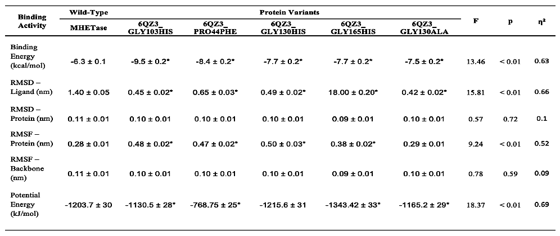
Table 2. ANOVA summary of MHETase WT and protein variants, and their binding activity.
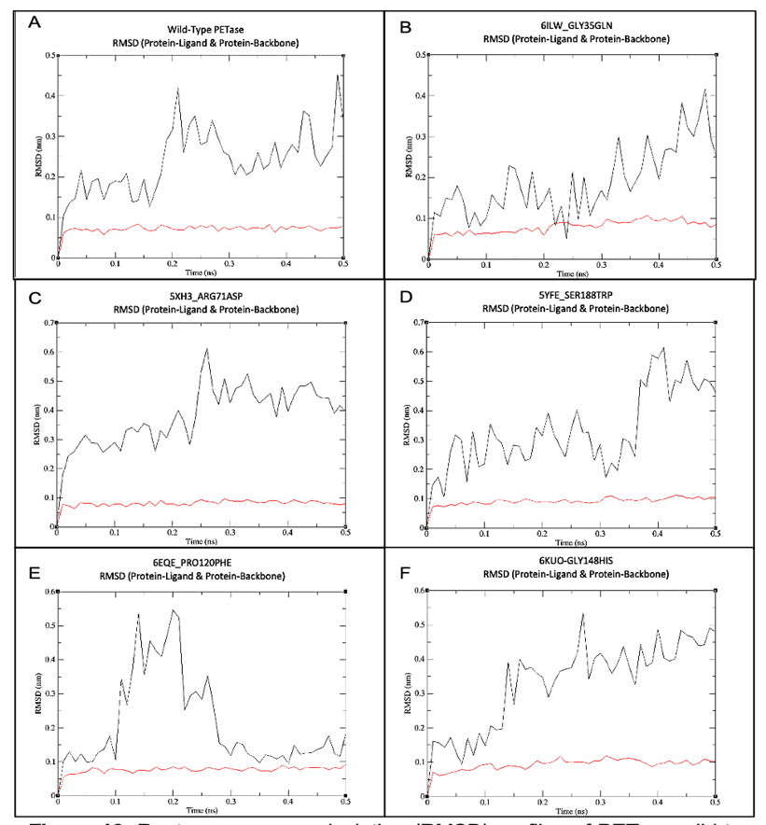
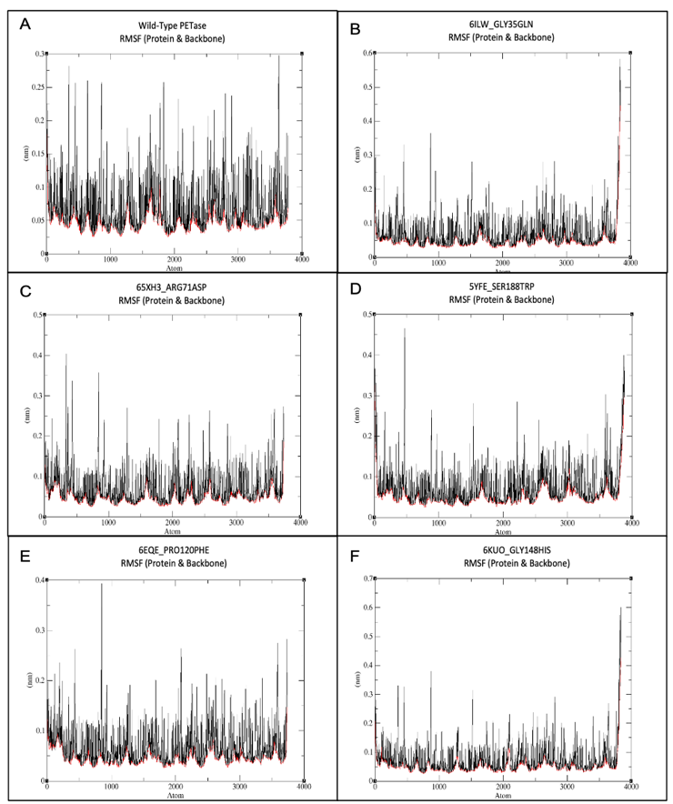
Note: *Post hoc significance (WT vs PV); p < 0.01 marked with *.
Figure 7. Root-mean-square deviation (RMSD) profiles of PETase wild-type and engineered variants showing structural stability during simulation. Ligand (black line) and Backbone (red line).

Figure 8. Root-mean-square fluctuation (RMSF) profiles of PETase wild-type and engineered variants, illustrating residue flexibility during the simulation. Protein (black line) and Backbone (red line).

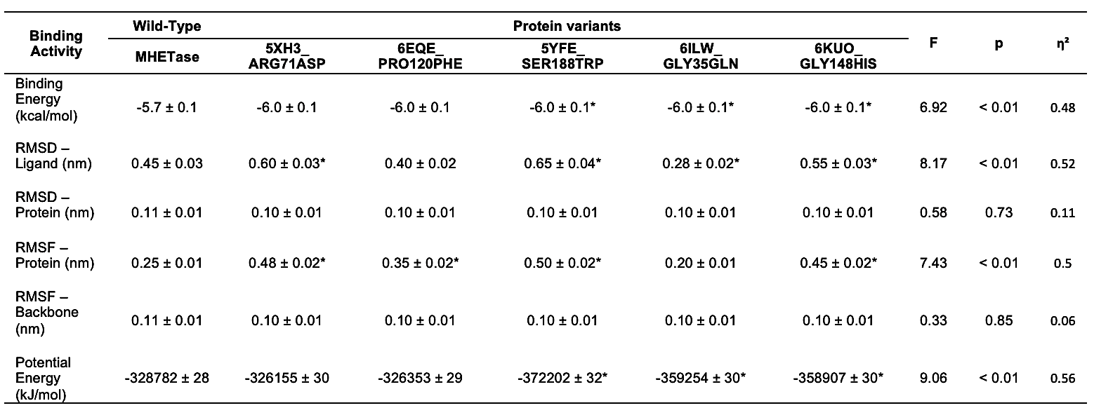
Table 3. ANOVA summary of PETase WT and protein variants, and their binding activity
Note: *Post hoc significance (WT vs PV); p < 0.01 marked with *.
CONCLUSION
This study demonstrated the use of computational protein engineering in enhancing the functional performance of homologous PETase and MHETase enzymes for potential application in plastic biodegradation. Through multiple sequence alignment, homologs of Ideonella sakaiensis PETase and MHETase were identified, with PETase showing greater phylogenetic diversity and MHETase exhibiting high conservation, especially within Piscibacter sakaiensis. Site saturation mutagenesis enabled the design of engineered variants targeting key ligand-interacting residues. Molecular docking and interaction profiling confirmed that several mutations significantly improved binding energy and ligand interactions compared to the wild-type enzymes. Molecular dynamics simulations further validated these findings by showing lower ligand RMSD values, stable protein structures, and reduced potential energy in the engineered variants. Among all tested enzymes, MHETase variants GLY103ALA, PRO44PHE, and GLY165HIS, along with PETase variant GLY35GLN, consistently exhibited the best binding performance, dynamic stability, and structural integrity. These results confirm that targeted in silico mutagenesis can enhance enzyme-ligand interactions without compromising protein architecture. Overall, the results show that in silico mutagenesis and simulation are effective for identifying stable, high-affinity protein variants with potential for microplastic degradation.
RECOMMENDATIONS

Based on the findings of this study, several recommendations are proposed to guide future research and improve the application of enzyme engineering for plastic degradation. These suggestions aim to refine methodologies, broaden the range of tested substrates, and enhance the functional performance of the designed protein variants.

First, it is recommended to repeat molecular dynamics simulations using longer time frames. Although short simulations provided useful insights, extended runs can reveal more accurate protein flexibility and ligand behavior, capturing dynamics that may not be apparent in shorter durations. Second, increasing the number of protein variants screened may lead to the discovery of additional beneficial mutations. Expanding the mutant library improves the likelihood of identifying variants with enhanced binding and stability. Third, future work should explore multiple-point mutations in promising variants. While single-site mutations demonstrated improved binding in this study, combining two or more favorable mutations may further elevate enzymatic activity and structural resilience. Lastly, enzyme variants should be tested against a broader range of plastic compounds. In addition to MHET and PET, evaluating the enzymes on other plastic substrates or degradation intermediates can determine whether their effectiveness extends across diverse chemical targets, supporting broader environmental applications.

REFERENCES
- Rorrer, N. A., Kearns, F. L., Silveira, R. L., & Beckham, G. T. (2018). Characterization and engineering of a plastic-degrading aromatic polyesterase. Proceedings of the National Academy of Sciences, 115(19), E4350–E4357. https://doi.org/10.1073/pnas.1718804115
- Charupanit, K., Tipmanee, V., Sutthibutpong, T., & Limsakul, P. (2022). In silico identification of potential sites for a plastic-degrading enzyme by a reverse screening through the protein sequence space and molecular dynamics simulations. Molecules, 27(10), 3353. https://doi.org/10.3390/molecules27103353
- Chen, S., Su, L., Chen, J., Wu, J., & Chen, G. Q. (2023). Protein engineering of PETase from Ideonella sakaiensis to enhance PET degradation via rational design. Biotechnology Advances, 64, 108108. https://doi.org/10.1016/j.biotechadv.2023.108108
- Danso, D., Schmeisser, C., Chow, J., Zimmermann, W., Wei, R., Leggewie, C., Li, X., Hazen, T., & Streit, W. R. (2018). New insights into the function and global distribution of polyethylene terephthalate (PET)-degrading bacteria and enzymes in marine and terrestrial metagenomes. Applied and Environmental Microbiology, 84(8), e02773-17. https://doi.org/10.1128/AEM.02773-17
- Duru, C. E., Duru, I. A., & Enyoh, C. E. (2021). In silico binding affinity analysis of microplastic compounds on PET hydrolase enzyme target of Ideonella sakaiensis. Bulletin of the National Research Centre, 45(1), 35. https://doi.org/10.1186/s42269-021-00563-5
- Graf, N., Altenbuchner, J., & Groll, M. (2021). Structural and functional characterization of MHETase variants to improve enzymatic PET degradation. Nature Communications, 12(1), 1–12. https://doi.org/10.1038/s41467-021-21999-2
- Jambeck, J. R., Geyer, R., Wilcox, C., Siegler, T. R., Perryman, M., Andrady, A., Narayan, R., & Law, K. L. (2015). Plastic waste inputs from land into the ocean. Science, 347(6223), 768–771. https://doi.org/10.1126/science.1260352
- Maity, J. P., Chen, C. Y., & Chen, C. A. (2021). A review of biocatalysts and bioreactors for PET degradation. Environmental Pollution, 273, 116513. https://doi.org/10.1016/j.envpol.2020.116513
- Raza, M., Lee, J.-Y., & Cha, J. (2022). Microplastics in soil and freshwater: Understanding sources, distribution, potential impacts, and regulations for management. Science Progress, 105(3), 003685042211266. https://doi.org/10.1177/00368504221126676
- Wei, R., & Zimmermann, W. (2017). Biocatalysis as a green method for polyester waste recycling. Trends in Biotechnology, 35(6), 501–510. https://doi.org/10.1016/j.tibtech.2017.01.009
- Yoshida, S., Hiraga, K., Takehana, T., Taniguchi, I., Yamaji, H., Maeda, Y., ... & Oda, K. (2016). A bacterium that degrades and assimilates poly(ethylene terephthalate). Science, 351(6278), 1196–1200. https://doi.org/10.1126/science.aad6359

