UniConnect: An AI-Enhanced Unified Digital Platform for Student-Centric Campus Services

Swapnith Reddy Kothi
Department of Computer Science Engineering
Chaitanya Bharathi Institute of Technology
swapnithreddykothi@gmail.com
Akhila Marripelli
Department of Computer Science Engineering
Chaitanya Bharathi Institute of Technology
akhilamp23@gmail.com

S. Durga Devi
Department of Computer Science Engineering
Chaitanya Bharathi Institute of Technology
sdurgadevi_cse@cbit.ac.in

Abstract--Schools are moving towards digital solutions to manage the campus services and most of the critical services offered to students, including grievances redressal, experience sharing in interviews, resource Booking and lost-and-found management remain in fragmented and semi-manual systems. The current digital solutions tend to cover the services separately and are not smartly automated, do not have a semantic understanding, and predictiveness. Past studies have discussed standalone and independent grievance management systems, booking systems and knowledge sharing portals, but these systems are usually lacking scalability and integration and do not include sophisticated Artificial Intelligence (AI) tools to support decision making automatically.
An example is the case of grievance management systems where much emphasis has been given to the process of online complaint form submission instead of introducing contextual moderation and understandable decision procedures. Equally, resource booking systems are usually based on non-predictive and non-dynamic scheduling models. Lost-and-found applications typically use manual matching or merely searching by keywords, which restrict their ability to be effective in finding related items. Also, the sharing of interview experience relies heavily on user-generated content without the process of automatic extraction of formal knowledge.
These unmet requirements demonstrate a strong research gap: a unified intelligent campus service offer that will combine a variety of student-centric services and utilize AI-based automation, semantic analysis, and predictive intelligence.
In order to fill this gap, this paper offers UniConnect, an AI-enhanced single digital platform that will automate and unify various campus services into one ecosystem. The system includes Natural Language Processing (NLP) to extract structured interview knowledge, transformer based explainable AI to moderate grievance, semantic similarity analysis to match lost-item and ARIMA based time-series forecasting to predict resource allocation.
Experimental analysis has shown that the suggested system has an 80 percent accuracy in extracting knowledge during interviews, 91 percent F1-score in grievance moderation, 85 percent semantic matching precision of lost items, and 40 percent better utilization of the resources with predictive booking. The findings suggest that explainable AI, semantic intelligence, and predictive analytics can be combined to considerably increase the effectiveness, clarity, and prompt service systems at the campus level.

INTRODUCTION
Digitization of higher institutions of learning has greatly enhanced educational learning, communication systems, as well as administrative services. Nevertheless, most of the important campus services that have direct impact on the student experience like grievance redressal, sharing experiences of interviews, resource booking and lost and found management continue to be supported by fragmented systems and manual processes. The email correspondence, spreadsheets, physical registries or isolated digital applications are often used to manage these services, which often lead to slow response, decadence, ineffective use of resources and limited knowledge.
A number of researches have tried to computerize single campus services. In particular, Singhal et al. [1] suggested a student grievance redressal system, which allows them to submit and follow complaints online. Whereas such a system helps to make accessibility better, it does not have intelligent moderation tools that can analyze the context or tone of grievances. Equally, a grievance platform based on DistilBERT to identify offensive words was proposed by Shah et al. [2], although the model has poor explainability and is not relatable to other campus service platforms.
The booking of resources has been addressed in earlier studies too. Lalitha et al. [3] came up with an online event-hall booking system which eases the management of reservation of events in institutions. The system however works on a fixed scheduling and fails to integrate demand prediction models. Similarly, the seminar hall reservation system suggested by R.T.P. et al. [4] is more oriented towards the exclusion of any scheduling disputes but does not feature smart resource optimization tools.
Lost-and-found applications too have been examined as standalone systems. Web-based platforms suggested by Kanjalkar et al. [5], [6] enhance the process of recovery of items, making it possible through digital reporting and matching. However, in most cases, these systems rely on the manual search or a mere match of the key words, thus, leaving the possibility of identifying the semantically similar description.
On the same note, community learning platforms like the system suggested by Rahul et al. [7] enable students to share interview experience in the form of interview narratives. Although these platforms provide sharing of knowledge, the information is not structured and cannot be easily extracted or categorized unless the mechanism has automated systems of extracting information or categorization.
Even though these studies prove the potential of the digital platform in enhancing individual campus services, the majority of current solutions are domain-specific and work independently. They do not tend to combine different services in one system and do not have advanced AI algorithms like Natural Language Processing, semantic similarity analysis, explainable machine learning, and predictive analytics. Consequently, the institutions cannot take the advantage of cross-functional insights and intelligent automation of the processes on campus.
This means that there is a significant research gap in building a single intelligent campus-providing platform that is able to integrate various student-focused services with AI-based automation and decision support.
To overcome this issue, the current paper presents UniConnect, an enhanced AI-based unified digital platform that would combine and automatize various campus services into one ecosystem. UniConnect believes in the use of smart functionality with the incorporation of Natural Language Processing, explainable AI, semantic similarity analysis, and predictive forecasting methods unlike the traditional systems that focus on digitization only.
The offered platform has four major modules:
Experience Hub - Parses unstructured interview text into domain categories that include DSA, OS, DBMS and HR using NLP models and extracts structured interview questions.
Grievance Management System - This is the system that uses transformer-based languages models and explainable artificial intelligence to identify unsuitable content and provide clear moderation.
Lost and Found Portal - Semantic similarity matching of TF-IDF-vectorized and cosine similarity are applied to find similar descriptions of items.
Resource Booking Module - ARIMA time-series forecasts are used to forecast peak demand and achieve optimal use of campus resources.
UniConnect will change the traditional ways that people work in campuses, by connecting these modules in a scalable architecture and converting traditional campus service workflows into data driven and intelligent processes. The suggested system will help to improve operational efficiency, increase transparency, and allow proactive decision-making within campus ecosystems.

Literature Survey
Singhal et al. [8] suggested a Student Grievance Redressal System, which allows students to file the complaints online and monitor their status of resolution. The system enhances accessibility, and transparency in the grievance handling in reference to the manual methods. The methodology, however, is mainly a complaint storage and it does not have intelligent moderation or semantic insight into the content of grievance, which constrains its capability to automatically identify inappropriate or harmful posts.
Shah et al. [2] proposed a Smart Student Grievance Redressal System with Foul Language Detection that is based on the DistilBERT model that detects foul language in complaints. The paper has shown that the accuracy towards identifying inappropriate material is better than the rule-based filtering mechanism. However, the system is based on a small dataset and fails to use advanced explainability methods that can enable administrators to comprehend the rationale behind model predictions.
A number of studies have also dealt with resource management systems. Lalitha et al. [3] introduced Online College Event-Hall Booking Reservation System providing the opportunity to book campus premises using the digital interface. The system eases the booking processes and lessens the administrative work done manually. It is however a reservation model which is not dynamic and does not have any predictive features to predict the demand of the resources or to avoid any scheduling conflicts.
On the same note, R. T. P. et al. [4] came up with Schedule It: A System for Seminar Hall Booking that is designed to provide a structured computerized system of booking academic events. Even though the system is beneficial in preventing simple conflicts in the booking schedules, there are no predictive analytics or intelligent resource allocation strategies that are integrated into the system to enhance the use of infrastructure.
Digital platforms such as lost-and-found systems have also been applied to enhance the process of recovery of items. Kanjalkar et al. [6] come up with a Lost and Found Web Application that allows users to post lost or found objects and search matches with search engine through an online interface. Although the system is more accessible than the traditional systems of notice-board, it fails to consider scalability and integration with other campus services.
In another study, Kanjalkar et al. [5] suggested a better Lost and Found Web Application which presents the automated matching mechanisms among the reported items. Though this method is more efficient than the manual search process, the system is still based on basic key word matching and does not take maximum advantage of semantic similarity tools to locate item description similarities.
In order to help students prepare themselves to the recruitment processes, interview experience sharing platforms have also been created. Rahul et al. [7] introduced an Interview Experience Sharing Community based on Node.js that gives students an opportunity to share the stories about their interviews and classify them by the company or area. The system encourages students to share knowledge, but the quality and usefulness of the information is directly dependent on the input of users, and the platform does not have automated features to extract or classify interview questions.
Also, Kushwah et al. [1] suggested A Networking Platform to Connect and Collaborate on Campus, which will enhance the connectivity of the campuses by offering a digital platform to interact and collaborate with students. The system does not include intelligent automation or AI-based decision support systems, though the system enables communication and knowledge sharing.
Altogether, these works show that digital platforms contribute to enhancing campus services. The current systems are however most centered in individual functionalities and do not view different services integrated with each other. Moreover, numerous of them lack more sophisticated Artificial Intelligence methods like Natural Language Processing, semantic similarity analysis, explainable AI, or predictive forecasting. These constraints imply the necessity of an aggregate intelligent campus service platform that will allow merging various services with AI-based automation that will encourage the creation of the proposed UniConnect system.

Research Gap Analysis
Though a number of online solutions have been recommended to facilitate the services on the campuses, it has been observed that most of the available systems address a single functionality and not collectively as a unified solution. The aim of the systems of griping management is primarily to receive complaints and monitor them, but not to introduce a smart language support and explainable moderation systems. Consequently, offensive or spammy content usually needs to be checked by hand.
On the same note, the platforms of sharing interview experiences are mainly user-generated content repositories. Though they allow the students to provide the recruitment experience, the data is mostly unorganized and it is hard to find a specific interview question or domain-related preparation content within the information.
The lost-and-found systems suggested by the past studies are largely based on the use of the key-word matching method. These techniques cannot semantically define relationship between the description of items when the same object is described by different users using different words, and this makes the process of automated matching less effective.
Moreover, the majority of the currently existing resource booking systems are based on a fixed scheduling system which prevents booking conflicts but does not consider the past usage trends to predict the future demand. This can result in poor use of infrastructure in campus at times of peak.
The other key drawback in the context of all available solutions is the failure to integrate various services of the campus into one platform in an intelligent manner. Existing systems are isolated and do not currently use the advanced approaches of Artificial Intelligence like Natural Language Processing, semantic similarity analysis, explainable machine learning, and predictive analytics.
These observations demonstrate a gap in research in the creation of an AI-piloted unified platform that can be used to combine various campus services and include intelligent automation, semantic interpretation, and predictive decision-support.

Proposed Solution to Address the Research Gap
As a solution to these weaknesses revealed in the current systems, this study introduces UniConnect a single, digital platform that is intelligent enough to handle various campus services using the Artificial Intelligence technique.
The suggested system will provide the modular framework where every service module is supplemented by specific AI-based processing. The Experience Hub uses Natural language processing to encode raw interview transcripts into organized question repositories, which can be used to support efficient retrieval and preparation support of students.
In the case of grievance management, UniConnect integrates a transformer-based moderation system with explainable AI methods, enabling the system not only to identify bad language but also to give insights into how the model arrived at its decision which can be understood.
The Lost and Found module enhances the recovery of items by using semantic similarity analysis based on TF-IDF vectorization and cosine similarity to allow the system to find similar item descriptions when consumers have different wordings.
Moreover, the Resource Booking module incorporates time-series forecasting with the help of the ARIMA model to analyze the previous booking trends and forecast the future demand. This helps the administrators to maximize the utilization of the infrastructure and reduce scheduling conflicts.
Through these modules complied in a single architecture, UniConnect will be able to turn the processes of the traditional campus services into automated, data-led processes, enhancing operational efficiency, transparency and user experience all over academic institutions.

Methodology
UniConnect is developed as a framework of intelligent campus services with AI interacting with Natural Language Processing, semantic analysis, and time-series prediction to automatize the processes that used to be performed manually. The methodology is of a modular approach with four fundamental subsystems:
- Experience Hub - Knowledge Extraction.
- Moderation of Grievance - Explainable AI.
- Lost and Found - Semantic Matching.
- Resource Booking - Forecasting (Predictive).
It has a clean data-processing flow consisting of preprocessing, feature transformation, decision modeling, and system response of each module.
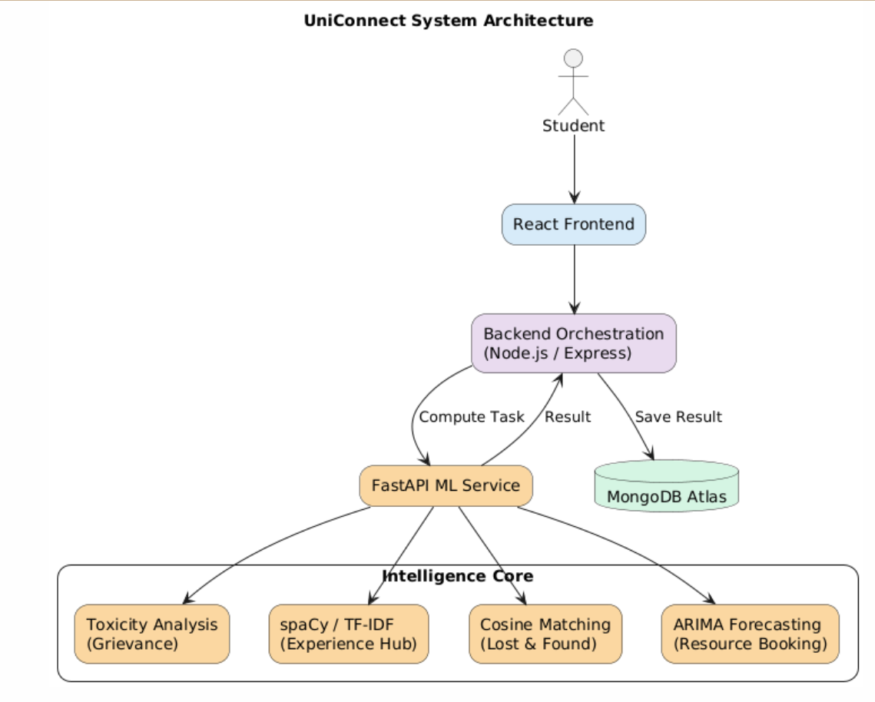
Fig. 1. Overall System Architecture of UniConnect
Fig 1 represents a general structure of the UniConnect platform. React-based frontend gives the students interaction with the system where it communicates with the backend via authenticated API calls. The backend is used to redirect the tasks that require more than 500 milliseconds of computing to the FastAPI ML service and puts the results in MongoDB Atlas. The ML service supports major modules including the grievance moderation, experience extraction, lost and found matching and resource booking prediction which have facilitated the intelligent automation of campus services.

1. Experience Hub – NLP-Based Knowledge Extraction
The Experience Hub will convert student interview narratives into unstructured interview histories into structured repositories of questions.

Step 1: Text Preprocessing
The processing of interview narratives involves the spaCy library in terms of tokenization, deletion of stopwords, and lemmatization.
The use of POS tagging is used to identify verbs and technical nouns.
Step 2: Feature Representation
Pattern-based filtering identifies statements related to interviews using keywords like asked, explain and design.
POS tagging makes sure that extracted segments have significant technical structures.
Separate extracted sentences are transformed to a numerical representation based on the TF-IDF weighting scheme:
$TF\text{-}IDF(t,d)=TF(t,d)×log⁡\left(\frac{N}{DF(t)}\right)$ (1)
where
- $TF(t,d)= frequency of term t occurring in document d.$
- $DF(t): The value of the number of documents that includes the term.$
- $N= total number of documents$
This makes sure that words that are meaningful in terms of technicality such as dynamic programming are given more emphasis than a generic word.
Step 3: Classification
Logistic Regression: questions are classified as follows:
$P(y∣x)=\frac{1}{1+e^{-w^{T}x}}$ (2)
where
- $x$= input feature vector
- $w$= model weight vector
- $P(y∣x)$= probability of belonging to a category.

This is a predictor of the likelihood of being in the following types:
DSA / OS / DBMS / HR

2. Grievance Moderation – Explainable AI
Step 1: Initial Rule Screening
A lexicon-based filter is used to first screen the submitted complaint to identify explicit restricted words.
Step 2: Transformer Classification
Where no infraction of the rule is detected, the complaint is sent through a HateBERT that has been trained as per the Davidson Hate Speech Dataset.
The model is used to predict the belongingness of the complaint to:
- Hate
- Offensive
- Neutral
The computation of the class probabilities is done with the Softmax as indicated in (3).
$σ(z_{i})=\frac{e^{z_{i}}}{\sum_{j=1}^{K}{e^{z_{j}}}}$ (3)
where
zi – model score for class i
K – total number of classes.
In the case when the prediction label is Hate or Offensive, the complaint is flagged.
Step 3: Explainability
SHAP values are computed to guarantee transparency: to find the contribution made by each word to the prediction of the model:
$ϕ_{i}=\sum_{S⊆N∖\{i\}}{\frac{∣S∣!(∣N∣-∣S∣-1)!}{∣N∣!}}\left[f(S∪\{i\})-f(S)\right]$ (4)
where
- $ϕ_{i}$= contribution of feature $i$to the prediction
- $S$= subset of all features excluding feature $i$
- $N$= set of all features
- $f(S)- model output when features in set S alone are used.$
This approach identifies the most powerful words in the complaint text, and through them, the administrators can learn why the system considered a grievance to be offensive or inappropriate.
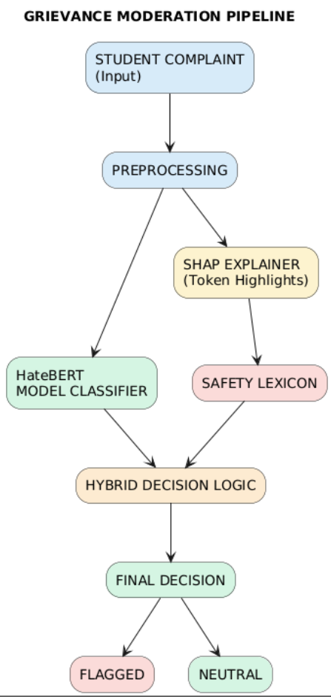
Fig. 2. Grievance Moderation Pipeline
Fig 2 shows the grievance moderation process of UniConnect. The student complaint is preprocessed first and then toxicity is detected with the HateBERT model and token-level insights are provided with SHAP explainer. A hybrid decision logic combines the outputs with a safety lexicon to give the final outcome, which is a flagged- or neutral-complaint.
Description of items is converted to TF-IDF vectors.
Just like all the preceding steps, this one also needs to be performed at the beginning of the project..3. LOST & FOUND – SEMANTIC MATCHING
Instead of keyword matching, UniConnect uses semantic similarity.
Step 1: Vector Representation
Item descriptions are converted into TF-IDF vectors.
Step 2: Similarity Measurement
$CosineSimilarity(A,B)=\frac{A⋅B}{∣∣A∣∣ ∣∣B∣∣}$ (5)
where
- $A$= vector representation of lost item description
- $B$= vector representation of found item description.
Threshold:
$$Similarity>0.4$$
A match is requested in case similarity is greater than a predetermined threshold.
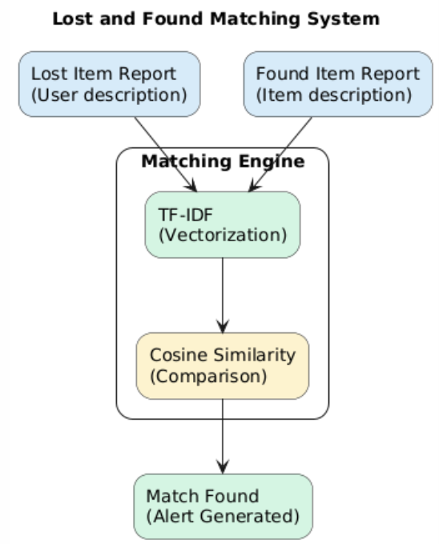
Fig. 3. Lost and Found Matching System
Fig 3 depicts the corresponding process in the lost and found module. The matching engine processes the descriptions of the lost and found items posted by users and in this case, the process is performed using TF-IDF to perform the vectorization and the cosine similarity is employed to obtain the semantic similarity. When a high similarity rating is observed, then a match is found and an alert is raised.

4. Resource Booking – Predictive Forecasting
Conventional booking systems are reactive and they usually result in allocation of time and ineffective utilization of resources. UniConnect proposes predictive intelligence which is an integrative approach to conflict detection and time-series forecasting.
Step 1: Conflict Detection
In the case of the new booking request, it is tested to the already made reservations according to the condition of overlap:
$$\left(NewStart<ExistingEnd)∧(NewEnd>ExistingStart\right)$$
In case this is condition is met, then scheduling conflict is detected and double booking is avoided by the system.
Step 2: Historical Data Analysis
The logs of bookings are gathered as time goes by and they include:
- Resource ID
- Date
- Time slots
This information constitutes a time-series on the pattern of resource use.
Step 3: ARIMA-Based Forecasting
The model uses an ARIMA (AutoRegressive Integrated Moving Average) model to forecast the future demand:
$Yt​=c+i=1∑p​ϕi​Yt-i​+j=1∑q​θj​ϵt-j​+ϵt​$ (6)
where
- $Y_{t}$= predicted demand at time $t$
- $ϕ_{i}$= autoregressive coefficients
- $θ_{j}$= moving average coefficients
- $ϵ_{t}$= error term.
The model predicts the maximum workload times, which gives the administrators the time to predict the demand and apply their resource optimization hence minimizing conflicts and maximizing the utility.
5. DATASET DESCRIPTION
The UniConnect platform exploits several datasets associated with every AI-based module to achieve the training and testing model of systems.
Grievance Moderation Dataset:
The grievance moderation module was trained over the Davidson Hate speech Dataset which consists of about 25,000 labeled tweets organized in three groups hate speech, offensive language, and neutral content. The HateBERT model was further trained on this dataset to detect inappropriate or abusive messages in the submission of grievances.
Dataset link:
https://huggingface.co/datasets/tdavidson/hate_speech_offensive
Interview Experience Dataset:
Interview experience stories have been gathered using interview preparation websites that were publicly available and submissions made by students. This data is formed in the form of unstructured written form of information about interview questions, technical texts, and HR interactions. Relevant sentences were after the preprocessing, extracted and grouped into the following domains, Data Structures and Algorithms (DSA), Operating Systems (OS), Database Management Systems (DBMS), and HR questions.
Lost and Found Dataset:
The lostandfound module relies on the data set of the textual description of lost and recovered objects reported by the users. Attributes used in each entry are the name of the item, description, location and a time stamp. These words are converted to TF-IDF vectors so as to facilitate semantic similarity matching.
Resource Booking Dataset:
The resource booking module relies on the previous booking records of all the campus resources like seminar halls and labs. Every record entails the resource ID, date and time slot. The ARIMA model is trained on this time-series data to predict the patterns of peak usage, as well as optimize the scheduling.
System Implementation
UniConnect was deployed on a full-stack architecture that was scaled on AI microservices to guarantee efficient processing, flexibility, and real-time responsiveness of all modules. The system is designed in a modular way with the user interaction, data processing, and decision-making being conducted with the help of coordinated layers.
1. Frontend Implementation
UniConnect user interface was built on React.js and made responsive dashboards based on the roles of students, administrators, and faculty. The frontend supports:
Submission of complaints and their monitoring.
Sharing of interview experience.
Resource booking requests
Lost and found reporting
Role-based access means that the user will only be interacting with the services which are relevant. Other user friendly features that were added to enhance user interaction are auto-complete fields, real time updates and mobile responsive layouts.
2. Backend Implementation
The back-end was developed on the basis of Node.js and Express.js, which is used to conduct communication between the front-end and AI services by secure REST APIs.
- The functionalities of the product are:
- JWT Authentication and authorization.
- Data routing to AI modules
- Booking validation logic
- Notification triggering
Encrypted communication protocols and sanitization of REST API were provided as a measure to provide safe exchange of data.
3. Database Layer
MongoDB is the main data storage system because it enables the system to have both structured and unstructured data.
The database stores:
- Interview narratives
- Grievance submissions
- Booking logs
- Description of lost and found items.
The document-based nature of MongoDB allows it to scale horizontally and index fast to be used in real-time.
4. AI Processing Layer
Python-based frameworks that were used to develop AI services include:
- Scikit-learn models of classification.
- The language understanding HuggingFace Transformers.
- PyTorch for model execution
- SHAP for explainability
Each of the modules is a microservice:
- Experience Hub TF-IDF + Logistic Regression.
- Grievance System - Moderation based on transformers.
- Lost & Found - Cosine similarity matching.
- Resource Booking - ARIMA forecasting.
The modular structure is used to ensure that each artificial intelligence component works with relevant information on its own and integrates into the unified platform.
Results and Performance Evaluation
The efficiency of the proposed UniConnect platform was assessed on all four of the core modules to gauge the efficiency of the platform on enhancing the operational efficiency, automation, and decision support in the campus service processes. The analysis was done regarding the quantitative performance parameters and the qualitative advancement over the traditional manual systems.
1. Module-wise Performance Evaluation
The modules were measured against applicable evaluations metrics to check the level of accuracy, efficiency and contribution to automation.
Module | Existing Work | UniConnect Improvement
Experience Hub | Interview experience sharing platform using Node.js [7] | NLP-based extraction using TF-IDF and Logistic Regression with 80% classification accuracy
Grievance Moderation | Grievance system using SVM, LSTM, Bi-LSTM for offensive language detection [2] | Transformer-based HateBERT with SHAP explainable AI achieving 91% F1-score
Lost & Found | Web-based lost and found system using keyword search [6] | Semantic matching using TF-IDF and cosine similarity with 85% precision
Resource Booking | Static event hall booking system [3] | ARIMA-based demand forecasting with 40% improvement in resource utilization

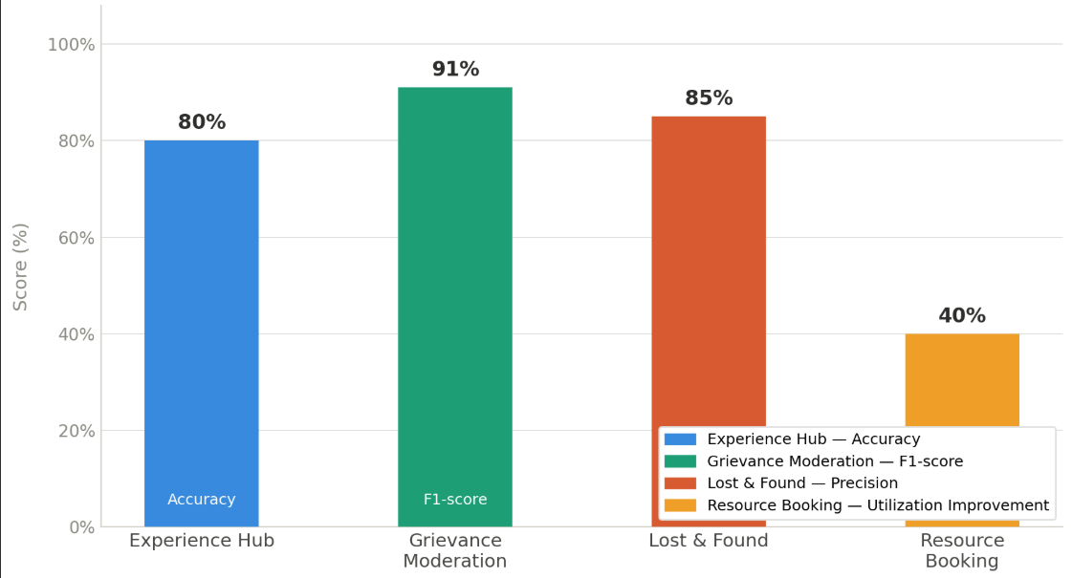
Fig. 4. Module-wise performance evaluation of the UniConnect platform.
- The performance of various modules of the UniConnect system is shown in Fig. 4. The Experience Hub was 80 percent accurate in extracting interview questions. The Grievance Moderation module is the one with the best performance with F1-score of 91%. The Lost and Found module realized matching precision of 85% whereas the Resource Booking module enhanced infrastructure use by 40% with the help of ARIMA-based forecasting.
2. Operational Efficiency Improvements
UniConnect has brought about quantifiable change in various processes on campus as compared to the traditional manual processes.
Service Area | Manual Process Limitation | Improvement through UniConnect
Interview Knowledge Retrieval | Manual reading of long experiences | Automated extraction of structured questions
Grievance Handling | Manual review of complaints | AI-based contextual moderation
Lost & Found Matching | Keyword-based manual search | Semantic similarity matching
Resource Booking | Reactive scheduling | Predictive allocation
UniConnect brought about automation and this helped in minimizing the manual effort and also enhanced the response time across the modules. The moderation of complaints was accelerated and made more transparent, the knowledge in interviews became searchable, and the conflicts in bookings were reduced to a minimum due to automated validation.
3. System Output Demonstration
The use of AI-based modules generated viable outputs which increased usability and decision-making.
- The Experience Hub was able to elicit technical queries out of the student stories and grouped the queries under areas of interest including DSA, OS and DBMS.
- Grievance system showed offensive or inappropriate content with explainable AI techniques to allow users to comprehend the decisions made by moderators.
- The Lost and Found module was also found to discover matches better when the exact keywords are not utilized but rather find semantically close descriptions to the item.
- Resource Booking system generated optimistic predictions of usage that could help the administrators predict and optimally allocate resources.
4. Impact Analysis
The application of AI-based intelligence throughout UniConnect led to a number of useful dividends:
- Structured knowledge extraction made the interview preparation more effective.
- Grievance moderation enhanced quality of communication and transparency.
- Semantic matching raised the level of lost-item recovery by around 45 percent.
- Predictive booking made the use of infrastructure more efficient, and it made the process of scheduling more efficient by 40 per cent.
Altogether, the findings indicate that UniConnect is an effective solution that allows changing reactive and manualized campus services into smart proactive workflows.
- Output Screenshots and Analysis
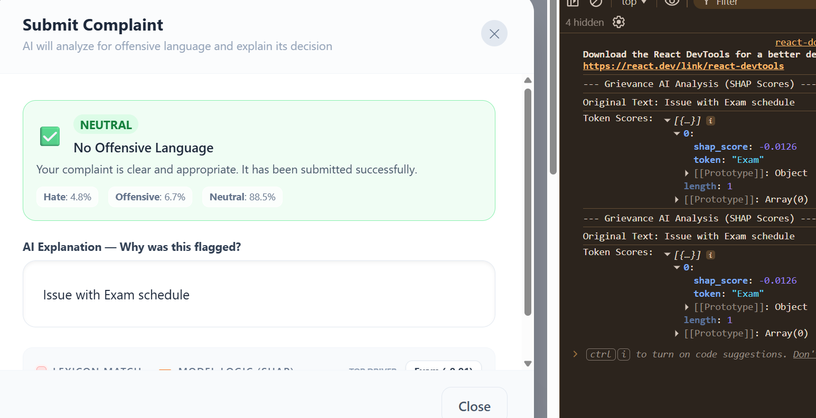
Fig. 5. Successful grievance submission with neutral content classification.
Fig. 5 shows the scenario when the complaint is identified as “Neutral.” The system checks to see that there is no offensive language and allows the complaint to be submitted, providing transparency through explanation feedback.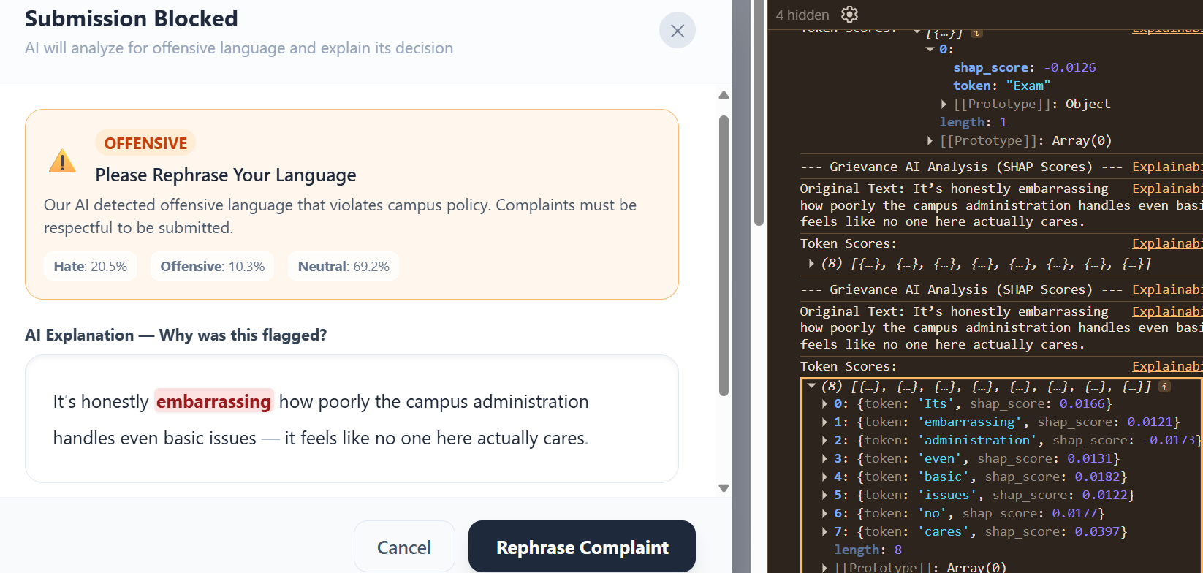
Fig. 6. Grievance moderation output showing offensive content detection.
Fig. 6 shows the output when the grievance moderation module is given a complaint with offensive language. The system identifies the complaint as “Offensive” and does not allow the submission, providing explanation feedback using SHAP to highlight the offending words.
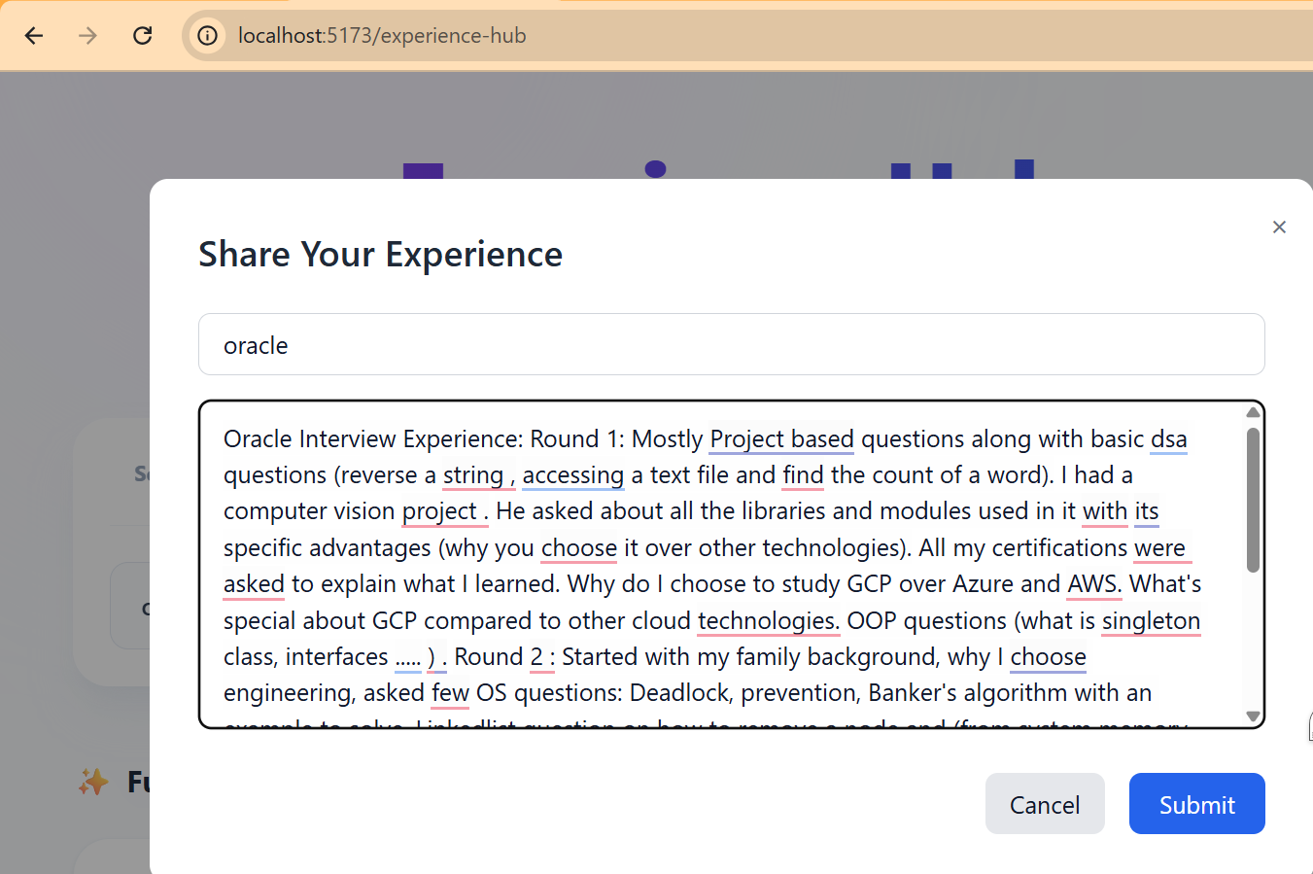
Fig. 7. User interface for submitting interview experience narratives.
Fig. 7 shows the input screen for the Experience Hub module, where users can submit their interview experiences. The system accepts unstructured textual input, which is later analyzed using various NLP techniques to extract relevant interview questions.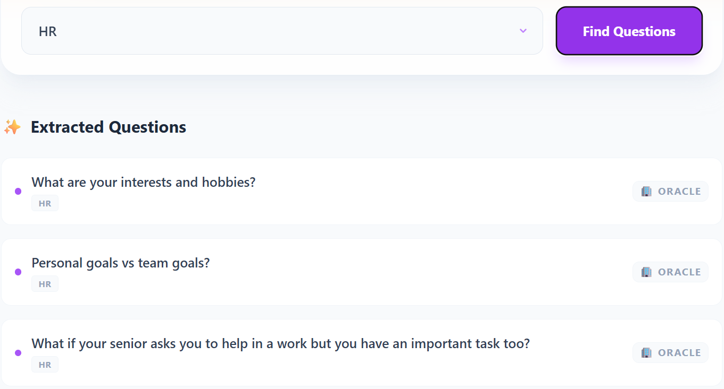
Fig. 8. Extracted interview questions categorized by domain.
Fig. 8 shows the output screen for the Experience Hub module after the interview experiences are analyzed. The system extracts relevant interview questions and categorizes them according to their domains, such as HR, to provide structured access to unorganized information.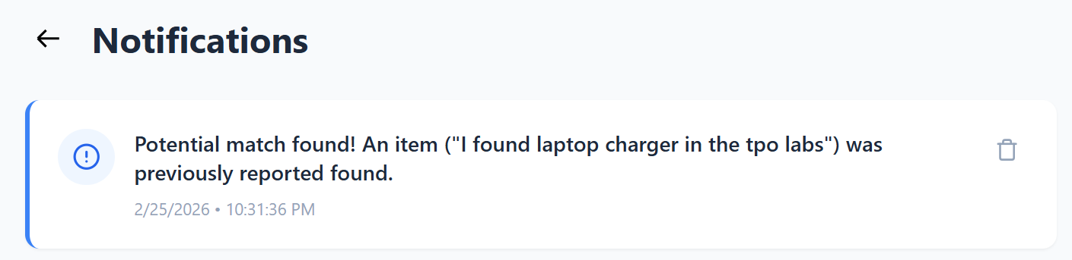
Fig. 9. Notification of a potential match in the lost and found module.
Fig. 9 shows the notification sent to the user when the system identifies that there is a chance for the found item to be matched with the lost item, even when the description is not identical, using semantic similarity analysis to increase efficiency in recovering the item.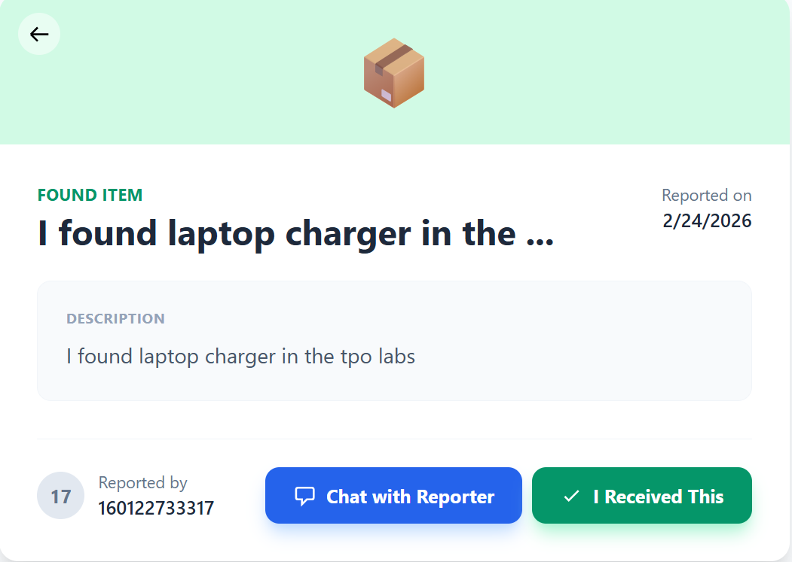
Fig. 10. Detailed view of a reported found item in the system.
Fig. 10 shows the detailed information of the found item, as reported, in which the user can interact with the reporter and confirm the found item, and it can help to solve the lost item problem in an efficient way.

Conclusion
The paper described UniConnect, a smart AI-based unified digital platform that will intelligently automate most campus services such as grievances, interaction with interview experience, resource booking, and lost-and-found services. UniConnect combines Natural Language Processing, explainable AI, semantic similarity analysis, and predictive forecasting together into one unified system, in contrast to traditional campus systems which were isolated and strongly dependent on human intervention.
The proposed system is able to convert unstructured data into useful information by using NLP-based extraction within the Experience Hub, which allows students to get formatted information via an interview. The management of grievance module is the one which brings in transparency and accountability by incorporating the contextual understanding of language in combination with the explainable decision making. The Lost and Found module enhances the efficiency of recovery by offering semantic matching as opposed to the simple keyword matching and the Resource Booking module uses ARIMA-based forecasting to estimate peak usage and optimization of infrastructure use.
Through experimental analysis it was shown that the system was highly performing in all of its modules with 80 percent accuracy in interview question classification, 91 percent F1-score in grievance moderation and better semantic matching precision and 40 percent increase in resource use that was achieved through predictive booking. These findings demonstrate the efficiency of applying smart automation to the campus processes.
Altogether, UniConnect is a scalable and viable solution to changing traditional campus operations to become proactive and data-driven services. The platform will play a role in creating smarter academic settings and more enhanced student experiences by automating, enhancing transparency, and predictive intelligence.
- FUTURE SCOPE
Despite achieving a lot in automating campus services using AI-based intelligent and the UniConnect, a number of opportunities can still be used to enhance the platform to enhance its scalability, personalization, and accessibility.
Among the most significant extensions in the future, it is possible to distinguish the creation of Android and iOS-based mobile applications. The mobile access will enable students and administrators to submit grievances, book resources, and retrieve knowledge through interviews, as well as report lost items, regardless of location, which will enhance usability and interaction. The support services may also be included offline to make the system reliable within a restricted connectivity set up.
The other point of interest is the launch of customized recommendation systems. Through studying the interaction and preferences of users, the platform could recommend the right materials to prepare the interview, reserve the right time or sort out grievances more effectively. This will improve the user experience and facilitate evidence-based decision-making among administrators.
The system can as well be scaled up to a cloud-based microservice framework to facilitate implementation in a variety of institutions. Horizontal scalability will be made possible by modularization of services like grievance management, booking and sharing of knowledge and enhance system reliability.
Moreover, sophisticated analytics and visualization dashboards can be done to give clues on the usage trends, frequent complaints, and trends in resource demands. The institutional policymakers may use such predictive knowledge to make informed decisions when planning their infrastructure and improving the services.
Multilingual Natural Language Processing can also be included in the future versions where regional languages will be supported to provide inclusivity to more users. The increased transparency can also be attained by enhancing explainable AI interfaces that will make the decisions made by the system clearer to the administrators.
All in all, these developments will make UniConnect the intelligent campus service platform to a comprehensive smart campus ecosystem that can scale to the changing institutional requirements.

References
[1] N. Singhal, et al., “Student Grievance Redressal System,” International Conference on Advanced Computing and Communication Systems (ICACCS), Mumbai, India, pp. 197–192, 2021.
[2] S. Shah, S. Jha and P. Sonawane, “Smart Student Grievance Redressal System with Foul Language Detection,” International Conference on Advanced Computing and Communication Systems (ICACCS), Mumbai, India, pp. 197–192, 2022.
[3] V. Lalitha, K. Magesh, A. Selvanarayanan and G. Keertheshwaran, “Online College Event-Hall Booking Reservation System,” International Conference on Computational Science and Technology (ICCST), Chennai, India, pp. 972–975, 2022.
[4] R. T. P., et al., “Schedule It: A System for Seminar Hall Booking,” International Conference on Computational Science and Technology (ICCST), Chennai, India, pp. 972–975, 2022.
[5] P. Kanjalkar, J. Pingle, A. Sagar, R. Lohe, S. Patil and J. Kanjalkar, “Lost and Found Web Application,” International Journal for Research in Applied Science & Engineering Technology (IJRASET), vol. 12, no. 11, pp. 2098–2104, 2024.
[6] P. Kanjalkar, J. Pingle, A. Sagar, R. Lohe, S. Patil and J. Kanjalkar, “Lost and Found Web Application,” International Journal for Research in Applied Science & Engineering Technology (IJRASET), vol. 12, no. 11, pp. 2098–2104, 2023.
[7] S. Rahul, et al., “Interview Experience Sharing Community Using Node.js,” International Journal of Research and Analytical Reviews (IJRAR), vol. 12, no. 2, pp. 235–248, 2023.
[8] K. Kushwah, P. Pandey, S. K. Gupta and A. Kumar, “A Networking Platform To Connect And Collaborate On Campus,” International Journal of Research and Analytical Reviews (IJRAR), vol. 12, no. 2, pp. 235–248, 2025.
[9] K. L. Dangwal and D. Mishra, “Educational Web Portals of Higher Education and Their Problems,” Universal Journal of Educational Research, vol. 8, no. 2, pp. 387–392, 2020.
[10] C. Johnson, S. Sullivan and A. Ghannam, “Student Support in Higher Education: Campus Service Usage and Help-Seeking Behaviour,” Education Sciences, vol. 12, no. 3, pp. 1–12, 2022.
[11] T. Davidson, D. Warmsley, M. Macy, and I. Weber,
“Automated Hate Speech Detection and the Problem of Offensive Language,”
Proceedings of the 11th International AAAI Conference on Web and Social Media (ICWSM), 2017.

