SmartGym: A Web-Based Fitness Program Management and Membership Tracking System for Vinathletics Fitness Gym

A Thesis
Submitted to the Faculty
of Institute of Computer Studies

In Partial Fulfillment of the requirement

for the Degree of Bachelor of Science
in Computer Science

By:

De Leon, Jarri
Dela Peña, Aidrian
Escalante, Nathaniel
Jurane, Adrian
Rivas, Ivan Greg
Sison, Johann Carlo
Tanay, Karl Charton

April 2026

TABLE OF CONTENTS
CHAPTER I INTRODUCTION………………………………………………………….…3
Background of the Study……………………………………………3
Statement of the Problems…………………………………………4
Objective of the Study………………………………………………6
Significance of the Study……………………………………………7
Scope and Delimitation……………………………………………..8
Definition of Terms………………………………………………..…11
CHAPTER II REVIEW OF RELATED LITERATURE AND STUDIES……………………...12
Related Literature ( Foreign & Local) …………………………...12
Related Studies ( Foreign & Local) ………………………………19
CHAPTER III METHODS OF RESEARCH AND PROCEDURES………………………..22
Research Methodology……………………………………………22
Research Design…………………………………………………….22
Data Gathering . ……………………………………………………26
Statistical Treatment…………………………………………….….26
CHAPTER IV SUMMARY OF FINDINGS, CONCLUSSIONS AND RECOMMENDATIONS…………………………………………...………28
Summary of Findings…………………………………..……………28
Conclusions……………………………………………………..……34
Recommendations…………………………………………………35

APPENDICES……………………………………………………………………………………37
DFD Diagram……………………………………………………….….…39
Context Diagram………………………………………………...…42
Program Flowchart……………………………………………………...53
VTOC Diagram……………………………………………………..……64
IPO Diagram…………………………………………………..…………66
Sample Screen Output…………………………………………………81
Program Listing……………………………………..……………………83
Users Manual……………………………………………………..………85
Evaluation Result……………………………………………………...…74
T-Test…………………………………………………….…………………92
Cost Benefit Analysis…………………………………………….………97
BIBLIOGRAPHY…………………………………………………………………………………75
CURRICULUM VITAE………………………………………………………………….………101

CHAPTER I
Problem and Its Background

Background of the Study

Staying healthy and fit has become more important in today’s busy lifestyle. Many people join gyms and fitness centers to follow exercise programs and reach their fitness goals. However, managing workout programs and keeping track of members is often a challenge. Manual systems, such as paper records or simple spreadsheets, can lead to problems like lost files, inaccurate data, and delays in updating information.

With the help of technology, these problems can be solved more efficiently. A web-based system allows both gym administrators and members to access information inside the gym only using the internet. For administrators, it makes it easier to manage membership records, attendance, and workout schedules in an organized way. For members, it provides a clear view of their fitness plans, attendance history, and overall progress, which helps them stay motivated and consistent.

This study focuses on creating a Web-Based Fitness Program Management and Membership Tracking System. The system aims to provide a reliable platform for organizing membership data, managing workout programs, and tracking progress. By using this system, gyms and fitness centers can improve their services, reduce errors in management, and encourage members to stay active in their fitness journey.

Statement of the Problem

General Problem
Gym and fitness centers, particularly Vinathletics Fitness Gym, experience operational inefficiencies due to the continued use of manual and fragmented systems for managing memberships, workout programs, attendance, and communication. These limitations result in inaccurate records, delayed processes, and reduced service quality. There is a need for a centralized and web-based system that can effectively address and resolve these operational challenges.

Specific Problems
This study seeks to address the following specific problems and provide system-based solutions:
- How can inaccurate and inefficient record-keeping of membership and attendance be resolved?
Manual recording of member information and attendance often leads to data loss, duplication, and human error. The proposed SmartGym system aims to resolve this by providing a centralized and automated database for accurate and secure record management.
- How can the absence of a centralized platform for monitoring workout programs and member progress be addressed?
Many gyms lack a unified system for tracking workout routines and fitness progress. SmartGym addresses this problem by offering a web-based platform where trainers can manage programs and members can monitor their progress in real time.
- How can delays and errors in data processing be minimized?
Manual data entry and updates cause delays and inconsistencies in reporting.

The SmartGym system resolves this issue by automating data storage, updates, and retrieval, ensuring timely and accurate information.
- How can communication between trainers and members be improved?
Limited communication tools result in missed updates on schedules and workout plans. SmartGym addresses this by providing an accessible online system that enables efficient sharing of workout programs, schedules, and progress-related information.
These challenges reduce operational efficiency, affect record accuracy, and limit effective communication between trainers and members. Without a modern, web-based system, fitness centers may struggle to deliver organized and reliable services that meet the needs of both staff and members.

Objectives of the Study

General Objective
To develop a web-based fitness program management and membership tracking system that improves operational efficiency, record accuracy, and service quality of Vinathletics Fitness Gym by automating gym processes and providing accessible digital tools for administrators, trainers, and members.
Specific Objectives
Specifically, this study aims to:
- To design and implement a centralized system that allows gym administrators to efficiently manage membership records and attendance through an automated and secure database.
- To provide trainers with a workout program management tool that enables them to create, update, assign, and monitor customized workout programs for gym members through the web-based platform.
- To enable gym members to track their fitness progress and attendance by allowing them to view their assigned workout programs, attendance history, and recorded progress indicators through a personalized online dashboard.
- To minimize errors and delays in gym operations by automating data entry, storage, and real-time updates of membership, attendance, and workout information.
- To enhance communication between trainers and members by providing a centralized online platform where workout programs, schedules, and progress-related information can be easily accessed and monitored.

Significance of the Study

This study is significant as it addresses key challenges faced by gym and fitness center operators in managing membership data and workout programs. By developing a Web-Based Fitness Program Management and Membership Tracking System, this research aims to streamline administrative processes, reduce errors.

- For gym administrators, the system will provide an efficient and reliable platform to manage membership records, attendance, and workout schedules. It will reduce the manual workload and prevent data loss, errors, and delays. For trainers, it will offer a tool to customize and monitor workout programs, enabling better tracking of members' fitness progress.
- For gym members, the system will provide easy access to their fitness data, including attendance history, workout plans, and performance progress. This will help keep members motivated and engaged, ultimately improving retention rates.

- The researchers and developers, the study contributes to knowledge in the field responsible for the systematic planning, development, and evaluation of the Web-Based Fitness Program Management and Membership Tracking System. Their role includes conducting a comprehensive analysis of the existing challenges in gym operations, designing the system architecture, and developing the functional modules aligned with the needs of administrators, trainers, and members.

Furthermore, this study contributes to the growing body of research on the role of technology in enhancing fitness management and improving operational efficiency in fitness-related businesses.

Scope and Delimitation

Scope of the Study
This study focuses on the design, development, implementation, and evaluation of SmartGym: A Web-Based Fitness Program Management and Membership Tracking System for Vinathletics Fitness Gym. The system is developed to digitalize and streamline gym operations by providing a centralized, web-accessible platform for administrators, trainers, and gym members.
Specifically, the scope of the system includes the following functionalities:
- Membership Management
The system allows gym administrators to register members, update personal profiles, assign membership plans, and manage account status. All membership information is stored in a centralized database to ensure accuracy, consistency, and easy retrieval.
- Attendance Tracking
SmartGym provides an automated attendance tracking feature where member check-ins are recorded digitally and time-stamped. This reduces manual logging errors and allows administrators and trainers to monitor attendance history in real time.
- Workout Program Management
Trainers are provided with a web-based workout program management tool that enables them to create, update, and assign customized workout programs to members. These programs may include exercise routines, difficulty levels, and duration, which are stored and managed within the system.
- Fitness Progress Monitoring
The system allows members to track their fitness progress through a personalized dashboard. Members can view their assigned workout programs, attendance records, and progress indicators recorded by trainers, enabling them to monitor consistency and improvement over time.
- User Access and Roles
The system supports role-based access, distinguishing between administrators, trainers, and members. Each user role has specific permissions and system features relevant to their responsibilities.
- System Evaluation
The usability, effectiveness, and acceptability of the system will be evaluated through surveys conducted among the gym owner, staff/trainers, and selected gym members.
Overall, the scope of the study emphasizes improving operational efficiency, reducing errors in record management, enhancing communication, and providing accessible fitness-related information through a web-based platform.

Delimitation of the Study
While the SmartGym system provides essential tools for fitness program and membership management, the study is subject to the following limitations:
- Limited System Features
The system does not include online payment processing, billing automation, or financial transaction management. Membership payments are handled outside the system.
- No Advanced Biometric or Sensor Integration
The system does not integrate biometric devices, wearable fitness trackers, or IoT-based exercise monitoring systems. Fitness progress tracking is limited to data recorded within the system.
- Web-Based Access Only
SmartGym is developed as a web-based application and does not include a dedicated mobile application, although it may be accessed through mobile web browsers.
- Single-Gym Implementation
The study is limited to Vinathletics Fitness Gym and does not cover multi-branch or franchise-level gym management.
- User Dependency on Internet Connectivity
Since the system is web-based, its functionality depends on stable internet access, and offline features are not supported.
- Context Limitation
The system is designed specifically for gym and fitness center operations and is not intended for other types of fitness-related or health institutions.
- Restricted Local Access
The application is accessible only within the gym’s local network and requires connection to the gym’s Wi-Fi for use.

Definition of Terms
Attendance Tracking – The method of recording and monitoring a member’s visits to the gym, typically for the purpose of ensuring regular participation and accountability.
Membership Management – The process of tracking and managing information about gym members, including registration, payments, and attendance records.
Progress Tracking – The process of monitoring a member’s fitness improvements, such as strength, endurance, weight loss, or other health-related metrics.
System Usability – A measure of how effectively and efficiently users can perform tasks within the system, typically evaluated through user feedback and testing.
User Interface (UI) – The design and layout of a software system that allows users (e.g., gym administrators, trainers, and members) to interact with the system.
Web-Based System – A software application that is accessed and used over the internet, requiring no installation on users' devices other than a web browser.
Workout Programs – Exercise plans designed by trainers to help gym members meet their fitness goals. These may include specific exercises, sets, repetitions, and rest periods.

Chapter II
Related Literature
Recent studies indicate a growing emphasis on the digitalization of gym operations, fitness tracking, and membership systems to improve efficiency and service quality.
Foreign Literature
Hussain et al. (2025) explain that the Q-Fitness Gym System (QFGS) is a web-based management platform designed to improve the operational efficiency of fitness centers through automation and system integration. The platform centralizes key functions such as member registration, class scheduling, staff and instructor management, and secure payment processing. Developed using the Agile methodology, the system supports iterative development, adaptability, and continuous improvement based on user feedback. Its architecture follows a three-tier design, ensuring scalability and enhanced data security through the use of a MySQL relational database. The system underwent comprehensive testing, including unit, integration, and user acceptance testing, to verify its functionality, usability, and reliability. The implementation of QFGS resulted in significant improvements in administrative productivity, efficient resource utilization, and increased member satisfaction by minimizing manual processes and delivering a user-friendly digital experience. Overall, the system provides an innovative solution for modern gym management, supporting the transition from traditional operations to smart digital systems.

Nishanthan et al. (2023) explain that people have recently become more concerned about their food and health, making going to the gym a logical choice. The JK Fitness centers in the Jaffna district are the intended users of the system. The gym is equipped with up-to-date equipment aligned with current fitness trends and offers additional products to enhance client services. As membership is expected to grow daily, gym management opted for an IT solution to handle increasing demand.
After identifying user needs through various data collection methods to ensure clear requirements, the system was developed using an incremental and iterative approach. The JK Fitness Office software is designed to replace the existing manual system and aims to provide members with quick access to gym resources while improving overall facility management. The system’s primary features include member management, attendance tracking, payment and expense management, and report generation. Access control is implemented through login credentials and user-level permissions. Additionally, the system can track memberships nearing expiration and automatically send email reminders. It is highly customizable, allowing administrators to manage both user access and system appearance. The system was developed as a web-based application for broader accessibility, utilizing .NET 5 Core framework, C# programming language, jQuery, JavaScript, and CSS, with Microsoft Visual Studio as the IDE and Microsoft SQL as the database.
Thapa et al. (2021) explain that websites play a major role in today’s digital world, as they provide accessible information about a particular business to users. Having a website is an essential tool for every business. For this reason, an online system in the form of a website was developed for gym owners, allowing customers to access information about the gym and register themselves. Traditionally, managers or staff maintain records using paper or logbooks, which leads to redundancy and a higher chance of errors. Updating records also requires repeated changes across multiple files. The gym website, which includes a Gym Management System, eliminates many of these limitations of the existing manual system.
It improves efficiency and effectiveness through automation, accuracy, a user-friendly interface, better information availability, enhanced communication, easier maintenance, and cost reduction. The system introduces new features along with essential functionalities, such as receiving client details, allowing data entry by administrators or receptionists, searching client or trainer information by ID or name, and deleting records of clients and trainers.
Villanueva et al. (2025) developed the Olympic Fitness Gym Management System with Integrated QR Code Technology. They noted the increasing trend of individuals joining fitness clubs to improve their health and physical appearance. Despite being a well-known gym in Tacloban City, Olympics Fitness Gym still relies on manual processes for monitoring and data management. To address these limitations, the proposed system integrates QR Code technology to automate key operations such as recording sales, generating reports, and monitoring customer attendance and subscriptions, thereby improving efficiency and effectiveness. The study employed a descriptive research method, utilizing interviews, observations, and questionnaires. The key informants included the gym owner and two staff members.
Findings revealed that the existing manual system is inefficient and time-consuming, particularly in areas such as attendance and subscription monitoring, data and backup security, and record management. To address these issues, the researchers implemented a QR Code-based solution to enhance attendance tracking and membership subscription monitoring. The study recommends automating manual processes through the implementation of a management system with integrated QR Code technology to improve efficiency in attendance tracking, sales monitoring, and overall data management.
Zhao et al. (2023) They explained that with the rapid development of China’s economy, more people are actively participating in fitness activities and joining gyms. To adapt to this growing demand and the evolving social market, a comprehensive gym management system has become essential for both operators and users. The system was designed to provide practical application value by managing various types of data and information generated in daily gym operations, while also assisting users in their tasks. The system adopts a Browser/Server (B/S) architecture, utilizing JSP to handle client requests and dynamically generate web pages for the front-end interface. A MySQL database is used to design data tables for data storage, and the development environment is supported by the Eclipse IDE.
Local Literature
Abilar et al. (2023) explain that many individuals in today’s society have limited knowledge regarding physical fitness, proper nutrition, and the benefits of maintaining a healthy lifestyle. In response to this gap in awareness, the researchers developed a game-based application designed to educate users and improve their understanding of fitness concepts. The primary purpose of the application is to introduce users to various fitness routines and allow them to explore different physical exercises. Through this approach, the system aims to increase familiarity with exercise activities while also highlighting the benefits of regular physical activity in daily life. The project serves as a proactive initiative to address the lack of fitness knowledge and encourage healthier lifestyles among users. During development, the researchers considered key issues such as user engagement and retention, user understanding of the application’s features, limited available guidance from similar game applications, and improvements to gameplay flow.

The evaluation of the application was based on selected sub-characteristics of the ISO 25010 standard, appropriate for assessing gaming systems. Results showed that Functional Suitability obtained a weighted mean of 3.94, Performance Efficiency and Usability both scored 3.81, Security scored 3.56, and Portability scored 3.82. Additionally, using the Weka software and Naive Bayes classification, the confusion matrix revealed 90% correctly classified instances and 10% incorrectly classified instances, indicating that the application’s algorithm is highly accurate
Bulaclac et al. (2025) developed and evaluated the King’s Way Cashless Payment and Product Monitoring System with QR Technology, specifically designed for the fitness industry. The study aimed to enhance operational efficiency, improve transaction security, and provide a seamless experience for gym members and administrators through digital transformation. The system’s innovation lies in its integration of QR-based payment transactions with automated membership and product monitoring features within a unified platform, a combination that is not yet widely implemented in small and medium-sized fitness enterprises.

The study also highlighted the growing importance of digital payment technologies, as cashless transactions have become essential in modern business operations. The fitness industry, which involves frequent financial transactions and dynamic membership management, continues to face challenges due to inefficiencies in manual payment systems. These limitations further emphasize the need for automated and secure digital solutions to improve overall operational performance and user experience.

Cabauatan et al. (2021) conducted a study using a quasi-experimental non-equivalent pre-test and post-test design to determine the effectiveness of mobile fitness applications and gym-based exercises in improving the health-related fitness performance of first-year college students at Carlos Hilado Memorial State College during the A.Y. 2019–2020. The study involved two groups: an experimental group of ten students who were exposed to mobile application-based exercises, and a control group of ten students who participated in gym-based exercises.

The Philippine Physical Fitness Test was used as the standardized tool to assess students’ physical fitness performance. Statistical analyses, including the t-test for dependent samples, Wilcoxon test, and Mann-Whitney U test, were used to determine differences in pre-test and post-test results, as well as differences in mean gain scores between the two groups. The findings revealed that mobile fitness application exercises are as effective as traditional gym exercises in improving students’ health-related fitness performance levels.

Cauilan et al. (2023) explain that exercise provides numerous health benefits, including increased energy, reduced risk of health problems, and the release of endorphins. Fitness gyms are considered one of the most effective environments for physical activity due to their wide range of equipment and well-trained staff. To ensure high-quality service, gyms require an organized management system that can efficiently store and manage records related to members, employees, inventory, and billing. Such a system supports customers in performing proper exercise routines while also improving the productivity and efficiency of business operations. In this project, the proponents designed and developed the Strong Tower Management System to address inefficiencies in the gym’s manual processes. The proposed system provides a more efficient approach to managing services, inventory, workout programs, and membership plans. The development of the system was guided by the Rapid Application Development (RAD) methodology. The Strong Tower Management System with Health Monitoring Progress is a web-based application that integrates multiple application programming interfaces (APIs).
It was developed using Hypertext Markup Language (HTML), Cascading Style Sheets (CSS), JavaScript, and PHP, with MySQL used as the database management system. The implementation required various resources, including hardware, software, and human resources, as well as a web server for deployment and access. The system’s usability was evaluated using the System Usability Metric for Usability (SUMI), focusing on efficiency, affect, helpfulness, control, and learnability. The results of the usability testing showed that the system met the expectations and requirements of the Strong Tower Fitness Gym owner, confirming that it is usable and effective.

Sabado et al. (2025) developed a web-based gym member monitoring system that uses predictive analytics and decision tree algorithms to improve gym operations and management. The system integrates QR code attendance tracking, automated payments, and data analysis to enhance efficiency and decision-making. It applies algorithms such as Linear Regression, Logistic Regression, Random Forest, and K-Means Clustering to predict trends, classify members, and support personalized programs. Developed using Agile methodology and evaluated through ISO 25010 standards, the system showed excellent performance in reliability, efficiency, and security. The study concludes that the system effectively transforms manual processes into an automated and intelligent platform for gym management.
Related Studies
Local Studies

Recent studies in the Philippines have explored the development of gym management and fitness monitoring systems to improve operational efficiency and user experience.

A study conducted in 2025 titled “Revolutionizing Gym Management: A QR-Enabled Cashless System for Smarter Payments and Tracking” developed a system that integrates QR-based attendance monitoring and cashless payment solutions. The researchers found that automation significantly improved transaction efficiency and reduced manual errors in gym operations. This study demonstrates the effectiveness of integrating modern technologies into traditional gym management processes.

Similarly, another study in 2025, “Fit Track: A Gym Member Monitoring System with Predictive Analytics,” introduced a system designed to monitor gym members’ activities and predict user engagement using data analytics. The findings revealed that predictive features can assist gym administrators in decision-making and enhance member retention by identifying usage patterns.

Despite these developments, there remains a limited number of published local studies specifically focused on comprehensive gym management systems. Most existing works are institutional or unpublished capstone projects, indicating a gap in accessible research within the Philippine context. This limitation highlights the importance and relevance of the present study in contributing to localized system development for fitness centers.

Foreign Studies

Internationally, numerous studies have examined the use of digital technologies in fitness systems, particularly focusing on mobile applications, user engagement, and system effectiveness.

A study by Springer Nature (2023), titled “A Systematic Review of Intention to Use Fitness Apps,” analyzed multiple research works published between 2020 and 2023. The study concluded that the adoption of fitness applications has increased significantly due to rising health awareness and advancements in digital technology. It emphasized that ease of use and perceived usefulness are key factors influencing user adoption.

In another study published in 2022, “Factors Affecting Users’ Stickiness of Fitness Apps,” researchers examined the elements that contribute to long-term usage of fitness applications. The findings revealed that user engagement, social interaction, and personalization features play a crucial role in retaining users and improving their overall experience.

Furthermore, a 2021 study titled “Influence of Fitness Apps on Sports Habits and Satisfaction” found that fitness applications positively impact users’ exercise habits and satisfaction levels. The study concluded that digital fitness tools can effectively motivate individuals to maintain consistent physical activity.

A more recent study in 2024, “A Virtual Gym in Your Pocket: An Augmented Reality Exercise Application,” explored the use of augmented reality in fitness systems. The results indicated that immersive technologies enhance user motivation and provide a more engaging workout experience, suggesting future directions for fitness system development.

Lastly, a 2024 study on “Security Analysis of Top-Ranked mHealth Fitness Apps” highlighted potential security vulnerabilities in widely used fitness applications. The research emphasized the importance of implementing secure system architectures to protect user data and maintain trust in digital health platforms.

Synthesis

The reviewed studies, both local and foreign, demonstrate the growing role of technology in improving fitness management systems. Local studies emphasize system automation and monitoring within gym environments, while foreign studies focus more on user engagement, advanced technologies, and security. However, the limited availability of comprehensive local research highlights a gap that the present study aims to address by developing a web-based gym management system tailored to a specific fitness center.

CHAPTER III
METHODS OF RESEARCH AND PROCEDURES

Research Methodology
This study employs a Descriptive–Quantitative Research Method to evaluate the acceptability of the implemented SmartGym: A Web-Based Fitness Program Management and Membership Tracking System at Vinathletics Fitness Gym. The quantitative approach is used to collect numerical data and statistically analyze the perceptions of users regarding the system’s performance in terms of accuracy, reliability, and user satisfaction.
The descriptive method is applied to describe the respondents’ assessments of the SmartGym system based on measurable indicators gathered through a structured questionnaire.

Research Design
The study follows a Descriptive–Quantitative Survey Design. This design is appropriate as it allows the researchers to quantitatively measure the level of system acceptability based on the actual experiences of users who interacted with the implemented SmartGym system.
Data are collected through a survey questionnaire adapted from existing system acceptability studies and analyzed using statistical tools to describe the overall evaluation of the system.

1. System Architecture
The system follows a Three-Tier Architecture, ensuring a separation of concerns between the user interface, data processing, and data storage.
Presentation Layer (Client-Side): The user interface is developed using HTML5 and CSS3 for structure and styling.
The system uses custom CSS variables to manage dynamic themes like Dark and Light mode. Vanilla JavaScript serves as the engine for the Single Page Application (SPA), allowing dynamic view switching without page reloads.
Application Layer (Server-Side): The core logic is powered by Python using the FastAPI framework. This layer processes HTTP requests, handles authentication, and manages business rules, such as preventing duplicate attendance entries.
Data Layer (Database): Data is stored in SQLite, a serverless relational database engine. The system uses SQLAlchemy ORM to map Python classes to database tables, ensuring efficient data retrieval.

2. Data Modeling
To support the gym's operations, the database schema was designed with four primary entities.
Users: Stores system access credentials, distinguishing between "Admin/Staffs” and "Member" roles.
Members: Contains profile information, membership plans (Basic, Premium, Elite), and account status.
Programs: Stores workout routines created by trainers, including difficulty levels and duration.
Attendance: Logs daily check-ins, linking specific users to time-stamped records.

Data Gathering
The data gathering phase outlines the respondents, the instrument, and
The procedure used in the study.

Respondents of the Study
The respondents of the study consist of the following users of Vinathletics Fitness Gym:
- Gym Owner – approximately 1 respondents
- Gym Trainers/Staff – approximately 4 respondents
- Gym Members – approximately 45 respondents
The respondents are selected using purposive sampling, as they are the primary users who directly interact with the SmartGym system and are therefore capable of providing valid and relevant feedback regarding its acceptability.

Research Instrument
The primary data-gathering instrument is a survey questionnaire adapted from existing system acceptability studies. The questionnaire is designed to evaluate the SmartGym system based on the following criteria:
- Accuracy – the correctness and consistency of data such as membership records, attendance logs, and workout information
- Reliability – the system’s ability to perform consistently without errors or failures
- User Satisfaction – the level of satisfaction of users in terms of ease of use, accessibility, and overall experience
The questionnaire uses a 5-Point Likert Scale, interpreted as follows:
5 – Strongly Agree
4 – Agree
3 – Neutral
2 – Disagree
1 – Strongly Disagree

Data Gathering Procedure
The data gathering process is conducted in three stages:
- System Implementation
The SmartGym system is fully implemented and deployed for actual use at Vinathletics Fitness Gym.
- System Orientation and Usage
Respondents are oriented on the system’s features and allowed to use the SmartGym system, including membership management, attendance tracking, workout program viewing, and progress monitoring.
- Survey Distribution and Collection
After system usage, the adapted questionnaire is distributed to the selected respondents. Completed questionnaires are collected and prepared for statistical analysis.
Statistical Treatment of Data
To analyze the data gathered from the respondents, the following statistical tools are used:
- Frequency and Percentage Distribution
This is used to describe the profile of the respondents in terms of role (Owner, Trainer/Staff, Member).
- Weighted Mean
This is used to determine the level of acceptability of the SmartGym system in terms of accuracy, reliability, and user satisfaction.

The formula used is:
WM = Σfx / N
Where:
WM = Weighted Mean
Σfx = Sum of the products of frequency and weight
N = Total number of respondents
The computed weighted mean is interpreted using the 5-point Likert scale.
3. Likert Scale Interpretation To interpret the computed weighted mean, the following scale will be used:

Range | Weight | Verbal Interpretation
4.20 – 5.00 | 5 | Strongly Agree (The feature is highly necessary/beneficial)
3.40 – 4.19 | 4 | Agree (The feature is necessary/beneficial)
2.60 – 3.39 | 3 | Neutral (Undecided)
1.80 – 2.59 | 2 | Disagree (The feature is not necessary)
1.00 – 1.79 | 1 | Strongly Disagree (The feature is highly unnecessary)

CHAPTER IV
Recommendations, CONCLUSIONS AND RECOMMENDATIONS

Summary of Findings
This chapter presents the findings based on the data gathered using the Descriptive–Quantitative Survey Design described in Chapter III. The responses were analyzed using the Weighted Mean (WM = Σfx / N) and interpreted using the approved 5-Point Likert Scale.
The respondents consisted of fifty (50) participants, including the gym owner, trainers/staff, and gym members of Vinathletics Fitness Gym, selected through purposive sampling. These respondents directly interacted with the SmartGym system and were therefore capable of providing valid and reliable evaluations regarding its acceptability.

1. Accuracy
The overall weighted mean for Accuracy is computed as follows:
(3.7 + 4.8 + 4.7 + 4.5 + 3.2) / 5 = 4.18
Interpretation: Agree (The feature is necessary/beneficial)
Findings:
- Respondents strongly agreed that attendance records are correct (WM = 4.8).
- Workout programs shown in the system match trainer assignments (WM = 4.7).
- System updates are reflected correctly and immediately (WM = 4.5).
- Member information is generally stored accurately (WM = 3.7).
- The system moderately minimizes errors compared to manual recording (WM = 3.2).
This indicates that SmartGym performs well in terms of correctness, consistency, and reliability of stored and displayed data.

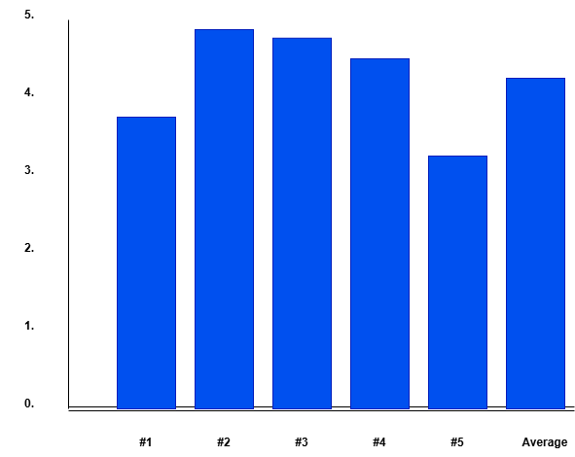

2. Reliability
The overall weighted mean for Reliability is:
(3.2 + 2.8 + 3.5 + 4.2 + 4.5) / 5 = 3.64
Interpretation: Agree (The feature is necessary/beneficial)
Findings:
- The system provides dependable support for daily gym operations (WM = 4.5).
- Data stored in the system remains secure and consistent (WM = 4.2).
- The system performs tasks with minimal crashes (WM = 3.5).
- System functionality during regular use received moderate agreement (WM = 3.2).
- Accessibility whenever needed received the lowest rating (WM = 2.8 – Neutral).
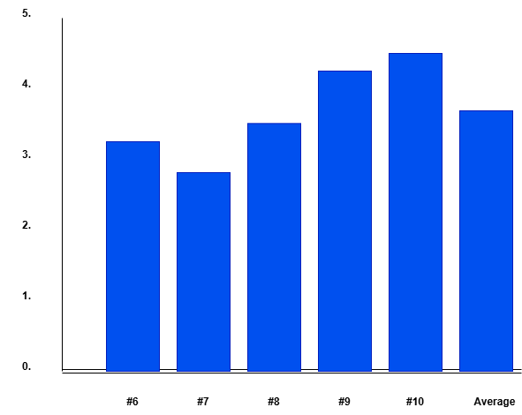
The results show that SmartGym is generally reliable; however, improvements in accessibility and performance stability are recommended.

3. User Satisfaction
The overall weighted mean for User Satisfaction is:
(4.8 + 4.9 + 4.5 + 3.8 + 4.5) / 5 = 4.50
Interpretation: Strongly Agree (The feature is highly necessary/beneficial)
Findings:
- The system interface is clear and user-friendly (WM = 4.9).
- The system is easy to use and understand (WM = 4.8).
- The system helps users perform tasks more efficiently (WM = 4.5).
- Users are satisfied overall with the SmartGym system (WM = 4.5).
- The system improves overall gym management (WM = 3.8).
This indicates that SmartGym achieved a high level of acceptance in terms of usability, clarity, and overall user experience among the 40 respondents.

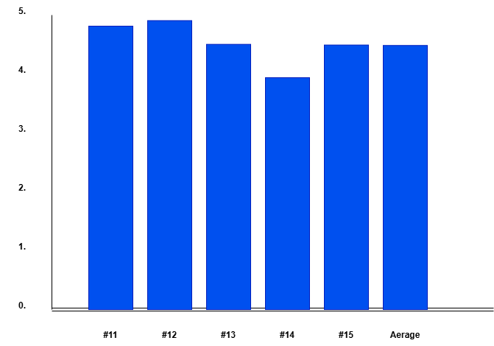
4. Overall System Acceptability
The overall weighted mean for System Acceptability is:
(3.2 + 4.4 + 3.3 + 3.5 + 3.8) / 5 = 3.64
Interpretation: Agree (The system is acceptable and beneficial)
Findings:
- The system improves efficiency of gym management processes (WM = 4.4).
- Users would recommend continued system use (WM = 3.8).
- Users are moderately satisfied with overall performance (WM = 3.5).
- The system enhances service quality (WM = 3.3).
- Integration into current gym operations received moderate agreement (WM = 3.2).
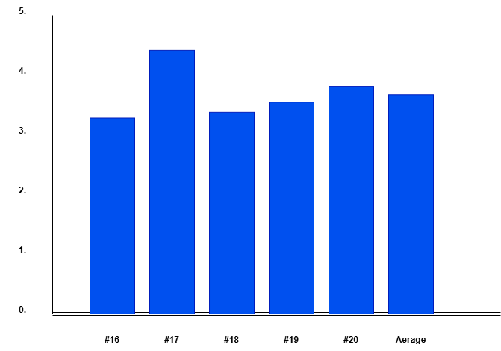
The findings show that SmartGym is generally acceptable for full implementation, although further system enhancements can strengthen integration and service quality.
Overall Grand Mean
To determine the general level of acceptability:
Accuracy = 4.18
Reliability = 3.64
User Satisfaction = 4.50
Overall Acceptability = 3.64
Grand Mean = (4.18 + 3.64 + 4.50 + 3.64) / 4 = 3.99

Final Interpretation: Agree
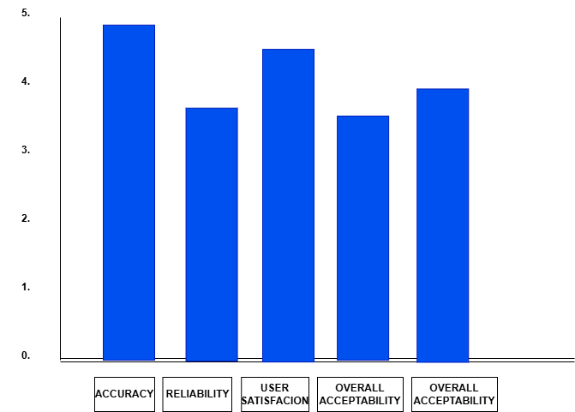
This means that based on the evaluation of 40 respondents, the SmartGym system is considered acceptable, beneficial, and suitable for gym operations.

Conclusions
Based on the findings of the study, the following conclusions are drawn:
- The SmartGym system effectively improves the accuracy of membership, attendance, and workout program records compared to manual processes.
- The system demonstrates satisfactory reliability in supporting daily gym operations; however, improvements in accessibility and performance stability are necessary.
- The system achieved a high level of user satisfaction, particularly in ease of use and interface design, as reflected by the “Strongly Agree” rating.
- With a computed grand mean of 3.99 (Agree), the SmartGym system is acceptable for integration into Vinathletics Fitness Gym operations.
- The Descriptive–Quantitative evaluation conducted among 50 participants confirms that SmartGym meets its objectives of enhancing operational efficiency, improving record accuracy, and supporting gym management processes.

Recommendations
Based on the conclusions of the study, the following recommendations are proposed:
- Improve System Accessibility
Enhance hosting infrastructure and internet optimization to ensure 24/7 access and minimize downtime.
- Strengthen System Performance
Optimize the backend system and database queries to improve speed and reduce potential crashes.

- Integrate Additional Features
Future enhancements may include:
  - Online payment and billing integration
  - SMS or email notification system
  - Dedicated mobile application version
  - Advanced data analytics and reporting tools
- Conduct Regular System Maintenance
Periodic updates, monitoring, and security audits should be implemented to maintain system reliability and protect stored data.
- Expand Research Scope
Future studies may evaluate the system across multiple gym branches or incorporate biometric and IoT-based tracking technologies.
- Continuous System Evaluation
It is recommended that follow-up surveys be conducted annually to continuously assess system performance and user satisfaction.
Overall, the SmartGym: Web-Based Fitness Program Management and Membership Tracking System has been evaluated by 50 respondents and has proven to be an acceptable and beneficial technological solution for improving the operational efficiency of Vinathletics Fitness Gym.

APPENDICES
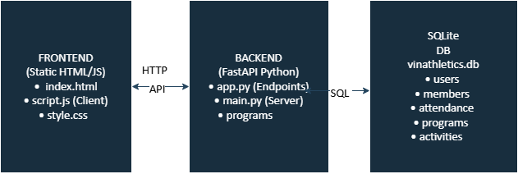
SYSTEM ARCHITECTURE

The SmartGym system follows a three-tier architecture, consisting of the Frontend, Backend, and Database layers. These components work together to ensure efficient data processing, user interaction, and system functionality.
1. Frontend Layer (Client-Side)
The frontend is developed using static web technologies, including HTML, CSS, and JavaScript. It serves as the user interface where gym staff and users interact with the system. Key files include:
- index.html – Provides the structure and layout of the web application
- style.css – Handles the design and visual presentation
- script.js – Manages client-side logic and user interactions

This layer is responsible for collecting user inputs (e.g., registration, attendance, program selection) and sending requests to the backend through HTTP.
2. Backend Layer (Application Server)
The backend is built using FastAPI (Python), which processes client requests and handles business logic. It consists of:

- main.py – Acts as the main server that runs the application
- app.py – Contains API endpoints that define how the system responds to request
- Programs module – Manages fitness program-related operations

The backend receives HTTP requests from the frontend, processes them, and communicates with the database using SQL queries. It ensures data validation, logic execution, and secure handling of information.
- Database Layer (Data Storage)
The system uses an SQLite database (vinathletics.db) to store and manage data. It contains the following tables:

- users – Stores system user accounts
- members – Contains gym member information
- attendance – Records member check-ins and activity logs
- programs – Stores available fitness programs
- activities – Tracks specific workout or gym-related activities
The database layer is responsible for persistent data storage and retrieval, ensuring that all system information is organized and accessible.

4. Data Flow

- The user interacts with the frontend interface.
- The frontend sends an HTTP request to the backend via API.
- The backend processes the request and performs necessary operations.
- If needed, the backend communicates with the SQLite database using SQL queries.
- The database returns the requested data to the backend.
- The backend sends a response back to the frontend.
- The frontend displays the updated information to the user.

Summary
This architecture separates concerns into distinct layers, making the system modular, maintainable, and scalable. The frontend handles presentation, the backend manages logic and communication, and the database ensures reliable data storage.
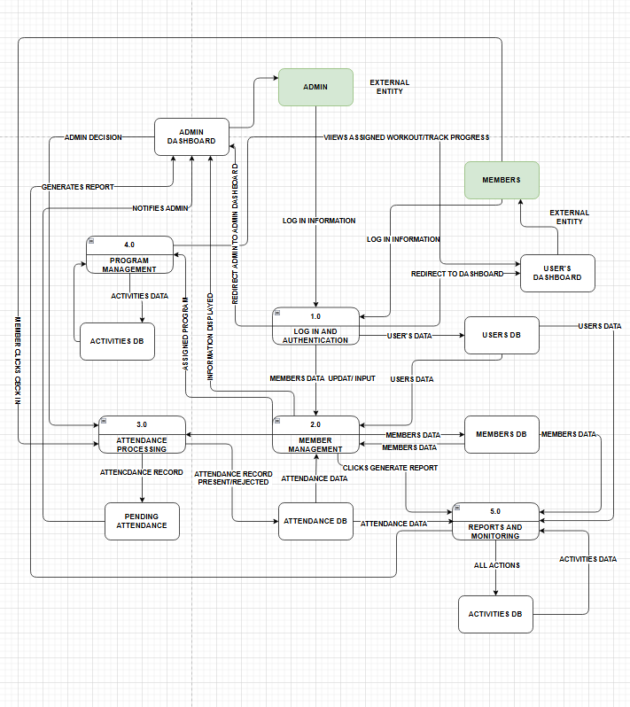
MAIN DATA FLOW DIAGRAM LEVEL 1

EXPLANATION
1. Login and Authentication (1.0)
- Both Admin and Member enter login credentials
- The system verifies data using the Users Database
- Once validated:
  - Admin → redirected to Admin Dashboard
  - Member → redirected to Member Dashboard
This ensures secure system access and role-based control

2. Member Management (2.0)
- Admin can:
  - Add members
  - Update profiles
  - Archive accounts
- Data is stored in the Members Database
This replaces manual record-keeping and improves accuracy

3. Attendance Processing (3.0)
Flow:
- Member clicks Check-In
- System records attendance as Pending
- Data is saved in Attendance Database
- Admin views pending requests
- Admin approves/rejects:
  - Approved → status = Present
  - Rejected → status = Rejected
This is your core system feature

4. Program Management (4.0)
- Admin:
  - Creates workout programs
  - Assigns programs to members
- Member:
  - Views assigned workout
  - Tracks progress
Stored in Programs Database

5. Reports and Monitoring (5.0)
- System generates:
  - Attendance reports
  - Member activity logs
  - System history
- All actions are stored in Activities Database
Ensures:
- Transparency
- Monitoring
- Decision-making support

CONTEXT DIAGRAM LVL 0
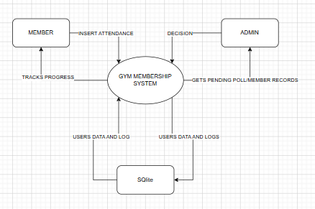
This diagram illustrates the Member Check-In Process of the Gym Membership System, showing how data flows between the Member, Admin, and the SQLite Database. It focuses on how attendance is recorded, validated, and updated within the system.

1. Member Initiates Check-In
The process begins when the Member attempts to check in.
- The Member sends a request:
POST /check-in → Gym Membership System (Backend)
- The system processes the request and stores the attendance as:
INSERT attendance (Pending) → SQLite DB
At this stage, the check-in is not yet finalized and requires Admin approval.

2. System Logs the Activity
After receiving the check-in request:
- The Gym Membership System records an activity log:
"Requested Check-in" → SQLite DB
This ensures that all actions are tracked for monitoring and auditing purposes.

3. Admin Retrieves Pending Requests
The Admin monitors pending check-ins.
- The Admin sends a request:
GET /pending (poll) → Backend
- The system retrieves data from the database:
attendance status = "Pending" ← SQLite DB
The Admin is then able to view all pending attendance records that require action.

4. Admin Makes a Decision
After reviewing the request:
- The Admin sends a decision:
PUT /approve/{id} → Backend
- The system updates the attendance record:
UPDATE attendance (Present) → SQLite DB
If rejected, the status would be updated accordingly (e.g., Rejected).

5. System Logs Approval
Once the Admin approves the check-in:
- The system logs the action:
"Approved Check-in" → SQLite DB
This maintains a complete history of system activities.

6. Member Receives Updated Status
Finally, the Member checks their attendance status:
- The Member sends a request:
GET /attendance/{user} (poll) → Backend
- The system retrieves updated data:
status = "Present" ← SQLite DB
The Member can now see that their check-in has been successfully approved.

Overall Flow Summary
- The Member initiates check-in.
- The System records it as pending and logs the action.
- The Admin retrieves and reviews pending requests.
- The Admin approves the check-in.
- The System updates and logs the final status.
- The Member receives the confirmed attendance status.

Conclusion
This diagram clearly shows a controlled and validated attendance process, where:
- The Member provides input (check-in request)
- The Admin verifies and approves the request
- The Gym Membership System handles processing and logging
- The SQLite Database ensures reliable data storage and retrieval
This flow ensures accuracy, accountability, and real-time tracking of gym attendance.

Level 2 DFD further explodes Process 3.0 Admin Management Dashboard from Level 1 into sub-processes.
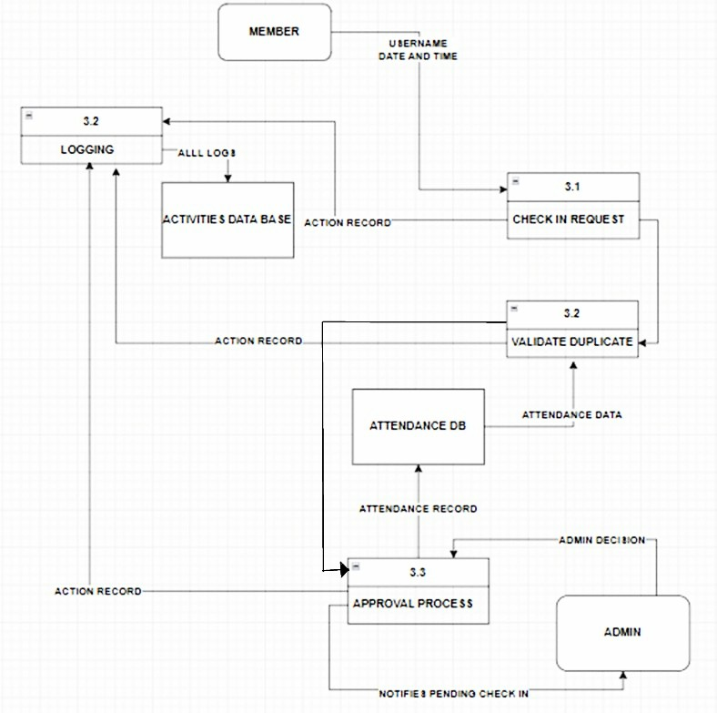
DETAILED EXPLANATION (LEVEL 2)
Overview
The Level 2 Data Flow Diagram provides a detailed breakdown of the Attendance Processing System, which is the core function of SmartGym. It shows how a check-in request moves step-by-step from the member to the admin and back to the system.

Sub-Processes Explanation
3.1 Check-In Request
- The member initiates a check-in
- Sends request to the system
- Data includes:
  - Username
  - Date and time
This starts the attendance process
3.2 Validate Duplicate
- System checks if the member already checked in for the day
- Uses Attendance Database
If duplicate → request is rejected
If not → proceed to next step
Prevents multiple check-ins in one day
3.3 Approval Process
- Admin views pending check-ins
- Admin decides:
  - Approve → status = Present
  - Reject → status = Rejected
Ensures controlled and verified attendance

3.4 Logging
- Every action is recorded:
  - Check-in request
  - Approval/rejection
- Stored in Activities Database
Provides audit trail and transparency
3.5 Status Update / Output
- System updates final attendance status:
  - Pending
  - Present
  - Rejected

Core Data Flow Paths
A. User Authentication Flow
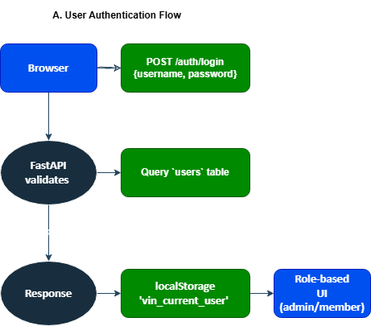3. Key Components & Data Movement
Component Purpose Data In Data Out
script.js Client logic API responses (JSON) API requests (POST/PUT/GET/DELETE)
app.py API Layer HTTP requests, DB sessions JSON responses, DB commits
Models DB Schema Pydantic schemas SQLAlchemy ORM objects
DB Tables Persistence ORM objects Query results
CORS Enabled: Frontend can call backend from any origin (allow_origins=["*"])
________________________________________
4. Role-Based Data Access
ADMIN (role="admin"):
├─ Full CRUD: members, programs, users
├─ Approve/reject check-ins
└─ View all analytics/logs

MEMBER (role="member"):
├─ View own attendance/profile/program
├─ Request check-in (pending approval)
└─ Update own workout progress
________________________________________
5. Live Synchronization
• Polling: Frontend polls APIs every 5s (setInterval)
• Real-time feel: Check-ins, approvals, activity logs update instantly
• Local Storage: User session persists across refreshes

B. Member Check-in Flow (Primary Use Case)
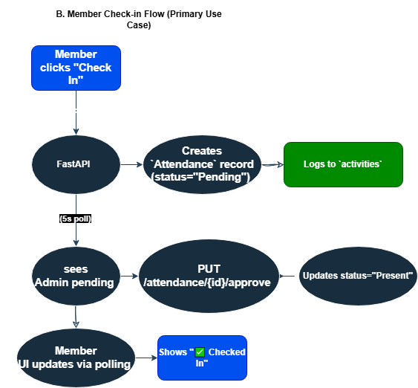
Example Live Flow:
Member A checks in → DB writes "Pending" → Admin approves → DB writes "Present"
↕️ Polling keeps all UIs synced within 5s
This creates a responsive gym management dashboard where frontend drives user interaction, backend handles secure API/DB operations, and SQLite provides lightweight persistence. Perfect for small-medium gyms.
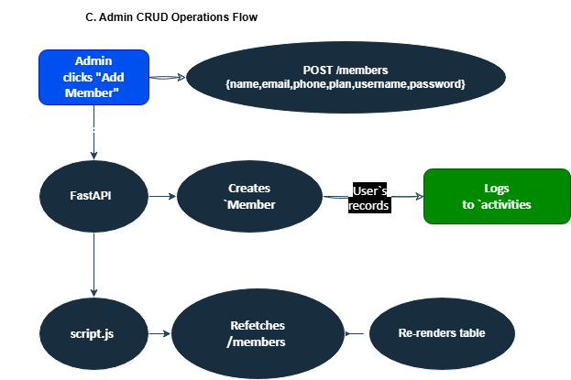
C. Admin CRUD Operations Flow

VINATHLETICS PROGRAM FLOW CHART
Here's the complete program execution flow from startup to live operation, visualized as a flowchart:
1. Overall Program Flow (Chat Diagram)
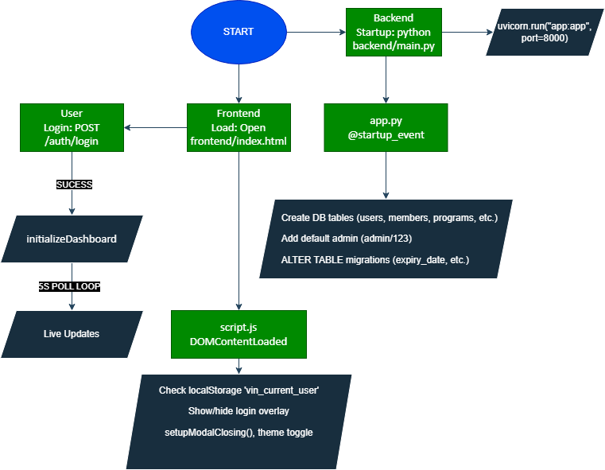
2. Detailed Backend Startup Flow
main.py → uvicorn "app:app"
│
app.py startup_event():
├─ SessionLocal() → Connect SQLite vinathletics.db (or cloud)
├─ Base.metadata.create_all()
├─ TRY: ALTER TABLE members ADD expiry_date, etc.
├─ Check/Create admin user
└─ Server READY: http://127.0.0.1:8000

3. Frontend Program Flow (Main Dashboard)
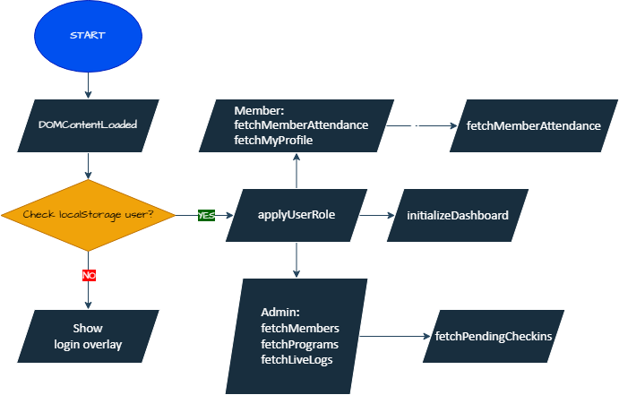

4. Critical User Flows (Sequence Diagrams)
A. Member Check-in Flow
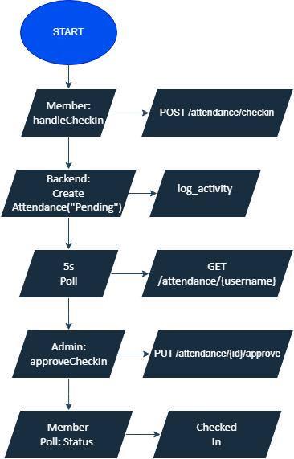

B. Admin Add Member Flow
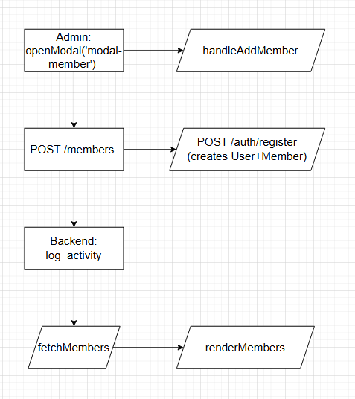

C. Live Activity Feed Flow
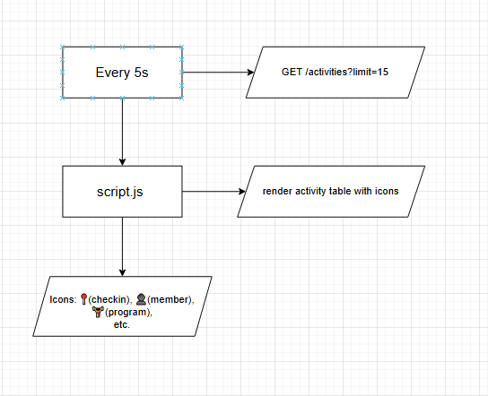

5. Event-Driven Flows
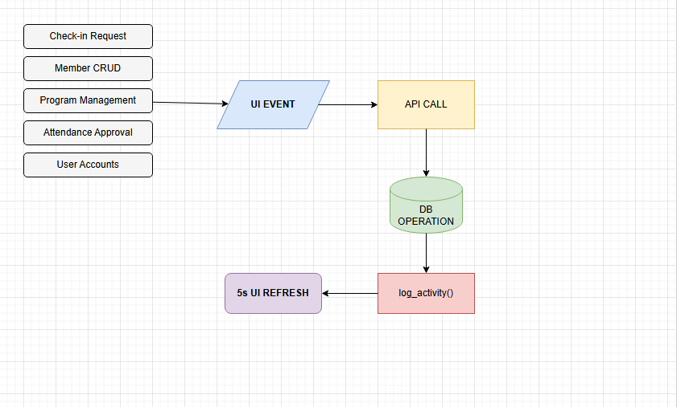
6. Error Handling Flow
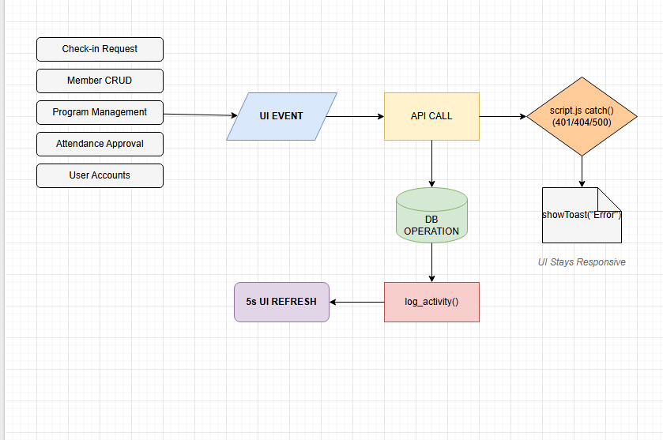

7. Demo Command /// Adrian
# Terminal 1:
cd "c:/Users/juran/Desktop/THESIS/backend"
python main.py
# Terminal 2: Open frontend/index.html in browser
# Login: admin / 123
Key Insight: Polling-based real-time (no WebSockets) + Role-based rendering + Activity logging for audit trail creates a smooth SPA-like experience from static HTML/JS.
The program is production-ready for small gyms with instant sync across admin/member views!
1. Overall Program Flow (Chat Diagram)
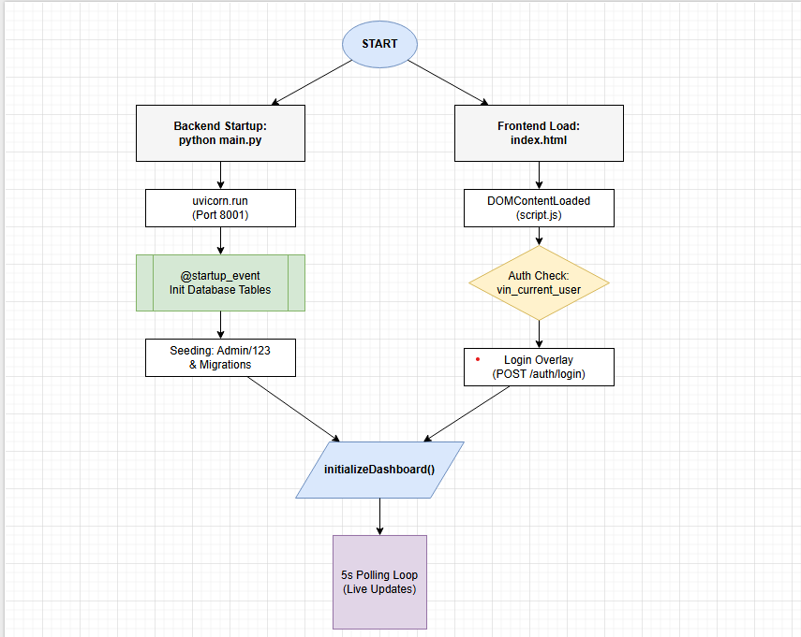
2. Backend Startup Sequence
1. main.py.main() → uvicorn.run("app:app", host="0.0.0.0", port=8001)
2. app.py FastAPI() + CORSMiddleware(*)
3. @app.on_event("startup"):
├── DB Engine: sqlite:///vinathletics.db
├── Base.metadata.create_all()
├── Migrations: ALTER TABLE ADD expiry_date/phone/etc.
└── Create default admin: username="admin", password="123"

4. Server listening: http://127.0.0.1:8001
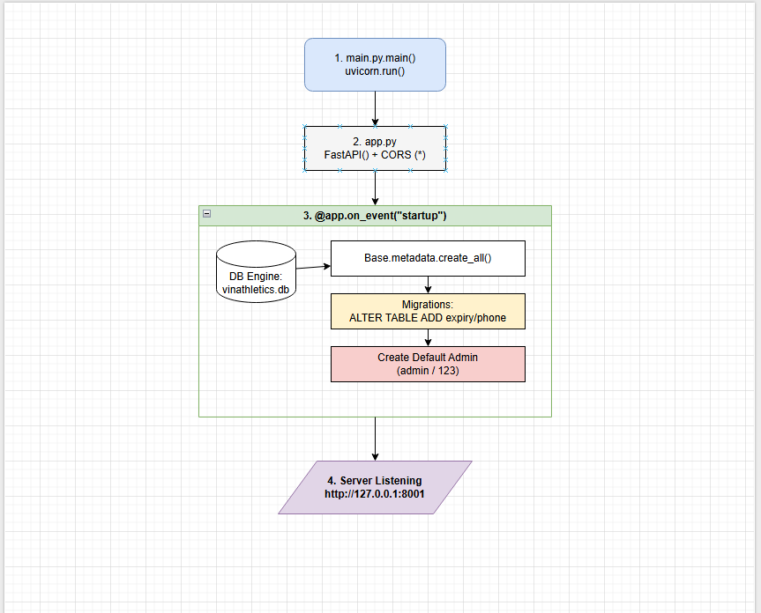

3. Frontend Initialization Flow
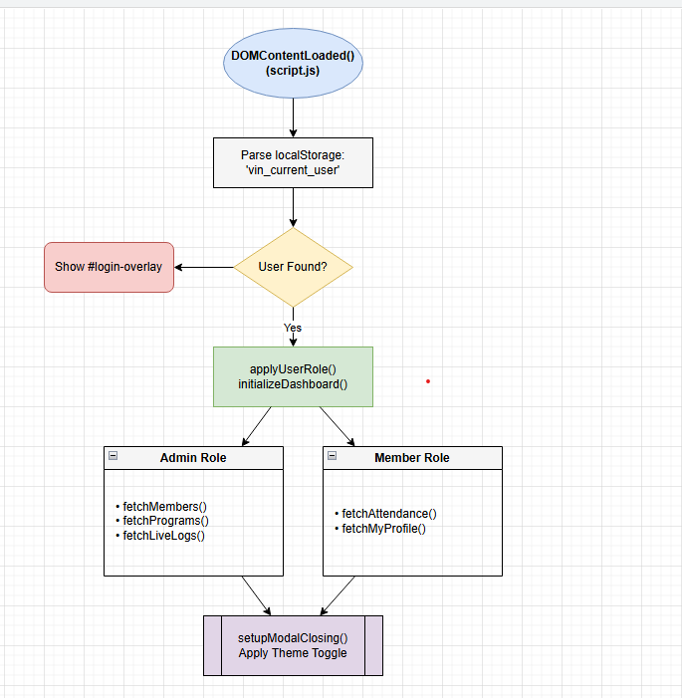

4. Core Runtime Flows (5s Polling Engine)
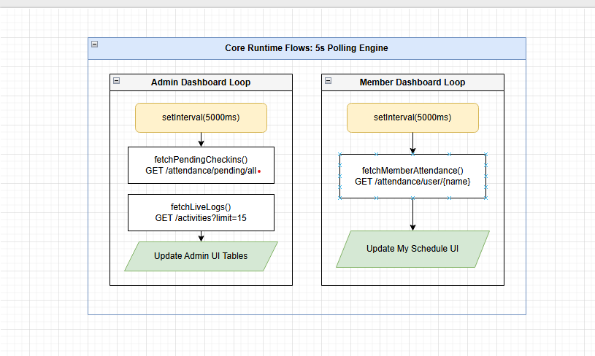
5. Key User Action Flows
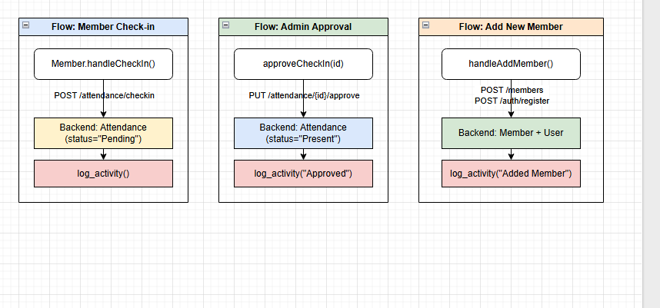

6. Event Loop Architecture
Demo:
cd "c:/Users/juran/Desktop/THESIS/backend" && python main.py
# Browser: Open frontend/index.html
# Login: admin/123 → Watch live sync!
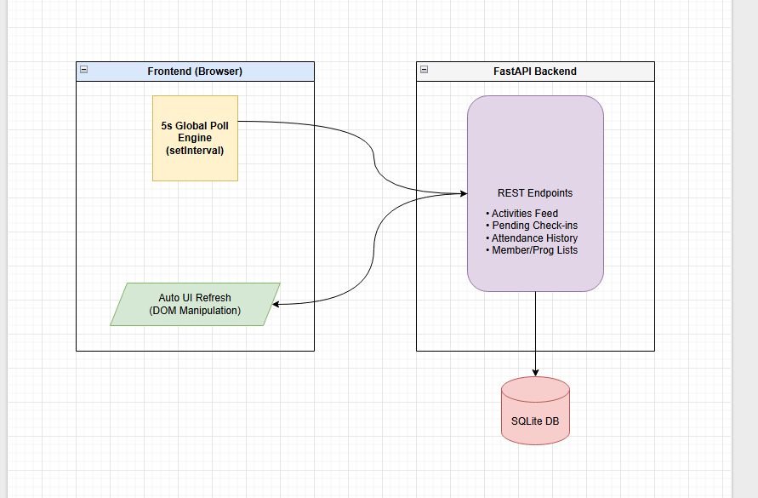
VTOC
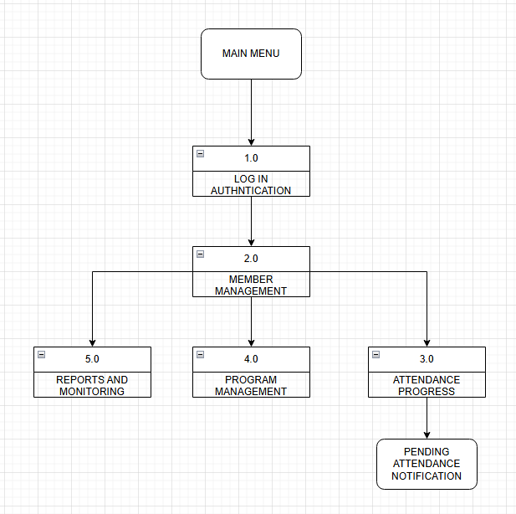
Visual Table of Contents (VTOC) Explanation
The VTOC presents the hierarchical structure of the system, outlining its major processes and how users navigate through them from the main entry point.
At the top level, the system begins with the Main Menu, which serves as the primary interface for users to access system functionalities.
From the Main Menu, users proceed to Process 1.0: Log In / Authentication. This module is responsible for verifying user credentials and ensuring secure access to the system. Only authenticated users can proceed further.
Once logged in, users enter Process 2.0: Member Management, which acts as the central hub of the system. This module allows users to manage member-related information and provides access to other key system functions.
From Member Management, the system branches into three main sub-processes:
- Process 3.0: Attendance Progress
This module tracks and monitors attendance records. It also triggers Pending Attendance Notifications, which alert users about incomplete or missing attendance data.
- Process 4.0: Program Management
This section handles the creation, updating, and organization of programs within the system. It ensures that all program-related data is properly maintained.
- Process 5.0: Reports and Monitoring
This module generates reports and provides analytical insights, enabling administrators to monitor system performance, member activity, and attendance trends.

Summary of Flow
- Main Menu
- Log In / Authentication (1.0)
- Member Management (2.0)
- Branch to:
  - Attendance Progress (3.0) → Pending Attendance Notification
  - Program Management (4.0)
  - Reports and Monitoring (5.0)

IPO DIAGRAM

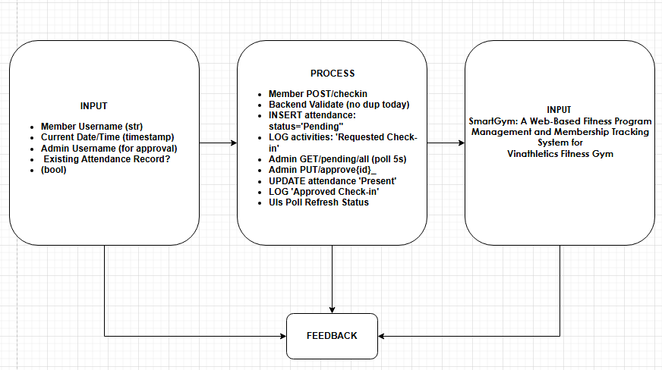

Explanation of the IPO Diagram
The diagram illustrates the flow of data within the system, beginning with the required inputs, followed by the internal processing steps, and ending with the generated outputs. It also includes a feedback mechanism to ensure system updates and user awareness.
1. Input
The system requires specific data to initiate the attendance process:
- Member Username (string): Identifies the member attempting to check in.
- Current Date/Time (timestamp): Records when the check-in request is made.
- Admin Username (for approval): Identifies the administrator responsible for validating the request.
- Existing Attendance Record (boolean): Determines whether the member has already checked in for the day, preventing duplicate entries.
These inputs ensure that the system has sufficient and accurate data before processing any attendance request.

2. Process
The process section outlines the sequence of operations performed by the system:
- The member submits a POST request to check in.
- The system performs backend validation to ensure no duplicate attendance exists for the current day.
- If valid, the system inserts a new attendance record with a status of Pending.
- The system logs the activity as “Requested Check-in” for tracking purposes.
- The admin interface retrieves pending requests via a GET request.
- The administrator reviews and approves the request using a PUT request.
- Once approved, the system updates the attendance status to “Present.”
- The system logs the action as “Approved Check-in.”
- The user interface refreshes automatically to reflect the updated status.
This structured process ensures data integrity, accountability, and proper authorization before confirming attendance.

3. Output
After processing, the system generates the following outputs:
- Display of confirmation status: Notifies the user whether their check-in is approved or pending.
- Updated attendance status: Reflects the member’s official attendance record.
- Activity logs: Maintains a history of actions for auditing and monitoring.
- Monthly reports: Compiles attendance data into reports for administrative use.

4. Feedback
The feedback loop connects the output back to the system and users. This ensures that:
- Users receive real-time updates on their check-in status.
- The system continuously updates records and logs.
- Administrators can monitor and adjust actions based on system responses.

Summary
Overall, the IPO diagram demonstrates a controlled and validated attendance workflow where user inputs are carefully processed, verified by an administrator, and transformed into meaningful outputs such as attendance records and reports. The inclusion of a feedback loop enhances system reliability and user interaction.

Software Development Life Cycle (SDLC)

Agile Model
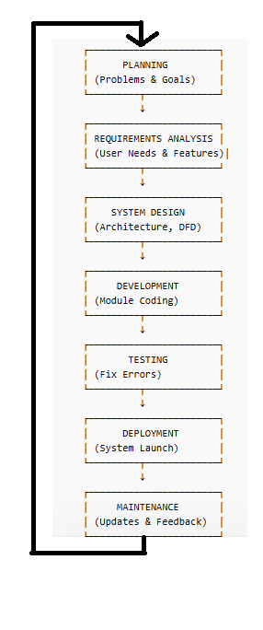
This study adopted the Agile Software Development Life Cycle (SDLC) Model in the development of the SmartGym: Web-Based Fitness Program Management and Membership Tracking System. The Agile model is an iterative and incremental approach that emphasizes flexibility, continuous improvement, and active user involvement throughout the development process.
The selection of the Agile model is appropriate for this system because it allows the researchers to develop the application in phases while continuously testing and improving each module. Since the system includes multiple components such as membership management, attendance tracking, workout program management, and progress monitoring, Agile enables the gradual integration of these features while ensuring that user requirements are consistently met.
Phases of the Agile SDLC Model
1. Planning Phase
The planning phase involves identifying the problems and defining the objectives of the system. Based on the initial assessment, Vinathletics Fitness Gym experiences inefficiencies due to manual record-keeping, data inaccuracies, and delays in processing information.
In this phase, the researchers established the general and specific objectives of the study, identified the target users (administrators, trainers, and members), and determined the overall scope and limitations of the system.
2. Requirements Analysis Phase
During this phase, the researchers gathered and analyzed the system requirements through observation, interviews, and review of existing processes. The requirements were categorized into functional and non-functional requirements.
The key functional requirements identified include:
- Membership Management
- Attendance Tracking
- Workout Program Management
- Fitness Progress Monitoring
- Role-Based User Access
Non-functional requirements such as system usability, reliability, performance, and security were also considered to ensure the system meets quality standards.

3. System Design Phase
In the design phase, the overall architecture and structure of the system were defined. The SmartGym system follows a three-tier architecture, consisting of:
- Presentation Layer (Frontend): Developed using HTML, CSS, and JavaScript
- Application Layer (Backend): Developed using Python with FastAPI
- Data Layer (Database): Managed using SQLite with SQLAlchemy ORM
Additionally, system design tools such as Data Flow Diagrams (DFD), Input-Process-Output (IPO) diagrams, and database schema designs were created to visualize system processes and data flow.
4. Development Phase
The development phase involves the actual coding and implementation of the system. Using the Agile approach, the system was developed incrementally, with each module built and tested separately before integration.
The major modules developed include:
- User Authentication System
- Membership Management Module
- Attendance Tracking Module
- Workout Program Management Module
- Progress Monitoring Dashboard
Each module was continuously refined based on testing results and feedback from users.

5. Testing Phase
The testing phase ensures that the system functions correctly and meets user requirements. Various testing methods were applied, including:
- Unit Testing – to verify individual components
- Integration Testing – to ensure modules work together properly
- User Acceptance Testing (UAT) – to evaluate system usability and functionality
Errors and bugs identified during testing were immediately corrected in subsequent iterations, ensuring system reliability and performance.

6. Deployment Phase
After successful testing, the system was deployed for actual use at Vinathletics Fitness Gym. The system was made accessible through a web browser, allowing users to log in and utilize its features in real time.
During deployment, users were oriented on how to use the system, including membership registration, attendance check-in, and program monitoring.
7. Maintenance and Continuous Improvement
The final phase involves maintaining and improving the system based on user feedback and performance evaluation. Since Agile promotes continuous iteration, updates and enhancements are regularly implemented.
Future improvements may include:
- Integration of online payment systems
- SMS or email notification features
- Development of a mobile application version
- Advanced analytics and reporting tools
This phase ensures that the system remains effective, up-to-date, and aligned with the evolving needs of the users.

Summary
The Agile SDLC model provided a structured yet flexible framework for the development of the SmartGym system. Through iterative development, continuous testing, and user feedback integration, the system was successfully designed and implemented to improve gym operations, enhance data accuracy, and provide a better user experience for administrators, trainers, and members.

EVALUATION RESULT
Summary of Findings
This chapter presents the findings based on the data gathered using the Descriptive–Quantitative Survey Design described in Chapter III. The responses were analyzed using the Weighted Mean (WM = Σfx / N) and interpreted using the approved 5-Point Likert Scale.
The respondents consisted of fifty (50) participants, including the gym owner, trainers/staff, and gym members of Vinathletics Fitness Gym, selected through purposive sampling. These respondents directly interacted with the SmartGym system and were therefore capable of providing valid and reliable evaluations regarding its acceptability.

Conclusions
Based on the findings of the study, the following conclusions are drawn:
- The SmartGym system effectively improves the accuracy of membership, attendance, and workout program records compared to manual processes.
- The system demonstrates satisfactory reliability in supporting daily gym operations; however, improvements in accessibility and performance stability are necessary.
- The system achieved a high level of user satisfaction, particularly in ease of use and interface design, as reflected by the “Strongly Agree” rating.
- With a computed grand mean of 3.99 (Agree), the SmartGym system is acceptable for integration into Vinathletics Fitness Gym operations.
- The Descriptive–Quantitative evaluation conducted among 50 participants confirms that SmartGym meets its objectives of enhancing operational efficiency, improving record accuracy, and supporting gym management processes.

Recommendations
Based on the conclusions of the study, the following recommendations are proposed:
- Improve System Accessibility
Enhance hosting infrastructure and internet optimization to ensure 24/7 access and minimize downtime.
- Strengthen System Performance
Optimize the backend system and database queries to improve speed and reduce potential crashes.
- Integrate Additional Features
Future enhancements may include:
  - Online payment and billing integration
  - SMS or email notification system
  - Dedicated mobile application version
  - Advanced data analytics and reporting tools
- Conduct Regular System Maintenance
Periodic updates, monitoring, and security audits should be implemented to maintain system reliability and protect stored data.
- Expand Research Scope
Future studies may evaluate the system across multiple gym branches or incorporate biometric and IoT-based tracking technologies.
- Continuous System Evaluation
It is recommended that follow-up surveys be conducted annually to continuously assess system performance and user satisfaction.
Overall, the SmartGym: Web-Based Fitness Program Management and Membership Tracking System has been evaluated by 50 respondents and has proven to be an acceptable and beneficial technological solution for improving the operational efficiency of Vinathletics Fitness Gym.

BIBLIOGRAPHY

References:
2021
Cabauatan, K. A. F., & Lopez, G. A. D. (n.d.). Effectiveness of mobile fitness applications and gym exercises in improving health-related fitness performance among college students.
https://www.globusedujournal.in/wp-content/uploads/2021/11/GE-JD21-King-Abram-F.-Cabauatan.pdf
Mahesh Thapa (2021) developed Gym Management System.
https://dspace.sxcjpr.edu.in/jspui/bitstream/123456789/836/1/Informatica2020_21.pdf#page=9
2023
- Author(s): Minseong Kim, Sae-Mi Lee
- Year: 2023
- Link: Read Study
- Summary:
Identified factors influencing satisfaction and dissatisfaction in fitness apps, emphasizing usability and system design.
- Author(s): Kittiya Sae-lee et al.
- Year: 2023
- Link: Read Study
- Summary:
Focused on workout tracking through a mobile health app and its impact on weight reduction across different age groups.
- Author(s): Chao Wang, Zhigang Wang
- Year: 2023
- Link: Read Study
- Summary:
Explored how user involvement and experience influence value creation in fitness apps, highlighting the importance of engagement features.
- Author(s): Mastura Ramli, Suzana Yusof
- Year: 2023
- Link: Read Study
- Summary:
Developed a responsive web-based gym system that automates membership management, scheduling, and payments. Results showed improved efficiency in gym operations.
- Author(s): Salvador Angosto, Jerónimo García-Fernández, Moisés Grimaldi-Puyana
- Year: 2023
- Link: Read Study
- Summary:
A systematic review of 29 studies showing that fitness app adoption increased significantly due to digital transformation and health awareness.
- Author(s): Jerzy Tchórzewski, Wojciech Nabiałek, Artur Księżopolski
- Year: 2023
- Link: Read Study
- Summary:
Analyzed a web-based gym management system using systems theory and modeling. It demonstrated how system structure improves gym operations and data processing.
Abilar, J. C., Artica, B. B., Limsiaco, C. I. R., Subade, D. P., Tanael, D. V., & Centeno, C. J. (n.d.). Fitness game application for promoting physical activity and healthy lifestyle using ISO 25010 evaluation.
https://pdfs.semanticscholar.org/a458/7a9b8689b2f7ddaae09e44b57b14c2268a07.pdf
Cauilan, J. M., Macaraeg, A. D., Parreño, R. S., Solomon, M. M., & Teria, J. K. R. (n.d.). Strong Tower Management System with health monitoring progress.
https://www.scribd.com/document/648536224/5-25-2023
Nishanthan, M.(2023) developed JK Fitness Office: Web based Gym Management System.
https://dl.ucsc.cmb.ac.lk/jspui/handle/123456789/4712
Zhao, D., Wang, F., & Zhu, X.-f. (2023). Design and implementation of gym management system based on web.
https://books.google.com/books?hl=en&lr=&id=97nJEAAAQBAJ&oi=fnd&pg=PA44&dq=web+based+gym+management+system&ots=YPo6lKZhmE&sig=RVq4l8DTpI_TTJLuB9QwuybE6Ic

2022
- Author(s): Mobark Q. Aldossari, Quynh N. Nguyen, Anh Tac, Steven A. Schulz
- Year: 2022
- Link: Read Study
- Summary:
Examined how system quality and information quality influence user behavior and performance in fitness apps.

2025
Bulaclac, J. R., Pastorfide, J. M. V., Herrera, N. G., & Tambio, C. N. C. (n.d.). King’s Way cashless payment and product monitoring system with QR technology for the fitness industry. Nueva Ecija University of Science and Technology, Philippines.
https://www.ijikm.org/Volume20/IJIKMv20Art035Bulaclac12314.pdf
Hussain, A. R., Yi, K. W., Halimi, S. N. A. R., & Abidin, S. M. F. S. (n.d.). Q-Fitness Gym System (QFGS): A web-based gym management platform.
https://rsisinternational.org/journals/ijriss/view/q-fitness-gym-system-an-integrated-web-application-for-smart-gym-operations-and-member-engagement
Sabado, S. C., Espartinez, R. A., Acepcion, R., Jr., Bautista, J. V. P., Mancera, F. W., & Magdael, A. J. (n.d.). A web-based gym member monitoring system using predictive analytics and decision tree algorithm. Arellano University, Pasig Campus.
https://www.ijltemas.in/submission/online/article/view/3287?utm_source
Villanueva, M. C., Sevilla, S. A. S., & Verecio, R. L. (2025). Development of Olympic Fitness Gym Management System with integrated QR code technology.
https://doi.org/10.46932/sfjdv6n4-030

SAMPLE SCREEN OUTPUT
1. MEMBER VIEW - Before Check-In
┌─ My Attendance Stats ──────────────────────┐
Total Days Present 5
Last Visit : March 15,2026

┌─ Today's Status ───────────────────────────┐
Not Checked In [ Check In Now ] ← Active Button
Date: March 15, 2026

2. MEMBER VIEW - After Request (Pending)
┌─ Today's Status ───────────────────────────┐
│ Waiting for Admin │
│ │
│ [ Pending Approval ] ← Disabled │
│ Date: March 15, 2026 │
└──────────────────────────────────────┘
Toast: "Check-in requested! Waiting for admin. "

- MEMBER VIEW - After Approval (Present)
┌─ Today's Status ───────────────────────────
│ Present Today ← Green text
│
│ [ Checked In ] ← Green, Disabled
│ Date: March 15, 2026
└──────────────────────────────────────

- ADMIN DASHBOARD - Pending Check-Ins
┌─ Pending Check-ins ──────────────────────
│ ┌─────┬────────────────────┬──────┬────────┐
│ │ │ @john_doe │2:30P │[Approve][Reject]│
│ └─────┴────────────────────┴──────┴────────┘
└─────────────────────────────────────────────
- ADMIN - After Approval (Activity Log)
┌─ Recent Activity ─────────────────────────────────
│ ┌─────┬────────────┬─────────────────┬──────┐
│ │ │ @admin │ Approved │ 2:31P │
│ │ │ Check-in │ for @john_doe │ │
│ └─────┴────────────┴─────────────────┴──────┘
└─────────────────────────────────────────────
Pending table: Row removed

PROGRAM LISTING
  - Frontend - Member Check-In (script.js)
// Line 85-105: handleCheckIn()
async function handleCheckIn() {
const user = JSON.parse(localStorage.getItem('vin_current_user'));
const btn = document.getElementById('btn-checkin');
btn.innerText = "Processing...";

await fetch(`${API_URL}/attendance/checkin`, {
method: 'POST',
headers: {'Content-Type': 'application/json'},
body: JSON.stringify({ username: user.username })
});

showToast("Check-in requested! Waiting for admin.", "success");
fetchMemberAttendance(user.username); // Poll refresh
}

2. Backend - Check-In Endpoint (app.py Lines 210-225)
@app.post("/attendance/checkin")
def check_in(data: AttendanceCreate, db: Session = Depends(get_db)):
now = datetime.now()
date_str = now.strftime("%b %d, %Y")

# Duplicate check (Step 2.1)
existing = db.query(Attendance).filter(
Attendance.username == data.username,
Attendance.date == date_str
).first()
if existing:
raise HTTPException(400, "Already requested today!")

# Insert Pending (Step 2.1)
new_log = Attendance(username=data.username, date=date_str,
time=now.strftime("%I:%M %p"), status="Pending")
db.add(new_log)
db.commit()

log_activity(db, data.username, "Requested Check-in") # Step 2.2
return new_log

3. Backend - Admin Approval (app.py Lines 240-250)
@app.put("/attendance/{record_id}/approve")
def approve_attendance(record_id: int, user: str, db: Session = Depends(get_db)):
record = db.query(Attendance).filter(Attendance.id == record_id).first()
if record:
record.status = "Present" # Step 2.3
db.commit()
log_activity(db, user, "Approved Check-in", f"@{record.username}")

4.Frontend Polling - Real-time Sync (script.js Lines 50-70)
// 5s Poll for Member
setInterval(() => fetchMemberAttendance(user.username), 5000);

// Admin Pending Table
async function fetchPendingCheckins() {
const pending = await fetch(`${API_URL}/attendance/pending/all`);
// Render Approve/Reject buttons
}

USER’S MANUAL
SmartGym: Web-Based Fitness Program Management and Membership Tracking System

1. Introduction
The SmartGym System is a web-based application designed to manage gym membership, attendance tracking, workout programs, and user progress. It provides an efficient and user-friendly platform for administrators, trainers, and members of Vinathletics Fitness Gym.
This manual serves as a guide for users to understand how to operate the system effectively.
2. System Requirements
- Hardware Requirements
• Desktop or Laptop Computer
• Minimum 4GB RAM
• Stable Internet Connection
• Mobile Device (smartphone or tablet) capable of running a modern web browser
- Software Requirements
• Web Browser (e.g., Google Chrome, Microsoft Edge, or equivalent)
• Backend Server (FastAPI running locally or hosted)
3. Accessing the System
Step 1: Start the System
- Open terminal/command prompt
- Navigate to backend folder
- Run the command:
python main.py
- Open the frontend file (e.g., index.html or siadaw.html) in a browser
Step 2: Login
- Enter your Username
- Enter your Password
- Click “Login” or “Access Dashboard”
Default Admin Account:
Username: admin
Password: 123

4. User Roles and Access
The system has two primary user roles:
4.1 Administrator
- Manage members
- Approve/reject attendance
- Create workout programs
- View reports and logs
4.2 Member
- Request attendance check-in
- View workout programs
- Track progress and attendance history

5. Administrator Guide
5.1 Dashboard Overview
After logging in, the administrator will see:
- Member List
- Pending Check-ins
- Activity Logs
- Reports Section

5.2 Managing Members
Add Member
- Go to Members Tab
- Click “Add Member”
- Fill in required details:
  - Name
  - Email
  - Contact Number
  - Membership Plan
- Click Save

Update Member
- Select a member from the list
- Click Edit
- Update details
- Click Save

Archive Member
- Select member
- Click Archive
- Confirm action

5.3 Attendance Management
View Pending Requests
- Go to Dashboard
- Check Pending Check-ins Table
Approve Check-in
- Click Approve button
- Status changes to Present
Reject Check-in
- Click Reject button
- Status changes to Rejected

5.4 Program Management
Create Program
- Go to Programs Tab
- Click Add Program
- Enter:
  - Program Name
  - Difficulty Level
  - Duration
  - Workout Details
- Click Save
Assign Program to Member
- Go to Members Tab
- Select a member
- Assign a program
- Save changes

5.5 Viewing Reports
- Navigate to Reports Tab
- View:
  - Attendance statistics
  - Member activity
- Print or export if available
5.6 Activity Logs
- Go to Activity Tab
- View system logs:
  - Check-ins
  - Approvals
  - Updates

6. Member Guide
6.1 Dashboard Overview
Members can view:
- Attendance Status
- Workout Program
- Progress Tracking

6.2 Check-In Process
Request Check-In
- Click “Check In Now”
- Status becomes Pending Approval
After Approval
- Status changes to Present
- Button becomes disabled

6.3 Viewing Attendance
- View attendance history
- Check total days present
- See last visit

6.4 Viewing Workout Program
- Go to My Program Section
- View assigned exercises
- Track completed workouts

6.5 Updating Progress
- Mark completed workouts
- Save progress
- System updates automatically

7. System Features
- Automated attendance tracking
- Real-time check-in approval
- Membership management
- Workout program assignment
- Activity logging system
- Role-based access control

8. Troubleshooting Guide
Issue | Possible Solution
Cannot login | Check username/password
Button not working | Refresh the page
No pending check-ins | No requests submitted
Server not running | Run python main.py
Duplicate check-in error | Only one check-in per day allowed

9. Security Notes
- Do not share login credentials
- Logout after use
- Only administrators can modify data
- System logs track all activities

10. Summary
The SmartGym system provides a centralized and efficient platform for managing gym operations. By following this manual, users can easily navigate the system, perform tasks, and maximize its features for improved fitness management and administrative efficiency.
T-TEST ANALYSIS

Purpose of the T-Test
A T-test is a statistical method used to determine whether there is a significant difference between a sample mean and a known or hypothesized population mean.
In this study, the T-test is used to evaluate the system performance, specifically the response time of the SmartGym system, to determine if it meets the acceptable standard.

Hypotheses
- Null Hypothesis (H₀):
The system response time is greater than or equal to 2 seconds (μ ≥ 2.0) → Not acceptable
- Alternative Hypothesis (H₁):
The system response time is less than 2 seconds (μ < 2.0) → Acceptable

Formula Used
t=xˉ−μ0snt = \frac{\bar{x} - \mu_0}{\frac{s}{\sqrt{n}}}t=n​s​xˉ−μ0​​
Where:
- xˉ\bar{x}xˉ = sample mean
- μ0\mu_0μ0​ = hypothesized mean
- sss = standard deviation
- nnn = sample size

Given Data
- Sample Size (n) = 30
- Mean ( xˉ\bar{x}xˉ ) = 0.478 seconds
- Standard Deviation (s) = 0.078
- Hypothesized Mean (μ₀) = 2.0 seconds
- 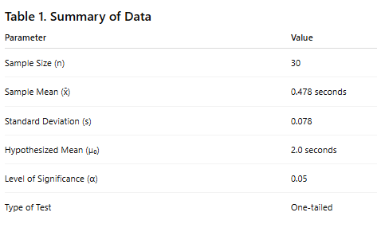

Solution
Substitute the values:
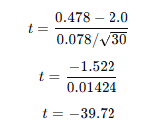
Critical Value
- Level of Significance: α = 0.05
- Degrees of Freedom: df = 29
- Critical t-value ≈ -1.699 (one-tailed test)
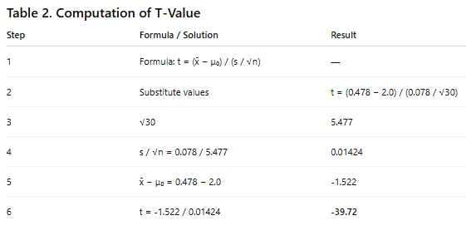

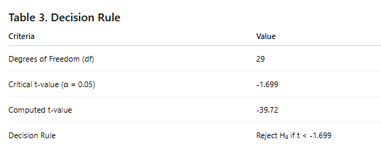Decision Rule
- If t < -1.699, reject H₀
- If t ≥ -1.699, accept H₀

Decision
Since:
t=−39.72<−1.699t = -39.72 < -1.699t=−39.72<−1.699
Reject the Null Hypothesis (H₀)

Basis | Result
Comparison | -39.72 < -1.699
Decision | Reject H₀

Interpretation
The result shows that the system’s response time is significantly less than 2 seconds. Therefore, the SmartGym system meets the required performance standard.

Conclusion
The T-test analysis confirms that the SmartGym system performs efficiently, with an average response time of 0.478 seconds, which is significantly faster than the acceptable threshold of 2 seconds. This indicates that the system provides a fast and responsive user experience.

COST BENEFIT ANALYSIS
Overview
This section presents the cost–benefit analysis of the SmartGym: Web-Based Fitness Program Management and Membership Tracking System. The analysis evaluates the financial feasibility of implementing the system at Vinathletics Fitness Gym, considering its defined scope and limitations.
The system focuses on membership management, attendance tracking, workout program management, and progress monitoring, without including advanced features such as online payments, biometric integration, or multi-branch deployment.

1. Development Costs (One-Time Cost)
Category | Cost (PHP) | Description
System Development | 25,000 | Estimated 50 hours of development (₱500/hour)
Testing and Evaluation | 5,000 | Includes system testing and user evaluation
Software Tools | 0 | Open-source tools (FastAPI, SQLite, HTML, CSS, JavaScript)
Total Development Cost | ₱30,000

2. Operational Costs (Annual)
Category | Cost (PHP) | Description
Hosting / Server | 6,000 | VPS hosting (₱500/month) or local hosting option
System Maintenance | 10,000 | Updates, bug fixes, and monitoring
Data Backup | 1,200 | Cloud storage for database backup
Total Operational Cost (Annual) | ₱17,200

3. Expected Benefits (Annual)
Since the system does not include payment processing, benefits are focused on operational efficiency and cost savings.
Benefit | Value (PHP) | Description
Labor Cost Savings | 240,000 | Reduced manual work (2 hrs/day × 300 days × ₱400/hr)
Error Reduction | 50,000 | Minimizes data loss, duplication, and manual errors
Improved Decision-Making | 30,000 | Accurate reports for attendance and member tracking
Total Benefits (Annual) | ₱320,000

4. Net Benefit Analysis

Item | Amount (PHP)
Total Annual Benefits | 320,000
Total Costs (Year 1) | 47,200
Net Benefit (Year 1) | ₱272,800

5. Return on Investment (ROI
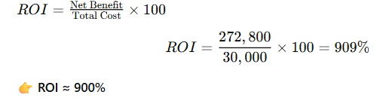
6. Payback Period
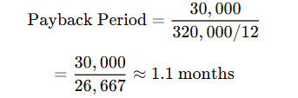
The system pays for itself in approximately 1 month
7. Consideration of Scope and Delimitations
The cost–benefit results are influenced by the system’s defined limitations:

Excluded Features
- No online payment system
- No biometric or IoT integration
- No mobile application
- Single-gym implementation only

Impact on Costs
- Lower development cost (no complex integrations)
- Reduced maintenance complexity
- Minimal infrastructure requirements

Impact on Benefits
- No direct revenue from payment automation
- Benefits mainly come from:
  - Efficiency improvements
  - Labor savings
  - Data accuracy
8. Sensitivity Analysis
Scenario | Members | Annual Benefit | Payback Period
Base Case | 100 | ₱320,000 | 1.1 months
Small Gym | 50 | ₱160,000 | 2.2 months
Expanded Use | 200 | ₱640,000 | < 1 month
9. Summary
The cost–benefit analysis demonstrates that the SmartGym system is financially viable and highly beneficial. Despite its limited scope, the system provides significant savings through improved efficiency and reduced manual workload.
With a high ROI of approximately 900% and a payback period of about one month, the implementation of the system is strongly justified.
Conclusion
The SmartGym system is a cost-effective solution for improving gym operations. Even without advanced features such as payment integration or multi-branch support, the system delivers substantial operational and financial benefits. Therefore, it is recommended for immediate implementation in Vinathletics Fitness Gym

Researcher / programmer


dE LEON, JARRI a

Phone number: 09852122307 Email: jarrideleon.scc@gmail.com Address: PH 7B, BLK 37, LOT 16, PKG 16, Bagong Silang Caloocan City.

Education
2024-PRESENT | ST. CLARE COLLEGE OF CALOOOCAN  BSCS
2016-1018 | ST. DOMINIC SAVIO COLLEGE  STEM
2012-2016 | TALA HIGH SCHOOL

Researcher


dela peÑa, aidrian b

Phone number: 09563957714 Email: aidriandelapena.scc@gmail.com Address: #3081 A. Mabini St. Bagong Pag-Asa Camarin, Caloocan City.

Education
2022 – present | ST. CLARE COLLEGE OF CALOOOCAN  Bachelor of Science in Computer Science
2020 – 2022 | ACCESS COMPUTER COLLEGE  General Academic Strand
2019 – 2020 | SAMPAGUITA HIGH SCHOOL  Learner/Junior high school
2009 – 2016 | SAMPAGUITA ELEMENTARY SCHOOL

Researcher / programmer

ESCALANTE, NATHANIEL R

Phone number: 09382494423 Email: nathanielescalante.scc@gmail.com Address: 092 Magnolia St. Bo. San Lazaro Brgy.187 T.C.C

Education
2022 – present | ST. CLARE COLLEGE OF CALOOOCAN  Bachelor of Science in Computer Science
2020 – 2022 | SAMARIA SENIOR HIGH SCHOOL  General Academic Strand
2019 – 2020 | ALTERNATIVE LEARNING SYSTEM  Learner/Junior high school
2009 – 2016 | APOLINARIO MABINI ELEMENTARY SCHOOL

Researcher / programmer


JURANE, ADRIAN D

Phone number:09956490960 Email: adrianjurane1.scc@gmail.com Address: BLK 18 LOT 22 LOT 22 Dao Street Camarin Road, Hillcrest Village Barangay 173, Caloocan City

Education
2024-PRESENT | ST. CLARE COLLEGE OF CALOOOCAN  BACHELOR OF SCIENCE IN COMPUTER SCIENCE
2021-2023 | AMA COMPUTER COLLEGE  BSIT
2019-2021 | BESTLINK COLLEGE OF THE PHILIPPINES  ICT

Researcher


IVAN GREG A. RIVAS

Phone number: 09455800573 Email: ivangregrivas.scc@gmail.com Address: BLK 5 LOT 2 Maharlika Homes Brgy. 171 Saranay Bagumbong Caloocan City

Education
2023-PRESENT | ST.CLARE COLLEGE OF CALOOCAN  Bachelor of Science in Computer Science
2021-2022 | ST. CLARE COLLEGE OF CALOOCAN  ICT
2016-2020 | BAGUMBONG HIGH SCHOOL

Researcher


SISON, JOHANN CARLO H

Phone number:09947836071 Email:johanncarlosison.scc@gmail.com Address: BLK 12 LOT 13 Ph2 Solar Urban Homes Bagumbong Caloocan City

Education
2023– present | ST. CLARE COLLEGE OF CALOOOCAN  Bachelor of Science in Computer Science
2020 – 2022 | ST. CLARE COLLEGE OF CALOOOCAN  ICT
2016 – 2020 | BAGUMBONG HIGH SCHOOL  Learner/Junior high school
2015– 2016 | RIDGEWOOD SCHOOL OF CALOOCAN

Researcher


KARL CHARTON M. TANAY

Phone number: 09483529843 Email: karltanay.scc@gmail.com Address: blk 23 lot 19 D parnassus st. North Olympus Kaligayahan Quezon city

Education
2022 – present | ST. CLARE COLLEGE OF CALOOOCAN  Bachelor of Science in Computer Science
2020 – 2022 | ST. CLARE COLLEGE OF CALOOOCAN  ICT
2019 – 2020 | CIELITO ZAMORA JR HIGH SCHOOL  Learner/Junior high school
2009 – 2016 | URDUJA ELEMENTARY SCHOOL

