FACTORS INFLUENCING SUKUK DEMAND IN NIGERIA

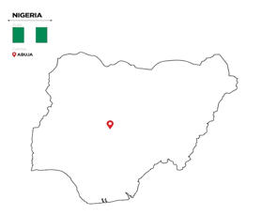

Abstract
Sukuk, often referred to as Islamic bonds, have emerged as a key financial element for ethical investment and infrastructure development across the Muslim borders. However, in Nigeria, the level of Sukuk demand remains modest despite the country’s large Muslim population and its growing appetite for faith-compliant finance. This study enriches with the factors influencing Sukuk demand in Nigeria, examining how trust, religiosity, risk perception, financial literacy, and institutional frameworks shape investor decisions. The study adopts a behavioral finance perspective, recognizing that investor demand in Islamic finance is not only driven by profit motives but also by belief, confidence, and perceived moral justifications. Drawing from secondary data, policy reports, and existing literature, the research highlights that demand is often hindered by low financial literacy, limited awareness, and inconsistent regulatory coordination. Yet, success stories recorded such as the Osun State Sukuk demonstrate how transparency and visible development outcomes can build public confidence and expand participation. Ultimately, this paper argues that enhancing Sukuk demand in Nigeria request more than product promotion, it demands rebuilding trust, simplifying structures, strengthening Shariah governance, and integrating digital and educational inclusion strategies. In truth, finance cannot thrive where belief is weak; and where trust is nurtured, demand follows naturally.
_______________________________________________________________________


1. Introduction
Typically, we hear that people do not want to invest due to a lack of funds. However, the reality is that people may have the funds but lack trust, comprehension, and reason to make the investment. It’s like teaching the man to fish. He knows how to cast the net. But if he doesn’t believe that the fish are in the water anymore, he won't attempt to cast the net. That is the real representation of the demand for Sukuk in Nigeria. It should boom on paper. We boast the largest Muslim population on the African continent. Awareness of Islamic finance is on the increase. However, the numbers of people who are actually involved in the Sukuk market are extremely low. Sukuk market goes beyond being merely a financial market. It’s all about beliefs.
Demand for sukuk also doesn’t depend on market rates of return. Such market rates do not make sukuk attractive because sukuk is free from interest. Equally, neither market rates of return nor the free interest rate is the platform on which the sukuk market survives. Alam & Yousaf (2021) aptly pointed out the importance of trust in the Islamic finance industry: “trust is the currency of Islamic finance.” However, aside from the aspect of trust and believe, other strands in the narrative include religiosity, financial literacy, risk perception, and the institutional environment. Each strand significantly influence the thoughts of Nigerians on how they understand and ultimately require Sukuk.
Various works like those from Usman & Bello (2023) and Mohamed et al. (2022) highlighted the fact that the vast majority of people who invest in Sukuk are attracted by its religiosity but are afraid of the outcome. Thus, the topic of interest for this research revolves around the dynamics that are shaping the demand for Sukuk in Nigeria. This research clearly indicates that the answer to how Sukuk access can scale lies not in the realm of better policies alone but in the areas of building systems that bring people together through human connections. At the end of the road, finance is not all about numbers. It is all about faith. And in the world of Sukuk finance, the challenge is no longer if people want to invest. Rather, the challenge lies in whether people trust the waters enough to cast their nets.

Research Objectives;
This research intends to:
- To investigate the determinants of sukuk demand in Nigeria including trust, religiosity, perceived risk, and financial literacy.
- To assess the importance of institutional structures, regulation policies, and digital inclusion in influencing the engagement of investors in sukuk.
Research Question:
- What are the factors significantly influencing the demand for sukuk in Nigeria and how do trust, religiosity, risk, financial literacy shape their engagement?

2. Literature Review
Every financial system has its mathematics. However, not every system may have its soul. Sukuk is more than just a financial (Sakk) contract. Sukuk is the confluence of the world of conscience and the world of commerce. However, the story of the demand for Sukuk in Nigeria won't be one that is quantified. It must instead come from the hearts and the minds of the people in terms of what they think, what they fear, and what they understand. This is the story the literature suggests if we focus on the human aspects of finance.

2.1 Trust: The Silent Currency of Finance
In Islamic finance, trust is not merely vital but the ‘oxygen that sustains the system.’ Alam & Yousaf (2021) find trust to be ‘the currency of Islamic finance.’ Without it, ‘each Sukuk paper becomes no more than an IOU on blank paper.’ Concerning Nigeria’s culture of trust on the other hand, everyone holds ‘old’ memories of ‘financial let-down.’ Such pains ‘leave the imprint of trust scars.’ So despite the good intention behind the application of Sukuk in the economy and the attractive rate of return on the investment, many ‘are wary and tentative.
However, trust in Sukuk is neither restored through ad campaigns in the media nor through promotional blares on all types of communication networks. Trust in Sukuk ‘emerges from what people observe.’ Observation opens their eyes to the reality on the ground. When the Osun State Sukuk (2013 & 2018) made their ‘funds bloom into roads & classrooms,’ trust in Sukuk was reinstated. At least now ‘investors began to realize that Sukuk was no longer just Islamic finance’s pipedream but was perhaps on their horizon too.

2.2 Religiosity: The Power of Faith and Identity
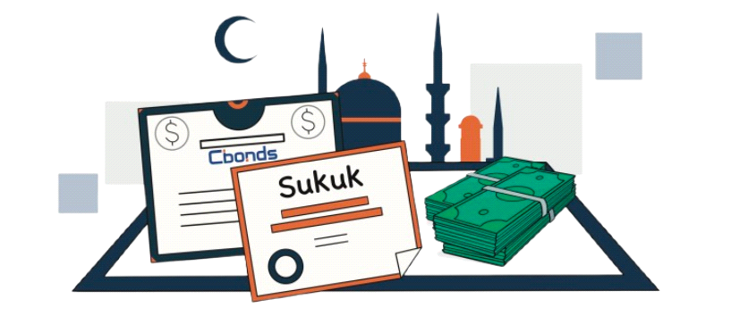
In every human society, the aspect of religion continues to influence people’s behavior in silent ways sometimes and in loud ways at other times. To Muslims, in particular, the aspect of investment is not just financial but also spiritual. Sukuk presents believers with the opportunity to bring their finances in line with their values. According to Usman & Bello (2023), many Nigerian Muslims want to engage in Sukuk investment because “it is halal.” However, many of them are often faced with the challenge of financial realism. Not many people understand the reality that religiosity is the one that fuels intention. According to Alam, Hassan & Rizwan (2021), people might want to engage in Sukuk investment because it suits their spiritual values but might lack the means in terms of money. This means people might want to do the right thing spiritually but might lack the resources. This is the double-standard effect of religiosity.
2.3 Risk Perception: The Fear of the Unknown

Every individual dread the loss, but for the Nigerian common man, the dread also carries history. Over the years of economic uncertainty and the failure of government programs, people know enough to doubt anything that appears alien. However, Sukuk’s faith-related components make it fit the bill. Sukuk might very well be the real deal it’s faith-related and legitimate. But for many people, it’s something foreign. According to Mohamed et al. (2022), it’s the effect of familiarity bias a mental shortcut towards something we know. Nigerians know conventional bank models. Nigerians know how the bank language goes. However, Sukuk looks complicated. It’s all in Arabic jargon that looks like “Mudarabah” and “Ijara” to the average person. Thus, it appears different enough in the bank department to produce uncertainty. According to Rizvi & Arshad (2020), Islamic risk perception is psychological rather than factual. Hence, the answer is clear. Communication in the form of simple ‘nontechnical’ language explanation through learning and the attainment of common knowledge will strip the complexity away. Once individuals ‘know better,’ the fear dissipates. Once the fear dissipates, the demand will increase. All that Sukuk marketers in Nigeria must do is speak in terms of common familiarity.
2.4 Financial Literacy: The Missing Bridge
Financial literacy is like the lighting of the darkness the enlightened observe the opportunity, while the unenlightened stumble in the darkness. Financial literacy in literature consistently ranks as one of the top predictors for Sukuk engagement (Nasir et al. 2022; Olanrewaju et al. 2023). However, in the Nigerian context, the lighting levels are patchy. Urban Nigerian cities like Lagos and Abuja enjoy access to banking literacy lessons. However, in some rural areas where Islamic finance is expected to resonate most, the literacy level on Sukuk is low. People’s faith may be deep but the language of finance keeps them from expressing their faith.
Hassan et al. (2024) assert that digital access is the answer to all of the above. Through mobile learning classes on finance through podcasts on the web, people’s access to financial literacy might soon not require proximity to the institutions. Nevertheless, one often hears the phrase a tool is like the fishing net given to the people if one hasn't taught them where the water sources are. Thus, the amelioration of the demand for Sukuk in Nigeria is predicated on the translation of literacy to the power to do by explaining the meaning behind the messages of Sukuk through its beliefs.

2.5 Institutional and Policy Framework
Regardless of the authenticity of the players in the market, the system in which they undertake their operations must therefore ensure stability. According to the SEC (2023), the institutional framework is one of the prominent determinants in the demand for Sukuk. Frequent fluctuations in government policies affect the market negatively. Lack of clarity on the issue of government collaboration also has the same effect. Despite the advancement in the Securities and Exchange Commission’s (SEC) issuance of Sukuk guidelines in Nigeria’s capital market, the region still faces the problem of various levels of collaboration. This was explained by Ahmed & Noor (2024), who argued that “Policy inconsistency remains the silent killer of confidence.’’ To boost the market and make continued Sukuk-related advancement more effective in the region, lessons from Malaysia/Indonesia’s comparative analysis (Hassan & Rizwan, 2021) must therefore be adopted.

2.6 The Human Side of Sukuk Demand
When all the literature is studied collectively, one aspect becomes crystal clear: the demand for Sukuk is not merely financial in nature. It is human. Every single time a financial decision is made for investment purposes, the process is connected to emotions, memory, and faith. Theories surrounding behavioural finance clearly validate for us the fact that people do not make purely financial decisions based on numbers. People make those decisions based on faith, social pressures, and the perception of fairness (Kassim & Abdullah, 2021). So how do two people who earn the same amount of money and who also have the same access to the same amount of Sukuk act differently in the market? Well, one person allows the values of the Sukuk to align because they want to act on their faith. However, the other person stays away due to fears and apprehensions.

3. Research Methodology
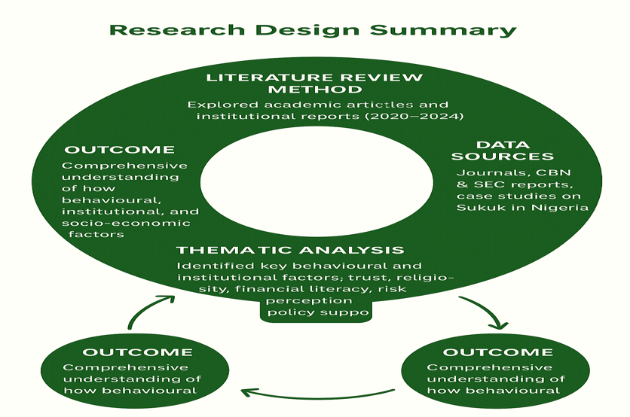
This research work primarily utilized the literature review approach to analyze the determinants of Sukuk demand in the Nigerian market. Additionally, in the process of obtaining data for the research, the qualitative approach was used in gathering information on behavior dynamics among sukuk clients. To thoroughly follow the process in obtaining the relevant context from the sources for analysis, the research used the Journal publications and organizational reports from reputable sources from the year 2020 to 2024 on the subject of Sukuk dynamics, these institutions include the Securities & Exchange Commission (SEC) in Nigeria. Other institutional reports from the Central Bank of Nigeria (CBN). However, A thematic analysis approach was used to identify key institutional factors as well as comparative evaluation of performance reported in the literature.

4. Findings and Discussion
4.1. Trust as the Cornerstone of Participation

Trust in the Islamic finance industry is the silent currency that lends all instruments their value. Sukuk structures will never make any meaning if the system surrounding them lacks reliability. Old bruises from failed cooperative efforts, untrustworthy government bonds, and erratic follow-through still linger for many Nigerian investors. Alam & Yousaf (2021) observe that “trust is not a financial variable. It’s the moral foundation.” This stems from the Nigerian context that despite being attractive in terms of the return on investment, Sukuk still fares low in terms of participation. One cannot link the system if he or she lacks confidence in the sender. Even if it is Shariah-compliant, no one trusts simply because it is obligatory to keep going. It is interesting to note in the Osun Sukuk projects in 2013 & 2018 that once Nigerians physically witnessed road infrastructure, school infrastructure, bridges being erected through Sukuk funding, their interests heightened for a brief period. It was not marketing but infrastructure they witnessed that made their trust heighten. Something profound is noted in all of this. Nigerians love what they witness. Any promise rings the bell for the mirage in the desert. To increase the demand for Sukuk funding, one must convert their financial clarity into public testimony. I always remark that “Numbers convince the mind. Evidence convinces the heart”.
4.2 Religiosity and Moral Identity
The second prominent theme in sukuk is religiosity. This theme serves both as an effective stimulus and an effective deterrent. Many Nigerians, especially in Kano, Ilorin, and the Lagos regions, want to genuinely make use of Sukuk. But the reason many people don't is because religiosity doesn't always ensure economic ability. According to the research by Usman & Bello (2023), despite the fact that more than 60% of Muslims prefer Shariah-compliant investments, less than 20% of them pursued the same. Why the disparity? Well, religiosity doesn't always ensure economic ability. People want the right thing to happen. However, they physically lack the means/money to accomplish the same. Economically, people want the right outcome. However, they lack the knowhow to accomplish the same. This serves to reaffirm the fact that faith triggers interest. But it’s the knowledge that fuels engagement. Islamic finance firms must therefore strike the right note between religiosity and knowhow. Only then will Sukuk continue to witness natural demand. There’s no better way to describe the importance of religiosity than to say it’s not specific to the Islamic faith. Many Christians are now beginning to exhibit their heart for Sukuk because of its transparent business model.
4.3. Risk Perception and Cognitive Bias
Even in the instance where the investors are literate, liberated, and motivated, the perception of risk continues to play an important defining role. Among the Nigerians, the Sukuk instrument is viewed as ‘new,’ ‘complex,’ and in some aspects ‘too religiously technical.’ According to Mohamed etal. (2022), the familiarity bias exists.
People are used to conventional bank systems throughout their life. To shift towards Sukuk means entering a whole new world a new sun rising but also navigating through unfamiliar territory. People may fear the prospect of losses, while others might fear being labeled if they do not grasp the basics of Shariah concepts. This psychological resistance erects both the wall and the bridge. Clarity and consistency are the answer. It is crucial for the world of Sukuk to speak in terms that the common person can grasp. Everything must not be in legal language. It must also not contain Arabic terms. The more the discussion revolves around Sukuk in both language and personal experiences, the less fearsome the risks involved in people’s perspectives.
4.4. Financial Literacy and Digital Inclusion
Sukuk would require educating them financially because in the same nation where less than 40% of the youth are financially literate (EFInA, 2023), to expect considerable participation in Sukuk without educating them would amount to same harvest without planting. Financial literacy acquires meaning beyond educating people on how to manage their finances. Financial literacy helps to influence the attitude people take towards opportunity and risk. According to Nasir et al. (2022), literacy mediates the interrelationship between religiosity and investment behavior in that for all religions, the individual would hold back their capital if they do not understand how the Sukuk works. Since many Nigerians would remember Sukuk simply by its meaning ‘government religious projects,’ the business would require efforts to educate them. Digital learning would play an important role in bridging the same gap. According to Hassan et al. (2024), mobile learning platforms, podcasts, and Islamic fintech portals play an important place in hastening the process of awareness for the same investors. However, for all intents and purposes, I like to maintain that ‘technology without understanding is like a net thrown into the wide but dry sand: wide but useless.’ Digital portals would require teaching beyond marketing.
4.5. Institutional Framework and Policy Support
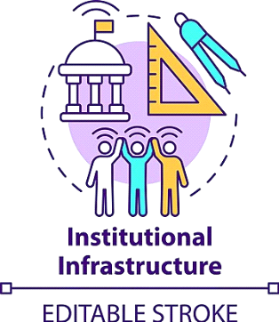

Institutional Framework and Policy Support Each financial system flourishes in its policy environment. Sukuk is no different. While the pace in Nigeria appears to be marked by some progress in disjointed fashion. There appears to be some level of support for Sukuk by the Securities and Exchange Commission (SEC, 2023), the Debt Management Office (DMO), though inter-governmental coordination is shallow. Analyzing the model in Malaysia’s successful Islamic finance system allows for the determination of the National Islamic Finance Coordination Council. This serves to provide one common platform for all the concerned parties in Islamic finance. Once the policy is clear on the rules of the road and stability in the policy regimes, the behavior would automatically shift for the better. Institutions make people behave in the best possible ways. People don’t respond to the carrot in the words of the common explanation by the behaviorist school of economics. People respond to the system they think is just.
4.6. The Human Side of Sukuk Demand
Beyond the data and the policies, the demand for Sukuk also has a human narrative concerning faith, identity, and hope. People who buy Sukuk are not merely buying a return on their investment but are purchasing values. The Nigerian investor is very sober and inquisitive. He wants to be associated with something sincere, transparent, and positive. However, Sukuk will be the answer if it becomes something the community uses instead of something the government produces. Nigeria can bring its trust, knowhow, and policies together on one single platform. That’s how Sukuk ceases to be the niche market item. It becomes the national instrument of faith-based development where ethics & economics align.

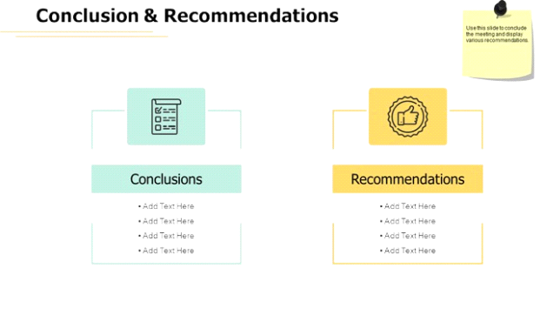

5. Conclusion and Recommendations
Beyond the data and the policies, the demand for Sukuk also has a human narrative concerning faith, identity, and hope. People who buy Sukuk are not merely buying a return on their investment but are purchasing values. The Nigerian investor is very sober and inquisitive. He wants to be associated with something sincere, transparent, and positive. However, Sukuk will be the answer if it becomes something the community uses instead of something the government produces. Nigeria can bring its trust, knowhow, and policies together on one single platform. That’s how Sukuk will ceases to be the niche market item and becomes the national instrument of faith-based development where ethics & economics align.
Religiosity and moral identity play their part in demand too. There is the call of halal values. Investors want to bring their faith in line with their investment practice. However, the social realities of poverty, lack of disposable income, lack of financial literacy, and unfamiliarity with the structure of Sukuk stand in the way. Policymakers do not just preach the importance of Shariah compliance. There is the need to embed accessibility in the very fabric of Sukuk structures. Risk perception and cognitive biases lie in the way. There is the issue of familiarity aversion. People are afraid of the complexity involved in Sukuk. Additionally, people fear the violation of religious tenets.
Thus, many stay in the conventional bank. Digital inclusion and financial literacy act as bridges over the notion of inaccessibility. Technology in terms of mobile solutions for online seminars and fintech solutions for Islamic finance courses for investors in cities and rural areas is very effective. However, the use of technology in Islamic finance will not work if the population is not educated. Interestingly enough, if the platform is not accompanied by understanding, it would be like the throwing of a fishing net into parched land. It is wide but gets no catch. Of course, Nigeria’s efforts toward improvements are appreciated. However, the disconnection on the part of the federal agencies slows down the pace. Perhaps the Islamic Finance Development Council along the line of the interconnect model in Malaysia would work wonders.

5.1 Recommendations:

Owing to the aforementioned objectives concerning the desire to grasp the dynamics surrounding sukuk demand, the proposed recommendations for improving sukuk market engagement in Nigeria are as follows:
- Rebuild Trust through Transparency: Share Sukuk performance updates, improve Shariah governance structures, and highlight the achievements of the project from the institution.
- Faith-Literate Financial Education: Islamic finance courses must be integrated into university programs and mosque-based institutions like community centers to educate people on the topic.
- Simplify the Narrative: Use analogies that people understand to describe Sukuk structures instead of speaking in industry terms.
- Leverage Digital Platforms: Enhance mobile-based Sukuk platforms offering readily available guidance and learning capabilities.
- Institutional Integration: There must be an integrated Islamic finance system developed in order to ensure coherence in the federal and state levels’ strategies in promoting and regulating it.
Change is incremental, and the human beliefs system cannot be hurried.
However, much like fishing lessons, once people trust the lake, they will cast their nets. The future of Sukuk in Nigeria will depend less on how effectively we communicate finance ideas and more on how effectively we understand the human tidal pools beneath.


References:
- Busari, S. A. & Salaudeen, A. O. (2024) ‘The Role of Islamic Social Finance Instruments Towards Poverty Alleviation in Nigeria: A Juristic Analysis’, International Journal of Fiqh and Usul Al‑Fiqh Studies, 8(2), pp. 173‑186. https://doi.org/10.31436/ijfus.v8i2.347.

- ‘Islamic Finance Industry in Nigeria To Benefit From Sukuk Fitch’ (2025) DMarketForces. Available at: https://dmarketforces.com/islamic-finance-industry-in-nigeria-to-benefit-from-sukuk-fitch/ (Accessed 11 November 2025]).

- ‘Slow but steady growth of sukuk in Africa’ (2024) African Banker, April. Available at: https://african.business/2024/04/african-banker/slow-but-steady-growth-of-sukuk-in-africa (Accessed: 11 November 2025).

- Abdulkadir, S., Sa’ad, A. A. & Hassan, A. (2024) ‘Regulating Islamic P2P Financing in Nigeria: A Case for a Compliance Framework’, Al‑Qanatir: International Journal of Islamic Studies, 33(6), pp. 269‑276. from https://www.al HYPERLINK "https://www.al‐qanatir.com/aq/article/view/953"‑ HYPERLINK "https://www.al‐qanatir.com/aq/article/view/953"qanatir.com/aq/article/view/953 (Accessed: 12 November 2025).

- Boukhatem, J. (2022) ‘How does financial risk affect sukuk market development? Empirical evidence from Saudi Arabia’, Heliyon, 8(5), e09453. https://doi.org/10.1016/j.heliyon.2022.e09453.

- Asadov, A. (2024) ‘Empirical Analysis of Demand for Sukuk in Uzbekistan’, Economies, 12(8), 220. https://doi.org/10.3390/economies12080220.

- Alam, A., Ratnasari, R.T., Latifathul Jannah, I. & El Ashfahany, A. (2023) ‘Development and evaluation of Islamic green financing: A systematic review of green sukuk’, Business Perspectives, 14(1), pp.61‑72. https://doi.org/10.21511/ee.14(1).2023.06.

- Fachsandy, F. & Akbar, N. (2024) ‘How Financial Risk Affects Indonesia Sovereign Sukuk Market Development’, The Journal of Muamalat and Islamic Finance Research, 21(1), pp.127‑138. https://doi.org/10.33102/jmifr.534.
- ‘Nigeria makes up only 0.9% of global Islamic finance market – SEC DG’ (2023) Nairametrics, 6 December. Available at: https://nairametrics.com/2023/12/06/nigeria-makes-up-only-0-9-of-global-islamic-finance-market-sec-dg/ (Accessed: 12 November 2025).

- ‘Investor Demand Pushes Subscription for FG’s N150bn Sovereign Sukuk to over N652bn’ (2023) THISDAYLIVE, 14 October. Available at: https://www.thisdaylive.com/2023/10/14/investor-demand-pushes-subscription-for-fgs-n150bn-sovereign-sukuk-to-over-n652bn/ (Accessed: 15 November 2025).

- ‘Nigeria’s N1.1 Trillion Sukuk Gamble: Bold Infrastructure Dreams or Another Debt Trap?’ (2024) Atlantic Post, 11 months ago. Available at: https://atlanticpostng.com/nigerias-n1-1-trillion-sukuk-gamble-bold-infrastructure-dreams-or-another-debt-trap/ (Accessed: 15 November 2025).

- ‘Sukuk: FG raised N1.1 trn to finance 124 road projects – SEC’ (2024) Vanguard Nigeria, 12 December. Available at: https://www.vanguardngr.com/2024/12/sukuk-fg-raised-n1-1trn-to-finance-124-road-projects-sec/ (Accessed: 16 November 2025).

- ‘The rise of digital finance: Financial inclusion or debt trap’ (2022) Yue, P., Korkmaz, A.G., Yin, Z. & Zhou, H., armir Available at: https://arxiv.org/abs/2201.09221 (Accessed: 17 November 2025).

- Husein, M. (2025) ‘The Effect of Islamic Financial Literacy, Return Perception, and Risk Perception on Investment Decisions in Sharia Stocks…’, Economics & Islamic Finance Journal (ECIF), 2(1), pp.39‑57. https://doi.org/10.70550/ecif.v2i1.101.

