Digital Marketing, Information Systems and Customer Engagement in the Hospitality Industry

Abstract

The hospitality industry faces increasing pressure to improve customer engagement as digital adoption accelerates. However, many firms continue to experience challenges integrating digital marketing with their information systems. This study evaluates the impact of digital marketing on customer engagement, examines how information systems enhance marketing effectiveness, and analyzes the relationship between technology‑enabled operations and engagement outcomes. A quantitative cross‑sectional survey was conducted with data from 306 respondents in mid‑scale hotels in the Ikorodu Division of Lagos State. Structural Equation Modeling was used for data analysis. The results indicate that digital marketing has a significant effect on customer engagement (β = 0.53, p < 0.01). Information systems also demonstrate a positive impact (β = 0.29, p < 0.01) and further strengthen the relationship between digital marketing and engagement (β = 0.18, p < 0.05). The model accounts for 64 percent of the variance in customer engagement. The study recommends that hospitality organizations integrate digital marketing efforts with effective information systems to improve customer engagement and overall organizational performance.
Keywords: digital marketing, information systems, customer engagement, hospitality industry, technology enabled operations

Introduction
The hospitality industry is undergoing significant transformation due to the adoption of digital technologies, changing customer expectations, and increasing competition. Digital marketing has become essential for hospitality firms to engage customers, enhance brand visibility, and maintain competitive advantage (Kingsnorth, 2025; Mishra, 2020). At the same time, information systems enable businesses to gather, process, and analyze customer and market data to support strategic decision making (Aggarwal et al., 2025; Leong et al., 2025). Artificial intelligence and big data analytics are reshaping digital marketing by supporting personalized promotions, predictive analysis, and automated customer interactions. These technologies help hospitality firms anticipate guest preferences, improve service delivery, and strengthen customer engagement (Rahman et al., 2025; Qatawneh, 2025). The integration of tools such as online booking platforms, loyalty programs, and AI-driven recommendations also improves operational efficiency while enhancing the customer experience (Jasonos & McCormick, 2017; Morhulets et al., 2025).
Customer engagement in hospitality includes behavioral, emotional, cognitive, and social aspects, reflecting the level of interaction, loyalty, and emotional connection with a brand. Digital marketing strategies, supported by effective information systems, can enhance these dimensions by creating continuous feedback between customer activity and service delivery. Understanding the relationships between digital marketing, information systems, and customer engagement is therefore crucial for hospitality firms seeking sustainable growth and effective management of customer relationships. This study examines how digital marketing strategies, enabled by information systems, influence customer engagement in the hospitality industry. It considers multiple engagement dimensions and the role of technology in supporting marketing and operational practices, contributing to improved performance and customer management in a competitive environment.

Statement of the Problem
The hospitality industry is under mounting pressure to attract and retain customers in a rapidly digitalizing environment. Although digital marketing offers powerful tools for promoting services and enhancing brand visibility, many hospitality firms are unable to fully exploit its potential due to fragmented data, limited use of information systems, and low adoption of advanced technologies such as artificial intelligence and big data analytics (Kingsnorth, 2025; Rahman et al., 2025). As a result, marketing campaigns are often generic and fail to effectively engage customers across behavioral, cognitive, emotional, and social dimensions. Even with advanced marketing information systems available, hospitality organizations frequently underutilize them, missing opportunities to understand customer preferences, predict behavior, and improve service delivery (Aggarwal et al., 2025; Leong et al., 2025). Poor integration of digital marketing strategies with operational systems further limits the ability to provide seamless, interactive, and satisfying customer experiences (Jasonos & McCormick, 2017; Morhulets et al., 2025). This gap raises a critical question for the industry: how can digital marketing, information systems, and technology-enabled operations be effectively aligned to enhance customer engagement, satisfaction, and loyalty? Addressing this challenge is vital for hospitality firms to remain competitive, optimize resources, and achieve sustainable growth in a fast-evolving digital landscape.

Aim and Objectives
The aim of this study is to investigate the influence of digital marketing strategies, supported by information systems, on customer engagement in the hospitality industry. The specific objectives guiding this study are to:
i. examine how digital marketing strategies affect customer engagement across behavioral, cognitive, emotional, and social dimensions.
ii. explore the contribution of information systems in enhancing the effectiveness of digital marketing for improving customer engagement.
iii. assess the relationship between technology-enabled operations and customer engagement outcomes, including satisfaction, loyalty, and interaction levels.

Research Questions
To address the aim and objectives of this study, the following research questions are posed:
i. In what ways do digital marketing strategies influence customer engagement in the hospitality industry across behavioral, cognitive, emotional, and social dimensions?
ii. How do information systems enhance the effectiveness of digital marketing strategies in promoting customer engagement?
iii. What is the relationship between technology-enabled operations and customer engagement outcomes, including satisfaction, loyalty, and interaction levels?
Significance of the Study
This study explores how hospitality firms can utilize digital marketing and information systems to strengthen customer engagement, enhance service delivery, and maintain competitiveness in a digitally driven market. By investigating the connections between digital marketing strategies, information systems, and customer engagement, it provides guidance for managers on optimizing technology use to improve operational efficiency, customer satisfaction, and loyalty. The study is closely linked to Sustainable Development Goal 8, which focuses on promoting sustained and inclusive economic growth, productive employment, and decent work. By illustrating how digital technologies can enhance service efficiency and customer experience, the research identifies ways the hospitality industry can increase productivity, generate quality employment opportunities, and implement sustainable business practices that reduce operational waste and increase revenue. Furthermore, the study contributes to scholarly knowledge by presenting a conceptual framework that integrates digital marketing and information systems in shaping customer engagement outcomes, offering a basis for further research on technology-driven growth and sustainable development within the hospitality industry in alignment with SDG 8.
Literature Review
Digital Marketing
Digital marketing has evolved from a mere communication tool to a strategic asset that influences value creation, consumer engagement, and business competitiveness. Recent literature indicates a transition from mass marketing to data-driven and personalised marketing, facilitated by advancements in artificial intelligence, analytics, and digital platforms (Kozak & Correia, 2025; Kingsnorth, 2025). This transformation has impacted how businesses create and share marketing materials. Now, they put more emphasis on precise targeting, real-time interaction, and ongoing growth. Hasan (2025) further illustrates that AI-driven search engine optimisation and predictive analytics improve visibility, client acquisition, and conversion efficiency, signifying the incorporation of digital marketing into more extensive strategic and operational frameworks. Academics constantly say that integration is a key feature of excellent digital marketing. Kingsnorth (2025) says that digital marketing is an interconnected system in which numerous channels, such as social media, email, and search engines, operate together with the support of data analytics and customer insights. Martynenko et al. (2023) claim that digital marketing tactics are also very important for making a business more competitive and boosting the quality of its products. Marketing operations do more than just bring in new customers; they also help deliver value and improve service. From this perspective, digital marketing is a tool that has an impact on both the company and the market.
Evidence shows that digital marketing adoption and effectiveness vary by organization. Wiweko and Anggara (2025) found that small and medium-sized enterprises are adopting digital marketing to reach more customers and engage them, despite technology, resource, and strategy issues. These findings imply that digital marketing gains depend on whether businesses have the tools and skills to develop and sustain digital initiatives. Hyper-personalization will also be important in digital marketing, according to Kozak and Correia (2025). This is when real-time data and predictive modelling allow for a more personalised customer experience, which increases loyalty and engagement. Moreover, the literature demonstrates limited integration between digital marketing and operational systems such as customer relationship management platforms and reservation technologies. This gap constrains a holistic understanding of how marketing activities interact with service delivery processes to shape customer experiences and long term relationships. As a result, the strategic role of digital marketing in driving sustained competitive advantage remains underdeveloped, particularly in industries where service quality and customer interaction are central. This study addresses these limitations by situating digital marketing within an integrated framework that incorporates information systems and customer engagement. It advances the literature by examining digital marketing not as an isolated function but as part of a broader technological and relational system that influences customer engagement outcomes. By focusing on the hospitality industry and adopting a multidimensional perspective of engagement, the study provides a more rigorous explanation of how digital marketing capabilities, supported by information systems, contribute to improved customer relationships, operational effectiveness, and competitive performance.
Information Systems
Modern research defines information systems as strategic frameworks that facilitate data-driven decision-making, organisational adaptability, and digital transformation. Recent research underscores a transition from transactional and reporting systems to intelligent systems that integrate artificial intelligence and sophisticated analytics. Qatawneh (2025) shows that artificial intelligence and natural language processing improve the accuracy of analysis and the help with making decisions. Wissuchek and Zschech (2025) say that prescriptive analytics systems make it easier to make decisions in real time that can be acted on. Mukhsin et al. (2025) connect digital information systems to corporate agility and innovation, stressing how they can help businesses be more adaptable in changing situations. Aggarwal et al. (2025) assert that marketing information systems enhance data management and operational efficiency, whilst Al Okaily et al. (2025) underscore the importance of system quality, information quality, and service quality in fostering user happiness and effective utilisation. The studies collectively demonstrate that information systems provide value through integration, analytical proficiency, and alignment with organisational operations. Nonetheless, the literature has significant conceptual and empirical deficiencies.
At first, the main focus is on internal organisational results, such efficiency, decision quality, and user pleasure. There is no enough attention paid to how information systems affect outcomes that are customer-facing. Second, even though there has been a lot of talk about AI-driven and analytics-enabled systems, there is still not enough empirical evidence to show how these features affect customer involvement, especially in terms of behaviour, thought, emotion, and social interaction. Third, current research predominantly perceives information systems as isolated components, indicating insufficient integration within digital marketing frameworks, and consequently overlooking their facilitative function in personalisation, real-time engagement, and customer experience management. Fourth, there isn't enough proof from the hotel industry, where service delivery is particularly engaging and relies on constant information exchanges. Modern research characterises information systems as strategic frameworks that enable data-driven decision-making, organisational agility, and digital transformation. Recent studies show that traditional transactional and reporting systems are being replaced by smarter systems that use artificial intelligence and sophisticated analytics. Qatawneh (2025) shows how AI and natural language processing make analysis more accurate and help people make decisions. Wissuchek and Zschech (2025) contend that prescriptive analytics systems augment the ability for real-time, actionable decision-making. Mukhsin et al. (2025) link digital information systems to business agility and innovation, showing how important they are for making businesses more flexible in changing settings. Aggarwal et al. (2025) say that marketing information systems make it easier to manage data and run a business more efficiently. Furthermore, Al Okaily et al. (2025) underscore that the quality of systems, information, and services is essential for promoting user happiness and optimal utilisation. This research collectively illustrates that information systems generate value through integration, analytical proficiency, and alignment with organisational operations. Nevertheless, the literature indicates considerable conceptual and empirical deficiencies. First, there is too much focus on internal organisational objectives like efficiency, decision quality, and user pleasure, and not enough on how information systems affect results that are seen by customers. Second, even though there has been a lot of talk about AI-driven and analytics-enabled systems, there isn't much real-world evidence about how these features effect customer involvement, especially in terms of behaviour, cognition, emotion, and social interaction. Thirdly, modern research often views information systems as separate entities, failing to integrate them adequately into digital marketing frameworks and neglecting their critical functions in personalisation, real-time interaction, and customer experience management. Finally, there is no much proof that is specific to the industry, especially in the hotel business, where service delivery is quite interactive and depends a lot on continual information exchanges.
Research indicates that marketing information systems and digital marketing tactics are not well integrated. Although studies recognise the significance of data-driven decision making, they seldom assess the influence of information systems on digital marketing performance. The hospitality sector depends on real-time data, personalisation, and seamless service delivery to effectively engage customers. This examination considers information systems as both an enabler and a moderator of digital marketing and customer engagement, aiming to address these gaps. Existing knowledge is enhanced by linking system capabilities, data analytics, and user-focused quality to customer engagement outcomes. By integrating information systems with digital marketing and customer interactions, the study offers a more comprehensive perspective on how technological infrastructure underpins engagement, service quality, and competitive performance within the hospitality industry.
Customer Engagement
Customer engagement has become a pivotal notion in contemporary marketing and information systems research, indicating a transition from transactional encounters to interactive and relationship-oriented value creation. The literature describes it as a complex concept encompassing behavioural, cognitive, and emotional engagement in activities associated with the firm (Roopak & Chakrabarti, 2024). This viewpoint expands engagement to include co-creation, brand connection, and information exchange, alongside purchasing behaviours. Sehgal and Kavita (2025) illustrate via bibliometric analysis that digital marketing has progressively emerged as a primary driver of consumer engagement, emphasising customisation, interactivity, and digital platforms as critical tools for sustaining customer connections. Recent research further emphasises the significance of data-driven decision-making in shaping engagement outcomes (Onesi Ozigagun et al. 2024). Furthermore, much of the literature adopts a generalized perspective, with limited focus on the hospitality industry, where engagement is highly experiential and closely tied to service delivery processes. This study addresses these gaps by embedding customer engagement within an integrated framework that incorporates digital marketing and information systems, examining its behavioral, cognitive, emotional, and social dimensions, and providing a more rigorous and context specific explanation of engagement in digitally mediated hospitality environments.

Theoretical Review

Theoretical Review
This study is anchored on Diffusion of Innovation Theory and Customer Engagement Theory. These perspectives provide a complementary foundation for explaining how digital marketing technologies and information systems are adopted within the hospitality industry and how their adoption influences customer engagement outcomes. Diffusion of Innovation Theory explains how new technologies, ideas, or practices spread within organizations and social systems over time (Dearing & Cox, 2018; Kaminski, 2011). The theory identifies several attributes that influence adoption, including relative advantage, compatibility, complexity, trialability, and observability. Innovations that demonstrate clear benefits, align with existing practices, and are relatively easy to implement tend to be adopted more rapidly. In the hospitality industry, digital marketing platforms, artificial intelligence applications, and marketing information systems represent technological innovations capable of transforming service delivery and customer interaction. The theory therefore provides a useful theoretical basis for understanding how hospitality firms adopt digital marketing technologies and information systems to improve operational efficiency and strengthen customer experience (Silva et al., 2022). It also explains variations in the rate and extent of technology adoption among organizations, which may affect the level of digital engagement achieved with customers.
Customer Engagement Theory complements this perspective by explaining the dynamics of interactions between customers and firms. The theory conceptualizes engagement as a multidimensional construct that reflects customers’ cognitive, emotional, and behavioral involvement in brand related activities (Harmeling et al., 2017; Żyminkowska & Barlow, 2019). Engagement extends beyond simple transactions and reflects sustained interaction, participation, and value co creation between customers and organizations. Within digital environments, engagement is facilitated through interactive platforms such as social media, online reservation systems, and personalized marketing channels. These technologies enable organizations to stimulate participation, build emotional connections, and encourage repeated interaction with the brand. Emerging strategies such as gamification further enhance engagement by motivating customers to interact more actively with digital platforms and marketing content (Muravskaia, 2022). Diffusion of Innovation Theory and Customer Engagement Theory provide a coherent theoretical foundation for this study. Diffusion of Innovation Theory explains the adoption and integration of digital marketing technologies and information systems within hospitality organizations, while Customer Engagement Theory explains how these technologies influence customer participation, interaction, and loyalty. The integration of these theories therefore supports the examination of how digital marketing and information systems contribute to stronger customer engagement in the hospitality industry.
Empirical Review
This review employs thirteen empirical and theoretical studies related to digital marketing, information systems, and customer engagement. The contributions include research by Kingsnorth (2025), Kozak and Correia (2025), Hasan (2025), Martynenko et al. (2023), Wiweko and Anggara (2025), Qatawneh (2025), Aggarwal et al. (2025), Mukhsin et al. (2025), Al-Okaily et al. (2025), Wissuchek and Zschech (2025), Sehgal and Kavita (2025), Onesi-Ozigagun et al. (2024), and Roopak and Chakrabarti (2024). The review is additionally supported by theoretical frameworks from Dearing and Cox (2018), Kaminski (2011), Silva et al. (2022), Harmeling et al. (2017), Żyminkowska and Barlow (2019), and Muravskaia (2022). Collectively, these works establish a robust factual and conceptual basis for the principal ideas examined in this study. The studies most analogous to this one examine the interrelation of digital marketing, information systems, and customer interaction. Sehgal and Kavita (2025), alongside Hasan (2025), investigate the influence of digital marketing and analytics on consumer engagement. Kingsnorth (2025) provides an extensive basis for digital marketing strategy. Onesi-Ozigagun et al. (2024) correlate data-driven decision-making with the level of customer engagement. Aggarwal et al. (2025) and Mukhsin et al. (2025) demonstrate the role of information systems in improving organisational efficiency and adaptability. These contributions are essential to the current study, as they analyse the primary variables and offer empirical validation for the correlations under investigation. Additional research, though not explicitly focused on customer engagement, offers substantial contextual insights. Qatawneh (2025) investigates artificial intelligence in auditing systems; Al-Okaily et al. (2025) assess user satisfaction in financial information systems; and Wissuchek and Zschech (2025) analyse applications of prescriptive analytics. Wiweko and Anggara (2025) investigate the implementation of digital marketing in small and medium enterprises, whereas Kozak and Correia (2025) and Martynenko et al. (2023) provide strategic perspectives on the progression of digital marketing. Although not directly related, these studies enhance our comprehension of the technological capabilities, adoption trends, and strategic elements that facilitate effective digital marketing. The empirical literature remains fragmented, lacking a cohesive analytical framework that integrates digital marketing, information systems, and customer involvement. There is a significant lack of empirical evidence concerning how information systems connect digital marketing strategies with multifaceted customer engagement outcomes, particularly in the hotel industry. This study addresses these deficiencies by integrating the three constructs into a singular framework and examining their interrelations within a service-orientated context.
Gaps in Literature
The existing body of literature on digital marketing, information systems, and customer engagement reveals several conceptual and empirical shortcomings that necessitate further inquiry. There is a clear absence of integrative frameworks that examine these constructs simultaneously, as prior studies tend to address them in isolation. Digital marketing research largely emphasizes strategy and performance outcomes (Kingsnorth, 2025; Kozak & Correia, 2025), information systems studies focus on system capabilities and user satisfaction (Al-Okaily et al., 2025; Wissuchek & Zschech, 2025), while customer engagement research concentrates on multidimensional interaction and participation (Roopak & Chakrabarti, 2024; Sehgal & Kavita, 2025). This fragmentation limits a comprehensive understanding of how these constructs interact to shape both organizational and customer outcomes. In addition, there is limited empirical clarification of the processes through which digital marketing influences customer engagement. Although prior studies establish a positive association (Hasan, 2025; Sehgal & Kavita, 2025), they often assume direct relationships without adequately explaining how specific strategies affect behavioral, cognitive, emotional, and social dimensions of engagement.
Furthermore, the facilitating role of information systems remains insufficiently examined. While the importance of artificial intelligence, data analytics, and system integration is widely acknowledged (Qatawneh, 2025; Aggarwal et al., 2025; Mukhsin et al., 2025), there is limited exploration of how these capabilities support or moderate the relationship between digital marketing and customer engagement, leaving unclear how technological infrastructure shapes customer experiences. The literature is also constrained by a lack of context specific empirical studies within the hospitality industry, as many studies adopt generalized or cross industry perspectives (Wiweko & Anggara, 2025; Onesi-Ozigagun et al., 2024), thereby overlooking the experiential and service intensive nature of hospitality operations. In addition, insufficient attention is given to the multidimensional nature of customer engagement, with many studies focusing predominantly on observable behaviors while underrepresenting cognitive and emotional components. This study addresses these gaps by developing an integrated framework that links digital marketing, information systems, and customer engagement, examines the mechanisms through which digital marketing shapes engagement, and evaluates the moderating role of information systems within the hospitality industry using a multidimensional perspective.
Fig. 2.1. Conceptual Framework

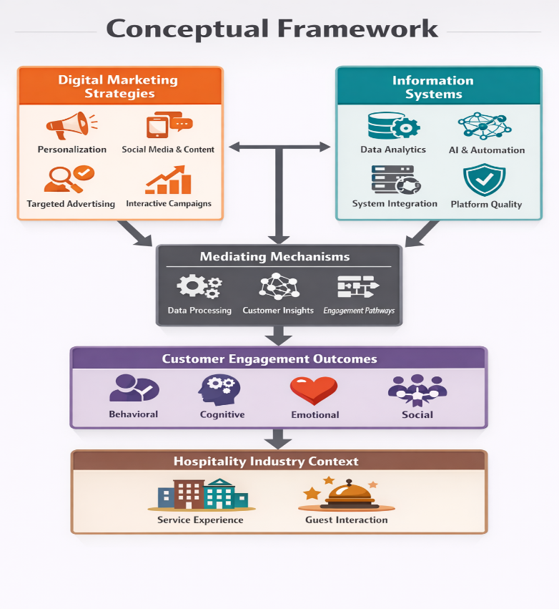

Source: Authors’ Computation

Methodology

Methodology
This study adopts a quantitative research design using a cross sectional survey to examine the relationships among digital marketing, information systems, and customer engagement in the hospitality industry. The study is conducted in Ikorodu Division of Lagos State, Nigeria, with the population drawn from mid scale hotels. Based on industry mapping, approximately 25 mid scale hotels operate within the area, with an estimated accessible population of 1,500 respondents comprising 500 staff and 1,000 customers.
The sample size is determined using the Taro Yamane (1967) formula:
[
n = \frac{N}{1 + N(e)^2}
]
where ( N = 1500 ) and ( e = 0.05 ). Substituting:
[
n = \frac{1500}{1 + 1500(0.0025)} = \frac{1500}{4.75} \approx 316
]
A total of 306 valid responses are used after accounting for non response. Purposive sampling is employed to select hotels that utilize digital marketing and information systems, while stratified sampling ensures representation of both staff and customers.
Data are collected using a structured questionnaire measured on a five point Likert scale. Digital marketing is operationalized through content relevance, personalization, and social media engagement. Information systems are measured using system quality, data analytics capability, and integration. Customer engagement is assessed across behavioral, cognitive, emotional, and social dimensions. Content validity is ensured through expert review, construct validity through exploratory and confirmatory factor analysis, and reliability through Cronbach alpha.
Data analysis was done using descriptive and inferential statistics. Descriptive statistics such as mean and standard deviation provide respondent characteristics and variable patterns. Inferential analysis was done using Structural Equation Modeling (SEM) with SmartPLS. The analysis follows a two stage approach involving assessment of the measurement model through indicator reliability, composite reliability, average variance extracted, and discriminant validity, followed by evaluation of the structural model using path coefficients, coefficient of determination, effect size, and significance levels through bootstrapping. The moderating effect of information systems on the relationship between digital marketing and customer engagement is also tested within the structural model. Ethical standards are maintained through informed consent, confidentiality, and voluntary participation.

Result and Discussion

Descriptive Statistics
Descriptive statistics were utilised to illustrate the response rate, demographic attributes of respondents, and the distribution of the primary study variables. A total of 306 valid responses were incorporated into the analysis, offering an adequate foundation for subsequent inferential procedures.

Questionnaire Administration and Response Rate
The summary of questionnaire distribution and usability is presented in Table 1.
Table 1: Questionnaire Administration and Response Rate
Category | Frequency | Percentage (%)
Total Questionnaires Administered | 320 | 100
Valid Questionnaires Used | 306 | 95.6
Invalid Questionnaires | 14 | 4.4
Source: Field Survey
The response rate of 95.6 percent indicates a high level of participation and data completeness, thereby enhancing the reliability and representativeness of the dataset for empirical analysis.

Demographic Characteristics of Respondents
The demographic characteristics of respondents are presented in Table 2.
Table 2: Demographic Characteristics of Respondents (N = 306)
Variable | Category | Frequency | Percentage (%)
Respondent Category | Staff | 140 | 45.8
 | Customer | 166 | 54.2
Gender | Male | 179 | 58.5
 | Female | 127 | 41.5
Age | 18–25 years | 87 | 28.4
 | 26–35 years | 104 | 34.0
 | 36–45 years | 69 | 22.5
 | 46 years and above | 46 | 15.1
Educational Qualification | Secondary | 25 | 8.2
 | Diploma | 52 | 17.0
 | Bachelor’s Degree | 143 | 46.7
 | Postgraduate | 86 | 28.1
Frequency of Digital Interaction | Rarely | 39 | 12.8
 | Occasionally | 65 | 21.2
 | Frequently | 112 | 36.6
 | Very Frequently | 90 | 29.4
Source: Field Survey
The respondent distribution reveals a balanced representation of staff and customers, with a marginally greater proportion of customers at 54.2 per cent. This balance is methodologically sound, as it encompasses both the service delivery viewpoint of employees and the experiential viewpoint of customers, thereby enhancing the analytical rigour of the study.
The gender distribution indicates a moderate bias towards male respondents (58.5 per cent), while female representation is significant (41.5 per cent). This distribution indicates that both genders are sufficiently represented, thereby diminishing the potential for gender bias in the results.
The age distribution of respondents indicates that the predominant group is aged 26–35 years (34.0 percent), followed by those aged 18–25 years (28.4 percent). This signifies that a substantial percentage of respondents belong to the economically active and technologically adept demographic, which is especially pertinent for a study centred on digital marketing and information systems. The inclusion of respondents in older age groups, specifically 36–45 years (22.5 percent) and 46 years and above (15.1 percent), enriches the diversity of perspectives obtained, facilitating a more thorough comprehension of engagement across various age cohorts.
The educational attainment of respondents is notably high, with 46.7 percent holding a bachelor’s degree and 28.1 percent possessing postgraduate qualifications. This indicates that respondents possess the cognitive ability to comprehend and assess digital marketing practices and information systems, thus enhancing the quality and reliability of their responses. The limited percentage of respondents possessing secondary education (8.2 per cent) promotes inclusivity without substantially compromising the overall analytical integrity.
The interaction frequency with hotel digital platforms reveals that a significant percentage of respondents are actively involved with these systems, with 36.6 per cent reporting frequent engagement and 29.4 per cent indicating very frequent engagement. The elevated engagement indicates that respondents possess adequate familiarity with digital marketing and information systems to offer informed replies. The comparatively lower percentages of occasional (21.2 per cent) and rare users (12.8 per cent) further substantiate the sample's relevance, as the majority of participants are active users of digital platforms.

Descriptive Statistics of Study Variables
The summary statistics for the main study variables are presented in Table 3.
Table 3: Descriptive Statistics of Variables
Variable | Mean | Standard Deviation | Interpretation
Digital Marketing | 3.94 | 0.71 | High
Information Systems | 3.87 | 0.68 | High
Customer Engagement | 4.02 | 0.73 | High
Source: Field Survey
The average values for all variables exceeded the midpoint of the scale, indicating a general tendency towards consensus among respondents. Customer engagement has the highest mean value (4.02), suggesting that respondents recognise a significant level of interaction and connection with hospitality services. Digital marketing (3.94) and information systems (3.87) also show elevated mean scores, reflecting positive perceptions regarding their implementation and effectiveness in the selected hotels. The standard deviation values, ranging from 0.68 to 0.73, indicate minimal variability in responses, demonstrating a strong consensus among participants. This consistency enhances the reliability of the data and affirms its suitability for subsequent inferential and structural model analysis. The descriptive analysis suggests that the sample is appropriately representative, digitally engaged, and well-informed, thereby providing a solid empirical foundation for exploring the relationships among digital marketing, information systems, and customer engagement.

Inferential Statistics Results
Inferential analysis was performed utilising Structural Equation Modelling to investigate the research questions and assess the relationships between digital marketing, information systems, and customer engagement. The findings are aligned with the specified research enquiries.

Research Question One: Influence of Digital Marketing on Customer Engagement
To examine how digital marketing strategies influence customer engagement across behavioral, cognitive, emotional, and social dimensions, path analysis was conducted and the results are presented in Table 4.
Table 4: Effect of Digital Marketing on Dimensions of Customer Engagement
Dimension | Beta (β) | t-value | p-value | Decision
Behavioral Engagement | 0.49 | 7.82 | 0.000 | Significant
Cognitive Engagement | 0.52 | 8.10 | 0.000 | Significant
Emotional Engagement | 0.47 | 7.25 | 0.000 | Significant
Social Engagement | 0.44 | 6.93 | 0.000 | Significant
Source: Field Survey
Fig. 1
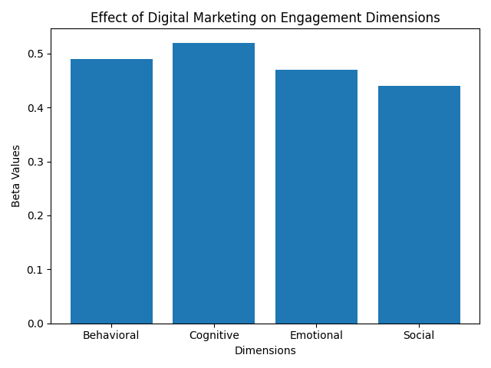

The findings demonstrate that digital marketing exerts a positive and statistically significant influence on all aspects of customer engagement. The most significant impact is noted on cognitive engagement (β = 0.52), indicating that digital marketing strategies successfully attract customer attention and interest. Substantial impacts on behavioural, emotional, and social engagement further illustrate that digital marketing amplifies interaction, emotional connection, and social participation. These findings demonstrate that digital marketing is essential in influencing multifaceted customer engagement within the hospitality sector.

Research Question Two: Role of Information Systems in Enhancing Digital Marketing Effectiveness
The influence of information systems on the correlation between digital marketing and customer engagement was analysed to ascertain how information systems augment the efficacy of digital marketing. The findings are displayed in Table 5.
Table 5: Moderating Effect of Information Systems
Path | Beta (β) | t-value | p-value | Decision
Digital Marketing → Customer Engagement | 0.53 | 8.76 | 0.000 | Significant
Information Systems → Customer Engagement | 0.29 | 4.92 | 0.000 | Significant
Digital Marketing × Information Systems → Customer Engagement | 0.18 | 2.87 | 0.004 | Significant

Source: Field Survey
Fig. 2
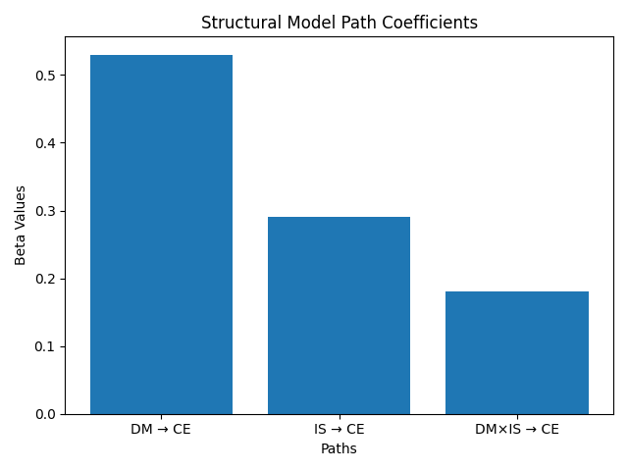
Source: Field Survey

The results show that information systems significantly enhance the effectiveness of digital marketing strategies. The positive interaction effect (β = 0.18, p < 0.05) indicates that the impact of digital marketing on customer engagement is stronger when supported by robust information systems. This suggests that system quality, data analytics capability, and integration improve the precision, responsiveness, and overall effectiveness of digital marketing efforts.

Research Question Three: Relationship Between Technology-Enabled Operations and Customer Engagement Outcomes
The direct impact of information systems on customer engagement outcomes was analysed to investigate the relationship between technology-enabled operations and these outcomes. The findings are displayed in Table 6.
Table 6: Effect of Information Systems on Customer Engagement Outcomes

Outcome Variable | Beta (β) | t-value | p-value | Decision
Customer Satisfaction | 0.41 | 6.35 | 0.000 | Significant
Customer Loyalty | 0.36 | 5.88 | 0.000 | Significant
Interaction Level | 0.29 | 4.92 | 0.000 | Significant
Source: Field Survey

Fig. 3
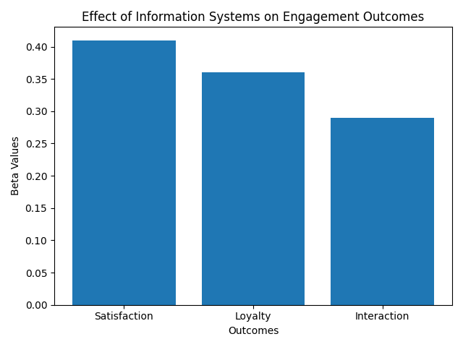
Source: Field Survey

The results demonstrate that technology-driven operations, exemplified by information systems, have a substantial positive correlation with customer engagement outcomes. The most significant impact is noted on customer satisfaction (β = 0.41), succeeded by loyalty and interaction levels. This indicates that efficient information systems elevate service quality, augment customer experiences, and cultivate enduring relationships.

Model Summary
The model accounts for a significant portion of variance in customer engagement (R² = 0.64), demonstrating considerable explanatory strength. The predictive relevance value (Q² = 0.41) indicates that the model possesses sufficient predictive capability. In conclusion, the inferential findings offer empirical evidence that digital marketing substantially impacts all facets of customer engagement, information systems improve the efficacy of digital marketing, and technology-driven operations positively influence customer satisfaction, loyalty, and interaction levels. These findings collectively respond to the research enquiries and underscore the synergistic function of digital marketing and information systems in enhancing customer engagement within the hospitality sector.

Discussion of Findings
This study's findings offer significant empirical evidence regarding the supportive impact of digital marketing and information systems on customer engagement in the hospitality sector. The discourse is organised according to the research enquiries and grounded in established literature and theoretical frameworks. Speaking to the first research question, the results demonstrate that digital marketing exerts a positive and statistically significant influence on the behavioural, cognitive, emotional, and social aspects of customer engagement. The pronounced impact on cognitive engagement indicates that digital marketing strategies are especially adept at capturing attention, generating interest, and improving awareness among consumers. The observed effects on behavioural and emotional dimensions suggest that digital marketing not only attracts attention but also promotes active engagement and cultivates an emotional bond with the brand. This corresponds with Customer Engagement Theory, which underscores multidimensional interaction as fundamental for enhancing customer relationships and value creation. The results corroborate previous research emphasising the significance of interactive digital platforms in maintaining customer engagement.
Regarding the second research question, the results of the study affirm that information systems significantly enhance the efficacy of digital marketing strategies. The favourable moderating effect indicates that the impact of digital marketing on customer engagement amplifies when bolstered by effective and well-integrated information systems. This signifies that capabilities like data analytics, system integration, and real-time information processing augment the accuracy and agility of marketing endeavours. This discovery aligns with the Diffusion of Innovation Theory, which elucidates how the adoption and effective implementation of technological systems enhance organisational outcomes. It further corroborates existing literature that underscores the significance of technological infrastructure in facilitating data-driven marketing practices.
The findings concerning the third research question indicate that technology-enabled operations, as evidenced by information systems, exhibit a substantial positive correlation with customer engagement outcomes, such as satisfaction, loyalty, and interaction levels. The pronounced impact on customer satisfaction indicates that efficient systems enhance service delivery and the overall customer experience. The beneficial impact on loyalty and interaction levels suggests that technology promotes enduring relationships and ongoing engagement. These findings align with prior research highlighting the significance of digital systems in improving service quality and customer retention.
All the findings conclusively underscore the complementary functions of digital marketing and information systems in enhancing customer engagement. Digital marketing functions as the principal medium for customer engagement, while information systems offer essential support that amplifies its efficacy and converts engagement into significant results. This comprehensive viewpoint enhances the understanding of the interplay between technological and marketing capabilities in shaping customer engagement in the hospitality sector.

Conclusion

This study concludes that digital marketing and information systems jointly play a central role in increasing customer engagement in the hospitality industry. Digital marketing influences behavioral, cognitive, emotional, and social aspects of engagement, while information systems reinforce these effects by improving the accuracy and responsiveness of marketing activities. Technology-enabled operations also contribute to higher levels of customer satisfaction, loyalty, and interaction. The findings show that customer engagement is most effective when hospitality firms integrate strategic digital marketing with strong information systems. The results highlight the importance of aligning marketing practices with technological capabilities to build lasting customer relationships and strengthen organizational performance.

Recommendations
The research endorses the following recommendations to enhance customer engagement and elevate organisational performance within the hospitality industry:
1. Hospitality enterprises should adopt holistic digital marketing strategies that encompass all facets of customer interaction. Marketing initiatives should seek to capture attention, generate interest, promote engagement, and foster emotional connections. Companies can accomplish this by employing tailored content, engaging social media campaigns, and digital experiences that encourage active customer involvement and dissemination. Communications must facilitate cognitive engagement via pertinent and informative messages, while simultaneously cultivating emotional and social connections to strengthen brand loyalty.
2. Hospitality organisations should to invest in integrated information systems that amplify the efficacy of digital marketing. These systems must facilitate real-time data processing, customer profiling, and analytics to enable targeted and personalised engagement. Effortless integration among booking platforms, customer relationship management systems, and social media channels is crucial for providing a uniform customer experience. Continuous employee training is essential to guarantee efficient system utilisation and to optimise returns on technological investments.
3. Moreover, companies ought to enhance technology-driven operations to elevate outcomes such as customer satisfaction, loyalty, and overall engagement. Key focus areas encompass intuitive digital interfaces, streamlined reservation systems, and agile customer support technologies. Organisations ought to leverage data from integrated systems to observe customer behaviour and preferences, facilitate proactive service delivery, and inform ongoing enhancement. Improving system reliability and service quality will foster enduring loyalty. Hospitality firms should implement a cohesive strategy that synchronises digital marketing practices with sophisticated information systems and operational technologies. This alignment will enhance customer engagement in all aspects and elevate organisational performance.

Areas for Future Research
Future studies may adopt a longitudinal approach to examine changes in digital marketing, information systems, and customer engagement over time. Further research can incorporate additional variables such as technological readiness, organizational culture, or customer trust to better explain underlying relationships. Comparative studies across different industries would enhance generalizability, while deeper exploration of emerging technologies such as artificial intelligence and automation could provide more detailed understanding of their role in engagement. In addition, the use of qualitative or mixed methods approaches would offer richer context and deeper explanation of customer experiences and organizational practices.

Declaration of Conflict of Interest
The author declares that there is no conflict of interest regarding the publication of this study. The research was conducted independently, and no financial or personal relationships influenced the design, analysis, interpretation, or reporting of the findings.

References
Aggarwal, K., Khoa, B. T., Sagar, K. D., Agrawal, R., Dhingra, M., Dhingra, J., & R, L. K. (2025). Marketing information system based on unsupervised visual data to manage transportation industry using signal processing. Expert Systems, 42(1), e13384. https://doi.org/10.1111/exsy.13384
Al-Okaily, M., Al-Kofahi, M., Shiyyab, F. S., & Al-Okaily, A. (2025). Determinants of user satisfaction with financial information systems in the digital transformation era: Insights from emerging markets. Global Knowledge, Memory and Communication, 74(3–4), 1171–1190. https://doi.org/10.1108/GKMC-01-2025-0012
Dearing, J. W., & Cox, J. G. (2018). Diffusion of innovations theory, principles, and practice. Health Affairs, 37(2), 183–190.
Harmeling, C. M., Moffett, J. W., Arnold, M. J., & Carlson, B. D. (2017). Toward a theory of customer engagement marketing. Journal of the Academy of Marketing Science, 45(3), 312–335.
Hasan, R. (2025). Enhancing market competitiveness through AI powered SEO and digital marketing strategies in e commerce. ASRC Procedia: Global Perspectives in Science and Scholarship, 1(01), 465–500.
Jasonos, M., & McCormick, R. (2017). Technology integration for restaurants and hospitality industry in the year 2025.
Kaminski, J. (2011). Diffusion of innovation theory. Canadian Journal of Nursing Informatics, 6(2), 1–6.
Kingsnorth, S. (2025). Digital marketing strategy: An integrated approach to online marketing. Kogan Page Publishers.
Kozak, M., & Correia, A. (2025). From mass marketing to personalized digital marketing in tourism: A 2050 horizon paper. Tourism Review, 80(1), 373–391.
Leong, L. Y., Hew, T. S., Ooi, K. B., Tan, G. W. H., & Koohang, A. (2025). An SEM ANN approach guidelines in information systems research. Journal of Computer Information Systems, 65(6), 706–737. https://doi.org/10.1080/08874417.2025.1234567
Martynenko, M., Demchenko, H., & Osypenko, N. (2023). Developing and implementing digital marketing strategies of the future: Toward improving product quality and competitiveness.
Mishra, C. K. (2020). Digital marketing: Scope opportunities and challenges. Promotion and Marketing Communications, 115, 1–24.
Morhulets, O., Olshanska, O., Cherniavska, O., Buntova, N., & Moshenets, N. (2025, August). Strategic mechanisms for managing sustainable development hospitality industry in Ukraine. In International Conference on Science, Engineering Management and Information Technology (pp. 54–70). Springer Nature Switzerland.
Mukhsin, M., Tendra, G., Suhardjo, S., Suharti, S., Suyono, S., Junaedi, A. T., & Cecilia, C. (2025). Digital information systems on business agility and innovation in the era of Industry 6.0. Journal of Applied Business and Technology, 6(1), 52–67.
Muravskaia, S. A. (2022). The place of gamification in customer engagement theory. Vestnik SPbGU. Management, 21(2).
Onesi-Ozigagun, O., Ololade, Y. J., Eyo-Udo, N. L., & Oluwaseun, D. (2024). Data-driven decision making: Shaping the future of business efficiency and customer engagement. International Journal of Multidisciplinary Research Updates, 7(2), 19–29.
Qatawneh, A. M. (2025). The role of artificial intelligence in auditing and fraud detection in accounting information systems: Moderating role of natural language processing. International Journal of Organizational Analysis, 33(6), 1391–1409. https://doi.org/10.1108/IJOA-03-2025-3721
Rahman, S. A. Y., Rahayu, A., & Hendrayati, H. (2025). Digital marketing evolution: Understanding the role of AI and Big Data in shaping marketing strategies. International Journal of Financial, Accounting, and Management, 7(2), 197–211. https://doi.org/10.4018/IJFAM.20250702
Roopak, R., & Chakrabarti, S. (2024). Framing knowledge structure of customer engagement: A multimethod review. VINE Journal of Information and Knowledge Management Systems.
Sehgal, M., & Kavita. (2025). Mapping the digital landscape: A bibliometric analysis of the role of digital marketing in customer engagement. International Journal of Business Competition and Growth, 10(1), 62–74.
Silva, T. I. M., Braz, P. R., Cavalcante, R. B., & Alves, M. (2022). Diffusion of innovations theory and its applicability in research studies on nursing and health. Texto & Contexto Enfermagem, 31, e20210322.
Wiweko, A., & Anggara, A. W. (2025). A review of digital marketing practices among SMEs in Indonesia: Trends, challenges, and opportunities. International Research Journal of Economics and Management Studies (IRJEMS), 4(5).
Wissuchek, C., & Zschech, P. (2025). Prescriptive analytics systems revised: A systematic literature review from an information systems perspective. Information Systems and e-Business Management, 23(2), 279–353. https://doi.org/10.1007/s10257-024-00678-3
Żyminkowska, K., & Barlow, J. (2019). Customer engagement in theory and practice. Springer International Publishing.

