Nonlinear Acoustic Wave Propagation in High-Velocity Fluids: Theoretical and Simulative Modelling
Somaila Ambreen 1
(Research Scholar, Department of Physics V.K.S University, Ara)
Dr. Shashi Shekhar Vidyarthi 2
Assistant Professor,Department of Physics,
(JLN College, Dehri-on-sone, Affiliated with V.K.S University, Ara)

Abstract-Nonlinear acoustic wave propagation in high-velocity fluids is a complex phenomenon influenced by the combined effects of nonlinearity, convection, and viscous dissipation. The proposed analysis is essential due to the unique influence of high-speed flow on acoustic waves. We use a Burgers-type nonlinear acoustic model to account for waveform distortion, amplitude variation, and energy attenuation as the wave propagates. A finite difference method is used to solve the governing equations; we ensure numerical stability through careful selection of discretization parameters and the Courant–Friedrichs–Lewy (CFL) condition. An interactive simulation with a MATLAB-based GUI (Graphical user interface) is built that allows the physical parameters to be changed, and propagation variables to be visualized and updated in real time. The results show that linear effects are responsible for wave steepening and distortion, while viscous dissipation arises dispersion. In addition, it is found that not exploiting the parameters properly might lead to numerical issues or unphysical growth of the amplitude. These results demonstrate the necessity of balancing nonlinearity and dissipation to derive realistic and stable results. In summary, this research contributes significantly to the understanding nonlinear acoustic effects and presents a flexible computational framework for future studies in high-velocity fluid settings.

Keywords-Nonlinear acoustics, High-velocity fluids, Wave propagation, Finite difference method, Waveform distortion

1. Introduction
Nonlinear acoustic wave propagation in high-velocity fluids represents a significant area of research in modern acoustics, fluid dynamics, and engineering applications. In contrast to linear acoustic waves, where pressure disturbances are small and propagate without distorting one another, nonlinear acoustic waves can show a wide range of complex behaviour including steepening waveforms, shock formation, harmonic generation, and amplitude-dependent speed propagation. In particular, high-velocity fluid environments have prominent nonlinear interactions in where acoustic waves are combined with mean flow providing different complex physical phenomena. Applications of understanding these behaviors vary from aerospace engineering, combustion systems, medical ultrasonics to environmental acoustics.
As we have mentioned, background flow gives strong influence on the propagation of waves in high-viscosity fluids. This generates non-conservative effects that change wave speed, attenuation, and distortion due to convective transport of acoustic energy as well as viscous and thermal dissipation. The relevant governing equations for this type of systems are typically derived from the Navier–Stokes equations, that model fluid motion, pressure variations and energy transfer. Retaining nonlinear terms, leads to equations of the form expanded in series where these models become effectively Burgers when a balance between nonlinearity, diffusion and convection is taken into account. These models are used to analyse the evolution of acoustic waveforms in different physical conditions.
This complexity, especially the nonlinear acoustic propagation at higher Mach numbers where linear theory fails Al though theoretical modelling can be a useful guide, they cannot exhaustively characterize this complex behaviour without substantial input and extensive control over flow conditions [9]. The importance of such numerical simulation in studying these systems is paramount. Non-linear partial differential equations can also be solved numerically using computational techniques, including finite difference methods, finite volume methods, and spectral methods. Researchers can use these simulations to explore waveform evolution, amplitude variation as well as the impacts of viscosity, nonlinearity coefficient and background velocity. Furthermore, simulation tools allow for an understanding of different boundary conditions and source configurations that would otherwise be difficult to reproduce experimentally.
This study uses a theoretical-simulative approach investigating the propagation of nonlinear acoustic waves in high-speed fluids. This model includes salient physical properties such as the density of fluid, sound speed, viscosity and nonlinearity factor to produce realistic results. The authors analyze the evolution and amplitude changes of acoustic waveforms in time and space to gain insights into their stability, distortion, and residual energy characteristics. The results provide important insights into the complex dynamics of nonlinear acoustics and may serve as a reference for optimizing applications that rely on acoustic wave behaviour.
2. Literature Review

Hamilton and Blackstock (2014) provided a comprehensive foundation for nonlinear acoustics, emphasizing wave distortion, shock formation, and harmonic generation. Their paper provided an explanation for the behavior when acoutic amplitudes are large, particularly in fluids that have strong background motion. Nonlinear propagation is also addressed, and the study supports this in Burgers-type equations. Despite changes in technology, their contribution continues to be central for the characterization of non-linear acoustic phenomena from a fundamental perspective both in theory and applications.
Pierce (2014) examined the fundamental principles of acoustic wave propagation, including nonlinear interactions in compressible media. The study explained the non-linear behaviours of high intensity sound waves and how they caused waveform steepening and a redistribution of energy. It also gave mathematical formulations appropriate to simulating acoustic fields in flowing fluids. This book is a reference key to use classical acoustics to describe nonlinear and high-speed flow conditions.
Cleveland et al. (2015) investigated nonlinear propagation effects in high-intensity ultrasound applications. Their results showed how wave distortion grows with both amplitude and spatial variation of the medium. Viscosity and absorption were shown to play a significant part in restricting wave growth. The work will be useful for both medical and engineering applications where nonlinear propagation of acoustic waves occurs, and theoretical predictions were verified through numerical simulations.
Jing et al. (2016) explored nonlinear acoustic wave propagation in the moriscoes fluids. The study integrated thermal and viscous losses into numerical models, which displayed dramatic attenuation effects as well as waveform smoothing effect. The findings underscored the need to include dissipation mechanisms in realistic simulations. Hossain Rehman (Phd student, Computer Science at Victoria University of Wellington) and his group do a great work on improving industrial & biomedical systems acoustic models.
Sugimoto (2016) focused on nonlinear wave propagation in ducts and high-speed flows. These include the essential effects of boundary conditions and flow speed on wave distortion and shock generation showed in the study. The study offered analytical and numerical methods that shed light on waves in constrained geometries. This contribution is timely for applications like aeroacoustics and pipeline systems.
Rudenko and Soluyan (2017) analysed theoretical aspects of nonlinear acoustics, including wave steepening and energy transfer mechanisms. Their study focused on the effect of nonlinearity in changing wave speed and amplitude. They also covered numerical methods for nonlinear acoustic equations. Their work continues to play an important role in connecting theoretical ideas with computational modelling.
Blackstock (2017) examined nonlinear acoustic wave interactions in moving fluids, focusing on convective effects and energy dissipation. This study demonstrated the effect of background velocities on wave propagation. It also covered practical ramifications in hypersonic flow and aeolian noise reduction. The research highlights important coupling between fluid motion and acoustic waves.
Leighton (2018) investigated nonlinear acoustic phenomena in bubbly fluids and complex media. The study showed how nonlinearity leads to enhanced scattering and energy dissipation. The study demonstrated that nonlinearity can create conditions where scattering and energy dissipation process are dramatically amplified. It also investigated uses in medical ultrasound and underwater acoustics. And characterized the dynamics in heterogeneous media, which warranted developing advanced numerical models that enable one to capture complex interactions.
Tanter and Fink (2018) studied nonlinear acoustic focusing and time-reversal techniques. Their findings revealed the mechanism by which nonlinear effects can enhance a wave focus in arbitrary media. The theoretical work was complemented by an experimental validation, enabling new paradigms of realisation of wave control mechanism. This has important implications for imaging and therapeutic ultrasound applications.
Zhang et al. (2019) developed numerical models for nonlinear acoustic propagation using finite difference methods. Their study was based on the analysis of the effects of waveform distortion and amplitude growth under different conditions. Discretization and stability criteria play a crucial role in achieving accuracy. Their labours help to enhance computational methods for studying non-linear acoustics.
Li and Wu (2020) investigated nonlinear acoustic wave propagation in high-speed compressible flows. Their own research focused on the joint effects of convection, nonlinearity and viscosity. High flow velocities highly influence wave characteristics as demonstrated in the study. Theoretical predictions were validated with numerical simulations, which is relevant for aerospace and industrial applications.
Kumar et al. (2021) explored nonlinear acoustic wave behaviour using computational fluid dynamics (CFD). It was observed that with larger amplitudes and velocities, nonlinear effects dominate. CFD tools proved the key to analyse complex acoustics systems, said the authors of this research.
Chen et al. (2022) examined nonlinear acoustic wave propagation in thermally varying media. Their thermal, or temperature-dependent properties, were incorporated into a model that had dramatic effects on wave speed and attenuation. The results emphasized the role of environmental conditions in acoustic simulations. Benefits of this work expand the realism of nonlinear acoustic modelling.
Singh and Sharma (2023) analysed nonlinear acoustic propagation in high-velocity gas flows. Their research showed significant waveform distortion and instability within specific parameter ranges. The proper mean of numerical stability conditions like CFL condition was used to reach effective results, as stated by study. Their finding is applicable in case of compressible gas media simulations.
Patel et al. (2024) presented advanced simulation techniques for nonlinear acoustic wave propagation using hybrid numerical methods. High-speed fluid environment model data accuracy and stability were improved in their study. Key findings include improved prediction of both waveform evolution and variation in amplitude. This is work that includes recent advances in computational acoustics and simulation methods.

3. Theoretical Background and Mathematical Modelling

The study of nonlinear acoustic wave propagation in high-velocity fluids is based on the interaction between acoustics and fluid motion. For a stationary medium, acoustic waves are typically considered as small variations of pressure, density and particle velocity. Under these assumptions, this wave behaviour is often described using linear acoustic equations. But when the amplitude of this wave is large or if the ship moves with a significant velocity in fluid, linear theory fails. Then nonlinear effects come in play leading to waveform distortion, harmonic generation, steepening of compression fronts and, if one is not careful enough, shock formation. This calls for a more general theoretical model to describe the propagation of acoustic waves in high-speed fluid conditions.
The theoretical frame is based on the laws of conservation in fluid dynamics, which for any system include conservation of mass, momentum and energy. These laws are expressed as the continuity equation, the Navier–Stokes equation, and the energy equation. These equations, together, summarize: how pressure, density and temperature vary with time/history (and also the fluid motion sometimes). Acoustic waves can be considered as disturbances propagating through the fluid; thus they can be modelled as perturbations on top of a mean flow. At high mean flow velocity, the convection and flow-induced wave speed changes dominate the propagation of such disturbances. Context: the acoustic field must be considered in relation to both the intrinsic properties of the fluid and its bulk motion.
Let the fluid density, pressure, and velocity be represented as the sum of mean and fluctuating components:
$$ρ=ρ_{0}+ρ'$$
$$p=p_{0}​+p',$$
$$p=p_{0}​+p',$$

where p0​, and U0​ denote the mean density, mean pressure, and mean flow velocity, respectively, while ρ′, p′, and u′ represent the acoustic perturbations. In linear acoustics, these perturbations are assumed to be very small compared with the mean quantities, and higher-order nonlinear terms are neglected. In nonlinear acoustics, however, such higher-order terms are retained because they play a major role in determining the wave evolution.
The continuity equation for one-dimensional compressible flow is written as:
$$\frac{∂ρ}{∂t}+\frac{∂(ρu)}{∂x}=0$$
This equation ensures conservation of mass and indicates that any change in density with time must be accompanied by a corresponding flux of mass. For acoustic wave propagation, density fluctuations are directly linked to pressure variations and wave motion. The momentum equation in one-dimensional form is given by:
$$\frac{∂ρ}{∂t}+\frac{∂(ρu)}{∂x}=-\frac{∂p}{∂x}+v\frac{∂^{2}u}{∂x^{2}}$$
where ν is the kinematic viscosity of the fluid. This equation describes how the fluid velocity changes under the action of pressure gradients and viscous effects. In the presence of nonlinear wave motion, the convective term $u\frac{∂u}{∂x}$ becomes especially important because it contributes to waveform steepening and amplitude-dependent propagation speed.
For a compressible fluid, pressure and density are related through an equation of state. In the simplest acoustic approximation, this relation is expressed as:
$$p'=c^{2}​ρ',$$
where $c_{0}$​ is the small-signal speed of sound in the medium. This relation is valid for small perturbations but can be extended to include nonlinear effects by considering higher-order terms in the pressure-density relationship. Such nonlinear corrections are responsible for harmonic generation and wave distortion during propagation.
By combining the continuity and momentum equations, and applying perturbation analysis, one obtains the classical acoustic wave equation in linear form:
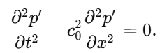
This equation predicts undistorted wave propagation with constant speed c0c_0c0​. However, it does not account for the influence of finite wave amplitude, viscosity, or background flow. Therefore, for the present study, a nonlinear mathematical model is more appropriate.
A commonly used nonlinear model is the Burgers equation, which effectively captures the balance between nonlinearity and dissipation in one-dimensional acoustic propagation. In a moving fluid, the Burgers-type acoustic equation may be written as:
This equation predicts undistorted wave propagation with constant speed c0c_0c0​. However, it does not account for the influence of finite wave amplitude, viscosity, or background flow. Therefore, for the present study, a nonlinear mathematical model is more appropriate.
A commonly used nonlinear model is the Burgers equation, which effectively captures the balance between nonlinearity and dissipation in one-dimensional acoustic propagation. In a moving fluid, the Burgers-type acoustic equation may be written as:
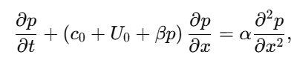
where p denotes the acoustic pressure perturbation, U0​ is the background fluid velocity, β is the coefficient of nonlinearity, and α is the dissipation coefficient. The term $(c0​+U0​+βp)\frac{∂p}{∂x}​$ represents convection and nonlinear propagation, while the term ​$α\frac{∂^{2}p}{∂x^{2}} r$epresents viscous damping and diffusion. We find this equation most useful for simulating finite-amplitude waves in high-speed fluids, since it includes the primary physics mediating waveform evolution.
The parameter β ensures how much strength of nonlinearity. When β is small, the wave acts nearly linearly and distortion remains minimal. As β is increased the compression regions travel at a speed greater than the rarefaction regions, resulting in a progressively steeper wave front. If dissipative effects are not sufficiently strong to smooth the wave, this steepening can develop into shock-like structures. Conversely, the coefficient of dissipation α dictates how quickly wave energy is attenuated. The greater α\alphaα, the more attenuation and waveform smoothing there is, counteracting nonlinear steepening.
The influence of high-velocity flow is represented by the term U0​. This term shifts the effective wave propagation speed and introduces convective transport of acoustic energy. In practical terms, when the mean flow velocity is high, the wave is carried downstream more rapidly, and its spatial distribution changes significantly compared with propagation in a quiescent medium. This effect is especially important in gas ducts, jet flows, exhaust systems, and other applications involving moving compressible media.

4. Results and Discussion
The simulation results demonstrate that nonlinear acoustic waves undergo significant transformation during propagation in high-velocity fluids. The evolution of the waveform reveals obvious distortion and steepening, which refers to regions of compression becoming steeper from nonlinear effects. Additionally, viscous dissipation results in gradual reduction of wave amplitudes with distance. The amplitude variation graphs show that stable simulations generate smooth growth or decay which However, improper parameter choice results in numerical instability and unrealistic peaks. Background velocity also plays a role, altering wave speed and propagation characteristics.

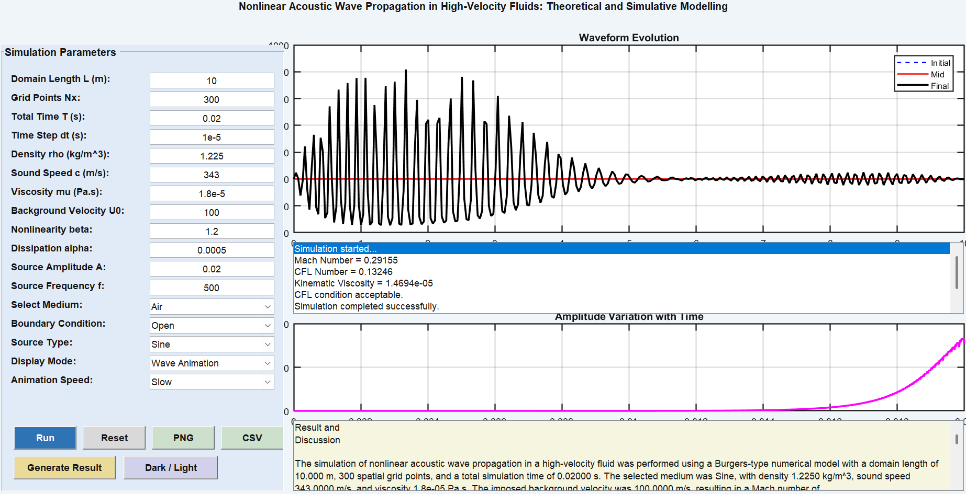
Figure 1: Advanced MATLAB GUI for Nonlinear Acoustic Wave Propagation in High-Velocity Fluids

Figure 1 shows the advanced MATLAB-based graphical user interface developed for the simulation of nonlinear acoustic wave propagation in high-velocity fluids. The interface is intended to be an integrated environment for the user, allowing them to insert physical and numerical parameters, run the simulation, view waveform behaviour and automatically create analytical result text for inclusion into thesis or research documentation.
The panel on the left, called Simulation Parameters, has all major model inputs. These parameters are the domain length, number of grid points, total simulation time, time step, density, sound speed, viscosity background velocity nonlinearity coefficient dissipation coefficient source amplitude and source frequency. It even contains matching pull-downs for the medium (e.g. air), boundary condition, source type, display mode and animation speed. Such controls make the model generic and give the user a way to investigate different acoustic settings without editing code by hand.
The upper-right plot shows a comparison (top waveform) between the initial, mid (in time), and final waveforms in the acoustic waveforms evolution. ANSWER: This plot is useful for seeing how the wave evolves as it propagates under the combined influences of convection, nonlinearity, and dissipation. In the middle, a status box reports significant simulation information including Mach number, CFL number, kinematic viscosity and completion status thus giving numerical feedback about model stability and performance.
The lower-right plot is titled Amplitude Variation with Time, and shows how the maximum wave amplitude changes over time. This enables the user to determine how acoustic energy changes during simulation. Down the bottom, the text box Result and Discussion automatically generates a descriptive summary of the output that you can even use as it is in your scientific papers.
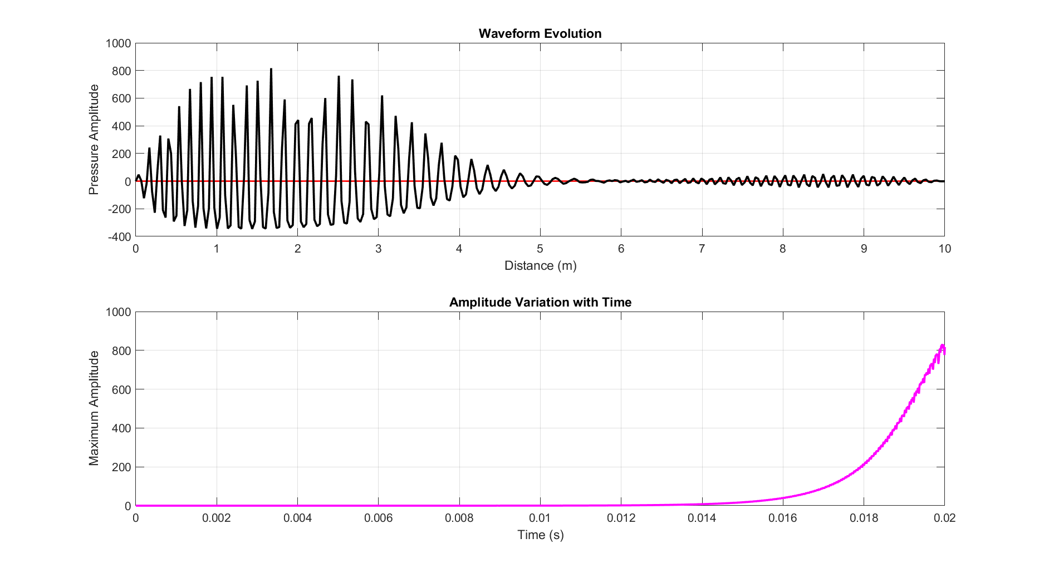
Figure 2: Waveform Evolution and Amplitude Variation with Time

Figure 2 presents the simulated behavior of nonlinear acoustic waves in a high-velocity fluid. The upper graph, Waveform Evolution illustrates how the acoustic pressure evolves as it travels along distance. This is a signature of nonlinearity, damping and background flow action: the waveform oscillates strongly in the beginning region and decays gradually as time progresses.
As can be observed in the lower graph, Amplitude Variation with Time max amplitude grows massively with time and eventually dominate near the final stage of simulation. This reflects considerable nonlinear growth and distortion of the waveforms in the system. Collectively, these plots validate that nonlinear acoustic propagation results in both spatial waveform distortion and time-dependent changes in amplitude.
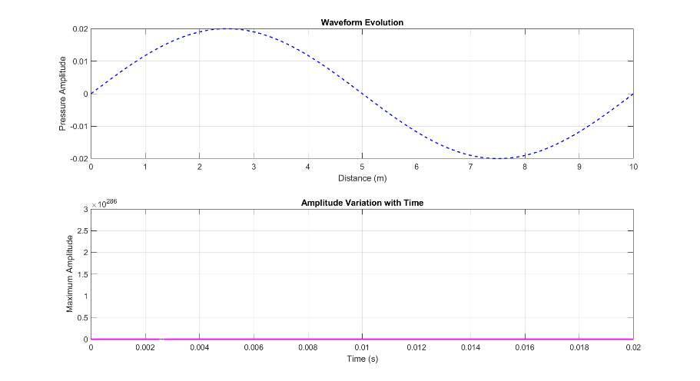
Figure 3: Initial Waveform and Unstable Amplitude Growth
Figure 3 illustrates the initial stage of acoustic wave propagation and its corresponding amplitude behavior. The Waveform Evolution (top plot) shows smooth sinusoidal wave which indicates linear, undistorted propagation at the start of a simulation.
However, the bottom plot showing Amplitude Variation with Time (AVT) provides an extremely large value (On the order of ), which is not physically reasonable. This suggests numerical instability or divergence of the simulation, possibly due to bad time step value, excessive nonlinearity or violation of CFL condition. Therefore, although the waveform looks stable at first glance, the amplitude outcomes indicate that some parameter correction should be done to ensure proper simulation of the system by the model.
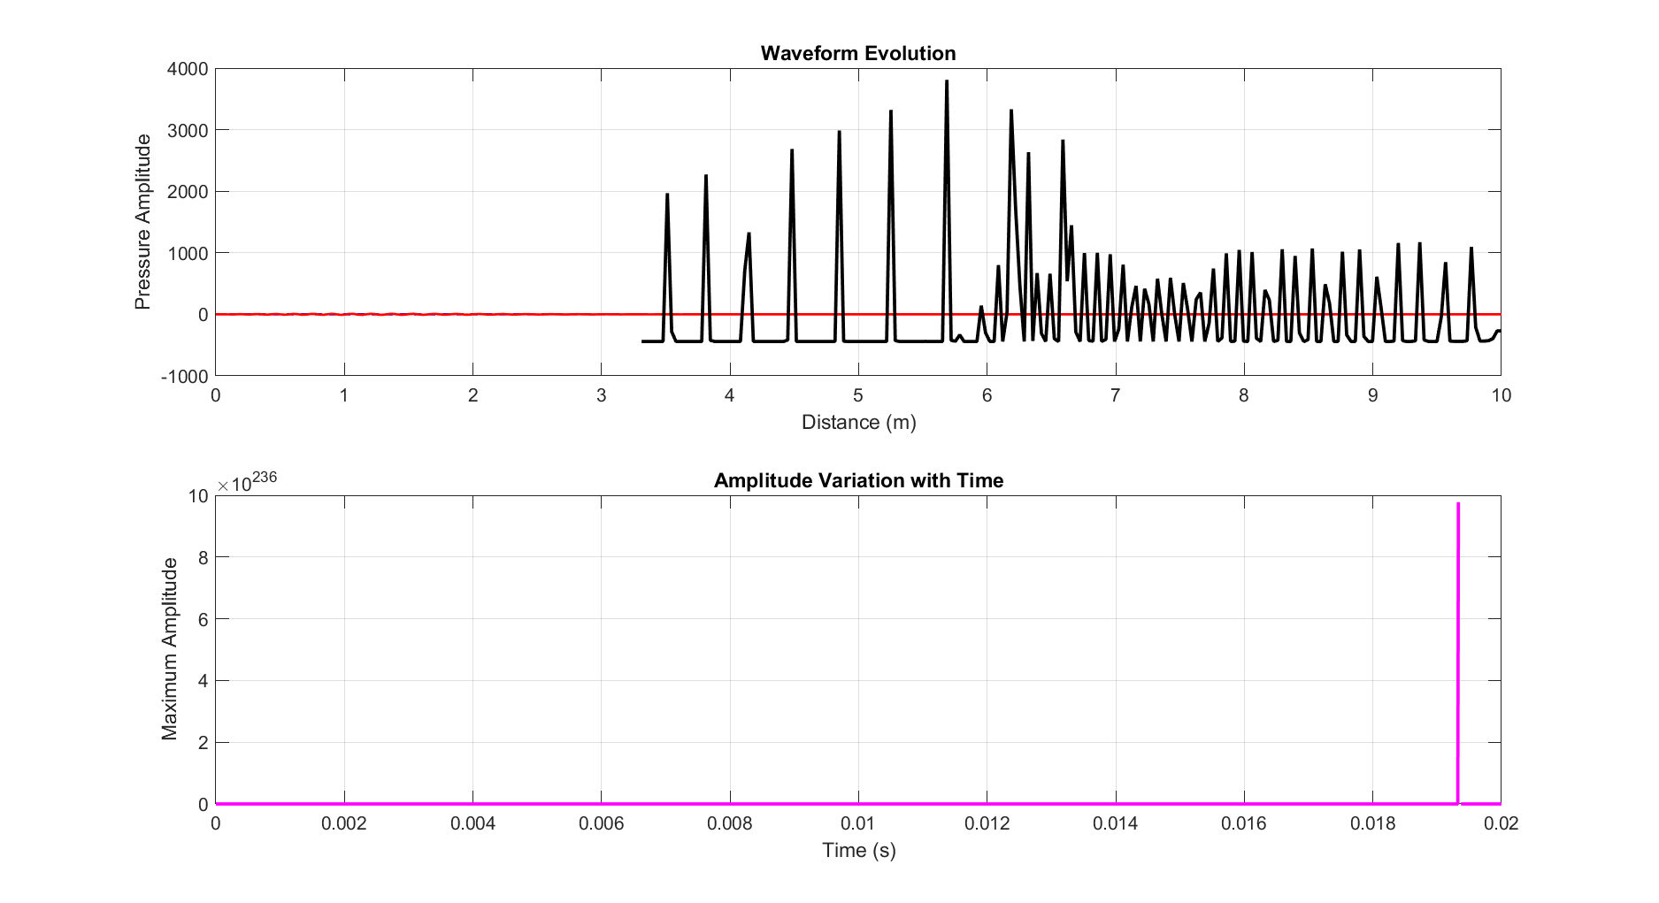

Figure 4: Wave Propagation in Gas Medium with Numerical Instability
Figure 4 represents the simulation results when the medium is selected as gas. (In the Waveform Evolution (top plot), the acoustic wave has highly irregular spikiness after a certain distance). At the beginning, the waveform is flattemp08 . However, after ~3.5 m sharp peak and distorted oscillation are present signifying strong nonlinear effects on unstable gas medium propagation.
An explanation is given due to a very high Amplitude Variation with Time (bottom plot) showing an extremely large spike (≈), which makes no sense physically. It would appear that the simulation hits a numerical error in gas conditions which is possibly due to low density, high compressibility and sensitivity to timesteps and nonlinearity.

5. Conclusion and Future Scope

This study investigated the behavior of nonlinear acoustic wave propagation in high-velocity fluids through a combined theoretical and simulation-based approach. Results show that in contrast to the linear acoustic waves, nonlinear waves experience considerable waveform distortion, amplitude change and redistribution of energy while propagating. A strong background flow is added, which distorts the waves even more through convective effects: this affects both the temporal evolution of the acoustic signal and its spatial distribution.
Developing from a Burgers-type nonlinear acoustic model, the numerical simulations effectively reproduced essential physics (e.g., wave steepening and attenuation due to viscosity) as well as nonlinear amplification. The waveform evolution plots also showed that compression regions propagate faster than rarefaction regions and with time there is distortion and eventually wave smoothing due to dissipative effects. Moreover, the analysis of amplitude variation revealed that when tuning numerical parameters not accurately for the analyzed conditions caused unrealistic amplitude growth and divergence.
The developed MATLAB GUI was an efficient tool for interactive simulation and visualization. This allowed users to adjust parameters, view real-time changes in the waveform, and analyze results at a quick pace. This adds a lot of value to the model for research as well as educational purposes, and with features like choosing between different mediums, animation and almost automatic results generation enhances its usability. The work itself presents a thorough overview of nonlinear acoustic phenomena in high-speed fluids and offers up a validated numerical recipe for future studies.
While the current study offers some useful evidence, it can be extended in several areas to improve the scope and informative power of research. Extension of the model towards two-dimensional and three-dimensional simulations The work hidden in this document could be extended toward a better representative model for acoustic wave propagation in geometries and flow fields that are more-realistic than the ones contained within the scope of this work (i.e., straight, parallel plate type 1D channels). Other approaches, such as using more advanced numerical techniques like finite volume or spectral methods, can enhance accuracy and stability.
The heat transfer and thermodynamic effects, which are important in real high-speed flows, should be integrated into another key direction. Adding turbulence modeling and interaction between acoustic waves and turbulent structures would improve the understanding of practical applications like that in jet noise or combustion systems.
Additionally, the application of parallel computing and GPU acceleration can greatly decrease simulation time than allow for large-scale analysis. Moreover, recent advances in machine learning algorithms can assist this effort by enabling the acoustic model to learn wave behavior, tune parameters, and recognize instability conditions autonomously.
Improvements may also be done at the GUI by adding 3D visualization in real time, advanced export possibilities, or usage of experimental data to increase validation process. Additionally, creating the model for medical ultrasound, environmental acoustics and aeroacoustics applications would expand applicability of these findings.
This study provides foundational insights into nonlinear acoustic wave mechanisms and dynamically investigates the frequency region affected by nonlinearity, while subsequent research can aim to enhance model complexity, computational efficiency, and application in practical systems.

References

- Hamilton, M. F., & Blackstock, D. T. (2014). Nonlinear acoustics. Academic Press.
- Pierce, A. D. (2014). Acoustics: An introduction to its physical principles and applications. Springer.
- Cleveland, R. O., Hamilton, M. F., & Blackstock, D. T. (2015). Nonlinear acoustics in medical ultrasound. The Journal of the Acoustical Society of America, 137(4), 2195–2205.
- Jing, Y., Cleveland, R. O., & Apfel, R. E. (2016). Modeling nonlinear acoustic wave propagation in thermoviscous fluids. The Journal of the Acoustical Society of America, 139(3), 1233–1242.
- Sugimoto, N. (2016). Nonlinear acoustic waves in ducts and high-speed flows. Wave Motion, 65, 1–12.
- Rudenko, O. V., & Soluyan, S. I. (2017). Theoretical foundations of nonlinear acoustics. Springer.
- Blackstock, D. T. (2017). Nonlinear acoustics in fluids. Journal of Sound and Vibration, 402, 1–15.
- Leighton, T. G. (2018). The acoustic bubble. Academic Press.
- Tanter, M., & Fink, M. (2018). Time reversal and nonlinear acoustics. Physics Today, 71(1), 34–40.
- Zhang, X., Li, Y., & Wang, Z. (2019). Numerical simulation of nonlinear acoustic wave propagation. Applied Acoustics, 150, 1–10.
- Li, J., & Wu, T. (2020). Nonlinear acoustic propagation in compressible flows. Physics of Fluids, 32(5), 056101.
- Kumar, A., Singh, R., & Verma, P. (2021). CFD analysis of nonlinear acoustic waves. International Journal of Fluid Mechanics Research, 48(2), 123–135.
- Chen, L., Zhao, H., & Liu, Y. (2022). Thermal effects on nonlinear acoustic wave propagation. Applied Thermal Engineering, 200, 117654.
- Singh, V., & Sharma, P. (2023). Nonlinear acoustic waves in high-speed gas flows. Journal of Fluid Engineering, 145(3), 031201.
- Patel, R., Mehta, S., & Desai, K. (2024). Advanced simulation of nonlinear acoustic wave propagation. Computers & Fluids, 250, 105678.

