CLIMATE CHANGE SCENARIOS AND MONTHLY PRECIPITATION IN CONGO-BRAZZAVILLE BETWEEN 2021 AND 2040 : CMIP6 MULTI-MODEL PROJECTIONS

Introduction
Congolese territory, located on the western margins of Congo Basin between longitudes 11° and 19° East and latitudes 4° North and 5° South with altitudes exceeding 900 meters altitude (figure 1). Meteorological, hydrological and climatological hazards cause, each year, disasters that claim many victims and delay economic and social development in several regions of the world. Congolese territory is already a victim of this. For better social and economic health, knowledge of rain system should be a primary challenge for decision-makers and scientists. Congolese social and economic atmosphere undoubtedly depends on rhythm of rains. Country's main economic activities such as agriculture and forestry are dictated by climate and especially by rains. However, the Congolese rain system is not homogeneous. Works of Mpounza M. and Samba-Kimbata J-M. (1990), Bigot S., Moron V., Melice J-L. et al., (1998), G. Samba and M. Mpounza (2005), G. Samba and D. Nganga (2012) and G. Toli and G. Samba (2022) have announced problem of precipitation disturbances on Congolese territory. However, analyses remain pessimistic and several works announce a significant decrease in precipitation on Congolese territory. It is in this momentum that we questioned future rhythm of monthly precipitation in Congo-Brazzaville based on projections of CMIP6 multi-model. All this aims to develop an appropriate response to climate change-related vulnerability in Congolese landscapes by providing scientists, political decision-makers, practitioners and local communities with reliable and updated information and analyses to design and implement climate change adaptation policies and projects.
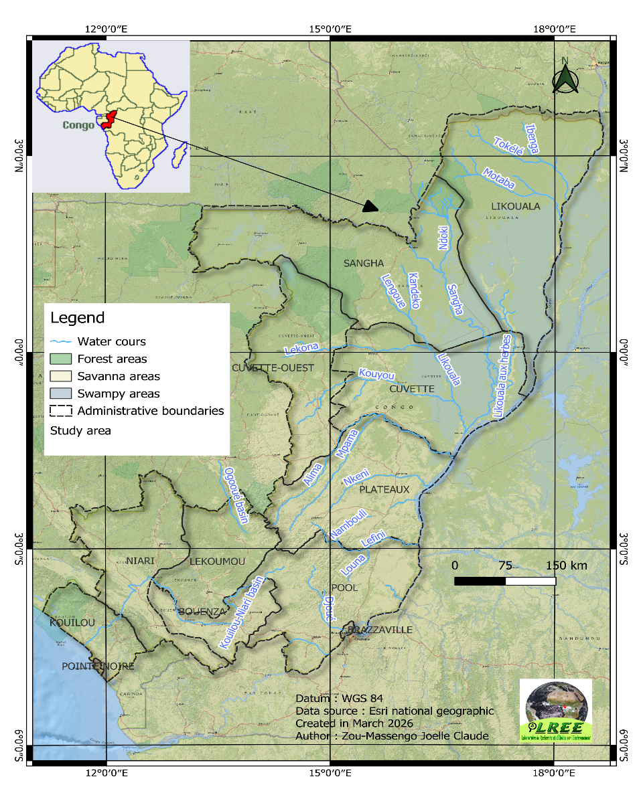
Figure 1: vegetation and hydrographic network of the study area
Data and Methods
Data
Data selected consist essentially of precipitation measured at monthly time steps for a 0.25°×0.25° grid from GeoTiff files from WorldClim. These are simulations from the CMIP6 model developed by the National Center for Meteorological Research (CNRM) of France. From these files, we extracted rainfall simulation data for entire Congolese territory for the SSP1-2.6 scenario and for the period from 2021 to 2040. Data available here are future climate projections at reduced scale CMIP6. Downscaling and calibration (bias correction) were performed with WorldClim v2.1 as reference climate.
Methods
We used various methods and statistical tests for processing precipitation data using Excel 2016 and Xlstat 2014 software. different methods used are :
Cumulative
This is the sum of values contained in a series or matrix. This method allowed us to extract cloud occurrences during the September-October-November 2020 season. It is defined as follows:
$$\sum{Xi}$$

With: Xi as series variable (here, xi = precipitation).

Arithmetic Mean
It is ratio of sum of values in the statistical series to number of values. It allowed us to represent averaged values of precipitation occurring during each season. This method is defined as follows:
$$\overline{X}=\frac{1}{N}\sum_{i=0}^{n}{Xi}$$

With: Xi, series variable; n, variable frequency; N, total frequency
IDW Interpolation
Representation of precipitation values was done through a geographic information system (GIS) using cubic interpolation with IDW method. IDW interpolation (or inverse distance weighting) is a type of multivariate interpolation method with a set of known scattered points. Values assigned to unknown points are calculated with a weighted average of available values at known points. Algorithm of this interpolation method is programmed and integrated into ArcGIS 10.8 software that we used.
Results and Discussion
Climate State through the SSP1-2.6 Scenario of the CMIP 6 Multi-Model
Climate Model Intercomparison Program (CMIP) is a program created by World Climate Research Programme (WCRP) to promote international cooperation between climate modeling centers. Climate numerical simulations from CMIP feed numerous scientific projects for understanding mechanisms and model evaluation, multidisciplinary impact studies and serve as reference for IPCC reports. Each phase of this program therefore advances the foundation of climate knowledge and particularly its probable evolution, foundation on which policies are then based. These simulations also feed emerging climate services (CEA/CNRS/Météo-France, 2019). CMIP6 project took shape in 2015 and is based on 21 model intercomparison sub-projects (MIP) contributing to seven major challenges of World Climate Research Programme (figure 2): clouds, atmospheric circulation and climate sensitivity (i); changes affecting the cryosphere (ii); climate extremes (iii); water availability (iv); regional sea level rise (v); decadal prediction (vi); biogeochemical forcings and feedbacks (vii).
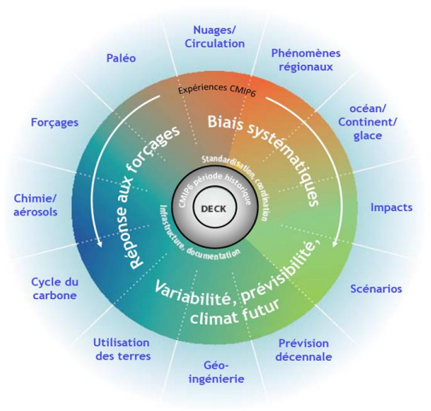
Figure 2: Schematic representation of scientific themes and CMIP6 organization (source: CEA/CNRS/Météo-France 2019)

In order to study, climate state through the SSP1-2.6 scenario, we selected two essential climate parameters: temperatures and precipitation. SSP1-2.6 scenario starts in 2015 and emits climate change assumptions based on low GHG emissions, with CO2 emissions decreasing to net zero emissions around or after 2050, followed by varying levels of negative net CO2 emissions (IPCC, 2021, p.16). SSP1-2.6 scenario, which presents climate simulations highlighting less pronounced human action on climate, emits an assumption that implies that global warming cannot exceed 2°C during the 21st century (IPCC, 2021, p.15). In Figure 3 from year 2015, global average temperatures remain below 2°C for the SSP1-2.6 scenario. Regarding precipitation, the SSP1-2.6 scenario suggests an increase in precipitation at high latitudes, in equatorial Pacific and in certain parts of monsoon regions, but a clear decrease in certain parts of subtropical regions and in limited areas of tropics (IPCC, 2021, p.19). Figure 3 presents evolution of global average precipitation from 1850 to 2100 through the different CMIP6 scenarios. We note, for SSP1-2.6 scenario, an upward evolution of precipitation from year 2016. This evolution will slow down from the 2070s and continue its evolution until 2100 (figure 3).
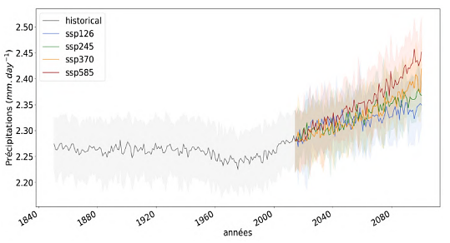

Figure 3: Projections on evolution of global average precipitation according to CMIP6 model scenarios (Source: IPCC, 2021).

Monthly average precipitation in Congo-Brazzaville between 2021 and 2040 rainfall regime
Rainfall regime
Data from Climate Explorer allowed us to develop rainfall regime for entire territory. Observation is that during the projected period (2021-2040), rainfall regime of Congo-Brazzaville remains bimodal with seasonal alternation. However, data show that rains occurring during months of December, January and February record low precipitation quantities with values that hardly exceed 1 mm of water per day. Month that receives less rain per day is January against September whose rain values exceed 8 mm of water per day (figure 4).
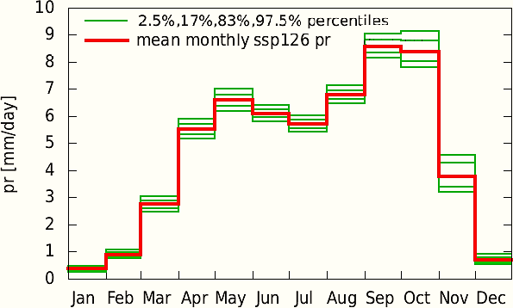
Figure 4: rainfall regime
Spatial distribution of precipitation
Monthly average precipitation values from 2021 to 2040 vary, overall, between 0 and 376.5mm. Results attest that southern parts (southeast and southwest) of Congolese territory will be increasingly rainy during months of January, February, March, April, November and December with average precipitation values varying between 28.1 and 376.5 mm (Figure 5). In January, rainfall values in south-Congo will reach 28.1 while in North-Congo, 202 mm of water will be recorded. An increase will be observed in next month (February) in the South 47 mm of water against 217 mm of water in the northern part. Month of March will record rainfall values of 116 (South) to 265 mm of water for north-Congo. April will present an upward trend of 139 for south-Congo and 249 mm of water for the northern zone. Considerable increase in precipitation during these months would be attributable to rainy season in South-Congo.
During month of May, South-Congo will record 63 mm of water while north-Congo will experience 207 mm of water. Month of June will be marked by low rainfall quantity in south-Congo, i.e., 0.3 mm of water; in North-Congo, we will observe a rainfall increase notably 200 mm of water. This can be explained by fact that these Congolese climate zones do not have same rainfall rhythm. In July, as in August, South-Congo will have recorded insignificant precipitation values while north will experience 202 and 245 mm of water. In month of September, south-Congo will be marked by rainfall of 6.3 mm of water. On the other hand, in north-Congo, we will observe 237 mm of water. Months of October, November and December will experience respectively 45, 113 and 44 mm of water in south-Congo. While rainfall values in North-Congo will be 315, 376 and 250 mm of water.

January  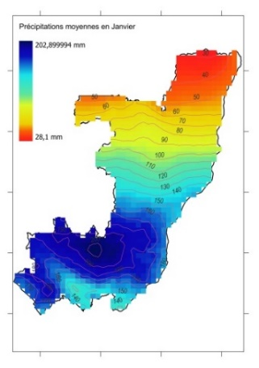 | February  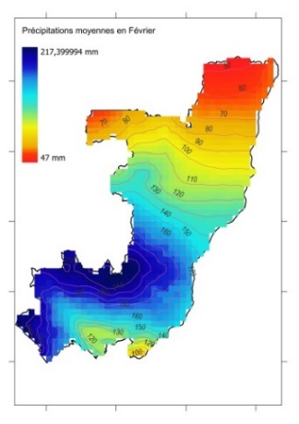 | March  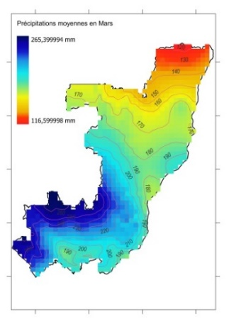 | April  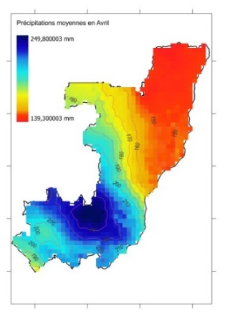
May  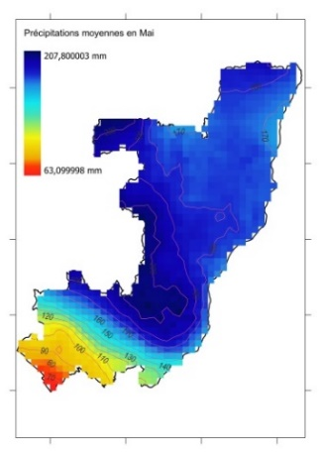 | June  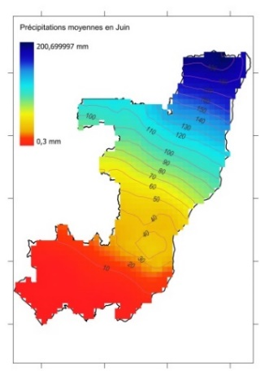 | July  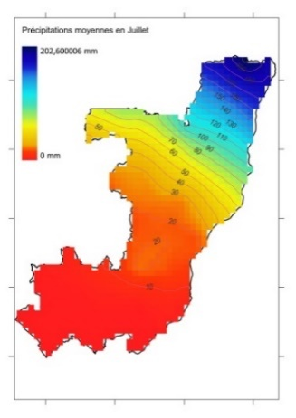 | August  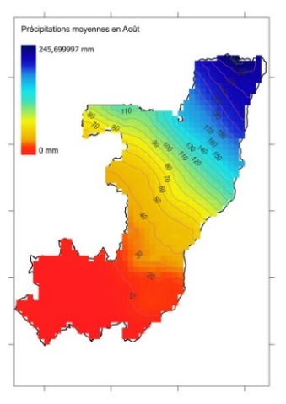
September  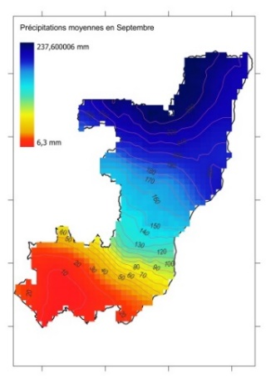 | October  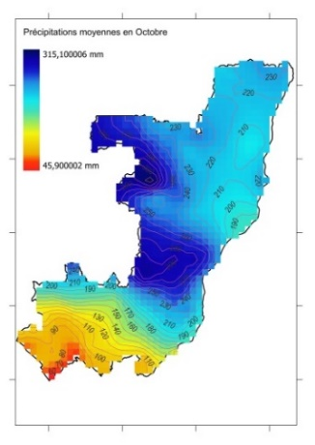 | November  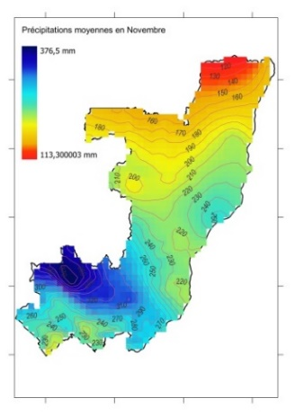 | December  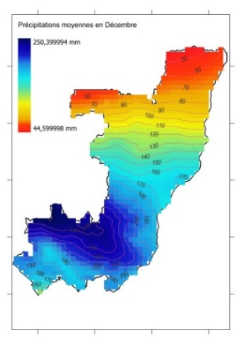
Figure 5: distribution of monthly average precipitation
Discussion
Congo has seen an increase in rainfall since 2016. This trend will slow down by 2070 and 2100. Thus, their average monthly values from 2021 to 2040 vary between 0 and 376.5 mm. This is conclusion reached by Samba G. (2014b). Author points out the presence of two climatic regions with opposite trends in terms of rainfall variability: northern Congo is experiencing a downward trend, while rainfall in southern Congo is increasing. However, work of Samba G. (2020) indicates that rainfall will decline until 2100. In his book, Samba G. (2024) shows that 1980s and 1990s were characterized by a considerable rainfall deficit of between 10 and 20 %. Work carried out by Toli G. and Samba G. (2022), by Samba G., (2014 a) and by Samba G. and Nganga D. (2013) confirm the results we have obtained. Authors indicate that Congo has two rainfall regimes: an equatorial regime in northern Congo and a regime with a strong tropical humid influence in the south of the country. There is an alternation of rainy and less rainy seasons. The maximum rainfall occurs from March to May (MAM) or from September to November (SON), and the minimum rainfall from December to February (DJF) or from June to August (JJA). During the SON season, a recurring maximum is observed at all stations in November throughout the Congolese territory.
Global climate changes remain one of humanity's major concerns whose effects affect all sectors of world including that of rainfall. Rainfall variability observed in African sub-regions particularly in Congo-Brazzaville which is the region of the present study is influenced by several factors including climate changes. Results obtained in this study allow us to observe temperature changes based on low GHG emissions, with CO2 emissions through the SSP1-2.6 scenario and an increase in monthly average precipitation values from 2021 to 2040 which vary overall between 0 and 376.5 mm. Also, during the projected period (2021-2040), rainfall regime of Congo-Brazzaville remains bimodal with seasonal alternation. These results agree with the main conclusions of research works that focused on the sub-region (Zou-Massengo J. C., 2020) which show that the organization of monthly precipitation in this region translates into bimodal rainfall regimes and by an increase in rainfall quantity in certain rainfall stations.
Conclusion
This study aims to analyze projections of climate deteriorations and monthly precipitation in a developing country between 2021 and 2040. Results obtained indicate an upward evolution of precipitation from the year 2016. This evolution will slow down from the 2070s and continue its evolution until 2100. In Congo-Brazzaville, monthly average precipitation values from 2021 to 2040 vary between 0 and 376.5 mm. In terms of future prospects, our study focuses on adaptation strategies of Congolese populations in face of climate change.
References

BIGOT Sylvain, CAMBERLIN Pierre, MORON Vincent et RICHARD Yves, 1997, Structures spatiales de la variabilité des précipitations en Afrique : une transition climatique à la fin des années 1960 ?, Géophysique externe climat et environnement C.R. Acad. Sci. Paris, t. 324, série IIa, pp.181-188.
BIGOT Sylvain, MORON Vincent, MELICE Jean-Luc, SERVAT Eric et PATUREL Jean-Emmanuel., 1998, Fluctuations pluviométriques et analyse fréquentielle de la pluviosité en Afrique Centrale, Century Proceedings Of The Abidjan'98 Conference Held At Abidjan, Côte D'ivoire, pp.71-78.
CAMBERLIN Pierre, 2007, L’Afrique Centrale dans le contexte de la variabilité climatique tropicale interannuelle et intrasaisonnière, Presses Universitaires d’Orléans, l’Afrique Centrale, le Cameroun et les changements globaux, Yaoundé, Cameroun. pp.25-39.
CAMBERLIN Pierre, BELTRANDO Gerard, FONTAINE Bernard et RICHARD Yves., 2002, Pluviométrie et crises climatiques en Afrique Tropicale : changements durables ou fluctuations interannuelles ? Historiens& Géographes n°379, pp.263-273.
Climate Service Centre., 2013, Climate Change Scenarios for the Congo Basin, [Haensler A., Jacob D., Kabat P., Ludwig F. (eds.)]. Climate Service Centre, Report No. 11, Hamburg, Germany, ISSN: 2192-4058, 219p.
DJOUFACK-MANETSA Viviane., 2011, Étude multi-échelles des précipitations et du couvert végétal au Cameroun : analyses spatiales, tendances temporelles, facteurs climatiques et anthropiques de variabilité du NDVI, Thèse de Doctorat, Université de Yaoundé I/Université de Bourgogne, 303p.
HUA Wenjian, ZHOU Liming, NICHOLSON Sharon E., CHEN Haishan and QIN Minhua., 2019, Assessing reanalysis data for understanding rainfall climatology and variability over Central Equatorial Africa, Climate Dynamics 53: pp.651–669. https://doi.org/10.1007/s00382-018-04604-0
LOUZOLO-KIMBEMBÉ Paul, 2013, Changement climatique : Enjeux socio-économiques et déﬁs technologiques dans les pays du bassin du Congo, Actes du colloque international de Brazzaville du 1er au 3 décembre 2009, L’Harmattan, pp23-25..
MPOUNZA Marcel et SAMBA-KIMBATA Marie Joseph., 1990, Aperçu sur le climat de l'Afrique centrale occidentale In : lanfranchi raymond (ed.), schwartz dominique (ed.). Paysages quaternaires de l'Afrique centrale atlantique. Paris : ORSTOM, pp. 31-41. (Didactiques). ISBN 2-7099-1022-5. ISSN 1142-2580.
NICHOLSON SE., 2018 : The ITCZ and the seasonal cycle over equatorial Africa. Bull Am Meteorol 546 Soc 30 : 337–348
OMM, 2011, Guide des pratiques climatologiques, OMM-N° 100, CH-1211 Genève 2, Suisse, ISBN 978-92-63-20100-3, 152p.
OMM, 2019, Rapport annuel 2018 : L’OMM au XXIe siècle, OMM-N° 1229, 25 p : https://public.wmo.int/fr/ressources/meteoterm.
SAMBA Gaston and NGANGA Dominique., 2012, Rainfall variability in Congo-Brazzaville: 1932–2007, Int. J. Climatol. 32, pp854–873. https://doi:10.1002/joc.2311
SAMBA Gaston et MPOUNZA Marcel, 2005, Application du processus de Markov sur les occurrences des précipitations journalières au Congo-Brazzaville, Compte Rendu Géoscience (337) : pp.1355– 1364. https://doi:10.1016/j.crte.2005.07.010
SAMBA Gaston et NGANGA Dominique, 2013 : Variabilité pluviométrique dans le Bassin du Congo, Éd. L’Harmattan, 19 : 53-72.
SAMBA Gaston, 2014a : Occurrences des précipitations journalières au Congo Brazzaville (1950-2010), in Revue de Géographie de Lomé À H כֿ H כֿ, 16 : 120-136, ISSN 1993-3134.
SAMBA Gaston, 2014b : Le Congo-Brazzaville, Climat et environnement, Paris, Éd. L’Harmattan, 155 p.
SAMBA Gaston, 2020 : Le climat du Congo-Brazzaville, Paris, Éd. L’Harmattan, Coll. « Études africaines », 241 p.
SAMBA Gaston, 2024 : Rainfall variability in Congo-Brazzaville, Generis Publishing, Moldavie, 87 p.
TOLI Ghislain and SAMBA Gaston, 2022, Spatial and Temporal Distribution of Rainfall on the Western Margins of Congo Basin, ResearchGate.net, publication/359246122, last Updated : March 2022, 14p.https://www.researchgate.net/publication/359246122
TOLI Ghislain et SAMBA Gaston, 2022, Tendances et ruptures des précipitations sur la partie congolaise du Bassin du CONGO, Revue Espace Géographique et Société Marocaine, Vol.1, N°60, pp.181-197. https://doi.org/10.34874/IMIST.PRSM/EGDM/32318
ZOU-MASSENGO Joëlle Claude, 2020 : Organisation spatio-temporelle des précipitations journalières dans le Sud-Congo, Mémoire de Master de Recherche, Spécialité Géographie physique, Faculté des Lettres, Arts et Sciences Humaines (Université Marien Ngouabi), 74 p.

