The Health Benefits of Traditional Games in Mental Well-being of BPE Students

INTRODUCTION
Background of the Study
As an expression of cultural heritage, beliefs, and passions, traditional games reflect the living conditions of their time while playing a significant role in preserving national identities with their modern and traditional features against the efforts of global powers to eliminate national cultures. Research indicated that traditional games provide benefits not only for children's psychological well-being but also for their physical fitness (Parlebas, 2014).
Worldwide, the massive penetration of smartphones and digital consumptions has reshaped leisure activities, younger generations have a strong preference for digital games rather than traditional games (Rahman, 2025). This transition resulted in less physical activity and interaction with others, both of which are essential for mental and emotional well-being. The children’s and young people’s traditional games are being looked down upon in comparison to attractive, more colorful screens and visual digital games, which is leading to a loss of interest among the children and young people. Time-honored Filipino games that were mostly played on the streets and public areas such as patintero and tumbang preso have been played for many generations, though few are still played today, among the youth in particular. It is said to have decreased due to the impact of digital technology and sedentary lifestyle that distract Filipino children’s attention from active play towards screen-related activities, elevating inactivity- and poor mental health-related vulnerabilities among them (Dizer et al., 2022). Digital and social media use for entertainment ha
been increasingly favored by Filipino youth, which also poses greater risk of anxiety, depression, social withdrawal and decreased physical activity (Karaköse et al., 2023). Considering the mental health situation of Filipino students, traditional games are still untapped in public health and educational initiatives (Villar et al., 2015). Furthermore, changing cultural practices and westernization degraded traditional games leading to the reduction and loss of Filipino cultural heritage which is linked to the mental wellbeing (Basri et al., 2018).
In Bacolod City, the issue of dying traditional games is more than just a matter of culture; it is also a matter of the mental health of the young people. The city is experiencing an increase in mental health concerns among students, including higher rates of anxiety, depression, and behavioral problems, which are linked partly to decreased physical activity and social interaction (Bacolod City Health Office, Magluyan & San Jose, 2025). Traditional games have been found to improve physical health, emotional regulation, socialization interaction, and cognitive skills which are fundamental elements in achieving mental wellness (Dizer et al., 2022). Yet, these games have been declining because of urbanization, the scarcity of safe play spaces to its own kind, and digital technology taken over them. But the articles are online schools and community programs in the city of Bacolod have not yet fully adopted the equipment in mental health or PE syllabus associated with those tools in the culture that’s become a home to these are very relevant implement in the local community.
Traditional sports and games have been found to inculcate values cooperation, discipline, friendship, and psychological strength which contribute to mental health (Siregar & Ilham, 2019). These positive aspects notwithstanding, support from institutions is scarce, and the contribution to mental health has been little researched, especially in local context. Hence, this research is intended to contribute to the
evidence base for the safeguarding and dissemination of traditional games in the face of competing ‘educational’ and ‘healthy lifestyle’ priorities by demonstrating how the games can be used to promote mental health and, by doing so, ensuring cultural continuity and well-being among Filipino youth.
Even as mental health and mindfulness in schools are becoming more recognized, the vast majority of schools still operate within a tightly-regimented system that gives little consideration to rest, mindfulness, or general well-being. In particular, Physical Education lessons are not able to deliver mindfulness-based blocks and many HE courses are the same. This exposed a blind spot in the teaching methods of today’s schools: (Donato, et al.2025) The traditional method of education which those methods relied so heavily on for providing an academic and occupational work ethic, neglected the health of mind and emotions creating an environment that stifled the potential to foster mindfulness education. While previous research demonstrated positive physical and academic benefits for students from quality physical activity programming with a high degree of objectivity, there are limited studies that examined what would motivate or discourage students in the Philippines to join school-based fitness activities. The absence of locally produced evidence-based data hinders the development of learner-sensitive/culture-specific intervention package. To address the void, the study investigated the advantages of traditional games to Filipino college students in their mental well-being.
Despite these positive insights, local literature remained largely descriptive, focusing on cultural preservation and general student engagement rather than rigorous
measurement of mental health outcomes. (Magalona, 2025) Few Philippine studies have applied standardized psychological instruments such as the Perceived Stress Scale (PSS) or the Generalized Anxiety Disorder scale (GAD-7) to evaluate the impact of traditional games. Consequently, the effect of traditional play on stress, anxiety, or depression among tertiary-level students particularly Bachelor of Physical Education (BPE) majors remained under-explored. Addressing this gap through quasi-experimental research will not only strengthen the evidence base but also provide practical guidance for integrating traditional games into formal education as a strategy for promoting mental well-being.
Statement of the problem
The main aim of this research is to determine the influence of traditional games on the mental health of Bachelor of Physical Education (BPE) students through a quasi-experimental design specifically, the study seeks to answer the following questions;
- What are the mental Well-being of the participants before and after the Traditional game in term of gender?
- Compare the pre-test and post-test results of BPE students who engaged in traditional games.
- Is there a significant difference between pre-test and post-test?

Scope and limitation
This study investigates how students from Central Philippine Adventist College, particularly those in the barangays, are affected by traditional sports that require physical activity during the academic year 2025–2026 in Alegria, Murcia, Negros Occidental. Ten students enrolled in the Bachelor of Physical Education program are the participants. Among various traditional Filipino games, the study focuses solely on the slipper game to evaluate its impact on psychological well-being and physical fitness.
Significance of the study
This study investigates the health advantages of traditional games in college students' physical activities, with a focus on how they affect mental well-being. College students, P.E., and other stakeholders can benefit from the research's conclusions. Teacher, heads of departments, and aspiring researchers.
College Students. This study emphasizes how playing traditional games as part of physical activities can improve mental well-being and physical fitness. Students may be inspired to engage in more leisure activities if they are aware of the advantages, which can enhance their cardiovascular health, muscular strength, coordination, and collaboration.
P.E. Teachers. For Physical Education instructors, this research provides insights into how traditional games can be integrated into lesson plans to improve student engagement and overall fitness. It supports the idea that traditional games are not only enjoyable but also serve as effective tools for promoting physical well-being and social interaction among students.
Department Head. The study provides department heads with useful information for creating and executing curriculum improvements. Department heads may push for the inclusion of traditional games in school activities if there is proof of their advantages, which will promote a more engaging and comprehensive approach to physical education.
Future Researchers. Future research on the effects of traditional physical activities on students' social behavior and health can use this study as a guide. It opens the door for more research on game-based exercise regimens, comparisons with contemporary fitness fads, and long-term impacts on students' health. To further understand their advantages, future researchers can build on this study by looking at various age groups, cultural effects, or game modifications.
Definition of Terms
Traditional Games. Conceptually: Philippine indigenous games, widely known as Laro ng Lahi, are a collection of traditional games, with pre-colonial and colonial-era historical origins, and are usually played in recreational and nonmainstream contexts to demonstrate or test an individual or group’s strength, endurance, and dexterity (Mabborang et al., 2022). Operationally, these games bring people together and help pass down important values and stories from older generations to younger ones. Playing these games is not just for fun; it helps keep traditions alive and strengthens the sense of community among people.
Bachelor of Physical Education (BPE) Students. Conceptually: Bachelor of Physical Education (BPE) students are individuals enrolled in a four-year academic program that develops their knowledge, skills, and competencies in physical education, sports, fitness, and health promotion. The curriculum integrates courses in sports science, coaching, sports psychology, and physical activity to prepare students as effective physical educators who can promote lifelong wellness. BPE students also receive hands-on training in teaching, coaching, and managing physical education programs to respond to diverse learning needs and foster holistic development (University of the Philippines Visayas, 2022). Operationally, BPE students refer to the fourteen participants from the Selected BPE students at Central Philippine Adventist College who took part in the traditional game interventions.
Mental Well-being. Conceptually: Mental well-being is defined as a positive state of mental health characterized by the ability to manage stress, experience positive emotions, build meaningful relationships, and maintain psychological resilience (World Health Organization, 2018). Operationally, mental well-being is measured using pre-test and post-test evaluations focusing on stress reduction, positive affect, and changing mood among BPE students.

CHAPTER II
REVIEW RELATED LITERATURE
This chapter examines the body of research on the health advantages of playing traditional games while physical activity, with a particular emphasis on how they affect college students' social interaction and level of fitness. Important topics including the psychological and emotional advantages of social play, the physiological benefits of movement-based games, and the contribution of classic games to encouraging an active lifestyle will all be covered in the conversation. The review will also highlight research that contrasts contemporary fitness methods with traditional physical activities, highlighting how well they work to promote student involvement and sustained exercise.
History of Traditional Games
Traditional games are the informal learning activities, through which children acquire various physical, cognitive and social skills by playing with readily available or natural materials (Woodard, 2004). Such games are usually transmitted orally, generation to generation and in the process they conserve cultural traditions and community values, that is what Opie and Opie (1969) stated in relation to this particular type of games. From ancient times to modern day, numerous traditional games have evolved yet persist in one form or another, such as tag played worldwide in many variations, hopscotch, and many more (Pellegrini, 2009), proving that such games have cultural and temporal relevance. Traditional Filipino games are not just play for children and communities they are also important tools for physical growth and development, social engagement and cultural identity. These promoted teamwork, respect, dexterity, creativity and strategic doing as they connect the young generations with ancestral ways and common cultural values (Ferolino & Marasigan, 2022). They are still culturally important despite the rise of digital and modern games which dominate the pastime of today’s children. Across all cultures, traditional games have proven to be very resilient to change in society and technology. Numerous archaic play forms, including tag, games of wrestling, and hopping games, still existed in diverse culturally-modulated expressions, showing the pertinence of their meaning in play and the global applicability of their play forms. Through the years of the colonial rule of the Spain and America in the Philippines, traditional games in the country have gradually developed by adapting foreign elements. Although Western sports and formal physical education institutions were introduced, native games were still widely played in the communities because they were simple to play, culturally familiar, and played in groups (Hortelano et al., 2015). These games were not simply pastimes, but also modes of instilling values such as bayanihan (cooperation), the respect for rules, discipline, and emotional regulation.
Traditional games within Southeast Asia were developed through regional communal living patterns and climates particular to that of the Philippines. When practiced, they helped shape an active body, which, just like the hardworking farmer and good neighbor, must be physically agile, enduring, and cooperative virtues that had been practical demands by Filipino agriculture labor and community relations of shared labor even before colonization. Games like patintero developed awareness of space and cooperation while tumbang preso necessitated accuracy, planning, and teamwork. They are life-skills games, ones that teach you things to help you live, even ones that teach you how to live and play your part (Hortelano et al., 2015). In the colonial era, customary games continued to be played in the Philippines alongside the introduction of western sports and systems of formalized physical education. Instead of vanishing, a lot native games existed with colonial influences, borrowing rules and contexts of the colonial source but maintaining its cultural core (Ferolino & Marasigan, 2022).This flexibility is a testament to the vitality of traditional games as living culture that can change form, without losing its core values. Physical and social skills are also honed in other games like Luksong Tinik or "Jumping over thorns," in which players leap over raised "thorns" made-up of the hands and feet of other players, increasing their dexterity and agility Players of Sipa are required to keep a small rattan ball or object in the air, striking it with feet and other body parts except the hands, thereby improving balance and stamina; it has cultural connections with football games played in South East Asia (Sunstar, 2025). Piko, the Filipino version of hopscotch, helped improve balance, focus, and fine motor skills as players jump on grid patterns traced on the dirt floor (Ferolino & Marasigan, 2022).
Mental Well- being
Studies indicated that students’ poor mental health is characterized by growing incidences of anxiety, depression, stress, and affective disorders, which are related to academic pressure as well as sedentary life habits (Paquin et al., 2023). Studies conducted in schools have consistently reported the importance of physical activity in buffering psychological distress. Regular physical activity is known to alleviate symptoms of anxiety and depression through neurobiological systems including endorphin release and the modulating effects on stress hormones. Social physical activities such as team sports also promoted feelings of belongingness, connectedness, and emotional regulation in students (Lumpkin, 2017). This evidence highlighted that physical activity is not only beneficial for the body but also for the mind. Liu (2024) showed that physical activity was significantly negatively associated with negative emotions including depression, anxiety and stress in college students. Notably, this association was mediated by improved psychological resilience and positive coping styles, suggesting that students engaged in physical activities were more emotionally stable and equipped with better means to handle stress and mental/psychological suffering. It has recently been reported that such problems are on the increase in students of tertiary institutions, manifesting in anxiety, mood disruption and stress of a related emotional nature. Such problems are sometimes aggravated by academic stress, the lack of physical activity, too much screen time, and few chances for meaningful social contact (Paquin et al., 2023). Exercise has long been identified as a protective factor for mental health. Regular participation in physical activity is known to reduce anxiety, improve mood and emotional regulation through the activation of neurochemical processes such as the release of endorphins and regulation of stress hormones, physical activities such as team sports that promote social interaction create feelings of belonging and group support, which are key elements of mental health (Lumpkin, 2017). Hu (2025) also found a strong positive correlation between physical activity and mental health, with better emotion regulation and self-efficacy as leading mediators in the relation of exercise and psychological well-being in higher education. Taken together, these results highlighted that engaging in physical activity leads to improvements not only in physical health outcomes, but also fundamental psychological capabilities including mood regulation and stressor adaptation (Hu, 2025). Regular exercise appeared to attenuate symptoms of depression and anxiety, improve affect, and enhance cognitive function via modulation of neurotransmitters including endorphins and dopamine and reduction in levels of stress-related hormones such as cortisol.

Traditional Games and it’s Impact to Mental Well -being
Traditional games such as the Filipino Laro ng Lahi have proven to greatly enhance emotional, physical and social health of the players (Lumpkin, 2017). These games encouraged interaction, collaboration and discipline and promote positive mindset in the person and also skills for life like communication and leadership (Pica, 2010). There is evidence that playing traditional games is effective in decreasing anxiety, anger, and depression, and increasing happiness, emotional satisfaction, and emotional flexibility (Eime et al., 2013).
Health Benefits of Traditional Games in Physical Activities
In the Philippine context, traditional games such as patintero, tumbang preso, luksong tinik, and sipa have long been valued not only for their entertainment but also for their role in holistic development. Local studies highlighted that the integration of these games into physical education classes fosters engagement, enjoyment, and cooperation among learners (Rosanes et al., 2024). These activities created a participatory atmosphere where students build teamwork, leadership, and communication skills. Importantly, scholars emphasized that traditional Filipino games carry cultural identity, helping learners appreciate heritage while simultaneously supporting their social and emotional growth (Preservation, Utilization, and Promotion of Philippine Traditional Games, 2025). Beyond cultural enrichment, Philippine research has linked traditional games to psycho-social and mental-health benefits. Reports from program evaluations and classroom-based projects indicated that students who actively engaged in indigenous games demonstrated reduced classroom stress, stronger peer bonds, and improved morale (Torres & Salazar, 2023). By requiring physical activity and social interaction, these games provided a constructive outlet for energy and emotions, which contributed to stress relief and improved well-being. This aligned with international findings but grounded them in a local educational setting where Filipino students experience mental wellness as an outcome of play integrated with values of pakikisama (companionship) and bayanihan (cooperation).
Theoretical Framework
This study on the health benefits of traditional games in the mental well-being of Bachelor of Physical Education (BPE) students is grounded in several established theories.
Flow Theory (Csikszentmihalyi, 1990) explained how deep engagement or "flow" state achieved during traditional gameplay reduced anxiety and increased happiness. When students become absorbed in these activities, they experience positive psychological effects that last beyond gameplay. This state of flow supported mental well-being by providing an effective escape from daily stressors. It highlighted the psychological benefits of immersive play in traditional games. This theory supported the study’s focus on mental health improvements through engagement.
The Broaden-and-Build Theory of Positive Emotions (Fredrickson, 2001)
Broaden-and-Build Theory said that positive emotions (joy, excitement, enjoyment, relaxation) helped to broaden a person’s thinking, and ultimately build long-term psychological and emotional resources. Positive emotions helped a person to cope with stress, solve problems and maintain emotional balance.
Students often have fun and exciting times with traditional games. The fun and recreational nature of these activities can foster positive emotions that contributed to students feeling happier, calmer and less stressed. Students who repeatedly experience these positive emotions over time are likely to build a greater sense of emotional resilience, improve their coping skills, and enjoy better mental health.
This theory is in favor of the study because traditional games provided opportunities for positive emotional experiences that led to a better mood and emotional well-being. Regular involvement may lead students to be more emotionally stable, socially connected, and psychologically healthy.

Conceptual Framework
This conceptual framework presents the process of determining the effects of traditional games on the mental well-being of BPE students. The participants of the study are BPE students aged 18 to 22, composed of both male and female respondents. The research follows a pre-test and post-test design where the participants undergo an intervention through participation in traditional games. The pre-test measures the students’ initial mental well-being before the intervention, while the post-test evaluates the changes after the activity.

PARTICIPANTSs
RESEARCH PROCESS
BPE Students
Post- Test
Interv-ention
Pre- Test

Anxiety Alleviation
Positive Affect
Mood Improvement
Age: 18 to 22
Gender: 7 Male
3 Female

OUTCOMES
Reduced anxiety

Positive affect

Better mood

CHAPTER III
METHODOLOGY
Research Design
This study utilized a quasi-experimental research design, specifically the one-group pretest-posttest design, to determine the effects of classic games on the mental well-being of Bachelor of Physical Education (BPE) students at Central Philippine Adventist College (CPAC). This design allowed the researchers to measure the participants’ anxiety levels before and after the intervention through the administration of a pre-test and post-test using the MHA Screening (2014) Anxiety Test.
The quasi-experimental design was considered appropriate because the researchers intended to examine whether participation in traditional or classic games could significantly influence the mental well-being of the respondents. The study involved a structured intervention in which participants engaged in selected classic games for three sessions lasting 60 minutes each. The comparison of pre-test and post-test results helped determine if there was a significant change in the anxiety levels of the participants after exposure to the intervention.
The design followed the sequence below:
Pre-test → Intervention (Traditional Games) → Post-test
Before the intervention, the participants answered the anxiety test questionnaire to assess their initial mental well-being condition. After the implementation of the traditional game sessions, the same questionnaire was administered again to identify any changes in the participants’ anxiety levels. The collected data were analyzed using a paired t-test to determine the significance of the difference between the pre-test and post-test scores at the 0.05 level of significance.
This research design was suitable for the study because it enabled the researchers to observe changes in mental well-being among the participants after participating in traditional games, thereby providing evidence regarding the effectiveness of classic games as a recreational activity that may contribute to reducing anxiety and promoting positive emotional health among BPE students.
Research Setting
The study was conducted at CPAC, a physical activity center located within the Central Philippine Adventist College gymnasium, also known as Noah's Ark. Central Philippines Adventist College, offers the course Bachelor of Physical Education and provides a controlled environment suitable for physical education activities. It is equipped with the necessary sports facilities and equipment to conduct the experimental tasks for the study. This setting was chosen due to its accessibility to the selected BPE students and its relevance for observing and engaging participants in physical performance tasks pertinent to the research.
Participants
The participants of this study consisted of 14 selected BPE (Bachelor of Physical Education) students. These participants were divided into two equal teams, with 7 members each. Within each team, roles were assigned to ensure active engagement in the activity under observation. One player from the opposing team was chosen as the pitcher (taya), while the rest of the members took on the roles of strikers and catchers.

Sampling Technique
In this research, purposive sampling method was used in order to economize time, money, and efforts, and arrive just the same, at the most reliable findings desired by researcher. However, the purposive sampling was applied. In this study the subject was judge, to be the typical of the population or represent each type of the desired characteristic that best serve the purpose of examining the health benefits of classic games on mental well-being among Bachelor of Physical Education (BPE) students at CPAC. (sampling)
Instrumentation
The Research Instrument used was MHA Screen (2014) – The Anxiety Test The study was used the MHA Screening (2014) Anxiety Test as the instrument of research anxiety test anxiety instrument tool.
- This standardized instrument needs to be filled out by the participants to evaluate their emotional and psychological health with a special emphasis on the signs of anxiety.
Pre-Test Administration Procedure: The pre-test procedure will be no different from hearing the next lines from closing the reliability and consistency of the process of data collection.
2. Placement of the Tool: The researchers handed out the anxiety screening surveys to the qualifying participants. Orientation and Directions You will be given clear and concise directions before taking the test. Sample items will be read and discussed to facilitate participants’ comprehension of the questionnaire.
3. Test Administration: In an effort to promote honest and accurate answers, a quiet, and distraction free environment was provided to the participants to finish the questionnaire in about 15 to 20 minutes. Response Collection and Verification Upon completion of the questionnaires, the researchers gathered the questionnaires and scrutinize for the completeness in answering all the questions if in case it is not completed, the same procedure was implemented, until all the answers have been gathered prior to the next stage of this study.
Validity
Validity of the Instrument
In order to ensure the fidelity of the data, the research instrument the MHA Screening (2014) Anxiety Test—was subjected to multiple validation tests. This enabled the researcher to confirm that the instrument accurately measured the constructs the study intended to assess in terms of mental well-being, such as anxiety reduction, positive affect, and changes in mood.
A panel of psychologists, educators, and clinical instructor reviewed the questionnaire and rated how well each item represented the pertinent areas of mental well-being and proposed wording changes to improve clarity and relevance or to increase cultural appropriateness (review of content validity) (Polit & Beck, 2006).
The instrument underwent construct validation by verifying that it is consistent with related theoretical frameworks, e.g., Flow Theory (Csikszentmihalyi, 1990) and Self-Determination Theory (Deci & Ryan, 1985), which focused on the psychological advantages of involvement and intrinsic motivation in activities such as traditional games.

Data Gathering Procedure
To gather the data the steps followed the systematic procedures undertaken in the conduct of the study to ensure the orderly, ethical, and accurate collection of data. The data gathering process was designed to align with the quasi-experimental research design and to safeguard the rights and welfare of the participants. Proper coordination with institutional authorities was observed, and clear communication with the respondents was established prior to the implementation of the research activities. First, the researchers sought permission from the office of the School of Arts, Science, and Education (SASED) Dean and approval of letter from program coordinator through a letter indicating the purpose of the study. Second, the researchers identified and gathered the respondents enrolled in BPE program and distributed a letter of consent to the participants of the study, then the respondents were called for a brief orientation. Third, after the consent was given, approval of letter and brief orientation researchers started the Pre-test. Then, the intervention started when the researchers gathered all the respondent and divided them into two groups and asked one participant from each group to toss a coin, and the team that won chose the first player for the slipper game. The other group served as the pitcher and catcher. Lastly, after the game, the researcher gathered the respondents again and administer the post-test questionnaire to be answered. This procedure was conducted for three sessions, with each session lasting 60 minutes.
Data Analysis
A paired t-test was used to evaluate student responses from pre and post treatment. The t-test was used to determine any differences between the responses of the experimental and control groups on the instrument. The t-test was conducted with student responses on the pretest and post-test CEG results. The results were analyzed to see if the findings were significant. All data were entered in to Microsoft Excel and statistical analysis was performed at the 0.05 level of alpha.
Ethical Consideration
This research conformed to high ethical standards to protect the rights, dignity and welfare of the participants. Informed consent preceded participation for each participant, allowing them to be fully aware of the study objectives, procedures, risks and benefits. Informed Consent and Voluntary Participation: Participation in the study is voluntary and participants may discontinue participation at any point for any reasons without penalties or consequences. These ethical guidelines are in line with well recognized principles of research ethics such as respect for persons, beneficence, and justice (American Psychological Association, 2020).
Confidentiality and anonymity of the participants’ personal information and responses will be maintained at all stages of the research through the application of codes and storage of data on secure servers. The potential physical and psychological risk will be minimal as activities during the traditional games will be closely supervised and assistance provided if necessary (Creswell & Creswell, 2018).
In addition, the study observed the cultural sensitivities on traditional games and mental health. Results were reported honestly and transparently with no fabrication or bias and used, to positively impact the knowledge of the effect of classic games on mental health (American Psychological Association, 2020).

Biblical Perspective
The Bible taught that the body is God’s temple and must be cared for properly. “Do you not know that your bodies are temples of the Holy Spirit?”(1 Corinthians 6:19). The active nature of traditional games created stress relief through movement and social interaction and fun activities which result in better mental health outcomes. Proverbs 17:22 also says, “A merry heart doeth good like a medicine.” Joyful and wholesome activities strengthened the mind and emotions.
Ellen G. White strongly supported the importance of recreation and balanced living. She wrote, “There is a distinction between recreation and amusement. Recreation, when true to its name, re-creation, tended to strengthen and build up.” Education, p. 207. This proved that people can use wholesome activities which included traditional games to refresh both their minds and bodies without experiencing harm. She also emphasized the value of exercise and social interaction for health. Healthy recreation provided people with renewed energy which benefits both their body and mind according to her statement in The Adventist Home, p. 493. Traditional games build social bonds through cooperative play while teaching players self-discipline which resulted in positive emotional development and strengthened relationships.

CHAPTER IV
PRESENTATION, DISCUSSION, AND INTERPRETATION
In this chapter, the results of the study, which investigated the impact of traditional games on the mental health of participants through a quasi-experimental research design, is discussed. Data collection was conducted through pre-test and post-test using the MHA Screening (2014) Anxiety Test. Outcomes The results are presented, analyzed, and interpreted with respect to the study objectives.

Objective # 1. Mental Well-being of the participants before and after the Traditional game in term of gender.
Group Pre-test Mean Post Test Mean Direction of Change Significance (p two- tailed)
Male 2.42 1.76 Decreased 0.00011883
Female 2.76 1.82 Decreased 0.000121075

In males, the mean score of mental well-being dropped from 2.42 (at pre-test) to 1.76 (at post-test), and the certification of this result is P = 0.00011883. This showed a positive change in mental well-being after the involvement in the traditional game among males. For the females, the mean score was 2.76 at pre-test and 1.82 at post-test, statistically significant (p = 0 . 000121075). This confirmed a marked increase in the mental well-being of the girls after the traditional game.
With males and females analyzed separately, both sexes have large decreases in score (indicating improved well-being), and with very similar t and p values. Females began with somewhat worse (higher) pre-test scores but finished with post­ test scores that were essentially tied with the males’, indicating that the traditional game is helpful to both genders and that for females it may even be a way to “catch up” in terms of well-being. (WHO, 2020)
The improvement in male and female scores from the pre to post assessment indicated that traditional game playing is a good means of improving mental well-being in both males and females. Traditional games often require physical activity, teamwork, and playing, which has the potential to alleviate stress, yield positive emotions, and boost social bonds all of which have been linked to improved mental health.
The similar degree of change between the males and females suggested that the game is a safe space where both genders can participate, feel validated, and reap psychological benefits. This reinforced the concept that traditional culturally familiar, cost-effective games can be utilized as a feasible approach to promote mental health in schools and communities. Cifo Izquierdo et al. (2021).

Objective # 2. Comparison of Pre-test and post-test results of BPE students who engaged in traditional games.

Question | Pre-test Mean | Interpretation | Post- test Mean | Interpretation | Mean Difference
1. I find it hard to stop or control worrying. | 2.40 | Needs Improvement | 1.93 | Low | 0.47
2. I worrying too much about  different  things. | 2.73 | High | 1.67 | Very Low | 1.06
- I find it hard to relax after  Stressful situations. | 3.00 | High | 1.87 | Low | 1.13
4. I feel being so restless that it is difficult to stay still. | 2.47 | High | 1.93 | Low | 0.54
5. I become easily annoyed or irritable. | 2.33 | Needs Improvement | 1.80 | Low | 0.53
6. I feel afraid, as if something bad might happen. | 2.27 | Needs Improvement | 1.60 | Very Low | 0.67
7. I often anticipate the worst or feel | 2.47 | Needs Needs Improvement | 1.93 | Low | 0.54
8. I experienced feeling tense when stressed. | 2.53 | High/ needs Improvement | 1.67 | Very Low | 0.86
9. I loss interest or pleasure in hobbies, sports or other  activities. | 2.87 | High | 1.87 | Low | 1.00
10. I often feel nervous | 2.47 | Needs Improvement | 1.53 | Very Low | 0.94
Over all Mean | 2.55 | High | 1.78 | Low | 0.77
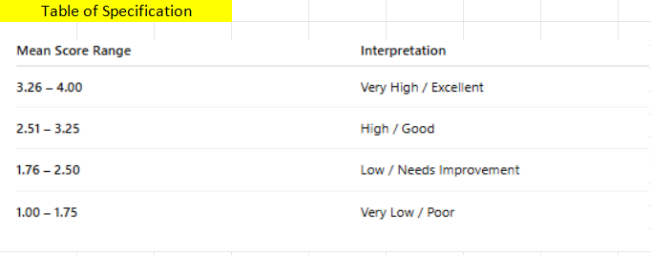

The chart showed a steady decline in average scores over all ten indicators from the pre-test (M = 2.55) to the post-test (M = 1.78). This decline trend showed a clear improvement in subscales of mental well-being after playing traditional games. A total mean difference of 0.77 indicated a large positive change after the intervention. Garaigordobil et al. (2020)
Izquierdo et al. reported that traditional opposition play led to noteworthy mood state alterations in university students and pre- and post-session evaluations revealed significant decreases in negative affective components (e.g., tension, tiredness, and bewilderment) and simultaneous amelioration in positive mood sub-scales according to the POMS, a widely accepted psychological tool (Izquierdo et al., 2019). In line with these results, a traditional game was found to be a culturally sensitive form of physical activity which not only promoted physical fitness, but also reduced stress, increased attention and concentration and contributed to happiness and general psychological health in various ages and cultures, as reported in a systematic review in an open access health sciences journal (Martinez-de-Quel et al., 2020). Overall, these things considered, this evidence base steers endorsement of traditional games as efficacious and meaningful psycho-social tools to foster greater emotional modulation and well-being.
Objective #3. Paired Samples t-Test Results Between Pre-Test and Post-Test of BPE Students Engaged in Traditional Games
Statistic | Pre-Test (Variable 1) | Post-Test (Variable 2)
Mean | 2.55 | 1.78
Variance | 0.0563 | 0.0228
Observations (n) | 10 | 10
Pearson Correlation | 0.205 | —
Hypothesized Mean Difference | 0 | —
Degrees of Freedom (df) | 9 | —
t-value | 9.64 | —
p-value (one-tailed) | 0.00000243 | —
p-value (two-tailed) | 0.00000486 | —

The paired samples t-test was run to examine if the mean pre-test and post-test scores of BPE students were significantly different after playing traditional games. The results indicated a mean reduction from 2.55 (pre-test) to 1.78 (post-test), reflecting an enhancement in the mental well-being indicators assessed after the intervention.
The calculated t-value of 9.64 is much greater than the critical t at 2.26 for the 0.05 level. Furthermore, the two-tailed p-value (p = 0.00000486) is significantly lower than the typical alpha value of 0.05. So, the null hypothesis is rejected.
This validated that there existed a significant difference between the pre-test and post-test scores of BPE students after playing traditional games.
The large decline in post-test mean scores demonstrated that traditional games seemed to have a significant impact on the mental health of the BPE students. Engagement in traditional games may have led to better mood, less anxiety, and greater positive affect as a result of exercise, social contact, and cultural involvement.
These results reinforced the premise that traditional games are not only recreational activities but also powerful psychosocial tools. These results are in line with studies that have highlighted play-based physical activities as a way to reduce stress and increase positive emotional states in students. On the whole, the findings indicated that traditional games can be adopted as a promising approach to enhancing mental health in physical education for college students, especially those specializing in BPE, which thus strongly supported the feasibility of the present research approach. Eime et al. (2015).

CHAPTER V
SUMMARY, CONCLUSION, AND RECOMMENDATION
This chapter contains the discussion, conclusion, and recommendations based on the findings of the study entitled “The Health Effects of Traditional Games to the Mental Health of Bachelor of Physical Education (BPE) Students”. In summary, this chapter brings together the results of the quasi-experimental study, relates those results to the original research questions and theoretical grounding, and discusses the wider implications of the research. The chapter further presents reflections on the limitations of the study and practical and research recommendations for prospective research and practice.
Summary of the Study
This research is conducted in view of an emerging problem presented in Chapter I; the diminishing traditional Filipino games among students, and the growing mental health problem particularly in the part of students who have sedentary, screen-based lifestyle. The present study sought to establish if playing traditional games would significantly enhance the mental well-being of BPE students. The findings reported in Chapter IV supported a harmonious and statistically significant increase in mental well-being after participation in traditional games. For all the indicators, the post-test scores were lower than the pre-test scores, which means a decrease in anxiety-related and negative emotional symptoms. The null hypothesis was rejected as the paired samples t-test showed that these changes were not attributable to chance.
Going by gender, there were significant improvements for both male and female participants. Female students registered marginally higher pre-test anxiety levels However, their post-test scores matched with those of the male students. It appeared that the traditional games fostered a gender-neutral and positive atmosphere where students of all genders could derive benefit from the experience. These results are consistent with previous literature demonstrating that physical social play has a positive influence on emotion regulation and reduction of stress.
The observed enhancements may be due to several intertwined factors. Traditional games need people to be physically active, and movement can activate the neurobiological pathways related with mood improvement. At the same time, these games encouraged socialization/group formation, cooperation, and fun, which led to emotional support and to feeling that a person belongs to the group. Investigation of cultural aspects also revealed that participation in the Filipino traditional games contributed to the development of identity and cultural pride, which may have acted as an indirect mechanism for enhancing psychological well-being.
Viewed through the lens of Flow Theory, these findings supported the idea that students were immersed in and enjoying the game to the point that they temporarily disengaged from academic and personal concerns. Similarly, Self-Determination Theory helped justify positive outcomes, as the games fostered intrinsic motivation, relatedness and competence three core psychological needs related to mental well-being. the results suggested that the traditional games are not simply playtime activities, but rather they are a form of meaningful psychosocial healing processes in physical education.

Conclusion
This study concludes that the implementation of traditional Filipino games significantly improves the mental well-being of BPE students, particularly in reducing anxiety levels. The statistically significant decrease in post-test anxiety scores compared to pre-test results led to the rejection of the null hypothesis, confirming the effectiveness of traditional games as a psychosocial intervention. The findings also revealed that the positive effects of the intervention were experienced by both male and female students, indicating that traditional games provide an inclusive and gender-neutral approach to promoting mental well-being
The improvement in students' mental well-being may be attributed to the combined effects of physical activity, social interaction, cooperation, and cultural engagement embedded in traditional games. These activities not only encouraged emotional support and a sense of belonging among participants but also strengthened cultural identity and pride. Furthermore, the findings support the principles of Flow Theory and Self-Determination Theory, suggesting that traditional games help students become fully engaged while satisfying their psychological needs for competence, relatedness, and intrinsic motivation.
Overall, traditional Filipino games are more than recreational activities; they are meaningful, accessible, cost-effective, and culturally relevant tools that can be integrated into physical education programs to support holistic student development and mental health. Despite the limitation of having a small sample size from a single institution, this study contributes valuable local evidence demonstrating that traditional games can serve as an effective and culturally grounded strategy for enhancing student mental well-being.
Recommendations
This section outlines key recommendations based on the findings and limitations of the study, offering guidance for practice, research, and policy to enhance students’ mental well-being through the use of traditional games.
College students. Encouraged to actively participate in traditional games when offered in physical education or recreational settings, recognizing the dual benefits for mental well-being (stress reduction, mood improvement) and physical fitness (cardiovascular health, strength, coordination). Beyond formal classes, students may initiate peer-led traditional game sessions during break times or through student organization activities, fostering social connection and making leisure time more engaging and culturally meaningful. By self-monitoring changes in stress and mood before and after playing traditional games, students can personally validate the positive effects, which in turn increases long-term motivation to remain physically active.
P.E. Teachers. Physical Education teachers are recommended to integrate traditional games at regular intervals within their lesson plans, using them as warm-ups, main activities, or cool-downs to improve student engagement, reduce anxiety (especially among less motivated students), and promote teamwork in a fun, low-pressure environment. Teachers should also document their observations of student behavior, participation levels, and emotional responses during traditional game sessions, as these informal records help tailor game selection to class needs and provide qualitative evidence to share with department heads. Furthermore, collaborating with students to reintroduce local or indigenous games from their own communities increases cultural relevance, student ownership, and sense of pride.
For Department Heads. Department heads and curriculum developers are urged to formally include traditional games in the physical education curriculum as a required or elective module, emphasizing their role in holistic student development. Given the cost-effectiveness of traditional games compared to modern fitness equipment, department heads should allocate resources for minimal necessary items such as stones, chalk, ropes, and small balls. Organizing school-wide traditional game events or tournaments can build community involvement, cultural pride, and cross-year student interaction, while also providing opportunities to collect preliminary data on student well-being. Additionally, department heads should encourage P.E. faculty to share best practices and conduct peer observations of traditional game implementation, fostering a collaborative approach to curriculum innovation.
Future Research. For future research, it would be advisable to conduct further studies to overcome the limitation of this study. The findings may be replicated, including larger and more heterogeneous samples from various institutions to increase the external validity of the results. Studying more traditional games and executing longer interventions could provide more insights into their diverse effects on students’ mental well-being. It is also suggested that mixed method research designs be employed to capture not only quantitative results, but also the lived experiences, perceptions and emotional responses of students. Prospective research could also investigate the enduring effects on mental health of engaging in traditional games, as well as perform comparative studies with modern-day physical activity or fitness-focused interventions to assess relative efficacy.

References
American Psychological Association. (2020). Publication manual of the
American Psychological Association (7th ed.). APA Publishing.

Angeles, B. J. B., & Beniero, J. I. (2021/2022). Slipper game or shakay [Studocu document]. Studocu.

Ashar, A., Mania, S., Ibrahim, M. M., Syamsudduha, S., Sadaruddin, & Dewi, A. C. (2024).
The impact of traditional games on social-emotional development: A comprehensive review of existing research. Journal of Learning and Development Studies, 4(2), 39–51.

Bacolod City Health Office. (2024). Annual mental health status report.

Bandura, A. (1977). Social learning theory. Englewood Cliffs, NJ: Prentice Hall.

Bandura, A. (1986). Social foundations of thought and action: A social cognitive theory. Prentice-Hall.

Basri, H., Author2, A. B., & Author3, C. D. (2018). Western cultural influence on indigenous play. Publisher.

Brown, J. P., & Lee, H. K. (2025). Game-based classroom interventions to promote adolescent mental health literacy: A systematic review. Journal of School Mental Health, 17(2), 145–162.

Csikszentmihalyi, M. (1990). Flow: The psychology of optimal experience. Harper & Row.

Deci, E. L., & Ryan, R. M. (1985). Intrinsic motivation and self-determination in human behavior. Plenum Press.

Deci, E. L., & Ryan, R. M. (2000). The “what” and “why” of goal pursuits: Human needs and the self-determination of behavior. Psychological Inquiry, 11(4), 227–268.

Dela Cruz, M. A., & Santos, R. J. (2024). Laro ng Lahi: Perceived psychological benefits of indigenous Filipino games among junior high school students. Philippine Journal of Social Sciences and Humanities, 22(1), 91–114.

Dizer, R., Logan, I. L. N., & Raval, K. M. R. (2022). Laro ng Lahi: A study on the perceived benefits of playing indigenous games on the holistic development of Filipinos born in the '80s. University of the Philippines Visayas.

Donato, S. R., Ignacio, Q. A., & Manumbali, P. T. (2025). Traditional Filipino games in a digital world: Cultural shifts and engagement trends. International Journal of Advanced and Applied Sciences, 12(4), 173–183. https://doi.org/10.21833/ijaas.2025.04.019

Dyson, B., Griffin, L. L., & Hastie, P. (2004). Sport education, tactical games, and cooperative learning: Theoretical and pedagogical considerations. Quest, 56(2), 226–240.

Eime, R. M., Young, J. A., Harvey, J. T., Charity, M. J., & Payne, W.R. (2013). A systematic review of the psychological and social benefits of participation in sport for children and adolescents. International Journal of Behavioral Nutrition and Physical Activity, 10(1), 98.

Engel, G. L. (1977). The need for a new medical model: A challenge for biomedicine. Science, 196(4286), 129–136.

Ferolino, & Marasigan. (2022). Cultural heritage and traditional Filipino games in modern society. Humanities, Society and Community.

Gautam, S., Jain, A., Chaudhary, J., et al. (2024). Concept of mental health and well-being, its determinants and coping strategies. Indian Journal of Psychiatry.

Hassani, F., & Afazeli, Z. (2024). Be more active with traditional games: Traditional review. Turkiye Klinikleri Journal of Sports Sciences, 16(1), 119–128.

Hu, Y. & Liu, B. (2025). The impact of physical exercise on college students’ mental health through emotion regulation and self‑efficacy. Scientific Reports,

Ismoyo, I., Ahmad Nasrulloh, Hermawan, H. A., & Ihsan, F. (2024). Health benefits of traditional games: A systematic review. Retos, 59, 843– 856.

Janz, K. F., Dawson, J. D., & Mahoney, L. (2002). [Title of the article]. Journal Name, Volume(Issue).

Karaköse, T., Yıldırım, B., Tülübaş, T., & Kardaş, A. (2023). A comprehensive review on emerging trends in the dynamic evolution of digital addiction and depression. Frontiers in Psychology, 14, Article 1126815.

Kartal, G., & Demir, S. (2023). Traditional games as a school-based intervention for reducing emotional problems in children. International Journal of Instruction, 16(4), 241–258.

Li, R., & Huang, R. (2025). The influence of physical activity on mental well- being in college students:

Liu, M., Liu, H., Qin, Z., Tao, Y., Ye, W., & Liu, R. (2024). Effects of physical activity on depression, anxiety, and stress in college students: the chain-based mediating role of psychological resilience and coping styles. Frontiers in Psychology,
systematic review. Frontiers in Psychology.

Lumpkin, A. (2017). Introduction to physical education, exercise science, and sport studies (10th ed.). McGraw-Hill Education.

Magluyan, W., & San Jose, D. B. S. (2025). Magluyan, W., & San Jose, D. B. S. (2025). A Study on the Physical Activity and Mental Health Status among Filipino Young Adults in Bacolod City, Negros Occidental, Philippines. International Journal of Multidisciplinary Research and Growth Evaluation, 6(3):1534-1539.

Magalona, J. C. (2025). Preservation, utilization, and promotion of Philippine traditional games of the Bachelor in Physical and Health Education pre-service teachers. Humanities, Society, and Community, 2(2). https://doi.org/10.31098/hsc.v2i2.3244

Meyer, C., & Pomerantz, E. (2023). How adolescents’ perceptions of parental involvement influence their school engagement. Journal of Educational Psychology, 115(2), 213–227.

Nugroho, R. A., Prasetyo, A., & Widodo, S. (2021). Traditional games as therapeutic activities to reduce anxiety among elementary pupils. Malaysian Journal of Research, 9(2), 55–66.

Ortega, F. B., Ruiz, J. R., Castillo, M. J., & Sjostrom, M. (2008). [Title of the article]. Journal Name, Volume(Issue).

Paquin, R., [Other Authors], & [Last Author]. (2023). Digital gaming and mental health risks among adolescents. Journal Name, Volume(Issue).

Pellegrini, A. D. (2009). The role of play in human development. Oxford University Press.

Pica, R. (2010). Moving and learning across the curriculum: More than 300 activities and games to make learning fun. Delmar Cengage Learning.

Polit, D. F., & Beck, C. T. (2006). The content validity index: Are you sure you know what’s being reported? Critique and recommendations. Research in Nursing & Health, 29(5), 489–497.
Rahman, N. A., Ismail, S., & Ahmad, F. (2022). The impact of traditional games on emotional well-being among primary school students. Asian Journal of Education and Training, 8(4), 201–209.

Rahman, Z. S. A. (2025). [Title of the article]. Journal Name, Volume(Issue)
.
Rachmad, Y. E. (2022). Mental well-being theory. Retrieved from https://www.academia.edu/download/119322587/BOOK_2022_047_OSF.pdf

Silva, C. M. (2024). Culturally grounded physical activities and adolescent mental health: A controlled trial of traditional games. Health Psychology Report, 12(2), 89–101.

Stiefel, M. C., Riley, C. L., Roy, B., McPherson, M., & Nagy, J. M. (2020). Health and well-being measurement approach and assessment guide (100 Million Healthier Lives). Institute for Healthcare Improvement.

Villar, M. A., Author2, A. B., & Author3, C. D. (2010). Traditional games and holistic well-being. Publisher.

World Health Organization (WHO). (2025). Mental health: Strengthening our response. https://www.who.int/news-room/fact-sheets/detail/mental- health-strengthening-our-response

Appendices

Appendix A- Letter of Permission
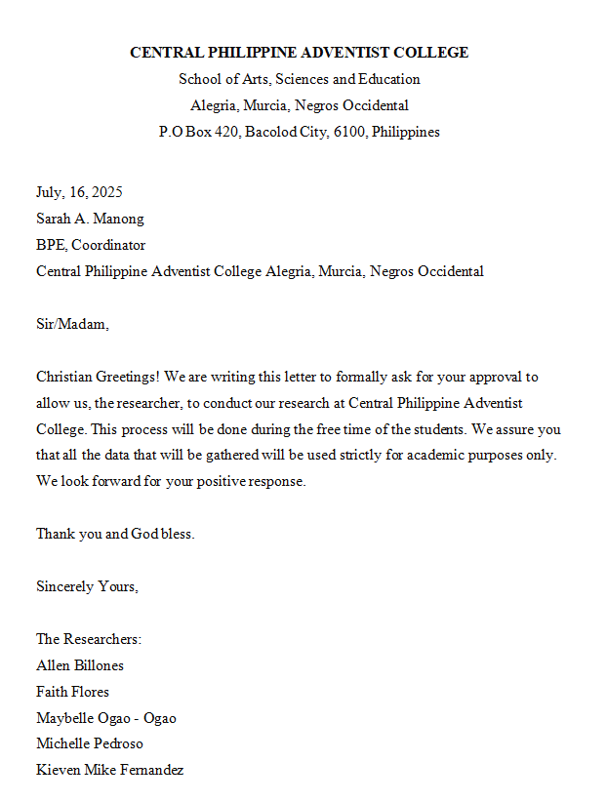

Appendix B- Informed Consent
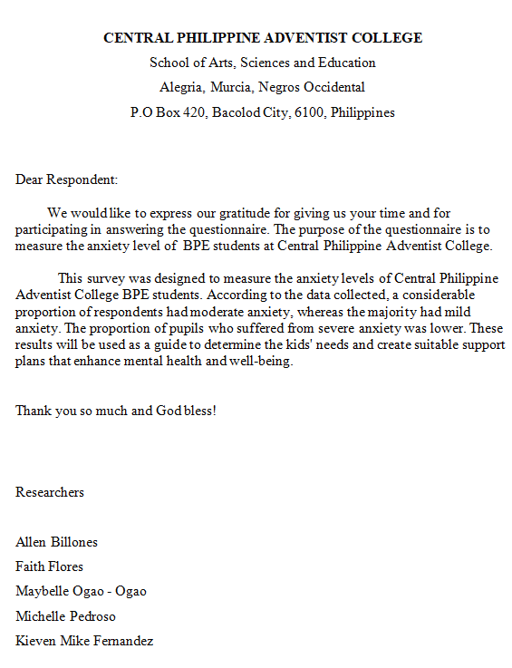

Appendix C- Research Instrument

Evaluation of the Self-Made Questionnaire
(Using the Criteria of Carter V. Good & Douglas E. Scates)
Instrument Title: BPE Pre-Test and Post-Test (Adapted from Mental Health
America, 2024)
Questions | Always  4 | Often  3 | Sometimes  2 | Never  1
1. I find it hard to stop or control worrying.
2. I worrying too much about
different
things.
- I find it hard to relax after
Stressful situations.
4. I feel being so restless that it is difficult to stay still.
5. I become easily annoyed or irritable.
6. I feel afraid, as if something bad might happen.
7. I often anticipate the worst or feel
8. I experienced feeling tense when stressed.

9. I loss interest or pleasure in hobbies, sports or other
activities.
10. I often feel nervous

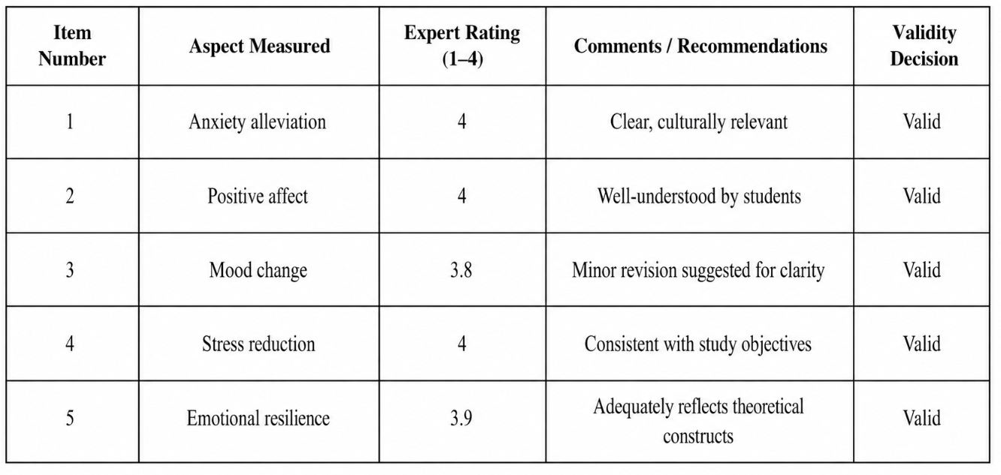
Appendix D- Expert Validation Results
Appendix E- Traditional Game Intervention

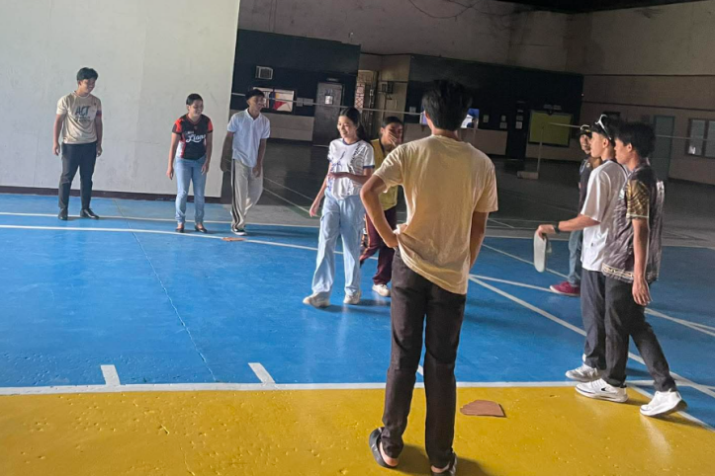

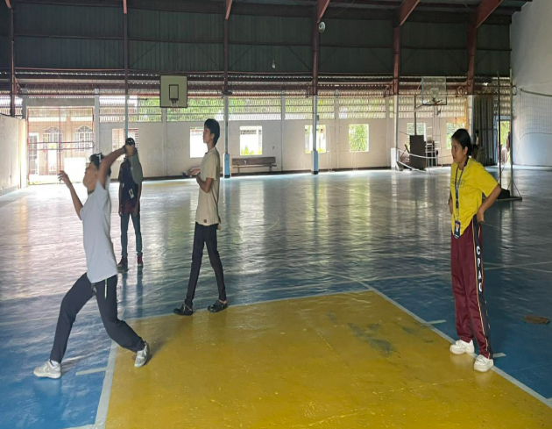

December 2025- Traditional Games, Slipper game
Appendix F- Ethics Clearance
This is to certify that the proposal of Billones, Allen Ray, Fernadez, Kieven Mike, Flores, Faith, Pedroso, Michelle Khay, and Ogao- Ogao, Maybelle, entitled “THE HEALTH BENEFITS OF TRADITIONAL GAMES IN MENTAL WELL -BEING AMONG BPE STUDENTS,”submitted in partial fullfilment of the requirements in Research Method in School of Arts Science and Education, has been reviewed and is found to be technically feasible and ethically compliant

Recommended by:

Allen G. Amarilla, Phd, LPT
Advisor

Review by:

Jhonna G. Toledo, Phd, RPsy, RGC, LPT Danna Faye Facto, MA Psych, RPm
Member Member

Approved for Implementation on

Allen G. Amarilla, Phd, LPT
Chairman/Dean, SASED

Appendix G- Summary of Statistical Results

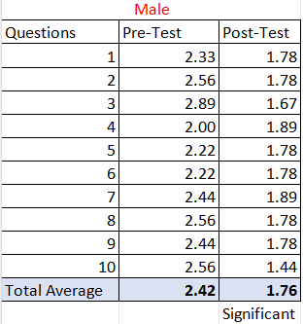
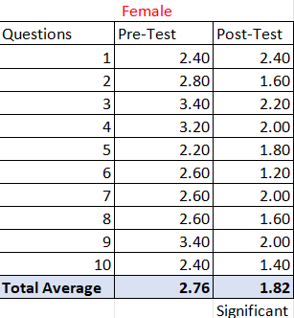
Appendix G- Grammar Evaluation
