AttendScan: A Facial Recognition Based-Attendance Monitoring System For Jesus Reigns Christian College Staff

ABSTRACT

Artificial Intelligence (AI) has become one of the most significant technological advancements in modern society, improving automation, security, and operational efficiency across different industries. In educational institutions, attendance monitoring remains an essential administrative task; however, traditional attendance systems are often time-consuming, prone to human error, and vulnerable to attendance fraud. Facial recognition technology offers a modern solution by enabling automatic identification and verification of individuals through digital image processing. This study presents AttendScan, a Facial Recognition-Based Attendance Monitoring System developed for the staff of Jesus Reigns Christian College. The main objective of the system is to automate attendance recording and provide a centralized platform for monitoring and managing staff attendance records. The system utilizes facial recognition technology for real-time identification and verification of staff members during time-in and time-out procedures.AttendScan was developed using the Agile Software Development Life Cycle methodology. The system uses Python and Flask for backend development, HTML, CSS, and JavaScript for the web interface, OpenCV for facial detection and recognition, and MySQL for database management. The system includes features such as staff registration, facial data capture, attendance logging, and report generation.The implementation of AttendScan provides a more efficient, accurate, and secure attendance monitoring process compared to manual attendance methods. The system minimizes administrative workload, reduces attendance manipulation, and improves record accessibility through digital automation. The study concludes that facial recognition technology can significantly enhance attendance management in educational institutions by providing reliable and automated monitoring solutions.

Keywords: Facial Recognition, Attendance Monitoring System, Artificial Intelligence, OpenCV, Educational Technology

INTRODUCTION

Educational institutions are increasingly incorporating digital technology to increase administrative operations' efficiency, security, and dependability in the quickly evolving technological environment of today. One of the most important administrative procedures is attendance tracking, which guarantees employee accountability, timeliness, and accurate record-keeping. Payroll processing, performance reviews, and institutional transparency are all directly impacted by effective attendance management. Demand for intelligent and automated technologies that improve data accuracy and decrease manual processes is rising as schools transition to digital.
Staff attendance at Jesus Reigns Christian College is often recorded using manual logbooks or basic timekeeping tools. Although these techniques are simple to use, there are a number of operational difficulties. Manual recording takes a lot of time and is prone to human error, which can result in unreadable data, incorrect calculations, and incomplete entries. Furthermore, fraudulent activities such as proxy attendance or "buddy punching," in which one employee enters attendance on behalf of another, can compromise traditional systems. Payroll inconsistencies, erroneous attendance records, and decreased institutional effectiveness could result from these problems.
Another significant limitation of conventional attendance systems is the lack of real-time monitoring and automated reporting. Administrative personnel must manually review attendance records to detect tardiness, absences, or inconsistencies. The preparation of weekly or monthly attendance summaries requires additional effort and increases the risk of computational errors. Studies on automated attendance systems suggest that manual processes often reduce productivity and data reliability, while technology-based systems significantly enhance operational efficiency and accuracy (Kumar & Patel, 2021). These findings highlight the need for modernized attendance solutions in educational institutions.
This study suggests Attendscan: A Facial Recognition-Based Attendance Monitoring System for Jesus Reigns Christian College Staff in order to address the issues that have been identified. The solution automates attendance recording by combining IoT-enabled devices with AI-powered facial recognition. A smart camera takes a picture of the employee's face when they arrive and go. Without requiring human input, the system automatically logs the time-in and time-out in a centralized database after confirming the identity. Administrators may remotely monitor attendance and rapidly generate automatic reports thanks to real-time transmission of attendance data to a secure server via IoT connectivity.
The goals of using Attendscan: A Facial Recognition-Based Attendance Monitoring System for Jesus Reigns Christian College Staff are to improve the accuracy and dependability of attendance data, avoid proxy attendance, remove manual errors, and lessen administrative workload. Jesus Reigns Christian College can improve institutional efficiency and update its attendance tracking system by implementing an AI and IoT-based solution. The ultimate goal of this research is to aid in the creation of intelligent attendance systems that facilitate educational institutions' digital transformation.

RELATED LITERATURE AND STUDIES
Recent studies highlight the increasing use of facial recognition technology and artificial intelligence in attendance monitoring systems within educational institutions. Gupta (2024) explained that facial recognition plays an important role in image processing and authentication systems, particularly in student attendance management. The study emphasized that traditional attendance methods are time-consuming, prone to manipulation, and inefficient compared to automated facial recognition systems. Similarly, Kumar (2025) discussed how Facial Recognition Technology (FRT) has transformed attendance tracking by improving efficiency, accuracy, and automation in educational and organizational environments.
Several researchers also support the use of facial recognition algorithms and computer vision technologies for automated attendance systems. Ansari (2024) proposed a smart attendance system that utilizes the LBPH algorithm for facial recognition and automatic attendance recording through Excel-based reports. Likewise, Kumari (2025) developed a facial recognition attendance system using OpenCV, Haar Cascade classifiers, and LBPH algorithms to automate attendance recording while minimizing unauthorized access and administrative workload. Kesarinath (2024) further emphasized that combining facial recognition with modern sensor technologies can improve the security, reliability, and usability of attendance management systems.
Previous studies also explored the practical implementation of facial recognition attendance systems using Python and OpenCV. Jadhao (2024) introduced a real-time attendance monitoring system with automated attendance updates and database integration through facial recognition technology. Kumar (2024) demonstrated that automated attendance systems using machine learning and OpenCV can reduce manual effort while improving attendance accuracy and record management. Similarly, Gupta (2024) and Kumar (2025) showed that facial recognition systems using Haar Cascade classifiers and LBPH algorithms provide efficient and dependable attendance monitoring in educational institutions. Revathi (2024) further confirmed that integrating facial recognition with IoT and web-based technologies enables real-time attendance monitoring and improved accessibility for administrators.

RESEARCH DESIGN AND METHODOLOGY
Research Design
This study utilizes a developmental research design, which is commonly applied in the creation and improvement of systems, tools, or technological solutions intended to address real-world problems. This type of research focuses on the systematic process of designing, developing, and evaluating a product to ensure its effectiveness and functionality.
According to Rita C. Richey (1994), developmental research is defined as the systematic study of designing, developing, and evaluating programs, processes, or products to meet standards of effectiveness and consistency. It emphasizes both the development of a working system and the assessment of its performance in solving a specific problem.
The research in this study follows a developmental research approach, aiming to design and implement an intelligent and secure attendance monitoring system that leverages facial recognition and IoT technologies. Rather than replacing existing manual systems, the project seeks to enhance and automate attendance tracking, addressing critical issues such as delayed reporting, inaccurate records, and proxy attendance. By combining Artificial Intelligence (AI) and Internet of Things (IoT) technologies, AttendScan provides a smart attendance solution that automatically recognizes staff members upon arrival and departure, logs their time-in and time-out in a centralized database, and delivers real-time alerts and reports to administrators. The system enhances operational efficiency, improves data accuracy, and strengthens campus security.
The proposed system is being developed using the Software Development Life Cycle (SDLC) method. The proponents decided to use the Agile Model because it is an iterative and flexible approach that supports continuous development, testing, and improvement of the system.
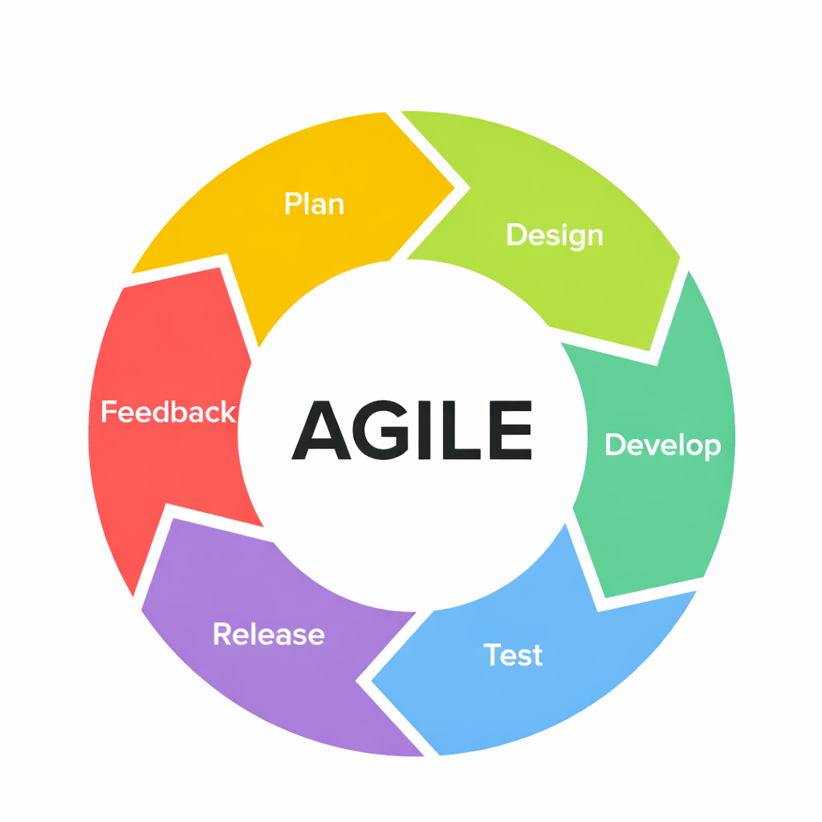
Figure 1: Agile Model
The Agile model allows the system to be developed in incremental cycles, where each cycle includes planning, designing, developing, and testing. This enables the proponents to identify issues early, improve system performance, and adapt to changes based on testing results and user feedback. The diagram below presents the SDLC model used, illustrating how each phase contributes to the development of a reliable and efficient attendance monitoring system.
In this study, the proponents applied the Agile model to guide the development of AttendScan in a systematic yet flexible manner. Unlike traditional models, Agile emphasizes continuous improvement and collaboration, allowing the system to evolve based on actual performance and real-world conditions. This is particularly important for the facial recognition component, where accuracy may vary due to lighting conditions, facial angles, and environmental factors.

Dataset Description
The AttendScan system uses three main types of data, which include facial images and staff metadata and historical attendance records. The facial image data sets include staff member photos that were obtained from publicly accessible facial image databases and from self-taken photos, which received permission from all subjects. Staff metadata contains essential details, which include staff members' names and their identification numbers and their department affiliations and their job role classifications. The system uses this data to match recognized faces with their corresponding staff profiles, which enables correct attendance reporting while reducing the chance of misidentification. The organization maintains its records of historical attendance data together with pilot testing information. The data sets document employee interactions with IoT-enabled smart cameras, which operate during their work simulation tests.
SYSTEM ARCHITECTURE
The system architecture of AttendScan functions as a structural design which shows how the system components work together to achieve their designated goals. The system demonstrates complete data movement throughout its processes which begin with facial recognition input and continue through recognition algorithm processing until accurate real-time attendance data is produced for administrators.
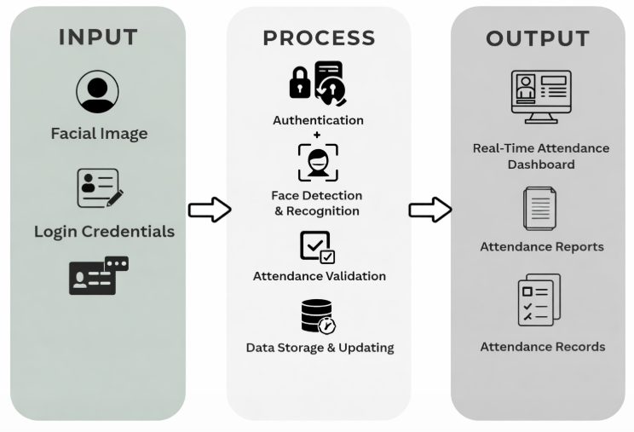
Figure 2: AttendScan System Architecture
The primary input is facial image capture, where a camera is used to acquire real-time images of staff members for identification and attendance recording. The system also includes administrator login credentials, which provide secure access to the system for authorized users only. In addition, employee registration data is stored in the system, including staff personal information and registered facial templates, which serve as the reference dataset for facial recognition and matching. These inputs are essential in ensuring accurate identification, secure system access, and reliable attendance tracking.
The system follows an Input–Process–Output (IPO) model to manage the flow of data efficiently. The input stage includes facial image capture through a webcam or camera, administrator authentication credentials, and registered employee data. The process stage involves several sequential operations such as user authentication, face detection, facial recognition, attendance validation, and data storage. During this stage, the system compares captured facial images with stored facial templates to verify identity and determine attendance status. Once validated, attendance records are automatically updated in the database. The output stage generates real-time attendance information and system-generated reports for administrative use.
The processed data is handled through a structured system workflow that ensures accuracy, security, and consistency.The system utilizes a preloaded database containing employee profiles and facial data, which enables precise matching during recognition. Captured images are transmitted to the system for processing, where facial detection and recognition algorithms analyze facial features for identification. After successful verification, the system applies attendance rules such as time-in and time-out logging. All validated data is then stored in a centralized database, which maintains both current and historical attendance records for reference and reporting purposes.The system provides two main outputs for user interaction and decision-making. The primary output is a real-time attendance dashboard that displays staff attendance status, including time-in, time-out, and overall attendance records. The system also generates alerts and notifications for events such as late arrivals, absences, or discrepancies to assist administrators in immediate decision-making. In addition, the system produces exportable attendance reports and summaries that support administrative tasks such as record-keeping, monitoring, and institutional reporting, ensuring that attendance data remains accurate, secure, and efficiently managed.

SYSTEM METHODS
This section provides the hardware and software requirements necessary to develop and operate Attendscan: A Facial Recognition-Based Attendance Monitoring System for Jesus Reigns Christian College staff. These requirements were chosen to ensure the system functions efficiently, accurately records staff attendance, and provides real-time notifications to administrators. This section details the specific methods and procedures employed to develop the system. Each procedure is aligned with the study’s objectives, explaining exactly how the system was built, configured, and implemented.
Method 1: Development of a Contactless Facial Recognition Attendance System
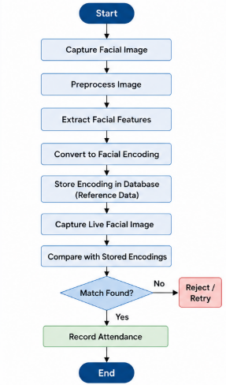
Figure 3: Facial Data Registration and Recognition Process
This method explains the structured process used to develop the contactless attendance system. It begins with the collection of facial data by capturing multiple clear images of each staff member, which are then preprocessed through resizing, normalization, and enhancement to improve image quality and ensure consistent recognition results.The processed images are then converted into facial encodings using feature extraction techniques, where unique numerical representations of each face are generated and stored in the database as reference templates.Finally, a facial matching module is used to capture live images, process them, and compare them with the stored encodings to automatically verify identity and record attendance. Through this process from data collection, preprocessing, encoding, and matching the system enables accurate and automated attendance recording without manual or physical contact.

Method 2: Implementation of Real-Time Attendance Monitoring and Reporting
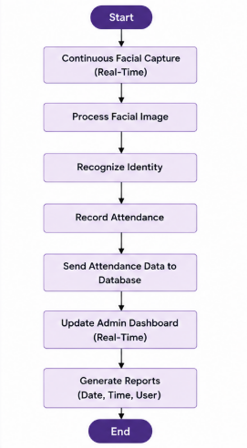
Figure 4: Real-Time Attendance Process and Reporting
This method describes the system’s continuous processing workflow designed to support real-time attendance monitoring. The system captures facial input continuously and processes each frame immediately after detection to ensure fast and accurate identity recognition. Once a staff member is identified, attendance data is automatically recorded and transmitted to the central database for instant storage. It also includes a web-based administrative dashboard that is integrated with the database to display attendance records in real time. The system dynamically fetches and updates data, allowing administrators to monitor attendance as it happens. In addition, reporting functions were implemented to organize, filter, and generate attendance logs based on date, time, and staff identity. This method ensures that the system provides real-time updates, efficient monitoring, and accurate report generation for effective attendance management.

Method 3: Development of Accurate Attendance Records with Reduced Manual Errors
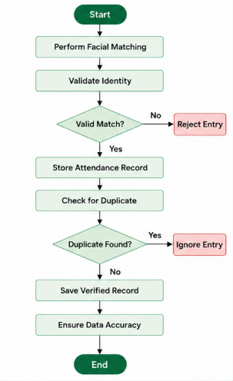
Figure 5: Data Validation and Attendance Recording Workflow
This method describes the validation and control mechanisms implemented to ensure data accuracy in the system. Before any attendance record is saved, the system performs identity validation by checking if the facial recognition result meets a required accuracy threshold, automatically rejecting invalid or unrecognized inputs. It also includes a duplicate detection process that prevents multiple attendance entries from the same user within a defined time interval. Only verified and unique records are stored in the database to avoid redundancy. In addition, data consistency checks are applied to ensure that all recorded attendance information is complete and correct. Through these validation mechanisms, accuracy checking, duplicate prevention, and data consistency verification the system ensures reliable records and minimizes errors commonly found in traditional attendance methods.\

SYSTEM DIAGRAMS AND TOOLS
This section presents the hardware, software, and development tools used in the design and implementation of ATTENDSCAN. These tools are used to support the system’s overall functions and are illustrated through technical diagrams such as the system flowchart, use case diagram, entity-relationship diagram, and data flow diagrams. Together, these models present a clear and organized view of how ATTENDSCAN operates in terms of facial recognition, attendance processing, data management, and real-time monitoring.

Flowchart of the Proposed System
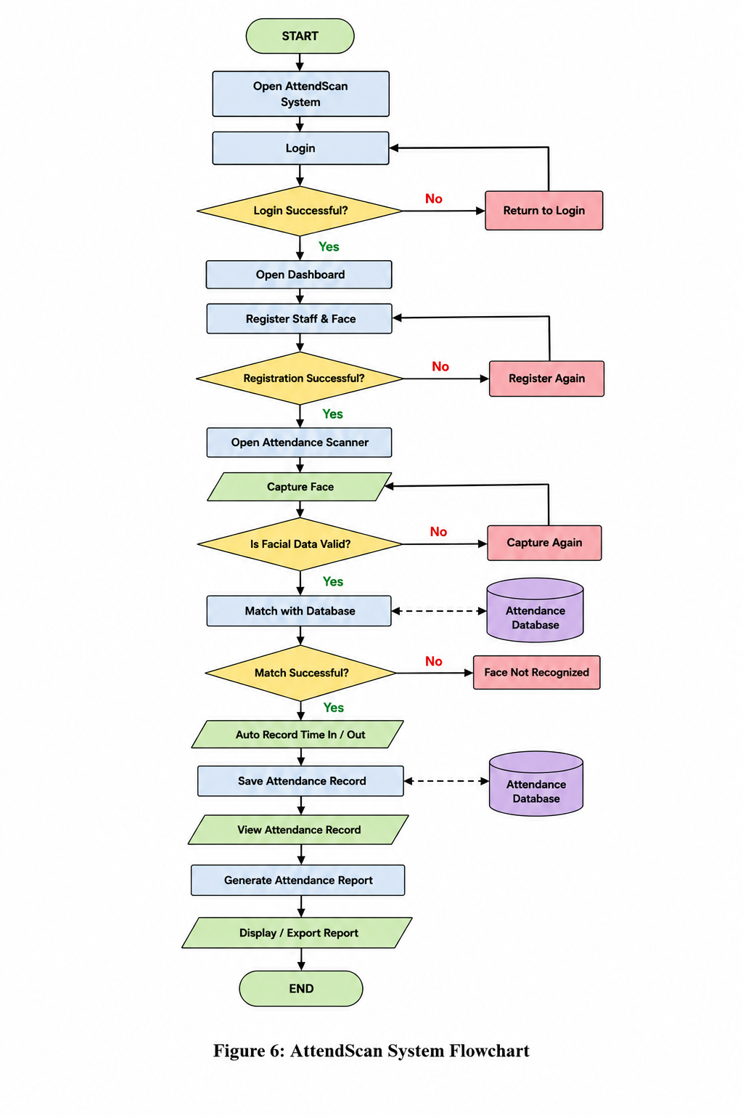
Figure 6: AttendScan System Flowchart
This flowcharts presents the complete workflow of the ATTENDSCAN: A Facial Recognition-Based Attendance Monitoring System from user authentication to attendance recording and report generation. The process begins when the user accesses the system and logs in or creates an account. Once authenticated, the system initializes the camera for facial data capture and prepares the recognition module. The system then captures the user’s facial image and processes it to check quality and validity. If the image is unclear or invalid, the system prompts the user to retry the scan. If the facial data is valid, it proceeds to the identity verification stage, where the system compares the extracted facial features with the stored database records. When a match is successfully identified, the system automatically records the user’s attendance, including time-in and time-out, and stores it in the database. If no match is found, the system notifies the user and allows another attempt. All validated records are saved and used to generate attendance reports such as daily, weekly, or monthly summaries, which are displayed to the administrator for monitoring and analysis.
Data Flow Diagram — Level 0

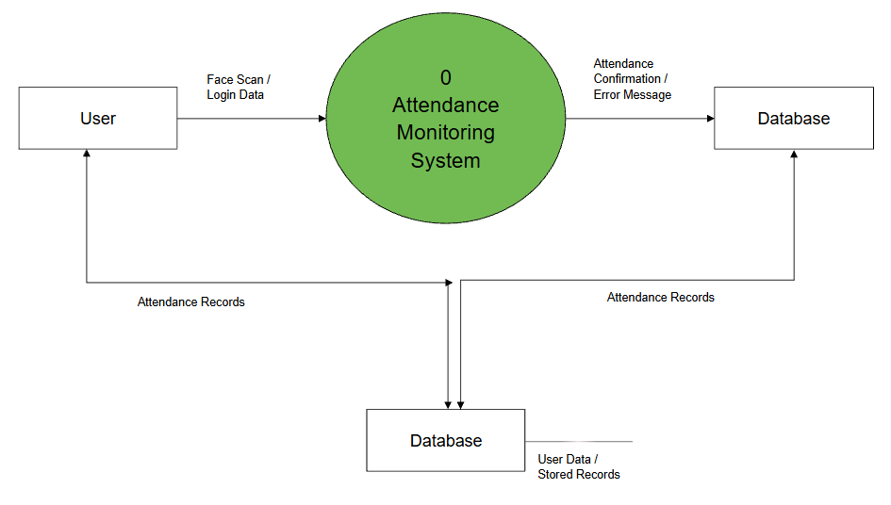
Figure 7: Data Flow Diagram (DFD) Level 0

The Level 0 Data Flow Diagram provides a simplified view of the entire Attendance Monitoring System. By supplying login credentials and facial recognition information for the purpose of documenting attendance, it presents the user as the external entity interacting with the system. These inputs are processed by the system to carry out identification and authentication.The database functions as the storage component, storing and retrieving attendance records and user data as needed. At this stage, the system takes in input, processes it, and gives the user outputs like error messages or attendance confirmations.

Data Flow Diagram — Level 1
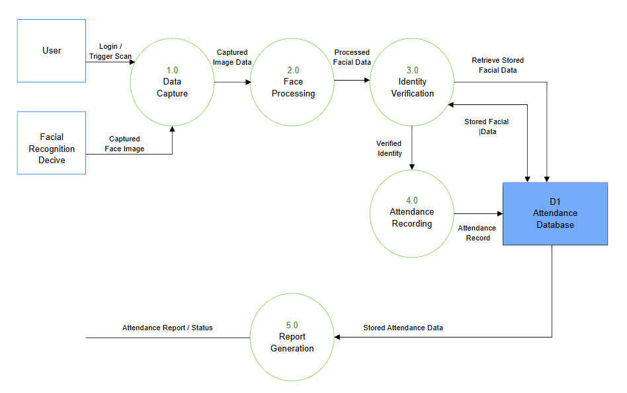
Figure 8: Data Flow Diagram (DFD) Level 1

The Level 1 Data Flow Diagram illustrates the detailed internal processes of the Attendance Monitoring System, focusing on how data flows from input to output. The user and the facial recognition device are depicted in the diagram as external parties that communicate with the system. 1.0 Data Capture is the first step in the process. The user starts a login or scan request, and the facial recognition equipment provides the image of the captured face. After that, the information is sent to 2.0 Face Processing, where it is processed and pertinent face features are extracted from the taken picture. Following processing, the data moves on to 3.0 Identity Verification, where the D1 Attendance Database's recorded records and the processed face data are compared. To confirm the user's identification, the system gets stored face data from the database. After verification is finished, the outcome is sent to 4.0 Attendance Recording, where the system logs the user's time in and out. In order to guarantee that all transactions are appropriately kept for later use, the recorded attendance data are subsequently stored back into the database.

Entity-Relationship Diagram
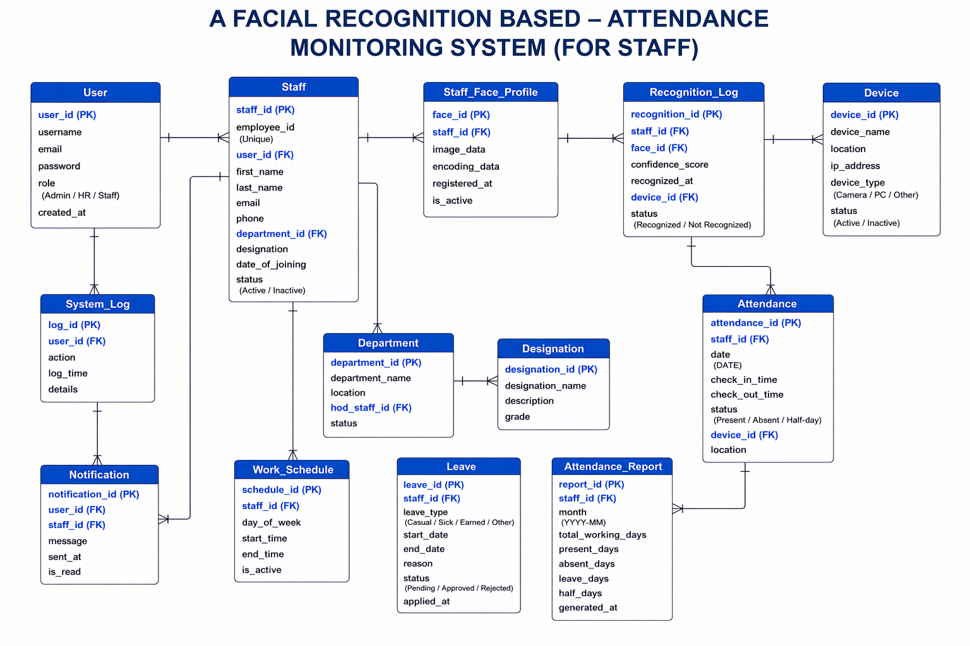
Figure 9: Entity Relationship Diagram

This demonstrates how the core information items in the Facial Recognition-Based Attendance Monitoring System relate to one another. Each user is associated with a Staff profile that contains personnel information, and the User entity controls system access. Every employee is identified by their Staff_Face_Profile. When an employee is acknowledged, a Recognition_Log is generated and utilized to produce Attendance records, which include status and check-in/check-out times. Department, Designation, Work_Schedule, and Leave are examples of supporting entities that assist in managing attendance conditions and organizing staff data. The system can retain records effectively and produce correct attendance reports because of this structure, which keeps data connected and ordered.

Use Case Diagram
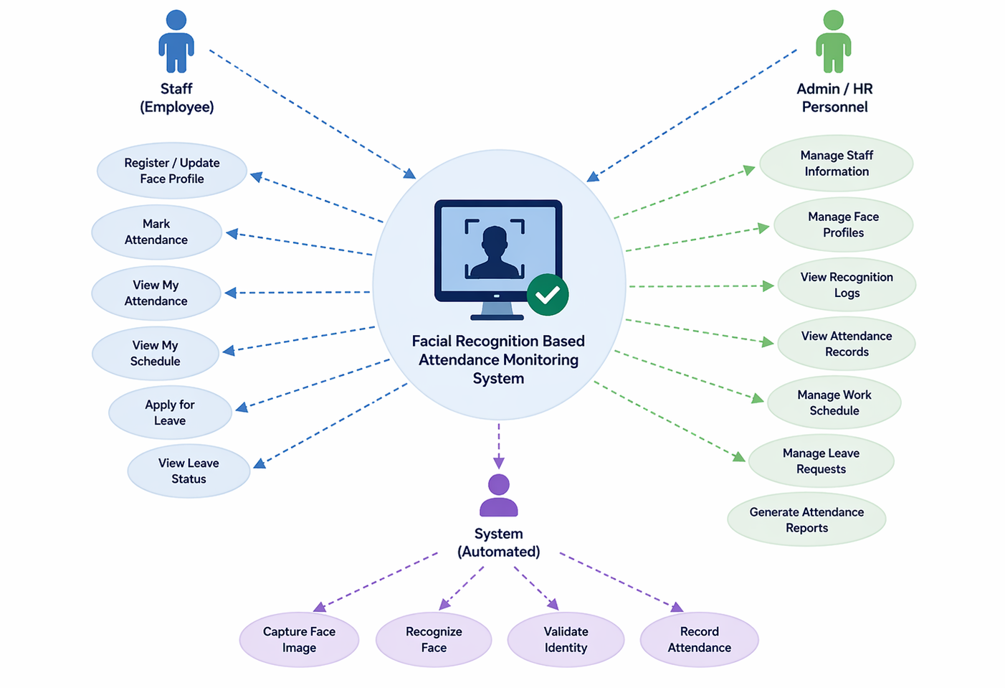
Figure 10: Use Case Diagram

This presents the main interaction between staff members and the Facial Recognition–Based Attendance Monitoring System. The main actor is the staff, who use the system to register or update their face profile, check schedules, view attendance records, mark attendance using facial recognition, and request time off. Conversely, administrative or HR staff members create reports, keep an eye on attendance records, and handle personnel data. The system combines these tasks into a single workflow that is assisted by automatic facial recognition, as shown in the diagram. Without the need for human input, the system tracks attendance, maintains logs, and collects and validates facial data.

RESULTS AND DISCUSSIONS

This section presents the results of the developed ATTENDSCAN: A Facial Recognition-Based Attendance Monitoring System for Jesus Reigns Christian College Staff, a facial recognition-based solution designed to provide accurate, automated, and efficient attendance tracking. The findings are presented through screenshots of the application of three main functionalities: a facial recognition system that identifies and confirms users by processing images and matching them against a database, an automated logging mechanism that thoroughly records when users arrive and depart, and a reporting capability that extracts accumulated attendance information to create structured reports on a daily, weekly, or monthly basis. By integrating these features, the system seeks to minimize the reliance on manual attendance methods, boost accuracy, and improve the overall efficiency of attendance tracking.
The discussion in each section explains how the implemented features operate within the system and how the integrated technologies contribute to the facial recognition-based attendance monitoring of ATTENDSCAN.

Facial Recognition-Based Attendance System

The first objective was to create an attendance system that uses facial recognition technology to establish a contactless and automated attendance solution for staff members of Jesus Reigns Christian College. This objective was successfully achieved through the integration of a webcam-based facial capture module, OpenCV for face detection and recognition, and a trained facial encoding database that enables accurate staff identification during attendance recording.

Results:
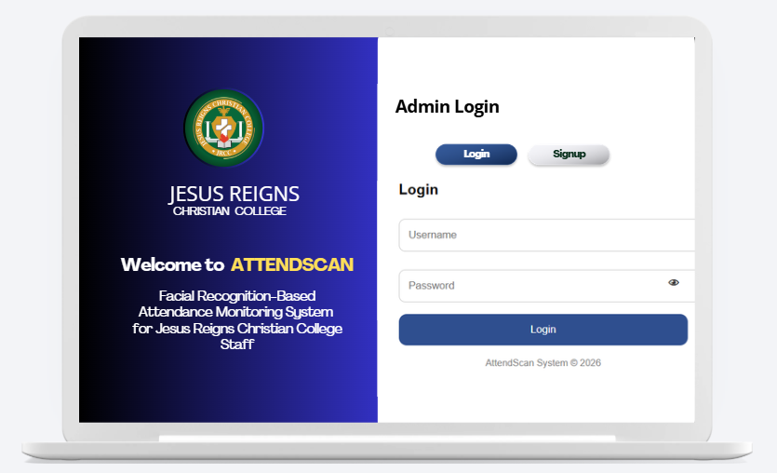
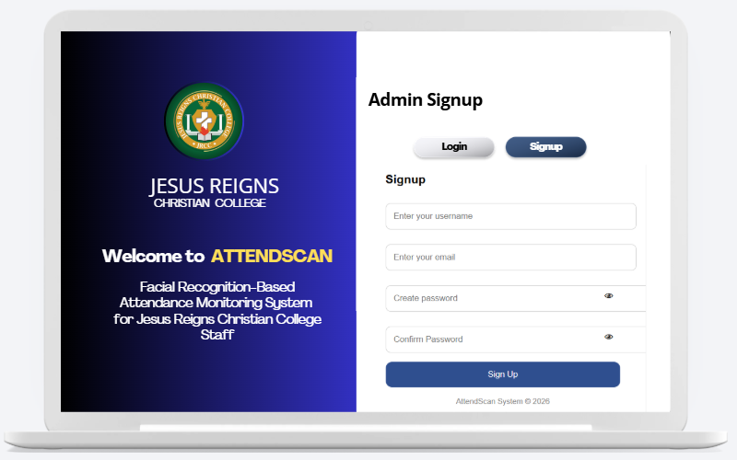
Figure 11: AttendScan Landing Page and System Flow

Figure 11 shows the Admin Login and Signup screen for the AttendScan system, it works like the main access page when you open the application. In the picture, the layout is split into two sections, on the left side you can see the official logo and identity of Jesus Reigns Christian College, plus the title “AttendScan” , and on the right side there’s the administrator authentication area. The screen gives two main choices, Login and Signup , so a user can either enter an existing account or create a brand-new one. Under those choices there are input fields for username and password, and there is also a password visibility icon to help the admin double check credentials faster. There’s a Login button too, which then enables secure access to the Facial Recognition-Based Attendance Monitoring System, for staff management and attendance tracking, overall. At the bottom, the system footer states “AttendScan System © 2026,” which reinforces the app branding and ownership. The overall arrangement, plus the simple navigation and institutional color scheme, make it feel accessible, professional, and easy to operate for administrators using the system.
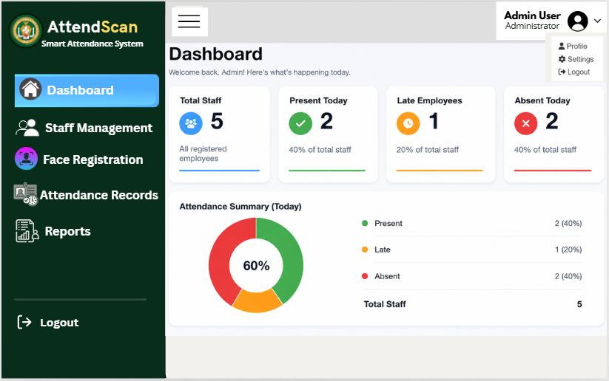

Figure 12: Admin Dashboard Screen of the AttendScan System

Figure 12 shows the Dashboard screen for the AttendScan system, which you can open right after the administrator logs in successfully. From what is shown there, the dashboard basically gives a real time overview of staff attendance monitoring at Jesus Reigns Christian College . On the left side, there is a navigation panel with the major modules , like Dashboard, Staff Management, Face Registration, Attendance Records, Reports, and Logout. This setup helps the administrator move around the system features without too much hassle.
Discussion:

On the main dashboard area, attendance statistics appear through summary cards. For example, the Total Staff card indicates that there are five registered employees in the system , meanwhile the Present Today card shows two staff members are currently marked present. The Late Employees card also records that one employee is tagged late, and the Absent Today card shows two employees are absent for the day. Each card uses different colors so the information is easier to read, and so the status can be identified quickly.

Below that, the Attendance Summary section presents a visual display of the current attendance distribution. It uses a circular chart where the figures show that 40% of staff members are present, 20% are late, and 40% are absent, with the matching numerical values placed beside the graphic. Also, the dashboard header welcomes the administrator and gives a quick picture of daily attendance activity. In the upper right corner, there is an administrator profile menu , this menu includes Profile, Settings, and Logout, which supports account and system handling. Overall the dashboard feels like a centralized, practical interface for tracking employee attendance records, and for managing the AttendScan system efficiently.
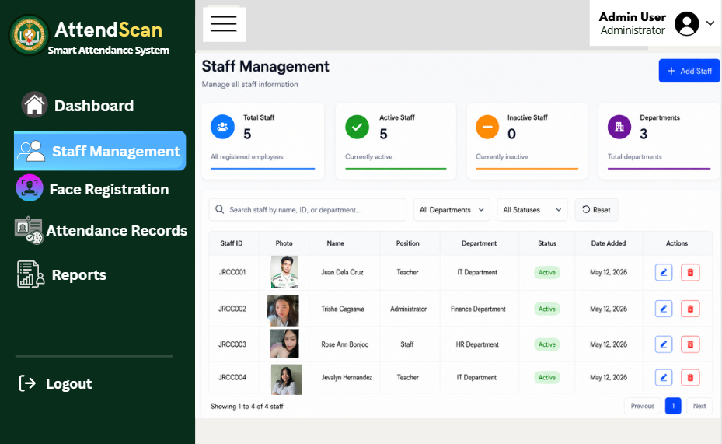
Figure 13: Staff Management Screen of the AttendScan System

Figure 13 shows the Staff Management screen in the AttendScan system. This screen helps administrators manage and keep track of employee information, inside Jesus Reigns Christian College , sort of in one place. In the screenshot, you can see there is a centralized table with staff details like staff ID, staff photo, name, job position, department, employment status, and the date the record was added. Alongside that, there are action controls too, where administrators can edit or remove a staff entry directly from the system, without extra steps.
On top of the interface, there’s also an upper area with summary cards. These cards give a quick overview of staff-related data, for example total staff, active staff, inactive staff, and how many departments are currently registered in the system. There’s a search bar and some filter options as well. These make it easier to find employees fast by using their name , staff ID, department, or even status , so record management feels more controlled and less time consuming.

AI-Based Attendance Monitoring and Analysis (AttendScan)

AttendScan is an AI powered attendance setup that uses computer vision together with real time video streams, so it can automatically spot, detect, recognize, and log people’s attendance. With camera modules plus OpenCV based image processing, the system pulls out facial features, then compares them to already stored data, and finally tags the outcome as either recognized or unrecognized. When identification is confirmed, it outputs the usual results like time in , time out , and the attendance status, and overall it keeps things efficient and contactless too.

Results:

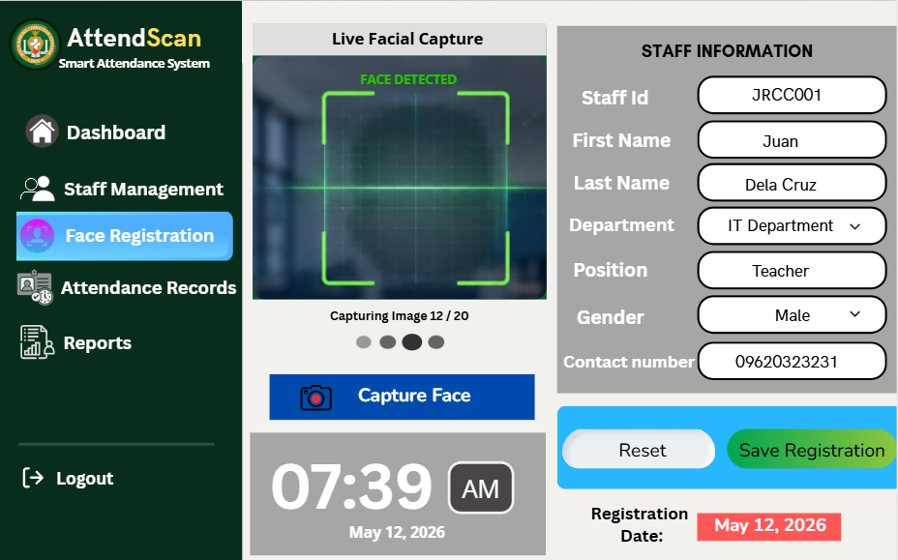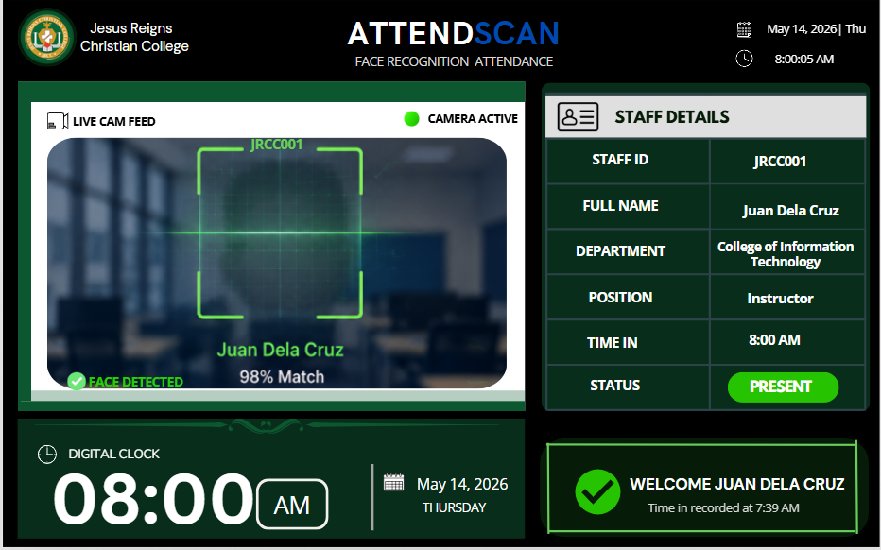
Figure 14: AttendScan Attendance Monitoring and Recognition Process

The images illustrate the operational flow of an AI-based facial recognition attendance system, specifically highlighting the time-in and time-out processes. The system uses a live camera feed to capture facial images in real time and applies computer vision techniques to detect and recognize an individual’s face. Once a face is detected, the system compares it with stored facial data and displays a match percentage, confirming the identity of the user. In the first image, the recognized individual is marked as “present,” and the system records the time-in, accompanied by a confirmation message indicating successful attendance logging.
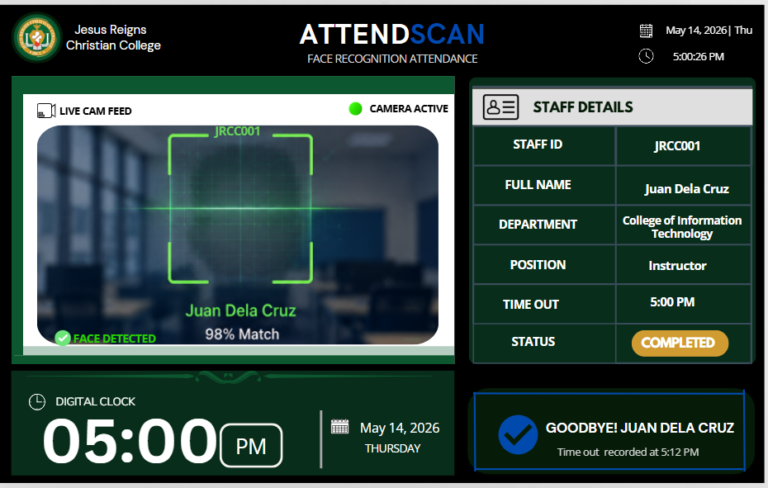

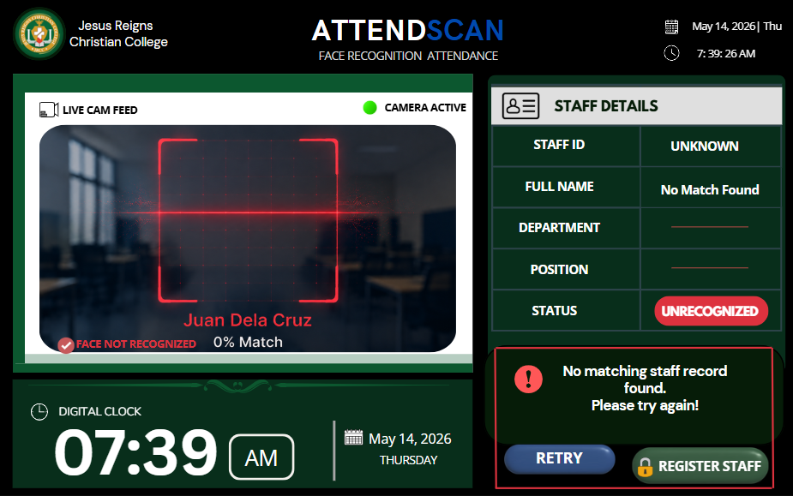

Figure 15: Facial Recognition Registration AI-driven page

In the following images, the same process is applied during the time-out phase. The system again detects and verifies the individual’s face, ensuring consistency and accuracy in identification. After successful recognition, the system records the time-out and updates the attendance status to “completed.” This demonstrates the system’s ability to handle both entry and exit monitoring using the same AI-driven recognition process.
Overall, these images show how the facial recognition system automates attendance tracking through real-time image capture, identity verification, and status classification. The integration of a live camera feed, recognition algorithm, and interactive dashboard ensures a seamless, efficient, and contactless method of recording attendance while minimizing manual intervention and potential errors.

Discussion:

This build follows a core idea that shows up in AI based behavioral analysis systems, where a continuous video feed is processed in order to capture meaningful patterns. But instead of looking at fish movement or something similar, AttendScan turns the focus toward face landmarks, plus identity verification, so it kind of shows how adaptable computer vision can be across different areas.
The development of AttendScan also stresses how well artificial intelligence can automate monitoring and analysis jobs using visual input. In other words, AttendScan takes these same technologies and applies them to human identification alongside attendance tracking, rather than some unrelated use case. In AttendScan, the involved processes are used in a way that supports accurate identity recognition and reliable attendance recording. That parallel indicates AI based computer vision solutions can be flexible and scalable for real time monitoring, whether the scene is an aquatic environment, or an institutional setting.
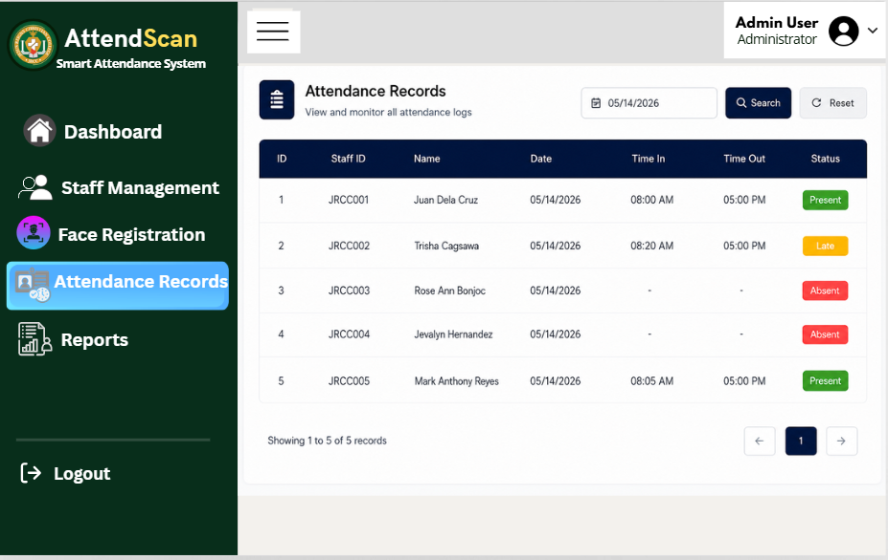
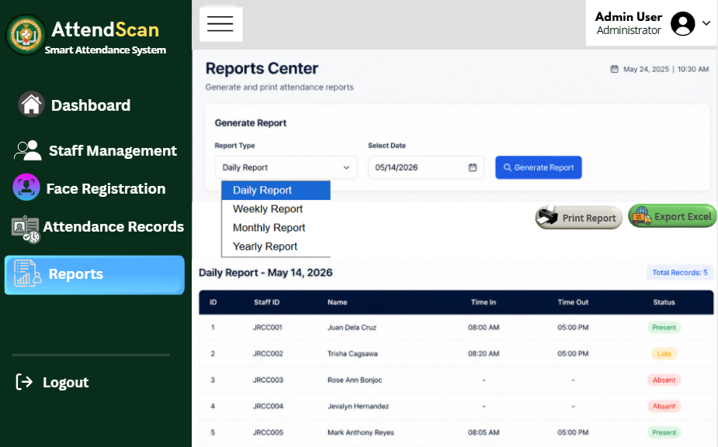

Figure 16: Results, Record logs, and Analytics Screens
Figure 15 shows the Reports Center part of the attendance monitoring system, it’s kind of where the data turns into something more useful. Basically, this module is meant to generate, manage, and review attendance records in a smoother way. It helps administrators make attendance reports across different time spans, like daily, weekly, monthly, and yearly, so they can monitor progress and do evaluation without digging through everything manually.

Discussion :
In the interface you’ll find a Report Type dropdown menu, the administrator picks the kind of report they want, then they move to the date selection field. After choosing both, the system generates the attendance information and shows it right away in a table view. Usually the report includes key items, like the employee or student ID, full name, time-in, time-out , and the attendance status, so it’s easier to spot what’s going on for each person.
There is also a printable angle here, which is pretty important for record keeping. The system gives options to either print the report right away or export it into an Excel format, so documentation feels a bit more organized. This supports admin needs such as attendance tracking, payroll preparation, performance monitoring, and finally the submission of formal attendance records.
On top of that, the analytics and record logs area lets administrators look at attendance patterns, and even notice oddities such as absences, late arrivals, or logs that are incomplete. because the report creation runs automatically, it reduces the amount of manual work, lowers chances of human mistakes, and it makes the whole attendance monitoring more dependable and accurate.
CONCLUSION

AttendScan offers this kind of integrated, AI based approach to a very common headache in attendance managing. Like, making sure every person's presence gets recorded in a way that’s accurate, efficient, and pretty much contactless. Instead of doing everything by hand or relying on stuff that gets messy over time, AttendScan pulls together computer vision facial recognition, real time video processing, and a web monitoring dashboard, all inside one system. It kind of tackles the weak points of older attendance methods that depend on manual input, ID cards, or biometric devices that can be slow , and sometimes inaccurate.
In particular it hits three main issues. First, manual recording takes too long and it’s easy to make mistakes. Second, there’s always the chance of proxy attendance or unauthorized entries, so the whole thing can be gamed. Third, many solutions don’t provide true time monitoring, or a centralized way to manage records. With its setup including a high resolution camera, a computer platform with enough processing power, Python and OpenCV for facial recognition, Flask for the dashboard, and MySQL for the database side, AttendScan allows automated identification, live attendance logging, and safe data storage. Because everything is connected like this, the attendance process ends up more streamlined and the records stay consistent, plus users can access results through an interactive interface.
The impact is not just for one kind of user or one place. Schools, educational institutions, and different organizations can use it to cut down administrative load and reduce human error. Administrators also get access to real time attendance information and reporting tools, which helps with smoother decision making and record keeping. Even developers and researchers can treat AttendScan as a useful example, showing how AI plus computer vision can solve real world tracking and monitoring problems without turning into an overcomplicated mess.
As supported by existing studies on AI-based recognition systems, computer vision technologies have consistently demonstrated improvements in accuracy, efficiency, and automation across various domains. AttendScan builds upon these advancements by implementing a practical and scalable solution tailored for attendance monitoring. Future enhancements may include the integration of more advanced facial recognition models such as FaceNet, improved performance under varying lighting conditions, and the addition of features such as mobile access, cloud synchronization, and enhanced security protocols.
REFERENCES
- Barhate, M., Ramdasi, I., Shaikh, I., Ingawale, V., Ingle, P., Ingle, P., & Jadhao, M. (2024). Innovative attendance tracking: Facial recognition. 2024 International Conference on Emerging Smart Computing and Informatics (ESCI), 1–6. https://doi.org/10.1109/esci59607.2024.10497364
- Bavaskar, V. (2024). Face recognition attendance system (Undergraduate dissertation, Sant Gadge Baba AmravatiUniversity,Amravati). https://www.ssgmce.ac.in/uploads/UG_Projects/cse/202324/Project%20Report%20Gr.%20No.%2010_2023-24.pdf
- Bondugula, V., Thummanapelli, S., Yadagiri, S., & Kumari, A. (2025). Advancements in student attendance management: A facial recognition-based system. AIP Conference Proceedings, 3297(1), 060012. AIP Publishing. https://doi.org/10.1063/5.0294678
- Chempavathy, B., Dhanalakshmi, M., Varun, M. G., Bohra, V., & Kalsariya, V. A. (2024). An improved attendance monitoring system through facial recognition using RetinaFace algorithm. 2024 3rd International Conference for Innovation in Technology (INOCON), 1–5. https://doi.org/10.1109/inocon60754.2024.10511664
- Chukwude, O. M., Surajudeen-Bakinde, N. T., Zakariyya, S. O., Ogunsakin, J. B., Akanni, J., Olayanju, S. A., & Ehiagwina, F. O. (2023). Development of a face recognition-based attendance system. SLU Journal of Science and Technology,6,214–224. https://api-uilspace.unilorin.edu.ng/server/api/core/bitstreams/ad26d58c-9829-4597-b0e1-e8a07383a8e6/content
- Darshan, V., Kenny, D. S., Shreyas, H. R., Vinay, N., & Revathi, S. (2024). IoT-based attendance monitoring system using facial recognition. 2024 Second International Conference on Advances in Information Technology (ICAIT), 1–6. https://doi.org/10.1109/icait61638.2024.10690462
- Karthick, V., Kumar, P., Divyaprasath, R., & Kesarinath, K. (2024). Facial recognition based attendance management system. SSRN. https://doi.org/10.2139/ssrn.4834649
- Kumar, N. (2025). Smart attendance by using face recognition. 2025 International Conference on Intelligent and Innovative Technologies in Computing, Electrical and Electronics (IITCEE), 1–5. https://doi.org/10.1109/IITCEE64140.2025.10915432
- Kumar, V., Yadav, A., Rai, A., Narwaria, M., & Mishra, R. (2025). Facial recognition for attendance systems: Trends and challenges. In the International Conference on Mathematics and Logics in Computer Science (pp. 402–411). Springer Nature Switzerland. https://doi.org/10.1007/978-3-032-14156-9_33
- Kumar, V. N., & Kumar, S. (2024). Real time attendance system using facial recognition. In Multidisciplinary Approaches for Sustainable Development (pp. 317–320). CRC Press. https://doi.org/10.1201/9781003543633-51
- Patel, K., Zagade, A., & Gupta, D. (2024). Automated facial authentication attendance system. International Journal for Research in Applied Science and Engineering Technology (IJRASET), 12(4). https://doi.org/10.22214/ijraset.2024.59809
- Raj, A., Srivastav, H., Shukla, S., & Gupta, N. (2024). Facial recognition-based student attendance system. 2024 11th International Conference on Reliability, Infocom Technologies and Optimization (Trends and Future Directions) (ICRITO), 1–5. https://doi.org/10.1109/ICRITO61523.2024.10522165
- Sain, A., Dutta, S., Saha, R., & Mandal, U. (2023). Automated facial recognition-based attendance system using OpenCV in Python. International Journal of Scientific Research in Computer Science, Engineering and Information Technology, 9(6), 105–111. https://doi.org/10.32628/CSEIT2390617
- Sharma, S. K., Kumar, S., Kumar, S., Prajapati, S., & Ansari, I. (2024). Smart attendance system using face recognition. 2024 International Conference on Computing, Sciences and Communications (ICCSC), 1–7. https://doi.org/10.1109/ICCSC62048.2024.10830336
- Vardhan, R., Aftab, S., Sanyal, N., Ali, K., & Kumar, A. (2025). Automated attendance system using facial recognition: A comprehensive review. In Challenges and Opportunities for Innovation in India (pp. 117–122). Taylor & Francis. https://doi.org/10.1201/9781003606260-20

