BIOCHEMICAL ANALYSIS OF LENTIL SEED AND PLANT SEEDLING INFECTED WITH FUSARIUM OXYSPORUM AND RHIZOCTONIA SOLANI.
Singh Anita
Career Point University, Kota, Rajasthan
Abstract
The present research work entitled biochemical analysis of lentil seed and plant seedling infected with fusarium oxysporum and rhizoctonia solani was conducted during Rabi season 2024-25 at the laboratory of modi institute of technology,Kota Rajasthan. The counter parts (Like leaf,stem,fruite and seeds) of lentil were selected for the study. The experiment was conducted using a Completely Randomized Design (CRD) with three replications to evaluate these parts.
Lentil (Lens culinaris) is an important legume crop grown around the world, but its yield often decreases due to fungal infections from Rhizoctonia solani and Fusarium oxysporum, which lead to root rot and damping-off diseases. The biochemical changes that these infections cause in lentil seeds and seedlings are examined in this study. The levels of total protein, phenolic content, antioxidant enzyme activity (peroxidase, catalase, and superoxide dismutase), and lipid peroxidation were among the biochemical markers that were examined in both infected and healthy samples. The results showed that defense-related enzyme activity was noticeably increased in infected plants and oxidative stress indicators, indicating an activated defensive mechanism. This response suggests that lentil plants have developed a robust defense system to combat the effects of rot and damping-off diseases. Further investigation into the specific pathways involved in these biochemical responses could provide valuable insights for improving disease resistance in lentil crops.
Additionally, variations in the accumulation of secondary metabolites were noted, highlighting their possible function in plant defense. The metabolic reactions of lentils to fungal diseases are better understood thanks to this study, which could also help create efficient disease control plans. Using standard quantitative techniques of biochemical analysis, important components of lentil seeds, such as lipid, starch, protein, phenol, and related enzymes, such as α- and β-amylase, polyphenol oxidase, protease, and lipase, were examined in the seeds infected with Rhizoctonia solani and Fusarium oxysporum.
Keywords: Lens culinaris medic, biochemical analysis
Introduction:
Legumes are highly nutritious crops due to their high protein content, making them a key dietary crop all over the world. Lentil (Lens culinaris) Medik is an essential agricultural commodity, which belongs to family Leguminosae, subfamily Papilionaceae. It is one of the native species of southwest Asia exhibiting immense economic importance globally. It is mainly grown in Pakistan, India, Nepal, Bangladesh and Iran (Javeria Ayub et al.,2024). Fusarium wilt (FW) disease is the key constraint to grain legume production worldwide (Erum s et.al 2025). Fusarium wilt (caused by Fusarium sp.) is the most devastating yield limiting factor of lentil. Like other crops, the growth of lentil is severely affected by biotic and abiotic factors which alter the biochemical and physiological processes of cell, thus reducing the plant growth and yield (Javeria Ayub et al.,2024). For managing wilt, the projected climate change is likely to exacerbate the current scenario of the various plant protection measures, genetic improvement of the disease resistance of crop cultivars remains the most economic, straightforward and environmental-friendly option to mitigate the risk. (UC Jha, A Bohra, S Pandey, SK Parida - Frontiers in Genetics, 2020). Lentil is an important legume crop, but it is plagued by a plethora of diseases, which limits its productivity considerably (Choudhury, S., et al 2025). Fusarium oxysporum f. sp. lentis (Fol) is considered the most destructive disease for lentil (Lens culinaris Medik.) worldwide. Despite the extensive studies elucidating plants’ metabolic response to fungal agents, there is a knowledge gap in the biochemical mechanisms governing Fol-resistance in lentil (Foti,C.,et al., (2024). Lentil (Lens culinaris Medik subsp. culinaris) is an important dietary source of protein and other essential nutrients in South and West Asia, North and East Africa. Lentil crops are vulnerable to a number of diseases caused by fungi, viruses, nematodes, insect pests, parasitic plants and abiotic stresses. Among them, the most significant and serious soil-borne disease is Fusarium wilt (Fusarium oxysporum f.sp. lentis: Fol) (Tiwari, N et al., 2018). With a high protein content, complex carbohydrates (which are made up of less crude fiber and slowly digestible starch), vital minerals, vitamins, and a high energy content, lentils are a nutrient-dense diet (Dhull et al., 2022; Joshi et al., 2017). Canada, India, Australia, Turkey, and the United States are the leading lentil producers, which are farmed in more than 40 countries (FAO, 2021). According to Hill (2022), consumers in affluent nations have been favoring plant-based protein sources as animal substitutes more and more in recent years. Numerous baked goods and extruded goods employ lentil flour. However, the sustainability of these enlarged applications over the long run hinges on assessing and comprehending the functional qualities of lentil flour and how they affect the final products' sensory qualities (Sidhu et al., 2022). The present study's objective is to comprehend how diseased plant components change physiologically. An estimate of the biochemical estimation was made.
Material and Methods
Protein content in lentil counter plant parts (Like healthy and infected leaf,stem and seed) were determined by the Lowry’s method, (1951). Soluble protein Albumin protein content was analyzed as described by the Horn et al., (1946). Carbohydrate content in lentil counter plant parts (Like healthy and infected leaf,stem and seed) were observed by the method of Yemm and Willis (1954). starch content in lentil counter plant parts (Like healthy and infected leaf,stem and seed) were observed by the method of McCready et al., 1950. To estimate total phenols in each of the test sample, the protocol of Bray and Thorpe (1954) was followed, wherein a standard curve of caffeic acid (a phenol) was prepared. Lipid content in lentil counter plant parts (Like healthy and infected leaf,stem and seed) were observed by the method of Jayaraman, 1981. Polyphenol oxidase activity was assayed by the method of (Shinshi and Noguchi, 1975). Lipase activity was determined with p-nitrophenyl palmitate (pNPP) by the method reported by Licia et al. (2006).

Results
Biochemical analyses were performed to assess the levels of protein, starch, phenol, and lipid, along with the activity of their associated enzymes—protease, α-amylase, polyphenol oxidase, and lipase—in different plant tissues subjected to varying conditions.
Protein Levels and Protease Activity: Among all the samples, the Normal Leaf (NL) exhibited the highest protein concentration (0.322 mg/g), followed by DLF (0.196 mg/g) and DLR (0.191 mg/g). The lowest protein content was found in DsdR (0.0118 mg/g). A similar pattern was observed in protease activity, with DLF recording the highest (0.006 units/sec/mg) and DSR the lowest (0.002 units/sec/mg).
Starch Levels and Alpha-Amylase Activity: Starch content was considerably elevated in Nsd (1.737 mg/g) and DsdF (1.629 mg/g), indicating enhanced starch synthesis or storage. Conversely, DLR had the least starch content (0.036 mg/g). Alpha-amylase activity was most pronounced in DsdF (0.011 units/sec/mg), suggesting intensified starch degradation.
Phenol Levels and Polyphenol Oxidase Activity: The NS sample had the highest phenol concentration (0.09 mg/g), while Nsd showed the lowest (0.01 mg/g). Polyphenol oxidase activity peaked in the NL sample (0.017 units/sec/mg), implying a heightened Défense response in that tissue.
Lipid Content and Lipase Activity: The DLF sample showed the highest lipid content (0.28 mg/g), followed closely by DsdF and DLR (each 0.20 mg/g). Lipase activity was greatest in DLF and DsdF (0.006 and 0.005 units/sec/mg, respectively), pointing to increased lipid breakdown, likely as part of a stress-related response mechanism.
Discussion
Boyle et al. (2010) reported that green lentils contained 23.0% protein, while red lentils had a slightly higher protein content of 25.8%. According to Suleiman et al. (2008), lentil proteins were classified based on their solubility into albumin, globulin, prolamin, and glutelin fractions. Singh et al. (2014) noted that the majority of lentil proteins are storage proteins, which are typically utilized by the seed during germination. Qayyum et al. (2012) also found protein levels in lentils to be within a comparable range. Similarly, Moldovan et al. (2015) observed a similar protein range and additionally reported that green lentils generally have a higher protein content than red lentils.
Alalshoimy (2007) conducted a study focused on the isolation and partial characterization of proteins extracted from chickpea, lupine, and lentil seeds.
The protein content of groundnuts infected with Cercospora personatum increased, according to Kaur and Dhillon (1990). Malik et al. (2002) found that infected pods of the T-9 type of Vigna mungo sensitive to leaf crinkle virus had a higher total protein content. Enzymes are proteins, as is well known, and the increased synthesis of proteins during an infection may be the result of enzyme activation, which is necessary for the synthesis of several defensive chemicals (Vidyasekaran, 2001).
In comparison to pea plants infected with Erysiphe pisi, Bahadur Singh et al. (2005) found that healthy stems, leaves, and roots had a higher protein content.
Jain and Yadav (2003) found a significant positive connection between total and reducing sugars and leaf and week infection. Similar alterations in carbohydrate levels were observed in multiple hosts infected by different infections. According to Kushwaha and Narain (2005), healthy leaves had higher levels of total and lowering sugar than resistant-type leaves. According to one theory, the disruption of normal phloem transport during pathogenesis may be the cause of the rise in total soluble sugars.
According to Prasad et al. (1988), Aspergillus niger infection in lablab beans caused a rise in total sugar and a decrease in sugar. Due to Aspergillus flavus infection, Singh et al. (1990) discovered that sensitive types of different pulses had higher levels of total sugar. According to Shukla, Dube, and Tripathi (1988), inoculated surface-sterilized wheat seeds infected with Aspergillus niger and Aspergillus tamariti exhibited a decrease in insoluble sugar and an increase in total soluble sugar, whereas inoculated seeds infected with Aspergillus flavus and Aspergillus parasiticus exhibited an increase in insoluble sugar and a decrease in total soluble sugar. According to Bhatnagar (1992), Alternaria burnsii-infected cumin plants showed a considerable increase in soluble sugar content and decreasing sugar content in their stems and stem tissues.
Flavus A. The association of different fungi, such as Aspergillus flavus, A. niger, Fusarium moniliforme, and Drechslera hawaiiensis, caused a decrease in the starch content of pigeonpea seeds, according to Sinha, Singh, and Prasad (1981). They also discovered that the starch content of seeds with a mycelial mat decreased less than that of seeds from which the mycelium was removed. According to Mathur (1992) and Sharma (1992), Rhizoctonia bataticola infection in soybean seeds results in a decrease in starch content. Reducing sugars rose in healthy pea plants and continued to rise in moderate infections, according to Rathi, Parashar, and Sindhan (1998). However, following a severe powdery mildew infection, there was a significant depletion.
According to Muthukumar et al. (2007), Alternaria alternata infection resulted in a decrease in total sugars, both reducing and non-reducing sugars.
The defense mechanism may be the cause of the rise in total phenol content (Jain and Yadav, 2003). The high concentration of phenols contributed to the resistance to sickness brought on by the fungi (Parashar and Lodha, 2007).
Singh (2000) documented the correlation between resistance and the rise in phenolics in Brassica.
According to Ghoshal et al. (2004), PAL activation and the ensuing rise in phenol levels were general responses linked to plant resistance mechanisms. Sesamum indicum infected with curvularia phaseoli phenolics may exhibit decreased polyphenol oxidase activity, which could signal the start of an infestation of insect pests (Rao and Panwar, 2001).
Agarwal (1989) found that after Phytophthora drechsleri was inoculated into resistant pigeonpea, the total phenol content rose, but it decreased in susceptible pigeonpea leaves. The total phenol content of groundnut seeds was found to be elevated by infection with Curvularia lunata, Aspergillus flavus, Penicillium fumiculosum, P. varians, and Fusarium oxysporum (Kamble & Gangwane, 1987). When Macrophomina phaseolina-infected mothbean seedlings germinated, Singh and Srivastava (1988) saw an increase in the overall phenolic content.
Singh et al. (1990), however, who evaluated thirty-eight distinct cultivars of black gram, pigeonpea, soybean, gram, and green gram, discovered that resistant variants had higher total phenols and that phenol degradation occurred during infection in all samples except soybean. Chakraborty and Chakraborty (2002) found that Helopeltis theivora's attack on immature tea leaves resulted in a drop in the total phenol, protein, and carbohydrate contents.
A review of lipid breakdown during seed deterioration was conducted by Angelo and Ory (1983). Food's organoleptic qualities may be diminished as a result of lipid peroxidation processes (Villaume et al. 1993). The lipoxygenase enzyme found in lentils naturally makes unsaturated fatty acids more likely to turn rancid (Maccarrone et al., 1997).
The significant difference in lipids profiling of the resistant and susceptible eggplants to Fusarium infection ensured the important role of the lipids in resistance mechanism against diseases. The total lipids in the resistant plants increased under infection and decreased in the susceptible plants (Deyala M. Naguib,2019).
Expression of Gratitude
The authors are thankful to Mr. Om Maheshwari, Director, and Mr. Pramod Maheshwari, Career Point University, Kota (Rajasthan), for offering access to library and laboratory facilities.
Conflicts and interest: The authors declare that they have no known personal or financial affiliations or interests that could appear to influence the work in this study.
References
Alalsohoimy, S.A.; Sitohy; M.Z and El- Masry, R.A. (2007). Isolation and partial characterization of chickpea, lupine and lentil seed proteins. World Jour. of Agric. Sci., 3(1):123-129.
Bhatnagar K (1992) Investigation into blight of cumin (Cuminum cyminum L.) caused by Alternaria burnsii in Rajasthan with special emphasis on its management. Ph.D. Thesis, Univ. Raj., Jaipur.
Bahadur A, Singh DP, Singh UP (2005) Biochemical changes in peas infected with Erysiphe pisi. Indian J. Plant Pathol. 23(1-2): 31-36.
Boyle, JL; S. Aksay, S; Roufik, S; Ribereau, M; Mondor, M; Mondor, E; Farnworth and S.H. Rajamohamed. (2010). Comparison of the functional properties of pea, chickpea and lentil protein concentrates processed using ultrafiltration and isoelectric precipitation techniques. Food Res. Int., 43: 537-546.
Chakraborty U, Chakraborty N (2002) Altered metabolic response of tea (Camellia sinensis) following attack by Helopeltis theivora Waterhouse. J. Mycol. Pl. Pathol. 32(3): 379.
Choudhury, S., Mahapatra, S., Chakraborty, S. et al. (2025). Revitalizing the lentil crop by use of a native Trichoderma sp. for Fusarium wilt and collar rot disease management and plant growth promotion. BioControl (2025). https://doi.org/10.1007/s10526-025-10366-6
Dube S, Shukla HS,Tripathi SC (1988) Changes in sugar and protein contents of wheat due to Aspergilli. India Phytopath. 4: 633-635.
Dhull, SB, Kinabo, J,Uebersax MA (2022) Nutrient profile and effect of processing methods on the composition and functional properties of lentils (Lens culinaris Medik)—A review. Legume Science, e156. https://doi.org/10.1002/leg3.156
Foti, C., Zambounis, A., Bataka, E. P., Kalloniati, C., Panagiotaki, E., Nakas, C. T., Flemetakis, E., & Pavli, O. I. (2024). Metabolic Aspects of Lentil–Fusarium Interactions. Plants, 13(14), 2005. https://doi.org/10.3390/plants13142005
FAO (Food and Agriculture Organization) (2021) Crop Production and Trade Data. Accessed September 18, 2021. http://www.fao.org/faostat/en/#home
Ghoshal TK, S. Dutta, SK Senapati, DC Deb (2004) Role of phenol contents in legume seeds and its effect on the biology of collosobrocnus chinensis. Ann. Pl. Prot. Sci. 12: 442-444.
Hill H (2022) Utilization of dry beans and other pulses as ingredients in diverse food products. In M. Siddiq & M. A. Uebersax (Eds.). Dry Beans and Pulses: Production, Processing, and Nutrition (Second ed.) (pp. 307–329). John Wiley & Sons. https://doi.org/10.1002/9781119776802.ch12
Irum, S., Khalid, M. H. B., Hussain, T., Saeed, A., Haider, I., Ahmed, Z., ... & Elshikh, M. S. (2025). Comprehensive evaluation of agronomic traits, physiological responses, and gene expression in chickpea cultivars under fungal stress. Functional Plant Biology, 52(10) https://doi.org/10.1071/FP25100
Jayaraman J (1981) Laboratory manual in biochemistry. Willey Eastern Ltd., New Delhi, pp. 96-97.
Jain AK, HS Yadav (2003) Biochemical constituents of finger millet genotypes associated with resistance to blast caused by Pyricularis grisea. Ann.Pl.Protec.Sci. 11: 70-74.
Joshi M, Timilsena Y, Adhikari B (2017) Global production, processing, and utilization of lentils: A review. Journal of Integrative Agriculture, 16, 2898–2913. https://doi.org/10.1016/S2095-3119(17)61793-3
Kaur J,Dhillon M (1990) Biochemical alteration in groundnut leaves induced by Cercosporium personatum. Indian J. Mycol. Pl. Path. 19: 151-156.
Kushwaha KPS, Udit Narain (2005) Biochemical changes in pigeon pea leaves infested with Alternaria tenuissima. Ann. Pl. Protec. Sci. 13: 415-417.
Kushwaha KPS, Udit Narain (2005) Biochemical changes in pigeon pea leaves infested with Alternaria tenuissima. Ann. Pl. Protec. Sci. 13: 415-417.
Licia MP, Cintia MR, Mario DB, Guillermo RC (2006) Catalytic Properties of Lipase Extracts from Aspergillus niger, Food Technol. Biotechnol. 44(2): 247-252.
Mathur R. (1992) Pathological and physiological studies on some seed disorders in soybean. Ph.D. Thesis, Rajasthan, Univ. Jaipur.
Maccarrone M, Veldink GA, Vliegenthart JFG, Agro AF (1997) Ozone stress modulates amino oxidase and lipooxygenase expression in lentil (lens culinaris) seedlings. FEBS. Lett. 408, 241-244.
Maria de Mascena DM, Marcia Maria CM, Marcos A, Eduardo H, Jose L (1999) Production of extracellular lipase by the phytopathogenic fungus Fusarium solani FSI. Rev. Microbiol., 30: 3714-3721.
Malik S, Kumar P, Panwar JDS, Rathi YPS (2002) Physiological and biochemical alterations induced by urdbean leaf crinkle virus in Vigna mung. Ann. Pl. Protec. Sci. 10: 91-94.
Maheshwari M, Uma S, Suresh and N Emmaneul (2006) Biochemical basis of resistance in rice hybrids and conventional varieties against brown planthopper. Ann. Pl. Protec. Sci. 14: 69-72.
Muthukumar A,Bhaskaran R, Eswaran A, Rajkumar M (2007) Studies on the biochemical properties of healthy and leaf spot-infected tuberose plants. Indian J. Hort. 64(2): 190-193.
Moldovan, O; Paucean, A; Vlaic, R; Bors,D.M and Muste, S. (2015). Preliminary assessment of the nutritional quality of two types of lentils (Lens culinaris Medik) by Near Infrared Reflectance Spectroscopy Technology (NIRS). Bulletin Uasvam Food Science and Technology 72(1).
Pustovoit GV, Borodin SG (1983) Harmfulness of grey rot of sunflower. Zashcia Rastenil. No. 91: 41.
Prasad BK, Prasad A, Shankar U, Kumar S (1988) Levels of change in carbohydrate in lablab bean FD5 CV S. seeds due to seed-borne Aspergillus niger. Indian J. Mycol. Pathol. 17: 145-148.
Parashar A, Lodha P (2007) Phenolic estimation in Foeniculum vulgare infected with Ramularia blight. Ann. Pl. Protec. Sci. 15: 396-398.
Qayyum, N.M.M., Butt, S.M., Anjum, M.F. and Nawaz, H. (2012). Composition analysis of some selected legumes for protein isolates recovery. The journal of animal & plant sciences, 22(4): 1156-1162.
Rathi AS, Parashar RD, Sindhan GS (1998) Biochemical changes in pea leaves due to powdery mildew infection. Ind. J. Mycol. and Plant Pathol. 28(3): 330-333.
Rao CN, Panwar VPS (2001) Biochemical plant factors affecting resistance to Atherigona spp. In maize. Ann. Pl. Protec. Sci. 9: 37-42.
Shukla HS, Dube KS, Tripathi SC (1988) Change in protein content of arhar (Cajanus cajan) due to fungal association. Legume Research, 11: 85-88.
Singh SK, Srivastava HP (1988) Phenolic changes in moth bean (Vigna aconintifolia (Jacq.) Marechal) during Macrophomia phaseolina infection. Indian J. Mycol. Pl. Pathol. 18: 314-316.
Singh D, Singh KG (1990) Occurrence of fungi in rubber of Malaysia. Indian Journal of Natural Rubber Research, 3: 64-65.
Singh P, Bhagat S, Ahmad SK (1990) Aflatoxin elaboration and nutrition deterioration in some pulse cultivars during infestation with A. flavus. J. Food Sci. Technol. (Mysore). 27(1): 60-62.
Sharma J (1992) Mycoflora of soybean seeds and their pathological effects. Ph.D. Thesis, Univ. Raj., Jaipur.
Singh HV (2000) Biochemical basis of resistance in Brassica species against downy mildew and white rust of mustard. Pl. Dis. Res. 15: 75-77.
Singh HV (2004) Biochemical transformation in Brassica spp. due to Peronospora parasitica infestation. Ann. Pl. Protec. Sci. 12: 301-304.
Singh, K.A., Kumar, P., Singh, J., Rani, R., Rani, A., Shukla, P. and Misra, P. (2014). Biochemical profiling of lentil (lens culinarismedik) germplasm at different growth stages. J. Biol. Eng. Res. & Rev 2 (1) 01-06.
Singh Anita "Quantification of Total Protein and Related Enzymes in Fusarium Wilt-Infected Lens culinaris medic." J Microbiol Pathol 5 (2021): 1-3.
Singh Anita "Quantification of Total lipid and Related Enzymes in Fusarium Wilt-Infected Lens culinaris medic." International Journal of Science and Research (IJSR) 11(2022): 187-189. DOI: 10.21275/SR22624135154
Singh Anita and Varma Rashmi "Quantification of Total Phenol and Related Enzymes in Fusarium Wilt-Infected Lens culinaris medic." Indian journal of applied and pure biology 5 (2010): 269-271.
Singh Anita and Varma Rashmi "Quantification of Total Carbohydrate and Related Enzymes in Fusarium Wilt-Infected Lens culinaris medic." International journal of mendel 27 (2010): 49-51.
Sidhu JS, Zafar T, Benyathiar P, Nasir M (2022) Production, processing, and nutritional profile of chickpeas and lentils. In M. Siddiq & M. A. Uebersax (Eds.). Dry Beans and Pulses: Production, Processing, and Nutrition (Second ed.) (pp. 383–407). John Wiley & Sons. https://doi.org/10.1002/9781119776802.ch15
Tiwari, N., Ahmed, S., Kumar, S., & Sarker, A. (2018). Fusarium Wilt: A Killer Disease of Lentil. InTech. DOI: 10.5772/intechopen.72508
Tripathi AK, RK. Pandya, MLTripathi (2001) Effect of nitrogen, phosphorus, and potassium on stem gall disease and yield of coriander. Ann. Pl. Protec. Sci. 9: 337-339.
Jha, U. C., Bohra, A., Pandey, S., & Parida, S. K. (2020). Breeding, genetics, and genomics approaches for improving Fusarium wilt resistance in major grain legumes. Frontiers in Genetics, 11, 1001. https://www.frontiersin.org/journals/genetics/articles/10.3389/fgene.2020.01001/full
Villaume C,Chandrasir V,Bau HM, Nicolas JP, Mejean L (1993) Effect du traitement technologique de preparation des proteines de soja sur la prise alimentaire du rat en croissance. Sci. Alim. 13:377-383.
Vidyasekaran P (2001) Physiology of disease resistance. In: Principles of Plant Pathology (1st Ed.). C.B.S. Publishers & Distributors, New Delhi, pp. 106-116.
Deyala M. Naguib (2019). Comparative lipid profiling for studying resistance mechanism against Fusarium wilt,Physiological and Molecular Plant Pathology, 108:101421https://doi.org/10.1016/j.pmpp.2019.101421.
Javeria Ayub et al., (2024). Effective biological control of Lentil (Lens culinaris) Fusarium wilt and plant growth promotion through native Rhizobacteria,Physiological and Molecular Plant Pathology, https://doi.org/10.1016/j.pmpp.2023.102203

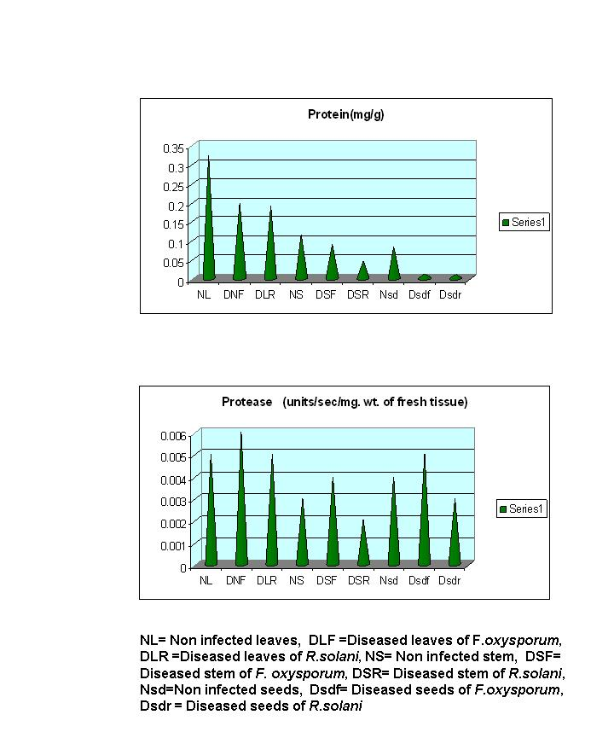
Figure 3.

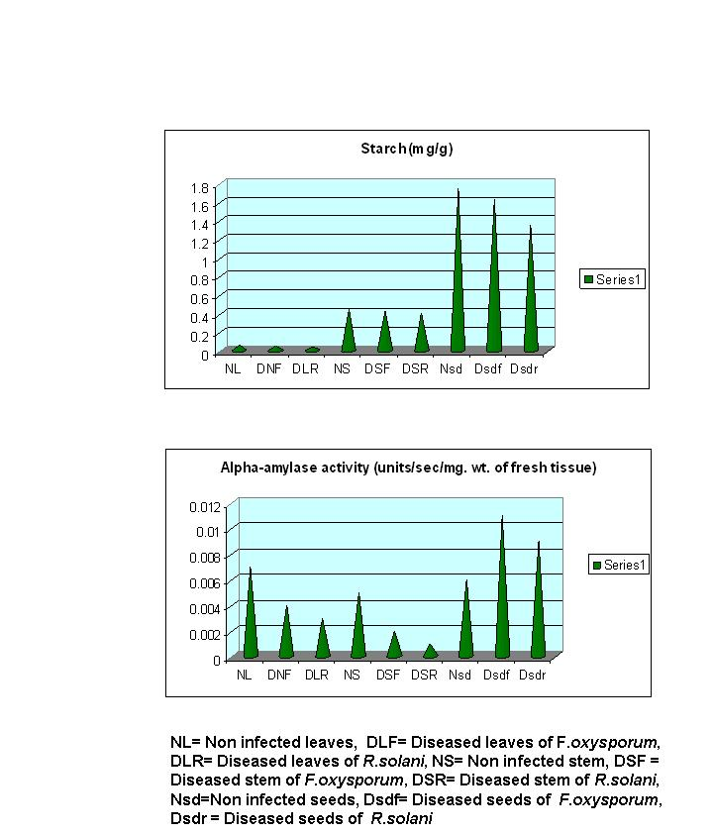

Figure-4
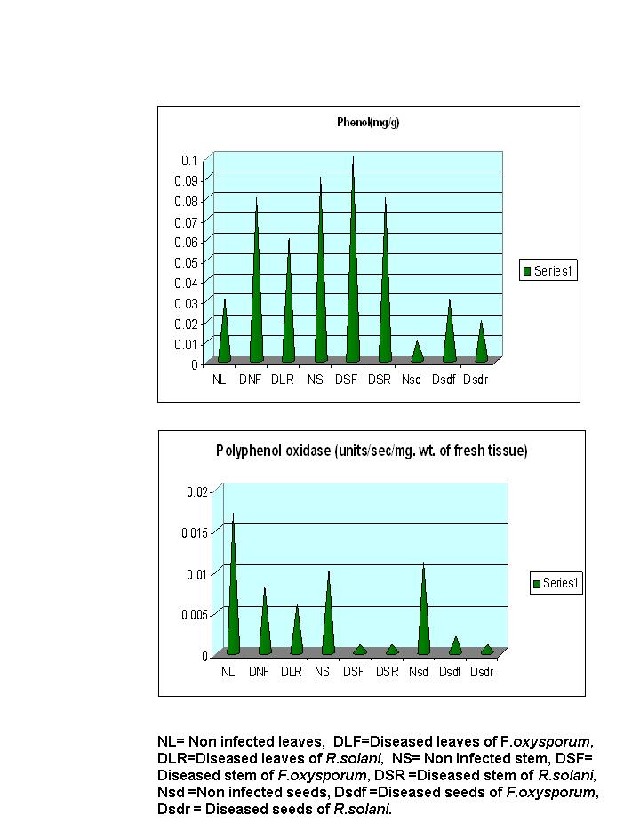
Figure-5
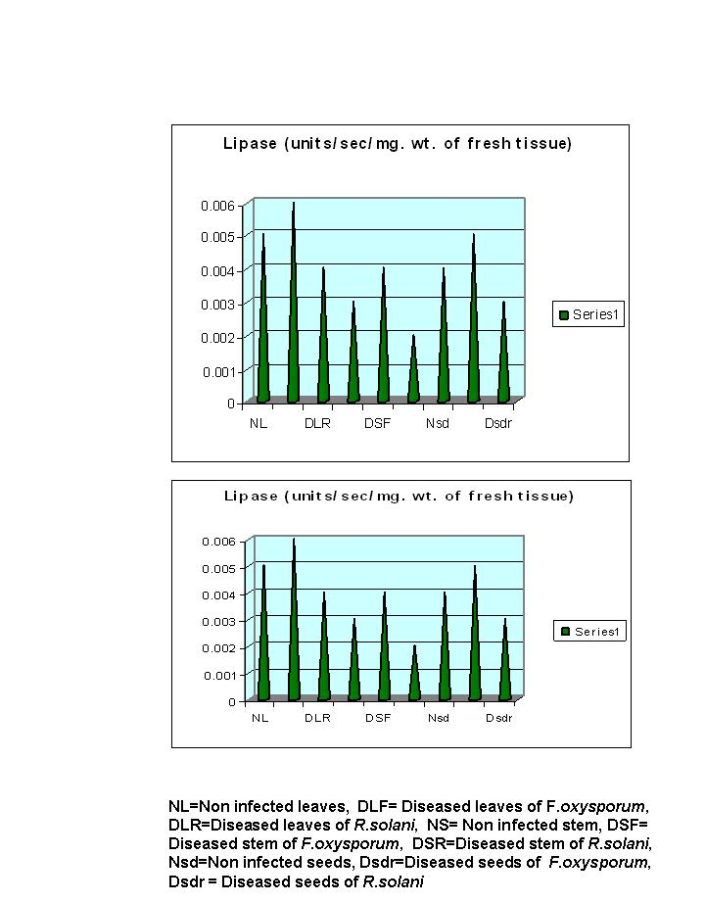
Figure-6

Table -1: QUANTIFICATION OF PROTEIN, STARCH, PHENOL, LIPID AND THEIR RELATED ENZYMES.

Concentration | Protein (mg/g) | Protease activity (units per second per milligram of fresh tissue). | Starch (mg/g) | Alpha-amylase activity (units per second per milligram of fresh tissue). | Phenol (mg/g) | Polyphenol oxidase activity (units per second per milligram of fresh tissue). | Lipid (mg/g) | Lipase activity (units per second per milligram of fresh tissue).
NL | 0.322 | 0.005 | 0.063 | 0.007 | 0.03 | 0.017 | 0.06 | 0.005
DLF | 0.196 | 0.006 | 0.045 | 0.004 | 0.08 | 0.008 | 0.28 | 0.006
DLR | 0.191 | 0.005 | 0.036 | 0.003 | 0.06 | 0.006 | 0.2 | 0.004
NS | 0.116 | 0.003 | 0.45 | 0.005 | 0.09 | 0.01 | 0.07 | 0.003
DSF | 0.0489 | 0.004 | 0.423 | 0.002 | 0.1 | 0.001 | 0.18 | 0.004
DSR | 0.0451 | 0.002 | 0.405 | 0.001 | 0.08 | 0.001 | 0.1 | 0.002
Nsd | 0.0826 | 0.004 | 1.737 | 0.006 | 0.01 | 0.011 | 0.11 | 0.004
DsdF | 0.0122 | 0.005 | 1.629 | 0.011 | 0.03 | 0.002 | 0.2 | 0.005
DsdR | 0.0118 | 0.003 | 1.35 | 0.009 | 0.02 | 0.001 | 0.17 | 0.003
SEM ± | 0.0347 | 0.00042 | 0.23154 | 0.00109 | 0.01119 | 0.00189 | 0.02408 | 0.00041
CD at 5% | 0.08002 | 0.00098 | 0.53393 | 0.00252 | 0.02581 | 0.00435 | 0.05553 | 0.00094

